FEDERAL COURT OF AUSTRALIA

Warrie (formerly TJ) (on behalf of the Yindjibarndi People) v State of Western Australia (No 2) [2017] FCA 1299

File number: | WAD 6005 of 2003
Judge: | RARES J
Date of judgment: | 13 November 2017
Catchwords: | NATIVE TITLE – Native Title Act 1993 (Cth) – final determination under s 225 – whether appropriate to include notation under a provision in final determination that purports to describe what would have been native title rights and interests in certain area had Court not determined that ss 47A and 47B applied to that area – effect of final determination on native title rights and interests
Legislation: | Corporations (Aboriginal and Torres Strait Islander) Act 2006 (Cth)  Native Title Act 1993 (Cth) ss 11, 47A, 47B, 56, 84, 225
Cases cited: | Administration of the Territory of Papua and New Guinea v Daera Guba (1973) 130 CLR 353  Banjima People v Western Australia (No 2) (2015) 328 ALR 637  Daniel v State of Western Australia [2003] FCA 666  Gumana v Northern Territory (2005) 141 FCR 457  Mabo v Queensland (No 2) (1992) 175 CLR 1  Members of the Yorta Yorta Aboriginal Community v Victoria (2002) 214 CLR 422  Nana Ofori Atta II v Nana Abu Bonsra II [1958] AC 95  Precision Data Holdings Ltd v Wills (1991) 173 CLR 167  Warrie (formerly TJ) (on behalf of the Yindjibarndi People) v State of Western Australia [2017] FCA 803  Western Australia v Ward (2002) 213 CLR 1
Date of hearing: | Determined on the papers
Date of last submissions: | 30 October 2017
Registry: | Western Australia
Division: | General Division
National Practice Area: | Native Title
Category: | Catchwords
Number of paragraphs: | 30
Counsel for the Applicant: | Mr V Hughston SC with Ms T Jowett
Solicitor for the Applicant: | Mr G Irving
Counsel for the First Respondent: | Mr DP O’Gorman SC with Mr M Pudovskis
Solicitor for the First Respondent: | State Solicitors Office
Counsel for the Second Respondent: | Mr S Glacken QC with Mr A Sharpe
Solicitor for the Second Respondent: | Green Legal
Solicitor for the Third Respondent: | Ashurst Australia
Solicitor for the Fourth Respondent: | Hancock Prospecting Pty Ltd
Solicitor for the Fifth Respondent: | Yamatji Marlpa Aboriginal Corporation
Counsel for the Sixth Respondent: | Mr S Wright
Solicitor for the Sixth Respondent: | Integra Legal

Table of Corrections
30 November 2017 | In the Appearances on the cover page Solicitor for the Applicant has been amended from Yindjibarndi Aboriginal Corporation to Mr G Irving.

ORDERS
 |  | WAD 6005 of 2003
BETWEEN: | WARRIE (FORMERLY TJ) (ON BEHALF OF THE YINDJIBARNDI PEOPLE) (and others named in the Schedule)  Applicant
AND: | STATE OF WESTERN AUSTRALIA (and others named in the Schedule)  First Respondent

JUDGE: | RARES J
DATE OF ORDER: | 13 NOVEMBER 2017

THE COURT ORDERS THAT:

1. There be a determination of native title in terms of the attached Determination.
2. The Yindjibarndi Ngurra Aboriginal Corporation (ICN 8721) shall hold the determined native title in trust for the native title holders pursuant to s 56(2)(b) of the Native Title Act 1993 (Cth).
3. There be no order as to costs.

AND THE COURT DECLARES THAT:
4. Winningbung was not Yindjibarndi and is not an apical ancestor of the Yindjibarndi People;
5. None of the following is one of the Yindjibarndi People:
(a) Phyllis Harris (neé Todd), Lindsay Todd and Margaret Todd (the Todd respondents);
(b) the siblings of the Todd respondents (the siblings);
(c) the children and later issue of the Todd respondents and the siblings unless the other parent of any such child or issue is one of the Yindjibarndi People and the child or issue has elected, or is capable of electing and does elect, to be Yindjibarndi.

DETERMINATION

THE COURT ORDERS, DECLARES AND DETERMINES THAT:

Existence of native title (s 225 Native Title Act)
- Native title exists in the Determination Area in the manner set out in paragraphs 3 and 4 of this Determination.

Native title holders (s 225(a) Native Title Act)
- The native title in the Determination Area is held by the Yindjibarndi People. The Yindjibarndi People are the people referred to in Schedule 6.

The nature and extent of native title rights and interests and exclusiveness of native title (s 225(b) and (e) Native Title Act)
- Subject to paragraphs 4, 5, 6 and 9, the nature and extent of the native title rights and interests in relation to the Determination Area are that they confer the following rights on the Yindjibarndi People, including the right to conduct activities necessary to give effect to them:
  - A right to access (including to enter, to travel over and remain);
  - A right to engage in ritual and ceremony (including to carry out and participate in initiation practices);
  - A right to camp and to build shelters (including boughsheds, mias and humpies) and to live temporarily thereon as part of camping or for the purpose of building a shelter;
  - A right to fish from the waters;
  - A right to collect and forage for bush medicine;
  - A right to hunt and forage for and take fauna;
  - A right to forage for and take flora;
  - A right to take and use resources;
  - A right to take water for drinking and domestic use;
  - A right to cook on the land including light a fire for this purpose;
  - A right to protect and care for sites and objects of significance in the Determination Area (including a right to impart traditional knowledge concerning the area, while on the area, and otherwise, to succeeding generations and others).
- Subject to paragraph 5, in the Exclusive Area, the native title rights and interests confer the right to possession, occupation, use and enjoyment of that area to the exclusion of all others.

Qualifications on the native title rights and interests
- The native title rights and interests set out in paragraphs 3 and 4:
(a) are subject to and exercisable in accordance with:
(i) the laws of the State and the Commonwealth, including the common law; and
(ii) the traditional laws and customs of the Yindjibarndi People;
(b) do not confer exclusive rights in relation to water in any watercourse, wetland or underground water source as is defined in the Rights in Water and Irrigation Act 1914 (WA) as at the date of this Determination; and
(c) do not confer any rights in relation to:
(i) minerals as defined in the Mining Act 1904 (WA) (repealed) and in the Mining Act 1978 (WA);
(ii) petroleum as defined in the Petroleum Act 1936 (WA) (repealed) and in the Petroleum and Geothermal Energy Resources Act 1967 (WA);
(iii) geothermal energy resources and geothermal energy as defined in the Petroleum and Geothermal Energy Resources Act 1967 (WA); or
(iv) water captured by the holders of the Other Interests pursuant to those Other Interests.

- Subject to paragraph 4 the native title rights and interests set out in paragraph 3:
(a) do not confer:
(i) possession, occupation, use and enjoyment on the Yindjibarndi People to the exclusion of all others; or
(ii) a right to control the access to, or use of, the land and waters of the Determination Area or its resources.

Areas to which ss 47A or 47B of the Native Title Act apply
- Sections 47A and 47B of the Native Title Act apply to disregard any prior extinguishment in relation to the land and waters described in Schedule 4.

The nature and extent of any other interests (s 225(c) Native Title Act)
- The nature and extent of the Other Interests are described in Schedule 5.

Relationship between native title rights and other interests (s 225(d) Native Title Act)
- Except as otherwise provided for by law, the relationship between the native title rights and interests described in paragraphs 3 and 4 and the Other Interests apart from exploration licence 47/1349 is that:
(a) to the extent that any of the Other Interests are inconsistent with the continued existence, enjoyment or exercise of the native title rights and interests, the native title rights and interests continue to exist in their entirety, but the native title rights and interests have no effect in relation to the Other Interests to the extent of the inconsistency during the currency of the Other Interests; and otherwise,
(b) the existence and exercise of the native title rights and interests do not prevent the doing of any activity required or permitted to be done by or under the Other Interests, and the Other Interests, and the doing of any activity required or permitted to be done by or under the Other Interests, prevail over the native title rights and interests and any exercise of the native title rights and interests but do not extinguish them.
- Except as otherwise provided for by law, the relationship between the native title rights and interests described in paragraphs 3 and 4 and exploration licence 47/1349 is that:
(a) to the extent that the rights under the licence are inconsistent with the continued existence, enjoyment or exercise of the native title rights and interests, the rights under the licence continue to exist in their entirety, but have no effect in relation to the native title rights and interests to the extent of the inconsistency during the currency of the licence; and otherwise,
(b) the existence and exercise of the rights under the licence do not prevent the doing of any activity required or permitted to be done by or under and in accordance with the native title rights and interests, and the doing of such activities prevails over the exercise of any rights under the licence to the extent of inconsistency with those rights.

Definitions and Interpretation
- In this determination, unless the contrary intention appears:
Commonwealth means Commonwealth of Australia;
Determination Area means the land and waters within the external boundary described in Part 1 of Schedule 1 and depicted on the maps at Schedule 3, but not including the Unclaimed Area;
Exclusive Area means that part of the Determination Area described in Part 2 of Schedule 1 and depicted on the maps in Schedule 3;
land has the same meaning as in the Native Title Act and, for the avoidance of doubt, includes any natural collection of water found on the land which does not fall within the definition of “waters”;
Other Interests means the legal or equitable estates or interests and other rights in relation to the Determination Area described in Schedule 5 and referred to in paragraph 8, as at the date of this determination;
Native Title Act means the Native Title Act 1993 (Cth);
resources means flora, fauna, and other natural resources such as charcoal, stone, soil, wood, resin, and ochre (except, for the avoidance of doubt, ochres for use in the manufacture of porcelain, fine pottery or pigments which are minerals pursuant to the Mining Act 1904 (WA) (repealed));
State means State of Western Australia;
Unclaimed Area means the land and waters described in Schedule 2 and shaded pink on the maps in Schedule 3;
underground water includes water that percolates from the ground;
waters has the same meaning as in the Native Title Act.
- In the event of any inconsistency between the written description of an area in Schedule 1 or 2 and the area as depicted on the maps at Schedule 3, the written description prevails.

SCHEDULE 1: Determination area and EXCLUSIVE area
part 1: DETERMINATION AREA
All those lands and waters commencing at the intersection of Native Title Determination WAD6208/1998 Eastern Guruma (WCD2007/001) with a eastern boundary of Native Title Determination WAD6090/1998 Kuruma Marthudunera (Part A) (WCD2016/006) at Latitude 22.003438 South and extending generally northeasterly along boundaries of that native title determination to the intersection with a western boundary of Native Title Determination WAD6017/1996 Ngarluma/Yindjibarndi (WCD2005/001) at Latitude 21.955526 South; then southerly, generally easterly and northerly along boundaries of that native title determination to the intersection with a western boundary of Native Title Application WAD6169/1998 Kariyarra People (WC1999/003); then generally southeasterly along the boundaries of that native title application through the following coordinate positions:
LATITUDE (SOUTH) | LONGITUDE (EAST)
21.874703 | 118.591512
21.860344 | 118.676151

Then continuing southwesterly along the boundary of that native title application to the intersection of the eastern bank of the Cockeraga River with a line joining coordinate positions Latitude 21.860344 South, Longitude 118.676151 East and Latitude 22.008794 South, Longitude 118.814893 East; then generally southerly along that river bank to the intersection with a northern boundary of Native Title Determination WAD6096/1998 Banjima People (WCD2014/001); then generally westerly, generally northwesterly, generally southwesterly and southeasterly along boundaries of that native title determination to the intersection with a northern boundary of Reserve 30082 (Karijini National Park) at Longitude 118.124481 East; then westerly and southerly along boundaries of that reserve to the intersection with a eastern boundary of Native Title Determination WAD6208/1998 Eastern Guruma (WCD2007/001); then northwesterly along the boundary of that native title determination to the intersection with a southern boundary of Pastoral Lease N050483 (Mt Florance) at Longitude 117.966611 East; then generally northwesterly through the following coordinate positions:
LATITUDE (SOUTH) | LONGITUDE (EAST)
22.220779 | 117.965134
22.216053 | 117.959709
22.211266 | 117.953720

Then northwesterly to the intersection of a western boundary of Pastoral Lease N050483 (Mt Florance) with Latitude 22.210019 South being a point on the present boundary of Native Title Determination WAD6208/1998 Eastern Guruma (WC2007/001) and then generally northwesterly along the boundaries of that native title determination back to the commencement point.

Note: Geographic Coordinates provided in Decimal Degrees.

Cadastral boundaries sourced from Landgate’s Spatial Cadastral Database dated 31 July 2017.

Cockeraga River data based on 250K vector data © Commonwealth of Australia (Geoscience Australia) 2008.

For the avoidance of doubt the application excludes any land and waters already claimed by:

Native Title Determination WAD6017/1996 Ngarluma/Yindjibarndi (WCD2005/001) as Determined in the Federal Court on the 2nd May 2005.

Native Title Determination WAD6096/1998 Banjima People (WCD2014/001) as Determined in the Federal Court on the 11th March 2014.

Native Title Determination WAD6208/1998 Eastern Guruma (WCD2007/001) as Determined in the Federal Court on the 1st March 2007.

Native Title Determination WAD6090/1998 Kuruma Marthudunera (Part A) (WCD2016/006) as Determined in the Federal Court on the 1st November 2016.

Native Title Determination Application WAD6169/1998 Kariyarra People (WC1999/003) as Registered in the Federal Court on the 22nd April 1999.

Datum: Geocentric Datum of Australia 1994 (GDA94)

Prepared By: Graphic Services (Landgate) 18th October 2017

Use of Coordinates:
Where coordinates are used within the description to represent cadastral or topographical boundaries or the intersection with such, they are intended as a guide only. As an outcome to the custodians of cadastral and topographic data continuously recalculating the geographic position of their data based on improved survey and data maintenance procedures, it is not possible to accurately define such a position other than by detailed ground survey.

part 2: Exclusive Area
The Exclusive Area, shaded in green on the maps in Schedule 3, comprises:
Areas where section 47A applies

Reserve 31428

Areas where section 47B applies

UCL 01, except to the extent covered by mineral lease AML70/00004 as at the date the application was filed

UCL 02, except to the extent covered by mineral lease AML70/00004 as at the date the application was filed

UCL04

UCL06

UCL 07, except to the extent covered by:

(a) mineral lease AML70/00004; and

(b) miscellaneous licence 47/47

as at the date the application was filed.
UCL08

UCL09

UCL10

UCL11

UCL13, except to the extent covered by mineral lease AML70/00004 as at the date the application was filed

UCL14

UCL17

UCL18

UCL19

UCL22

UCL23

UCL24

WATER1, except to the extent covered by mineral lease AML70/00004 as at the date the application was filed

SCHEDULE 2: unclaimed area
The following areas, shaded in pink on the maps at Schedule 3, being land and waters where native title has been completely extinguished, were excluded from the application for native title in WAD 6005 of 2003 and are excluded from the Determination Area:
- Reserves
Reserve No. | Current / Last Purpose
31429 | Conservation of flora and fauna
38991 | Water supply
- leases
Lease No. | Summary / General Description of the Current / Last Purpose
GE H954583 | Permanent campsite for use in connection with the Tom Price to Dampier railway (Camp Anderson)
SL 3116/7842  (GE I123646) | Construction and operation of a 220 KV power transmission line and ancillary purposes (the Dampier/Paraburdoo Power Transmission Line)
SL 3116/4984  (GE I195323) | Railway and ancillary purposes (the Dampier/Tom Price Railway)
- Roads and associated features
(a) Dedicated roads, roads set aside, taken or resumed, or roads which are to be considered public works (as that expression is defined in the Native Title Act and the Titles (Validation) and Native Title (Effect of Past Acts) Act 1995 (WA)), including the following:
MapInfo ID | Description | Shown /referred to in
ROAD 01 | Roebourne-Wittenoom Road, including a 200m-wide corridor | Cancelled public plan 503 154 (97/300) dated 30 June 1941  1: 250,000 plan for Pyramid (SF50-7, Edition 1)  Map 2553 1: 100 000 plan for Wittenoom (Edition 1)
ROAD 02 | Road 1644 | Government Gazette 31 July 1903, 1 April 1904, 4 December 1914  Cancelled public plan 505 558 dated 28 March 1894  Cancelled public plan 506 648 dated 15 August 1903
HISTORICAL ROAD 01 | Nanutarra-Wittenoom Road, including a 200m-wide corridor | Cancelled public plan 502 692 dated August 1963  1: 250 000 plan for Mt Bruce (F50) dated January 1969  1: 250 000 plan for Mount Bruce (SF50-11, Edition 1)  Map 2553 1: 100 000 plan for Wittenoom (Edition 1)
- | Fortescue Valley Crossing Road | Map 2553 Wittenoom 1:100 000, dated 20 March 1996  Plan LAWA 1221 dated 29 November 1996  Government Gazette 15 July 1997, 18 May 1999
- | Hooley Road (north-south road from Hooley Station homestead to Roebourne-Wittenoom Road) | Map 2553 Wittenoom 1:100 000, dated 20 March 1996  1: 250,000 plan for Pyramid (SF50-7, Edition 1)  Map 2553 1: 100 000 plan for Wittenoom (Edition 1)
- | Hooley Road (east-west road from Hooley Station homestead to Roebourne-Wittenoom Road) | Cancelled public plan 503 155 (97/3000) dated 9 November 1951  1: 250,000 plan for Pyramid (SF50-7, Edition 1)

(b) The following public works (as that expression is defined in the Native Title Act and the Titles (Validation) and Native Title (Effect of Past Acts) Act 1995 (WA)) associated with the roads identified in sub-paragraph 3(a) above:
Public work | Location /description
Material pit 1 | Main Roads Western Australia material pit at 337.58 straight line kilometres along Nanutarra-Wittenoom Road at Longitude 118.007943°, Latitude 22.191282°, approximately 250m from the left-hand side of the road
Material pit 2 | Main Roads Western Australia material pit at 337.67 straight line kilometres along Nanutarra-Wittenoom Road at Longitude 118.007943°, Latitude 22.191282°, approximately 180m from the left-hand side of the road
Material pit 3 | Main Roads Western Australia material pit at 338.12 straight line kilometres along Nanutarra-Wittenoom Road at Longitude 118.013747°, Latitude 22.189070°, approximately 150m from the right-hand side of the road
Material pit 4 | Main Roads Western Australia material pit at 338.21 straight line kilometres along Nanutarra-Wittenoom Road at Longitude 118.013747°, Latitude 22.189070°, approximately 150m from the right-hand side of the road
Material pit 5 | Main Roads Western Australia material pit at 341.29 straight line kilometres along Nanutarra-Wittenoom Road at Longitude 118.042615°, Latitude 22.185471°, approximately 210m from the left-hand side of the road
Water bore | Main Roads Western Australia Pilbara bore No. 211 at 345.9 straight line kilometres along the Nanutarra-Wittenoom Road at Longitude 118.076340°, Latitude 22.158818°, approximately 1.2km from the left-hand side of the road.
- resumptions for vesting of estates in fee simple
MapInfo ID | Description / purpose
Resumption 2 | Additions to Hamersley-Tom Price Railway Lease

SCHEDULE 3: Maps of determination area

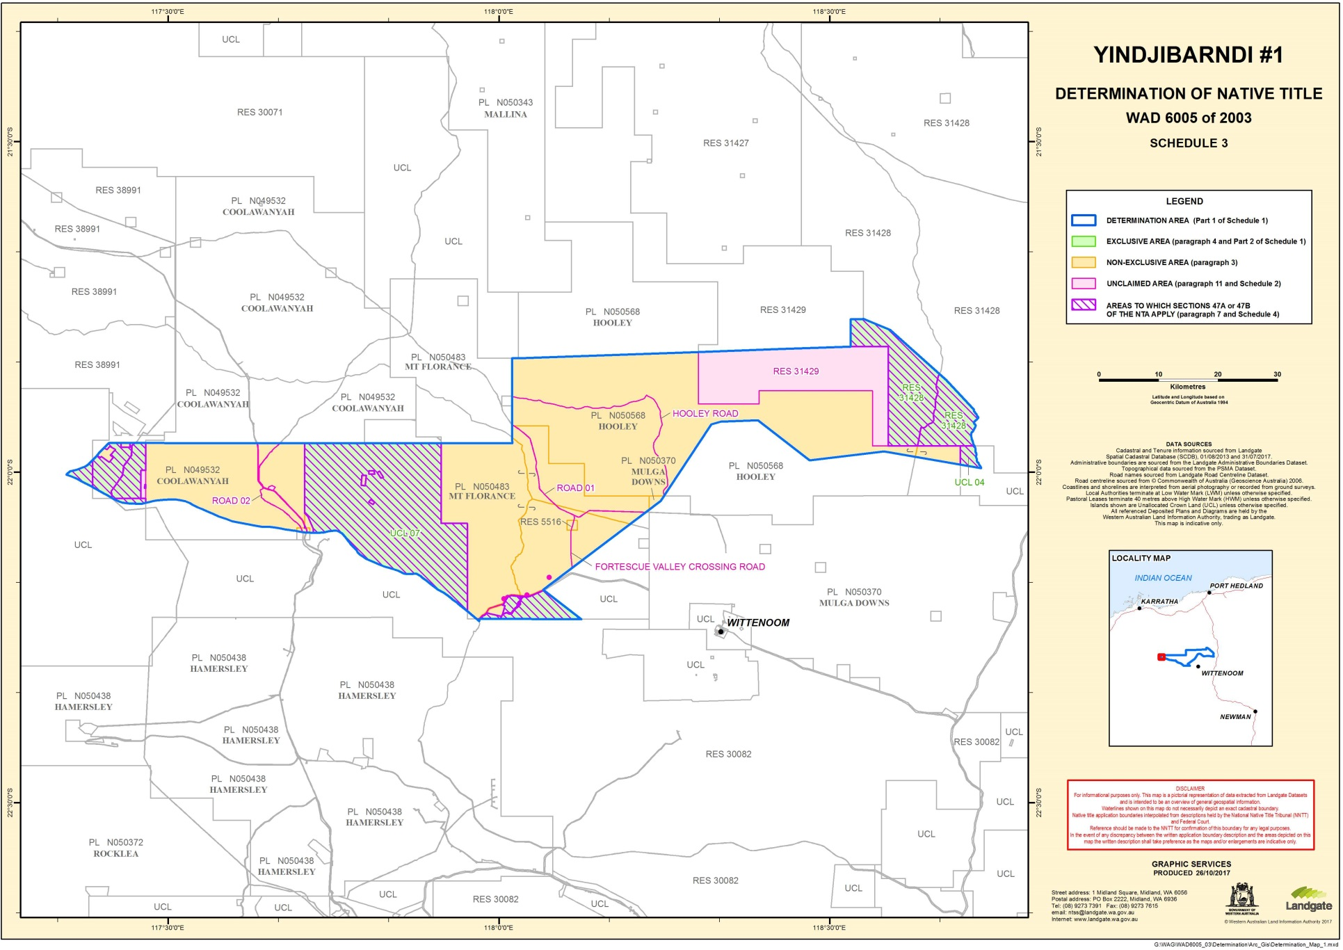
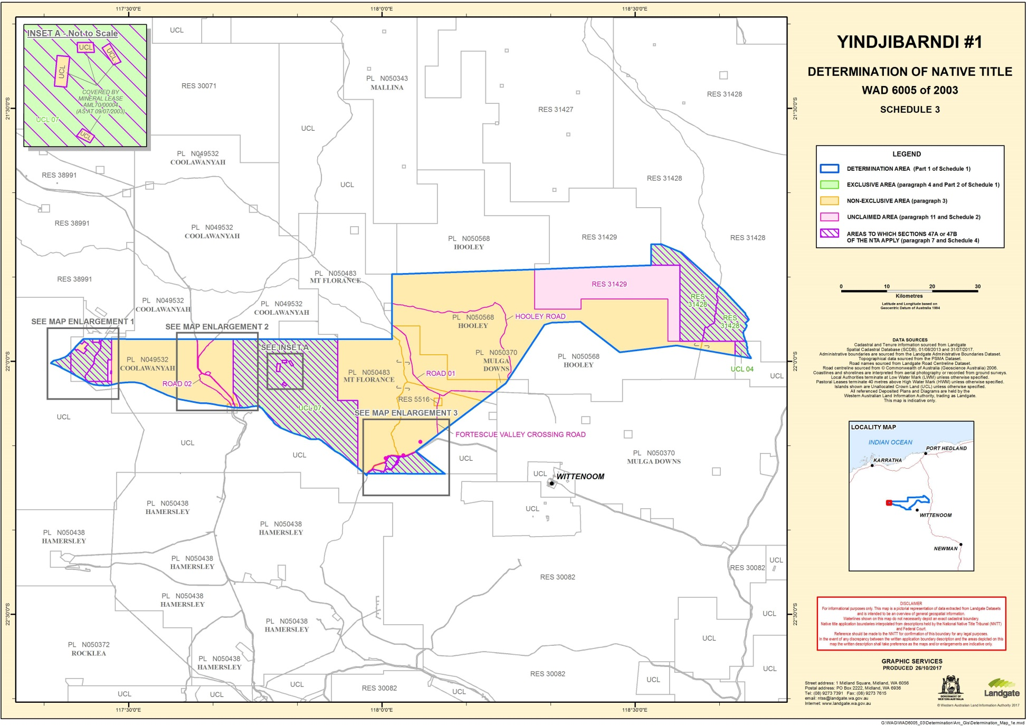
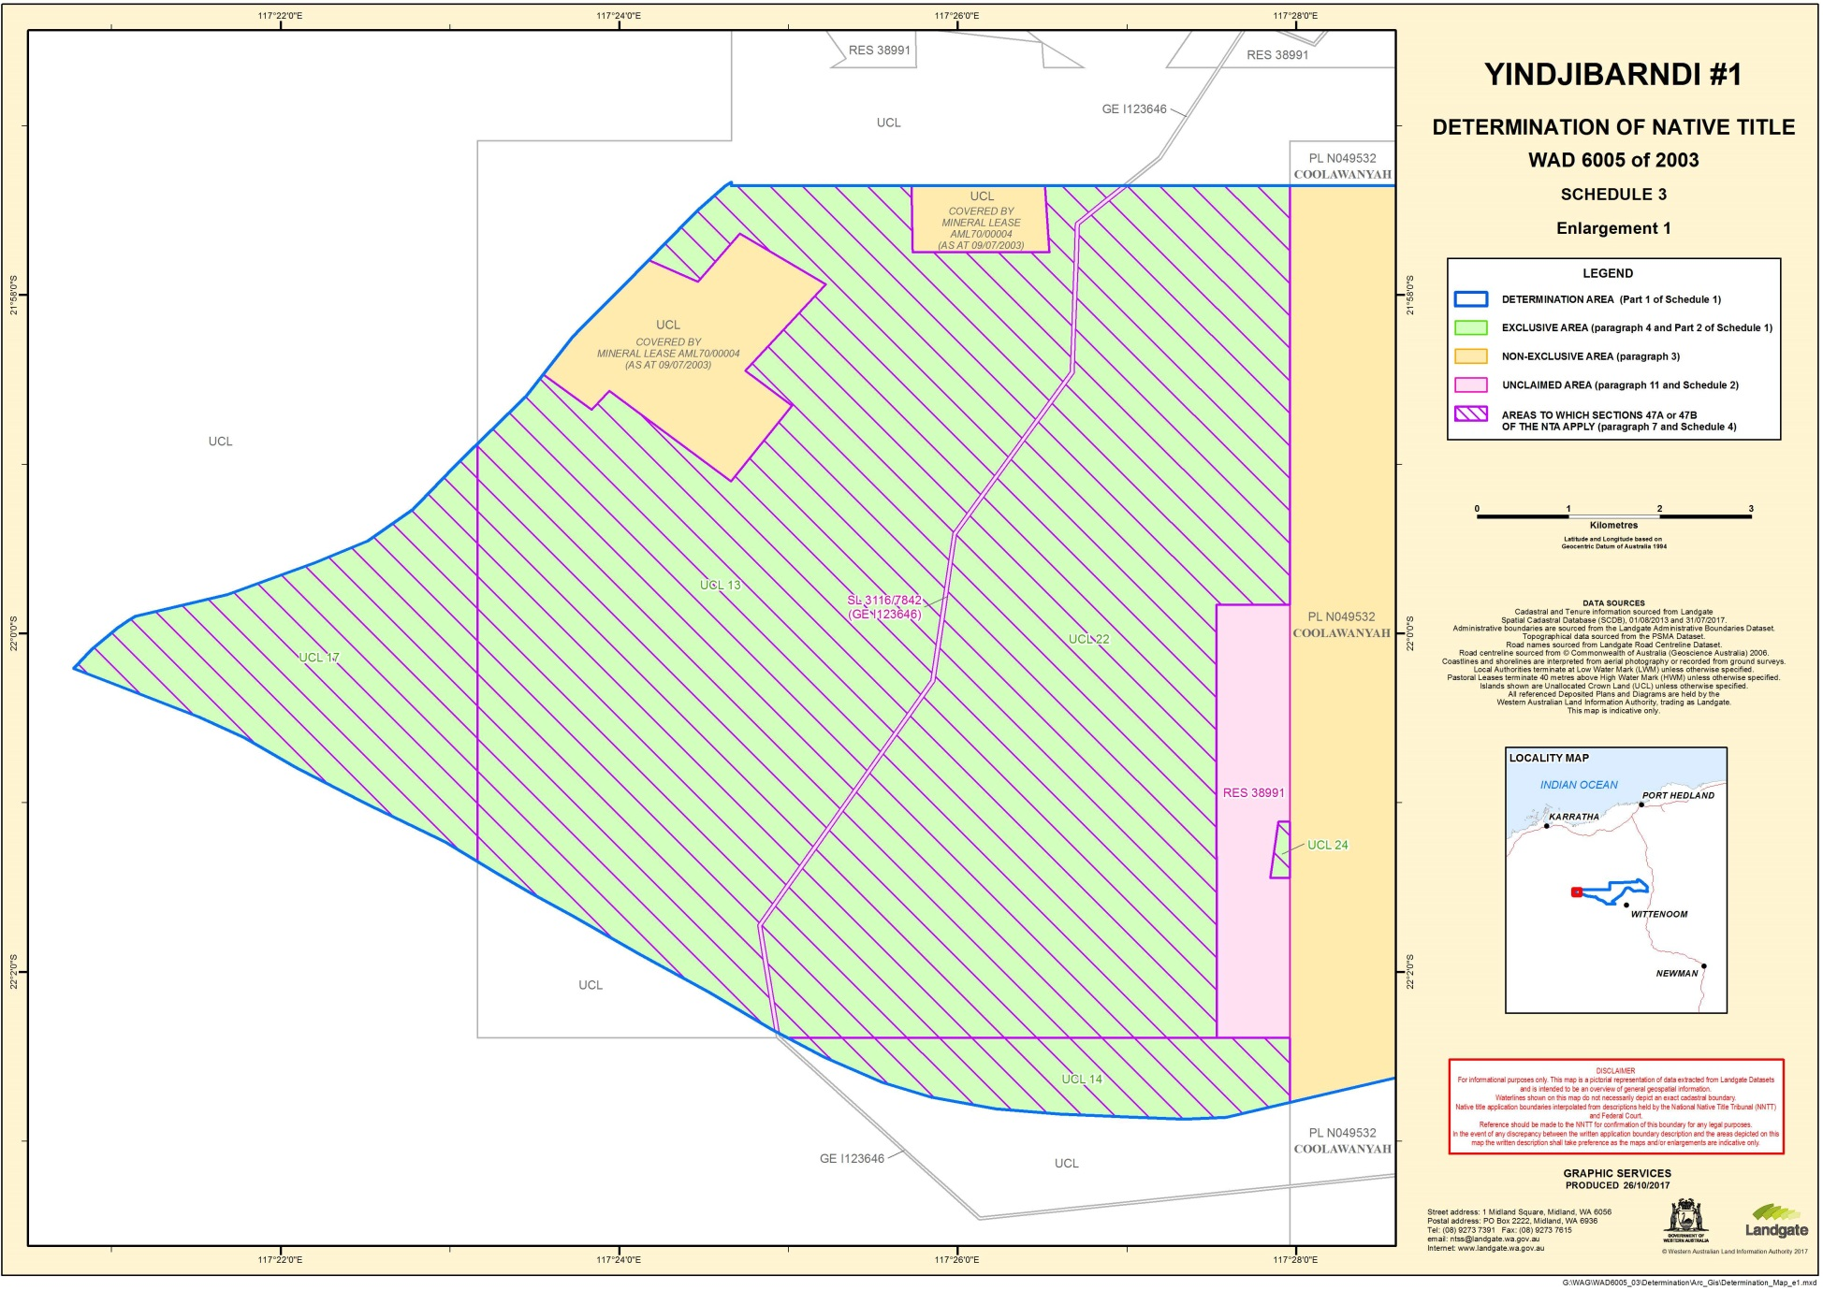
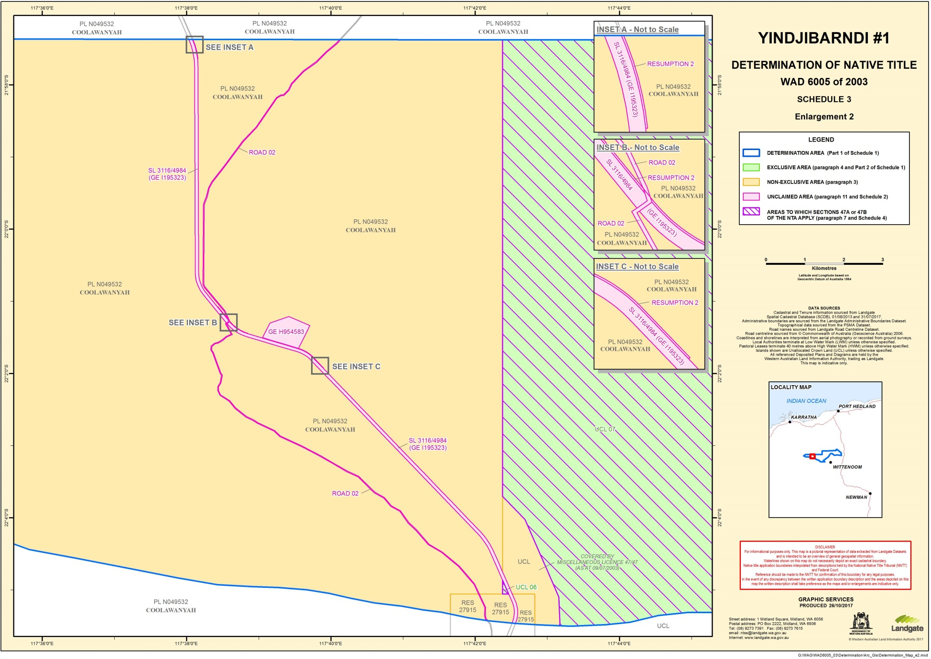
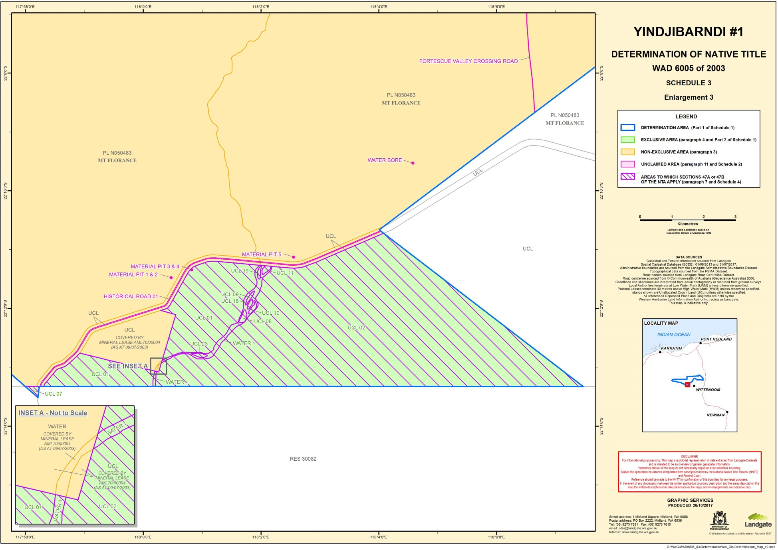

SCHEDULE 4: areas to which section 47a and 47B apply (PARAGRAPH 7)

Sections 47A or 47B of the Native Title Act apply to the following land and waters within the Determination Area, which are generally shown as hatched in purple on the maps at Schedule 3:
1. Section 47A
Section 47A of the Native Title Act applies with the effect that any extinguishment by the creation of prior interests, including those referred to below, in relation to those parts of the Determination Area the subject of the following interests has been disregarded:
Areas where section 47A applies

Reserve 31428

2. Section 47b
Section 47B of the Native Title Act applies with the effect that any extinguishment by the creation of prior interests in relation to those parts of the Determination Area referred to below has been disregarded:
Areas where section 47B applies

UCL 01, except to the extent covered by mineral lease AML70/00004 as at the date the application was filed

UCL 02, except to the extent covered by mineral lease AML70/00004 as at the date the application was filed

UCL04

UCL06

UCL 07, except to the extent covered by:
(a) mineral lease AML70/00004; and
(b) miscellaneous licence 47/47
as at the date the application was filed.

UCL08

UCL09

UCL10

UCL11

UCL13, except to the extent covered by mineral lease AML70/00004 as at the date the application was filed

UCL14

UCL17

UCL18

UCL19

UCL22

UCL23

UCL24

WATER1, except to the extent covered by mineral lease AML70/00004 as at the date the application was filed

SCHEDULE 5: other interests (paragraph 8)

The nature and extent of the Other Interests in relation to the Determination Area as at the date of this Determination are:
1. Reserves
(a) the following reserves:
Reserve No. | Current Purpose
5516 | Water
27915 | Resting Place Travellers and Stock
31428 | Use and benefit of Aborigines
(b) the rights and interests of persons who have the care, control and management of the reserves identified in paragraph 1(a) above;
(c) the rights and interests of persons entitled to access and use the reserves identified in paragraph 1(a) above for the respective purposes for which they are reserved, subject to any statutory limitations upon those rights; and
(d) the rights and interests of persons holding leases over areas of the reserves identified in paragraph 1(a) above, including lease 353382 over reserve 31428.
2. Pastoral Leases
(a) The following pastoral leases and the rights and interests of the holders from time to time of those leases:
Lease No. | Station Name
PL N049532 | Coolawanyah Station
PL N050483 | Mt Florance Station
PL N050568 | Hooley Station
PL N050370 | Mulga Downs Station
(b) Any rights and obligations of the pastoralists pursuant to the pastoral leases referred to in paragraph 2(a) above to adopt and exercise best practice management of the pasture and vegetation resources, livestock and soils within the boundaries of the pastoral leases in order to manage stock and for the management, conservation and regeneration of pasture for permitted uses.

3. water interests
(a) The following licences and permits granted pursuant to the Rights in Water and Irrigation Act 1914 (WA) and the rights and interests of the holders from time to time of those licences and permits:
(i) Licences to take groundwater:
Licence ID
GWL160076(6)
GWL162582(6)
GWL164735(4)
GWL171729(2)
GWL174095(7)
GWL175224(2)
GWL179579(1)
GWL179792(1)
GWL180991(1)
(ii) Licences to construct or alter wells:
Licence ID
CAW181825(1)
CAW181841(1)
CAW182162(1)
CAW200255(1)
(iii) Permits to obstruct or interfere:
Licence ID
PMB180179(2)
(b) The following proclamations made under the Rights in Water and Irrigation Act 1914 (WA) and the rights and interests comprised in, conferred under or in accordance with those proclamations:
(i) Pilbara Surface Water Area Proclamation 1965 (proclaimed on 13 August 1965); and
(ii) Pilbara Ground Water Area Proclamation 1965 (proclaimed on 12 February 1965 and varied by proclamation on 21 December 1990 and 2 May 1997)
4. Mining Tenements
(a) The following mining tenements under the Mining Act 1904 (WA) (repealed) and the Mining Act 1978 (WA) and the rights and interests of the holders from time to time of those mining tenements:
(i) Mining leases
Tenement ID
M47/542
M47/543
M47/1409
M47/1411
M47/1413
M47/1431
M47/1453
M47/1473
M47/1475
(ii) Miscellaneous licences
Tenement ID
L47/0047
L47/0048
L47/0361
L47/0362
L47/0363
L47/0367
L47/0472
L47/0697
(iii) Exploration Licences
Tenement ID |  | Tenement ID
E47/0054 |  | E47/1397
E47/0473 |  | E47/1398
E47/0474 |  | E47/1399
E47/0475 |  | E47/1447
E47/0585 |  | E47/1489
E47/1311 |  | E47/1557
E47/1314 |  | E47/2769
E47/1315 |  | E47/3132
E47/1319 |  | E47/3205
E47/1333 |  | E47/3397
E47/1334 |  | E47/3464
E47/1349 |  | E47/3483
E47/1384 |  | E47/3491

(iv) Prospecting licences
Tenement ID
P47/1601
P47/1701
(b) The agreement as amended and ratified by the Iron Ore (Hamersley Range) Agreement Act 1963 (WA) and rights and interests comprised in, conferred under or in accordance with, or pursuant to that agreement, including the following mining tenements:
Tenement ID | Tenement Type
AML7000004 (ML 4SA) | Mineral lease
(c) The agreement as amended and ratified by the Railway and Port (The Pilbara Infrastructure Pty Ltd) Agreement Act 2004 (WA) and rights and interests comprised in, conferred under or in accordance with, or pursuant to that agreement, including the following mining tenements:
Tenement ID | Tenement Type
AL7000001 (L 1SA) | Miscellaneous licence
5. Petroleum Interests
(a) The following petroleum title under the Petroleum Pipelines Act 1969 (WA) and the rights and interests of the holders from time to time of that petroleum title:
Title ID | Title Type
PL 105 | Pipeline Licence
6. Other
The following rights and interests:
(a) Valid or validated rights and interests, including licences and permits, granted by the Crown in right of the State or of the Commonwealth pursuant to statute or otherwise in the exercise of its executive power and any regulations made pursuant to such legislation.
(b) Valid or validated rights or interests held by reason of the force and operation of the laws of the State or of the Commonwealth, including but not limited to, the force and operation of the Rights in Water and Irrigation Act 1914 (WA) and the Land Administration Act 1997 (WA).
(c) The right to access the Determination Area by:
(i) an employee, agent or instrumentality of the State;
(ii) an employee, agent or instrumentality of the Commonwealth;
(iii) an employee, agent or instrumentality of any local government or other statutory authority;
as required and permitted by law in the performance of his or her statutory or common law duty.
(d) So far as confirmed pursuant to s 212(2) of the Native Title Act and s 14 of the Titles (Validation) and Native Title (Effect of Past Acts) Act 1995 (WA), any then-existing public access to, and enjoyment of, the following places in the Determination Area:
(i) waterways;
(ii) beds and banks or foreshores of waterways;
(iii) stock routes; and
(iv) areas that were public places at the end of 31 December 1993.
(e) Any other valid or validated:
(i) legal or equitable estate or interest in the land or waters; or
(ii) any other right (including a right under an option and a right of redemption), charge, power or privilege over, or in connection with:
(A) the land or waters; or
(B) an estate or interest in the land or waters; or
(iii) restriction on the use of the land or waters, whether or not annexed to other land or waters.

SCHEDULE 6: native title holders (paragraph 2)

Yindjibarndi People are Aboriginal persons who recognised themselves as, and are recognised by other Yindjibarndi People as, members of the Yindjibarndi language group.

Note: Entry of orders is dealt with in Rule 39.32 of the Federal Court Rules 2011.

REASONS FOR JUDGMENT
RARES J:
- On 20 July 2017, I delivered reasons in which I decided almost all of the issues in dispute in this proceeding. I ordered that the parties consult and seek to agree and prepare a draft determination of native title for the Court to make under s 225 of the Native Title Act 1993 (Cth): Warrie (formerly TJ) (on behalf of the Yindjibarndi People) v State of Western Australia [2017] FCA 803 (my principal reasons). (I will use the same abbreviations in these reasons as in my principal reasons.)
- The parties worked constructively together and prepared a detailed draft determination that, however, left only two matters in dispute, namely:
(a) whether, as FMG contended, paragraph 4 of the final determination, which identified the area in which the Yindjibarndi had exclusive possession rights, should include a note in the following terms:
Note: Sections 47A and 47B apply in relation to that part of the determination area referred to in paragraphs 4 and 7 so that for all purposes under the Native Title Act in relation to the claimant application, including the making of this determination, prior extinguishment is to be disregarded, but otherwise native title would be wholly extinguished in those areas to which section 47A applies and the following areas to which section 47B applies: UCL 13, UCL 22 and UCL 24. In the other areas to which section 47B applies, the native title rights and interests are those referred to at paragraph 3 (the FMG note issue).

(b) in what form a declaration should be made in respect of the Todd respondents’ unsuccessful claim to be recognised as Yindjibarndi (the Todd declaration issue).

The FMG note issue – FMG’s submissions
- FMG argued that it was appropriate to include the note in order to identify what would have been the native title rights and interests in the area comprising the land and waters covered by the Reserve and UCLs affected by the six exploration licences, had I not found that ss 47A(2) and 47B(2) of the Act applied to that area. FMG argued that the effect of ss 47A and 47B was “to revive native title rights that have been extinguished which happens on the making of the determination” and that the sections “operate to create different native title rights: Gumana v Northern Territory (2005) 141 FCR 457 at [268]”. FMG submitted that there could be occasions where a third party needed to know what the native title rights and interests were before and after a determination.
- The Yindjibarndi and the State opposed the inclusion of the note in the final determination.

The FMG note issue – consideration
- I reject FMG’s argument as untenable. It ignored the express words of ss 47A(2) and 47B(2) that require that any extinguishment of the native title rights and interests in land and waters to which either section applies “must be disregarded” for “all purposes under this Act”. Since s 11(1) provides that “Native title is not able to be extinguished contrary to this Act”, there are no situations in which anyone can have had any rights or interests in land or waters to which ss 47A(2) and 47B(2) might apply prior to a determination of native title that are inconsistent with the rights and interests as recorded in the determination itself: see Members of the Yorta Yorta Aboriginal Community v Victoria (2002) 214 CLR 422 at 453 [75]-[76] per Gleeson CJ, Gummow and Hayne JJ, McHugh J agreeing at 467 [127]-[128], 468 [134]; and my principal reasons at [350]-[351]. As Mansfield, Kenny, Rares, Jagot and Mortimer JJ held in Banjima People v Western Australia (No 2) (2015) 328 ALR 637 at 648 [35]:
The ordinary and natural meaning of “disregard” is “to treat as of no importance; to pay no attention to” (Oxford English Dictionary online, sense b.) and “to pay no attention to; leave out of consideration” (Macquarie Dictionary online, sense 1). The legislative command in s 47B(2) is to pay no attention to any extinguishment of native title rights and interests in relation to that area that are claimed in the application where that area satisfies one of the three criteria in s 47B(1)(b) and each criterion in s 47B(1)(a) and (c). (italic emphasis in original; bold emphasis added)

- FMG did not argue that Banjima 328 ALR 637 was wrongly decided. The effect of the activities on which the Yindjibarndi relied to establish occupation and the legal effect of the six exploration licences were the only matters on which the State and FMG had relied to defeat the operation of ss 47A(2) and 47B(2) in relation to the relevant areas of land and waters. I found that the Yindjibarndi had established that one or more members of the claim group had occupied the respective land and waters and that those prior interests did not operate to extinguish native title over the land and waters that each affected. Accordingly, by force of ss 11(1), 47A(2) and 47B(2) no extinguishment of native title rights and interests ever occurred in respect of those areas of land and waters.
- Moreover, in Gumana 141 FCR at 528 [268] Selway J rejected an argument that s 47A conferred on this Court a non-judicial function of creating new rights. Rather, he found that the Act itself, by requiring the Court to disregard any interest that met the statutory preconditions in s 47A(1), resulted in the “creation” of the rights when the final determination gave effect to the legislative requirement in s 47A(2) of disregarding any act that at common law would have extinguished native title.
- When the Court applies either of ss 47A(2) or 47B(2) in making a final determination it is exercising judicial power in the sense described by Mason CJ, Brennan, Deane, Dawson, Toohey, Gaudron and McHugh JJ in Precision Data Holdings Ltd v Wills (1991) 173 CLR 167 at 188. In such a case, the Court is making a binding declaration of right (subject to its indefinite character as explained in Western Australia v Ward (2002) 213 CLR 1 at 71-72 [32] per Gleeson CJ, Gaudron, Gummow and Hayne JJ and my principal reasons at [350]-[354]) by way of the adjudication of a dispute about rights and obligations arising from the operation of law (here, the Act) upon past events or conduct. The Court does not create any new rights when making a final determination of native title under s 225 of the Act including when it specifies, in such a determination, the legal consequences for which ss 47A(2) or 47B(2) provide.
- While a determination made under s 225 of the Act may be seen as a new development, it is not itself creative of any new rights or interests. Rather the determination recognises what has not been extinguished in accordance with the Act and so confirms the existing rights and interests in the land and waters, just as Mabo v Queensland (No 2) (1992) 175 CLR 1 recognised that at common law native title rights and interests in land and waters had survived the Crown’s acquisition of sovereignty and radical title (see 175 CLR at 69 par 3 per Brennan J).
- A final determination is declaratory of the rights and interests that the Court has ascertained by applying the Act, and any other applicable law (whether statutory or judicially decided), to the facts as found by the Court.
- For these reasons, the note should not be included in the final determination that I will now make.

The Todd declaration issue – the parties’ submissions
- The Todd respondents argued that their position should be reflected in a declaration that:
Phyllis Harris (Todd), Lindsay Todd and Margaret Todd are not Yindjibarndi People.

They contended that such a declaration would avoid inconsistency with Nicholson J’s finding in Daniel v State of Western Australia [2003] FCA 666 at [509] that the Hicks family (of which the Todd respondents formed part) had Yindjibarndi ancestry to which I referred at [510] of my principal reasons. They also submitted that a declaration in the form that they proposed would avoid potential unfairness for persons who were not parties to the proceeding.
- The Yindjibarndi argued that a declaration, in the form that I had suggested in an email from my associate to the parties dated 25 September 2017, namely that the Todd respondents “do not have a Yindjibarndi parent and are not Yindjibarndi people” was unnecessarily narrow. They contended that based on my findings at [513]-[514] of my principal reasons, the declaration should record that the Todd respondents “do not have a Yindjibarndi ancestor and are not Yindjibarndi people”. The Yindjibarndi argued that their interests and those of the three Todd respondents went beyond the issue of whether those three individuals were Yindjibarndi, as I discussed at [391]-[392] of my principal reasons.
- The State did not object to my suggested wording but did not make any further submissions on this issue.
- After receiving those submissions, I suggested that the declaration be worded as below and invited further submissions as to its form:
- Phyllis Harris (neé Todd), Lindsay Todd and Margaret Todd and their living family members:
(a) have an apical ancestor, Winningbung, who was not a Yindjibarndi;
(b) do not have a Yindjibarndi parent and are not Yindjibarndi.

As I discuss at [20] below, the Todd respondents identified difficulties with that formulation.

The Todd declaration issue – consideration
- In my principal reasons I found that:
- one of the Todd respondents’ two apical ancestors, Winningbung, was not Yindjibarndi ([407]);
- the Todd respondents did not have a Yindjibarndi ancestor [509];
- the Todd respondents and their living family members were not Yindjibarndi ([513]-[514]);
- all of the Yindjibarndi, in authorisation meetings held for the purpose of authorising this proceeding, had said that the Hicks and Todd families were not Yindjibarndi ([503], [506], [515]);
- none of the relatives of the Todd respondents who claimed to be Yindjibarndi, and entitled to join YAC, was Yindjibarndi ([502]-[503], [506], [515]).
- In the circumstances, the Todd respondents, supported by WMYAC and its resources, as well as by FMG, did not make out their claim to be Yindjibarndi. Their other living relatives did not apply under s 84(5) of the Act to be joined to this proceeding, but by their conduct appeared to be content for the three Todd respondents to make the claim, on their behalf, that they all had a right to be recognised as Yindjibarndi: cf Nana Ofori Atta II v Nana Abu Bonsra II [1958] AC 95 at 102; Administration of the Territory of Papua and New Guinea v Daera Guba (1973) 130 CLR 353 at 403 per Barwick CJ (with whom McTiernan J agreed at 405), at 405 per Menzies J and at 459-460 per Stephen J both of whom agreed with the Chief Justice and Gibbs J on this point, and at 456 per Gibbs J. That is why I was not satisfied, first, that the Todd respondents had established that they are Yindjibarndi and, secondly, that any of their living family members had established that they are either (at [513] of my principal reasons).
- As I noted in my principal reasons at [514], I formed the impression that, Nibbin, the second indigenous apical ancestor of the Todd respondents, appeared to be a Mardudhunera or a Ngarluma, although she may have been a Kariyarra. Moreover, I was not satisfied that the Todd respondents had proved, if (as I found at [513]) they had the onus of proof, that Nibbin was a Yindjibarndi. However uncertain the position was with Nibbin’s heritage, I was satisfied that the whole claim group had said that the Todd family was not Yindjibarndi in the authorisation meetings for the present claim (see my principal reasons at [475], [515]). That occurred well before the divisions that occurred in the claim group which led to the foundation in 2010 of WMYAC (see [391]-[392] and [506] of my principal reasons).
- Moreover, Charlotte Lockyer, Nibbin’s daughter, is an apical ancestor for the Ngarluma township claim and, as Prof Trigger recognised, that indicated that she had elected to follow the Ngarluma language group, if she had had a choice between being a member of that group and being Yindjibarndi (see [420]-[421] of my principal reasons).
- In all of the circumstances, I am of opinion that the appropriate way in which to reflect my findings is to make more limited declarations that, first, the apical ancestor of the Todd respondents, Winningbung, was not Yindjibarndi and, secondly, to the effect, as the claim group had decided in authorising this proceeding, the Todd respondents and their living family members are not Yindjibarndi. However, the Todd respondents argued that the use of the phrase “their living family members”, if used in a declaration, would create imprecision and ambiguity because it could include relatives who were descended from ancestors who were themselves Yindjibarndi. I accept that submission.
- Since I found that the Todd respondents did not have a Yindjibarndi ancestor, it follows that they, their siblings and all of their children are not Yindjibarndi. However, it may be that the later issue of those children can become Yindjibarndi if the other parent of any such issue is Yindjibarndi and the issue (being a child of a descendant of any of the Todd respondents or their siblings and a Yindjibarndi parent) has elected, or being capable of making an election does elect, to be Yindjibarndi. The final form of declaration should preserve the rights of any such issue to follow his or her Yindjibarndi parent (being the non-Todd family parent).
- In my opinion the following declarations will adequately identify the family members to whom it applies so as not to affect adversely persons who have or will have a parent who is one of the Yindjibarndi people, as defined in the determination:
- Winningbung was not Yindjibarndi and is not an apical ancestor of the Yindjibarndi People;
- None of the following is one of the Yindjibarndi People:
(a) Phyllis Harris (neé Todd), Lindsay Todd and Margaret Todd (the Todd respondents);
(b) the siblings of the Todd respondents (the siblings);
(c) the children and later issue of the Todd respondents and the siblings unless the other parent of any such child or issue is one of the Yindjibarndi People and the child or issue has elected, or is capable of electing and does elect, to be Yindjibarndi.

Other matters
- On 11 October 2017, Yindjibarndi Ngurra Aboriginal Corporation (YNAC) was registered as an indigenous corporation under the Corporations (Aboriginal and Torres Strait Islander) Act 2006 (Cth). Under s 56(2)(a) of the Native Title Act, the members of the applicant have nominated YNAC to hold on trust, as the prescribed body corporate, the Yindjibarndi’s native title rights and interests over the claimed area the subject of the determination, and YNAC accepted that nomination on 26 October 2017. Accordingly, by force of s 56(2)(b) of the Native Title Act, YNAC will hold the native title rights and interests in the determination from time to time comprising the native title on trust for the Yindjibarndi people.

Conclusion
- Today marks the conclusion of this proceeding. The final determination that the Court will make records, as s 225 of the Act requires, that the Yindjibarndi are the persons who hold the common or group rights comprising the native title in the claimed area (s 225(a)), the nature and extent, in the claimed area, of, first, their native title rights and interests, secondly, any other rights and interests, and, thirdly, the relationship between the two (s 225(b), (c) and (d)), and, to the extent that the land and waters in the claimed area are not covered by a non-exclusive pastoral lease, the extent that I have found in my principal reasons that the Yindjibarndi’s native title rights and interests are exclusive (s 225(e)).
- The determination of native title, that I am now making, is a formal order of the Court. That order acknowledges that the Yindjibarndi people not only possess today, but also have continuously possessed, since before the British Crown claimed sovereignty over Australia, specific native title rights and interests in the claimed area that have not been wholly or partially extinguished. Those are the rights and interests that exist under the traditional laws that the Yindjibarndi people acknowledge and the traditional customs that they observe by which they have a connection with the claimed area and which Australian law also recognises.
- YNAC will hold the native title rights and interests identified in the determination on trust for the Yindjibarndi people (s 56(2)(b)). The final orders will also declare that, first, Winningbung was not Yindjibarndi and, secondly, the Todd respondents and their siblings are not Yindjibarndi nor are their children and later issue, unless the child or issue has a Yindjibarndi parent and has elected to be Yindjibarndi.
- All of the Yindjibarndi people, regardless of whether they support WMYAC or not, are now entitled to the benefit of the exclusive and non-exclusive rights and interests that YNAC will hold in trust for them in large parts of the claimed area. That area they know, is to the south of where the Court has convened today here at Millstream.
- I have found they have exclusive possession rights and interests over the Yandeeyara Reserve, unallocated Crown land around Garliwinjinha, Bangkangarra, including FMG’s Solomon Hub mine, and some other areas of unallocated Crown land.
- In addition, however, the determination also specifies land and waters where acts, like the grant of a freehold interest or a pastoral lease, have extinguished wholly or partly the pre-existing native title rights or interests. So, the determination records that there are large areas over which the Yindjibarndi have and will continue to enjoy non-exclusive legal rights and interests in, among other places, the Coolawanyah, Mt Florance, Hooley and Mulga Downs pastoral leases.
- I now make the orders and determination that will finalise this proceeding.

I certify that the preceding thirty (30) numbered paragraphs are a true copy of the Reasons for Judgment herein of the Honourable Justice Rares.

Associate:

Dated: 13 November 2017

SCHEDULE OF PARTIES

WAD 6005 of 2003

BETWEEN:

STANLEY WARRIE, KEVIN GUINESS, ANGUS MACK, MICHAEL WOODLEY, JOYCE HUBERT, PANSY SAMBO, JEAN NORMAN, ESTHER PAT, JUDITH COPPIN, and MAISIE INGIE, ON BEHALF OF THE YINDJIBARNDI PEOPLE
Applicant

AND:

STATE OF WESTERN AUSTRALIA
First Respondent

FORTESCUE METALS GROUP LTD (ACN 002 594 872), THE PILBARA INFRASTRUCTURE PTY LTD (ACN 103 096 340) and FMG PILBARA PTY LTD (ACN 106 943 828)
Second Respondent

ROBE RIVER MINING CO PTY LTD, HAMERSLEY IRON PTY LTD and HAMERSLEY EXPLORATION PTY LTD
Third Respondent

GEORGINA HOPE RINEHART and HANCOCK PROSPECTING PTY LTD
Fourth Respondent

YAMATJI MARLPA ABORIGINAL CORPORATION
Fifth Respondent

MARGARET TODD, LINDSAY TODD and PHYLLIS HARRIS
Sixth Respondent

