FEDERAL COURT OF AUSTRALIA

Muir on behalf of the Woppaburra People v State of Queensland [2021] FCA 1505

|  |  |  |
| --- | --- | --- |
| File number: |  | |
|  |  | |
| Judgment of: | **RANGIAH J** | |
|  |  | |
| Date of judgment: | 3 December 2021 | |
|  |  | |
| Catchwords: | **NATIVE TITLE** – application for consent determination of native title under s 87 of the *Native Title Act 1993* (Cth) – whether the parties have satisfied the criteria set out in s 87 – whether it is appropriate for the Court to make orders in terms of the agreement reached by the parties – determination made | |
|  |  | |
| Legislation: | *Native Title Act 1993* (Cth) ss 3, 55, 56, 57, 61, 66, 87, 223 and 225  *Native Title Amendment Act 2009* (Cth)  *Native Title Legislation Amendment Act 2021* (Cth) | |
|  |  | |
| Cases cited: | *Cox on behalf of the Yungngora People v State of Western Australia* [2007] FCA 588  *Munn for and on behalf of the Gunggari People v State of Queensland* (2001) 115 FCR 109  *Nangkiriny v State of Western Australia* (2002) 117 FCR 6  *Sampi v Western Australia* [2005] FCA 777 | |
|  |  |
| Division: | General Division |
|  |  |
| Registry: | Queensland |
|  |  |
| National Practice Area: | Native Title |
|  |  |
| Number of paragraphs: | 32 | |
|  |  | |
| Date of hearing: | 3 December 2021 | |
|  |  | |
| Solicitor for the Applicant: | Ms S Sharma of Queensland South Native Title Services Limited | |
|  |  | |
| Solicitor for the First Respondent: | Ms A Wilson of Crown Law | |
|  |  | |
| Solicitor for the Second Respondent: | Ms E Hunt of Australian Government Solicitor | |
|  |  | |
| Counsel for the Third to Eighth Respondents: | The Third to Eighth Respondents did not appear | |

ORDERS

|  |  |  |
| --- | --- | --- |
|  | | QUD 16 of 2019 |
|  | | |
| BETWEEN: | ROBERT MUIR SENIOR, LESLEY BARNEY, JOH-ANN COATES, SAMALA CRONIN, SELWYN CUMMINS, YASMIN GREEN, CORNELIA KYLE, JILL LINDA MCBRIDE, NERARK MORRIS, ROBERT MUIR JNR, VINCENT SINGLETON AND DEBBRA WITTEMAN ON BEHALF OF THE WOPPABURRA PEOPLE  Applicant | |
| AND: | STATE OF QUEENSLAND  First Respondent  COMMONWEALTH OF AUSTRALIA  Second Respondent  MICHAEL ROBERT FIKUS (and others named in the Schedule)  Third Respondent | |

|  |  |
| --- | --- |
| order made by: | RANGIAH J |
| DATE OF ORDER: | 3 DECEMBER 2021 |

THE COURT NOTES THAT:

A. Having regard to the need to balance the limited availability of public resources with the competing need to resolve applications for a determination of native title in an efficient, cost effective and timely manner, the parties agree that the question of whether s 47C of the *Native Title Act 1993* (Cth) (**NTA**) would apply to any of the park areas in the Determination Area will be addressed after the matter has proceeded to determination.

B. The Woppaburra People indicated a desire to enter into negotiations with the State in relation to whether s 47C of the NTA would have application to any of the park areas in the Determination Area.

C. Subject to paragraph D below, the parties agree that, if agreement is reached with the registered native title body corporate in accordance with s 47C(1)(b) of the NTA with respect to any of the park areas within the Determination Area, the parties would not oppose an application being brought by the registered native title body corporate, pursuant to ss 13(1)(b) and (5) of the NTA, to vary the determination in relation to each park area in relation to which agreement is reached regarding the application of s 47C of the NTA.

D. The agreement of the parties in paragraph C above not to oppose an application to vary the determination in relation to each park area, is subject to the parties having reached agreement on the nature and extent of the native title rights and interests that would be determined to exist in relation to each park area.

**BEING SATISFIED** that an order in the terms set out below is within the power of the Court, and it appearing appropriate to the Court to do so, pursuant to s 87 of the NTA:

BY CONSENT THE COURT ORDERS THAT:

1. There be a determination of native title in the terms set out below (the determination).

2. Each party to the proceedings is to bear its own costs.

BY CONSENT THE COURT DETERMINES THAT:

3. The determination area is the land and waters described in Schedule 4 to these Orders and depicted in the map attached to Schedule 6 to these Orders to the extent those areas are within the External Boundary and not otherwise excluded by the terms of Schedule 5 to these Orders (the **Determination Area**). To the extent of any inconsistency between the written description and the map, the written description prevails.

4. Native title exists in the Determination Area.

5. The native title is held by the Woppaburra People described in Schedule 1 to these Orders (the **Native Title Holders**).

6. Subject to Orders 9, 10 and 11 below the nature and extent of the native title rights and interests in relation to the land and waters described in Part 1 of Schedule 4 to these Orders are:

(a) other than in relation to Water, the right to possession, occupation, use and enjoyment of the area to the exclusion of all others; and

(b) in relation to Water, the non-exclusive rights to:

(i) hunt, fish and gather from the Water of the area;

(ii) take the Natural Resources of the Water in the area; and

(iii) take the Water of the area,

for personal, domestic and non-commercial communal purposes.

7. Subject to Orders 9, 10 and 11 below the nature and extent of the native title rights and interests in relation to the land and waters described in Part 2 of Schedule 4 to these Orders are the non-exclusive rights to:

(a) access, be present on, move about on and travel over the area;

(b) camp, and live temporarily on the area as part of camping, and for that purpose build temporary shelters;

(c) hunt, fish and gather on the land and waters of the area for personal, domestic and non-commercial communal purposes;

(d) take, share and exchange Natural Resources from the land and waters of the area for personal, domestic and non-commercial communal purposes;

(e) take the Water of the area for personal, domestic and non-commercial communal purposes;

(f) conduct ceremonies on the area;

(g) bury Native Title Holders within the area;

(h) maintain places of importance and areas of significance to the Native Title Holders under their traditional laws and customs and protect those places and areas from physical harm;

(i) teach on the area the physical and spiritual attributes of the area;

(j) hold meetings on the area; and

(k) light fires on the area for domestic purposes including cooking, but not for the purpose of hunting or clearing vegetation.

8. Subject to Orders 9, 10 and 11 below the nature and extent of the native title rights and interests in relation to the land and waters described in Part 3 of Schedule 4 to these Orders are the non-exclusive rights to:

(a) access, be present on, move about on and travel over the area;

(b) hunt, fish and gather on the land and waters of the area for personal, domestic and non-commercial communal purposes;

(c) take Natural Resources from the land and waters of the area for personal, domestic and non-commercial communal purposes; and

(d) maintain places of importance and areas of significance to the Native Title Holders under their traditional laws and customs and protect those places and areas from physical harm.

9. The native title rights and interests are subject to and exercisable in accordance with:

(a) the Laws of the State and the Commonwealth; and

(b) the traditional laws acknowledged and traditional customs observed by the Native Title Holders.

10. The native title rights and interests referred to in Orders 6(b), 7 and 8 do not confer possession, occupation, use or enjoyment to the exclusion of all others.

11. There are no native title rights in or in relation to minerals as defined by the *Mineral Resources Act 1989* (Qld) and petroleum as defined by the *Petroleum Act 1923* (Qld) and the *Petroleum and Gas (Production and Safety) Act 2004* (Qld).

12. The nature and extent of any other interests in relation to the Determination Area (or respective parts thereof) are set out in Schedule 2 to these Orders.

13. The relationship between the native title rights and interests described in Orders 6, 7 and 8 and the other interests described in Schedule 2 to these Orders (the **Other Interests**) is that:

(a) the Other Interests continue to have effect, and the rights conferred by or held under the Other Interests may be exercised notwithstanding the existence of the native title rights and interests;

(b) to the extent the Other Interests are inconsistent with the continued existence, enjoyment or exercise of the native title rights and interests in relation to the land and waters of the Determination Area, the native title continues to exist in its entirety but the native title rights and interests have no effect in relation to the Other Interests to the extent of the inconsistency for so long as the Other Interests exist; and

(c) the Other Interests and any activity that is required or permitted by or under, and done in accordance with, the Other Interests, or any activity that is associated with or incidental to such an activity, prevail over the native title rights and interests and any exercise of the native title rights and interests but will not extinguish them except in relation to acts that consist of the construction or establishment of a public work, done after this determination where s 24JA of the NTA applies.

DEFINITIONS AND INTERPRETATION

14. In this determination, unless the contrary intention appears:

|  |
| --- |
| “External Boundary” means the area described in Schedule 3 to these Orders; |
| “High Water Mark” has the meaning given in the *Land Act 1994* (Qld); |
| “land” and “waters”, respectively, have the same meanings as in the NTA; |
| “Laws of the State and the Commonwealth” means the common law and the laws of the State of Queensland and the Commonwealth of Australia, and includes legislation, regulations, statutory instruments, local planning instruments and local laws; |
| “Local Government Act” has the meaning given in the *Local Government Act 2009* (Qld); |
| “Local Government Area” has the meaning given in the *Local Government Act 2009* (Qld); |
| “Natural Resources” means: |
| (a) any animal, plant, fish and bird life found on or in the lands and waters of the Determination Area; and |
| (b) any clays, soil, sand, gravel or rock found on or below the surface of the Determination Area, |
| that have traditionally been taken and used by the Native Title Holders, but does not include: |
| (a) animals that are the private personal property of another; |
| (b) crops that are the private personal property of another; and |
| (c) minerals as defined in the *Mineral Resources Act 1989* (Qld); or |
| (d) petroleum as defined in the *Petroleum Act 1923* (Qld) and the *Petroleum and Gas (Production and Safety) Act 2004* (Qld); |
| “Water” means: |
| (a) water which flows, whether permanently or intermittently, within a river, creek or stream; |
| (b) any natural collection of water, whether permanent or intermittent; |
| (c) tidal water; and |
| (d) water from an underground water source. |

Other words and expressions used in this determination have the same meanings as they have in Part 15 of the NTA.

THE COURT DETERMINES THAT:

15. The native title is held in trust.

16. The Woppaburra Saltwater Aboriginal Corporation (ICN: 9584), incorporated under the *Corporations (Aboriginal and Torres Strait Islander) Act 2006* (Cth), is to:

(a) be the prescribed body corporate for the purpose of ss 56(2)(b) and 56(3) of the NTA; and

(b) perform the functions mentioned in s 57(1) of the NTA after becoming a registered native title body corporate.

Note: Entry of orders is dealt with in Rule 39.32 of the *Federal Court Rules 2011*.

**Schedule 1**

**Native Title Holders**

1. The native title holders are the Woppaburra People. The Woppaburra People are the descendants of one or more of the following people:

(a) Yulowa “Weerobilling”;

(b) Nellie “Ooroong-ooran”;

(c) Oyster Maggie; or

(d) Fanny Lohse/Singh.

**Schedule 2**

**Other Interests in the Determination Area**

The nature and extent of the other interests in relation to the Determination Area are the following as they exist as at the date of the determination:

1. The rights and interests of the Livingstone Shire Council for that part of the Determination Area within its Local Government Area, including:

(a) as the owner and operator of infrastructure, facilities and other improvements which are in the Determination Area as at the date of this determination;

(b) the right to enter the Determination Area and exercise its powers and responsibilities under Local Government Acts; and

(c) under any lease, licence, access agreement, easement, reserve or other interest in the Determination Area.

2. The rights and interests of Sojourn Properties Pty Ltd (ACN 104 443 503) as the holder of the following permits issued pursuant to the *Great Barrier Reef Marine Park Regulations 1983* (Cth) and the *Marine Parks Regulation 2017* (Qld):

(a) G19/41873.1 for Operation of Primary Mooring GM0782;

(b) G19/42850.1 for Conduct of:

(i) a Tourist Program - Vessel Program;

(ii) a Charter Operation - Vessel Charter Program;

(iii) Conduct of a Tourist Program and Any Other Purpose - Hire Program;

(iv) Operation of Three (3) Mooring Facilities - Primary Moorings:

(A) GM2760 at Pumpkin Island Reef (23-005);

(B) GM2761 at Pumpkin Island Reef (23-005);

(C) GM2762 at Pumpkin Island Reef (23-005); and

(c) G18/41737.1 for Conduct of:

(i) a Tourist Program;

(ii) a Charter Operation.

3. The rights and interests of the Australian Institute of Marine Science, pursuant to its powers and functions under the *Australian Institute of Marine Science Act 1972* (Cth) as the owner, manager or operator of the automatic weather station (AWS) located at Square Rocks, the Keppels at coordinates -23.09842 decimal degrees south, 150.88553 decimal degrees east.

4. The rights and interests of the Australian Fisheries Management Authority in relation to plans of management made under the *Fisheries Management Act 1991* (Cth), including for the Eastern Tuna and Billfish Fishery, the Eastern Skipjack Fishery and the Southern Bluefin Tuna Fishery.

5. The rights and interests of the Great Barrier Reef Marine Park Authority and any other person existing by reason of the force of operation of:

(a) the *Great Barrier Reef Marine Park Act 1975* (Cth);

(b) the *Great Barrier Reef Marine Park Regulations 2019 (*Cth);

(c) the *Great Barrier Reef (Declaration of Amalgamated Marine Park Area) Proclamation 2004* (Cth); and

(d) the *Great Barrier Reef Marine Park Zoning Plan 2003* (Cth).

6. The rights and interests of the parties under the Woppaburra Traditional Use of Marine Resources Agreement (TUMRA) – TUMRA Accreditation No: GTGT14/36384.1.

7. The rights and interests of the Australian Maritime Safety Authority as the owner, manager or operator of aids to navigation pursuant to s 190 of the *Navigation Act 2012* (Cth), and in performing the functions of the Authority under s 6(1) of the *Australian Maritime Safety Authority Act 1990* (Cth) including to be a national marine safety regulator, to combat pollution in the marine environment and to provide a search and rescue service.

8. The rights and interests of the State of Queensland and the Livingstone Shire Council to access, use, operate, maintain and control the dedicated roads in the Determination Area and the rights and interests of the public to use and access the roads.

9. The rights and interests of the State of Queensland in Reserves, the rights and interests of the trustees of those Reserves and the rights and interests of the persons entitled to access and use those Reserves for the respective purpose for which they are reserved, including the rights and interests of the holders of permits issued by the trustees of the Reserves.

10. The rights and interests of the State of Queensland or any other person existing by reason of the force and operation of the laws of the State of Queensland, including those existing by reason of the following legislation or any regulation, statutory instrument, declaration, plan, authority, permit, lease or licence made, granted, issued or entered into under that legislation:

(a) the *Fisheries Act 1994* (Qld);

(b) the *Land Act 1994* (Qld);

(c) the *Nature Conservation Act 1992* (Qld);

(d) the *Forestry Act 1959* (Qld);

(e) the *Water Act 2000* (Qld);

(f) the *Petroleum Act 1923* (Qld) or *Petroleum and Gas (Production and Safety) Act 2004* (Qld);

(g) the *Mineral Resources Act 1989* (Qld);

(h) the *Planning Act 2016* (Qld);

(i) the *Transport Infrastructure Act 1994* (Qld);

(j) the *Fire and Emergency Services Act 1990* (Qld) or *Ambulance Service Act 1991* (Qld);

(k) the *Marine Parks Act 2004* (Qld);

(l) the *Coastal Protection and Management Act 1995* (Qld);

(m) the *Transport Operations (Marine Safety) Act 1994* (Qld); and

(n) the *Transport Operations (Marine Pollution) Act* *1995* (Qld).

11. The rights and interests of members of the public arising under the common law, including but not limited to the following:

(a) any subsisting public right to fish; and

(b) the public right to navigate.

12. So far as confirmed pursuant to s 212(2) of the NTA and s 18 of the *Native Title (Queensland) Act* *1993* (Qld) as at the date of this determination, any existing rights of the public to access, and enjoy, the following places in the Determination Area:

(a) waterways;

(b) beds and banks or foreshores of waterways;

(c) coastal waters;

(d) beaches; and

(e) areas that were public places at the end of 31 December 1993.

13. Any other rights and interests:

(a) held by the State of Queensland or Commonwealth of Australia; or

(b) existing by reason of the force and operation of the Laws of the State and the Commonwealth.

**Schedule 3**

**External Boundary**

The area of land and waters commencing:

The external boundary is the external boundary of the Woppaburra Traditional Use of Marine Resources Agreement (TUMRA) further described as:

Commencing a point in the Coral Sea at Longitude 150.858337° East, Latitude 22.999987° South and extending east, south-easterly, again east, then south, south-westerly, west and north-westerly passing through the following coordinate points:

|  |  |
| --- | --- |
| **Longitude (East)** | **Latitude (South)** |
| 150.941667 | 22.999987 |
| 151.050007 | 23.108317 |
| 151.133337 | 23.108317 |
| 151.133337 | 23.224987 |
| 151.100007 | 23.258317 |
| 150.950007 | 23.258317 |
| 150.858337 | 23.166657 |

Then north back to the commencement point.

Data Reference and source

• Determination boundary based on information sourced from the Commonwealth of Australia, NNTT and Great Barrier Reef Marine Park Authority (April 2021).

Reference datum

Geographical coordinates are referenced to the Geocentric Datum of Australia 2020 (GDA2020), in decimal degrees.

Use of Coordinates

Where coordinates are used within the description to represent cadastral or topographical boundaries or the intersection with such, they are intended as a guide only. As an outcome to the custodians of cadastral and topographic data continuously recalculating the geographic position of their data based on improved survey and data maintenance procedures, it is not possible to accurately define such a position other than by detailed ground survey.

**Schedule 4**

**Description of Determination Area**

The Determination Area comprises all of the land and waters described in Parts 1, 2 and 3 immediately below, and depicted in the maps in Schedule 6, to the extent those areas are within the External Boundary and not otherwise excluded by the terms of Schedule 5.

Part 1 — Exclusive Areas

All of the land and waters described in the following table and depicted in dark blue on the determination map contained in Schedule 6:

|  |  |
| --- | --- |
| **Area description (at the time of the determination)** | **Determination Map Sheet Reference** |
| Lot 10 on USL36825 | 1 |
| Lot 12 on AP11326~ | 6 |
| Lot 1 on AP23402 | 7 |
| Lot 29 on SP190994^ | 6 |
| Lot 3 on CP900494~ | 6 |
| That part of Lot 403 on NPW915 formerly described as Lot 3 on USL36825 | 2 |
| Lot 50 on SP190989^ | 5 |
| Lot 51 on SP190992^ | 5 & 6 |
| Lot 52 on SP190991^ | 5 |
| Lot 53 on SP190990^ | 5 |
| Lot 5 on USL36825 | 4 |
| Lot 7 on CP836478~ | 3 |

[* denotes areas to which s 47 of the NTA apply]

[^ denotes areas to which s 47A of the NTA apply]

[~ denotes areas to which s 47B of the NTA apply]

Part 2 — Non-Exclusive Areas Onshore

All of the land and waters described in the following table and depicted in light blue on the determination map contained in Schedule 6:

| **Area description (at the time of the determination)** | **Determination Map Sheet Reference** |
| --- | --- |
| That part of Lot 2 on CP900494 excluding former Lot 41 on LN1828 | 6 |
| That part of Lot 39 on LN2681 excluding former Portion 39 on LN1845 | 6 |
| That part of Lot 403 on NPW915 excluding former Portion 4 and 5, Parish of Keppel, County of Livingstone and former Portion 38 on LN1837 | 2, 3, 4 & 5 |
| Lot 440 on NPW549 | 7 |
| That part of Lot 50 on CP866044 excluding former Portion 25 on LN1583 | 6 |
| That part of Lot 59 on SP268496 excluding former Portion 25 on LN1583 | 6 |
| Lot 5 on AP11326 | 6 |
| Lot 62 on SP268496 | 6 |
| That part of Lot 63 on SP268495 excluding an area of former Esplanade (Road) as shown on LN1583 | 6 |
| An area of road identified and delineated by stations D-2-8-F-12-G-13-H-15-11-J-K-9-3-1-D on SP268496 excluding an area covered by former Portion 25 on LN1583 | 6 |

Part 3 - Sea areas

All the land and waters described in the following table and depicted in teal on the determination map contained in Schedule 6:

|  |  |
| --- | --- |
| **Area description (at the time of the determination)** | **Determination Map Sheet Reference** |
| Lot 60 on SP268497 | 5 & 6 |
| Keppel Bay | Keymap, 1, 2, 3, 4, 5 & 6 |
| Considine Bay | 1 & 3 |
| Coral Sea | Keymap, 1, 2, 3, 5 & 7 |

**Schedule 5**

**Areas Not Forming Part of the Determination Area**

The following areas of land and waters are excluded from the Determination Area as described in Parts 1, 2, and 3 of Schedule 4:

1. Those land and waters within the External Boundary which at the time the native title determination application was made were the subject of one or more Previous Exclusive Possession Acts, within the meaning of s 23B of the NTA as they could not be claimed in accordance with s 61A of the NTA.

2. Specifically, and to avoid any doubt, the land and waters described in (1) above includes:

(a) the Previous Exclusive Possession Acts described in ss 23B(2) and 23B(3) of the NTA to which s 20 of the *Native Title (Queensland) Act 1993* (Qld) applies, and to which none of ss 47, 47A or 47B of the NTA applied, including, but not limited to the whole of the land and waters described as:

(i) Lot 24 on LN1452;

(b) the land and waters on which any public work, as defined in s 253 of the NTA, is or was constructed, established or situated, and to which ss 23B(7) and 23C(2) of the NTA and to which s 21 of the *Native Title (Queensland) Act 1993* (Qld), applies, together with any adjacent land or waters in accordance with s 251D of the NTA.

3. Those land and waters within the External Boundary on which, at the time the native title determination application was made, public works were validly constructed, established or situated after 23 December 1996, where s 24JA of the NTA applies, and which wholly extinguished native title.

4. Those land and waters within the External Boundary which, at the time the native title determination application was made, were the subject of one or more Pre-existing Rights Based Acts, within the meaning of s 24IB of the NTA, which wholly extinguished native title.

**Schedule 6**

**Map of Determination Area**

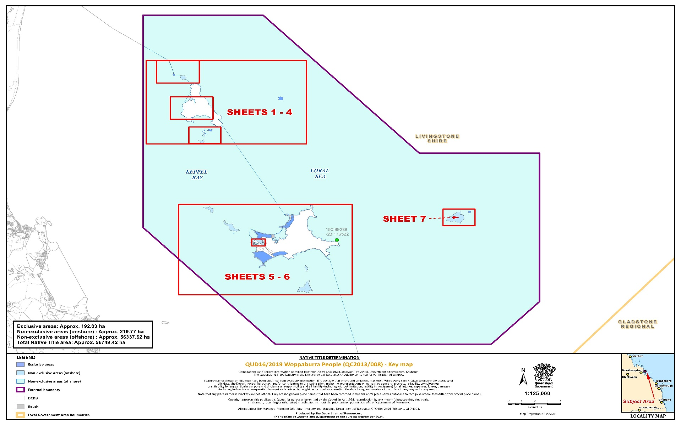

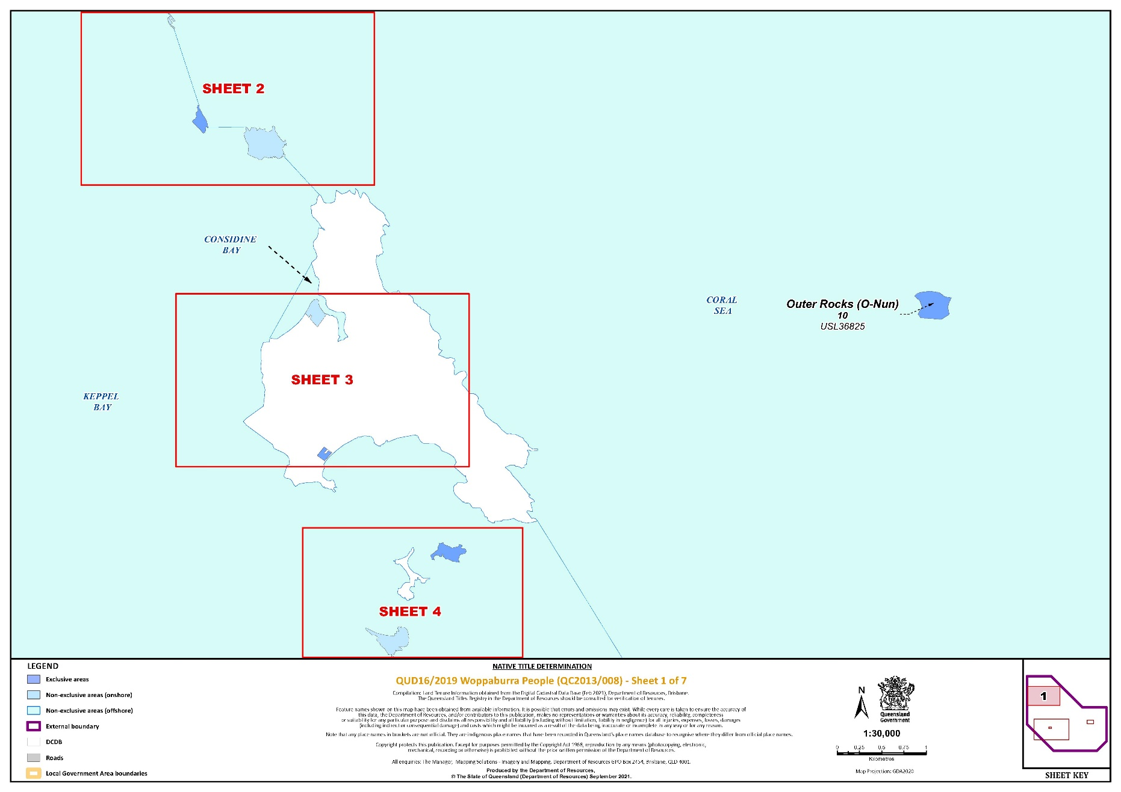

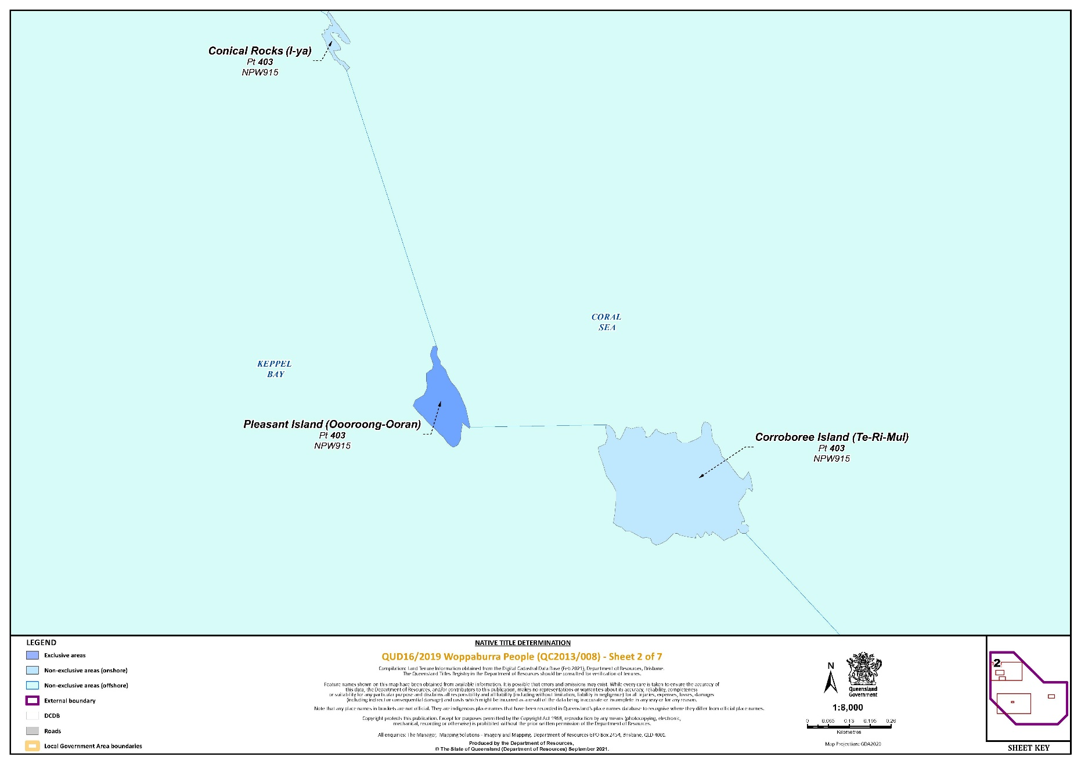

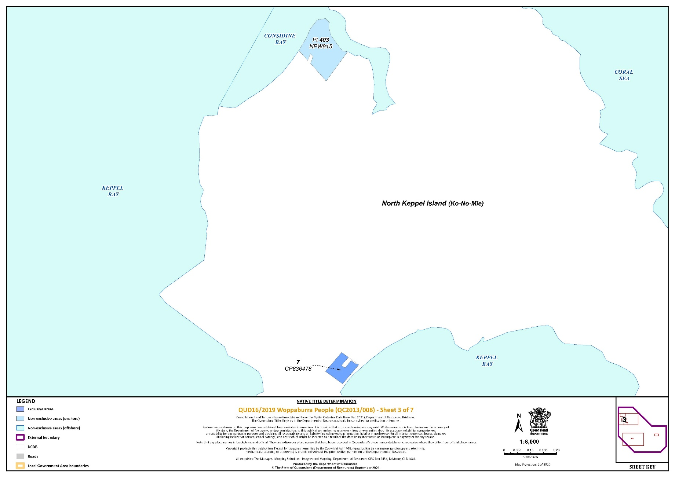

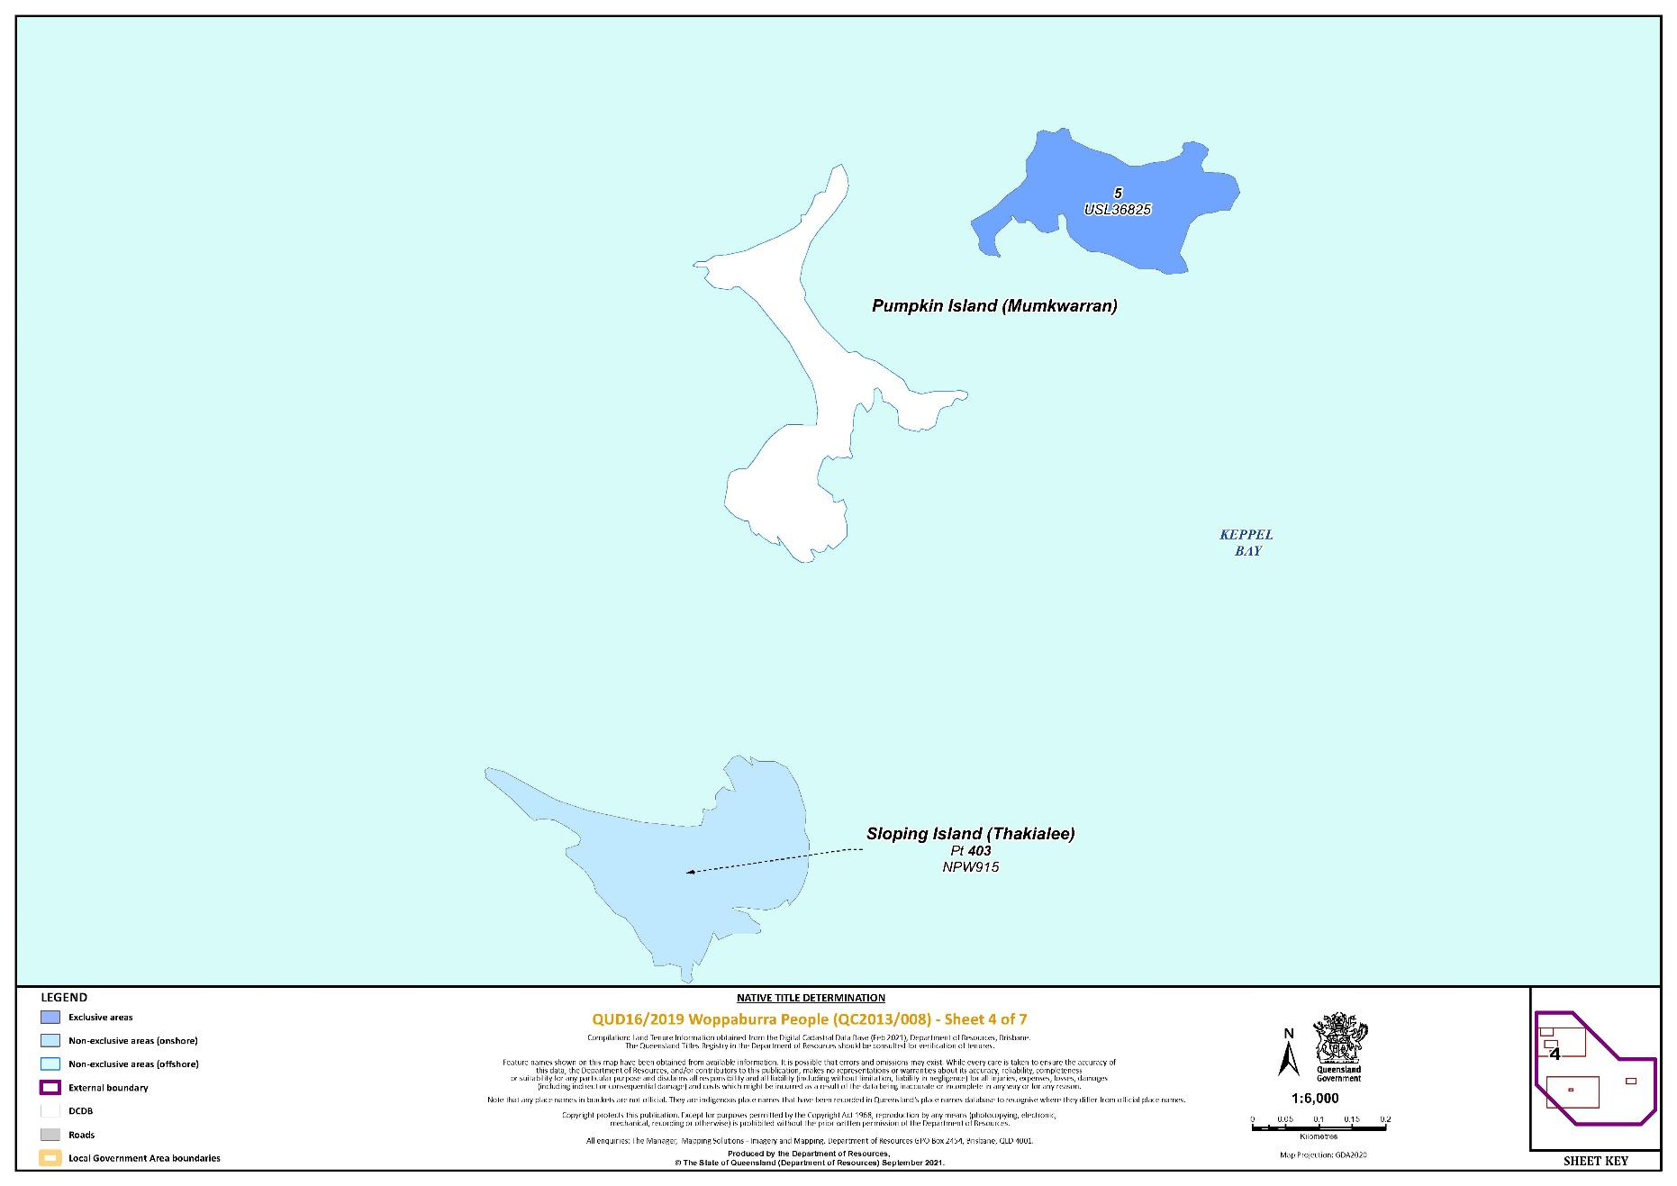

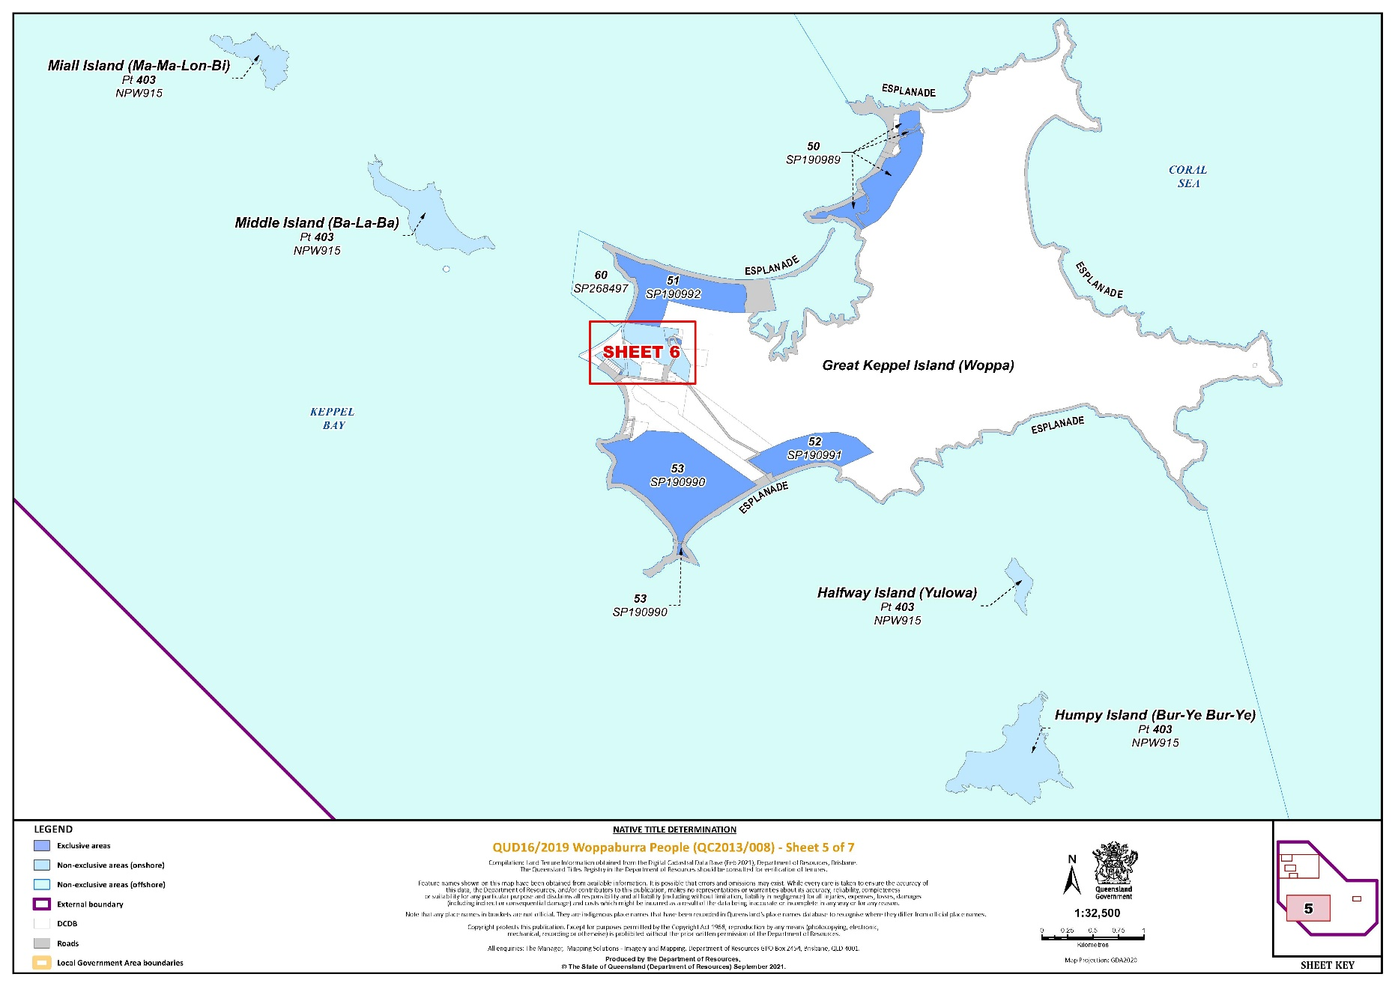

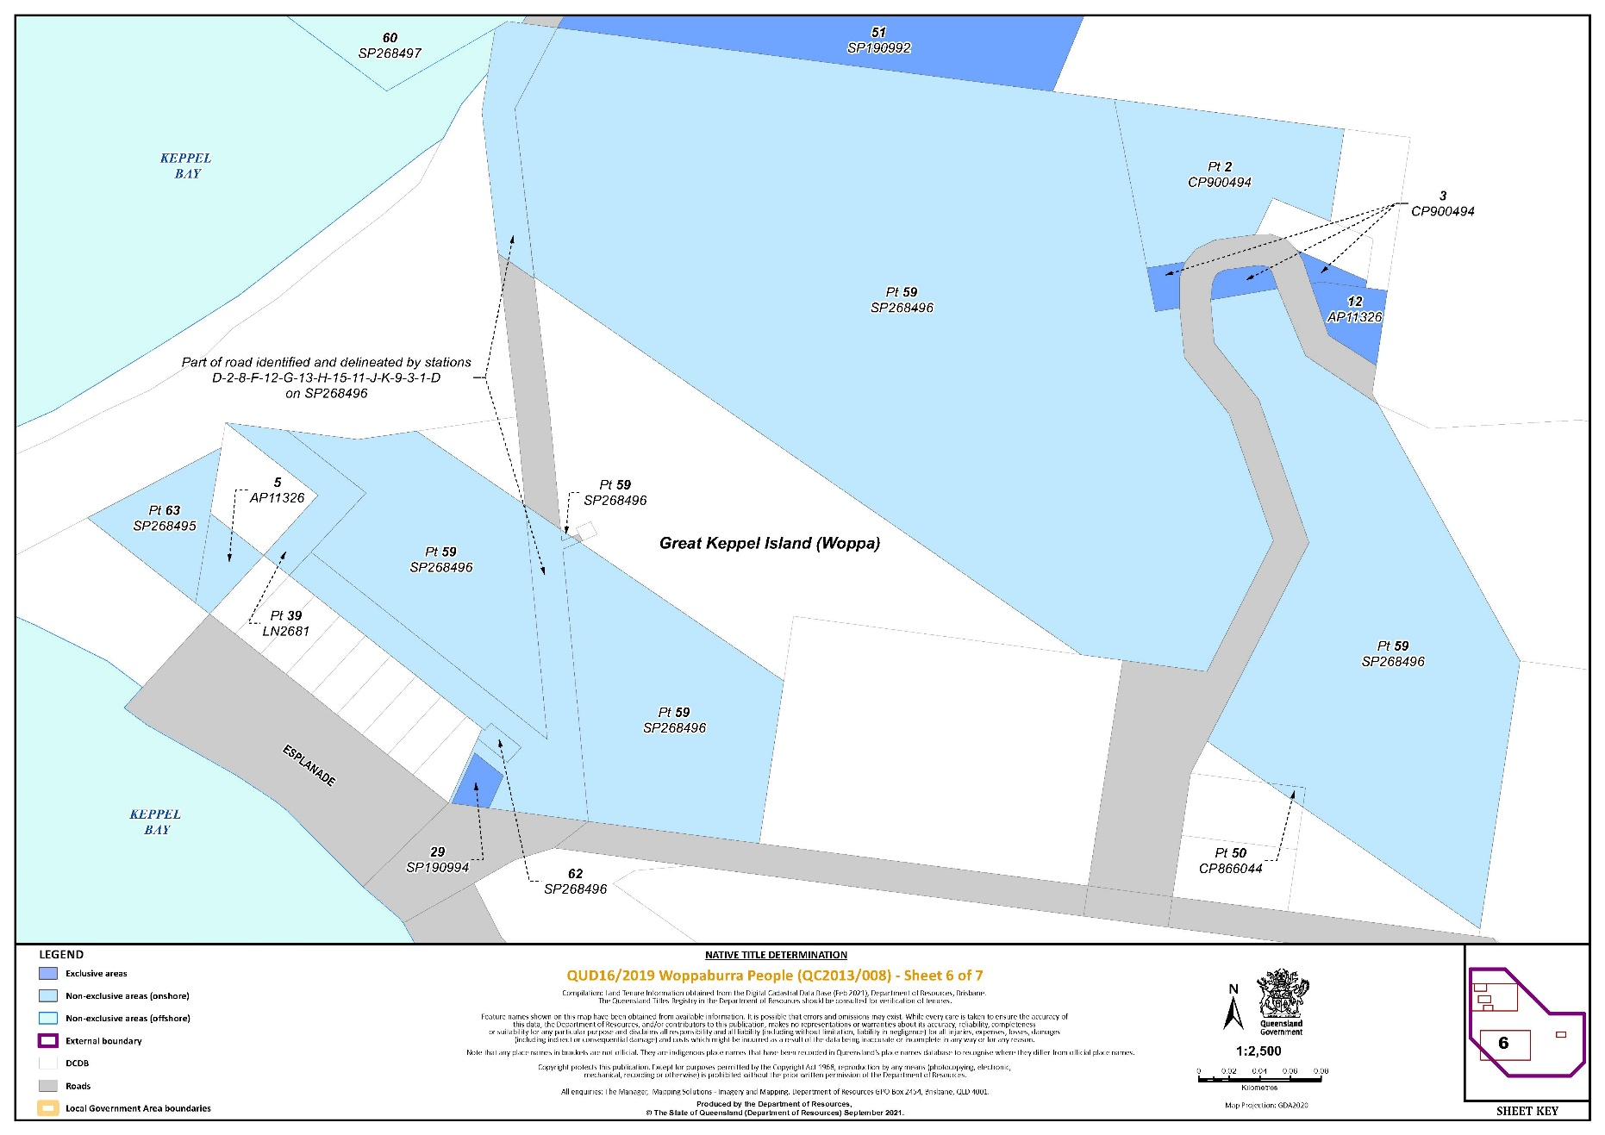

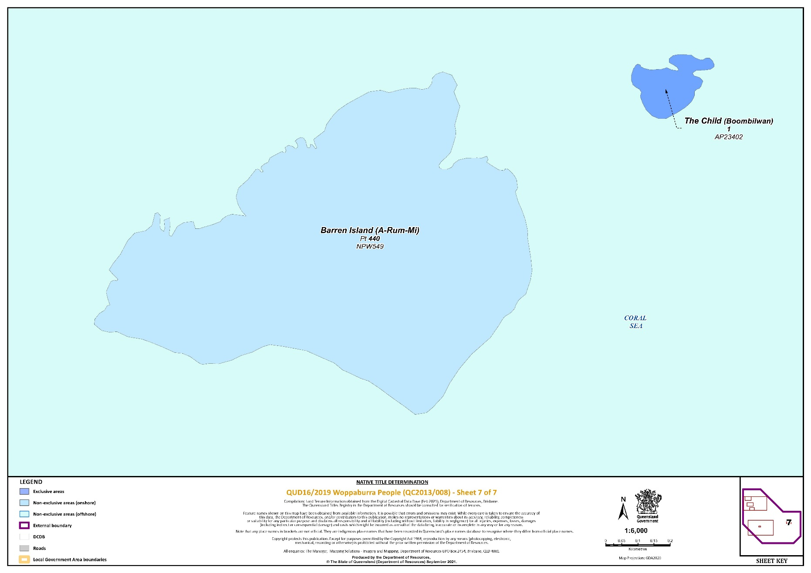

REASONS FOR JUDGMENT

RANGIAH J:

1 The applicant seeks a determination of native title pursuant to ss 61 and 225 of the *Native Title Act 1993* (Cth) (the **NTA**) on behalf of the Woppaburra People.

2 The claim is over lands and waters in the Keppel Islands and adjacent sea country, in the Capricorn Coast area of Central Queensland. The external boundaries of the claim area cover approximately 570 km2.

3 The parties have indicated their consent to a determination that the Woppaburra People are the holders of native title in the claim area.

4 By the Court making that determination, the Australian community will collectively recognise that status. But it is important to emphasise that the Court’s orders do not grant native title. The Court is merely recognising rights and interests that have existed under the traditional laws and customs of the Woppaburra People for thousands of years before European settlement.

## The Native Title Act

5 In the preamble, the NTA recognises, on behalf of all people of Australia, that the Aboriginal peoples of Australia inhabited the country prior to European settlement and that the Aboriginal peoples were progressively dispossessed of their lands. It records that the Constitution was amended, by the overwhelming vote of the people of Australia, to enable laws such as the NTA to be passed and to facilitate recognition by our shared legal system of native title rights and interests.

6 Section 3 of the NTA states that the main objects of the NTA include to protect and recognise native title, establish ways in which future dealings in relation to native title may proceed, and set standards for those dealings and establish a mechanism for determining native title claims.

7 An objective of the NTA is the resolution of claims for native title by agreement. That objective has been facilitated by amendments to s 87 of the NTA brought about by the *Native Title Amendment Act 2009* (Cth) and the *Native Title Legislation Amendment Act 2021* (Cth). The agreement of the parties to the terms of the proposed orders is consistent with that objective.

8 Section 61 of provides that an application for a determination of native title may be made by persons authorised by all the persons, who, according to their traditional laws and customs, hold the common or group rights and interests comprising the particular native title claimed.

9 Section 223(1) of the NTA explains the meaning of “native title”:

*Common law rights and interests*

(1) The expression ***native title*** or ***native title rights and interests*** means the communal, group or individual rights and interests of Aboriginal peoples or Torres Strait Islanders in relation to land or waters, where:

(a) the rights and interests are possessed under the traditional laws acknowledged, and the traditional customs observed, by the Aboriginal peoples or Torres Strait Islanders; and

(b) the Aboriginal peoples or Torres Strait Islanders, by those laws and customs, have a connection with the land or waters; and

(c) the rights and interests are recognised by the common law of Australia.

10 Section 225 of the NTA describes what is meant by a “determination of native title”:

**225 Determination of native title**

A ***determination of native title*** is a determination whether or not native title exists in relation to a particular area (the ***determination area***) of land or waters and, if it does exist, a determination of:

(a) who the persons, or each group of persons, holding the common or group rights comprising the native title are; and

(b) the nature and extent of the native title rights and interests in relation to the determination area; and

(c) the nature and extent of any other interests in relation to the determination area; and

(d) the relationship between the rights and interests in paragraphs (b) and (c) (taking into account the effect of this Act); and

(e) to the extent that the land or waters in the determination area are not covered by a non‑exclusive agricultural lease or a non‑exclusive pastoral lease—whether the native title rights and interests confer possession, occupation, use and enjoyment of that land or waters on the native title holders to the exclusion of all others.

…

## The application

11 The applicant’s application was filed on 6 November 2013. It seeks a determination of native title on behalf of the Woppaburra People over land and waters within the external boundaries of the claim area. An amended application was filed on 25 November 2014.

12 The respondents to the application are the State of Queensland, the Commonwealth of Australia, Livingstone Shire Council, Michael Robert Fikus, Francis Valentine Hayward, Ted Loveday, Gary Sikes, and Sojourn Properties Pty Ltd.

13 There are no overlapping or competing native title claims over the land and waters covered in this application. There are no approved determinations of native title that affect any part of the claim area.

14 All parties to the application have reached agreement that native title exists in the claim area, and as to the nature and extent of those native title rights and interests in relation to the claimed area. That agreement, made under s 87(1) of the NTA, was filed on 28 October 2021.

15 The evidence of connection filed in the Court by the applicant includes that of Frederick Saunders, Hendrick Van Issum, Julie Ann Blair, Nellie Ann Richards, Samala Cronin, Vanessa Kirk, Angela Leitch, Debbra Witteman, Gordon Barney and Nerark Morris. The evidence of members of the native title claim group about their traditional laws and customs and rights and responsibilities in respect to land and waters is of the highest importance: *Sampi v Western Australia* [2005] FCA 777 at [48].

16 The applicant also relies on reports of an expert anthropologist, Dr Kevin Mayo, as follows:

(1) Expert Anthropological Report dated 11 March 2019, filed on 15 March 2019.

(2) Supplementary Expert Anthropological Report dated 20 February 2020, filed on 21 February 2020.

17 The Woppaburra People are the descendants of one or more of the following persons:

(1) Yulowa “Weerobilling”;

(2) Nellie “Ooroong-ooran”;

(3) Oyster Maggie;

(4) Fanny Lohse/Singh.

18 The evidence filed by the applicant provides cogent evidence that the Woppaburra People have maintained a continuous presence on their country to the extent possible within the context of the decimation of the population and removal from traditional lands and waters. The evidence supports the claim that the traditional laws acknowledged and the customs observed by the Woppaburra People give them the right to possess, occupy, use and enjoy the land and waters in the claim area.

19 The anthropological reports detail the continued acknowledgement and observance by the Woppaburra People of a range of laws and customs in respect of language, cultural knowledge, totemic and spiritual beliefs, sites, dispute resolution, decision-making, bush tucker and medicines.

20 In his 2019 report, Dr Mayo states at paragraph 177:

…[T]he clear identification of Woppaburra families has continued within the context of removal and resettlement until the present day. It has been marked not only by knowledge of family lines but by recognition of themselves as “salt water people” from the Keppel Islands with a deep knowledge of and spiritual attachment to the sea; retention of values and behaviours related to kinship, communal sharing and reciprocity, respect for elders, and transmission of knowledge and skills; retention of aspects of language and naming; knowledge of creation stories and totems specifically related to the Keppel Islands; belief in ancestral spirits and ancestral attachment to the Keppel Islands; and an assertion of connectedness through activism and cultural practices. This set of understandings, beliefs, and practices held by contemporary Woppaburra people all intersect in their acknowledgement of ancestors in ancestral place. This has a deep continuity with traditional belief and traditional law and custom that defines the holders of rights and interests in unalienable lands and waters.

21 Dr Mayo further states at paragraph 295:

…[I]t is possible to clearly identify the Woppaburra descent groups. It is possible to clearly identify the area of the Woppaburra Native Title claim without overlap of other claims. The body of traditional laws and customs of the wider society that were operative at effective Sovereignty can be identified or inferred and these include identification of a land holding group. That the Woppaburra were the traditional holders of rights in interests in the lands and waters of the Keppel Islands is apparent from these communal laws and customs and they were, and still are, acknowledged by neighbouring groups. The contemporary claimants have asserted this connection for generations. This connection has been expressed and is still expressed through recognition of descent as the primary means of incorporation, maintenance of family connections through traditional behaviours and values; through language and naming practices; through the transmission of knowledge and skills in fishing and in close relation with coastal areas; through the retention of spiritual beliefs and stories, especially related to the *Mugga Mugga* as the Woppaburra totem, through spiritual beliefs that link ancestors to country and to future generations, and through active engagement with the process of reclaiming acknowledgement of Woppaburra connection to the Keppel Islands.

## The agreement reached between the parties

22 Sections 87(1A) and (2) of the NTA give the Court the power to make an order consistent with the terms of a proposed determination of native title agreed between the parties to the proceeding without holding a hearing in relation to the application, if the Court considers that:

(a) an order in, or consistent with, the terms of the proposed determination would be within its power: s 87(1)(c); and

(b) it would be appropriate to do so: s 87(1A).

23 The conditions under s 87 of the NTA that enable the Court to make the determination without a hearing are:

• At any stage of proceedings after the end of the period specified in the notice given under s 66, agreement is reached on the terms of an order of the Court in relation to the proceedings, a part of the proceedings, or a matter arising out of the proceedings: s 87(1)(a).

• Certain persons are parties to the agreement: s 87(1)(aa).

• The terms of the proposed determination are in writing and signed by or on behalf of each of those parties: s 87(1)(b).

• The Court is satisfied that an order in, or consistent with, those terms would be within its power: s 87(1)(c).

• The Court considers it appropriate to make the orders sought: s 87(1A).

24 The Court is not required to embark upon an inquiry as to the merits of the claim to be satisfied that the orders are supportable and in accordance with the law: *Cox on behalf of the Yungngora People v State of Western Australia* [2007] FCA 588 at [3]. However, the Court will consider evidence for the limited purpose of determining whether the parties who have agreed to compromise the claim, particularly the State and the Commonwealth on behalf of the community generally, have made a rational decision and are acting in good faith: *Munn for and on behalf of the Gunggari People v State of Queensland* (2001) 115 FCR 109 at [30]. The primary consideration of the Court is to determine whether there is an agreement and whether it was freely entered into on an informed basis: *Nangkiriny v State of Western Australia* (2002) 117 FCR 6 at [14].

25 State, Territory and Commonwealth governments are responsible for ensuring that community interests are protected by getting involved in a process that assesses the underlying evidence as to the existence of native title. In this case, the State of Queensland and the Commonwealth of Australia are satisfied that the claim group is an appropriate one to be recognised as holding native title rights and interests, that it is appropriate to recognise the rights and interests proposed and that it is appropriate for the State and the Commonwealth to enter into the determination.

26 The requirements of the NTA have been satisfied:

• The period for notification of the application under s 66 of the NTA has ended: s 87(1).

• The parties have reached an agreement as to the terms of a determination of native title in relation to the claim area: s 87(1)(a).

• The necessary persons are parties to the agreement: s 87(1)(aa).

• The parties have recorded their agreement in a Minute of Consent which has been filed with the Court: s 87(1)(b).

• An order in terms of the Minute, or consistent with the Minute, would be within the Court’s power because:

• the application has been made in accordance with s 61 of the NTA;

• the application is for a determination of native title in relation to an area for which there was no approved determination of native title: s 13(1)(a); and

• the Minute agreed to by the parties complies with ss 94A and 225 of the NTA: s 87(2).

27 In addition, I am satisfied that it is appropriate for the Court to make the orders sought because:

• The active parties have freely entered into an agreement.

• The parties have agreed as to the nature and extent of rights and interests, and the proposed determination is unambiguous and certain as to the rights and interests declared.

• There are no proceedings before the Court relating to native title determination applications that cover any part of the area that is the subject of this application.

• The State and the Commonwealth have played an active role in the negotiation of the determination and, in doing so, have taken an interest in the proceeding on behalf of the community and given appropriate consideration to the connection material.

28 The terms of the proposed determination also satisfy the requirements of s 225 of the NTA.

## Prescribed Body Corporate

29 Section 55 of the NTA requires the Court to make such determinations as are required by ss 56 and 57 at the same time as, or as soon as practicable after, the determination of native title is made. Order 16 of the s 87 agreement signed by the parties seeks a determination that the Woppaburra Saltwater Aboriginal Corporation (ICN 9584) is to be the prescribed body corporate for the purposes of ss 56(2)(b) and 56(3) of the NTA to perform the functions set out in s 57(1).

30 The nomination is supported by the affidavit of Laura Shepherd filed on 29 October 2021, which annexes a letter dated 25 October 2021 from a member of the applicant, Robert Muir (Snr), to this Court nominating the Woppaburra Saltwater Aboriginal Corporation (ICN 9584) to the be the prescribed body corporate for the purposes of the NTA.

31 Accordingly, the Court determines that the Woppaburra Saltwater Aboriginal Corporation is to be the prescribed body corporate for the purposes of s 56(1) of the NTA.

## Conclusion

32 The Court will make orders in accordance with the orders agreed by the parties.

|  |
| --- |
| I certify that the preceding thirty-two (32) numbered paragraphs are a true copy of the Reasons for Judgment of the Honourable Justice Rangiah. |

Associate:

Dated: 3 December 2021

SCHEDULE OF PARTIES

|  |  |
| --- | --- |
|  |  |
| Respondents |  |
| Fourth Respondent: | FRANCIS VALENTINE HAYWARD |
| Fifth Respondent: | TED LOVEDAY |
| Sixth Respondent: | GARY SIKES |
| Seventh Respondent: | SOJOURN PROPERTIES PTY LTD |
| Eighth Respondent: | LIVINGSTONE SHIRE COUNCIL |