FEDERAL COURT OF AUSTRALIA

Dodd v State of South Australia [2012] FCA 519

Citation: |  | Dodd v State of South Australia [2012] FCA 519
Parties: |  | REGINALD DODD, LAURIE STUART (DECEASED) and MILLIE WARREN v THE STATE OF SOUTH AUSTRALIA, COMMONWEALTH OF AUSTRALIA, SOUTH AUSTRALIAN NATIVE TITLE SERVICES INC, KUYANI PEOPLE, DIERI PEOPLE, AUSTRALIAN WILDLIFE CONSERVANCY, TONY BOYD, ANDREW TREVOR CLARKE, MACUMBA PASTORAL COMPANY PTY LTD, MULOORINA STATION, STRANGWAYS SPRINGS PTY LTD, BLANUSA OPALS PTY LTD, LAURA HOLDINGS PTY LTD, ALFONZ NAGYSZOLLOSI, MARY M NAGYSZOLLOSI, OZ MINERALS PROMINENT HILL OPERATIONS PTY LTD, SCORPION EXPLORATION PTY LTD, TASMAN RESOURCES LTD, BHP BILLITON OLYMPIC DAM CORPORATION PTY LTD, TELSTRA CORPORATION LIMITED, TERMITE RESOURCES N.L. and SOUTH AUSTRALIAN APIARISTS ASSOCIATION INC
File number: |  | SAD 6025 of 1998
Judge: |  | FINN J
Date of judgment: |  | 22 May 2012
Catchwords: |  | NATIVE TITLE - Consent Determination - requirements under s 87 of the Native Title Act 1993 (Cth)
Legislation: |  | Native Title Act 1993 (Cth) s 47A, s 47B, s 87, s 223, s 225, Part 2, Division 3  Aboriginal Heritage Act 1988 (SA)
Cases cited: |  | King v South Australia (2011) 285 ALR 454 cited  Yorta Yorta Aboriginal Community v Victoria (2002) 214 CLR 422 cited  Risk v Northern Territory [2006] FCA 404 cited  De Rose v State of South Australia (No 2) (2005) 145 FCR 290 cited
Date of hearing: | 22 May 2012
Place: | Finniss Springs Station, South Australia
Division: | GENERAL DIVISION
Category: | Catchwords
Number of paragraphs: | 77
Counsel for the Applicants: | Mr S Kenny
Solicitor for the Applicants: | Camatta Lempens
Counsel for the First Respondent: | Ms G Reid
Solicitor for the First Respondent: | Crown Solicitor's Office
Counsel for the Pastoralists: | Mr T Mellor
Solicitor for the Pastoralists: | Mellor Olsson
Counsel for the South Australian Native Title Services: | Ms B Lena
Solicitor for the South Australian Native Title Services: | South Australian Native Title Services Ltd
Counsel for Oz Minerals Prominent Hill Operations Pty Ltd: | Ms J Dnistrianski
Solicitor for Oz Minerals Prominent Hill Operations Pty Ltd: | Finlaysons

IN THE FEDERAL COURT OF AUSTRALIA
SOUTH AUSTRALIA DISTRICT REGISTRY
GENERAL DIVISION | SAD 6025 of 1998

BETWEEN: | REGINALD DODD, LAURIE STUART (DECEASED), MILLIE WARREN  Applicants
AND: | THE STATE OF SOUTH AUSTRALIA, COMMONWEALTH OF AUSTRALIA, SOUTH AUSTRALIAN NATIVE TITLE SERVICES INC, KUYANI PEOPLE, DIERI PEOPLE, AUSTRALIAN WILDLIFE CONSERVANCY, TONY BOYD, ANDREW TREVOR CLARKE, MACUMBA PASTORAL COMPANY PTY LTD, MULOORINA STATION, STRANGWAYS SPRINGS PTY LTD, BLANUSA OPALS PTY LTD, LAURA HOLDINGS PTY LTD, ALFONZ NAGYSZOLLOSI, MARY M NAGYSZOLLOSI, OZ MINERALS PROMINENT HILL OPERATIONS PTY LTD, SCORPION EXPLORATION PTY LTD, TASMAN RESOURCES LTD, BHP BILLITON OLYMPIC DAM CORPORATION PTY LTD, TELSTRA CORPORATION LIMITED, TERMITE RESOURCES N.L., SOUTH AUSTRALIAN APIARISTS ASSOCIATION INC  Respondents

JUDGE: | FINN J
DATE OF ORDER: | 22 MAY 2012
WHERE MADE: | FINNISS SPRINGS STATION, SOUTH AUSTRALIA

Preamble
- The Applicant first lodged Native Title Determination Application No. SAD 6025 of 1998 (the Application) with the National Native Title Tribunal on 16 January 1998 in relation to lands and waters in northern South Australia which are now the subject of a proposed determination of native title. The Application was referred to the Federal Court of Australia on 30 September 1998.
- The Applicant, the State of South Australia and the other respondents have reached an agreement as to the terms of a determination of native title to be made in relation to the land and waters covered by the Application. They have filed with this Court pursuant to s 87 of the Native Title Act 1993 (Cth) (the Native Title Act) an agreement in writing to seek the making of consent orders for a determination.
- The State of South Australia asserts that the Vesting (as defined in paragraph 1 (b)) in the Crown of those parts of the Determination Area listed in Schedule 4 (“the Schedule 4 Areas”) means that the exercise of all native title rights and interests in relation to those areas was suppressed at the date of the Vesting, pursuant to the non-extinguishment principle established by the Native Title Act. Accordingly, all native title rights and interests in the Schedule 4 Areas remain suppressed for as long as those areas remain vested in the Crown under the National Parks and Wildlife Act 1972 (“the NPWA”) or other relevant State legislation.
- The Applicants assert with regard to the Schedule 4 Areas that some native title rights are not suppressed by the Vesting but acknowledge the operation of the non-extinguishment principle provided for in the Native Title Act.
- The Parties have agreed to the following orders in relation to the native title rights and interests, reflecting (insofar as those orders relate to the Schedule 4 Areas) a compromise of the issue addressed in Recitals C and D.
- The Parties acknowledge that the effect of the making of the determination will be that the members of the native title claim group, in accordance with the traditional laws acknowledged and the traditional customs observed by them, will be recognised as the native title holders for the Determination Area as defined by Paragraph 2 of this Order.
- The Parties have requested that the Court determine the proceedings without a trial.

Being satisfied that a determination in the terms sought by the Parties would be within the power of the Court and it appearing to the Court appropriate to do so and by the consent of the Parties:

THE COURT ORDERS, DECLARES AND DETERMINES BY CONSENT THAT:
Interpretation & Declaration
- In this determination, including its schedules:
  - unless the contrary intention appears, the words and expressions used have the same meaning as they are given in Part 15 of the Native Title Act;
  - “the Vesting” means the vesting of a Park or Reserve in the Crown pursuant to the NPWA as listed in Schedule 4; and
  - in the event of an inconsistency between a description of an area in a schedule and the depiction of that area on the map in Schedule 2, the written description shall prevail.
Determination Area
- Native title exists in the areas described in Schedule 1 with the exception of those areas described in Paragraphs 10, 12, 13 and 15 (“the Determination Area”).
- Section 47A and section 47B of the Native Title Act apply to those parcels or parts of parcels described in schedule 5. Subject to paragraphs 12 and 13, all extinguishment of native title rights and interests over those areas is disregarded.
- The Court notes that the State and the Applicants have agreed to execute an ILUA (the Arabana Native Title Claim Settlement ILUA) contemporaneously with this determination whereby native title will be surrendered over those of the parcels where native title still exists within the government town of Marree as described in part 4 of schedule 3 on registration of that ILUA.
Native Title Holders
- Under the relevant traditional laws and customs of the Arabana people the native title holders comprise those living Aboriginal people who both self-identify as Arabana and who are recognised as being Arabana by other Arabana people based on:
      - Filiation, including by adoption, from an Arabana parent or grandparent; or
      - Long term co-residence with Arabana people on Arabana country;

and who satisfy one or more of the following criteria:

- Being raised in Arabana country and being bound by its system of law and custom;
- Living and behaving appropriately with Arabana people in accordance with Arabana laws and customs;
- Having knowledge of Arabana country and its stories and taking appropriate responsibility, under Arabana custom and law, for that knowledge;
- Having knowledge of Arabana society and the relationships of people within it and seeking to maintain proper relationships amongst Arabana people;
- Having knowledge of Arabana language;
- Displaying an active interest and engagement in Arabana affairs;
Rights and Interests
- Subject to Paragraphs 7, 8 and 9 the nature and extent of the native title rights and interests of the Arabana People in relation to the Determination Area are non-exclusive rights to use and enjoy in accordance with their traditional laws and customs the land and waters of the Determination Area, being:

  - the right to access and move about the Determination Area;

  - the right to live, to camp and, for the purpose of exercising their native title rights and interests, to erect shelters and other structures on the Determination Area;

  - the right to hunt and fish on the land and waters of the Determination Area;

  - the right to gather and use the natural resources of the Determination Area such as food, medicinal plants, wild tobacco, timber, resin, ochre and feathers, but excluding those resources referred to in Paragraph 12;

  - the right to share and exchange the subsistence and other traditional resources of the Determination Area;

  - the right to use the natural water resources of the Determination Area;

  - the right to cook on the Determination Area and to light fires for domestic purposes but not for the clearance of vegetation;

  - the right to engage and participate in cultural activities on the Determination Area including those relating to births and deaths;

  - the right to conduct ceremonies and hold meetings on the Determination Area;

  - the right to teach on the Determination Area the physical and spiritual attributes of locations and sites within the Determination Area;

  - the right to visit, maintain and protect sites and places of cultural and religious significance to Native Title Holders under their traditional laws and customs on the Determination Area; and

  - the right to be accompanied on to the Determination Area by those people who, though not Native Title Holders, are:
    - spouses of native title holders; or
    - people required by traditional law and custom for the performance of ceremonies or cultural activities on the Determination Area; or
    - people who have rights in relation to the Determination Area according to the traditional laws and customs acknowledged by the native title holders.
General Limitations
- The native title rights and interests are for personal, domestic and communal use but do not include commercial use of the Determination Area or the resources from it.

- The native title rights and interests described in paragraph 6 do not confer possession, occupation, use and enjoyment of the Determination Area, including those areas described in schedule 5, on the native title holders to the exclusion of others.

- Native title rights and interests are subject to and exercisable in accordance with:
  - the traditional laws and customs of the native title holders; and
  - the valid laws of the State and Commonwealth, including the common law.

For the avoidance of doubt, the native title interest expressed in paragraph 6(f) (the right to use the natural water resources of the Determination Area) is subject to the Natural Resources Management Act 2004 (SA).

- Native title rights and interests have been extinguished in respect of those parts of the Determination Area being any house, shed or other building or airstrip or any dam or other stock watering point constructed pursuant to the pastoral leases referred to in Paragraph 16(a) below constructed prior to the date of this determination. These areas include any adjacent land or waters the exclusive use of which is necessary for the enjoyment of the improvements referred to.

- To be clear, Paragraph 10 does not preclude the possibility of further extinguishment, according to law, of native title over other limited parts of the Determination Area by reason of the construction of new pastoral improvements of the kind referred to in Paragraph 10 after the date of this determination.

- Native title rights and interests do not exist in:

- Minerals, as defined in s 6 of the Mining Act 1971 (SA); or
- Petroleum, as defined in section 4 of the Petroleum and Geothermal Energy Act 2000 (SA); or
- a naturally occurring underground accumulation of a regulated substance as defined in s 4 of the Petroleum and Geothermal Energy Act 2000 (SA), below a depth of 100 metres from the surface of the earth; or
- a natural reservoir, as defined in s 4 of the Petroleum and Geothermal Energy Act 2000 (SA), below a depth of 100 metres from the surface of the earth;
- geothermal energy, as defined in s 4 of the Petroleum and Geothermal Energy Act 2000 (SA) the source of which is below a depth of 100 metres from the surface of the earth.
For the purposes of this paragraph 12 and the avoidance of doubt:
- a geological structure (in whole or in part) on or at the earth's surface or a natural cavity which can be accessed or entered by a person through a natural opening in the earth's surface, is not a natural reservoir;
- thermal energy contained in a hot or natural spring is not geothermal energy as defined in section 4 of the Petroleum and Geothermal Energy Act (SA) 2000;
- the absence from this order of any reference to a natural reservoir or a naturally occurring accumulation of a regulated substance, as those terms are defined in s 4 of the Petroleum and Geothermal Energy Act 2000 (SA), above a depth 100 metres below the surface of the earth or geothermal energy the source of which is above a depth of 100 metres below the surface of the earth is not, of itself, to be taken as an indication of the existence or otherwise of native title rights or interests in such natural reservoir, naturally occurring accumulation of a regulated substance or geothermal energy.
- Native title rights have been extinguished in the areas covered by Public Works (including the land defined in section 251D of the Native Title Act) which were constructed, established or situated prior to 23 December 1996 or commenced to be constructed or established on or before that date, including but not limited to those public works identified in schedule 3.

- Public Works constructed, established or situated after 23 December 1996 have had such effect as has resulted from Part 2, Division 3, of the Native Title Act or as agreed pursuant to the Arabana Native Title Claim Settlement ILUA as described in Schedule 6.

- Those areas described in Schedule 3 have been excluded from the Determination Area because native title has been extinguished over them.
Other Interests & Relationship with Native Title
- The nature and extent of other interests in the Determination Area are:

  - the interests within the Determination Area created by the following pastoral leases:
Lease name | Pastoral Lease No | Crown Lease
Allandale | PE 2408 | Volume 1333 Folio 25
Anna Creek | PE 2433 | Volume 1331 Folio 50
Arckaringa | PE 2418 | Volume 1333 Folio 7
Balta Baltana South | PE 2147 | Volume 1159 Folio 4
Billa Kalina | PE 2415 | Volume 1323 Folio 10
Callanna | PE 2302 | Volume 1289 Folio 6
Coorikiana | PE 2476 | Volume 1397 Folio 26
Kallakoopah West | PE 2534 | Volume 1628 Folio 21
Lake Eyre | PE 2416 | Volume 1323 Folio 11
Lake Letty | PE 2402 | Volume 1607 Folio 55
Macumba | PE 2528 | Volume 1607 Folio 55
Marree Station | PE 2266 | Volume 1287 Folio 66
Millers Creek | PE 2315 | Volume 1286 Folio 42
Mount Barry | PE 2411 | Volume 1327 Folio 9
Mount Eba | PE 2340 | Volume 1289 Folio 41
Mulgaria | PE 2431A | Volume 1379 Folio 26
Muloorina | PE 2400 | Volume 1319 Folio 15
Mundowdna | PE 2298 | Volume 1294 Folio 15
Nilpinna | PE 2420 | Volume 1323 Folio 34
St Stephens Pond | PE 2256 | Volume 1287 Folio 9
Stuarts Creek | PE 2431 | Volume 1378 Folio 16
The Peake | PE 2432 | Volume 1332 Folio 1
Toondina | PE 2475 | Volume 1396 Folio 1
Toondina East | PE 2455 | Volume 1362 Folio 39
Witchelina | PE 2311 | Volume 1294 Folio 17

  - the interests of the Crown in right of the State of South Australia;

  - in relation to those Reserves set out in Schedule 7:
    - the rights and interests of the Crown of South Australia pursuant to the NPWA; and
    - the rights and interests of the public to use and enjoy those Reserves consistent with the NPWA.

  - the interests of persons to whom valid or validated rights and interests have been granted or recognised by the Crown in right of the State of South Australia or by the Commonwealth of Australia pursuant to statute or otherwise in the exercise of executive power including, but not limited to, rights and interests granted or recognised pursuant to the Crown Land Management Act 2009 (SA), Crown Lands Act 1929 (SA), Mining Act 1971 (SA), Petroleum and Geothermal Energy Act 2000 (SA) and Opal Mining Act 1995 (SA), all as amended from time to time;

  - rights or interests held by reason of the force and operation of the laws of the State or of the Commonwealth;

  - the rights to access land by an employee or agent or instrumentality of the State, Commonwealth or other statutory authority as required in the performance of his or her statutory or common law duties where such access would be permitted to private land;

  - the rights and interests of those parties to the Indigenous Land Use Agreements listed in Schedule 6 arising by reason of those agreements;

  - the rights and interests of Telstra Corporation Limited (or its corporate successor):
    - as the owner or operator of telecommunications facilities within the Determination Area;
    - created pursuant to the Post and Telegraph Act 1901 (Cth), the Telecommunications Act 1975 (Cth), the Australian Telecommunications Corporation Act 1989 (Cth), the Telecommunications Act 1991 (Cth) and the Telecommunications Act 1997 (Cth) including rights;
      - to inspect land
      - to install and operate existing and new telecommunication facilities;
      - to alter, remove, replace, maintain, repair and ensure the proper functioning of its telecommunications facilities; and
      - for its employees, agents or contractors to access its telecommunications facilities in and in the vicinity of the Determination Area in performance of their duties;
    - under any lease, licence, access agreement or easement relating to its telecommunications facilities in the Determination Area;
  - the rights and interests of the Commonwealth in the Woomera Prohibited Area, being:

    - the rights and interests authorised under regulation 34 of the Defence Force Regulations 1952 on 22 May 2007, by the Minister for Defence, to enter upon, and the use on behalf of the Commonwealth of, the area of land situated in the State of South Australia and delineated on the plan numbered GP 249/1989 deposited in the General Registry Office at Adelaide, South Australia, for the purpose of carrying out operations for the testing of war material and;

    - the rights and interests of the Commonwealth in the area, being all that piece of land situate in the State of South Australia and delineated on the plan deposited in the General Registry Office at Adelaide and numbered GP 249/1989, declared as a prohibited area under regulation 35 of the Defence Force Regulations 1952 on 29 June 1989 by the Minister for Defence Science and Personnel (Commonwealth of Australia Gazette No GN 26, 12 July 1989, 1564).

  - the rights and interests of BHP Billiton Olympic Dam Corporation Pty Ltd:

    - in the Indenture (as amended) and ratified by the Roxby Downs (Indenture Ratification) Act 1982 (SA), and rights, powers, privileges and interests comprised in, conferred under or in accordance with or pursuant to that Indenture and the Roxby Downs (Indenture Ratification) Act 1982 (SA);
    - as the holder of a Special Water Licence over Borefield B (SWL Borefield B) granted pursuant to the Indenture ratified by the Roxby Downs (Indenture Ratification) Act 1982 (SA);
    - as the holder of a Special Water Licence over Wellfield A (SWL2 Borefield A) granted pursuant to the Indenture ratified by the Roxby Downs (Indenture Ratification) Act 1982 (SA);
    - as the owner of the following Easements;
      - CT 4401/481;
      - CT 4401/642;
      - CT 4401/643;
      - CT 4401/749; and
      - CT 5514/452;
    - to use, access and maintain the road known as Borefield Road; and
    - for its employees, agents or contractors to enter the Determination Area to access BHP Billiton Olympic Dam Corporation Pty Ltd’s rights and interests and to do all things necessary to exercise those rights and interests in the vicinity of the Determination Area in performance of their duties.

  - the rights and interests of Termite Resources N.L. ACN 112 036 398 (Termite):

(i) as lessee and operator of Mining Lease 6303 granted pursuant to the Mining Act 1971 (SA) and any subsequent and associated authorities:

(ii) for Termite, its employees, agents and contractors (or any of them) to enter the Determination Area to exercise Termite’s rights and interests in relation to the land the subject of the previous sub-paragraph and all related infrastructure and access corridors (Mine Area) and to do all things necessary to exercise those rights and interests and perform all obligations in the vicinity of the Determination Area in performance of their duties; and

(iii) to the extent permitted by law, to restrain any person from performing any act, or compel any person to perform any act for the purposes of ensuring that Termite complies with its obligations under any law, including but not limited to, excluding any person from entering the Mine Area for the purposes of maintaining the safety of any person and protection of the Mine Area and its operations.

  - The rights and interests of Oz Minerals Prominent Hill Operations Pty Ltd ACN 091 546 691 (OZ):
    - As the holder of:
      - Miscellaneous Purpose Licence 114;
      - Miscellaneous Purpose Licence 115;
      - Miscellaneous Purpose Licence 116; and
      - Miscellaneous Purpose Licence 117
    - For Oz, its employees, agents and contractors to enter the Determination Area to access OZ’s rights and interests and to do all things necessary to exercise those rights and interests in the vicinity of the Determination Area in performance of their duties.
  - the rights, interests and entitlements of ETSA Utilities (a partnership of Spark Infrastructure SA (No.1) Pty Ltd, Spark Infrastructure SA (No.2) Pty Ltd, Spark Infrastructure SA (No.3) Pty Ltd, CKI Utilities Development Limited and HEI Utilities Development Limited) and its related and successor entities, including its rights, interests and entitlements:
    - to exercise its entitlements and discharge its obligations as the owner and/or operator of electricity infrastructure (as defined in the Electricity Act 1996 (SA) (“Electricity Act”) and telecommunications facilities and infrastructure within the Determination Area (“Existing Infrastructure”);
    - to exercise its entitlements and discharge its obligations as the holder of a licence under the Electricity Act and/or as an electricity entity under the Electricity Act;
    - to exercise its entitlements and discharge its obligations as the holder of a carrier licence under the Telecommunications Act 1997 (Cth);
    - to install new electricity and telecommunications infrastructure within the Determination Area (“New Infrastructure”) and modify, maintain and repair Existing Infrastructure;
    - under easements, leases or licences (whether registered, unregistered, statutory or otherwise) relating to Existing Infrastructure or New Infrastructure within the Determination Area (“Easements”);
    - to provide its employees, agents or contractors with access to Existing Infrastructure, New Infrastructure and the Easements within the Determination Area; and
    - to the extent permitted by law, to restrain any person from performing any act, or compel any person to perform any act, for the purposes of ensuring that ETSA Utilities complies with its obligations under any law, including, but not limited to, excluding any person from entering an area containing Existing Infrastructure or New Infrastructure for the purposes of maintaining the safety of any person and the security and protection of such infrastructure.
- The relationship between the native title rights and interests in the Determination Area that are described in Paragraph 6 and the other rights and interests that are referred to in Paragraph 16 (“the Other Interests”) is that:
  - to the extent that any of the Other Interests are inconsistent with the continued existence, enjoyment or exercise of the native title rights and interests, the native title rights and interests continue to exist in their entirety, but the native title rights and interests have no effect in relation to the Other Interests to the extent of the inconsistency during the currency of the Other Interests; and otherwise,
  - the existence and exercise of the native title rights and interests do not prevent the doing of any activity required or permitted to be done by or under the Other Interests, and the Other Interests, and the doing of any activity required or permitted to be done by or under the Other Interests, prevail over the native title rights and interests and any exercise of the native title rights and interests, but, subject to any application of section 24IB or section 24JA of the Native Title Act, do not extinguish them.
  - in the Schedule 4 Areas, the native title rights and interests continue to exist but have no effect in relation to the Vesting.
  - the native title rights and interests are subject to extinguishment by:
    - the lawful powers of the Commonwealth and of the State of South Australia; and/or
    - the lawful grant or creation of interests pursuant to the Laws of the Commonwealth and the State of South Australia
AND THE COURT MAKES THE FOLLOWING FURTHER ORDERS:
- The native title is not to be held in trust.

- The Arabana Aboriginal Corporation is to:
  - be the prescribed body corporate for the purposes of s 57(2) of the Native Title Act 1993 (Cth); and
  - perform the functions mentioned in s 57(3) of the Native Title Act 1993 (Cth) after becoming a registered native title body corporate.

- The Parties have liberty to apply on 14 days notice to a single judge of the Court for the following purposes:

  - to establish the precise location and boundaries of any public works and adjacent land and waters referred to in Paragraph 13 and 14 of this Order;

  - to determine the effect on native title rights and interests of any public works referred to in Paragraph 14 of this Order;

  - to determine whether a particular area is included in the description in Paragraph 10 of this Order; or
  - to determine the areas where native title exists within the government town of Marree in the event that the Arabana Native Title Claim Settlement ILUA is not registered within 12 months of the Determination Date.

Schedules

SCHEDULE 1 – Location of and areas comprising the Determination Area

External Boundary Description
The Determination Area is located wholly within and comprises all land and waters bounded by the following line with the exception of those areas described in paragraphs 10, 12, 13 and 15:

Commencing at a point at Longitude 138.128406 East, Latitude 29.693668 South (south-east of the Town of Marree). Then generally south-easterly and south-westerly in straight lines connecting the following coordinate points:
Longitude (East) Latitude (South)
138.144200 29.734763
138.143748 29.743720
138.115372 29.797709
137.862798 29.956059
137.743113 29.987386
137.559420 30.034075
137.428211 30.074928
137.311580 30.1187697
to the northernmost shoreline of Lake Torrens, then south-easterly along the eastern shoreline of Lake Torrens to it’s intersection with Latitude 30.163922 South. Then westerly in straight lines connecting the following coordinate points:
Longitude (East) Latitude (South)
137.234649 30.165197
136.201326 30.065208
Then in a straight line to the intersection of the eastern boundary of Allotment 2042 in Deposited Plan 40325 with Latitude 30.041105 South.
Then generally north-westerly and generally northerly in straight lines connecting the following coordinate points:
Longitude (East) Latitude (South)
135.936706 29.872461
135.955450 29.851079
135.001927 29.093096
135.193440 27.846677
Then easterly to the intersection of the eastern boundary of Block 1215, OH(Oodnadatta) at Latitude 27.846807 South. Then northerly along the eastern boundary of the said Block 1215 to the southern boundary of Allotment 2006 in Deposited Plan 30223. Then easterly and northerly along the southern and eastern boundaries of the said Deposited Plan 30223 to a north-western corner of Allotment 2019 in Deposited Plan 34373. Then generally easterly, north-westerly and northerly to the intersection of a western boundary of the said Allotment 2019 with Latitude 27.369452 South. Then north-easterly in a straight line connecting the following coordinate points:
Longitude (East) Latitude (South)
135.687164 27.214986
135.716786 27.204628
the latter coordinate being a point on the centreline of the Macumba River. Then generally easterly and south-easterly along the centreline of Macumba River to it’s intersection with the centreline of the Warburton River. Then generally south-westerly to the intersection of the centreline of the said Warburton River with the boundary of Section 1466, being portion of Lake Eyre (North). Then generally south-easterly along the boundary of the said Section 1466 to its intersection with the boundary of Dieri Native Title Claim (SAD6017/98), being a point on the straight lines connecting the following coordinate points:
Longitude (East) Latitude (South)
137.918432 29.031378
137.918432 29.038588
137.918424 29.041867
137.918423 29.041873
Then generally southerly, from the above mentioned intersection point, in straight lines connecting the above coordinate points and the following coordinate points:
Longitude (East) Latitude (South)
137.910504 29.092890
137.900117 29.114544
137.891015 29.158576
137.887980 29.193497
137.895568 29.222344
137.901636 29.248155
137.930464 29.267894
137.954739 29.296741
137.972946 29.317996
137.985083 29.343808
137.988118 29.375693
137.994812 29.423969
137.993502 29.461999
138.001364 29.479046
138.019786 29.487773
138.039704 29.535114
138.070049 29.607993
138.109497 29.668725
to the point of commencement.

Reference datum
Geographical coordinates have are referenced to the Geocentric Datum of Australia 1994 (GDA94), in decimal degrees.

Rivers and topographical features referenced to 1:1 000 000 Topographic Mapping Series – sourced from Geoscience Australia dated 4/5/2010.

SCHEDULE 2 - Map of the Determination Area
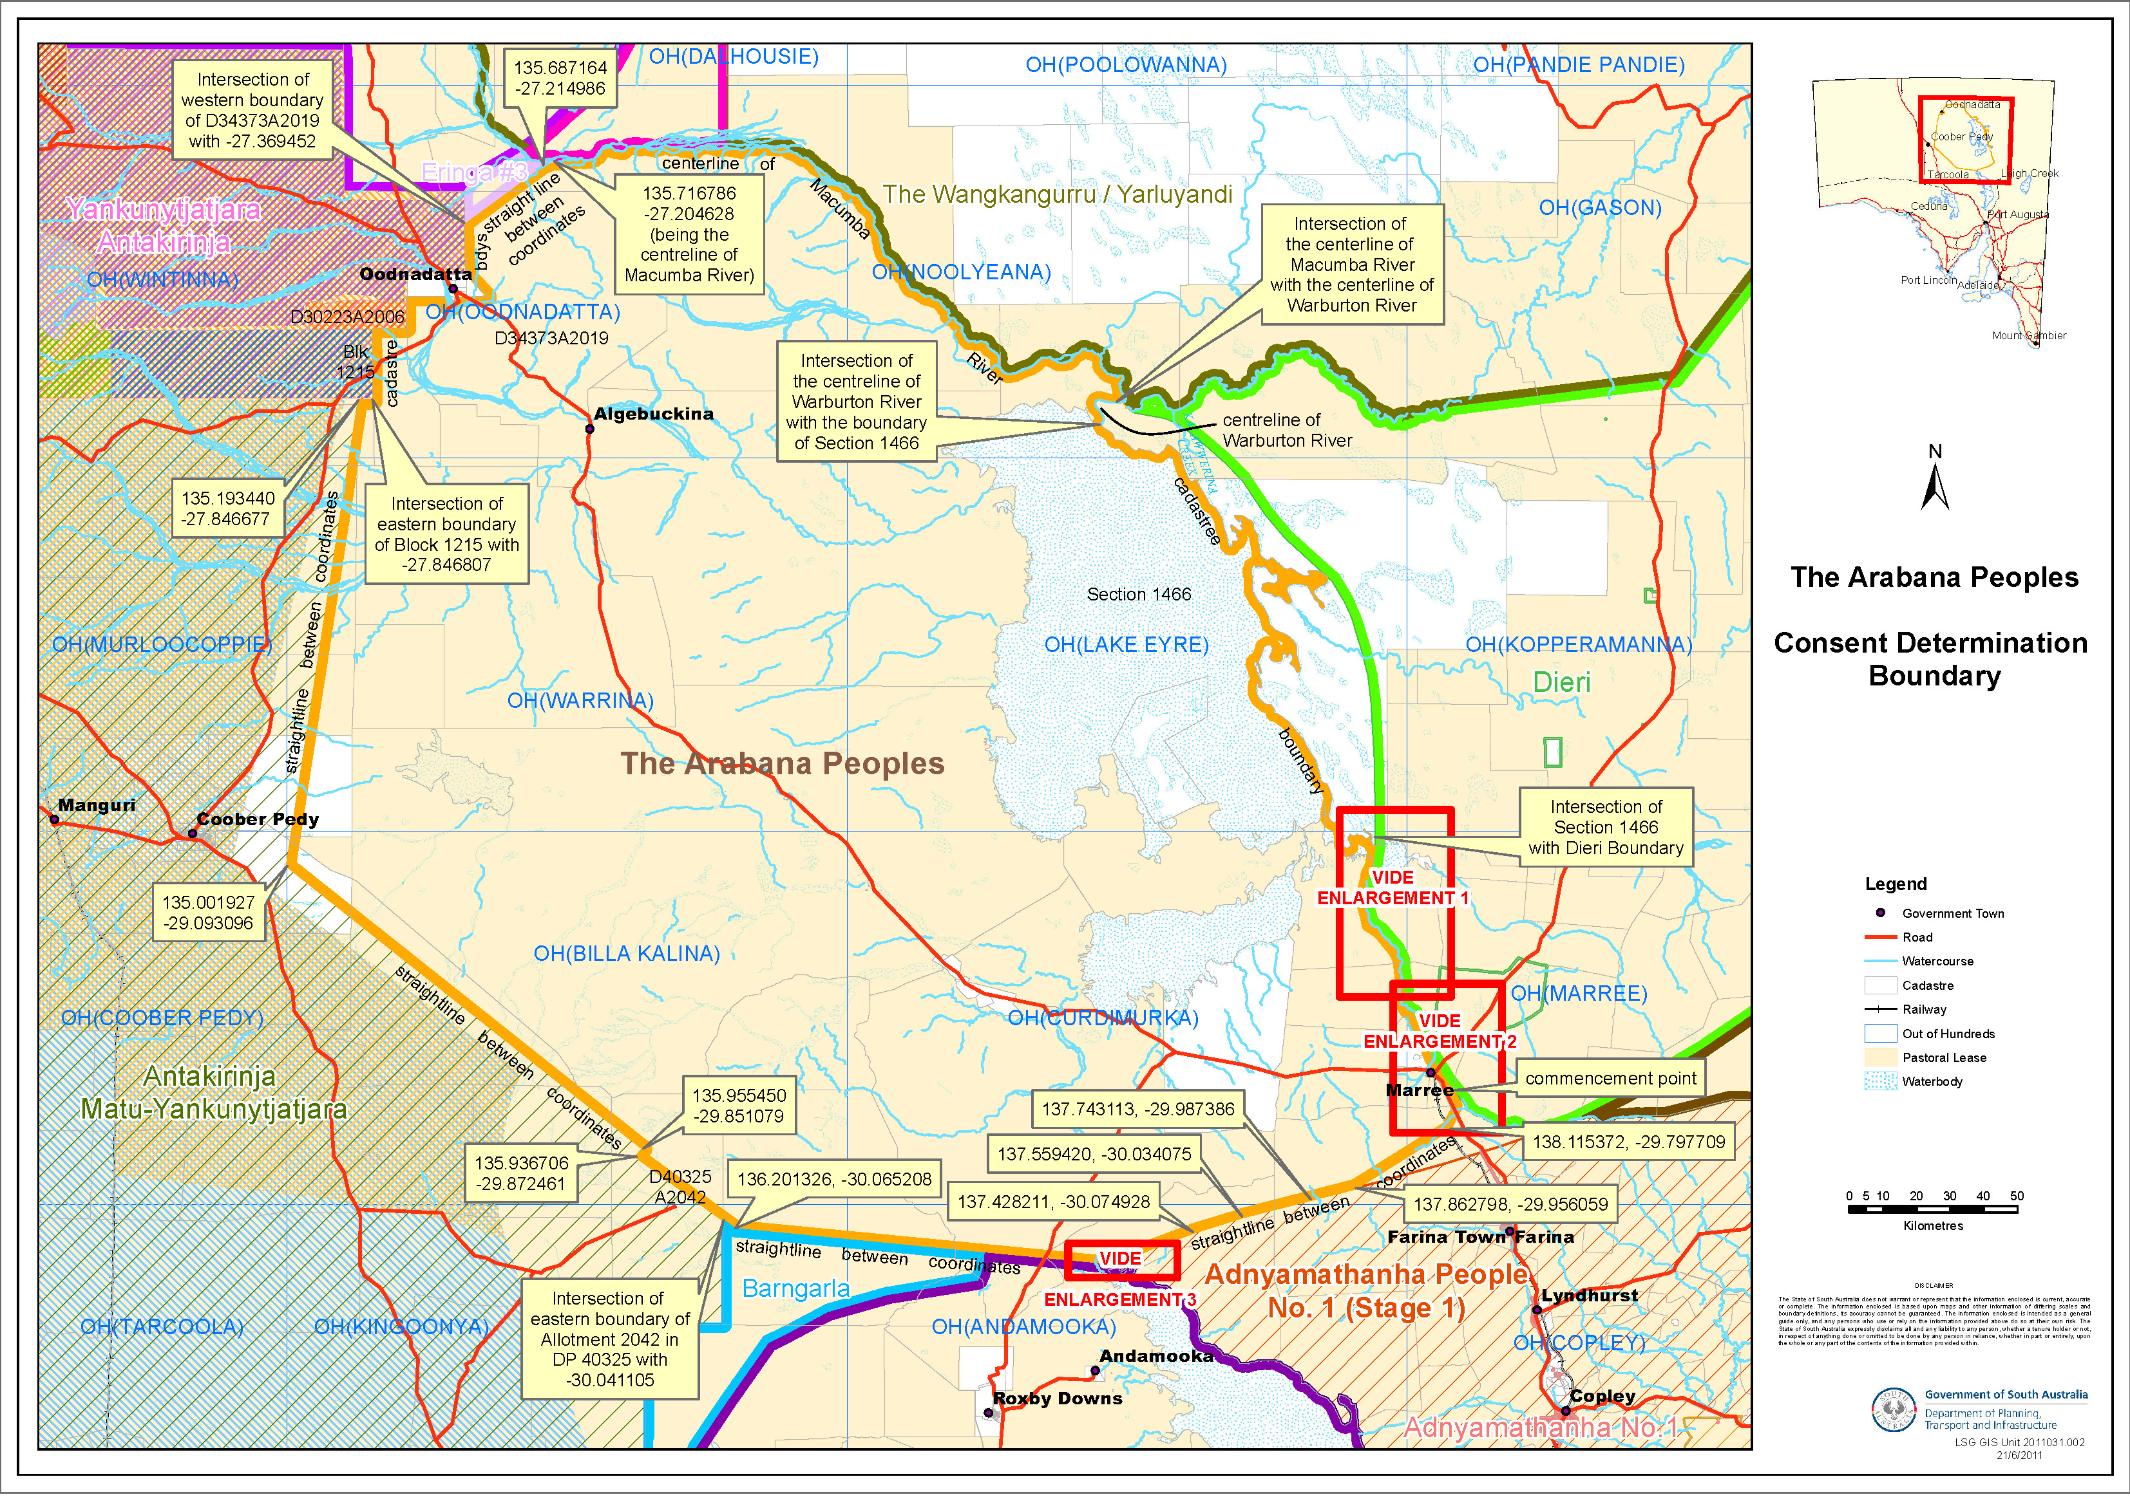
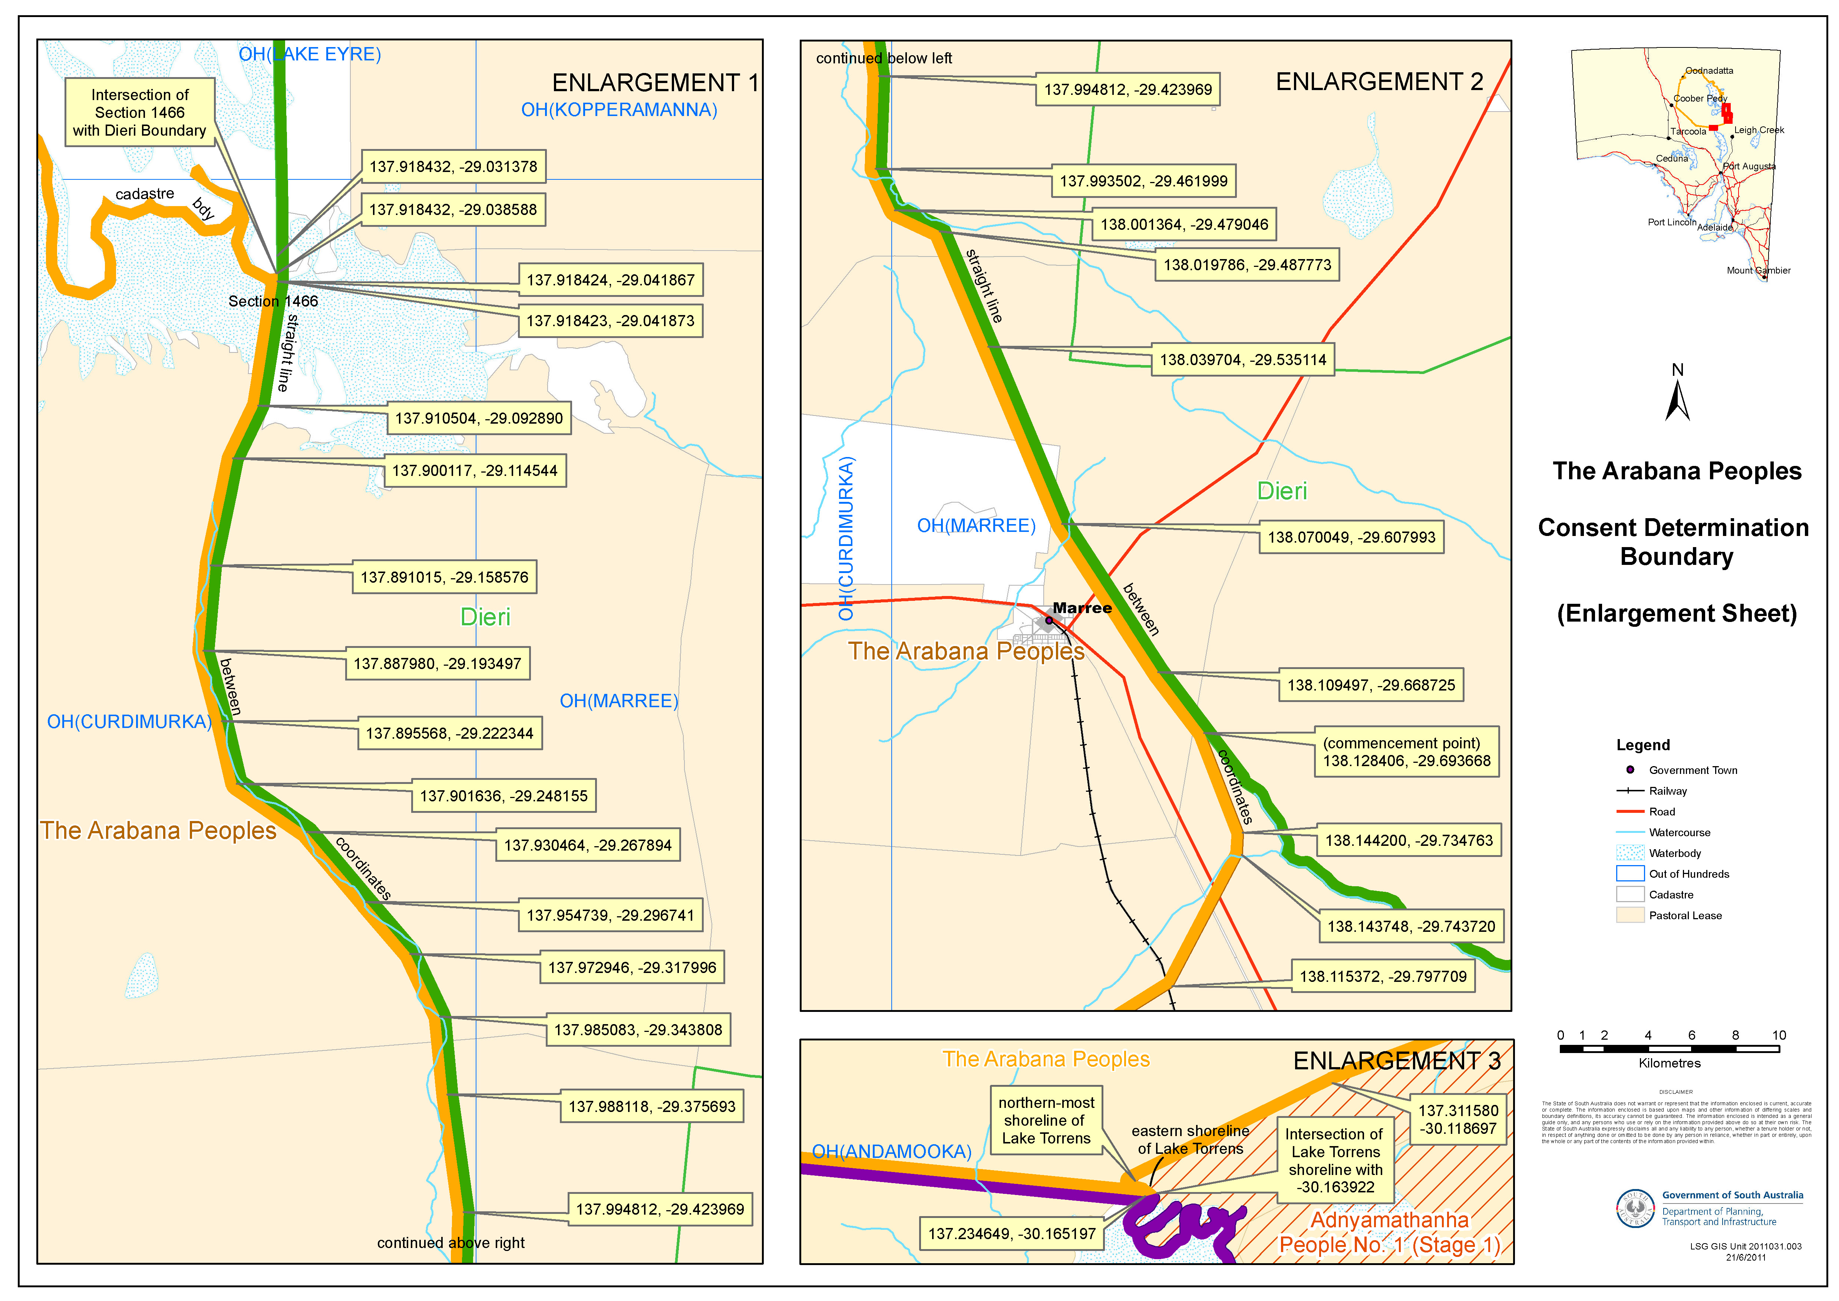

SCHEDULE 3 – Areas within the external boundaries of the Determination Area which are excluded from the Determination Area because native title has been extinguished

The following areas are agreed to have been excluded from the Determination Area by reason of the fact that native title has been extinguished in those areas:

- All roads which have been delineated in a public map pursuant to section 5(d)(II) of the Crown Lands Act 1929 (SA) or s70(3) or (4) of the Crown Land Management Act 2009 or which have otherwise been validly established pursuant to South Australian Statute or common law as shown in brown on the maps attached to this Schedule.

- Identified public works as shown on the attached map:
  - The Airstrip at William Creek being located on portion of Allotment 20 in Deposited Plan 32887 Out of Hundreds (Warrina); and
  - The Airstrip at Marree being located on portion of Block 489 Out of Hundreds (Marree) and portion of Allotment 1 in Deposited Plan 33224 Out of Hundreds (Marree);
  - The Charlie DRCS repeater being located on portion of Allotment 3 in Deposited Plan 34847 OH (Andamooka);

- The following listed land parcels:
Crown Land over which native title is extinguished
Parcel Identifier | Hundred | Current Tenure | Locality
D32887 A7 | OH (WARRINA) | CR 5349/834 OL20120 for Infrastructure Purposes | William Creek
D32887 A11 | OH (WARRINA) | CL 1644/12 OM21111 | William Creek
D32887 A17 | OH (WARRINA) | CL 1599/59 OM18271 | William Creek
D54997 A1 | OH (CURDIMURKA) | CL 1638/9 OM29678 | Stuarts Creek Station (Coward Springs)
D35810 A220 | OH (ANDAMOOKA) | CR 5351/448 Digital Radio Concentrator Reserve | Stuarts Creek Station (Gregory DRCS Repeater)
D41355 A221 | OH (ANDAMOOKA) | CR5266/555 Digital Radio Concentrator Reserve | Stuarts Creek (Bubbler DRCS Repeater)
H832200 S49 | OH (LAKE EYRE) | CR 5435/453 | Elliot Price Conservation Park
H833000 S571 | OH (CURDIMURKA) | CR 5756/647 Historic Reserve | Anna Creek Station
H833000 S572 | OH (CURDIMURKA) | CR 5756/647 Historic Reserve | Anna Creek Station
H833000 S574 | OH (CURDIMURKA) | CR 5756/647 Historic Reserve | Anna Creek Station
H833100 S340 | OH (MARREE) | CR 5747/875 OL10827 | St Stephens Pond
F36617 A1 | OH (MARREE) | CL 1595/99 OM18147 | Adjacent and Suburban Marree
F36617 A2 | OH (MARREE) | CL 1595/99 OM18147 | Adjacent and Suburban Marree
F36617 A3 | OH (MARREE) | CL 1595/99 OM18147 | Adjacent and Suburban Marree
F36617 A4 | OH (MARREE) | CL 1595/99 OM18147 | Adjacent and Suburban Marree
F36617 A5 | OH (MARREE) | CL 1595/99 OM18147 | Adjacent and Suburban Marree
F36617 A6 | OH (MARREE) | CL 1595/99 OM18147 | Adjacent and Suburban Marree
F36617 A7 | OH (MARREE) | CL 1595/99 OM18147 | Adjacent and Suburban Marree
F36617 A8 | OH (MARREE) | CL 1431/17 OM15875 | Adjacent and Suburban Marree
F36617 A9 | OH (MARREE) | CL 1431/17 OM15875 | Adjacent and Suburban Marree
F36617 A10 | OH (MARREE) | CL 1431/17 OM15875 | Adjacent and Suburban Marree
F36617 A11 | OH (MARREE) | CL 1431/17 OM15875 | Adjacent and Suburban Marree
F36617 A12 | OH (MARREE) | CL 1431/17 OM15875 | Adjacent and Suburban Marree
F36617 A13 | OH (MARREE) | CL 1431/17 OM15875 | Adjacent and Suburban Marree
F36617 A14 | OH (MARREE) | CL 1431/17 OM15875 | Adjacent and Suburban Marree
F36617 A15 | OH (MARREE) | CL 1431/17 OM15875 | Adjacent and Suburban Marree
F36617 A16 | OH (MARREE) | CL 1431/17 OM15875 | Adjacent and Suburban Marree
F36617 A17 | OH (MARREE) | CL 1595/99 OM18147 | Adjacent and Suburban Marree
F36617 A18 | OH (MARREE) | CL 1595/99 OM18147 | Adjacent and Suburban Marree
F36617 A19 | OH (MARREE) | CL 1595/99 OM18147 | Adjacent and Suburban Marree
F36617 A20 | OH (MARREE) | CL 1595/99 OM18147 | Adjacent and Suburban Marree
F36617 A21 | OH (MARREE) | CL 1595/99 OM18147 | Adjacent and Suburban Marree
F36617 A22 | OH (MARREE) | CL 1595/99 OM18147 | Adjacent and Suburban Marree
F36617 A23 | OH (MARREE) | CL 1595/99 OM18147 | Adjacent and Suburban Marree
F36617 A24 | OH (MARREE) | CL 1595/99 OM18147 | Adjacent and Suburban Marree
F36617 A65 | OH (MARREE) | CL 1595/99 OM18147 | Adjacent and Suburban Marree
F36617 A66 | OH (MARREE) | CL 1595/99 OM18147 | Adjacent and Suburban Marree
F36617 A67 | OH (MARREE) | CL 1595/99 OM18147 | Adjacent and Suburban Marree
F36617 A68 | OH (MARREE) | CL 1595/99 OM18147 | Adjacent and Suburban Marree
F36617 A69 | OH (MARREE) | CL 1595/99 OM18147 | Adjacent and Suburban Marree
F36617 A70 | OH (MARREE) | CL 1595/99 OM18147 | Adjacent and Suburban Marree
F36617 A71 | OH (MARREE) | CL 1595/99 OM18147 | Adjacent and Suburban Marree
F36617 A72 | OH (MARREE) | CR 5333/821 Refuse Depot Reserve | Adjacent and Suburban Marree
F36617 A73 | OH (MARREE) | CR 5333/821 Refuse Depot Reserve | Adjacent and Suburban Marree
F36617 A75 | OH (MARREE) | CL 1431/17 OM15875 | Adjacent and Suburban Marree
F36617 A76 | OH (MARREE) | CL 1431/17 OM15875 | Adjacent and Suburban Marree
F36617 A77 | OH (MARREE) | CL 1431/17 OM15875 | Adjacent and Suburban Marree
F36617 A78 | OH (MARREE) | CL 1431/17 OM15875 | Adjacent and Suburban Marree
F36617 A79 | OH (MARREE) | CL 1431/17 OM15875 | Adjacent and Suburban Marree
H833100 S484 | OH (MARREE) | CR 5757/299 Depot Reserve | Adjacent and Suburban Marree
H833100 S700 | OH (MARREE) | CR 5757/335 Highways Dept Reserve | Adjacent and Suburban Marree
H833100 S985 | OH (MARREE) | CR 5758/584 Water Works Reserve | Adjacent and Suburban Marree
H833100 S987 | OH (MARREE) | CR 5759/714 Cemetery Reserve | Adjacent and Suburban Marree

Land within Claim area held under Certificate of Title
Parcel Identifier | Hundred | Current Tenure | Locality
D32887 A1 | OH (WARRINA) | CT 5784/612 | William Creek
D32887 A2 | OH (WARRINA) | CT 5426/54 | William Creek
D32887 A3 | OH (WARRINA) | CT 5220/194 | William Creek
D32887 A4 | OH (WARRINA) | CT 5870/824 | William Creek
D32887 A6 | OH (WARRINA) | CT 5428/920 | William Creek
D32887 A8 | OH (WARRINA) | CT 5868/792 | William Creek
D32887 A15 | OH (WARRINA) | CT 5868/792 | William Creek
D32887 A16 | OH (WARRINA) | CT 5868/792 | William Creek
D54997 A2 | OH (CURDIMURKA) | CT 5845/542 | Stuarts Creek Station (Coward Springs)
F218779 A1 | OH (MARREE) | CT 5883/110 | Marree Station
F218779 A2 | OH (MARREE) | CT 5883/110 | Witchelina Station
H831300 S1521 | OH (OODNADATTA) | CT 5835/360 | Anna Creek Station (Dutton DRCS Repeater)
H832100 S1522 | OH (WARRINA) | CT 5834/27 | The Peake Station (Bungadillina DRCS Repeater)
H832100 S1523 | OH (WARRINA) | CT 5834/661 | Nilpinna Station (Anna Marla DRCS Repeater)
D33389 A505 | OH (MARREE) | CT 5179/49 | Adjacent and Suburban Marree
D33389 A506 | OH (MARREE) | CT 5179/49 | Adjacent and Suburban Marree
D33389 A507 | OH (MARREE) | CT 5179/49 | Adjacent and Suburban Marree
D71248 A1 | OH (MARREE) | CT 5978/368 | Adjacent and Suburban Marree
D71248 Q2 | OH (MARREE) | CT 5978/369 | Adjacent and Suburban Marree
D71248 A3 | OH (MARREE) | CT 5978/370 | Adjacent and Suburban Marree
D71248 A4 | OH (MARREE) | CT 5978/371 | Adjacent and Suburban Marree
D71248 A5 | OH (MARREE) | CT 5978/372 | Adjacent and Suburban Marree
D71248 A6 | OH (MARREE) | CT 5978/373 | Adjacent and Suburban Marree
D71248 A7 | OH (MARREE) | CT 5978/374 | Adjacent and Suburban Marree
D71248 A8 | OH (MARREE) | CT 5978/375 | Adjacent and Suburban Marree
D71248 A9 | OH (MARREE) | CT 5978/376 | Adjacent and Suburban Marree
D71248 A10 | OH (MARREE) | CT 5978/377 | Adjacent and Suburban Marree
D71248 Q11 | OH (MARREE) | CT 5978/378 | Adjacent and Suburban Marree
D71248 A12 | OH (MARREE) | CT 5978/379 | Adjacent and Suburban Marree
D71248 A13 | OH (MARREE) | CT 5978/380 | Adjacent and Suburban Marree
D71248 A15 | OH (MARREE) | CT 5978/382 | Adjacent and Suburban Marree
D71248 A17 | OH (MARREE) | CT 5978/384 | Adjacent and Suburban Marree
D71248 A18 | OH (MARREE) | CT 5978/385 | Adjacent and Suburban Marree
D71248 A19 | OH (MARREE) | CT 5978/386 | Adjacent and Suburban Marree
D71248 Q20 | OH (MARREE) | CT 5978/369 | Adjacent and Suburban Marree
D71248 Q21 | OH (MARREE) | CT 5978/378 | Adjacent and Suburban Marree
D75532 A51 | OH (MARREE) | CT 6003/608 | Adjacent and Suburban Marree
D75532 A52 | OH (MARREE) | CT 6003/609 | Adjacent and Suburban Marree
F36617 A63 | OH (MARREE) | CT 5493/660 | Adjacent and Suburban Marree
H83100 S986 | OH (MARREE) | CT 5843/43 | Adjacent and Suburban Marree

- Parcels within the township of Marree where native title is extinguished or it is agreed that native title will be surrendered pursuant to the Arabana Native Title Claim Settlement ILUA:

Parcel Identifier | Hundred | Current Tenure | Locality
D17834 A4 | OH (MARREE) | CT 5773/478 | Marree (township)
D17834 A5 | OH (MARREE) | CT 5773/479 | Marree (township)
D34670 A1 | OH (MARREE) | CT 5087/611 | Marree (township)
D34670 A2 | OH (MARREE) | CT 5087/612 | Marree (township)
D71248 A14 | OH (MARREE) | CT 5978/381 | Marree (township)
D78211 A200 | OH (MARREE) | CT 6020/557 | Marree (township)
F16633 A2 | OH (MARREE) | CT 5469/356 | Marree (township)
F16633 A3 | OH (MARREE) | CT 5065/305 | Marree (township)
F199237 A343 | OH (MARREE) | CT 5830/825 | Marree (township)
F199238 A344 | OH (MARREE) | CT 5830/824 | Marree (township)
F199239 A345 | OH (MARREE) | CT 5659/853 | Marree (township)
F199240 A346 | OH (MARREE) | CT 5659/852 | Marree (township)
F199241 A347 | OH (MARREE) | CT 5543/928 | Marree (township)
F199242 A348 | OH (MARREE) | CT 5779/963 | Marree (township)
F199243 A349 | OH (MARREE) | CT 5805/935 | Marree (township)
F217963 A50 | OH (MARREE) | CT 6020/558 | Marree (township)
F217963 A51 | OH (MARREE) | CT 5800/435 | Marree (township)
F217963 A52 | OH (MARREE) | CT 5800/435 | Marree (township)
F217963 A53 | OH (MARREE) | CT 5800/435 | Marree (township)
T833101 A1 | OH (MARREE) | CR 5763/599 | Marree (township)
T833101 A2 | OH (MARREE) | CR 5763/600 | Marree (township)
T833101 A3 | OH (MARREE) | CT 5581/484 | Marree (township)
T833101 A4 | OH (MARREE) | CR 5761/164 | Marree (township)
T833101 A5 | OH (MARREE) | CR 5761/164 | Marree (township)
T833101 A6 | OH (MARREE) | CT 5581/677 | Marree (township)
T833101 A7 | OH (MARREE) | CR 5758/136 | Marree (township)
T833101 A8 | OH (MARREE) | CT 5502/480 | Marree (township)
T833101 A9 | OH (MARREE) | CT 5663/515 | Marree (township)
T833101 A10 | OH (MARREE) | CT 5757/486 | Marree (township)
T833101 A11 | OH (MARREE) | CR 5753/875 | Marree (township)
T833101 A12 | OH (MARREE) | CR 5753/875 | Marree (township)
T833101 A13 | OH (MARREE) | CT 5649/428 | Marree (township)
T833101 A14 | OH (MARREE) | CT 5697/336 | Marree (township)
T833101 A15 | OH (MARREE) | CT 5441/166 | Marree (township)
T833101 A16 | OH (MARREE) | CT 2583/69 | Marree (township)
T833101 A17 | OH (MARREE) | CT 5489/699 | Marree (township)
T833101 A18 | OH (MARREE) | CT 5927/321 | Marree (township)
T833101 A19 | OH (MARREE) | CR 5771/764 | Marree (township)
T833101 A20 | OH (MARREE) | CR 5771/765 | Marree (township)
T833101 A21 | OH (MARREE) | CT 5841/22 | Marree (township)
T833101 A22 | OH (MARREE) | CT5841/22 | Marree (township)
T833101 A23 | OH (MARREE) | CT 5841/22 | Marree (township)
T833101 A24 | OH (MARREE) | CR 5771/766 | Marree (township)
T833101 A25 | OH (MARREE) | CR 5771/767 | Marree (township)
T833101 A26 | OH (MARREE) | CR 5771/768 | Marree (township)
T833101 A27 | OH (MARREE) | CR 5771/769 | Marree (township)
T833101 A28 | OH (MARREE) | CT 5837/75 | Marree (township)
T833101 A29 | OH (MARREE) | CR 5771/770 | Marree (township)
T833101 A30 | OH (MARREE) | CT 5841/22 | Marree (township)
T833101 A31 | OH (MARREE) | CR 5771/771 | Marree (township)
T833101 A32 | OH (MARREE) | CR 5771/772 | Marree (township)
T833101 A33 | OH (MARREE) | CR 5771/773 | Marree (township)
T833101 A34 | OH (MARREE) | CT 5841/22 | Marree (township)
T833101 A35 | OH (MARREE) | CT 5841/22 | Marree (township)
T833101 A36 | OH (MARREE) | CR 5771/774 | Marree (township)
T833101 A37 | OH (MARREE) | CT 5821/658 | Marree (township)
T833101 A38 | OH (MARREE) | CT 5489/695 | Marree (township)
T833101 A39 | OH (MARREE) | CT 5821/657 | Marree (township)
T833101 A40 | OH (MARREE) | CT 5660/98 | Marree (township)
T833101 A41 | OH (MARREE) | CT 5777/344 | Marree (township)
T833101 A42 | OH (MARREE) | CT 5413/729 | Marree (township)
T833101 A43 | OH (MARREE) | CT 5326/554 | Marree (township)
T833101 A44 | OH (MARREE) | CT 5326/554 | Marree (township)
T833101 A45 | OH (MARREE) | CR 5753/875 | Marree (township)
T833101 A46 | OH (MARREE) | CR 5753/875 | Marree (township)
T833101 A47 | OH (MARREE) | CT 788/6 | Marree (township)
T833101 A48 | OH (MARREE) | CT 5502/480 | Marree (township)
T833101 A49 | OH (MARREE) | CT 5502/480 | Marree (township)
T833101 A50 | OH (MARREE) | CT 5502/480 | Marree (township)
T833101 A51 | OH (MARREE) | CT 5821/658 | Marree (township)
T833101 A52 | OH (MARREE) | CT 5601/411 | Marree (township)
T833101 A53 | OH (MARREE) | CR 5757/311 | Marree (township)
T833101 A54 | OH (MARREE) | CT 5393/57 | Marree (township)
T833101 A55 | OH (MARREE) | CR 5763/601 | Marree (township)
T833101 A56 | OH (MARREE) | CT 5821/657 | Marree (township)
T833101 A57 | OH (MARREE) | CT 5821/658 | Marree (township)
T833101 A58 | OH (MARREE) | CT 5254/586 | Marree (township)
T833101 A59 | OH (MARREE) | CT 5741/245 | Marree (township)
T833101 A60 | OH (MARREE) | CT 5741/723 | Marree (township)
T833101 A61 | OH (MARREE) | CT 5821/656 | Marree (township)
T833101 A62 | OH (MARREE) | CT 5821/658 | Marree (township)
T833101 A63 | OH (MARREE) | CT 5797/477 | Marree (township)
T833101 A64 | OH (MARREE) | CT 5740/801 | Marree (township)
T833101 A65 | OH (MARREE) | CT 5557/709 | Marree (township)
T833101 A66 | OH (MARREE) | CT 5738/155 | Marree (township)
T833101 A67 | OH (MARREE) | CT 5738/154 | Marree (township)
T833101 A68 | OH (MARREE) | CT 5749/794 | Marree (township)
T833101 A69 | OH (MARREE) | CT 5834/708 | Marree (township)
T833101 A70 | OH (MARREE) | CT 5834/708 | Marree (township)
T833101 A71 | OH (MARREE) | CT 5346/478 | Marree (township)
T833101 A72 | OH (MARREE) | CT 5680/827 | Marree (township)
T833101 A73 | OH (MARREE) | CT 5644/669 | Marree (township)
T833101 A74 | OH (MARREE) | CT 5644/669 | Marree (township)
T833101 A75 | OH (MARREE) | CT 5569/809 | Marree (township)
T833101 A76 | OH (MARREE) | CT 5405/940 | Marree (township)
T833101 A77 | OH (MARREE) | CT 5405/940 | Marree (township)
T833101 A78 | OH (MARREE) | CT 5841/22 | Marree (township)
T833101 A79 | OH (MARREE) | CT 5548/594 | Marree (township)
T833101 A80 | OH (MARREE) | CT 5548/594 | Marree (township)
T833101 A81 | OH (MARREE) | CR 5771/775 | Marree (township)
T833101 A82 | OH (MARREE) | CR 5771/776 | Marree (township)
T833101 A83 | OH (MARREE) | CT 5821/658 | Marree (township)
T833101 A84 | OH (MARREE) | CT 5428/451 | Marree (township)
T833101 A85 | OH (MARREE) | CT 5801/670 | Marree (township)
T833101 A86 | OH (MARREE) | CT 5841/22 | Marree (township)
T833101 A87 | OH (MARREE) | CT 5841/22 | Marree (township)
T833101 A88 | OH (MARREE) | CT 5841/22 | Marree (township)
T833101 A89 | OH (MARREE) | CT 5908/888 | Marree (township)
T833101 A90 | OH (MARREE) | CT 5841/22 | Marree (township)
T833101 A91 | OH (MARREE) | CT 5841/22 | Marree (township)
T833101 A92 | OH (MARREE) | CT 5405/940 | Marree (township)
T833101 A93 | OH (MARREE) | CT 5833/230 | Marree (township)
T833101 A94 | OH (MARREE) | CT 5814/845 | Marree (township)
T833101 A95 | OH (MARREE) | CT 5813/822 | Marree (township)
T833101 A96 | OH (MARREE) | CT 5847/896 | Marree (township)
T833101 A97 | OH (MARREE) | CT 5779/617 | Marree (township)
T833101 A98 | OH (MARREE) | CT 5798/11 | Marree (township)
T833101 A99 | OH (MARREE) | CT 5525/929 | Marree (township)
T833101 A100 | OH (MARREE) | CT 5525/930 | Marree (township)
T833101 A101 | OH (MARREE) | CT 5574/265 | Marree (township)
T833101 A102 | OH (MARREE) | CT 5811/541 | Marree (township)
T833101 A103 | OH (MARREE) | CT 5788/231 | Marree (township)
T833101 A104 | OH (MARREE) | CT 5558/46 | Marree (township)
T833101 A106 | OH (MARREE) | CT 5752/875 | Marree (township)
T833101 A107 | OH (MARREE) | CT 5293/528 | Marree (township)
T833101 A108 | OH (MARREE) | CT 5821/656 | Marree (township)
T833101 A109 | OH (MARREE) | CT 5821/658 | Marree (township)
T833101 A110 | OH (MARREE) | CT 5801/671 | Marree (township)
T833101 A111 | OH (MARREE) | CT 5834/714 | Marree (township)
T833101 A112 | OH (MARREE) | CT 5821/659 | Marree (township)
T833101 A113 | OH (MARREE) | CT 5312/428 | Marree (township)
T833101 A114 | OH (MARREE) | CT 5835/594 | Marree (township)
T833101 A115 | OH (MARREE) | CT 5312/540 | Marree (township)
T833101 A116 | OH (MARREE) | CT 5821/658 | Marree (township)
T833101 A117 | OH (MARREE) | CT 5312/426 | Marree (township)
T833101 A118 | OH (MARREE) | CT 5556/132 | Marree (township)
T833101 A119 | OH (MARREE) | CT 5492/708 | Marree (township)
T833101 A120 | OH (MARREE) | CT 5719/241 | Marree (township)
T833101 A121 | OH (MARREE) | CT 5809/315 | Marree (township)
T833101 A122 | OH (MARREE) | CT 5908/889 | Marree (township)
T833101 A123 | OH (MARREE) | CT 5667/61 | Marree (township)
T833101 A124 | OH (MARREE) | CT 5801/668 | Marree (township)
T833101 A127 | OH (MARREE) | CT 5798/298 | Marree (township)
T833101 A128 | OH (MARREE) | CT 5721/362 | Marree (township)
T833101 A131 | OH (MARREE) | CT 5441/165 | Marree (township)
T833101 A132 | OH (MARREE) | CT 5568/169 | Marree (township)
T833101 A134 | OH (MARREE) | CT 5821/658 | Marree (township)
T833101 A135 | OH (MARREE) | CT 5841/22 | Marree (township)
T833101 A136 | OH (MARREE) | CT 5821/658 | Marree (township)
T833101 A137 | OH (MARREE) | CT 5801/669 | Marree (township)
T833101 A138 | OH (MARREE) | CT 2583/69 | Marree (township)
T833101 A139 | OH (MARREE) | CT 5821/658 | Marree (township)
T833101 A140 | OH (MARREE) | CR 5763/602 | Marree (township)
T833101 A141 | OH (MARREE) | CR 5771/777 | Marree (township)
T833101 A142 | OH (MARREE) | CR 5771/778 | Marree (township)
T833101 A143 | OH (MARREE) | CT 5655/361 | Marree (township)
T833101 A144 | OH (MARREE) | CT 5343/138 | Marree (township)
T833101 A145 | OH (MARREE) | CT 5342/690 | Marree (township)
T833101 A146 | OH (MARREE) | CT 5579/422 | Marree (township)
T833101 A147 | OH (MARREE) | CT 5481/380 | Marree (township)
T833101 A162 | OH (MARREE) | CT 5322/900 | Marree (township)
T833101 A163 | OH (MARREE) | CT 5322/923 | Marree (township)
T833101 A164 | OH (MARREE) | CT 5322/923 | Marree (township)
T833101 A169 | OH (MARREE) | CT 5976/807 | Marree (township)
T833101 A170 | OH (MARREE) | CT 5976/807 | Marree (township)
T833101 A171 | OH (MARREE) | CT 5976/805 | Marree (township)
T833101 A175 | OH (MARREE) | CT 5662/891 | Marree (township)
T833101 A176 | OH (MARREE) | CT 5662/890 | Marree (township)
T833101 A177 | OH (MARREE) | CT 5662/890 | Marree (township)
T833101 A178 | OH (MARREE) | CT 5720/62 | Marree (township)
T833101 A179 | OH (MARREE) | CT 5717/226 | Marree (township)
T833101 A180 | OH (MARREE) | CT 5927/336 | Marree (township)
T833101 A181 | OH (MARREE) | CT 5594/457 | Marree (township)
T833101 A182 | OH (MARREE) | CT 5594/457 | Marree (township)
T833101 A183 | OH (MARREE) | CT 5821/636 | Marree (township)
T833101 A184 | OH (MARREE) | CT 5821/636 | Marree (township)
T833101 A185 | OH (MARREE) | CT 5801/539 | Marree (township)
T833101 A186 | OH (MARREE) | CR 5771/779 | Marree (township)
T833101 A187 | OH (MARREE) | CT5801/538 | Marree (township)
T833101 A188 | OH (MARREE) | CT 5575/939 | Marree (township)
T833101 A189 | OH (MARREE) | CT 5575/939 | Marree (township)
T833101 A190 | OH (MARREE) | CR 5771/780 | Marree (township)
T833101 A191 | OH (MARREE) | CR 5771/781 | Marree (township)
T833101 A192 | OH (MARREE) | CR 5771/782 | Marree (township)
T833101 A193 | OH (MARREE) | CR 5770/221 | Marree (township)
T833101 A194 | OH (MARREE) | CR 5770/222 | Marree (township)
T833101 A195 | OH (MARREE) | CT 5573/635 | Marree (township)
T833101 A196 | OH (MARREE) | CT 5573/635 | Marree (township)
T833101 A197 | OH (MARREE) | CT 5573/635 | Marree (township)
T833101 A198 | OH (MARREE) | CR 5770/223 | Marree (township)
T833101 A199 | OH (MARREE) | CR 5770/224 | Marree (township)
T833101 A200 | OH (MARREE) | CR 5770/225 | Marree (township)
T833101 A201 | OH (MARREE) | CR 5770/226 | Marree (township)
T833101 A202 | OH (MARREE) | CR 5770/227 | Marree (township)
T833101 A203 | OH (MARREE) | CR 5770/228 | Marree (township)
T833101 A204 | OH (MARREE) | CR 5747/876 | Marree (township)
T833101 A205 | OH (MARREE) | CR 5770/229 | Marree (township)
T833101 A206 | OH (MARREE) | CR 5747/877 | Marree (township)
T833101 A207 | OH (MARREE) | CR 5747/878 | Marree (township)
T833101 A208 | OH (MARREE) | CR 5770/230 | Marree (township)
T833101 A209 | OH (MARREE) | CT 5821/636 | Marree (township)
T833101 A210 | OH (MARREE) | CT 5821/636 | Marree (township)
T833101 A211 | OH (MARREE) | CR 5763/603 | Marree (township)
T833101 A212 | OH (MARREE) | CR 5763/604 | Marree (township)
T833101 A213 | OH (MARREE) | CT 5570/510 | Marree (township)
T833101 A214 | OH (MARREE) | CT 5570/454 | Marree (township)
T833101 A215 | OH (MARREE) | CT 5809/931 | Marree (township)
T833101 A216 | OH (MARREE) | CT 5814/929 | Marree (township)
T833101 A217 | OH (MARREE) | CT 5662/79 | Marree (township)
T833101 A218 | OH (MARREE) | CT 5811/24 | Marree (township)
T833101 A219 | OH (MARREE) | CT 5811/24 | Marree (township)
T833101 A220 | OH (MARREE) | CT 5811/24 | Marree (township)
T833101 A221 | OH (MARREE) | CT 5976/806 | Marree (township)
T833101 A222 | OH (MARREE) | CT 5976/806 | Marree (township)
T833101 A223 | OH (MARREE) | CT 5976/807 | Marree (township)
T833101 A224 | OH (MARREE) | CT 5976/806 | Marree (township)
T833101 A225 | OH (MARREE) | CT 6015/248 | Marree (township)
T833101 A226 | OH (MARREE) | CT 6015/248 | Marree (township)
T833101 A227 | OH (MARREE) | CT 6015/248 | Marree (township)
T833101 A228 | OH (MARREE) | CT 6015/248 | Marree (township)
T833101 A229 | OH (MARREE) | CT 5597/198 | Marree (township)
T833101 A230 | OH (MARREE) | CT 5949/759 | Marree (township)
T833101 A231 | OH (MARREE) | CT 5590/93 | Marree (township)
T833101 A232 | OH (MARREE) | CT 5441/164 | Marree (township)
T833101 A233 | OH (MARREE) | CT 5441/163 | Marree (township)
T833101 A234 | OH (MARREE) | CT 5490/783 | Marree (township)
T833101 A235 | OH (MARREE) | CT 5490/782 | Marree (township)
T833101 A236 | OH (MARREE) | CT 5815/729 | Marree (township)
T833101 A237 | OH (MARREE) | CT 5815/729 | Marree (township)
T833101 A238 | OH (MARREE) | CT 5782/363 | Marree (township)
T833101 A239 | OH (MARREE) | CT 5834/866 | Marree (township)
T833101 A240 | OH (MARREE) | CT 5824/179 | Marree (township)
T833101 A241 | OH (MARREE) | CT 5840/16 | Marree (township)
T833101 A242 | OH (MARREE) | CT 5840/16 | Marree (township)
T833101 A243 | OH (MARREE) | CT 5801/866 | Marree (township)
T833101 A244 | OH (MARREE) | CT 5801/866 | Marree (township)
T833101 A245 | OH (MARREE) | CT 5801/540 | Marree (township)
T833101 A246 | OH (MARREE) | CT 5686/603 | Marree (township)
T833101 A247 | OH (MARREE) | CR 5770/231 | Marree (township)
T833101 A248 | OH (MARREE) | CR 5770/232 | Marree (township)
T833101 A249 | OH (MARREE) | CR 5770/233 | Marree (township)
T833101 A250 | OH (MARREE) | CT 5818/953 | Marree (township)
T833101 A251 | OH (MARREE) | CR 5770/234 | Marree (township)
T833101 A252 | OH (MARREE) | CR 5770/235 | Marree (township)
T833101 A253 | OH (MARREE) | CR 5770/236 | Marree (township)
T833101 A254 | OH (MARREE) | CR 5770/237 | Marree (township)
T833101 A255 | OH (MARREE) | CR 5770/238 | Marree (township)
T833101 A256 | OH (MARREE) | CR 5770/239 | Marree (township)
T833101 A257 | OH (MARREE) | CR 5770/240 | Marree (township)
T833101 A258 | OH (MARREE) | CR 5770/241 | Marree (township)
T833101 A259 | OH (MARREE) | CR 5770/242 | Marree (township)
T833101 A260 | OH (MARREE) | CR 5770/243 | Marree (township)
T833101 A261 | OH (MARREE) | CT 5801/540 | Marree (township)
T833101 A262 | OH (MARREE) | CR 5770/244 | Marree (township)
T833101 A263 | OH (MARREE) | CT 5840/16 | Marree (township)
T833101 A264 | OH (MARREE) | CT 5840/16 | Marree (township)
T833101 A265 | OH (MARREE) | CT 5840/16 | Marree (township)
T833101 A266 | OH (MARREE) | CT 5840/16 | Marree (township)
T833101 A267 | OH (MARREE) | CT 5782/364 | Marree (township)
T833101 A268 | OH (MARREE) | CT 5824/849 | Marree (township)
T833101 A269 | OH (MARREE) | CT 5782/364 | Marree (township)
T833101 A270 | OH (MARREE) | CT 5428/446 | Marree (township)
T833101 A271 | OH (MARREE) | CT 5428/449 | Marree (township)
T833101 A272 | OH (MARREE) | CT 5441/162 | Marree (township)
T833101 A273 | OH (MARREE) | CT 5441/26 | Marree (township)
T833101 A274 | OH (MARREE) | CT 5590/93 | Marree (township)
T833101 A275 | OH (MARREE) | CT 5590/93 | Marree (township)
T833101 A276 | OH (MARREE) | CT 6028/5 | Marree (township)
T833101 A277 | OH (MARREE) | CT 6028/5 | Marree (township)
T833101 A278 | OH (MARREE) | CT 6028/5 | Marree (township)
T833101 A279 | OH (MARREE) | CT 5992/252 | Marree (township)
T833101 A280 | OH (MARREE) | CT 5992/252 | Marree (township)
T833101 A281 | OH (MARREE) | CT 5820/5 | Marree (township)
T833101 A282 | OH (MARREE) | CT 5820/5 | Marree (township)
T833101 A283 | OH (MARREE) | CT 5787/562 | Marree (township)
T833101 A284 | OH (MARREE) | CT 5621/365 | Marree (township)
T833101 A285 | OH (MARREE) | CT 5614/48 | Marree (township)
T833101 A286 | OH (MARREE) | CT 5262/5 | Marree (township)
T833101 A287 | OH (MARREE) | CT 5262/3 | Marree (township)
T833101 A288 | OH (MARREE) | CT 5262/6 | Marree (township)
T833101 A289 | OH (MARREE) | CT 5262/7 | Marree (township)
T833101 A290 | OH (MARREE) | CT 5397/252 | Marree (township)
T833101 A291 | OH (MARREE) | CR 5758/585 | Marree (township)
T833101 A292 | OH (MARREE) | CR 5758/585 | Marree (township)
T833101 A293 | OH (MARREE) | CT 5989/623 | Marree (township)
T833101 A294 | OH (MARREE) | CT 5989/623 | Marree (township)
T833101 A295 | OH (MARREE) | CT 5428/447 | Marree (township)
T833101 A296 | OH (MARREE) | CT 5428/450 | Marree (township)
T833101 A297 | OH (MARREE) | CR 5770/245 | Marree (township)
T833101 A298 | OH (MARREE) | CR 5770/246 | Marree (township)
T833101 A299 | OH (MARREE) | CR 5770/247 | Marree (township)
T833101 A300 | OH (MARREE) | CT 5294/396 | Marree (township)
T833101 A301 | OH (MARREE) | CT 5294/396 | Marree (township)
T833101 A302 | OH (MARREE) | CR 5770/248 | Marree (township)
T833101 A303 | OH (MARREE) | CR 5770/249 | Marree (township)
T833101 A304 | OH (MARREE) | CR 5770/250 | Marree (township)
T833101 A305 | OH (MARREE) | CR 5770/251 | Marree (township)
T833101 A306 | OH (MARREE) | CR 5770/252 | Marree (township)
T833101 A307 | OH (MARREE) | CR 5770/253 | Marree (township)
T833101 A308 | OH (MARREE) | CR 5770/254 | Marree (township)
T833101 A309 | OH (MARREE) | CR 5770/255 | Marree (township)
T833101 A310 | OH (MARREE) | CR 5770/256 | Marree (township)
T833101 A311 | OH (MARREE) | CR 5770/257 | Marree (township)
T833101 A312 | OH (MARREE) | CR 5770/258 | Marree (township)
T833101 A313 | OH (MARREE) | CR 5770/259 | Marree (township)
T833101 A314 | OH (MARREE) | CR 5770/260 | Marree (township)
T833101 A315 | OH (MARREE) | CR 5770/261 | Marree (township)
T833101 A316 | OH (MARREE) | CT 5294/397 | Marree (township)
T833101 A317 | OH (MARREE) | CT 5294/397 | Marree (township)
T833101 A318 | OH (MARREE) | CR 5770/262 | Marree (township)
T833101 A319 | OH (MARREE) | CR 5770/263 | Marree (township)
T833101 A320 | OH (MARREE) | CR 5770/264 | Marree (township)
T833101 A321 | OH (MARREE) | CR 5770/265 | Marree (township)
T833101 A322 | OH (MARREE) | CR 5770/266 | Marree (township)
T833101 A323 | OH (MARREE) | CT 5783/484 | Marree (township)
T833101 A324 | OH (MARREE) | CT 5783/484 | Marree (township)
T833101 A325 | OH (MARREE) | CT 5783/485 | Marree (township)
T833101 A326 | OH (MARREE) | CT 5782/353 | Marree (township)
T833101 A327 | OH (MARREE) | CT 5782/353 | Marree (township)
T833101 A328 | OH (MARREE) | CT 5262/8 | Marree (township)
T833101 A329 | OH (MARREE) | CT 5262/9 | Marree (township)
T833101 A330 | OH (MARREE) | CT 5262/4 | Marree (township)
T833101 A331 | OH (MARREE) | CT 5262/4 | Marree (township)
T833101 A332 | OH (MARREE) | CT 5798/301 | Marree (township)
T833101 A333 | OH (MARREE) | CT 5798/301 | Marree (township)
T833101 A334 | OH (MARREE) | CT 5798/301 | Marree (township)
T833101 A335 | OH (MARREE) | CT 5838/545 | Marree (township)
T833101 A336 | OH (MARREE) | CT 5838/545 | Marree (township)

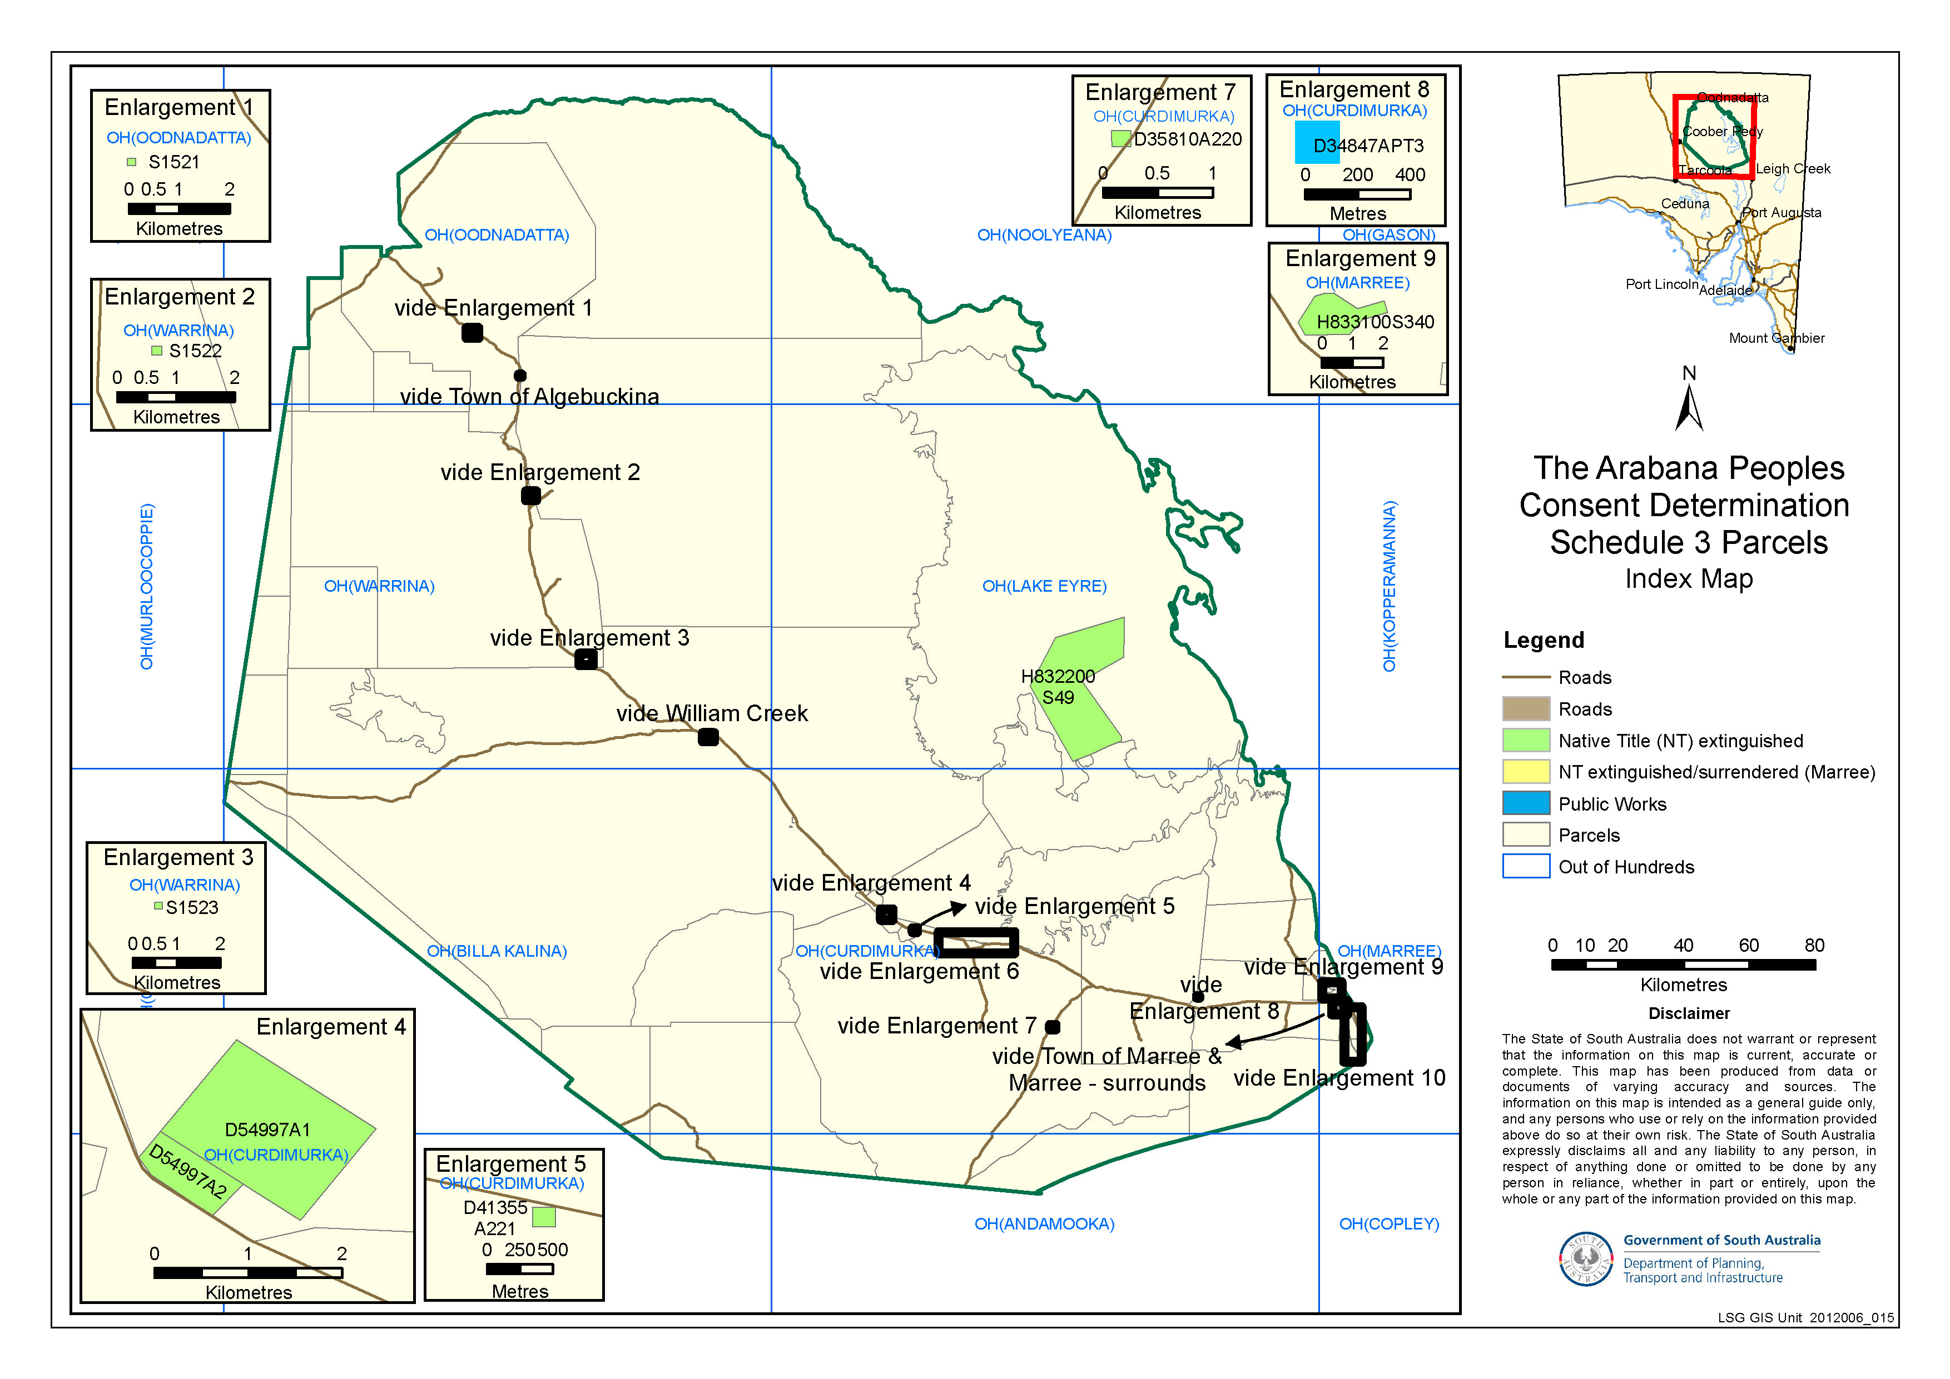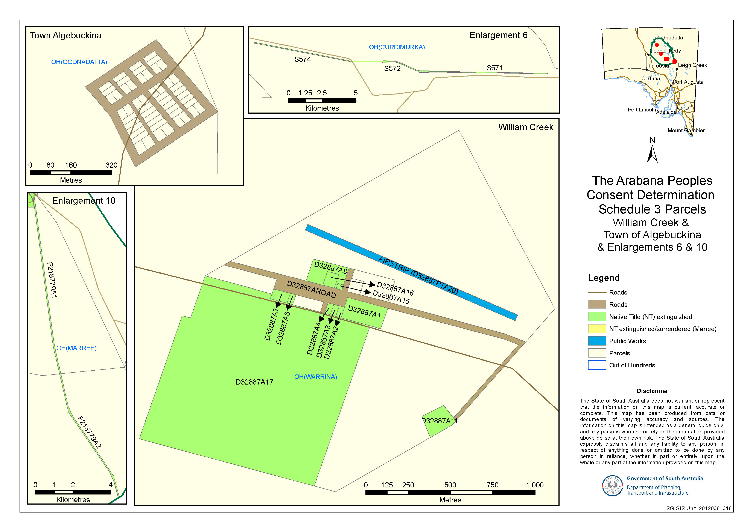
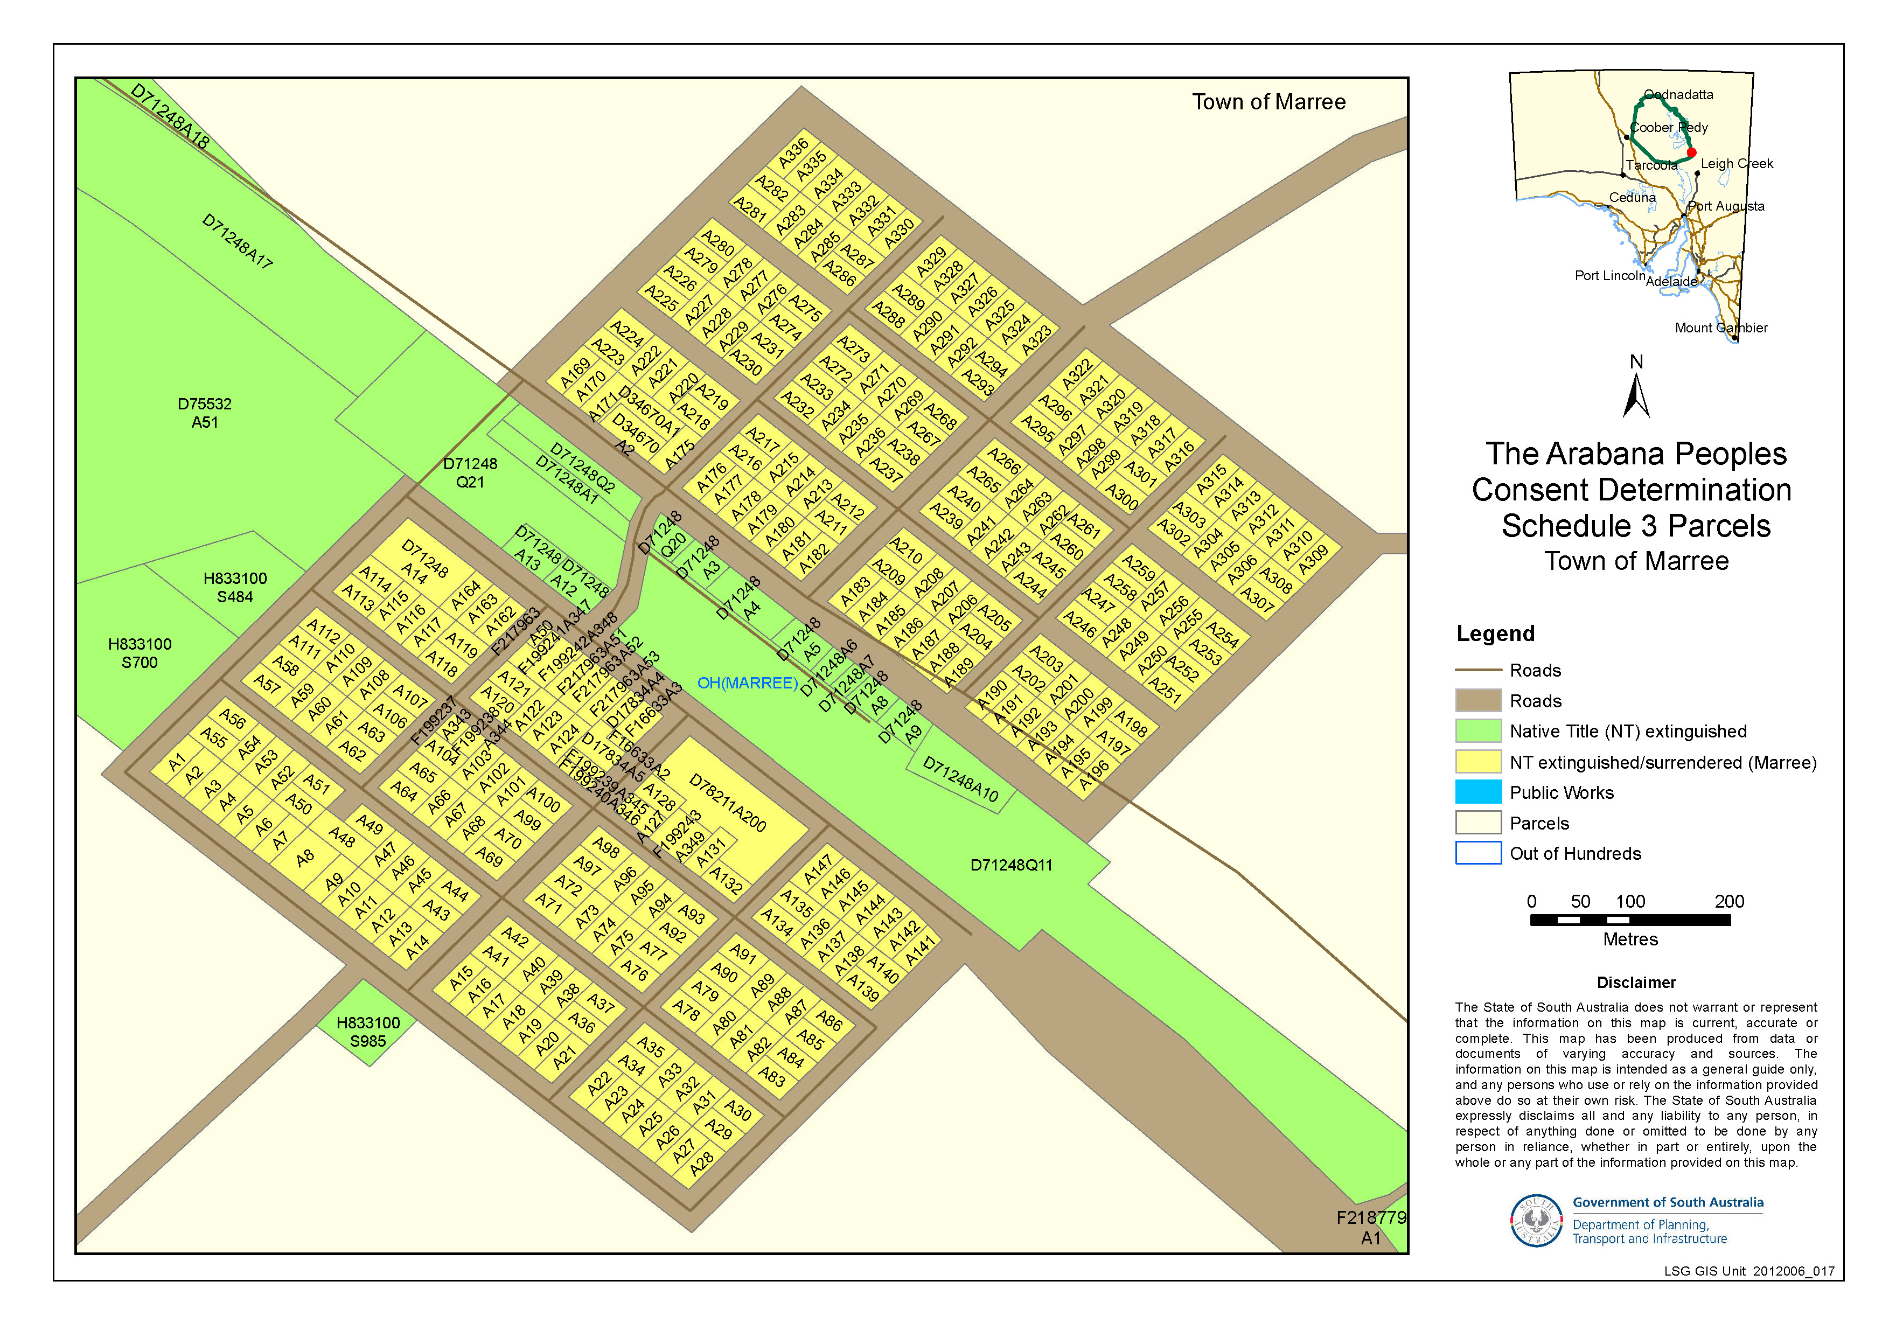
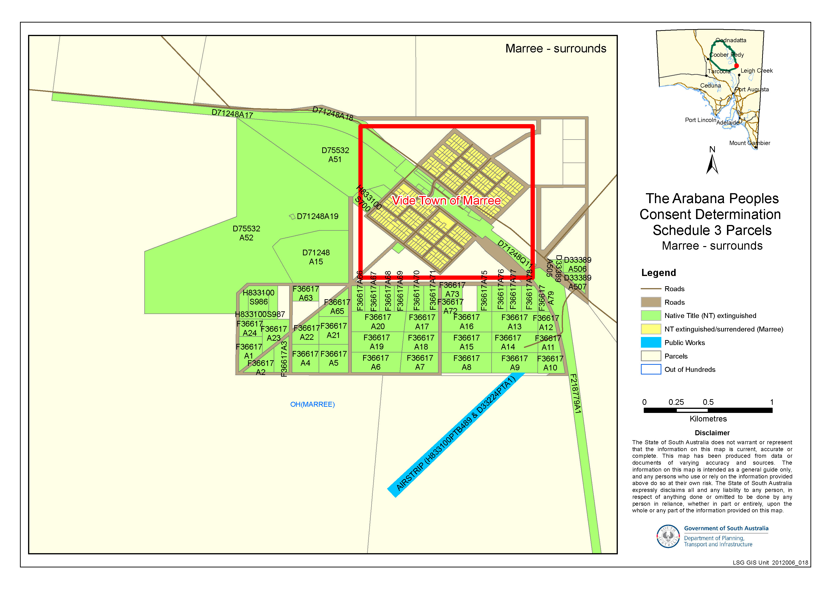

SCHEDULE 4 - Areas where the non-extinguishment principle applies by reason of a Vesting

Park name | Legislation proclaimed under | Crown Record No
Lake Eyre National Park (Part) | National Parks and Wildlife Act 1972  Gazettals 30.10.1988 and 19.12.1991 | Section 1466, OH (Curdimurka, Noolyeana, Marree, Lake Eyre), s1467, OH (Curdimurka, Lake Eyre), Section 1468 OH (Curdimurka, Kopperamanna, Lake Eyre) Crown Record 5772/920
Lake Torrens National Park (Part) | National Parks and Wildlife Act 1972  Gazettal 19.12.1991 | Section 1532 OH (Torrens) Crown Record 5773/872

SCHEDULE 5 - Areas where extinguishment of native title must be disregarded

Areas to which section 47A of the NTA applies
Parcel Identifier | Hundred | Current Tenure | Locality
H832100 S712 | OH (WARRINA) | CT 5483/463 | Anna Creek Station
FP36617 A94 | OH (MARREE) | CT 5830/494 | Adjacent and Suburban Marree

Areas to which section 47B of the NTA applies
Parcel Identifier | Hundred | Current Tenure | Locality
D32887 A18 | OH (WARRINA) | CR 5789/153 | William Creek
D32887 A20 (portion – excluding the airstrip and the gymkhana area) | OH (WARRINA) | CR 5789/151 | William Creek
D32887 A21 | OH (WARRINA) | CR 5789/152 | William Creek
D34847 A2 (portion – excluding the area contained within SWL Borefield B, SWL2 Borefield A and the easement contained in CT 4401/481) | OH (CURDIMURKA) | CR 5751/53 | Finniss Springs
H833100 S547 | OH (MARREE) | CR 5771/762 | Mundowdna Station
F36617 A25 | OH (MARREE) | CR 5333/827 | Adjacent and Suburban Marree
F36617 A26 | OH (MARREE) | CR 5333/828 | Adjacent and Suburban Marree
F36617 A64 | OH (MARREE) | CR 5333/826 | Adjacent and Suburban Marree
F36617 A74 | OH (MARREE) | CR 5333/825 | Adjacent and Suburban Marree

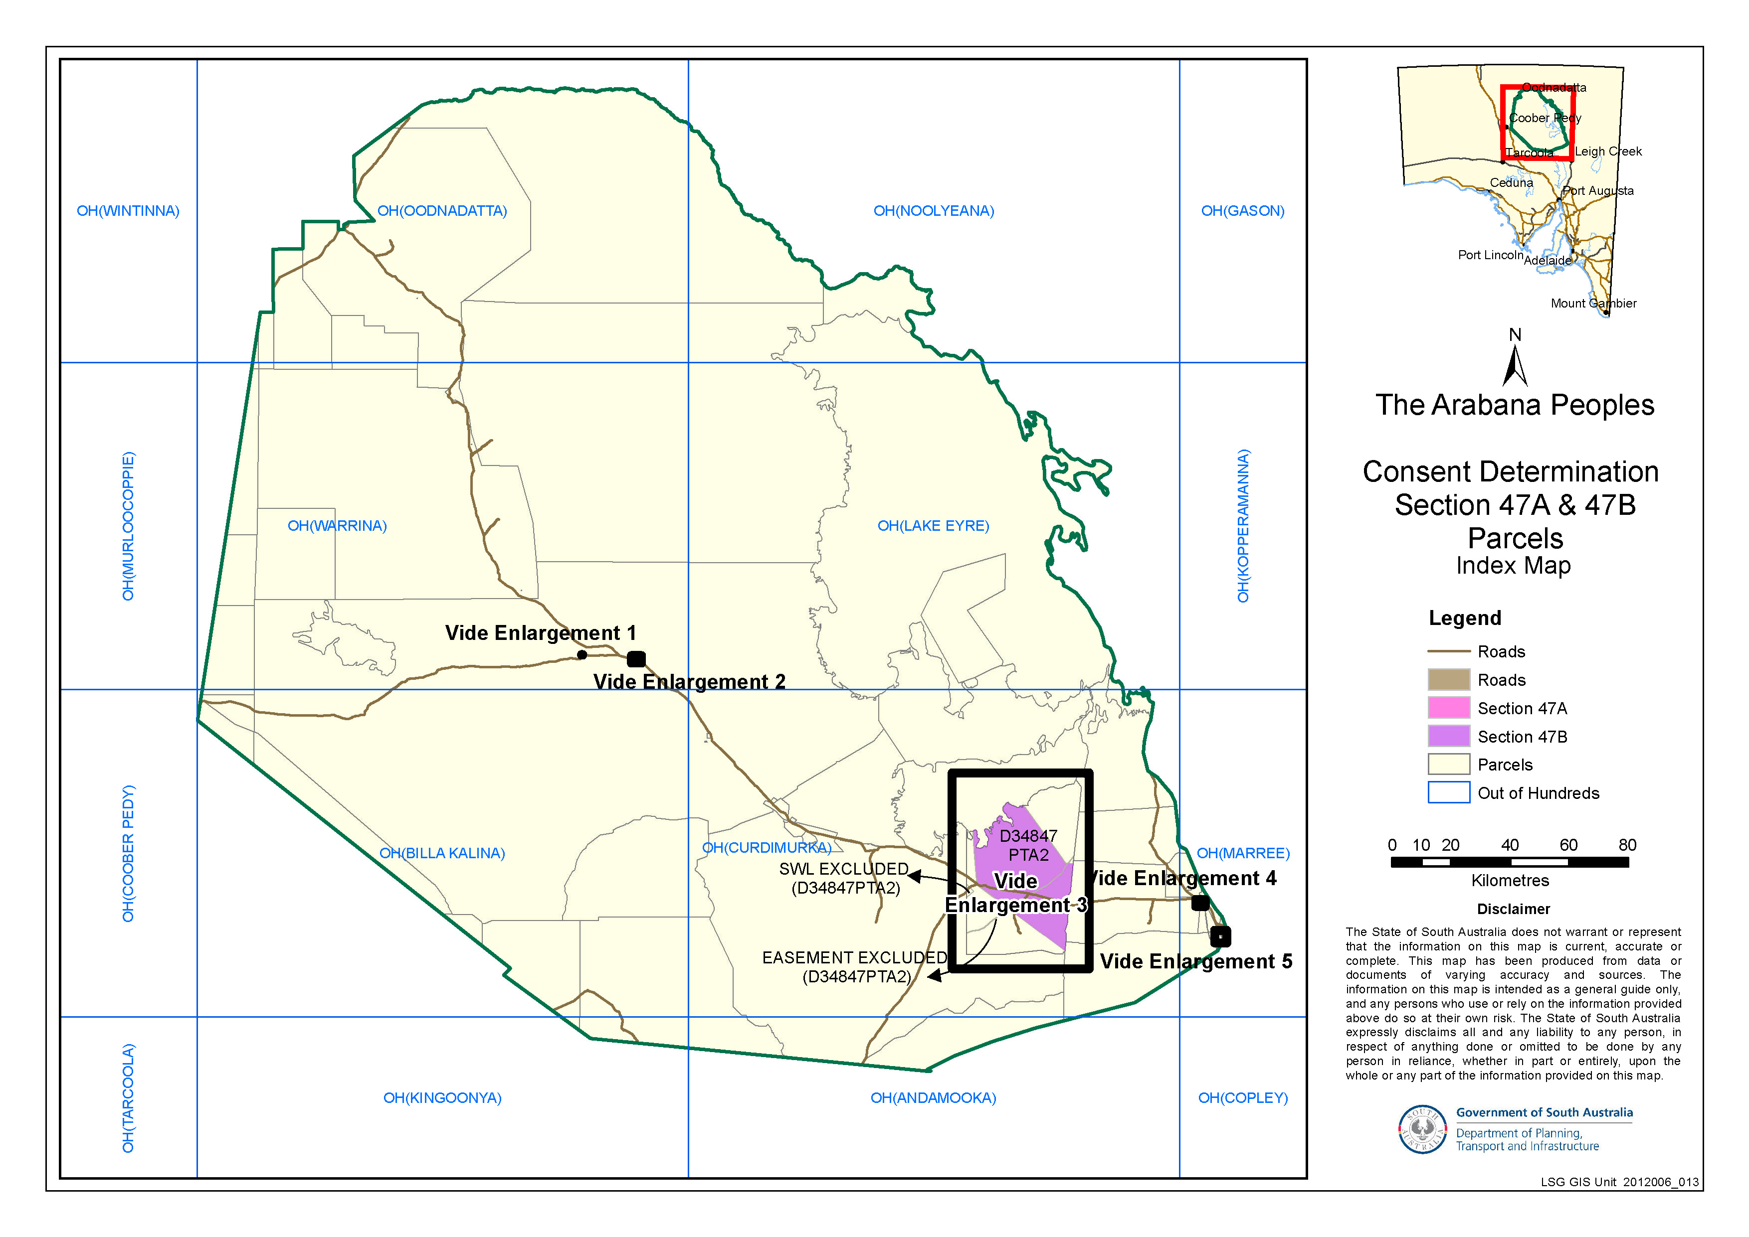
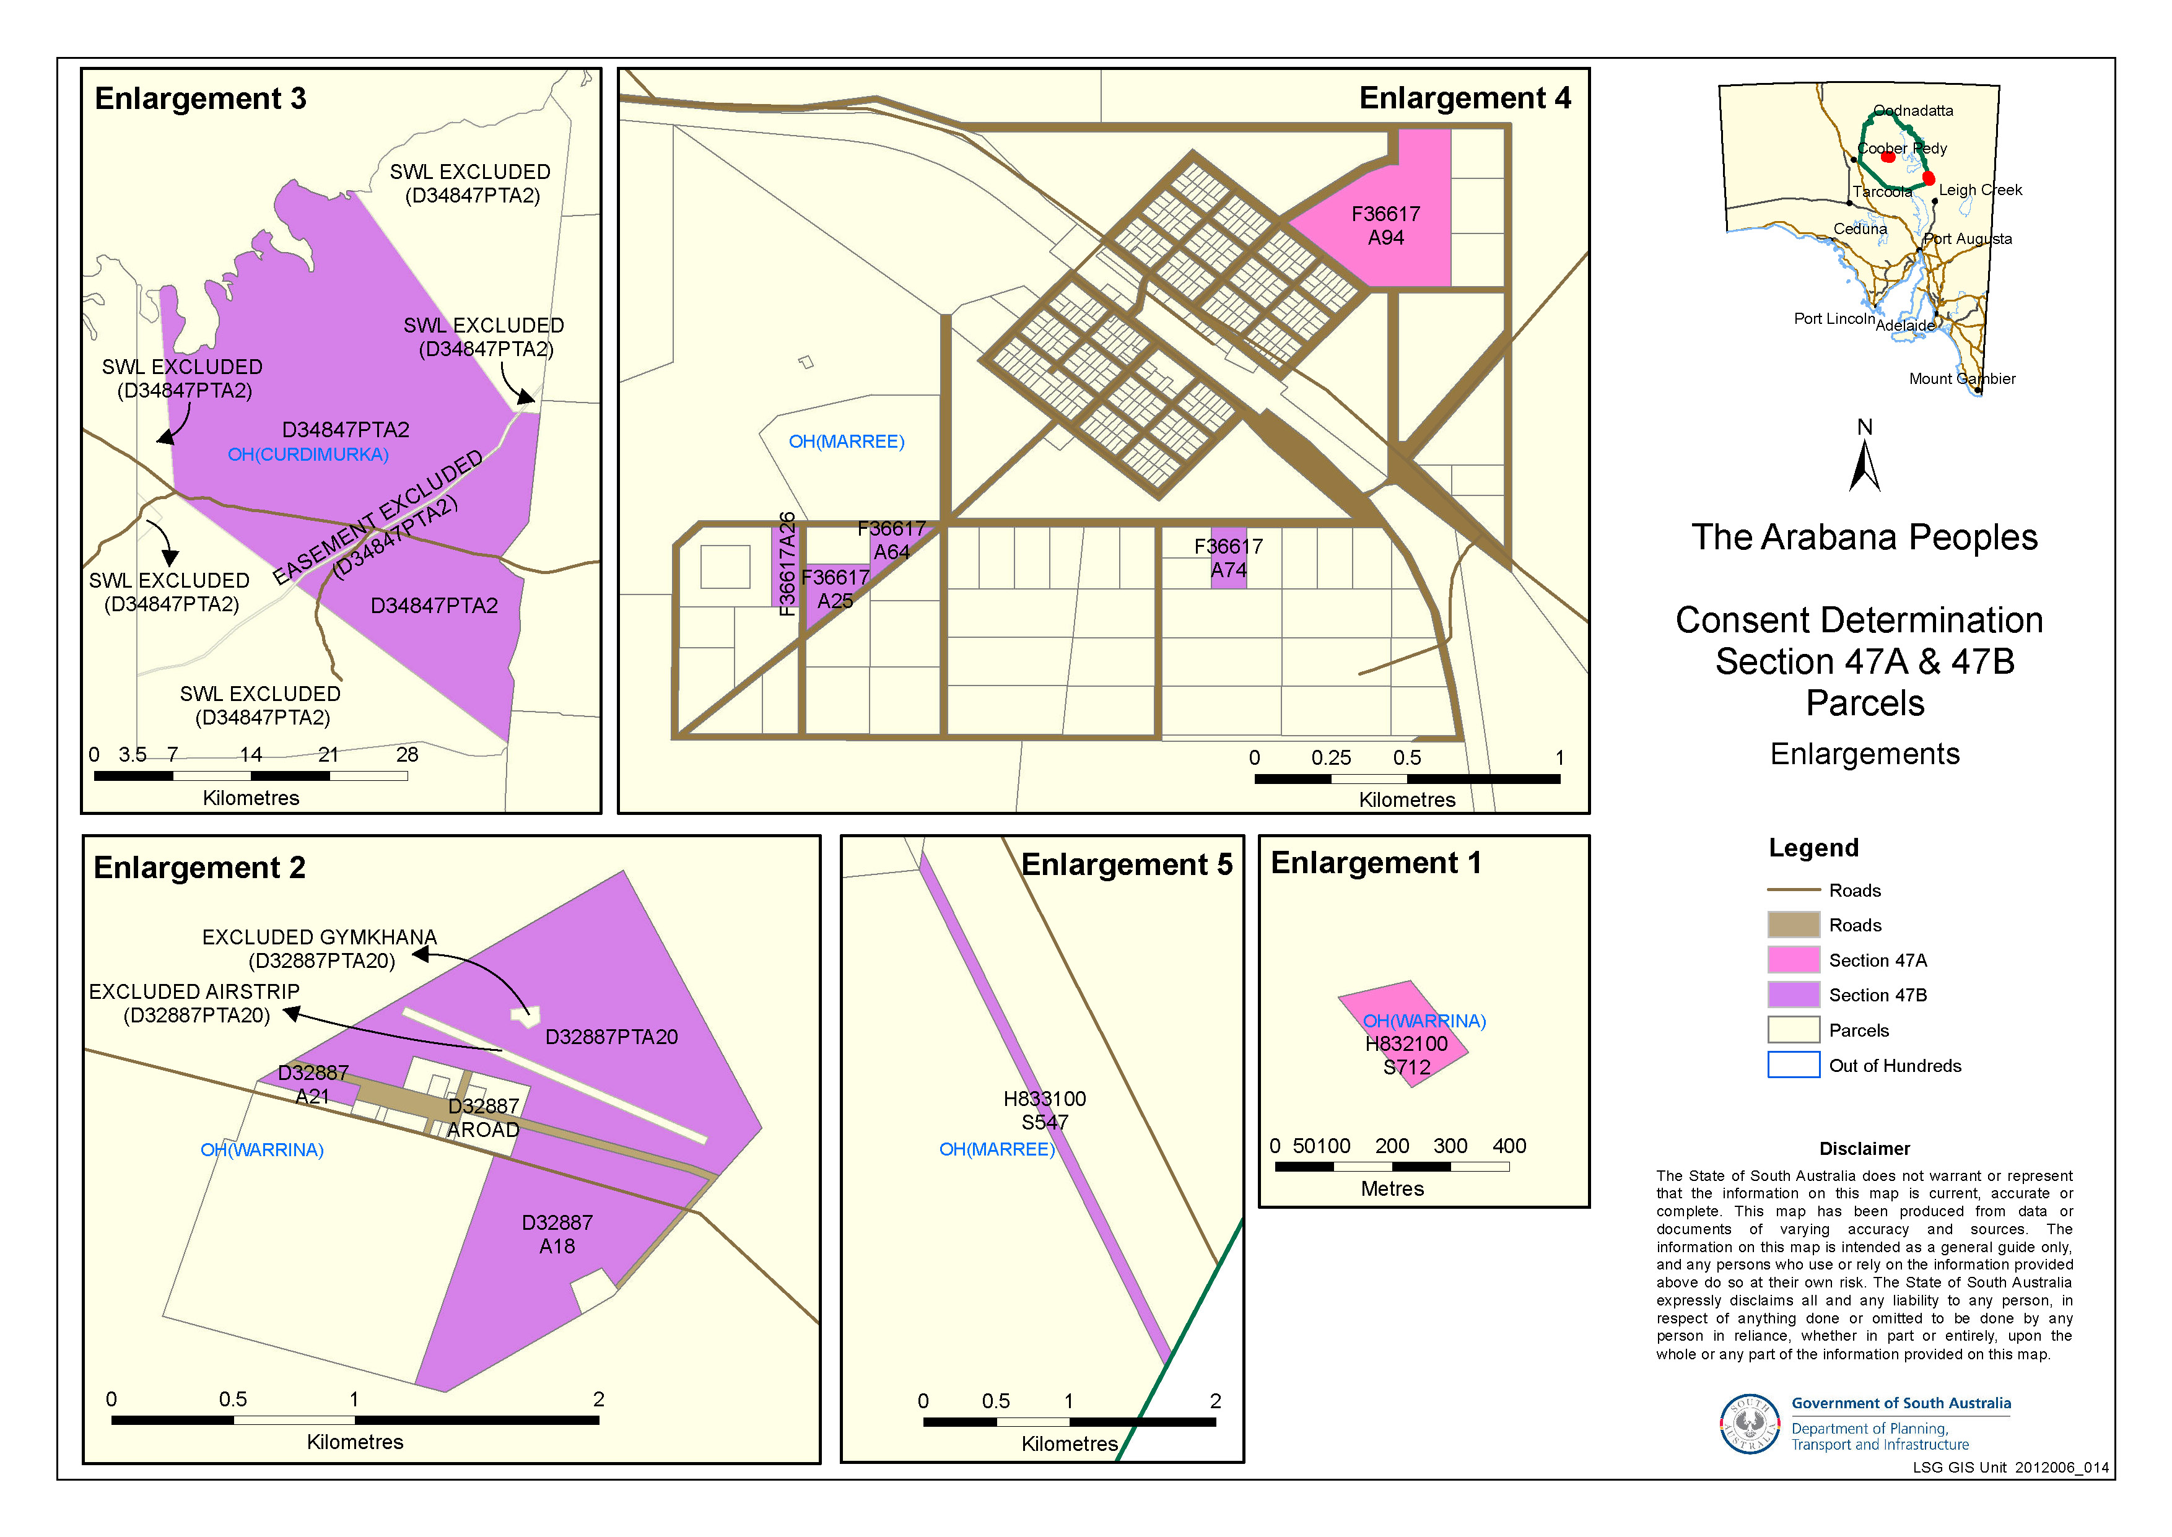

SCHEDULE 6 - Details of Indigenous Land Use Agreements in the Determination Area

- Arabana Area Minerals Exploration ILUA, Registered 13/10/2004, NNTT reference S12003/008
- Arabana Native Title Claim Settlement ILUA (Area Agreement)
- Arabana Parks ILUA (Area Agreement)
SCHEDULE 7 - Reserves under NPWA in Determination Area

Park name | Legislation proclaimed under | Crown Record No
Lake Eyre National Park (Part) | National Parks and Wildlife Act 1972  Gazettals 30.10.1988 and 19.12.1991 | Section 1466, OH(Curdimurka, Noolyeana, Marree, Lake Eyre), s1467, OH(Curdimurka, Lake Eyre), Section 1468 OH(Curdimurka, Kopperamanna, Lake Eyre) Crown Record 5772/920
Lake Torrens National Park (Part) | National Parks and Wildlife Act 1972  Gazettal 19.12.1991 | Section 1532 OH (Torrens) Crown Record 5773/872
Wabma Kadarbu Mound Springs Conservation Park | National Parks and Wildlife Act 1972  Gazettal 18 July 1996 | DP 42441 allotment 320 OH (Curdimurka) Crown Record 5308/800 ; DP 42441 allotment 321 OH (Curdimurka) Crown Record 5308/801; and allotments 31 and 32 in DP 54705 Out of Hundreds (Curdimurka) Crown Record 5856/379

SCHEDULE 8

No. SAD 6025 of 1998
Federal Court of Australia
District Registry: South Australia
Division: General

NATIVE TITLE ACTION FILED BY THE ARABANA PEOPLE on 30 September 1998

Applicants
Applicant: Reginald Dodd
Applicant: Millie Warren
Applicant: Laurie Stuart (deceased)

Respondents
Respondent: State of South Australia
Respondent: Commonwealth of Australia
Respondent: South Australian Native Title Services Inc
Respondent: Kuyani People
Respondent: Dieri People
Respondent: Australian Wildlife Conservancy
Respondent: Tony Boyd
Respondent: Andrew Trevor Clarke
Respondent: Macumba Pastoral Company Pty Ltd
Respondent: Muloorina Station
Respondent: Strangways Springs Pty Ltd
Respondent: Blanusa Opals Pty Ltd
Respondent: Laura Holdings Pty Ltd
Respondent: Alfonz Nagyszollosi
Respondent: Mary M Nagyszollosi
Respondent: Oz Minerals Prominent Hill Operations Pty Ltd
Respondent: Scorpion Exploration Pty Ltd
Respondent: Tasman Resources Ltd
Respondent: BHP Billiton Olympic Dam Corporation Pty Ltd
Respondent: Telstra Corporation Limited
Respondent: Termite Resources N.L.
Respondent: South Australian Apiarists Association Inc

Note: Entry of orders is dealt with in Rule 39.32 of the Federal Court Rules 2011.

IN THE FEDERAL COURT OF AUSTRALIA
SOUTH AUSTRALIA DISTRICT REGISTRY
GENERAL DIVISION | SAD 6025 of 1998

BETWEEN: | REGINALD DODD, LAURIE STUART (DECEASED), MILLIE WARREN  Applicants
AND: | THE STATE OF SOUTH AUSTRALIA, COMMONWEALTH OF AUSTRALIA, SOUTH AUSTRALIAN NATIVE TITLE SERVICES INC, KUYANI PEOPLE, DIERI PEOPLE, AUSTRALIAN WILDLIFE CONSERVANCY, TONY BOYD, ANDREW TREVOR CLARKE, MACUMBA PASTORAL COMPANY PTY LTD, MULOORINA STATION, STRANGWAYS SPRINGS PTY LTD, BLANUSA OPALS PTY LTD, LAURA HOLDINGS PTY LTD, ALFONZ NAGYSZOLLOSI, MARY M NAGYSZOLLOSI, OZ MINERALS PROMINENT HILL OPERATIONS PTY LTD, SCORPION EXPLORATION PTY LTD, TASMAN RESOURCES LTD, BHP BILLITON OLYMPIC DAM CORPORATION PTY LTD, TELSTRA CORPORATION LIMITED, TERMITE RESOURCES N.L., SOUTH AUSTRALIAN APIARISTS ASSOCIATION INC  Respondents

JUDGE: | FINN J
DATE: | 22 MAY 2012
PLACE: | FINNISS SPRINGS STATION, SOUTH AUSTRALIA

REASONS FOR JUDGMENT
- The Arabana native title claim was first lodged with the National Native Title Tribunal on 16 January 1998. Though it may be a matter of some regret that it has taken over 14 years to reach the point where it can now be finalised, that passage of time at least allowed all relevant interest holders in the claim area an opportunity to take part in the proceeding. The lengthy period during which it was in mediation enhanced this opportunity.
- The claim is over an area in the central/far north of South Australia spanning between Marree in the southeast, and Oodnadatta in the northwest. The claim area has been slightly amended in the years since it was first lodged, predominantly to remove boundary overlaps with neighbouring groups. The area to be covered by the Consent Determination is approximately 68,823 square kilometres, and includes Lake Eyre, Marree and William Creek.
- The Arabana, the State of South Australia, and a range of pastoral, mining and other interests within the Determination area who are parties to the proceedings have come to an agreement as to the orders that should be made by the court and now applies to the court to make a Consent Determination under s 87 of the Native Title Act 1993 (Cth).

The Native Title Act Requirements
- Section 87 of the Act empowers the court to make orders by consent for the determination of native title if certain conditions, which are not onerous, have been satisfied. These conditions, their significance and how their satisfaction may be demonstrated, have recently been considered at some length by Keane CJ in King v South Australia (2011) 285 ALR 454 (“King”) at [12]-[23]. I need only reiterate what his Honour said there:
12 Certain of those conditions are procedural in nature. The period of notice under s 66 must have elapsed. It has clearly done so in relation to both Eringa #1 and Eringa #3. A signed copy of the agreed orders must have been filed with the court. That has also taken place.

13 More substantively, s 87(1) of the Native Title Act requires that, for the court to make the proposed consent determination of native title without a hearing, the court must be satisfied that such an order would be within its power, and s 87(2) requires the court to be satisfied that it would be appropriate to make the orders agreed upon. In addition, because the orders seek a determination of native title, they must comply with s 94A of the Native Title Act. That section requires the proposed orders to set out details of the matters mentioned in s 225 of the Native Title Act.

14 Section 225 defines a determination of native title as:

A determination … whether or not native title exists in relation to a particular area (the determination area) of land or waters and, if it does exist, a determination of:

(a) who the persons, or each group of persons, holding the common or group rights comprising the native title are; and
(b) the nature and extent of the native title rights and interests in relation to the determination area; and
(c) the nature and extent of any other interests in relation to the determination area; and
(d) the relationship between the rights and interests in paras (b) and (c) (taking into account the effect of this Act); and
(e) to the extent that the land or waters in the determination area are not covered by a non-exclusive agricultural lease or a non-exclusive pastoral lease — whether the native title rights and interests confer possession, occupation, use and enjoyment of that land or waters on the native title holders to the exclusion of all others.

15 The term “native title rights and interests” is defined in s 223(1) of the Native Title Act as:

[T]he communal, group or individual rights and interests of Aboriginal peoples … in relation to land or waters, where:

(a) the rights and interests are possessed under the traditional laws acknowledged, and the traditional customs observed, by the Aboriginal peoples …; and
(b) the Aboriginal peoples …, by those laws and customs, have a connection with the land or waters; and
(c) the rights and interests are recognised by the common law of Australia.

16 It is important to explain why those requirements are satisfied. It is especially important, because the recognition given by the orders to be made will apply not just between the parties who have participated in the proceeding, but to all the people of Australia: Munn for and on behalf of the Guggari People v Queensland (2001) 115 FCR 109 ; [2001] FCA 1229 (Munn).

17 In Lota Warria on behalf of the Poruma and Masig Peoples v Queensland (2005) 223 ALR 62 ; [2005] FCA 1117, Black CJ said of those requirements (at [5]–[8]):

5 … There can be no doubt as to the jurisdiction of the court to make the orders sought (see s 81 of the Act) and there is nothing in the agreed terms that would suggest that the power of the Court would be exceeded by making those orders. As the proposed order sets out details of each of the matters mentioned in s 225, the requirements of s 94A of the Act are satisfied.

6 It remains only to consider whether it would be “appropriate” to make the orders sought.

7 As I have noted elsewhere, the discretion conferred by s 87(1) must be exercised judicially, and within the broad boundaries ascertained by reference to the subject matter, scope and purpose of the Act. The matters to be taken into account in the exercise of the discretion, and the weight to be given to those matters, may very well vary according to the particular circumstances of each case.

8 In the present case, it is clear that the parties have had independent and competent legal advice and there is no suggestion that the agreement was not freely entered into. The agreed terms of the proposed orders are unambiguous and are appropriate in the circumstances.

18 His Honour then proceeded to consider briefly the material before the court. He considered it appropriate to make the orders as agreed.

19 More recently, the court has been prepared to rely upon the processes of the relevant state or territory about the requirements of s 223 being met to be satisfied that the making of the agreed orders is appropriate. That is because each state and territory has developed a protocol or procedure by which it determines whether native title (as defined in s 223) has been established. It acts in the public interest and as the public guardian in doing so. It has access to anthropological, and where appropriate, archaeological, historical and linguistic expertise. It has a legal team to manage and supervise the testing as to the existence of native title in the claimant group. Although the court must, of course, preserve to itself the question whether it is satisfied that the proposed orders are appropriate in the circumstances of each particular application, generally the court reaches the required satisfaction by reliance upon those processes. They are commonly explained in the joint submissions of the parties in support of the orders agreed. That is the case in this instance.

20 Hence, in Lovett (on behalf of the Gunditjmara People) v Victoria [2007] FCA 474, North J stated at [36]–[37] that:

36 … The Act [Native Title Act] is designed to encourage parties to take responsibility for resolving proceeding without the need for litigation. Section 87 must be construed in this context. The power must be exercised flexibly and with regard to the purpose for which the section is designed.

37 In this context, when the court is examining the appropriateness of an agreement, it is not required to examine whether the agreement is grounded on a factual basis which would satisfy the Court at a hearing of the application. The primary consideration of the Court is to determine whether there is an agreement and whether it was freely entered into on an informed basis: Nangkiriny v State of Western Australia (2002) 117 FCR 6 ; [2002] FCA 660; Ward v Western Australia [2006] FCA 1848. Insofar as this latter consideration applies to a State party, it will require the Court to be satisfied that the State party has taken steps to satisfy itself that there is a credible basis for an application: Munn v Queensland (2001) 115 FCR 109 ; [2001] FCA 1229.

21 The court does not therefore routinely embark on its own inquiry of the merits of the claim made in the application to be satisfied that the orders sought are supportable and in accordance with the law: Cox on behalf of the Yungngora People v Western Australia [2007] FCA 588 at [3] per French J. However, it might consider that evidence for the limited purpose of being satisfied that the state is acting in good faith and rationally: Munn at [29]–[30] per Emmett J. See also Smith v Western Australia (2000) 104 FCR 494 ; [2000] FCA 1249 at [38] per Madgwick J:

38 … State governments are necessarily obliged to subject claims for native title over lands and waters owned and occupied by the State and State agencies, to scrutiny just as careful as the community would expect in relation to claims by non-Aborigines as to significant rights over such land.

22 That approach has been adopted in a number of recent decisions: Jungarrayi on behalf of the Mirtartu, Warupunju, Arrawajin and Tijampara Landholding Groups v Northern Territory [2011] FCA 766; Kngwarraye on behalf of the members of the Arnerre, Wake-Akwerlpe, Errene and Ileyarne Landholding Groups v Northern Territory [2011] FCA 765; Campbell v Northern Territory [2011] FCA 580; King v Northern Territory [2011] FCA 582; Wavehill v Northern Territory [2011] FCA 581; Wavehill v Northern Territory [2011] FCA 584; Young v Northern Territory [2011] FCA 585; Young v Northern Territory [2011] FCA 583; Jones v Northern Territory [2011] FCA 573; Carlton v Northern Territory [2011] FCA 576; Paddy v Northern Territory [2011] FCA 574; Simon v Northern Territory [2011] FCA 575; Long v Northern Territory [2011] FCA 571; Rosewood v Northern Territory [2011] FCA 572; Barunga v Western Australia [2011] FCA 518; Goonack v Western Australia [2011] FCA 516; Kngwarrey on behalf of the members of the Irrkwal, Irrmarn, Ntewerrek, Aharreng, Arrty/Amatyerr and Areyn Landholding Groups v Northern Territory [2011] FCA 428; and Nelson v Northern Territory (2010) 190 FCR 344 ; [2010] FCA 1343 (Nelson).

23 In Nelson, Reeves J adopted that approach and explained the reasons for doing so in the following way (at [12]–[13]):

12 It is appropriate to make some comments about the difficult balance a State party needs to strike between its role in protecting the community’s interests, including the stringency of the processes it follows in assessing the underlying evidence going to the existence of native title, and its role in the native title system as a whole, to ensure that it, like the Court and all other parties, takes a flexible approach that is aimed at facilitating negotiation and achieving agreement. In Lovett North J commented:

“… There is a question as to how far a State party is required to investigate in order to satisfy itself of a credible basis for an application. One reason for the often inordinate time taken to resolve some of these cases is the overly demanding nature of the investigation conducted by State parties. The scope of these investigations demanded by some States is reflected in the complex connection guidelines published by some States.

The power conferred by the Act on the Court to approve agreements is given in order to avoid lengthy hearings before the Court. The Act does not intend to substitute a trial, in effect, conducted by State parties for a trial before the Court. Thus, something significantly less than the material necessary to justify a judicial determination is sufficient to satisfy a State party of a credible basis for an application. The Act contemplates a more flexible process than is often undertaken in some cases.”

13 I respectfully agree with North J in these observations. In my view, it would be perverse to replace a trial before the Court with a trial conducted by a State party respondent and I do not consider that is what is intended by the provisions of s 87 of the Act.
- I have had the benefit of joint submissions filed by the applicant and the State. As will be seen they demonstrate why the State is satisfied that the agreed determination is an appropriate and proper one. The submission itself provides considerable reassurance to the court in the present application. I will refer to the material it traverses at some length, beginning with a description of the Determination area itself which is of no little significance to Australians generally.

The Determination Area
- The land is largely arid. Natural springs occur throughout the determination area as an outflow of pressurised water from the artesian basin below. The majority of springs form mounds of deposited sediment and carbonated material, of varying width and height, and some springs are soaks which spread out over the land without enclosing banks. These mound springs and soaks supported Aboriginal occupation of this area pre-sovereignty and form an integral part of the Arabana cultural landscape.
- The first contacts between Europeans and the Aboriginal inhabitants of the Lake Eyre region occurred in the late 1850s in the course of separate expeditions by the explorers Babbage, Warburton, Gregory and J McD Stuart. Pastoral settlement of the area closely followed the activities of the explorers.
- The majority of the determination area is covered by pastoral lease. It includes Anna Creek Station, the largest cattle station in the world, as well as Finniss Springs, a former pastoral station of particular significance to the Arabana. There are also three reserves within the claim area, being the Elliot Price Conservation Park, the Lake Eyre National Park, and Wabma Kadarbu Mound Springs Conservation Park.
- The old Ghan Railway line, constructed between Marree and Oodnadatta in the 1880s and 1890s, traversed the determination area, providing a means of supply and distribution of goods along its route. In the early 1980s the railway line was re-routed through Tarcoola and the Marree to Oodnadatta section of the old Ghan railway was closed.
- Finniss Springs pastoral station was owned and worked for many years by Francis Dunbar Warren and William Woods. Francis Warren married an Arabana women, and their children are the antecedants of a number of contemporary Arabana claimants, who were born and grew up on Finniss Springs. In addition, a United Aborigines Mission was located on Finniss Springs Station from 1939 to 1960 and a significant number of elder Arabana people, as well as other indigenous people from the surrounding region, were either born or spent time living on the Station. Pursuant to the Arabana Settlement ILUA, which is being entered into following the making of these orders, the State has agreed to grant long-term tenure over Finniss Springs to the Arabana native title holding body.
- An Application has been brought to amend the Arabana claim to withdraw the eastern boundary of the claim to the eastern shoreline of Lake Eyre. This reflects the evidence that the area to the east of Lake Eyre was not traditionally Arabana country.

The Evidence
- The experts engaged on behalf of the Applicants, Drs Deane Fergie and Rod Lucas, prepared an expert report which addressed a series of propositions directed at s 223 of the Act the provisions of which are referred to below. These propositions were formulated through consultation between the experts and the State (“Table of Expert Opinions”).
- Prior to considering the propositions the State, through its in-house anthropologist Mr Kim McCaul, conducted a thorough review of the publically available ethno-historical literature for the claim area. As a result, the State was able to agree several propositions at the outset without requiring they be further substantiated.
- Except where the State agreed that no further evidence was required, the expert material consists of the opinions reached by the experts in relation to the propositions, and the evidence or other material relied on by them to form their opinions.
- Drs Deane Fergie and Rod Lucas are consultant anthropologists with considerable professional and academic experience, both generally and with regard to native title. Dr Fergie holds a Senior Lectureship in Anthropology at the University of Adelaide and is the founder of LocuSAR, an interdisciplinary social analysis and research team at the University of Adelaide. Dr Fergie has prepared native title reports for claims in both South Australia and Victoria. Dr Lucas also holds a Lectureship in Anthropology at the University of Adelaide. He has been a consultant on a large number of cultural heritage surveys and several native title matters and in these contexts he has worked with a number of Aboriginal groups across South Australia.
- The above material was also supplemented by historical and genealogical research undertaken by the State’s in-house historian, Mr Tom Gara. Mr Gara is a professional Historian who has specialised in native title matters since 1995. As a Consultant Historian, he has carried out historical research for a number of native title claims, both in South Australia and interstate.
- With the agreement of the Applicants, State officers participated in a fieldtrip, during which a legal officer and Mr McCaul accompanied the experts and members of the claim group through the southern half of the claim area, between Marree and Coober Pedy, over a period of four days.
- This approach has not previously been adopted by either the State or any applicant group in South Australia. Overall, the State found this process helpful in providing a fuller understanding of the claim group, the claim area, and the nature of the claimants’ contemporary connection to country. The State officers found the claimants who participated in the fieldtrip to be credible and knowledgeable and to have demonstrated that there continues to be a strong contemporary connection to the determination area.
- The expert material provided by the Applicants, including selected video footage from the joint fieldwork, together with the ethno-historical literature and archival material, was considered by external Counsel on behalf of the State, Mr Andrew Hall. Mr Hall is Special Counsel for Norman Waterhouse Lawyers. He was previously an Assistant Crown Solicitor with the State Crown Solicitor’s Office, as well as a Native Title Commission for the Environment, Resources and Development Court.
- In May 2011, Counsel provided his written opinion that a decision by the State to consent to orders recognising native title rights in favour of the claim group over the claim area would be justifiable on the basis of the material before him.
- A position paper explaining the basis for the State’s view was distributed to all other respondent parties in June 2011.

Section 223 of the Act
- The terms of s 233 insofar as presently relevant are set out in the above quotation from Keane CJ’s reasons in King.
- The section has been considered extensively by the High Court, most notably in Yorta Yorta Aboriginal Community v Victoria (2002) 214 CLR 422. Subsequently, several Federal Court Judges have summarised the relevant principles, including in Risk v Northern Territory [2006] FCA 404 at [44]-[58].
- A threshold requirement is that the evidence show that there is a recognisable group or society that presently recognises and observes traditional laws and customs in the determination area. In defining that group or society, the following must also be addressed:
(i) that they are a society united in and by their acknowledgement and observance of a body of accepted laws and customs;
(ii) that the present day body of accepted laws and customs of the society, in essence, is the same body of laws and customs acknowledged and observed by the ancestors or members of the society adapted to modern circumstances; and
(iii) that the acknowledgement and observance of those laws and customs has continued substantially uninterrupted by each generation since sovereignty and that the society has continued to exist throughout that period as a body united in and by its acknowledgment and observance of those laws and customs.
- The claimants must show that they still possess rights and interests under the traditional laws acknowledged and the traditional customs observed by them and that those laws and customs give them a connection to the land.

The relevant society for the purposes of s 223
- The Evidence suggests that there remains a distinct social group which identifies as “Arabana”, and which observes normative rules about succession to membership of the group.
- The experts consider that it is likely that Arabana mechanisms of succession are, as a result of the radical pressures arising from settlement and de-population of their traditional country, undergoing transition from a system which has two cross-cutting principles - matrifiliation (as a system of social organisation and marriage preferences) and patrifiliation (as a basis for land rights) into a system in which the transmission of connection to country is established through membership of families based on cognatic descent.
- As a consequence, the experts consider that membership of contemporary Arabana society is based on filiation, including by adoption, from a recognised Arabana person as mother, father or grandparent. Based on their investigations, the experts also concluded that long term co-residence with Arabana people on Arabana country could result in a person being identified as Arabana, provided the wider Arabana society recognises them as a member.
- In addition to filiation or co-residence, together with self-identification as an Arabana person, as one’s primary identity and acceptance and recognition of that identity by other members of Arabana society, it is the opinion of the experts that a person, to be a member of the society (and accordingly hold rights in Arabana land), must ‘activate’ their membership in any one or more of the following ways:
(a) being raised in Arabana country and or by Arabana people and being bound by its system of custom and law;
(b) living and behaving appropriately with Arabana people in accordance with Arabana laws and customs;
(c) having knowledge of Arabana country and its stories and taking appropriate responsibility, under Arabana custom and law, for that knowledge;
(d) having knowledge of Arabana society and the relationships of people within it and seeking to maintain proper relationships amongst Arabana people;
(e) having knowledge of Arabana language and being able to speak for the land; and/or
(f) displaying an active interest and engagement in Arabana affairs.
I am satisfied the level of detail provided by the Applicant to identify the native title claim group and its society satisfies the requirements of the NTA.

The relationship between the claim group’s society and the society in the Determination Area at sovereignty
- The relevant date of sovereignty for this area is 1788. The area to the west of Lake Eyre, which forms the substantial part of the claim area, has been recorded historically as being traditional Arabana country. The State accepts the proposition that people identified as Arabana (or Urabanna) occupied a substantial portion of the claim area at the time of sovereignty.
- As was generally the case elsewhere in Australia, the establishment of pastoral runs and other effects of European settlement disrupted the patterns of Aboriginal occupation of the land traditionally occupied by the Arabana, reducing the Aboriginal population in the area.
- In the opinion of the experts, it can be inferred that members of the contemporary claim group are the descendants or successors of people who were native title holders for the claim area at sovereignty.
- On the basis of the records of the Basedow expedition in 1920 and oral testimony from their informants, the experts demonstrate connections between members of the claim group and persons recognised as Arabana back to the mid to late 19th century.
- For the purposes of reaching an agreement under s 87 of the Native Title Act, it would be proper to infer, on the basis of the historical literature and in the absence of any evidence to the contrary, that those people identified by the experts as Arabana at around the turn of the 20th century derived, through a traditional process of transmission, rights and interests in the claim area from those persons who held them at sovereignty.

Has there been substantially uninterrupted observance of traditional laws and customs since sovereignty?
- The State and the applicants agreed at the outset that classical Arabana society formed part of what is now known as the Lakes cultural grouping and was defined by the following key features:
(i) A system of kinship and marriage, underpinned by the practice of exogamy and the avoidance of incest, which was central to defining relationships between Arabana people, and between Arabana people and the land. This classical Arabana kinship system was characterised by -
(a) a classificatory kin system which attributed kin terms to classes of relationships and in turn predicated normative behaviour between those classes of relationships;
(b) two exogamous matrilineal moieties known as Mutherri (Matthurie) and Kararru (Kirirawa) as well as by exogamous totemic divisions which regulated marriage and were significant in some ceremonial responsibilities; and
(c) preferential marriage rules which were indicated in the classificatory kin system and which oriented marriage (and ceremonial) relationships;
(ii) A division into small localised groups with particular association with certain areas within Arabana country. Some members of those smaller groups would come together for ceremony, trade and major decision making;
(iii) A distinct language comprising a number of closely related dialects; and
(iv) A male initiation process that included the Wilyaru ceremony.
- The Evidence indicates that there has clearly been some transformation in some of the characteristics of the ‘classical’ Arabana society as described above since sovereignty. The traditional customs and laws concerning social organisation and group membership have transformed since settlement, as a consequence of the demographic pressures of radical depopulation and displacement from estates. Similarly, classical marriage rules (such as the requirement that marriage partners be of the opposite matrilineal moieties and the regulation of marriage by reference to totemism) are no longer observed or even remembered by younger claimants.
- However, it is the opinion of the experts that
…the Arabana system of kinship and marriage has… evolved since sovereignty in ways that are founded in and consistent with the classical system. Kinship relations, and their normative expression, continue to structure all aspects of Arabana life. Exogamy, and its consequence the offence (or taboo) or incest, continues to be a fundamental principle in Arabana custom and law and is reflected in the normative system.

- The Evidence supports the opinion of the experts that the classificatory kinship system remains a key feature of contemporary Arabana custom and law. This was also apparent to the State officers who participated in the field trip. Under this system, terms (both in Aboriginal English and the Arabana language) equivalent to brother/sister, daughter/son, aunt/uncle and grandparent/grandchild are extended to include wider ranges of collateral relatives. Siblings, first cousins and second cousins in English kin terminology, for example, are all ‘classified’ as brother/sister in Arabana kinship terminology and are addressed as such.
- In the opinion of the experts, the kinship classifications bring with them normative obligations and expected behaviours, such as responsibility, nurturing, discipline and teaching from the older relatives to the younger, as well as respect from the younger to the older. There was evidence of other normative behaviours predicated on kinship, including the practice of children being “brought up” by relatives (generally classificatory parents or grandparents) other than their biological parents, the obligations of a man’s wife towards his (classificatory) brothers, and the view that (classificatory) sisters can share their husbands.
- The evidence suggests that the classical system of landholding by localised groups based on patrafilial Ularaka (ie traditional stories) is no longer observed. Contemporary Arabana people consider that all of Arabana country belongs to Arabana people generally. Nevertheless, the evidence demonstrates that some individuals or families are recognised as having special knowledge of and responsibility for particular areas and their Ularaka, including related songs.
- In the context of negotiations for a consent determination, the State could properly accept that the changes in traditional rules of succession to country that accommodate both patrifilial and matrifilial descent, and succession to the country as a whole (as distinct from particular parts of the country) have their basis in traditional law and custom. For these purposes, the State accepts that the pre-sovereignty normative society has continued to exist throughout the period since sovereignty, notwithstanding an inevitable adaptation and evolution of the laws and customs of that society.

Connection to the Determination Area by traditional laws and customs
- Substantial evidence was provided of the continuing connection of members of contemporary Arabana society by their laws and customs with a substantial part of the claim area through their laws and customs.
- The State raised the proposition that the association of the Arabana people to the south-eastern portion of the claim area was not traditional, but resulted from historic circumstances such as the move of Francis Warren Dunbar from Anna Creek to Finniss Springs in 1919 and the attraction of Marree as a regional hub. The experts did not agree with this proposition.
- The experts presented historical evidence of Arabana place names in the area (taken from Hillier’s 1904 map of Reuther place names), together with evidence of knowledge of Arabana Uluraka sites (related to place names), which led the experts to conclude that the Arabana have long-standing traditional interests in the southeast of the claim area. They considered that whilst there was evidence that the Kuyani people might also have traditionally held some rights and interests in this area, in their opinion those rights had been transmitted, by way of a traditional process, to the Arabana people. This opinion was supported by oral evidence and by evidence of intermarriage between Arabana and Kuyani peoples in earlier generations.
- The State is of the view there is sufficient evidence of a traditional Arabana connection to the southern portion of the claim area, coupled with extensive contemporary connection, which justifies a consent determination being made over that area in favour of the Arabana.
- It was the opinion of the experts, amply supported by the evidence, that contemporary connection to country by Arabana people continues to be governed by laws and customs, including those which go to authority, gender and knowledge of the physical and cultural geography of the claim area, including Ularaka.
- The Evidence indicates that the term “Ularaka” has two different, but related, meanings. Firstly, the term Ularaka can be translated as that body of knowledge, custom and law now commonly referred to as ‘dreaming’. The term also refers to (patrifilial) land holding groups called Ularaka who are charged with the care of particular localised Ularaka (dreaming) manifested in song, object and site.
- There is evidence that Arabana society continues to have normative rules relating to authority, including gender specific divisions of knowledge and authority, and rules which govern the transmission of Arabana traditional law and custom to younger members of the group. Whilst Arabana language is only spoken by some senior members of the claim group, Arabana names are still used to refer to places and sites within Arabana country. Similarly, Arabana kinship terms are still used.
- There is substantial evidence that senior members of the group are familiar with the traditional Ularaka and the normative rules related to those Ularaka, such as the gender specific sites, the songs with which various sites are associated, and requirements as to when and by whom and in whose presence those songs can be sung, as well as the responsibility for looking after significant sites.
- A number of Ularaka, many of which have previously been recorded by earlier researchers, is in evidence. The Evidence indicates considerable contemporary knowledge by members of the claim group of the ‘Ularaka’, that the ‘Ularaka’ has been a feature of Arabana law and custom since a time prior to sovereignty, and that the contemporary knowledge and practices of members of the claim group indicates the evolution of these traditions in a manner consistent with Arabana law and custom.

The relationship between the traditional laws and customs of the relevant society and the rights and interests claimed by the applicant
- The rights and interests proposed be recognised through a native title determination are set out at paragraph 6 of the Consent Determination.
- These rights are consistent with rights recognised by the Federal Court elsewhere in South Australia. The rights and interests recognised are consistent with the traditional rights and interests that would have been observed previously.
- The Evidence shows that a significant number of Arabana people continue to have a physical connection with the determination area and regularly access the area for traditional purposes. A number of contemporary Arabana claimants continue to live on the claim area, including in Marree, at Finniss Springs, and on a number of the pastoral stations, including Macumba, Nilpinna, Anna Creek, and Stuart Creek. A number of contemporary claimants were born or raised on the claim area and have lived on the claim area for periods of their life. Others have worked across the claim area. A number of the ancestors of contemporary claimants are buried on the claim area.
- The Evidence shows that contemporary Arabana people continue to have a detailed knowledge of the claim area, its water sources, flora and fauna, and cultural geography.
- Whilst the need for bush tucker has diminished, there is evidence that a number of claimants continue to access the resources of the claim area for flora and fauna, wood and water. Arabana people continue to hunt on the claim area, including for kangaroos, bush turkey, rabbit and lizards, including perente, kadni and kalta. There is also evidence that Arabana people continue to have knowledge of bush tucker and bush medicine, which is transmitted to younger generations. This includes knowledge of where and when to find resources such as yalka, edible berries, milky bush, bush tomato, bush cucumber, and bush potato.
- Whilst Wilyaru and other ceremonies no longer occur on Arabana land, Evidence shows that Arabana people still meet regularly on country for important communal events such as annual reunions, funerals and special birthdays, as well as rodeos, races and bronco brandings. In the opinion of the experts, these communal gatherings remain an important element of Arabana custom and law and provide an important context in which ‘proper’ Arabana behaviour is practised, monitored and transmitted between generations. It provides a forum in which membership of Arabana society is activated, maintained and policed.
- Evidence was presented of the transmission of knowledge from Arabana people in the oldest known generation, via contemporary elders, to middle-aged and young Arabana people. Evidence was given about rules or norms which govern the transmission of knowledge, including that knowledge is passed from elders to younger members of the group and that knowledge is usually, though not always, transmitted between people of the same gender. Most commonly, knowledge is transmitted from (classificatory) grandfathers to grandsons, grandmothers to granddaughters, uncles to nephews or aunties to nieces. Evidence was also presented of the importance of transmitting knowledge while on Arabana country.
- Evidence was given of the importance to Arabana people of protecting their country, in particular, the preservation of their mound springs and other water sources, which are both critical natural resources and the loci of many Ularaka. Arabana people have sought over a number of years to have areas and places of significance entered on the heritage register under the Aboriginal Heritage Act 1988 (SA) and there are a large number of recorded sites across the claim area.

Conclusion on s 223
- I conclude for present purposes that the steps taken by the State to satisfy itself of the matters stipulated in s 223 as they relate to the Arabana claim were rigorous and, as described in the Submissions could properly satisfy it that there was a credible basis for the Arabana’s application.

Section 225 of the Act
- The terms of the proposed Consent Determination satisfy the requirements of s 225 of the Act. The Consent Determination sets out with particularity the area in which native title exists (the Determination Area). Paragraphs 10, 12, 13 and 15 (Schedule 3) set out all areas excluded from the determination area because native title has been extinguished.
- For the purposes of s 225(a), paragraph 5 of the Consent Determination defines the group of native title holders and the criteria by which they have group membership.
- For the purposes of s 225(b), paragraph 6 of the Consent Determination sets out the nature and extent of the native title rights and interests in the determination area. The rights so recognised are non-exclusive rights.
- For the purposes of s 225(c), paragraph 16 of the Consent Determination sets out the nature and extent of other interests in the determination area. The State’s comprehensive tenure searches have not identified any other relevant interest holders in the determination area.
- For the purposes of s 225(d), paragraph 17 of the Consent Determination describes the relationship between the native title rights in paragraph 6 and those other rights in paragraph 16.
- For the purposes of s 225(e), the majority of the Determination Area is covered by non-exclusive pastoral leases. There are no exclusive native title rights in the determination area.

Other Matters
- I would note that all but two of the respondent parties have signed the Minute of Consent. One of these, Laura Holdings Pty Ltd, is no longer at its address for service. An ASIC gazette of 26 March 2010 listed it as being deregistered. The other listed respondent, Raelene Warren, was served with the draft consent orders on several occasions and was contacted by phone by a solicitor for the State on several occasions. Mrs Warren refused to indicate whether she would or would not sign the minute. She has had every opportunity to make her views known to the parties and to the court but has not done so.
- I would also note that most of the parties to this determination (which include the Commonwealth, very substantial mining interests and pastoralists) have had independent legal advice in the proceeding.

Extinguishment
- A full tenure history of the claim area was provided by the State, and made available to all the parties to the claim. The State carried out a detailed analysis of both historic and current tenure which informed the consent determination negotiations. This has allowed the State and the Applicants to agree those areas where native title has been extinguished by prior grant of tenure and to record those areas with specificity in the Consent Determination.
- The Consent Determination also records where, by virtue of ss 47A and 47B of the Act, prior extinguishment of native title is to be disregarded. Those areas are described in Schedule 5 of the Determination. The native title rights and interests recognised in those areas are non-exclusive rights.
- In line with decision of the Full Court of the Federal Court in De Rose v State of South Australia (No 2) (2005) 145 FCR 290 and subsequent consent determinations in this State, paragraph 10 of the Consent Determination recognises the extinguishment of native title rights and interests over those parts of the pastoral leases within the Determination Area where exclusive possession-style improvements authorised by the pastoral leases have been constructed.
- Paragraph 11 of the Consent Determination allows for the possibility of further extinguishment, according to law, by the construction of new pastoral improvements.
- Extinguishment of native title rights and interests in the Determination Area by reason of the construction of Public Works is provided for in paragraphs 13 and 14 of the Consent Determination. These paragraphs provide for native title to be wholly extinguished over Public Works constructed, established or situated, or commenced to be constructed or established, prior to 23 December 1996, and leaves it to Part 2 Division 3 of the Act to determine the effect of those Public Works constructed, established or situated after 23 December 1996, subject to the Arabana Native Title Claim Settlement Indigenous Land Use Agreement agreed between the Applicant and the State and due to be entered into contemporaneously with this Order (“the Arabana Settlement ILUA”).

The Arabana Settlement ILUA
- Immediately following the making of the Determination, the State, the Applicant and the nominated native title holding body will execute the Arabana Settlement ILUA.
- Pursuant to this ILUA, the Arabana people have consented to surrender their native title rights over those parcels within the town of Marree where native title has not been previously extinguished. The surrender, and consequent extinguishment, of native title over those areas will take place upon the registration of the ILUA by the National Native Title Tribunal. Schedule 3, Part 4 of the Consent Determination records native title as being extinguished over all allotments within the government town of Marree. In the event that the ILUA is not registered within 12 months of the date of the making of the Determination, the Parties seek Orders giving them liberty to apply to the Court to determine those areas where native title continues to exist within the government town of Marree.
- The Arabana Settlement ILUA also provides for a process, as the alternative to Division 3 Part 2 of the Act, pursuant to which the State may undertake future acts in the Determination Area.
- In addition, the Arabana Settlement ILUA addresses the provision of compensation in full and final settlement of the State’s existing compensation liability pursuant to the Act in relation to the Determination Area.

Conclusion
- The Native Title Act encourages the resolution by agreement of claims for determinations of native title. For the reasons set out above, I am satisfied that the Consent Determination (in conjunction with the Arabana Settlement ILUA) is appropriate and should be made in this proceeding. I will make the orders proposed.
I certify that the preceding seventy-seven (77) numbered paragraphs are a true copy of the Reasons for Judgment herein of the Honourable Justice Finn.

Associate:
Dated: 22 May 2012

