FEDERAL COURT OF AUSTRALIA

Aplin on behalf of the Pitta Pitta People v State of Queensland [2012] FCA 883

|  |  |
| --- | --- |
| Citation: | Aplin on behalf of the Pitta Pitta People v State of Queensland [2012] FCA 883 |
|  |  |
| Parties: | **NEVILLE APLIN, CARMEL BELFORD, NOEL DOYLE, JEAN JACKS, FLORENCE MELVILLE AND ALFRED NATHAN ON BEHALF OF THE PITTA PITTA PEOPLE v STATE OF QUEENSLAND, BOULIA SHIRE COUNCIL, CLONCURRY SHIRE COUNCIL, DIAMANTINA SHIRE COUNCIL, WINTON SHIRE COUNCIL, ERGON ENERGY CORPORATION LIMITED, IVANHOE (OSBORNE) PTY LTD, ROVERTON PTY LTD and AUSTRALIAN AGRICULTURAL COMPANY LIMITED, VIDA FELICIA BEAUCHAMP, REGINALD HASTED BEAUCHAMP, ROSLYN ANN BLACKET, ROBERT STIRLING BLACKET, WILLIAM HENRY CAMERON, KALINDA LOUISE CLUFF, WILLIAM PATRICK CLUFF, GLADYS MAY ELLIOT, JOHN MAXMILLIAN FEGAN, PHILIP GREGORY PRINCE, SCHOLEFIELDS BOULIA PTY LTD AS TRUSTEE FOR THE JBS TRUST AND JAMES BRITTAIN SCHOLEFIELD, ADRIAN JOSEPH WELLS AND VICKI ANN WELLS** |
|  |  |
| File number: |  |
|  |  |
| Judge: |  |
|  |  |
| Date of consent determination: | 28 August 2012 |
|  |  |
| Place: |  |
|  |  |
| Division: |  |
|  |  |
| Category: | No catchwords |
|  |  |
| Number of paragraphs: | 39 |
|  |  |
| Counsel for the Applicant: | Mr T McAvoy |
|  |  |
| Solicitor for the Applicant: | Mr C Reiach of Queensland South Native Title Services |
|  |  |
| Solicitor for the First Respondent: | Ms K Stride of Crown Law |
|  |  |
| Solicitor for the Second, Third, Fourth and Fifth Respondents: | The Second, Third, Fourth and Fifth Respondents did not appear |
|  |  |
| Solicitor for the Sixth Respondent: | The Sixth Respondent did not appear |
|  |  |
| Solicitor for the Seventh Respondent: | The Seventh Respondent did not appear |
|  |  |
| Solicitor for the Eighth Respondent: | The Eighth Respondent did not appear |
|  |  |
| Solicitor for the Ninth Respondent: | The Ninth Respondent did not appear |

|  |  |
| --- | --- |
| IN THE FEDERAL COURT OF AUSTRALIA |  |
| QUEENSLAND DISTRICT REGISTRY |  |
| GENERAL DIVISION | QUD 6025 of 1999 |

|  |  |
| --- | --- |
| BETWEEN: | NEVILLE APLIN, CARMEL BELFORD, NOEL DOYLE, JEAN JACKS, FLORENCE MELVILLE AND ALFRED NATHAN ON BEHALF OF THE PITTA PITTA PEOPLE  Applicants |
| AND: | STATE OF QUEENSLAND  First Respondent  BOULIA SHIRE COUNCIL  Second Respondent  CLONCURRY SHIRE COUNCIL  Third Respondent  DIAMANTINA SHIRE COUNCIL  Fourth Respondent  WINTON SHIRE COUNCIL  Fifth Respondent  ERGON ENERGY CORPORATION LIMITED  Sixth Respondent  IVANHOE (OSBORNE) PTY LTD  Seventh Respondent  ROVERTON PTY LTD  Eighth Respondent  AUSTRALIAN AGRICULTURAL COMPANY LIMITED, VIDA FELICIA BEAUCHAMP, REGINALD HASTED BEAUCHAMP, ROSLYN ANN BLACKET, ROBERT STIRLING BLACKET, WILLIAM HENRY CAMERON, KALINDA LOUISE CLUFF, WILLIAM PATRICK CLUFF, GLADYS MAY ELLIOT, JOHN MAXMILLIAN FEGAN, PHILIP GREGORY PRINCE, SCHOLEFIELDS BOULIA PTY LTD AS TRUSTEE FOR THE JBS TRUST AND JAMES BRITTAIN SCHOLEFIELD, ADRIAN JOSEPH WELLS AND VICKI ANN WELLS  Ninth Respondents |

|  |  |
| --- | --- |
| JUDGE: | DOWSETT J |
| DATE OF ORDER: | 28 AUGUST 2012 |
| WHERE MADE: | BOULIA |

THE COURT ORDERS THAT:

**BEING SATISFIED** that an order in the terms set out below is within the power of the Court, and it appearing appropriate to the Court to do so, pursuant to s 87 of the *Native Title Act 1993* (Cth)

**BY CONSENT THE COURT ORDERS THAT:**

1. There be a Determination of native title in the terms set out below (“the Determination”).

2. The Determination will take effect on the agreements referred to in item 1 of Schedule 7 of the Determination being registered on the Register of Indigenous Land Use Agreements.

3. In the event that the agreements referred to in order 2 are not registered on the Register of Indigenous Land Use Agreements within twelve (12) months of the date of this order the matter be listed for further directions.

4. Each party in the proceeding is to bear its own costs.

**THE COURT DETERMINES THAT:**

5. Native title exists in that part of the Determination Area identified in Schedule 3 and does not exist in that part of the Determination Area identified in Schedule 4.

6. The native title is held communally by the group of people described in Schedule 2 (“the Native Title Holders”).

7. Subject to paragraphs 9, 10 and 11, the nature and extent of the native title rights and interests, other than in relation to Water, are:

(a) in relation to that part of the Determination Area identified in Schedule 3, the non-exclusive rights to:

(i) be present on, by accessing, traversing and Camping on the area.

(ii) hunt and gather on the area for non-commercial; personal, domestic, social, cultural and communal purposes;

(iii) take and use Natural Resources from the area for non-commercial; personal, domestic, social, cultural and communal purposes;

(iv) maintain places of importance and areas of significance to the Native Title Holders under their traditional laws and customs and protect those places and areas from physical harm;

(v) conduct ceremonies on the area;

(vi) teach on the area the physical and spiritual attributes of the area; and

(vii) light fires on the area for domestic purposes including cooking, but not for the purpose of hunting or clearing vegetation.

8. In relation to Water in that part of the Determination Area identified in Schedule 3 and subject to paragraphs 9, 10 and 11 the non-exclusive rights to:

(a) hunt, fish and gather from the Water for personal, domestic, social, cultural and non-commercial communal purposes; and

(b) take and use the Water for personal, domestic and non-commercial communal purposes.

9. The native title rights and interests are subject to and exercisable in accordance with:

(a) the Laws of the State and the Commonwealth; and

(b) the traditional laws acknowledged and traditional customs observed by the Native Title Holders.

10. The native title rights and interests referred to in paragraph 7 and 8 do not confer possession, occupation, use or enjoyment to the exclusion of all others.

11. There are no native title rights in or in relation to minerals as defined by the *Mineral Resources Act 1989* (Qld) and petroleum as defined by the *Petroleum Act 1923* (Qld) and the *Petroleum and Gas (Production and Safety) Act 2004* (Qld) or any other minerals which are vested in the Crown.

12. The nature and extent of other rights and interests in relation to that part of the Determination Area identified in Schedule 3 are the rights and interests set out in Schedule 7 (the “Other Interests”).

13. The relationship between the native title rights and interests described in paragraphs 7 and 8 and the Other Interests described in Schedule 7 is that:

(a) the Other Interests continue to have effect, and the rights conferred by or held under the Other Interests may be exercised notwithstanding the existence of the native title rights and interests;

(b) to the extent the Other Interests are inconsistent with the continued existence, enjoyment or exercise of the native title rights and interests in relation to any part of the Determination Area, the native title continues to exist in its entirety but the native title rights and interests have no effect in relation to the Other Interests to the extent of the inconsistency for so long as the Other Interests exist; and

(c) the Other Interests and any activity that is required or permitted by or under, and done in accordance with, the Other Interests, or any activity that is associated with or incidental to such an activity, prevail over the native title rights and interests and any exercise of the native title rights and interests but do not extinguish them except in accordance with law.

14. Pursuant to section 56 of the *Native Title Act 1993* (Cth), upon the Determination taking effect, the Court determines that the native title is held in trust.

15. The Pitta Pitta Aboriginal Corporation, ICN 3943 incorporated under the *Corporations (Aboriginal and Torres Strait Islander) Act 2006* (Cth), is to:

(a) be the prescribed body corporate for the purpose of section 56(1) of the *Native Title Act 1993* (Cth); and

(b) perform the functions mentioned in section 57(1) of the *Native Title Act 1993* (Cth) after becoming a registered native title body corporate.

16. The words and expressions used in this Determination have the same meanings as they have in Part 15 of the *Native Title Act 1993* (Cth) except for the following defined words and expressions:

“**Camping**” means the act of residing on the Determination Area on a temporary basis and for that purpose, erecting temporary shelters on the area and does not include permanent residence or the construction of permanent structures or fixtures;

“**Determination Area**” means the land and waters described in Schedules 3 and 4 excluding areas in Schedule 5 as shown in Schedule 6, and to the extent of any inconsistency Schedules 3, 4 and 5 prevail over Schedule 6;

“**Laws of the State and the Commonwealth**” means the common law and the laws of the State of Queensland and the Commonwealth of Australia, and includes legislation, regulations, statutory instruments, local planning instruments and local laws;

“**Natural Resources**” means:

(a) any animal, plant, fish or bird (excluding any that are the private or personal property of another); and

(b) ochre,

that has traditionally been taken and used by the Native Title Holders;

“**Water**” means water as defined by the *Water Act 2000* (Qld).

SCHEDULE 1 – OTHER RESPONDENT PARTIES

SCHEDULE 2 – NATIVE TITLE HOLDERS

SCHEDULE 3 – DETERMINATION AREA – AREAS WHERE NON-EXCLUSIVE NATIVE TITLE RIGHTS AND INTERESTS EXIST

SCHEDULE 4 – DETERMINATION AREA – AREAS WHERE NATIVE TITLE HAS BEEN EXTINGUISHED

SCHEDULE 5 – AREAS NOT INCLUDED IN OR EXCLUDED FROM THE DETERMINATION AREA AS PEPAs

SCHEDULE 6 – DETERMINATION PLAN

SCHEDULE 7 – OTHER INTERESTS IN THAT PART OF THE DETERMINATION AREA IDENTIFIED IN SCHEDULE 3

**SCHEDULE 1**

**OTHER RESPONDENT PARTIES**

BOULIA SHIRE COUNCIL

CLONCURRY SHIRE COUNCIL

DIAMANTINA SHIRE COUNCIL

WINTON SHIRE COUNCIL

ERGON ENERGY CORPORATION LIMITED

IVANHOE (OSBORNE) PTY LTD

ROVERTON PTY LTD

AUSTRALIAN AGRICULTURAL COMPANY LIMITED

BEAUCHAMP, VIDA FELICIA

BEAUCHAMP, REGINALD HASTED

BLACKET, ROSLYN ANN

BLACKET, ROBERT STIRLING

CAMERON, WILLIAM HENRY

CLUFF, KALINDA LOUISE

CLUFF, WILLIAM PATRICK

ELLIOT, GLADYS MAY

FEGAN, JOHN MAXMILLIAN

PRINCE, PHILIP GREGORY

SCHOLEFIELDS BOULIA PTY LTD AS TRUSTEE FOR THE JBS TRUST

SCHOLEFIELD, JAMES BRITTAIN

WELLS, ADRIAN JOSEPH

WELLS, VICKI ANN

**SCHEDULE 2**

**NATIVE TITLE HOLDERS**

The group of persons claiming to hold the common or group rights comprising the native title is the Pitta Pitta People.

A person is a Pitta Pitta person if and only if the other Pitta Pitta People recognise that he or she is biologically descended from a person who they recognise as a Pitta Pitta ancestor, including the following deceased persons:

(a) King Bob ‘Walpa Currie’

(b) King Bob ‘Wheelpoolie’

(c) Dinah Aplin nee Craigie

(d) Geraldine Craigie aka ‘Cherida Craigie’ aka ‘May Cherita’

(e) Juno

(f) Linda ‘Junnaburri’ Allen

(g) Jacob ‘Tulikamali’ Cameron

(h) Joseph ‘Joe’ Allen

(i) Pilot Jack

**SCHEDULE 3**

**DETERMINATION AREA** – **AREAS WHERE NON-EXCLUSIVE NATIVE TITLE RIGHTS AND INTERESTS EXIST**

The land and waters comprised of the lots and part lots listed below:

17. Lot 10 on WI22 (referred to as Kalkadoon) not subject to Schedule 4(2);

18. Lot 11 on GI844080 (referred to as Badalia) not subject to Schedule 4(2);

19. Part of Lot 11 on B2678 (Local Government Reserve) not subject to Schedule 5;

20. Lot 12 on WI18 (referred to as Clear View) not subject to Schedule 4(2);

21. Lot 12 on WI19 (referred to as Montagu Downs) not subject to Schedule 4(2);

22. Part of Lot 13 on B2679 (Recreation Reserve) not subject to Schedule 5;

23. Part of Lot 16 on WI40 (Pound Reserve);

24. Lot 17 on WNR14 (referred to as Hylass) not subject to Schedule 4(2);

25. Part of Lot 18 on WNR14 (referred to as Hylass) not subject to Schedule 4;

26. Lot 1 on MW7 (referred to as Milkamungra) not subject to Schedule 4(2);

27. Lot 1 on WB14 (referred to as Warenda) not subject to Schedule 4(2);

28. Lot 1 on WI20 (referred to as Montagu Downs) not subject to Schedule 4(2);

29. Lot 1 on WI22 (referred to as Kalkadoon) not subject to Schedule 4(2);

30. Lot 1 on WI26 (referred to as Mudgeacca) not subject to Schedule 4(2);

31. Lot 1 on WI4 (referred to as Hartnell Downs) not subject to Schedule 4(2);

32. Lot 1 on WNR13 (referred to as Momedah) not subject to Schedule 4(2);

33. Part of Lot 2 on HL13 (referred to as Canary) not subject to Schedule 4;

34. Lot 2 on WI20 (referred to as Montagu Downs) not subject to Schedule 4(2);

35. Lot 2 on WI24 (referred to as Mudgeacca) not subject to Schedule 4(2);

36. Lot 2 on WNR12 (referred to as Pathungra) not subject to Schedule 4(2);

37. Lot 3203 on PH804 (referred to as Waterford) not subject to Schedule 4(2);

38. Lot 3247 on PH2088 (referred to as Wirrilyerna) not subject to Schedule 4(2);

39. Lot 3275 on PH805 (referred to as Tour-ur-rong) not subject to Schedule 4(2);

40. Lot 3328 on PH2098 (referred to as Neena) not subject to Schedule 4(2);

41. Part of Lot 33 on SP158998 (Township Reserve);

42. Lot 3412 on PH2113 (referred to as Kewpie) not subject to Schedule 4(2);

43. Lot 3416 on PH657 (referred to as Bengeacca) not subject to Schedule 4(2);

44. Lot 3560 on PH2144 (referred to as Strathelbiss) not subject to Schedule 4(2);

45. Part of Lot 3642 on PH1212 (referred to as Westward Ho) not subject to Schedule 4;

46. Lot 1 on SP249543 (referred to as Wilgunya) not subject to Schedule 4(2);

47. Part of Lot 3872 on PH1148 (referred to as Granton) not subject to Schedule 4;

48. Part of Lot 3906 on PH1761 (referred to as Scarsdale) not subject to Schedule 4;

49. Lot 3 on HL12 (referred to as Slashes Creek) not subject to Schedule 4(2);

50. Lot 3 on HL14 (referred to as Warra) not subject to Schedule 4(2);

51. Lot 3 on WI22 (referred to as Old Goodwood) not subject to Schedule 4(2);

52. Lot 3 on WI25 (referred to as Mudgeacca) not subject to Schedule 4(2);

53. Lot 3 on WI39 (referred to as Montagu Downs) not subject to Schedule 4(2);

54. Part of Lot 4017 on PH1061 not subject to Schedule 4(2) (referred to as Stockport);

55. Lot 4171 on PH133 (referred to as Berrimilla) not subject to Schedule 4(2);

56. Part of Lot 4197 on PH1680 (referred to as Macsland) not subject to Schedule 4;

57. Lot 4737 on PH1764 (referred to as Black Mountain) not subject to Schedule 4(2);

58. Lot 4739 on PH2236 (referred to as Dover) not subject to Schedule 4(2);

59. Lot 4751 on PH1665 (referred to as Pollygammon) not subject to Schedule 4(2);

60. Part of Lot 4 on HL6 (referred to as Cazna Downs) not subject to Schedule 4;

61. Lot 4 on WI19 (referred to as Old Goodwood) not subject to Schedule 4(2);

62. Lot 4 on WI5 (referred to as Hartnell Downs) not subject to Schedule 4(2);

63. Lot 4 on WI62 (Camping and Water Reserve) not subject to Schedule 4(2);

64. Lot 5051 on PH392 (referred to as Braeside) not subject to Schedule 4(2);

65. Lot 5210 on PH1762 (referred to as Datchet South) not subject to Schedule 4(2);

66. Lot 5 on WI37 (referred to as Kalkadoon) not subject to Schedule 4(2);

67. Lot 5 on WI49 (Term Lease) not subject to Schedule 4(2);

68. Lot 5 on WI60 (Police Paddock Reserve) not subject to Schedule 4(2);

69. Lot 6 on WI37 (referred to as Cazna Downs) not subject to Schedule 4(2);

70. Lot 6 on WI49 (Term Lease) not subject to Schedule 4(2);

71. Lot 73 on B2672 (Electrical Works Reserve);

72. Lot 75 on B2672 (Pound Reserve);

73. Lot 78 on B2672 (Building Reserve);

74. Lot 7 on WI63 (Camping and Water Reserve);

75. Lot 35 on CP903937 (Aboriginal Land Act freehold Deed of Grant in Trust);

76. Part of Lot 5354 on PH1831 (referred to as Kheri) not subject to Schedule 4(2);

77. Part of Lot 346 on PH1950 (referred to as Toolebuc) not subject to Schedule 4(2);

78. Part of Lot 4170 on PH1127 (referred to as Alderley) not subject to Schedule 4(2);

79. Part of Lot 3 on AM805052 (referred to as Marion Downs) not subject to Schedule 4(2);

80. Part of Lot 550 on SP106516 (referred to as Coorabulka) not subject to Schedule 4(2);

81. Lot 26 on WI44;

82. Lot 24 on WI33.

**SCHEDULE 4**

**DETERMINATION AREA – AREAS WHERE NATIVE TITLE HAS BEEN EXTINGUISHED**

1. Native Title has been extinguished over the land and waters described below in respect of which native title rights and interests were taken by the State of Queensland by Proclamation dated 30 January 1997 as amended by the Proclamation dated 11 June 1998:

(a) Easements U and V on SP101046 over Lot 2 on HL13;

(b) Easements S and T on SP101045 over Lot 3642 on PH1212;

(c) Easements N, P and R on SP101044 over Lot 4197 on Plan PH1680;

(d) Easements K, L and M on SP101043 over 3872 on PH1148;

(e) Easement J on SP101042 over Lot 4 on HL6;

(f) Easement H on SP101041 over Lot 3906 on PH1761.

2. Native Title has been extinguished over the areas of land and waters within the boundaries of the pastoral leases listed at paragraph 17 of Schedule 7 on which any permanent improvement consisting of:

(a) a house, shed or other outbuilding;

(b) an airstrip;

(c) a dam, stock watering point, bore, turkey nest, squatters' tank or any other water;

(d) storage facility; or

(e) stock yard or trap yard,

has, at the date of the Determination, been constructed (including any adjacent land the exclusive use of which is necessary for the enjoyment of the improvement) in accordance with the rights of the lessee under the pastoral lease.

**SCHEDULE 5**

**AREAS NOT INCLUDED IN OR EXCLUDED FROM THE DETERMINATION AREA**

1. The parties have agreed that the following areas are excluded from the Determination Area on the grounds that they have been the subject of a previous exclusive possession act, as defined in section 23B of the *Native Title Act 1993* (Cth) and that none of sections 47, 47A or 47B of the *Native Title Act 1993* (Cth) applied to them at the time at which the Application was made:

(a) **Tenure Based Exclusions (s 23B (2) and (3) NTA):**

(i) Lot 10 on Plan GI844079 and as shown on Determination Plan AP 20092;

(ii) Lot 1 on Plan HL11 and as shown on Determination Plan AP 20092;

(iii) Lot 1 on Plan WI77 and as shown on Determination Plan AP 20092;

(iv) Lot 2 on Plan WI77 and as shown on Determination Plan AP 20092;

(v) Lot 3 on Plan WI77 and as shown on Determination Plan AP 20092;

(vi) Lot 8 on Plan WI31 and as shown on Determination Plan AP 20092;

(vii) Lot 25 on Plan SP127205 and as shown on Determination Plan AP 20092;

(viii) Lot 701 on Plan B2671 and as shown on Determination Plan AP 20092;

(ix) Lot 710 on Plan B2671 and as shown on Determination Plan AP 20092;

(x) Lot 14 on Plan SP158998 and as shown on Determination Plan AP 20092;

(xi) Lot 14 on Plan SP197816 and as shown on Determination Plan AP 20092;

(xii) Lot 15 on Plan SP127194 and as shown on Determination Plan AP 20092;

(xiii) Lot 32 on Plan SP127174 and as shown on Determination Plan AP 20092;

(xiv) Lot 17 on WI19 and as shown on Determination Plan AP 20092;

(xv) Lot 1 on Plan AP9339 and as shown on Determination Plan AP 20092;

(xvi) Lot 33 on Plan AP9339 and as shown on Determination Plan AP 20092;

(xvii) Lot 7 on AP15903 and as shown on Determination Plan AP 20092;

(xviii) Lot 902 on Plan B2672 and shown on Determination Plan AP 20092;

(xix) Lot 903 on Plan B2672 and as shown on Determination Plan AP 20092;

(xx) Lot 904 on Plan B2672 and as shown on Determination Plan AP 20092; and

(b) **Public Works Based Exclusions:**

The land and waters on which a public work, as defined in section 253 of the *Native Title Act 1993* (Cth), is constructed, established or situated, and to which sections 23B(7) and 23C(2) of the *Native Title Act 1993* (Cth) and/or section 23B(7) of the *Native Title Act 1993* (Cth) and section 21 of the *Native Title (Queensland) Act 1993*, applies, together with any adjacent land or waters in accordance with section 251D of the *Native Title Act 1993* (Cth).

(c) Specifically, and to avoid any doubt, the land and waters described in paragraph (b) above includes the whole of the land and waters described as:

(i) Lot 1 on SP210358 and as shown on Determination Plan AP 20092;

(ii) Lot 2 on SP210358 and as shown on Determination Plan AP 20092;

(iii) Lot 79 on Plan B2672 and as shown on Determination Plan AP 20092;

(iv) Lot 27 on Plan WI73 and as shown on Determination Plan AP 20092;

(v) Part of Lot 33 on Plan SP158998 and as shown on Determination Plan AP 20092;

(vi) Lot 48 on B2672 and as shown on Determination Plan AP 20092;

(vii) Lot 16 on WI61 (Recreation Reserve) and as shown on Determination Plan AP 20092.

**SCHEDULE 6**

**DETERMINATION AREA PLAN**

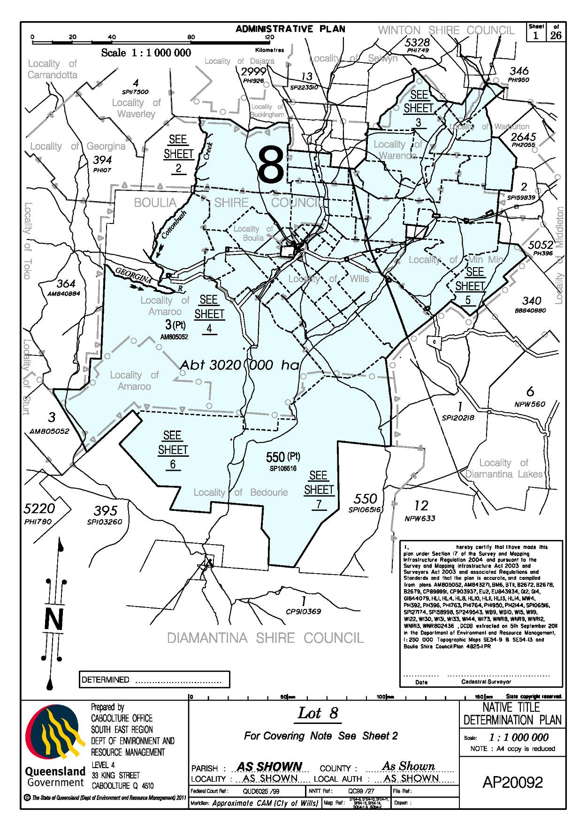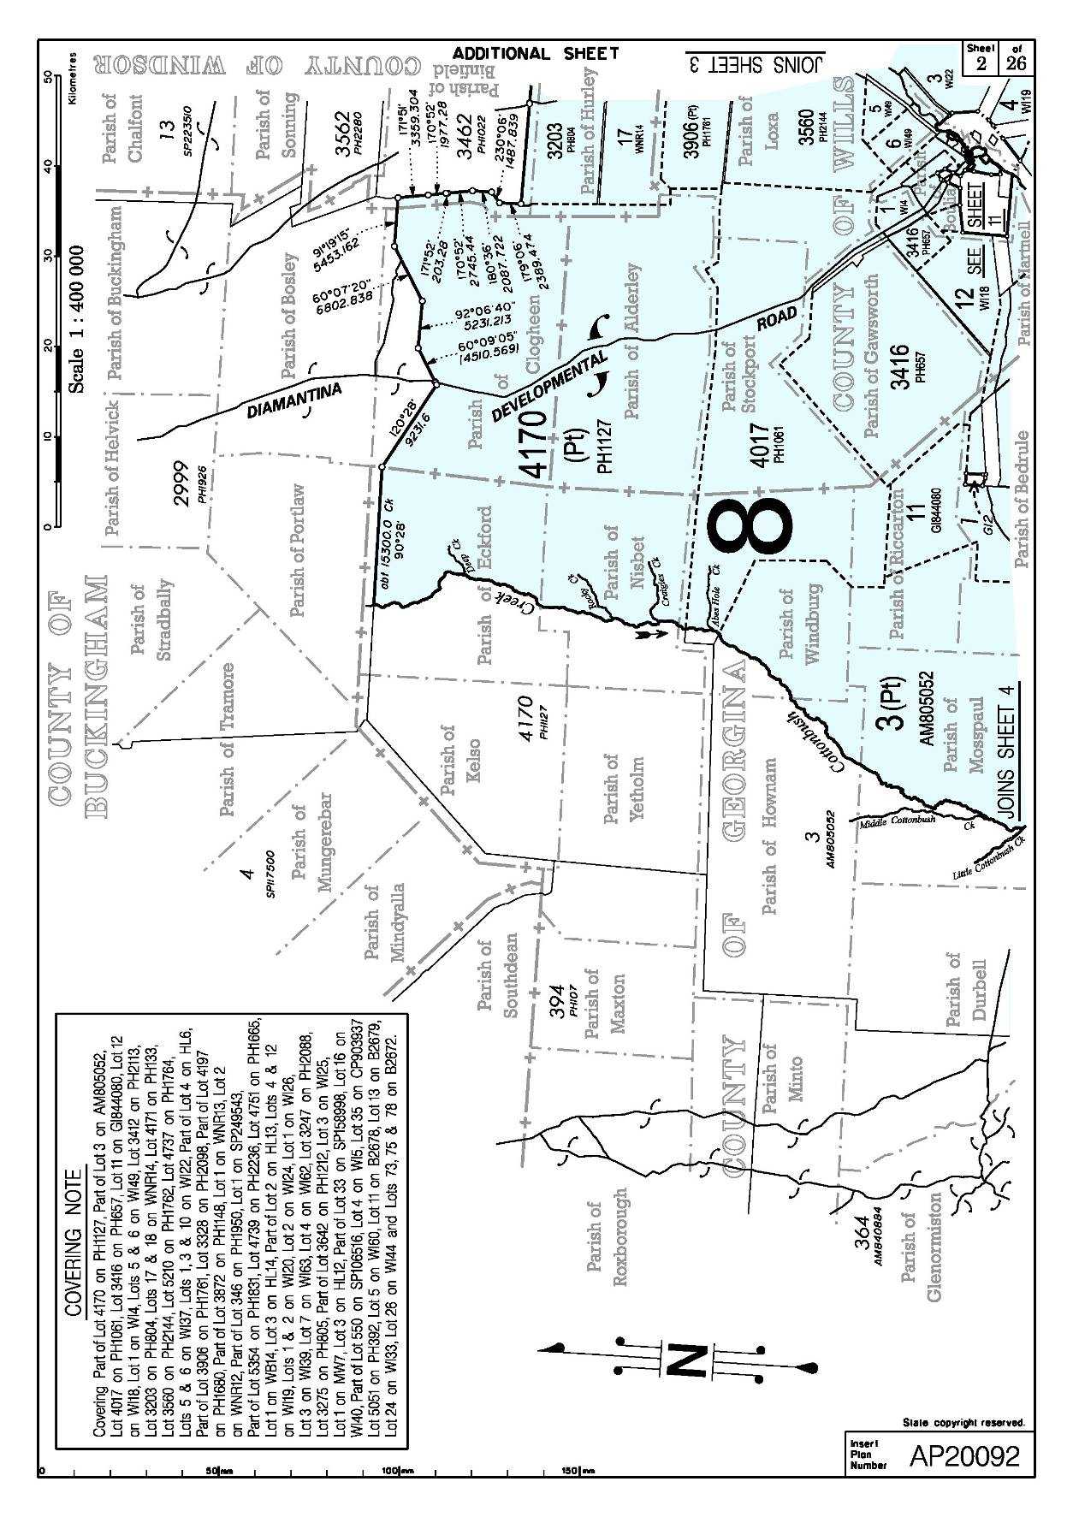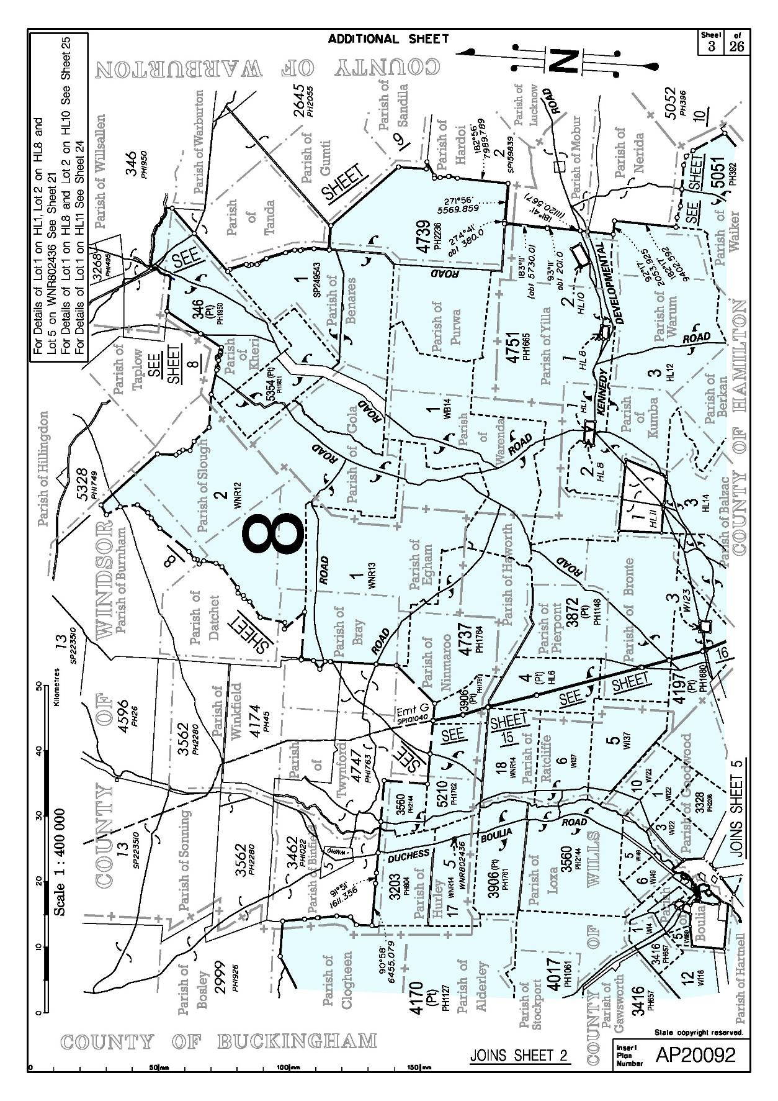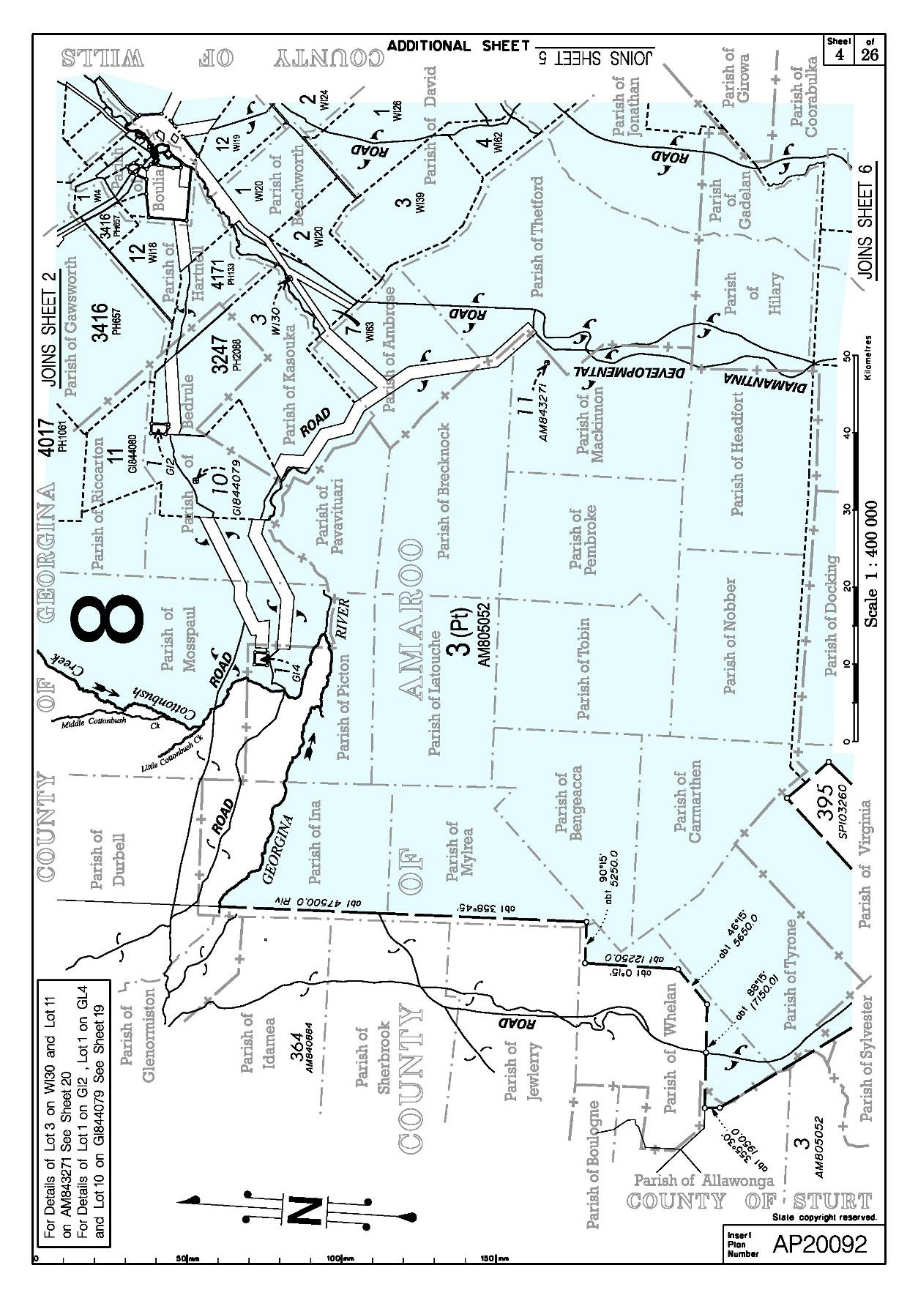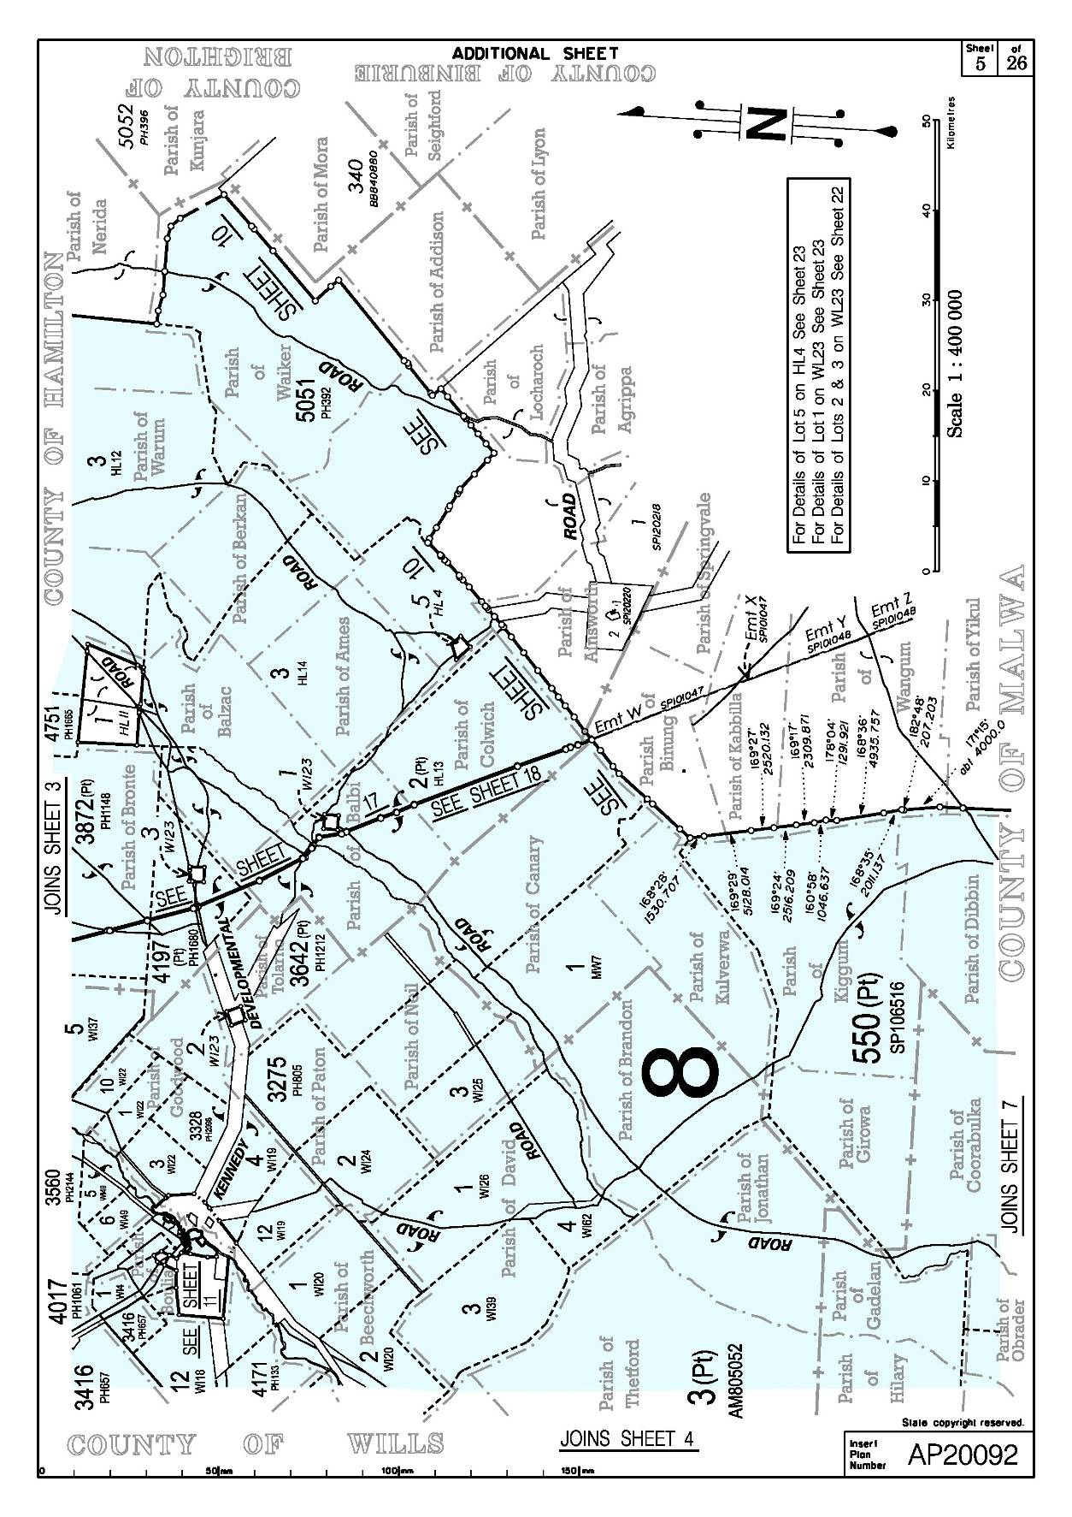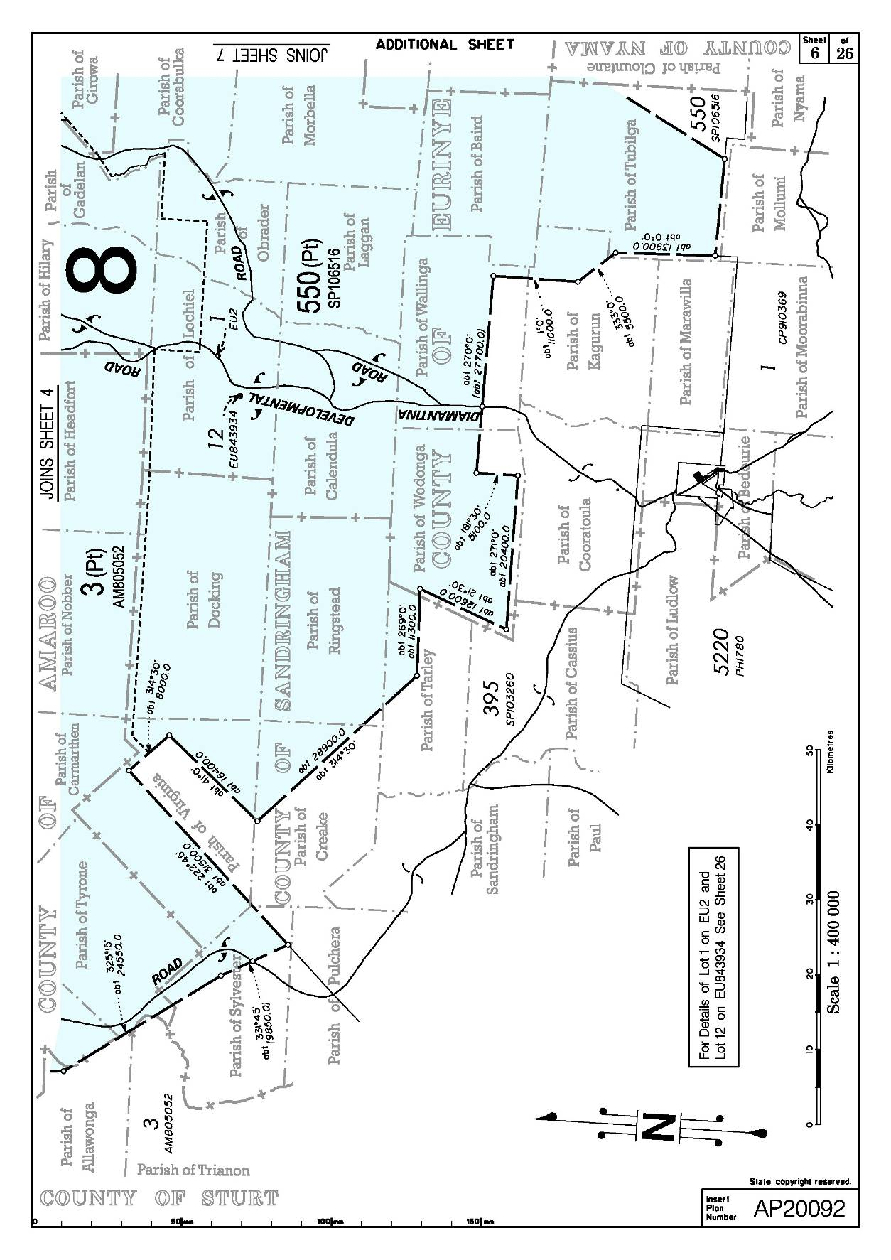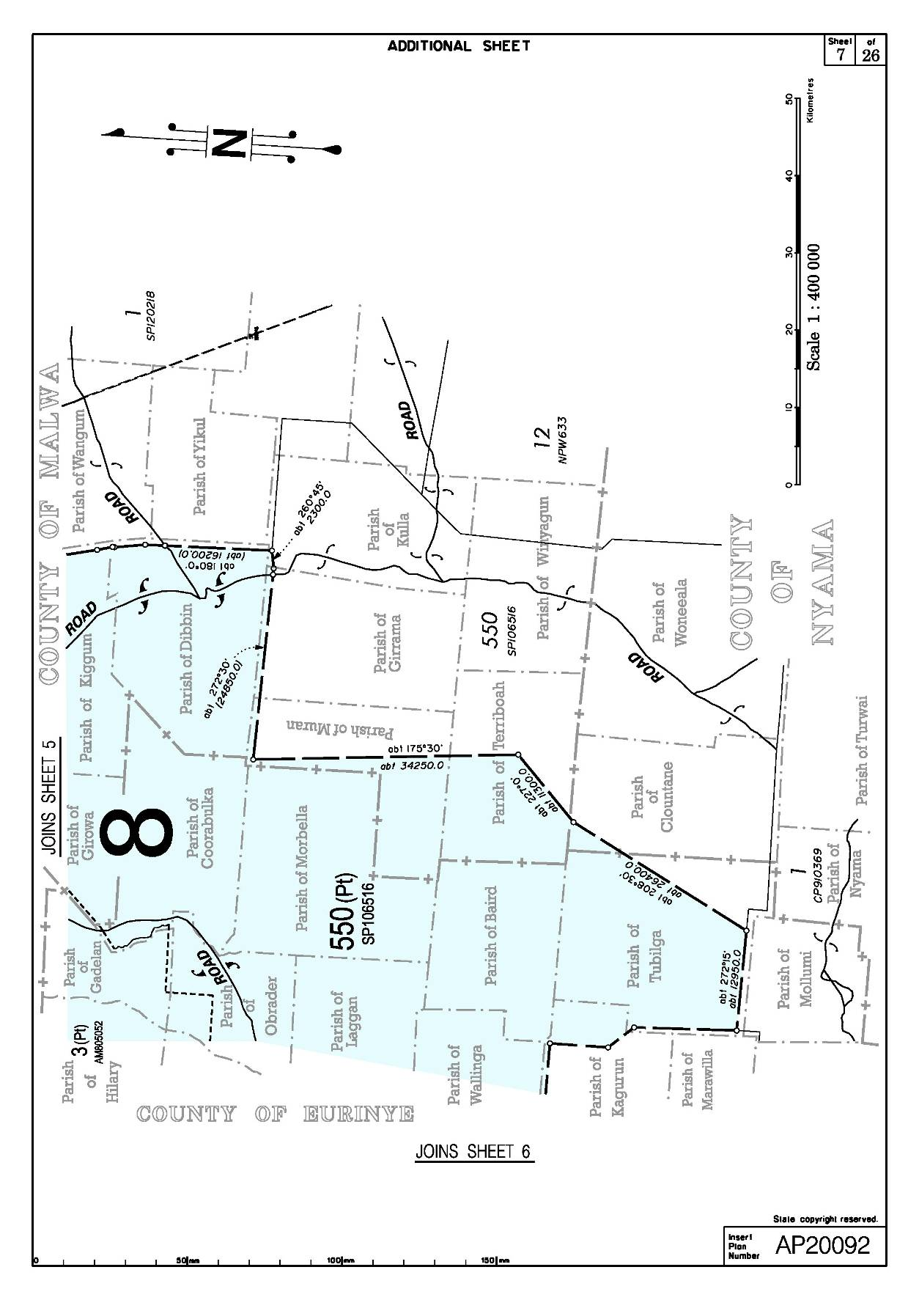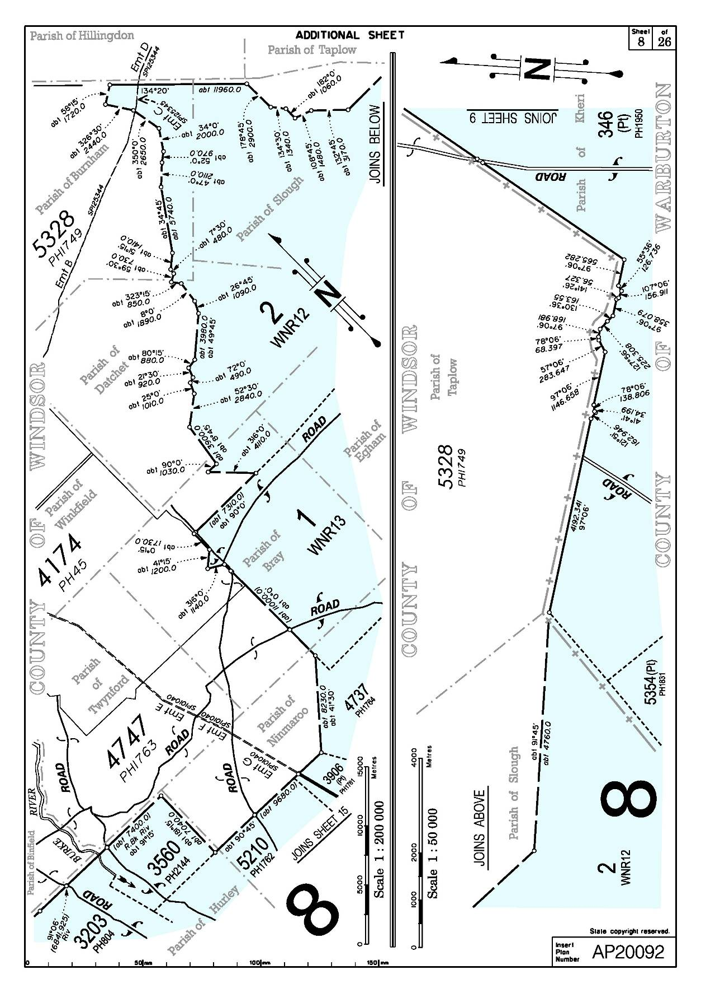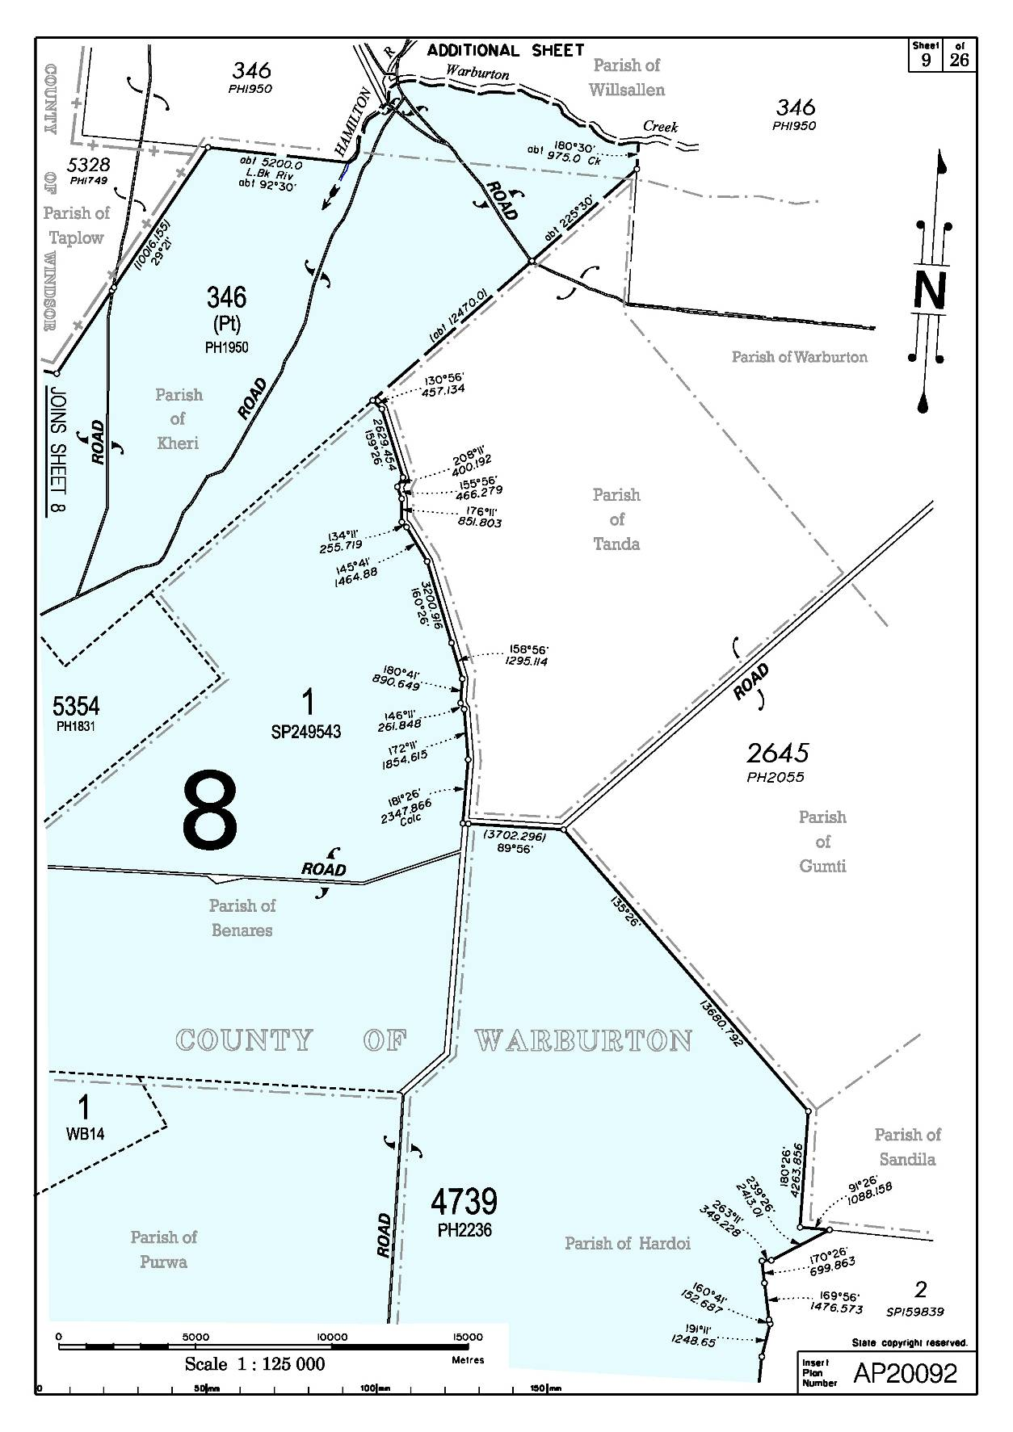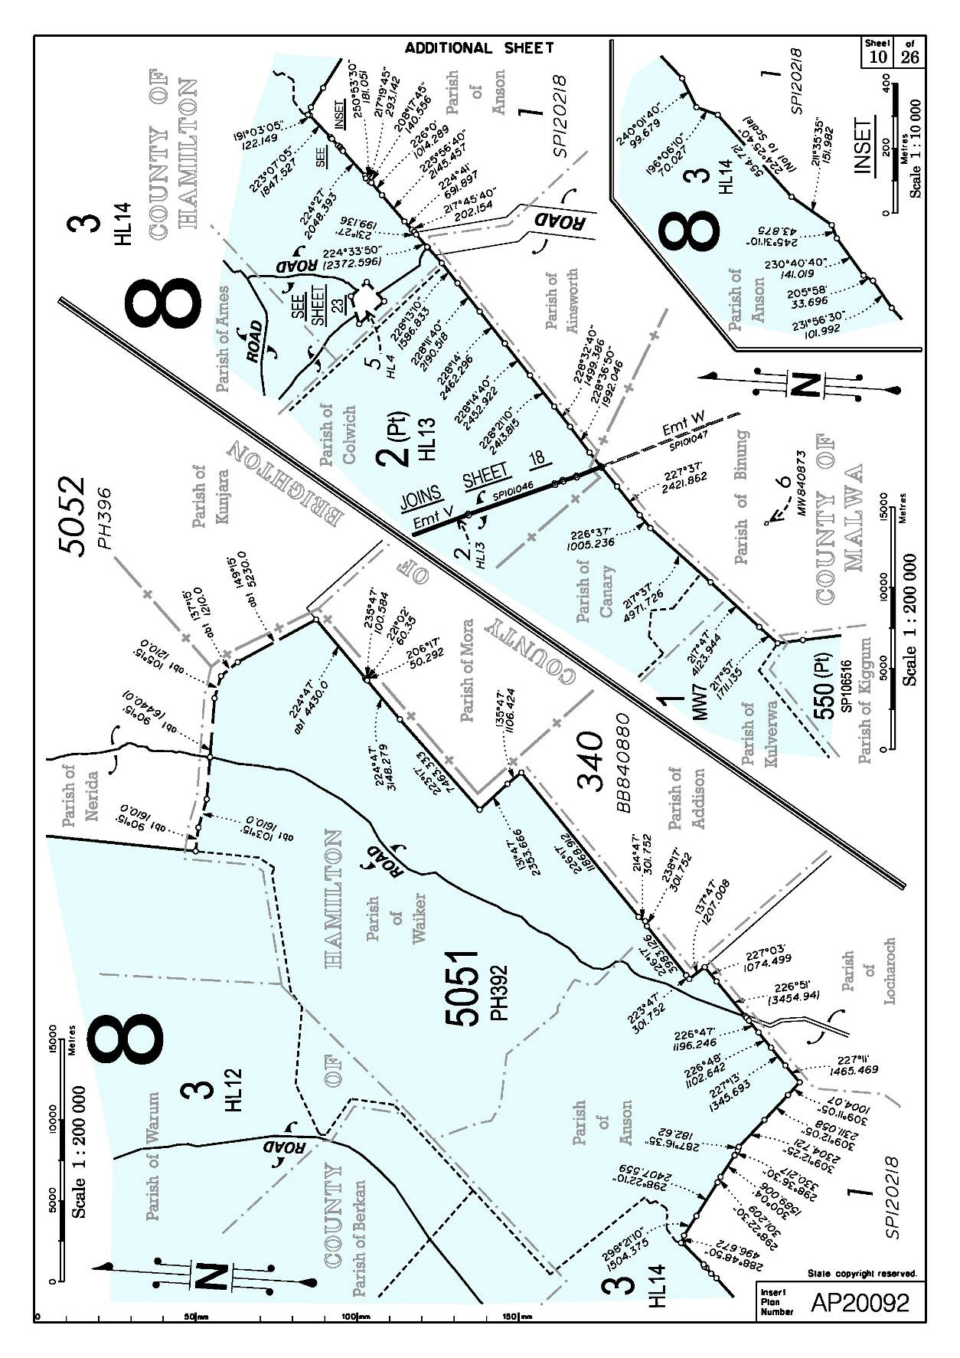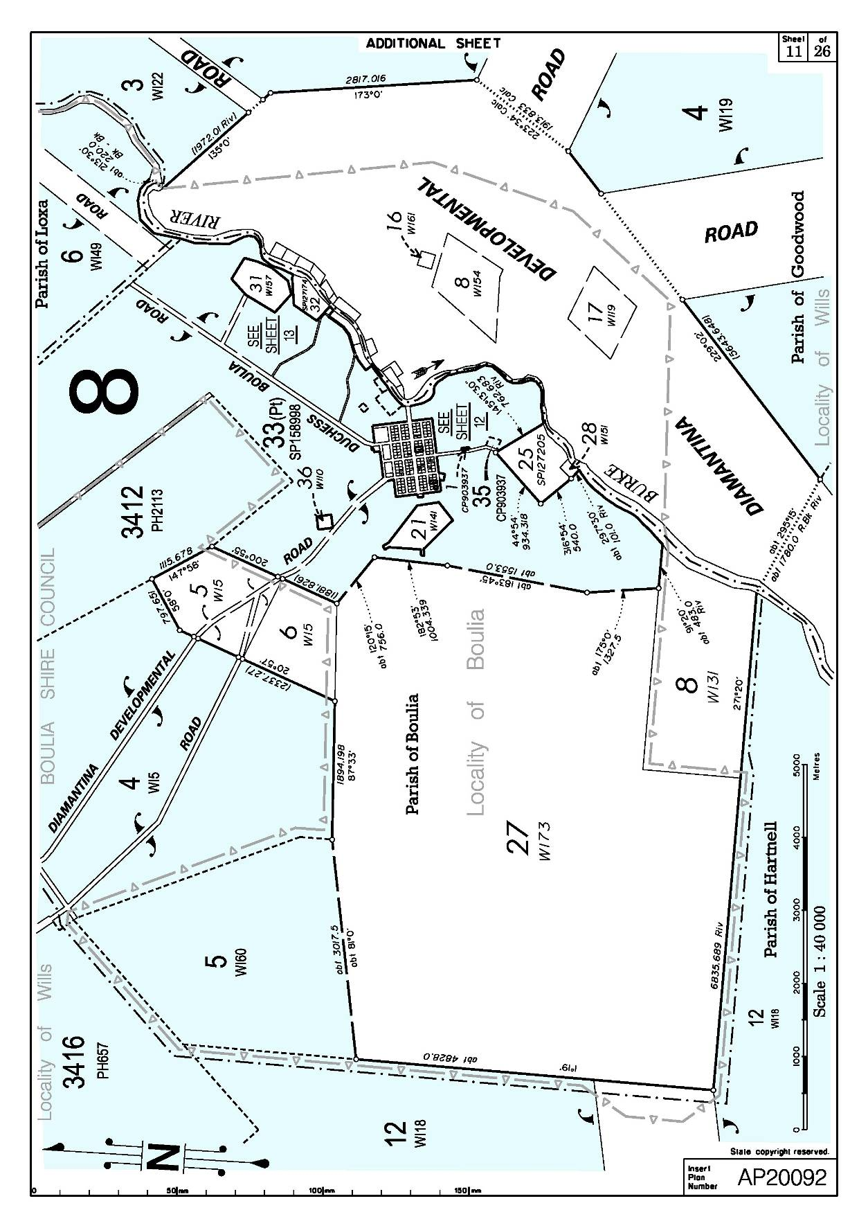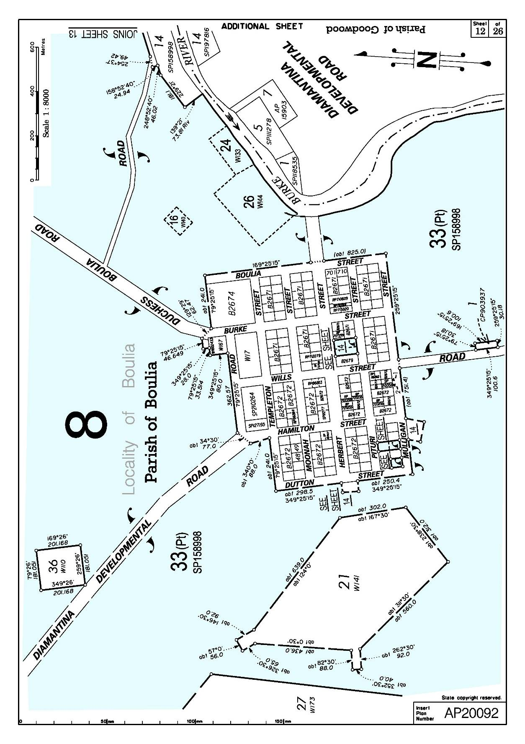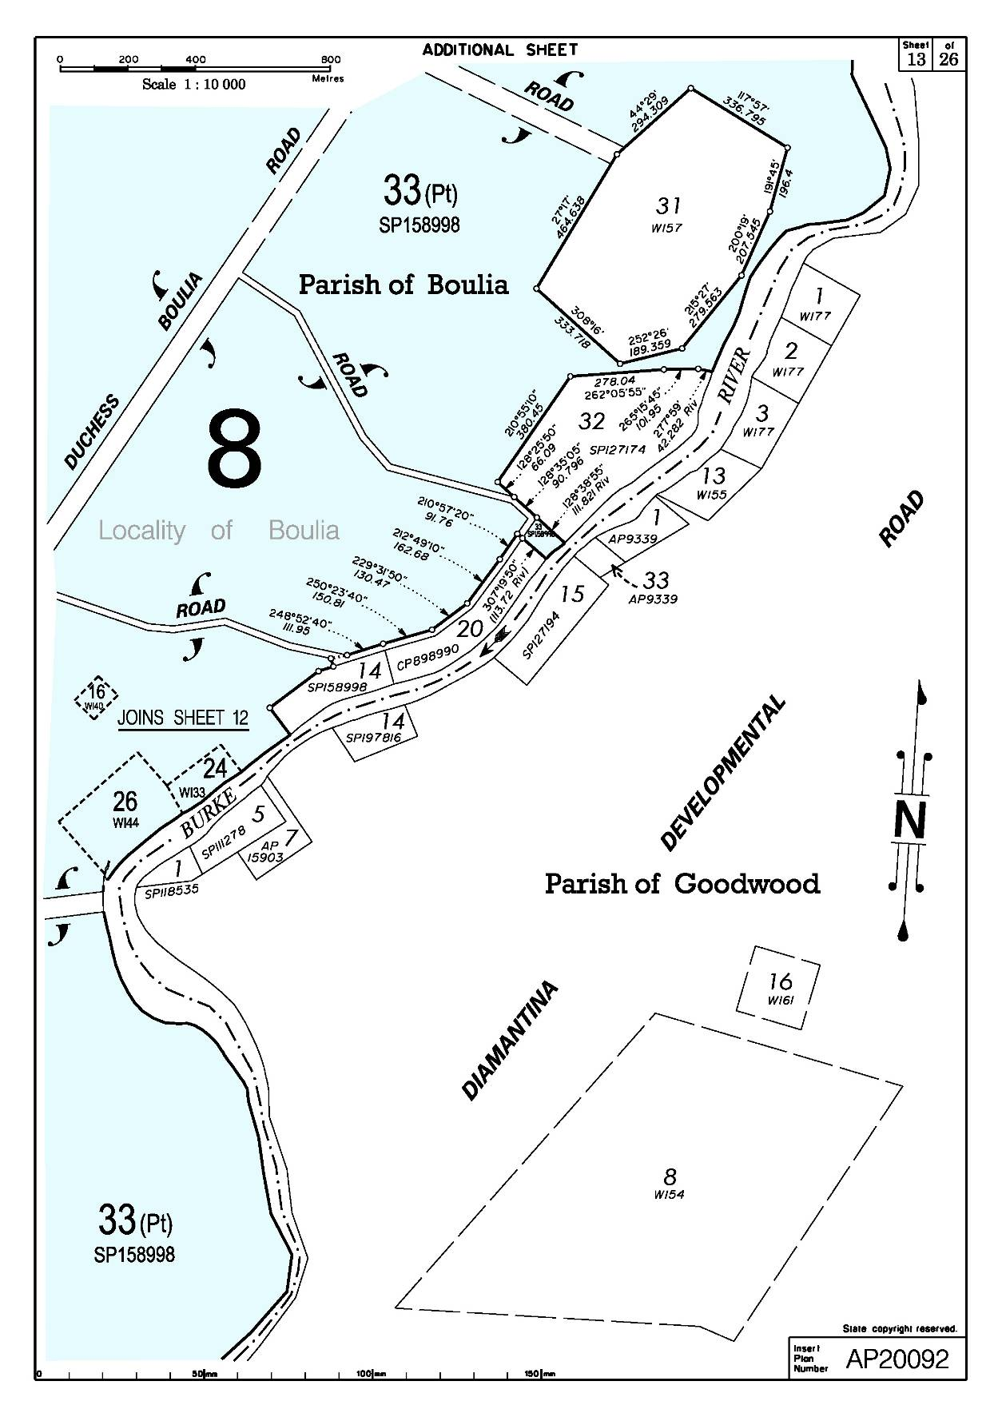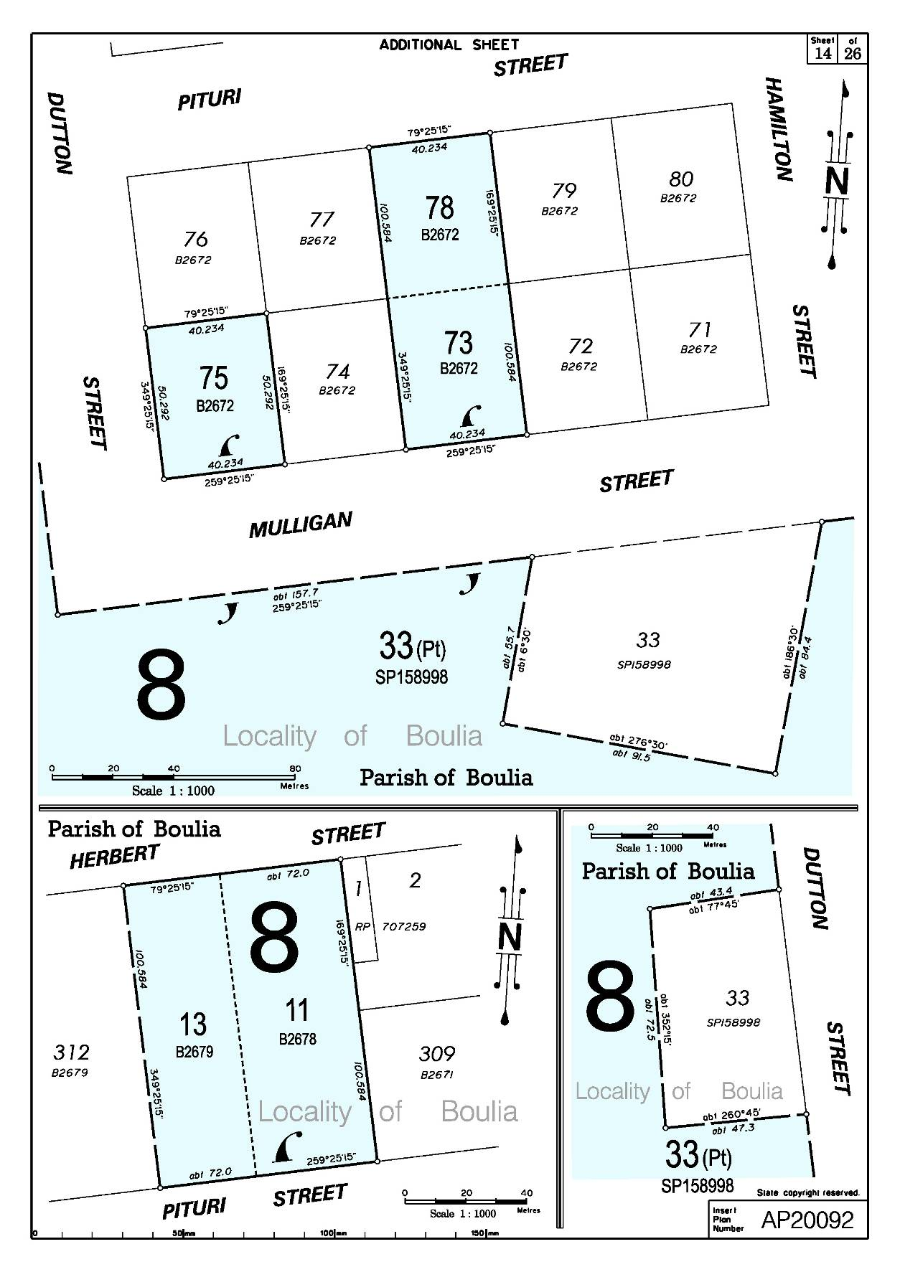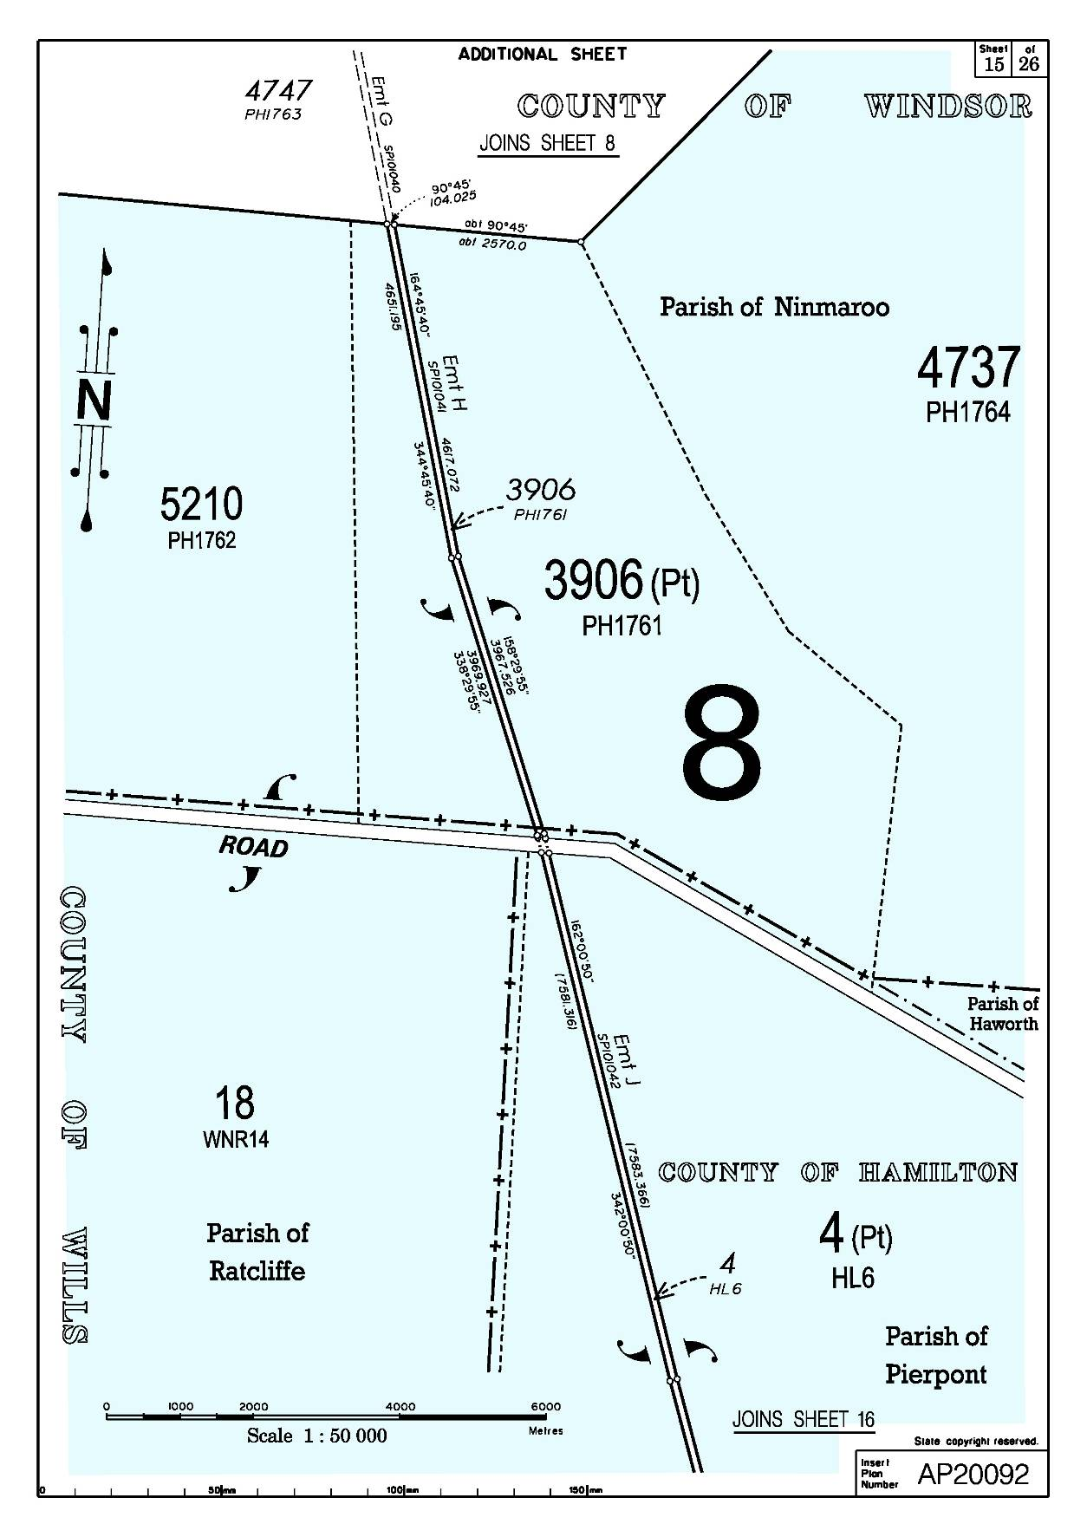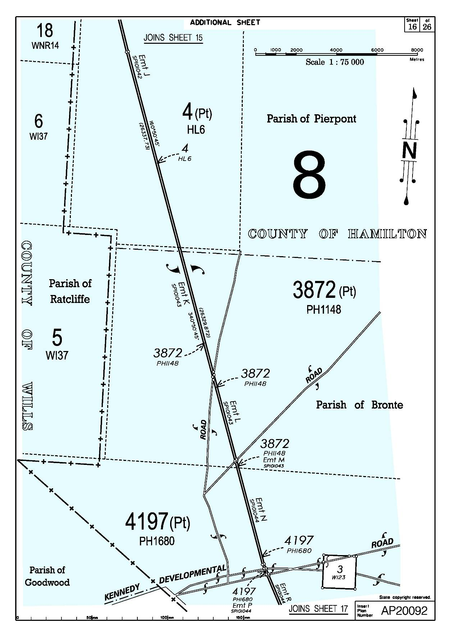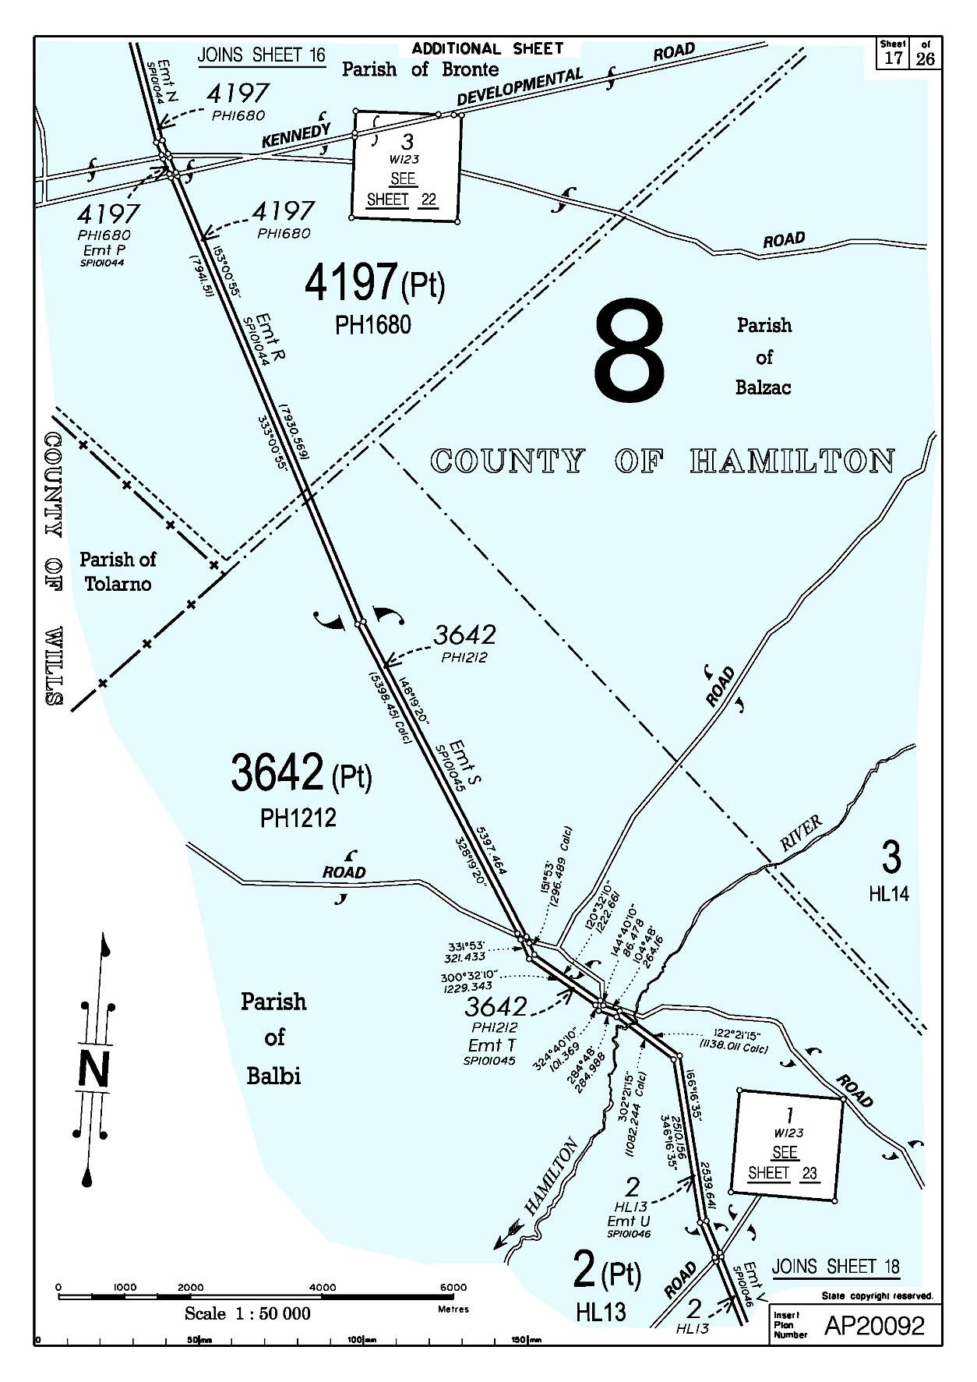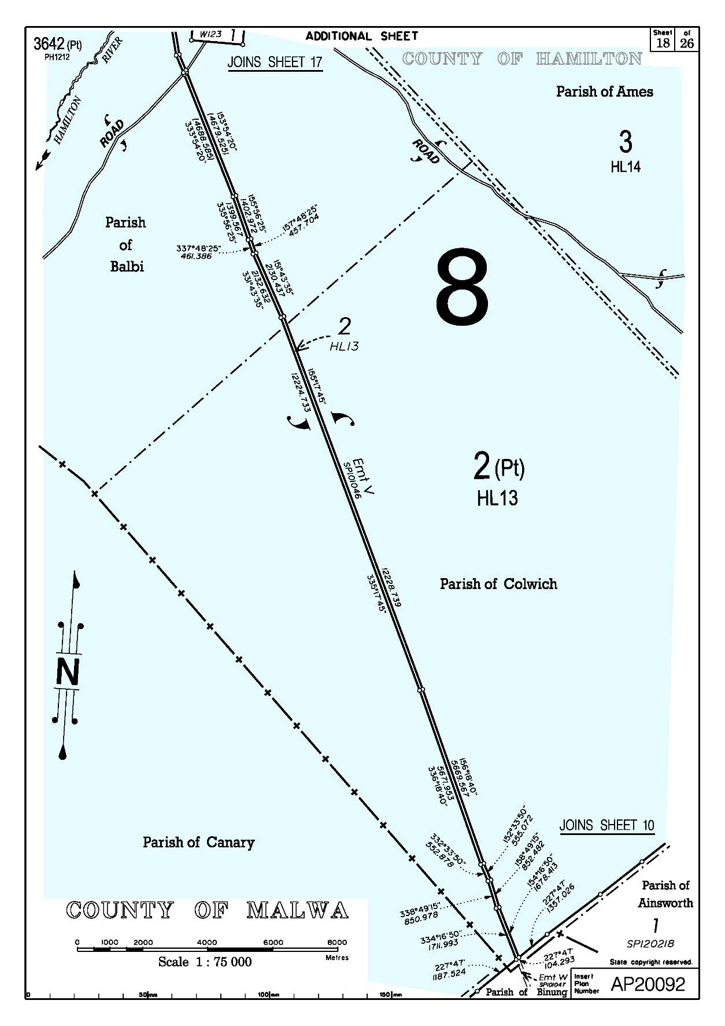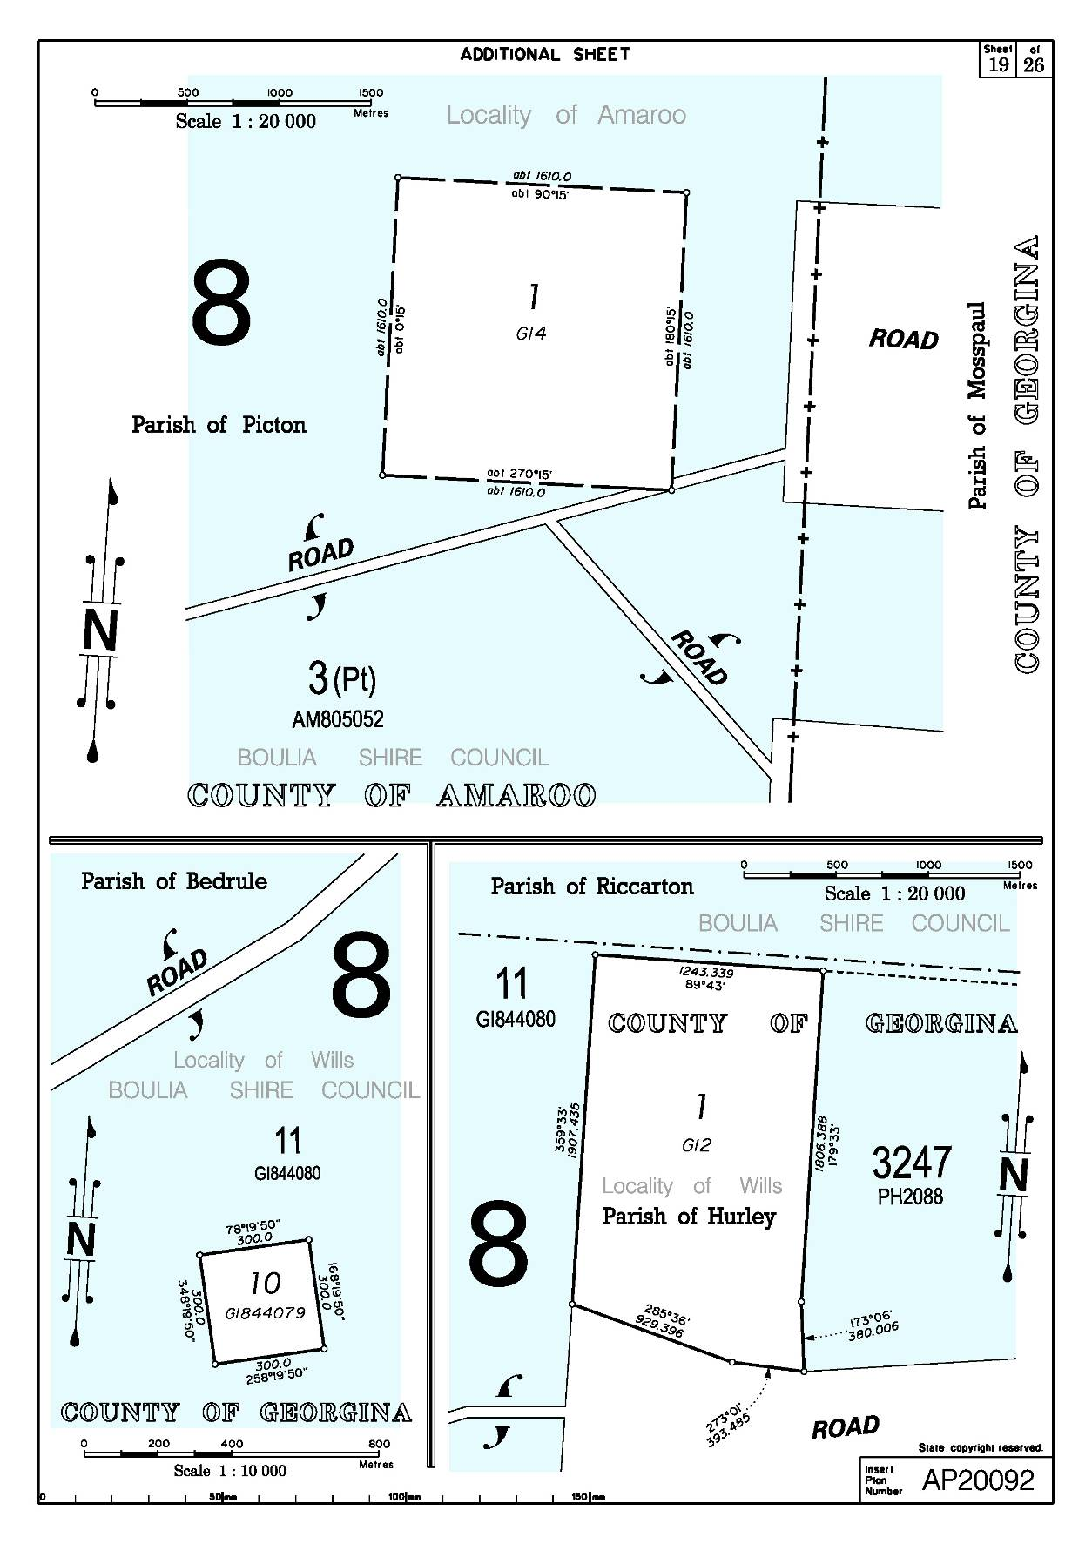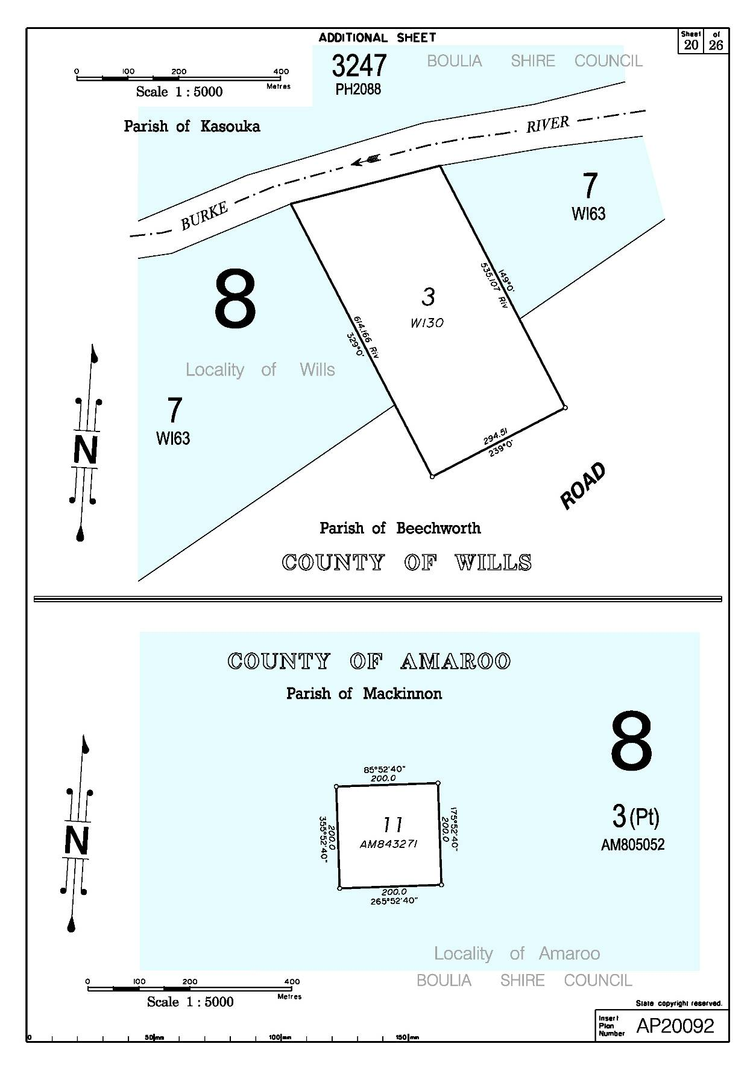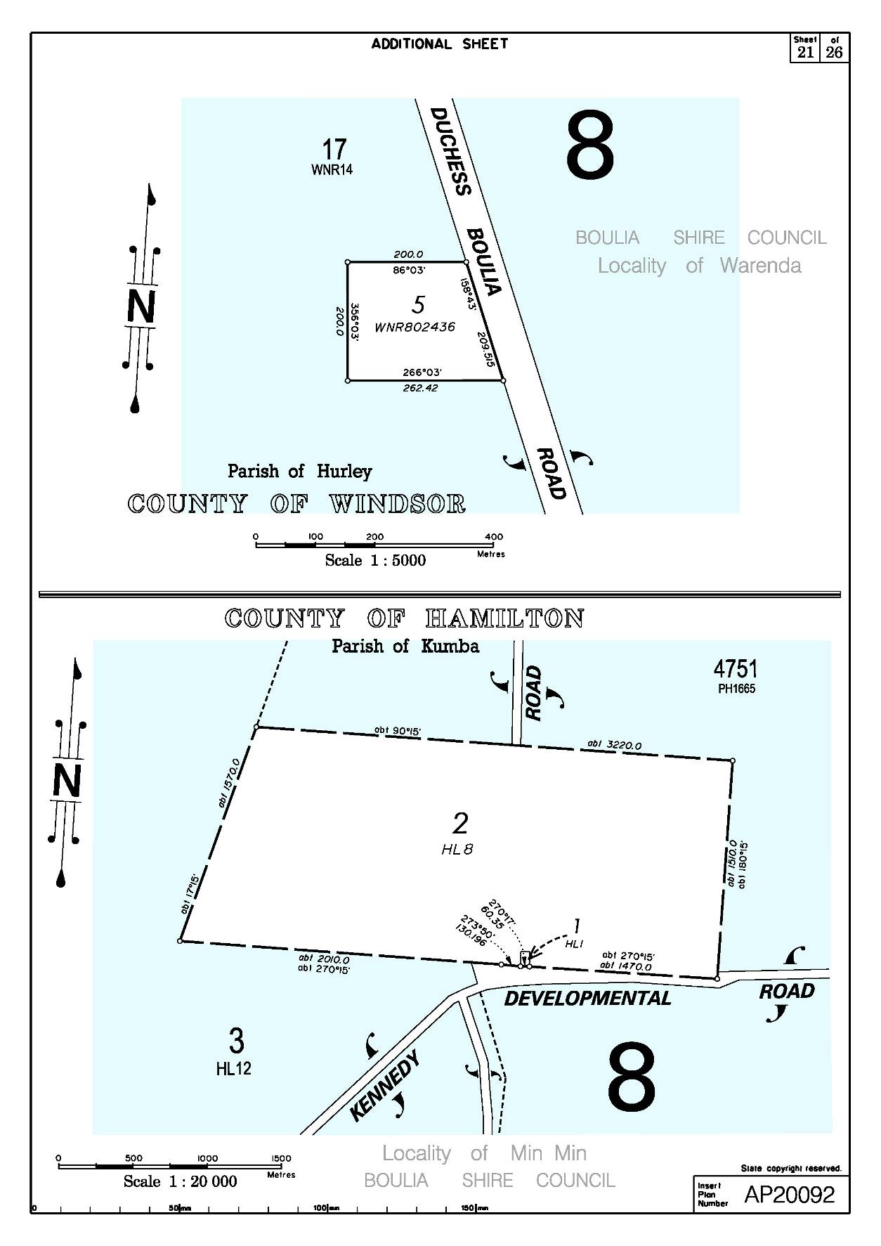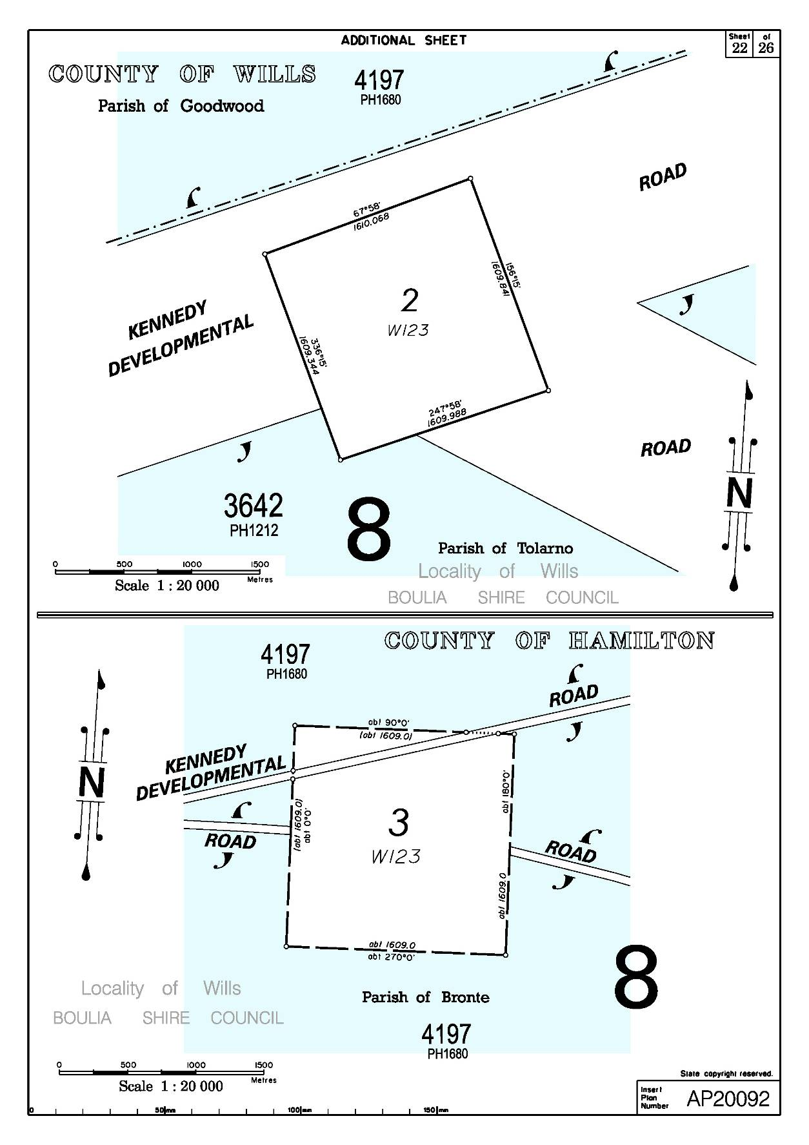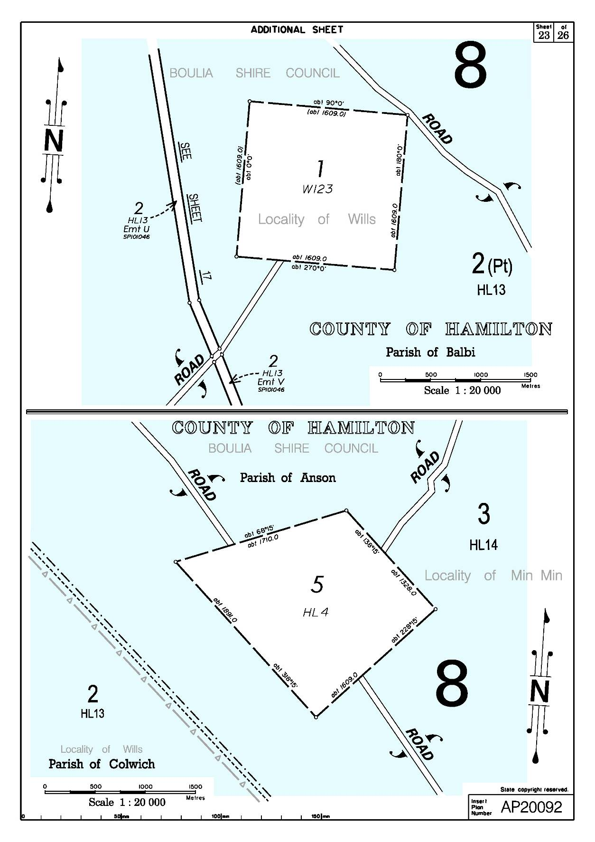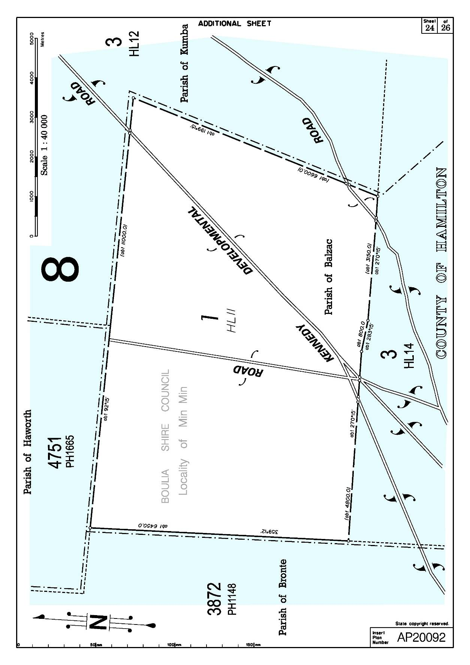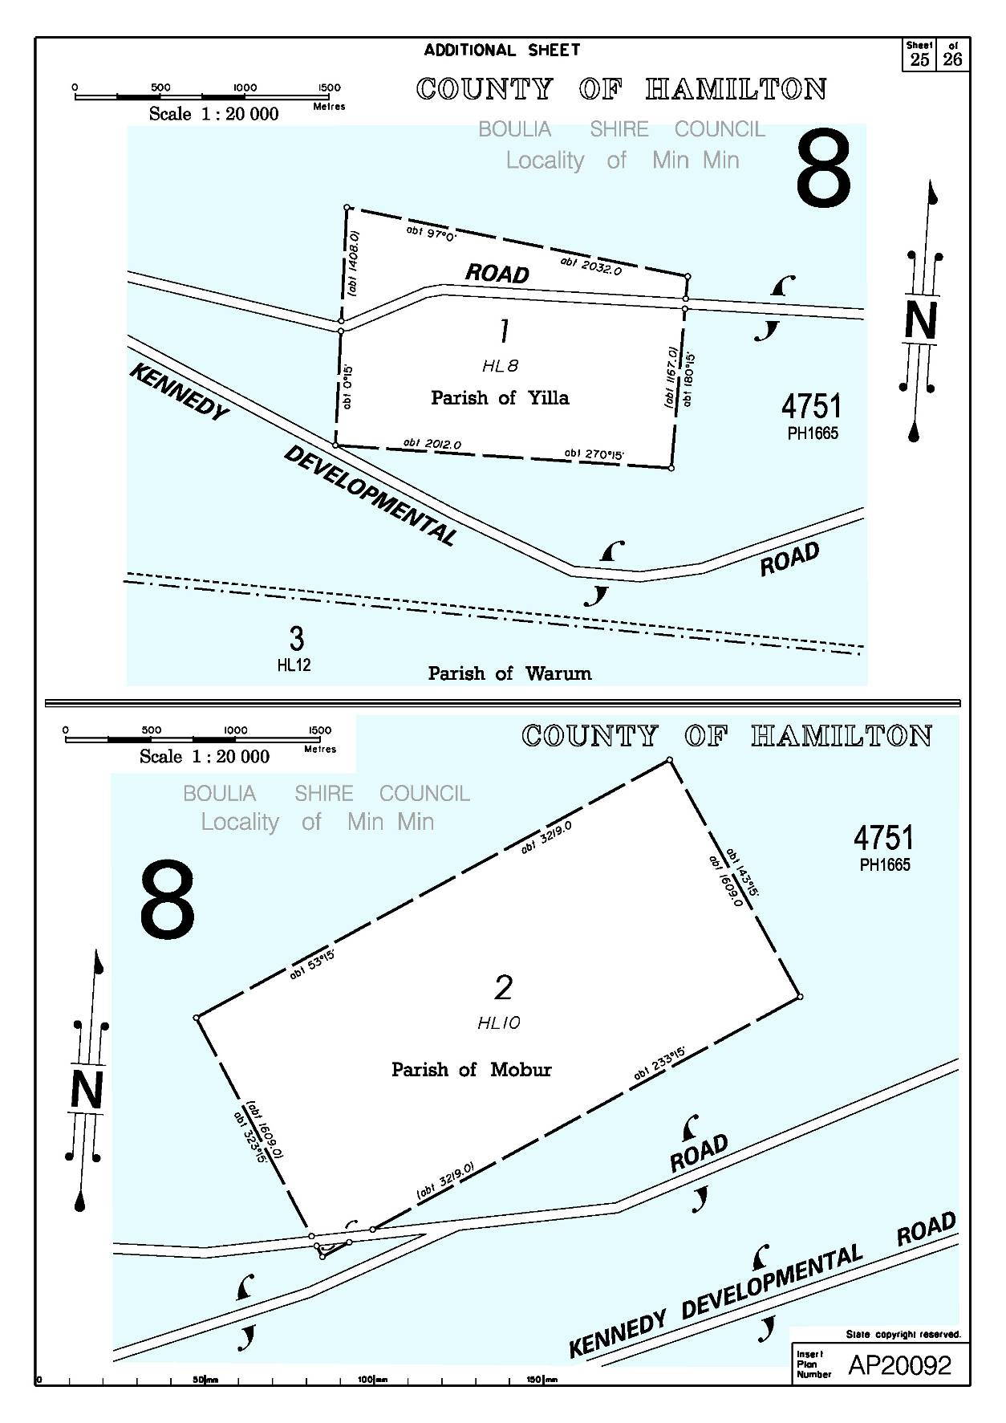

**SCHEDULE 7**

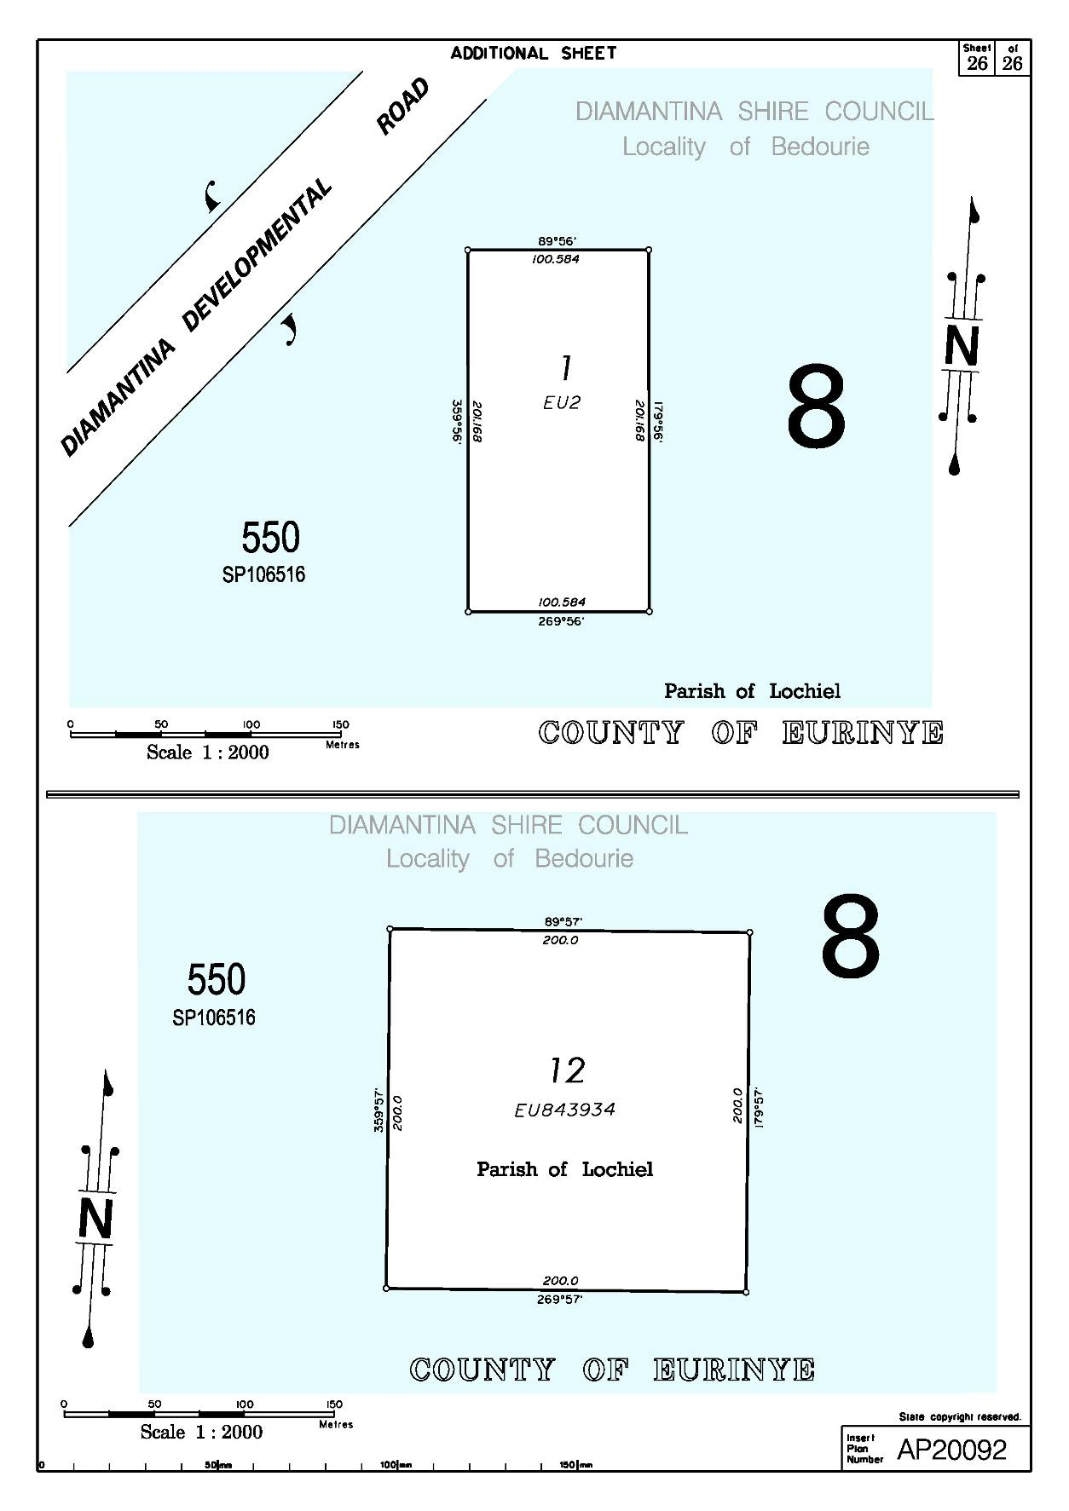

**OTHER INTERESTS IN THAT PART OF THE DETERMINATION AREA IDENTIFIED IN SCHEDULE 3**

The nature and extent of Other Interests in relation to the Determination Area are the Other Interests current as at the date of the Determination which comprise the following:

1. The rights and interests of the parties under the following Indigenous Land Use Agreements (ILUAs):

(a) “Pitta Pitta People/Alderley ILUA” between Alfred Nathan, Jean Jacks, Neville Aplin, Carmel Belford, Noel Doyle, Florence Melville and Robert Stirling & Roslyn Ann Blackett authorised on 27 May 2012;

(b) “Pitta Pitta People/Bengeacca and Stockport ILUA” between Alfred Nathan, Jean Jacks, Neville Aplin, Carmel Belford, Noel Doyle, Florence Melville and Reginald Hasted & Vida Felicia Beauchamp authorised on 27 May 2012;

(c) “Pitta Pitta People/Blair Athol (aka Hylass) ILUA” between Alfred Nathan, Jean Jacks, Neville Aplin, Carmel Belford, Noel Doyle, Florence Melville and William Patrick & Kalinda Louise Cluff authorised on 27 May 2012;

(d) “Pitta Pitta People/Braeside ILUA” between Alfred Nathan, Jean Jacks, Neville Aplin, Carmel Belford, Noel Doyle, Florence Melville and Australian Agricultural Company Limited authorised on 27 May 2012;

(e) “Pitta Pitta People/Canary ILUA” between Alfred Nathan, Jean Jacks, Neville Aplin, Carmel Belford, Noel Doyle, Florence Melville and Gordon Leonard Robinson authorised on 27 May 2012;

(f) “Pitta Pitta People/Cazna Downs, Elrose, Granton and Warenda ILUA” between Alfred Nathan, Jean Jacks, Neville Aplin, Carmel Belford, Noel Doyle, Florence Melville and Adrian Joseph & Vicki Ann Wells authorised on 27 May 2012;

(g) “Pitta Pitta People/Coorabulka and Marion Downs ILUA” between Alfred Nathan, Jean Jacks, Neville Aplin, Carmel Belford, Noel Doyle, Florence Melville and North Australian Pastoral Company Pty Ltd authorised on 27 May 2012;

(h) “Pitta Pitta People/Datchet South and Strathelbiss ILUA” between Alfred Nathan, Jean Jacks, Neville Aplin, Carmel Belford, Noel Doyle, Florence Melville and Jersey Plains Pastoral Company Pty Ltd authorised on 27 May 2012;

(i) “Pitta Pitta People/Hartnell Downs ILUA” between Alfred Nathan, Jean Jacks, Neville Aplin, Carmel Belford, Noel Doyle, Florence Melville and M & M Campbell Pty Ltd authorised on 27 May 2012;

(j) “Pitta Pitta People/Kheri ILUA” between Alfred Nathan, Jean Jacks, Neville Aplin, Carmel Belford, Noel Doyle, Florence Melville and William Henry Cameron authorised on 27 May 2012;

(k) “Pitta Pitta People/Lorna Downs (aka Milkamungra) ILUA” between Alfred Nathan, Jean Jacks, Neville Aplin, Carmel Belford, Noel Doyle, Florence Melville and John Maximillian Fegan authorised on 27 May 2012;

(l) “Pitta Pitta People/Momedah ILUA” between Alfred Nathan, Jean Jacks, Neville Aplin, Carmel Belford, Noel Doyle, Florence Melville and Ian Charles & Marianna Campbell authorised on 27 May 2012;

(m) “Pitta Pitta People/Pollygammon and Tour-ur-rong ILUA” between Alfred Nathan, Jean Jacks, Neville Aplin, Carmel Belford, Noel Doyle, Florence Melville and Scholefields Boulia Pty Ltd authorised on 27 May 2012;

(n) “Pitta Pitta People/Toolebuc and Wilgunya ILUA” between Alfred Nathan, Jean Jacks, Neville Aplin, Carmel Belford, Noel Doyle, Florence Melville and Andrew William Jesse Daniels, Samuel Donald James Daniels and Gabrielle Kennedy authorised on 27 May 2012;

(o) “Pitta Pitta People/Warra ILUA” between Alfred Nathan, Jean Jacks, Neville Aplin, Carmel Belford, Noel Doyle, Florence Melville and Gladys May & Rodney Harold & Charles Samuel Werner Elliot authorised on 27 May 2012;

(p) “Pitta Pitta People/Waterford ILUA” between Alfred Nathan, Jean Jacks, Neville Aplin, Carmel Belford, Noel Doyle, Florence Melville and Dale Reginald Nielson authorised on 27 May 2012;

(q) “Pitta Pitta People/Westward Ho ILUA” between Alfred Nathan, Jean Jacks, Neville Aplin, Carmel Belford, Noel Doyle, Florence Melville and Gregory Phillip Prince authorised on 27 May 2012;

(r) Indigenous Land Use Agreement between Alfred Nathan, Jean Jacks, Neville Aplin, Carmel Belford, Noel Doyle, Florence Melville and Ergon Energy Corporation Limited executed on/registered on 8 August 2012;

(s) “Pitta Pitta People Exploration Permit Backlog Project Indigenous Land Use Agreement (Area Agreement)” registered on the Register of Indigenous Land Use Agreements on 6 November 2003;

(t) “Boulia Tenure Resolution Indigenous Land Use Agreement (Area Agreement)” between Alfred Nathan, Jean Jacks, Neville Aplin, Carmel Belford, Noel Doyle, Florence Melville and the State of Queensland executed on 23 July 2012; and

(u) The Pitta Pitta People and Local Government Indigenous Land Use Agreement between Alfred Nathan, Jean Jacks, Neville Aplin, Carmel Belford, Noel Doyle, Florence Melville and Boulia Shire Council, Cloncurry Shire Council and Diamantina Shire Council executed on 14 June 2012.

2. The rights and interests of the State of Queensland in the following reserves, the rights and interests of the persons in whom they are vested and the rights and interests of the persons entitled to access and use those reserves for the respective purpose for which they are reserved:

(a) Lot 5 on WI60 (Police Paddock Reserve); and

(b) Lot 78 on B2672 (Building Reserve)

3. The rights and interests of the State of Queensland pursuant to the *Nature* *Conservation Act 1992* (Qld) and relevant regulations and conservation plans made under that Act; and the rights and interests of the persons in whom they are vested and interests of the persons entitled to access and use those protected areas for the respective purposes for which they are dedicated.

4. The rights and interests of the State of Queensland and any other person existing under or by reason of the force and operation of:

(a) the *Transport Infrastructure Act 1994* (Qld) and relevant regulations made under that Act;

(b) the *Integrated Planning Act 1997* (Qld) or the *Sustainable Planning Act 2009* (Qld);

(c) the *Fire and Rescue Services Act 1990* (Qld) and the *Ambulance Service Act 1991* (Qld); and

(d) any subordinate legislation or regulations made under those Acts.

5. The rights and interests of the holders of any leases, licences, permits or authorities issued or made under the *Forestry Act 1959* (Qld).

6. The rights and interests of the holders of any authority, licences or permits under the *Water Act 2000* (Qld) and any relevant regulations, plans or subordinate legislation made under that Act.

7. The rights and interests granted under the *Land Act 1994* (Qld), and any relevant regulations or subordinate legislation made under that Act, including, the rights and interests of the holders of any leases, licences, reservations, permits, easements or authorities.

8. The rights and interests of holders of any interests granted under the *Mineral Resources Act 1989* (Qld) and under the *Petroleum Act 1923* (Qld) and the *Petroleum and Gas (Production and Safety) Act 2004* (Qld) and any subordinate legislation or any other resources legislation or declarations.

9. The rights and interests of the Pitta Pitta Land Trust as the grantee and as an entity exercising statutory powers under the Deed of Grant of Land dated 23 October 2003 on behalf of Aboriginal people and their ancestors and descendants, being Title Reference No. 40039541 comprising Lot 35 on CP903937 and pursuant to the *Aboriginal Land Act 1991* (Qld) and the *Aboriginal and Torres Strait Islander Communities (Justice, Land and other Matters) Act 1984* (Qld).

10. The rights and interests of Ergon Energy Corporation Limited:

(a) as the owner and operator of any “Works” as that term is defined in the *Electricity Act 1994* (Qld);

(b) as a distribution entity and the holder of a distribution authority under the *Electricity Act 1994* (Qld);

(c) created under the *Electricity Act 1994* (Qld) and the *Government Owned Corporations Act 1993* (Qld); including:

(i) rights in relation to any agreement relating to the Determination Area;

(ii) rights to enter the Determination Area by its employees, agents or contractors to exercise any of the rights and interests referred to in this paragraph; and

(iii) to inspect, maintain and manage any Works in the Determination Area.

11. The rights and interests of the State of Queensland, of Boulia Shire Council, Cloncurry Shire Council, Diamantina Shire Council and Winton Shire Council to access, use, operate, maintain and control the dedicated roads in the Determination Area and the rights and interests of the public to use and access roads.

12. The rights and interests of each of Boulia Shire Council and Diamantina Shire Council:

(a) under its local government jurisdiction and functions under the *Local Government Act 2009* (Qld), under the *Land Protection (Pests and Stock Route Management) Act 2002* (Qld) and under any other legislation, for that part of the Determination Area within the area declared to be Council’s local government area;

(b) as the:

(i) lessor under any leases which were entered into before the date on which these Orders are made and whether separately particularised in these Orders or not,

(ii) grantor of any licences or other rights and interests which were granted before the date on which these Orders were made and whether separately particularised in these Orders or not,

(iii) holder of any estate or interest in land, and as trustee of any reserves, that exist on or before the date on which these Orders are made;

(c) as the owner and operator of infrastructure, facilities and other improvements located in the Determination Area on or before the date on which these Orders are made, including but not limited to:

(i) dedicated roads operated by Council;

(ii) gravel pits operated by Council;

(iii) undedicated but constructed roads except for those not operated by Council;

(iv) water pipelines and other water supply infrastructure;

(v) drainage facilities;

(vi) cemetery and cemetery related facilities;

(d) to enter the land described in paragraphs 12(b), 12(c) and 12(d) above by its employees, agents or contractors to:-

(i) exercise any of the rights and interests referred to in paragraph 11 of this Schedule;

(ii) inspect, maintain and repair the infrastructure, facilities and other improvements referred to in paragraph 12(d) above; and

(iii) undertake operational activities in its capacity as a local government such as feral animal control, weed control, erosion control, waste management and fire management.

13. The rights and interests of each of Winton Shire Council and Cloncurry Shire Council under its local government jurisdiction and functions under the *Local Government Act 2009* (Qld), under the *Land Protection (Pests and Stock Route Management) Act 2002* (Qld) and under any other legislation, for that part of the Determination Area within the declared Local Government Area.

14. The rights and interests of Telstra Corporation Limited:

(a) as the owner or operator of telecommunications facilities;

(b) created pursuant to the *Post and Telegraph Act 1901* (Cth), the *Telecommunications Act 1975* (Cth), the *Australian Telecommunications Corporation Act 1989* (Cth), the *Telecommunications Act 1991* (Cth) and the *Telecommunications Act 1997* (Cth) including rights:

(i) to inspect land;

(ii) to install and operate telecommunication facilities;

(iii) to alter, remove, replace, maintain, repair and ensure the proper functioning of its existing and any new telecommunication facilities; and

(iv) to occupy its Hamilton Radio Telecommunications site being a 4 hectare square the centre point of which is at Latitude -22.774179 and Longitude 140.590168;

(c) for its employees, agents or contractors to access its telecommunications facilities in and in the vicinity of the Determination Area in performance of their duties; and;

(d) under any lease, licence or access agreement relating to its telecommunications facilities.

15. The rights and interests of Roverton Pty Ltd:

(a) as the owner and operator of gaseous petroleum and associated liquid petroleum distribution facilities within the Determination Area;

(b) as the holder of Pipeline Licence No.41 dated 20 March 1997 granted under the *Petroleum Act 1923* (Qld);

(c) the Miscellaneous Transport Infrastructure Corridor easement created pursuant to the *Transport Infrastructure Act 1994* (Qld);

(d) as the holder of a Corridor Licence dated 27 March 1997 between Roverton Pty Ltd and the Chief Executive created under the *Transport Infrastructure Act 1994* (Qld) (“Corridor Licence”) including rights:

(i) to access, inspect and patrol (including aerial patrol) the land;

(ii) to construct and operate gaseous petroleum and associated liquid petroleum distribution facilities both above ground and under ground;

(iii) to maintain, repair, replace, alter, remove and ensure the proper functioning of its existing and any new gaseous petroleum and associated liquid petroleum distribution facilities;

(iv) to install any new gaseous petroleum and associated liquid petroleum distribution facilities within the areas referred to in the Corridor Licence; and

(v) for its employees, agents or contractors to access the Determination Area for the purpose of exercising the rights in (i), (ii), (iii) and (iv) above in respect of gaseous petroleum and associated liquid petroleum distribution facilities in the Determination Area.

16. The rights and interests of APT Pipelines (Qld) Pty Limited:

(a) as the owner and operator of gaseous petroleum and associated liquid petroleum distribution facilities within the Determination Area; and

(b) as the holder of Pipeline Licence No.42 dated 14 May 1998 granted under the *Petroleum Act 1923* (Qld).

17. The rights and interests of the following pastoral lessees:

(i) Adrian Joseph Wells and Vicki Ann Wells under term lease for pastoral purposes dated 21 November 1963 being Title Reference No. 17663241 comprising Lot 1 on WI22, Lot 5 on WI37 and Lot 10 on WI22 and known locally as Kalkadoon Pastoral Lease.

(ii) Leonard, Veronica May and Shayne Percival Brooke McGlinchey under the term lease for pastoral purposes dated 4 August 1983 being Title Reference No. 17663250 comprising Lot 11 on GI844080 known locally as Badalia Pastoral Lease.

(iii) Athol Vincent Prince under the term lease for pastoral purposes dated 9 August 1962 being Title Reference No. 17663246 comprising Lot 12 on WI19, Lot 1 & 2 on WI20 and Lot 3 on WI39 known locally as Montagu Downs Pastoral Lease.

(iv) William Patrick and Kalinda Louise Cluff under the term lease for pastoral purposes dated 13 August 1962 being Title Reference No. 17663235 comprising Lot 17 & 18 on WNR14 known locally as Hylass Pastoral Lease.

(v) John Maxmillian Fegan under the term lease for pastoral purposes dated 21 March 1985 being Title Reference No. 17664018 comprising Lot 1 on MW7 known locally as Milkamungra Pastoral Lease.

(vi) Adrian Joseph Wells and Vicki Ann Wells under the term lease for pastoral purposes dated 3 April 1986 being Title Reference No. 17669130 comprising Lot 1 on WB14 known locally as Warenda Pastoral Lease.

1. Montague Nominees Pty Ltd ACN 063 350 505 as trustee for Rural Investment trust under the term lease for pastoral purposes dated 23 August 1962 being Title Reference No. 17663246 comprising Lot 2 on WI24, Lot 3 on WI25 and Lot 1 on WI26 known locally as Mudgeacca Pastoral Lease.

(viii) M and M Campbell Pty Ltd under the term lease for pastoral purposes dated 13 June 1963 being Title Reference No. 17663239 comprising Lot 1 on WI4, Lot 4 on WI5, Lot 5 on WI5 and Lot 6 on WI5 known locally as Hartnell Downs Pastoral Lease.

(ix) Ian Charles Campbell and Marianna Campbell under the term lease for pastoral purposes dated 1 July 1984 being Title Reference No. 17664019 comprising Lot 1 on WNR13 known locally as Momedah Pastoral Lease.

(x) Leonard Gordon Robinson under the term lease for pastoral purposes dated 3 July 1986 being Title Reference No. 17664020 comprising Lot 2 on HL13 known locally as Canary Pastoral Lease.

(xi) John Harvey, Partricia Marshall and Graham Harvey Treloar under the term lease for pastoral purposes dated 21 March 1985 being Title Reference No. 17664017 comprising Lot 2 on WNR12 known locally as Pathungra Pastoral Lease.

(xii) Dale Reginald Nielson under the term lease for pastoral purposes dated 18 May 1972 being Title Reference No. 17663229 comprising Lot 3203 on PH804 known locally as Waterford Pastoral Lease.

(xiii) Sanela Pty Ltd ACN 010 075 877 under the term lease for pastoral purposes dated 9 April 1959 being Title Reference No. 17663230 comprising Lot 3247 on PH2088 known locally as Wirrilyerna Pastoral Lease.

(xiv) Scholefields Boulia Pty Ltd under the term lease for pastoral purposes dated 18 May 1972 being Title Reference No. 17663231 comprising Lot 3275 on PH805 known locally as Tour-ur-ong Pastoral Lease.

(xv) Louis Charles and Lynnette Eileen Britton as trustee for the Britton Family Superannuation Fund under the term lease for pastoral purposes dated 23 August 1962 being Title Reference No. 17663232 comprising Lot 3328 on PH2098 known locally as Neena Pastoral Lease.

(xvi) Bric Charles Britton and Ann Mary Britton under the term lease for pastoral purposes dated 19 April 1962 being Title Reference No. 17663233 comprising Lot 3412 on PH2113 known locally as Kewpie Pastoral Lease.

(xvii) Reginald Hasted Beauchamp and Vida Felicia Beauchamp under the term lease for pastoral purposes dated 26 June 1969 being Title Reference No. 17663234 comprising Lot 3416 on PH657 known locally as Bengeacca Pastoral Lease.

(xviii) Jersey Plains Pastoral Company Pty Ltd the lessees under the term lease for pastoral purposes dated 23 August 1962 being Title Reference No. 17663238 comprising Lot 3560 on PH2144 known locally as Strathelbiss Pastoral Lease.

(xix) Phillip Gregory Prince under the term lease for pastoral purposes dated 19 October 1961 being Title Reference No. 17663240 comprising Lot 3642 on PH1212 known locally as Westward Ho Pastoral Lease.

(xx) Andrew William Jesse Daniels, Samuel Donald James Daniels, Gabrielle Kennedy, Jeffrey Robert James Daniels and Luke William Jesse Daniels the lessees under the term lease for pastoral purposes dated 12 February 1959 being Title Reference No. 17669171 comprising Lot 1 on SP249543 known locally as Wilgunya Pastoral Lease.

(xxi) Adrian Joseph and Vicki Ann Wells under the term lease for pastoral purposes dated 13 August 1962 being Title Reference No. 17663242 comprising Lot 3872 on PH1148 known locally as Granton Pastoral Lease.

(xxii) Eric Charles Britton under the term lease for pastoral purposes dated 23 January 1964 being Title Reference No. 17663243 comprising Lot 3906 on PH1761 known locally as Scarsdale Pastoral Lease.

(xxiii) Tewinga Pastoral Holdings Pty Ltd ACN 095 066 863 as trustee under the term lease for pastoral purposes dated 3 October 1985 being Title Reference No. 17664005 comprising Lot 3 on HL12 known locally as Slashes Creek Pastoral Lease.

(xxiv) Gladys May Elliott, Rodney Harold Elliott and Charles Samuel Werner Elliott the lessees under the term lease for pastoral purposes dated 12 March 1987 being Title Reference No. 17664021 comprising Lot 3 on HL14 known locally as Warra Pastoral Lease.

(xxv) Eric Charles and Ann Mary Britton under the term lease for pastoral purposes dated 2 August 1962 being Title Reference No. 17663244 comprising Lot 4 on WI19 and Lot 3 on WI22 known locally as Old Goodwood Pastoral Lease.

(xxvi) Reginald Hasted Beauchamp and Vida Felecia Beauchamp under the term lease for pastoral purposes dated 23 August 1962 being Title Reference No. 17663245 comprising Lot 4017 on PH1061 known locally as Stockport Pastoral Lease.

(xxvii) Victor Russell Jones under the term lease for pastoral purposes dated 1 October 1964 being Title Reference No. 17663248 comprising Lot 4171 on PH133 known locally as Berrimilla Pastoral Lease.

(xxviii) Elrose Channel Country Beef Pty Ltd ACN 128 332 561 as trustee under the term lease for pastoral purposes dated 30 January 1964 being Title Reference No. 17663249 comprising Lot 4197 on PH1680 known locally as Macsland Pastoral Lease.

(xxix) Eric Charles and Ann Mary Britton under the term lease for pastoral purposes dated 30 August 1962 being Title Reference No. 17664001 comprising Lot 4737 on PH1764 known locally as Black Mountain Pastoral Lease.

(xxx) Brendon Robert and Theresa Louise Curr under the term lease for pastoral purposes dated 2 August 1962 being Title Reference No. 17664002 comprising Lot 4739 on PH2236 known locally as Dover Pastoral Lease.

(xxxi) Scholefields Boulia Pty Ltd under the term lease for pastoral purposes dated 18 May 1972 being Title Reference No. 17664004 comprising Lot 4751 on PH1665 known locally as Pollygammon Pastoral Lease.

(xxxii) Adrian Joseph and Vicki Ann Wells under the term lease for pastoral purposes dated 15 February 1962 being Title Reference No. 17664007 comprising Lot 4 on HL6 and Lot 6 on WI37 known locally as Cazna Downs Pastoral Lease.

(xxxiii) Australian Agricultural Company Limited as under the term lease for pastoral purposes dated 25 November 1965 being Title Reference No. 17669106 comprising Lot 5051 on PH392 known locally as Braeside Pastoral Lease.

(xxxiv) Jersey Plains Pastoral Company Pty Ltd under the term lease for pastoral purposes dated 28 August 1975 being Title Reference No. 17664009 comprising Lot 5210 on PH1762 known locally as Datchet South Pastoral Lease.

(xxxv) William Henry Cameron under the term lease for pastoral purposes dated 24 May 1984 being Title Reference No. 17666108 comprising Lot 5354 on PH1831 known locally as Kheri Pastoral Lease.

(xxxvi) Andrew William Jesse Daniels, Samuel Donald James Daniels, Gabrielle Kennedy, Jeffrey Robert James Daniels and Luke William Jesse Daniels the lessees under the term lease for pastoral purposes dated 4 June 1959 being Title Reference No. 17666010 comprising Lot 346 on PH1950 known locally as Toolebuc Pastoral Lease.

(xxxvii) Fran Sterling Blacket and Rahda Blacket under the term lease for pastoral purposes dated 21 September 1961 being Title Reference No. 17663247 comprising Lot 4170 on PH1127 known locally as Alderley Pastoral Lease.

(xxxviii) North Australian Pastoral Company Pty Ltd under the term lease for pastoral purposes dated 3 November 1983 being Title Reference No. 17664015 comprising Lot 3 on AM805052 known locally as Marion Downs Pastoral Lease.

(xxxix) North Australian Pastoral Company Pty Ltd under the term lease for pastoral purposes dated 21 June 1956 being Title Reference No. 17663224 comprising Lot 550 on SP106516 known locally as Coorabulka Pastoral Lease.

(xl) Boulia Shire Council under the term lease for grazing purposes dated 1 October 1998 being Title Reference No. 40017198 comprising Lot 4 on WI62.

(xli) Brett William and Mari Louise Gundersen under the term lease for grazing purposes dated 17 December 1998 being Title Reference No. 40017531 comprising Lot 5 on WI49.

(xlii) Trustee under the term lease for grazing purposes dated 20 November 1997 being Title Reference No. 40012668 comprising Lot 5 on WI60.

(xliii) Brett William and Mari Louise Gundersen under the term lease for grazing purposes dated 1 October 1998 being Title Reference No. 40017187 comprising Lot 6 on WI49.

18. The rights and interest of AGL Pipelines (Qld) Pty Ltd with respect to Easement C on SP125345 in Lot 2 on WNR12 being Dealing No. 704479717.

19. The rights and interests of Ivanhoe (Osborne) Pty Ltd:

(a) as the holder of mining lease ML 90057 granted under the *Mineral Resources Act 1989* (Qld); and

(b) as the holder of exploration permit EPM 9624 granted under the *Mineral Resources Act 1989* (Qld).

20. The rights and interests of members of the public arising under the common law, including but not limited to:

(a) any subsisting public right to fish; and

(b) the public right to navigate.

21. So far as confirmed pursuant to section 212(2) of the *Native Title Act 1993* (Cth) and section 18 of the *Native Title (Queensland) Act 1993* (Qld) as at the date of this Determination, any existing public access to, and enjoyment of, the following places:

(a) waterways;

(b) beds and banks or waterways;

(c) stock routes; and

(d) areas that were public places at the end of 31 December 1993.

22. Any other rights and interests:

(a) held by the State or Commonwealth; or

(b) existing by reason of the force and operation of the Laws of the State or the Commonwealth.

Note: Entry of orders is dealt with in Rule 39.32 of the Federal Court Rules 2011.

|  |  |
| --- | --- |
| IN THE FEDERAL COURT OF AUSTRALIA |  |
| DISTRICT REGISTRY |  |
|  |  |

|  |  |
| --- | --- |
| BETWEEN: | NEVILLE APLIN, CARMEL BELFORD, NOEL DOYLE, JEAN JACKS, FLORENCE MELVILLE AND ALFRED NATHAN ON BEHALF OF THE PITTA PITTA PEOPLE  Applicants |
| AND: | STATE OF QUEENSLAND  First Respondent  BOULIA SHIRE COUNCIL  Second Respondent  CLONCURRY SHIRE COUNCIL  Third Respondent  DIAMANTINA SHIRE COUNCIL  Fourth Respondent  WINTON SHIRE COUNCIL  Fifth Respondent  ERGON ENERGY CORPORATION LIMITED  Sixth Respondent  IVANHOE (OSBORNE) PTY LTD  Seventh Respondent  ROVERTON PTY LTD  Eighth Respondent  AUSTRALIAN AGRICULTURAL COMPANY LIMITED, VIDA FELICIA BEAUCHAMP, REGINALD HASTED BEAUCHAMP, ROSLYN ANN BLACKET, ROBERT STIRLING BLACKET, WILLIAM HENRY CAMERON, KALINDA LOUISE CLUFF, WILLIAM PATRICK CLUFF, GLADYS MAY ELLIOT, JOHN MAXMILLIAN FEGAN, PHILIP GREGORY PRINCE, SCHOLEFIELDS BOULIA PTY LTD AS TRUSTEE FOR THE JBS TRUST AND JAMES BRITTAIN SCHOLEFIELD, ADRIAN JOSEPH WELLS AND VICKI ANN WELLS  Ninth Respondents |

|  |  |
| --- | --- |
| : |  |
| DATE: |  |
| PLACE: |  |

**REASONS FOR JUDGMENT**

1. On 29 September 1999, the Pitta Pitta people filed an application for a determination as to the existence of native title. The application has been amended on a number of occasions. On 5 March 2001 it was accepted for registration and subsequently notified as required by the *Native Title Act* 1993 (Cth) (the “Act”). Following further research other amendments were made. In some cases the amendments reduced the claim area. Others amended the claim group description and the rights and interests claimed.
2. Neville Aplin, Jean Jacks, Alfred Nathan, Carmel Belford, Noel Doyle and Florence Melville now comprise the applicant. Mr Aplin, Ms Jacks and Mr Nathan were three of the five people who made the original application. Alice James was another of those five people. She moved from western Queensland to live the final years of her life in Ipswich. She came to Brisbane for directions hearings over the many years during which this claim was proceeding. Sadly, she died without seeing today’s recognition of her native title. The fifth person was Henry Marion. Unfortunately he also has not lived to see this day.
3. The respondents to the claim are the State of Queensland, the Boulia, Cloncurry, Diamantina and Winton Shire Councils, Ergon Energy Corporation Limited, Ivanhoe (Osborne) Pty Ltd previously known as Placer Pacific (Osborne) Pty Limited, Roverton Pty Ltd and a large number of pastoralists.
4. The claim area includes about 30,000 square kilometres near the Queensland/Northern Territory border and about 200 kilometres south of Mt Isa. It is centred on the township of Boulia. It covers low lying plains in the Channel Country and the Burke, Hamilton and Georgina Rivers. The area enjoys a warm, semi-arid climate. Thus waterholes and watercourses were, and are an important part of the relationship between the people and the land.
5. The parties were, for some years, involved in long and complex negotiations conducted in the National Native Title Tribunal (the “Tribunal”). On 7 March 2011, the matter was removed from the Tribunal and referred to intensive case management in the Court. The parties have now reached agreement.
6. The Act authorizes the Court to determine that native title exists over areas in respect of which there is no existing determination. The Pitta Pitta claim area is not subject to any other claim or approved determination. Where, at any time after notification, the parties agree upon the orders to be made in relation to such proceedings, the Court may make appropriate orders. In exercising the judicial power of the Commonwealth, this Court resolves disputes identified by the parties. The parties may narrow those issues by admission or concession. Any such agreement must be freely made, on an informed basis. In some cases, the Court may decline to act upon admissions or concession. Where, as here, the proceedings have significance for people other than the parties, I must give careful consideration to the appropriateness of the proposed consent orders.
7. I see no reason to doubt the appropriateness of the parties’ consensual resolution of the matters previously in dispute. They have had the benefit of legal advice and substantial anthropological and other research. The proceedings have been on foot for almost 13 years and have been publicized in accordance with the Act. I am satisfied that the proposed orders have been drafted with regard to the public interest, represented by the State of Queensland and interested local authorities.
8. The parties agree that the native title rights and interests in that part of the claim area identified in Schedule 3 (other than in relation to water), are subject to paras 9, 10 and 11 of the proposed orders, the non-exclusive rights to:

(i) be present on, by accessing, traversing and camping on the area;

(ii) hunt and gather on the area for non-commercial, personal, domestic, social, cultural and communal purposes;

(iii) take and use natural resources from the area for non-commercial, personal, domestic, social, cultural and communal purposes;

(iv) maintain places of importance and areas of significance to the native title holders under their traditional laws and customs and protect those places and areas from physical harm;

(v) conduct ceremonies on the area;

(vi) teach on the area the physical and spiritual attributes of the area; and

(vii) light fires on the area for domestic purposes including cooking, but not for the purpose of hunting or clearing vegetation.

1. The parties agree that the native title rights and interests in relation to water in that part of the Determination Area identified in Schedule 3 are, subject to paras 9, 10 and 11 of the proposed orders, the non-exclusive rights to:

(i) hunt, fish and gather from the water for personal, domestic, social, cultural and non-commercial communal purposes; and

(ii) take and use the water for personal, domestic and non-commercial communal purposes.

1. Where the Court determines that native title exists, s 94A of the Act requires that the Court determine the matters mentioned in s 225. I must therefore identify:

* the persons or groups holding the native title;
* the nature and extent of the native title rights and interests in relation to the claim area;
* the nature and extent of any other interests in relation to the determination area;
* the relationship between such rights and interests and those other interests; and
* to the extent that the land and water in the claim area are not covered by a non-exclusive agricultural lease or a non-exclusive pastoral lease, whether the native title rights and interests confer exclusive possession, occupation, use and enjoyment of that land and water.

1. In considering these matters, I have been greatly assisted by the extensive material filed in support of the claim. The history of the Pitta Pitta people since first European contact is well documented. Burke and Wills passed through the area in 1860 and probably encountered ancestors of the present claim group. Pastoralists arrived shortly thereafter. In 1872, copper was discovered in the area and by the turn of the century, at least two copper mines had been established. I infer that observations concerning indigenous people in the claim area at that time demonstrate the conditions and circumstances which prevailed at the time of first European settlement in Australia in 1788.
2. Walter Edmund Roth came to the area in 1894. His anthropological work provides a firm basis for understanding the culture and social organisation of indigenous people in the area in the years immediately after first European contact. The material demonstrates that Roth took a keen and sympathetic interest in the people whom he identified as Pitta Pitta and associated groups. More recently, numerous reports have been prepared by Mr Michael Southon, an anthropologist, and Dr Kevin Mayo, an anthropologist and genealogist. Other anthropological research has been done by Dr B Sommer and Dr E Sommer. Dr G Breen, a linguist, has also prepared a report. Professor Peter Sutton has been engaged in assessing the available material.
3. Roth gave a detailed picture of life in the claim area as he observed it. He identified many small groups in the area, describing them as comprising a “tribe”. Mr Southon classifies these groups as clans rather than one tribe. However the evidence suggests that the clan groups shared perceptions of common interest and unity in such activities as dealing with common enemies and celebrations. Their languages were related, and they inter-married.
4. Concerning the effects of European settlement upon traditional law and custom Southon says:

Two expeditions followed that of Burke and Wills: McKinlay’s in 1862 – which discovered copper in the Selwyn Range – and Hodgkinson’s in 1876. At least two mines, Selwyn and Wee McGregor, were established in Pitta Pitta country by the turn of the century. But mining posed less of a threat to the subsistence base of Aboriginal populations than pastoralism and it wasn’t until pastoralists entered that area in 1874 that frontier violence began in earnest. As elsewhere in Australia, much of the violence between Pitta Pitta people and pastoralists was over access to waterholes, which were vital to Aboriginal subsistence in this semi-arid region. The cattle polluted the waterholes, prompting Aborigines to spear the cattle, which in turn brought retaliation from the pastoralists.

1. The years following European settlement were marked by conflict and violence. In 1878, an infamous massacre of Pitta Pitta people occupied at the Woonamo waterhole, about 25 kilometres north of Boulia. In the late 1880s and 1890s Pitta Pitta people settled in camps on the cattle stations where they sought to maintain their traditional way of life, no doubt suffering, and surviving great hardship.
2. Southon reports that Roth’s work shows numerous aspects of a continuing and functioning traditional society, including:

(a) initiation;

(b) ceremony;

(c) a class system;

(d) marriage rules;

(e) rules for inheritance of rights in country;

(f) rules of etiquette regarding access to country of neighbouring groups;

(g) a vital and interconnected regional system of long-distance trade;

(h) a complex material culture, including three types of semi-permanent dwelling; and

(i) hunting and gathering for a wide variety of fauna and flora using a range of different techniques.

1. The evidence demonstrates that in Roth’s time in the area there was organized occupation and possession of the claim area. Such occupation and possession almost certainly dated back to the time of Burke and Wills and to times prior to 1788.
2. Roth observed quite sophisticated hunting and trapping techniques which were dependent upon communal organisation, preparation and execution. Various groups had well-established systems of food taboos, depending upon descent lines. Roth identified long-established trade routes along which the various clans were free to travel.
3. Twenty five Pitta Pitta claimants, ranging in age from 32 to 96 have provided affidavit material attesting to the continued acknowledgment and observance of traditional laws and customs by the Pitta Pitta people in relation to the land and water which are the subject of this determination. Those affidavits contain comprehensive descriptions of traditional law and custom including dreaming stories, spiritual matters, language and significant sites and boundaries, as well as detail concerning the methods of transmission of such knowledge. There is also substantial evidence of continuing exercise, enjoyment and recognition of rights, interests and obligations pursuant to traditional laws and custom.
4. Ms Alice James was born on 23 July 1916, not long after Roth’s time in the area. Given that Roth arrived a little more than 40 years after Burke and Wills, we have a nearly contemporaneous account of Pitta Pitta history for the whole period from first European contact to the present time.
5. In her later years Ms James continued to conduct smoking ceremonies, smoking houses and people. She observed traditional funereal practices and understood the Pitta Pitta language. She gave evidence of traditional foods, ceremonies, craft and burial sites. She passed on much of this information to her descendants.
6. Henry Marion was born in 1932. He attended corroborees and gave evidence of traditional food gathering. He knew of forbidden places. Alfred Nathan was born in 1930. He gives detailed evidence of his family, methods of hunting and gathering, bush medicines, taboo foods and many other aspect of traditional life.
7. Neville Aplin was born in 1946. His parents and other Pitta Pitta people taught him to hunt, fish and gather plants in order to survive on “bush tucker” and “bush medicine”. He hunts and camps on the claim area but avoids some places because of bad spirits. He has raised his children to know “everything about the bush”. He is aware of food taboos.
8. Ms Carmel Belford was born in 1950. She knows sites which are of traditional or ceremonial importance, and rules relating to access to Pitta Pitta country and traditional beliefs and practices. She gives detailed evidence of Pitta Pitta life and culture.
9. Jean Jacks was born in 1953. She knows the Pitta Pitta language. She is aware of food taboos to which she is subject. She has experience of traditional hunting, fishing and preparation of food and of spiritual matters. She and her husband have passed on hunting techniques to their children. She knows of traditional sites and stories.
10. There is much other evidence. Evidence from younger people demonstrates that the Pitta Pitta people continue to pass on traditional laws and customs.
11. Clearly, traditional laws and customs have survived, although in a modified form, any changes being properly seen as attributable to the need to adapt to European settlement. There is no suggestion that those occupying and possessing the area in the 1860s and their descendants have, at any time, ceased either to reside in, or visit the area. I infer that the members of the claim group are the descendants of those clans, comprising a federation, which occupied the claim area at the time at which Roth entered it. Those clans were probably the descendants of people who lived there in the early 1860s and, by inference, prior to 1788.
12. Hence the Pitta Pitta people have an unbroken physical connection to the claim area, dating back to a time prior to 1788.

# ORDERS AND DETERMINATION

1. The Court has had the benefit of the applicant’s comprehensive submissions. The State has conducted a thorough examination of the available material and is satisfied that the proposed determination is appropriate. The respondent parties agree.
2. I find that the claim group comprises Pitta Pitta people descended from people who, pursuant to traditional law and custom, were in occupation of the land and water of the claim area at the time of assertion of British sovereignty. Those people formed and form a society, united in and by their acknowledgement and observance of those traditional laws and customs. Through their observance of these traditional laws and customs, the Pitta Pitta people have maintained a connection with the claim area since a time prior to 1788.
3. The proposed orders recognize that the Pitta Pitta people, as holders of Native Title over the claim area, are entitled to the non-exclusive use and enjoyment of the land and water described in Schedule 3. Schedule 7 and order 13 of the proposed orders recognize other interests in the claim area and the relationships between those interests and the native title rights and interests.
4. The Pitta Pitta people are described in Schedule 2 of the proposed orders as those persons recognized by the Pitta Pitta people as being biologically descended from the following ancestors:

(a) King Bob ‘Walpa Currie’;

(b) King Bob ‘Wheelpoolie’;

(c) Dinah Aplin nee Craigie;

(d) Geraldine Craigie aka ‘Cherida Craigie’ aka ‘May Cherita’;

(e) Juno;

(f) Linda ‘Junnaburri’ Allen

(g) Jaboc ‘Tulikamali’ Cameron

(h) Joseph ‘Joe’ Allen

(i) Pilot Jack

1. Dr Kevin Mayo has prepared genealogical charts that set out in detail the presently known members of the Pitta Pitta claim group and their biological descent from the named Pitta Pitta ancestors.
2. The applicant proposes that its native title be held on trust by the Pitta Pitta Aboriginal Corporation (ICN 3943). That corporation is also to perform the functions set out in s 57(1) of the Act. The Corporation was registered on 5 February 2002 under the *Corporations (Aboriginal and* *Torres Strait Islander) Act 2006* (Cth). The applicant has complied with the requirements of s 56(2).
3. I am satisfied that the Court should make the orders sought.
4. I make orders in terms of the draft which has been signed by the parties, which I now initial and place with the papers.
5. I have not come here today to give anything to the Pitta Pitta people. Rather I have come to recognise, on behalf of all Australians, that the Pitta Pitta people are the traditional owners of this land pursuant to traditional laws and customs which have their roots in ancient times. I now recognize that traditional ownership. In so doing, I bind all Australians for all time, including the Commonwealth of Australia, the State of Queensland, the Boulia Shire Council, the Cloncurry Shire Council, the Diamantina Shire Council and the Winton Shire Council.
6. I congratulate the parties upon the spirit of co-operation which has, after long delay, led to this happy day. I have referred only briefly to the pain and sadness which the Pitta Pitta people have suffered as the result of European settlement. We all hope that the pride and benefits which flow from the strong, democratic and humane society, of which we are all part, will in the end, be just compensation for your suffering and for that of your ancestors. We hope, too, that today’s determination will be a step towards your enjoying that pride and those benefits.
7. On behalf of all Australians and, particularly on behalf of the Judges of this Court and our staff, I congratulate you, the Pitta Pitta people upon this recognition of your traditional rights and wish you well for a future in which we all will share.

|  |
| --- |
| I certify that the preceding thirty-nine (39) numbered paragraphs are a true copy of the Reasons for Judgment herein of the Honourable Justice Dowsett. |

Associate:

Dated: 18 January 2013