FEDERAL COURT OF AUSTRALIA

Wuthathi People #2 v State of Queensland [2015] FCA 380

|  |  |
| --- | --- |
| Citation: | Wuthathi People #2 v State of Queensland [2015] FCA 380 |
|  |  |
| Parties: | **JOHNSON CHIPPENDALE, MOIRA MACUMBOY, RICHARD MCLEAN, JEAN MOSBY, PHILLIP WALLIS, DOUGLAS WILSON ON BEHALF OF THE WUTHATHI PEOPLE #2 v STATE OF QUEENSLAND and COOK SHIRE COUNCIL** |
|  |  |
| File number(s): | QUD 6022 of 2002 |
|  |  |
| Judge(s): | **GREENWOOD J** |
|  |  |
| Date of judgment: | 29 April 2015 |
|  |  |
| Catchwords: | **NATIVE TITLE** – consideration of a proposed consent determination of native title rights and interests made under the provisions of the *Native Title Act 1993* (Cth) – consideration of whether the proposed orders are appropriate and whether orders ought to be made having regard to s 87 of that Act |
|  |  |
| Legislation: | *Native Title Act 1993* (Cth), ss 13(1), 61(1), 87, 94A, 223, 225 |
|  |  |
| Cases cited: | *Members of the Yorta Yorta Aboriginal Community v State of Victoria* (2002) 214 CLR 422  *Wik and Wik Way Native Title Claim Group v State of Queensland* [2009] FCA 789; (2009) 258 ALR 306 |
|  |  |
| Date of hearing: | 29 April 2015 |
|  |  |
| Date of last submissions: | 29 April 2015 |
|  |  |
| Place: | Cairns |
|  |  |
| Division: | GENERAL DIVISION |
|  |  |
| Category: | Catchwords |
|  |  |
| Number of paragraphs: | 39 |
|  |  |
| Solicitor for the Applicants: | Mr A McLean, Cape York Land Council |
|  |  |
| Solicitor for the State of Queensland: | Ms M Gittins, Crown Law |
|  |  |
| Solicitor for the Cook Shire Council: | Mr M Wright, Preston Law |

|  |  |
| --- | --- |
| IN THE FEDERAL COURT OF AUSTRALIA |  |
| QUEENSLAND DISTRICT REGISTRY |  |
| GENERAL DIVISION | QUD 6022 of 2002 |

|  |  |
| --- | --- |
| BETWEEN: | JOHNSON CHIPPENDALE, MOIRA MACUMBOY, RICHARD MCLEAN, JEAN MOSBY, PHILLIP WALLIS, DOUGLAS WILSON ON BEHALF OF THE WUTHATHI PEOPLE #2  Applicants |
| AND: | STATE OF QUEENSLAND  First Respondent  COOK SHIRE COUNCIL  Second Respondent |

|  |  |
| --- | --- |
| JUDGE: | GREENWOOD J |
| DATE OF ORDER: | 29 APRIL 2015 |
| WHERE MADE: | CAIRNS |

**BEING SATISFIED** that an order in the terms set out below is within the power of the Court, and it appearing appropriate to the Court to do so, pursuant to s 87 of the *Native Title Act 1993* (Cth),

**THE COURT ORDERS BY CONSENT THAT:**

1. There be a determination of native title in the terms set out below (“the determination”).
2. Each party to the proceedings is to bear its own costs.

**THE COURT DETERMINES BY CONSENT THAT:**

1. The Determination Area is the land and waters described in Part A of Schedule 1, and depicted on the plan in Part B of Schedule 1.
2. Native title exists in relation to the Determination Area described in Part A of Schedule 1.
3. The native title is held by the Wuthathi People described in Schedule 2 (“the native title holders”).
4. Subject to paras 7, 8 and 9 below the nature and extent of the native title rights and interests in relation to the land and waters described in Part A of Schedule 1 are:
   1. other than in relation to Water, the rights to possession, occupation, use and enjoyment of the area to the exclusion of all others; and
   2. in relation to Water, the non-exclusive rights to:
      1. hunt, fish and gather from the Water of the area;
      2. take and use the Water of the area; and
      3. access and be present on and in the Water of the area,

for cultural, personal, domestic and communal purposes.

1. The native title rights and interests are subject to and exercisable in accordance with:

(a) the Laws of the State and the Commonwealth;

(b) the traditional laws acknowledged and traditional customs observed by the native title holders; and

(c) the terms and conditions of the agreement referred to in item 1 of Schedule 3.

1. The native title rights and interests referred to in para 6(b) do not confer possession, occupation, use or enjoyment to the exclusion of all others.
2. There are no native title rights in or in relation to minerals as defined by the *Mineral Resources Act 1989* (Qld) and petroleum as defined by the *Petroleum Act 1923* (Qld) and the *Petroleum and Gas (Production and Safety) Act 2004* (Qld).
3. The nature and extent of any other interests in relation to the Determination Area (or respective parts thereof) are set out in Schedule 3.
4. The relationship between the native title rights and interests described in para 6 and the other interests described in Schedule 3 (the "other interests") is that:

(a) the other interests continue to have effect, and the rights conferred by or held under the other interests may be exercised notwithstanding the existence of the native title rights and interests;

(b) to the extent the other interests are inconsistent with the continued existence, enjoyment or exercise of the native title rights and interests in relation to the land and waters of the Determination Area, the native title continues to exist in its entirety but the native title rights and interests have no effect in relation to the other interests to the extent of the inconsistency for so long as the other interests exist; and

(c) the other interests and any activity that is required or permitted by or under, and done in accordance with, the other interests, or any activity that is associated with or incidental to such an activity, prevail over the native title rights and interests and any exercise of the native title rights and interests.

**DEFINITIONS AND INTERPRETATION**

1. In this determination, unless the contrary intention appears:

“High‑Water Mark” means the ordinary high‑water mark at spring tides;

“land” and “waters”, respectively, have the same meanings as in the *Native Title Act 1993* (Cth);

“Laws of the State and the Commonwealth” means the common law and the laws of the State of Queensland and the Commonwealth of Australia, and includes legislation, regulations, statutory instruments, local planning instruments and local laws; and

“Water” means:

(a) water which flows, whether permanently or intermittently, within a river, creek or stream; and

(b) any natural collection of water, whether permanent or intermittent.

Other words and expressions used in this determination have the same meanings as they have in Part 15 of the *Native Title Act 1993* (Cth).

**THE COURT DETERMINES THAT:**

1. Upon the determination taking effect:

(a) the native title is held in trust; and

(b) the Wuthathi Aboriginal Corporation (ICN: 7157), incorporated under the *Corporations (Aboriginal and Torres Strait Islander) Act 2006* (Cth), is to:

(i) be the prescribed body corporate for the purpose of ss 56(2)(b) and 56(3) of the *Native Title Act 1993* (Cth); and

(ii) perform the functions mentioned in s 57(1) of the *Native Title Act 1993* (Cth) after becoming a registered native title body corporate.

**SCHEDULE 1**

**DETERMINATION AREA**

1. **Description of Determination Area**

1. The Determination Area comprises all of the land and waters described as:

(a) Lot 3 on SP189937;

(b) Lot 17 on SP189951;

(c) Lot 18 on SP189951 excluding areas identified as:

(i) Former Mining Lease No. 5940;

(ii) Former Mining Lease No. 5941; and

(iii) “Road 60 Wide” delineated by stations "A-B-C-D-A" on Crown Plan 857658;

(d) Lot 20 on SP189951 excluding an area identified as “Road 60 Wide” delineated by stations "A-B-C-D-A" on Crown Plan 857658;

(e) Lot 4 on SP189951;

(f) Balance part of Lot 5117 on SP137279;

(g) Lot 1 on AP15618;

(h) Lot 2 on AP15618;

(i) Lot 3 on AP15618;

(j) Lot 4 on AP15618; and

(k) “Road 60 Wide” delineated by stations "A-B-C-A", "D-E-F-D" and "G-H-J-Ck-K-G" on SP137279.

2. The land and waters described above do not include any:

(a) land and waters below the High-Water Mark; or

(b) esplanade.

**2. Plan of Determination Area**

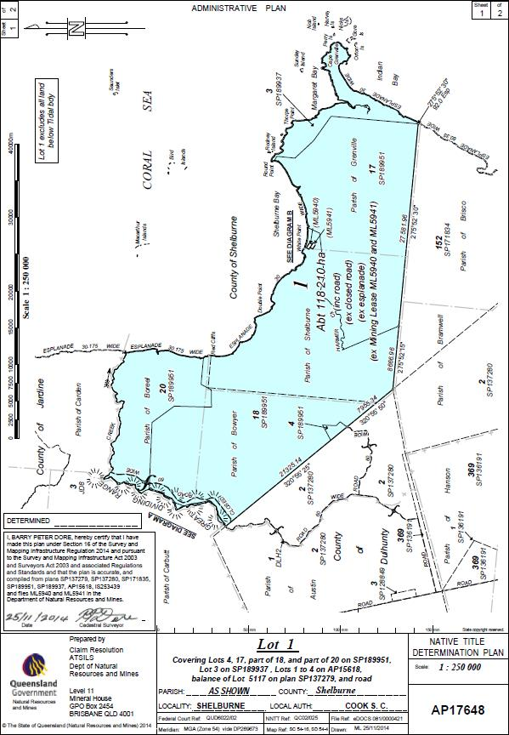

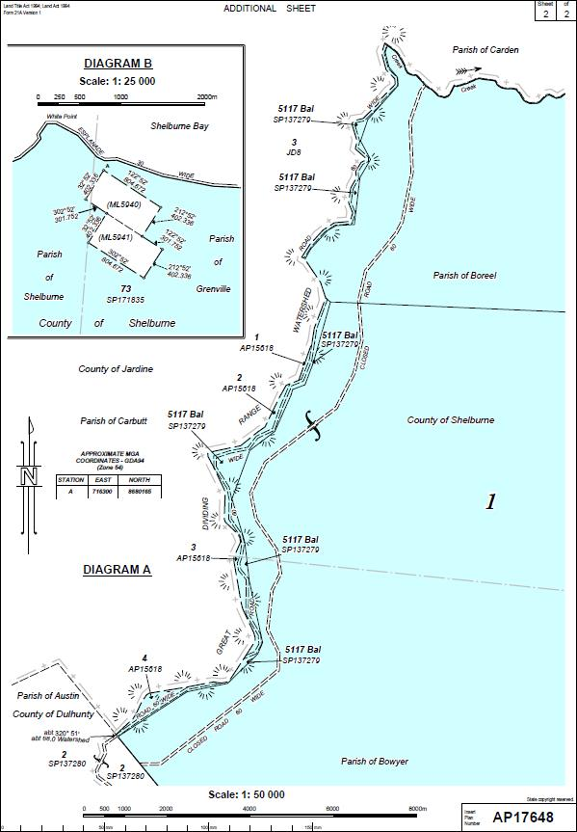

**SCHEDULE 2**

**NATIVE TITLE HOLDERS**

The native title holders are the Wuthathi People being:

1. the descendants of:

(a) Pintharra;

(b) Johnson Moreton;

(c) Frank Wilson;

(d) Ida Temple (Waterbag);

(e) Moe Rie Warren;

(f) Innis Pascoe;

(g) Dinah;

(h) Ada Lancaster;

(i) Annie Punda (Athanamu);

(j) Nara Jira Para;

(k) Ela (Illa);

(l) Eliza (wife of Tom Ware); and

2. those persons adopted by any Wuthathi People referred to in item 1 in accordance with traditional laws and customs.

**SCHEDULE 3**

**OTHER INTERESTS IN THE DETERMINATION AREA**

The nature and extent of the other interests in relation to the Determination Area are the following as they exist as at the date of the determination:

1. The rights and interests of the parties under the Wuthathi People and Cook Shire Council (Area Agreement) indigenous land use agreement (QI2007/020) registered on 26 June 2009.

2. The rights and interests of the Cook Shire Council including any rights the Council, its employees, agents and contractors have:

(a) under its local government jurisdiction and functions contained in the *Local Government Act 2009* (Qld), under the *Land Protection (Pest and Stock Route Management) Act 2002* (Qld) and any other legislation, for that part of the determination area within its local government area as defined in the *Local Government Act 2009* (Qld);

(b) as the owner and operator of infrastructure facilities and other improvements located in the Determination Area as at the date of the determination including but not limited to dedicated roads controlled by Council;

(c) to enter land described in paras 2(a) and 2(b) in compliance with any legislative requirements regarding notice or otherwise to:

(i) exercise any of the rights and interests referred to in paras 2(a) and 2(b);

(ii) inspect, maintain and repair the infrastructure facilities and other improvements referred to in para 2(b); and

(iii) undertake operational activities in its capacity as a local government such as feral animal control, weed control, erosion control, waste management and fire management.

3. The rights and interests of the State of Queensland and the Cook Shire Council to access, use, operate and maintain the area delineated as road on Plan SP137279 for its dedicated purpose and the rights and interests of the general public to access and use that road.

4. Any other rights and interests:

(a) held by the State of Queensland or Commonwealth of Australia; or

(b) existing by reason of the force and operation of the Laws of the State or the Commonwealth.

Note: Entry of orders is dealt with in Rule 39.32 of the *Federal Court Rules 2011*.

|  |  |
| --- | --- |
| IN THE FEDERAL COURT OF AUSTRALIA |  |
| QUEENSLAND DISTRICT REGISTRY |  |
| GENERAL DIVISION | QUD 6022 of 2002 |

|  |  |
| --- | --- |
| BETWEEN: | JOHNSON CHIPPENDALE, MOIRA MACUMBOY, RICHARD MCLEAN, JEAN MOSBY, PHILLIP WALLIS, DOUGLAS WILSON ON BEHALF OF THE WUTHATHI PEOPLE #2  Applicants |
| AND: | state of queensland  First Respondent  COOK SHIRE COUNCIL  Second Respondent |

|  |  |
| --- | --- |
| JUDGE: | GREENWOOD J |
| DATE: | 29 APRIL 2015 |
| PLACE: | CAIRNS |

**REASONS FOR JUDGMENT**

1. The Federal Court convenes here today to make and explain the reasons for making orders that will finally determine the Wuthathi People’s native title determination application under s 87 of the *Native Title Act 1993* (Cth) (“the Act”). It has been eighteen years since the Wuthathi People first lodged a native title determination application in the *National Native Title Tribunal* on 10 October 1997. The intervening years have seen the passing of many senior Wuthathi elders who ought to have had the opportunity of enjoying the recognition by all Australians of their native title rights and interests.
2. Following upon lodgement of the first Wuthathi application over the former Shelburne pastoral lease and occupation licence in 1997, a lengthy period of negotiation and mediation commenced which ultimately led to discontinuance of the original application on 22 August 2002.
3. The change to the character of the tenure from a pastoral lease to unallocated State land made it possible for the Wuthathi People to engage the application of s 47B of the Act as one or more members of the claim group were in occupation of the claim area at the time the relevant application was made, namely, 23 May 2002. Thus, by operation of s 47B(2) for all purposes under the Act in relation to the present application, any prior extinguishment of native title rights and interests in the claim area must be disregarded.
4. On 23 May 2002, Gordon Pablo, Johnson Chippendale, Jean Mosby, Douglas Wilson, Phillip Wallis and Moira Macumboy on behalf of the Wuthathi People filed a new application over approximately 1181 square kilometres of unallocated State land above the High Water Mark but excluding any esplanade that had previously been the Shelburne pastoral lease which is properly described in Pt A of Sch 1 to the orders (“the Determination Area”). The Determination Area is in an ecologically sensitive and beautiful area around Shelburne Bay on the northern tip of Cape York Peninsula.
5. The native title claim group is comprised of all persons descended from the identified apical ancestors whose names are set out in Sch 2 to the orders made today.
6. The native title holders are the Wuthathi People being the descendants of:

(a) Pintharra,

(b) Johnson Moreton;

(c) Frank Wilson;

(d) Ida Temple (Waterbag);

(e) Moe Rie Warren;

(f) Innis Pascoe;

(g) Dinah;

(h) Ada Lancaster;

(i) Annie Punda (Athanamu);

(j) Nara Jira Para;

(k) Ela (Illa).

(l) Eliza (wife of Tom Ware).

1. The native title holders of the Wuthathi People also include those persons adopted by any Wuthathi People referred to in [6] of these reasons in accordance with the traditional laws and customs of the Wuthathi People.
2. Mediation in respect to the earlier application had commenced in the National Native Title Tribunal in 2003 and continued in relation to the current application until the Court ordered that mediation cease on 9 December 2009 at the request of the applicant.
3. This application has been amended on four separate occasions. Firstly, by orders of the Court on 12 December 2002, the rights and interests claimed by the applicant were clarified. The application was amended again on 4 December 2008 when the composition of the applicant claim group was amended pursuant to s 66B of the Act. On 23 October 2012, leave was granted to further amend the rights and interests claimed in the application together with changes to the composition of the claim group and the description of the claim area. On 14 October 2013, the Court granted leave to amend the membership of the applicant group in accordance with s 66B of the Act and to add two apical ancestors. In addition, some small technical corrections to the application were ordered.
4. The application passed the registration test pursuant to s 190A of the Act on 10 February 2003 and remains on the Register of Native Title Claims. The notification period ended on 11 June 2003 pursuant to s 66 of the Act and the State of Queensland and the Cook Shire Council were joined and remain as respondents to the proceedings.
5. The respondent parties acknowledge that s 47B of the Act applies to the Determination Area. The parties further agree that, at the time the application was made, one or more members of the claim group occupied the Determination Area. Having regard to s 47B of the Act, prior extinguishment must be disregarded for the purposes of the determination application. Thus, the granting of the former pastoral lease must be disregarded in identifying and recognising by operation of the orders today the native title rights and interests of the claim group in the claim area.
6. The applicant group presently consists of Johnson Chippendale, Jean Mosby, Douglas Wilson, Phillip Wallis, Moira Macumboy and Richard McLean.
7. The Cape York Land Council is the native title representative body for the area and is the legal representative for the Wuthathi People in relation to the application.
8. An agreement signed by the parties under s 87 of the Act was filed on behalf of the applicant on 19 December 2014. The consent orders which the parties ask the Court to make are attached to the agreement.
9. Section 13(1) of the Act provides that an application for a determination of native title may be made under Part 3 of the Act in relation to an area for which there is no approved determination of native title. The present application is made under s 61 of the Act within Part 3 and there is no approved determination in relation to the land and waters within the Determination Area. I am familiar with the material in this application having been involved in the case management of the Wuthathi proceedings since August 2008.
10. Section 87 confers power on the Court to make orders in, or consistent with, the terms agreed by parties to the proceeding without holding a hearing if an agreement contemplated by s 87(1)(a) is reached; written terms of it signed by the parties are filed with the Court (s 87(1)(b)); and the Court is satisfied that orders in or consistent with those terms would be within power (s 87(1)(c)). I am satisfied that the provisions of s 87 have been satisfied and that it would be appropriate to make the orders sought.
11. The orders that I will make today under s 87 of the Act not only take effect inter‑parties in the resolution of the claims made in the proceedings but represent an independent judicial determination, in the exercise of the judicial power of the Commonwealth, that may be asserted, as a matter of law, against anyone. Although the Act by s 223(1)(c) in part defines *native title* or *native title rights and interests* by reference to the rights and interests recognised by the common law of Australia, a determination of native title expresses the recognition and protection of those rights and interests in relation to land and waters defined and described in s 223 of the Act which find their *origin* in traditional laws and customs, not the Act (*Members of the Yorta Yorta Aboriginal Community v State of Victoria* (2002) 214 CLR 422 at [75] and [76] per Gleeson CJ, Gummow and Hayne JJ).
12. As I have indicated in earlier determinations, a number of considerations are to be taken into account in determining whether the proposed orders appear appropriate to the Court.
13. *Firstly*, the Act recognises and encourages the resolution of applications by mediation, negotiation and ultimately agreement without the need for a hearing and the assessment of evidence and fact‑finding by the Court necessary in the course of resolving a controversy. Similarly, the Act recognises and encourages the determination of native title in relation to an area within the area covered by an application, by mediation, negotiation and ultimately agreement without the need for a hearing.
14. *Secondly*, the Court will be concerned to understand and place emphasis upon whether the agreement is freely made on an informed basis by all parties to the determination and whether the parties are represented by experienced independent lawyers. In the case of a State party representing the public interest, the Court will consider whether appropriate consideration has been given to the issues raised by the proposed consent determination.
15. *Thirdly*, so far as the State is concerned, the Court recognises that a State has access to its own archival material and generally has had a long period of engagement with Aboriginal communities and is therefore likely to be familiar with the historical arrangements within those communities.
16. *Fourthly*, although it is not necessary for the Court to consider the body of material that would be available to it in the course of a contested hearing, the Court ought to have regard to sufficient material which is capable of demonstrating that the agreement and the proposed orders are “rooted in reality” (“*Native Title – A Constitutional Shift?*”, University of Melbourne Law School, JD Lecture Series, Chief Justice French, 24 March 2009): *Wik and Wik Way Native Title Claim Group v State of Queensland* [2009] FCA 789; (2009) 258 ALR 306.
17. In that sense, the Court ought to be satisfied that the proposed orders are *prima facie* appropriate in order to satisfy the test under s 87 of the Act.
18. In this case, the parties to the proposed determination are represented by lawyers experienced in the conduct of native title proceedings and the analysis of issues arising in such proceedings. There has been extensive anthropological research carried out over a number of years, firstly to inform an inquiry conducted by the Commonwealth in 1986 and then to support the Wuthathi People’s claim under the *Aboriginal Land Act 1991* (Qld) to Ten Islands near Cape Grenville. Most recently, the anthropological research has focussed on assisting the claimants to establish their connection to and the extent of that country and the content of their traditional laws and customs. That evidence has been considered by the State of Queensland and the Cook Shire Council who, through their various officers, have had a long engagement with the Aboriginal people of the Determination Area. I am entirely satisfied that the parties to this agreement have been represented by lawyers experienced in these issues and that the parties have come to a fully informed agreement.
19. I have had regard to the Overview of Connection Material prepared by Dr David Thompson and Professor Athol Chase and a number of informative affidavits from members of the claim group. Both Dr Thompson and Professor Chase have worked in the northern part of Cape York for over 40 years. Professor Chase has assisted the Wuthathi People with a Report on Anthropological Investigations into Wuthathi Aboriginal Association with the Shelburne Bay – Cape Grenville Areas of Cape York Peninsula for the Commonwealth Government which was co-authored with Ray Wood in 1986, the Aboriginal Land Tribunal Report in 1996 and the subsequent Connection Reports for the Bromley and Wuthathi claims in 2005 and 2006. Dr Thompson has undertaken research with the Wuthathi People and neighbouring groups since 1969. This long involvement with the claimants is reflected in the clarity of the work in the Overview which was filed in these proceedings on 19 December 2014. Both Professor Chase and Dr Thompson have had access to an extensive body of research that has been conducted over the broad Cape York region by many eminent anthropologists including Drs Walter Roth, Norman Tindale, David Thomson, Wolfgang Laade and Bruce Rigsby.
20. The claim area is described in the Overview as lying wholly within the wider area of Wuthathi country, which extends along the coast to Captain Billy Landing in the north, extending southwards to south of the Olive River, and east to the Great Barrier Reef. In the west it extends to the watershed division in the region of the Richardson Range.
21. The applicant’s submissions examine the observations of Europeans made shortly prior to and shortly after the assertion of sovereignty in 1788, and say that it could not be doubted that the Determination Area, or at least those parts of it that were observed, was occupied at those times and at the time of the assertion of sovereignty. On 18 August 1770, Captain Cook sailed past what is probably Hicks Island, a short distance from Cape Grenville and described it as “inhabited”. Cook named Cape Grenville. In his journal for the same day, Banks recorded the presence on a small island of “5 natives, 2 of whoom [sic] carried their Lances in their hands”.
22. On 29 May 1789, Captain Bligh made landfall at Restoration Island, in the traditional homelands of the southern neighbours of the Wuthathi, the Kuuku Ya’u people. Bligh observed fireplaces, huts and a spear, as well as armed Aboriginal people on the nearly mainland. The next day, Bligh’s party set off north on their way to Batavia, passing Fair Cape just north of the Pascoe River mouth. In the vicinity of the promontory of Cape Grenville, Bligh’s party there saw a party of seven “Indians” who were “running towards us, shouting and making signs for us to land”.
23. A later observation of Aboriginal people on or near the proposed determination area occurred in 1848 when Edmund Kennedy’s party which had set out to explore inland areas of Cape York Peninsula, reached the eastern coast on the southern side of the Pascoe River mouth. While Kennedy and three others set off for Somerset, the bulk of the party remained near the Pascoe River mouth, awaiting rescue. Those who stayed behind were offered food by Aborigines, though most of them died. Near Captain Billy Landing (at the northern end of Wuthathi country), Kennedy and his small party encountered signs of “plenty of blacks”, evident in their camps, tracks and smoke. The rescuers on board the *Ariel* saw two Aborigines on the beach at Shelburne Bay and some 40 other Aborigines in the vicinity. The *Ariel* landed at Double Point (on the proposed determination area), where they found a canoe, then walked to White Point (also on that area) where they found about 50 to 100 natives on the beach.
24. In 1896, Meston noted that the tribes:

[f]rom Newcastle Bay south to Princess Charlotte Bay … are still in their original condition… There is no settlement whatever, nor is there a single white man resident over the whole of that extensive territory, except for a few miners on one locality … the tribes to the westward [of the east coast], between the coast and the telegraph line, are still absolutely wild, and … free from any intercourse of contamination by white men.

1. In 1880 at Captain Billy Landing, Robert Logan Jack encountered “a large number of natives, including many women and children”. They visited Jack’s party, speaking a “pidgin English”. The leading man introduced himself as “Captain Billy. As late as 1880, there had been no penetration by European settlers of areas inland from the shore. However, those living on the coast had by this time had substantial intercourse with Europeans, albeit that there do not appear to have been any settlements or outposts established on or near Wuthathi territory. By 1880, the coastline was well-travelled by *beche-de-mer* fishing vessels and there were manned lightships along the inner marine channel, just several miles off shore, or even closer.
2. As early as 1883, there were some 200 boats operating in the area, employing some 1500 people. A series of *beche-de-mer* treatment plants had been established on the northeast coast and its islands. In his 1890 Annual Report, Government Resident John Douglas referred to the participation of coastal Aboriginal people in the *beche-de-mer* trade, sometimes on an unwilling basis. He also referred to the abduction of Aboriginal women by fisherman.
3. The Overview explores the traditional law and custom that gives rise to the rights and interests that I will recognise today. Dr Thompson and Professor Chase opine that:

In the traditional law and custom of the Wuthathi and their Aboriginal neighbours with whom they share the same understanding of contemporary customary doctrines and presumptions, ownership of land goes hand in hand with ownership and the exercise of rights and responsibilities in relation to what is commonly referred to as the cultural heritage or cultural estate of the group. Land and waters are not only the property of the native title holders in the sense of material/physical property, but are also the basis of group identity and its culture. Story-Places (or “sacred sites”) are the most obvious example of cultural estate with associated oral narratives found on each group’s lands and waters. These, along with the songs, dances, ceremonies and names associated with them, are the property of the applicant group. Most significantly, possession, use and occupation of the claim area, and all the alternative and several native title rights and responsibilities which flow from this, is in Aboriginal doctrine held to be the source of the native title holders’ membership and group identity.

1. Professor Chase and Dr Thompson identify the evidence of the continuing exercise of rights and interests in the contemporary society. They refer to the ownership of country and the responsibility to look after it in both a material and cultural sense:

The integration of both people and country is founded upon cosmological beliefs and associates sites and ceremonies. It is noted that this spiritual and social integration with land and waters is expressed and passed on through both social usage of country and the *Ukaynta* initiation ceremonies. These ceremonies have continued from pre-contact times into the modern period. In the context of the government settlement from 1967, the Wuthathi families at Lockhart River formed a combined northern group with Kuuku Ya’u and some Kaanju and Uutaalnganu focal rivals to perform the *Ukaynta* ceremonies in conjunction with the southern grouping of Umpila and other Kaanju and Uutaalnganu focal individuals who perform the Thiira ceremonies.

The transmission of the rights and interests through birth or other incorporation into the system of cognatic descent of the corporate core group is a feature of Wuthathi law and custom and also the rights to settle disputes.

1. Johnson Chippendale, Phillip Wallis, John Chippendale, Moira Macumboy and Ray Wallis, who are members of the claim group, have provided affidavits deposing to the exercise of their traditional rights to camp, hunt and fish with their families and friends in the Determination Area.
2. I am satisfied that the anthropological material demonstrates that the Wuthathi People are descended from a society of Aboriginal people who were in occupation of the land and waters of the Determination Area, at sovereignty and who formed a society united by their acknowledgement and observance of a normative body of traditional laws, customs and beliefs. Through their continued acknowledgement and observance of these normative laws and customs, the Wuthathi People have, since sovereignty, maintained a connection with the Determination Area. I am satisfied that the content of those native title rights and interests which derive from the practice of traditional laws and customs have been identified and established through the anthropological material and can be properly described as the right to possession, occupation, use and enjoyment of the area to the exclusion of all others, and the native title rights in relation to Water as defined in the proposed Order 12 are properly described as the non-exclusive right to take and use water for personal, domestic and non-commercial communal purposes.
3. Section 225 of the Act provides that a determination of native title requires the Court to determine who are the persons or group of persons who hold the common or group rights comprising the native title; the nature and extent of those rights and interests in the Determination Area; the nature and extent of any other interests; and the relationship between the native title rights and interests and those other interests, in the Determination Area. I am satisfied that the proposed orders address each of those elements and that the orders appear appropriate in accordance with s 87 of the Act.
4. Sections 55 and 56 of the Act require that the Court determine whether the native title is to be held in trust and, if so, by whom. Order 13 of the proposed orders provides that native title is to be held in trust by the Wuthathi Aboriginal Corporation (ICN 7157) to perform the functions set out in s 57(1) of the Act and the *Native Title (Prescribed Bodies Corporate) Regulations 1999* (Cth). The Notice of Nomination and Consent of the Prescribed Body Corporate was filed on 2 May 2014. The requirements of ss 55 and 56 of the Act are satisfied.
5. For the reasons I have indicated, I make the orders and determination sought by the parties. These orders made today give recognition within the Australian legal system to the native title rights and interests of the Wuthathi People in relation to the Determination Area born out of traditions honoured and customs practised by the ancestors of the claimants and observed and practised by their descendants continuously over time and recognised and protected under the *Native Title Act 1993* (Cth).

|  |
| --- |
| I certify that the preceding thirty‑nine (39) numbered paragraphs are a true copy of the Reasons for Judgment herein of the Honourable Justice Greenwood. |

Associate:

Dated: 29 April 2015