FEDERAL COURT OF AUSTRALIA

Foxtel Management Pty Ltd v TPG Internet Pty Ltd [2018] FCA 933

|  |  |
| --- | --- |
| File number: |  |
|  |  |
| Judge: | **NICHOLAS J** |
|  |  |
| Date of judgment: | 19 June 2018 |
|  |  |
| Catchwords: | **Copyright** – application for “site blocking” orders under s 115A of the *Copyright Act 1968* (Cth) – whether requirements of s 115A satisfied – whether orders should be made |
|  |  |
| Legislation: | *Copyright Act 1968* (Cth) s 115A |
|  |  |
| Cases cited: | *Foxtel Management Pty Limited v TPG Internet Pty Ltd* (2017) 126 IPR 579  *Roadshow Films Pty Ltd v Telstra Corporation Ltd* (2016) 248 FCR 178  *Roadshow Films Pty Ltd v Telstra Corporation Limited* [2017] FCA 965  *Universal Music Australia Pty Ltd v TPG Internet Pty Ltd* (2017) 126 IPR 219 |
|  |  |
| Date of hearing: | 18 June 2018 |
|  |  |
| Registry: |  |
|  |  |
| Division: |  |
|  |  |
| National Practice Area: |  |
|  |  |
| Sub-area: |  |
|  |  |
| Category: | Catchwords |
|  |  |
| Number of paragraphs: | 22 |
|  |  |
| Counsel for the Applicant: | Ms J Beaumont with Mr G Tsang |
|  |  |
| Solicitor for the Applicant: | Minter Ellison |
|  |  |
| Counsel for the First to Thirty-First Respondents | The First to Thirty-First Respondents filed submitting appearances |
|  |  |
| Counsel for the Thirty-Second to Forty-Ninth Respondents | The Thirty-Second to Forty-Ninth Respondents did not appear |

ORDERS

|  |  |  |
| --- | --- | --- |
|  | | NSD 498 of 2018 |
|  | | |
| BETWEEN: | FOXTEL MANAGEMENT PTY LTD (ACN 068 671 938)  Applicant | |
| AND: | TPG INTERNET PTY LTD(ACN 068 383 737) (and others named in the Schedule  First Respondent | |

|  |  |
| --- | --- |
| JUDGE: | NICHOLAS J |
| DATE OF ORDER: | 19 June 2018 |

In these orders, the following terms have the following meanings:

1. **Domain Name** means a name formed by the rules and procedures of the **Domain Name System (DNS)** and includes subdomains.
2. **DNS Blocking** means a system by which any user of a Respondent’s service who attempts to use a DNS resolver that is operated by or on behalf of that Respondent to access a Target Online Location is prevented from receiving a DNS response other than a redirection as referred to in order 5.
3. **IP Address** means an Internet Protocol address.
4. **Optus** means the twenty second to thirty first Respondents.
5. **Target Online Locations** means the online locations:
   1. referred to in Schedule 1 to these orders as HDO, HDEuropix, 123Hulu, Watch32, Sockshare, NewEpisodes, 1Movies, 5Movies, WatchFreeMovies, SeriesTop, ETTV, MagnetDL, Torrent Download, Torrent Room, and Torrents; or
   2. the primary purpose of which is to facilitate access to URLs, IP Addresses or Domain Names at which the online locations referred to in Schedule 1 to these orders as HDO, HDEuropix, 123Hulu, Watch32, Sockshare, NewEpisodes, 1Movies, 5Movies, WatchFreeMovies, SeriesTop, ETTV, MagnetDL, Torrent Download, Torrent Room, and Torrents can be accessed,

and that are or were accessible:

* + 1. at the IP Addresses listed in Schedule 1 to this order (together, the **Target IP Addresses**); and
    2. at the Domain Names listed in Schedule 1 to this order (together, the **Target Domain Names**).

1. **Telstra** means the nineteenth to twenty first Respondents.
2. **TPG** means the first to eighteenth Respondents.
3. **URL** means a Uniform Resource Locator.
4. **Vocus** means the thirty second to forty ninth Respondents.

**THE COURT ORDERS THAT:**

1. The requirement under s 115A(4) of the *Copyright Act 1968* (Cth) that the Applicant give notice of its application to the persons who operate the Target Online Locations be dispensed with in so far as any such notice has not already been given.
2. Each Respondent must, within 15 business days of these orders, take reasonable steps to disable access to the Target Online Locations.
3. Order 2 is taken to have been complied with by a Respondent if that Respondent implements any one or more of the following steps:
   1. DNS Blocking in respect of the Target Domain Names;
   2. IP Address blocking or re-routing in respect of the Target IP Addresses;
   3. URL blocking in respect of the Target URLs and the Target Domain Names, if Target URLs are listed in Schedule 1 to this order; or
   4. any alternative technical means for disabling access to the Target Online Locations as agreed in writing between the Applicant and a Respondent.
4. If a Respondent in complying with order 2 does not implement one of the steps referred to in order 3, that Respondent must, within 15 business days of these orders, notify the Applicant of the step or steps it has implemented.
5. Each Respondent must redirect any communication by a user of its service seeking access to a Target Online Location which has been disabled pursuant to order 2 to a webpage established, maintained and hosted by either:
   1. the Applicant, or its nominee, pursuant to order 6; or
   2. that Respondent or its nominee.

The Applicant's obligations pursuant to orders 6 and 7 only arise if a Respondent notifies the Applicant that the Respondent will redirect a communication pursuant to order 5(a) and for so long as at least one Respondent redirects communications to that webpage.

1. The Applicant, or its nominee, must establish, maintain and host a webpage which informs users of a Respondent's service who have been redirected to the webpage pursuant to order 5 that access to the website has been disabled because this Court has determined that it infringes or facilitates the infringement of copyright.
2. Within 5 business days of these orders, the Applicant will notify each of the Respondents in writing of the URL of the webpage established, maintained and hosted under order 6 and, if the webpage ceases to operate for any reason, will notify each of the Respondents in writing of a different URL that complies with order 6.
3. If, in complying with order 5, a Respondent redirects any communication by a user of its service to a webpage established, maintained and hosted by it, that Respondent or its nominee must ensure that the webpage informs the user of that Respondent's service that access to the website has been disabled because this Court has determined that it infringes or facilitates the infringement of copyright.
4. In the event that the Applicant has a good faith belief that:
5. any Target URL, Target IP Address or Target Domain Name which is subject to these orders has permanently ceased to enable or facilitate access to a Target Online Location; or
6. any Target URL, Target IP Address or Target Domain Name has permanently ceased to have the primary purpose of infringing or facilitating the infringement of copyright,

a representative of the Applicant must, within 15 business days of the Applicant forming such a good faith belief, notify each Respondent of that fact in writing, in which case the Respondents shall no longer be required to take steps pursuant to order 2 to disable access to the relevant Target URL, Target IP Address or Target Domain Name that is the subject of the notice.

1. A Respondent will not be in breach of order 2 if it temporarily declines or temporarily ceases to take the steps ordered in order 2 (either in whole or in part) upon forming the view, on reasonable grounds, that suspension is necessary to:
2. maintain the integrity of its network or systems, or functioning of its blocking system;
3. upgrade, troubleshoot or maintain its blocking system;
4. avert or respond to an imminent security threat to its network or system; or
5. ensure the reliable operation of its ability to block access to online locations associated with criminal content if it reasonably considers that such operation is likely to be impaired, or otherwise to comply with its legal obligations (other than any contractual obligations to its customers) including under section 313(3) of the *Telecommunications Act 1997* (Cth) or otherwise,

provided that:

1. unless precluded by law, it notifies the Applicant or their legal representative(s) of such suspension, including the reasons and the expected duration of such suspension by 5.00 pm on the next business day; and
2. such suspension lasts no longer than is reasonably necessary and, in any case, no longer than 3 business days or such longer period as the Applicant may agree in writing or the Court may allow.
3. The owner or operator of any of the Target Online Locations and the owner or operator of any website who claims to be affected by these orders may apply on 3 days' written notice, including notice to all parties, to vary or discharge these orders, with any such application to:
4. set out the orders sought by the owner or operator of the Target Online Locations or affected website; and
5. be supported by evidence as to:
   * 1. the status of the owner or operator of the Target Online Locations or affected website; and
     2. the basis upon which the variation or discharge is sought.
6. The parties have liberty to apply on 3 days' written notice, including, without limitation, for the purpose of any application:
7. for further orders to give effect to the terms of these orders;
8. for further orders in the event of any material change of circumstances including, without limitation, in respect of the costs, consequences for the parties and effectiveness of the technical methods under order 3; and/or
9. for orders relating to other means of accessing the Target Online Locations not already covered by these orders.
10. If a website the subject of any of the Target Online Locations is at any time during the operation of these orders provided from a different Domain Name, IP Address or URL:
    * 1. the Applicant may file and serve:
         1. an affidavit which:
            1. identifies the different Domain Name, IP Address or URL;
            2. states that, in the good faith belief of the deponent, the website operated from the different Domain Name, IP Address or URL is a new location outside Australia for the Target Online Locations the subject of these orders and brief reasons therefor; and
         2. proposed short minutes of order to the effect that:
            1. the definition of Target Online Locations in these orders is amended to include the different Domain Name, IP Address or URL; and
            2. the time period in order 2 of these orders starts to run in relation to the different Domain Name, IP Address or URL upon service in accordance with order 17(d) of the orders as made.
11. These orders are to operate for a period of 3 years from the date of these orders.
12. Six months prior to the expiry of these orders:

(a) the Applicant may file and serve:

(i) an affidavit which states that, in the good faith belief of the deponent, that some or all of the Target Online Locations continue to have the primary purpose of infringing or facilitating the infringement of copyright; and

(ii) short minutes of order extending the operation of these orders in relation to the relevant Target Online Locations for a further 3 year period; and

* + 1. the process contained in order 17 shall apply.

1. The affidavits referred to in orders 13 and 15 are to be given by a deponent duly authorised to give evidence on behalf of the Applicant and may be given by its solicitor.
2. If an affidavit and short minutes of order are filed and served in accordance with orders 13 or 15:
3. within 7 business days, the Respondents must notify the Applicant and the Court if they object to the orders being made in accordance with the short minutes of orders served by the Applicant;
4. if any Respondent gives notice of any objection, or the Court otherwise thinks fit, the proceeding will be relisted for further directions;
5. if no Respondent gives notice of any objection and the Court does not otherwise require the proceeding to be relisted, then the Court may make orders in terms of the short minutes of orders served by the Applicant without any further hearing; and
6. the Applicant must serve on the Respondents any such orders made.
7. The Applicant pay Telstra’s, Optus’, Vocus’ and TPG’s compliance costs calculated at the rate of $50 per Domain Name the subject of DNS Blocking undertaken for the purposes of complying with order 2 hereof.
8. There be no other order as to costs.

Note: Entry of orders is dealt with in Rule 39.32 of the *Federal Court Rules 2011*.

**Schedule 1**

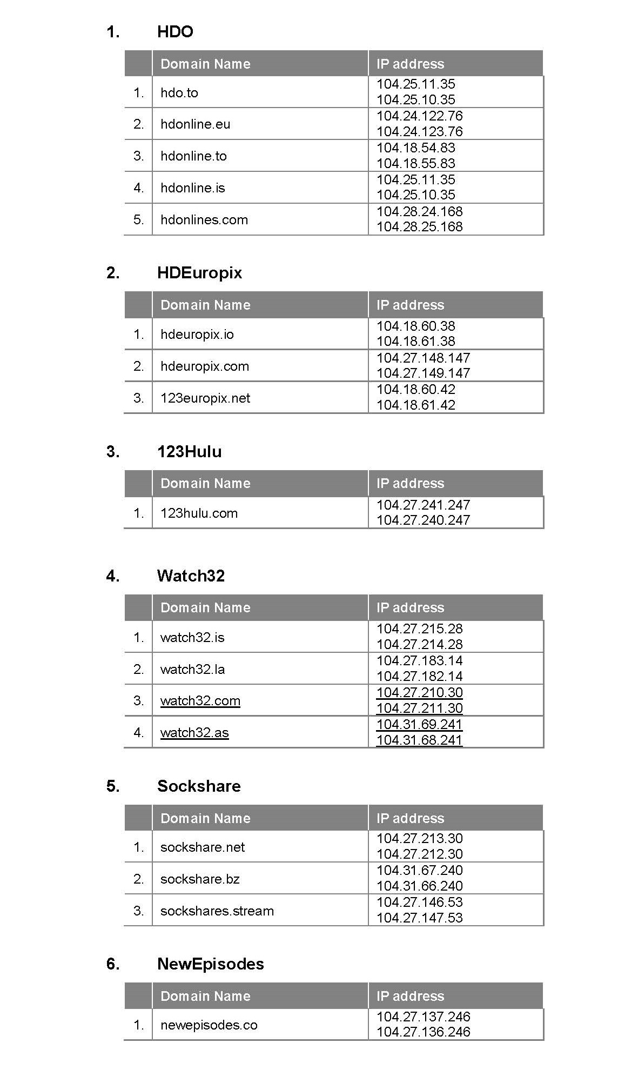

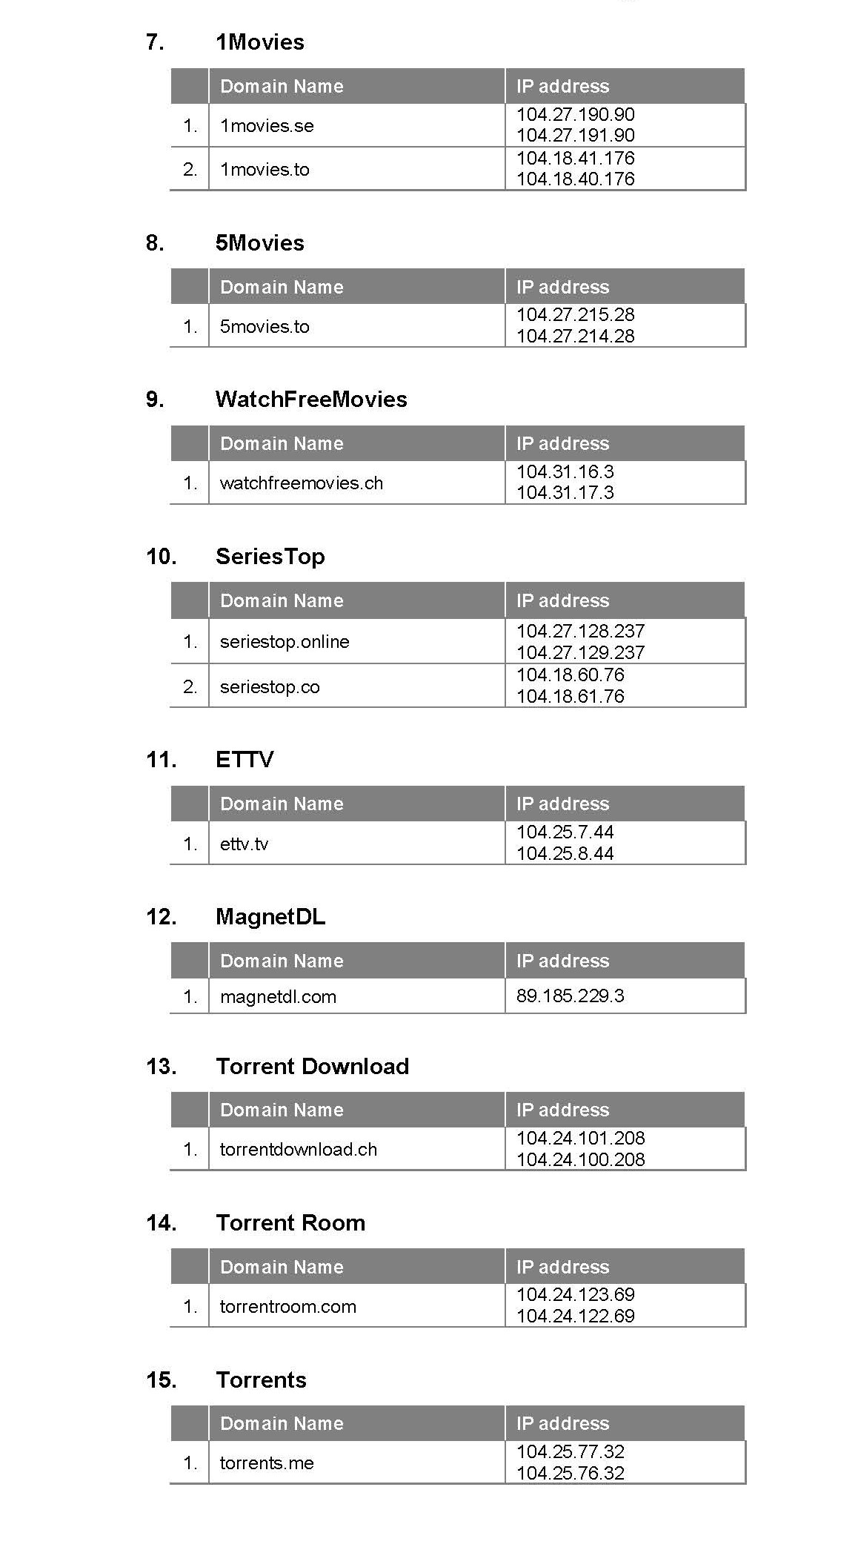

REASONS FOR JUDGMENT

NICHOLAS J

1. Before me is an application brought by the applicant seeking orders under s 115A of the *Copyright Act 1968* (Cth) (“the Act”) requiring the respondents, each of which is a carriage service provider, to take reasonable steps to disable access to various online locations (“the target online locations”). The target online locations, identified by reference to their domain name and IP address, are out in a schedule to the applicant’s amended originating application. The orders sought by the applicant are to the same general effect as those were made in a previous proceeding brought by it under s 115A.
2. There are 49 respondents, each of which is a carriage service provider and a member of Telstra, Optus, Vocus (formerly M2) or TPG groups. I am satisfied that each of the respondents has been served with copies of both the originating application and the amended originating application. I am also satisfied that each of the respondents either consents to, or does not oppose, the making of the orders sought by the applicant.
3. The evidence relied upon by the applicant consists of affidavits made by Ms Sheenal Singh of Minter Ellison, the solicitors for the applicant, and Ms Claire Southey, the applicant’s Head of Content Protection Technology.
4. Ms Singh gives evidence concerning her investigations into each of the target online locations including their location and content, copyright material (including copyright material owned by the applicant) accessible at or via the target online locations, and her attempts to communicate with the website operators.
5. Ms Southey, who has expertise in information technology, gives evidence as to the subsistence and ownership of copyright in various television programs, the location of the target online locations, and the technology used or made available at the target online locations.
6. There are 28 target online locations. These can be grouped into 15 different categories consisting of a primary domain name and various secondary domain names at which the same content can be found. For example, category 1 consists of five domain names that operate under the “HDO” name. The primary site is found at the hdo.to domain name, and four secondary sites at locations the names of which also include the HDO name. This categorisation of primary and secondary locations is based on what appeared, at a particular time, to be the main or most popular domain name for the online location to which the other sites with similar domain names redirect.
7. The 15 categories of target online locations are:

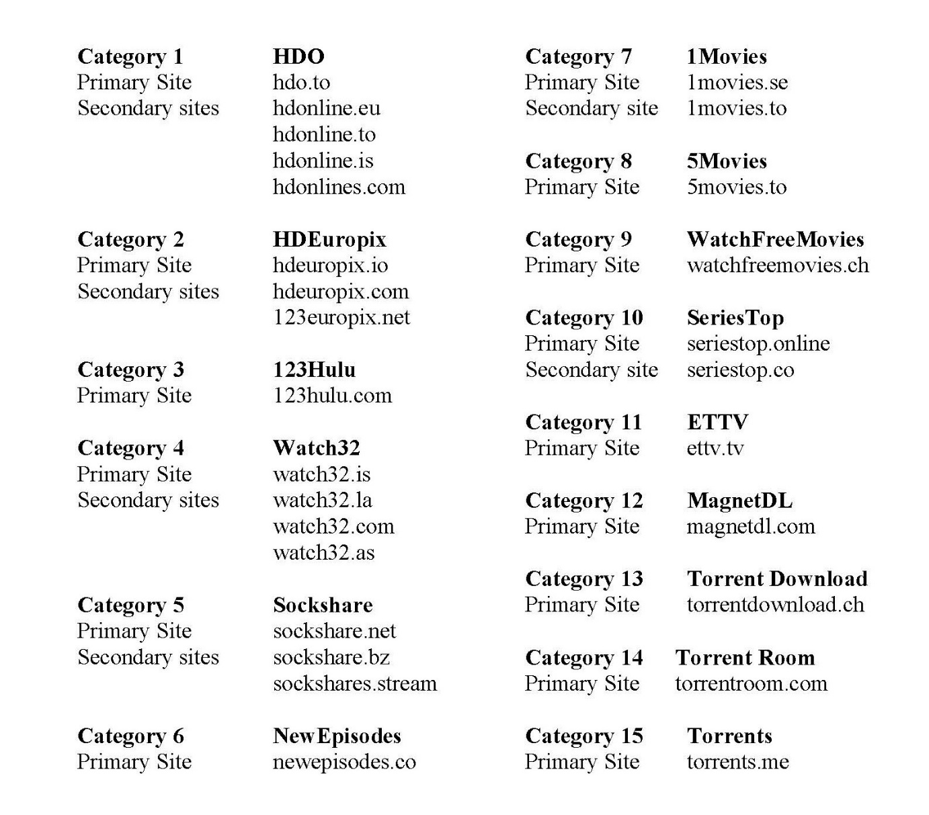

1. Section 115A(1) and (2) of the Act provide:

(1) The Federal Court of Australia may, on application by the owner of a copyright, grant an injunction referred to in subsection (2) if the Court is satisfied that:

(a) a carriage service provider provides access to an online location outside Australia; and

(b) the online location infringes, or facilitates an infringement of, the copyright; and

(c) the primary purpose of the online location is to infringe, or to facilitate the infringement of, copyright (whether or not in Australia).

(2) The injunction is to require the carriage service provider to take reasonable steps to disable access to the online location.

1. The operation of s 115A has been considered in the number of cases including, *Roadshow Films Pty Ltd v Telstra Corporation Ltd* (2016) 248 FCR 178 (“*Roadshow*”)*, Foxtel Management Pty Limited v TPG Internet Pty Ltd* (2017) 126 IPR 579, *Universal Music Australia Pty Ltd v TPG Internet Pty Ltd* (2017) 126 IPR 219 and *Roadshow Films Pty Ltd v Telstra Corporation Limited* [2017] FCA 965. The orders originally made in *Roadshow* in Proceeding NSD 241 of 2016 (in which the present applicant was also the applicant) were amended on 21 December 2017 to modify the definition of “Target Online Locations”. The orders sought by the applicant in this proceeding incorporate a definition of “Target Online Locations” to the same effect.
2. The applicant has taken reasonable steps to determine the identity and address of the operator of each of the target online locations. With one exception, Ms Singh’s communications using the contact information associated with the target online locations received either no or no substantive reply. The operator of the target online location with the domain name 1Movies did respond to an email from Ms Singh to advise her that the website does not host any of the content offered on its server. Of course, that is no answer to the allegation that the website facilitates the infringement of copyright.
3. In my view the applicant has taken reasonable steps to notify the operators of the target online locations of this application and it is appropriate to make an order dispensing with the requirement to give notice in accordance with s 115A(4)(b) to the extent that such notice has not already been given.
4. I am satisfied that each of the target online locations allows users to access audio-visual material consisting of cinematograph films using either torrent technology or streaming technology that enables users to access and view such material on devices connected to the internet. Each of the target online locations facilitates the download (either directly or via other websites to which they provide links) of many well-known commercially released motion pictures and television programs. Some of these were released or broadcast for the first time only recently. The nature of the content, and the manner in which it is made available to users, including the fact that it is delivered free of charge, strongly suggests that such material is being made available online without the licence of the owners of the copyright in such material.
5. Most of the target online locations provide internet users with a browsable and/or searchable index or directory of audio-visual content from which the user can make a selection, and categorises its index of audio-visual content by reference the title such as “Movies” and “TV”.
6. One of the target online locations, torrents.me, allows users to search for and download torrent files and, in addition, provides users with an index of sites from which a user can access other torrent files. The index of proxy sites found at torrents.me includes links to many proxies for other well-known sites that infringe or facilitate the infringement of copyright in audio-visual websites including the Pirate Bay.
7. I am satisfied that the applicant is an owner of copyright in the cinematograph films comprising each episode of the television series known as Wentworth, Season 3 (“Wentworth”). Copyright notices appearing on all such episodes identify the applicant as a copyright owner. I am also satisfied that each of the target online locations either infringes or facilitates the infringement of the applicant’s copyright in one or more episodes of Wentworth: see *Roadshow* at [42]-]47].
8. The evidence includes the results of searches conducted by Ms Singh at ascertaining the country in which each of the relevant domain names is registered. The methodology used by Ms Singh is essentially the same as that which was employed by the experts who gave evidence in previous proceedings brought under section 115A. All of the target online locations appear to be located outside Australia.
9. As was explained in *Roadshow* at [49]:

The purpose of the online location may be ascertained by a consideration of the use that is or may be made of it. If the Court is satisfied that the principal activity for which the online location is used or designed to be used is copyright infringement or the facilitation of copyright infringement, then it will be open to conclude that the primary purpose of the online location is to infringe, or to facilitate the infringement of, copyright.

1. The infringement of copyright in audio-visual material by making such material available online free of charge, or assisting users to access other online locations that do so, appears to be the principal activity for which each of the target online locations is designed.
2. Based on the evidence before me, I am satisfied that:

* the respondents provide access to the target online locations each of which is located outside Australia;
* each of the target online locations have infringed or facilitated the infringement of the applicant’s copyright in Wentworth; and
* the primary purpose of each of the target online locations is to facilitate the infringement of copyright.

1. I am satisfied that the power to make orders under s 115A in respect of the target online locations is enlivened.
2. The nature and extent of the copyright material made available at each of the target online locations, or at other online locations, to which they provide links, demonstrates a flagrant disregard by the operators of the rights of copyright owners. The only persons likely to be interested in communicating with the target online locations are those who seek instant access to movies and television programs without having to pay for it. There are in my view no relevant discretionary considerations that weigh against the making of the orders sought by the applicant in respect of each of the target online locations.
3. I consider this is an appropriate case in which to make the orders under s 115A sought by the applicants.

|  |
| --- |
| I certify that the preceding twenty-two (22) numbered paragraphs are a true copy of the Reasons for Judgment herein of the Honourable Justice Nicholas. |

Associate:

Dated: 19 June 2018

SCHEDULE OF PARTIES

|  |  |  |  |
| --- | --- | --- | --- |
|  |  | | |
| Respondents |  | | |
| Second Respondent | | IINET LTD ACN 068 628 937 |
| Third Respondent | | TPG NETWORK PTY LTD ACN 003 064 328 |
| Fourth Respondent | | FTTB WHOLESALE PTY LTD ACN 087 533 328 |
| Fifth Respondent | | CHARIOT PTY LTD ACN 088 377 860 |
| Sixth Respondent | | SOUL PATTISON TELECOMMUNICATIONS PTY LTD ACN 001 726 192 |
| Seventh Respondent | | SPT TELECOMMUNICATIONS PTY LIMITED ACN 099 173 770 |
| Eighth Respondent | | SPTCOM PTY LIMITED ACN 111 578 897 |
| Ninth Respondent | | SOUL COMMUNICATIONS PTY LTD ACN 085 089 970 |
| Tenth Respondent | | PIPE NETWORKS PTY LTD ACN 099 104 122 |
| Eleventh Respondent | | INTRAPOWER TERRESTRIAL PTY LTD ACN 081 193 259 |
| Twelfth Respondent | | INTERNODE PTY LTD ABN 82 052 008 581 |
| Thirteenth Respondent | | TRANSACT CAPITAL COMMUNICATIONS PTY LTD ACN 093 966 888 |
| Fourteenth Respondent | | TRANSACT VICTORIA COMMUNICATIONS PTY LTD ACN 063 024 475 |
| Fifteenth Respondent | | WESTNET PLY LTD ACN 086 416 908 |
| Sixteenth Respondent | | ADAM INTERNET PTY LTD ACN 055 495 853 |
| Seventeenth Respondent | | AAPT LTD (ACN 052 082 416) |
| Eighteenth Respondent | | REQUEST BROADBAND PTY LTD (ACN 091 530 586) |
| Nineteenth Respondent | | TELSTRA CORPORATION LIMITED ABN 33 051 775 556 |
| Twentieth Respondent | | PACNET INTERNET (A) PTY LTD (ACN 085 213 690) |
| Twenty First Respondent | | PACNET SERVICES (A) PTY LTD ACN 056 783 852 |
| Twenty Second Respondent | | OPTUS MOBILE PTY LTD ACN 054 365 696 |
| Twenty Third Respondent | | OPTUS NETWORKS PTY LIMITED ACN 008 570 330 |
| Twenty Fourth Respondent | | OPTUS ADSL PTY LTD ACN 138 676 356 |
| Twenty Fifth Respondent | | OPTUS SATELLITE PTY LTD ACN 091 790 313 |
| Twenty Sixth Respondent | | UECOMM OPERATIONS PTY LTD ACN 093 504 100 |
| Twenty Seventh Respondent | | VIVIDWIRELESS PTY LTD ACN 137 696 461 |
| Twenty Eighth Respondent | | OPTUS INTERNET PTY LTD ACN 083 164 532 |
| Twenty Ninth Respondent | | VIRGIN MOBILE AUSTRALIA PTY LTD (ACN 092 726 442) |
| Thirtieth Respondent | | ALPHAWEST SERVICES PTY LIMITED (ACN 009 196 347) |
| Thirty First Respondent | | OPTUS WHOLESALE PTY LTD ACN 092 227 551 |
| Thirty Second Respondent | | M2 WHOLESALE PTY LTD ABN 99 119 220 843 |
| Thirty Third Respondent | | M2 WHOLESALE SERVICES PTY LTD ACN 071 659 348 |
| Thirty Fourth Respondent | | M2 COMMANDER PTY LTD ACN 136 950 082 |
| Thirty Fifth Respondent | | PRIMUS NETWORK (AUSTRALIA) PTY LTD (ACN 109 142 216) |
| Thirty Sixth Respondent | | PRIMUS TELECOMMUNICATIONS PTY. LTD. (ACN 071 191 396) |
| Thirty Seventh Respondent | | PRIMUS TELECOMMUNICATIONS (AUST) PTY LTD ACN 061 754 943 |
| Thirty Eighth Respondent | | DODO SERVICES PTY LTD ACN 158 289 331 |
| Thirty Ninth Respondent | | ENGIN PTY LTD ACN 080 250 371 |
| Fortieth Respondent | | EFTEL CORPORATE PTY LTD ACN 154 634 054 |
| Forty First Respondent | | EFTEL PTY LTD ACN 092 667 126 |
| Forty Second Respondent | | EFTEL WHOLESALE PTY LTD ACN 123 409 058 |
| Forty Third Respondent | | CLUBTELCO PTY LTD ACN 144 488 620 |
| Forty Fourth Respondent | | WHOLESALE COMMUNICATIONS GROUP PTY LTD ACN 109 626 011 |
| Forty Fifth Respondent | | 2TALK PTY LTD ACN 161 656 499 |
| Forty Sixth Respondent | | VOCUS PTY LTD (ACN 127 842 853) |
| Forty Seventh Respondent | | AMCOM IP TEL PTY LTD (ACN 065 092 962) |
| Forty Eighth Respondent | | AMNET BROADBAND PTY LTD (ACN 092 472 350) |
| Forty Ninth Respondent | | NEXTGEN NETWORKS PTY LTD (ACN 094 147 403) |