FEDERAL COURT OF AUSTRALIA

Turner v State of South Australia [2011] FCA 1312

|  |  |  |
| --- | --- | --- |
| Citation: | | Turner v State of South Australia [2011] FCA 1312 |
|  | |  |
| Parties: | | **DOROTHY TURNER, MARK AGIUS, JEAN AGIUS, DENISE VARCOE, JIM ABDULLAH, LORETTA SMITH, GEORGE TRIPP, GLADYS E SUMNER AND GLENDA RIGNEY v STATE OF SOUTH AUSTRALIA, NEIL JOHANSEN, WENDY FAYE BELL, BRENTON PAUL BELL, ROWLAND JOHN BEECH, IAN CHARLES BAXTER, BARMERA DISTRICT WAR MEMORIAL COMMUNITY CENTRE, PHILIPPA MARY AUSTIN, TREVOR PAUL ARNOLD, IAN LESLIE ARMSTRONG, RODNEY NORMAN STOECKEL, SOUTH AUSTRALIAN RECREATIONAL FISHING ADVISORY COUNCIL INC, EVELYN MYRTLE ENGLISH, EDWARD REGINALD ENGLISH, CORNEL CRACIUN, ALEXANDRA CRACIUN, MARIA DEL PILAR ESTEBAN, GLENDA MAY CLEMENTS, JOSE ANTONIO ESTEBAN, ERROL MATSCHOSS MOTORS PTY LTD, ROBERT JAN CORNELSEN, GM ARNOLD & SON PTY LTD, STEVEN PETER HUDSON, STEPHEN MICHAEL HOGG, CATHERINE McGILL HEWETT, BRUCE WILLIAM HEWETT, JUNG BAHADUR SINGH GREWAL, KERYN LEE GORMAN, TREVOR CLYDE MANUEL, ERROL LEITH MATSCHOSS, GREGORY RONALD MICKE, ARNOLD MALCOLM NICOLAI, JEANETTE MARGARET O’LEARY, LEO JOHN O’LEARY, LYNTON MURRAY SCOTT, SHELL COMPANY OF AUSTRALIA LIMITED, CAROLE ANNE STAFFORD, JAYNE VAN DER BIEZEN, OSCAR TONEGUZZO, COLLEEN PATRICIA THOMPSON, GRAHAM CHARLES GEORGE STAFFORD, TONY VAN DER BIEZEN, JENNY VONIC, LESLEE WALLACE, MAUREEN JOAN WATSON, COLIN HERBERT WEGNER, MEREDITH MARY WEGNER, KRIS ANDRE WERNER, SUZANNE MARY WHETSTONE, TIMOTHY JOHN WHETSTONE, SOUTH AUSTRALIAN FIELD & GAME ASSOCIATION INC, SOUTH AUSTRALIAN APIARISTS ASSOCIATION INC, ROYAL AUSTRALASIAN ORNITHOLOGISTS UNION, ELECTRANET PTY LTD, JACQUE ZAGOTSIS, CON ZAGOTSIS, GLEN FREDERICK WOOLDRIDGE, WILLIAM ROY WILDEN, MID MURRAY COUNCIL, DISTRICT COUNCIL OF RENMARK PARINGA, DISTRICT COUNCIL OF LOXTON WAIKERIE, BERRI BARMERA COUNCIL, COMMONWEALTH OF AUSTRALIA, MITOLO HOLDINGS PTY LTD, JOHN MURRAY LUNN, ENVESTRA LTD, ANTHONY LEVER, BERRI IRRIGATION TRUST, JOSEPHINE LORNA ARMSTRONG, SIETSE VENEMA, COLIN TERRENCE WESLEY VENABLES, STEINER HOLDINGS PTY LTD, IAN ROSS CLEMENTS, GAIL ROSEMARY CAMPAIN, COBDOGLA IRRIGATION TRUST, ANTHONY MICHAEL ENGLISH, MICHAEL RICHARD KASSEBAUM, DEBBIE ELIZABETH MILBURN, RAELENE GLORIA LEATHERS, JOANNE KEIGHTLEY, DEBRA L SCOTT, ST JOHN AMBULANCE AUSTRALIA SA INC, ETSA UTILITIES, SALWA VALETTI, TELSTRA CORPORATION LIMITED, DIRECTOR OF NATIONAL PARKS, WAIKERIE IRRIGATION TRUST, DAMIEN JOHN WILKSCH, GARRY IAN WARRICK, SOUTH AUSTRALIAN NATIVE TITLE SERVICES LTD, WILDCATCH FISHERIES SA INC** |
|  | |  |
| File number: | |  |
|  | |  |
| Judge: | |  |
|  | |  |
| Date of judgment: | | 18 November 2011 |
|  | |  |
| Catchwords: | | **NATIVE TITLE** – consent determination – conditions prescribed by s 87A of the *Native Title Act 1993* (Cth) satisfied – resolution by agreement of claims for determination of native title |
|  | |  |
| Legislation: | | *Native Title Act 1993* (Cth) s 87A  Native Title Amendment Act 1998 (Cth) |
|  | |  |
| Cases cited: | | *De Rose v State of South Australia (No 2)* (2005) 145 FCR 290 cited  *Lovett on behalf of the Gunditjmara People v State of Victoria* [2007] FCA 474 cited  *Cox on behalf of the Yungngora People v State of Western Australia* [2007] FCA 588 cited  *Munn for and on behalf of the Gunggari People v State of Queensland*(2001) 115 FCR 109 cited  *Smith v State of Western Australia* (2000) 104 FCR 494 cited |
|  |  | |
| Date of hearing: | 18 November 2011 | |
|  |  | |
| Date of last submissions: | 24 October 2011 | |
|  |  | |
| Place: |  | |
|  |  | |
| Division: |  | |
|  |  | |
| Category: | Catchwords | |
|  |  | |
| Number of paragraphs: | 58 | |
|  |  | |
| Counsel for the Applicants: | R Bradshaw | |
|  |  | |
| Solicitor for the Applicants: | Johnston Withers | |
|  |  | |
| Counsel for the State of South Australia: | V Leek | |
|  |  | |
| Solicitor for the State of South Australia: | Crown Solicitor’s Office | |
|  |  | |
| Counsel for the Pastoralists & Commercial Fishing: | T Mellor | |
|  |  | |
| Solicitor for the Pastoralists & Commercial Fishing: | Mellor Olsson | |
|  |  | |
| Counsel for the Commonwealth: | V Vuksan | |
|  |  | |
| Solicitor for the Commonwealth: | Australian Government Solicitor | |
|  |  | |
| Counsel for the Local Councils: | R Craddock | |
|  |  | |
| Solicitor for the Local Councils: | Rosemary H Craddock | |
|  |  | |
| Counsel for SA Native Title Service: | A Beckworth | |
|  |  | |
| Solicitor for SA Native Title Service: | South Australian Native Title Services | |

|  |  |
| --- | --- |
| IN THE FEDERAL COURT OF AUSTRALIA |  |
| SOUTH AUSTRALIA DISTRICT REGISTRY |  |
| GENERAL DIVISION | SAD 6026 of 1998 |

|  |  |
| --- | --- |
| BETWEEN: | DOROTHY TURNER, MARK AGIUS, JEAN AGIUS, DENISE VARCOE, JIM ABDULLAH, LORETTA SMITH, GEORGE TRIPP, GLADYS E SUMNER AND GLENDA RIGNEY  Applicants |
| AND: | STATE OF SOUTH AUSTRALIA, NEIL JOHANSEN, WENDY FAYE BELL, BRENTON PAUL BELL, ROWLAND JOHN BEECH, IAN CHARLES BAXTER, BARMERA DISTRICT WAR MEMORIAL COMMUNITY CENTRE, PHILIPPA MARY AUSTIN, TREVOR PAUL ARNOLD, IAN LESLIE ARMSTRONG, RODNEY NORMAN STOECKEL, SOUTH AUSTRALIAN RECREATIONAL FISHING ADVISORY COUNCIL INC, EVELYN MYRTLE ENGLISH, EDWARD REGINALD ENGLISH, CORNEL CRACIUN, ALEXANDRA CRACIUN, MARIA DEL PILAR ESTEBAN, GLENDA MAY CLEMENTS, JOSE ANTONIO ESTEBAN, ERROL MATSCHOSS MOTORS PTY LTD, ROBERT JAN CORNELSEN, TG ARNOLD & SON PTY LTD, STEVEN PETER HUDSON, STEPHEN MICHAEL HOGG, CATHERINE McGILL HEWETT, BRUCE WILLIAM HEWETT, JUNG BAHADUR SINGH GREWAL, KERYN LEE GORMAN, TREVOR CLYDE MANUEL, ERROL LEITH MATSCHOSS, GREGORY RONALD MICKE, ARNOLD MALCOLM NICOLAI, JEANETTE MARGARET O’LEARY, LEO JOHN O’LEARY, LYNTON MURRAY SCOTT, SHELL COMPANY OF AUSTRALIA LIMITED, CAROLE ANNE STAFFORD, JAYNE VAN DER BIEZEN, OSCAR TONEGUZZO, COLLEEN PATRICIA THOMPSON, GRAHAM CHARLES GEORGE STAFFORD, TONY VAN DER BIEZEN, JENNY VONIC, LESLEE WALLACE, MAUREEN JOAN WATSON, COLIN HERBERT WEGNER, MEREDITH MARY WEGNER, KRIS ANDRE WERNER, SUZANNE MARY WHETSTONE, TIMOTHY JOHN WHETSTONE, SOUTH AUSTRALIAN FIELD & GAME ASSOCIATION INC, SOUTH AUSTRALIAN APIARISTS ASSOCIATION INC, ROYAL AUSTRALASIAN ORNITHOLOGISTS UNION, ELECTRANET PTY LTD, JACQUE ZAGOTSIS, CON ZAGOTSIS, GLEN FREDERICK WOOLDRIDGE, WILLIAM ROY WILDEN, MID MURRAY COUNCIL, DISTRICT COUNCIL OF RENMARK PARINGA, DISTRICT COUNCIL OF LOXTON WAIKERIE, BERRI BARMERA COUNCIL, COMMONWEALTH OF AUSTRALIA, MITOLO HOLDINGS PTY LTD, JOHN MURRAY LUNN, ENVESTRA LTD, ANTHONY LEVER, BERRI IRRIGATION TRUST, JOSEPHINE LORNA ARMSTRONG, SIETSE VENEMA, COLIN TERRENCE WESLEY VENABLES, STEINER HOLDINGS PTY LTD, IAN ROSS CLEMENTS, GAIL ROSEMARY CAMPAIN, COBDOGLA IRRIGATION TRUST, ANTHONY MICHAEL ENGLISH, MICHAEL RICHARD KASSEBAUM, DEBBIE ELIZABETH MILBURN, RAELENE GLORIA LEATHERS, JOANNE KEIGHTLEY, DEBRA L SCOTT, ST JOHN AMBULANCE AUSTRALIA SA INC, ETSA UTILITIES, SALWA VALETTI, TELSTRA CORPORATION LIMITED, DIRECTOR OF NATIONAL PARKS, WAIKERIE IRRIGATION TRUST, DAMIEN JOHN WILKSCH, GARRY IAN WARRICK, SOUTH AUSTRALIAN NATIVE TITLE SERVICES LTD, WILDCATCH FISHERIES SA INC  Respondents |

|  |  |
| --- | --- |
| JUDGE: | MANSFIELD J |
| DATE OF ORDER: | 18 NOVEMBER 2011 |
| WHERE MADE: | BARMERA |

THE COURT NOTES THAT:

A. The Applicants first lodged Native Title Determination Application No. SAD 6026 of 1998 (the Application) with the National Native Title Tribunal on 9 April 1998 in relation to lands and waters in South Australia which are now the subject of a proposed determination of native title. The Applicants has amended the application to reduce the area claimed. The Application was referred to the Federal Court of Australia on 30 September 1998.

B The Applicants, the State of South Australia and the other respondents have reached an agreement as to the terms of a determination of native title to be made in relation to the land and waters covered by that part of the Application. They have filed with this Court pursuant to s 87A(2) of the *Native Title Act 1993* (Cth) (the Native Title Act) an agreement in writing to seek the making of consent orders for a determination.

C The area covered by this determination and the native title rights and interests recognised herein are a compromise position of the parties including all applications of ss 47, 47A and 47B.

D The State of South Australia asserts that the Vesting (as defined in paragraph 1 (b)) of those parts of the Determination Area in the Crown listed in Schedule 4 (the Schedule 4 Areas) means that the exercise of all native title rights and interests in relation to those areas (whether exclusive or non-exclusive) were suppressed at the date of the Vesting, pursuant to the non-extinguishment principle established by the Native Title Act. Accordingly, all native title rights and interests in the Schedule 4 Areas remain suppressed for as long as those areas remain vested in the Crown under the *National Parks and Wildlife Act 1972* (SA) (the NPWA) or other relevant State legislation.

E The Applicants asserts with regard to the Schedule 4 Areas that some native title rights are not suppressed by the Vesting but acknowledge the operation of the non-extinguishment principle provided for in the Native Title Act.

F The Parties have agreed to the following orders in relation to the native title rights and interests, reflecting (insofar as those orders relate to the Schedule 4 Areas) a compromise of the issue addressed in Recitals D and E.

G The Parties agree grants of a miscellaneous leases for grazing and cultivation purposes pursuant to the *Crown Lands Act 1929* (SA) and its predecessors prior to 23 December 1996 are excepted acts for the purposes of s 36F of the *Native Title (South Australia) Act 1994* (SA). Accordingly, whether they effected extinguishment of native title is a matter for consideration under common law.

H The State of South Australia asserts that they effected extinguishment of native title rights and interests but this assertion is challenged by the Applicants. The Applicants assert that native title rights and interests are partially extinguished by the miscellaneous leases referred to in Recital G.

1. The Parties have agreed to the following orders in relation to the native title rights and interests over particular areas of the floodplains adjacent to the River Murray where the miscellaneous leases referred to in Recital G have been granted, reflecting a compromise of the issue addressed in Recitals G and H.

J. The Parties acknowledge that the effect of the making of the determination will be that the members of the native title claim group, in accordance with the traditional laws acknowledged and the traditional customs observed by them, will be recognised as the native title holders for the Determination Area as defined by paragraph 2 of this Order.

K. The Parties have requested that the Court determine the proceedings without a trial.

Being satisfied that a determination in the terms sought by the Parties would be within the power of the Court and it appearing to the Court appropriate to do so and by the consent of the parties:

**THE COURT ORDERS, DECLARES AND DETERMINES BY CONSENT THAT:**

## Interpretation & Declaration

1. In this determination, including its schedules:

(a) unless the contrary intention appears, the words and expressions used have the same meaning as they are given in Part 15 of the Native Title Act;

(b) “the Vesting” means the vesting of a Park or Reserve in the Crown pursuant to the NPWA as listed in Schedule 4; and

(c) in the event of an inconsistency between a description of an area and the depiction of that area on the map in Schedule 2, the written description shall prevail.

2. Native title exists in the areas described in Schedule 1 with the exception of those areas described in paragraph 9 and Schedule 3 (“the Determination Area”).

## Native Title Holders

3. The Native Title Holders are all those Aboriginal people who:

(a) hold in common the body of traditional laws and customs governing the Determination Area:

(b) pursuant to and by those laws and customs, have traditional rights and interests in, and are connected to, the Determination Area, having regard to the relevant normative rules relating to:

(i) ancestral descendedness;

(ii) lifetime (or prolonged) association with country; and

(iii) knowledge of country; and

(c) are recognised by senior Native Title Holders under those traditional laws and customs as having rights and interests in the Determination Area,

being at the date of this Order all those of the Aboriginal people listed below and their descendants (whether biological or social) who are living at that date and are recognised in accordance with subparagraph (c) of this paragraph:

3.1 “King” John and his wife “Queen” Monarta. Children of this union include Jerry Mason (also known as King Jerry Mason) whose wife was Jinny Christmas (also known as Jenny Christmas);

3.2 The unnamed mother of Jinny Christmas;

3.3 Charles Nattoon (also written Netoon, Natoon) whose wife was Lizzie;

3.4 Annie Disher, the mother of Sam and Richard Disher, including:

(i) The children of Sam Disher and Annie Perry; and

(ii) The children of Richard Disher and Annie McLean, who was the sister of Jack McLean, and together were the children of John McLean;

3.5 Tommy Bookmark (also known as Bookmark Tommy) whose known wife was Ellen Bookmark. Children of this union include Mary Jane, who is known to have married George Beck;

3.6 The unnamed mother of George Lindsay, Bella Lindsay and Ted Lindsay;

3.7 John Perry;

3.8 Nelly Perry;

3.9 Willie Robinson/Scrubber, whose partner was Emily Turvy;

3.10 James Wanganeen (also known as James Moore);

3.11 The children of John Mack;

3.12 The unnamed mother and father of Fanny Pennyfather (also known as Halfpenny);

3.13 Frank Fletcher and his wife Esther;

3.14 The children of Winnie Murray (nee Reed);

## Rights And Interests

4. Subject to paragraphs 5, 6, 7 & 8, the nature and extent of the native title rights and interests in relation to the Determination Area are non-exclusive rights to use and enjoy in accordance with the native title holders’ traditional laws and customs the land and waters of the Determination Area, being:

(a) the right to access and move about the Determination Area;

(b) the right to hunt and fish on the land and waters of the Determination Area;

(c) the right to gather and use the natural resources of the Determination Area such as food, medicinal plants, wild tobacco, timber, resin, ochre and feathers;

(d) the right to share and exchange the subsistence and other traditional resources of the Determination Area;

(e) the right to take the natural water resources of the Determination Area and insofar as native title rights and interests may provide a right to take water from watercourses or lakes, that right is limited to a right to take water from such for domestic use;

(f) the right to camp and, for the purpose of exercising the native title rights and interests, to erect temporary shelters and other structures on the Determination Area;

(g) the right to cook on the Determination Area and to light fires for domestic purposes but not for the clearance of vegetation;

(h) the right to engage and participate in cultural activities on the Determination Area including those relating to births and deaths

(i) the right to conduct ceremonies and hold meetings on the Determination Area;

(j) the right to teach on the Determination Area the physical and spiritual attributes of locations and sites within the Determination Area;

(k) the right to visit, maintain and protect sites and places of cultural and religious significance to Native Title Holders under their traditional laws and customs on the Determination Area;

(l) the right to be accompanied on to the Determination Area by those people who, though not Native Title Holders, are:

(i) spouses of native title holders; or

(ii) people required by traditional law and custom for the performance of ceremonies or cultural activities on the Determination Area; or

(iii) people who have rights in relation to the Determination Area according to the traditional laws and customs acknowledged by the native title holders.

## General Limitations

5. The native title rights and interests are for personal, domestic and communal use and do not include commercial use of the Determination Area or the resources from it.

6. The native title rights and interests do not confer possession, occupation, use and enjoyment of the Determination Area on the native title holders to the exclusion of others.

7. Native title rights and interests are subject to and exercisable in accordance with:

(a) the traditional laws and customs of the native title holders;

(b) the valid laws of the State and Commonwealth, including the common law.

For the avoidance of doubt, the native title interest expressed in paragraph 4(e) (the right to use the natural water resources of the Determination Area) does not include the right to control and manage the flow of water and is subject to the *Natural Resources Management Act* *2004* (SA).

8. For the avoidance of doubt any operation of s 47A or s 47B of the Native Title Act over parts of the Determination Area does not affect the nature of the native title rights and interests held over those parts which remain as set out in paragraph 4.

9. Native title does not exist in the areas and resources described in paragraphs 10, 11 and 13 and in those parts of the claim area covered by valid Public Works pursuant to ss 24JA & 24JB of the Native Title Act.

10. Native title rights and interests do not exist in:

(a) Minerals, as defined in s 6 of the *Mining Act 1971* (SA); or

(b) Petroleum, as defined in s 4 of the *Petroleum and Geothermal Energy Act 2000* (SA); or

(c) a naturally occurring underground accumulation of a regulated substance as defined in s 4 of the *Petroleum and Geothermal Energy Act 2000* (SA), below a depth of 100 metres from the surface of the earth; or

(d) a natural reservoir, as defined in s 4 of the *Petroleum and Geothermal Energy Act 2000* (SA), below a depth of 100 metres from the surface of the earth;

(e) geothermal energy, as defined in s 4 of the *Petroleum and Geothermal Energy Act 2000* (SA) the source of which is below a depth of 100 metres from the surface of the earth.

For the purposes of this paragraph 10 and the avoidance of doubt:

(i) a geological structure (in whole or in part) on or at the earth's surface or a natural cavity which can be accessed or entered by a person through a natural opening in the earth's surface, is not a natural reservoir;

(ii) thermal energy contained in a hot or natural spring is not geothermal energy as defined in s 4 of the *Petroleum and Geothermal Energy Act 2000* (SA);

(iii) the absence from this Order of any reference to a natural reservoir or a naturally occurring accumulation of a regulated substance, as those terms are defined in s 4 of the *Petroleum and Geothermal Energy Act 2000* (SA), above a depth 100 metres below the surface of the earth or geothermal energy the source of which is above a depth of 100 metres below the surface of the earth is not, of itself, to be taken as an indication of the existence or otherwise of native title rights or interests in such natural reservoir, naturally occurring accumulation of a regulated substance or geothermal energy.

11. Native title rights and interests do not exist in respect of those parts of the Determination Area being any house, shed or other building or airstrip or any dam or other stock watering point constructed pursuant to the pastoral leases referred to in paragraph 15(b) below constructed prior to the date of this Determination. These areas include any adjacent land or waters the exclusive use of which is necessary for the enjoyment of the improvements referred to.

12. To be clear, paragraph 11 does not preclude the possibility of further extinguishment, according to law, of native title over other limited parts of the Determination Area by reason of the construction of new pastoral improvements of the kind referred to in paragraph 11 after the date of this determination.

13. Native title rights do not exist in the areas covered by Public Works (including the land defined in s 251D of the Native Title Act) which were constructed, established or situated prior to 23 December 1996 or commenced to be constructed or established on or before that date.

14. Public Works constructed, established or situated after 23 December 1996 have had such effect as has resulted from Part 2, Division 3, of the Native Title Act, subject to the River Murray and Crown Lands Indigenous Land Use Agreement agreed between the Applicants and the State of South Australia and due to be entered into contemporaneously with this Order (“the River Murray and Crown Lands ILUA”).

## Other Interests & Relationship with Native Title

15 The nature and extent of other interests to the Determination Area are:

(a) the interests of the Crown in right of the State of South Australia;

(b) the interests of the holder of the Calperum Pastoral Lease, being Crown Record No.1381/44, Pastoral Lease No.2457 and Crown Record No. 1381/45, Pastoral Lease No 2459;

(c) the interests of persons to whom valid or validated rights and interests have been granted or recognised by the Crown in right of the State of South Australia or by the Commonwealth of Australia pursuant to statute or otherwise in the exercise of executive power including, but not limited to:

(i) rights and interests granted or recognised pursuant to the *Mining Act 1971* (SA), *Petroleum and Geothermal Energy Act 2000* (SA), *Opal Mining Act 1995* (SA), *Natural Resources Management Act 2004* (SA) and *Crown Lands Management Act 2009* (SA), all as amended from time to time;

(ii) the interests of persons holding licences, permits, statutory fishing rights, or other statutory rights pursuant to:

(1) the *Fisheries Management Act 2007* (SA), or regulations or management plans made under that Act;

(2) the *Fisheries Management Act 1991* (Cth), or regulations or management plans made under that Act;

(3) any other legislative scheme for the control, management and exploitation of the living resources of the Determination Area

(d) rights or interests held by reason of the force and operation of the laws of the State or of the Commonwealth;

(e) so far as confirmed pursuant to s 39 of the *Native Title (South Australia) Act 1994* (SA), public access to and enjoyment of the following places:

(i) waterways;

(ii) beds and banks or foreshores of waterways;

(iii) beaches;

(iv) stock-routes;

(v) areas that were public places as at 31 December 1993;

(f) any public right to fish;

(g) the public right to navigate;

(h) the rights to access land by an employee or agent or instrumentality of the State, Commonwealth or other statutory authority as required in the performance of his or her statutory or common law duties where such access would be permitted to private land;

(i) the rights and interests of Telstra Corporation Limited (or its corporate successor):

(i) as the owner or operator of telecommunications facilities within the Determination Area;

(ii) created pursuant to the *Post and Telegraph Act 1901* (Cth), the *Telecommunications Act 1975* (Cth), the *Australian Telecommunications Corporation Act 1989* (Cth), the *Telecommunications Act 1991* (Cth) and the *Telecommunications Act 1997* (Cth) including rights:

(1) to inspect land;

(2) to install and operate telecommunications facilities;

(3) to alter, remove, replace, maintain, repair and ensure the proper functioning of its existing and any new telecommunications facilities; and

(4) for its employees, agents or contractors to access its telecommunications facilities in and in the vicinity of the Determination Area in performance of their duties;

(iii) under any licences, access agreements or easements relating to its telecommunications facilities in the Determination Area.

(j) the rights, interests and entitlements of ETSA Utilities (a partnership of Spark Infrastructure SA (No. 1) Pty Ltd, Spark Infrastructure SA (No. 2) Pty Ltd, Spark Infrastructure SA (No. 3) Pty Ltd, CKI Utilities Development Limited and HEI Utilities Development Limited) and its related and successors entities, including its rights, interests and entitlements:

(i) to exercise its entitlements and discharge its obligations as the owner and/or operator of electricity infrastructure (as defined in the *Electricity Act 1996* (SA) (the Electricity Act) and telecommunications facilities and infrastructure within the Determination Area (Existing Infrastructure);

(ii) to exercise its entitlements and discharge its obligations as the holder of a licence under the Electricity Act and/or as an electricity entity under the Electricity Act;

(iii) to exercise its entitlements and discharge its obligations as the holder of a carrier licence under the *Telecommunications Act 1997* (Cth);

(iv) to install new electricity and telecommunications infrastructure within the Determination Area (New Infrastructure) and modify, maintain and repair Existing Infrastructure;

(v) under easements, leases or licences (whether registered, unregistered, statutory or otherwise) relating to Existing Infrastructure or New Infrastructure within the Determination Area (Easements);

(vi) to provide its employees, agents or contractors with access to Existing Infrastructure, New Infrastructure and the Easements within the Determination Area; and

(vii) to the extent permitted by law, to restrain any person from performing any act, or compel any person to perform any act, for the purposes of ensuring that ETSA Utilities complies with its obligations under any law, including, but not limited to, excluding any person from entering an area containing Existing Infrastructure or New Infrastructure for the purposes of maintaining the safety of any person and the security and protection of such infrastructure.

(k) the rights and interests of all parties under the River Murray and Crown Lands ILUA;

(l) the rights and interests of Envestra (SA) Limited as holder of natural gas Pipeline Licence No. 11 (PL 11) held pursuant to the *Petroleum and Geothermal Act 2000* (SA) together with all associated rights and interests conferred by statute, grants of easements or otherwise.

16. Subject to paragraph 17, the relationship between the native title rights and interests in the Determination Area that are described in paragraph 4 and the other rights and interests described in paragraph 15 (“the Other Interests”) is, as follows:

(a) The Other Interests co-exist with the native title rights and interests;

(b) The determination does not affect the validity of those Other Interests;

(c) to the extent that any of the Other Interests are inconsistent with the continued existence, enjoyment or exercise of the native title rights and interests, the native title rights and interests continue to exist in their entirety, but the native title rights and interests have no effect in relation to the Other Interests to the extent of the inconsistency during the currency of the Other Interests; and otherwise,

(d) the existence and exercise of the native title rights and interests do not prevent the doing of any activity required or permitted to be done by or under the Other Interests, and subject to paragraph 16(e), the Other Interests, and the doing of any activity required or permitted to be done by or under the Other Interests, prevail over the native title rights and interests and any exercise of the native title rights and interests, but, subject to any application of section 24JA of the Native Title Act, do not extinguish them (save for where otherwise provided by the River Murray ILUA;

(e) in relation to the Other Interests referred to in paragraph 15(e), 15(f) and 15(g), the native title rights and interests yield to those Other Interests, to the extent of any inconsistency;

(f) in the Schedule 4 Areas, the native title rights and interests continue to exist but have no effect in relation to the Vesting.

(g) the native title is subject to extinguishment by:

(i) the lawful powers of the Commonwealth and of the State of South Australia; and/or

(ii) the lawful grant or creation of interests pursuant to the Laws of the Commonwealth and the State of South Australia.

17. For the avoidance of doubt, the relationship between the Aboriginal-held interests listed in Schedule 5 and the native title rights and interests in the Determination Area that are described in paragraph 4 is governed by the non-extinguishment principle as defined in the s 238 of the Native Title Act.

**AND THE COURT MAKES THE FOLLOWING FURTHER ORDERS:**

18. The native title is to be held in trust.

19. The River Murray and Mallee Aboriginal Corporation is to:

(a) be the prescribed body corporate for the purposes of s 56(2) of the Native Title Act; and

(b) perform the functions mentioned in s 57(1) of the Native Title Act.

20. The Parties have liberty to apply on 14 days notice to a single judge of the Court for the following purposes:

(a) to establish the precise location and boundaries of any public works and adjacent land and waters referred to in paragraphs 13 and 14 of this Order;

(b) to determine the effect on native title rights and interests of any public works as referred to in paragraphs 13 or 14 of this Order; or

(c) to determine whether a particular area is included in the description in paragraph 11 or Schedule 3 of this Order.

Note: Entry of orders is dealt with in Order 39.32 of the Federal Court Rules 2011.

**Schedules**

**SCHEDULE 1 – Location of and areas comprising the Determination Area**

Subject to paragraph 4 of this Schedule (and to paragraphs 13 and 14 of this Order), the Determination Area is comprised of:

1. All those parts of Calperum Pastoral Lease (Crown Record No.1381/44, Pastoral Lease No.2457 and Crown Record No.1381/45, Pastoral Lease No.2459) within a distance of 8 kms from the existing cadastral boundary where the Calperum Pastoral Lease abuts the stem of the River Murray; and

2. The land and waters described in the attached Annexure A;

3. The bed and banks and waters:

a. of the main stem of the River Murray to the existing cadastral boundaries on either side of the said waters; and

b. all those portions of anabranches, tributaries and creeks of the River Murray to the extent that they are not covered by a parcel identifier and lie within a distance of 8 kms from the main stem of the River Murray

within South Australia between the South Australian and New South Wales border (longitude 141 East) and longitude 139.65027 East;

4. In relation to the land parcels marked with an asterisk in Annexure A, those parts which were not at any time the subject of a freehold estate or a lease conferring the right of exclusive possession and which were at 9 April 1998 not subject to either:

a. one or more infrastructure purpose licences; or

b. a freehold estate, lease, reservation, proclamation, dedication, condition, permission or authority (excluding an infrastructure purpose licence) of a kind referred to in s 47B(1)(b)(ii) of the Native Title Act.

**SCHEDULE 2 – Map of the Determination Area**

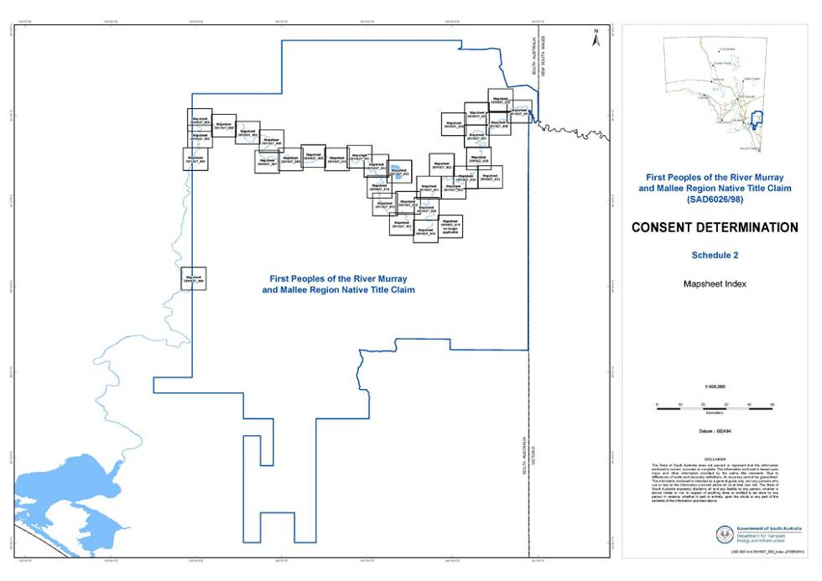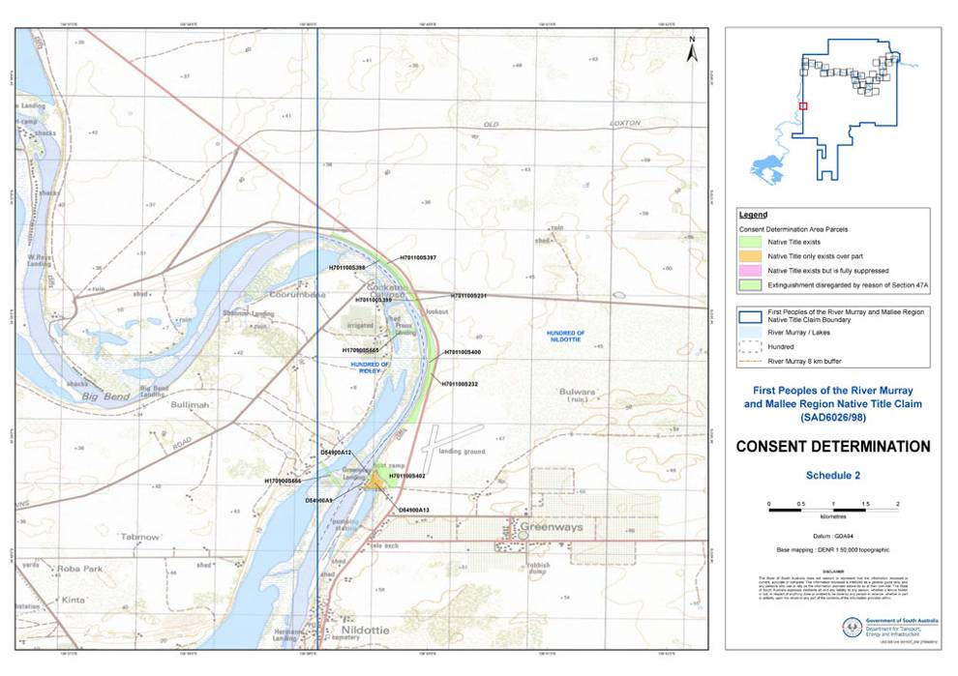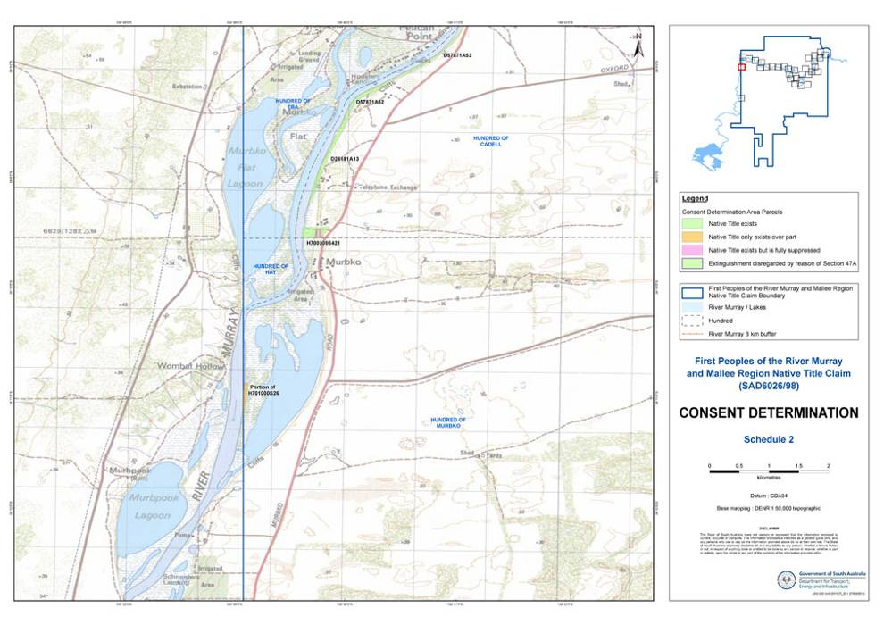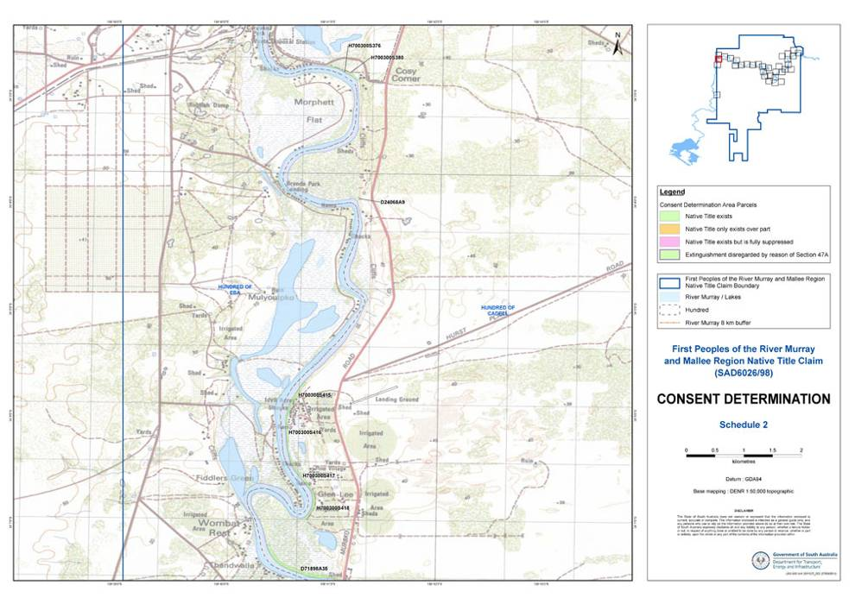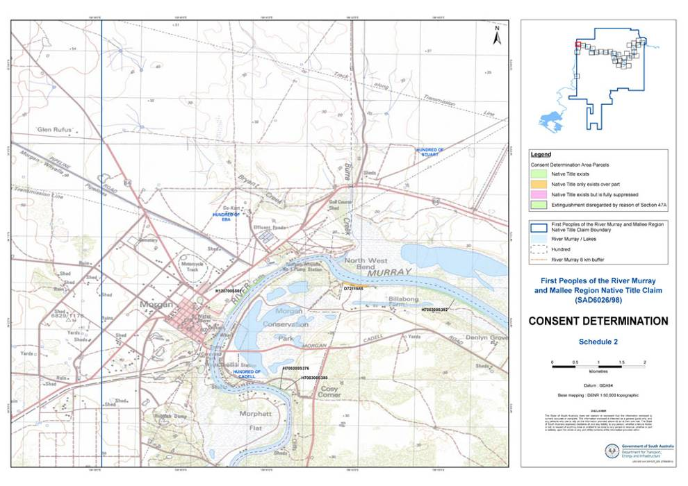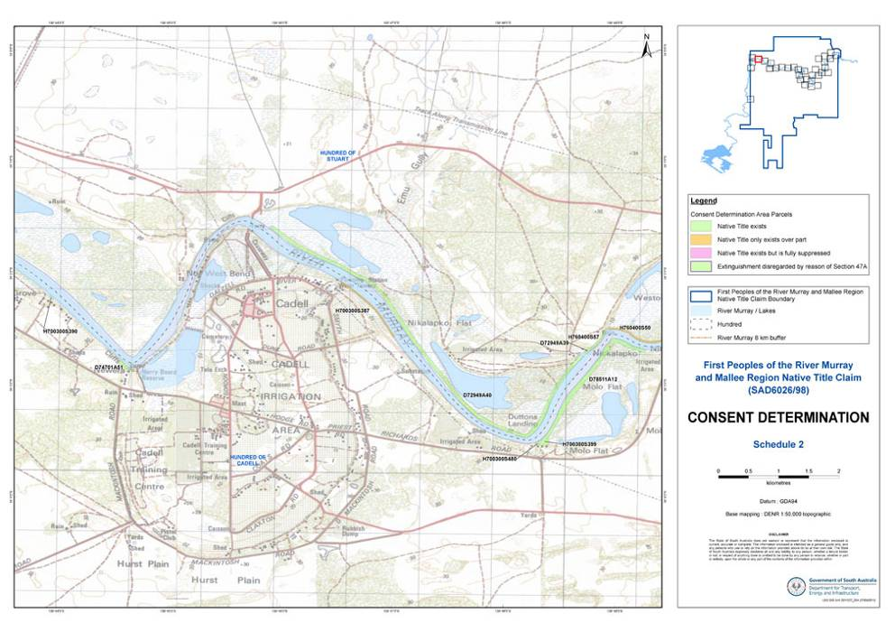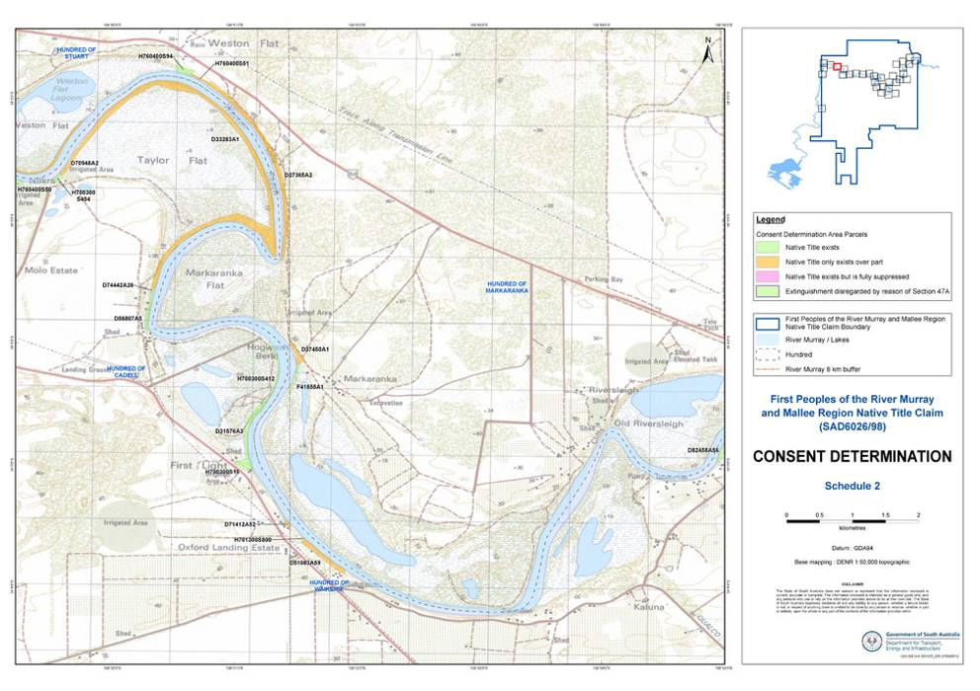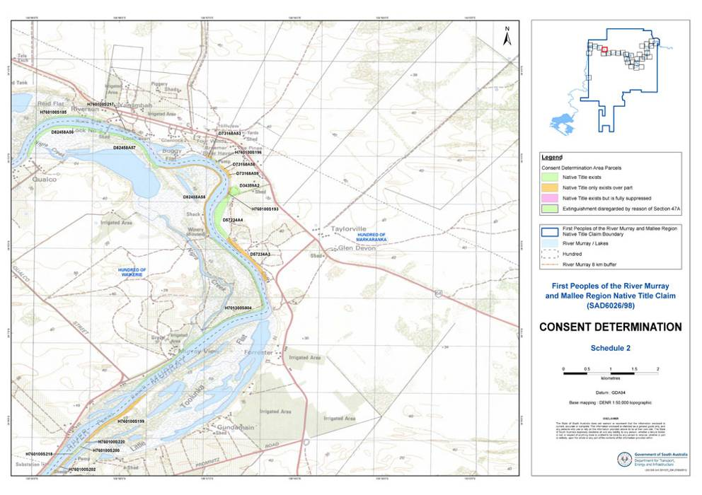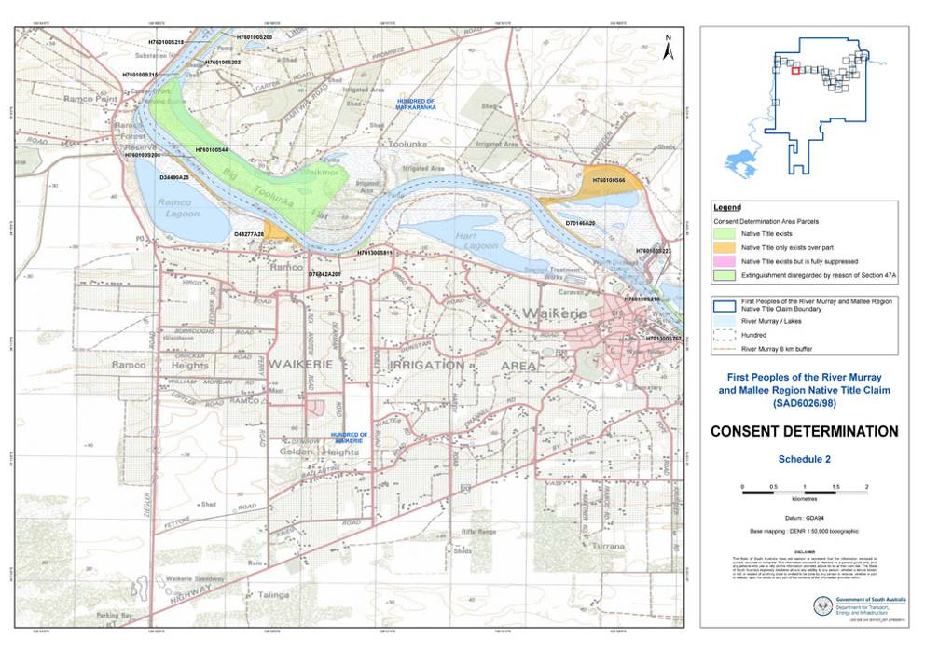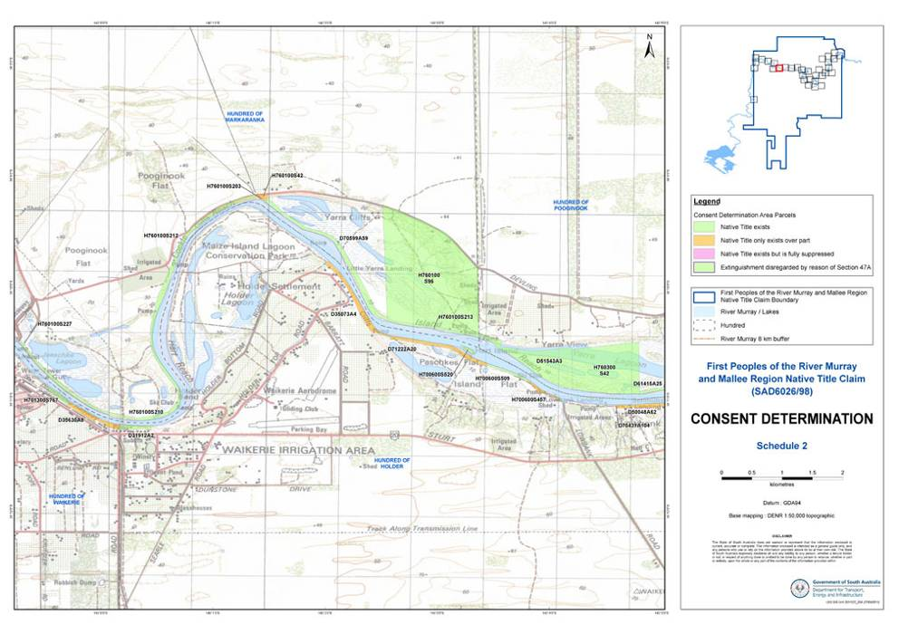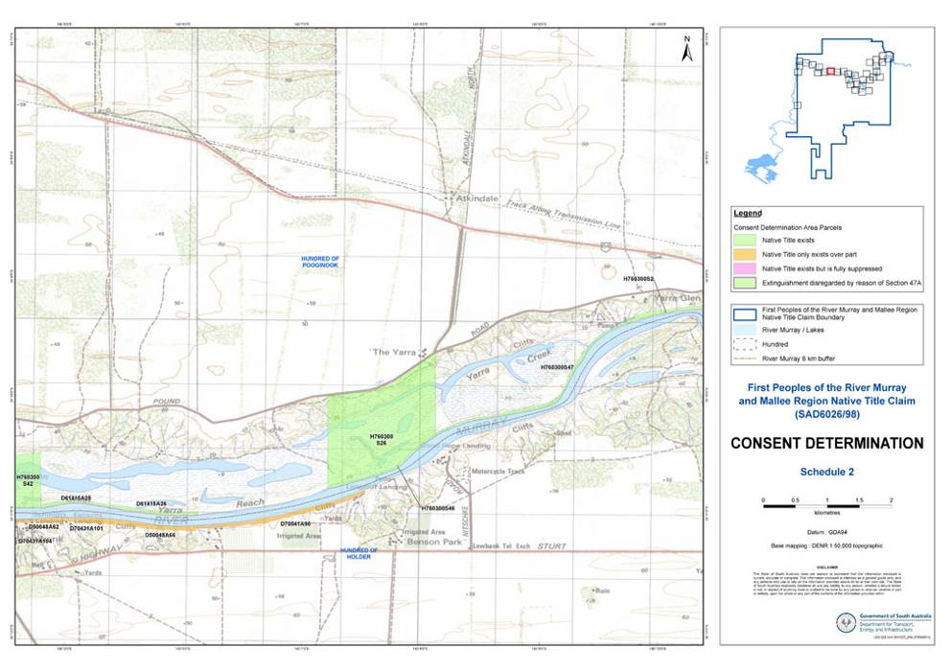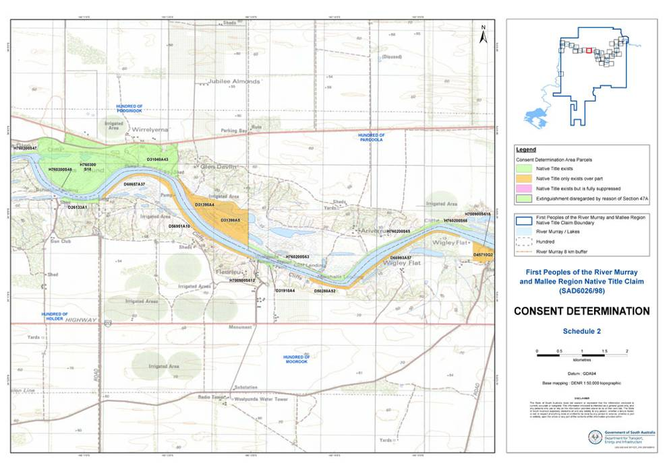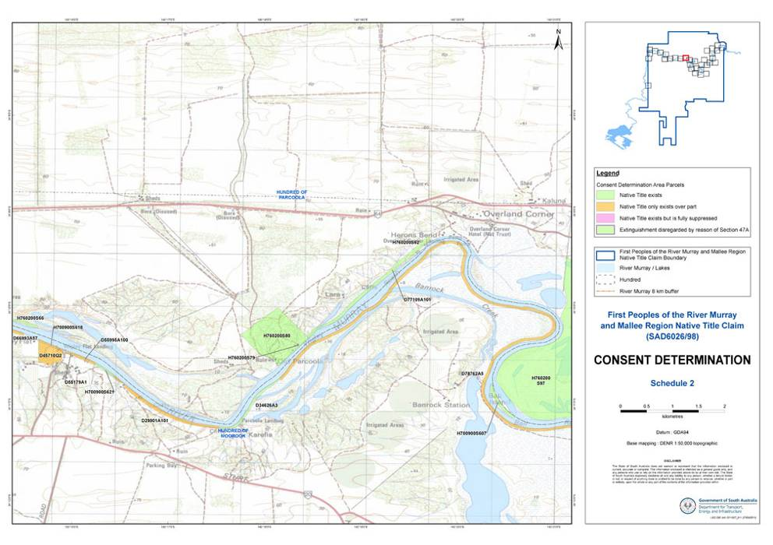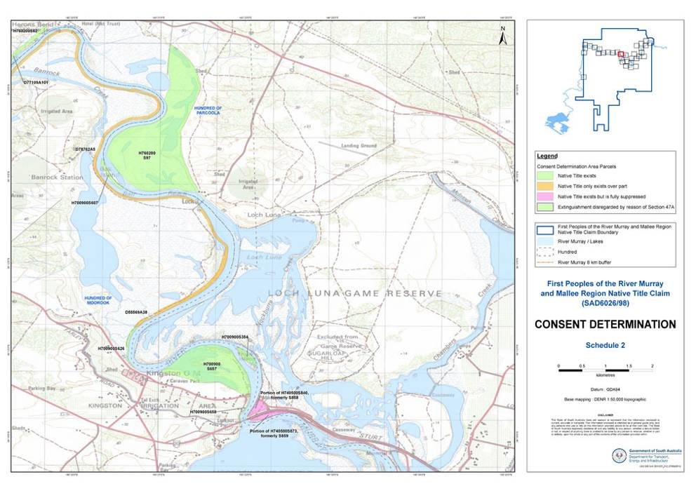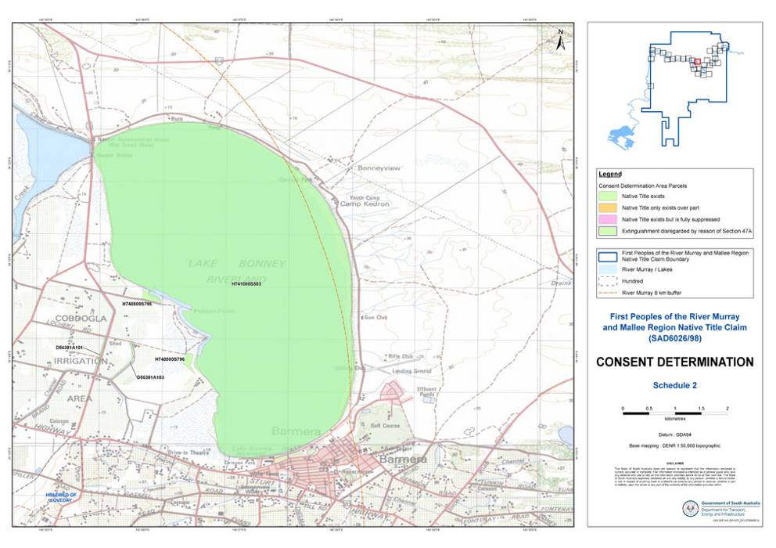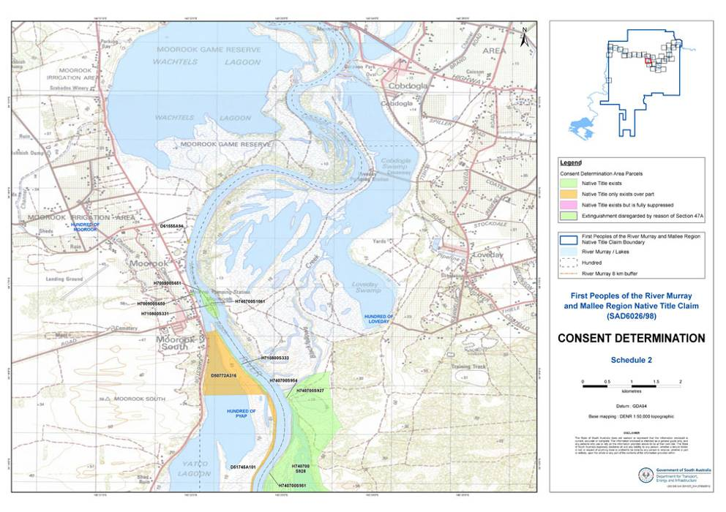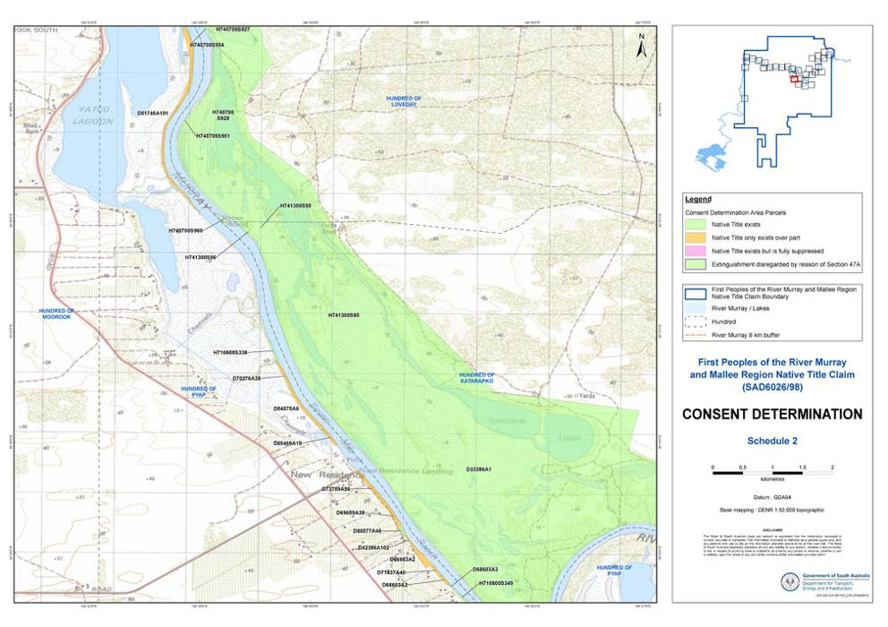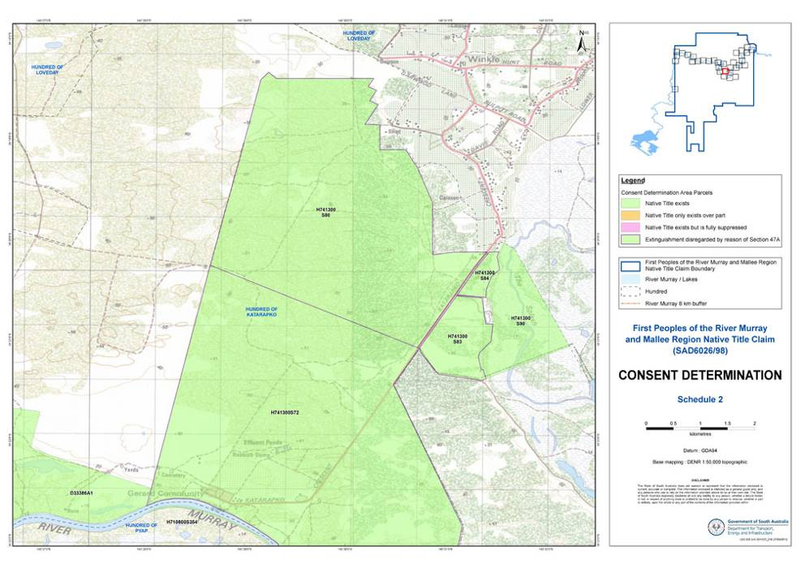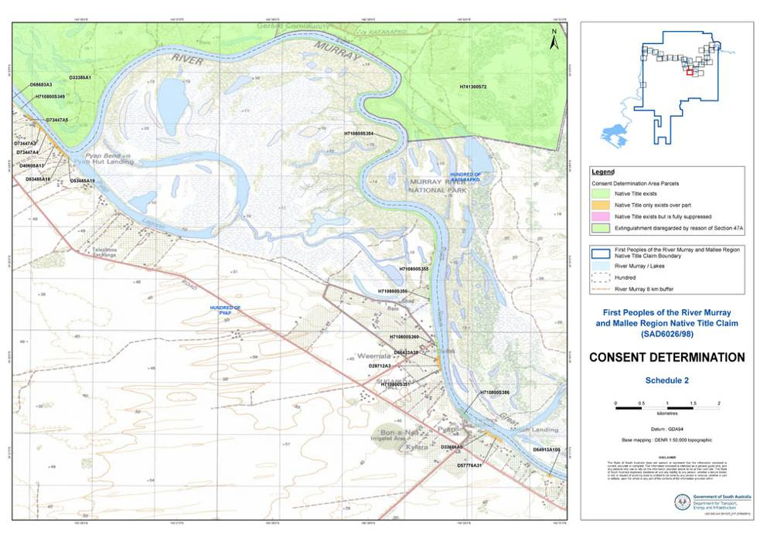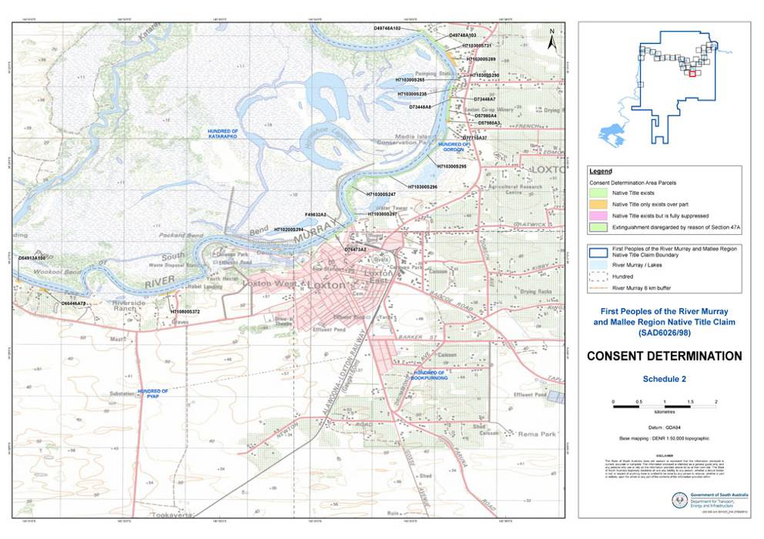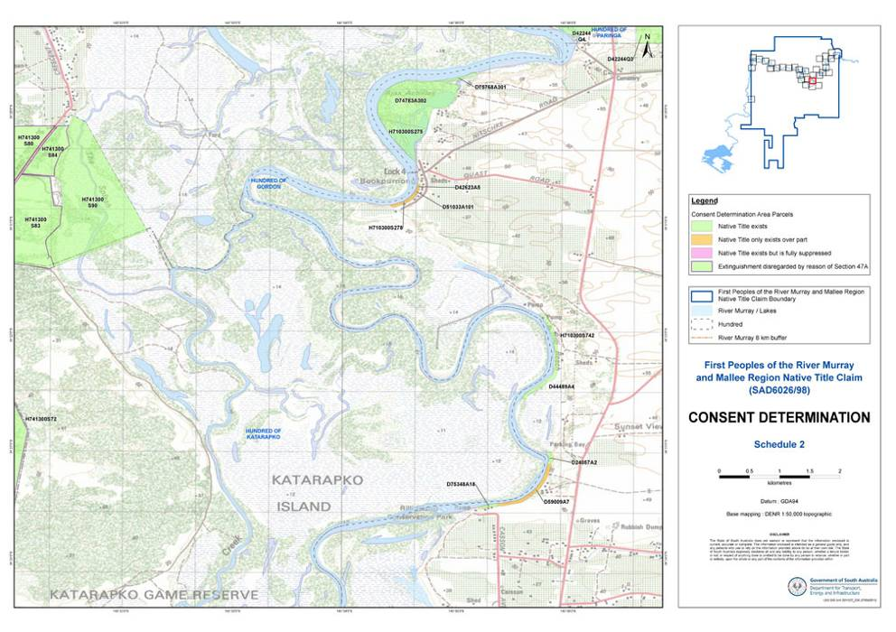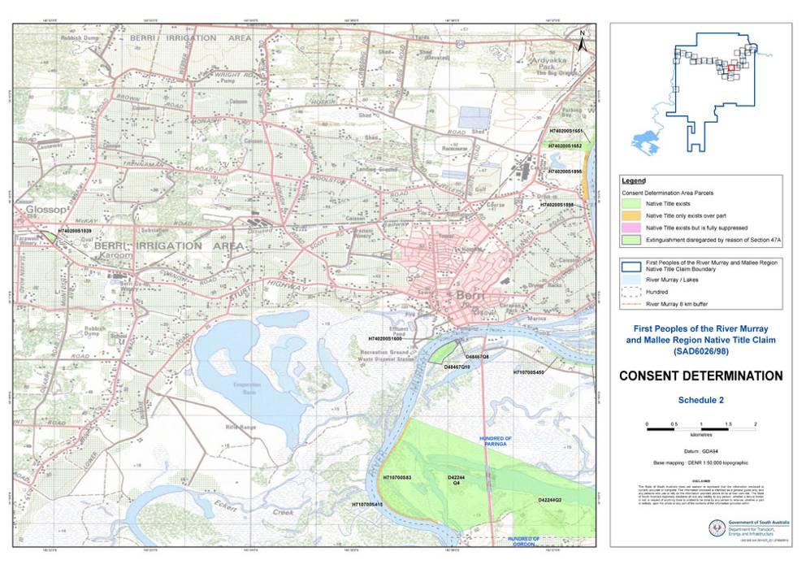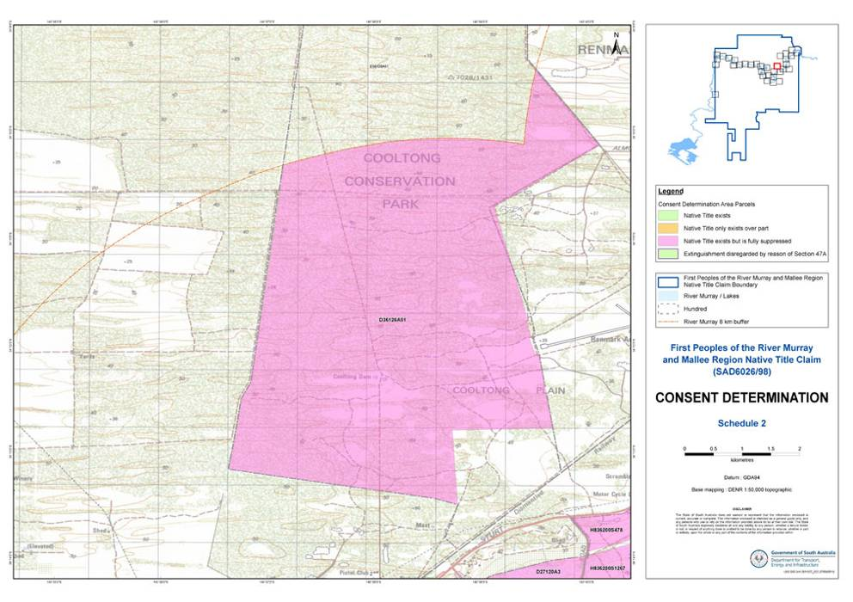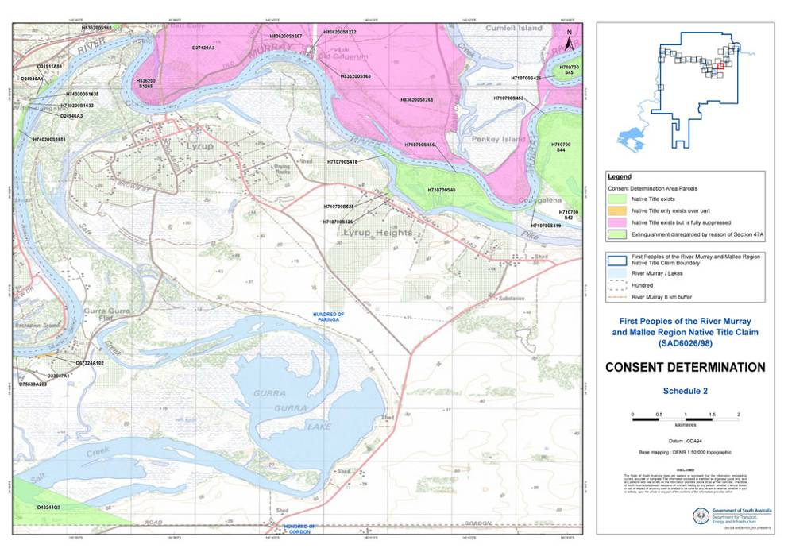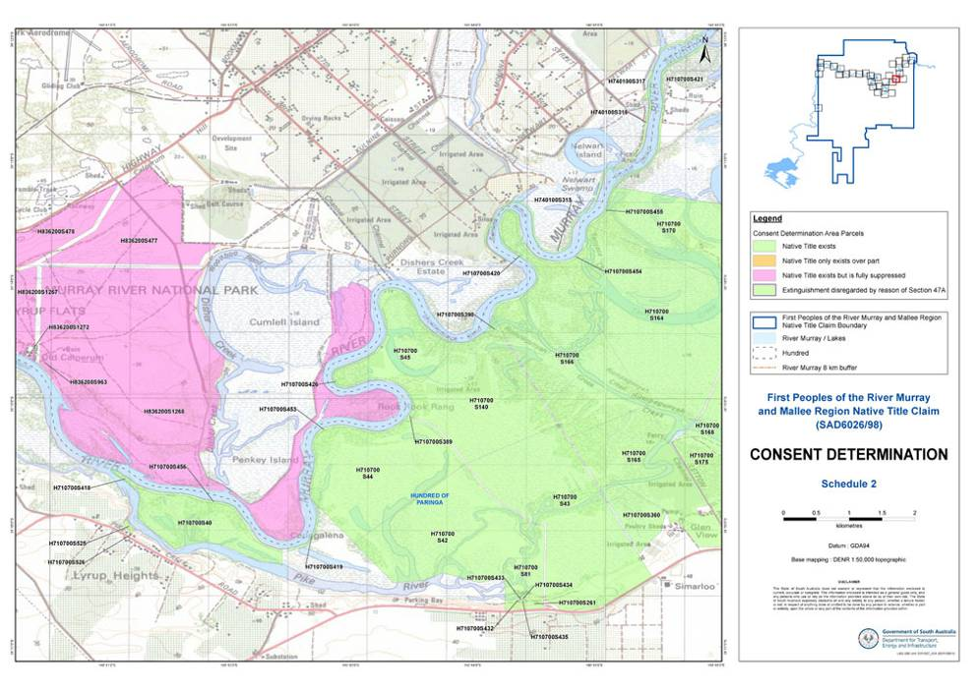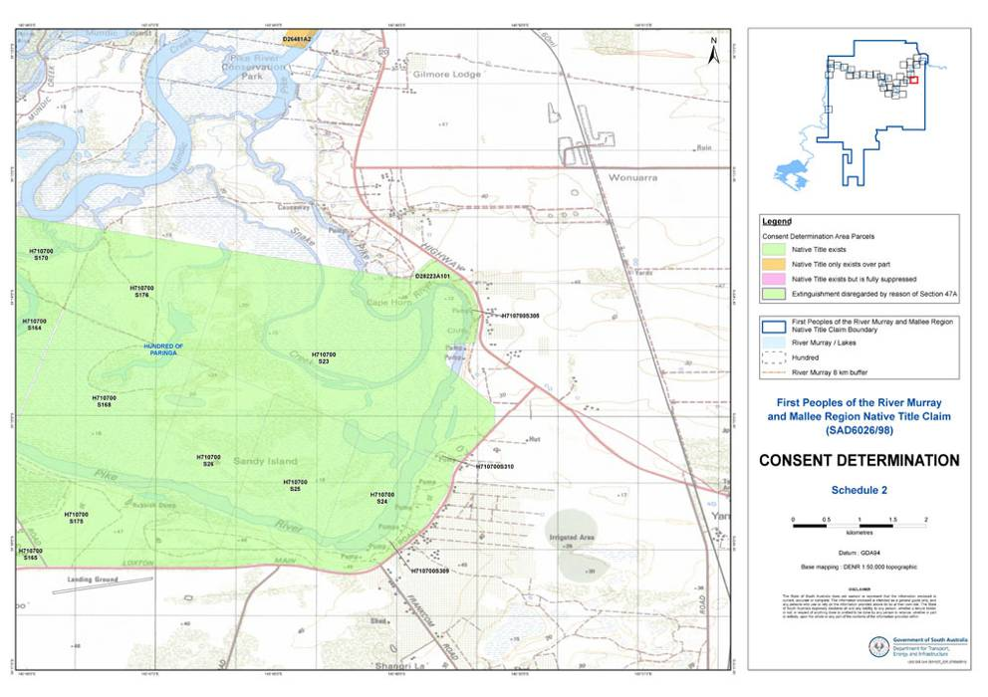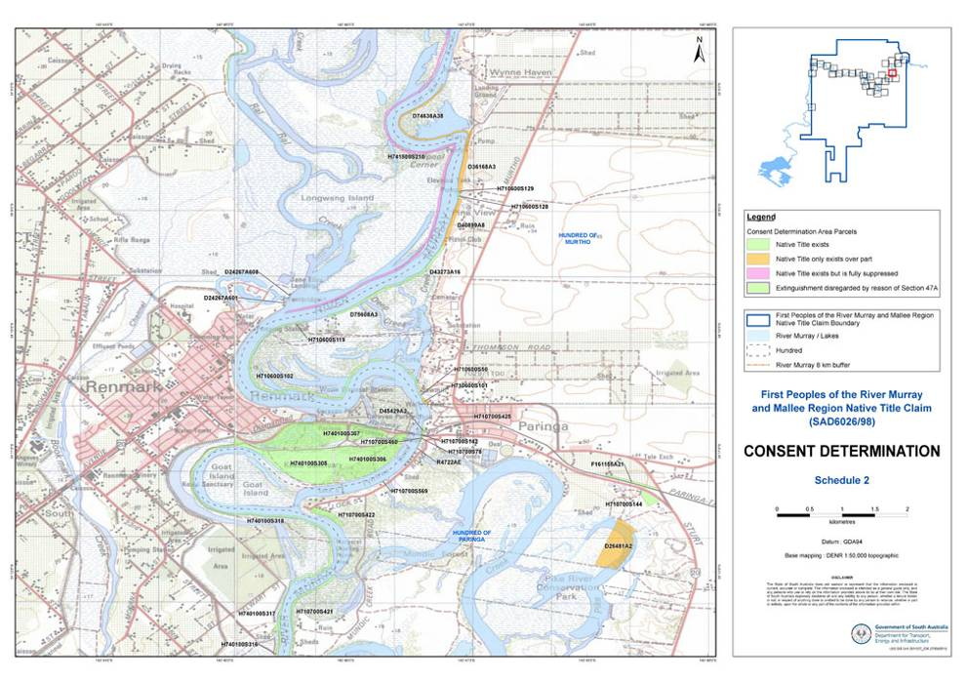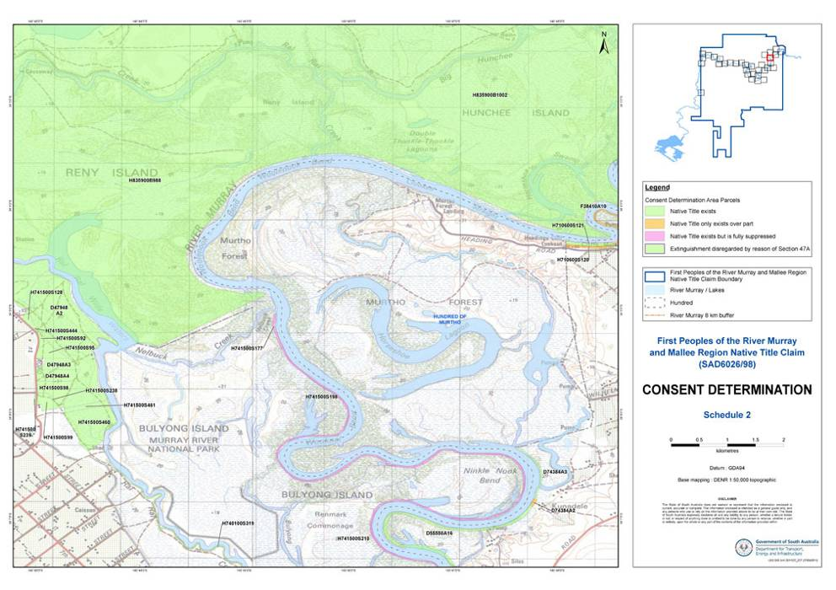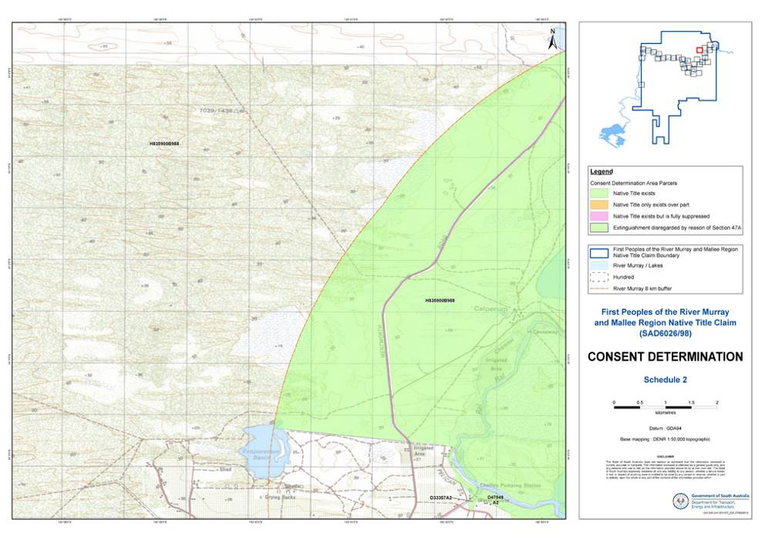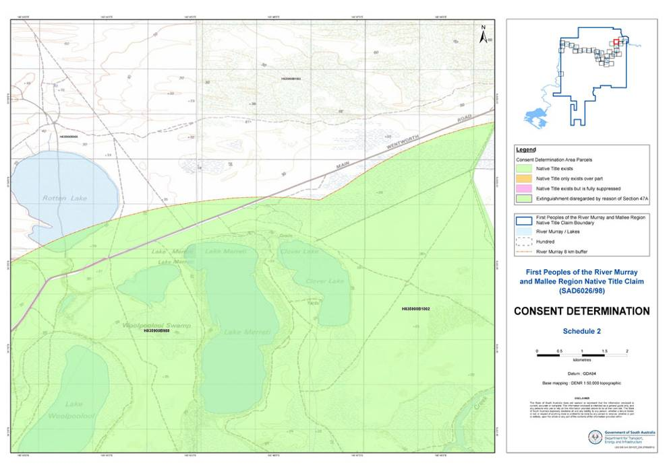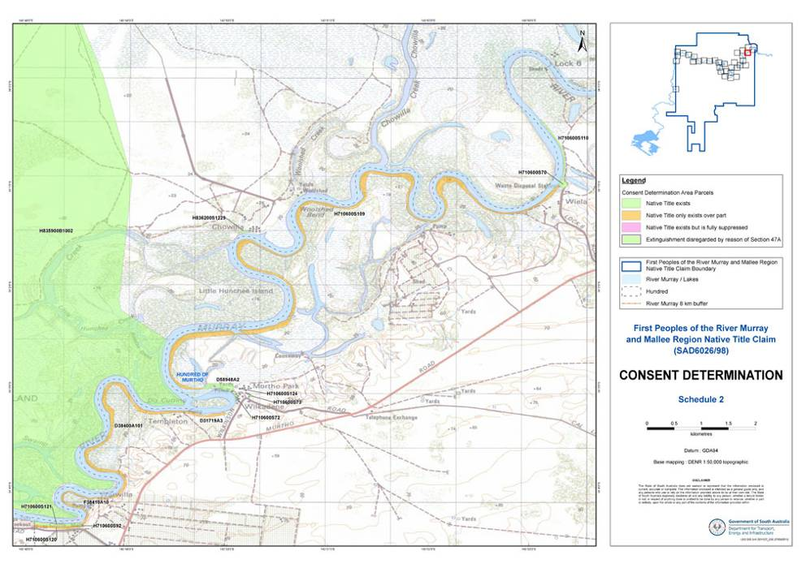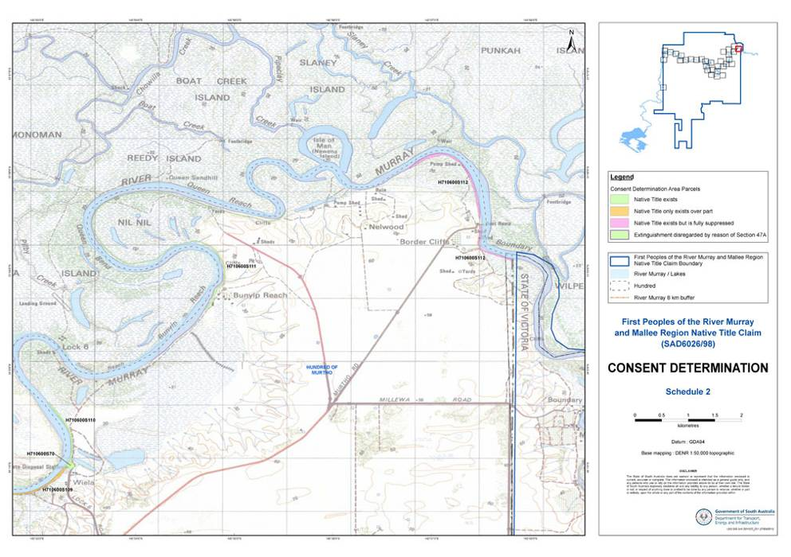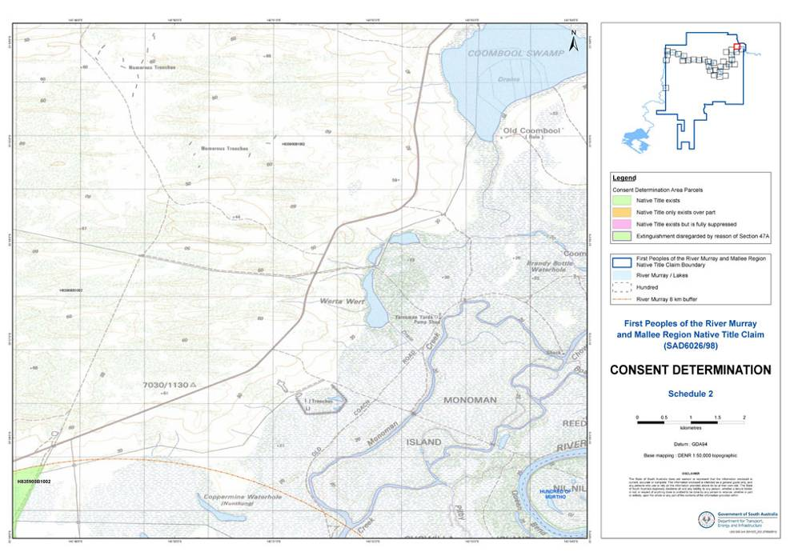

**SCHEDULE 3 – Areas within the external boundaries of the Determination Area where native title does not exist**

1. All roads which have been established under South Australian legislation.

**SCHEDULE 4 – Areas where the non-extinguishment principle applies by reason of a Vesting**

**Parcel Identifier Title Hundred Tenure**

D27120A3 CR5770/259 OH(Renmark) RM National Park

H836200S477 CR5779/259 OH(Renmark) RMNational Park

H836200S478 CR5779/259 OH(Renmark) RM National Park

H836200S963 CR5779/259 OH(Renmark) RM National Park

H836200S1265 CR5779/259 OH(Renmark) RM National Park

H836200S1267 CR5779/259 OH(Renmark) RM National Park

H836200S1268 CR5779/259 OH(Renmark) RM National Park

H836200S1272 CR5779/259 OH(Renmark) RM National Park

H741500S177 CR5779/259 OH(Renmark) RM National Park

H741500S198 CR5779/259 OH(Renmark) RM National Park

H741500S210 CR5779/259 OH(Renmark) RM National Park

Ptn H710600S112 – excluding

Customs House, its environs &

251D area CR5394/393 Murtho Chowilla GR

H836200S1229 CR5394/393 Murtho Chowilla GR

Ptn H740500S840 which was

formerly s 858 CR5755/974 OH(Renmark) Loch Luna GR

Cogdogla IA

Ptn H740500S873 which was

formerly s 859 CR5755/974 OH(Renmark) Loch Luna GR

Cobdogla IA

Ptn D36126A51 within 8 km

of the River Murray CR5694/147 OH(Renmark) Cooltong CP

**SCHEDULE 5 – Areas where extinguishment of native title must be disregarded by reason of s 47A of the *Native Title Act 1993* (Cth)**

The following parcels:

1. D48467Q8

2. D48467Q10

3. H740200S1039

4. H741300S72

5. H741300S80

6. H741300S83

7. H741300S84

**SCHEDULE 6 - Section 47B Parcels**

1. The Parties agree that, for the purposes of this Consent Determination, s 47B applies as indicated in the column entitled “Application of s 47B” in the Annexure A to Schedule 1.

2. In respect of parcels marked “Y”, s 47B applies to the entire parcel;

3. In respect of parcels marked “N”, s 47B does not apply to the parcel.

4. In respect of parcels marked “P”, s 47B applies only to the extent that the parcel was not covered by a licence for infrastructure purposes at 9 April 1998.

**Annexure A**

|  |  |  |  |
| --- | --- | --- | --- |
| **8 km buffer from Murray R within FPRMM Native Title Claim (SAD6026/98).** | | | |
| **Parcel_Id** | **Crown Record** | **Hundred** | **s47B applies?** |
| Portion Block 988 | CL 1381/44 | OH(Chowilla and Renmark) | N |
| Portion Block 1002 | CL 1381/45 | OH(Chowilla and Renmark) | N |
| D24057A2 | CR 5750/459 | Gordon | N |
| D24068A9 | CR 5763/693 | Cadell | N |
| D24267A601 | CR 5763/694 | OH(Renmark) | N |
| D24267A608 | CR 5763/694 | OH(Renmark) | N |
| D24946A1 | CR 5564/919 | OH(Renmark) | N |
| D24946A3 | CR 5572/737 | OH(Renmark) | N |
| D26133A1 | CR 5581/81 | Holder | Y |
| D26181A13 | CR 5750/478 | Cadell | N |
| D26481A2* | CR 5750/480 | Paringa | P |
| D27120A3 | CR 5770/259 | OH(Renmark) | Y |
| D27365A2* | CR 5491/687 | Stuart | P |
| D28223A101 | CR 5748/135 | Paringa | Y |
| D28712A3* | CR 5748/144 | Pyap | P |
| D29901A101* | CR 5750/517 | Moorook | P |
| D31040A43 | CR 5962/125 | Pooginook | P |
| D31398A4* | CR 5750/557 | Pooginook | N |
| D31398A5* | CR 5750/558 | Pooginook | N |
| D31576A3 | CR 5748/188 | Cadell | N |
| D31719A3* | CR 5750/560 | Murtho | P |
| D31910A4 | CR 5763/757 | Moorook | Y |
| D31911A51 | CR 5921/323 | OH(Renmark) | N |
| D31912A2 | CR 5641/980 | Holder | N |
| D33047A1 | CR 5383/686 | Paringa | Y |
| D33283A1* | CR 5401/581 | Cadell | N |
| D33357A2 | CR 5502/667 | OH(Renmark) | N |
| D33386A1 | CR 5926/538 | Katarapko | N/A |
| D33686A5* | CR 5693/749 | Pyap | P |
| D34359A2 | CR 5751/49 | Markaranka | P |
| D34490A25* | CR 5693/27 | Waikerie | N |
| D34626A3 | CR 5763/773 | Moorook | N |
| D35073A4* | CR 5423/658 | Holder | N |
| D35630A8* | CR 5715/234 | Waikerie | N |
| D36126A51 (portion) | CR 5694/147 | OH(Renmark) | N |

|  |  |  |  |
| --- | --- | --- | --- |
| **8 km buffer from Murray R within FPRMM Native Title Claim (SAD6026/98).** | | | |
| **Parcel_Id** | **Crown Record** | **Hundred** | **s47B applies?** |
| D36168A3* | CR 5748/232 | Murtho | N |
| D37450A1* | CR 5622/802 | Markaranka | P |
| D38400A101* | CR 5700/688 | Murtho | P |
| D40605A13* | CR 5742/982 | Pyap | P |
| D40899A8* | CR 5291/150 | Murtho | N |
| D42244Q3 | CR 5323/50 | Paringa | N |
| D42244Q4 | CR 5323/50 | Paringa | N |
| D42386A102* | CR 5690/488 | Pyap | N |
| D42623A5* | CR 5277/122 | Gordon | P |
| D43273A16 | CR 5322/153 | Murtho | P |
| D44489A4 | CR 5372/331 | Gordon | N |
| D45429A2 | CR 5357/574 | Paringa | Y |
| D45710Q2* | CR 5381/472 | Moorook | N |
| D47948A2 | CR 5501/328 | OH(Renmark) | N |
| D47948A3 | CR 5501/329 | OH(Renmark) | N |
| D47948A4 | CR 5501/330 | OH(Renmark) | N |
| D48277A28* | CR 5574/717 | Waikerie | N |
| D48467Q8 | CT 5860/142 | Paringa | N/A |
| D48467Q10 | CT 5860/142 | Paringa | N/A |
| D49748A102 | CR 5563/304 | Gordon | N |
| D49748A103 | CR 5563/305 | Gordon | N |
| D50048A62* | CR 5655/889 | Holder | N |
| D50048A66* | CR 5655/890 | Holder | N |
| D50288A52* | CR 5682/383 | Moorook | P |
| D50772A316* | CR 5614/128 | Pyap | P |
| D51033A101* | CR 5704/595 | Gordon | P |
| D51083A59* | CR 5753/111 | Waikerie | N |
| D51543A3 | CR 5698/248 | Pooginook | P |
| D51745A101* | CR 5734/951 | Pyap | N |
| D53485A18* | CR 5742/982 | Pyap | P |
| D53485A19* | CR 5742/982 | Pyap | P |
| D54575A6* | CR 5787/747 | Pyap | N |
| D54900A12 | CR 5837/806 | Nildottie | N |
| D54900A13* | CR 5837/807 | Nildottie | P |
| D54900A9 | CR 5837/804 | Nildottie | N |
| D54913A100* | CR 5873/348 | Pyap | P |
| D55179A1* | CR 5855/900 | Moorook | P |

|  |  |  |  |
| --- | --- | --- | --- |
| **8 km buffer from Murray R within FPRMM Native Title Claim (SAD6026/98).** | | | |
| **Parcel_Id** | **Crown Record** | **Hundred** | **s47B applies?** |
| D55469A10* | CR 5873/346 | Pyap | N |
| D55550A16 | CR 5846/664 | Murtho | P |
| D55569A38* | CR 5856/468 | Moorook | N |
| D55995A100* | CR 5935/606 | Moorook | N |
| D56381A101 | CR 5855/315 | OH (Renmark) | N |
| D56381A103 | CR 5855/316 | OH (Renmark) | N |
| D56807A5 | CR 5923/283 | Cadell | N |
| D56951A10* | CR6024/673 | Moorook | N |
| D57234A3* | CR 5885/149 | Markaranka | P |
| D57234A4 | CR 5885/150 | Markaranka | P |
| D57776A31* | CR 5927/732 | Pyap | N |
| D57871A52 | CR 5881/370 | Cadell | N |
| D57871A53 | CR 5881/370 | Cadell | N |
| D57980A3* | CR 5869/657 | Gordon | P |
| D57980A4 | CR 5869/658 | Gordon | N |
| D58948A2 | CR 5892/50 | Murtho | N |
| D59009A7* | CR 5929/481 | Gordon | P |
| D61415A25 | CR 5930/680 | Pooginook | Y |
| D61415A26 | CR 5930/681 | Pooginook | Y |
| D61555A94* | CR 5924/192 | Moorook | P |
| D66433A38* | CR 5942/950 | Pyap | N |
| D66446A78* | CR 5964/387 | Pyap | P |
| D66983A2* | CR 5963/677 | Pyap | P |
| D66993A57* | CR 5981/643 | Moorook | N |
| D67324A102* | CR 5977/250 | Paringa | P |
| D68603A2* | CR 5972/225 | Pyap | P |
| D68603A3 | CR 5972/226 | Pyap | Y |
| D68657A37* | CR 5966/95 | Moorook | P |
| D69659A38* | CR 5971/832 | Pyap | P |
| D70041A90* | CR 5975/6 | Holder | N |
| D70146A20* | CR 5972/469 | Markaranka | P |
| D70276A38* | CR 5984/155 | Pyap | N |
| D70431A101* | CR 5976/567 | Holder | P |
| D70431A104* | CR 5976/567 | Holder | P |
| D70599A59 | CR 6014/494 | Markaranka | N |
| D70948A2* | CR 5990/232 | Cadell | N |
| D71222A20* | CR 6003/515 | Holder | N |
| D71412A52* | CR 5984/157 | Cadell | P |
| D71837A40* | CR 5983/281 | Pyap | N |
| **8 km buffer from Murray R within FPRMM Native Title Claim (SAD6026/98).** | | | |
| **Parcel_Id** | **Crown Record** | **Hundred** | **s47B applies?** |
| D71898A35 | CR 5986/110 | Cadell | N |
| D72119A5* | CR 5996/318 | Cadell | N |
| D72949A39 | CR 6024/997 | Stuart | N |
| D72949A40 | CR 6024/997 | Stuart | N |
| D73168A53* | CR 6034/414 | Markaranka | P |
| D73168A58* | CR 6034/414 | Markaranka | P |
| D73168A59* | CR 6034/414 | Markaranka | P |
| D73447A3* | CR 6005/624 | Pyap | P |
| D73447A4* | CR 6005/624 | Pyap | P |
| D73447A5* | CR 6005/624 | Pyap | P |
| D73448A7* | CR 6037/588 | Gordon | N |
| D73448A8 | CR 6037/590 | Gordon | Y |
| D73759A56* | CR 5997/112 | Pyap | N |
| D74384A2* | CR 5998/415 | Murtho | P |
| D74384A3 | CR 5998/416 | Murtho | N |
| D74442A26 | CR 6010/253 | Cadell | P |
| D74638A38* | CR 6005/58 | Murtho | P |
| D74701A51 | CR 6007/442 | Cadell | N |
| D74783A302 | CR 6012/230 | Gordon | N |
| D75348A18 | CR 6008/849 | Gordon | P |
| D75530A203 | CR 6013/311 | Paringa | N |
| D75608A3 | CR6024/436 | Murtho | N |
| D75768A301 | CR 6017/84 | Gordon | P |
| D76473A2 | CR 6012/664 | Bookpurnong | N |
| D76842A201 | CR 6016/979 | Waikerie | N |
| D77109A101 | CR 6057/490 | Parcoola | N |
| D77710A37 | CR 6039/779 | Gordon | P |
| D78511A12 | CR 6029/611 | Cadell | P |
| D78762A5* | CR 6065/115 | Moorook | Y |
| D80577A48 | CR 6057/843 | Pyap | N |
| D82458A56 | CR 6070/841 | Waikerie | Y |
| D82458A57 | CR 6070/841 | Waikerie | Y |
| D82458A58* | CR 6070/841 | Waikerie | Y |
| F161155A21 | CR 5458/978 | Paringa | Y |
| F38410A10* | CR 5401/573 | Murtho | P |
| F41855A1 | CR 5802/151 | Markaranka | Y |
| F49832A2 | CR 5991/779 | Gordon | Y |
| H120700S501 | CR 5765/449 |  | N |
| H170900S665 | CR 5762/26 | Ridley | N |

|  |  |  |  |
| --- | --- | --- | --- |
| **8 km buffer from Murray R within FPRMM Native Title Claim (SAD6026/98).** | | | |
| **Parcel_Id** | **Crown Record** | **Hundred** | **s47B applies?** |
| H170900S666 | CR 5762/27 | Ridley | N |
| H700300S15 | CR 5763/400 | Cadell | N |
| H700300S376 | CR 5746/527 | Cadell | N |
| H700300S380 | CR 5607/879 | Cadell | N |
| H700300S387* | CR 5749/681 | Cadell | P |
| H700300S390 | CR 5771/298 | Cadell | N |
| H700300S392 | CR 5771/299 | Cadell | N |
| H700300S399 | CR 5763/401 | Cadell | N |
| H700300S404 | CR 5759/770 | Cadell | Y |
| H700300S412 | CR 5746/540 | Cadell | N |
| H700300S415 | CR 5510/99 | Cadell | N |
| H700300S416 | CR 5746/542 | Cadell | N |
| H700300S417 | CR 5746/543 | Cadell | N |
| H700300S418 | CR 5746/544 | Cadell | N |
| H700300S421 | CR 5510/99 | Cadell | N |
| H700300S480 | CR 5746/547 | Cadell | N |
| H700600S457* | CR 5771/308 | Holder | Y |
| H700600S509 | CR 5771/309 | Holder | Y |
| H700600S520 | CR 5771/310 | Holder | Y |
| H700900S354 | CR 5771/450 | Moorook | N/A |
| H700900S607 | CR 5771/453 | Moorook | Y |
| H700900S612 | CR 5771/454 | Moorook | Y |
| H700900S618* | CR 5693/753 | Moorook | P |
| H700900S621 | CR 5771/455 | Moorook | Y |
| H700900S626 | CR 5279/993 | Moorook | N |
| H700900S650 | CR 5440/691 | Moorook | N |
| H700900S651 | CR 5771/456 | Moorook | N/A |
| H700900S657 | CR 5764/266 | Moorook | N |
| H700900S658 | CR 5749/693 | Moorook | N |
| H701000S26 (portion within claim area) | CR 5749/697 | Murbko | N |
| H701100S231 | CR 5771/472 | Nildottie | N |
| H701100S232 | CR 5771/473 | Nildottie | N |
| H701100S397 | CR 5771/477 | Nildottie | N |
| H701100S398 | CR 5771/478 | Nildottie | N |
| H701100S399 | CR 5771/479 | Nildottie | N |
| H701100S400 | CR 5771/480 | Nildottie | N |

|  |  |  |  |
| --- | --- | --- | --- |
| **8 km buffer from Murray R within FPRMM Native Title Claim (SAD6026/98).** | | | |
| **Parcel_Id** | **Crown Record** | **Hundred** | **s47B applies?** |
| H701100S402 | CR 5837/810 | Nildottie | N |
| H701300S767 | CR 5771/487 | Waikerie | N |
| H701300S800 | CR 5747/88 | Waikerie | N |
| H701300S804 | CR 5747/89 | Waikerie | N |
| H701300S811 | CR 5750/89 | Waikerie | N |
| H710200S294 | CR 5750/92 | Bookpurnong | N |
| H710300S235 | CR 5750/94 | Gordon | N |
| H710300S247 | CR 5771/543 | Gordon | Y |
| H710300S265 | CR 5771/545 | Gordon | Y |
| H710300S275 | CR 5750/96 | Gordon | Y |
| H710300S278* | CR 5747/97 | Gordon | P |
| H710300S289* | CR 5750/100 | Gordon | N |
| H710300S290 | CR 5771/546 | Gordon | Y |
| H710300S295* | CR 5257/976 | Gordon | P |
| H710300S296 | CR 5771/549 | Gordon | Y |
| H710300S297 | CR 5771/550 | Gordon | Y |
| H710300S731 | CR 5510/96 | Gordon | Y |
| H710300S742* | CR 5750/101 | Gordon | N |
| H710600S50* | CR 5747/111 | Murtho | P |
| H710600S70 | CR 5750/20 | Murtho | N |
| H710600S72 | CR 5623/713 | Murtho | N |
| H710600S73 | CR 5764/334 | Murtho | N |
| H710600S92 | CR 5747/112 | Murtho | Y |
| H710600S101* | CR 5750/102 | Murtho | P |
| H710600S102 | CR 5750/103 | Murtho | Y |
| H710600S109* | CR 5750/703 | Murtho | P |
| H710600S110 | CR 5750/704 | Murtho | N |
| H710600S111 | CR 5747/113 | Murtho | N |
| H710600S112 excluding Customs House, its environs & 251D area | CR 5394/393 | Murtho | Y |
| H710600S119 | CR 5779/695 | Murtho | Y |
| H710600S120* | CR 5340/644 | Murtho | P |
| H710600S121 | CR 5750/705 | Murtho | N |
| H710600S124 | CR 5764/335 | Murtho | Y |
| H710600S128 | CR 5696/852 | Murtho | N |
| H710600S129* | CR 5750/706 | Murtho | P |

|  |  |  |  |
| --- | --- | --- | --- |
| **8 km buffer from Murray R within FPRMM Native Title Claim (SAD6026/98).** | | | |
| **Parcel_Id** | **Crown Record** | **Hundred** | **s47B applies?** |
| H710700S23 | CR 5647/298 | Paringa | N |
| H710700S24 | CR 5677/349 | Paringa | N |
| H710700S25 | CR 5652/545 | Paringa | N |
| H710700S26 | CR 5652/544 | Paringa | N |
| H710700S40 | CR 5750/707 | Paringa | N |
| H710700S42 | CR 5779/750 | Paringa | Y |
| H710700S43 | CR 5747/114 | Paringa | N |
| H710700S44 | CR 5747/115 | Paringa | N/A |
| H710700S45 | CR 5749/573 | Paringa | N/A |
| H710700S78 | CR 5330/302 | Paringa | Y |
| H710700S81 | CR 5750/709 | Paringa | N/A |
| H710700S83 | CR 5239/655 | Paringa | N/A |
| H710700S140 | CR 5749/572 | Paringa | N/A |
| H710700S142 | CR 5779/254 | Paringa | Y |
| H710700S144 | CR 5769/33 | Paringa | Y |
| H710700S164 | CR 5747/119 | Paringa | N/A |
| H710700S165 | CR 5749/574 | Paringa | N/A |
| H710700S166 | CR 5747/120 | Paringa | N/A |
| H710700S168 | CR 5747/121 | Paringa | N/A |
| H710700S170 | CR 5747/122 | Paringa | N/A |
| H710700S175 | CR 5747/123 | Paringa | N/A |
| H710700S176 | CR 5747/124 | Paringa | N/A |
| H710700S261 | CR 5750/711 | Paringa | P |
| H710700S305 | CR 5581/715 | Paringa | P |
| H710700S309 | CR 5652/543 | Paringa | P |
| H710700S310 | CR 5652/542 | Paringa | P |
| H710700S360 | CR 5750/712 | Paringa | N |
| H710700S389 | CR 5764/336 | Paringa | Y |
| H710700S390 | CR 5764/337 | Paringa | Y |
| H710700S415* | CR 5747/126 | Paringa | P |
| H710700S418 | CR 5769/35 | Paringa | Y |
| H710700S419 | CR 5747/128 | Paringa | N/A |
| H710700S420 | CR 5747/129 | Paringa | N/A |
| H710700S421 | CR 5769/36 | Paringa | Y |
| H710700S422 | CR 5501/20 | Paringa | Y |
| H710700S425 | CR 5764/343 | Paringa | Y |
| H710700S426 | CR 5747/130 | Paringa | N/A |

|  |  |  |  |
| --- | --- | --- | --- |
| **8 km buffer from Murray R within FPRMM Native Title Claim (SAD6026/98).** | | | |
| **Parcel_Id** | **Crown Record** | **Hundred** | **s47B applies?** |
| H710700S432 | CR 5769/37 | Paringa | Y |
| H710700S433 | CR 5750/714 | Paringa | Y |
| H710700S434 | CR 5769/38 | Paringa | Y |
| H710700S435 | CR 5769/39 | Paringa | Y |
| H710700S450 | CR 5747/135 | Paringa | N |
| H710700S453 | CR 5746/586 | Paringa | N/A |
| H710700S454 | CR 5746/587 | Paringa | N/A |
| H710700S455 | CR 5746/588 | Paringa | N/A |
| H710700S456 | CR 5750/718 | Paringa | N/A |
| H710700S460 | CR 5754/414 | Paringa | N |
| H710700S525 | CR 5746/589 | Paringa | P |
| H710700S526 | CR 5769/42 | Paringa | Y |
| H710700S569 | CR 5746/590 | Paringa | Y |
| H710800S331 | CR 5769/43 | Pyap | N/A |
| H710800S333 | CR 5769/44 | Pyap | Y |
| H710800S338 | CR 5746/595 | Pyap | N |
| H710800S349 | CR 5750/723 | Pyap | N |
| H710800S351* | CR 5464/762 | Pyap | P |
| H710800S354 | CR 5539/564 | Pyap | N |
| H710800S355 | CR 5746/601 | Pyap | N |
| H710800S356 | CR 5750/725 | Pyap | N |
| H710800S360 | CR 5464/763 | Pyap | N |
| H710800S372* | CR 5746/609 | Pyap | P |
| H710800S386 | CR 5769/45 | Pyap | Y |
| H740100S305 | CR 5382/928 | OH(Renmark) | N |
| H740100S306 | CR 5382/928 | OH(Renmark) | N |
| H740100S307 | CR 5382/928 | OH(Renmark) | N |
| H740100S315 | CR 5750/676 | OH(Renmark) | N |
| H740100S316 | CR 5747/159 | OH(Renmark) | N |
| H740100S317 | CR 5611/730 | OH(Renmark) | N |
| H740100S318 | CR 5385/162 | OH(Renmark) | N |
| H740100S319 | CR 5747/160 | OH(Renmark) | N |
| H740200S1039 | CT 5963/675 | OH(Renmark) | N/A |
| H740200S1600 | CR 5771/559 | OH(Renmark) | N |
| H740200S1633 | CR 5747/162 | OH(Renmark) | N |
| H740200S1635 | CR 5750/678 | OH(Renmark) | N |
| H740200S1651 | CR 5884/143 | OH(Renmark) | N |
| H740200S1652 | CR 5884/144 | OH(Renmark) | N |
| H740200S1895* | CR 5689/952 | OH(Renmark) | N |

|  |  |  |  |
| --- | --- | --- | --- |
| **8 km buffer from Murray R within FPRMM Native Title Claim (SAD6026/98).** | | | |
| **Parcel_Id** | **Crown Record** | **Hundred** | **s47B applies?** |
| H740200S1898 | CR 5750/680 | OH(Renmark) | N |
| H740500S795 | CR 5771/576 | OH (Renmark) | N |
| H740500S796 | CR 5771/577 | OH (Renmark) | N |
| Portion of H740500S840 that was formerly s 858 | CR 5755/974 | OH (Renmark) | N |
| Portion of H740500S873 that was formerly s 859 | CR 5755/974 | OH (Renmark) | N |
| H740700S927 | CR 5750/685 | Loveday | N/A |
| H740700S928 | CR 5750/686 | Loveday | N/A |
| H740700S951 | CR 5750/687 | Loveday | N/A |
| H740700S954 | CR 5747/170 | Loveday | N/A |
| H740700S960 | CR 5771/589 | Loveday | N |
| H740700S1061 | CR 5771/590 | Loveday | N/A |
| H741000S503 | CR 5762/324 | OH(Renmark) | N |
| H741300S72 | CT 5584/149 | Katarapko | N/A |
| H741300S80 | CT 5472/99 | Katarapko | N/A |
| H741300S83 | CT 5472/99 | Katarapko | N/A |
| H741300S84 | CT 5472/99 | Katarapko | N/A |
| H741300S85 | CR 5750/690 | Katarapko | N/A |
| H741300S90 | CR 5747/180 | Katarapko | N/A |
| H741300S95 | CR 5750/691 | Katarapko | N/A |
| H741300S96 | CR 5750/692 | Katarapko | N/A |
| H741500S92 | CR 5304/90 | OH(Renmark) | N |
| H741500S95 | CR 5304/91 | OH (Renmark) | N |
| H741500S98 | CR 5304/94 | OH(Renmark) | N |
| H741500S99 | CR 5304/95 | OH(Renmark) | N |
| H741500S128 | CR 5304/101 | OH(Renmark) | N |
| H741500S177 | CR 5779/259 | OH(Renmark) | N |
| H741500S198 | CR 5779/259 | OH(Renmark) | N |
| H741500S210 | CR 5779/259 | OH(Renmark) | N |
| H741500S238 | CR 5306/2 | OH(Renmark) | N |
| H741500S239 | CR 5306/3 | OH(Renmark) | N |
| H741500S444 | CR 5307/412 | OH(Renmark) | N |
| H741500S460 | CR 5304/348 | OH(Renmark) | N |
| H741500S461 | CR 5304/349 | OH(Renmark) | N |

|  |  |  |  |
| --- | --- | --- | --- |
| **8 km buffer from Murray R within FPRMM Native Title Claim (SAD6026/98).** | | | |
| **Parcel_Id** | **Crown Record** | **Hundred** | **s47B applies?** |
| H760100S42* | CR 5750/654 | Markaranka | P |
| H760100S44 | CR 5771/669 | Markaranka | Y |
| H760100S66* | CR 5750/655 | Markaranka | P |
| H760100S96 | CR 5331/661 | Markaranka | N/A |
| H760100S185 | CR 5748/979 | Markaranka | Y |
| H760100S193* | CR 5748/983 | Markaranka | P |
| H760100S196 | CR 5701/510 | Markaranka | N |
| H760100S199* | CR 5750/662 | Markaranka | N |
| H760100S200 | CR 5748/984 | Markaranka | N |
| H760100S202* | CR 5748/985 | Markaranka | N |
| H760100S203* | CR 5750/663 | Markaranka | P |
| H760100S204 | CR 5771/671 | Markaranka | Y |
| H760100S210 | CR 5750/664 | Markaranka | N |
| H760100S212 | CR 5750/665 | Markaranka | N |
| H760100S213 | CR 5748/988 | Markaranka | N |
| H760100S215 | CR 5748/990 | Markaranka | N |
| H760100S217* | CR 5419/436 | Markaranka | P |
| H760100S218 | CR 5771/672 | Markaranka | Y |
| H760100S220 | CR 5770/106 | Markaranka | Y |
| H760100S227 | CR 5763/581 | Markaranka | Y |
| H760200S62 | CR 5968/773 | Parcoola | N |
| H760200S63 | CR 5748/994 | Parcoola | N |
| H760200S65 | CR 5897/260 | Parcoola | Y |
| H760200S66 | CR 5750/667 | Parcoola | N |
| H760200S79 | CR 5748/995 | Parcoola | N |
| H760200S80 | CR 5729/826 | Parcoola | N |
| H760200S97 | CR 5748/998 | Parcoola | N/A |
| H760300S2* | CR 5750/669 | Pooginook | P |
| H760300S18 | CR 5750/13 | Pooginook | N/A |
| H760300S26 | CR 5748/999 | Pooginook | N/A |
| H760300S42 | CR 5770/107 | Pooginook | Y |
| H760300S46 | CR 5749/2 | Pooginook | N/A |
| H760300S47 | CR 5752/785 | Pooginook | N |
| H760300S48 | CR 5752/786 | Pooginook | N/A |
| H760400S50* | CR 5749/8 | Stuart | N |
| H760400S51* | CR 5752/787 | Stuart | P |
| H760400S57 | CR 5749/10 | Stuart | N |

|  |  |  |  |
| --- | --- | --- | --- |
| **8 km buffer from Murray R within FPRMM Native Title Claim (SAD6026/98).** | | | |
| **Parcel_Id** | **Crown Record** | **Hundred** | **s47B applies?** |
| H760400S94 | CR 5758/28 | Stuart | N |
| H836200S477 | CR 5779/259 | OH (Renmark) | N |
| H836200S478 | CR 5779/259 | OH (Renmark) | N |
| H836200S963 | CR 5779/259 | OH (Renmark) | N |
| H836200S965 | CR 5764/653 | OH (Renmark) | Y |
| H836200S1229 | CR 5394/393 | Murtho | N |
| H836200S1265 | CR 5779/259 | OH(Renmark) | N |
| H836200S1267 | CR 5779/259 | OH(Renmark) | N |
| H836200S1268 | CR 5779/259 | OH(Renmark) | N |
| H836200S1272 | CR 5779/259 | OH(Renmark) | N |
| R4722AE | CR 5376/116 | Paringa | Y |
| For the avoidance of doubt, and irrespective of the description above, the whole of Lake Bonney Riverland (H741000S503) is included in CD land | | | |

|  |  |
| --- | --- |
| IN THE FEDERAL COURT OF AUSTRALIA |  |
| DISTRICT REGISTRY |  |
|  |  |

|  |  |
| --- | --- |
| BETWEEN: | DOROTHY TURNER, MARK AGIUS, JEAN AGIUS, DENISE VARCOE, JIM ABDULLAH, LORETTA SMITH, GEORGE TRIPP, GLADYS E SUMNER AND GLENDA RIGNEY  Applicants |
| AND: | STATE OF SOUTH AUSTRALIA, NEIL JOHANSEN, WENDY FAYE BELL, BRENTON PAUL BELL, ROWLAND JOHN BEECH, IAN CHARLES BAXTER, BARMERA DISTRICT WAR MEMORIAL COMMUNITY CENTRE, PHILIPPA MARY AUSTIN, TREVOR PAUL ARNOLD, IAN LESLIE ARMSTRONG, RODNEY NORMAN STOECKEL, SOUTH AUSTRALIAN RECREATIONAL FISHING ADVISORY COUNCIL INC, EVELYN MYRTLE ENGLISH, EDWARD REGINALD ENGLISH, CORNEL CRACIUN, ALEXANDRA CRACIUN, MARIA DEL PILAR ESTEBAN, GLENDA MAY CLEMENTS, JOSE ANTONIO ESTEBAN, ERROL MATSCHOSS MOTORS PTY LTD, ROBERT JAN CORNELSEN, GM ARNOLD & SON PTY LTD, STEVEN PETER HUDSON, STEPHEN MICHAEL HOGG, CATHERINE McGILL HEWETT, BRUCE WILLIAM HEWETT, JUNG BAHADUR SINGH GREWAL, KERYN LEE GORMAN, TREVOR CLYDE MANUEL, ERROL LEITH MATSCHOSS, GREGORY RONALD MICKE, ARNOLD MALCOLM NICOLAI, JEANETTE MARGARET O’LEARY, LEO JOHN O’LEARY, LYNTON MURRAY SCOTT, SHELL COMPANY OF AUSTRALIA LIMITED, CAROLE ANNE STAFFORD, JAYNE VAN DER BIEZEN, OSCAR TONEGUZZO, COLLEEN PATRICIA THOMPSON, GRAHAM CHARLES GEORGE STAFFORD, TONY VAN DER BIEZEN, JENNY VONIC, LESLEE WALLACE, MAUREEN JOAN WATSON, COLIN HERBERT WEGNER, MEREDITH MARY WEGNER, KRIS ANDRE WERNER, SUZANNE MARY WHETSTONE, TIMOTHY JOHN WHETSTONE, SOUTH AUSTRALIAN FIELD & GAME ASSOCIATION INC, SOUTH AUSTRALIAN APIARISTS ASSOCIATION INC, ROYAL AUSTRALASIAN ORNITHOLOGISTS UNION, ELECTRANET PTY LTD, JACQUE ZAGOTSIS, CON ZAGOTSIS, GLEN FREDERICK WOOLDRIDGE, WILLIAM ROY WILDEN, MID MURRAY COUNCIL, DISTRICT COUNCIL OF RENMARK PARINGA, DISTRICT COUNCIL OF LOXTON WAIKERIE, BERRI BARMERA COUNCIL, COMMONWEALTH OF AUSTRALIA, MITOLO HOLDINGS PTY LTD, JOHN MURRAY LUNN, ENVESTRA LTD, ANTHONY LEVER, BERRI IRRIGATION TRUST, JOSEPHINE LORNA ARMSTRONG, SIETSE VENEMA, COLIN TERRENCE WESLEY VENABLES, STEINER HOLDINGS PTY LTD, IAN ROSS CLEMENTS, GAIL ROSEMARY CAMPAIN, COBDOGLA IRRIGATION TRUST, ANTHONY MICHAEL ENGLISH, MICHAEL RICHARD KASSEBAUM, DEBBIE ELIZABETH MILBURN, RAELENE GLORIA LEATHERS, JOANNE KEIGHTLEY, DEBRA L SCOTT, ST JOHN AMBULANCE AUSTRALIA SA INC, ETSA UTILITIES, SALWA VALETTI, TELSTRA CORPORATION LIMITED, DIRECTOR OF NATIONAL PARKS, WAIKERIE IRRIGATION TRUST, DAMIEN JOHN WILKSCH, GARRY IAN WARRICK, SOUTH AUSTRALIAN NATIVE TITLE SERVICES LTD, WILDCATCH FISHERIES SA INC  Respondents |

|  |  |
| --- | --- |
| : |  |
| DATE: |  |
| PLACE: |  |

**REASONS FOR JUDGMENT**

1. This application for the determination of native title rights and interests is one of the earliest claims made in South Australia under the *Native Title Act 1993* (Cth) (the Native Title Act). The application was lodged on 9 April 1998 to the National Native Title Tribunal, under the procedure then in force and subsequently transferred to the Court following the enactment of the *Native Title Amendment Act 1998* (Cth).
2. The claim is made over a significant part of the eastern region of South Australia on behalf of the claim group known as the First Peoples of the River Murray and the Mallee Region.
3. It comprises an area running west and south from the South Australian border with Victoria at about the point where the River Murray first enters South Australia. It runs westerly about 150 km to Morgan on the River Murray, and runs south along the border also for about a further 150 km and then roughly westerly more or less along the course of the River Murray to Morgan. That suggests a claim area almost square in shape, but that would be a little misleading. The claim area is accurately depicted in the maps which comprise Schedule 2 to the Orders made today, incorporating the Carcuma Conservation Park significantly further south from the shape I have described. The River Murray from the point where it enters South Australia from Victoria wends its way somewhat south and east but very roughly in an easterly direction towards Morgan. The claim area includes extensive areas of land north of the Murray River between the South Australian border and more extensively, south of the Murray River commonly described as the Mallee Region.
4. The First Peoples of the River Murray and the Mallee Region, the State of South Australia, the Commonwealth and the other parties to the application have come to an agreement as to how the claim should be resolved.
5. Not surprisingly, the agreed resolution is somewhat complex.
6. Firstly, there is to be a Determination of native title rights and interests. The Determination proposed relates to a significant number of areas of land and waters within the claim area, including the area of Calperum Pastoral Lease within 8 km of the stem of the River Murray, numerous other allotments and as well the bed bank and waters of the River Murray. Those areas are fully described in Order 2 and Schedule 1 and Annexure A to the Determination. The detailed maps in Schedule 2 also depict clearly those areas. Secondly, it is proposed to enter into an Indigenous Land Use Agreement (the Determination Area).
7. Immediately following the making of the Determination, the State and the Applicants will execute the River Murray and Crown Lands Indigenous Land Use Agreement (the ILUA). It provides for, among other things, the manner of exercise of native title rights in the Determination Area, the exercise of traditional rights in other designated areas of the claim area, compensation benefits for any native title holders in relation to the claim area and a process for the undertaking of future acts by the State in the claim area. The ILUA covers the entire claim area and provides for the withdrawal of the remainder of the claim (with a promise not to lodge any further applications within the ILUA Area). It also provides that all benefits provided by it are full and final settlement of any compensation liability, meaning there will be no compensation claim over the claim area. Immediately following the execution of the ILUA, the Applicant will discontinue the claim over the balance of the claim area.
8. The context of the agreed resolution is, of course, the necessary balancing of rights and interests which the Native Title Act requires. The Determination, and the terms of the ILUA, together give effect to that balancing, which includes provision for compensation as well as the exercise of traditional rights by the First Peoples of the River Murray and the Mallee Region and for their role in the future in respect of the balance of the claim area. That is explained in the joint submissions of the First Peoples of the River Murray and the Mallee region and the State of South Australia. The agreed resolution required the parties to consider the application of the detailed provisions of ss 47, 47A and 47B of the Native Title Act. It also required detailed consideration of the tenure history over the claim area.
9. A tenure history of the claim area was provided by the State, and made available to all the parties to the claim. The State has carried out a very detailed historical analysis of this tenure which informed the consent determination negotiations. This has allowed the State and the Applicants to agree on a defined set of specific parcels to comprise the Determination Area rather than generically describing this area. In line with decision of the Full Court of the Federal Court in *De Rose v State of South Australia (No 2)* (2005) 145 FCR 290 (*De Rose Hill*) and subsequent Consent Determinations in this State, paragraph 11 of the Determination recognises the extinguishment of native title rights and interests over the pastoral leases within the Determination Area (the Calperum Leases), where exclusive possession-style improvements authorised by the Pastoral Leases have been constructed.
10. There are a number of observations to be made.
11. The first is that, by the Determination of native title rights and interests over the Determination Area, and including the arrangements which are to be effected by the proposed ILUA, the First Peoples of the River Murray and the Mallee Region are being recognised on behalf of all the people of Australia as the Aboriginal Peoples who inhabited this country prior to European settlement. The preamble to the Native Title Act recognised, on behalf of all the people of Australia, that the Aboriginal Peoples of Australia variously inhabited this country for many years prior to European settlement, and that they had progressively been dispossessed of their lands. It recorded that by the overwhelming vote of the People of Australia, the Constitution was amended to enable laws such as the Native Title Act to be passed to facilitate recognition of the native title rights and interests of Aboriginal Peoples in their land. The Determination that the First Peoples of the River Murray in the Mallee Region were and are the traditional owners of the land we are on is a recognition of that status. It is important to emphasise that the Court does not grant that status. It declares that it exists and has always existed at least since European settlement. The Determination is made recognising the existence of native title rights and interests with the consent of the State of South Australia and the Commonwealth, and all the respondents whose interests might be affected by the orders made today. It is therefore a community recognition of that status.
12. It is also important to note that, the Native Title Act by the Preamble recognises that European settlement progressively dispossessed Aboriginal Peoples of their lands, largely without compensation, and in significant respects at least to date without reaching a lasting and equitable agreement with Aboriginal Peoples concerning the use of their lands. The parties have now, as the Act contemplated, undertaken negotiations which enabled them to reach certainty and to recognise the significance that certain acts made before 1993 when the Native Title Act came into existence have had an extinguishing effect. Following those acts, they are to be validated or to be compensated for in accordance with the proposed ILUA. Those negotiating the resolution of this claim on behalf of the First Peoples of the River Murray and the Mallee Region, and for the State and the Commonwealth, as well as the other parties have no doubt approached the negotiations resulting in a sensible way to agree upon the outcome to be effected today. Such a task was no doubt a challenging one. The Court should encourage resolution of claims such as the present by giving effect to the agreement of the parties where it is appropriate to do so.
13. However, the Court must be satisfied in terms of s 87A of the Native Title Act, that it should make the Determination of native title by consent as proposed. The applicants and the State have together filed the following documents, all of which have been signed by the parties:
14. Minute of proposed orders and determination of native title by consent;
15. Submissions of the State and the applicants dated 24 October 2011 which incorporates the agreed facts;
16. Affidavit of Andrew Allan Jantke affirmed on 24 October 2011.
17. Section 87A enables the Court to make such a Determination without a hearing under certain conditions. They are:

(a) the period specified in the notice given under s 66 of the Native Title Act has ended and there is an agreement between all the parties on the terms of a proposed order of the Court in relation to the proceedings (s 87A(1)(b) and (c));

(b) the terms of the proposed Determination agreement are in writing and are signed by or on behalf of the parties and filed with the Court (s 87A(1)(d));

(c) the Court is satisfied that an order in, or consistent with, those terms would be within its power (s 87A(4)(a)); and

(d) the Court considers that it would be appropriate to make the order sought (ss 87A(4)(b)).

1. The focus of the Court in considering whether the orders sought are appropriate under s 87A(4)(a) is on the making of the agreement by the parties. In *Lovett on behalf of the Gunditjmara People v State of Victoria* [2007] FCA 474 North J stated at [36]-[37] that:

The Act [Native Title Act] is designed to encourage parties to take responsibility for resolving proceeding without the need for litigation. Section 87 must be construed in this context. The power must be exercised flexibly and with regard to the purpose for which the section is designed.

In this context, when the court is examining the appropriateness of an agreement, it is not required to examine whether the agreement is grounded on a factual basis which would satisfy the Court at a hearing of the application. The primary consideration of the Court is to determine whether there is an agreement and whether it was freely entered into on an informed basis: *Nangkiriny v State of Western Australia* (2002) 117 FCR 6; [2002] FCA 660, *Ward v State of Western Australia* [2006] FCA 1848. Insofar as this latter consideration applies to a State party, it will require the Court to be satisfied that the State party has taken steps to satisfy itself that there is a credible basis for an application: *Munn v Queensland* (2001) 115 FCR 109; [2001] FCA 1229.

1. Therefore, the Court does not need to embark on its own inquiry of the merits of the claim made in the application to be satisfied that the orders sought are supportable and in accordance with the law: *Cox on behalf of the Yungngora People v State of Western Australia* [2007] FCA 588 at [3] per French J. However, it might consider that evidence for the limited purpose of being satisfied that the State is acting in good faith and rationally: *Munn for and on behalf of the Gunggari People v State of Queensland*(2001) 115 FCR 109 at [29]-[30] per Emmett J. See also *Smith v State of Western Australia* (2000) 104 FCR 494 at [38] per Madgwick J:

State governments are necessarily obliged to subject claims for native title over lands and waters owned and occupied by the State and State agencies, to scrutiny just as carefully as the community would expect in relation to claims by non-Aborigines to significant rights over such land.

# CONSIDERATION

1. I am satisfied that the requirements of s 87A of the Native Title Act have been satisfied in the present case. It is clear that the period specified in the notice given under s 66 has expired, and that the parties have reached an agreement as to the terms of a proposed determination of native title and the parties have recorded their agreement in the Minute.
2. An order in terms of or consistent with the proposed orders would be within the Court’s power because the application is valid and was made in accordance with s 61 of the Native Title Act, the application is for a determination of native title in relation to an area for which there is no approved determination of native title, and the proposed orders comply with ss 94A and 225 of the Native Title Act.
3. It is appropriate that the Court make the orders sought because all parties are legally represented. The State of South Australia as First Respondent obtained searches of land tenure and mining and other relevant interests to determine the extent of “other interests” within the proposed determination area and provided copies of those searches to all parties, and that information has been taken into account by the parties in reaching their proposed agreed orders.
4. The parties have agreed the nature and extent of interests in relation to the Determination Area and those interests are described in paragraphs 4 to 14. There are no other proceedings before the Court relating to native title determination applications that cover any part of the area the subject of the Application which would otherwise require orders to be made under s 67(1) of the Native Title Act. The State has played an active role in the negotiation of the consent determination. In doing so, it has acted on behalf of the community generally, having had regard to the requirements of the Native Title Act. It has conducted a thorough assessment process, and is satisfied that the determination is justified in all the circumstances.
5. The Court is mindful of the caution appropriate where a declaratory order is proposed to be made involving more than just inter partes property rights. In particular, it is necessary to consider whether all parties likely to be affected by an order have had independent and competent legal representation, whether the rights and interests that are to be declared in the determination are recognised by the law of the Commonwealth or the State which the land is situated, and as noted, that all of the requirements of the Native Title Act are complied with. Those matters have been addressed.
6. The fact that the State, through its legal representation, is sufficiently satisfied as to the proposed evidence of the First Peoples of the River Murray and the Mallee Region and has considered the interests of the community generally, means the Court can move with some assurance to proceed to make the Determination. In this matter, it is evident that the State has applied a rigorous process to assess the proposed evidence of the claims, broadly in accordance with its document entitled Consent Determinations in South Australia: A Guide to Preparing Native Title Reports (sometimes called the State’s CD Policy).
7. The Court places considerable weight on the joint submissions of the First Peoples of the River Murray and the Mallee Region and of the State of South Australia in the circumstances.
8. The material presented confines the thoroughness and carefulness of the State’s approach. There has been considerable anthropological evidence presented through Mr Rod Hagen and Dr Amy Roberts, after their extensive research into the claim area. Mr Hagen is a consultant anthropologist with lengthy experience both generally and in regard to native title. Dr Roberts is an anthropologist and an archaeologist, also with considerable experience in investigating and preparing native title claims within South Australia. Their reports have been “peer reviewed” by Mr Ray Wood, a consultant anthropologist engaged by the State, who has extensive experience in matters of Aboriginal anthropology and heritage, and also by Dr Rod Lucas, an anthropologist also with extensive experience particularly with Aboriginal groups in South Australia, and then by independent legal counsel also experienced in native title claims under the Native Title Act.
9. There is no reason to suspect that that process was not thorough, scrupulous and professional, or that it supports the views which the State has reached with the other parties.
10. Accordingly, in terms of s 223(1) of the Native Title Act, I am satisfied that the First Peoples of the River Murray and the Mallee Region as described in the proposed consent determination, are a recognisable group or society that presently recognises and observes traditional laws and customs in the determination area. I am satisfied on the material before me that they are a society united in and by their acknowledgment and observance of a body of accepted traditional laws and customs. I am further satisfied that the present day body of accepted laws and customs of that society is in essence the same body of laws and customs acknowledged and observed by their ancestors and members of the society adapted to modern circumstances, and finally for this purpose, I am satisfied that the acknowledgment and observance of those laws and customs has continued substantially uninterrupted by each generation since sovereignty, that is as noted since 1788, and that the society has continued to exist throughout that period as a body united in and by its acknowledgment and observance of those laws and customs.
11. It is appropriate to refer briefly to why I am satisfied of those matters, on the material available to the State and presented in the joint submission, in a little more detail.
12. The First Peoples of the River Murray and the Mallee Region identifies itself as the traditional owner of the claim area because its members are descended from those who had close ties to this area at sovereignty. The claim group members do not go under one tribal label. The ethnographic record points to six previous tribal groups along the river within the claim area: Nganguruku, Nagaiawang, Ngawait, Erawirung, Ngintait and Maraura; with another group occupying the south-eastern part of the claim area (the Mallee): the Ngarkat. The claimants can trace themselves to apical ancestors from a particular tribe with varying degrees of accuracy. The material suggests that the claim group is part of a wider society taking in the Ngarrindjeri peoples to the south and the Maraura tribe which extends upstream into New South Wales as far the River Murray’s junction with the Darling River. Mr Hagen and Dr Roberts assert that the claimants are part of a “Murray Mallee” community made up of those families who can trace descent from antecedents who were also associated with the area, or come from groups who are assumed to have some association with the area or its parts. Membership is obtained pre-eminently by descent through cognatic parental filiation, including by adoption or “social parenting”. Membership must also be supported by a second order rule requiring:

* long term residence in the area; and/or
* continued visitation to the area; and/or
* mutual acknowledgement of and by other families similarly identified; and
* acknowledgment of the authority of elders and the practice of respect towards them.

This second order rule qualifies the cognatic descent rule and ensures that the group does not extend to the entire cognatic stock of relatives.

1. As mentioned above, the claim area was the subject of a “devastating history of colonisation”, (an expression used in the joint submissions). Dr Lucas and the independent counsel agree that that imposed limitations on the obtaining of evidence about specific forms of social organisation of the group, cultural rules and respect protocols that continue to shape and constrain the behaviour of claimants, and the passing on of knowledge, attitudes and affects learnt from antecedents somewhat difficult, but that the available evidence supports the conclusion that the claim group forms a normative society.
2. The relevant date of sovereignty for the vast majority of this area is 1788. The State is prepared in this matter to infer connection from the earliest records of contact. That is an entirely sensible approach. The anthropological material analysed the contents of the genealogies supplied with the reports. Mr Wood described the primary material as an exhaustive piece of research work documenting the ancestry of the claimants’ families and their family histories. It shows the claimants are biologically and socially descended from people in Aboriginal occupation of the claim area in the 19th Century and early 20th Century. A close association with the claim area is shown by the dense association of those names with the claimants’ ancestors all through the records made by Tindale, the work of Ronald and Catherine Berndt, and other records. Mr Wood accepted this as attesting to the historicity of the claimant families’ connection with the claim area. Dr Lucas is in broad agreement with this.
3. Given the history of colonisation, it is not surprising that it is difficult to clearly ascertain from the material whether there has been uninterrupted observance of traditional laws and customs since sovereignty. Experienced officers from the State spoke to claimants on areas of country along the River Murray and its environs, visited places of significance to them and observed their activities on site. That evidence indicated clearly that members of the claim group observe traditional law and customs, and that such traditional law and customs have continued existence and vitality in their lives. Many of the claimants and their families cited throughout the material state that they feel deeply connected to the places, activities, memories and traces of their forebears. They have an obvious emotional, biographical and practical attachment to the area. As the State has done, it is reasonable to infer that those contemporary expressions are sourced in the earlier laws and customs. Dr Lucas was prepared to make inferences about the connection of the currently practiced traditional law and custom to those at sovereignty. Counsel agreed that such inferences are open and should be made.
4. Examples from that material that the claimants exhibit behaviour that is regulated or influenced by laws and customs which have been handed down from previous generations are found in the practices and beliefs surrounding kinship, decision-making and authority structures, “Dreaming stories”, specific rules for hunting and gathering, ceremonial and site-based behaviour, particularly smoking oneself and “crying for the dead” at funerals, maintaining or protecting sites or areas of significance and spiritual forces relating to land, people and animals.
5. In regard to land-holding rules, the material shows that the claimants’ society has gone from localised small land-holding groups to a single group claiming generalised rights over the whole area. The claimants argue and those advising the State accept that this can be seen as an acceptable transformation. It is supported by anthropological evidence.
6. The Court is prepared to accept, as the State is, that there is sufficient direct and inferred evidence of the continued existence and vitality of a system of law and customs, substantially uninterrupted since sovereignty, among that claim group operational along the River Murray and its environs.
7. The claimants show a connection to the land through identifying it as the land of their forebears, having current knowledge of the area and by linking their traditional laws and customs to the claim land.
8. In addition to the initial anthropological reports, the on-country trip by the State provided useful information of the actual knowledge and observance by claimants of the traditional law and custom related to the claim area. For example, the trip to Gerard, Katarapko and Ral Ral Creek elicited relevant evidence from the claimants about the land. Apart from using natural resources for traditional activities (parts of trees for artefacts, reeds for baskets) they talked of many examples of the traditional connections in the claim area based on their law and customs:

* Dreaming stories (Witj Witj and Ngaut Ngaut) concerning men from either side of the river fighting;
* Thamburu spirits in the sandy areas away from the river;
* The spiritually significant “ring trees”;
* Smoking rituals practiced when crossing boundaries in the claim area;
* The spirits of a woman and her baby in the spring near Gerard;
* They had experiences following the taking of photographs at a particular place on the claim area, or after visiting a burial site at Ral Ral;
* A claimant feeling his spirit travels to parts of the claim area when he sleeps;
* Smoking rituals before going to a particular burial site;
* Smoking rituals before crossing the river at a particular place;
* A red cliff out of Ral Ral that had “mamu”;
* Avoidance of eating kangaroo that may be “spirits of the dead” on one particular side of the creek;
* Talk of “Witj Witj” spirit/ghost country within the claim area;
* Eagle and crow stories in the Chowilla area;
* Emu territory connections;
* Sacred area at Sugarloaf.

There were many more examples from the on country visits to Lake Bonney, Nappers Bridge and other places. The reports of Mr Hagen and Dr Roberts also summarise the mythological stories known by the claimants and outline how the stories connect with the claim area and the claimants.

1. There appears to be significant transmission of cultural knowledge of the claim land area through the generations. Older claim members talk of this and the State’s on-country trip provided significant evidence.
2. The Court agrees with the State that the material is sufficient to show that the native title claim group’s traditional laws and customs give them a connection to the land along the River Murray and its immediate environs.
3. The rights and interests which it is contemplated will be recognised through a native title determination are set out at paragraph 4 of the Determination. These rights are consistent with rights recognised by the Federal Court elsewhere in South Australia. The rights and interests recognised are consistent with the traditional rights and interests that would have been observed previously.
4. The material, including from the on-country visits, provides evidence that a number of claimants continue to regularly access and move about the claim area, including for the purpose of camping, hunting and gathering, and that their actions whilst undertaking these activities are governed by traditional laws and customs. A number of the older claimants have also lived on the claim area for substantial periods. There is evidence that a number of claimants know medicinal plants from the area, and continue to access fish, swans and ducks and their eggs, turtles, kangaroos and rabbits, mallee grubs, quandongs and other plant matter.
5. The Court agrees with the State that it is properly satisfied that the native title rights and interests claimed arise from the claimants’ traditional law and customs and inferences can be made that they have evolved from the native title rights and interests as they were likely to have been at sovereignty.
6. There is no right or interest within the Determination that would not be recognised by the laws of Australia.
7. Section 225 of the Native Title Act governs what the Determination must include. The Applicants and the State submit that the Determination complies with each requirement.
8. Paragraph 3 of the Determination defines the group of native title holders and the criteria by which they have group membership: s 225(a). The description in paragraph 3 reflects the material about relevant ancestors through whom individuals hold rights and interests in land. It also fulfils the requirements of s 61(4) of the Native Title Act as it is possible to ascertain whether any particular individual is within the native title claim.
9. Paragraphs 4 to 8 of the Determination set out the nature and extent of the native title rights and interests in the Determination Area: s 225(b). Schedule 1 lists identified parcels of land and waters (listed in detail in Annexure A) and other defined areas where non-exclusive native title exists and which comprise the Determination Area. Schedule 3 indicates that native title does not exist in areas of the Determination Areas where roads have been established under legislation.
10. Paragraphs 9 to 15 of the Determination list the nature and extent of other interests in the Determination Area. This has been the subject of some negotiation between the applicant and the State and various respondents. There has been ample opportunity for any other interest-holders in the area to identify themselves and join as parties to the claim. The State’s comprehensive tenure searches have not identified any other relevant interest holders in the Determination Area.
11. Paragraph 16 of the Determination describes the relationship between the native title rights in paragraphs 4 to 8 and those other rights in paragraphs 9 to 15: s 225(d).
12. A small portion of the non-exclusive Calperum Pastoral Leases is situated in the Determination Area: s 225(e). There are no exclusive native title rights in the Determination Area.
13. As noted above, all parties to the proceeding with an interest in any part of the Determination Area have agreed on the making of and the terms of the Determination and have signed it.
14. The First Peoples of the River Murray and Mallee Region claim was first lodged in April 1998 over a larger area of land than the current Determination Area. The claim was amended on 6 September 1999 to reduce the northern boundary. The application was first lodged on 30 September 1998 and full notification by the National Native Title Tribunal under s 66 of the Native Title Act (using current tenure data provided by the State) closed on 1 November 2000. The Court is satisfied that all relevant interest holders in the area have had an opportunity to take part in the proceeding. The South Australian Native Title Services Ltd is the only relevant representative body for the Determination Area and is a party to the Determination. The Commonwealth is a party to the Determination as it holds the Calperum Pastoral Leases. All local government bodies for the Determination Area are a party to the Determination. The parties who have signed the Minute are:

(1) The Applicants

(2) The State of South Australia

(3) The Commonwealth of Australia

(4) The Director of National Parks

(5) The District Councils of Loxton Waikerie, Mid Murray, Berri, Barmera and Renmark Paringa

(6) Pastoralists - John Murray Lunn and Mitolo Holdings Pty Ltd

(7) Wildcatch Fisheries SA Inc

(8) ETSA Utilities

(9) South Australia Field & Game Association Inc

(10) SA Recreational Fishing Advisory Council Inc

(11) South Australian Apiarists Association Inc

(12) South Australian Native Titles Services Ltd

(13) Telstra Corporation Limited

(14) Errol Matschoss

1. The State has filed the final Determination, signed as described above.
2. Certain parties have withdrawn from this claim on the basis they consider their rights and interests to be sufficiently protected. Other parties, who no longer have an interest in the Determination Area, have been notified of the proposed Determination. The affidavit of Andrew Allan Jantke, affirmed on 24 October 2011 and filed herein, sets out the details of the parties who have withdrawn or have no interest.
3. Apart from Mr Errol Matschoss, who has a relatively minor interest, all parties to the Determination have had independent and competent legal advice in the proceeding. There is no reason to believe that the lack of representation will have disadvantaged Mr Matschoss such that a final determination should not be made.
4. The Determination Area in Schedule 1 to the Determination contains a detailed description of the claim area.
5. Section 87A of the Native Title Act allows the Court to make a consent determination in the native title proceeding even though the proceeding has not been heard by the Court. In all the circumstances, the Court considers that it is appropriate to make a final determination over the Determination Area on the basis of the evidence presented by the Applicant for the reasons set out above. The other respondents agree.
6. Due to disagreement between the parties on whether the Full Court decision in *De Rose Hill* held that all future pastoral improvements occurring after the date of the consent determination extinguish native title, paragraph 12 of the Determination has been drafted to cover the position until the law in relation to future improvements is settled.
7. Extinguishment of native title rights and interests in the Determination Area by reason of the construction of Public Works is provided for in paragraphs 13 and 14 of the Determination. These paragraphs provide for native title to be wholly extinguished over Public Works constructed, established or situated, or commenced to be constructed or established, prior to 23 December 1996, and leaves it to Part 2, Division 3 of the Native Title Act to determine the effect of those Public Works constructed, established or situated after 23 December 1996, subject to the ILUA agreed between the Applicants and the State and due to be entered into contemporaneously with this Order.

# CONCLUSION

1. The *Native Title Act 1993* (Cth) encourages the resolution by agreement of claims for determinations of native title. The package of measures referred to above fully deals with native title issues over the claim area. For the reasons set out above, the Court considers the Determination is appropriate and should be made in this proceeding. The Court makes an order in terms of the Determination.

|  |
| --- |
| I certify that the preceding fifty-eight (58) numbered paragraphs are a true copy of the Reasons for Judgment herein of the Honourable Justice Mansfield. |

Associate:

Dated: 18 November 2011