FEDERAL COURT OF AUSTRALIA

Gepp-Kennedy on behalf of the Dieri People v State of South Australia

[2017] FCA 1156

|  |  |
| --- | --- |
|  |  |
| File number: | SAD 133 of 2014 |
|  |  |
| Judge: | **CHARLESWORTH J** |
|  |  |
| Date of judgment: | 28 September 2017 |
|  |  |
| Catchwords: | **NATIVE TITLE** – consent determination – whether orders under s 87 of the *Native Title Act 1993* (Cth) within the power of the Court and appropriate |
|  |  |
| Legislation: | *Native Title Act 1993* (Cth) |
|  |  |
| Cases cited: | *Cox on behalf of the Yungngora People v State of Western Australia* [2007] FCA 588  *Dodd v State of South Australia* [2012] FCA 519  *Far West Coast Native Title Claim v South Australia (No 7)* [2013] FCA 1285  *Gunditjhmara People v State of Victoria* [2007] FCA 474  *Lander v State of South Australia* [2012] FCA 427  *Lander v State of South Australia* [2014] FCA 125  *Lovett on behalf of the Gunditjara People v State of Victoria* [2007] FCA 474  *Members of the Yorta Yorta Aboriginal Community v State of Victoria* (2002) 214 CLR 422  *Munn for and on behalf of the Guggari People v Queensland* [2001] FCA 1229  *Nelson v Northern Territory of Australia* (2010) 190 FCR 344; [2010] FCA 1343  *Smith v State of Western Australia* (2000) 104 FCR 494 |
|  |  |
| Date of hearing: | 28 September 2017 |
|  |  |
| Registry: |  |
|  |  |
| Division: |  |
|  |  |
| National Practice Area: | Native Title |
|  |  |
| Category: | Catchwords |
|  |  |
| Number of paragraphs: | 41 |
|  |  |
| Counsel for the Applicants: | Mr S Kenny |
|  |  |
| Solicitor for the Applicants: | Camatta Lempens |
|  |  |
| Counsel for the First Respondent: | Mr P Tonkin with Ms S Hoffman |
|  |  |
| Solicitor for the First Respondent: | Crown Solicitor for the State of South Australia |
|  |  |
| Counsel for the Second Respondent: | The Second Respondent did not appear |
|  |  |
| Counsel for the Third Respondent: | The Third Respondent appeared by its representative, Ms R Cairns |

ORDERS

|  |  |  |
| --- | --- | --- |
|  | | SAD 133 of 2014 |
|  | | |
| BETWEEN: | RHONDA GEPP-KENNEDY  First Applicant  IRENE KEMP  Second Applicant  EDWARD LANDER  Third Applicant  DAVID MUNGERANNIE  Fourth Applicant  SYLVIA STUART  Fifth Applicant | |
| AND: | STATE OF SOUTH AUSTRALIA  First Respondent  BHP BILLITON OLYMPIC DAM CORPORATION PTY LTD  Second Respondent  AUSTRALIAN WILDLIFE CONSERVANCY  Third Respondent | |

|  |  |
| --- | --- |
| JUDGE: | CHARLESWORTH J |
| DATE OF ORDER: | 28 sEPTEMBER 2017 |

# Preamble

A The applicant filed the Native Title Determination Application No. SAD 133 of 2014 (the Application) with the Federal Court of Australia on 6 June 2014.

B The applicant, the State of South Australia and the other respondents have reached agreement as to the terms of a determination of native title to be made in relation to these proceedings. They have filed with this Court pursuant to s 87 of the *Native Title Act 1993* (Cth) an agreement in writing to seek the making of consent orders for a determination.

C The parties acknowledge that the effect of the making of the determination will be that members of the native title claim group, in accordance with the traditional laws acknowledged and the traditional customs observed by them, will be recognised as the Native Title Holders for the Native Title Land as defined at paragraph 3 of these orders.

D The parties have reached agreement as to the extinguishing effect of the various tenures granted in the Determination Area for the purposes of the making of consent orders. The Parties agree that native title is extinguished over those items and areas set out in Schedule 4 to these Orders.

E The parties have requested that the Court determine these proceedings without a trial.

**Being satisfied that a determination in the terms sought by the parties would be within the power of the Court and it appearing to the Court appropriate to do so and by the consent of the parties**:

# THE COURT ORDERS, DECLARES AND DETERMINES BY CONSENT THAT:

## Interpretation & Declaration

1. In this Determination, including its schedules:

(a) unless the contrary intention appears, the words and expressions used have the same meaning as they are given in Part 15 of the Native Title Act; and

(b) in the event of an inconsistency between a description of an area in a schedule and the depiction of that area on the maps in Schedule 2 and 3, the written description shall prevail.

## Determination Area

1. Schedule 1 describes the external boundaries of the Determination Area (the Determination Area).

## Areas within the Determination Area where native title exists (Native Title Land)

1. Subject to those items and areas described in Schedule 4, native title exists in the lands and waters described in Schedule 3.

## Areas within Determination Area where native title is extinguished

1. Native title has been extinguished in those items and areas described in Schedule 4.

## Native Title Holders

1. The Native Title Holders hold the Native Title Rights and Interests in the Native Title Land.
2. Under the traditional laws and customs of the Dieri People, the Native Title Holders are those living Aboriginal people who:

(a) are the descendants of the following apical ancestors:

* + 1. Ruby Merrick (also known as Kulpadakuni; Hannah or Anna) and Tim Maltalinha (also known as Tim Merrick) who are the parents of the sibling set - Martin, Gottlieb, Rebecca, Selma (or Thelma), Albert and Alfred;
    2. Kuriputhanha (known as ‘Queen Annie’), mother of Karla-warru (also known as Annie);
    3. Mary Dixon (born at Killalpaninna), mother of the sibling set - Dear Dear (known as ‘Tear’), Jack Garret, George Mungerannie, Joe Shaw, and Henry;
    4. Bertha, mother of the sibling set - Johannes and Susanna;
    5. Walter Kennedy, husband of Selma (also known as Thelma) nee Merrick;
    6. Florrie, wife of Martin Merrick;
    7. Clara Stewart (nee Murray), mother of Eddie Stewart; and
    8. The man Pinngipania (born at Lake Hope) and the woman Kulibani (born at Kalamarina) who are the parents of Sam Tintibab (or Dindibana Ginjmilina); and

(b) identify as Dieri; and

(c) are recognised by the other Native Title Holders under the relevant Dieri traditional laws and customs as holding native title rights and interests in the Native Title Land.

## Native Title Rights and Interests

1. Subject to paragraphs 8, 9 and 10, the nature and extent of the Native Title Rights and Interests in relation to the Native Title Land are non-exclusive rights to use and enjoy, in accordance with the Native Title Holders’ traditional laws and customs, the Native Title Land being:
   1. the right to access and move about;
   2. the right to hunt and fish;
   3. the right to gather and use the natural resources of the Native Title Land such as food, medicinal plants, wild tobacco, timber, stone, resin, ochre and feathers but excluding those resources referred to in item 2 of Schedule 4;
   4. the right to use the natural water resources of the Native Title Land;
   5. the right to live, to camp and, for the purpose of exercising the Native Title Rights and Interests, to erect shelters and other structures;
   6. the right to cook and to light fires for domestic purposes but not for the clearance of vegetation;
   7. the right to engage and participate in cultural activities including those relating to births and deaths;
   8. the right to conduct ceremonies and hold meetings;
   9. the right to teach on the Native Title Land the physical and spiritual attributes of locations and sites;
   10. the right to visit, maintain and protect sites and places of cultural and religious significance to the Native Title Holders under their traditional laws and customs;
   11. the right to distribute, trade or exchange the subsistence and other traditional resources of the Native Title Land; and
   12. the right to be accompanied on to the Native Title Land by those people who, though not Native Title Holders, are:

(i) spouses of Native Title Holders; or

(ii) people required by traditional law and custom for the performance of ceremonies or cultural activities on the Native Title Land; or

(iii) people who have rights in relation to the Native Title Land according to the traditional laws and customs acknowledged by the Native Title Holders.

## General Limitations

1. The Native Title Rights and Interests are for personal, domestic and communal use but do not include commercial use of the Native Title Land or the resources from it.
2. The Native Title Rights and Interests described in paragraph 7 do not confer possession, occupation, use and enjoyment of the Native Title Land on the Native Title Holders to the exclusion of others.
3. The Native Title Rights and Interests are subject to and exercisable in accordance with:

(a) the traditional laws and customs of the Native Title Holders; and

(b) the laws of the State and Commonwealth, including the common law.

For the avoidance of doubt, the native title interest expressed in paragraph 7(d) (the right to use the natural water resources of the Native Title Land) is subject to the *Natural Resources Management Act 2004* (SA).

## Other Interests & Relationship with Native Title

1. The nature and extent of other interests in the Native Title Land are:

(a) the interests created by the following pastoral leases:

| **Lease name** | **Pastoral Lease No** | **Crown Lease** |
| --- | --- | --- |
| Kalamurina | PE 002412 | CL 1323/22 |
| Kallakoopah West | PE 002534 | CL 6185/388 |

(b) the interests of the Crown in right of the State of South Australia;

(c) in relation to the Kati Thanda - Lake Eyre National Park:

(i) the rights and interests of the Crown of South Australia pursuant to the *National Parks and Wildlife Act 1972* (SA); and

(ii) the rights and interests of the public to use and enjoy the Park consistent with the *National Parks and Wildlife Act 1972* (SA);

(d) the interests of persons to whom valid or validated rights and interests have been granted or recognised by the Crown in right of the State of South Australia or by the Commonwealth of Australia pursuant to statute or otherwise in the exercise of executive power including, but not limited to, rights and interests granted or recognised pursuant to the *Crown Land Management Act 2009* (SA), *Crown Lands Act 1929* (SA), *Mining Act 1971* (SA), *Petroleum Act 1940* (SA), *Petroleum and Geothermal Energy Act 2000* (SA) and *Opal Mining Act 1995* (SA), all as amended from time to time;

(e) rights or interests held by reason of the force and operation of the laws of the State or of the Commonwealth;

(f) the rights to access land by an employee or agent or instrumentality of the State, Commonwealth or other statutory authority as required in the performance of his or her statutory or common law duties;

(g) the rights and interests of BHP Billiton Olympic Dam Corporation Pty Ltd:

(i) in the Indenture (as amended) and ratified by the *Roxby Downs (Indenture Ratification) Act 1982* (SA), and rights, powers, privileges and interests comprised in, conferred under or in accordance with or pursuant to that Indenture and the *Roxby Downs (Indenture Ratification) Act 1982* (SA);

(ii) as the holder of a Special Water Licence over Borefield B (SWL Borefield B) granted pursuant to the Indenture ratified by the *Roxby Downs (Indenture Ratification) Act 1982* (SA); and

(iii) for its employees, agents or contractors to enter the Determination Area to access BHP Billiton Olympic Dam Corporation Pty Ltd’s rights and interests and to do all things necessary to exercise those rights and interests in the vicinity of the Determination Area in performance of their duties.

1. The relationship between the Native Title Rights and Interests in the Native Title Land that are described in paragraph 7 and the other rights and interests described in paragraph 11 (the Other Interests) is that:

(a) to the extent that any of the Other Interests are inconsistent with the continued existence, enjoyment or exercise of the Native Title Rights and Interests, the Native Title Rights and Interests continue to exist in their entirety, but the Native Title Rights and Interests have no effect in relation to the Other Interests to the extent of the inconsistency during the currency of the Other Interests; and otherwise,

(b) the existence and exercise of the Native Title Rights and Interests do not prevent the doing of any activity required or permitted to be done by or under the Other Interests, and the Other Interests, and the doing of any activity required or permitted to be done by or under the Other Interests, prevail over the Native Title Rights and Interests and any exercise of the Native Title Rights and Interests, but, subject to any application of the Native Title Act or the *Native Title (South Australia) Act 1994* (SA), do not extinguish them.

# AND THE COURT MAKES THE FOLLOWING FURTHER ORDERS:

1. The native title is not to be held in trust.
2. The Dieri Aboriginal Corporation RNTBC (ICN 3890) is to:

(a) be the prescribed body corporate for the purposes of s57(2) of the *Native Title Act 1993* (Cth); and

(b) perform the functions mentioned in s57(3) of the *Native Title Act 1993* (Cth) after becoming a registered native title body corporate.

1. The applicant (through the prescribed body corporate), the State or any other Respondent have liberty to apply on 14 days’ notice to a single judge of the Court for the following purposes:

(a) to establish the precise location and boundaries of any public works and adjacent land and waters referred to in items 3 and 4 of Schedule 4; or

(b) to determine the effect on native title rights and interests of any public works as referred to in item 4 of Schedule 4.

## Schedules

## SCHEDULE 1 – Location of and areas comprising the Determination Area

## External boundary description

The Determination Area is located wholly within and comprises all the land and waters bounded by the following line:

Commencing at a point being the intersection of Longitude 137.266565° East with the centreline of the Warburton River then generally south-easterly and generally southerly in straight lines connecting the following coordinate points:

|  |  |
| --- | --- |
| Longitude East | Latitude South |
| 137.266671 | 27.874909 |
| 137.352898 | 27.891359 |
| 137.386075 | 27.905125 |
| 137.416907 | 27.927044 |
| 137.464081 | 27.966385 |
| 137.515186 | 28.010973 |
| 137.561049 | 28.058181 |
| 137.620021 | 28.147353 |
| 137.675058 | 28.212921 |
| 137.772030 | 28.300780 |
| 137.802169 | 28.328318 |
| 137.835278 | 28.384300 |
| 137.854122 | 28.426935 |
| 137.867644 | 28.469885 |
| 137.881166 | 28.515289 |
| 137.898375 | 28.584008 |
| 137.906981 | 28.653955 |
| 137.915587 | 28.813484 |
| 137.916817 | 28.909201 |
| 137.917126 | 28.955526 |
| 137.918278 | 29.008523 |
| 137.918433 | 29.031378 |
| 137.918433 | 29.038515 |
| 137.918433 | 29.038588 |

then southerly along a straight line towards a point at Longitude 137.918425° East, Latitude 29.041867° South to its intersection with the southern boundary of Section 1468, Out of Hundreds (Curdimurka) & Out of Hundreds (Lake Eyre) [being along portion of the external boundary of the Dieri native title Consent Determination area – SAD6017/1998 (SCD2012/001)].

Then generally westerly and generally north-westerly along the southern and western boundaries of the said Section 1468, Out of Hundreds (Curdimurka) & Out of Hundreds (Lake Eyre) (being portion of Kati Thanda – Lake Eyre National Park).

Then generally north-westerly along the western boundary of Allotment 2036 of Deposited Plan 38061 (Kalamurina Pastoral Lease, PE2412); generally north-westerly along the southern boundary of Block 425, Out of Hundreds (Noolyeana) (Kallakoopah West Pastoral Lease, PE2534) to its intersection with the centreline of the Warburton River at Longitude 137.180870° East, Latitude 27.910140° South [being portion of the external boundary of Kati Thanda – Lake Eyre National Park].

Then generally northerly and generally north-easterly along the centreline of the Warburton River passing through the following coordinate points:

|  |  |
| --- | --- |
| Longitude East | Latitude South |
| 137.266671 | 27.874909 |
| 137.352898 | 27.891359 |
| 137.386075 | 27.905125 |
| 137.416907 | 27.927044 |
| 137.464081 | 27.966385 |
| 137.515186 | 28.010973 |
| 137.561049 | 28.058181 |
| 137.620021 | 28.147353 |
| 137.675058 | 28.212921 |
| 137.772030 | 28.300780 |
| 137.802169 | 28.328318 |
| 137.835278 | 28.384300 |
| 137.854122 | 28.426935 |
| 137.867644 | 28.469885 |
| 137.881166 | 28.515289 |
| 137.898375 | 28.584008 |
| 137.906981 | 28.653955 |
| 137.915587 | 28.813484 |
| 137.916817 | 28.909201 |
| 137.917126 | 28.955526 |
| 137.918278 | 29.008523 |
| 137.918433 | 29.031378 |
| 137.918433 | 29.038515 |
| 137.918433 | 29.038588 |

Then southerly along a straight line towards a point at Longitude 137.918425° East, Latitude 29.041867° South to its intersection with the southern boundary of Section 1468, Out of Hundreds (Curdimurka) & Out of Hundreds (Lake Eyre) [being along portion of the external boundary of the Dieri native title Consent Determination area – SAD6017/1998 (SCD2012/001)].

Then generally westerly and generally north-westerly along the southern and western boundaries of the said Section 1468, Out of Hundreds (Curdimurka) & Out of Hundreds (Lake Eyre) (being portion of Kati Thanda – Lake Eyre National Park).

Then generally north-westerly along the western boundary of Allotment 2036 of Deposited Plan 38061 (Kalamurina Pastoral Lease, PE2412); generally north-westerly along the southern boundary of Block 425, Out of Hundreds (Noolyeana) (Kallakoopah West Pastoral Lease, PE2534) to its intersection with the centreline of the Warburton River at Longitude 137.180870° East, Latitude 27.910140° South [being portion of the external boundary of Kati Thanda – Lake Eyre National Park].

Then generally northerly and generally north-easterly along the centreline of the Warburton River passing through the following coordinate points:

|  |  |
| --- | --- |
| Longitude East | Latitude South |
| 137.185090 | 27.904590 |
| 137.187900 | 27.900150 |
| 137.188330 | 27.893610 |
| 137.184160 | 27.882760 |
| 137.180090 | 27.876870 |
| 137.175800 | 27.870650 |
| 137.168180 | 27.863670 |
| 137.164350 | 27.852240 |
| 137.168950 | 27.845580 |
| 137.170130 | 27.844930 |
| 137.172520 | 27.844330 |
| 137.179430 | 27.844160 |
| 137.192300 | 27.848850 |
| 137.202960 | 27.851280 |
| 137.214030 | 27.851390 |
| 137.217760 | 27.851270 |
| 137.221110 | 27.851780 |
| 137.224850 | 27.854160 |

To its intersection with the centreline of the Macumba River at Longitude 137.225940° East, Latitude 27.854100° South; generally north-easterly along the centreline of the Macumba River passing through the following coordinate points:

|  |  |
| --- | --- |
| Longitude East | Latitude South |
| 137.227300 | 27.854010 |
| 137.228390 | 27.852980 |
| 137.232410 | 27.850990 |
| 137.236880 | 27.849660 |
| 137.241250 | 27.849050 |

To its intersection with the centreline of an un-named creek at Longitude 137.243340° East, Latitude 27.849160° South [being along portion of the external boundary of the Arabana People native title Consent Determination area – SAD6025/1998 (SCD2012/002)].

Then generally south-easterly along the centreline of the said un-named creek passing through the following coordinate points:

|  |  |
| --- | --- |
| Longitude East | Latitude South |
| 137.243520 | 27.850600 |
| 137.244110 | 27.852350 |
| 137.244780 | 27.853490 |
| 137.245440 | 27.854260 |
| 137.246050 | 27.854860 |
| 137.247060 | 27.855190 |
| 137.247580 | 27.855530 |
| 137.248730 | 27.856550 |
| 137.249350 | 27.857680 |
| 137.249620 | 27.858350 |
| 137.249610 | 27.858920 |
| 137.250630 | 27.861060 |
| 137.250500 | 27.862530 |
| 137.249930 | 27.863290 |

The latter coordinate being the intersection of the centreline of the said un-named creek and the centreline of the Warburton River; generally south-easterly along the centreline of the Warburton River passing through the following coordinate points:

|  |  |
| --- | --- |
| **Longitude East** | **Latitude South** |
| 137.251770 | 27.864100 |
| 137.255200 | 27.864100 |
| 137.256720 | 27.865230 |
| 137.258000 | 27.866810 |
| 137.260540 | 27.868390 |
| 137.259640 | 27.869970 |
| 137.260800 | 27.871770 |
| 137.262830 | 27.872220 |
| 137.265880 | 27.874030 |

And in a straight line to the point of commencement [being along portion of the external boundary of The Wangkangurru / Yarluyandi Native Title Claim Consent Determination area – SAD6016/1998 (SCD2014/005)].

## SCHEDULE 2: Maps of the External Boundaries of the Determination Area

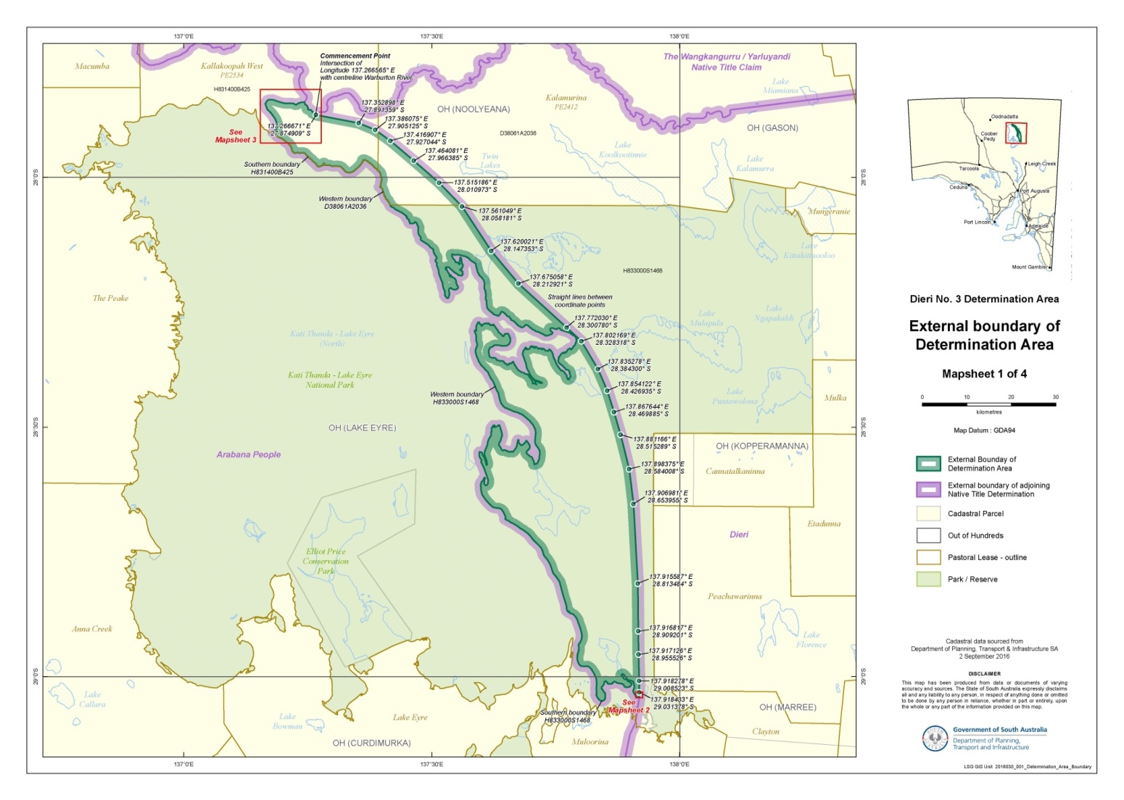

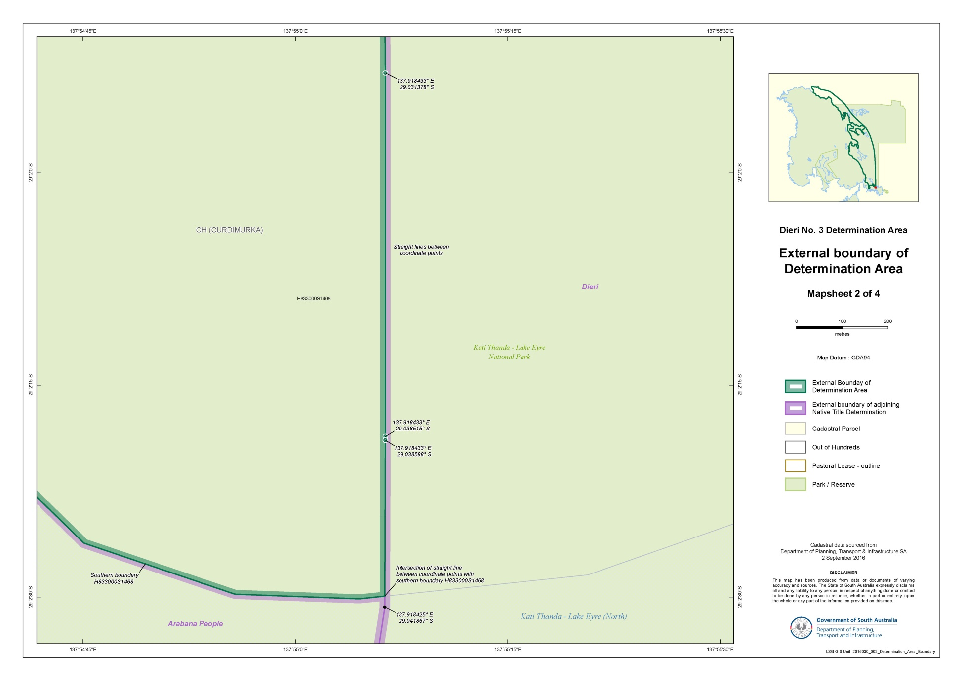

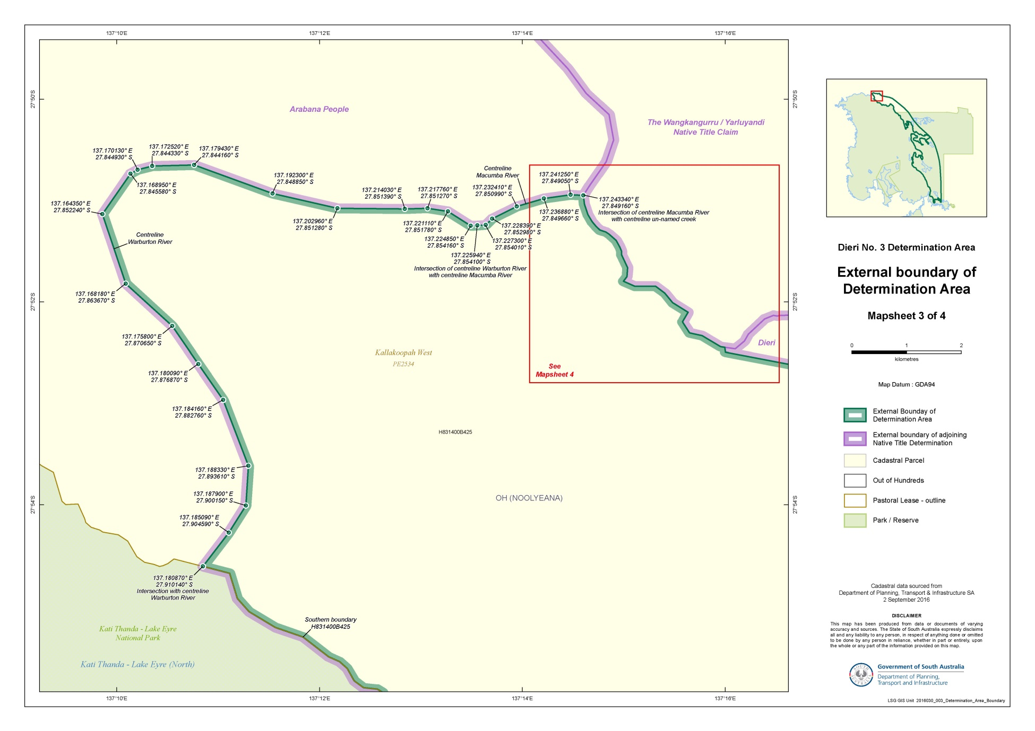

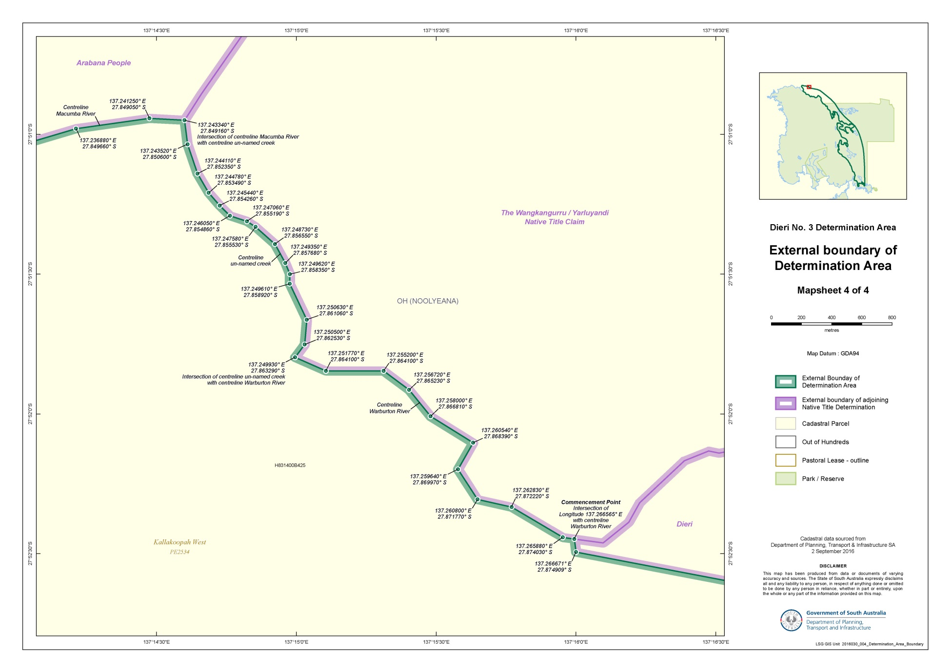

## SCHEDULE 3 – Land and waters within the Determination Area where native title exists (Native Title Land) – See next page for Mapsheet

| **DCDBID** | **Hundred** | **Title Reference** | **Locality** |
| --- | --- | --- | --- |
| D38061A2036 | OH (Noolyeana) & OH (Lake Eyre) | CL 1323/22 | Kalamurina Pastoral Lease 002412 |
| H831400B425 | OH (Noolyeana) | CL 6185/388 | Kallakoopah West Pastoral Lease 002534 |
| H833000S1468 | OH (Lake Eyre) & OH (Curdimurka) | CR 5772/920 | Kati Thanda - Lake Eyre National Park |

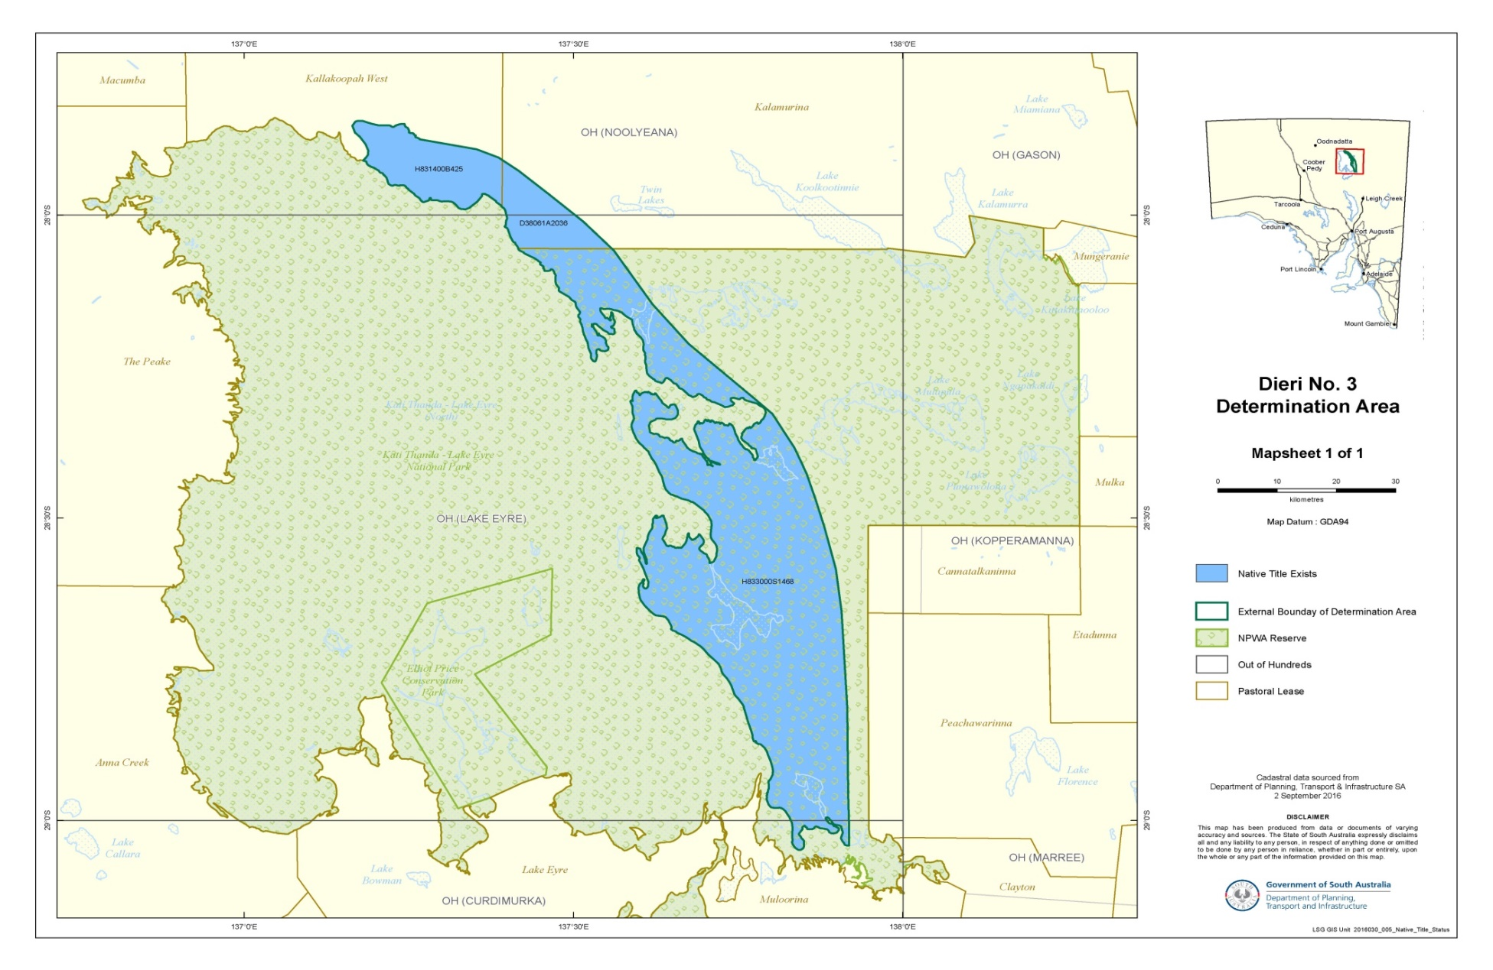

## SCHEDULE 4 - Land and waters within Determination Area where native title has been extinguished

1. Native Title Rights and Interests have been extinguished over all roads which have been delineated in a public map pursuant to section 5(d)(ii) of the *Crown Lands Act 1929* (SA) or section 70(3) or (4) of the *Crown Land Management Act 2009* (SA) or which have otherwise been validly established pursuant to South Australian statute or common law.

2. Native Title Rights and Interests do not exist in:

2.1. Minerals, as defined in section 6 of the *Mining Act 1971* (SA);

2.2. Petroleum, as defined in section 4 of the *Petroleum and Geothermal Energy Act 2000* (SA);

2.3. a naturally occurring underground accumulation of a regulated substance as defined in section 4 of the *Petroleum and Geothermal Energy Act 2000* (SA), below a depth of 100 metres from the surface of the earth;

2.4. a natural reservoir, as defined in section 4 of the *Petroleum and Geothermal Energy Act 2000* (SA), below a depth of 100 metres from the surface of the earth; or

2.5. geothermal energy, as defined in section 4 of the *Petroleum and Geothermal Energy Act 2000* (SA) the source of which is below a depth of 100 metres from the surface of the earth.

For the purposes of this item 2 and the avoidance of doubt:

2.6. a geological structure (in whole or in part) on or at the earth's surface or a natural cavity which can be accessed or entered by a person through a natural opening in the earth's surface, is not a natural reservoir;

2.7. thermal energy contained in a hot or natural spring is not geothermal energy as defined in section 4 of the *Petroleum and Geothermal Energy Act 2000* (SA); and

2.8. the absence from this order of any reference to a natural reservoir or a naturally occurring accumulation of a regulated substance, as those terms are defined in section 4 of the *Petroleum and Geothermal Energy Act 2000* (SA), above a depth 100 metres below the surface of the earth or geothermal energy the source of which is above a depth of 100 metres below the surface of the earth is not, of itself, to be taken as an indication of the existence or otherwise of Native Title Rights or Interests in such natural reservoir, naturally occurring accumulation of a regulated substance or geothermal energy.

3. Native Title Rights and Interests have been extinguished in the areas covered by Public Works (including the land and waters defined in section 251D of the Native Title Act) which were constructed, established or situated prior to 23 December 1996 or commenced to be constructed or established on or before that date.

4. Public Works constructed, established or situated after 23 December 1996 have had such effect as has resulted from Part 2, Division 3, of the Native Title Act.

Note: Entry of orders is dealt with in Rule 39.32 of the *Federal Court Rules 2011*.

REASONS FOR JUDGMENT

CHARLESWORTH J:

1. This is an application for the determination of native title under the *Native Title* ***Act*** *1993* (Cth) on behalf of a claim group known as the Dieri People. The claim relates to an area covering about 2115 sq km on the eastern shores of Lake Eyre in South Australia.
2. The parties join in an application for orders resolving the whole of this claim by consent under s 87 of the Act. Proposed orders were lodged on 21 July 2017 together with a Minute of Consent executed by the parties’ legal representatives.
3. The determination area is described in detail in Schedule 1 to the proposed orders and is depicted in a series of maps in Schedule 2. Its eastern boundary adjoins a large area already subject to a determination of native title in favour of the Dieri People on an application filed in August 1997: *Lander v State of South Australia* [2012] FCA 427 (**Dieri No. 1**). The area covered by the present claim was not included in Dieri No. 1 because, at the time of the original claim, it fell within an area subject to a claim made on behalf of the Arabana People. Shortly before the determination in Dieri No. 1, the Arabana People amended their claim to exclude the area now forming the subject of this claim: *Dodd v State of South Australia* [2012] FCA 519.
4. In February 2014, a second native title determination was made on the application of the Dieri People in respect of an area adjoining the southern boundary of the Dieri No. 1 determination area: *Lander v State of South Australia* [2014] FCA 125 (**Dieri No. 2**). The land subject to the Dieri No. 2 determination extends to the southern boundary of Murnpeowie Station, includes part of Wilpoorinna Station in the west, but stops at Yerila Creek in the east.
5. It is appropriate that the Court make the orders now sought by consent on this claim, known as Dieri No. 3.
6. Some matters of general significance should be mentioned before explaining why the orders should be made.
7. As can be seen, the making of this determination concludes a series of claims made on behalf of the Dieri People, the first of which was commenced more than 20 years ago. The orders declare and recognise that native title exists, and always has existed, and that the Dieri People are native title holders in relation to the area in accordance with their traditional laws and customs. Although this is the third determination made in favour of the Dieri People, the boundaries between the land forming the subject of each determination area are immaterial as far as the traditional laws and customs of the Dieri People are concerned. The boundaries reflect the pragmatic procedural course in which the three claims have been made and resolved over time under the Act. Now viewed together, the three determination areas reflect the very large area of land with which the Dieri People have a connection in accordance with the traditional laws they acknowledge and the traditional customs they observe. For the purposes of the Act, the connection has persisted since the British Crown asserted sovereignty in 1788, although it does, of course, predate that year by a span of time as ancient as the Dieri People themselves.
8. The significance of such orders for the Dieri People and for the wider Australian community was explained by Mansfield J when he made the determination in Dieri No. 1 at Maree station on 1 May 2012, some 15 years after that application was filed (at [7]):

… by the Determination of native title rights and interests over the Determination area, the Dieri People are being recognised on behalf of all the people of Australia as the Aboriginal Peoples who inhabited this country prior to European settlement. The preamble to the Native Title Act recognised, on behalf of all the people of Australia, that the Aboriginal Peoples of Australia variously inhabited this country for many years prior to European settlement, and that they had progressively been dispossessed of their lands. It recorded that by the overwhelming vote of the People of Australia, the Constitution was amended to enable laws such as the Native Title Act to be passed to facilitate recognition of the native title rights and interests of Aboriginal Peoples in their land. The Determination that the Dieri People were and are the traditional owners of the land we are on is a recognition of that status. It is important to emphasise that the Court does not grant that status. It declares that it exists and has always existed at least since European settlement. The Determination is made recognising the existence of native title rights and interests with the consent of the State of South Australia, and all the respondents whose interests might be affected by the orders made today. It is therefore a community recognition of that status.

1. Like the determinations made in Dieri No. 1 and Dieri No. 2, the determination now to be made is by the consent of all of the parties. The joint submissions prepared on behalf of the State of South Australia and the Dieri People draw appropriately upon the cooperation and understanding that characterised the earlier claims. The agreement reached by the parties avoids the necessity for the Court to determine the claim in a litigious contest. As North J said in ***Lovett*** *on behalf of the Gunditjara People v State of Victoria* [2007] FCA 474 at [53] the resolution of native title claims by consent is a reflection of the development of the Court system in Australia. His Honour continued:

The system is designed as an instrument of our society to resolve disputes. In times past the emphasis has been on the provision by courts of judicial determination of disputes as the single means to achieve that end. But it has become more and more recognised that judicial determination is but one means of dispute resolution. A greater role is now given to dispute resolution by mediation and other methods such as early neutral evaluation. The advantages of parties to disputes taking control and responsibility for outcomes rather than leaving results in the hands of judges are well recognised. Some disputes are particularly appropriate for assisted dispute resolution. Many native title cases fall within this category because the issues raised often concern the very identity, beliefs, culture and history of people. It is unlikely that an enforced resolution of such issues by judicial determination will be accepted or durable.

1. The role of the Court is to give effect to the parties’ agreement, subject to a number of statutory conditions, to which I now turn.

# the requirements of section 87

1. Section 87 of the Act enables the Court to make a determination of native title with the consent of the parties and without holding a hearing. Its purpose is to encourage parties to resolve claims of native title by agreement without the necessity of a contested hearing. Although the Court may give effect to the agreement, without itself determining the merits of the application, the requirements set out in s 87 must nonetheless be satisfied for a determination of native title to be made by consent as proposed: ***Far West Coast*** *Native Title Claim v South Australia (No 7)* [2013] FCA 1285 at [11]. As French J observed in *Cox on behalf of the Yungngora People v State of Western Australia* [2007] FCA 588 at [3]:

A determination of native title not only binds the parties to these proceedings, it is good against the whole world.  So the Court must be satisfied that the orders sought are supportable and are in accordance with the law.

1. See also ***Munn*** *for and on behalf of the Guggari People v Queensland* [2001] FCA 1229 at [22]; (2001) 115 FCR 109 at 114.
2. Relevantly, the requirements of s 87 of the Act are that:
3. after the end of a period specified in a notice given under s 66 of the Act (here, being a period ending on 11 March 2015), agreement is reached between the parties on the terms of an order in relation to the proceedings (s 87(1 )(a)(i));
4. the terms of the agreement, in writing signed by or on behalf of the parties, are filed with the Court (s 87(1)(b));
5. the Court is satisfied that an order in, or consistent with, those terms would be within the power of the Court (s 87(1 )(c)); and
6. the Court considers it appropriate to make the orders sought without holding a hearing (s 87(1A) and (2)).
7. The first two requirements are procedural and are satisfied in this case. The agreement has been reached by all of the parties to the application, being the named applicant comprised of five persons on behalf of the Dieri People, the State of South Australia (first respondent), BHP Billiton Olympic Dam Corporation Pty Ltd (second respondent) and Australian Wildlife Conservancy (third respondent).
8. The focus of the Court’s consideration is on the remaining two requirements.
9. The power in s 87 of the Act is to be exercised flexibly and with proper regard to the purposes for which it was enacted: *Lovett* at [36]. The section contemplates that the Court may make a determination of native title in the absence of a comprehensive evidentiary case sufficient to establish all of the facts supporting the determination. The focus is upon the making of the agreement, and especially upon the role of the State party (here the State of South Australia) in scrutinising the claim “just as carefully as the community would expect in relation to claims by non-Aborigines to significant rights over such land”: *Smith v State of Western Australia* (2000) 104 FCR 494 at [38] (Madgwick J).
10. As North J explained in *Lovett* at [37]*:*

… when the Court is examining the appropriateness of an agreement, it is not required to examine whether the agreement is grounded on a factual basis which would satisfy the Court at a hearing of the application. The primary consideration of the Court is to determine whether there is an agreement and whether it was freely entered into on an informed basis: *Nangkiriny v State of Western Australia* (2002) 117 FCR 6; [2002] FCA 660, *Ward v State of Western Australia* [2006] FCA 1848. Insofar as this latter consideration applies to a State party, it will require the Court to be satisfied that the State party has taken steps to satisfy itself that there is a credible basis for an application: *Munn v Queensland* (2001) 115 FCR 109; [2001] FCA 1229.

1. In *Nelson v Northern Territory of Australia* (2010) 190 FCR 344; [2010] FCA 1343 at [12], Reeves J described the role of the State party as one that requires the striking of a balance between:

… its role in protecting the community’s interests, including the stringency of the process it follows in assessing the underlying evidence going to the existence of native title, and its role in the native title system as a whole, to ensure that it, like the Court and all other parties, takes a flexible approach that is aimed at facilitating negotiation and achieving agreement.

1. In satisfying itself that there is a credible basis for a native title determination, the State party is not required to conduct a comprehensive and inflexible inquiry in substitution for a trial. It may rely upon significantly less material that would be necessary to justify a judicial determination of the issues: *Lovett* at [38].
2. The joint submissions of the State of South Australia and the Dieri People are detailed. There has been, I am satisfied, a careful assessment made of the claim by the State against the requirements of the Act and against its policy document titled *Consent Determinations in South Australia: A Guide to Preparing Native Title Reports*. The material provided in support of the proposed determination was provided to external counsel for assessment. Counsel provided a written opinion to the effect that there was sufficient material to make it appropriate for the State to agree to a determination and that no further evidence was required in relation to this area for the purposes of a settlement. A position paper explaining the basis for the State’s views was distributed to the two other respondent parties in October 2016, and all affected parties have signed the proposed determination to indicate their agreement to it.
3. All parties likely to be affected by the proposed orders have received independent legal advice and the joint submissions contain appropriate assurances that the State has satisfied itself that the consent determination should be made. The Court will rely upon those assurances in relation to matters the parties have considered.
4. It is against that background that the requirements of ss 87(1)(c) and 87(1A) of the Act are to be assessed.

# CONSIDERATION

1. The proposed orders will be within the power of the Court to make if they conform with the requirements of the Act. Section 225 of the Act requires that the order specify:

(a) who the persons, or each group of persons, holding the common or group rights comprising the native title are; and

(b) the nature and extent of the native title rights and interests in relation to the determination area; and

(c) the nature and extent of any other interests in relation to the determination area; and

(d) the relationship between the rights and interests in paragraphs (b) and (c) (taking into account the effect of this Act); and

(e) to the extent that the land or waters in the determination area are not covered by a non‑exclusive agricultural lease or a non‑exclusive pastoral lease—whether the native title rights and interests confer possession, occupation, use and enjoyment of that land or waters on the native title holders to the exclusion of all others.

1. The expressions “native title” and “native title rights and interests” are defined in s 223(1) of the Act as:

… the communal, group or individual rights and interests of Aboriginal peoples or Torres Strait Islanders in relation to land or waters, where:

(a) the rights and interests are possessed under the traditional laws acknowledged, and the traditional customs observed, by the Aboriginal peoples or Torres Strait Islanders; and

(b) the Aboriginal peoples or Torres Strait Islanders, by those laws and customs, have a connection with the land or waters; and

(c) the rights and interests are recognised by the common law of Australia.

1. The definition in s 223(1) was given extensive consideration by the High Court in *Members of the* ***Yorta Yorta*** *Aboriginal Community v State of Victoria* (2002) 214 CLR 422. The relevant principles have since been summarised by this Court, most conveniently by Mansfield J in *Far West Coast* at [38]-[39]:

A threshold requirement is that the evidence show that there is a recognisable group or society that presently recognises and observes traditional laws and customs in the Determination Area. In defining that group or society, the following must also be addressed:

(1) that they are a society united in and by their acknowledgement and observance of a body of accepted laws and customs;

(2) that the present day body of accepted laws and customs of the society, in essence, is the same body of laws and customs acknowledged and observed by the ancestors or members of the society adapted to modern circumstances; and

(3) that the acknowledgement and observance of those laws and customs has continued substantially uninterrupted by each generation since sovereignty and that the society has continued to exist throughout that period as a body united in and by its acknowledgment and observance of those laws and customs.

The claimants must show that they still possess rights and interests under the traditional laws acknowledged and the traditional customs observed by them and that those laws and customs give them a connection to the land.

## The claim group

1. For the purpose of this determination, the majority of the evidence relied upon by the Dieri People had already been supplied to, and favourably assessed by, the State for the purposes of the consent determinations in Dieri No. 1 and Dieri No. 2. The evidence included two reports prepared in 2002 by expert anthropologists, Drs Rod Lucas and Deane Fergie. Additional information was provided to the State by way of affidavits from members of the claim group. The affidavits addressed their connection with the claim area now under consideration.
2. In Dieri No. 1 and Dieri No. 2, this Court accepted there that the Dieri People are an identified society united by traditional law and custom. The claimant group for this area is the same as that for the earlier determinations and therefore has already been recognised as a society, united by traditional law and custom, that satisfies the requirements s 223(1) of the Act.
3. The relevant date of sovereignty for this area is 1788.
4. Evidence provided to the State in respect of the present claim makes reference to the “Thirrari people”, who were recorded in the proposed determination area in the early ethnography. The Dieri People claim that the Thirrari (or Tirari) were the original inhabitants of this area but when they died out, the Dieri People assumed the rights and responsibilities of caring for Tirari country. That gives rise to an issue of importance arising on this application that did not arise in connection with the earlier determinations. As Gleeson CJ, Gummow and Hayne JJ said in *Yorta Yorta* at [53]:

When the society whose laws and customs existed at sovereignty ceases to exist, the rights and interests in land to which these laws and customs gave rise, cease to exist. If the content of the former laws and customs is later adopted by some new society, those laws and customs will then owe their new life to that other, later, society and they are the laws acknowledged by, and customs observed by, *that later society,* they are not laws and customs which can now properly be described as being the existing laws and customs of the earlier society. The rights and interests in land to which the re-adopted laws and customs give rise are rights and interests which are not rooted in pre-sovereignty traditional law and custom but in the laws and customs of the new society.

1. The significance of references in the early ethnography to the Tiari people has not been overlooked by the parties. The subject is dealt with in the parties’ joint submission in the following terms:

Accounts of traditional Tirari territory consistently place them on the east and/or southeast shores of Lake Eyre, to the immediate west of the Dieri. In addition to being neighbouring language/tribal groups, a wealth of ethnographic material shows the Dieri and Tirari shared many social features, including matrilineal marriage moieties, patrilineal mythological/ceremonial totems associated with particular sites, and the Wilyaru initiation rite. They also shared marriage, trade and ceremonial relationships.

In traditional Aboriginal Australia, successors to country where the original inhabitants have died out tend to be those who have acquired secondary rights in that country, whether through kinship or marriage ties, common moiety affiliation, or through shared totemic/ritual obligations. Given the proximity, similarities, and close relationship between the two groups prior and subsequent to the disruption brought by European settlement, it is certainly plausible that the Dieri have legitimately succeeded the Tirari in assuming the rights and responsibilities of caring for Tirari country.

The State’s independent counsel and in-house anthropological assistant consider that the people who identified as Dieri and those who once identified as Tirari shared common ancestry, language and laws and customs to such an extent that **the inference can readily be made that the Tirari were part of the Dieri society which acknowledges and observes a body of laws and customs which is substantially the same normative system as that which existed at sovereignty**.

(Emphasis added)

1. The agreed conclusion stated in the emphasised closing passage is one arrived at upon careful consideration after obtaining appropriate advice and expert assistance. The State, in particular, has satisfied itself that the requirements of s 223(2) of the Act are met in respect of the contemporary claim group.
2. In respect of the earlier determinations, the State accepted that the Dieri People, in respect of the subject areas, exercise traditional laws and customs which continue to have vitality in contemporary society. The proposed determination is based upon that acceptance, together with further statements received specifically in connection with the proposed determination area. On the basis of that evidence, the parties’ joint position is that the claimants’ behaviour is “regulated or influenced by those traditional laws and customs and that there has been continuity of the core features of Dieri society from the past to the present”. The Court may act on the assurance of the parties that the material supports the inference expressed in the joint submissions as follows:

… the pre-sovereignty normative society (i.e. the Dieri inclusive of the Tirari) has continued to exist throughout the period since sovereignty, and whilst there has been inevitable adaptation and evolution of the laws and customs of that society, there is nothing apparent in the evidence to suggest the inference should not be made that the society today (as descendants of those placed in the area in the earliest records) acknowledges and observes a body of laws and customs which is substantially the same normative system as that which existed at sovereignty.

## Connection

1. The parties’ agreement is based in part on evidence provided in the claimants’ statements regarding the continuing connection of members of the contemporary Dieri group, with at least a substantial part of the proposed determination area through their laws and customs. The statements evidence activities undertaken in and across the area, including:
2. travelling over and monitoring land;
3. visiting and camping there;
4. hunting, fishing, gathering and sharing resources;
5. spiritual practices;
6. using Dieri language; and
7. telling dreaming stories.
8. The dreaming stories travelling through the area include Goanna Dreaming and the story of the Stumpy Tail Perentie. The Seven Sisters Story runs along the eastern edge of Lake Eyre, connecting the sacred wells in the area. Living members of the Dieri People continue to care for Dieri burial sites and to observe the rules that apply when a member of the Dieri People dies. There is evidence in the claimants’ statements that a number of Dieri People continue to have a physical connection with the proposed determination area, and continue to access the area for traditional purposes, including the purposes of showing younger members of the group the sites of significance and telling them stories associated with the land. Dieri People continue to access the resources of the area, including by hunting for kangaroo, gathering bush foods and, when the Cooper Creek is running, by fishing.
9. These rights are consistent with rights and interests recognised by this Court in Dieri No. 1 and Dieri No. 2. They are consistent with the rights and interests that would have been observed traditionally. The State has reasonably drawn the inference that the native title rights and interests arise from the claimants’ traditional laws and customs, and inferences can be made that they have evolved from laws and customs as they were likely to have been at sovereignty. It is appropriate to accept the State’s assurance that the claim group’s traditional laws and customs give them a connection to the proposed determination area.
10. Whether the rights and interests that are to be declared in the determination are recognisable by the law of Australia or the State in which the land is situated is another matter the Court must take into account, although the Court may accept that those matters have been considered by the parties, and rely on appropriate assurances: *Munn* at [31]. There are appropriate assurances in the parties’ joint submission to this effect.
11. The State has undertaken tenure searches and sought input from other respondent parties to the claim. The State’s tenure searches have not identified any other relevant interest holders in the proposed determination area. There has otherwise been sufficient opportunity for any other interest holders in the area to identify themselves and join as parties to the claim.

## The requirements of s 225 of the Act

1. The proposed orders set out with particularity the area in which native title exists (Sch 3) and those items and areas within the area where native title is extinguished (Sch 4). The proposed orders otherwise fulfil the requirements of s 225 of the Act, in that:
2. paragraph 6 defines the group of native title holders and the criteria by which they have group membership: see s 225(a) of the Act;
3. paragraph 7 sets out the nature and extent of the native title rights and interests in the determination area and paragraphs 8 and 10 set out the general limitations on their exercise: see s 225(b) of the Act;
4. paragraph 11 sets out the nature and extent of other interests in the determination area: see s 225(c) of the Act;
5. paragraph 12 describes the relationship between the native title rights in [7] and those other rights in [11]: see s 225(d) of the Act; and
6. for the purpose of s 225(e) of the Act, para 7 states that the native title rights and interests recognised in the determination are non-exclusive.

## The prescribed body corporate

1. Together, ss 55 and 56 of the Act require the Court, when making a native title determination (or as soon as practicable after) to determine whether the native title is to be held on trust and, if so, by whom.  Paragraph 13 of the proposed orders is to the effect that the native title recognised in the determination is not to be held in trust.
2. A representative of the Dieri People has nominated the registered native title body corporate Dieri Aboriginal Corporation to be the prescribed corporation in respect of this determination, and it has given its written consent to be the prescribed body corporate. It is to perform the functions given to it as a registered native title body corporate under the Act and the *Native Title Regulations (Prescribed Bodies Corporate) Regulations* 1999 (Cth): see ss 57(2) and 57(3) of the Act and para 14 of the orders.

# CONCLUSION

1. For the reasons given above, I am satisfied that an order in, or consistent with, the proposed orders would be within the power of the Court (s 87(1)(c) of the Act). I consider it appropriate to make the orders (s 87(1A)). Orders will be made in terms of the draft jointly provided by the parties, without substantive alteration.

|  |
| --- |
| I certify that the preceding forty-one (41) numbered paragraphs are a true copy of the Reasons for Judgment herein of the Honourable Justice Charlesworth. |

Associate:

Dated: 28 September 2017