AUSTRALIAN COMPETITION TRIBUNAL

Application by Flexigroup Limited (No 2) [2020] ACompT 2

Review from: | Application for authorisation AA1000439 lodged by Australian Energy Council, Clean Energy Council, Smart Energy Council and Energy Consumers Australia in respect of the New Energy Tech Consumer Code
File number: | ACT 1 of 2019
Tribunal: | O'Bryan J (Deputy President)  DR J WALKER (Member)  MS D EILERT (Member)
Date of Determination: | 15 September 2020
Date of publication of reasons: | 28 September 2020
Catchwords: | COMPETITION AND CONSUMER – review under s 101 of the Competition and Consumer Act 2010 (Cth) of authorisation granted by the Australian Competition and Consumer Commission – voluntary code of conduct for suppliers of New Energy Tech (including solar panels) for residential and small business use – code of conduct restricts the offer of unregulated consumer credit (including buy now pay later) in connection with unsolicited sales of New Energy Tech – code of conduct stipulates conditions in relation to the offer of unregulated consumer credit (including buy now pay later) in connection with unsolicited sales of New Energy Tech – under the code of conduct, suppliers must comply with mandatory standards prepared by Code Administrator – where code of conduct likely to give rise to public benefits but also likely to give rise to public detriments – where public detriments can be removed or reduced by conditions of authorisation requiring amendments to the code of conduct – whether appropriate to impose conditions of authorisation relating to reporting – determination of the Australian Competition and Consumer Commission varied
Legislation: | Competition and Consumer Act 2010 (Cth) Schedule 2 (Australian Consumer Law)  Competition and Consumer Act 2010 (Cth), ss 45AD, 45, 46, 47, 88, 90, 91B, 91C, 101, 102, 109  Australian Securities and Investments Commission Act 2001 (Cth)  Corporations Act 2001 (Cth)  National Consumer Credit Protection Act 2009 (Cth)  National Consumer Code  National Consumer Credit Protection Regulations 2010 (Cth)  Parliamentary Privileges Act 1987 (Cth)  Privacy Act 1988 (Cth)  Treasury Laws Amendment (Design and Distribution Obligations and Product Intervention Powers) Act 2019 (Cth)
Cases cited: | Application by Medicines Australia Inc [2007] ACompT 4; ATPR ¶42-164  Herald & Weekly Times Ltd (1978) 17 ALR 281  Re 7-Eleven Stores Pty Ltd [1994] ATPR ¶41-357  Re 7-Eleven Stores Pty Ltd [1998] ACompT 3; ATPR ¶41-666;  Re Media Council of Australia Authorisation (1987) 88 FLR 1; [1987] ATPR ¶40-774  Re Queensland Co-operative Miling Association Ltd (1976) 25 FLR 169; [1976] ATPR ¶40-012
Date of hearing: | 9 – 12 June 2020
Registry: | Victoria
Category: | Catchwords
Number of paragraphs: | 426
Counsel for the Applicant: | Mr N De Young SC with Ms C van Proctor
Solicitor the Applicant: | Clayton Utz
Counsel for the Authorisation Applicants: | Mr D Preston
Solicitor for the Authorisation Applicants: | Allens
Counsel for Australian Competition and Consumer Commission: | Dr R Higgins SC with Mr C Tran
Solicitor for Australian Competition and Consumer Commission: | Australian Government Solicitor
Counsel for Australian Securities and Investments Commission: | Mr M D Tehan
Solicitor for Australian Securities and Investments Commission: | Mr J Walker, Australian Securities and Investments Commission
Counsel for RateSetter Australia RE Limited: | Mr A Barraclough
Solicitor for RateSetter Australia RE Limited: | Johnson Winter & Slattery
Counsel for Consumer Action Law Centre: | Mr T Clarke with Mr M Peckham
Solicitor for Consumer Action Law Centre: | Consumer Action Law Centre

IN THE AUSTRALIAN COMPETITION TRIBUNAL
 |  | ACT 1 of 2019
RE: | APPLICATION FOR AUTHORISATION AA1000439 LODGED BY AUSTRALIAN ENERGY COUNCIL, CLEAN ENERGY COUNCIL, SMART ENERGY COUNCIL AND ENERGY CONSUMERS AUSTRALIA IN RESPECT OF THE NEW ENERGY TECH CONSUMER CODE
by: | FLEXIGROUP LIMITED  Applicant

TRIBUNAL: | O’BRYAN J (Deputy President)  Dr J WALKER (Member)  Ms D EILERT (Member)
DATE OF DETERMINATION: | 15 SEPTEMBER 2020

THE TRIBUNAL DETERMINES THAT:
- The determination of the Australian Competition and Consumer Commission dated 5 December 2019 granting conditional authorisation to application AA1000439 made by the Australian Energy Council, Clean Energy Council, Smart Energy Council and Energy Consumers Australia (together, the authorisation applicants) is varied as follows:
  - the authorisation applies to the following conduct:
    - the authorisation applicants and future signatories to the New Energy Tech Consumer Code (Code) becoming signatories to, agreeing to comply with and giving effect to the provisions of the Code;
    - the persons constituting the Administrator and Code Monitoring and Compliance Panel from time to time performing the functions and powers given to them under the Code;
  - the conditions of authorisation specified by the Australian Competition and Consumer Commission are replaced by the conditions set out in Annexure B to this determination; and
  - the authorisation remains in force for a period of 5 years from the date of this determination.
- The reasons for determination of the Tribunal in this proceeding are not to be disclosed to any person other than the external legal representatives of the parties in order that any party may make an application to redact or suppress any part of the reasons on the grounds of commercial confidentiality, any such application to be filed and served on or before 4pm on 25 September 2020. If no application is made by that time, the Tribunal will publish its reasons in full. If any application is made within that time, the Tribunal will determine the question of publication in the resolution of that application.

SUMMARY OF DETERMINATION
The determination made by the Tribunal today concerns a proposed industry code of conduct for suppliers of what are referred to as New Energy Technology products (principally solar panels, energy storage systems and other emerging products and services). To assist the public in understanding the Tribunal’s determination, the Tribunal has prepared this brief summary of the determination. The summary is not a substitute for, or a qualification of, the published reasons of the Tribunal.
The proposed code of conduct was developed by the Australian Energy Council, Clean Energy Council, Smart Energy Council and Energy Consumers Australia. It sets minimum standards that suppliers of New Energy Technology products must comply with when interacting with customers, from initial marketing and promotion through to installation and complaints handling. The proposed code of conduct is a voluntary code. Suppliers of New Energy Technology products can elect whether they wish to become signatories. However, once a supplier becomes a signatory, the supplier agrees to comply with the requirements of the code.
The proponents of the code have applied for authorisation under the Competition and Consumer Act 2010 (Cth). Authorisation provides an exemption from the application of the competition laws in that Act. The Tribunal must only grant authorisation if it is satisfied that the conduct would result, or be likely to result, in a benefit to the public and the benefit would outweigh the detriment to the public that would result, or be likely to result, from the conduct.
The proposed code of conduct is a form of industry self-regulation. While industry codes of practice, as a form of private regulation, have become common place in Australia, they have the potential to generate both public benefits and detriments. Benefits will arise when codes of practice complement public regulation in ways that reflect community attitudes and expectations and deal with market failures (that is, where markets would otherwise fail to result in an efficient allocation of resources). Anti-competitive public detriment will arise when codes of practice give their participants power to bring about market outcomes that differ from competitive market outcomes and result in restrictions on the types of products that may be supplied, the quantity that may be supplied or the methods or channels of supply. Such restrictions substitute collective supplier preference for consumer choice and would only be justified if required to address demonstrable market failure. Absent significant market failure, competition can generally be relied on to promote the interests of consumers and the community at large. Public regulation which imposes restrictions on competition, where those restrictions are seen to be necessary to achieve community benefits, are expressed and scrutinised through the democratic process of government. Private regulation which imposes restrictions on competition has the potential to result in significant public detriment by restricting market access, innovation and the offers available to consumers. The proponents of such restrictions need to demonstrate that they are likely to result in sufficient public benefit to justify exempting the restrictive conduct from the normal application of the Competition and Consumer Act.
Many of the provisions of the proposed code reflect existing consumer protection laws that are applicable to suppliers of New Energy Technology products. The Tribunal has concluded that those provisions generate public benefits because the code is likely to lead to greater compliance with those laws. The code of conduct will be publicised and provided to consumers and the code provides for oversight by an industry body and dispute resolution processes. There are also many provisions of the proposed code that extend or amplify consumer protection laws that apply to suppliers of New Energy Technology products. The Tribunal considers that those provisions also generate net public benefits. Even if the enhanced obligations were to increase supply costs, the Tribunal considers that the obligations reflect community expectations of the standard of commercial conduct by suppliers and the community would therefore accept any associated increase in the cost of supply. The code is also likely to improve the information made available to consumers, enhancing consumers’ ability to make informed choices that suit their needs and thereby enhancing competition in the supply of New Energy Technology products. In that way, the code addresses a market failure arising from information asymmetry.
However, the Tribunal has concluded that other provisions of the proposed code are likely to generate significant public detriments. Those provisions concern two topics. The first topic relates to the supply of consumer credit that is not regulated by the National Consumer Credit laws, particularly the supply of “buy now pay later” credit. The second topic relates to provisions of the proposed code that empower the administrator of the code to stipulate mandatory standards with which suppliers must comply.
In relation to unregulated consumer credit (which includes “buy now pay later” products), the proposed code places a number of restrictions on the ability of suppliers of New Energy Technology products to offer such credit in connection with the sale of the New Energy Technology products. The code prohibits the offer of such credit if the New Energy Technology product was sold as a result of the supplier initiating contact with the customer (an unsolicited sale). The code also prohibits the offer of such credit unless the credit provider has implemented procedures equivalent to the responsible lending obligations under the National Consumer Credit laws.
The Tribunal considers that unregulated consumer credit in the form of “buy now pay later” finance is a significant and popular form of finance used by consumers to acquire New Energy Technology products desired by those consumers and therefore the supply of such finance provides economic benefits. The evidence does not establish that the provision of such finance in connection with the supply of New Energy Technology products generates material consumer harm. The data before the Tribunal indicates that arrears and defaults are significantly lower for all types of finance extended in the New Energy Technology sector compared to other sectors, which is likely due to the nature of the product (which generates energy cost savings) and the demographics of the consumers (older home-owners). To the extent that such finance might facilitate consumer harm which is caused by poor or unlawful selling practices in respect of New Energy Technology products, the risk of such harm should be materially reduced by the consumer protection provisions of the proposed code. The Tribunal considers that most of the proposed restrictions on the supply of “buy now pay later” finance in the proposed code will generate substantial public detriments by reducing the availability of such finance to consumers, thereby reducing consumer access to NET products. ASIC has been actively considering whether the National Consumer Credit laws should be extended to cover “buy now pay later” products. ASIC’s review of the sector will have more evidence before it to consider whether such an extension is warranted.
In relation to the mandatory standards, the Tribunal is concerned about the open ended nature of the provisions in the proposed code, the potential effect of which is uncertain, but which could be used to restrict supply and competition. An agreement between competitors to abide by agreed mandatory standards could be used to restrict innovation and competitive offers by solar panel merchants in the future. This could result in unknown public detriments arising in the future, making it difficult for the Tribunal to be satisfied that the overall balance of public benefits and detriments arising from the code meets the test for authorisation. The Tribunal has concluded that the code should be amended to remove all references to mandatory standards.
The Tribunal has weighed the overall public benefits of the consumer protection provisions of the code against the public detriments that the Tribunal considers will arise from the provisions of the code concerning unregulated consumer credit and mandatory standards. The Tribunal considers that the latter outweigh the former. In other words, the Tribunal is not satisfied that the code, in its present form, would be likely to result in a net public benefit. Accordingly, the Tribunal is not willing to authorise the code in the form submitted to the Tribunal. However, with amendments to the code that remove the provisions that are likely to cause public detriment (which amendments are set out in Annexure B to the determination), the Tribunal would be satisfied that the code would be likely to result in a net public benefit. Accordingly, the Tribunal is willing to grant authorisation subject to a condition that the code is so amended.

REASONS FOR DETERMINATION
[Redacted version]
Introduction | [1]
Background to the authorisation | [17]
The residential solar panel sector | [17]
The development of the NET Code | [26]
Regulated and unregulated consumer credit | [31]
ASIC Report 600 | [53]
AFIA Code of Practice for BNPL providers | [62]
Overview of the NET Code | [65]
Part A | [69]
Part B | [70]
Annexure | [96]
The application to the ACCC for authorisation | [103]
Versions of the Code submitted by the authorisation applicants | [108]
ACCC’s assessment of public benefits | [120]
ACCC’s assessment of public detriments | [126]
Authorisation subject to conditions | [129]
The application to the Tribunal for review | [133]
Overview of the parties and the evidence | [142]
The authorisation applicants | [142]
Flexigroup | [154]
ASIC | [175]
RateSetter | [181]
CALC | [193]
Third party submissions | [219]
Tribunal’s data request | [233]
General consideration of the effects of the NET Code | [253]
Provisions that reflect or amplify consumer protection laws | [274]
Provisions concerning unregulated consumer credit | [284]
Overview | [284]
The parties’ submissions | [292]
Consideration of the consumer finance provisions | [327]
Summary of conclusions | [396]
Provisions concerning mandatory standards | [398]
should authorisation be granted? | [407]
reporting obligations | [411]
Conclusion | [422]

The Tribunal

Introduction
- On 30 December 2019, Flexigroup Limited (Flexigroup) filed an application pursuant to s 101 of the Competition and Consumer Act 2010 (Cth) (CCA) for a review of an authorisation granted by the Australian Competition and Consumer Commission (ACCC) under s 88(1) of the CCA on 5 December 2019 (ACCC determination).
- The applicants for the authorisation were the Australian Energy Council, Clean Energy Council, Smart Energy Council and Energy Consumers Australia (together, the authorisation applicants). The authorisation concerned a document called the New Energy Tech Consumer Code (NET Code or Code) which sets minimum standards that suppliers of “New Energy Tech” products (principally solar panels, energy storage systems and other emerging products and services) (NET products) must comply with when interacting with customers, from initial marketing and promotion through to installation and complaints handling. A copy of the NET Code in the final form in which the authorisation applicants sought authorisation from the ACCC, and which is the subject of this review, is attached as Annexure A to this determination.
- The authorisation granted by the ACCC determination enables the authorisation applicants and future signatories to the NET Code to agree, sign up to and comply with provisions of the Code. Signatories to the Code commit to abide by minimum standards of good business practice as set out in the Code. The Code also contains provisions for monitoring and sanctioning non-compliance by signatories, and the Administrator of the Code has powers to require a signatory to rectify breaches. Where there is serious non-compliance, the Administrator may propose to the Code Monitoring and Compliance Panel that the signatory be suspended or expelled. In accordance with s 88(1) of the CCA, the authorisation expressly exempted the authorisation applicants and signatories to the Code from the following provisions in Part IV of the CCA in so far as they engage in the conduct described in the authorisation: s 45AD (cartel conduct), s 45 (contracts, arrangements or understandings that restrict dealings or affect competition, including concerted practices), s 46 (misuse of market power) and s 47 (exclusive dealing).
- The NET Code is a voluntary code. Suppliers of NET products can elect whether they wish to become signatories. However, once a supplier becomes a signatory, the supplier agrees to comply with the requirements of the Code. While the Code does not, of itself, have the force of law, the Code requires signatories to include in their customer quotes and contracts a promise to comply with the Code. By that mechanism, the obligations under the Code are incorporated into customer contracts and become enforceable by customers against signatories. Thus, it can be expected that signatories to the Code would enjoy a considerable marketing and branding advantage by reason of the additional consumer protection obligations they undertake and there will be a corresponding degree of commercial pressure for suppliers of NET products to become signatories to the Code. It is also possible that, in the future, the availability of government subsidies or incentives for NET products will be restricted to products supplied by Code signatories, creating further commercial pressure for suppliers of NET products to become signatories.
- While the NET Code is a voluntary code, it is nevertheless a form of industry self-regulation. NET providers who become signatories will form a body of suppliers, able to market and present themselves as signatories, and who agree to comply with the business and trading practices stipulated by the Code. The potential for industry codes of conduct, as a form of self-regulation, to have anti-competitive effects is discussed later in this determination.
- The application for review by Flexigroup principally concerns provisions of the NET Code governing the offer of deferred payment arrangements (consumer credit) that are not regulated under the National Consumer Credit Protection Act 2009 (Cth) (NCCP Act) and the National Credit Code in connection with the supply of NET products. A growing area of “unregulated” consumer credit, both for NET products and consumer goods more generally, is known as “buy now pay later” (BNPL) finance. BNPL providers in the NET market include Flexigroup, Brighte Capital Pty Ltd (Brighte) and Devizo Pty Ltd which trades as Payright. In this determination, we will use the expression “unregulated consumer credit” when referring to consumer credit that is not regulated by the NCCP Act and National Credit Code such as BNPL finance. However, and as discussed in more detail below, we note that such credit arrangements are not completely unregulated and are subject to various consumer protection laws, including those in the Australian Consumer Law (being Schedule 2 of the CCA) and the Australian Securities and Investments Commission Act 2001 (Cth) (ASIC Act), as well as recently enacted “product intervention powers” granted to the Australian Securities and Investments Commission (ASIC) under Part 7.9A of the Corporations Act 2001 (Cth) (Corporations Act) (which commenced in April 2019) and the “design and distribution obligations” to be imposed by Part 7.8A of the Corporations Act (which will commence in October 2021).
- The effect of the NET Code as authorised by the ACCC (when read with the conditions of authorisation imposed in its determination) in respect of unregulated consumer credit is that:
  - signatories must not offer customers unregulated consumer credit in connection with the sale of a NET product if the sale of the NET product is unsolicited (see para 3(d) of the Code when read with the condition in paragraph 5.13 of the ACCC determination); and
  - signatories may only offer unregulated consumer credit in connection with the sale of a NET product if (amongst other things) the Administrator under the NET Code has either:
    - determined that the credit provider is a signatory to an industry code of conduct that requires the credit provider to comply with (on an equivalent basis) the responsible lending, hardship and dispute resolution provisions of the NCCP Act; or
    - approved the credit provider’s deferred payment contract as an interim measure (being an interim measure that expires on 1 January 2022),
(see para 25(a)(ii) of the Code when read with the condition in paragraph 5.12 of the ACCC determination).
- Flexigroup is a financial services group providing a range of finance products to consumers and businesses including interest free cards and no interest payment plans to retail customers through its product “humm” which is a form of BNPL finance. In the period since 1 January 2010, Flexigroup's humm product has financed the purchase of more than 210,000 solar product installations in Australia, being approximately 9% of all solar installations in Australia. By its application, Flexigroup seeks the review of the authorisation of those provisions of the NET Code and the ACCC’s conditions of authorisation that relate to unregulated consumer credit summarised above (unregulated consumer credit provisions). Flexigroup seeks to maintain the authorisation of the NET Code, but subject to conditions of authorisation that require the deletion or amendment of the unregulated consumer credit provisions.
- As the proponents of the NET Code, the authorisation applicants support its authorisation. However, over the course of the review, the support of the authorisation applicants for the unregulated consumer credit provisions changed. In particular, by the conclusion of the review, the authorisation applicants no longer supported para 3(d) of the Code (and the associated ACCC condition).
- On 16 March 2020, the Tribunal gave leave to the following persons to intervene in this proceeding pursuant to s 109(2) of the CCA: ASIC, the Consumer Law Action Centre (CALC) and RateSetter Australia RE Limited (RateSetter). Each of the interveners has an interest in the unregulated consumer credit provisions.
- ASIC is responsible for the regulation of financial products and has recently conducted a study of the BNPL sector (ASIC Report 600 dated November 2018). ASIC supported the authorisation of the NET Code and the conditions imposed by the ACCC in its determination in relation to unregulated consumer credit.
- CALC is an independent, not-for-profit consumer organisation with specialist expertise in consumer credit law and policy. It provides financial counselling and legal assistance services to people experiencing disadvantage in Victoria. It has acted for clients who have acquired NET products using unregulated consumer credit. CALC supports the authorisation of the NET Code, but considers that the Code should prevent the offer of unregulated consumer credit in connection with NET products in all circumstances. In the alternative, it supports the condition of authorisation imposed by the ACCC that NET merchants must not offer unregulated consumer credit in connection with an unsolicited sale of NET products. It also submitted that, if the Tribunal were concerned about differential treatment between regulated and unregulated consumer credit in the context of unsolicited sales, the Code should prevent merchants from offering any form of finance in connection with unsolicited sales.
- RateSetter supplies regulated consumer credit including in the NET sector and is therefore a competitor of Flexigroup and other providers of unregulated consumer credit. It does not supply unregulated consumer credit. RateSetter supports the authorisation of the NET Code. In broad terms, it supports the conditions imposed by the ACCC in relation to unregulated consumer credit. It also supports CALC’s submission that, if there is a concern about differential treatment between regulated and unregulated consumer credit in the context of unsolicited sales, the Code should prevent the offer of any form of finance in connection with unsolicited sales. Without intending any criticism, it can be observed that RateSetter’s views are to the benefit of its commercial interests by (i) restricting the supply of unregulated consumer credit (in connection with the supply of NET products) which is a financial product that competes with its regulated consumer credit products, and (ii) restricting the supply of consumer credit in connection with unsolicited sales of NET products which is a sales channel it does not participate in. This highlights a principal concern of the Tribunal, which is whether the NET Code would restrict the supply of goods or services to the detriment of consumers.
- Appropriately, the ACCC assisted the Tribunal in the review in an impartial manner. Given the presence of contradictors in the review, it was unnecessary for the ACCC to test the evidence before the Tribunal, present contrary material or make submissions putting forward an opposing point of view. The Tribunal is grateful for the submissions advanced by the ACCC which have been helpful in the analysis of the issues.
- Even though no participant in the review opposed the authorisation of the NET Code, as the Tribunal is conducting a de novo review of the grant of authorisation (including the conditions imposed by the ACCC), the Tribunal must decide for itself whether authorisation should be granted and whether conditions should be imposed.
- For the reasons that follow, the Tribunal has determined that the ACCC determination should be varied. The Tribunal has determined that the NET Code (in the form set out in Annexure A) should be authorised subject to the conditions set out in Annexure B to this determination. In summary, the conditions require the deletion or variation of the unregulated consumer credit provisions of the NET Code, and certain other provisions discussed below, that the Tribunal considers will have anti-competitive effects and result in significant public detriments.

Background to the authorisation

The residential solar panel sector
- Background information concerning the residential solar PV (photovoltaic) sector was contained in a report published in December 2016 by KPMG for Energy Consumers Australia.
- The report stated that, over the preceding decade, there had been a rapid increase in the number of households installing solar panel systems on their rooftop and that, as at the date of the report, approximately 1.5 million households had solar panels and were generating their own electricity. Since 2011, the rate of installations had lessened, however the average size of installations had grown over time as the cost of solar panels had decreased. In 2010, the average system size for new installations was 1.5 kW. By the end of 2015, the average system size for new residential installations had reached approximately 5.5 kW. Across Australia, over 5,000 MW of rooftop solar PV generation capacity had been installed which represented approximately 12% of total generation capacity in the National Electricity Market.
- By way of update to the data presented in the KPMG report, we note that recent data published by the Clean Energy Regulator shows that installations of small scale solar PV installations have continued to grow up to the present time. In the 2019 calendar year, there were approximately 280,000 installation of small-scale solar panel systems. As of 31 March 2020, there were over 2.3 million small-scale solar PV installations in Australia. Data published by the Australian Photovoltaic Institute, sourced from the Clean Energy Regulator, also shows that the trend toward larger systems (referred to in the KPMG report) has continued in the last few years, particularly in the range of 6.5 - 9.5 kW systems.
- The KPMG report described the financial value from a solar panel system for consumers and why it is difficult to calculate. The report explained that the value of solar PV is often marketed, and understood by consumers, in terms of the payback period, being the period it takes for financial returns from the system to pay off the initial costs of installation. The length of the payback period will depend on the upfront installation costs of the system, including any required grid connection and metering upgrade costs, relative to:
  - the Commonwealth Government’s subsidy under the Small Renewable Energy Scheme, which effectively provides an upfront reduction in the cost of installation;
  - feed-in-tariffs for energy generated by the solar panel system and exported to the network; and
  - savings in a consumer’s electricity bill from energy generated by the solar panel system and used by the household (in place of energy drawn from the grid).
- The Commonwealth’s Small Renewable Energy Scheme provides a financial incentive for individuals and businesses to install small-scale renewable energy systems such as rooftop solar, solar water heaters and heat pumps. This occurs in the form of small-scale technology certificates which are issued up front for a system’s expected power generation (based on its installation date and geographical location). The price of certificates changes according to market conditions. The total level of subsidy depends on several factors, including the location and size of the solar panel system and the price of certificates at the time the system is installed.
- Feed-in-tariffs are a payment to a customer for generating electricity, paid per kWh. The type and level of feed-in-tariff differs between jurisdictions and has reduced over time. As a consequence, different feed-in-tariffs now apply to different customers, depending on when they installed the solar panel system. Previously, and to encourage the adoption of solar installations, jurisdictional governments offered premium feed-in-tariff rates which were significantly higher than the wholesale cost of electricity. These rates were highly effective in fostering uptake of solar PV installations. Most jurisdictional governments closed eligibility for new entrants from 2011 onwards. Since then, new installations have been able to qualify for schemes available from their electricity retailer. Generally, these schemes provide a tariff payment that is equivalent to the avoided cost of supply due to the operation of a rooftop solar generator and are significantly lower than the previous government scheme rates. As part of a package of energy market reforms endorsed by the Council of Australian Governments (COAG) on 7 December 2012, COAG agreed to a revised set of National Principles for Feed-in Tariff Arrangements.
- The KPMG report expressed the view that the first two sources of return from the solar panel system (the Commonwealth’s Small Renewable Energy Scheme and feed-in-tariffs) are relatively certain and straightforward to predict for suppliers, but that savings in electricity bills will likely be the biggest component of the financial value for consumers and are more difficult to estimate. The value of these savings is equal to the net reduction in energy consumed at the household multiplied by the applicable volume based tariff for electricity payable by the consumer. The calculation will depend upon the configuration of the solar PV installation in terms of size and location (as this determines energy generated and the time of generation), the level and structure of the consumer’s retail tariffs and the consumption patterns of the household and whether the household changes its consumption behaviour following the installation (the solar panel system only generates electricity during the day, whereas households continue to consume electricity outside daylight hours). For most households, the variable component of their retail tariff will be higher than the applicable net feed-in tariff and hence the household has an incentive to shift its consumption of energy from nighttime to daytime. As a result, the capability of a consumer to maximise the financial value from the investment in solar PV will depend on the alignment of consumption with the output of the solar PV which will vary by household characteristics.
- A survey undertaken by UMR Research (in support of the analysis undertaken by KPMG) suggests that the majority of customers install solar panel systems to reduce their energy bills. A secondary reason is that customers are seeking greater energy independence (at a time of rising energy prices). Environmental concerns, while important, featured less strongly. The same survey indicated that the cost of installation appears to be the main barrier to consumers installing solar PV (approximately a third of customers surveyed that do not have solar PV consider it to be too expensive). Another third of customers surveyed were renting their home and cited this as the main barrier to installing solar PV. The UMR survey results also suggest that the majority of customers are unlikely to be undertaking their own financial assessment of the value of installing solar and the impact of different sized systems on their return. Rather, they are relying on information provided by the supplier.
- The KPMG report expressed the following conclusions (relating to the experience of customers):
  - Residential customers are generally satisfied with the performance of their system. However, many customers do not understand how their systems operate or how to get the most value from their systems. There is also evidence that some customers are being sold systems that are not appropriately sized for them.
  - Barriers to acquiring solar panel systems remain to certain customers, including the majority of apartment dwellers and renters, and those that cannot afford the upfront costs of installation.
  - Customers need access to information in order to make informed decisions. Battery storage adds an additional dimension to an already complex energy market and requires the customer to make decisions on multiple variables relating to the use of batteries and how to integrate batteries with a solar PV installation.

The development of the NET Code
- In late 2013, the COAG Energy Council (a forum for the energy ministers of the Commonwealth, States and Territories to work together in the pursuit of national energy reforms) resolved to establish a national energy consumer advocacy body. On 30 January 2015, Energy Consumers Australia was established by the COAG Energy Council for that purpose, with a mandate to act as a national energy consumer advocacy body for residential and small business energy consumers.
- In April 2016, Energy Consumers Australia engaged KPMG to analyse outcomes for residential solar PV customers and the impacts of solar PV on the broader energy market, as well as future developments linked to battery storage. KPMG presented its report in December 2016, which is referred to above.
- By letter dated 16 August 2017, the then Chair of the COAG Energy Council, the Hon Josh Frydenberg MP, wrote to Energy Consumers Australia in relation to consumer protections for energy products and services. Amongst other things, the letter requested Energy Consumers Australia to develop a range of consumer information products on consumer rights and protections for “behind-the-meter” products and services and also requested Energy Consumers Australia to work with industry to cooperatively develop a single, industry wide Code of Conduct for all behind-the-meter electricity supply services and products. The term “behind-the-meter” describes energy related products and services that are located on the consumer’s side of the energy meter installed at their premises (and which are not the responsibility of the relevant energy retailer or distributor). The letter requested that the Code address:
  - information provision;
  - dispute resolution mechanisms;
  - ensuring products are fit-for-purpose; and
  - customers in financial difficulty.
- A “behind-the-meter” working group (BTMWG) was established in October 2017, in order to give effect to the request of the COAG Energy Council. The members of the BTMWG were:
  - Energy Consumers Australia, as the national energy consumer advocacy body for residential and small business energy consumers;
  - Clean Energy Council, as the peak body for the clean energy industry in Australia representing businesses operating in, or supporting, the development of renewable energy (including solar, wind, hydro, bioenergy, geothermal and marine);
  - Australian Energy Council, as the industry body representing 23 businesses operating in the wholesale and retail energy markets;
  - Smart Energy Council, as the peak body for the solar, storage and smart energy industry in Australia;
  - Energy Networks Australia, as the industry body representing Australia’s electricity transmission and distribution and gas distribution networks;
  - Renew, a not-for-profit association that advocates for sustainable living practices;
  - CALC, a not-for-profit organisation which advocates for a fair marketplace for the benefit of consumers;
  - the Public Interest Advocacy Centre, being an association which tackles difficult social problems that impact on the lives of Australians;
  - Energy Queensland, which is responsible for the Queensland government’s electricity networks and retail businesses; and
  - the national electricity generator and retailer, AGL.
- A draft code of conduct was released for stakeholder consultation in late November 2018, with a request for feedback by 6 February 2019. Written submissions were received from many interested parties, addressing a range of issues, including the terms on which BNPL finance should be available to consumers seeking to acquire NET products and unsolicited sales of NET products. The final version of the code of conduct approved by the BTMWG entirely prohibited the offering of BNPL finance in connection with the supply of NET products. The code stipulated that signatories could only offer deferred payment arrangements which were regulated under the NCCP Act and the National Credit Code and which were provided by credit providers licensed under the NCCP Act. The proposed code of conduct was submitted to the ACCC for authorisation in April 2019.

Regulated and unregulated consumer credit
- A central issue in this review is whether the NET Code should permit signatories to offer unregulated consumer credit, particularly BNPL finance, in connection with the supply of NET products and, if so, in what circumstances.
- Various forms of credit activity are regulated by the NCCP Act and the National Credit Code (which, by s 3 of the NCCP Act, has effect as a law of the Commonwealth). Credit activity under those laws is defined to include:
  - being a credit provider under a credit contract (which is a contract under which credit, to which the National Credit Code applies, is or may be provided);
  - carrying on a business of providing credit to which the National Credit Code applies; or
  - performing the obligations, or exercising the rights, of a credit provider in relation to a credit contract or proposed credit contract (whether doing so as the credit provider or on behalf of the credit provider).
- Relevantly, credit to which the National Credit Code applies is credit that satisfies each of the following conditions:
  - the debtor is a natural person (or a strata corporation);
  - the credit is provided or intended to be provided wholly or predominantly:
    - for personal, domestic or household purposes; or
    - to purchase, renovate or improve residential property for investment purposes; or
    - to refinance credit that has been provided wholly or predominantly to purchase, renovate or improve residential property for investment purposes;
  - a charge is or may be made for providing the credit; and
  - the credit provider provides the credit in the course of a business of providing credit.
- However, by s 6(5) of the National Credit Code, the Code does not apply to the provision of credit under a continuing credit contract if the only charge that is or may be made for providing the credit is a periodic or other fixed charge that does not vary according to the amount of credit provided and the charge does not exceed the maximum charge prescribed by regulations. Regulation 51 of the National Consumer Credit Protection Regulations 2010 (NCCP Regulations) stipulates that the maximum charge is:
  - for the period of 12 months commencing when the debtor enters into the continuing credit contract - $200; and
  - for any subsequent period of 12 months during which the continuing credit contract is in effect - $125.
- BNPL providers have structured their business models to come within s 6(5) of the National Credit Code with the result that the consumer credit they offer is not credit to which the National Credit Code applies and is not regulated by the NCCP Act. The common feature of BNPL finance is that the credit providers do not charge interest to customers but instead charge customers various fixed fees (typically a loan establishment fee, a monthly fee and a late payment fee). Instead of charging interest to the borrower, BNPL credit providers charge merchants a fee equal to a percentage of the amount of the purchase being financed. The size of the merchant fee (as a percentage) depends on factors such as the volume of BNPL arrangements used by the merchant, the risk profile of the merchants and the types of goods and services offered by the merchant.

Obligations under the NCCP Act
- The NCCP Act and the National Credit Code impose various regulatory obligations on persons who provide credit to which the National Credit Code applies (which we will refer to as regulated consumer credit). The following regulatory obligations are relevant to the issues raised in this review.
- First, by s 29 of the NCCP Act, a person must not engage in a regulated credit activity unless they hold an Australian credit licence under the Act or they are an authorised credit representative of a person who holds an Australian credit licence.
- Second, s 47 of the NCCP Act imposes various conduct obligations on Australian credit licensees, including that the licensee must:
  - do all things necessary to ensure that the credit activities authorised by the licence are engaged in efficiently, honestly and fairly;
  - maintain the competence to engage in the credit activities authorised by the licence;
  - have an internal dispute resolution procedure that (i) complies with standards and requirements made or approved by ASIC in accordance with the regulations and (ii) covers disputes in relation to the credit activities engaged in by the licensee or its representatives; and
  - be a member of the external dispute resolution scheme operated by the Australian Financial Complaints Authority (AFCA) (for which an authorisation under Part 7.10A of the Corporations Act is in force).
- Third, by s 64, an Australian credit licensee may authorise a person to be their credit representative by written notice. By s 65, a credit representative that is a body corporate may authorise a natural person to be their representative provided the Australian credit licensee consents. The consent may be given in respect of an identified person or class of persons. By s 71, a person who authorises a credit representative under ss 64 or 65 must lodge a written notice with ASIC. A list of authorised credit representatives taken from ASIC’s register on 12 June 2020 showed that there are more than 38,000 such representatives. Credit representatives must also be members of the AFCA scheme.
- Fourth, ss 128 to 133 of the NCCP Act (within Divisions 3 of Part 3-2) require providers of regulated consumer credit to assess whether the credit contract will be unsuitable for the borrower before entering into the credit contract or increasing the credit limit, commonly referred to as responsible lending obligations. In particular, s 130 requires the credit provider:
  - to make reasonable inquiries about the consumer’s requirements and objectives in relation to the credit contract;
  - to make reasonable inquiries about the consumer’s financial situation; and
  - to take reasonable steps to verify the consumer’s financial situation.
- Section 131(2) provides that a credit contract will be unsuitable for the consumer if it is likely that, amongst other things, the consumer will be unable to comply with the consumer’s financial obligations under the contract, or could only comply with substantial hardship.
- ASIC has published Regulatory Guide 209 concerning the responsible lending obligations under the NCCP Act. The Guide indicates that reasonably detailed information concerning the customer’s financial position is required including the following:
  - In relation to income, the finance provider should seek the amount, frequency and source of income and changes that are reasonably foreseeable. The finance provider will need information to determine whether the income received in the last pay period is consistent and likely to remain at that level for the term of the credit product being considered. If the consumer has casual or seasonal employment, the finance provider will need information about the variations in hours and pay that may be expected.
  - In relation to outgoings, the finance provider should seek information about the customer’s current outgoings, and reasonably foreseeable changes to those outgoings. If there is a shortfall between income and outgoings (including the new financial obligations under the credit to be provided), the provider should assess whether the customer is likely to be able and willing to reduce some expenditure to meet the new financial obligations. In that regard, the finance provider will need to consider categories of outgoings that a customer is less likely to be able to reduce or eliminate.
  - In relation to assets, the Guide observes that the general position is that customers should be able to meet the financial obligations from income rather than equity in an asset. Nevertheless, assets may contribute to both the customer’s income and their expenditure. Assets may also, in some cases, be available to be sold by the consumer to enable them to meet financial obligations under a credit product if needed. Therefore the finance provider will require information about such assets and the expected use of the asset during the period of credit.
- Fifth, Division 3 of Part 4 of the National Credit Code imposes obligations on the credit provider in the event that the borrower notifies the credit provider that the borrower is unable to meet his or her obligations under the credit contract (which is referred to as a hardship notice). The credit provider may seek further information from the borrower and, within a specified period, notify the borrower whether the credit provider agrees to change the credit contract. If the credit provider does not change the credit contract as a result of a hardship notice by the borrower, the borrower may apply to the court to change the terms of the credit contract. The National Credit Code gives the court various powers to vary the credit contract in that event.
- In certain circumstances, a supplier of goods or services who also engages in a credit activity (typically, offering a customer a credit product to which the National Credit Code applies in connection with the sale of goods or services) is exempted from the requirement in s 29 to hold an Australian credit licence or be an authorised representative of a licensee: see s 110(a) of the NCCP Act and regulation 23(3) of the NCCP Regulations. However, the exemption does not apply if the person supplies goods or services to the consumer as a result of unsolicited contact with the consumer: see regulation 23(4). Accordingly, if a supplier wishes to offer regulated consumer credit in connection with a sale of goods or services that results from unsolicited contact with the customer, the supplier must either be the holder of an Australian credit licence or be an authorised representative of the licensed credit provider under ss 64 and 65 of the NCCP Act.

Obligations under the ASIC Act
- While BNPL finance is not regulated by the NCCP Act, it is nevertheless subject to regulation under various other laws, including particularly the ASIC Act. BNPL finance is a “credit facility” and therefore a financial product for the purposes of the ASIC Act: see s 12BAA(7)(k).
- Under the ASIC Act, a provider of BNPL finance must not:
  - engage in conduct which is unconscionable (ss 12CA and 12CB);
  - engage in conduct which is misleading or deceptive, likely to mislead or deceive or liable to mislead the public (ss 12DA and 12DF);
  - make false or misleading representations (s 12DB);
  - engage in bait advertising (s 12DG);
  - engage in referral selling (s 12DH); or
  - engage in harassment or coercion (s 12DJ).
- The ASIC Act provides for a range of remedies for contraventions of the above prohibitions, including pecuniary penalties, damages and compensatory orders.
- Additionally, any term of a standard form contract for the provision of BNPL finance to consumers or small business which is unfair is void (s 12BF). A term of a contract is unfair if:
  - it would cause a significant imbalance in the parties’ rights and obligations arising under the contract;
  - it is not reasonably necessary in order to protect the legitimate interests of the party who would be advantaged by the term; and
  - it would cause detriment (whether financial or otherwise) to a party if it were to be applied or relied on.

Obligations under the Corporations Act
- BNPL finance is also subject to regulation under various parts of the Corporations Act. The parties referred in particular to the provisions of the Corporations Act that were recently enacted by the Treasury Laws Amendment (Design and Distribution Obligations and Product Intervention Powers) Act 2019 (Cth). That Act contained two relevant amendments.
- The first commencing amendment is the insertion of a new Part 6-7A into the NCCP Act and a new Part 7.9A into the Corporations Act (titled “Product intervention orders”) in substantially the same form. The provisions in the Corporations Act commenced in April 2019 and apply to BNPL products. Under those provisions, ASIC is empowered to make a product intervention order in respect of a financial product issued or sold to retail clients if it is satisfied that the issue or sale of the product has resulted in, or will or is likely to result in, significant detriment to retail clients. The product intervention order is an order that a specified person must not engage in specified conduct in relation to the product, either entirely or except in accordance with conditions specified in the order. A product intervention order may also be issued in respect of a class of financial products. A person commits an offence, and is also subject to civil liability (including for damages), if they fail to comply with a product intervention order.
- The second commencing amendment is the insertion of a new Part 7.8A into the Corporations Act (titled “Design and distribution requirements relating to financial products for retail clients”). The provisions will commence on 5 October 2021 and will apply to BNPL products. The provisions will require BNPL finance providers to issue (and make public) “target market determinations” which describe the class of retail clients that comprises the target market for the product and specify any conditions and restrictions on retail product distribution in relation to the product. A target market determination must be such that it would be reasonable to conclude that if the product were to be issued or sold:
  - to a retail client in accordance with the distribution conditions, it would be likely that the retail client is in the target market; and
  - to a retail client in the target market, it would likely be consistent with the likely objectives, financial situation and needs of the retail client.
- A person who makes a target market determination for a financial product will be obligated to take reasonable steps to ensure that retail product distribution is consistent with the determination. ASIC will be given various powers to enforce the design and distribution obligations including the power to issue stop orders. There are also civil sanctions for non-compliance including the recovery of damages or compensation.

ASIC Report 600
- In November 2018, ASIC released Report 600 titled Review of buy now pay later arrangements. The report described BNPL arrangements as typically involving three contracts: a contract between the consumer and the BNPL provider (for repayment of the purchase over time); a contract between the consumer and the merchant (for the sale of goods or services); and a contract between the BNPL provider and the merchant (for the payment of the sale price less a merchant fee). ASIC observed that these arrangements can be cheaper for consumers than some other types of credit because consumers are generally not charged interest and there are limits on the fees that BNPL providers can charge (to remain within the exemption from the NCCP Act and the National Credit Code).
- In its review, ASIC examined six BNPL products:
  - Afterpay provided by Afterpay Pty Ltd;
  - zipPay provided by zipMoney Payments Pty Ltd;
  - Certegy Ezi-Pay (which has now become humm) provided by Flexigroup’s subsidiary Certegy Ezi-Pay Pty Ltd;
  - Oxipay provided by Oxipay Pty Ltd;
  - BrightePay provided by Brighte; and
  - Openpay provided by Openpay Pty Ltd.
- ASIC commissioned independent consumer research which included a qualitative online discussion board and a quantitative survey of 600 randomly selected consumers who had used a buy now pay later arrangement within 12 months of completing the survey. ASIC also consulted a range of stakeholders including other regulatory agencies, consumer advocates, the two ASIC-approved external dispute resolution schemes at the time and industry associations. ASIC also reviewed information provided by each BNPL provider, which included policies and procedures, responses to a qualitative survey and over 650 aggregated fields of data from each provider.
- The executive summary to the report contained the following findings made by ASIC:
1 In January 2018, ASIC commenced a review of ‘buy now pay later’ arrangements. These arrangements allow consumers to buy and receive goods and services immediately but pay for that purchase over time.
2 The market for these arrangements is diverse, evolving, and growing rapidly. The number of consumers who used at least one buy now pay later arrangement has increased about five-fold from 400,000 consumers during the 2015–16 financial year to over 2 million consumers during the 2017–18 financial year. This represents about 10% of the adult population in Australia.
3 Many buy now pay later users appear to be regular users of these arrangements. More than four in five consumers (86%) who had used a buy now pay later arrangement within the last 12 months plan to do so again. Most users also believe that these arrangements allow them to buy more expensive items, spend more than they normally would, or make more spontaneous purchases.
4 Buy now pay later arrangements can create some risks for consumers if they take on debt that they may have difficulty paying back. To make a scheduled repayment on a buy now pay later arrangement, some consumers delayed paying bills, became overdrawn, or borrowed money from family, friends or another loan provider.
5 Many consumers who have recently used a buy now pay later arrangement are also younger consumers and students who describe themselves as part-time employed or unemployed.
6 Buy now pay later providers take some steps to help consumers stay in control and make informed decisions about their purchases and repayments. For example, 75% of users keep track of their repayment obligations through notifications, online accounts and mobile applications from their buy now pay later provider. While we identified instances where providers could have done more, each provider demonstrated a readiness to work with ASIC by improving their practices in response to our recommendations.
7 The consumer protections under the National Consumer Credit Protection Act 2009 (National Credit Act) do not apply to buy now pay later arrangements. This means that buy now pay later providers do not need to hold an Australian credit licence (credit licence) to provide these arrangements, nor comply with the responsible lending obligations.
8 Only one out of six providers in our review examined the income and existing debts held by consumers before providing their services. We also received reports of instances where consumers were allowed to use a buy now pay later arrangement despite having limited or no income and substantial existing debt.
9 Currently, ASIC has limited jurisdiction to regulate conduct and address lending risks to consumers when they use a buy now pay later arrangement.
10 We consider that ASIC’s proposed product intervention power should apply to all credit facilities regulated under the Australian Securities and Investments Commission Act 2001 (ASIC Act), which includes buy now pay later arrangements. This would allow us to act quickly and effectively to address the causes of problems if we identify a significant detriment to consumers that cannot be resolved through other action.
11 In using the product intervention power, we would look for interventions that represent the most targeted and appropriate regulatory solutions to address identified consumer detriment.
- Two of the issues that arise in this review are the prevalence and significance of the practice of merchant surcharging and the extent to which BNPL products are governed by consumer protection laws.
- Merchant surcharging occurs when the merchant increases the price of the products sold to the consumer with BNPL finance to recover part or all of the merchant fee payable to the credit provider. ASIC summarised its findings on this practice as follows:
Finding 3: Some buy now pay later arrangements result in the price of goods being inflated
34 Each provider in our review contractually prevents merchants from charging consumers higher prices for using a buy now pay later arrangement.
35 For lower priced goods (typically under $1,000–2,000), and for goods sold at merchants that do not negotiate prices (such as online stores or department stores), consumers do not currently pay more for using a buy now pay later arrangement compared to other payment methods such as cash, a debit card or credit card. Given existing surcharges for some credit card transactions, merchants may in the future seek to introduce surcharges for buy now pay later arrangements. The implications of this would need to be considered.
36 However, we have received anecdotal evidence that some merchants may have charged consumers significantly higher prices for using a buy now pay later arrangement, including for:
(a) higher-value purchases (over $2,000);
(b) where the price of goods is less transparent and ‘negotiable’ (e.g. solar power products); or
(c) where consumers are acquiring services.
37 These higher prices can be misleading to consumers if they are not disclosed, because they can obscure the actual cost of using a buy now pay later arrangement. This can make it difficult for consumers to make an informed decision about the costs of the arrangement.
38 ASIC is considering the legal position of scenarios where a merchant inflates the cost of the underlying goods if a consumer uses a buy now pay later arrangement. We have taken action against credit providers for attempting to avoid the National Credit Code by creating artificial business models and for engaging in credit activities without a licence.
- With regard to consumer protection laws, the report noted that the NCCP Act does not apply to BNPL products, but the ASIC Act does apply as the products are credit facilities within the meaning of the ASIC Act. Accordingly, ASIC has responsibilities for the products in its administration of the prohibitions against misleading and deceptive conduct and unconscionable conduct in the ASIC Act. The report stated that ASIC had not yet formed a view whether BNPL providers should be required to comply with the NCCP Act. ASIC stated that its ongoing monitoring of the industry will help ASIC to assess whether it should advise the Government to consider further law reform. As a first step, though, ASIC recommended that the then proposed product intervention powers to be given to ASIC should be extended to all credit facilities regulated under the ASIC Act, which would include BNPL facilities.
- Subsequent to ASIC’s Report 600, the product intervention powers were enacted by the Treasury Laws Amendment (Design and Distribution Obligations and Product Intervention Powers) Act 2019 (Cth) which are described above.
- As discussed further below, since mid-2019 ASIC has been working on a follow up to Report 600 which is intended to be a public report.

AFIA Code of Practice for BNPL providers
- A code of practice for BNPL finance is currently being developed by the Australian Finance Industry Association (AFIA) and its BNPL members: Flexigroup, Afterpay, Brighte, Klarna, Latitude, Openpay, Payright and ZipMoney. A draft of the code of practice was circulated by AFIA in or around February 2020. By media release dated 18 May 2020, AFIA referred to the consultation process being undertaken in respect of the code and feedback received and stated that it aimed to finalise the code with a view to launching it on 1 January 2021.
- The code of practice is intended to be a voluntary code, binding on BNPL providers who become “members”. The stated objectives of the draft code of practice are to assist BNPL providers to “(a) Promote a customer-centric approach to the design, marketing and distribution of a Buy Now Pay Later Product or Service; (b) Promote high industry standards of service for customers and build best practices across the BNPL Industry; and (c) Support compliance with legal and industry obligations”. The draft code states that its provisions are contractually enforceable by BNPL customers.
- The commitments contained in the draft code include the following:
  - to ensure that BNPL products are suitable for the customer, taking into account customers’ characteristics based on the common aspects of their objectives, financial situation and needs;
  - to always act fairly and honestly, be ethical and treat the customer reasonably in all dealings;
  - BNPL product terms and conditions will be fair, clear and transparent and written in plain language and BNPL providers will provide clear and prominent information about scheduled repayments obligations and the fees charged;
  - in the event of late payment, the provider will contact the customer before charging late fees;
  - not to provide additional products or increase the amount borrowed if the customer is in arrears;
  - to have a complaints policy and handle complaints promptly and fairly;
  - provide customers with the opportunity to take complaints to AFCA and abide by AFCA’s rules; and
  - offer financial hardship assistance.

Overview of the NET Code
- The overview that follows is based on the form of the NET Code set out in Annexure A to this determination, which is the final form of the Code submitted by the authorisation applicants to the ACCC for authorisation. It does not include changes required by the ACCC conditions of authorisation. This is the version formally relied on by the authorisation applicants before the Tribunal although, as discussed below, the authorisation applicants invited the Tribunal to impose conditions of authorisation requiring the amendment of various provisions.
- The introduction to the NET Code states that its intention is to raise standards of consumer protection in the sector, to strengthen consumer confidence in NET products and to encourage innovation and the development of choice for consumers. Providers who are accepted by the Administrator as signatories to the Code are bound to comply with the Code.
- NET is defined in the Code as follows:
New Energy Tech are:
a) small-scale (in-home or small business) products and systems that generate, store or trade energy away from Australia’s main transmission and distribution Energy Networks or as distributed energy resources connected to an Energy Network
b) services that support or are closely related to those products and systems
c) products, systems and services that monitor or manage a Customer’s usage of energy whether on or off an Energy Network
d) any other product, system and service that the Administrator is satisfied is appropriately within this Code.
The term does not, however, include simple, low cost or off-the-shelf New Energy Tech that are within a class exemption made by the Administrator in accordance with paragraph 17 of the Annexure – Code Administration.
Examples of New Energy Tech are:
e) distributed energy resources owned by or leased to the Customer that are connected to an Energy Network for supplementary supply such as solar photovoltaic systems, wind turbines, hydro and bioenergy generators
f) a microgrid that may be connected or fully isolated from the Energy Network
g) a power system for a single Customer, whether or not the Customer is also connected to an Energy Network
h) energy management products, systems and services supplied to a Customer including home energy management systems and services, battery and other storage products, systems and services
i) programs aimed at stabilising the supply of energy including by paying Customers an incentive to reduce their usage during critical peak periods or by shutting down or restricting the power consumption of Customer appliances during critical peak periods
j) a Power Purchase Agreement
k) person to person energy trading systems and services
l) electric vehicle charging services
m) suppliers of repair, maintenance and removal services for New Energy Tech products and systems.
These examples are not intended to limit the scope of the definition. Rather the term has been defined to accommodate new products and services as they enter the Australian market where the nature, complexity and cost is such that the Code protections are appropriate.
- The Code is divided into four sections:
  - Part A provides an overview of the key commitments made to customers;
  - Part B sets out required practices in detail;
  - Part C defines key terms; and
  - the Annexure sets out how the Code is administered, monitored and enforced by the Administrator and the Code Monitoring and Compliance Panel.

Part A
- The key commitments in Part A of the Code are stated at a high level of generality. Para 1 states that the key commitments are to:
  - provide the customer with clear, accurate and relevant information to help the customer make informed choices;
  - encourage the customer to be aware of their rights under the law and the Code;
  - ensure that the provider’s sales practices are responsible;
  - ensure that products, systems, services and documentation provided under the Code are suitable and fit for purpose;
  - support staff training and work processes that ensure that the provider complies with the law and the Code; and
  - ensure that the provider will be responsive to the customer’s needs and takes prompt, appropriate action if the customer makes a complaint.

Part B
- The commitments in Part B of the Code are more specific. They are structured around the steps in the “customer journey”, being advertising and promotion; direct marketing and sales; fitness for purpose; quoting; contracts; payment and finance; delivery; installation and safety; activation; user information; customer service; warranty; and complaints and compliance.

Advertising and marketing
- Paras 2 and 3 of the Code contain a general commitment by providers that their advertisements and other promotional material will not include any false or misleading claims about the provider or their NET product, as well as specific commitments not to make false or misleading claims about different aspects of their products or services. Generally, the obligations do not go beyond the obligations imposed by the Australian Consumer Law in Part 2-1 (misleading and deceptive conduct) and Division 1 of Part 3-1 (false or misleading representations). There is one significant exception, which is one of the central issues raised in this review. It is para 3(d) which states that advertisements and promotional material will make no unsolicited offers of payment arrangements not regulated by the NCCP Act.

Direct marketing and sales
- Paras 4, 5 and 6 of the Code address direct marketing, including unsolicited contact whether by telephone or in person. The commitments reflect aspects of the obligation imposed by the Australian Consumer Law in respect of unsolicited sales in Division 2 of Part 3-2. However, the commitments go beyond those imposed by the law and include:
  - a commitment to provide the customer with the “Administrator approved Consumer Information Product that explains the consumer protection framework that applies under legislation and this Code;
  - a commitment to avoid high-pressure sales tactics and seeking to sell a product to a person who is unlikely to understand the product information or the contract; and
  - a commitment to take extra care if the provider becomes aware that the customer may be facing vulnerable circumstances (e.g. illness, impairment, a victim of abuse or financial stress).

Fit for purpose inquiry
- Paras 7 and 8 of the Code contain commitments directed to the fitness for purpose of the products offered to customers. The commitments include to make enquiries about the customer’s specific circumstances, needs and expectations and ensuring that any offer of products is fit for purpose in light of the circumstances, needs and expectations described by the customer. The commitment supplements the consumer guarantee in ss 55 and 61 of the Australian Consumer Law (that goods and services are fit for any disclosed purpose) by requiring the supplier to make enquiries about the customer’s purpose (circumstances, needs and expectations) in acquiring the goods or services.

Quoting
- Paras 9 to 18 of the Code contain commitments about quoting, divided into four sections: general requirements; financial disclosure; design; and connections. The commitments extend beyond the obligations at law and commit signatories to specific commercial practices.
- The general requirements in para 9 require signatories to provide customers with information about the supplier, the products to be supplied; performance estimates, the timeframe for supply, business terms, guarantees and warranties and, if applicable, cooling-off and termination rights under the Australian Consumer Law.
- The financial disclosure requirements in paras 10 to 16 require signatories to disclose the amount of any deposit, the total price payable, circumstances that may result in additional charges, any periodic charges that will apply. Significantly, para 15 requires that, if the provider makes a claim that the customer is likely to achieve a favourable return on their investment, the provider will include in the quote a return on investment calculation that is based on reasonable assumptions and where available from reputable sources and will set out the assumptions made.
- The design requirements in para 17 require signatories, if the quote includes products that require custom configuration or specification and/or physical installation, to include as part of the quote a site-specific installation design or plan.
- The connection requirements in para 18 require signatories, if the quote is for a product that requires approval from an energy supplier for connection to the energy network and/or reconfiguration of the meter, an offer to arrange this and an explanation of the steps that need to be taken to obtain approval.

Contracts
- Paras 19 to 23 of the Code contain commitments about the form and content of contracts. The commitments extend beyond the obligations at law, although many of the commitments are stated at a high level of generality. For example, para 19 requires signatories to provide the customer with a written contract that is clear, uses plain language and is in legible print. More significantly, para 20 requires signatories to include in their contract:
  - an undertaking by the provider to comply with the Code (thus making the terms of the Code part of the customer contract); and
  - information about how to make a complaint and the complaint resolution process including the customer’s right to take a complaint to the Administrator or a government regulator.

Payment and finance
- Paras 24 to 30 of the Code contain commitments about payment and finance. The primary obligation is contained in para 25, which is central to the issues raised in this review. It is an obligation that extends beyond obligations imposed by the law. It applies if the provider offers NET products to a residential customer with a deferred payment arrangement that includes an interest component, additional fees or an increased price. In that event, para 25 imposes three obligations on the provider in relation to the finance arrangement.
- The first obligation, in para 25(a), concerns the credit provider. The paragraph stipulates that either the credit provider must be licensed under the NCCP Act and the deferred payment arrangement must be regulated by the NCCP Act and the National Credit Code or, if that is not the case, the credit provider must be licensed under the NCCP Act and the deferred payment arrangement must be approved by the Administrator in one of two ways:
  - the first way is that the Administrator has determined that the credit provider is a signatory to an industry code of conduct that imposes obligations on the credit provider equivalent to those imposed by the NCCP Act and the National Credit Code in respect of responsible lending, financial hardship and dispute resolution; or
  - the second way, which is an interim measure until 1 January 2021, is that the Administrator has approved the credit provider’s deferred payment contract in accordance with procedures set out in the Annexure to the Code.
- The second obligation, in para 25(b), is that the term of the deferred payment contract must be no longer than the expected life of the product or system supplied to the customer.
- The third obligation, in para 25(c), is that the customer receives clear and accurate information concerning the credit provider and the finance arrangement including fees and charges. Significantly, para 25(c)(iii) requires that the customer must be told the proposed total cost under the deferred payment arrangement compared with the cost of that same NET product, system or service if the customer were to purchase it outright on that day.

Delivery, installation and safety
- Paras 31 and 32 of the Code contain commitments about delivery, installation and safety. Para 31 requires signatories to deliver and install products within the timeframe specified in the contract. Para 32 requires signatories to install in accordance with all applicable safety standards, manufacturer’s specifications, relevant Australian Standards, energy network standards, any binding guidance issued by the Administrator and good industry practice, using an installer that is trained, competent and (where applicable) holds any required qualification or certification to undertake the work.

Activation
- Paras 33 to 36 of the Code contain commitments about activation of the NET product. Para 33 contains commitments if the provider agrees to obtain energy network connection on behalf of the customer, and para 34 contains commitments if the customer elects to take responsibility for connection. In both cases, the provider commits to a full refund if connection is not achieved.

Operating information
- Para 37 of the Code contains commitments about operating information. It requires signatories to provide information about safe and effective operation, maintenance and optimisation of the product supplied and to advise how to use the product and/or assess the benefits of the product.

Performance
- Paras 38 to 40 of the Code contain commitments about performance. The obligations largely reflect obligations at law, being commitments to comply with contractual obligations and certain of the consumer guarantees in Division 1 of Part 3-2 of the Australian Consumer Law, including to meet the customer’s needs as explained to the provider (which is equivalent to the fitness for purpose guarantee in ss 55 and 61) and to provide services with all due care and skill (which is equivalent to the due care and skill guarantee in s 60).

Move from premises
- Para 41 contains a commitment to allow a customer, who sells their property, to assign an ongoing contract to the purchaser.

Warranty claim
- Paras 42 to 44 contain commitments about warranty claims. The commitments extend beyond obligations at law, but are stated at a high level of generality. They include commitments to respond promptly to claims.

Termination of contract
- Paras 45 to 50 contain commitments about the termination of the consumer’s contract. Signatories agree to allow termination of a contract, and provide a full refund, in a range of circumstances including:
  - the provider gives the customer a site-specific installation design or plan and site-specific performance estimate and the customer does not accept them;
  - the product requires physical installation and either the provider proposes to change the installation design or site conditions require additional costs and the provider is unwilling to bear them;
  - the provider fails to meet the timeframe specified in the contract for delivery and installation or commencement of service;
  - the customer takes responsibility for obtaining energy network connection approvals and the application is rejected; and
  - the property is strata title and the owners corporation refuses to give consent to the installation.

Customer service
- Paras 51 and 52 of the Code contain commitments about customer service. The commitments extend beyond obligations at law, but are stated at a high level of generality. They include commitments to provide fair terms, clear communication and maintain high standards of customer service at all times and respond courteously and promptly to any contact.

Complaints
- Paras 53 and 54 of the Code contain commitments about customer complaints. The commitments extend beyond obligations at law and commit signatories to responding to complaints within specified time periods.

Legal and privacy obligations
- Paras 55 to 57 of the Code contain commitments about certain legal and privacy obligations. Para 55 is a statement that the provider will comply with all applicable laws. Para 56 provides that, even if the provider is not bound by the Privacy Act 1988 (Cth), the provider will take reasonable steps to ensure the safety of the customer’s personal information and will only use the customer’s personal information:
  - for the purpose of providing the customer with a requested quote or carrying out the provider’s obligations under the contract;
  - for future marketing of other related NET or providing the customer with information that they might reasonably expect to receive from the provider; or
  - to provide the customer’s personal information to a third party if the customer has given express permission for this.

Training
- Paras 58 to 60 of the Code contain commitments about training of the provider’s sales agents, representatives, contractors and employees. The commitments extend beyond obligations at law, but are stated at a high level of generality. They include commitments to ensure the provider’s staff and representatives are competent and appropriately qualified.

Compliance with the Code
- By para 61 of the Code, providers agree to comply with the Code and any mandatory standards published by the Administrator that apply to NET products supplied by the provider. By para 62, providers agree that they will be responsible for all actions governed by the Code, whether taken by their employees, contractors, agents or representatives, including third parties engaged to undertake direct marketing or installation of products or systems.

Annexure
- The Annexure to the Code contains provisions governing the administration of the Code. It explains that the Code is administered in accordance with a Memorandum of Understanding agreed to on 24 January 2019 by Energy Consumers Australia, Energy Networks Australia, Public Interest Advocacy Centre, Clean Energy Council, Smart Energy Council, Australian Energy Council and Renew. The Memorandum of Understanding specifies that the Code will be governed and administered by:
  - the Council, which must comprise representatives of key stakeholders including industry associations and consumer bodies;
  - the Steward, appointed by the Council to be the legal entity responsible for the Code, for entering into any contracts related to the Code and funding any shortfall in Code revenue;
  - the Administrator, appointed by the Council and responsible for day to day administration of the Code;
  - the Code Monitoring and Compliance Panel appointed by the Council and comprising industry and consumer representatives and independent persons with relevant expertise.
- The following is a summary of relevant powers and obligations associated with the administration of the Code.

Applications and renewals
- By paras A3 to A6, the Administrator is empowered to approve industry participants as signatories to the Code and to approve renewals. In doing so, the Administrator takes into account the applicant’s processes and documents and, in the case of renewals, whether the signatory has cooperated with the Administrator. When an applicant is refused admittance or renewal, there is a right of appeal to the Panel.

Unregulated credit providers
- Para A7 governs the Administrator’s approval of an unregulated credit provider’s contract under para 25(a)(ii), and requires the Administrator to engage an appropriately qualified person and to assess whether the contract contains provisions equivalent to the obligations imposed by the NCCP Act and National Credit Code.

Supplementary materials
- By paras A15 to A18, the Administrator is empowered to develop supplementary materials to assist signatories to meet the expectations of the Code, including “mandatory and binding standards which must be followed where they apply”.

Monitoring and investigations
- By paras A22 to A27, the Administrator is required to monitor compliance with the Code by signatories. The Administrator has power to require a signatory, amongst other things, to rectify a breach and train staff to minimise the likelihood of repeat breaches. If the Administrator considers that a signatory has breached the Code in a way that may warrant the suspension or expulsion of the signatory, the Administrator may refer the matter to the Panel for its consideration.

Signatories’ obligations
- By paras A29 to A32, signatories must comply with the Code and all standards mandated by the Administrator in accordance with the Code and must co-operate with the Administrator and Panel in their exercise of their powers and responsibilities under the Code.

The application to the ACCC for authorisation
- The authorisation applicants applied to the ACCC for authorisation of the NET Code under s 88(1) of the CCA in April 2019. The application was made on behalf of the authorisation applicants and those providers of NET products who will become signatories to the NET Code. In respect of signatories, the application stated that:
Signatories are expected to number in the many hundreds. There are currently 280 signatories to the CEC Solar Retailers Code and they are likely to transfer to the new technology-neutral Code. It is projected that there will be at least another 300 additional future members of the Consumer Code (conservatively based on current growth trends arising from government incentive programs, interest registered by members of the Smart Energy Council and the application of a Code to a broader range of New Energy Tech and services).
- The conduct the subject of the application was for signatories to agree to comply with the requirements of the NET Code. In that regard, the application stated:
The proposed conduct is set out in the Consumer Code which requires voluntary signatories to meet certain minimum standards of good practice and consumer protection. The impact of the Consumer Code could be magnified if, as expected, government funded or approved New Energy Tech incentive schemes or rebates are only available for products or services provided by signatories to the Consumer Code or if governments mandate Consumer Code subscription for classes of government purchasing/supply. The result could be that signatories’ position in the market is enhanced to the detriment of those that are not prepared to meet those good practice and consumer protection standards.
- The application acknowledged that signatories may be competitors in NET markets, for example the supply of solar panels. The application stated that the following provisions of Part IV of the CCA may apply to the proposed conduct (in the absence of authorisation): cartel conduct (defined in s 45AD and prohibited by ss 45AF, 45AG, 45AJ and 45AK); contracts, arrangements, understandings or concerted practices that substantially lessen competition (prohibited by s 45); misuse of market power (prohibited by s 46); and exclusive dealing (prohibited by s 47).
- During the course of the ACCC’s consideration of the application, the authorisation applicants provided amended versions of the NET Code on 6 September 2019, 25 September 2019 and 11 November 2019. On 19 December 2019, the ACCC authorised the final amended version of the NET Code (which we will refer to as the November version) subject to conditions. The November version is Annexure A to this determination, although it incorrectly bears the date “September 2019” in the footer to the document.
- As already noted, the Tribunal’s review of the authorisation granted by the ACCC is a de novo review, which means that the Tribunal conducts a fresh hearing and determination of the authorisation. The Tribunal reviews the final determination of the ACCC, not the reasons for the determination. Accordingly, the Tribunal’s review is concerned with the authorisation of the November version of the NET Code put forward by the authorisation applicants and the conditions imposed by the ACCC on the grant of authorisation. It also follows that it is unnecessary to discuss the reasons set out in the ACCC’s determination in any detail.

Versions of the Code submitted by the authorisation applicants
- The original version of the NET Code lodged with the ACCC for authorisation in April 2019 is similar to the November version. However, it is relevant to note some points of difference as they provide context to the issues that arise in this review. As the ACCC explained in its determination:
Under the initial version of the Consumer Code, which the ACCC considered in its draft determination, signatories were entirely prohibited from offering deferred payment arrangements that are exempt from and/or not regulated under the National Consumer Credit Protection Act 2009 (Cth) (NCCPA) and National Credit Code (NCC) (i.e. BNPL products). During the course of this consultation, the Applicants have provided a number of versions of the Consumer Code in response to interested party feedback, including amendments to allow New Energy Tech suppliers to offer deferred payment arrangements from BNPL providers in certain circumstances. The ACCC considers that there would be a likely public detriment from excluding all BNPL finance entirely as some customers value these products.
- Specifically, para 24 of the original version of the NET Code stated that, if the supplier offered a deferred payment arrangement, the supplier would ensure that (amongst other things) the arrangement is offered through a credit provider licensed under the NCCP Act and that the deferred payment arrangement is regulated by the NCCP Act and the National Credit Code.
- The ACCC undertook consultation in relation to the application and released a draft determination on 1 August 2019. In its summary of its draft determination, the ACCC made the following statements regarding the exclusion of unregulated consumer credit:
Under the Consumer Code, consumer finance associated with New Energy Tech products and services is only permitted if the credit products are regulated under the National Consumer Credit Protection Act 2009 (NCCPA) and the National Credit Code (NCC) and provided by credit providers licensed under the NCCPA. These regulations provide important protections for consumers; they require credit providers to provide relevant product information disclosures, take appropriate steps to assess a consumer’s ability to pay, and provide access to external dispute resolution.
A number of ‘buy now, pay later’ (BNPL) providers that currently supply finance for a sizeable share of New Energy Tech products, particularly solar products, would not be permitted to provide finance under the Consumer Code as it is presently drafted. Although these providers are not captured by NCCPA and NCC regulation, they submit that they are subject to separate regulation and provide equivalent consumer safeguards. They submit that preventing consumers from accessing these finance arrangements will in turn restrict consumers’ access to New Energy Tech products.
The ACCC invites further submissions on whether it is feasible and desirable to modify these provisions of the Consumer Code to permit finance arrangements that fall under other regulatory regimes if they can be demonstrated to provide equivalent consumer safeguards to those in the NCCPA and NCC.
- Following the draft determination, the authorisation applicants proposed amendments to the NET Code concerning unregulated consumer credit reflecting the statements made by the ACCC in the draft determination and as a result of ongoing consultation with the ACCC. The changes concerned unsolicited sales and the conditions on which suppliers could offer unregulated consumer credit.
- In relation to unsolicited sales, the 25 September version of the NET Code introduced a new para 3(d) which provided as follows:
Our advertisements and other promotional material will not include any false or misleading claims about us or our New Energy Tech. In particular, our advertisements and promotional material will:
…
d) make no unsolicited offers of payment arrangements not regulated by the National Consumer Credit Protection Act (2009) (Cth) (“NCCPA”)
- In a letter to the ACCC, the authorisation applicants explained the purpose of the new paragraph as follows:
…we propose that signatories should not be able to offer finance products during unsolicited sales, unless they themselves hold an Australian Financial Services Licence. This ensures competitive neutrality, given the expanded clause 24(b). Without the additional limitation, Signatories would have only been able to offer products not regulated by the NCCPA during unsolicited sales…
- The explanation relates to regulation 23(4) of the NCCP Regulations, referred to above, which requires retailers to hold an Australian credit licence, or be an authorised representative of a licensee, if the retailer offers regulated consumer credit in connection with the sale of goods or services and the sale results from unsolicited contact with the customer. The requirement does not apply if the retailer offers unregulated consumer credit. The authorisation applicants argued, at that time, that that created a disparity between the offer of regulated and unregulated consumer credit in the context of unsolicited sales of NET products and an incentive for suppliers to offer unregulated consumer credit in the context of unsolicited sales. The merits of that argument are considered below. However, it can be observed immediately that the drafting of proposed para 3(d) did not address the issue of concern. The stated concern was the offer of unregulated consumer credit in connection with unsolicited sales of NET products whereas para 3(d) was directed to unsolicited offers of unregulated consumer credit.
- In relation to the offer of unregulated consumer credit more generally, the 25 September version of the NET Code amended what had been para 24 (but which had become para 25 in the 25 September version) to require that, amongst other things, any deferred payment arrangement:
  - be offered through a credit provider licensed under the NCCP Act; and
  - be either regulated by the NCCP Act and the National Credit Code or comply with a regulator approved code of conduct that is verified by the Administrator, in consultation with the Industry Council, as delivering substantially equivalent consumer protections.
- In a letter to the ACCC, the authorisation applicants explained that they understood that BNPL providers were intending to develop a code of conduct that, once in place, would provide substantively similar protections to consumers to the NCCP Act.
- In further consultation, the ACCC expressed the view that that proposed para 25 would not provide sufficient certainty to finance providers, suppliers or customers and lacked certainty regarding the timing of implementing a BNPL code of conduct. The ACCC prepared and consulted on an alternative version of the paragraph which would allow credit providers to offer unregulated consumer credit under the NET Code if the Administrator determined that the finance provider has policies and processes in place that require it to comply with the obligations contained in the NCCP Act and National Credit Code in respect of dispute resolution, hardship policies and responsible lending.
- In response to the ACCC’s alternative version and consultation, the authorisation applicants submitted a further revised version of the NET Code on 11 November 2019. Para 3(d) was unaltered. However, the relevant parts of para 25 were amended to the following form:
We may offer you New Energy Tech with a deferred payment arrangement as an alternative to upfront payment upon delivery or installation. If you are a Residential Customer and this deferred payment arrangement includes an interest component, additional fees or an increased price (see paragraph 3.n.), we will ensure that:
- this deferred payment arrangement is offered through a credit provider (whether ourselves or a third party) that is:
- licenced under the NCCPA and the deferred payment arrangement is regulated by the NCCPA and the National Consumer Code (“NCC”), or
- licensed under the NCCPA or is a related body corporate (as defined in section 5 of the NCCPA) of a credit provider licensed under the NCCPA and the deferred payment arrangement is exempt from the NCC, and:
- the Administrator has determined that the credit provider is a signatory to an industry code of conduct that requires the credit provider to:
- resolve any complaints you may have using an internal dispute resolution process and if the complaint remains unresolved, an external dispute resolution process (which must include the scheme operated by the Australian Financial Complaints Authority)
- have processes to identify whether you are experiencing payment difficulties due to hardship
- offer you alternative and flexible payment options if you are experiencing payment difficulties so that you can meet your repayments
- comply with the following sections of the NCCPA as if the credit provider was a licensee and the credit contract was regulated by the NCCPA and the NCC:
- s 128 (obligation to assess unsuitability)
- s 129 (assessment of unsuitability)
- s 130 (reasonable inquiries about the consumer)
- s 131 (when the credit contract must be assessed as unsuitable)
- s 132 (giving the consumer the assessment) and
- 133 (prohibition on entering, or increasing the credit limit of, unsuitable credit contracts), or
- the Administrator has approved the credit provider’s deferred payment contract in accordance with paragraph A7 of the Annexure – Code Administration. (This paragraph (B) is as an interim measure pending the development of an approved code of conduct that will enable paragraph (A) to apply. Paragraph (B) ceases to apply on 1 January 2021 regardless of whether a regulator approved code of conduct is in operation by that date)
- In its determination, the ACCC assessed the public benefits and public detriments that would be likely to result from NET suppliers agreeing to comply with the NET Code.

ACCC’s assessment of public benefits
- The ACCC considered three types of public benefits:
  - reduced information asymmetry and enhanced consumer ability to make informed choices that better suit their needs;
  - increased consumer protections arising from key commitments by signatories beyond what is currently explicitly required by the law; and
  - increased consumer protections from the requirement that finance arrangements meet certain regulatory obligations and standards.
- In relation to reduced information asymmetry, the ACCC concluded that adoption of the NET Code is likely to result in better informed consumers, due to the various commitments agreed to by signatories. These include:
  - commitments to take positive actions with respect to advertising and promotion;
  - commitments to educate consumers of their rights when undertaking direct marketing;
  - commitments to provide detailed information disclosures; and
  - a commitment to ensure that the credit provider (which includes BNPL providers where these arrangements are permitted under the NET Code) discloses all fees attached to the provision of credit (para 25).
- The ACCC considered that for complex products such as NET, the initiatives and commitments under the NET Code requiring additional information disclosures are likely to result in public benefits. Where consumers are able to make better and more informed purchasing decisions about the products or services that best meet their needs there may also be some efficiency improvements.
- In relation to increased consumer protections, the ACCC concluded that adoption of the NET Code is likely to result in public benefits by providing protections that reduce the likelihood and degree of consumer harm.
- In relation to the requirement that finance arrangements meet certain regulatory obligations and standards, the ACCC expressed the following views:
  - First, the ACCC considered that there is a “clear public benefit from the NET Code setting high standards of consumer protection required of signatory retailers when offering finance arrangements, which are likely to reduce harm to consumers from unsuitable finance arrangements”.
  - Second, the ACCC concluded that there is a benefit to allowing BNPL finance to be offered if providers are able to demonstrate that they offer customers adequate protections, encompassing key provisions contained in the NCCP Act and National Credit Code around undertaking responsible lending assessments, access to hardship policies, internal and external dispute resolution (including mandatory membership of the AFCA).
  - Third, the ACCC noted concerns raised by some interested parties in relation to surcharging by retailers offering BNPL finance and a lack of transparency in relation to fees and charges that may be passed on to the customer through an inflated price of the NET product. However, the ACCC noted that the final version of the NET Code includes a requirement to disclose any additional cost for finance when the cost is being recovered in the overall price (para 3(n)) and that this may assist customers to make a more informed purchasing decision.
  - Fourth, the ACCC noted that ASIC, in its report on BNPL finance released in November 2018, had stated that BNPL finance is an area of ongoing focus and that it will continue to monitor the industry; that the monitoring will assist ASIC’s assessment of the industry, including considering whether potential further regulation or law reform is required; and that ASIC has not reached a view as to whether it is necessary that BNPL providers should be required to comply with the NCCP Act.
- The ACCC also observed that effective administration and enforcement of a voluntary code are crucial to the realisation of the claimed public benefits under the code. The ACCC concluded that the NET Code had effective mechanisms in place including:
  - the Administrator is required to consider specific matters when assessing applications from merchants wishing to become a signatory;
  - decisions made by the Administrator requiring a signatory to rectify a breach are reviewable by the Panel if the signatory requests such a review and matters of expulsion or suspension are to be referred by the Administrator to the Panel for decision; and
  - the Panel is required to publish online an annual report about the Code’s operation, including information about each finding of breach and the remedial action or sanction imposed.

ACCC’s assessment of public detriments
- The ACCC considered two categories of potential public detriments:
  - a lessening of competition in the supply of NET products and services; and
  - a lessening of consumer choice due to the potential exclusion of some BNPL providers.
- In relation to a lessening of competition in the supply of NET products and services, the ACCC concluded that costs arising from the additional disclosure commitments and consumer protections are likely to reflect a corresponding increase in the quality of the goods and services supplied, for example as a result of the additional product information disclosures and requirement for the signatory to provide site design and development plans. The ACCC also noted that becoming a signatory to the NET Code may provide an advantage to suppliers of NET products and services over those that choose not to become members because consumers may perceive that signatories uphold better business practices and offer greater consumer protections than non-signatories. This advantage may be further increased if governments link supplier access to rebate or incentive schemes, or government tenders to membership of the NET Code. Overall, the ACCC considered that adoption of the NET Code is unlikely to result in public detriment from a lessening of competition in the supply of NET products and services.
- In relation to reduced consumer choice for finance arrangements, the ACCC recognised that a key attraction of BNPL arrangements, for customers and vendors, is the relative convenience and speed in obtaining that finance and completing a sale. The ACCC noted that this convenience and speed would be affected by some of the requirements in the NET Code, particularly in relation to requiring strict compliance with the responsible lending obligations set out in the NCCP Act, and that this may make BNPL finance less attractive to vendors. The ACCC also noted that, under the authorisation applicants’ final proposed version of para 25 of the NET Code, the BNPL industry code would need to be developed within 12 months of authorisation being granted, after which time, if no industry code is in place, BNPL providers will not be able to provide finance under the NET Code. The ACCC expressed the concern that the proposed 12 month deadline may be unrealistic. Overall, the ACCC concluded that the NET Code will result in some public detriment, to the extent that the standards required of BNPL providers could lessen the number of approved BNPL providers offering finance arrangements for the supply of NET, which in turn would result in a loss of consumer choice.

Authorisation subject to conditions
- Balancing the public benefits and detriments of the proposed NET Code, the ACCC was satisfied that the likely benefits would outweigh the likely detriments. As such, it determined to grant authorisation until 31 December 2024. However, the ACCC also considered that imposing conditions would enable the public benefits to be fully realised, and granted authorisation subject to three conditions.
- The first condition was that paras 25, A7 and A7A of the NET Code were required to be replaced by versions of those paragraphs set out in Attachment A to the ACCC determination. The relevant changes to para 25 of the NET Code required by this condition were:
  - removing the requirement that a BNPL provider (or its related body corporate) must hold an Australian credit licence in order to be allowed to provide finance under the NET Code;
  - requiring that BNPL providers undertake a responsible lending assessment, which provides substantially equivalent protections to those contained in specific sections of the NCCP Act, rather than requiring compliance with those sections as if the BNPL provider were regulated under the NCCP Act and National Credit Code;
  - including clearer obligations as to what is required of BNPL providers in relation to hardship and dispute resolution processes; and
  - amending the timeframe for transition to an industry code from 12 months to 24 months.
- The second condition was a requirement that signatories not offer customers finance arrangements not regulated by and/or exempt from the NCCP Act and National Credit Code in connection with the sale of a NET product if the sale of the NET product is unsolicited. The ACCC considered that the condition implemented the intended operation of para 3(d) (which, as noted earlier, referred to unsolicited offers of unregulated consumer credit rather than unsolicited sales of NET products).
- The third condition was a requirement that the Code Administrator provide the ACCC with annual reports, for publication on the ACCC’s public register, addressing a range of matters including the number of signatories to the Code; the outcome of complaints and alleged breaches of the Code by signatories; and the number and identity of BNPL providers that have been assessed in relation to compliance with para 25 of the Code.

The application to the Tribunal for review
- Section 88 of the CCA, within Division 1 of Part VII, empowers the ACCC to grant an authorisation to a person to engage in conduct, specified in the authorisation, to which one or more provisions of Part IV specified in the authorisation would or might apply. While the authorisation remains in force, those provisions of Part IV do not apply to the conduct to the extent it is engaged in by the applicant for authorisation, any other person named or referred to in the application as a person who is engaged in or proposed to be engaged in the conduct and any other particular persons or classes of persons, as specified in the authorisation, who become engaged in the conduct.
- Section 101 of the CCA, within Division 1 of Part IX, provides that a person dissatisfied with a determination by the ACCC under Division 1 of Part VII may apply to the Tribunal for a review of the determination. Subject to exceptions that are not presently relevant, a review by the Tribunal is a re-hearing of the matter. Section 102 provides that, on a review, the Tribunal may make a determination affirming, setting aside or varying the determination of the ACCC and, for the purposes of the review, may perform all the functions and exercise all the powers of the ACCC. The Tribunal is expressly permitted to have regard to any information furnished, documents produced or evidence given to the ACCC in connection with the making of the determination.
- As stated by the Tribunal (French J, Mr G Latta and Prof C Walsh) in Application by Medicines Australia Inc [2007] ACompT 4; ATPR ¶42-164 (Medicines Australia) at [135] and [138], the effect of the foregoing statutory provisions is that the Tribunal must “make its own findings of fact and reach its own decision as to whether authorisation should be granted or not and, if so, any conditions to which it is to be subject”. That function is not performed by considering “whether the ACCC was right or wrong in the conclusion it reached or whether it could have better formulated its determination”. Rather, the Tribunal must “assess the applications for authorisation on their merits and by reference to the information and evidence given to the ACCC and any material that the parties wish to put before the Tribunal”.
- The role of the Tribunal in conducting the review is not confined by the issues raised by the parties to the review and the Tribunal must determine itself whether the statutory test for authorisation is satisfied. However, as observed by the Tribunal (Deane J, Mr J Shipton and Mr J Walker) in Re Herald & Weekly Times Ltd (1978) 17 ALR 281 at 296, “[t]he published reasons for determination of the Commission may, in an appropriate case, prove a convenient reference point for defining the matters which are truly in dispute between all or any of the Commission, the applicants, and other parties represented, or interested, in the proceedings”. Further, where the parties agree with factual findings made by the ACCC in its determination, ordinarily the Tribunal need not itself examine the facts in detail. As explained by the Tribunal (von Doussa J, Dr B Aldrich, Prof D Round) in Re 7-Eleven Stores Pty Ltd [1998] ACompT 3; ATPR ¶41-666 at 41,453:
In curial proceedings based on the adversarial system, the role of a court is to determine issues identified by the parties, usually in pleadings. Proceedings before the Tribunal are not adversarial in nature, and the role of the Tribunal is not merely to resolve issues in dispute between the parties. It is an administrative tribunal with a much wider role. It is required to determine whether anti-competitive conduct or anti-competitive provisions in a contract, arrangement or understanding that would otherwise be unlawful, should, in the public interest, be authorised because the public benefit outweighs the detriment constituted by any lessening of competition. Determinations of the Tribunal are likely to impact on the commercial interests of many people who are not participants in the proceedings before the Tribunal.
Notwithstanding the positions taken by the parties in this case, the Tribunal in the exercise of its statutory functions, must consider each of the issues arising under [the applicable statutory provisions] which precede a consideration of the terms and duration of the further authorisation granted by the determinations under review. On these essential steps, the Tribunal must reach its own conclusions. It must make its own assessment of both benefit and detriment.
However, where the applicants and other parties participating in proceedings before the Tribunal agree with findings on factual matters set out in the Commission's published reasons for determination, the Tribunal would ordinarily be justified in treating those findings as common ground which significantly limits the areas of primary fact which the Tribunal is itself required to examine in detail; see Re Herald & Weekly Times Ltd (Media Council of Australia (No 1)) (1978) ATPR ¶40-058 at 17,601; (1978) 17 ALR 281 at 296 where the Tribunal (Deane J, President, Shipton and Walker, Members) observed that fairness and common sense combine to require that the Tribunal determine an application for review within the context of matters which can properly be seen to be in issue between the parties or which the Tribunal itself raises or indicates that it regards as being at large.
- The statutory precondition for authorisation is stated in ss 90(7) and (8) of the CCA. As the authorisation applicants seek authorisation in respect of the possible application of the cartel conduct prohibitions, the relevant statutory precondition is stated in s 90(7)(b). The ACCC, and the Tribunal on review, must not grant authorisation in relation to conduct unless it is satisfied that the conduct would result, or be likely to result, in a benefit to the public and the benefit would outweigh the detriment to the public that would result, or be likely to result, from the conduct. Thus, the statutory test requires the ACCC, and the Tribunal on review, to compare the future with the conduct and without the conduct: Medicines Australia at [117].
- The satisfaction of the statutory condition does not oblige the ACCC, or the Tribunal on review, to grant authorisation: Medicines Australia at [106]. Nevertheless, if the ACCC or the Tribunal on review were to be satisfied that the conduct is likely to result in a net public benefit, ordinarily authorisation would be granted.
- A benefit to the public includes “anything of value to the community generally, any contribution to the aims pursued by society including as one of its principal elements (in the context of trade practices legislation) the achievement of the economic goals of efficiency and progress”: Re Queensland Co-operative Miling Association Ltd (1976) 25 FLR 169 at 182-3; ATPR ¶40-012 (Woodward J, Mr J Shipton and Prof M Brunt) (QCMA). Similarly, a detriment to the public includes “any impairment to the community generally, any harm or damage to the aims pursued by the society including as one of its principal elements the achievement of the goal of economic efficiency”: Re 7-Eleven Stores Pty Ltd [1994] ATPR ¶41-357 at 42,683 (Lockhart J, Prof M Brunt and Dr B Aldrich). In Medicines Australia, the Tribunal stated (at [108]):
Although ‘‘detriment’’ covers a wider field than anti-competitive effects in many cases the important detriments will have that character. The relevant detriment will flow from the anti-competitive effect of the conduct to which authorisation is sought. This does not exclude consideration of other detriments which may be incidental to and therefore detract from a claimed public benefit. To that extent such detriment will be relevant in weighing the public benefit”.
- Under s 88(3), the ACCC, and the Tribunal on review, is empowered to specify conditions in the authorisation. The CCA does not stipulate criteria governing the power to impose conditions. Nevertheless, as a discretionary power, it must be exercised by reference to considerations relevant to its exercise, which are defined by the subject matter, scope and purpose of the power to grant authorisations in Part VII of the Act, which also takes into account the purposes of the CCA as a whole. As discussed in Medicines Australia at [129]-[133], the types of condition that may be imposed by the ACCC, or the Tribunal on review, are conditions that require something to be done before the authorisation comes into effect or conditions requiring something to be done for the authorisation to continue. The Tribunal considered that a condition may be imposed where:
  - the conduct does not satisfy the test for authorisation, but a condition requiring a variation to the conduct would render the test for authorisation satisfied (either by increasing the public benefits or by reducing the public detriments);
  - the conduct may result in a theoretically sufficient public benefit, but a condition may be imposed to vary the conduct so that the likelihood of the benefit resulting is raised to a sufficient level; or
  - the conduct satisfies the test for authorisation but the ACCC, or Tribunal on review, would not be prepared to exercise the discretion in favour of authorisation in the absence of a particular condition (recognising that the range of permissible conditions in those circumstances is limited by the considerations relevant to the exercise of the discretion).
- The Tribunal expressed the following caveat with respect to the power to impose conditions, with which we agree (at [134]):
The Tribunal accepts that where a proposed contract, arrangement or understanding, covenant or conduct is an industry code of ethics which creates a system of self-regulation in the public interest, it is not for the ACCC or the Tribunal to use the conditioning power and its discretion in order to construct and impose its ideal or preferred system of self-regulation. The imposition of a condition designed to enhance or increase the likelihood of benefits said to flow from a voluntary code is a far cry from redrafting the Code.

Overview of the parties and the evidence

The authorisation applicants
- The authorisation applicants are the Australian Energy Council, Clean Energy Council, Smart Energy Council and Energy Consumers Australia.
- The Clean Energy Council is a not-for-profit organisation which acts as the peak body for the clean energy industry in Australia. It represents over 600 businesses operating in, or supporting, the development of renewable energy (including solar, wind, hydro, bioenergy, geothermal and marine) and energy storage, as well as more than 6000 solar installers.
- The Australian Energy Council is the industry body representing 23 electricity and downstream natural gas businesses operating in the competitive wholesale and retail energy markets. These businesses collectively generate the overwhelming majority of electricity in Australia and sell gas and electricity to over 10 million homes and businesses.
- The Smart Energy Council is the peak body for the solar, storage and smart energy industry in Australia. The Smart Energy Council is a not-for-profit, membership organisation committed to clean, efficient, cheap and smart energy solutions for all Australians. Its membership encompasses installers, sales people, engineers, scientists, recruiters, managers and financiers; all of whom are in some way involved in the smart energy industry.
- Energy Consumers Australia is a body established by the COAG Energy Council in 2015. Its objective is to promote the long-term interests of consumers with respect to the price, quality, reliability, safety and security of energy supply.
- Evidence was given on their behalf by Ms Jacqueline Crawshaw and Mr Benjamin Barnes. Ms Crawshaw is the Associate Director, Advocacy and Communications for Energy Consumers Australia and she made a statement dated 5 May 2020. Mr Barnes is the General Manager, Retail Policy for Australian Energy Council and he made a statement dated 5 May 2020. Their evidence principally concerned the background to the NET Code, relevant parts of which have been referred to earlier. Information concerning the market for NET products, particularly solar panels, was presented in the KPMG report, also referred to earlier.
- The evidence of Ms Crawshaw and Mr Barnes indicated that each member of the BTMWG had their own views about the benefits of the proposed NET Code, and members had differing views about the proposed unregulated consumer credit provisions. In particular, their evidence indicated that CALC, as a member of the BTMWG, expressed strong views with respect to the use of BNPL finance in connection with NET products and sought to exclude the use of BNPL finance by signatories to the Code. That evidence is consistent with the submissions advanced by CALC in this review, which differed from the submissions of the authorisation applicants.
- In their evidence, Ms Crawshaw and Mr Barnes referred to two documents concerning the availability of BNPL finance in the NET sector.

CALC Report – Sunny Side Up
- The first document was a report published by CALC in April 2019 titled “Sunny Side Up: Strengthening the Consumer Protection Regime for Solar Panels in Victoria”. The report stated that, through its casework, CALC had observed consumer harm resulting from the supply of solar panels, particularly: failings in solar panel system installations or grid connection; inappropriate or unaffordable finance being offered to purchase solar panel systems; misleading and high-pressure sales tactics in the context of the unsolicited sale of solar panels; product faults; a lack of affordable dispute resolution; business closures; and poorly structured and highly problematic solar power purchase agreements. The report included seven case studies, which the report stated were only a small, indicative sample of the issues observed by CALC. However, the report did not attempt to quantify the extent of problems in the sector. In response to the perceived problems, CALC recommended that:
  - solar retailers should be responsible for ensuring that solar panels are properly connected to the grid, unless people elect to take responsibility themselves;
  - the national consumer credit laws should be amended so that all BNPL finance arrangements fall within their ambit;
  - unsolicited sales should be banned;
  - a 10 year statutory warranty applying to the whole solar panel system should be provided by solar panel retailers;
  - the jurisdiction of the Energy and Water Ombudsman Victoria should be extended to include the retail sale of new energy products and services;
  - a solar default fund should be established to provide compensation to those entitled to compensation but unable to access it due to the insolvency of a solar retail business; and
  - solar power purchase agreements should be included within the ambit of any new or extended regulatory regime covering new energy products and services, including the extension of the Energy and Water Ombudsman Victoria’s jurisdiction to cover all new energy products.

Deloitte report concerning BrightePay
- The second document was a confidential presentation concerning the results of a vendor and consumer study conducted by Deloitte on behalf of Brighte, a significant provider of BNPL finance in the NET sector. Its BNPL product is called BrightePay. In response to a request made by the Tribunal, Brighte agreed to produce a copy of the full Deloitte report, which is confidential to Brighte. Brighte was not a party to the review, although it made a submission to the Tribunal which is referred to below. We consider that the information presented in the report is relevant to the issues raised in this review, as it presents a survey of vendor and consumer attitudes toward unregulated consumer credit. The report presented the following results of the study:
  - Vendors offering BrightePay who were surveyed said that the reasons that they offered such finance included to smooth cash flows, to reduce administration costs, to eliminate the risk of non-payment by the consumer and to expand their customer base.
  - Brighte customers who were surveyed said that they chose BNPL finance because it was interest free (49%) and they liked being able to spread costs out over time to manage their budget (44%).
  - Brighte customers who considered that BrightePay was better than other finance options gave as reasons convenience and ease (67%), faster approval (60%) and ease of understanding (31%).
  - Brighte customers who used BNPL to purchase solar energy products said that, without access to that form of finance, they would not have purchased the product (32%) or they would have postponed their purchase (38%).
- The Deloitte report also expressed the opinion that, based on the present value of repayments, BrightePay is cheaper for the customer than paying cash upfront in most cases. We will return to that issue below, but we note that it is based on assumptions that are not established on the evidence before us. For that reason, we place no weight on that opinion.

Public benefits
- Apart from the issues concerning unregulated consumer credit, Ms Crawshaw expressed the view, which we infer broadly reflects the views of the authorisation applicants, that the proposed NET Code would help address the concerns expressed in the KPMG report (referred to earlier) and would provide significant benefits to both consumers and suppliers of NET products including:
  - the promotion of NET products in a manner which was likely to increase market penetration of those products and services, principally through a demystification of complex technology and its promotion in a consumer-friendly manner;
  - a likely reduction in energy costs for consumers through the adoption of appropriately tailored NET products;
  - the extension of consumer protections not otherwise available to consumers under existing consumer protection laws;
  - the publication of a document which clearly set out key consumer rights and supplier obligations in the one place and in plain English, making it accessible for consumers; and
  - consumers avoiding additional costs which might be passed on by suppliers if the suppliers were subject to a more heavy-handed form of industry regulation.

Flexigroup
- Flexigroup is an Australian company listed on the Australian Securities Exchange. It is a diversified financial services group with operations in Australia, New Zealand and Ireland across a diverse range of industries including: home improvement, solar energy, fitness, IT, electrical appliances, travel and trade equipment. Throughout these countries Flexigroup serves over 1.76 million customers. Flexigroup provides a range of finance products and payment solutions to consumers and businesses through a network of retail and business partners. This includes interest free cards, no interest ever payment plans and business leasing solutions. It is the oldest and one of the largest providers of BNPL finance in Australia.
- Flexigroup provides its BNPL product called “humm” (previously known as Certegy Ezi-Pay) through authorised merchants. Authorised merchants must enter into agreements with Flexigroup before the merchant can make humm available to its customers. If a customer purchase is made using humm, Flexigroup finances the purchase by paying the merchant the purchase price less a merchant fee (the rate for which is specified in the merchant agreement). Flexigroup's contracts with merchants stipulate that the merchant must not on-charge to customers the merchant fee paid to Flexigroup. The customer agrees to pay the amount of the purchase price to Flexigroup in instalments of fixed payments over a nominated period of time ranging from 10 weeks to 60 months. In addition to those repayment amounts, the customer must pay a monthly fee of $8 which applies to payment plans five months or greater. For purchases up to $30,000, an establishment fee of $35 - $90 also applies if a customer is new to humm or a $22 additional purchase fee if the customer has used humm before. If a customer is late with payment, there is a $6 late payment fee. Flexigroup may also charge a $30 collection fee. These are the only fees that a customer is required to pay. humm is available on purchases up to $30,000.
- Evidence was given on behalf of Flexigroup by Mr Taras Mysak and Ms Chantha Lake. Mr Mysak is the Head of Credit Risk – BNPL at Flexigroup. Mr Mysak made three statements dated 24 April 2020, 20 May 2020 and 8 June 2020 and was cross-examined. Ms Lake is the Director of Operations at SunEnergy Company Pty Ltd, a supplier of solar panel systems to residential and commercial customers throughout Australia, with the majority of its customers in South Australia and Queensland. Ms Lake made one statement dated 21 April 2020. SunEnergy is one of Flexigroup’s authorised merchants and SunEnergy offers the humm product to its customers.

The evidence of Mr Mysak
- Mr Mysak’s evidence described Flexigroup’s business, and particularly the provision of its humm product in connection with NET products.
- In order to become an authorised merchant of humm, the prospective merchant must pass an accreditation process conducted by Flexigroup. The purpose of this process is so that Flexigroup can ensure, as far as possible, that its merchants comply with the provisions of the Australian Consumer Law relating to unsolicited sales practices.
- A customer that wishes to use the humm product to finance a purchase of any product, including solar products, must apply to Flexigroup through the humm application process. The humm application process has been designed in accordance with Flexigroup’s risk management and credit policies. It is designed to be easy to use and to obtain the information from applicants which Flexigroup requires to assess their application. The customer must meet humm's standard lending criteria set out in the humm credit contract, being that the customer is in full time employment, or in permanent part time employment for more than 25 hours/week, or on age or veteran's pensions. For that purpose, the application process requires the customer to provide the following information: their name, address and date of birth (together with an identification document such as a driver’s licence or pension card); their employment status (including the name of their employer, whether the employment is full time or part time and the hours worked a week, but not salary); their credit card or bank account details; and consent to contact third parties to verify information for the purposes of anti-money laundering compliance.
- Flexigroup’s credit assessment process for humm finance does not involve assessment of the customer’s income or expenses, as would ordinarily be the case when complying with the responsible lending obligations under the NCCP Act. Rather, it involves checks of the customer’s external credit rating and the customer’s repayment history with Flexigroup and the use of an algorithm developed by Flexigroup to assess the risk of default. The Tribunal received the following more detailed evidence concerning Flexigroup’s credit assessment steps which is confidential:
  - [Redacted]
  - [Redacted]
  - [Redacted]
- Flexigroup’s objective is that most credit assessments will be completed in 45 seconds.
- Currently, Flexigroup has merchant agreements in place with about 350 solar merchants that offer humm (including SunEnergy). In the period since 1 January 2010, Flexigroup's humm product has financed the purchase of more than 210,000 solar product installations in Australia, being approximately 9% of all solar installations in Australia. Mr Mysak expressed the opinion that the humm product is popular with solar product merchants because it offers certainty of repayments. Merchants can inform potential customers of the total amount they will need to pay, and the fixed repayment amount and instalments up front.
- Mr Mysak gave evidence that unsolicited sales underpin the operating model for a large number of merchants in the solar industry and a significant proportion of sales of Flexigroup’s merchants originate through some form of unsolicited contact. Unsolicited sales include all sales in which the first contact with the customer is initiated by the merchant, whether by phone or at the door. Flexigroup’s top 10 merchants account for the majority of humm sales and, of those merchants, many have a high degree of reliance on merchant-led contact with customers (with the vast majority being initiated through telemarketing rather than door-to-door).
- Mr Mysak expressed the opinion that there is a relatively low default rate for purchases in industries that have a higher correlation to home ownership such as the solar industry, where the purchase is more considered and less likely to be impulsive, involves a number of points of contact with the customer, where there is an installation element at the customer's address and where the purchasers tend to be older than in some other industries in which humm is available. As a result, Mr Mysak considers that humm solar purchases are relatively low risk. We examine the available data concerning default rates in our consideration of the unregulated consumer credit provisions of the NET Code below.
- Mr Mysak’s evidence addressed the topic of merchant surcharging. As noted above, Flexigroup’s contracts with merchants require the merchant not to pass on to customers the merchant fee paid to Flexigroup. The relevant contractual clause provides that the merchant must not:
  - set or charge a purchase price for goods or services using a payment plan product that is higher than the price that would be, or is charged, if another payment method was used;
  - give or offer a discount or rebate because a customer does not use the payment plan product to pay for goods or services; and
  - charge fees for using a payment plan product to pay for goods or services.
- Despite that contractual term, the evidence shows that, on occasions, merchants do not comply with the term and advise customers that the purchase price would be lower if they paid cash as opposed to using humm to finance the purchase. Mr Mysak gave evidence of the steps taken by Flexigroup to enforce the “no surcharge” clause. Those steps include:
  - suspending or terminating merchant contracts;
  - implementing revised advertising guidelines for merchants which address merchant surcharging;
  - engaging a third party independent market research company called Colmar Brunton to undertake a shadow shopping analysis to detect potential surcharging by merchants offering humm; and
  - hiring a new Senior Manager - Operational Risk and Compliance on 28 October 2019, and recruiting an additional staff member into Flexigroup's Investigations and Compliance Department, to oversee pricing and quotes to better identify potential surcharging.
- Also, in about October 2019, ASIC and the ACCC wrote a joint letter to certain merchants who offered BNPL finance in conjunction with the sale of high value goods or services (having a sale price over $2,000) or where the sale price is less transparent or negotiable. This included merchants in sectors such as solar panels, air conditioning, home security, medical and dental and roofing. Flexigroup’s solar panel merchants were included. The letter advised the merchants to be careful not to charge customers who use BNPL finance a different price to those who do not because such conduct might be misleading and deceptive and breach the merchant agreement.
- Overall, the evidence establishes that merchant surcharging occurs notwithstanding the “no surcharge” clause and Flexigroup’s efforts to enforce the clause. It is not possible, on the basis of the evidence before us, to form an assessment of the prevalence of the practice, but nor do we consider it necessary for the purposes of this determination. We return to this topic in our consideration of the unregulated consumer credit provisions of the NET Code below.
- Mr Mysak also expressed the opinion that the cost of BNPL products such as humm to consumers is substantially lower than the cost of regulated products for the purchase of solar products. We will also return to that issue below, but we note at this stage that we consider that the opinion is based on assumptions that have not been established on the evidence before us, particularly the absence of merchant surcharging. For that reason, we place no weight on that opinion.
- In his evidence, Mr Mysak referred to a range of companies that Flexigroup consider to be competitors in offering finance for NET purchases. Those companies include:
  - Brighte which offers a BNPL product called BrightePay and a regulated “green” loan product;
  - RateSetter which offers a regulated “green” loan product;
  - ZipMoney which offers regulated personal loans targeted at energy related purchases;
  - Payright which offers a BNPL product;
  - HSBC though its credit card facilities;
and a number of banks and mutuals which offer regulated “green” loan products including Community First Credit Union, Bendigo Bank, Endeavour Mutual Bank WAW and Southern Cross Credit Union.

The evidence of Ms Lake
- Ms Lake gave evidence describing SunEnergy’s business and its offer of humm finance.
- SunEnergy is a Clean Energy Council Approved Solar Retailer. It markets and sells solar energy products to residential customers primarily by telephone calls, as well as other forms of engagement such as web traffic from advertising and email, but not door-to-door sales.
- SunEnergy markets a "Pay As You Save" finance solution for customers using the humm product. It seeks to develop a repayment plan for a solar panel system such that the repayments are equal to or less than the energy bill savings derived from the system. The intended result is that a homeowner can install a solar panel system with no initial deposit and use the money they would save on their power bill to make repayments for the solar panel system. The humm product is the only BNPL product offered by SunEnergy. Approximately 90% of SunEnergy's residential sales are financed using the humm product. The remaining 10% of purchases are unfinanced (i.e. cash).
- Ms Lake gave evidence that para 3(d) of the NET Code posed a significant risk to SunEnergy’s business because it would prevent SunEnergy from marketing its 'Pay As You Save' finance solution using the humm product in the manner in which it currently undertakes sales. Ms Lake forecast that, if SunEnergy is required to sell regulated consumer credit products in place of humm, SunEnergy's sales volume would drop to less than 50% of its current level. Ms Lake explained that this is because SunEnergy would not be able to prepare an upfront quote containing a repayment plan until a credit assessment and pre-approval process has been completed. In Ms Lake’s experience, this is a deterrent or impediment for many customers to take the step of purchasing a solar panel system.

ASIC
- ASIC has responsibility for the regulation of financial products under various statutes including the ASIC Act, the Corporations Act and the NCCP Act.
- Evidence was given on behalf of ASIC by Kevin Foo who is employed by ASIC as a Senior Manager in ASIC’s Credit, Retail Banking and Payments team. Mr Foo made two statements dated 5 May 2020 and 9 June 2020.
- Mr Foo explained that ASIC’s Credit, Retail Banking and Payments team (Credit team) oversees supervision of retail banking, consumer and small business credit, mortgage brokers and other credit intermediaries, and electronic payments. This includes responsibility for the regulation of responsible lending and ASIC’s work to monitor and review consumer outcomes from financial services. The Credit team works with other areas of ASIC to fulfil this role, including Misconduct and Breach Reporting (which deals with complaints and breach reports to ASIC) and Financial Services Enforcement. BNPL products are part of the Credit team’s responsibilities. This includes conducting reviews of the BNPL industry. To date, ASIC’s reviews have looked at the BNPL industry as a whole, rather than by specific reference to NET products. Mr Foo is the manager of a team of officers working on the regulation of BNPL products.
- Mr Foo adduced in evidence a copy of ASIC’s Report 600 which has been referred to above. Mr Foo said that, since mid-2019, his team at ASIC has been working on a follow up to Report 600 which is intended to be a public report. As part of that work, Mr Foo’s team has undertaken the following tasks:
  - in the second half of 2019, ASIC sent an information request to six BNPL providers, which sought qualitative and quantitative data over the three-year period from April 2016 to June 2019;
  - in the same period, ASIC also sent an information request to four major financial institutions which sought quantitative data on BNPL repayments made using banking products;
  - ASIC has engaged in consultation with a range of other stakeholders; and
  - quantitative and qualitative consumer research has been conducted by an external firm on ASIC’s behalf.
- As at the date of the hearing, the follow up report had not been completed (with the COVID-19 pandemic causing delay in ASIC’s work) and Mr Foo was not in a position to give evidence as to its likely contents. ASIC informed the Tribunal that the follow up report was likely to be released in the third quarter of this year.
- In his statement, Mr Foo also referred to the report of the Senate Economics References Committee published in February 2019 titled “Credit and hardship: report of the Senate inquiry into credit and financial products targeted at Australians at risk of financial hardship” and ASIC’s submission to the Senate Committee in connection with that report. However, in recognition of the provisions of s 16(3) of the Parliamentary Privileges Act 1987 (Cth), none of the parties sought to rely in this proceeding on that report, or submissions made to the Senate Committee in connection with the report.

RateSetter
- RateSetter is a consumer lending and investment business that offers automotive loans and personal loans to consumers. The loans offered by RateSetter are regulated by the NCCP Act and National Credit Code.
- Evidence was given on behalf of RateSetter by its CEO, Mr Daniel Foggo. Mr Foggo made three statements dated 8 May 2020, 25 May 2020 and 10 June 2020.
- In his first and third statements, Mr Foggo gave evidence about RateSetter’s business. The business offers personal loans through the RateSetter Lending Platform which is a registered managed investment scheme. Under the scheme, investors identify to RateSetter an amount they wish to invest, the lending “market” in which they wish to invest (which is defined by RateSetter) and a rate at which they are willing to invest. Borrowers submit loan applications to RateSetter, which RateSetter assesses to determine each borrower’s creditworthiness. Investors’ funds are then matched (in accordance with the investors’ instructions) to approved loans as the loans are drawn by borrowers. Borrowers’ loan payments are allocated to the investors to which the loans have been matched. When RateSetter started operating, it primarily used a “peer-to-peer” lending model matching funds of retail investors with borrowers. It subsequently expanded its funding base to include wholesale investors. More recently it established a warehouse funding facility with National Australia Bank as senior funder, specifically to fund secured automotive loans.
- In May 2017, RateSetter expanded its personal loan offering to include loans for the acquisition by consumers of certain NET products, which are commonly referred to as “green loans”. RateSetter facilitates unsecured fixed interest rate green loans of amounts from $2,001 to $45,000 that have terms from three to seven years. Unlike other personal loans, for green loans RateSetter disburses the funds loaned to the relevant NET merchant (following installation of the NET product) rather than the borrower. Consumers that draw a RateSetter green loan pay interest, an establishment fee (or credit assistance fee), a risk assurance charge and other fees as may be applicable such as account management fees. The risk assurance charge is paid into a “Provision Fund” and is an amount held on trust by a third party for RateSetter Lending Platform investors and used to compensate investors if borrowers are late in making payments or default on their loan.
- RateSetter distributes green loans in two ways: directly (through online applications on RateSetter’s website) and through NET suppliers that have been accredited by RateSetter and have agreed to its introducer terms and conditions. The vast majority of RateSetter’s loans are distributed through NET suppliers. Mr Foggo gave evidence that typically, NET suppliers do not offer a range of finance options to customers. Some provide a single quote or estimate, either for a BNPL product or a regulated consumer credit product. Others offer a regulated consumer credit product as a "primary" option and BNPL finance as an alternative if the consumer does not meet lending eligibility criteria for the regulated product.
- RateSetter does not permit NET suppliers to engage in unsolicited sales of RateSetter’s green loans. Mr Foggo said that, for loans to be offered on an unsolicited basis, RateSetter would need to appoint the NET merchant as its “credit representative” under the NCCP Act, the supplier would need to authorise each natural person who offered the green loans on behalf of RateSetter and RateSetter would need to consent to the authorisation. All such persons would require background checks and RateSetter considers that the required checks could be significant, require substantial time and resources and, where call centres are based offshore, practically difficult to carry out. Further, RateSetter would be responsible for the conduct of the representative, which would impose significant compliance obligations. Mr Foggo stated that he considers that the time, costs and risks associated with the above would be significant and outweigh the benefit to RateSetter in its loans being offered on an unsolicited basis. Mr Foggo also expressed the view that unsolicited sales activities were not aligned with RateSetter’s values and not in customers’ best interests because (in his opinion) the unsolicited sales models typically used by solar companies commonly utilise high-pressure sales tactics and other methods which increase the harm to consumers.
- Mr Foggo also stated that he was not aware of any other provider of regulated loans that appoints merchants as its credit representatives. In response to that evidence, Flexigroup tendered an extract from ASIC’s register of credit representatives which lists more than 38,000 authorised credit representatives.
- Mr Foggo also gave evidence about RateSetter’s loan application process. RateSetter has an online portal that NET suppliers can use to submit applications for loans on behalf of consumers. When applying for a loan using the portal, NET suppliers are required to provide proof of identity (driver's licence or Medicare card) and proof of income documents (two payslips or 90 days’ worth of bank statements). Submitting an application using the online portal typically takes less than 10 minutes. Once an application has been submitted, it takes two to four business hours (on average) for RateSetter to grant or refuse "conditional approval". If conditional approval is granted, RateSetter disburses the loan funds to the supplier provided that, within the following 90 days, the NET product is installed to the customer’s satisfaction, the customer maintains a good credit history with no material changes to his or her financial situation (e.g. to employment, income or expenses) and the NET supplier continues to be accredited by the Clean Energy Council. Mr Foggo said that, before NET suppliers apply for conditional approval, they can inform consumers of the likely amount of monthly repayments if the loan is approved. That can be done in two ways: (i) using RateSetter's “RateCard”, which sets out the monthly repayments based on various assumed loan amounts and terms; or (ii) using RateSetter's online “RateEstimate” calculator, which estimates monthly repayments based on a loan amount and term nominated by the applicant, and an interest rate determined by the calculator based on the applicant's individual circumstances.
- In his evidence, Mr Foggo set out an estimate of the costs involved for a business to obtain an Australian credit licence under the NCCP Act and offer regulated loans. Mr Foggo expressed the opinions that a business could be established and start providing regulated green loans in a period of 6 to 12 months with around $1 million of equity capital; and the costs associated with extending the offering of an established BNPL business to providing regulated green loans would be no more than $300,000.
- In his evidence, Mr Foggo referred to a range of companies that RateSetter considers to be competitors in offering finance for NET purchases. In addition to Flexigroup and the companies identified by Mr Mysak as competitors, Mr Foggo referred to the following companies:
  - GTL Renewable Pty Ltd which offers a lease-to-own energy product;
  - Latitude Finance Australia which offers a regulated credit card facility;
  - OurMoney Market Lending Pty Ltd which offers regulated personal loans; and
  - the following additional banks and mutuals which offer regulated “green” loan products: Australian Military Bank, Hunter United, Police Credit Union and Transport Mutual Credit Union.
- Mr Foggo also said that he is conscious of the potential for consumers to finance NET products using home loans (i.e. by extending their mortgage) and credit cards and that RateSetter tailors its products and promotional material in light of that potential.
- In his second statement, Mr Foggo gave evidence about a ‘mystery shopper’ exercise undertaken by RateSetter in June and July 2018 to assess the extent to which NET suppliers offer a higher retail price for NET products when the consumer acquires them with BNPL finance rather than cash (i.e. by credit card or bank transfer). In the exercise, 11 NET suppliers known to offer BNPL arrangements and comprising a range of business sizes were selected and were asked to quote on a solar panel system on a cash basis and an interest free loan basis with loan periods varying between three and five years. For each quote, the purchase price quoted for the system with an interest free loan was higher than the purchase price quoted on the basis of cash payment, with the median purchase price inflation being 22%.

CALC
- As stated on its website, CALC is a campaign-focused consumer advocacy organisation based in Melbourne. It was formed in 2006 by the merger of the Consumer Law Centre Victoria and the Consumer Credit Legal Service. CALC’s legal practice provides free legal advice and, in some cases, legal representation to Victorian residents in relation to consumer, consumer credit, debt-related and insurance law problems. The legal practice also provides legal assistance and professional training to community workers who advocate on behalf of consumers, such as financial counsellors and other community lawyers. Additionally, CALC pursues law reform across a range of consumer issues with the objective of advancing the interests of low-income and vulnerable consumers as well as consumers generally.
- CALC provided nine affidavits at the hearing which addressed the following matters:
  - three of the affidavits contained a case study concerning clients of CALC and their experiences in being sold a solar panel system for their home;
  - two of the affidavits collated data of consumer complaints received by several regulatory bodies in relation to the purchase of solar panels; and
  - four of the affidavits related to a survey of solar panel suppliers commissioned by CALC, directed at the issue of merchant surcharging.

Case studies
- The case studies were presented in the affidavits of Jane Foley affirmed 29 April 2020, Rex Punshon affirmed 3 May 2020 and Sue-Anne Thompson affirmed 1 May 2020.
- Ms Foley is a solicitor at the Financial Rights Legal Centre. Between January and March 2017 Ms Foley advised a man, aged in his late 60s, who was deaf and receiving an aged pension. Despite already having 8 solar panels installed (from about 2000), in mid-2016 Ms Foley’s client was sold an additional 10 solar panels through an unsolicited sale by a solar panel merchant at his house financed by a BNPL loan through Flexigroup’s subsidiary Certegy Ezi-Pay. The evidence given by Ms Foley indicates that the sale was inappropriate for her client, the merchant failed to explain the transaction and her client did not understand the essential terms of the purchase. On 8 February 2017, Ms Foley contacted Certegy and requested that it release her client from his obligations and refund amounts already paid. On 28 February 2017, Certegy agreed to do so.
- Mr Punshon is a solicitor at CALC. Between May and September 2019, Mr Punshon advised a husband and wife, aged in their 60s. The wife receives a disability support pension and her husband cares for her and receives a carer payment. Despite already having 12 solar panels, in March 2018 Mr Punshon’s clients were sold 8 additional solar panels through an unsolicited sale by a solar panel merchant at their house financed by a BNPL loan through Brighte. In May 2008, the same sales representative again attended the clients’ home and persuaded them to purchase 6 more panels at a price of $3,500. The clients were unable to pay for the additional panels. The sales representative returned and the clients agreed to pay a deposit of $500 and enter into a further loan with Brighte requiring total payments of $4,550. Mr Punshon said that the sales representative did not comply with the Australian Consumer Laws governing unsolicited sales, and that the clients did not understand that the second loan from Brighte would result in increased fortnightly repayments. Mr Punshon said that the loan repayments caused his clients hardship, including not having enough money for food and essential requirements such as medical appointments. In May 2019, Mr Punshon requested Brighte to suspend repayments, which it agreed to do. Mr Punshon then corresponded with Brighte over the following months, with Brighte ultimately resolving the matter (Mr Punshon’s statement did not state the basis of the resolution).
- Ms Thompson is a solicitor at CALC. Between October and December 2018, Ms Thompson advised a woman in her early 70s who lives in country Victoria and has serious health issues having suffered a number of strokes and is vision impaired. The Centrelink aged pension is her only source of income. In June 2018, Ms Thompson’s client was sold a solar panel system through an unsolicited sale by a solar panel merchant at her house financed by a BNPL loan through Flexigroup’s subsidiary Certegy Ezi-Pay. Ms Thompson said that the sales representative did not comply with the Australian Consumer Laws governing unsolicited sales. Ms Thompson’s client made two fortnightly payments under the loan agreement totalling $143.40. In September 2018, notice terminating the purchase as an unsolicited consumer agreement under s 82 of the Australian Consumer Law was given to the solar merchant. Between October and December 2018, Ms Thompson corresponded with Certegy. In December 2018, Certegy offered to resolve the matter by cancelling the loan contract and refunding the amount paid, and a settlement agreement was reached (with minor variations) shortly thereafter.
- The Tribunal considers that the evidence of the case studies is of very limited value in the context of this hearing. While the Tribunal accepts the basic facts described in the case studies, the evidence is necessarily a one-sided account. Neither the solar merchants involved nor Brighte are parties to this proceeding, and the proceeding is not an occasion for a trial of what occurred in each of the case studies particularly with respect to the sales process. Nevertheless, the Tribunal regards it as significant that the problems emerged by reason of poor (and possibly unlawful) sales practices on behalf of solar merchants and that, in each of the case studies, the lenders (Flexigroup and Brighte) resolved the matters by cancellation of the loans and repayment of amounts loaned.

Consumer complaint data
- Data concerning consumer complaints received by several regulatory bodies in relation to the purchase of solar panels was presented in a second affidavit of Mr Punshon affirmed 4 May 2020 and an affidavit of Ursula Claire Noye affirmed 4 May 2020.
- Mr Punshon conducted searches of CALC’s databases to determine how many discrete matters CALC’s legal practice had opened between 1 January 2016 and 14 April 2020 involving problems with solar panels and other NET products. The searches indicated that CALC’s legal practice received requests for assistance in 192 such matters.
- Mr Punshon also conducted searches of CALC’s databases to determine how many discrete matters CALC’s legal practice had opened between 1 January 2016 and 14 April 2020 involving problems with BNPL credit providers (confined to the six BNPL providers examined in ASIC’s Report 600, namely Afterpay, ZipMoney, Certegy Ezi-Pay, Oxipay, Brighte and Openpay). The searches indicated that CALC’s legal practice received requests for assistance in 146 such matters. Mr Punshon said that there was overlap with the results of the solar panel searches, comprising some 60 matters. Mr Punshon then performed some calculations on that data, breaking the numbers down by BNPL provider and presenting data about each BNPL provider including their respective years of operation, number of customers and number of merchants. Mr Punshon also conducted searches in the same time period for matters involving the four major banks, identifying some 2,214 matters.
- Mr Punshon also gave evidence about searches of CALC’s databases for matters opened between 1 January 2016 and 14 April 2020 to determine how many times CALC’s legal practice had submitted formal complaint letters to government regulators – namely ASIC, the ACCC and Consumer Affairs Victoria – in relation to consumer harm caused by the supply of solar panels or other NET products with a BNPL loan. The searches indicated that CALC’s legal practice submitted 27 regulator complaints which related to 16 discrete matters.
- The Tribunal considers that Mr Punshon’s evidence is of very limited value in the context of this hearing. No valid conclusions can be drawn about the data, either quantitatively or qualitatively. It is not possible to conclude that this is a large number of complaints; nor is it possible to draw any conclusions about the causes of the complaints; nor is it possible to draw any conclusions about the validity of the complaints. The Tribunal notes that, in the approximate period covered by the search, more than 900,000 small scale solar panel systems were installed nationally, and more than 180,000 in Victoria (the data being sourced from the Clean Energy Regulator website as at 25 June 2020). Even within the relatively small number of complaints concerning NET products the subject of Mr Punshon’s evidence, it appears that the majority of the complaints did not concern BNPL finance. Of even less assistance was Mr Punshon’s evidence seeking to compare the number of complaints received by CALC about each BNPL provider with the relative size of each BNPL provider. No attempt was made by Mr Punshon to assess whether the data presented was either comparable or relevant to an assessment of the relative performance of each BNPL provider.
- Mr Punshon also adduced in evidence three reports published by CALC relating to solar panels and NET products being:
  - the 2019 report titled “Sunny Side Up: Strengthening the consumer protection regime for solar panels in Victoria”;
  - the 2017 report titled “Knock it off! Door-to-door sales and consumer harm in Victoria”; and
  - the 2016 report titled “Power Transformed: Unlocking effective competition and trust in the transforming energy market”.
- The Sunny Side Up report has been referred to earlier.
- The Knock it off report seeks to contribute to the policy assessment of laws regulating unsolicited sales, and whether unsolicited selling practices should be banned altogether, through the presentation of case studies. The report argues that three consumer harm “hot zones” have been identified, one of which is the solar panel industry. The report expressed the following views:
… over half of the case studies presented in this report relate to the unsolicited sale of solar panels. It is clear that these sales are causing systemic consumer harm, and regulators must act to mitigate that harm. The report raises the possibility of an industry-specific trial of the opt-in model, to be applied to the unsolicited sale of solar panels. Given that the COAG Energy Council has recently announced its intention to develop an industry-led Code of Conduct for the sale of new energy products and services, the timing (and administrative machinery) for such a trial may be right. It should be noted that the energy sector generally has a long history of poor unsolicited sales practices—to the point where major energy retailers voluntarily chose to discontinue the practice in 2013 following significant public complaints.
- Although the report refers to the major energy retailers voluntarily choosing to discontinue unsolicited sales following significant public complaints, the Tribunal is aware that the decision followed enforcement proceedings taken by the ACCC against a number of the major energy retailers for contraventions of the applicable provisions of the Australian Consumer Law.
- The Knock it off report presented its findings and recommendations in seven dot points as follows:
- Consumer detriment caused by harmful unsolicited sales is significant and persistent.
- Vulnerable consumers including elderly consumers, CALD and Indigenous consumers appear to be disproportionately affected by harmful unsolicited sales.
- The efficacy of the ‘cooling-off’ protection is highly questionable and it seems largely an ineffective consumer protection—it is based on a false and now outdated understanding of human behaviour.
- An ‘opt-in model’ is preferable from a behavioural perspective—it restricts sales to where the purchaser clearly and intentionally chooses the product or service. Any impact on legitimate trade can be tested through a narrow trial of the model.
- Unsolicited retail sales of solar panels are currently causing significant consumer harm. This is driven by a number of factors including consumer anxiety over rising energy costs, limited understanding of the product and appropriate cost, and access to (often inappropriate) finance which makes the purchase achievable.
- An industry specific trial of the opt-in model may be useful to test the impact of such a model on both reducing consumer harm, and also the impact it has on legitimate trade. The solar panel industry seems the logical industry in which to conduct such a trial.
- Consideration should be given to broadening protections so that they apply to all ‘off-premises contracts’, as is currently the case in the EU and UK. This would ensure that consumers who are subject to high-pressure sales tactics through invited in-home sales, or attending timeshare style presentations, are also protected. This is significant because the behavioural aspects of those interactions are often very similar to unsolicited sales, creating the same difficulties for consumers that the unsolicited consumer agreement protections are designed to counter. Further, emerging legal uncertainty in case law concerning some off-premises sales and whether they qualify as unsolicited could be addressed by such a reform.
- The Power Transformed report discussed Australia’s evolving energy market, the increasing choices offered to consumers and the new products being created. The report described the establishment of the Demand-side Energy Reference Group established by CALC for the purpose of considering the implications for consumers from the changing market.
- Ms Noye is a solicitor at CALC. She gave evidence concerning requests she made of ASIC, Consumer Affairs Victoria, AFCA, the Energy and Water Ombudsman Victoria and Flexigroup for consumer complaints data concerning NET products and BNPL finance in the period from 1 January 2016. The responses are summarised in the following table (except for Flexigroup):
Body | Complaints about NET | Complaints about NET & BNPL | Complaints about BNPL
ASIC |  | 18 | 56
Consumer Affairs Victoria | 1,601 | 216
AFCA |  |  | 165
Energy and Water Ombudsman Victoria | 3,487 | 7
- For the same reasons as expressed in respect of Mr Punshon’s evidence concerning complaints data, the Tribunal considers that Ms Noye’s evidence is of very limited value in the context of this hearing. No valid conclusions can be drawn about the data, either quantitatively or qualitatively. Ms Noye also presented further analysis concerning the information provided by each body, which purported to analyse the data by, amongst other things, a generalised description of the subject matter of the complaint, the sales method used and the outcome. Given the starting point for the data (searches of files for ‘complaints’) and the nature of the data presented, we do not consider that the analysis undertaken by Ms Noye is of any statistical value.
- The complaints data relating to Flexigroup is confidential. As discussed below, the Tribunal sought various categories of data from a number of lenders to the NET sector, including complaints and arrears data. That data is considered below.

Survey of solar panel suppliers
- CALC also adduced evidence concerning a survey it commissioned of solar panel suppliers directed at the issue of merchant surcharging. The evidence was given in the affidavits of Ms Noye affirmed 5 May 2020, Elisa Jane Bolzonello affirmed 4 May 2020, Karl Roland Shami affirmed 5 May 2020 and Katherine Eliza Louise Ross affirmed 4 May 2020. Each of Ms Bolzonello and Ms Ross are employed as paralegals at Maurice Blackburn Lawyers, and Mr Shami is a lawyer at Maurice Blackburn Lawyers.
- Ms Noye gave evidence that she asked Maurice Blackburn to assist in conducting a survey of solar panel providers on the provision of options to finance the purchase of residential solar panels, including BNPL. The survey was conducted in the manner of a “mystery shopper” exercise whereby the persons conducting the exercise would pretend to be consumers seeking to purchase a solar panel system. Ms Noye instructed Maurice Blackburn that:
  - data be collected from at least 12 different solar panel providers, including 4 small providers, 4 medium sized providers and 4 large providers, and Ms Noye provided a reference list of 12 solar panel providers;
  - contact be made with solar panel providers by telephone or using a lead generation website; and
  - requests for quotes be made using a systematic approach, and Ms Noye provided a draft telephone script for that purpose.
- The evidence did not reveal how Ms Noye selected the solar panel retailers to be included on the list given to Maurice Blackburn.
- The task was undertaken by Ms Bolzonello, Ms Ross and Mr Shami of Maurice Blackburn. Each of their affidavits describe their interactions with solar panel providers. They contacted 25 providers in total, and were successful in obtaining a quote from 19. Of the 19 providers who provided a quote, 11 included an option for BNPL finance. Of the 11 offering BNPL, 7 either applied a surcharge to the price of the BNPL option or offered a discount if the product were to be purchased up front without finance, including in respect of providers offering Flexigroup’s humm product.
- The survey evidence supports a conclusion that, regardless of the terms of the contract between merchants and providers of BNPL finance, a number of merchants offer a discount for cash or a different price depending on the form of finance to be used for the purchase. In other words, a surcharge is applied by some merchants when offering BNPL finance. As the survey sample was not randomised and was relatively small, it is not possible to draw conclusions about the prevalence of the practice with any degree of confidence. CALC argued that the evidence also showed that the availability of a discount or lower prices if the purchase was to be made with cash or using non-BNPL finance was not readily proffered by merchants and only revealed if the customer actively sought that information. The Tribunal accepts that the price information was revealed by merchants in response to sequential questions. However, it is difficult to assess the extent to which merchants were willing to offer different prices. The impression from the evidence is, as would be expected, that some merchants were eager to secure a sale and willingly offered a cash discount. The evidence does not support a conclusion that information is unavailable to consumers. Nevertheless, the Tribunal accepts the contention that competition and consumer welfare is enhanced if clear information is provided to consumers about the price associated with different payment and finance methods. As discussed below, aspects of the NET Code seek to address that issue.

Third party submissions
- The Tribunal received three submissions from interested persons who did not wish to intervene and become parties to the proceeding.

COAG Energy Council’s Senior Committee of Officials
- In a submission dated 2 April 2020, the COAG Energy Council’s Senior Committee of Officials expressed its support for the importance of the NET Code generally. It noted the need to ensure strong consumer protections are maintained, including in relation to unregulated consumer credit arrangements and submitted that the NET Code will play an important role in improving protections for consumers in a changing energy market, where innovation and greater choice is leading to greater complexity and risks for consumers.
- The submission referred to the consultation undertaken by the authorisation applicants in developing the NET Code. The consultation confirmed that the consumer protection provisions of the Australian Consumer Law are generally sufficient, but stakeholders had identified two areas where action was needed to reduce risks to consumers:
  - First, there was a need for improvements to the consistency and quality of information available to consumers, particularly on issues such as their rights and obligations, whether a product is fit-for-purpose, and the financial, legal and practical (e.g. system maintenance) implications of long-term contracts.
  - Second, there needed to be accessible, simple and affordable complaints and dispute management.
- The COAG Energy Council decided to approach industry to facilitate a solution to these issues, rather than impose heavy-handed regulation on a fledgling industry. It was considered that a voluntary industry code could address these issues by establishing minimum standards of behaviour and good industry practice for providers in their dealings with residential and small business customers. The Senior Committee of Officials continues to be of the view that the proposed voluntary industry code is an appropriate mechanism to balance the need to enhance protections for consumers with market efficiency and the promotion of innovation.

AGL Energy Ltd
- In a submission dated 3 April 2020, AGL Energy Ltd expressed its support for the NET Code.
- AGL stated that it is one of Australia’s largest integrated energy companies and the largest ASX listed owner, operator and developer of renewable generation. Its diverse power generation portfolio includes base, peaking and intermediate generation plants, spread across traditional thermal generation as well as renewable sources. AGL is also a significant retailer of energy, providing energy solutions to around 3.72 million customers throughout eastern Australia. It has delivered multiple trials and projects that draw upon customers’ “distributed energy resources”.
- AGL submitted that the function of the NET Code is primarily to build customer confidence in “distributed energy resources” products, systems and services, thereby encouraging greater and faster participation in those emerging markets. The NET Code has the potential to complement current consumer protection requirements (i.e. the National Energy Consumer Framework and Australian Consumer Law) by facilitating customer confidence. Specifically, the NET Code reduces information asymmetry for consumers and requires minimum and consistent standards for sales practices. In relation to the proposed finance provisions of the NET Code, AGL submitted that the proposed requirements will provide a public benefit to consumers by improving information asymmetry, requiring a responsible lending assessment and enabling dispute resolution in certain circumstances.

Brighte
- In a submission dated 3 April 2020, Brighte expressed its general support for the NET Code and its aim to improve sales practices, but expressed opposition to the unregulated consumer credit provisions.
- Brighte holds an Australian credit licence. It provides two financing options to enable Australian homeowners to invest in solar, batteries and home improvement products: BrightePay and the Brighte Personal Loan (BPL). BrightePay is a BNPL product. It is a payment plan option that removes the upfront cost of a purchase and allows the customer to spread the cost over time. BrightePay is not regulated by the NCCP Act or National Credit Code. BPL is an interest bearing, loan product that is regulated under the NCCP Act and National Credit Code. Brighte stated that it is one of the largest providers of finance to enable homeowners to invest in solar products.
- Brighte submitted that BNPL products offer real benefits to consumers (in the context of NET products) by enabling consumers to make a capital investment in high-value goods that:
  - delivers savings on energy bills;
  - offers a cost-effective source of finance that delivers savings in comparison to the upfront cost of purchasing NET products; and
  - provides consumers with improved choice and access to financial options which are also convenient and easy to use.
- As at 31 March 2020, approximately 49,000 BrightePay BNPL payment plans and approximately 5,300 BPL loans have been approved by Brighte. Over 93% of these have been for the purposes of allowing consumers and small businesses to invest in NET products including solar and batteries. Relying on findings contained in the Deloitte report referred to earlier, Brighte submitted that:
  - BrightePay enables substantial savings on energy bills of more than $1,000 per year on average.
  - Deloitte estimated annual electricity bill savings for Brighte customers to be between $10 million and $23 million.
  - The survey undertaken by Deloitte found that, without BrightePay, 70% of Brighte customers would not have purchased solar, or would have postponed their purchase. A further 13% of customers would have paid using a credit card, personal loan or by redrawing from their mortgage, which are all potentially more expensive than BrightePay.
  - BrightePay provided other consumer benefits: greater choice (BNPL provides consumers with an alternative to paying up front with cash or traditional loan products, such as personal loans or credit cards); convenience and ease of use (BNPL products offer increased availability at the point of sale, speed of application process, greater transparency in relation to fees and obligations, and lower costs due to interest components and fees that do not exceed the low exemption thresholds in the NCCP Act); and ease of understanding (BNPL repayments and terms and conditions are easy to understand because prices are generally expressed in dollars rather than percentage terms).
- Brighte submitted that its BNPL product also provides benefits to vendors. Brighte has accredited 1,700 vendors with more than 5,000 agents, many of which are family run businesses or small businesses. Relying on findings contained in the Deloitte report referred to earlier, Brighte submitted that:
  - BrightePay assists vendors with acquisition of new customers. As a large number of customers surveyed by Deloitte responded that, without BrightePay, they would not have purchased solar or would have postponed their purchase, Brighte’s BNPL product has enabled vendors to bring solar within the reach of more Australian households.
  - BrightePay also assists vendors with cash flow and debt risk management. Brighte pays the vendor upfront and accepts the risk of non-payment by the consumer. An upfront payment ensures the wait times of traditional invoicing are avoided, giving a vendor greater cash flow and security. According to a report by the Australian Small Business and Family Ombudsman, almost half (45%) of the surveyed SMEs reported that they have more than 10 outstanding invoices per month (greater than 30 days late) and they need to pursue invoices more than twice before payment is received. This is a cost to SMEs including the cost of extra resources engaged in debt recovery.
- Brighte is a member of AFIA which is currently developing the BNPL code of practice. Brighte submitted that the current regulatory regime and the final BNPL code will deliver adequate and substantively equivalent consumer protections to those provided by the NCCP Act, particularly in relation to the assessment of a consumer’s financial circumstances, dispute resolution and hardship management.
- Brighte submitted that BNPL is a lawful, legitimate and popular method of financing which provides significant value to consumers, businesses and the economy. By restricting access to BNPL products, the NET Code in its current form will reduce consumer choice, innovation and competition in the NET and finance sectors and reduce the uptake of these products.

Tribunal’s data request
- Shortly prior to the hearing of this proceeding, the Tribunal gave written notices, pursuant to s 90(6)(c) and 102(1) of the CCA, to Flexigroup, Brighte, RateSetter, Devizo Pty Ltd (which trades as Payright) and ZipMoney seeking the following categories of data from them in respect of the two years prior to 30 April 2020:
  - size and nature of loan portfolio in terms of total number of transactions, amounts financed and average amounts financed and referable to NET products and non-NET products;
  - arrears, write-off, complaints and hardship applications;
  - the proportion and amount of financing provided in connection with unsolicited sales of NET products; and
  - the extent of merchant surcharging.
- The companies to whom the notices were issued offer regulated consumer credit, or unregulated consumer credit, or both, for the purchase of NET products and other products and were considered to be representative of lenders in those sectors. More specifically:
  - Flexigroup offers an unregulated consumer credit product called humm which is available for the purchase of NET products and other products and also offers regulated consumer credit for non-NET products;
  - Brighte offers a regulated consumer credit product called Brighte Personal Loan and an unregulated consumer credit product called BrightePay, both of which are available for the purchase of NET products and other products;
  - RateSetter offers a regulated consumer credit product which is available for the purchase of NET products and other products;
  - Payright offers an unregulated consumer credit product which is available for the purchase of NET products and other products; and
  - ZipMoney offers a regulated consumer credit product called Zip Money and an unregulated consumer credit product called Zip Pay. Zip Money is available for the purchase of NET products and other products but Zip Pay is only available for the purchase of non-NET products.
- Each of the companies provided information in response to the notices, requesting that the information be kept confidential. The Tribunal accepted that the information provided was commercially confidential and made orders restricting access to that information.
- Each of the companies also informed the Tribunal of various difficulties in extracting the data sought by the Tribunal from their information systems, and produced the data subject to identified qualifications. Aside from Flexigroup, the BNPL businesses are relatively new and there is a lack of maturity in tracking and reporting data. The Tribunal accepts the qualifications made by the companies, and acknowledges the difficulties in undertaking a detailed analysis of company data in the context of a proceeding such as the present. The Tribunal also acknowledges that the companies were given a relatively short timeframe within which to produce the data, and the Tribunal accepts that data limitations have arisen from the short timeframe.
- In the consideration of the evidence that follows, the Tribunal’s focus is not on the individual businesses of each company. Rather, the focus is on the question whether the Tribunal can be satisfied on the evidence before it that there is a discernible difference in consumer outcomes from the provision of regulated and unregulated consumer credit in connection with the purchase of NET products. For that reason, it is unnecessary for the Tribunal to publish confidential data relating to individual companies.
- During the hearing, the parties produced various confidential summaries of the data which were of assistance to the Tribunal.

Size and nature of loan portfolios
- The data revealed that the loan portfolios of each company differed materially in each category that was relevant to the Tribunal’s analysis: the total amounts financed and the average (per transaction) amount financed broken down as regulated and unregulated loans and NET and non-NET products. The portfolio size of each company differed by large factors, both in absolute terms and in relevant categories. Even more significantly, average transaction size differed markedly, no doubt reflecting the product market sectors targeted by each company. Understandably, average transaction size in respect of NET purchases was similar for each company (averaging around $8,000), reflecting the similarity in solar panel systems sold to residential households. For most of the companies, the average transaction size for non-NET purchasers was smaller than for NET purchases, although for one company the opposite was the case. These differences have made the Tribunal cautious in comparing the data of individual companies as it relates to consumer outcomes.
- In terms of total portfolio size for the purchase of NET products amongst the sample companies, unregulated loans comprised a much larger share than regulated loans. Between them, the unregulated loans made by Flexigroup, Brighte and Payright for the purchase of NET products (typically solar panel purchases) represented approximately 14% of total solar panel installations in Australia in the period May 2018 to April 2019 (with total solar panel installations in that period recorded as 244,921). Thus, unregulated consumer credit is a significant source of finance for solar panel purchases and it may be inferred that that source of finance is attractive to merchants and consumers.

Defaults, hardship and complaints
- As discussed above, a significant issue in this proceeding is whether providers of unregulated consumer credit for the purchase of NET products should be required to implement lending procedures equivalent to those imposed by the NCCP Act and the National Credit Code, particularly in relation to responsible lending, complaints handling and hardship policies.
- The second category of data sought by the Tribunal concerned arrears, write-offs, hardship applications and complaints on loans advanced by those companies by reference to whether the loan was regulated or unregulated and whether the loan was applied to purchase a NET product or a non-NET product. The purpose of seeking this data was to assess whether there is evidence of consumer harm in the context of unregulated consumer credit in the NET sector that differed from either regulated consumer credit in the NET sector or regulated or unregulated consumer credit in the non-NET sector.
- The Tribunal considers that arrears and write-off data provides information about the effectiveness of the lender’s method of assessing loan affordability and may provide a point of comparison between regulated and unregulated loans. However, a range of factors diminished the ability of the Tribunal to make comparisons and draw conclusions from the data received from the sample companies. The more significant factors were the following:
  - First, the incidence of loan defaults across a particular loan portfolio is likely to be affected by a range of factors including the purpose of the loan, size of the loan, duration of the loan and age of the loan. The Tribunal infers from the data it received that the loan portfolios of each of the sample companies are likely to differ markedly in each of these dimensions.
  - Second, when comparing data from a number of loan portfolios, those with higher growth rates will typically demonstrate lower relative arrears and write offs as the new transactions have not been open long enough to reach arrears and default stages. There were significant differences between the sample companies with respect to this factor, with certain of the companies being relatively new entrants into NET product finance with significant growth over the two year data period.
  - Third, the responses received by the Tribunal from the sample companies revealed a lack of consistency in definitions used to measure arrears and write-offs. For example, the term “default” has various meanings, depending on the lender. Typically a default is 30+ days in arrears (i.e. two missed payments), but it may be from as soon as the first payment is missed, or more than two payments. The term “write-off” is determined by each individual lender and there is no standard definition. Some lenders write-off a loan as soon as it is apparent a borrower will not likely repay the loan. Other lenders have a standard time that applies to their portfolio, for example 90 days past due to 180 days past due. The write-off data for one of the sample companies only included write-offs for loans written in the same period as the write-off, but not write-offs for loans written in an earlier period, which resulted in artificially low write-off figures.
  - Fourth, having regard to the explanations and qualifications concerning the manner in which each of the sample companies recorded business information, the Tribunal considers that the overall quality of the data provided to it was variable. That is not intended as a criticism of the sample companies which provided data in a relatively short timeframe prior to the hearing.
- Despite the above limitations, the data consistently showed that loans (whether regulated or unregulated) for the purchase of NET products exhibited significantly lower defaults in comparison to non-NET products. While the causes of the lower default rate may involve a degree of speculation, the overall evidence adduced in the proceeding suggests that two features of NET purchases contribute: first, the purchase is undertaken by homeowners or long term renters who are more likely to be older and have stable sources of income; and second, the NET product is an investment that generates a return for the purchaser by lowering the household energy bill.
- By reason of the limitations in the data referred to earlier, the Tribunal cannot and does not draw any conclusion about the relative performance of regulated and unregulated loans for the purchase of NET products in terms of defaults, complaints and hardship applications.

Unsolicited sales of NET products
- The third category of information sought by the Tribunal concerned the proportion and amount of financing provided in connection with unsolicited sales of NET products. In seeking this information, the Tribunal was conscious that it is merchants, not the lenders, who would be the primary source for such data. For that reason, the Tribunal asked the lenders for their best estimates. The responses can be summarised as follows:
  - Flexigroup estimated that [redacted]% of its lending in respect of NET products is through unsolicited sales.
  - Brighte was unable to provide a quantified estimate, but stated that it believed that a material proportion of its lending in respect of NET products is through unsolicited sales.
  - Payright stated that it does not have such data (as its supported merchants do not inform Payright of the sales method used in a transaction).
  - RateSetter and ZipMoney stated that they do not support unsolicited sales models.

Merchant surcharging
- The fourth category of information sought by the Tribunal concerned the nature and extent of fees charged to merchants in connection with the provision of unregulated consumer credit for NET purchases and the steps taken by lenders to prevent the fees being passed on to customers in the form of surcharges (i.e. a higher price for using BNPL finance compared with paying cash or using regulated consumer credit).
- As discussed earlier, the common feature of unregulated BNPL finance is that lenders do not charge interest to customers but instead charge customers various fixed fees (typically a loan establishment fee, a monthly fee and a late payment fee) and also charge merchants a fee equal to a percentage of the amount of the purchase being financed. The size of the merchant fee (as a percentage) depends on factors such as the volume of BNPL arrangements used by the merchant, the risk profile of the merchants and the types of goods and services offered by the merchant.
- It is also a common feature of unregulated BNPL finance that in their contracts with merchants, lenders require merchants to agree not to pass on the merchant fees to customers in the form of surcharges (i.e. a higher purchase price for the product when the customer uses BNPL finance compared with paying cash or using regulated consumer credit). By those contractual provisions, BNPL lenders seek to ensure that their loan product is less expensive to consumers than loans which accrue interest and cash (when the time value of money is taken into account).
- Each of the companies that provide BNPL finance in respect of NET products, Flexigroup, Brighte and Payright, adopt the business model described above. In their responses to the Tribunal, they provided information concerning the steps taken by them to ensure that merchants comply with the “no surcharging” contractual obligations and information concerning the extent to which merchants fail to comply.
- The responses from those companies indicates that each of the companies takes active steps to ensure that merchants comply with the “no surcharging” contractual obligations. That is not surprising, because the BNPL business model depends upon lenders persuading customers that a BNPL loan is financially attractive in comparison to other forms of funding. This requires lenders to convince merchants that they will be better off by offering BNPL loans: that the merchant fee payable by them will be recovered through a combination of increased sales and reduced bad debts.
- However, the responses from the companies also show that merchants do not always comply with the “no surcharging” contractual obligations. This is also reflected in the results of the “mystery shopping” exercises undertaken by RateSetter and CALC, referred to above, and was also the conclusion reached by ASIC in Report 600. The Tribunal notes that the “mystery shopping” exercises suggest that merchant surcharging is more prevalent than observed by the BNPL lenders in the course of their businesses, but it is not possible to reach any firm conclusions about the extent of surcharging.

General consideration of the effects of the NET Code
- As an industry code of conduct, the NET Code is a form of industry self-regulation. Each signatory to the Code makes a commitment to consumers to conduct their business in accordance with the Code requirements and does so knowing that all other signatories have made the same commitment. NET suppliers are willing to become signatories and make those commitments because of the expectation that a large number of other NET suppliers will make the same commitments. In that way, the NET Code constitutes a contract, arrangement, understanding or concerted practice between the NET suppliers who become signatories to conduct their businesses in accordance with the obligations stated in the Code.
- Many signatories to the NET Code will be competitors in relation to the supply of NET products. There was no disagreement between the parties to this review that markets will exist for particular categories of NET products, including particularly solar panel systems, within various geographic areas (likely comprising separate markets in metropolitan and various country regions) and that different signatories will compete in such markets. It is unnecessary for the purposes of this determination to identify or define such markets with greater precision.
- Many signatories to the NET Code will also be competitors in either the acquisition or supply of credit related services. The evidence shows that, for the purposes of offering consumer credit to their customers, NET merchants either acquire services from providers of consumer credit or supply services to providers of consumer credit. The Tribunal received in evidence a copy of Flexigroup’s standard retailer agreement by which Flexigroup agrees to make available its humm product to the merchant to be offered to the merchant’s customers, together with ancillary services such as training, documentation and customer service support. The Tribunal also received in evidence a copy of RateSetter’s standard “referrer” agreement by which merchants provide a service to RateSetter of introducing their customers to RateSetter for credit. Through such commercial arrangements, merchants are better able to compete by offering their NET products together with a finance option for the customer. Merchants have competitive incentives to make arrangements with credit providers by which credit can be made available to their customers conveniently and at least cost.
- As such, the authorisation applicants acknowledged in their application for authorisation that the following prohibitions in Part IV of the CCA may apply to the proposed conduct (in the absence of authorisation): cartel conduct; contracts, arrangements, understandings or concerted practices that substantially lessen competition; misuse of market power; and exclusive dealing.
- The potential for industry codes of practice to have anti-competitive effects was discussed by the Tribunal in Re Media Council of Australia Authorisation (1987) 88 FLR 1 (Lockhart J, Prof M Brunt and Dr B Aldrich) (Media Council) which concerned the Advertising Code of the Media Council of Australia. The Tribunal observed (at 32):
It follows that the "Self-Regulation Code System" is something of a misnomer. It is, rather, a system of private regulation (as opposed to public regulation) with the media (in contrast to the advertisers and the advertising agents) largely formulating the policy of the Codes and organising its implementation and enforcement for the advertising industry as a whole.
It is a system of private regulation of the market for advertising messages. It is effective because all significant competitors, on both sides of the market, are either bound by its rules or are induced to conform. The Codes describe attributes of advertising messages which are different from those that would emanate from the freer market alternative. The Codes are collectively implemented and enforced, such that the outcome constitutes an exercise of very significant market power.
Thus, the collective implementation of the Codes is, of its essence, anti-competitive.
It places constraints upon the functioning of the market for advertising messages; it changes the quality of the products emanating from that market and the manner in which they are produced. Clearly, also, those different advertising messages change the perceptions and, hence, the demands of consumers and thereby influence the functioning of the markets for advertised products. In thus characterising the Codes as anti-competitive, we adopt as our general concept of anti-competitive conduct any system (contract, arrangement or understanding) which gives its participants power to achieve market conduct and performance different from that which a competitive market would enforce, or which results in the achievement of such different market conduct and performance.
- In their determination, the Tribunal stated that it was not troubled by self-regulation in the form of rules of good practice which pay regard to the values and expectations of the community at large, nor in a code that reminds members about the requirements of the law and discourages wrongdoing. However, the Tribunal was concerned about rules that go beyond the law and are imposed by a private regulatory system that is enforced by an exercise of market power. The Tribunal considered that such rules, to be authorised, require a real and significant public benefit (at 42). The Tribunal stated (at 44-45):
Generally expressed rules that go beyond the requirements of law and that are enforced through a system of private regulation pose difficulties for the Tribunal in assessing benefit. For benefit to be found, the Tribunal must be satisfied that such rules genuinely reflect community attitudes and expectations and do not unnecessarily deny other significant and legitimate viewpoints.
- The potential benefits and detriments of industry codes of practice was revisited by the Tribunal some 20 years later in Medicines Australia. The Tribunal undertook a lengthy survey of the development of industry codes and academic and governmental commentaries on the benefits and detriments of such codes. The Tribunal observed (at [289]) that statutory regulation and industry regulation each has its own strengths and weaknesses but “[t]aken together in a relationship sometimes described as ‘co-regulation’, in the best cases, each can support the other in the public interest”. The Tribunal concluded that (at [308]):
The Tribunal accepts that there is strong public policy support for effective voluntary codes and that such codes can deliver public benefit especially where they complement and extend beyond the reach of statutory regulation in dealing with market failures.
- The Tribunal agrees with the observations and conclusions reached in both Media Council and Medicines Australia. While industry codes of practice, as a form of private regulation, have become common place in Australia, they have the potential to generate both public benefits and detriments. Benefits will arise when codes of practice complement public regulation in ways that “reflect community attitudes and expectations and do not unnecessarily deny other significant and legitimate viewpoints” and deal with market failures (that is, where markets would otherwise fail to result in an efficient allocation of resources). Anti-competitive public detriment will arise when codes of practice give their participants power to bring about market outcomes that differ from competitive market outcomes and result in restrictions on the types of products that may be supplied, the quantity that may be supplied or the methods or channels of supply. Such restrictions substitute collective supplier preference for consumer choice and would only be justified if required to address demonstrable market failure. Absent significant market failure, competition can generally be relied on to promote the interest of consumers and the community at large. Public regulation which imposes restrictions on competition, where those restrictions are seen to be necessary to achieve community benefits, are expressed and scrutinised through the democratic process of government. Private regulation which imposes restrictions on competition has the potential to result in significant public detriment by restricting market access, innovation and the offers available to consumers. The proponents of such restrictions need to demonstrate that they are likely to result in sufficient public benefit to justify exempting the restrictive conduct from the normal application of the CCA.
- In the course of the hearing, a number of parties emphasised that the NET Code will be a voluntary code of conduct and NET merchants were not required to become signatories. The implication of the submission appeared to be that, as merchants were not required to comply with the Code (it being a matter of choice), any public detriments associated with the Code were of a lesser magnitude.
- The Tribunal accepts that, all other things being equal, there is more scope for a mandatory code of conduct to cause public detriments in comparison to a voluntary code by virtue of the fact that a mandatory code removes trading freedoms entirely. However, all other things are rarely equal and the analysis of the potential benefits and detriments of mandatory and voluntary codes is more nuanced than implied by the submission made to the Tribunal. The Tribunal notes the following matters that are of particular relevance to the proposed NET Code.
- First, in the present case, the Tribunal considers that a large number of NET merchants are likely to become signatories to the NET Code. That view is based on the following facts: the Code has emerged at the urging of the COAG Energy Council and has been developed by a working group which has industry participation; it is intended to replace an existing industry code, being the Solar Retailer Code of Conduct; it is to be expected that the Code will be widely publicised and NET merchants will face commercial pressure to become signatories in order to present an attractive and competitive offer to the market; and it is possible that government subsidies for solar panel installation will be made conditional on purchase from a Code signatory. As noted earlier in this determination, the authorisation applicants stated in their application for authorisation that:
  - signatories are expected to number in the many hundreds, including the 280 signatories to the CEC Solar Retailers Code that are likely to transfer to the new NET Code and a predicted 300 additional future members (conservatively based on current growth trends); and
  - it is expected that government funded or approved NET incentive schemes or rebates will only be available for products or services provided by signatories to the Code.
- Second, to the extent that the NET Code contains anti-competitive restrictions, it matters little that it is voluntary as opposed to mandatory. Once a merchant becomes a signatory, the merchant agrees to comply with the restrictions. The most egregious forms of anti-competitive conduct, cartel arrangements, are at their inception voluntary in nature. The anti-competitive harm arises from the competitor voluntarily agreeing to the cartel restrictions.
- Third, if and to the extent the voluntary nature of the NET Code reduces its potential public detriments because merchants may choose not to become signatories, it equally reduces its potential public benefits.
- With those principles in mind, the Tribunal considers it convenient to assess the provisions of the NET Code under three topics.
- The first topic relates to provisions which reflect and state consumer protection laws that are already applicable to NET suppliers or which can be seen to be an amplification of such laws. Most of the provisions of the NET Code fall into this category. These consumer protection provisions were not opposed by any party. In submissions, the provisions were primarily addressed by the authorisation applicants.
- The second topic relates to the provisions concerning unregulated consumer credit. As discussed below, those provisions have the effect of restricting supply and consumer choice. It is those provisions that led Flexigroup to bring this application for review and the submissions of each of the parties to this review were primarily focussed on those provisions.
- The third topic relates to provisions which have uncertain effect but could be used to restrict supply and consumer choice. As discussed below, these provisions empower the Administrator to stipulate mandatory standards with which NET signatories must comply. Prior to the hearing, no party raised any concern about such provisions, although the provisions were the subject of submission before the ACCC. The Tribunal requested the parties to make submissions about the potential effects of the provisions and their benefits and detriments.
- While it is convenient to categorise the provisions of the Code under the above topics and consider the categories separately, the Tribunal is conscious that its task is to assess the conduct that is the subject of the authorisation (signatories agreeing to be bound by the Code). In undertaking that task, the Tribunal must weigh the benefits and detriments of all of the provisions of the Code and make an overall assessment. In Media Council, the Tribunal observed (at 33):
In the Tribunal's view, evident benefit from the application in practice of certain elements of the Codes does not excuse the detriment from full consideration that may arise from other elements. Neither does the existence of proven detriment in certain narrow respects blacken the entire structure. To determine, as the Tribunal must, whether on balance the overall benefit exceeds the overall anti-competitive detriment, requires separate consideration of the benefit and detriment resulting from the application of groups of rules that have some common characteristics.
- Accordingly, the Tribunal undertakes that task below and expresses its overall assessment.
- In order for a code of conduct to achieve its objectives, the code must be successfully promoted to suppliers and consumers and there must be confidence in the administration of the code, including the enforcement of its provisions. In that respect, we agree with the conclusions of the ACCC that the NET Code has effective mechanisms in place for administration and enforcement. The Tribunal considers that the roles of the Administrator and the Panel are important in that respect. It is appropriate that decisions made by the Administrator requiring a signatory to rectify a breach are reviewable by the Panel if the signatory requests such a review and matters of expulsion or suspension are to be referred by the Administrator to the Panel for decision. The operation of the Code will also be subject to public scrutiny by the requirement for the Panel to publish an annual report about the Code’s operation, including information about each finding of breach and the remedial action or sanction imposed.
- In its determination, the ACCC also imposed reporting conditions on the authorisation applicants. On this review, the authorisation applicants submitted that such conditions were unnecessary and should not be imposed by the Tribunal. That question is also addressed below.

Provisions that reflect or amplify consumer protection laws
- As discussed in section 3 above, there are many provisions of the NET Code which reflect and state consumer protection laws that are already applicable to NET suppliers. For example:
  - paras 2 and 3 of the Code contain a general commitment by providers that their advertisements and other promotional material will not include any false or misleading claims;
  - paras 4, 5 and 6 of the Code contain commitments reflecting aspects of the statutory obligations in respect of unsolicited sales in Division 2 of Part 3-2 the Australian Consumer Law; and
  - paras 38 to 40 of the Code contain commitments about performance of the supply contract which include certain of the consumer guarantees in Division 1 of Part 3-2 of the Australian Consumer Law.
- The authorisation applicants submitted that there is a public benefit in the centralisation of key consumer law principles in an approachable and understandable format, such that consumers of NET products can readily understand and be better informed about their existing rights. In that respect, the authorisation applicants relied on the KPMG report, referred to earlier, which concluded that many customers lacked the information and tools necessary to make informed decisions about the purchase of NET products. KPMG’s observation that many customers did not understand how their solar panel system operated, or how to get the most value from their system, is indicative of an information asymmetry between suppliers and consumers. The ability of customers to make informed choices and obtain the benefits from NET products that they are expecting is dependent upon the customer obtaining clear advice as to whether the product is fit for the customer’s purposes. The authorisation applicants submitted that the Code’s approach to mandating consistent minimum standards for suppliers is designed to enable these issues of complexity and information asymmetry to be overcome.
- As set out above, similar submissions were made to the Tribunal by COAG Energy Council’s Senior Committee of Officials and AGL Energy Limited.
- The Tribunal accepts those submissions. In particular, the KPMG report provides cogent evidence of the primary reasons why consumers wish to invest in a rooftop solar panel system, and an explanation of some of the difficulties experienced by consumers in making that purchase. The Tribunal accepts that the investment decision involves some complexity, particularly in the forecast of likely energy cost savings that will be generated by the installation of a particular system and the financial trade-off for a consumer between the cost of the system over time and the savings.
- Although many of the provisions of the NET Code merely restate consumer protection laws that already apply, a public benefit arises from the fact that the laws are restated within a code of conduct that will be publicised and provided to consumers and where the code also commits the suppliers to oversight by an industry body and dispute resolution processes. The Tribunal considers that those elements of an industry code, which are present in the NET Code, generate public benefits because there is likely to be greater compliance with existing laws. The Tribunal takes as given that improved compliance with laws constitutes a public benefit for the purposes of the CCA. Further, there is minimal associated public detriment (being the additional costs associated with the administration of the Code which will be borne by signatories to the Code).
- There are also many provisions of the NET Code that extend or amplify consumer protection laws that are already applicable to NET suppliers. For example:
  - Paras 7 and 8 of the Code contain commitments by suppliers to make enquiries about the customer’s specific circumstances, needs and expectations and ensuring that any offer of products is fit for purpose in light of the circumstances, needs and expectations described by the customer. The commitment goes beyond the consumer guarantee in ss 55 and 61 of the Australian Consumer Law by requiring the supplier to make enquiries about the customer’s circumstances, needs and expectations in acquiring the goods or services.
  - Paras 9 to 18 of the Code contain commitments about quoting which extend beyond the obligations at law and commit signatories to specific commercial practices. Para 9 requires suppliers to provide customers with information about the supplier, the products to be supplied performance estimates, the timeframe for supply, business terms, guarantees and warranties and, if applicable, cooling-off and termination rights under the Australian Consumer Law. Paras 10 to 16 require signatories to disclose the amount of any deposit, the total price payable, circumstances that may result in additional charges, any periodic charges that will apply and, if the supplier makes a claim that the customer is likely to achieve a favourable return on their investment, the investment calculation and the assumptions made.
  - Para 19 requires signatories provide the customer with a written contract that is clear, uses plain language and is in legible print.
  - Paras 33 to 36 of the Code contain commitments about activation of the NET product including that the supplier commits to a full refund if connection is not achieved.
  - Paras 45 to 50 require suppliers to allow termination of a contract, and provide a full refund, in a range of circumstances.
- In respect of those aspects of the NET Code, the authorisation applicants submitted that there is also a public benefit in supplementing existing consumer protection laws with additional rights for consumers (and obligations on suppliers), designed specifically for the supply of NET products. This provides additional protections for consumers, addresses the information asymmetry that exists and encourages the uptake of NET products through greater consumer confidence in the sector.
- Again, as set out above, similar submissions were made to the Tribunal by COAG Energy Council’s Senior Committee of Officials and AGL Energy Limited.
- The Tribunal also accepts those submissions. Each of the above obligations benefits consumers. The benefits are of two kinds. The first is increased protections for consumers. The obligations require fair and honest dealing by suppliers in the supply of NET products. Even if the enhanced obligations were to increase supply costs, the Tribunal considers that the obligations reflect community expectations of the standard of commercial conduct by suppliers and the community would therefore accept any associated increase in the cost of supply. The second form of benefit arises from improvements in the information made available to consumers, enhancing consumers’ ability to make informed choices that suit their needs and thereby enhancing competition in the supply of NET products. In that way, these provisions of the Code address a market failure identified by KPMG, being information asymmetry. As discussed earlier in this determination, the KPMG report concluded that many customers do not understand how their solar panel systems operate or how to get the most value from their systems; there is evidence that some customers are being sold systems that are not appropriately sized for them; and customers need access to information in order to make better informed decisions. Many of the consumer protection provisions of the Code directly address the information failures that have been identified. This is likely to improve consumer confidence to participate in the market and assist consumers make better informed choices that more closely meet their needs. The result should be market expansion and improved allocative efficiency. While there are costs associated with the quite prescriptive requirements, for example the fit for purpose obligations, quotes and energy saving claims, the Tribunal considers that the benefits will likely exceed the costs of these provisions.
- The Tribunal therefore concludes that the provisions of the NET Code that reflect and amplify consumer protection laws generate a material net public benefit sufficient to warrant authorisation of a code that contained only those provisions.

Provisions concerning unregulated consumer credit

Overview
- As discussed earlier, the NET Code, as proposed for authorisation in November 2019 by the authorisation applicants (and set out in Annexure A to this determination) contains two provisions concerning unregulated consumer credit. The first is para 3(d) which states that advertisements and promotional material will make no unsolicited offers of payment arrangements not regulated by the NCCP Act. The second is para 25 which imposes three relevant obligations on signatories:
  - The first obligation, in para 25(a), concerns the credit provider. The paragraph stipulates that either the credit provider must be licensed under the NCCP Act and the deferred payment arrangement must be regulated by the NCCP Act and the National Credit Code or, if that is not the case, the credit provider must be licensed under the NCCP Act and the deferred payment arrangement must be approved by the Administrator in one of two ways. The first way is that the Administrator has determined that the credit provider is a signatory to an industry code of conduct that imposes obligations on the credit provider equivalent to those imposed by the NCCP Act and the National Credit Code in respect of responsible lending, financial hardship and dispute resolution. The second way, which is an interim measure until 1 January 2021, is that the Administrator has approved the credit provider’s deferred payment contract in accordance with procedures set out in the Annexure to the Code.
  - The second obligation, in para 25(b), is that the term of the deferred payment contract must be no longer than the expected life of the product or system supplied to the customer.
  - The third obligation, in para 25(c), is that the customer receives clear and accurate information concerning the credit provider and the finance arrangement including fees and charges. Significantly, para 25(c)(iii) requires that the customer must be told the proposed total cost under the deferred payment arrangement compared with the cost of that same NET product, system or service if the customer were to purchase it outright on that day.
- It is the above provisions which are the subject of the application for authorisation and which must be assessed by the Tribunal. However, all of the parties (including the authorisation applicants) have submitted that the Tribunal ought to impose different provisions concerning unregulated consumer credit as a condition of granting authorisation. There is considerable variation in the positions adopted by the parties. In particular:
  - The authorisation applicants have proposed a variation to the November version of the provisions set out above to provide more scope for signatories to offer unregulated consumer credit in connection with the supply of NET products.
  - Flexigroup has proposed a more extensive variation to the ACCC’s conditions of authorisation (which varied the November provisions) to provide more scope for signatories to offer unregulated consumer credit in connection with the supply of NET products.
  - ASIC supports the ACCC’s conditions of authorisation which varied the above provisions.
  - CALC has proposed a variation to the ACCC’s conditions of authorisation to prevent signatories from offering unregulated consumer credit in connection with the supply of NET products in all circumstances. In the alternative, it supports the condition of authorisation imposed by the ACCC that NET merchants must not offer unregulated consumer credit in connection with an unsolicited sale of NET products. If the Tribunal were concerned about differential treatment between regulated and unregulated consumer credit in the context of unsolicited sales, it submitted that the Code should prevent merchants from offering any form of finance in connection with unsolicited sales.
  - RateSetter largely supports the ACCC’s conditions of authorisation, including the condition that NET merchants must not offer unregulated consumer credit in connection with an unsolicited sale of NET products. It also supported CALC’s proposed variation to extend the restriction on the offer of unregulated consumer credit in connection with unsolicited sales of NET products to regulated consumer credit.
- It is therefore convenient to begin with the submissions of the parties and a description of the different variations to the NET Code which they argue should be required by the Tribunal in the exercise of its power to impose conditions on the grant of authorisation. In that respect, it should be noted that the positions adopted by each of the parties changed during the course of the hearing.
- Before turning to the parties’ submissions, it is necessary to make some preliminary observations about the nature and effect of the proposed provisions relating to unregulated consumer credit.
- The first observation is that, by the provisions, NET merchants who become signatories to the Code will make an agreement not only about the acquisition and supply of NET products, but also about the acquisition and supply of a complementary product, consumer credit. Thus, the effect of the Code will extend beyond the markets for the supply of NET products to the supply of consumer credit.
- Second, BNPL finance, as a form of unregulated consumer credit, is a lawful source of finance for consumers enabling them to purchase a wide range of products. It is also a source of finance that consumers appear to find attractive. As noted earlier, approximately 14% of total solar panel installations in Australia in the period May 2018 to April 2019 were financed by unregulated loans made by Flexigroup, Brighte and Payright. As with most products supplied to consumers in Australia, the supply of BNPL finance is regulated by a range of strong consumer protection laws under the Australian Consumer Law and the ASIC Act. The supply of BNPL finance is also subject to ASIC’s product intervention powers in Part 7.9A of the Corporations Act and will become subject to the design and distribution obligations to be imposed by Part 7.8A of the Corporations Act (which will commence in October 2021). BNPL finance is also subject to ongoing review by ASIC, with ASIC due to release a further report into the sector in the near future. In the conduct of its review, the Tribunal understands that ASIC has obtained a deeper and richer set of data concerning unregulated consumer credit than is available to the Tribunal. In the future, unregulated consumer credit may be subjected to additional regulatory obligations if those obligations are assessed by government as being necessary in the public interest.
- Third, all of the proposed provisions of the NET Code concerning unregulated consumer credit would constitute a form of cartel behaviour between Code signatories that is often referred to as a collective boycott. As stated earlier, NET merchants compete not only in the supply of NET products, but also compete in either the acquisition or supply of credit related services. Merchants have competitive incentives to make arrangements with credit providers by which credit can be made available to their customers conveniently and at least cost. By collectively agreeing, through the NET Code, to prohibit or restrict the offer of unregulated consumer credit to their customers, signatories restrict competition in the acquisition and supply of credit related services.
- Thus, the starting point for the Tribunal in assessing the proposed provisions of the NET Code relating to unregulated consumer credit is to recognise the inherently anti-competitive effect of the provisions. The question that must be addressed is whether the evidence shows that the supply of unregulated consumer credit in connection with the sale of NET products is likely to cause consumer harm that would justify the proposals for the prohibition or restriction of the supply of such credit by Code signatories. The assessment of the evidence before the Tribunal must be undertaken against the background that:
  - the BNPL sector is already the subject of many strong consumer protection laws;
  - ASIC will shortly release a further analysis of the sector that might result in additional regulation; and
  - the consumer protection provisions of the NET Code, considered in the preceding section of these reasons, are likely to reduce the risk of harm associated with inappropriate sales practices.

The parties’ submissions

Authorisation applicants
- In their closing submissions concerning the unregulated consumer credit provisions, the authorisation applicants submitted that the Tribunal should, as a condition of authorisation, require the deletion of para 3(d) and require some relatively modest revisions to para 25 to address certain unintended consequences that had been identified during the hearing. The amendments were:
  - to the chapeau to para 25 to delete the requirement that the deferred payment arrangement includes an interest component, additional fees or an increased price;
  - to the chapeau to para 25(a)(ii) to remove the requirement for the provider of unregulated consumer credit to hold a licence under the NCCP Act; and
  - to para 25(a)(ii)(B) to extend the interim measure contemplated by that paragraph (approval of a credit provider’s contract) until 12 months from the date of authorisation of the Code.
- In relation to para 3(d), the authorisation applicants submitted that they now consider that the original basis for the inclusion of para 3(d) in the NET Code was misconceived and they consider that it should not form part of the Code. The evidence adduced by the authorisation applicants explained that para 3(d) was originally inserted into the NET Code with the object of achieving “competitive neutrality” between providers of regulated and unregulated consumer credit. It was thought that the NCCP Act and the National Credit Code imposed a similar restriction on providers of regulated consumer credit and the authorisation applicants wished to ensure that providers of unregulated consumer credit did not enjoy, as they put it, an “unfair advantage” (by being less restricted than providers of regulated consumer credit). The authorisation applicants originally considered that there might be a perverse outcome if a supplier of NET products was permitted to offer unregulated consumer credit but not permitted to offer regulated consumer credit in connection with unsolicited sales.
- The authorisation applicants observed that the foregoing rationale was based on an incorrect understanding of the regulatory framework. Under the NCCP Act and the National Credit Code, suppliers of NET products are able to offer regulated consumer credit in connection with unsolicited sales of NET Products, provided that they are a licensed credit provider or an authorised representative of a licensed credit provider under ss 64 and 65 of the NCCP Act. The authorisation applicants submitted that, whether a regulated consumer credit provider chooses to authorise a NET supplier under the NCCP Act is a matter for the credit provider, but there is nothing preventing them from doing so. In those circumstances, para 3(d) imposes a structural impediment to the supply of unregulated consumer credit in connection with unsolicited sales of NET products which is not faced by regulated consumer credit providers. The authorisation applicants submitted that, to the extent that there was potential consumer harm associated with the supply of unregulated consumer credit, that harm is addressed by para 25.
- In relation to para 25, the authorisation applicants advanced the following submissions in support of the paragraph (with the minor revisions referred to above).
- First, in its letter dated 16 August 2017, the COAG Energy Council specifically identified customers in financial difficulty as an issue that should be addressed by the NET Code. The authorisation applicants submitted that para 25 responds to that request.
- Second, the information produced by providers of unregulated consumer credit in response to the Tribunal’s request indicates that there is a cohort of consumers who have acquired NET products using unregulated consumer credit and experienced financial difficulty, as reflected in arrears data. The authorisation applicants submitted that the cohort, while not large in percentage terms, is nevertheless not immaterial. They further submitted that there is a difference in arrears data for unregulated consumer credit in comparison to regulated consumer credit. Para 25 seeks to address that consumer harm in a proportionate manner by requiring providers of unregulated consumer credit to comply with equivalent requirements to those imposed by the NCCP Act and the National Credit Code in respect of responsible lending, financial hardship and dispute resolution.
- Third, and contrary to the submissions of Flexigroup, the evidence indicates that the cost of compliance with such obligations is not large, and the evidence did not establish the likelihood that such costs would be passed on to consumers.

Flexigroup submissions
- At the commencement of the hearing, Flexigroup sought the following changes to the NET Code:
  - the deletion of para 3(d);
  - the deletion of para 25(a) and its replacement by a requirement that the deferred payment arrangement is regulated by the NCCP Act and the National Consumer Code or complies with a regulator-approved code of conduct or industry code that delivers substantively equivalent consumer protections to those contained in the NCCP Act; and
  - the deletion of para 25(c)(iv) and its replacement by a requirement that the customer receive the disclosures required under the National Consumer Code (if applicable), including in relation to fees and charges, or if the finance arrangement is exempt from or not regulated by the National Consumer Code, information as required by any regulator-approved code of conduct or industry code that delivers substantively equivalent consumer protections to those contained in the NCCP Act.
- During the course of the hearing, Flexigroup submitted that its principal concerns related to paras 3(d) and 25(a)(ii)(A)(IV) (which has the effect of requiring unregulated consumer credit providers to comply with responsible lending obligations when providing finance in connection with NET products). It was not troubled about the other requirements in para 25.
- In closing submissions, Flexigroup proposed more substantial revisions to para 25 to delete the requirement, contained in para 25(a)(ii)(A), for unregulated consumer credit providers to be signatories to an industry code or any requirement for the Administrator to approve the contracts, policies or processes of providers of unregulated consumer credit.
- Flexigroup submitted that para 3(d) and the ACCC condition relating to it, and para 25(a)(ii)(A)(IV) and the ACCC condition relating to it, would generate material net public detriments. It advanced the following submissions.
- First, it should be assumed that a large number of NET merchants will become signatories to the NET Code.
- Second, para 3(d) does not create competitive neutrality between providers of regulated and unregulated consumer credit. It has the opposite effect and puts providers of BNPL finance at a competitive disadvantage to providers of regulated consumer credit (for the reasons now recognised by the authorisation applicants, set out earlier).
- Third, the evidence shows that BNPL finance has been used in a material volume of solar panel sales, and that a substantial proportion of those sales were generated through unsolicited contact between the merchant and the customer. Flexigroup submitted that the effect of para 3(d) would be that a substantial proportion of future sales of that kind would not occur. Flexigroup acknowledged that para 3(d) would not result in the loss of all future sales of that kind because some customers with whom a merchant makes unsolicited contact might be prompted to initiate their own contact with another merchant who offered BNPL finance. Nevertheless, para 3(d) would prevent merchants who use an unsolicited sales model from offering BNPL and the evidence shows that the unavailability of BNPL is likely to reduce sales. In support of that submission, Flexigroup relied on the findings in the Deloitte report, referred to above. Flexigroup submitted that the restriction on supply, and the accompanying reduction in sales, is a public detriment.
- Fourth, Flexigroup submitted that the responsible lending requirements in para 25(a)(ii)(A)(IV) of the NET Code would have a number of detriments. An application process based on such requirements imposes additional burdens on consumers which would be likely to deter some customers from proceeding with an acquisition that they would otherwise make. Flexigroup submitted that it is a matter of ordinary experience, and is supported by Mr Mysak’s evidence, that some consumers are deterred from applying for finance if they have to disclose personal financial information and will more readily apply for finance if they do not have to do so. Further, requiring BNPL finance providers to comply with responsible lending requirements will impose regulatory costs that will inevitably be passed on to consumers. In so far as para 25(a)(ii) requires providers of BNPL finance to hold a credit licence under the NCCP Act, that raises a further barrier to entry to the provision of BNPL finance in connection with NET products.
- Fourth, there is no clear or compelling evidence of a risk of consumer harm from BNPL finance in the NET sector that justifies the para 3(d) prohibition on the offer of BNPL in connection with unsolicited sales of NET products or the para 25(a)(ii)(A)(IV) requirement to comply with responsible lending obligations. The mere fact that BNPL providers such as Flexigroup use an algorithmic method to assess loan applications based on generic consumer data, as opposed to a method that relies on customer specific data (to accord with regulated responsible lending requirements) does not mean that the former is less effective at preventing consumer harm. In relation to the data concerning financial arrears sought from a sample of regulated and unregulated consumer credit providers by the Tribunal, Flexigroup submitted that the difference between regulated and unregulated consumer credit was small. Given the limitations in the data, the difference was not sufficient to conclude that unregulated consumer credit was resulting in increased consumer harm compared to regulated consumer credit.
- Fifth, the risk of future consumer harm from BNPL finance in the NET sector should also be assessed having regard to the enhanced consumer protections in the NET Code, including those relating to unsolicited sales in paras 4 to 6.
- Flexigroup also submitted that the second category of consumer harm asserted by CALC and RateSetter, that consumers using BNPL finance may be misled into paying more for NET products, should be rejected by the Tribunal. Flexigroup observed that this category of asserted harm was not supported by the ACCC or by ASIC. It submitted that the theoretical basis of the asserted harm was incoherent and there was no evidentiary basis to support the asserted harm. Flexigroup further submitted that the risk of harm to consumers from unsolicited sales or misleading conduct is properly addressed by the requirements of the Australian Consumer Law and the ASIC Act which are enforced respectively by the ACCC and ASIC.
- Finally, in relation to the industry code being developed for unregulated consumer credit, Flexigroup submitted that it had become apparent that the timing for the industry code is uncertain and ASIC had a number of concerns about its legislative powers to provide oversight for the code. In those circumstances, Flexigroup submitted that it was preferable that the supply of unregulated consumer credit under the NET Code was not conditioned on the industry code.

ASIC submissions
- ASIC submitted that the provisions of the NET Code relating to unregulated consumer credit as modified by the ACCC conditions are appropriate. ASIC explained that, by using the word appropriate, ASIC considered those provisions will generate public benefits in the form of enhanced consumer protection. However, ASIC stated expressly that it has not undertaken any analysis of the possible public detriments associated with the provisions and makes no submission as to whether the benefits outweigh the detriments. ASIC did not express any concluded view about whether the form of regulation of unregulated consumer credit contained in the NET Code is the only or most appropriate form of regulation available.
- In relation to para 3(d), in its opening written submissions ASIC argued that the paragraph was appropriate because it mirrors an equivalent restriction imposed by regulation 23 of the NCCP Regulations in respect of regulated consumer credit. During the hearing, ASIC acknowledged that that contention was not correct, for the same reasons as now recognised by the authorisation applicants. NET merchants are permitted to offer regulated consumer credit in connection with unsolicited sales provided the merchant has been appointed as a credit representative of the finance provider. ASIC informed the Tribunal that the process of appointing a merchant as a credit representative was not burdensome.
- In relation to para 25, ASIC submitted that the obligations address several of the potential consumer detriments associated with BNPL finance referred to in ASIC Report 600. Relevantly, “Finding 6” of Report 600 identified a risk that BNPL finance can increase the amount of debt held by consumers and contribute to financial over-commitment; “Finding 7” was that BNPL providers take some steps to act fairly with consumers but can do more. The Report noted that all BNPL providers have a detailed written policy for responding to consumer complaints and to requests for hardship assistance. However, ASIC concluded that BNPL providers should ensure that consumers adequately understand the terms of their arrangement; a complaints process is visible and accessible for consumers; consumers understand that they can request financial hardship assistance from their provider; and merchants act consistently with guidelines supplied by the provider which limit how these arrangements may be promoted and provided to consumers.
- Conversely, ASIC submitted that the variations proposed by Flexigroup, especially insofar as they rely on a regulator-approved code of conduct for BNPL finance, will result in negative consumer outcomes by reason of inadequate consumer protections and significant uncertainty. In that respect, ASIC advanced two submissions concerning the draft BNPL code being prepared by AFIA. First, ASIC submitted that the draft BNPL code, in its present form, does not contain consumer protections that are equivalent to the protections afforded by the NCCP Act and the National Credit Code. ASIC identified many points of difference. However, of most relevance is the absence from the BNPL code of a requirement for the lender to assess the individual circumstances of the borrower, in a similar manner to the responsible lending obligations in the NCCP Act. Other significant differences include the absence of sanctions for breach that exist under the NCCP Act and the absence of requirements for insurance. Secondly, ASIC submitted that it is not clear that ASIC has any power to approve the proposed BNPL code. ASIC’s power to approve codes of conduct under s 241 of the NCCP Act is confined to the activities of holders of an Australian credit licence, and under s 1101A(1) of the Corporations Act is confined to the activities of financial services licensees. BNPL finance providers are not required to hold either.

CALC submissions
- CALC submitted that the NET Code should be authorised subject to a condition that para 25 be amended such that NET merchants are only permitted to offer regulated consumer credit, not unregulated consumer credit. In the alternative, CALC supported the condition of authorisation imposed by the ACCC that NET merchants must not offer unregulated consumer credit in connection with an unsolicited sale of NET products. If the Tribunal were concerned about differential treatment between regulated and unregulated consumer credit in the context of unsolicited sales, CALC proposed that the Code prevent merchants from offering any form of finance in connection with unsolicited sales.
- CALC’s submissions were based on the premise that BNPL finance for NET products generates two types of consumer harm: the first is that consumers may be misled into paying more for NET products; the second is that consumers may become over-extended in their financial commitments.
- As to the first kind of consumer harm, the starting point for CALC’s submissions was the contention that merchants who sell products using BNPL finance, and therefore pay a merchant fee to the finance provider, must as a matter of commercial and economic necessity increase their product price to recover the merchant fee in part or in full.
- As discussed earlier, the evidence before the Tribunal suggests that merchant surcharging when supplying NET products with BNPL finance is reasonably prevalent, but by no means universal. This indicates that some merchants offer differential prices depending on the form of finance chosen by the consumer (notwithstanding contractual provisions with BNPL providers seeking to prevent such differential pricing). Other merchants do not offer differential pricing. CALC submitted that consumer harm arose in both cases.
- CALC acknowledged that the fact of merchant surcharging (i.e. offering a higher product price with BNPL finance than without) would not constitute consumer harm, provided consumers are given clear information concerning the different prices that are applicable depending on the different finance options. However, CALC submitted that consumers are not always informed about merchant surcharging, and may be misled into believing that buying a product using BNPL would generate a less expensive overall price. In support of that submission, CALC argued that BNPL providers market their finance as less expensive than other forms of finance, and that the marketing was misleading because it ignored the product price inflation that resulted from the merchant fee.
- CALC submitted that consumer harm also arises when merchants comply with their contractual obligations with BNPL providers and do not offer a differential product price when the consumer uses BNPL finance. CALC argued that, if merchants trade in that manner, consumers can be misled into believing that they are obtaining near free finance when in fact the NET product price is likely to have been increased to cover the merchant service fee without that being disclosed to the customer. This misrepresents the real cost of BNPL finance and distorts the price information regarding the underlying NET products. CALC accepted that consumers could shop around for better prices, but argued that the complexity of NET products made price transparency and consumer choice more difficult, and those difficulties are exacerbated in the context of unsolicited sales.
- As to the second kind of consumer harm, CALC submitted that the absence of responsible lending obligations in respect of unregulated consumer credit substantially exacerbates the risks of permitting BNPL finance in the context of unsolicited sales of NET products. In support of that submission, CALC relied on the case studies adduced in evidence, which are described above, and the data concerning arrears and hardship sought by the Tribunal from a sample of regulated and unregulated consumer credit providers, also described above. In relation to the former, CALC submitted that if the BNPL provider in those case studies had undertaken responsible lending checks, the loans would not have been advanced and the transaction would not have occurred. In response to a question from the Tribunal, CALC conceded that, if the NET merchant in those case studies had complied with the consumer protection obligations of the NET Code, the transactions also would not have occurred. In relation to the latter, CALC submitted that the data concerning unregulated consumer credit showed a materially higher incidence of harm compared with regulated consumer credit.

RateSetter submissions
- Unlike CALC, RateSetter did not seek that the NET Code prevent merchants from offering unregulated consumer credit in all circumstances. Outside the context of unsolicited sales, it supported the ACCC’s condition of authorisation relating to para 25 of the Code (including the obligations concerning responsible lending). However, in the context of unsolicited sales, RateSetter adopted the same position as CALC. It supported the condition of authorisation imposed by the ACCC relating to para 3(d) (that NET merchants must not offer unregulated consumer credit in connection with an unsolicited sale of NET products). RateSetter also supported CALC’s further submission that, if the Tribunal were concerned about differential treatment between regulated and unregulated consumer credit in the context of unsolicited sales, the Code should prevent merchants from offering any form of finance in connection with unsolicited sales.
- Also like CALC, RateSetter argued that BNPL finance caused two types of consumer harm: consumers being unaware that they are paying more for NET products using BNPL finance; and consumers incurring debt that they cannot afford. The following summary identifies additional points raised by RateSetter.
- In relation to the first type of harm, RateSetter submitted that BNPL finance causes consumer harm by the combination of merchant fees and the contractual prohibition on the merchant engaging in surcharging (offering a different price for products sold with BNPL finance). Like CALC, it argued that the merchant fees will be reflected in the prices for NET products offered by the merchant. Where the merchant complies with the no surcharging prohibition, the merchant will spread the cost across all product sales; i.e. sales using BNPL finance and sales that do not use BNPL finance. But for the prohibition on surcharging, merchants would be free to offer a lower price for cash sales and a higher price for BNPL sales. Consumers undertaking a cash sale would not know that the merchant’s price has been inflated by part of the cost of the merchant fee payable in the context of BNPL sales, and that is a consumer harm. RateSetter submitted that consumers are unlikely to shop around to achieve lower prices because of the complexity of NET products which requires a consumer to engage heavily with a merchant to identify the most appropriate NET product for the consumer’s needs.
- In relation to the second type of consumer harm, RateSetter submitted that the information produced in response to the Tribunal’s requests of a sample of regulated and unregulated consumer credit providers shows that the incidence of repayment arrears and the average amounts written off were materially higher for unregulated loans in comparison to regulated loans. RateSetter submitted that this data supports the conclusion that the imposition of responsible lending obligations on providers of unregulated consumer credit, under para 25 of the NET Code, would generate a benefit by reducing that risk of harm.
- In relation to the potential detriments arising from para 3(d), RateSetter submitted that the paragraph is not likely to have any effect on competition for the supply of finance for NET products. It advanced three reasons for that submission. First, the paragraph only prevented unregulated consumer credit being offered in one area, viz unsolicited sales. Second, there are a large number of suppliers of regulated consumer credit for NET products. Third, barriers to entry to the supply of finance are low.

Consideration of the consumer finance provisions
- It can be seen from the above summary of the submissions made to the Tribunal that different parties argue for different forms of restrictions to be applied to unregulated consumer credit under the auspices of the NET Code. On a scale from most intrusive to least intrusive forms of restriction, the proposals are:
  - to prohibit entirely the offer of unregulated consumer credit in connection with NET products;
  - to prohibit the offer of unregulated consumer credit in connection with unsolicited sales of NET products; and
  - to require any offer of unregulated consumer credit in connection with NET products to comply with some or all of the responsible lending, financial hardship and dispute resolution obligations under the NCCP Act and the National Credit Code.
- In what follows, the Tribunal first sets out its consideration of the public benefits and detriments associated with the supply of unregulated consumer credit in connection with the supply of NET products without the above restrictions, before considering the public benefits and detriments associated with each type of restriction.

Benefits and detriments of unregulated consumer credit
- There may be a range of reasons that consumers use unregulated rather than regulated consumer credit. Some consumers may choose unregulated consumer credit because the application process is quick and easy, because it is interest free and/or because it requires the provision of less personal information; some consumers may not otherwise qualify for regulated finance; some may simply prefer the BNPL product features; some may fail to shop around and simply use BNPL on the recommendation of a single merchant.
- NET products provide consumers with access to a future stream of energy cost savings in return for an upfront investment. According to the KPMG report, this is the main reason consumers acquire NET products. A consumer survey undertaken for the purposes of the KPMG report indicates that an appropriately designed system is likely to generate energy cost savings that exceed the upfront cost (based on the UMR consumer survey, the KPMG report found that 86% of consumers said their systems performed as well or better than expected and 85% said they had as good or better than expected impact on energy bills). However, the KPMG report also found that the upfront cost of NET products was the most important barrier to consumers accessing the market(s) for NET products.
- The evidence shows that BNPL finance is used by thousands of consumers each year to purchase NET products (particularly solar panel systems). Data provided to the Tribunal by Flexigroup, Brighte and Payright shows that the three companies combined supplied BNPL finance in respect of more than 30,000 NET transactions in the period May 2018 to April 2019. The evidence also shows that BNPL finance providers aim to align a customer’s repayment obligations with energy cost savings.
- On the evidence before it, the Tribunal considers that unregulated consumer credit in the form of BNPL finance is a significant and popular form of finance used by consumers to acquire NET products desired by those consumers. In the absence of countervailing considerations, the Tribunal would conclude that the supply of such finance provides economic benefits: it increases the choice of finance available to consumers and thereby enhances competition in the supply of finance, and increases consumer access to NET products. As such, the supply of such finance constitutes a public benefit.
- In opposition to that conclusion, and as outlined above, CALC and RateSetter argue that BNPL finance causes two types of consumer harm in connection with the sale of NET products: consumers being unaware that they are paying more for NET products using BNPL finance; and consumers incurring debt that they cannot afford. It is necessary to examine those arguments having regard to the evidence before the Tribunal.

Is there a public detriment associated with consumers paying more for NET products using BNPL finance
- CALC and RateSetter argue that the Tribunal should accept as a matter of logic that the prices charged by BNPL merchants to all consumers must be higher than if those merchants did not offer BNPL finance. They argued that merchants simply cannot afford not to pass the cost of merchant service fees on to consumers. Since their contractual agreements with BNPL providers prohibit differential pricing, it was argued that prices to all consumers must be higher than they would be in the absence of a BNPL offer. The implication of this argument is that prohibiting the offer of BNPL finance by Code signatories would result in lower prices and increased sales - a combination of a transfer of surplus from (merchants and) BNPL providers to consumers and a reduction of dead weight loss from increased sales. Even if merchants do not comply with their contractual agreements and are willing to offer lower prices or discounts for payment by cash or the use of other forms of finance, it was argued that consumers are not generally made aware of this possibility.
- The Tribunal accepts that it is commercially rational for NET merchants to seek to price their products so as to recover their overall costs of supply, subject to the constraints of price competition in the market for the relevant NET products. However, there are a number of difficulties with the arguments advanced by CALC and RateSetter in relation to merchant prices.
- First and foremost, there is no empirical evidence before the Tribunal regarding the relative prices of NET products sold by merchants who offer BNPL finance and those that do not. Nor is there any substantial evidence before the Tribunal regarding the relative level of NET merchant margins. Different merchants may pursue different sales strategies (for example lower cost and/or higher margin distribution channels through which to promote BNPL). The Tribunal cannot infer from the limited evidence before us that merchant margins are or would be less than the cost of the merchant service fee and CALC and RateSetter did not attempt to prove such a conclusion. Additionally, the arguments advanced by CALC and RateSetter disregard other costs factors that may be affected by offering BNPL finance. In choosing to offer BNPL finance, merchants will incur the merchant fee, but may reduce the cost of bad debts (for example, in comparison to offering vendor finance). Depending on the attractiveness of BNPL finance to consumers, merchants may also enjoy a sales increase which, if prices exceed marginal costs, will make a contribution to covering their fixed costs. A merchant choosing to offer BNPL finance is likely to assess these cost trade-offs and set their prices having regard to competitive constraints.
- If merchants offering BNPL finance needed to charge higher prices for NET products in order to remain profitable, merchants who do not offer BNPL finance should have a competitive advantage in being able to offer lower prices for NET products. Consumers who shop around and are willing to pay upfront, or who find that the combined cost of the NET product and regulated finance are lower than the price of a BNPL financed product, will switch to those lower priced merchants, if the price advantage outweighs any non-price benefits of the BNPL offer. Other consumers may shop around and decide they prefer the combination of price and non-price features of the BNPL financed offer and would still acquire their NET products from a BNPL merchant.
- To the extent that merchants are able to charge higher prices because consumers do not shop around, they would likely be able to charge higher prices regardless of whether they offer BNPL finance. If they comply with the non-differentiated pricing requirement, merchants would be able to decide for themselves whether it was profit maximizing to charge higher prices and limit their sales to customers who do not shop around or to sell to a wider customer base at lower prices. It may be that a focus on unsolicited sales would target those consumers who are less likely to shop around and would enable merchants to charge higher prices, but this would in large part reflect a concern with unsolicited sales, rather than necessarily a concern with the offer of BNPL finance, and is discussed further below.
- The evidence shows that while some merchants rely on BNPL finance to generate most of their sales, others use BNPL finance for a minority of their sales. These sales may be marginal sales that would not otherwise be made absent the offer of BNPL finance. As long as the revenue covers the marginal cost to serve those customers, including the merchant service fee, they will make a contribution to the merchants overall profitability (and there will be no cross-subsidy). This could be a perfectly rational strategy for some merchants, a form of price discrimination whereby higher cost to serve consumers with lower willingness to pay are charged the same price as lower cost to serve consumers with higher willingness to pay. The Deloitte report indicates that market expansion is a significant advantage of BNPL for merchants and provides a case study example of a merchant using BNPL finance to generate sales in additional geographic areas characterised by lower income consumers.
- Only if the framing of BNPL finance offers as interest free results in a behavioural bias by consumers (such that they are less likely to shop around following an initial offer that incorporates BNPL finance) or if the offer of BNPL finance as interest free is actually misleading (because of surcharging or cash discounts - discussed further below) are profit maximising BNPL merchants likely to be able to charge higher prices to all their consumers than if they did not offer BNPL finance. There is no evidence before the Tribunal as to whether such a framing effect exists. ASIC Report 600 found framing problems in relation to consumers being over optimistic and focusing on individual repayment amounts rather than the overall cost of BNPL finance, but there is no specific evidence before the Tribunal in relation to how interest free representations affect whether consumers are less likely to shop around. The ASIC Report is not specific to the NET sector and there is evidence that suggests NET consumers have different demographic characteristics from other BNPL customers (in particular, they are likely to be home owners who are generally a better credit risk). While the Deloitte report indicates that a significant proportion of NET consumers may choose BNPL finance because their installer or vendor recommended it, it is unclear whether that reflects a framing problem and there is no comparable data before the Tribunal in relation to regulated finance. While there may be such an effect, the Tribunal is unable on the evidence before it to conclude that this will necessarily be the case. Any such effect may also differ as between those consumers who are attracted to using BNPL finance and those who would pay upfront despite the BNPL offer. The latter group of consumers may be less likely to be deterred from shopping around, since they do not want to use BNPL in any case, but it is this group who seem likely to suffer the most harm from any generalised price inflation by BNPL merchants.
- CALC and RateSetter also argued that in practice there is widespread surcharging for products financed through BNPL, or equivalently “cash discounts”. They presented evidence to the Tribunal of mystery shopper exercises which found a majority of BNPL merchants would offer non-advertised cash discounts when requested, in breach of their contractual obligations to the BNPL providers and possibly in breach of the requirements in s 6(5) of the National Credit Code with which BNPL providers seek to comply. ASIC Report 600 and subsequent research also found anecdotal evidence of surcharging for NET products financed through BNPL. Other evidence from Flexigroup and Deloitte in relation to Brighte suggested lower levels of surcharging or cash discounting than was indicated by the mystery shopper exercises, which to some extent may reflect the fact that consumers who have acquired products using BNPL finance may not have requested a cash discount.
- To the extent that users of BNPL finance are charged higher prices for NET products than they could have obtained by paying upfront or using regulated finance and this information is hidden from them, consumers may not choose the optimal combination of products and finance given their preferences and circumstances. This would result in allocative inefficiency and consumer and public detriment. It is difficult to assess the extent to which this may have occurred in the past. However, the Tribunal notes that any problem that may exist in relation to price transparency is already being addressed in a number of ways. First, through its ongoing review of the BNPL sector, ASIC is enquiring into the prevalence of merchant surcharging and its implications for the exemption provided under s 6(5) of the National Credit Code. Second, both the ACCC and ASIC have written to certain merchants of high value goods and services (including solar panels) who offer BNPL finance to advise them of their responsibilities not to mislead consumers in relation to prices that may be available to consumers. Third, the NET Code specifically addresses this transparency issue through the following provisions:
  - para 3(n) states that advertisements and promotional material must be clear about any additional cost for finance or an alternative purchasing arrangement for NET when the cost is being recovered in the overall price (e.g. where the price of financed NET is greater than the price that would apply if immediate payment is made); and
  - para 25(c) states that if the NET product is offered with a deferred payment arrangement, the merchant must provide clear and accurate information as to the proposed total cost under the deferred payment arrangement compared with the cost of the same NET product if the customer were to purchase it outright on that day.
- If those provisions are effective, and the Tribunal has no reason to believe that they will not be, any non-transparent surcharging or cash discounts should be reduced or eliminated in respect of sales undertaken by Code signatories.
- For those reasons, the Tribunal does not consider that that there is likely to be a significant public detriment associated with consumers paying more for NET products using BNPL finance.

Are consumers incurring debt that they cannot afford when using BNPL finance to acquire NET products?
- The evidence before the Tribunal suggests low levels of arrears and defaults for both regulated and unregulated consumer credit used to acquire NET products – significantly lower than for non-NET products. The evidence does not establish that there is any material difference in arrears and defaults between regulated and unregulated consumer credit within the NET sector. This may reflect the fact that consumers of NET products tend to be older home owners and/or the fact that NET products generate a stream of energy cost savings that should cover the cost of finance.
- ASIC and CALC submitted that financial hardship will not always be reflected in arrears and default data and that it is necessary to consider the full picture of consumers’ liabilities and sacrifices that might be made in order to maintain repayments. The Tribunal accepts that submission but considers that the evidence before it does not support a conclusion of any material difference in consumer outcomes from the purchase of NET products by reason of the use of unregulated as opposed to regulated consumer credit. While ASIC’s Report 600 stated that consumer research found that one in six BNPL users believed that they had experienced at least one type of negative impact due to a BNPL arrangement (becoming overdrawn, delaying bill payments, and borrowing additional money from family or friends), the research related to all BNPL finance and was not targeted to NET products typically sold to home owners. The evidence before the Tribunal did not support a conclusion that the credit assessment methods used by BNPL providers performed materially worse in comparison to those used by regulated consumer credit providers when providing credit for the purchase of NET products.
- As discussed earlier, CALC presented evidence of complaints data and a number of case studies where consumers got into financial distress as a result of being sold inappropriate NET products financed through BNPL. The limitations of that evidence are set out earlier. Amongst other limitations, the complaints data involved a small number of transactions when compared to the size of the market; and the information presented does not clearly reveal the underlying causes of the complaints and the extent to which a cause was irresponsible lending or merchants selling inappropriate products, making inaccurate claims about likely energy cost savings and/or engaging in high pressure sales techniques which also involved the use of BNPL finance. Flexigroup gave evidence that most of the complaints received directly by it relate to merchant conduct rather than the BNPL finance. Deloitte reports a similar finding in relation to Brighte. All of the case studies presented by CALC involved conduct that would have breached other provisions of the NET Code, and probably the Australian Consumer Law, in relation to the sale of inappropriate products, unsubstantiated claims of energy cost savings and/or high pressure sales conduct.
- The Tribunal considers that it is likely that the majority of the complaints and case studies the subject of CALC’s evidence would not have occurred if the merchant offering the NET product had been subject to and complied with the consumer protection provisions of the NET Code. In that regard, it is significant that all parties (and the Tribunal) accept that the consumer protection provisions of the NET Code are likely to generate public benefits that exceed the public detriments. This would not be the case if the provisions were likely to be ineffectual. Merchants who engage in trading practices in breach of those provisions risk being excluded from the Code, which will in turn likely reduce their potential customer base. To the extent that the Code is not effective in preventing such practices, it may be the case that BNPL finance could play a contributory role in facilitating sales of inappropriate NET products and the financial distress that can result from such sales. However, the Tribunal has no clear evidence as to the extent of that contribution.
- For those reasons, the Tribunal does not consider that that there is likely to be a significant public detriment associated with consumers incurring debt that they cannot afford when using BNPL finance rather than cash or regulated finance to acquire NET products.

Should unregulated consumer credit be prohibited under the NET Code?
- In light of the foregoing discussion, the Tribunal considers that CALC’s proposal that the NET Code should be amended so as to prohibit signatories from offering unregulated consumer credit in connection with the supply of NET products will give rise to very substantial net public detriments.
- As already noted, such a provision in the NET Code would constitute a form of cartel behaviour often referred to as a collective boycott. By collectively agreeing, through the NET Code, not to offer unregulated consumer credit to their customers, signatories would restrict competition in the acquisition and supply of consumer credit related services. Because BNPL is offered to consumers via merchants in a bundle with NET products and is used by a large number of those consumers to acquire NET products, such a boycott also restricts demand for and competition to supply the underlying NET products.
- If consumers could no longer access BNPL finance via merchant signatories to the Code, those consumers would either not acquire NET products; use an alternative form of finance (and some may pay upfront); or access unregulated consumer credit by using non-signatory merchants. Predictions about consumer behaviour in those circumstances are difficult to make. Nevertheless, the Deloitte report prepared for Brighte included a consumer survey in which a significant number of respondents said that, in the absence of BNPL finance, they would not have acquired the NET product or would have deferred the purchase.
- To the extent that the restriction on BNPL finance causes consumers to lose access to a NET product that would have generated future energy cost savings in excess of the cost of acquiring those products, or would have otherwise benefited those consumers, this is a dead weight loss to allocative efficiency and a public detriment. To the extent that consumers using BNPL finance would be paying a price for the NET products that is somewhat above the competitive level and purchases were accordingly reduced, the dead weight loss from prohibiting BNPL finance would also be somewhat lower.
- To the extent that the restriction on BNPL finance causes consumers to use their second preference form of finance and incur additional transactions costs, this would also constitute a loss of consumer welfare and public detriment, even if they were still able to acquire the NET products.
- To the extent that the restriction on BNPL finance causes consumers to access BNPL finance via merchants who are not signatories to the Code, those consumers would lose the benefit of the consumer protection provisions of the Code, which would reduce the public benefits arising from those provisions. They may also be ineligible for various government subsidy schemes, if those become contingent on using a Code signatory merchant.
- On the evidence before it, the Tribunal does not consider that a prohibition on signatories offering BNPL finance is justified by countervailing benefits. As discussed above, the Tribunal is not persuaded that BNPL finance offered in connection with NET products is causing material consumer harm in the form of increased prices or financial hardship. The prohibition of BNPL finance may result in some detrimental sales not occurring: sales that would not have benefited the consumer because the product was not fit for purpose, did not produce the required energy cost savings to justify the investment and/or would have resulted in financial hardship. However, the evidence before the Tribunal does not indicate that BNPL finance is a material cause or contributor to inappropriate sales of NET products, or that BNPL finance is a greater cause of financial hardship in comparison to regulated consumer credit in connection with the sale of NET products. Accordingly, to the extent that a prohibition on signatories offering BNPL finance generates a benefit by preventing such a sale, it would be coincidental and any such benefit would be greatly outweighed by the public detriment associated with the prohibition.
- For those reasons, the Tribunal rejects CALC’s proposed amendment to para 25 of the NET Code.

Should unregulated consumer credit be prohibited in connection with unsolicited sales of NET products?
- The evidence adduced by the authorisation applicants shows that para 3(d) of the NET Code was introduced out of a concern to ensure competitive neutrality between regulated and unregulated consumer credit providers. At the time that the application for authorisation was being considered by the ACCC, the authorisation applicants believed that the effect of regulation 23(4) of the NCCP Regulations was that merchants would be free to offer unregulated consumer credit in connection with unsolicited sales of NET products, but would not be free to offer regulated consumer credit. To address that disparity, the authorisation applicants proposed para 3(d) intending that it would prevent the offer of unregulated consumer credit in connection with unsolicited sales. However, the drafting of para 3(d) did not directly achieve that effect. It prohibited unsolicited offers of unregulated consumer credit. As a consequence, the ACCC imposed a condition of authorisation to clarify the intended effect of para 3(d).
- The authorisation applicants now accept that their concern was based on a misunderstanding of the national consumer credit laws. Merchants are able to offer regulated consumer credit in connection with unsolicited sales of NET products, provided the merchant holds an Australian credit licence or is an authorised representative of a licence holder. As a result, the authorisation applicants no longer support para 3(d).
- As noted earlier, Mr Foggo of RateSetter gave evidence that, as a regulated consumer credit provider, RateSetter chooses not to appoint merchants offering RateSetter’s finance products as its “credit representative” under the NCCP Act. In those circumstances, the effect of regulation 23(4) of the NCCP Regulations is that merchants can offer RateSetter’s regulated consumer credit products in connection with customer solicited sales, but not in connection with unsolicited sales. Mr Foggo identified a number of reasons that RateSetter chooses not to appoint merchants as its credit representative, including that RateSetter would become responsible for the conduct of the representative, which would impose significant compliance obligations. Mr Foggo considered that the time, costs and risks associated with such appointments would outweigh the benefit to RateSetter in its loans being offered on an unsolicited basis.
- The Tribunal accepts that the decision for regulated consumer credit providers whether to appoint merchants as credit representatives will involve a range of considerations as identified by Mr Foggo. While Mr Foggo expressed the opinion that RateSetter’s choice was the common practice in the industry, there was no evidence before the Tribunal to substantiate that opinion. The Tribunal notes that ASIC’s register of credit representatives lists more than 38,000 authorised credit representatives.
- Having regard to the evidence before it, the Tribunal is not persuaded that “competitive neutrality” is a justification for para 3(d) (whether in its original form or as varied by the ACCC), or that “competitive neutrality” is a public benefit in this context.
- In that regard, the Tribunal notes its caution about the concept of competitive neutrality and the potential for misuse of the concept. One of the objects of the CCA is the promotion of competition. However, competition is not valued for its own sake but for its ability to enhance the welfare of Australians. As explained by the Tribunal in QCMA (at 187-188), competition is a mechanism for firms discovering the kinds of goods and services the community wants and the manner in which these may be supplied in the cheapest possible way, with firms being rewarded or punished by the degree of success in achieving those goals. So understood, competitive neutrality may or may not be a desirable goal, depending on the steps taken to promote competitive neutrality. It may well be a desirable goal if the pursuit of competitive neutrality results in the removal of unnecessary impediments to competition between firms. However, it may not be a desirable goal if the pursuit of competitive neutrality involves the imposition of regulatory restrictions on one group of firms so that they face the same regulatory burdens as another group of firms. The imposition of regulatory restrictions may create public benefits and be justified if the restrictions are targeted at preventing public detriments that arise through market failure. However, if the benefits of the regulatory restrictions do not outweigh their detriments, the imposition of such restrictions on firms that are not otherwise subject to the restrictions with the aim of achieving competitive neutrality does not create a public benefit. It simply increases the public detriment associated with the regulatory restrictions. The imposition of regulatory restrictions needs to be justified by reference to the benefits and detriments associated with the restrictions.
- In contrast to the authorisation applicants, CALC and RateSetter argued for a prohibition on BNPL finance in connection with unsolicited sales because of the risks of consumer harm arising in connection with unsolicited sales. CALC and RateSetter submitted that if such a prohibition gave rise to a concern of competitive disadvantage to providers of unregulated consumer credit (because merchants would be able to offer regulated consumer credit in connection with unsolicited sales provided they are appointed as credit representatives of the consumer credit provider), they supported an extension of the prohibition to all forms of consumer credit in connection with unsolicited sales.
- Much of the case study evidence of harmful conduct presented by CALC relates to unsolicited sales of NET products. This was also the case for almost three quarters of BNPL/NET complaints recorded by CALC. Most of these involved door-to-door sales rather than telemarketing.
- It is widely accepted that unsolicited sales can result in harmful consumer outcomes, and allocative inefficiency. Consumers may not have considered purchasing the product in the absence of an unsolicited sales approach and may be pressured into purchasing a product, or using a form of finance, which does not meet their needs. Unless consumers were already in the process of considering a NET purchase, they will not have fully considered their options when approached with an unsolicited offer and they can feel pressured into making a purchase that they would not otherwise have done because of high pressure selling, particularly if it occurs in their own home.
- The case study evidence presented by CALC provides examples of conduct that involved high pressure sales of inappropriate products in the context of unsolicited sales that resulted in financial hardship, and in most if not all cases appeared to include breaches of the Australian Consumer Law provisions. CALC has argued that offering BNPL finance in the context of unsolicited sales increases the risk of harm to consumers because they can be more readily pressured into unsuitable purchases and may be more likely to end up in financial hardship as a result.
- However, unsolicited sales may also bring products to the attention of consumers that they would not otherwise have been aware of or that they may have considered were financially out of reach for them. As long as consumers are not pressured into acquiring unsuitable products or finance, unsolicited sales will not be detrimental and may well be beneficial. This includes bringing to consumers attention offers of NET products packaged with BNPL finance.
- Reflecting these potential detriments and benefits associated with unsolicited sales, the Australian Consumer Law contains specific obligations on merchants that engage in this type of selling. Amongst other requirements, the Australian Consumer Law requires merchants engaging in unsolicited sales to inform consumers of who they are and that they must leave if requested to do so. Consumers are also provided with a “cooling-off” period of ten business days, which allows them to shop around and cancel the unsolicited sale if they change their mind. In addition, the Australian Consumer Law prohibits misleading and deceptive conduct and unconscionable conduct which apply to all transactions, including unsolicited sales.
- The evidence before the Tribunal suggests that some NET merchants who offer BNPL finance rely heavily on unsolicited sales. Most of those sales do not result in complaints to CALC or regulators. To the extent that consumers would benefit from these sales, prohibiting them would be likely to result in similar public detriments to prohibiting all offers of BNPL finance, but to a lesser degree. Consumers would lose access to unsolicited offers of NET products bundled with BNPL finance. It may be possible for consumers to access BNPL finance separately from the acquisition of the NET product, although none of the parties before the Tribunal were clear about the intended scope of the prohibition in such circumstances. For example, it was not clear whether it was intended to prohibit the merchant from providing consumers with information about BNPL finance in connection with an unsolicited NET sale, to enable the consumer to make their own enquiries about such finance. Even if that was intended to be permitted, additional transaction costs would arise for the consumer and the prohibition would prevent the merchant from offering a product/finance package in the context of the unsolicited sale. The likely result of the prohibition would be that some and possibly many consumers would not acquire NET products that would otherwise result in consumer benefit. The loss of such sales would constitute a dead weight loss to allocative efficiency, and the imposition of additional transactions costs on some remaining consumers would constitute an additional public detriment.
- The Code addresses the potential harm from unsolicited sales both directly and indirectly. Paras 4 to 6 and 50 of the Code require signatories to comply with a range of requirements that reflect the obligations under the Australian Consumer Law in respect of unsolicited sales and which arguably go further. Amongst other things, signatories must commit to:
  - explain up-front the purpose of any unsolicited contact in person or by telephone and advise that the customer can ask the merchant to leave or end the contact at any time;
  - leave the customer’s premises or end the contact immediately if the customer makes that request;
  - provide the customer with the Administrator approved Consumer Information Product that explains the consumer protection framework that applies under legislation and the Code;
  - avoiding high pressure sales tactics and take extra care if the customer is vulnerable; and
  - affording the customer a 10 business day cooling-off period.
- More broadly, the Code requires signatories to commit to a range of obligations that are likely to reduce the risk of consumer harm in the context of unsolicited sales including fitness for purpose enquiries, financial disclosures and termination rights more generally.
- In the course of the hearing, CALC agreed that had the merchants, the subject of CALC’s case studies, been complying with the consumer protection provisions of the Code, the conduct evidenced in the case studies would not have occurred. However, CALC argued that in the event that these Code provisions were not effective, the availability of BNPL finance in the context of unsolicited sales would make the consequences of that conduct worse for consumers.
- The Tribunal considers that the public benefits offered by the consumer protection provisions of the Code would not be forthcoming if merchants do not comply with those provisions. Merchants should be incentivised to comply with the Code provisions or risk expulsion, potentially losing access to government rebates and subsidies and undermining their customer base. There is a risk that prohibiting offers of BNPL finance, or regulated finance, through unsolicited sales could result in merchants who focus on using these sales models not signing up to the Code at all, in which case their customers would lose access to the protections offered by the consumer protection provisions of the Code when approached by these merchants.
- However, there does appear to be scope to strengthen the unsolicited sales provisions of the Code, as acknowledged by both the authorisation applicants and by CALC. In particular, the Tribunal considers that there would be benefits to consumers from requiring signatories to bring the obligations around unsolicited sales and especially the cooling-off period more prominently to the attention of consumers. This could encourage more consumers to shop around and to cancel inappropriate unsolicited sales. This could be achieved by amending para 9(o) of the Code, which requires signatories to provide a written quote that sets out the customer’s cooling-off and termination rights under the Australian Consumer Law, to stipulate that that information must be set out prominently on the first page of the written quote. A similar amendment could be made to para 20 of the Code to reinforce the requirements of the Australian Consumer Law relating to unsolicited consumer agreements that cooling-off and termination rights be conspicuously and prominently disclosed on the front page of the agreement.
- In summary, the Tribunal considers that prohibiting BNPL finance (or consumer credit more generally) in the context of unsolicited sales is likely to result in public detriment through lost sales that would otherwise benefit consumers and additional transactions costs incurred to access BNPL or alternative finance. The public benefits associated with the consumer protection provisions of the Code could also be reduced somewhat if some merchants elect not to become signatories to the Code in order to continue to focus on unsolicited NET sales bundled with offers of BNPL finance. There may be some public benefit arising from a prohibition, to the extent that BNPL is a significant cause or contributor to the harmful effects that can arise from unsolicited sales. However, the Tribunal considers that the core problem is the high pressure selling of inappropriate products that can be associated with unsolicited sales. The Australian Consumer Law and the Code contain specific provisions to address those harms. The Tribunal considers that a more direct way of further addressing those harms and thereby securing greater public benefit, without producing all of the public detriment associated with a prohibition on offers of BNPL finance in the context of unsolicited sales, is to strengthen further the unsolicited sales provisions in the Code by requiring prominent notification of cooling-off and termination rights.

Should BNPL providers be required to comply with the responsible lending and other requirements of the NCCP Act?
- The intended effect of para 25 of the NET Code is to regulate the offer of unregulated consumer credit by Code signatories in connection with the supply of NET products. For the reasons explained earlier, this paragraph also operates as a form of collective boycott by signatories to the NET Code, albeit in a less restrictive form than prohibiting unregulated consumer credit entirely. Under para 25 (as now proposed by the authorisation applicants), Code signatories will agree not to offer unregulated consumer credit unless the credit provider, and the credit offered by the credit provider, has been approved by the Administrator in one of two ways. The Administrator either determines that the credit provider is a signatory to an industry code of conduct which requires the provider to comply with obligations equivalent to the responsible lending, financial hardship and dispute resolution provisions of the NCCP Act and the National Credit Code, or the Administrator has approved the credit provider’s terms of contract.
- In assessing the potential benefits and detriments of para 25, it is necessary to consider both the nature of the obligations sought to be imposed on providers of unregulated consumer credit and the method of imposing those obligations.

The obligations sought to be imposed
- The obligations sought to be imposed on providers of unregulated consumer credit are stated in paras 25(a)(ii)(A)(I) to (IV). We have previously referred to them as responsible lending, dispute resolution and financial hardship obligations.
- The dispute resolution and financial hardship obligations were not controversial. Flexigroup has polices in place in relation to those matters and considered that its policies would satisfy Code requirements in respect of such matters. The Tribunal considers that such provisions would benefit consumers and providers of unregulated consumer credit should have no difficulty complying with them.
- The controversy relates to the responsible lending obligations. At the heart of the controversy is a difference in approach between the method of credit assessment required by ss 128 to 133 of the NCCP Act and the method of credit assessment implemented by Flexigroup and other BNPL providers. As discussed earlier in these reasons, ss 128 to 133 of the NCCP Act require providers of regulated consumer credit to assess whether the credit contract will be unsuitable for the borrower before entering into the credit contract or increasing the credit limit. Amongst other things, those provisions require the credit provider to make reasonable inquiries about the consumer’s requirements and objectives in relation to the credit contract and about the consumer’s financial situation and to take reasonable steps to verify the consumer’s financial situation. ASIC’s Regulatory Guide 209 indicates that reasonably detailed information concerning the borrower’s income, expenses, assets and debts is required in order to satisfy those obligations. In contrast, Flexigroup’s credit assessment process for humm finance does not involve assessment of the customer’s income or expenses. Rather, it involves checks of the customer’s external credit rating and the customer’s repayment history with Flexigroup and the use of an algorithm developed by Flexigroup to assess the risk of default. The algorithm is based on a range of factors relating to the circumstances of the borrower and the proposed purchase transaction (which are confidential to Flexigroup), but not the income, expenses, assets and debts of the borrower. ASIC Report 600 reported that only one of the six BNPL providers the subject of ASIC’s study made enquiries about the income, expenses, assets and debts of the borrower.
- Non-compliance with the responsible lending provisions does not equate to irresponsible lending. Nor do the responsible lending provisions in the NCCP Act provide a guarantee against consumers getting into financial hardship. The major differentiating feature of the responsible lending provisions that was emphasised by ASIC and CALC is the requirement to consider the totality of a consumer’s financial circumstances, including their income and expenditure and other finance commitments. BNPL providers have a different process for assessing loan applications that involves less reliance on the individual consumer’s own data relating to income and expenses and relies more on benchmark data and algorithms. The process generally involves credit checks and in some cases also requires individual income and expense data, but this is not a universal requirement.
- BNPL providers carry the risk of defaults and arrears on loan repayments. Loan defaults result in the loss of the principal sum loaned, not merely profit margin. This provides a strong incentive for BNPL providers not to extend finance to high risk customers. As discussed earlier, the data received by the Tribunal indicated that arrears and defaults are significantly lower for all types of finance extended in the NET sector compared to the non-NET sector. However, given the limitations in the data before it, the Tribunal cannot conclude that there is any material difference in the rate of defaults between regulated and unregulated consumer credit provided in the NET sector. The Tribunal acknowledges that financial hardship will not always be reflected in arrears and defaults for any particular financial commitment. Other indicators that might also point to financial hardship are data on complaints, dispute resolution and hardship applications. Again, though, the evidence before the Tribunal did not reliably establish that unregulated loans performed worse on these measures in comparison to regulated loans.
- Although the proposition is superficially attractive, the Tribunal is not prepared to assume that implementing the responsible lending obligations will result in less defaults and financial hardship in comparison to the use of benchmark data and algorithms. It can be accepted that the responsible lending obligations require the lender to take into account the whole of the borrower’s financial circumstances. However, the reliability of the assessment is dependent on the reliability of the information provided by the borrower and the care with which the lender assesses the information. The lender’s assessment may also involve a degree of subjective assessment of the borrower’s willingness to give up some forms of discretionary expenditure. A possible strength of the use of benchmark data and algorithms to assess credit is that the information is objective. The Tribunal considers that the potential strengths and weaknesses of the alternative approaches should be assessed by empirical data as to their relative performance in minimising defaults and financial hardship.
- As already noted, the data before the Tribunal indicates that arrears and defaults are significantly lower for all types of finance extended in the NET sector compared to the non-NET sector. The Tribunal considers that this is likely due to the nature of the product (which generates energy cost savings) and the demographics of the consumers (older home-owners). The consumer protection provisions of the Code can be expected to improve further the quality of sales of NET products, so that consumers are not acquiring NET products that are not fit for purpose and do not generate the energy cost savings that cover the upfront investment and finance. In that way, the consumer protection provisions of the Code should reduce the extent of financial hardship associated with all types of consumer credit for NET purchases.
- Compliance with the responsible lending provisions of the NCCP Act would require BNPL providers to adapt or create new systems for processing loan applications. The application and approval process would be more complex and would require customers to provide more personal data. This could significantly alter the features of BNPL finance that consumers find attractive, particularly the less onerous and intrusive information requirements. Some consumers may value those features of BNPL finance, even though they may qualify for finance under the responsible lending requirements. The result of requiring providers of unregulated consumer credit to comply with the responsible lending obligations is that such consumers may not proceed with the purchase of the NET product (which would constitute a dead weight loss and public detriment); alternatively, they may proceed with the purchase through a merchant who is not a signatory to the NET Code (losing the consumer protection benefits of the Code); or they may incur the additional burdens associated with the responsible lending requirements. Each of those outcomes would result in a public detriment.
- Some consumers, who would benefit from acquiring NET products, may not qualify for finance under the responsible lending requirements but would not fall into financial hardship as a result of using BNPL finance, particularly as the NET products should generate future energy cost savings. If BNPL providers were required to comply with the responsible lending requirements, those consumers would either fall out of the NET market(s) (which would constitute a dead weight loss and public detriment) or would be forced to access BNPL finance from merchants who were not signatories to the Code (losing the consumer protection benefits of the Code). Again, each option generates public detriments.
- On the evidence before us, the Tribunal is not able to conclude that the public benefits of extending the responsible lending provisions of the NCCP Act to unregulated consumer credit providers in the NET sector exceed the public detriments that could arise. The consumer protection provisions of the Code, if effective, should reduce the extent of any financial hardship arising from NET purchases, whether financed by unregulated or regulated consumer credit. ASIC has been actively considering whether the NCCPA should be effectively extended to cover BNPL products. That review will have more evidence before it to consider whether such an extension is warranted. If sufficient time has passed, ASIC would also be able to take account of the effectiveness of the other Code provisions in reducing consumer purchases of inappropriate products and related financial hardship.

The method of imposing additional lending obligations
- In assessing the potential benefits and detriments of para 25, it is also necessary to consider the method of imposing the proposed additional obligations on providers of unregulated consumer credit.
- In the course of the authorisation application before the ACCC, para 25 underwent a number of changes. Initially, the paragraph (at that time para 24) stated that, if the supplier offered a deferred payment arrangement, the supplier would ensure that (amongst other things) the arrangement is offered through a credit provider licensed under the NCCP Act and that the deferred payment arrangement is regulated by the NCCP Act and the National Credit Code. In response to concerns raised by the ACCC in its draft determination, it was proposed that para 25 would allow merchants to offer unregulated consumer credit provided that the credit provider was a signatory to a code of conduct applying to such credit that was approved by the Administrator. Different formulations of such a condition were proposed, together with the option, as an interim measure, for the Administrator to approve an individual credit provider’s credit contract.
- At the time of the authorisation of the Code by the ACCC, it was contemplated that the code of practice for BNPL finance being developed under the auspices of AFIA would also receive regulatory approval by ASIC, and thus provide a suitable means by which the proposed additional regulation of BNPL finance could be imposed. However, ASIC has submitted to the Tribunal that it does not have a statutory power to approve the proposed code.
- A draft of the AFIA code of practice is in evidence before the Tribunal. However, that may not be the final form of the code. A press release issued by AFIA on 18 May 2020 stated that AFIA had received feedback on the draft code and an industry working group would consider the feedback and plan the next steps of the development of the code. The press release stated that the aim was to finalise the code by 1 January 2021.
- The Tribunal is concerned that para 25 of the NET Code will effectively require providers of unregulated consumer credit to become signatories to the AFIA code if they wish their finance products to be offered by NET merchants. While para 25 allows the Administrator to approve the credit contract of an unregulated consumer credit provider, that is an interim measure only. Longer term, the effect of para 25 as presently framed is that signatories will only be permitted to offer unregulated consumer credit to their customers if the credit provider has become a signatory to an industry code regulating the provision of such credit, where such a code does not presently exist. In circumstances where the terms of such a code have not been finalised, it is not possible for the Tribunal to assess the benefits or detriments of a provision that requires credit providers to become signatories to the code. The Tribunal considers that that is an unsatisfactory form of regulation of the provision of unregulated consumer credit under the NET Code with unknowable effects.
- In light of the Tribunal’s conclusions regarding responsible lending obligations, the additional obligations sought to be imposed on unregulated consumer credit providers by the NET Code (and which are uncontroversial) are those stated in paras 25(a)(ii)(A)(I)-(III), namely that the credit provider must:
  - resolve any complaints using an internal dispute resolution process and, if the complaint remains unresolved, an external dispute resolution process which must include the scheme operated by AFCA;
  - have processes to identify whether the borrower is experiencing payment difficulties due to hardship; and
  - offer the borrower alternative and flexible payment options if the borrower is experiencing payment difficulties.
- Those obligations lend themselves to implementation through the process currently contemplated by para 25(a)(ii)(B), namely the Administrator approving the credit provider’s contract on the basis that the contract contains those obligations, with a modest variation as contemplated by the ACCC’s conditions, that the Administrator should also approve the credit provider’s internal policies and procedures in respect of those matters. Implementation in that manner ensures that the public benefits associated with those obligations are achieved while avoiding unknowable effects of proposed para 25(a)(ii)(A). The potential for public detriments to arise from the exercise of such an approval power would also be ameliorated by a right of appeal to the Panel, in similar manner to the power to approve applications to become a signatory to the Code.

Summary of conclusions
- In summary, the Tribunal considers that unregulated consumer credit in the form of BNPL finance is a significant and popular form of finance used by consumers to acquire NET products desired by those consumers and therefore the supply of such finance provides economic benefits. The evidence does not establish that the provision of such finance in connection with the supply of NET products generates material consumer harm. Further, to the extent that such finance might facilitate consumer harm which is caused by poor or unlawful selling practices in respect of NET products, the risk of such harm should be materially reduced by the consumer protection provisions of the NET Code.
- The Tribunal considers that most of the proposed restrictions on the supply of such finance in the NET Code, particularly the restrictions in paras 3(d) and 25(a), will generate substantial public detriments, by reducing the availability of such finance to consumers. However, the Tribunal considers that no material detriments arise from requiring, through a suitable administrative mechanism, that the contracts and internal policies and procedures of providers of unregulated consumer credit implement the financial hardship and dispute resolution obligations in the NCCP Act.

Provisions concerning mandatory standards
- The third aspect of the NET Code that requires consideration are provisions which have uncertain effect but could be used to restrict supply and consumer choice.
- During the hearing, the Tribunal raised concerns with the parties about provisions of the Code that empower the Administrator to stipulate mandatory standards with which NET signatories must comply. In that regard, para 61 provides that signatories must comply with the Code and any mandatory standards published by the Administrator on the Code website. Paras A15 and A16 empowers the Administrator to develop supplementary materials “to assist Signatories to meet the expectations of the Code” and these materials may include “mandatory and binding standards which must be followed where they apply”. Para A17 requires the Administrator to consult with stakeholders for a period not less than three months when developing any such mandatory standards. Para A18 empowers the Administrator to refer the proposed standard to the Code Monitoring and Compliance Panel for decision where substantive disagreement emerges and requires such a referral where a signatory makes an application. The Memorandum Of Understanding between the members of the BTMWG in relation to the Governance, Accountability and Administration of the Code sets out the composition of the Panel, comprising between three and seven members, at least two of whom must be industry representatives and at least one of whom must be a consumer representative.
- The origin of the provisions in relation to mandatory standards lies in the design of the NET Code as technology neutral. It was, however, contemplated that, in due course, mandatory standards could be developed within the Code framework to protect consumer interests. Mr Barnes gave evidence that it was the intention of the BTMWG that as each technology matured and appropriate minimum standards became known, they could be included in the Code framework as mandatory standards.
- The Tribunal notes that a number of Australian Standards already apply to the design and installation of solar and battery systems. Clean Energy Council accredited installers are required to abide by these standards. Para 32 of the NET Code includes a commitment by merchants to undertake installations in accordance with all such standards.
- Only the authorisation applicants made submissions in relation to paras 32, 61 and A15 to A18 of the NET Code. Their primary position was that these provisions do not require amendment. In support of that position, they submitted that there are checks and balances in the Code which should address the potential anti-competitive effect of these provisions. Specifically, the Administrator is required to undertake consultation in relation to proposed mandatory standards. Where disagreement emerges, the Administrator may refer the proposed standards to the Panel for review. A signatory may also require such a referral. The authorisation applicants submitted that if the Tribunal considered that the provisions of the Code relating to mandatory standards required amendment, an appropriate amendment would be to replace the reference to mandatory standards with recommended standards and, in para 61, replace the obligation to comply with mandatory standards with an obligation to have regard to any recommended standards.
- The Tribunal is concerned about the open ended nature of the provisions in the Code relating to mandatory standards, the potential effect of which is uncertain, but which could be used to restrict supply and competition. An agreement between competitors to abide by agreed mandatory standards could be used to restrict innovation and competitive offers by solar merchants in the future. This could result in unknown public detriments arising in the future, making it difficult for the Tribunal to be satisfied that the overall balance of public benefits and detriments arising from the Code meets the test for authorisation.
- While the NET Code contains provisions for consultation in relation to any such mandatory standards, the Tribunal considers that where it is in the mutual interest of signatory merchants to restrict competition through mandatory standards, there would not necessarily be any referral to the Panel, since this is only a requirement when a signatory applies for such a referral. Further, in the event that the Administrator chooses to refer a proposed standard to the Panel as a result of substantive disagreement by other stakeholders, such as consumers or rival merchants who may wish to become signatories to the Code, the majority of the Panel will comprise industry representatives whose interests may be aligned with those of the merchant signatories to restrict competitive and innovative offers.
- To address the Tribunal’s concerns, the authorisation applicants initially proposed changing references to mandatory standards in the Code to references to recommended standards. However, when the Tribunal indicated that this would not necessarily address the Tribunal’s concerns, the authorisation applicants proposed that if the Tribunal did not accept their primary position and maintained its concern with these provisions, the relevant provisions should be removed from the Code.
- The Tribunal continues to be concerned about the uncertain and potentially anti-competitive effect of the provisions relating to mandatory standards, and the uncertain extent of public detriment that may arise from them. Accordingly, the Tribunal considers that the Code should be amended to remove all references to mandatory standards.

should authorisation be granted?
- The Tribunal must only grant authorisation if it is satisfied that the conduct would result, or be likely to result, in a benefit to the public and the benefit would outweigh the detriment to the public that would result, or be likely to result, from the conduct. While the satisfaction of the statutory condition does not oblige the Tribunal to grant authorisation, ordinarily satisfaction of the test would lead the Tribunal to authorise the conduct.
- The Tribunal has weighed the overall public benefits of the consumer protection provisions of the Code against the public detriments that the Tribunal considers will arise from the provisions of the Code concerning unregulated consumer credit and mandatory standards. The Tribunal considers that the latter outweigh the former. In other words, the Tribunal is not satisfied that the Code, in its present form, would be likely to result in a net public benefit (in comparison to the future without the Code). Accordingly, the Tribunal is not willing to authorise the Code in the form in Annexure A to this determination.
- However, with the amendments to the Code that have been described in the preceding sections of these reasons, the Tribunal would be satisfied that the Code would be likely to result in a net public benefit (in comparison to the future without the Code). Accordingly, the Tribunal is willing to grant authorisation subject to a condition that the Code is amended as described. The relevant condition, and the specific amendments required, are set out in Annexure B to this determination.
- One further question remains. In granting authorisation of the NET Code, the ACCC imposed a number of conditions requiring the authorisation applicants to submit annual reports to the ACCC in respect of a range of actions and decisions taken under the Code. The authorisation applicants submitted that reporting conditions are unnecessary, given the independence of the Administrator and that it is unnecessary for the Tribunal to exercise its discretion to impose conditions on any grant of authorisation. That question is considered in the following section.

reporting obligations
- In granting authorisation of the NET Code, the ACCC imposed a number of conditions requiring the authorisation applicants to submit annual reports to the ACCC in respect of a range of actions and decisions taken under the Code, including:
  - the number of applicants admitted as signatories to the Code;
  - the number of unsuccessful applications for admittance under the Code;
  - the number of appeals against a decision regarding admittance, and the outcome of those appeals;
  - the number of, and a description of, alleged breaches of the Code by signatories;
  - the number and nature of alleged breaches and/or complaints made in relation to signatories broken down by the type of finance arrangement used by the customer;
  - the outcome of complaints and alleged breaches of the Code by signatories, including:
    - the number of suspensions and identities of suspended signatories;
    - the number of expulsions and identity of expelled signatories;
    - other remedial actions imposed; and
    - whether the complaint or alleged breach was considered by AFCA and the outcome of those considerations; and
  - the number and identity of BNPL providers that have been assessed in relation to compliance with para 25 of the Code, broken down by:
    - those assessed as meeting the requirements of para 25 of the Code; and
    - those assessed as not meeting the requirements of para 25 of the Code.
- The authorisation applicants submitted that reporting conditions are unnecessary. No other party addressed the question of reporting conditions.
- The statutory power to impose conditions on the grant of authorisation was discussed earlier in these reasons. While there is no express limit on the power, it is not “at large”. As observed by the Tribunal in Medicines Australia at [129]-[133], the power must be exercised by reference to considerations relevant to its exercise, which are defined by the subject matter, scope and purpose of the power to grant authorisations. Although the categories of conditions referred to in Medicines Australia should not be regarded as fixed or definitive, a reporting condition generally falls into the third category referred to in that decision: a condition without which the ACCC or Tribunal on review would be unwilling to exercise the discretion to grant authorisation.
- It is possible to envisage a range of circumstances in which a reporting condition would constitute a lawful exercise of power. If the authorisation is subject to a condition that the authorisation is to cease if a particular event occurs, a further condition may be required to report the occurrence of that event. If the benefits from an authorisation of a code of conduct will be achieved through public awareness of actions taken pursuant to the code, a condition requiring an administrative body to report such actions publicly may be required in order to achieve the benefits. Under ss 91B and 91C of the CCA, the ACCC has power to revoke an authorisation, and a power to substitute a new authorisation in place of the revoked authorisation, if (amongst other things) there has been a material change in circumstances since the authorisation was granted. Accordingly, it is likely to be a lawful exercise of power to impose a reporting condition to enable the ACCC to receive information about the conduct the subject of the authorisation relevant to any exercise of power under ss 91B or 91C. In contrast, it is unlikely to be a lawful exercise of power to impose a condition requiring a party to an authorisation to report information to the ACCC simply for the purpose of enabling the ACCC to monitor an industry that the ACCC has an interest in.
- In its determination, the ACCC concluded that there are mechanisms in place to ensure the effective administration and enforcement of the Code. The ACCC referred to the following:
  - the Administrator is required to consider specific matters when assessing applications from those wishing to become a signatory to the Code;
  - decisions made by the Administrator requiring a signatory to rectify a breach are reviewable by the Panel if the signatory requests such a review and matters of expulsion or suspension are to be referred by the Administrator to the Panel for decision; and
  - the Panel is required to publish online an annual report about the Code’s operation, including information about each finding of breach and the remedial action or sanction imposed.
- The ACCC observed that the Panel’s reporting requirements, in addition to the appeals mechanism, means that it is unlikely that the Administrator will be able to inappropriately refuse membership or impose improper sanctions on signatories. The ACCC also noted that the Code provides for three-yearly independent reviews of its governance framework, including by seeking the views of stakeholders and revising the Code in light of that review. The ACCC concluded that the Code’s administrative framework under the Memorandum of Understanding contains sufficient rules, checks and balances to help ensure that the Administrator and the Panel will be sufficiently qualified and will appropriately assess applications for membership, appeals against a rejection of membership, and the level of sanctions against signatories for non-compliance.
- The Tribunal agrees with those observations and conclusions expressed by the ACCC. The Memorandum of Understanding provides for the establishment of the various bodies that will administer the Code, including the Administrator and the Panel. In respect of the Panel, the Memorandum of Understanding stipulates that the Panel will carry out the responsibilities set out in the Code assigned to it. Relevantly, para A28 of the Code provides as follows:
The Panel is responsible for:
a) overseeing the monitoring of compliance and enforcement of this Code by the Administrator
b) reviewing a proposed mandatory or safe-harbour standard or guideline referred to it by the Administrator under paragraph A18
c) reviewing a decision made by the Administrator requiring rectification of a breach (under paragraph A24), if the relevant Signatory requests a review
d) reviewing a decision made by the Administrator to refuse admittance or renewal as a Signatory if requested under Paragraph A6
e) deciding matters of suspension or expulsion referred under paragraph A26 to it by the Administrator
f) referring serious or systemic breaches of law to relevant regulators under paragraph A27
g) publishing on-line an annual report about the Code's operation. This must include reporting on Code compliance to enable assessment of the Code's effectiveness and extent to which the Code is promoting the confidence of the community in New Energy Tech. The report must also set out any exemptions from Code requirements agreed to by the Administrator. It must also include each finding of breach by the Administrator or Panel and the remedial action or sanction imposed on the relevant Signatory. This information must only identify the name of the relevant Signatory if the Signatory has been suspended or expelled
h) every 3 years, engaging an independent body to undertake a review of the Code and its governance framework including by seeking the views of stakeholders (the review report must be published on the Code website) and revising the Code in light of that review.
- Paras A28(f), (g) and (h) are of particular significance. They require the Panel to refer serious or systemic breaches of law to relevant regulators, to publish online an annual report about the Code's operation, including findings of breach and remedial actions taken, and to undertake a review of the Code every three years. Such reports are likely to produce public benefits because they will ensure industry and market scrutiny of the actions and decisions of the Panel under the Code, which will raise awareness of the Code and increase the accountability.
- In light of those obligations, a question arises as to the purpose and necessity of imposing further reporting obligations on the authorisation applicants as a condition of authorisation, and whether there is benefit in requiring reporting to the ACCC in addition to the public reporting that is already required by the Code, in circumstances where the ACCC proposes to publish reports on its public register.
- The Tribunal does not consider that there is any advantage in requiring two sets of reports to be prepared in respect of the Code. In circumstances where the Panel is required by the Code to publish annual reports, the Tribunal considers that that is an adequate method of publication of relevant actions taken under the Code.
- With regard to the content of the Panel’s annual report, the Tribunal considers that the categories of additional information proposed by the ACCC would provide useful information for the dual purposes of ensuring industry and market scrutiny of the actions and decisions taken by the Administrator and Panel under the Code and enabling the ACCC to assess, during the term of the authorisation, whether there has been a material change in circumstances since the grant of authorisation. The Tribunal will therefore require amendments to para A28 of the Code to achieve that objective.

Conclusion
- In conclusion, the Tribunal has determined to vary the determination of the ACCC dated 5 December 2019 granting conditional authorisation to application AA1000439.
- In place of the ACCC’s determination, the Tribunal grants conditional authorisation to the following conduct:
  - the authorisation applicants and future signatories to the Code becoming signatories to, agreeing to comply with and giving effect to the provisions of the Code; and
  - the persons constituting the Administrator and Code Monitoring and Compliance Panel from time to time performing the functions and powers given to them under the Code.
- The above description of the authorised conduct differs in certain respects from the description contained in paragraph 5.6 of the ACCC’s determination. The differences are of two kinds. First, the Tribunal has deleted aspects of the description in the ACCC’s determination that are adjectival or that summarise the effect of some aspects of the Code. The Tribunal considers that those aspects are unnecessary and might suggest an unintended limitation to the scope of the authorisation. Second, the Tribunal has included direct reference to the Administrator and the Panel and their conduct relating to monitoring and sanctioning non-compliance with the provisions of the Code. The Tribunal considers that the description of the authorised conduct ought to make express reference to those bodies to enable them to have the benefit of the authorisation under s 88(2) of the CCA.
- The authorisation is granted subject to the conditions set out in Annexure B to this determination (which replace the conditions of authorisation specified by the ACCC).
- The Tribunal grants the authorisation for a period of five years from the date of this determination.

I certify that the preceding four hundred and twenty-six (426) numbered paragraphs are a true copy of the Reasons for Determination of the Honourable Justice O'Bryan, Dr J Walker and Ms D Eilert.

Associate:

Dated: 15 September 2020

ANNEXURE A

NET Code submitted for authorisation
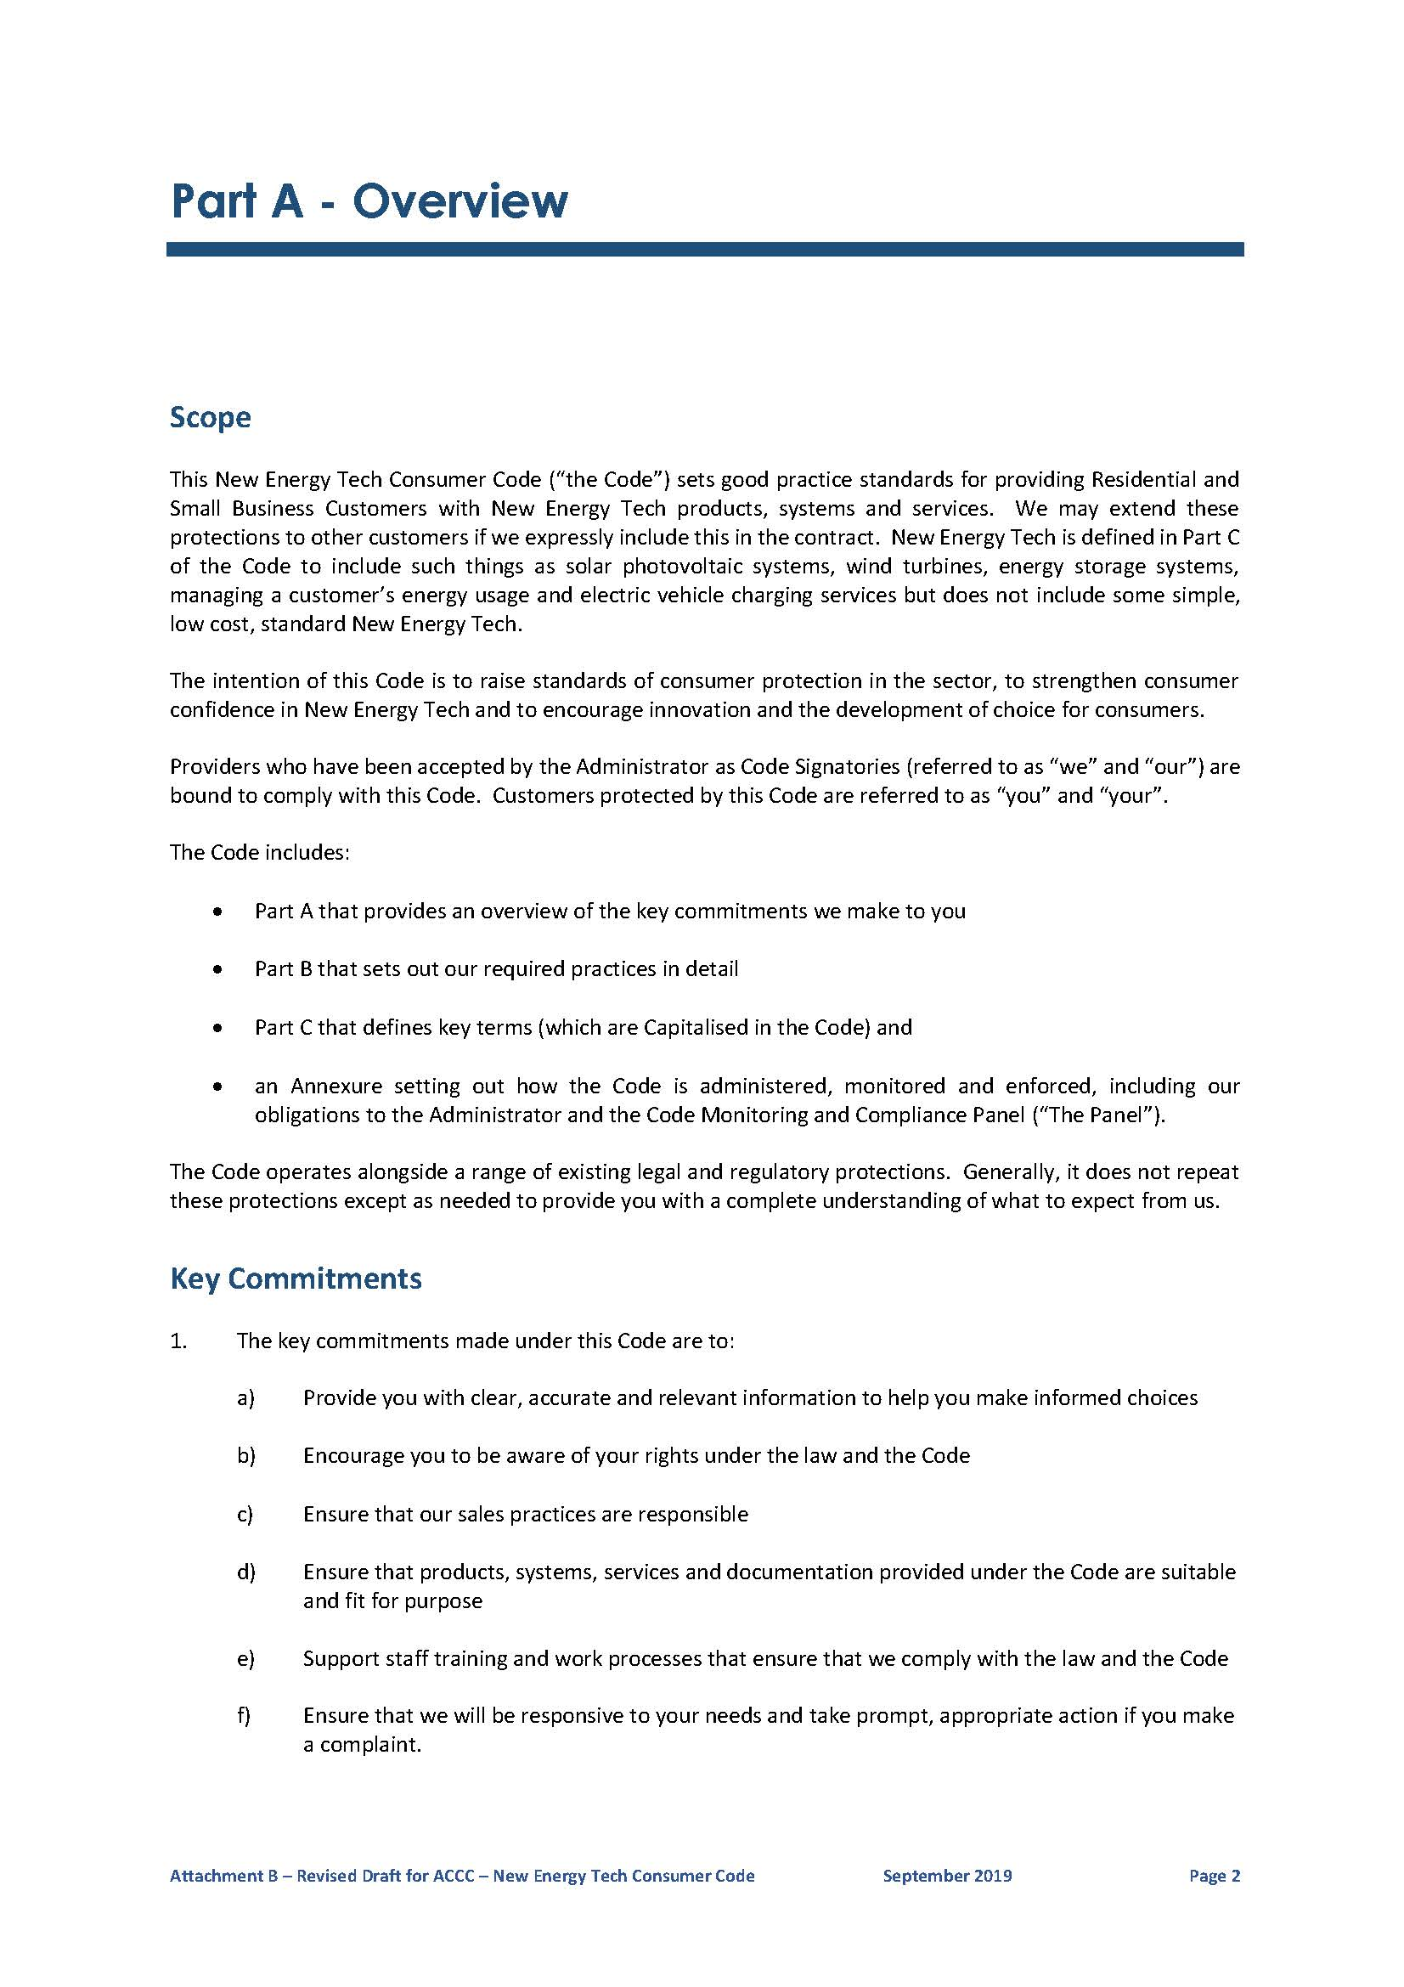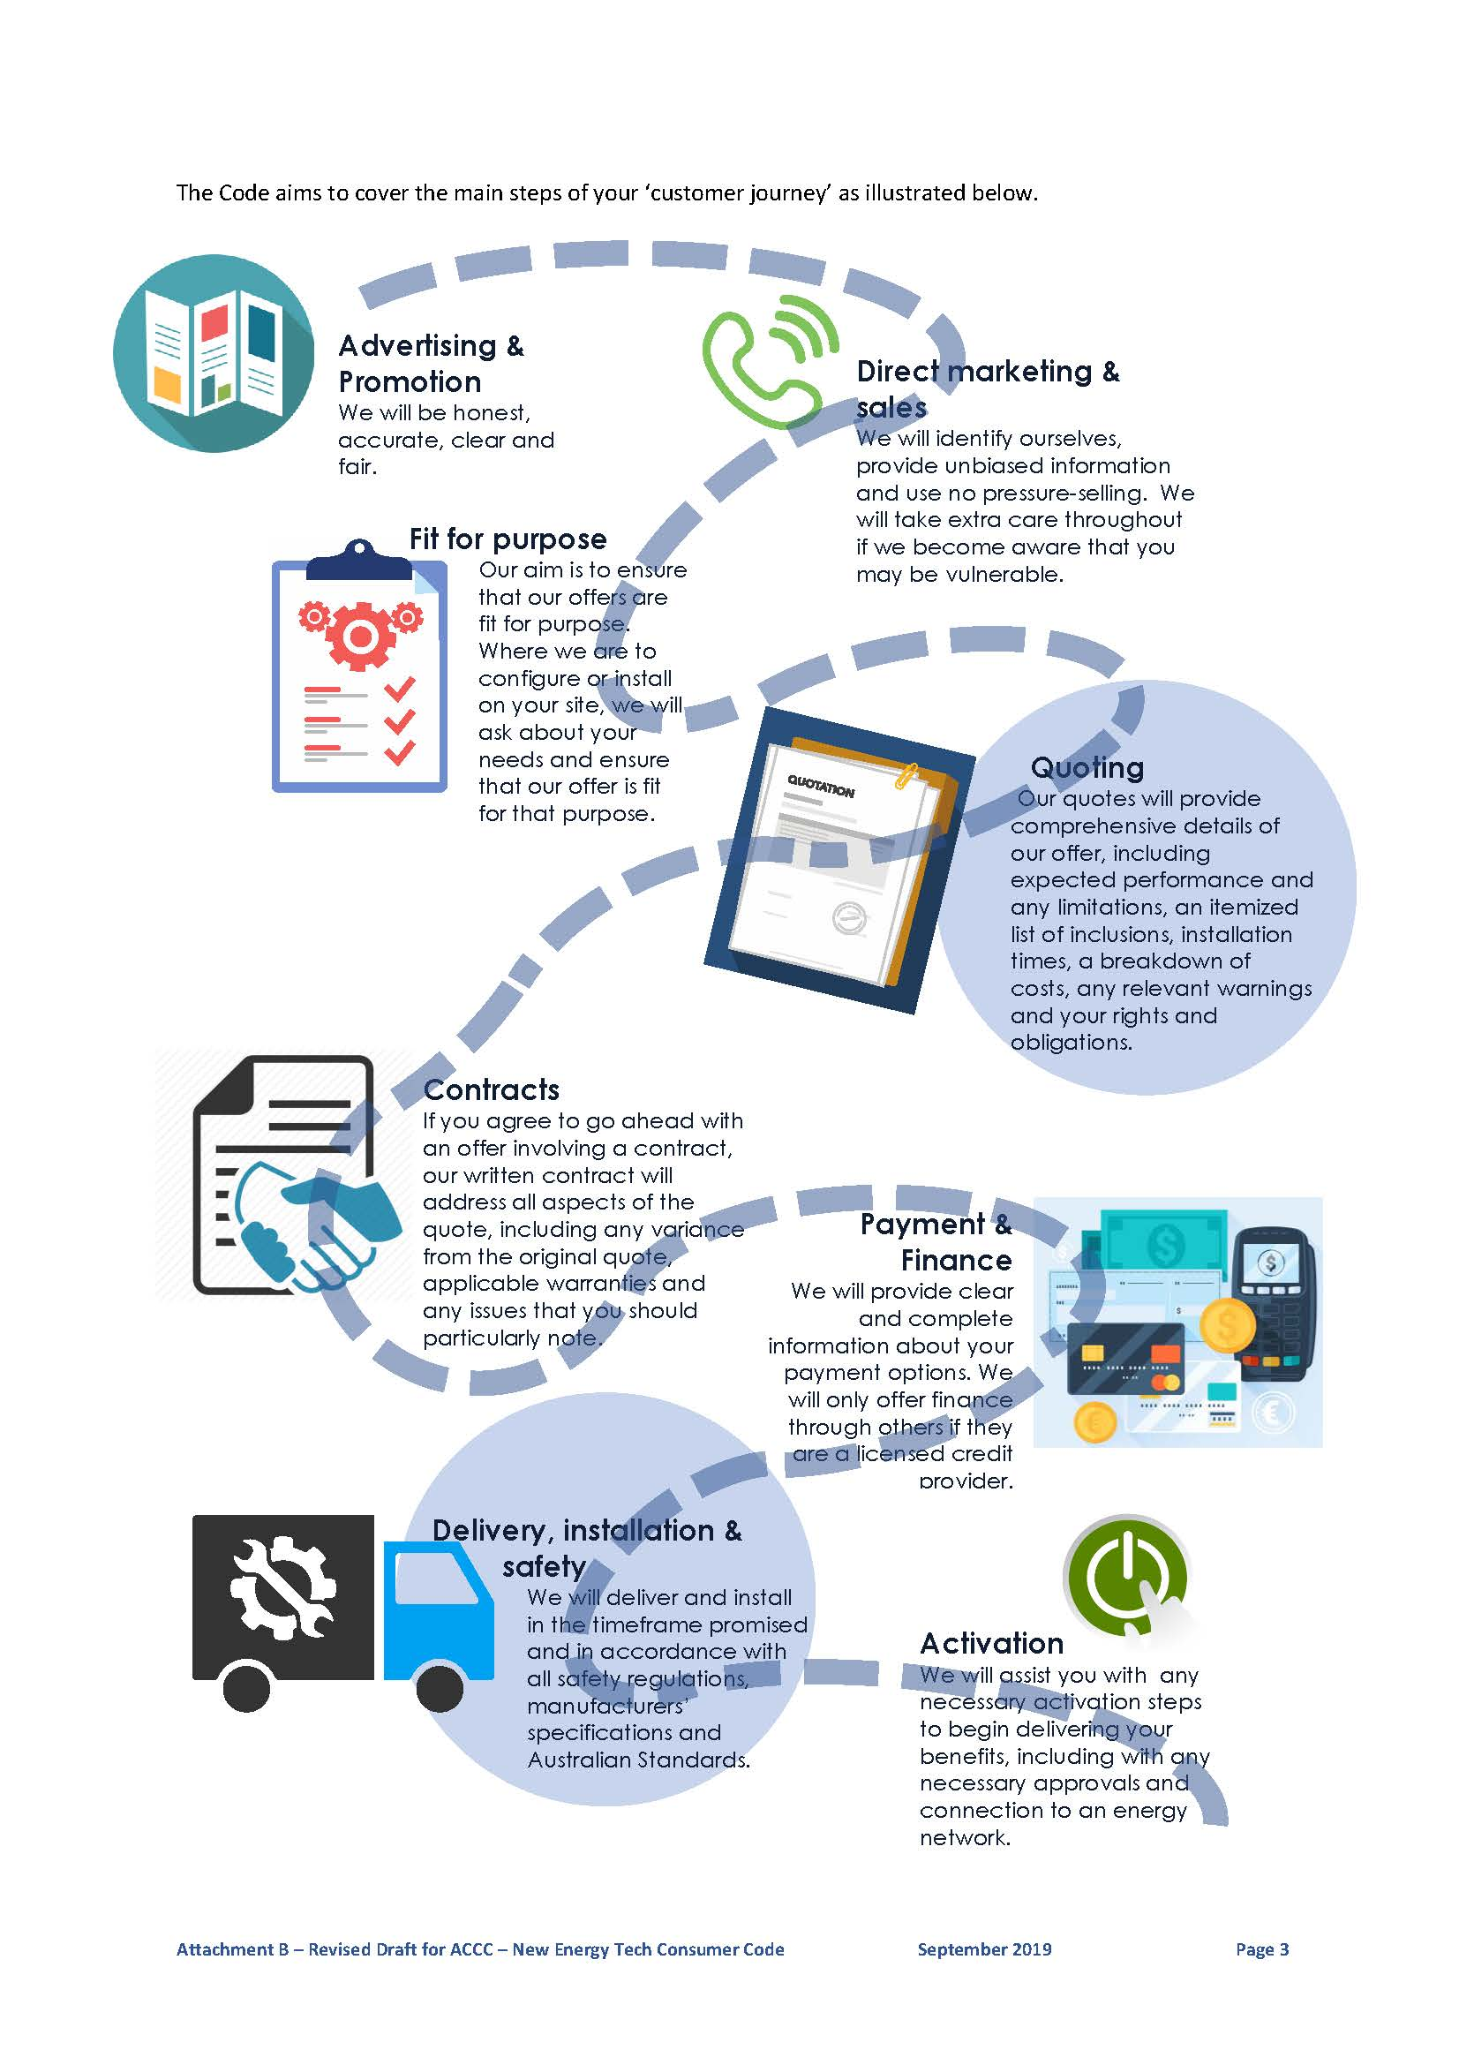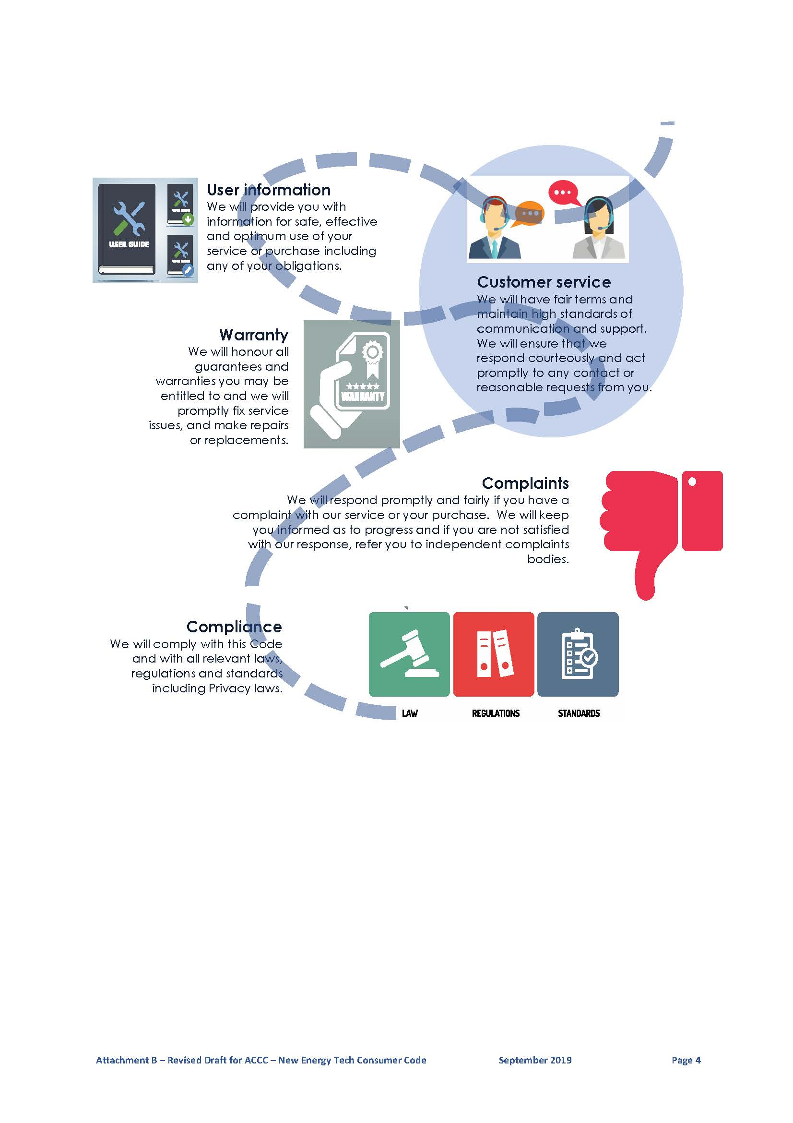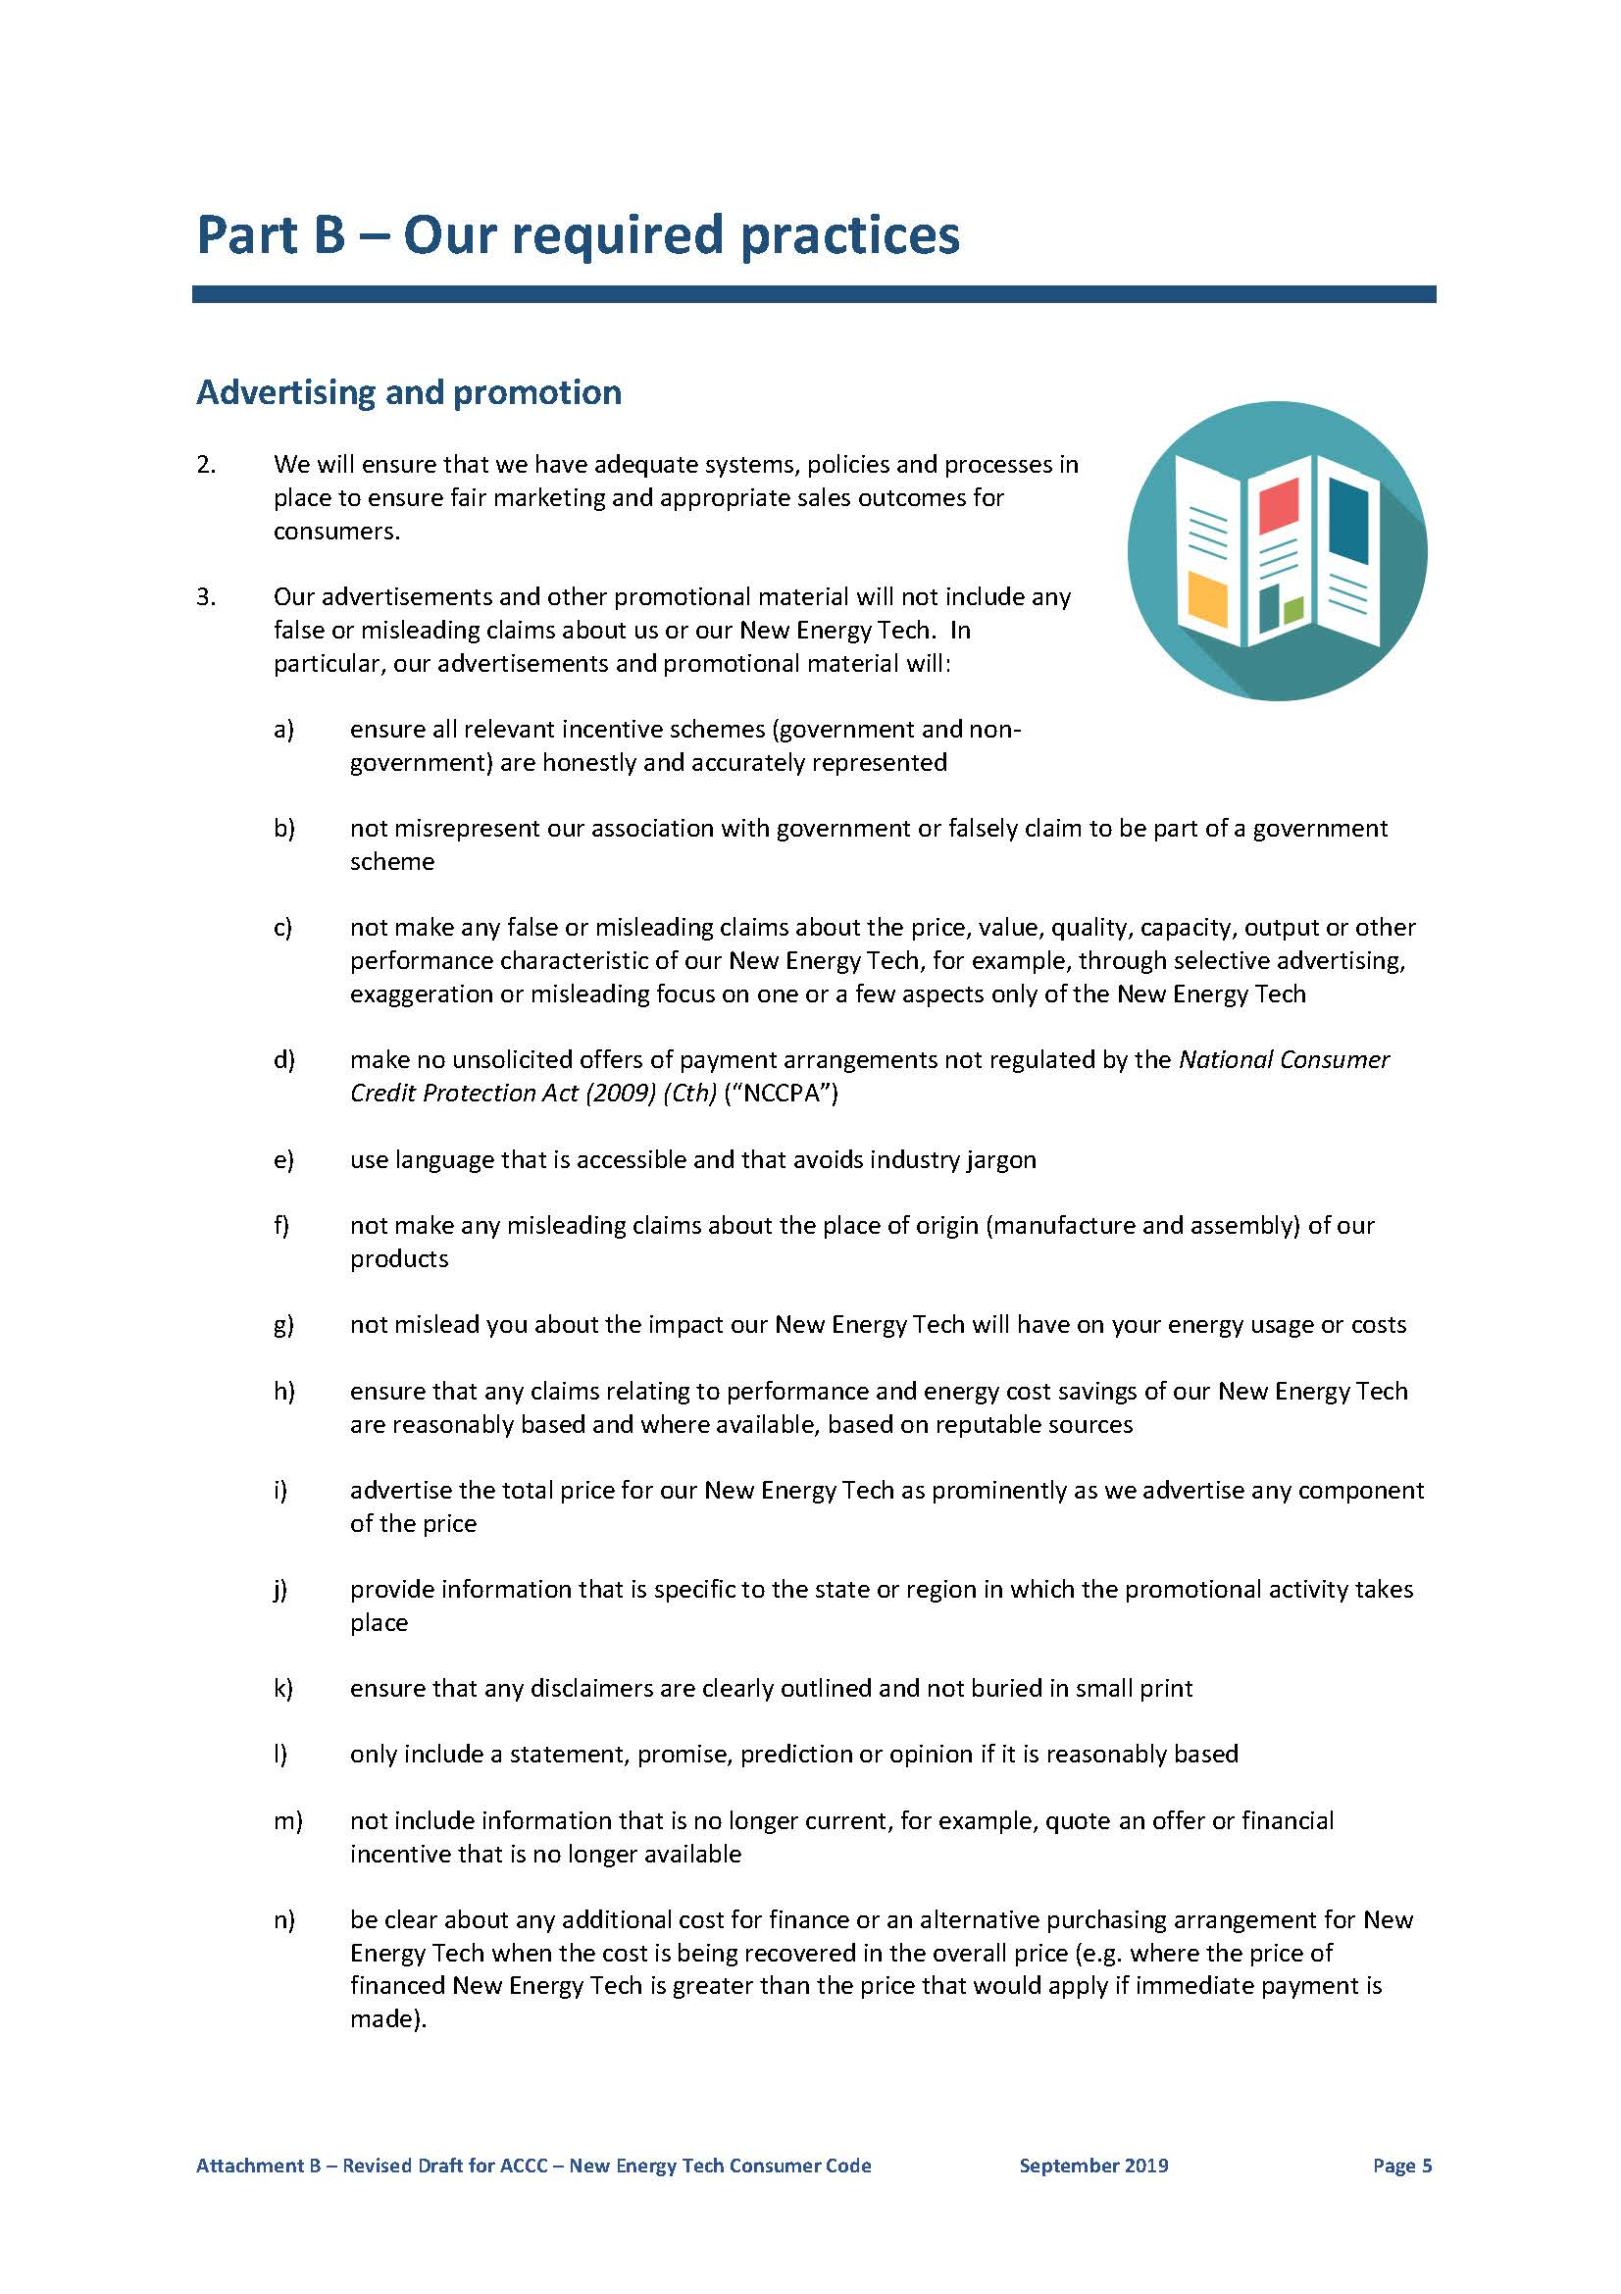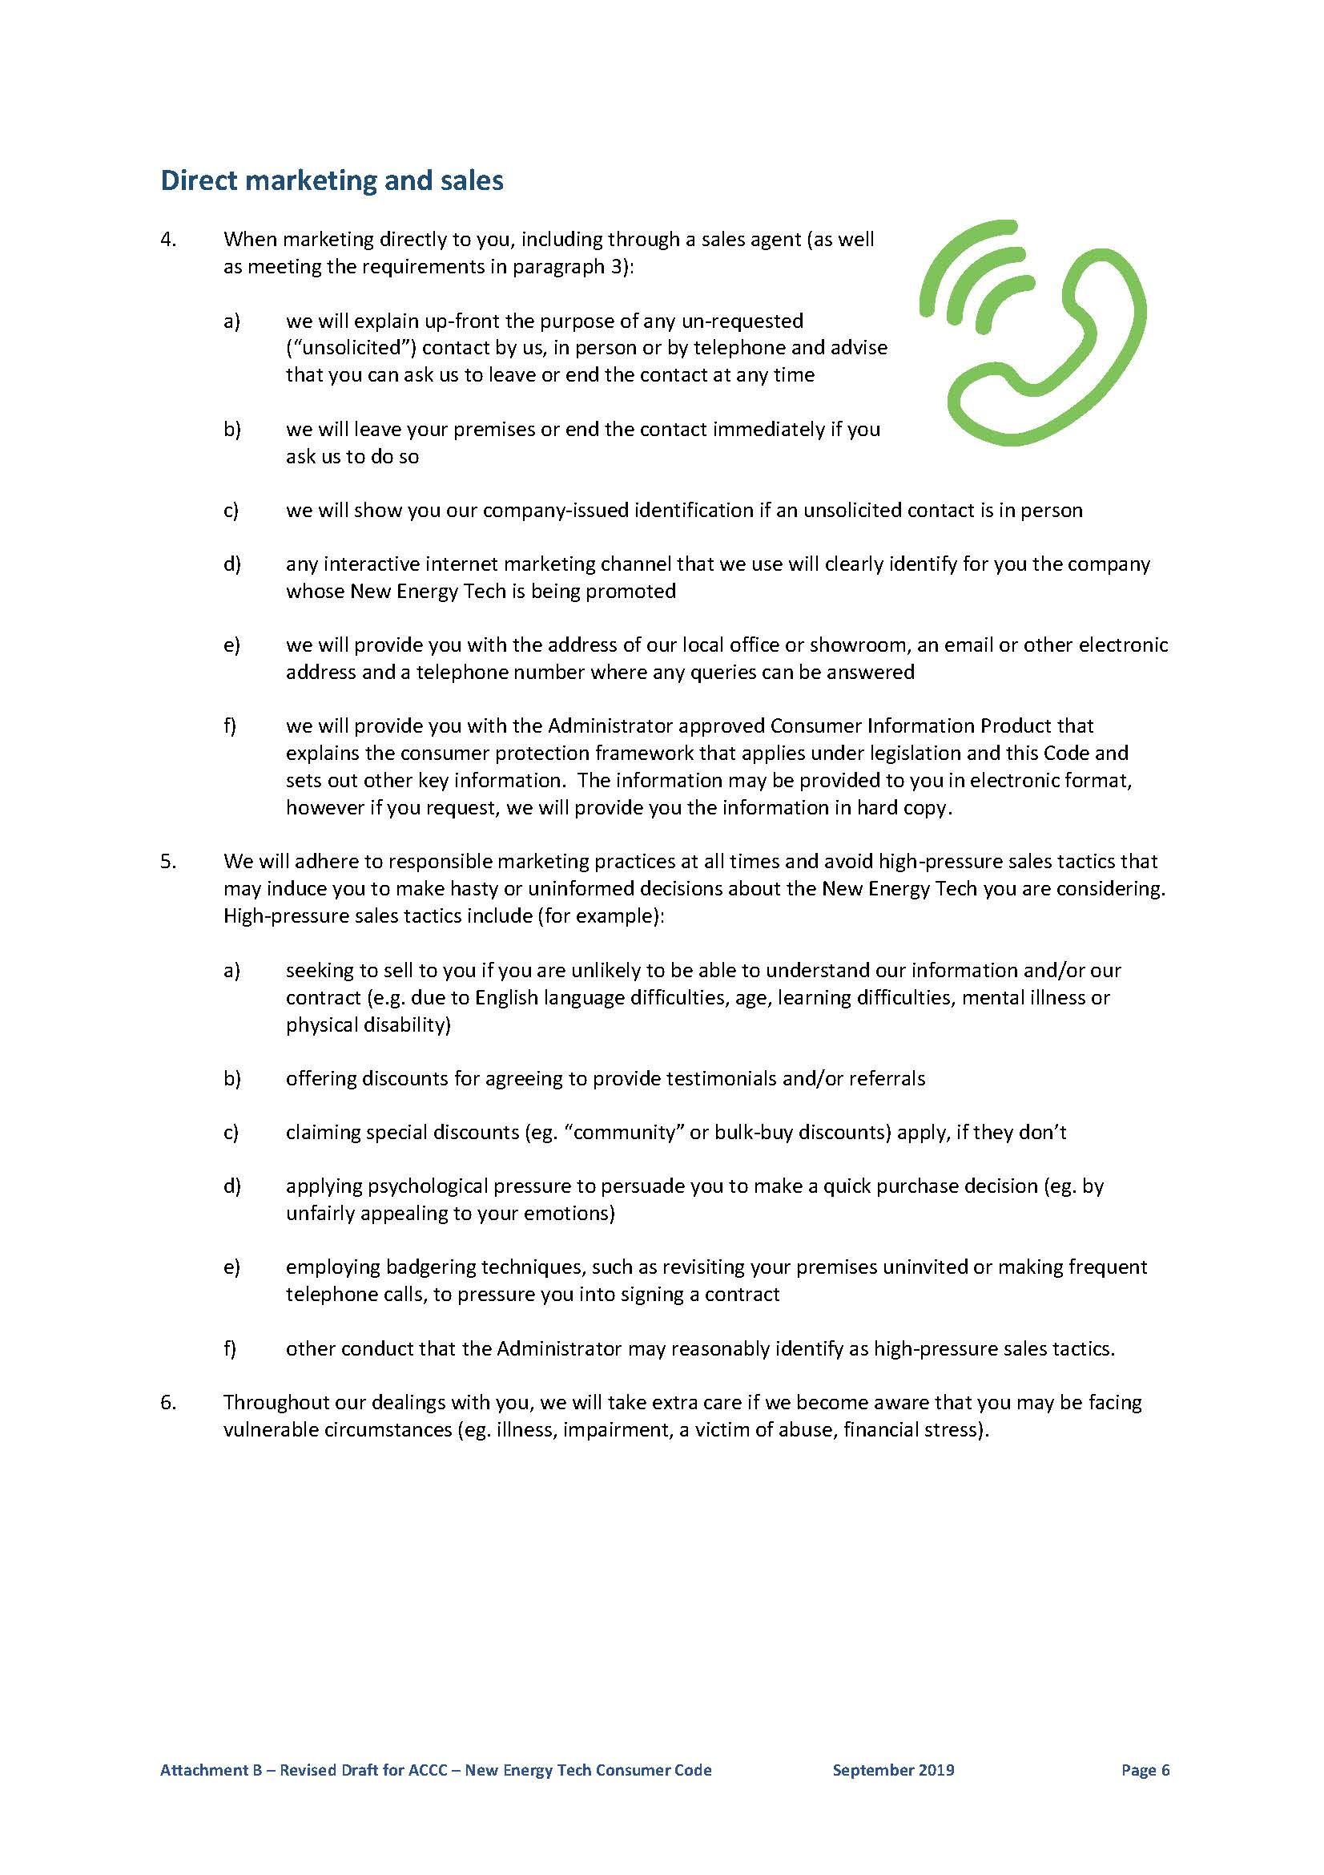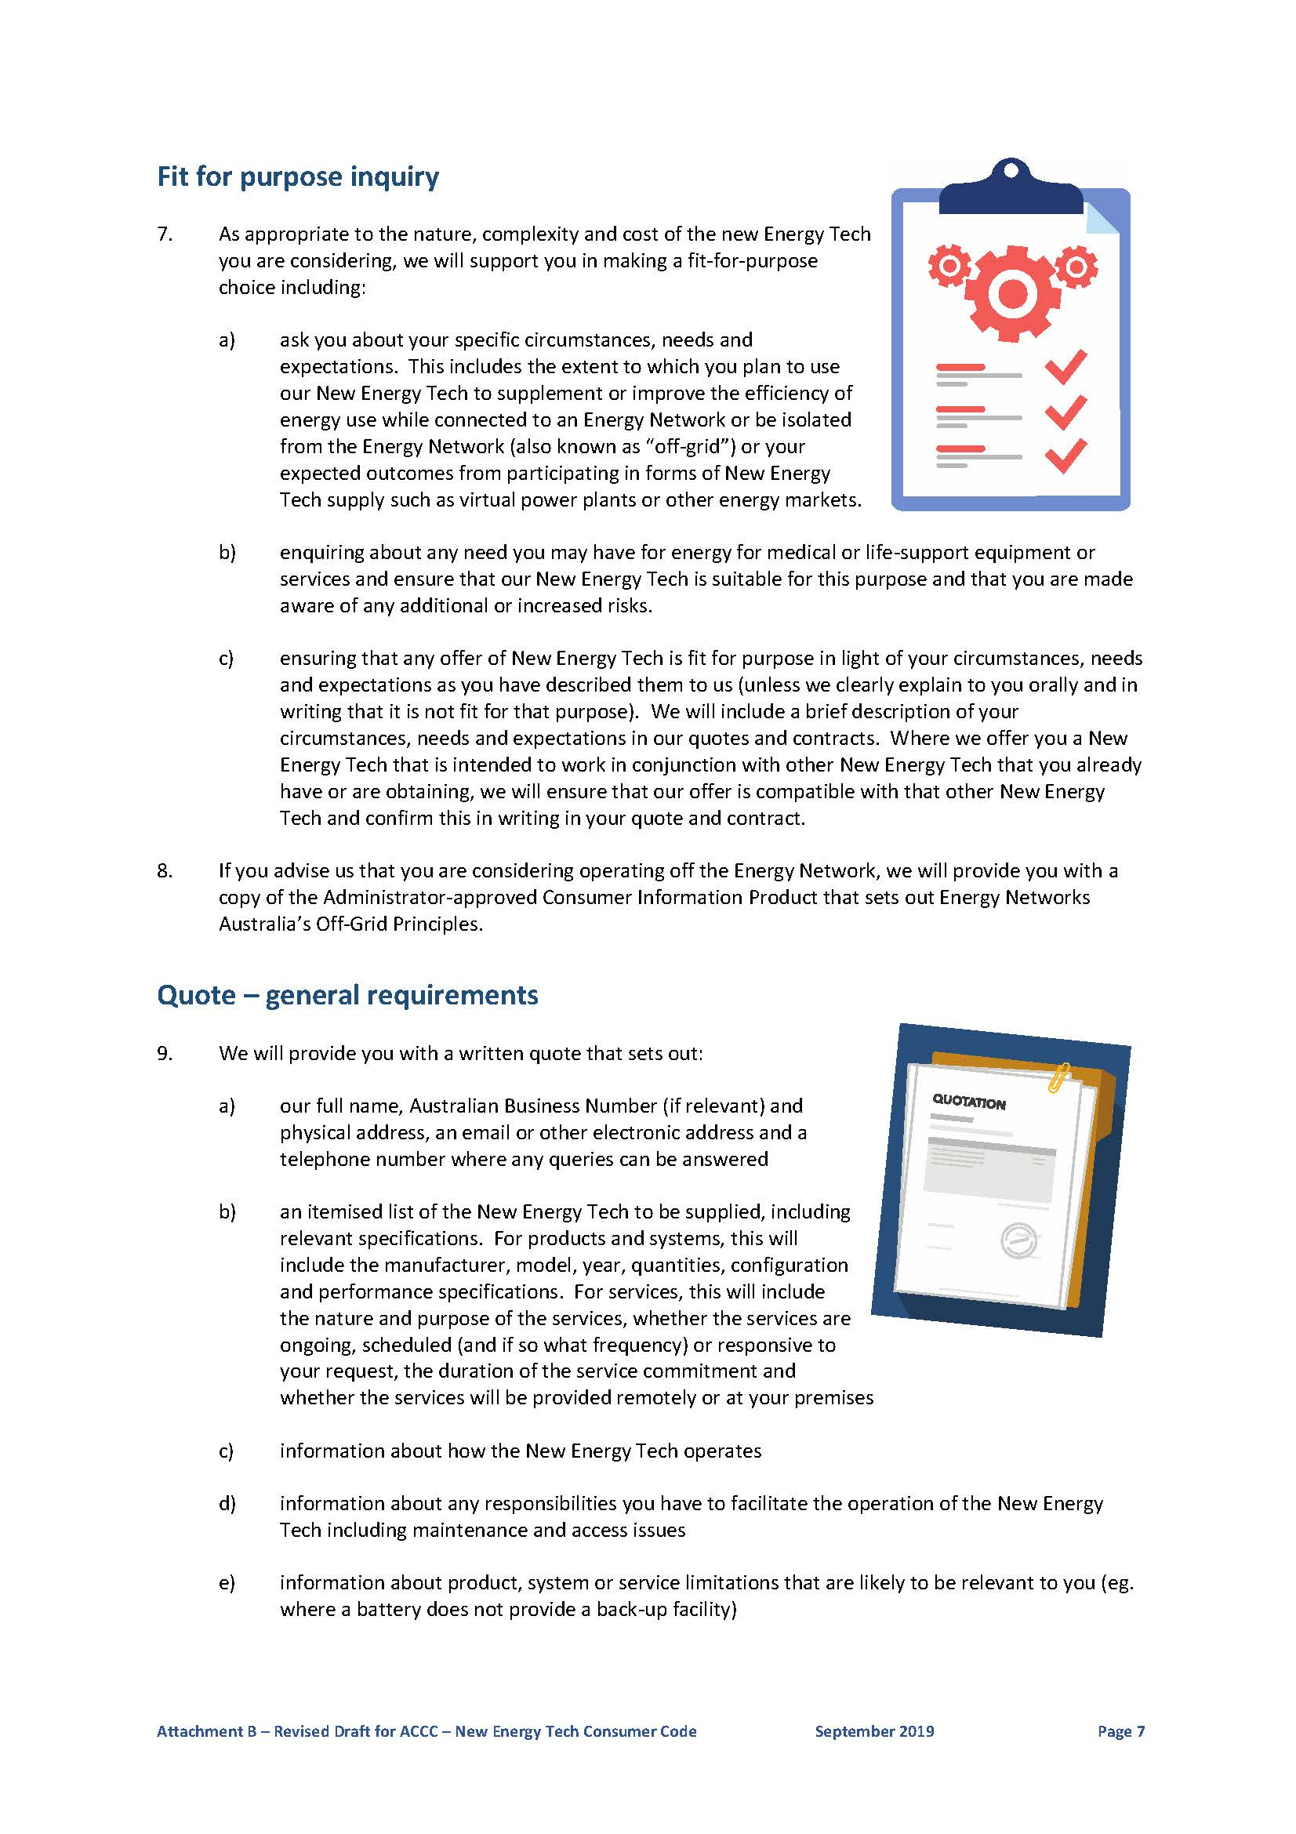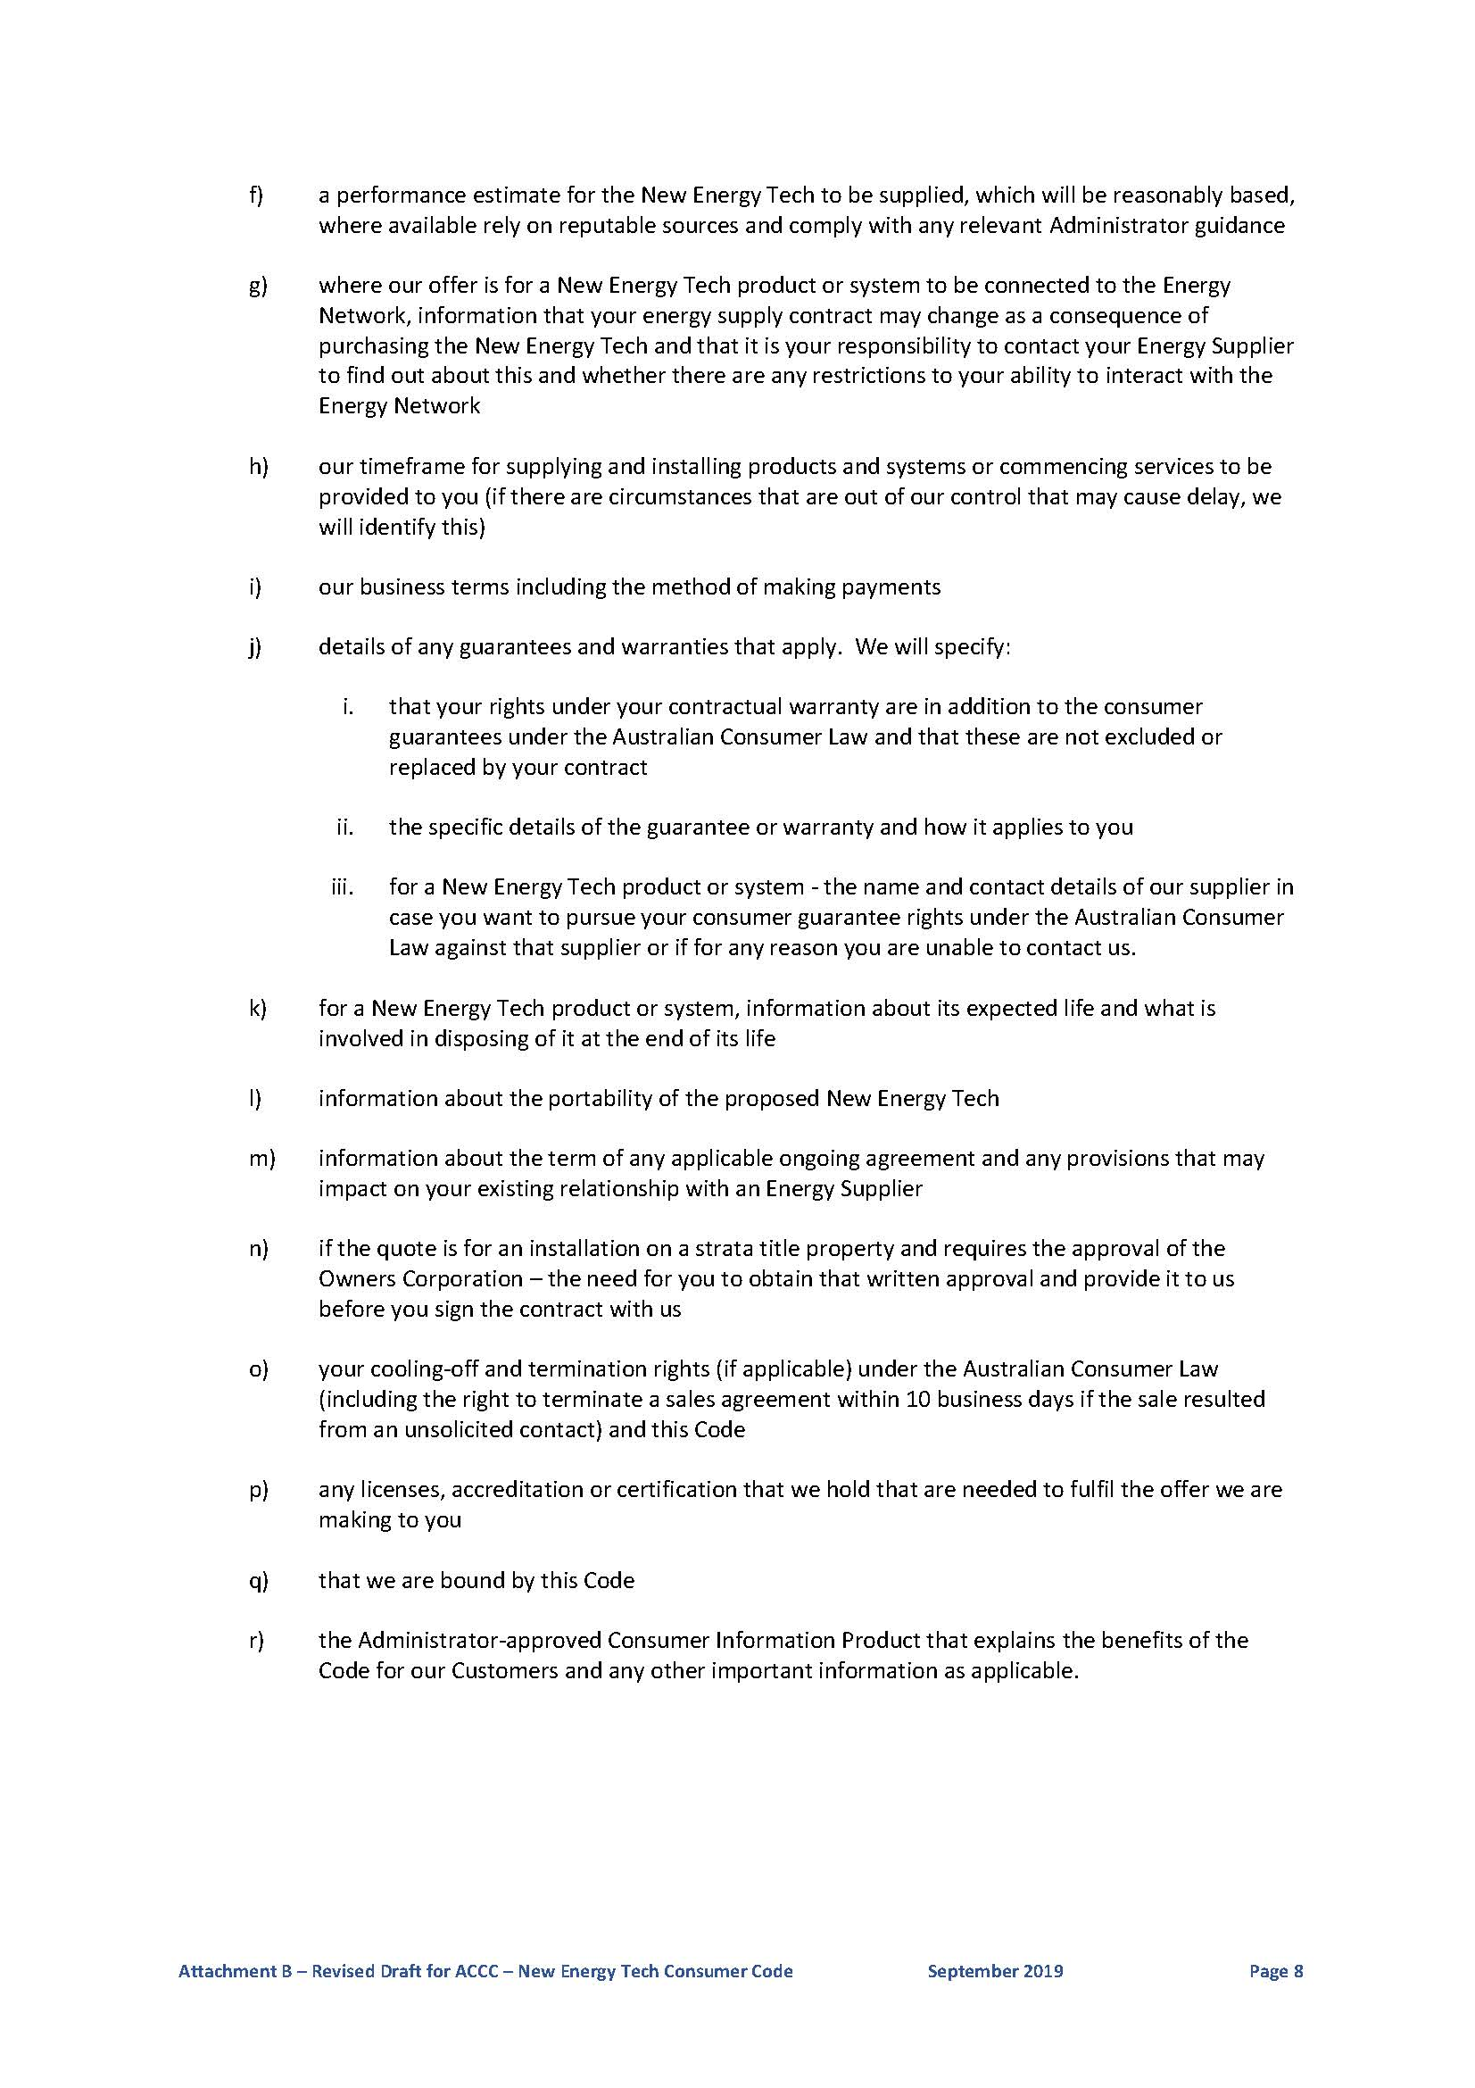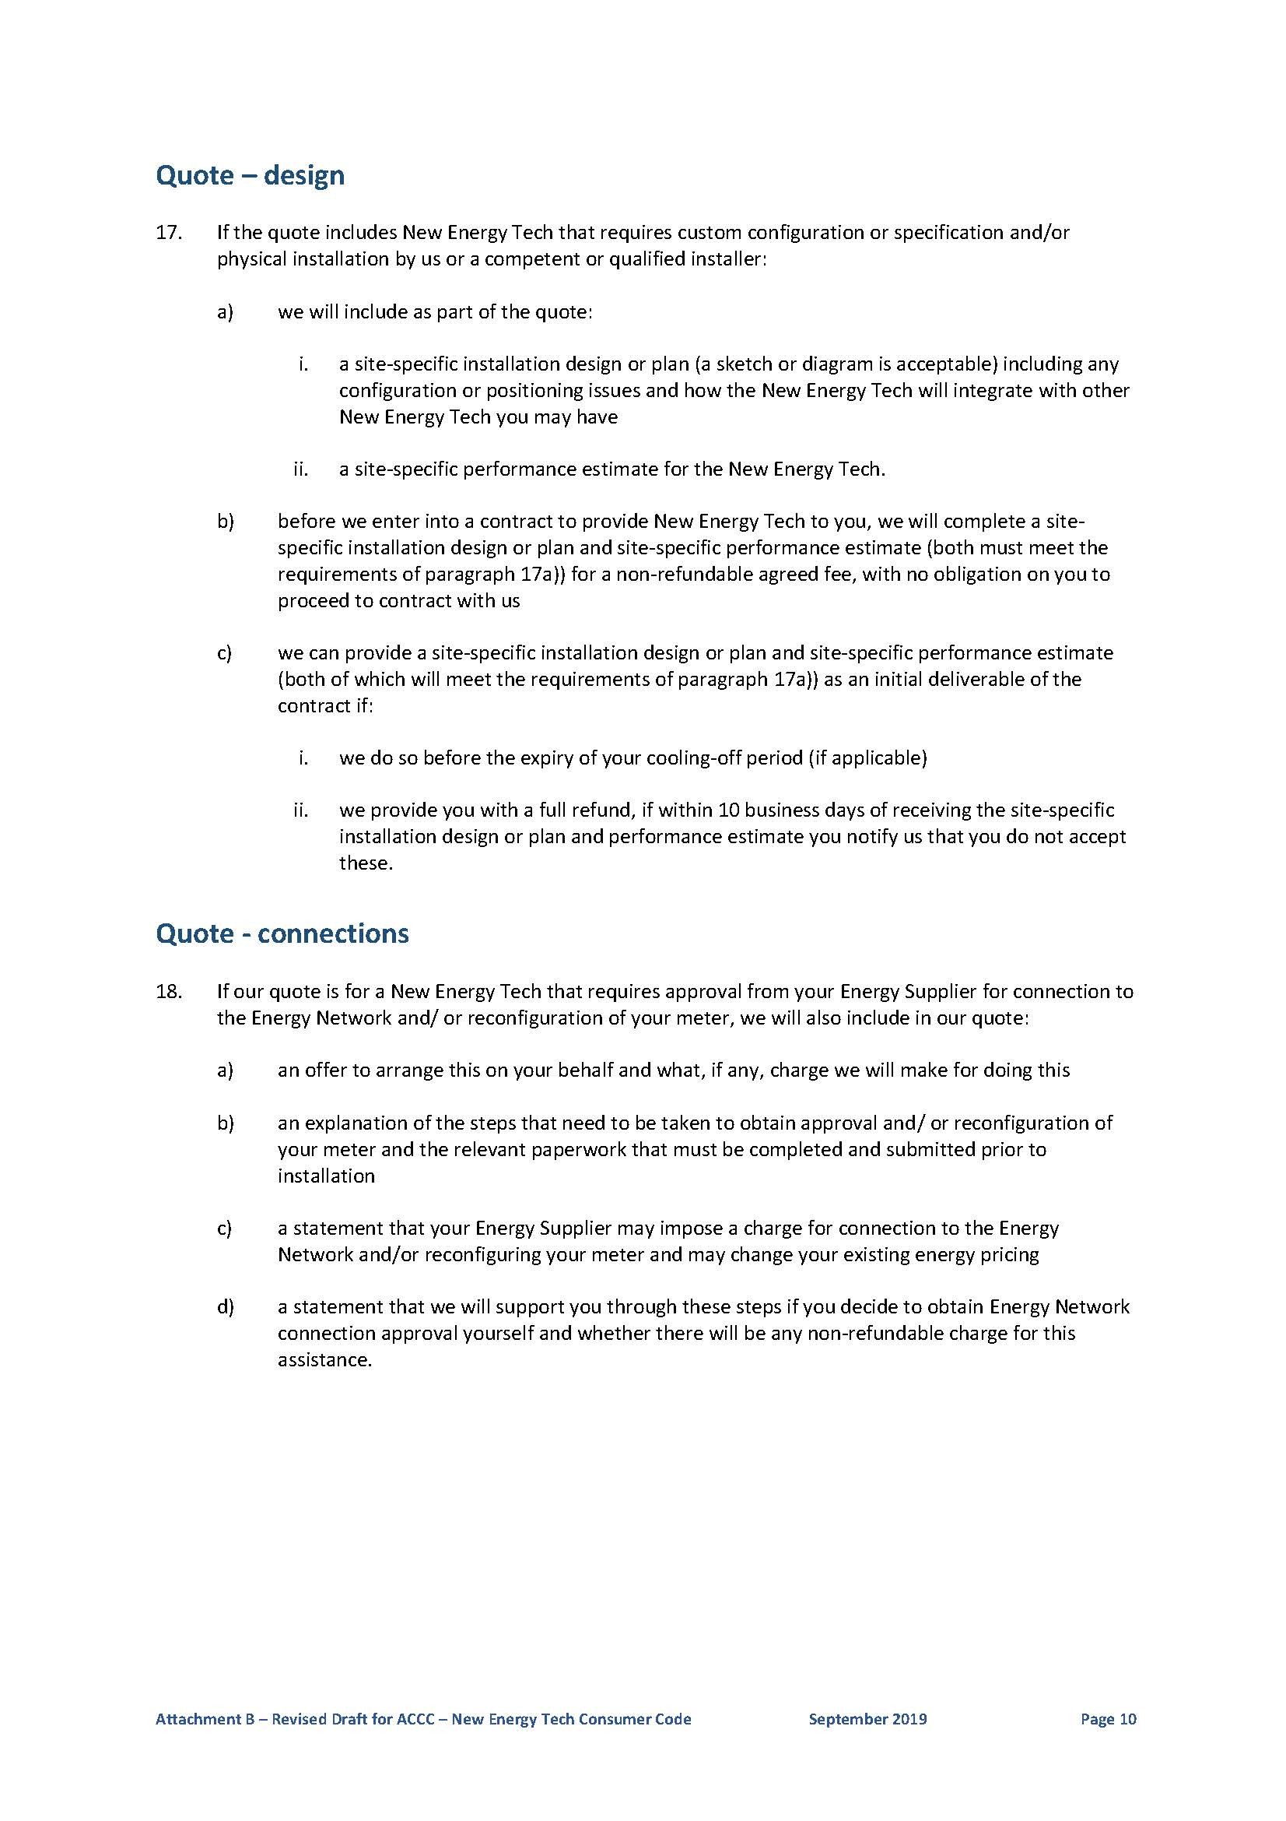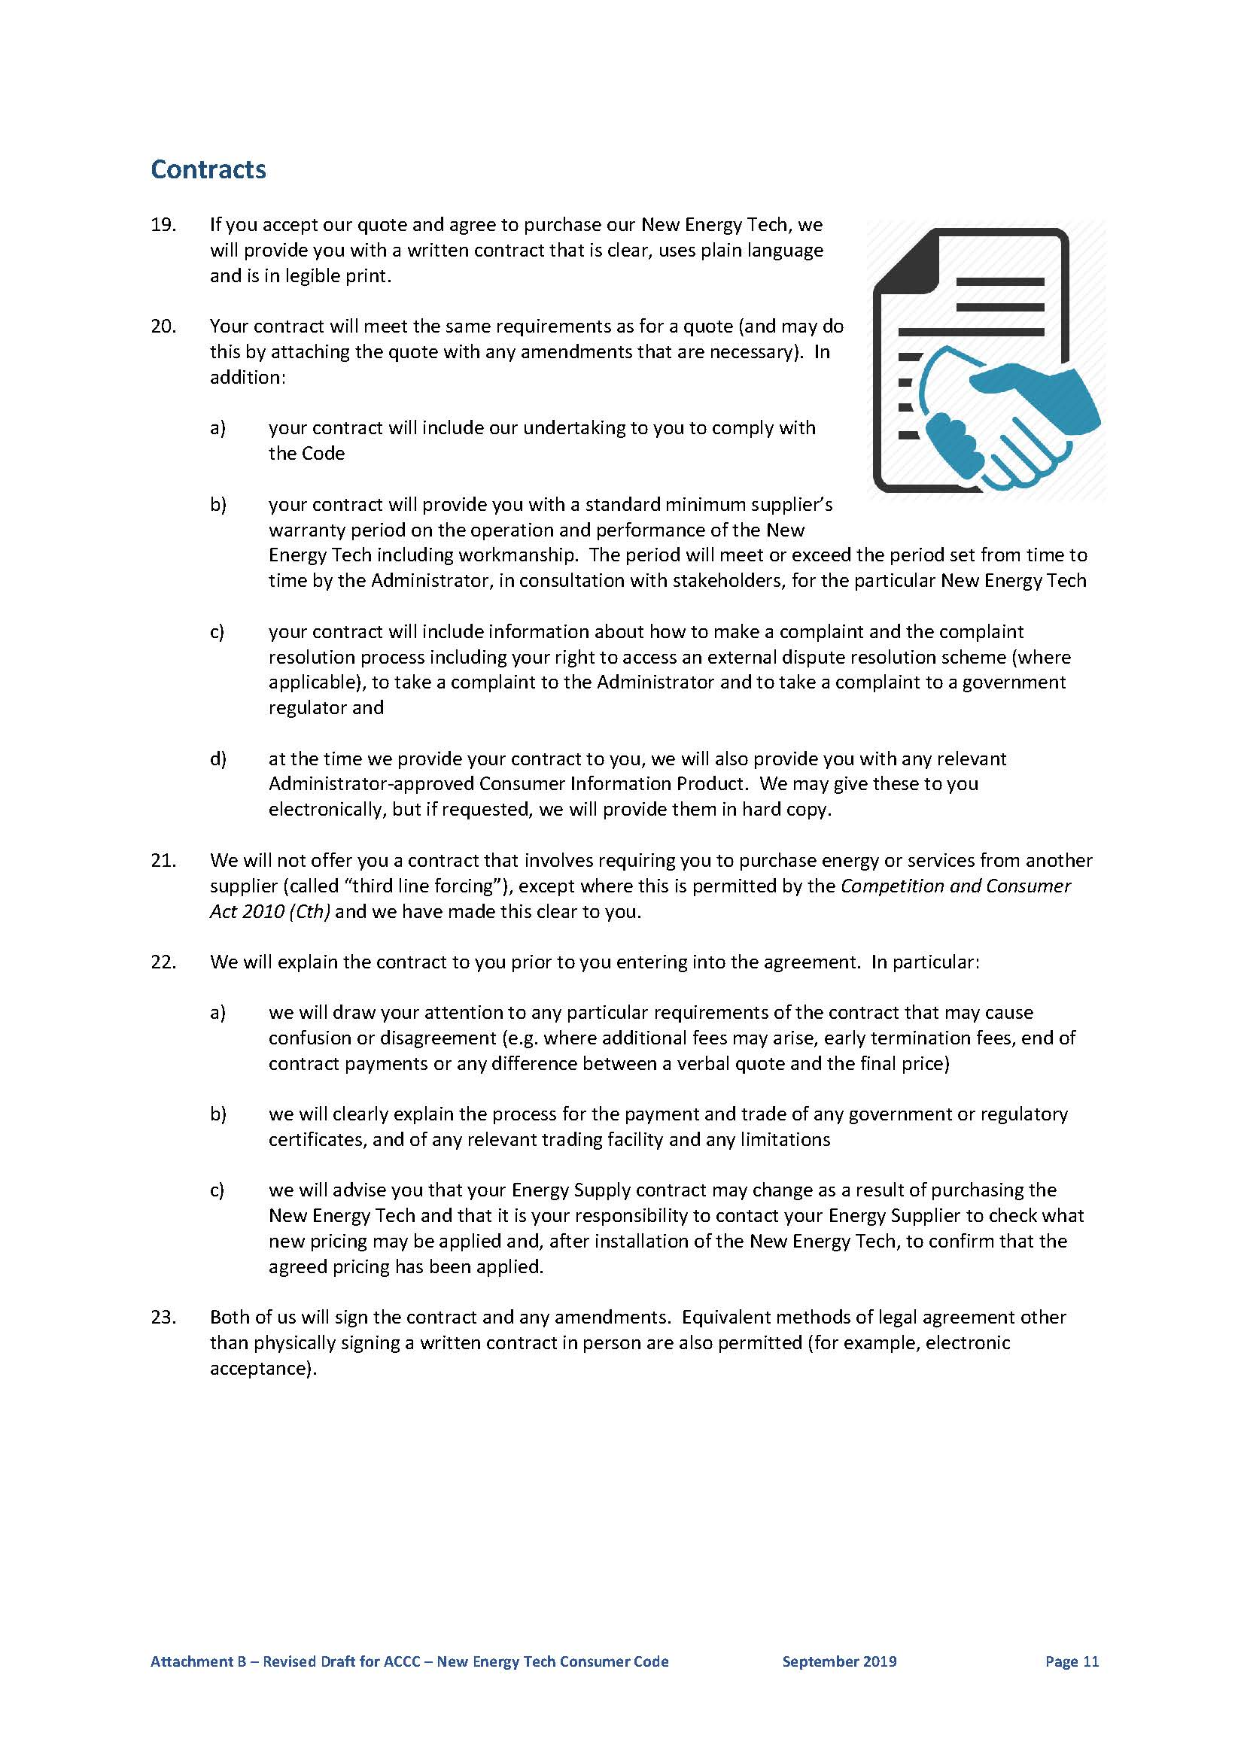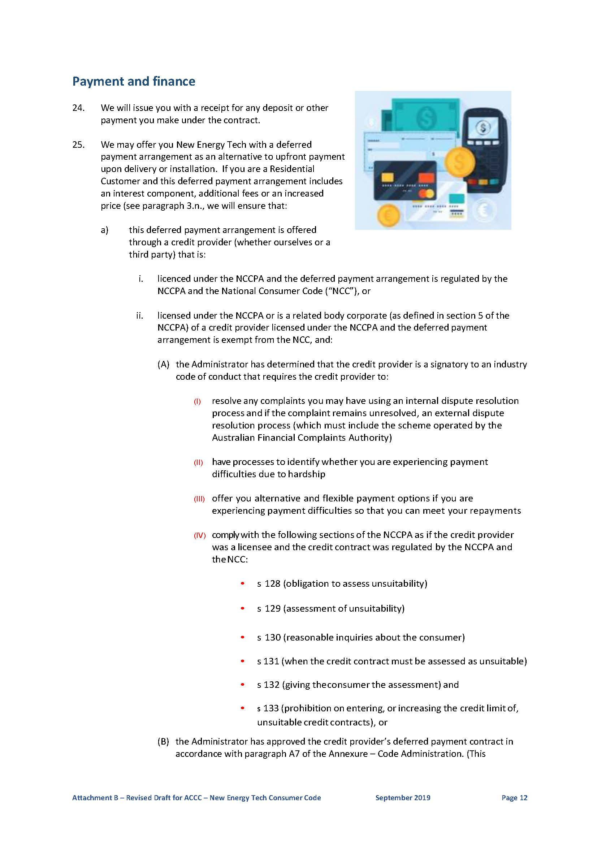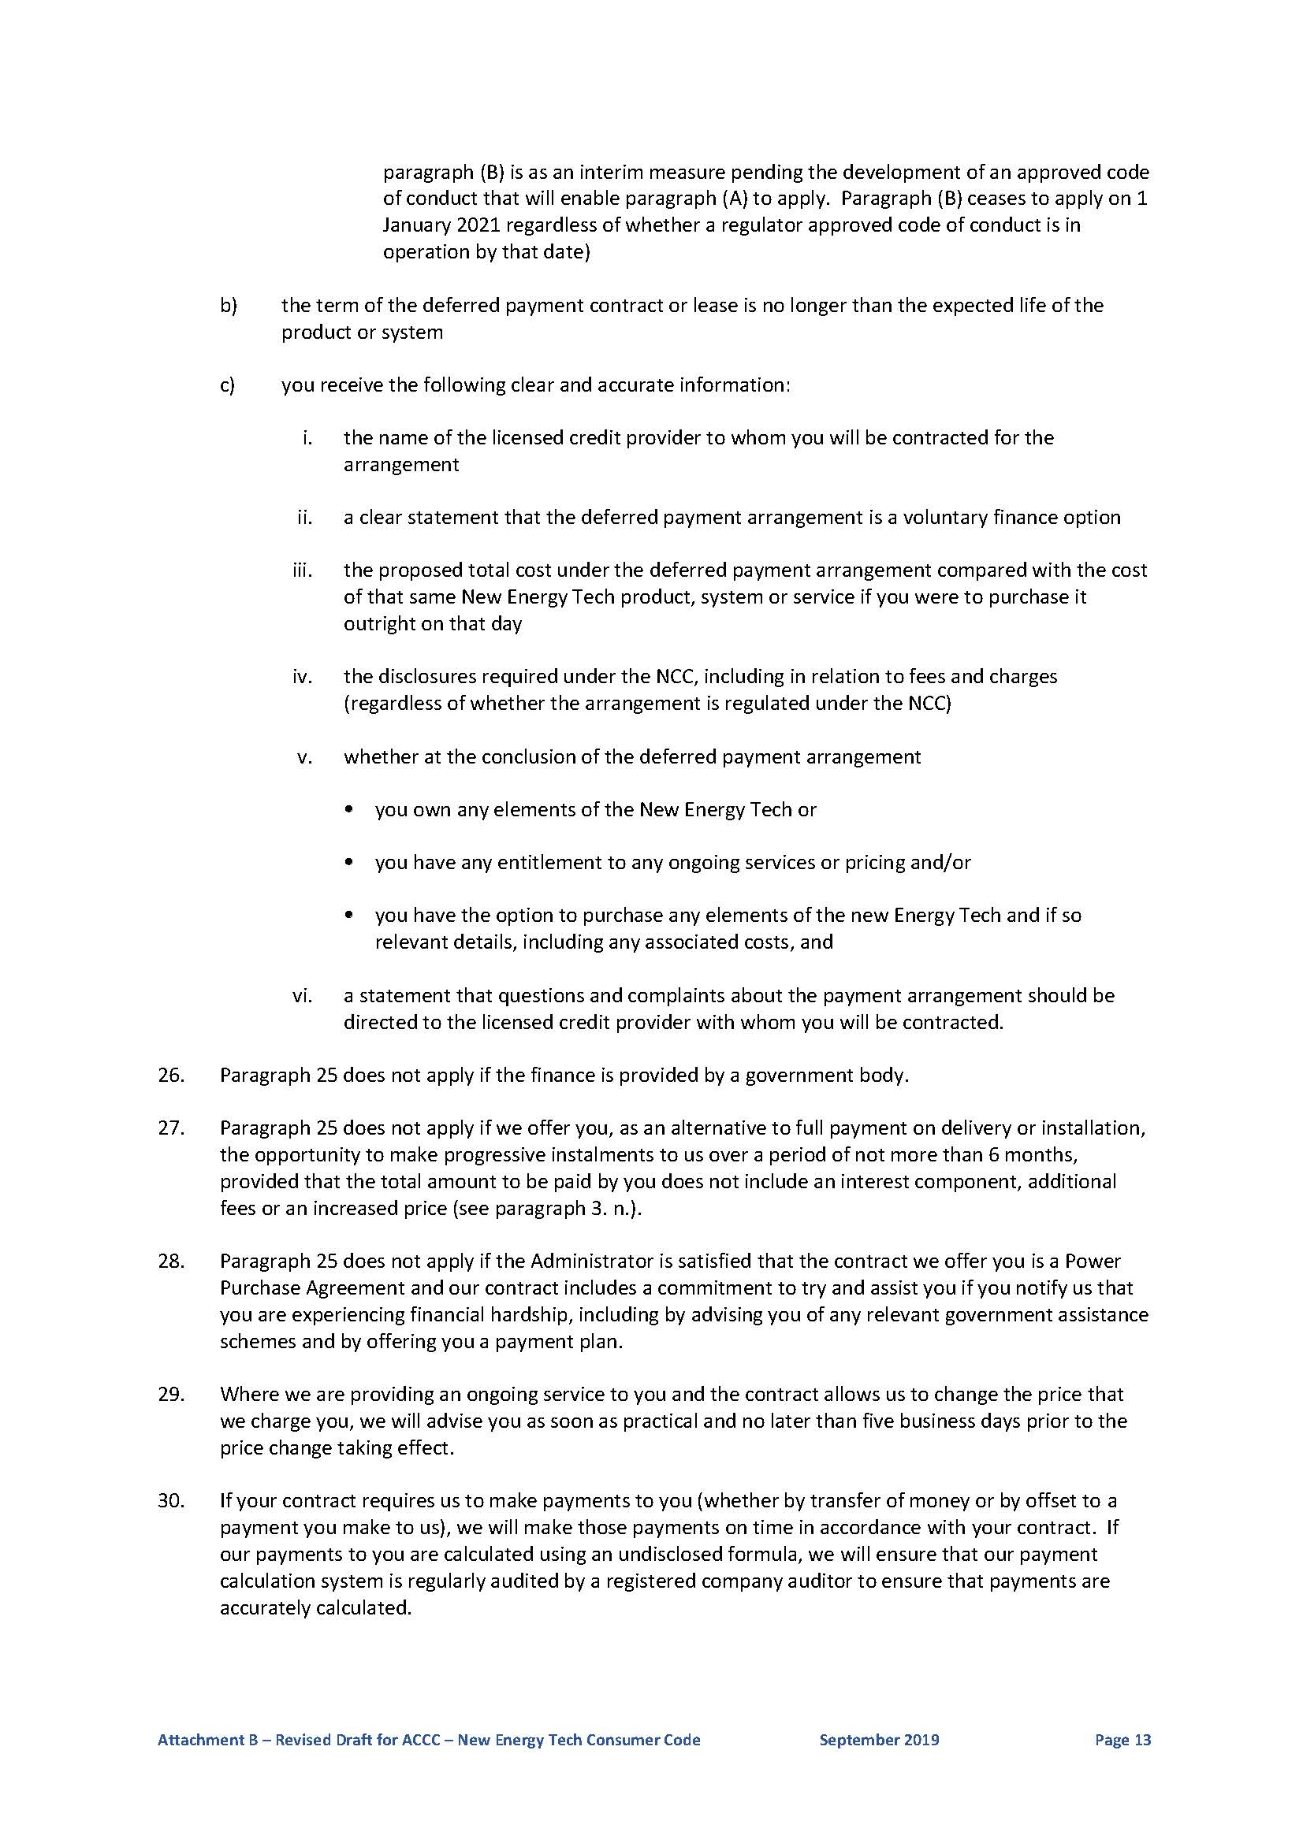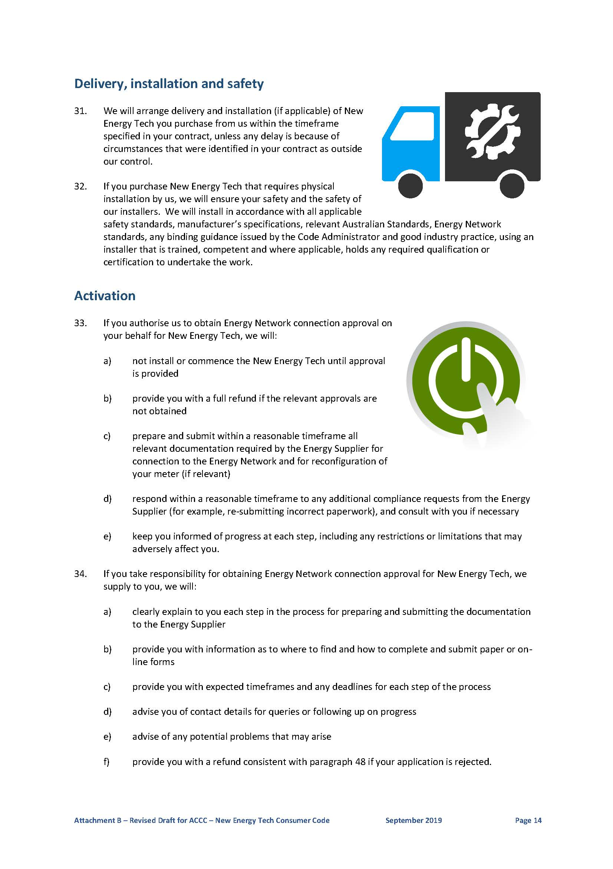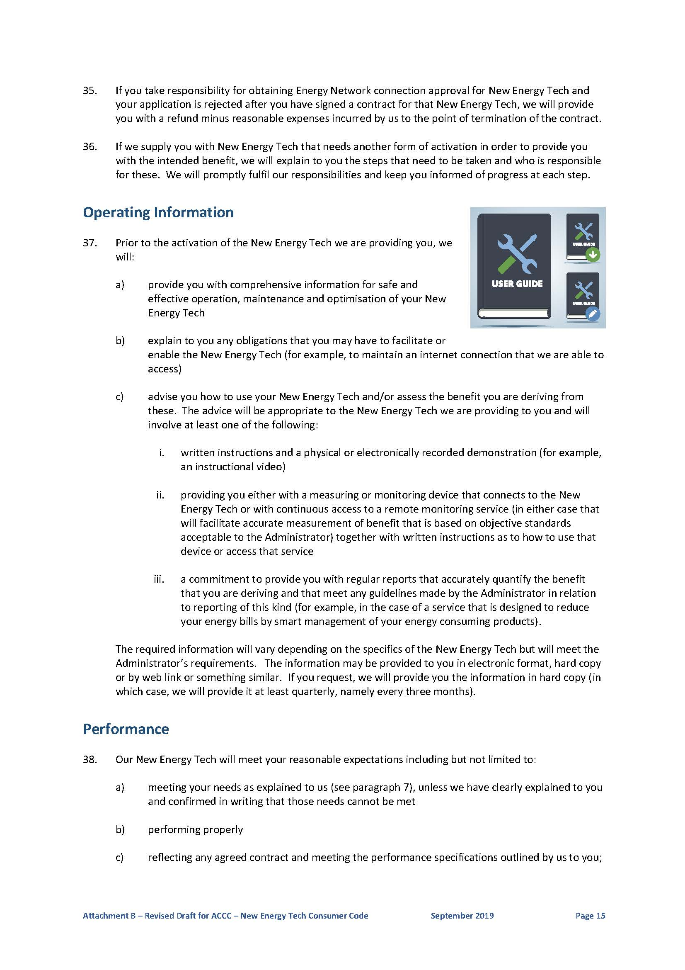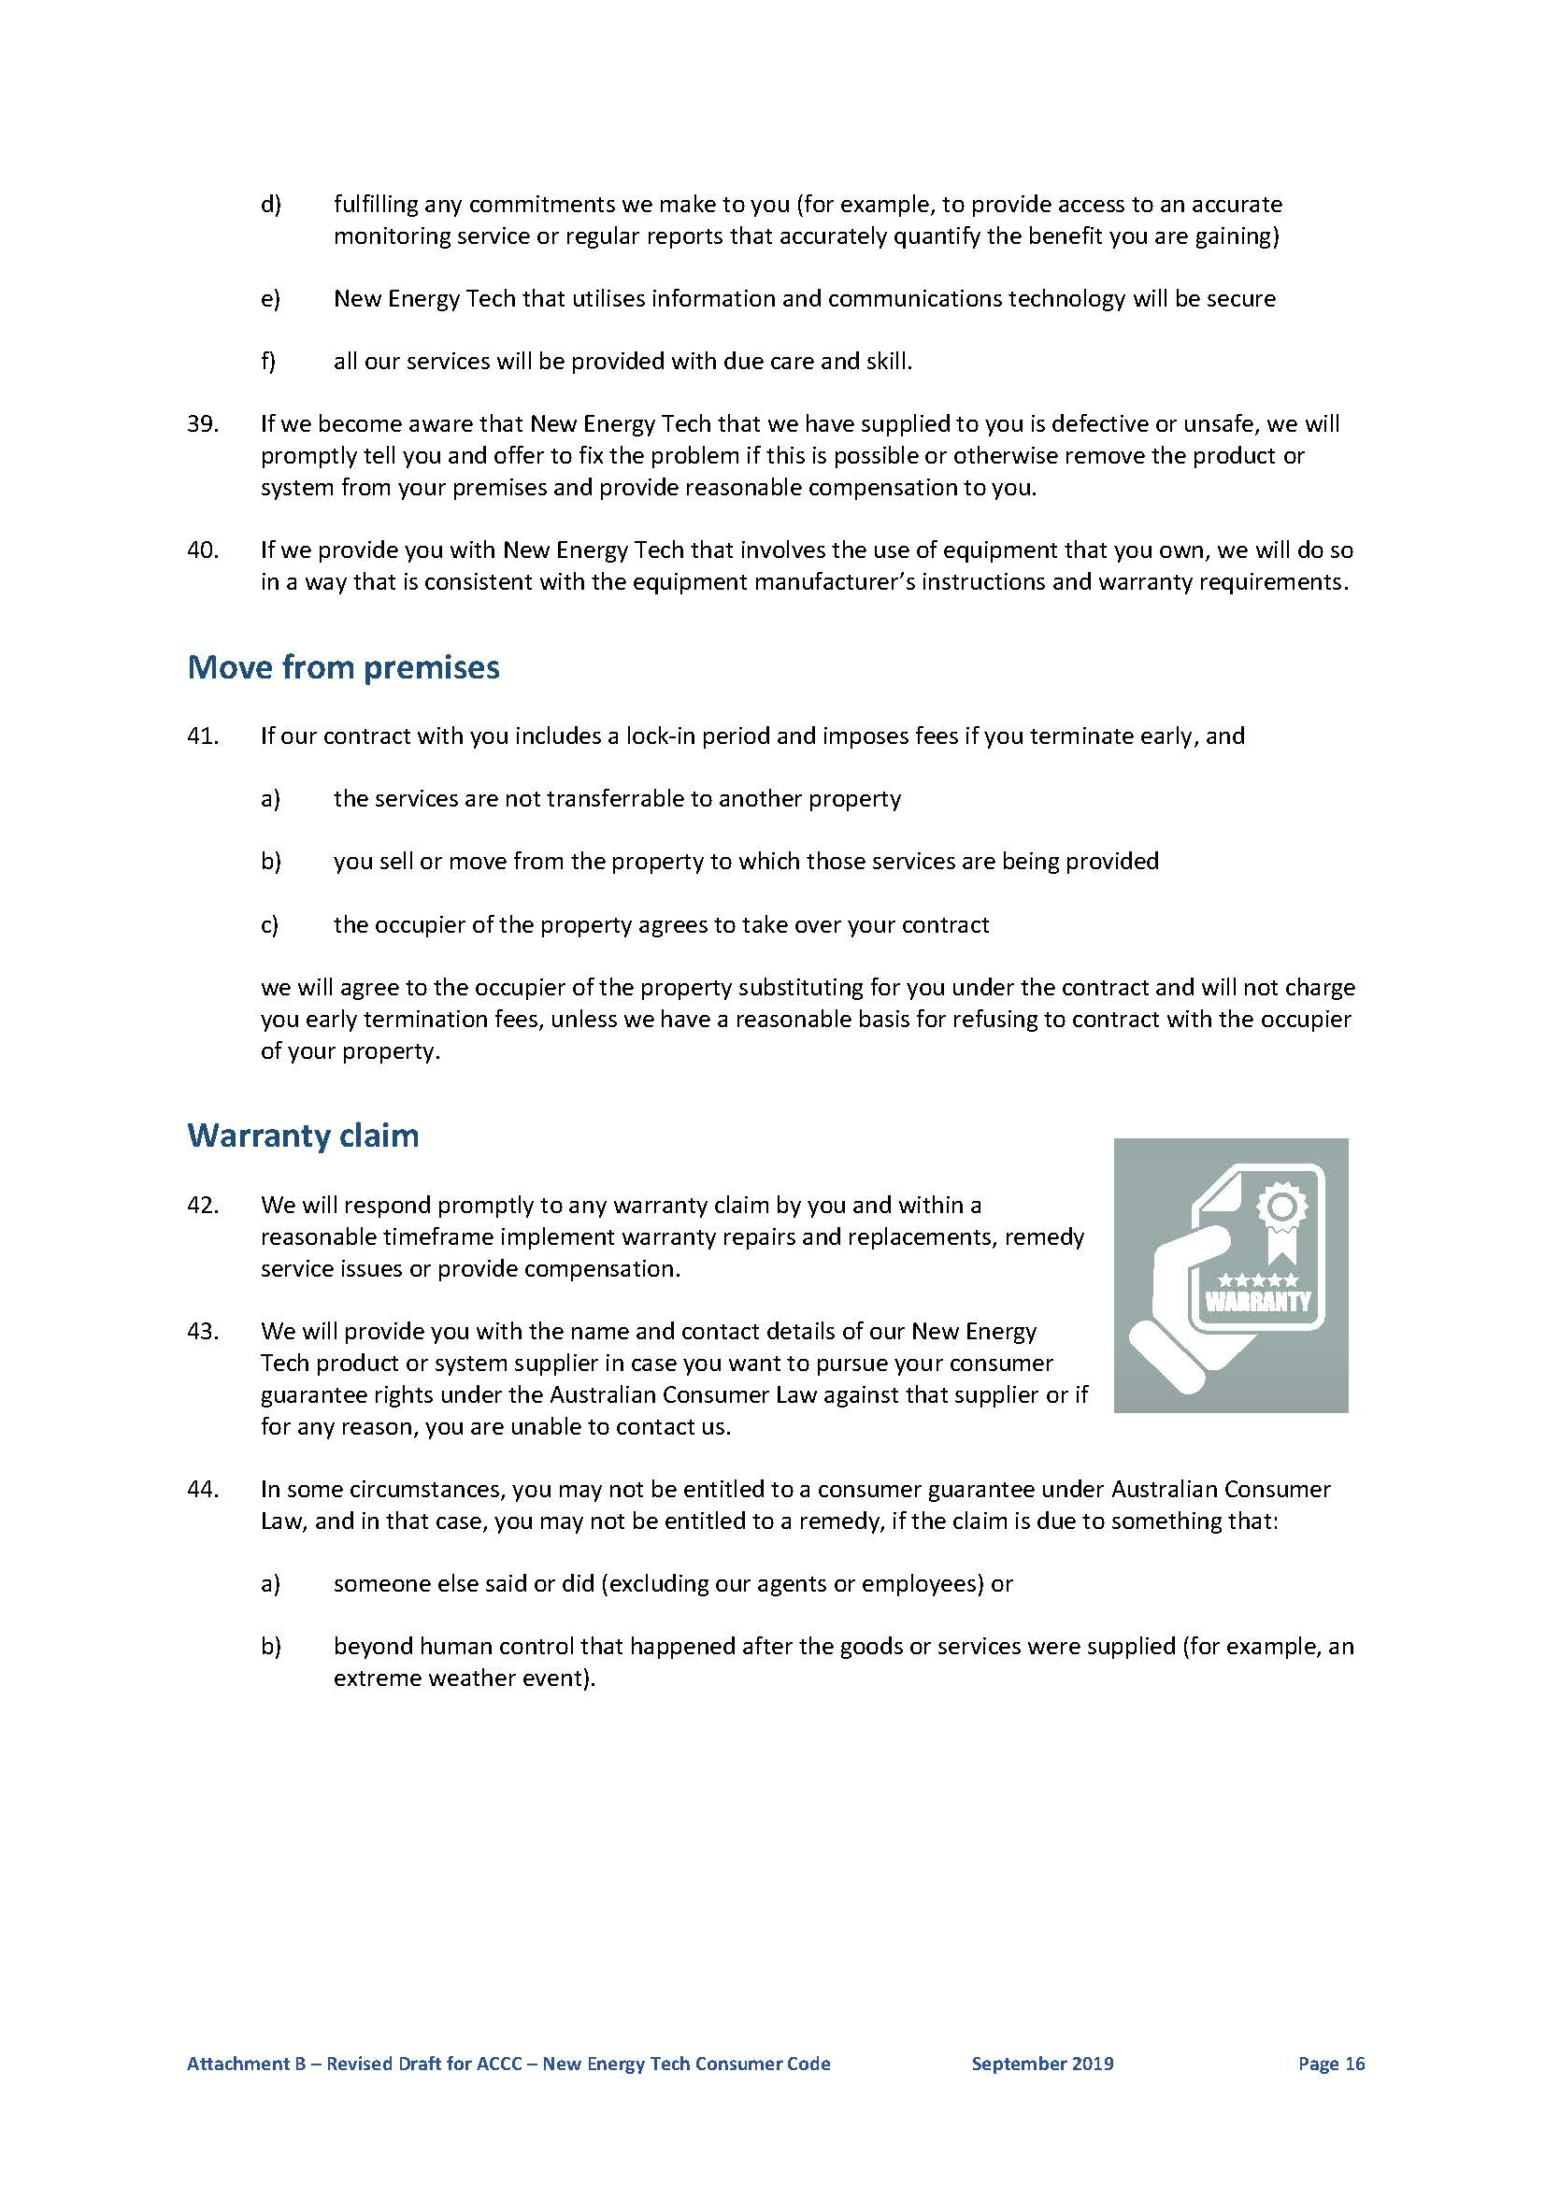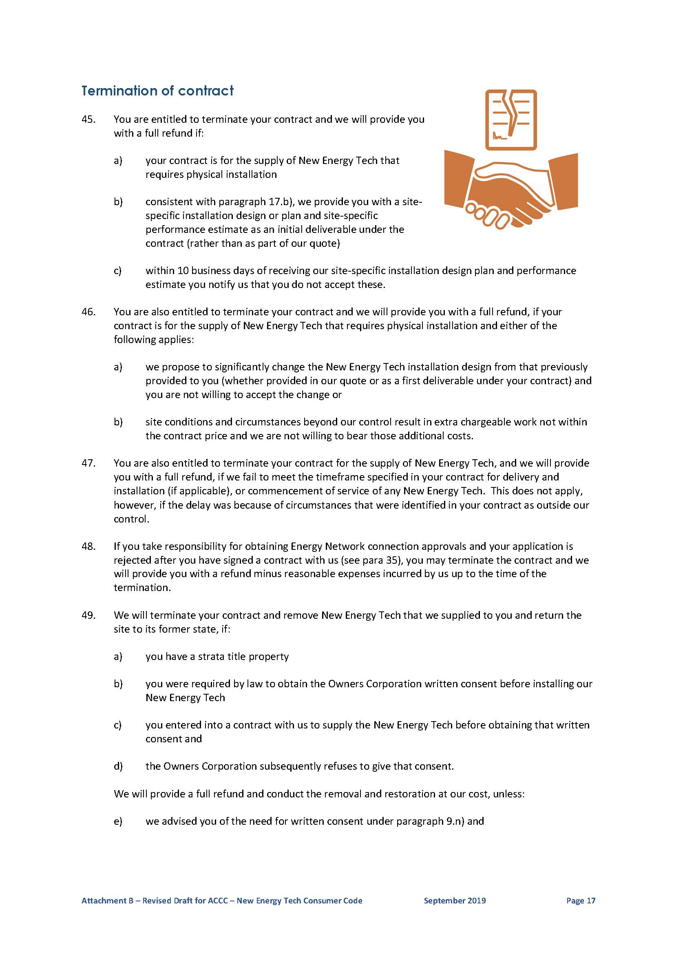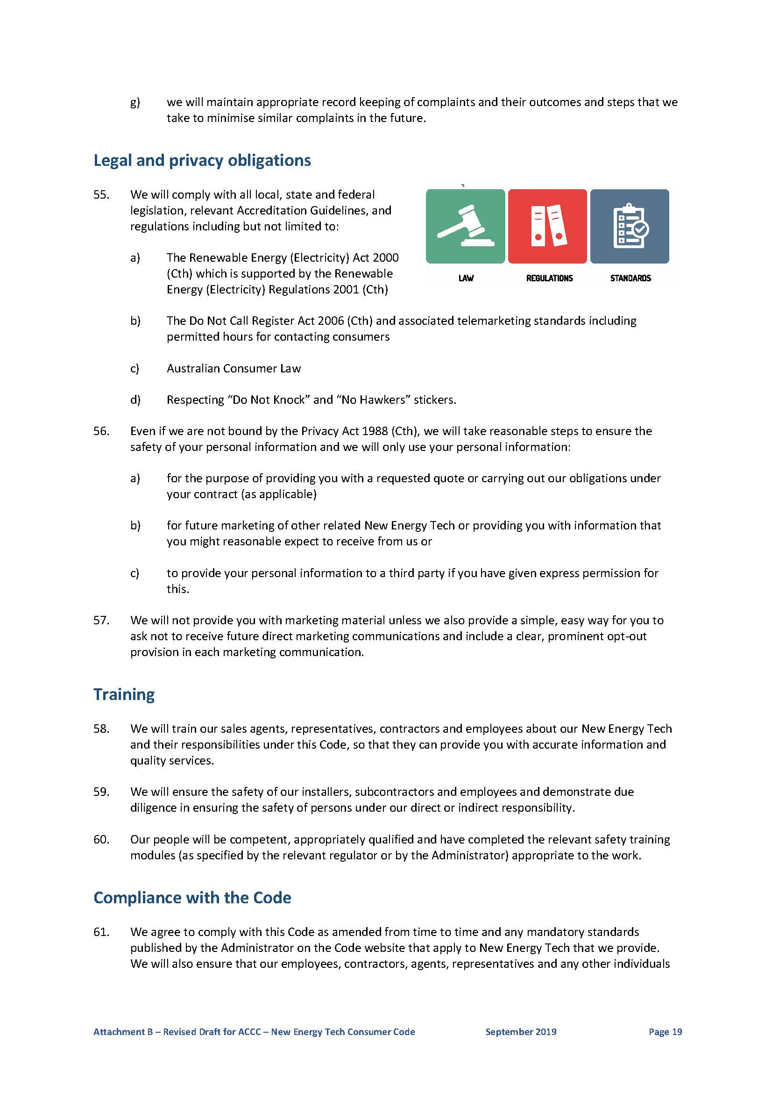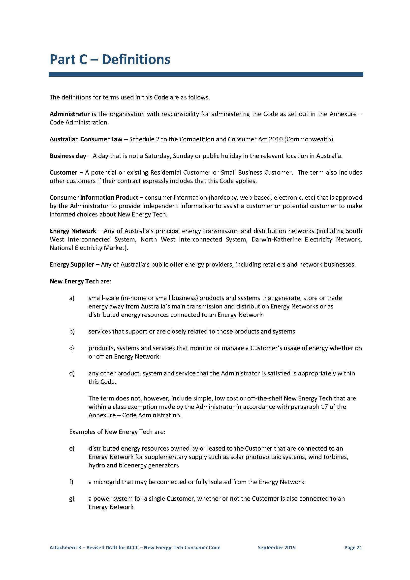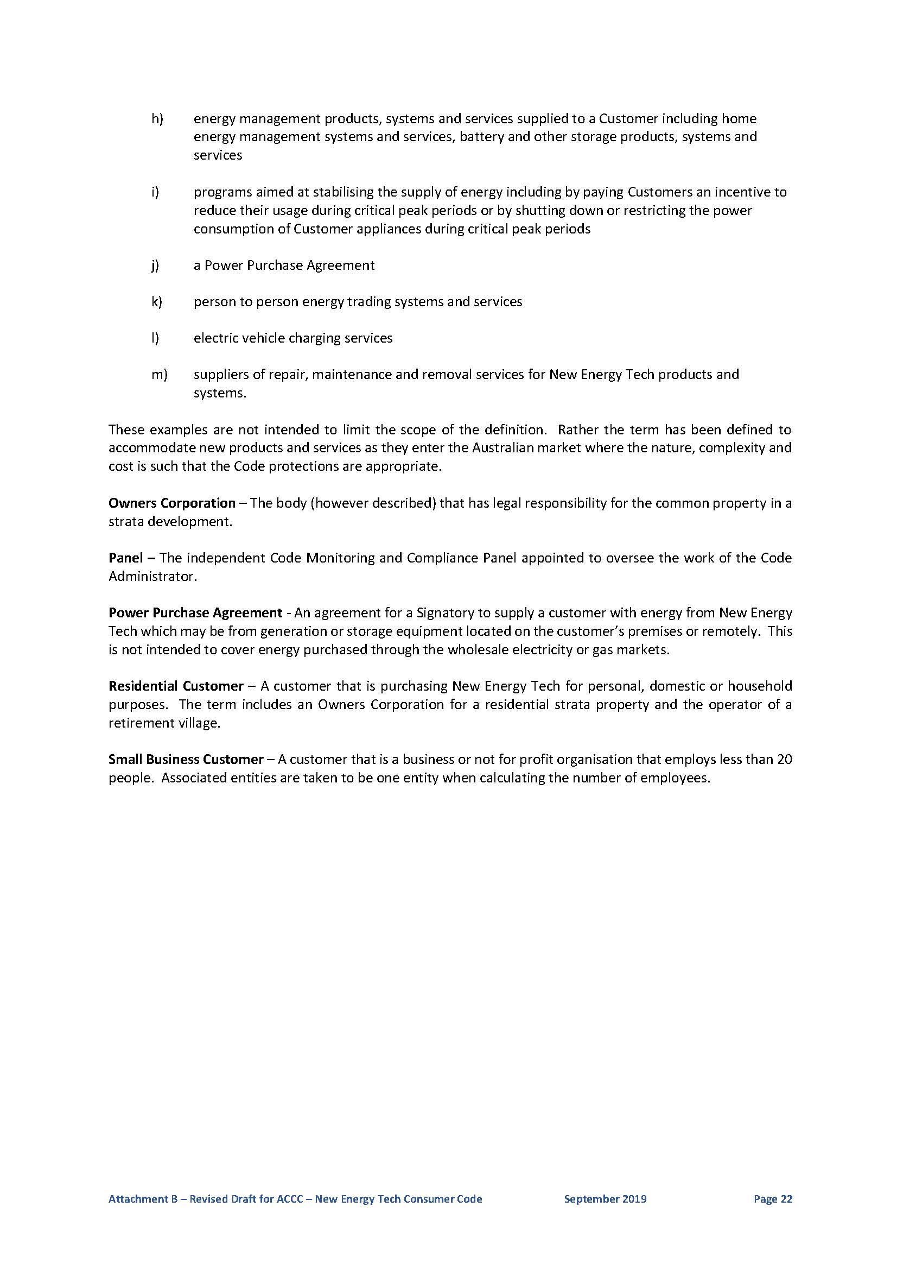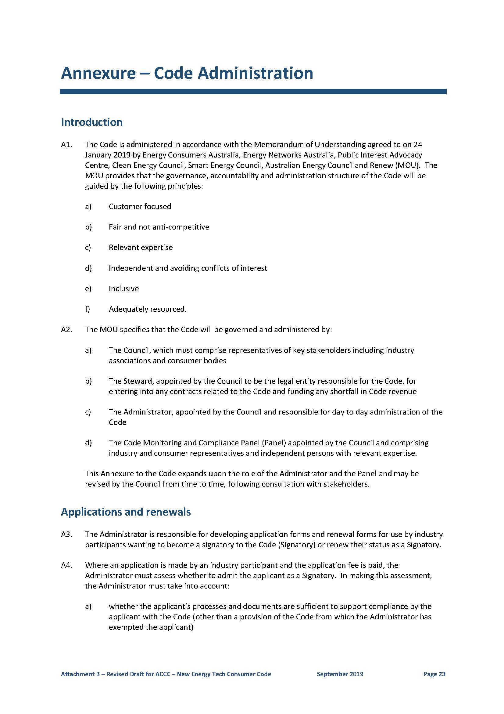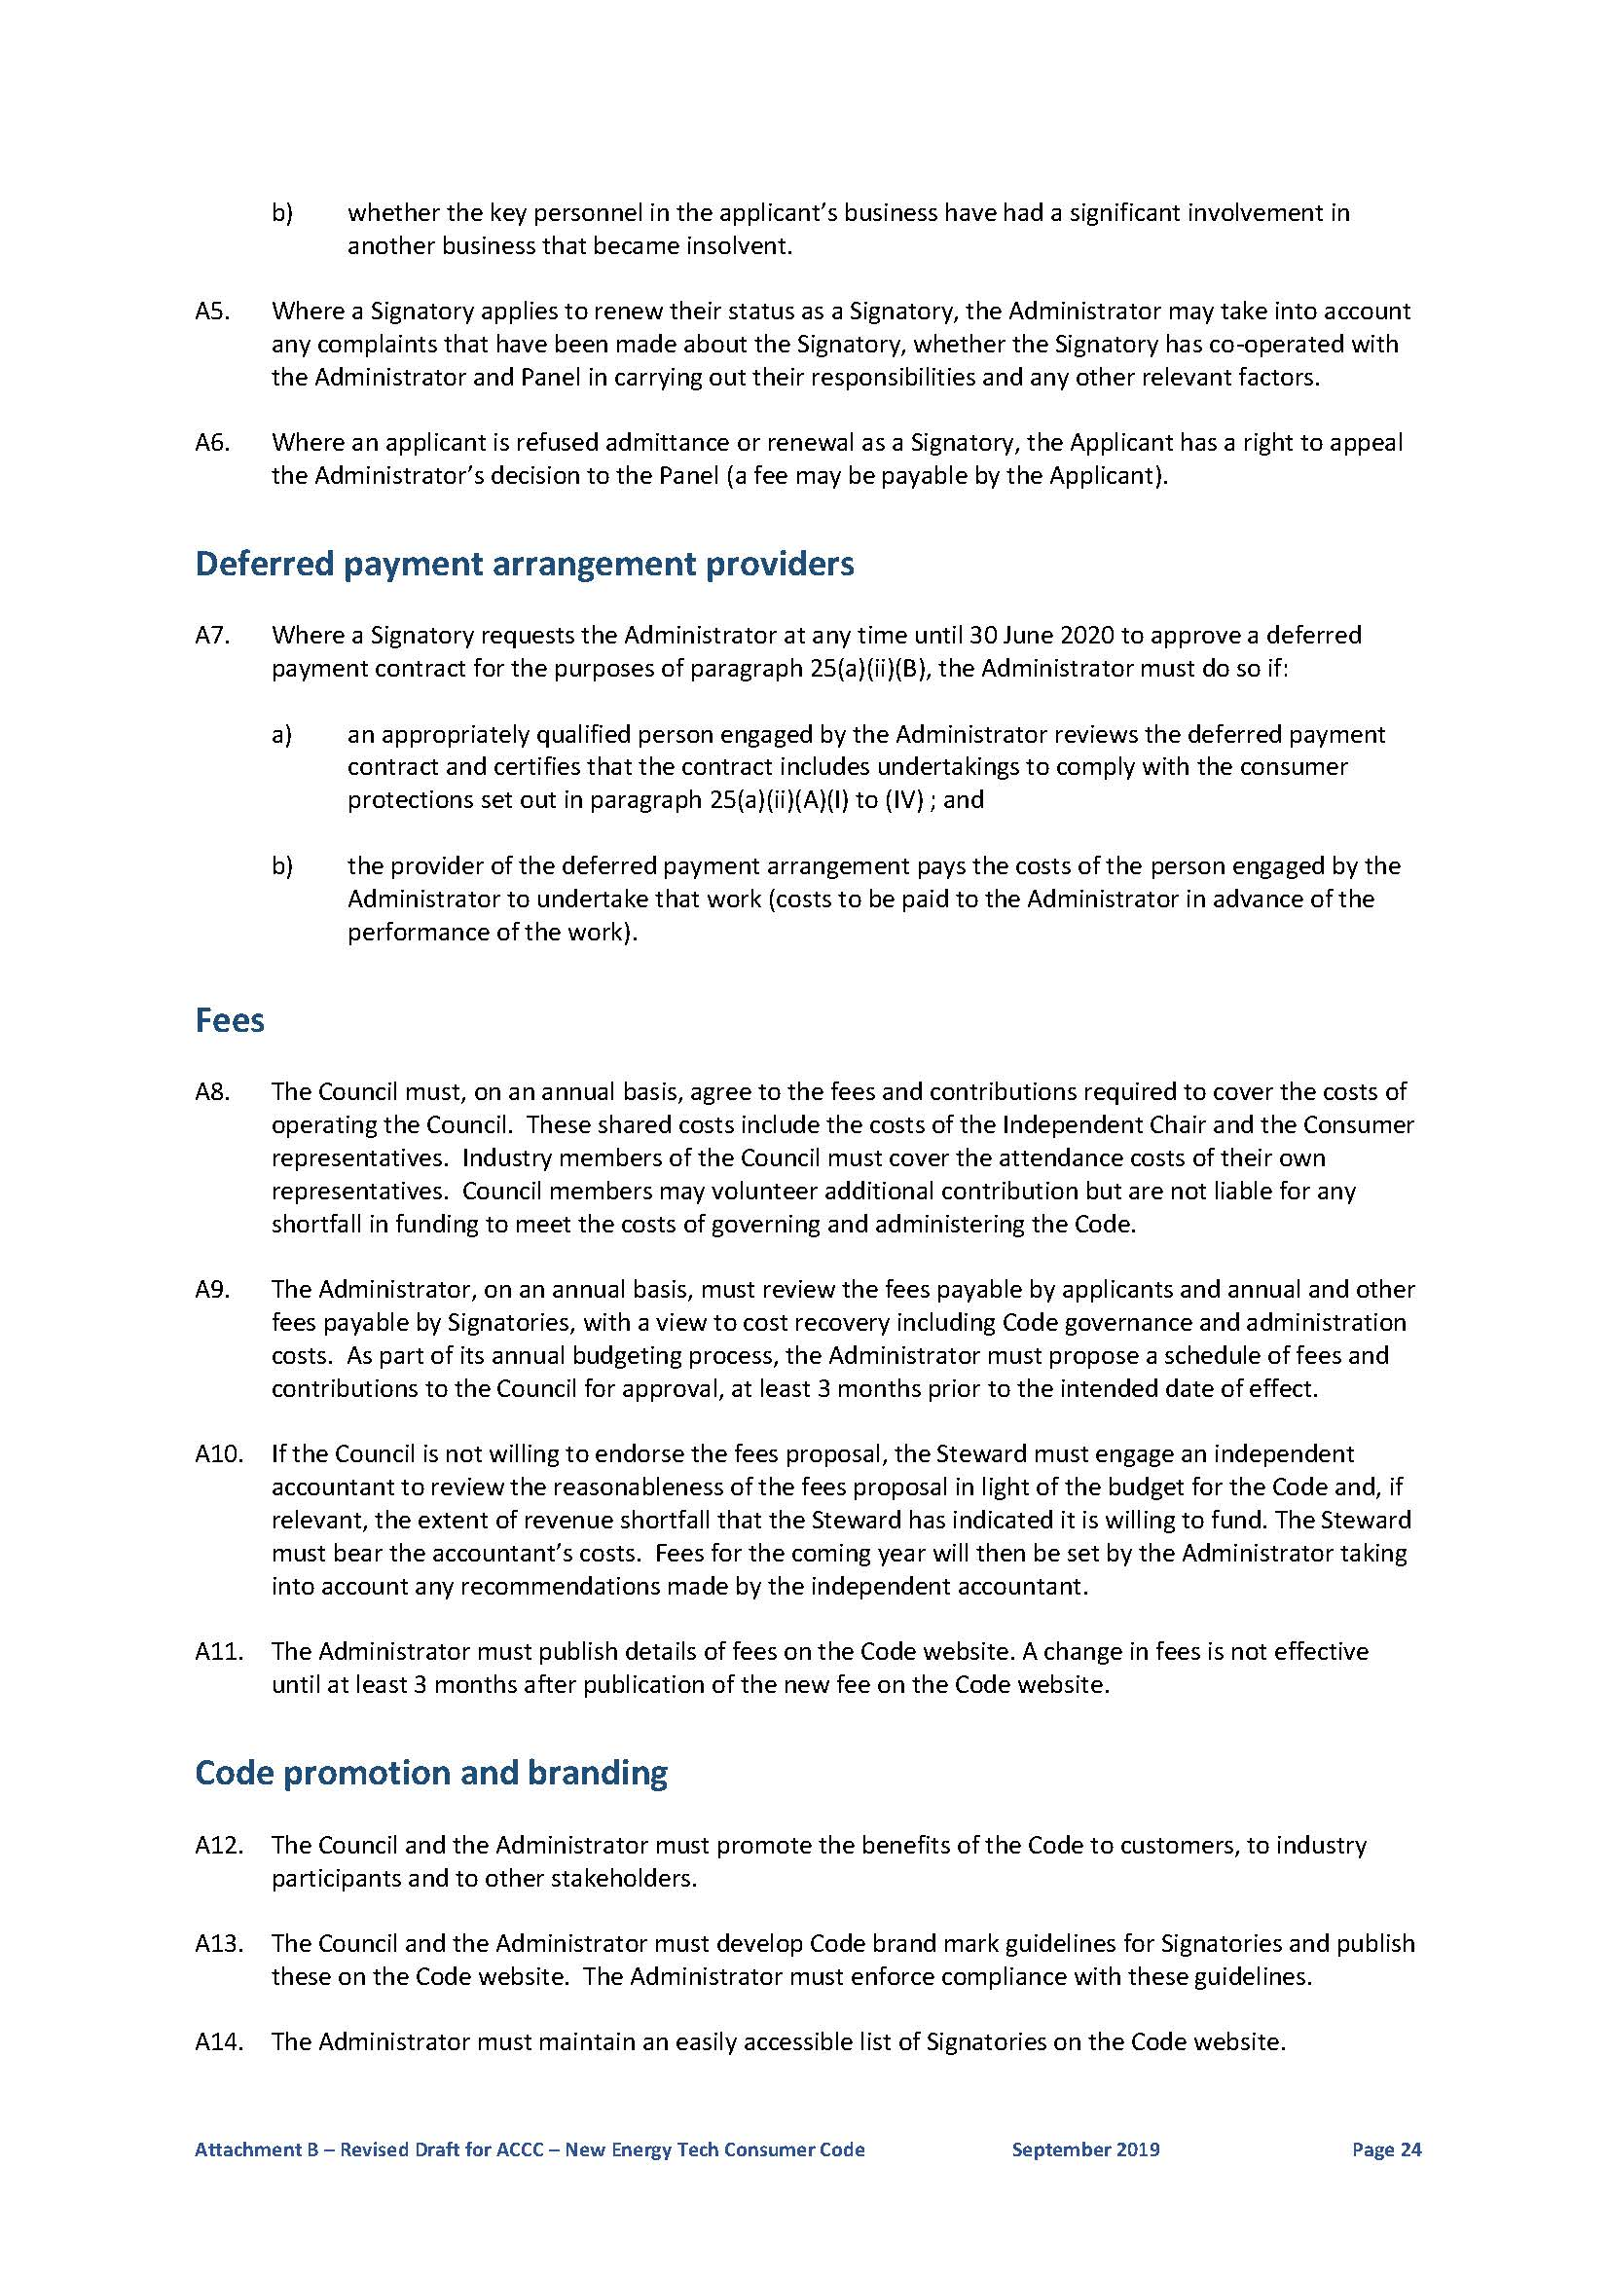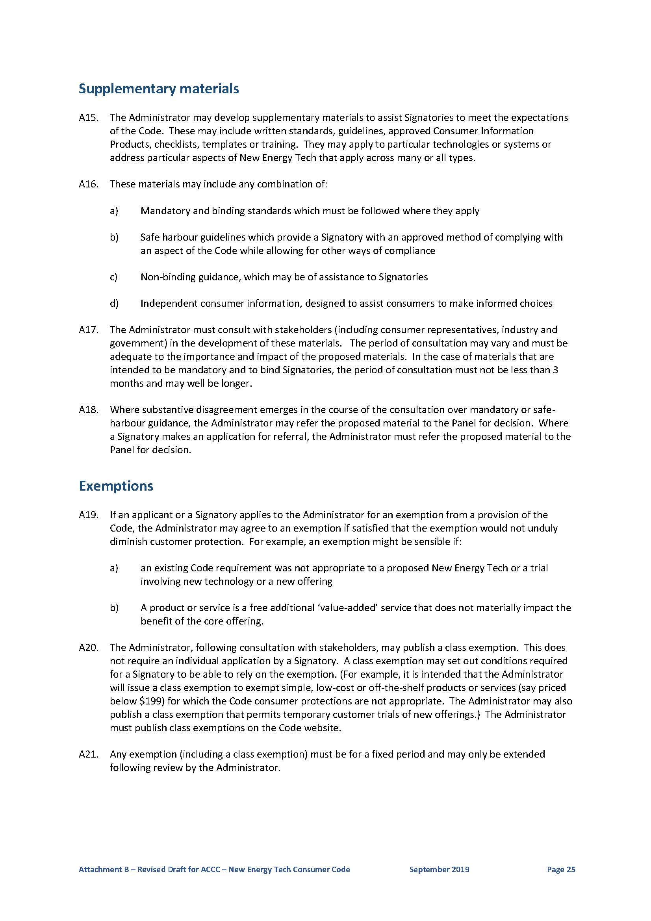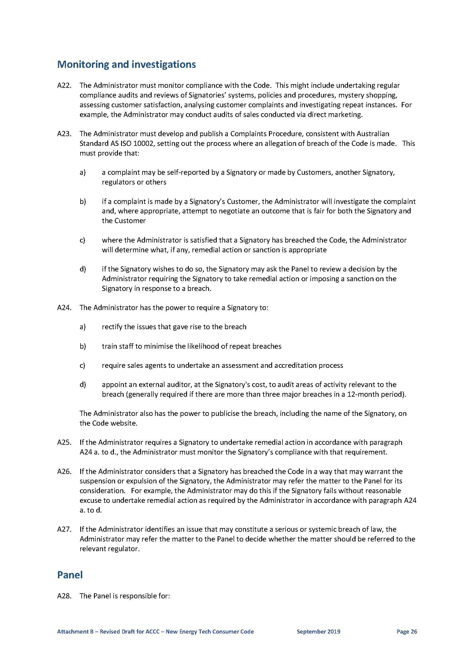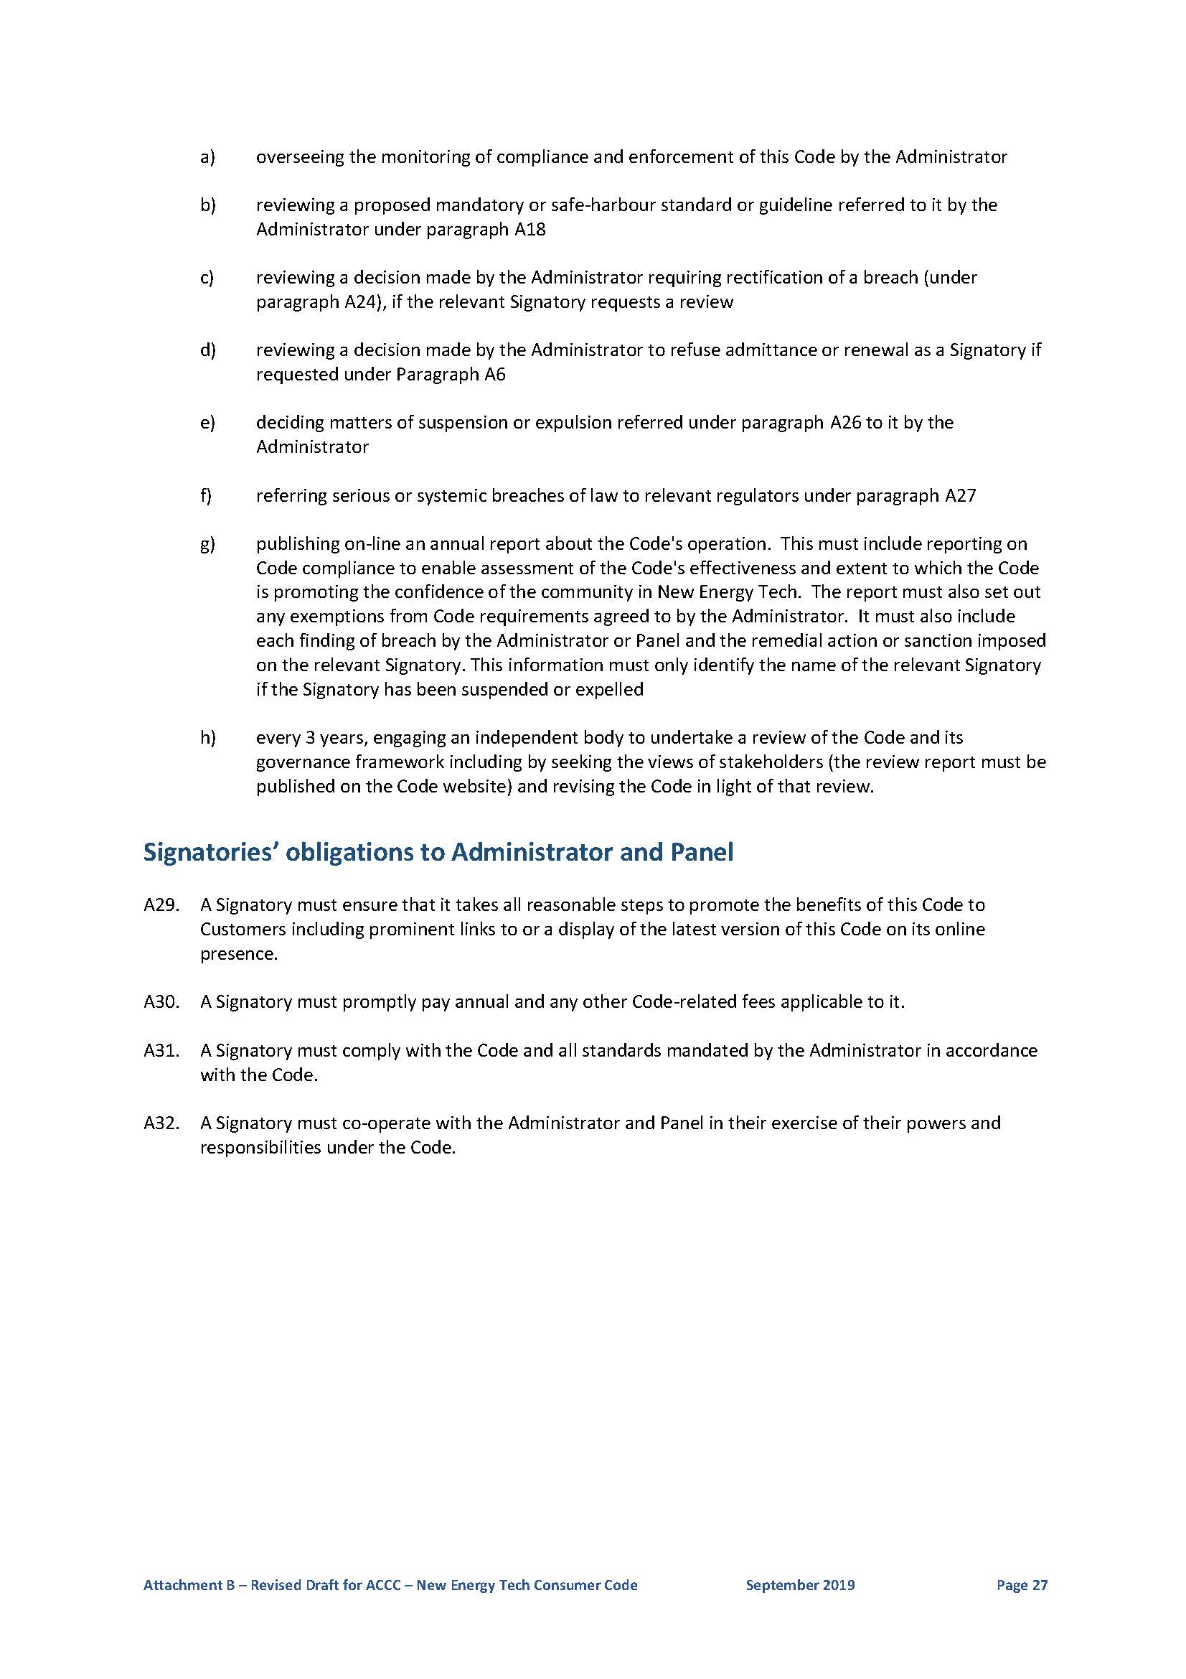

ANNEXURE B

Conditions of authorisation

Conditions amending the Code
- It is a condition of the authorisation that the Code is amended as follows:
  - Paragraph 3(d) of the Code is deleted.
  - Paragraph 9(o) of the Code is replaced by the following:
o) conspicuously and prominently on the front page of the quote, your cooling-off and termination rights (if applicable) under the Australian Consumer Law (including the right to terminate a sales agreement within 10 business days if the sale resulted from an unsolicited contact) and this Code
  - Paragraph 20 of the Code is amended by the inclusion of the following additional subparagraph:
e) if your contract is an unsolicited consumer agreement under the Australian Consumer Law, the front page of your contract will conspicuously and prominently inform you about your cooling-off rights (including the right to terminate the contract within 10 business days) and the manner in which those rights can be exercised.
  - Paragraph 25 of the Code is replaced by the following:
25. We may offer you New Energy Tech with a deferred payment arrangement as an alternative to upfront payment upon delivery or installation. If you are a Residential Customer, we will ensure that:
a) the deferred payment arrangement is offered through a credit provider (whether ourselves or a third party) that:
i. is licensed under the National Consumer Credit Protection Act (2009) (Cth) ("NCCPA") and the deferred payment arrangement is regulated by the NCCPA and the National Credit Code ("NCC"), or
ii. has had its deferred payment contract and its internal policies and procedures approved by the Administrator in accordance with paragraph A7 of the Annexure – Code Administration
b) the term of the deferred payment contract or lease is no longer than the expected life of the product or system
c) you receive the following clear and accurate information:
i. the name of the credit provider to whom you will be contracted for the arrangement
ii. a clear statement that the deferred payment arrangement is a voluntary finance option
iii. the proposed total cost under the deferred payment arrangement compared with the cost of that same New Energy Tech product, system or service if you were to purchase it outright on that day
iv. the disclosures required under the NCC, including in relation to fees and charges (regardless of whether the arrangement is regulated under the NCC)
v. whether at the conclusion of the deferred payment arrangement
• you own any elements of the New Energy Tech, or
• you have any entitlement to any ongoing services or pricing, and/or
• you have the option to purchase any elements of the new Energy Tech and if so relevant details, including any associated costs, and
vi. a statement that questions and complaints about the deferred payment arrangement should be directed to the credit provider with whom you will be contracted.
  - Paragraph 32 is amended as follows:
32. If you purchase New Energy Tech that requires physical installation by us, we will ensure your safety and the safety of our installers. We will install in accordance with all applicable safety standards, manufacturer’s specifications, relevant Australian Standards, Energy Network standards and good industry practice, using an installer that is trained, competent and where applicable, holds any required qualification or certification to undertake the work.
  - Paragraph 61 is amended as follows:
61. We agree to comply with this Code as amended from time to time. We will also ensure that our employees, contractors, agents, representatives and any other individuals or businesses acting on our behalf do likewise. This includes third parties we engage to undertake direct marketing and sales for us.
  - Paragraph A7 is amended as follows
A7. Where a provider of a deferred payment arrangement requests the Administrator to approve its deferred payment contract and internal policies and procedures for the purposes of paragraph 25(a)(ii), the Administrator must do so if:
- an appropriately qualified person engaged by the Administrator reviews the deferred payment contract and internal policies and procedures and certifies that they require the credit provider to:
(i) resolve any complaints with the customer using an internal dispute resolution process and, if the complaint remains unresolved, an external dispute resolution process which must include the scheme operated by the Australian Financial Complaints Authority;
(ii) have processes to identify whether the customer is experiencing payment difficulties due to hardship; and
(iii) offer the customer alternative and flexible payment options if the customer is experiencing payment difficulties so that the customer can meet their repayments;
- the provider of the deferred payment arrangement pays the reasonable costs of the person engaged by the Administrator to undertake that work (costs to be paid to the Administrator in advance of the performance of the work).
  - A new paragraph A7A is included as follows:
Where the Administrator refuses to approve a provider’s deferred payment contract and internal policies and procedures under paragraph A7, the provider has a right to appeal the Administrator’s decision to the Panel (a fee may be payable by the provider).
  - Paragraph A15 is amended as follows:
A15. The Administrator may develop supplementary materials to assist Signatories to meet the expectations of the Code. These may include Consumer Information Products, checklists, templates or training.
  - Paragraphs A16, A17, A18 and A28(b) are deleted.
  - Paragraph A28 is amended by the insertion of a new subparagraph as follows:
da) reviewing a decision made by the Administrator refusing to approve a provider’s deferred payment contract and internal policies and procedures if requested under paragraph A7
  - Paragraph A28(g) is amended as follows:
publishing online an annual report about the Code's operation which must include the following information:
(i) the number of applicants admitted as Signatories to the Consumer Code, the number of unsuccessful applications for admittance under the Consumer Code and the number of appeals against a decision regarding admittance, and the outcome of those appeals;
(ii) reporting on Code compliance to enable assessment of the Consumer Code's effectiveness and extent to which the Consumer Code is promoting the confidence of the community in New Energy Tech including the number and type of alleged breaches of the Consumer Code by Signatories;
(iii) reporting on each finding of breach of the Code by the Administrator or Panel and the remedial action or sanction imposed on the relevant Signatory (classified by reference to suspensions, expulsions and other remedial action - this information must only identify the name of the relevant Signatory if the Signatory has been suspended or expelled);
(iv) reporting on exemptions from Code requirements agreed to by the Administrator;
(v) reporting on the Administrator’s approval of unregulated consumer credit contracts, policies and procedures including the number and identity of such credit providers approved.
  - Paragraph A31 is amended as follows:
A31. A Signatory must comply with the Code.
- For the avoidance of doubt, the NET Code may also be amended to revise paragraph numbering and cross-referencing in light of the foregoing amendments and to correct typographical or grammatical errors.

