Federal Court of Australia

Lendlease Building Contractors Pty Limited v Australian Building and Construction Commissioner (No 2) [2022] FCA 192

|  |  |
| --- | --- |
| File number: | VID 56 of 2020 |
|  |  |
| Judgment of: | **SNADEN J** |
|  |  |
| Date of judgment: | 11 March 2022 |
|  |  |
| Catchwords: | **INDUSTRIAL LAW** – compliance notice issued under s 99 of *Building and Construction Industry (Improving Productivity) Act 2016* (Cth) – compliance notice alleged contravention of the *Code for the Tendering and Performance of Building Work 2016* (Cth) (“Building Code”) – display of union logos, mottos or indicia on project property and equipment – whether Building Code requires prevention of such display – validity of compliance notice challenged by alleged contravener – relevant provision of the Building Code ambiguous – proper construction of provision – principles of construction – regard to extrinsic material – whether compliance notice properly identified specified actions to be taken by alleged contravener – whether compliance notice properly identified alleged contravention – compliance notice valid – application dismissed  **CONSTITUTIONAL LAW** – implied freedom of political communication – whether relevant provision of the Building Code constitutionally invalid as an impermissible burden upon the implied freedom – no impermissible burden – relevant clause of the Building Code not constitutionally invalid  **EVIDENCE** – objections to evidence – constitutional facts – admissibility of constitutional fact evidence – whether normal rules of admissibility apply to factual matters relevant to the constitutional validity of a law or executive action – orthodox rules of admissibility not applicable – evidential objections dismissed |
|  |  |
| Legislation: | *Acts Interpretation Act 1901* (Cth) ss 15AA and 15AB  *Building and Construction Industry (Improving Productivity) Act 2016* (Cth)  *Crimes (Foreign Incursions and Recruitment) Act 1978* (Cth)  *Evidence Act 1995* (Cth)  *Fair Work Act 2009* (Cth) pt 3-1  *Federal Court Rules 2011* (Cth) pt 23  *Human Rights (Parliamentary Scrutiny) Act 2011* (Cth)  *Judiciary Act 1903* (Cth) s78B  *Legislation Act 2003* (Cth) ss 8 and 15G  *Racial Discrimination Act 1975* (Cth)  *Workplace Relations Act* *1996* (Cth)  *Pitjantjatjara Land Rights Act 1981* (SA)  *Code for the Tendering and Performance of Building Work 2016* (Cth)  *International Covenant on Civil and Political Rights*, opened for signature 16 December 1966, 999 UNTS 171 (entered into force 23 March 1976) arts 22 and 19  *International Covenant on Economic, Social and Cultural Rights*, opened for signature 16 December 1966, 993 UNTS 3 (entered into force 3 January 1976) art 8  *Freedom of Association and Protection of the Right to Organise Convention*, signed 9 July 1948 (entered into force 4 July 1950) |
|  |  |
| Cases cited: | *Australian Education Union v Department of Education* (2012) 248 CLR 1  *Alderton v Department of Police and Emergency Management* [2008] TASSC 69  *Amoonguna Community Inc v Northern Territory of Australia* [2014] NTSC 33  *Attorney-General (SA) v Corporation of the City of Adelaide* (2013) 249 CLR 1  *Australian Building and Construction Commissioner v Construction, Forestry, Mining and Energy Union* (2017) 254 FCR 68  *Australian Building and Construction Commissioner v Construction, Forestry, Mining and Energy Union (Footscray Station Case)* (2017) 274 IR 460  *Australian Building and Construction Commission v Construction, Forestry, Mining and Energy Union (Werribee Shopping Centre Case)* [2017] FCA 1235  *Australian Building and Construction Commissioner v Construction, Forestry, Mining and Energy Union* (2018) 265 FCR 208  *Australian Building and Construction Commissioner v Construction, Forestry, Maritime, Mining and Energy Union (Geelong Grammar School Case) (No 2)* [2019] FCA 1498  *Australian Building and Construction Commissioner v Construction, Forestry, Maritime, Mining and Energy Union (Castlemaine Police Station Case No 2)* [2020] FCA 202  *Australian Building and Construction Commissioner v Construction, Forestry, Maritime, Mining and Energy Union (The North Queensland Stadium Case)* [2020] FCA 947  *Australian Communist Party v The Commonwealth* (1951) 83 CLR 1  *Breen v Sneddon* (1961) 106 CLR 406  *Brown v Tasmania* (2017) 261 CLR 328  *Chu Keng Lim v Minister for Immigration, Local Government and Ethnic Affairs* (1992) 176 CLR 1  *Civil Aviation Safety Authority v Boatman* (2004) 138 FCR 384  *Clubb v Edwards* (2019) 267 CLR 171  *Coco v The Queen* (1994) 179 CLR 427  *Collector of Customs v Agfa-Gevaert Ltd* (1996) 186 CLR 389  *Commissioner of Stamp Duties v Permanent Trustee Co Ltd* (1987) 9 NSWLR 719  *Commonwealth Freighters Pty Ltd v Sneddon* (1959) 102 CLR 280  *Cunliffe v Commonwealth* (1994) 182 CLR 272  *Director of the Fair Work Building Industry Inspectorate v Construction, Forestry, Mining and Energy Union (The Mitcham Rail Case)* [2015] FCA 1173  *Director of the Fair Work Building Industry Inspectorate v Construction, Forestry, Mining and Energy Union (No 2)* [2016] FCA 436  *Electrolux Home Products Pty Ltd v Australian Workers’ Union* (2004) 221 CLR 309  *Gerhardy v Brown* (1985) 159 CLR 70  *Gifford v Strang Patrick Stevedoring Pty Ltd* (2003) 214 CLR 269  *Gill v Donald Humberstone & Co Ltd* [1963] 1 WLR 929  *King Gee Clothing Co Pty Ltd v Commonwealth* (1945) 71 CLR 184  *Lacey v Attorney-General (Qld)* (2011) 242 CLR 573  *Lange v Australian Broadcasting Corporation* (1997) 189 CLR 520  *Lee v Minister for Home Affairs* [2021] FCAFC 89  *Lee v NSW Crime Commission* (2013) 251 CLR 196  *Lendlease Building Contractors Pty Ltd v Australian Building and Construction Commissioner & Anor* [2020] FCA 240  *Levy v Victoria* (1997) 189 CLR 579  *Maloney v The Queen* (2013) 252 CLR 168  *McCloy v New South Wales* (2015) 257 CLR 178  *Murphy v Electoral Commissioner* (2016) 261 CLR 28  *Owners Corporation PS 501391P v Balcombe* (2016) 51 VR 299  *Project Blue Sky Inc v Australian Broadcasting Authority* (1998) 194 CLR 355  *R v Alqudsi* (2015) 328 ALR 517  *Re Day* (2017) 91 ALJR 262  *Sportodds Systems Pty Ltd v New South Wales* (2003) 133 FCR 63  *Stenhouse v Coleman* (1944) 69 CLR 457  *The Commonwealth v Baume* (1905) 2 CLR 405  *Thomas v Mowbray* (2007) 233 CLR 307 |
|  |  |
| Division: | Fair Work Division |
|  |  |
| Registry: | Victoria |
|  |  |
| National Practice Area: | Employment and Industrial Relations |
|  |  |
| Number of paragraphs: | 232 |
|  |  |
| Date of hearing: | 3-9 December 2020 |
|  |  |
| Counsel for the Applicant: | Mr PM O’Grady QC with Mr BJ Avallone |
|  |  |
| Solicitor for the Applicant: | Herbert Smith Freehills |
|  |  |
| Counsel for the Respondents: | Mr JL Bourke QC with Mr M Follett and Mr LR Howard |
|  |  |
| Solicitor for the Respondents: | Australian Government Solicitor |
|  |  |
| Counsel for the Intervener: | Mr NW Williams SC with Ms A Hammond |
|  |  |
| Solicitor for the Intervener: | Construction, Forestry, Maritime, Mining and Energy Union |

ORDERS

|  |  |  |
| --- | --- | --- |
|  | | VID 56 of 2020 |
|  | | |
| BETWEEN: | LENDLEASE BUILDING CONTRACTORS PTY LIMITED  Applicant | |
| AND: | AUSTRALIAN BUILDING AND CONSTRUCTION COMMISSIONER  First Respondent  AUSTRALIAN BUILDING AND CONSTRUCTION INSPECTOR ROBERT DALTON  Second Respondent | |
|  | CONSTRUCTION, FORESTRY, MARITIME, MINING AND ENERGY UNION  Intervener | |

|  |  |
| --- | --- |
| order made by: | SNADEN J |
| DATE OF ORDER: | 11 March 2022 |

THE COURT ORDERS THAT:

1. The application be dismissed.
2. The respondents and the intervener confer and, within 14 days of the date of these orders, submit to the court an agreed minute of proposed orders concerning costs (if it is agreed that any such orders should be made).
3. In the event that the respondents and the intervener are unable to reach such an agreement, the respondents advise the court accordingly and the matter be listed for case management on a date to be fixed.

Note: Entry of orders is dealt with in Rule 39.32 of the *Federal Court Rules 2011*.

REASONS FOR JUDGMENT

|  |  |
| --- | --- |
| Part 1: Overview | [1] |
| Part 2: The legislative framework | [9] |
| 2.1 The *BCIIP Act* | [10] |
| 2.2 The *Fair Work Act 2009* (Cth) | [16] |
| 2.3 The Building Code | [20] |
| Part 3: The compliance notice | [26] |
| Part 4: The proceeding | [31] |
| 4.1 Pre-trial considerations | [32] |
| 4.2 The evidence | [35] |
| 4.3 A justiciable controversy | [46] |
| Part 5: Logos, mottos and indicia | [49] |
| Part 6: The proper construction of s 13(2)(j) | [56] |
| 6.1 Principles of construction | [61] |
| 6.2 The words of section 13(2)(j) | [70] |
| 6.3 Contextual cues | [73] |
| 6.4 The principle of legality | [92] |
| 6.5 Extrinsic material | [99] |
| 6.6 Preference for “bright line” rules | [120] |
| 6.7 Conclusion | [129] |
| Part 7: Lendlease’s alternative avenues of attack | [130] |
| 7.1 Particulars of the contraventions | [133] |
| 7.2 Failure to identify corrective action | [141] |
| Part 8: Other contentions | [148] |
| Part 9: The constitutional validity of s 13(2)(j) | [154] |
| 9.1 Preliminary issue: resolution of evidential objections | [155] |
| 9.1.1 Summary | [155] |
| 9.1.2 Principles to be applied | [159] |
| 9.1.3 Application | [181] |
| 9.2 Nature of the implied freedom | [186] |
| 9.3 Limits of the constitutional protection | [190] |
| 9.4 Infringement of the right to communicate freely on political matters | [194] |
| 9.5 Legitimacy of purpose | [197] |
| 9.6 Advancement of that legitimate purpose | [200] |
| 9.6.1 Suitability | [202] |
| 9.6.2 Necessity | [207] |
| 9.6.3 Adequacy of balance | [213] |
| 9.7 The provision is valid | [230] |
| Part 10: Conclusion | [231] |

SNADEN J:

# Part 1: Overview

1. The applicant (“**Lendlease**”) operates a large and well-known construction business. The respondents are each the holders of offices established by the *Building and Construction Industry (Improving Productivity) Act 2016* (Cth) (the “***BCIIP Act***”). The first respondent is the Australian Building and Construction Commissioner. The second respondent, Mr Dalton, is an inspector appointed pursuant to s 66(1) of the *BCIIP Act*. The intervener (the “**CFMMEU**”) is a trade union that represents, or is eligible to represent, workers who perform construction work throughout Australia.
2. Between 2018 and 2020, Lendlease was engaged to construct what is now known as the Technology, Education and Design building at Monash University in Victoria (to the construction of which I shall refer, hereafter, as the “**TED Project**”). As is typical with projects of that nature, it maintained “crib rooms” or a lunchroom at the TED Project site, to which workers commonly retired during break periods. At times material to this matter (or, at the least, on Wednesday, 6 November 2019), the walls of those facilities (or some of them) were adorned with posters or other notices that, to varying degrees, bore the logos, mottos or indicia of various construction unions, including the CFMMEU. Additionally, Lendlease maintained at least two tower cranes at the site to assist with the project’s construction, to the machine deck of one of which it attached, or permitted to be attached, a flag bearing symbolism associated with the Eureka Rebellion (more commonly and conveniently referred to as a “**Eureka flag**”).
3. On 6 November 2019, two of Mr Dalton’s colleagues, Ms Knight and Mr Lindsay, attended at the TED Project site and observed that a Eureka flag was attached to one of the tower cranes there and that there were posters of the kind described above displayed on the walls of crib room buildings. They took photographs of what they observed, which were then provided to Mr Dalton. Upon consideration of those photos (further particulars of which are set out below), Mr Dalton was moved to issue Lendlease with a “compliance notice” under s 99(2) of the *BCIIP Act*. In point of fact, two such notices were issued but it is only the second of them that assumes any significance in the present matter.
4. That notice, dated 29 November 2019 (hereafter, the “**Compliance Notice**”), alleged that Lendlease had contravened s 13(2)(j) of the *Code for the Tendering and Performance of Building Work 2016* (Cth) (the “**Building Code**”) by permitting or failing to prohibit the display of the material (or some of the material) that Inspectors Knight and Lindsay had observed on Wednesday, 6 November 2019. Section 13(2)(j) of the Building Code assumes central significance in the present matter. It is the subject of substantial consideration below; but, in short, it concerns the display at certain building sites of at least some species of notices that bear the logos, mottos or indicia of building industry associations such as the CFMMEU.
5. Lendlease denies that it contravened s 13(2)(j) of the Building Code. It maintains (amongst other things) that the display of the material to which the Compliance Notice referred was not contrary to the requirements of s 13(2)(j) of the Building Code. It moves the court for relief—statutory, prerogative, injunctive and declaratory—by which it seeks to have the Compliance Notice set aside, quashed or cancelled, to restrain certain conduct that might otherwise be taken in reliance upon it, and to record its compliance with the requirements of the Building Code.
6. The present dispute fixes (for the most part) upon the proper construction of s 13(2)(j) of the Building Code. The respondents contend that that provision, properly construed, prohibits (or requires that entities like Lendlease take steps to prohibit) the display of the kinds of material to which the Compliance Notice referred. Lendlease and the CFMMEU maintain that, on its proper construction, it does not; and that the Compliance Notice should be set aside insofar as it progressed upon the contrary (and, they say, incorrect) premise. Lendlease further contends that the Compliance Notice should be set aside regardless for want of compliance with other statutory requirements (again, the particulars of which are explored below).
7. Additionally, the CFMMEU contends that, if, properly construed, the section purports to restrict (or otherwise to require the restriction of) the display of the kinds of material to which the Compliance Notice referred, then it is invalid as an impermissible restriction upon the CFMMEU’s implied constitutional right to communicate freely about matters of politics or government. It seeks declaratory relief that recognises that alleged constitutional overreach. The respondents contend that no such invalidity arises.
8. For the reasons that follow, no relief of any kind should (or will) be granted. Properly construed, s 13(2)(j) of the Building Code prohibits (or requires the effective prohibition of) the display of the kinds of materials to which the Compliance Notice referred. So construed, the provision does not trespass beyond what the Commonwealth Constitution authorises. The Compliance Notice was not premised upon an incorrect construction of the Building Code, and was not invalid or otherwise susceptible to the relief claimed. The application must (and will), for those reasons, be dismissed.

# Part 2: The legislative framework

1. There are several enactments, subordinate instruments and related instruments that assume prominence in this matter. It is convenient to set out the relevant terms of each.

## 2.1 The *BCIIP Act*

1. The *BCIIP Act* applies to the performance of “building work”; more precisely, to those who are engaged, or who engage others, to perform “building work”, and to those associations that represent employees, employers and contractors so engaged. It is not controversial that the TED Project involved the performance of building work, nor that Lendlease was a “building employer” and the CFMMEU was a “building association” for the purposes of the *BCIIP Act*.
2. Section 15 of the *BCIIP Act* establishes the office of the Australian Building and Construction Commissioner. Pursuant to s 66 of that act, the Commissioner is authorised to appoint inspectors, upon whom various statutory powers are conferred. Mr Dalton was one such inspector.
3. Chapter 3 of the *BCIIP Act* is entitled, “The Building Code”. Section 34(1) empowers the responsible Minister (presently the Minister for Employment) to issue, by legislative instrument, “…one or more documents that together constitute a code of practice that is to be complied with by persons in respect of building work”. Except insofar as is addressed below, it is not controversial that the Building Code was made through the valid exercise of that power.
4. Section 99 of the *BCIIP Act* relevantly provides (and, at material times, provided) as follows:

*Application of this section*

(1) This section applies if an inspector reasonably believes that a person has contravened one or more of the following to the extent that the contravention relates (whether directly or indirectly) to building work:

…

(c) the Building Code.

*Giving a notice*

(2) The inspector may (subject to subsection (4)) give the person a notice requiring the person to do either or both of the following within a reasonable time specified in the notice:

(a) take specified action to remedy the direct effects of the contravention referred to in subsection (1);

(b) produce reasonable evidence of the person’s compliance with the notice.

(3) The notice must also:

(a) set out the name of the person to whom the notice is given; and

(b) set out the name of the inspector who gave the notice; and

(c) set out brief details of the contravention; and

(d) explain that a failure to comply with the notice may contravene a civil remedy provision; and

(e) explain that the person may apply to a relevant court or a relevant State or Territory court for a review of the notice on either or both of the following grounds:

(i) the person has not committed the contravention set out in the notice;

(ii) the notice does not comply with subsection (2) or this subsection; and

(f) set out any other matters prescribed by the rules.

…

(7) A person must comply with a notice given under this section.

(8) Subsection (7) does not apply if the person has a reasonable excuse.

1. Subsection 99(7) of the *BCIIP Act* is a “civil remedy provision”: *BCIIP Act*, s 5. Conduct that contravenes it is remediable under s 81, which empowers this court (and others) to impose any orders that are considered appropriate, including pecuniary penalty orders. In the case of s 99(7) of the *BCIIP Act*, the maximum penalty that may be imposed in respect of conduct that contravenes the requirements of a compliance notice is 100 penalty units: *BCIIP Act*, s 81(2)(b).
2. Section 100 of the *BCIIP Act* concerns the review of compliance notices issued pursuant to s 99. It provides (and provided) as follows:

(1) A person who has been given a notice under section 99 (compliance notices) may apply to a relevant court or a relevant State or Territory court for a review of the notice on either or both of the following grounds:

(a) the person has not committed a contravention set out in the notice;

(b) the notice does not comply with subsection 99(2) or (3).

(2) At any time after the application has been made, the court may stay the operation of the notice on the terms and conditions that the court considers appropriate.

(3) The court may confirm, cancel or vary the notice after reviewing it.

This court is a “relevant court”: *BCIIP Act*, s 5.

## 2.2 The *Fair Work Act 2009* (Cth)

1. Although not directly relevant, several provisions of the *Fair Work Act 2009* (Cth) (the “***FW Act***”) bear noting (and are indirectly or potentially relevant to the proper construction of the Building Code).
2. Part 3-1 of the *FW Act* is entitled “general protections”. Amongst other things, it prohibits an employer from taking “adverse action” against an employee because of, or for reasons that include the fact that, the latter is or is not a member of an industrial association, or has or has not engaged in various species of “industrial activity”: *FW Act*, s 346. “Adverse action” is defined to include conduct by which an employee is injured in his or her employment, is subjected to some form of prejudicial alteration to his or her position, or is discriminated against: *FW Act*, s 342(1). It does not include conduct that is authorised by a law of the Commonwealth: *FW Act*, s 342(3).
3. A person is properly understood to have engaged in industrial activity if (amongst other things) he or she organises or promotes a lawful activity for or on behalf of an industrial association, encourages a lawful activity that is organised or promoted by an industrial association, complies with a lawful request or requirement of an industrial association, or represents or advances the views, claims or interests of an industrial association: *FW Act*, s 347(b). The CFMMEU is an industrial association.
4. Section 349 of the *FW Act* prohibits the making of certain false or misleading representations about a person’s obligation to engage in industrial activity.

## 2.3 The Building Code

1. As the *BCIIP Act* contemplates, the Building Code is a “legislative instrument”: *Legislation Act 2003* (Cth), s 8. It was registered on the Federal Register of Legislation on 2 December 2016 and took effect from that date. Amendments have since been made to it but none of them is of any present consequence.
2. On that same day (2 December 2016)—and consistently with s 15G of the *Legislation Act 2003* (Cth)—the Minister published an explanatory statement, the import of which will shortly become apparent.
3. Principally, the Building Code applies to building industry participants that undertake Commonwealth-funded building work (as well as to entities related to such participants). Such entities are referred to throughout the code as “code covered entit[ies]”. It is not controversial that Lendlease is and, at material times, was a code-covered entity (and, thus, was bound to observe the requirements of the Building Code).
4. As will already be apparent, s 13 of the Building Code—which is headed, “Freedom of association”—assumes paramount importance to the present matter. It is prudent to replicate it in full:

(1) A code covered entity must protect freedom of association in respect of building work by adopting and implementing policies and practices that:

(a) ensure that persons are:

(i) free to become, or not become, members of building associations; and

(ii) free to be represented, or not represented, by building associations; and

(iii) free to participate, or not participate, in lawful industrial activities; and

(iv) not discriminated against in respect of benefits in the workplace because they are, or are not, members of a building association.

(2) Without limiting subsection (1), the code covered entity must ensure that:

(a) personal information is dealt with in accordance with the *Privacy Act 1988* and the [*FW Act*]; and

(b) ‘no ticket, no start’ signs, or similar, are not displayed and such arrangements are not implemented; and

(c) signs that seek to vilify or harass employees who participate, or do not participate, in industrial activities are not displayed; and

(d) ‘show card’ days do not occur; and

(e) there is:

(i) no discrimination against elected employee representatives; and

(ii) no disadvantage to elected employee representatives; and

(f) forms are not used to require:

(i) an employee to identify whether they are a member of a building association; or

(ii) a subcontractor to identify whether the contractor or its employees or subcontractors are a member of a building association; and

(g) practices that are not authorised by law which require, directly or indirectly, a person to disclose whether or not they are a member of a building association, are not engaged in; and

(h) individuals are not refused employment or engagement because they are, or are not, a member of a building association; and

(i) the employment of employees or engagement of subcontractors is not terminated because they are, or are not, a member of a building association; and

(j) building association logos, mottos or indicia are not applied to clothing, property or equipment supplied by, or which provision is made for by, the employer or any other conduct which implies that membership of a building association is anything other than an individual choice for each employee; and

(k) reasonable requests from a workplace delegate to represent an employee of the code covered entity in relation to a grievance, a dispute or a discussion with a member of a building association are not refused; and

(l) requirements are not imposed, or attempted to be imposed, on the code covered entity or a subcontractor engaged by the code covered entity to:

(i) employ a non-working shop steward or job delegate; or

(ii) hire an individual nominated by a building association; and

(m) the code covered entity does not employ a non-working shop steward or job delegate; and

(n) individuals are not required to pay a ‘bargaining fee’ (howsoever described) to a building association of which the individual is not a member, in respect of services provided by the association; and

(o) employees must be provided a freedom of choice in deciding whether to be represented in grievance or dispute procedures (whether or not pursuant to an enterprise agreement), and, if so, by whom; and

(p) officials, delegates, or other representatives of a building association do not undertake or administer induction processes.

1. Section 11 of the Building Code also assumes some (at least contextual) significance. It concerns the terms of industrial instruments to which code-covered entities may agree. It is convenient also to replicate the relevant aspects of that provision in full:

(1) A code covered entity must not be covered by an enterprise agreement in respect of building work which includes clauses that:

(a) impose or purport to impose limits on the right of the code covered entity to manage its business or to improve productivity;

(b) discriminate, or have the effect of discriminating against certain persons, classes of employees, or subcontractors; or

(c) are inconsistent with freedom of association requirements set out in section 13 of this code of practice.

…

(3) Without limiting the generality of subsection (1), clauses are not permitted to be included in enterprise agreements that:

(a) prescribe the number of employees or subcontractors that may be employed or engaged on a particular site, in a particular work area, or at a particular time;

*Note: this does not prevent the inclusion of clauses in an enterprise agreement that encourage the employment of apprentices.*

(b) restrict the employment or engagement of persons by reference to the type of contractual arrangement that is, or may be, offered by the employer;

*Example: an agreement or practice that prohibits or limits the employment of casual or daily hire employees*.

(c) require, or result in, discrimination between classes of employees because of the basis on which they are lawfully entitled to work in Australia;

(d) require a code covered entity to consult with, or seek the approval of, a building association or an officer, delegate or other representative of the building association in relation to the source or number of employees to be engaged, or type of employment offered to employees;

(e) require a code covered entity to consult with, or seek the approval of, a building association or an officer, delegate or other representative of the building association in relation to the engagement of subcontractors;

(f) prescribe the terms and conditions on which subcontractors are engaged (including the terms and conditions of employees of a subcontractor);

(g) prescribe the scope of work or tasks that may be performed by employees or subcontractors;

(h) limit or have the effect of limiting the right of an employer to make decisions about redundancy, demobilisation or redeployment of employees based on operational requirements;

(i) prohibit the payment of a loaded rate of pay (whether or not expressed as an annual amount);

(j) require, or have the effect of requiring, the allocation of particular work to individual employees only if that allocation is extended to all other employees in the class of employees to which the individual employee belongs;

(k) provide for the monitoring of agreements by persons other than the employer and employees to whom the agreement applies;

(l) include requirements to apply building association logos, mottos or indicia to company supplied property or equipment;

(m) directly or indirectly require a person to encourage, or discourage, a person from becoming, or remaining, a member of a building association;

(n) directly or indirectly require a person to indicate support, or lack of support, for persons being members of a building association or any other measure that suggests that membership is anything other than a matter for individual choice;

(o) limit the ability of an employer to determine with its employees when and where work can be performed to meet operational requirements or limit an employer’s ability to determine by whom such work is to be performed;

(p) provide for the rights of an official of a building association to enter premises other than in compliance with Part 3-4 of the FW Act;

(q) provide for the establishment or maintenance of an area which is intended to be designated to be used by members, officers, delegates or other representatives of a building association in that capacity.

1. Section 18 of the Building Code is headed, “Consequences of breaching this code of practice”. Amongst other things, it provides for a process whereby a code-covered entity that fails to comply with the requirements of the Building Code may, by reason of that failure, be referred to the Minister, who, upon such referral, may impose certain sanctions against it. Those measures include subjection to an “exclusion sanction” period of up to one year’s duration, during which the entity is prohibited from tendering for or being awarded Commonwealth-funded building work.

# Part 3: The compliance notice

1. As has briefly been recited, the Compliance Notice charged Lendlease with having contravened s 13(2)(j) of the Building Code. Whether it recorded the “brief details” of those contraventions (as s 99(3)(c) of the *BCIIP Act* requires) is a matter in dispute; but it is plain enough that they were said to manifest in (or otherwise relate to) the display of certain posters in the TED Project lunchrooms and the display of a Eureka flag on one of the two TED Project tower cranes.
2. Attached to the Compliance Notice was a selection of 18 photographs (described collectively as a “Photo Index”), individually numbered “Photo No. 1” through to “Photo No. 18”. Under the heading, “Details of the contravention(s)”, the Compliance Notice recorded as follows (the references to “the Contractor” are references to Lendlease):

**Posters Contravention (subparagraph 13(2)(j))**

4. The Contractor has contravened subparagraph 13(2)(j) of the Code on the following basis:

a) The Contractor is a code covered entity within the meaning of the Code.

b) Photographs 10 to 18 (inclusive) document that the following listed posters shown in those photographs (**Posters**) had been applied to the walls of the lunchroom on the Project as of 6 November 2019:

i) In photograph 12, from left to right:

• a poster displaying the words 'We support John Setka';

• a poster of the Eureka Stockade symbol;

• a poster displaying the words 'How toxic is the west gate tunnel' and incorporating the ETU, PTEU, AMWU and CFMEU logo or indicia;

• a poster displaying an image of a chicken above the words 'When it is raining, come inside', in turn above a CFMEU logo or indicia;

ii) In photograph 13, from left to right:

• a poster displaying the words 'How toxic is the west gate tunnel' and incorporating the ETU, PTEU, AMWU and CFMEU logo or indicia;

• a poster displaying an image of a man with his arms crossed below a yellow ‘CFMEU’ logo and above the words 'Be paid up and proud';

• a poster displaying the Eureka Stockade symbol below the words 'United we stand';

iii) In photograph 14, from left to right:

• a poster of the Eureka Stockade symbol;

• two posters displaying an image of a chicken above the words 'When it is raining, come inside', in turn above a CFMEU logo or indicia;

• a poster displaying an image of a man with his arms crossed below a yellow ‘CFMEU’ logo and above the words 'Be paid up and proud';

iv) In photograph 15, from left to right:

• two posters displaying the words 'How toxic is the west gate tunnel' and incorporating the ETU, PTEU, AMWU and CFMEU logo or indicia;

• a poster displaying an image of a chicken above the words 'When it is raining, come inside', in turn above a CFMEU logo or indicia;

v) In photograph 16, from left to right:

• a poster of the Eureka Symbol;

• a poster displaying an image of a chicken above the words 'When it is raining, come inside', in turn above a CFMEU logo or indicia;

vi) In photograph 17:

• a poster displaying the words 'When injustice becomes law resistances becomes duty', with small Eureka symbols in each corner;

vii) In photograph 18:

• a poster displaying an image of a man with his arms crossed below a yellow ‘CFMEU’ logo and above the words 'be paid up and proud';

c) The Posters incorporate building association logos, mottos or indicia, being:

i) the CFMEU logo or indicia;

ii) the CFMMEU logo or indicia;

iii) the ETU logo or indicia;

iv) the PTEU logo or indicia;

v) the AMWU logo or indicia;

vi) the Eureka Stockade symbol, and

vii) the words 'United we stand', 'Be paid up and proud', 'When injustice becomes law, resistance becomes duty', or 'We support John Setka' which are mottos of the CFMMEU, a building association.

d) The lunchroom is property or equipment which either:

i) the Contractor supplied directly; or

ii) the Contractor made provision for, by way of a subcontracting arrangement with ATCO Structures & Logistics Pty Ltd (ACN 083 902 309).

**Flags Contravention (subparagraph 13(2)(j))**

5. The Contractor has contravened subparagraph 13(2)(j) of the Code on the following basis:

a) The Contractor is a code covered entity within the meaning of the Code.

b) Photographs 1, 2 and 5 document that the Eureka flag shown in those photos (**Eureka Flag**) had been applied to the Lendlease tower crane on the Project as of 6 November 2019.

c) The Eureka Flag is, or incorporates, a building association logo, motto or indicia, being the Eureka Stockade symbol.

d) The crane is property or equipment which the Contractor supplied directly.

1. For the sake of convenience, photographs numbered 1, 2, 5 and 12-18 are attached as schedule 1 to these reasons (and numbered consistently with how they were described in the “Photo Index” that was attached to the Compliance Notice). For the sake of completeness, it should be noted that it is not in dispute that:
2. the references to “the CFMEU” and “the CFMMEU” were references to the intervener (the CFMMEU); and
3. the references to “the ETU”, “the PTEU” and “the AMWU” were references to other building associations (within the meaning attributed to that phrase by the *BCIIP Act*).
4. Under the heading, “Required action under this Notice”, the Compliance Notice read as follows:

6. In accordance with section 99(2)(a) of the Act, **by 31 January 2020** the Contractor is required to:

**Posters Contravention**

a) Remove (or cause to be removed), or otherwise modify or alter (or cause to be modified or altered) the Posters, such that the building association logos, mottos or indicia described at 4(c) above are no longer applied to the walls of the lunchroom on the Project.

**Flags Contravention**

b) Remove (or cause to be removed), or otherwise modify or alter (or cause to be modified or altered), the Eureka Flag such that the building association logo, motto or indicia described at 5(c) above is no longer applied to the Lendlease tower crane on the Project.

7. In accordance with section 99(2)(b) of the Act, **by 31 January 2020** the Contractor is required to:

a) Produce reasonable evidence of the Contractor's compliance with the notice. Such evidence may be by letter.

8. The evidence referred to above must be provided to the ABCC **by 31 January 2020** by email to Robert.Dalton@abcc.gov.au.

1. Over the course of December 2019 and January 2020, the primary parties’ solicitors traded correspondence concerning the Compliance Notice. Lendlease indicated its belief that the Compliance Notice was premised upon an incorrect construction of s 13(2)(j) of the Building Code and that it intended to commence proceedings in this court for the relief for which it now moves. It sought the respondents’ consent to extend the deadline for compliance until after it could commence its action. It also sought an indication from the respondents that they would, once that action was commenced, consent to interlocutory orders staying the application of the Compliance Notice until the court was able to determine their dispute. The respondents obliged on both fronts.

# Part 4: The proceeding

1. There are several aspects of the proceeding’s trajectory that warrant noting.

## 4.1 Pre-trial considerations

1. The proceeding commenced by originating application filed on 31 January 2020. As it had (through its solicitors) foreshadowed, Lendlease sought interlocutory orders to stay the operation of the Compliance Notice “until the determination of the proceeding”. The respondents consented to that and, on 3 February 2020, Bromberg J, in his capacity as duty judge, made orders to that effect.
2. By an interlocutory application filed on 7 February 2020, the CFMMEU sought leave to intervene in the proceeding. Leave was granted over the concise objections of the respondents (Lendlease taking no position either way): *Lendlease Building Contractors Pty Ltd v Australian Building and Construction Commissioner & Anor* [2020] FCA 240 (Snaden J). Notices were later issued under s 78B of the *Judiciary Act 1903* (Cth).
3. Initially, it was envisaged that the matter would proceed to trial with some expedition but it quickly became apparent that the commitments of the parties and the court could not accommodate that course prior to the scheduled completion of the TED Project. It was agreed on that basis that the matter did not warrant expedition and, accordingly, it proceeded to trial in a more orthodox manner.

## 4.2 The evidence

1. At the trial of the matter, Lendlease relied upon the following affidavits, namely:
2. an affidavit affirmed by the Lendlease group’s “Executive General Manager People & Culture, Building”, Ms Sandra Lovaas, on 31 January 2020;
3. a second affidavit affirmed by Ms Lovaas on 14 May 2020;
4. a third affidavit affirmed by Ms Lovaas on 10 August 2020; and
5. an affidavit affirmed by its “Construction Director”, Mr Grant James Fenwick, on 14 May 2020.
6. Ms Lovaas’s first affidavit contained some agreed redactions, the detail of which needn’t here be described. Ms Lovaas was subjected to minimal cross-examination. Mr Fenwick was not required to give oral evidence.
7. Additionally, Lendlease established a body of largely formal matters by means of a notice to admit (and the respondents’ acceptance of the matters to which it referred).
8. The CFMMEU adduced evidence from six witnesses, five of whom gave oral, as well as written testimony. Specifically, it relied upon:
9. an affidavit of Jonathan Mark Armitage, a social researcher and director of Qdos Research Pty Ltd, affirmed on 10 August 2020;
10. an affidavit of Deirdire Ann Madigan, owner and Executive Creative Director of marketing agency Campaign Edge, affirmed on 10 August 2020;
11. an affidavit of Stephen Alexander Haslam, psychology professor at the University of Queensland, affirmed on 21 August 2020;
12. an affidavit of Randell John Fuller, a retired construction worker and construction union official, affirmed on 10 August 2020;
13. an affidavit of Thomas Brian Boyd, a retired construction worker and construction union official, affirmed on 10 August 2020;
14. an affidavit affirmed by its “Construction and General” division’s Senior National Legal Officer, Ms Lucinda Weber, on 7 February 2020; and
15. a second affidavit affirmed by Ms Weber on 15 May 2020.
16. All but Mr Armitage gave oral evidence at the trial. Mr Armitage, Ms Madigan and Professor Haslam all gave admissible opinion evidence relevant to their respective areas of expertise.
17. The respondents read five affidavits, namely:
18. an affidavit affirmed by Mr Dalton;
19. an affidavit affirmed by Mr Matthew Fedderson, an employee of the Australian Building and Construction Commission (the “**ABCC**”);
20. an affidavit affirmed by Mr Michael Peter Tahan, an employee of the ABCC;
21. an affidavit affirmed by Meredith Ann Knight, an inspector appointed under the *BCIIP Act*; and
22. an affidavit of Stephen Michael Sasse, principal of Alpheus Advisory, which is a consulting business that specialises in construction procurement, industrial relations, labour productivity, work health and safety governance, and related matters.
23. All but Mr Fedderson gave oral evidence at the trial. The evidence of Mr Fedderson related largely to his expertise and no objection to any of it was pressed on the basis that it comprised statements of opinion.
24. In addition to the witness testimony, the respondents tendered an array of documents and relied upon two notices to admit (and related responses).
25. Lendlease and the CFMMEU raised a number of objections to large swathes of the respondents’ testamentary and documentary evidence. Those objections are explored in detail below. For the most part, they focus upon hearsay representations and expressions of opinion contained within the affidavit material, documents and oral evidence upon which the respondents sought to rely. The objections are orthodox but the responses to them were less so. The respondents maintain that the impugned evidence is relevant to the court’s consideration of the CFMMEU’s contention that s 13(2)(j) of the Building Code, if construed as the respondents construe it, is invalid for want of constitutional authority. They maintain that, because the evidence in question goes to matters of constitutional, rather than adjudicative, fact, the traditional restraints upon the receipt of opinion and hearsay evidence do not apply.
26. Although the objections to the respondents’ evidence were raised and responded to in the usual way, it was not until shortly before the trial began that the bases upon which the respondents sought to answer them became apparent to the court. As the analysis below lays bare, the extent (if any) to which the rules of evidence differ as to the proof of constitutional and adjudicative facts is a matter of some complexity. It was not possible to resolve that question at the time of the trial and, for the sake of expedience, the court resolved instead to receive all of the evidence on the understanding that these reasons would address the unresolved questions of admissibility (as they do in some detail below).
27. There is an additional evidential matter that warrants attention. Nearly (but not quite all) of the evidence to which objection was taken was evidence that the respondents sought to lead solely in order that they might answer the CFMMEU’s challenge to the constitutional validity of s 13(2)(j) of the Building Code. It was agreed that, to the extent that that evidence might be admissible at all (a point that is addressed in detail below), its use should be limited pursuant to s 136 of the *Evidence Act 1995* (Cth) (hereafter, the “***Evidence Act***”) to the proof of facts relevant to that challenge. The objections were otherwise (that is to say, insofar as they pertained to matters that were not *solely* relevant to the proof of constitutional facts) resolved at the trial or not pressed.

## 4.3 A justiciable controversy

1. As is recited above, the TED Project completed some months prior to the trial of this matter. It was the case when the trial commenced—and, presumably, remains the case now—that there was no longer a lunchroom or tower crane at the site; and, hence, there was no action (or further action) that could sensibly be taken in compliance with the Compliance Notice.
2. Nonetheless, the parties maintained that there remained a matter properly before the court for consideration. Lendlease and the CFMMEU each moved for declaratory relief consistent with the contentions that they advanced: specifically (and compendiously), to record that the Compliance Notice proceeded upon an incorrect construction of s 13(2)(j) of the Building Code or, otherwise, that the Building Code (or that part of it) trespassed beyond the legislative competence of the Commonwealth. It was said that, notwithstanding the completion of the TED Project, some utility would emerge from relief of that nature, in that it would preclude or likely preclude (perhaps alongside injunctive relief) the imposition of an exclusion sanction under s 18 of the Building Code.
3. I accept that that is so.

# Part 5: Logos, mottos and indicia

1. The Compliance Notice concerned the display of seven posters and a Eureka flag. There is no dispute that the posters and the flag were displayed as the Compliance Notice alleges; that is, that they were attached to property or equipment that was supplied, or for which provision was made, by Lendlease.
2. Whether or to what extent the seven posters and the Eureka flag incorporated building association logos, mottos or indicia was the subject of contest (or, at least was *not* the subject of agreement). Although reproduced in the photos annexed to these reasons and described (to a degree) in the Compliance Notice, it is nonetheless convenient to record some additional description of the seven posters. By its written submissions, the CFMMEU did just that in the following terms, which I gratefully adopt (references omitted):

23. The Compliance Notice purports to require Lendlease to remove or modify the Posters and Flag, on the basis that the presence of these items contravenes cl 13(2)(j) of the Building Code. The seven Posters are:

23.1. a poster of a chicken wearing a hard hat and the words “The chicken has a brain the size of a pea, and even it knows to get undercover when it starts raining. Don’t let the boss make a chook out of you. When it’s raining, come inside”. It has the CFMMEU Victoria logo on it…;

23.2. a poster relating to a project on the Westgate Tunnel. It has the logos of multiple construction unions, including the CFMMEU logo, on it, and the words “How toxic is the West Gate Tunnel?”…;

23.3. a poster of the Eureka Stockade symbol…;

23.4. a poster with a black and white rectangle containing the words “We Support John Setka”…;

23.5. a poster showing the Eureka Stockade symbol and the words “United We Stand”…;

23.6. a poster showing a construction worker wearing a “Construction Union” t-shirt and a CFMMEU hard hat, the CFMMEU Logo and the words “Be paid up and proud”…; and

23.7. a poster in blue and white containing the words “When Injustice Becomes Law, Resistance Becomes Duty”…

1. The respondents, naturally enough, sought (and led evidence) to constitute each of the aspects of the posters and the flag that were recorded in the Compliance Notice (particularly at paragraph 4(c) thereof—above, [27]) as sufficient to incorporate a building association logo, motto or indicium. Lendlease accepted that each of the various acronyms to which the Compliance Notice referred (and which found expression, in stylised form or otherwise, on at least some of the posters there chronicled) was a building association logo or indicium. It also accepted that the Eureka Stockade symbol and the terminology within the posters upon which the Compliance Notice seized was, in each case, symbolism or terminology that the CFMMEU had “adopted…for its use”; but not that any such symbol or terminology therefore rose to the standard of a logo, motto or indicium for the purposes of s 13(2)(j) of the Building Code.
2. Although not admitted, the contentions were “not contest[ed]”. It is unnecessary to spend much time by way of analysis on that point. In the absence of some positive suggestion that the flag or the posters did *not* incorporate building association logos, mottos or indicia, the court need not entertain the notion that the Compliance Notice might be susceptible to relief on that basis. In any event, the evidence (including that of the CFMMEU) makes sufficiently clear that each of the symbols and phrases that find expression within the posters and the flag (and that are listed at paragraph 4(c) of the Compliance Notice) suffices to qualify as a building association motto or indicium. Particularly is that the case where those phrases or symbols appeared in posters that also bore building association logos.
3. It was not controversial that the lunchrooms and the relevant tower crane each amounted to property or equipment that Lendlease supplied, or for which it otherwise made provision, for the purposes of the TED Project.
4. The validity of the Compliance Notice, then, turns not upon whether the material in respect of which it was issued was material that incorporated building association logos, mottos or indicia; but, rather, upon whether the building association logos, mottos or indicia so incorporated were displayed contrary to the requirements of s 13(2)(j) of the Building Code.
5. That question turns upon the proper construction of the section.

# Part 6: The proper construction of s 13(2)(j)

1. The terms in which s 13(2)(j) of the Building Code is framed bear repeating:

(2) …[C]ode covered entit[ies] must ensure that:

…

(j) building association logos, mottos or indicia are not applied to clothing, property or equipment supplied by, or which provision is made for by, the employer or any other conduct which implies that membership of a building association is anything other than an individual choice for each employee…

1. On any view, s 13(2)(j) is poorly worded. The point in the phrase at which “any other conduct…” is introduced is impossible to integrate into what precedes it in a way that is grammatically functional. That impossibility has spawned the dispute upon which the present proceeding focuses. Both sides of the dispute seek to reconcile the provision’s inherent grammatical infelicity by construing it as though it contains words that, in fact, it does not contain. At issue is which “revision” should be preferred (that is to say, which most closely aligns with the intention by which the provision should be presumed to have been animated).
2. Lendlease and the CFMMEU submit that, insofar as concerns the attachment of building association logos, mottos or indicia to relevant clothing, property or equipment, the provision is engaged only if (and insofar as) that attachment serves to imply that membership of a building association is anything other than a matter of individual choice. The application of mottos, logos or indicia in a manner that does not trigger that implication, they say, is not something that the section proscribes.
3. The respondents, in contrast, submit that s 13(2)(j), properly construed, consists of two limbs: the first proscribes the relevant application of mottos, logos or indicia; the second proscribes other conduct to the extent that it implies that union membership is anything other than a matter of individual choice.
4. It was common ground between the parties that the Compliance Notice did not proceed upon the notion that the flag and posters to which it referred implied that membership of building associations was something other than a matter of individual choice. That being so, there was no contest that, if the court were to prefer the construction of s 13(2)(j) that was advanced by Lendlease and the CFMMEU, it would follow that the Compliance Notice would be vulnerable to the relief that the court was asked to grant.

## 6.1 Principles of construction

1. As has been recited, the Building Code is a Legislative Instrument: *Legislation Act 2003* (Cth), s 8. It must be construed consistently with the principles that regulate statutory construction: *King Gee Clothing Co Pty Ltd v Commonwealth* (1945) 71 CLR 184, 195 (Dixon J); *Collector of Customs v Agfa-Gevaert Ltd* (1996) 186 CLR 389, 398 (Brennan CJ, Dawson, Toohey, Gaudron and McHugh J). Those principles were not materially in contest.
2. As with all processes of construction, initial attention must focus upon the words of the provision to be construed. In the absence of ambiguity (assessed reading the words in their proper context), those words are to be accorded their natural, clear meaning.
3. If not apparent from the words in question, ambiguity may emerge from the context in which they are set. If it is apparent that the words of a provision, read in their proper context, are capable of sustaining more than one meaning, the court must embark upon a search for which of those meanings accords with the presumptive intention that animated their enactment. The task is to give effect to that construction, once identified.
4. That task may be assisted by reference to relevant extrinsic material. In *Lacey v Attorney-General (Qld)* (2011) 242 CLR 573, French CJ, Gummow, Hayne, Kiefel and Bell JJ) observed (at 592 [44]):

The application of the rules will properly involve the identification of a statutory purpose, which may appear from an express statement in the relevant statute, by inference from its terms and by appropriate reference to extrinsic materials. The purpose of a statute is not something which exists outside the statute. It resides in its text and structure, albeit it may be identified by reference to common law and statutory rules of construction.

1. Among those “statutory rules” are ss 15AA and 15AB of the *Acts Interpretation Act 1901* (Cth): *Legislation Act 2003* (Cth), s 13(1)(a). Section 15AA of that enactment gives statutory voice to the long-standing instruction that courts should construe legislation so as to give effect to the evident purpose or objective for which it was made. The section provides, simply enough:

In interpreting a provision of an Act, the interpretation that would best achieve the purpose or object of the Act (whether or not that purpose or object is expressly stated in the Act) is to be preferred to each other interpretation.

1. Section 15AB of the *Acts Interpretation Act 1901* (Cth) concerns the use that may be made of extrinsic materials during processes of statutory construction. Amongst other things, it permits judicial consideration of material that is capable of assisting in ascertaining the meaning of a statute or statutory provision that is ambiguous or obscure. Section 15AB(2) contains a non-exhaustive list of such material (which needn’t here be replicated).
2. Various common law norms or presumptions also guide the process of construction. Amongst them is the so-called principle of legality: the notion that, unless expressed in sufficiently clear terms, statutes should ordinarily be construed so as not to constrain or interfere with elemental rights, freedoms or immunities: *Coco v The Queen* (1994) 179 CLR 427 at 437 (Mason CJ, Brennan, Gaudron and McHugh JJ).
3. Similarly, where the words of a subordinate, rule-making instrument are capable of sustaining two competing constructions, it will ordinarily be presumed (subject always to competing indicia) that their authors intended that the resultant regulatory framework should apply in the manner most reasonably practicable: *Gill v Donald Humberstone & Co Ltd* [1963] 1 WLR 929, 934 (Lord Reid).
4. Additionally, the meaning of a statutory provision might be illuminated by the light afforded by interrelated statutes: *Commissioner of Stamp Duties v Permanent Trustee Co Ltd* (1987) 9 NSWLR 719, 721-722 (Kirby P). For present purposes, there is “…substantial interaction and overlap between the subject matter and drafting of the [BCIIP] Act and the [Fair Work Act 2009 (Cth)]”: *Australian Building and Construction Commissioner v Construction, Forestry, Maritime, Mining and Energy Union (The North Queensland Stadium Case)* [2020] FCA 947, [130] (Rangiah J).

## 6.2 The words of section 13(2)(j)

1. In this case, there can be no doubt that the terms in which s 13(2)(j) of the Building Code is framed have been poorly chosen. As has already been observed, they are grammatically nonsensical. It is common ground that that reality can only be overcome by reading the provision as though it contains words that are not present. Lendlease and the CFMMEU effectively construe the provision as though it read:

(2) …[C]ode covered entit[ies] must ensure that:

…

(j) they prevent the engagement in any conduct—including conduct involving the application of building association logos, mottos or indicia to clothing, property or equipment supplied by, or which provision is made for by, the employer—to the extent that it implies that membership of a building association is anything other than an individual choice for each employee…

1. The respondents, by contrast, construe the section as though it were in two parts:

(2) …[C]ode covered entit[ies] must ensure that:

…

(j) building association logos, mottos or indicia are not applied to clothing, property or equipment supplied by, or which provision is made for by, the employer—and also that they prohibit the engagement in any conduct that implies that membership of a building association is anything other than an individual choice for each employee.

1. Plainly, either construction requires significant alteration to the original text to overcome the inherent solecism and to deliver upon the effect for which each side contends that it was designed.

## 6.3 Contextual cues

1. Section 13 of the Building Code is headed, “Freedom of association”. Its objects are made clear enough by s 13(1), which recites the obligations of code-covered entities to adopt and implement policies and practices that “ensure that persons are…free to become, or not become, members of building associations [and are] free to participate, or not participate, in lawful industrial activities”.
2. The Building Code does not define what is meant by “industrial activities”, nor does the *BCIIP Act*. It is difficult to see how it might not conceptually include the posting of union-branded bills or correspondence, including by licence (implied or otherwise), upon the walls of buildings or upon equipment supplied or provided by a building employer or building contractor like Lendlease. The respondents did not contend otherwise.
3. Some guidance on this front may be drawn from pt 3-1 of the *FW Act*. As is apparent from the summary of those provisions set out above (at section 2.2, [16] and following), pt 3-1 of that Act serves to protect employees from subjection to “adverse action” on account of (amongst other things) their having engaged in certain species of “industrial activity”. Section 347 of the *FW Act* defines the circumstances in which a person is understood so to have engaged. Relevantly, a person is deemed to have engaged in industrial activity if he or she organises or promotes a lawful activity on behalf of an industrial association, encourages or participates in a lawful activity organised or promoted by an industrial association, complies with a lawful request made by, or a requirement of, an industrial association, or represents or advances the views, claims or interests of an industrial association.
4. Lendlease and the CFMMEU submit that s 13(2) of the Building Code should be understood as subordinate to the overarching obligations to which s 13(1) gives voice. Because, the submission continues, s 13(1)—and, specifically, s 13(1)(a)(iii)—requires that code-covered entities adopt and implement practices that ensure that building employees are free to participate in lawful industrial activities, s 13(2) should be construed consistently with that objective; and, more to the point, not in a way that cuts across it. The alternative construction of s 13(2)(j), they say, would serve to qualify building employees’ rights to participate in otherwise lawful industrial activity comprised of the posting of union-branded bills or correspondence of the sort (and in the manner) that is the subject of the Compliance Notice.
5. There is undoubted force to that contention. If the respondents’ construction of s 13(2)(j) is correct, it will serve to restrict (or to require that code-covered entities take measures to restrict) the manner in which building employees might participate in industrial activity that manifests in the posting of union-sponsored materials upon project-supplied clothing, property or equipment. It would require that code-covered entities implement practices to ensure that that mode of engagement in industrial activity is restricted to the posting of bills or other documents that do not sport the logos, mottos or indicia of building associations.
6. Lendlease and the CFMMEU contend that s 13(2) of the Building Code does no more than list focused examples of what code-covered entities must do in satisfaction of the more general requirements imposed by s 13(1). Moreover, they contend that none of the individual injunctions by which it does so serves as a restraint or qualification upon rights that building employees otherwise enjoy, including rights to engage in lawful industrial activities or rights otherwise related to their entitlement to associate freely. Instead, they contend, the enumerated restraints reflect requirements found elsewhere in laws that protect employees’ rights of free association and to partake of lawful industrial activity (including part 3-1 of the *FW Act*).
7. Respectfully, that is not so. Several of the commands enumerated in s 13(2) of the Building Code are directed to industrial activities in which building industry participants would otherwise be free to engage. Subparagraph 13(2)(d), for example, requires that code-covered entities ensure that “show card” days do not occur. The practice of an employee (usually a union delegate) requiring—including upon the policy or request of a union—that other employees at a particular site or undertaking produce evidence of union membership is not, of itself, offensive to employees’ freedom to associate (although it might lead to, or otherwise be suggestive of, other conduct that is). Section 13(2)(l)(i)—which, amongst other things, requires that code-covered entities take steps to ensure that no attempts are made to require the employment of “a non-working shop steward or job delegate”—likewise is aimed at what would (or *could*) otherwise be lawful industrial activity.
8. Other provisions within s 13(2) serve as stand-alone constraints upon (or, more accurately, as stand-alone requirements that steps be taken to constrain) conduct that, although not protected by rights of free association or free participation in lawful industrial activity (including those guaranteed by pt 3-1 of the *FW Act*), would nonetheless otherwise be lawful. In that category are the requirements inherent in subparagraphs (f), (g), (k), (l) (to the extent not already considered in the preceding paragraph), (m) and (p) of s 13(2).
9. Some insight into the intention that animated the inclusion of s 13(2)(j) in the Building Code emerges from consideration of s 11. That section is headed, “Content of agreements and prohibited conduct, arrangements and practices”. It requires (amongst other things) that code-covered entities not be covered by enterprise agreements (that is, enterprise-level agreements made and enforced under pt 2-4 of the *FW Act*) that include clauses that inhibit management rights or that “…are inconsistent with freedom of association requirements set out in section 13…” Section 11(3) then sets out a non-exhaustive series of more particular clauses that code-covered entities must eschew in satisfaction of that general requirement (amongst others). They include:
10. subparagraph (l), which prohibits the inclusion within code-covered entities’ enterprise agreements of clauses that “include requirements to apply building association logos, mottos or indicia to company supplied property or equipment”; and
11. subparagraph (n), which prohibits clauses that “…require a person to indicate support, or lack of support, for persons being members of a building association or any other measure that suggests that membership is anything other than a matter for individual choice”.
12. There is some obvious symmetry in language: sections 11 and 13 are both addressed, to one extent or another, to the application of building association logos, mottos or indicia, and to behaviour that suggests or implies “that membership [of a building association] is anything other than [an issue of] individual choice”.
13. Two observations bear noting.
14. First, s 11(3)(l) is, in terms, concerned with enterprise agreement clauses that “require” the application of building association logos, mottos or indicia to project-supplied property or equipment. It is aimed at application in any form, regardless of what implications might or might not arise.
15. Second (and although less pronounced), s 11(3)(n) contains drafting as similarly unfortunate as that which appears within s 13(2)(j). At first glance, the provision mandates (or might be thought to mandate) that code-covered entities not be covered by instruments containing clauses that require people to indicate their support or lack of support for (a) others being members of a building association or (b) any other measure that suggests that membership is otherwise than a matter of personal choice (on the other). On closer inspection, however, there are two other ways to read the provision.
16. One may (and, ordinarily, *would*) indicate one’s support or lack of support for the idea that others should join a building association without suggesting, by doing so, that membership is anything other than a matter of individual choice. That being the case, the trailing reference to “any other measure [etc]” might properly be construed as a stand-alone subject matter upon which the Building Code prohibits enterprise agreements from trespassing: that is to say, that it might serve to prohibit the inclusion within enterprise agreements of clauses that give effect to such measures (as opposed to clauses that merely require people to indicate their support or lack of support for them). Alternatively, that reference to “any other measure [etc]” might serve as a qualification upon the kinds of indications that code-covered entities’ enterprise agreements must not require: that is to say, that the whole passage should be read as though aimed at enterprise agreement provisions that require people to indicate their support, or lack of support, for building association membership in such a way that suggests that that matter is anything other than one of individual choice. In that sense, s 11(3)(n) suffers (or, at the very least, may suffer) from the same regrettable want of clarity as that which plagues s 13(2)(j).
17. Fortunately, it is not necessary to resolve that potential difficulty. Whatever might be the correct way to construe subs (3)(n), two matters are apparent from the structure and content of s 11 of the Building Code. First, the provision distinguishes between the application of building association logos, mottos or indicia to project-supplied property or equipment (on the one hand) and measures that imply that building association membership is something other than a matter of individual choice (on the other). Second, it purports to do so in furtherance of the general prohibition for which s 11(1)(c) provides (that is to say, in order to protect against the inclusion within enterprise agreements of clauses that are “…inconsistent with the freedom of association requirements set out in section 13…”).
18. That is a powerful indicator in favour of the respondents’ construction of s 13(2)(j). It suggests that a clause in an enterprise agreement that requires the application of building association logos, mottos or indicia to project-supplied property or equipment is one that is “inconsistent with a freedom of association requirement set out in section 13”. That, however, would not be so if s 13(2)(j)—which, of course, is the only provision within s 13 that deals with that subject matter—were read so as only to require that code-covered entities adopt practices to ensure that building association logos, mottos or indicia are not applied to project-supplied property or equipment in such a way as to suggest that membership is something other than a matter of personal choice. If s 13(2)(j) were to be read in that more limited way, a blanket ban upon enterprise agreement clauses that require the relevant application of logos, mottos or indicia—such as that for which s 11(3)(l) unambiguously provides—would trespass well beyond what it required.
19. It is, then, difficult to escape the conclusion that the blanket ban (in s 11(3)(l)) upon enterprise agreement clauses that require the application of building association logos, mottos or indicia to project-supplied property or equipment must have been intended to marry with an equivalent requirement in s 13. To put it another way: the interaction between the two provisions seems to contemplate that code-covered entities must adopt practices to ensure against the occurrence of that which s 11 prohibits enterprise agreements from requiring.
20. In answer to that, Lendlease submits that a distinction should be drawn between an enterprise agreement clause that requires a person to act in a particular way from one that merely permits them so to act. Section 11 of the Building Code, it is said, is directed to clauses of the former kind. It does not restrain code-covered entities from entering into enterprise agreements that contain clauses that *permit* the conduct with which s 11(3)(l) and (n) engage. The submission continues: just as s 11 proscribes only clauses that remove the ability of building industry participants to *choose* whether they might engage in the kinds of conduct to which it refers, so too should s 13 preserve the right of building employees to choose to engage in industrial activity by posting union-branded communications upon project buildings or equipment (with permission, implied or otherwise).
21. Superficially attractive though that contention is, it does not answer the observations made above (at [88]-[89]). Further, the distinction between clauses that require things and clauses that merely permit them might not be as significant as Lendlease appears to suggest. On its face, a clause that permits employees (or others) to apply building association logos, mottos or indicia to project-supplied property or equipment is a clause that *requires* such application insofar as that permission is invoked. It is one that *requires* the honouring of that which is *permitted*. Contextually, the interrelationship between ss 11 and 13 of the Building Code appears very much to favour the respondents’ construction of s 13(2)(j).

## 6.4 The principle of legality

1. Much was made of the weight that the court, in construing s 13(2)(j) of the Building Code, should attach to the so-called principle of legality: the notion that a statute should only be understood to interfere with important or “fundamental” rights or freedoms when it does so clearly by its terms. The respondents accepted—properly enough—that the principle arises in the case of legislation (and legislative instruments) that might be construed so as to trespass upon the liberty of individuals to communicate as they wish: see *Attorney-General (SA) v Corporation of the City of Adelaide* (2013) 249 CLR 1, 31 [43] (French CJ), 68 [152] (Heydon J).
2. In *Electrolux Home Products Pty Ltd v Australian Workers’ Union* (2004) 221 CLR 309 (“***Electrolux***”), Gleeson CJ observed (at 329 [21]) that the principle:

…is not merely a common sense guide to what a Parliament in a liberal democracy is likely to have intended; it is a working hypothesis, the existence of which is known both to Parliament and the courts, upon which statutory language will be interpreted.

1. All the same, it is far from uncommon, particularly in modern times, for Parliaments to enact laws that remove or qualify rights otherwise conferred by the common law: *Electrolux*,328 [19] (Gleeson CJ) citing *Gifford v Strang Patrick Stevedoring Pty Ltd* (2003) 214 CLR 269 284 [36] (McHugh J); *Lee v NSW Crime Commission* (2013) 251 CLR 196, 309-310 [312] (Gageler and Keane JJ). The principle of legality should not be thought of as—indeed, is not—some fetter upon their ability to do so: *Lee v NSW Crime Commission* (2013) 251 CLR 196, 310 [313] (Gageler and Keane JJ).
2. On either of the competing constructions of s 13(2)(j) of the Building Code, it is clear enough that the Minister has seen fit to interfere with what would otherwise be the right of building industry participants to freely communicate. On the respondents’ construction, the section would intrude upon what would otherwise be the right of building employees to engage in industrial activity comprised of the posting of communications bearing relevant logos, mottos or indicia upon clothing, property or equipment belonging to or supplied by (and with the consent of) their employers or principals.
3. It is in that sense that Lendlease and the CFMMEU invoked the principle. By its written submissions, Lendlease made the following observations:

There is no basis upon which to conclude that the 2016 Code is intended to impose an obligation upon a code covered entity which interferes with the freedom of association rights of a stranger, or the common law property rights of that stranger. The words of s.13(2)(j) do not provide a clear, unmistakeable or unambiguous intent to do so and could not be said to do so by necessary implication.

1. The “freedom of association rights” there referred to include the right of building employees to engage in industrial activity, including in the form of the posting (under licence, implied or otherwise) of union-branded messages upon project-supplied clothing, property or equipment. It is undoubtedly so that the “clear, unmistakeable or unambiguous intent” to which Lendlease referred is missing from the text of the section; but that seems as much a consequence of the unfortunate way in which it has been drafted as anything else. Where a clause is as poorly drafted and unclear as the one presently in focus, the absence from its text of some “clear, unmistakable or unambiguous intent” is less likely to serve as an indicator that one construction more probably aligns than another with what was hoped to be achieved.
2. Ultimately, I am not convinced that much may be made of the legality principle in the present context. However poorly chosen the words of the section are, there is ample other material that illuminates the design to which they should be presumed to have been intended to give effect. As the analysis that follows shows, that material favours the construction for which the respondents contended.

## 6.5 Extrinsic material

1. The court was taken to various extrinsic materials from which it was said some guidance might be drawn in ascertaining the proper construction of s 13(2)(j) of the Building Code. The material itself was not the subject of controversy, either in terms of its provenance or its capacity properly to inform the court’s present task.
2. Of primary significance is the explanatory statement that was issued at the time that the Building Code took effect (and consistently with the requirements of s 15G of the *Legislation Act 2003* (Cth)). Marked as “Attachment A” to that instrument is a document described as “[a]n overview of the contents of the code”. It contains explanatory notes about various of the provisions contained within the Building Code. As is sometimes the case with explanatory statements, most of them do not venture beyond bland restatements of what the code provides. Helpfully, however, there are some that do.
3. In relation to s 5 of the Building Code, the explanatory statement records (at [15]) that the code “…has been developed to ensure that Commonwealth funded building work is productive, efficient, delivered on time and on budget, and that those who engage in taxpayer funded building work do so in a manner that is fair, lawful and promotes freedom of association.”
4. Two passages from the explanatory memorandum warrant particular consideration. The first, at [66], concerns s 11(3)(l) (which, as has already been discussed, concerns the content of enterprise agreements). It makes the following observations about that provision (emphasis added):

Paragraph 11(3)(l) prohibits clauses that include requirements to apply building association logos, mottos or indicia to company supplied property or equipment. For example, clauses that require the presence of building association logos on clothing and equipment provided by an employer or the flying of a building association flag from a structure on site would be prohibited on the basis that these are **inconsistent with the proposition that membership of building associations is a matter of individual choice**. That is, such clauses result in **practices that imply that membership of a building association is a mandatory part of employment** with that employer, or to work on that particular site.

1. The second, at [98], concerns s 13(2) of the Building Code. It records that s 13(2) “…places a number of specific obligations on code covered entities in order to promote freedom of association”. In the series of dot points that follow, it records by way of example some measures that code-covered entities “must ensure”. One such measure aligns with s 13(2)(j) of the Building Code—it provides that code-covered entities must ensure that:

…conduct that implies that membership of a building association is anything other than an individual choice for each employee is not permitted. In support of this, **code covered entities are required to ensure that building association logos, mottos or indicia are not applied to clothing, property or equipment supplied by, or which provision is made for by, the employer (paragraph 13(2)(j))**. This is because such practices can result in an implication that membership of a building association is a mandatory requirement of employment with the particular employer or at a particular site. These **practices are inconsistent with the proposition that membership of a building association is a matter for individual choice**.

(emphasis added)

1. Again, those are powerful indicators that s 13(2)(j) of the Building Code should be construed in the manner for which the respondents contend. They are clear enough in terms: they reveal an intention to prohibit the application—*any* application—of building association logos, mottos or indicia to project-provided clothing, property or equipment on the justification that it can imply that building association membership is something other than a matter of individual choice.
2. Whether that connection (between the relevant application of logos, mottos or indicia and the implication to which reference is made) is correctly or properly or even fairly drawn is not to the point; what is plain is that it is, in fact, drawn. That connection (between application and implication), in turn, informs a proper assessment of the intention that might be presumed to have animated the inclusion of s 13(2)(j): the explanatory statement suggests, I think very clearly, that the purpose of the provision is to require that building association logos, mottos or indicia not be applied *at all* to project-supplied clothing, property or equipment.
3. That purpose appears to be reflected yet further in the “Statement of Compatibility with Human Rights” that comprises “Attachment B” to the explanatory statement (hereafter, the “**Statement of Compatibility**”). That attachment was apparently completed in accordance with the *Human Rights (Parliamentary Scrutiny) Act 2011* (Cth), which requires that federal bills and legislative instruments be accompanied by a “statement of compatibility”. Such a statement must, in turn, include an assessment of whether the bill or legislative instrument that it accompanies is compatible with human rights, defined by s 3 of that Act to mean “the rights and freedoms recognised or declared by” a number of international instruments.
4. Amongst other things, the Statement of Compatibility concludes that the Building Code “…is compatible with the human rights and freedoms recognised or declared in the international instruments listed in section 3 of the *Human Rights (Parliamentary Scrutiny) Act 2011*”. It recognises that the Building Code engages with various species of rights guaranteed by the *International Covenant on Civil and Political Rights*, opened for signature 16 December 1966, 999 UNTS 171 (entered into force 23 March 1976) (the “**ICCPR**”) and the *International Covenant on Economic, Social and Cultural Rights*, opened for signature 16 December 1966, 993 UNTS 3 (entered into force 3 January 1976) (the “**ICESCR**”). Of present significance are the right to free association for which art 22 of the ICCPR and art 8 of the ICESCR provide, and the right to freedom of expression for which art 19(2) of the ICCPR provides.
5. The Statement of Compatibility records, in broad terms, the objective of the Building Code to promote building employees’ rights to freely associate; that is, to join or not join a building association. Of some significance is the manner in which that right is said to interact with rights of free expression. The Statement of Compatibility recognises that the Building Code “…engages the right to freedom of expression by requiring code covered entities to ensure that a range of activities that offend the principle of freedom of association are not engaged in”. Specifically, it recognises that the Building Code gives effect to some constraints upon what would otherwise be rights of free expression (including, for example, that code-covered entities ensure against the display of “no ticket, no start” signs). Nonetheless, it concludes that such constraints as there are are “…reasonable, necessary and proportionate in the pursuit of the legitimate policy objective of protecting the rights and freedoms of employees in the building industry to choose to become, or not become, a member of a building association…”
6. The Statement of Compatibility pays particular attention to the subject matter of s 13(2)(j) of the Building Code. It states that s 13(2) of the Building Code requires that code-covered entities must ensure that “…building association logos, mottos or indicia are not applied to clothing, property or equipment supplied by, or which provision is made for by the employer”. That requirement is explained:

The right to freedom of association can also be infringed by the presence of building association logos, mottos or indicia on clothing, property or equipment that is supplied by, or which provision is made for by, the code covered entity. The presence of such signage on clothing or equipment that is supplied by a code covered entity carries a strong implication that membership of the building association in question is being actively encouraged or endorsed by the relevant employer and is against the principle that employees should be free to choose whether to become or not become a member of a building association. This prohibition only applies to clothing, property or equipment that is supplied by, or which provision is made for by, the code covered entity. Section 13 would not prevent these items from being applied to clothing, property or equipment that was supplied by other individuals at the site or by the relevant building association.

1. It is plain from those passages that the Building Code was designed to prevent—that is, to require that code-covered entities adopt practices to ensure against—the application *per se* of building association logos, mottos or indicia to relevant clothing, property or equipment. The evident inspiration for that intent is equally apparent: it emerges as a matter of policy judgment from a belief that the application of such logos, mottos or indicia to project-supplied property, clothing or equipment “…carries a strong implication that membership of the building association in question is being actively encouraged or endorsed [etc]”.
2. No doubt there is legitimate scope to argue against that policy judgment. On that score, two observations warrant noting. First, the existence of that judgment is impossible to ignore. Second and more importantly, the task for this court is not to second-guess whether it’s right or wrong. The court’s only task, for present purposes, is to divine and then give effect to a construction of the provision that aligns with the reason for which it was enacted. Again, the observations within the Statement of Compatibility serve as a powerful indicator in favour of the construction of s 13(2)(j) of the Building Code for which the respondents contend.
3. The extrinsic material is not all one way, however. In evidence before the court was correspondence dated 3 July 2017 that the Minister for Employment, Senator the Hon. Michaelia Cash, sent to the chairman of the Commonwealth Parliamentary Joint Committee on Human Rights, Mr Ian Goodenough MP. That correspondence records that it was sent by way of answer to correspondence that Mr Goodenough sent to the Minister on 15 June 2017 on behalf of the Committee that he chaired. Attached to the Minister’s correspondence was what she described as a “…detailed response to the questions raised by the Committee” about the Building Code.
4. The Minister’s response is split into multiple parts. One is headed “Prohibiting the display of particular signs and union logos, mottos or indicia – Right to freedom of expression and association and the right to form and join trade unions”. Within that part of the document, the Minister turned her attention to the effect of s 13(2)(j) of the Building Code. Although lengthy, it is convenient to replicate her observations:

…

Paragraph 13(2)(j) requires code covered entities to ensure that building association logos, mottos or indicia are not applied to clothing, property or equipment supplied or provided for by the employer, or any other conduct is engaged in which implies that membership of a building association is anything other than an individual choice for each employee.

The Statement of Compatibility with Human Rights for the 2016 Code states that these measures are reasonable, necessary and proportionate in pursuit of the legitimate policy objective of protecting the rights and freedoms of employees in the building and construction industry to choose to become, or not become, a member of a building association and ensure that this choice does not impact on an employee's ability to work on a particular site.

With regard to the stated objective, the Committee has noted that the ILO supervisory mechanisms have found that under the Freedom of Association and Protection of the Right to Organise Convention 1948 (No. 87) it is a matter for each nation state to decide whether it is appropriate to guarantee the right not to join a union. It is clear from the provisions of Part 3-l of the *Fair Work Act 2009* – as implemented by the then Federal Labor Government – that Australia has decided it is appropriate to also guarantee the right not to join a union.

These measures are necessary to protect the right to join or not to join a union because of the pervasive culture that exists within the building and construction industry in Australia in which it is understood that there is such a thing as a 'union site' and on those sites all workers are expected to be members of a building association. Evidence of the existence of this culture can be found in many decisions of the courts, including most recently:

* In *Australian Building and Construction Commissioner v Barker & Anor* [2017] FCCA 1143 the Federal Circuit Court was satisfied that two workers had been deprived of their right to work and earn income for two days when, on 28 January 2016, they were told by Mr Barker, a CFMEU official in the role of shop steward/delegate, that they could not work on the project unless they paid union fees. When a site manager informed Mr Barker that the workers had a right not to be in a union, Mr Barker replied 'No, everybody's got to be in the union, this is an EBA site, it's in your EBA that they all have to be on site in the union and have an EBA.'
* In *Australian Building and Construction Commissioner v Moses & Ors* [2017] FCCA 738 the Federal Circuit Court was satisfied that CFMEU organiser Mr Moses, accompanied by a CFMEU delegate, threatened workers at Queensland's Gladstone Broadwalk project to the effect that if they did not join the CFMEU then no work would occur by the workers that day and they would be removed from the project. He told the workers that if they wanted to work on the project, which was a union site, they would have to join the CFMEU.
* In *Director of the Fair Work Building Industry Inspectorate v Vink & Anor* [2016] FCCA 488 a CFMEU official was found to have entered a construction site and, in an incident described as "sheer thuggery" by the Court, removed workers' belongings from the site shed, including lunches from the refrigerator. The Court concluded the conduct on site was intended "to give a clear message to all employees that benefits on the work site would only be afforded to members of the union."

In this context, the measures prescribed in the Code are clearly necessary to ensure that freedom of association is protected. It is clear from the CFMEU's repeated record of contraventions of this right that it does not respect freedom of association and that it is therefore necessary that an instrument such as the Code include stronger protections of this right than those already contained in the *Fair Work Act 2009*.

The CFMEU's misrepresentation of a worker's choice to become or not become a member of a union has been ongoing with contraventions dating back a number of years.

There is also evidence that the idea that a worker must be a member of a building association has become so ingrained in the building and construction industry that even employers are making misrepresentations about freedom of association in fear of the CFMEU.

For example, in *Director of the Fair Work Building Industry Inspectorate v Construction Forestry, Mining and Energy Union (Quest Apartments and Greek Community Centre)* [2016] FCA 1262 the director of Arteam, Mr Hanna, was found to have sent a text message to workers on 11 March 2014 stating they must have union membership before starting work at two Melbourne projects. Despite a worker informing Mr Hanna of his right to choose whether or not he joined a union Mr Hanna told the worker that the CFMEU could close the site and prevent others from working if the employee refused to pay union membership fees. As a result, the worker left the site and did not perform any work. In handing down penalties Justice Tracey of the Federal Court stated:

*Mr Hanna had become immersed in the culture of at least some commercial construction sites on which compulsory union membership was accepted by both employers and employees...*

*There are thousands of small contractors involved in the construction industry. Many are, potentially, susceptible to pressure to require employees to join a union, fearing that if they do not do so they will not be engaged to work on commercial construction sites.*

The display of signs asserting that non-union members will not be permitted to work on a particular site, or that seek to vilify or harass employees who do not participate in industrial activities, along with the presence of union logos, mottos or indicia on clothing, property or equipment issued or provided for by the employer gives workers a strong impression that not only is union membership compulsory for anyone that wishes to work on the particular site, but that relevant employers support this position.

…

1. Again, those extracts tend to underline the intention that is the subject of analysis above: that is to say, an intention that the Building Code should serve to ensure against the relevant application of building association logos, mottos or indicia *per se*. Nonetheless, there is at least some reason to doubt that conclusion. Under the subheading “Conclusion – reasonable and proportionate measures to achieve the stated objective”, the Minister made the following observations:

To the extent that the right to freedom of expression is limited by these measures (noting the protection of freedom of association provided by paragraph 13(1) of the Code), that limitation is clearly reasonable and proportionate in pursuit of the legitimate objective explained given the culture of the building industry and the ongoing threats to freedom of association by certain building unions. For example, they do not prevent posters and signs that merely encourage or convey the benefits of union membership or communicate other union information from being displayed on a site, nor do they prevent workers from applying union logos, mottos or indicia to their own personal clothing, property or equipment.

1. A couple of observations may be made of that material. First, although not beyond reconciliation, the Minister’s statement that the Building Code does not constrain the display of “posters and signs that merely encourage or convey the benefits of union membership or communicate other union information” sits uneasily against the observations contained within the Explanatory Statement and the Statement of Compatibility. Although it is possible that posters or signs attached to project-supplied property or equipment might convey those messages without containing building association logos, mottos or indicia, it is much more realistic to assume that they would. If that assumption be drawn, there is an obvious tension between the above observations and those made earlier in the document, and within the Explanatory Statement and the Statement of Compatibility.
2. Second and more importantly, although there is no doubt that the Minister’s response to the Parliamentary Committee’s inquiries qualifies as relevant extrinsic material (the consideration of which the *Acts Interpretation Act* authorises for the purposes of divining the proper construction of the Building Code), it is appropriate to approach it with greater care than might be called for in respect of other material. The Minister’s response was not a contemporaneous explanation: it post-dated the introduction of the Building Code by many months. To the extent that it may be done at all, there is an obvious danger in construing legislative instruments according to subsequent conduct or statements: see, in that vein, *Australian Education Union v Department of Education* (2012) 248 CLR 1, 16 [33] (French CJ, Hayne, Kiefel and Bell JJ, with whom Heydon J agreed in the result). Moreover, the Minister’s response was given in answer to questions posed by a committee that was substantially comprised of her political opponents. It can be presumed to have been (and at least some of its content makes clear that it was) prepared with an eye to realising partisan political advantage (or avoiding political disadvantage) of one kind or another.
3. Lendlease and the CFMMEU both contended that s 13(2)(j) of the Building Code should be construed consistently with, or otherwise under the light afforded by, the ICCPR and the ICESCR. It is unnecessary to repeat the observations above about the interaction of s 13(2)(j) of the Building Code with those instruments. Nothing about the relevant rights that are sought to be established by them suffices to overcome the contextual and extrinsic indicators that favour the construction for which the respondents contended.
4. Additionally, the CFMMEU sought to rely upon the International Labor Organization *Freedom of Association and Protection of the Right to Organise Convention*, signed 9 July 1948 (entered into force 4 July 1950). It made the following submission:

41. Under international law, the right to freedom of association in a workplace focuses on a positive right to associate rather than a right not to associate. The display of union materials in a workplace is an element of this right. Though domestic Australian law also protects the right not to associate, that does not negate the importance of the positive limb of freedom of association.

42. The Freedom of Association Committee of the Governing Body of the ILO has considered the right to freedom of expression and concluded that “[t]he display of union flags at meetings in the workplace, the putting up of union bulletin boards, the distribution of union news and leaflets, the signing of petitions and participation in union rallies constitute legitimate trade union activities. The prohibition of the placing of posters stating the point of view of a central trade union organization is an unacceptable restriction on trade union activities”.

43. In cases of ambiguity, the BCIIP and the Building Code should be construed in a manner cognisant of these international rights, as expounded by the international bodies with the most expertise in their interpretation and application. In the case of cl 13(2)(j), that favours the construction advanced by Lendlease and the CFMMEU.

1. Accepting, as I do, the central thrust of that submission (if not its conclusion), the same point may be made about it as may be made of the other international instruments. Such light as they might shed upon which construction of s 13(2)(j) of the Building Code should be preferred is overcome by the contextual and extrinsic indicators already referred to.

## 6.6 Preference for “bright line” rules

1. The respondents contend that the construction of s 13(2)(j) of the Building Code that they favour should be preferred because it results in rules of clearer application than the alternative. If the provision were read so as to comprise of two “limbs”—one prohibiting the application of building association logos, mottos or indicia to project-supplied property or equipment, and one prohibiting conduct that implies that membership of building associations is something other than a matter of personal choice—there would be no need for building industry participants to assess upon which side of the proverbial dividing line the posting of union-branded communications on project-supplied clothing, property or equipment might fall.
2. That contrasts with the construction preferred by Lendlease and the CFMMEU. If the rule were construed so as to prohibit the application of building association logos, mottos or indicia only to the extent that it implied that membership was something other than a matter of personal choice, building industry participants would necessarily have to make assessments as to whether or not, in any given case, a communication crossed that line.
3. By their written submissions, the respondents contended that the Building Code:

…is an instrument directed at construction industry participants of differing sophistication. Its interpretation ought to reflect the nature of its audience. As an instrument directed at practical considerations, its construction should produce an outcome that ensures that the 2016 Code can be easily and practically applied. Therefore, “bright line rules” should be preferred to “fuzzy” regulation that will engender uncertainty for code covered entities in the field.

(references omitted)

1. As a general proposition, rule makers might be presumed to intend that their rules should be as easy to administer as possible, and apply with minimal scope for confusion or uncertainty. All other things being equal (which, of course, they never are) a clause that is susceptible to more than one construction might fairly be construed so as to prefer ease of administration over scope for confusion or debate.
2. Lendlease and the CFMMEU contend in response that the respondents’ construction of s 13(2)(j) does not, in fact, result in a rule of clear application. They maintain that the question of what is or is not a “logo, motto or indicia”—and, in particular, what is or is not a “motto”—of a building association would remain; and that, by its nature, it does not lend itself to the kind of “bright line” character that the respondents attribute to it. The point is well made: a building association logo might be easily discerned; but the same cannot always be said for mottos or indicia. A motto, in particular, might not always be easily identifiable as such. A phrase that might begin as nothing more than a short statement of policy might, through repetition or cadence or the enduring nature of its message, graduate to the rank of slogan; and, thereby, be thought of as a motto. But at what point does it progress from one to the other? No matter how s 13(2)(j) might be construed, there will remain an administrative burden placed squarely upon code-covered entities to assess for themselves whether particular imagery or phraseology qualifies as a building association logo, motto or indicium.
3. As fair as those observations are, though, it remains the case that the respondents’ construction of s 13(2)(j) is, at the very least, a “bright*er* line” construction than the alternative. It requires a single assessment (“Is this a building association logo, motto or indicium”), rather than two (“Is this a building association logo, motto or indicium; and, if so, does it imply that membership of a building association is something other than a matter of individual choice?”).
4. That observation dovetails into a further criticism that the respondents raised of the Lendease/CFMMEU construction of s 13(2)(j). On that construction, the first half of the provision is functionally redundant. If the provision is directed to nothing more than conduct that implies that membership of building associations is something other than a matter of personal choice, then that is achieved by the reference in the provision to that species of conduct. The reference to the application of logos, mottos or indicia to project-supplied clothing, property or equipment adds nothing.
5. Ordinarily, courts charged with construing ambiguous legislative rules will presume that all of the words that comprise them have been included for a reason: Dennis C Pearce, *Statutory Interpretation in Australia* (LexisNexis Butterworths, 9th ed, 2019) [2.43] 67-68; *Chu Keng Lim v Minister for Immigration, Local Government and Ethnic Affairs* (1992) 176 CLR 1, 12-13 (Mason CJ); *Project Blue Sky Inc v Australian Broadcasting Authority* (1998) 194 CLR 355, 382 [71] (McHugh, Gummow, Kirby and Hayne JJ), citing *The Commonwealth v Baume* (1905) 2 CLR 405, 414 (Griffith CJ). The most obvious way to explain the inclusion within s 13(2)(j) of the Building Code of reference to the application of logos, mottos or indicia to project-supplied clothing, property or equipment is that it serves to identify, by example, conduct of the species that is then more generally proscribed: that is to say, it is expressly included because it is considered to be one source of the implication that the provision is designed to avoid. As much is made clear beyond doubt by the Minister’s observations in the Explanatory Statement and the Statement of Compatibility (above, [102]-[103], [109]-[110]).
6. It may be (indeed it inevitably is) the case that there is legitimate scope to debate whether the link between the application of logos, mottos or indicia and the implication of compulsory unionism is fairly drawn. Again, though, that is not for the court to say. The Minister was entitled to proscribe *per se* the application of building association logos, mottos or indicia to project-supplied clothing, property or equipment on the basis of her (or *a*) judgment that it implied that building association membership was something other than a matter of personal choice.

## 6.7 Conclusion

1. Notwithstanding the legitimate scope for doubt—borne of the regrettable want of care with which its words were chosen—the better way to read s 13(2)(j) of the Building Code is as a provision in two parts. It serves, first, to require that code-covered entities take steps to ensure that building association logos, mottos or indicia are not applied to project-supplied property or equipment; and, second, to require that equivalent steps be taken to ensure against other conduct that implies that membership of a building association is anything other than a matter of individual choice. That is so in light of:
2. the words in which the provision is expressed (regrettable though they are);
3. their context within the instrument more broadly and their interaction with its other provisions (in particular, s 11); and
4. the extrinsic material that is the subject of analysis above.

# Part 7: Lendlease’s alternative avenues of attack

1. In the event that the respondents’ construction of s 13(2)(j) of the Building Code were preferred, Lendlease mounted an alternative challenge to the Compliance Notice: namely, that it should be the subject of equivalent relief for want of compliance with s 99 of the *BCIIP Act*.
2. The alternative submission assumed multiple dimensions. First, it was said that the Compliance Notice failed to satisfy the requirements of s 99(2)(a) of the *BCIIP Act*, in that it did not properly identify specified actions that Lendlease should take in order to remedy the contraventions to which it earlier referred. Second, it was said that the Compliance Notice did not, as s 99(3)(c) of the *BCIIP Act* requires, properly identify “brief details” of those contraventions.
3. Lendlease’s alternative challenges to the Compliance Notice proceed upon a careful—and, for reasons that will shortly become apparent, an unrealistic and, with respect, pedantic—construction of the terms of the Compliance Notice and s 99 of the *BCIIP Act*. It is convenient to split the following analysis into two parts: the first dealing with the suggestion that the Compliance Notice failed to particularise the contraventions in respect of which it was issued; the second dealing with whether or not it adequately identified what Lendlease was required to do by way of compliance.

## 7.1 Particulars of the contraventions

1. Under the heading, “Details of the contravention(s)”, the Compliance Notice purported to particularise the various contraventions that were alleged. Those particulars (above, [27]) comprised both definitional and conduct-specific dimensions. As to the former, they identified baseline facts (none of which is presently in contest) that were sufficient to establish that the Building Code applied to the TED Project, and that the crane and lunchroom qualified as project-supplied property or equipment. As to the latter, they referred to the posters that were depicted in the attached photographs having “…been applied to the walls of the lunchroom on the [TED] Project” and to the Eureka flag having “…been applied to the Lendlease tower crane on the [TED] Project”.
2. Lendlease complains that those particulars are insufficient to qualify as “brief details of the contravention[s]” for the purposes of s 99(3)(c) of the *BCIIP Act*. That is said to be so because of the language of s 13(2) of the Building Code, which requires that code-covered entities “must ensure that” the enumerated eventualities either do or (as in the case of s 13(2)(j)) do not transpire.
3. Lendlease submits that the Compliance Notice did not identify what it was that it was said to have done in contravention of the Building Code; that is, it did not identify any measure that Lendlease ought to have but did not take in order to ensure against the application of building association logos, mottos or indicia to project-supplied clothing, property or equipment.
4. That submission proceeds upon an unduly pedantic reading of the words of s 13 of the Building Code. The obligation there imposed is an obligation to ensure that certain things do or (as in this case) do not occur. It is plain beyond doubt that the section envisages that a contravention of that requirement will occur in the event that outcomes eventuate that are contrary to those expressed expectations. To put it another way: if an event against which a code-covered entity was bound to ensure were nonetheless to transpire, it will necessarily follow that the entity failed to ensure against it.
5. Insofar as concerns the requirements of s 13(2)(j) and the application of building association logos, mottos or indicia to relevant property or equipment, the position is straightforward (at least once the question of its proper construction is resolved). Code-covered entities are expected to ensure that no such application occurs. If it does, that reality will reflect a failure on their part to comply with that expectation.
6. At the very least, they are expected (as s 13(1) records) to adopt and implement policies and practices that ensure that (amongst other things) building association logos, mottos or indicia are not applied to relevant clothing, property or equipment. Even assuming, contrary to what appears above, that a code-covered entity might, in some circumstances, legitimately claim to have complied with that requirement notwithstanding that some proscribed application has occurred, this case is not in that category. For present purposes, it is clear that the flag and the posters that were the subject of the Compliance Notice were displayed with Lendlease’s permission (implicit or otherwise). There is no suggestion that Lendlease adopted and implemented any policy or procedure in alleged contravention of which the offending materials were displayed. Indeed, Lendlease’s primary contention was that it was wasn’t compelled to adopt or implement any such policy.
7. There is, then and with respect, a distinct patina of unreality to the submission that the Compliance Notice did not properly identify how it was that Lendlease was said to have contravened the requirements of s 13(2)(j) of the Building Code. That reflects in the fact that, in the correspondence that followed its issue (above, [30]), Lendlease did not raise with the respondents any suggestion of the kind now made. It merely contended (as it did in this court) that none of the material to which the Compliance Notice referred was displayed in circumstances that bespoke a contravention of s 13(2)(j) of the Building Code.
8. The description of the contraventions to which the Compliance Notice gave voice was sufficient to comply with the requirements of s 99(3)(c) of the *BCIIP Act*. It was enough for the notice to identify that the offending materials had been displayed in the way that they were. In the present circumstances, that fact alone sufficed to establish Lendlease’s failure to ensure what the Building Code required it to ensure. There is no warrant to read into s 99(3)(c) a requirement that contraventions be described with greater particularity than was here the case.

## 7.2 Failure to identify corrective action

1. Lendlease next contended that the Compliance Notice is vulnerable to the relief claimed because it did not specify, as s 99(2)(a) of the *BCIIP Act* requires, “…action to remedy the direct effects of the contravention[s]” that it alleged.
2. The Compliance Notice identified a suite of actions to which Lendlease might direct itself in order to remedy the effects of the contraventions that were alleged against it. All of them contemplated, in some form or another, the removal or modification of the offending material (above, [29]). Lendlease complains that:
3. the notice did not require any action to be taken in relation to clothing, property or equipment that it supplied or for which it provided; and, instead, that
4. the property to which the relevant logos, mottos or indicia were applied (and of which the notice contemplated removal or modification)—that is to say, the Eureka flag (and/or the pole to which it was attached) and the posters to which the notice referred—was, in each case, not property or equipment belonging to (or otherwise provided for by) Lendlease.
5. Additionally, Lendlease contended that:
6. any requirement imposed upon it by the Compliance Notice to remove the relevant flag and posters was one that went beyond what might be necessary to remedy the direct effects of the contraventions that it alleged; and
7. any requirement to modify the flag or the posters would require Lendlease to interfere with the property rights of others, or the rights of others to exercise their entitlement to associate freely and/or engage in lawful industrial activity.
8. With respect, those submissions also proceed on an unduly pedantic reading of the Compliance Notice and of the legislative provisions pursuant to which it was issued. Obviously enough, the notice was directed to the fact that building association logos, mottos or indicia were applied to (that is to say, found physical expression upon) the tower crane and the walls of the TED Project lunchroom, contrary to what s 13(2)(j) of the Building Code prohibits (or requires that code-covered entities take steps to prohibit). That that here occurred through the media of a flag and some posters—or that those items belonged otherwise than to Lendlease—is of no moment. It is plain that the reference in s 13(2)(j) of the Building Code to the application of logos, mottos or indicia suffices to describe application by display, howsoever achieved; in other words, that the section is apt to regulate logos, mottos or indicia that are reproduced in tangible forms—for example, on or within posters, stickers, flags, paintings, banners, or other decorations or adornments—that then, through processes of physical integration, projection or attachment, are seen to be associated with (which is to say, “applied to”) project-supplied clothing, property or equipment.
9. That understood, it is plain enough that the direct effects of the contraventions alleged by the Compliance Notice lay in the display of the offending logos, mottos or indicia upon relevant property or equipment. The Compliance Notice directed Lendlease to take steps to address that: either to change the offending material (the flag and the posters) so that they no longer displayed that to which s 13(2)(j) is directed; or, if that were not possible or desirable, to relocate them so that they no longer appeared on or attached to project-supplied property or equipment. It could either attend to those alternatives directly (that is to say, by means of its own officers or employees) or through the agency of others.
10. It is difficult to think of more obvious or straightforward measures that Lendlease might take to address the direct effects of the contraventions that were alleged against it: change the material or get rid of it; or get somebody else to... There is no warrant to read s 99(2)(a) of the *BCIIP Act* as requiring anything more than that compliance notices identify measures in plain terms that permit easily enough of understanding by those who read them practically and with a measure of common sense. They need not scale the exacting standards of enterprising lawyers or those who, whether for reasons of expedience or otherwise, would construe them with an eye keenly attuned to the perception of regulatory overreach (to adapt a phrase familiar within the realms of administrative law).
11. I do not accept that the Compliance Notice was invalid (or otherwise is vulnerable to relief) for want of compliance with the requirements of s 99 of the *BCIIP Act*.

# Part 8: Other contentions

1. Throughout the course of the written and oral submissions, other contentions were advanced about the nature of s 13(2)(j) of the Building Code and the requirements of s 99 of the *BCIIP Act*. They can be dealt with more swiftly than those addressed above.
2. It was suggested that the Compliance Notice was susceptible to the relief sought because the logos, mottos or indicia in respect of which it was issued were not “applied” to relevantly-supplied property or equipment. Insofar as concerned the seven posters, it was said that the offending logos, mottos and indicia were applied not to any project property but, instead, to the physical pieces of paper that comprised the individual posters, ownership in which rested not with Lendlease or interests associated with the management of the TED Project, but with others (presumably the members or officials of the building associations that appear to have produced them). Likewise in the case of the Eureka flag, it was said that the relevant logo or indicium was applied “…to the flag or, perhaps, the [flag] pole”, neither of which were relevantly project-supplied—they were merely affixed by somebody to the machine deck of the relevant tower crane.
3. To a large extent, I have already addressed that suggestion (above, [144]). It hangs upon an unrealistically narrow interpretation of the word “applied”. It is, I think, plain that s 13(2)(j) of the Building Code is apt to cover the tangible reproduction and display of otherwise intangible logos, mottos or indicia. Where such display occurs by means of the physical association of a tangible medium employed to that end (in this case, a flag and some posters) with relevantly-supplied clothing, property or equipment—including by sticking things to walls or erecting things upon machine decks—such logos, mottos or indicia can be said to have been “applied” for the purposes of s 13(2)(j) of the Building Code.
4. It was also suggested that s 13(2)(j) of the Building Code should not be construed as the respondents construe it because, if it were, it would effectively require that code-covered entities take (or, perhaps, oversee the taking of) “adverse action” (as the *FW Act* defines that concept) against those who are minded to apply building association logos, mottos or indicia to project-supplied clothing, property or equipment. It was said that the relevant application of, for example, posters or flags (as in this case) pursuant to an instruction or wish of a building association would likely amount to industrial activity for the purposes of s 347 of the *FW Act*. Section 13(2)(j) of the Building Code would, on the respondents’ construction, require that code-covered entities take steps to prohibit (or ensure against) that occurrence, which would or might offend against the various injunctions that find expression in division 4 of pt 3-1 of the *FW Act*.
5. Whether that is so or not can be doubted. Subjecting a person to conduct amounting to adverse action because the Building Code requires it is not the same as subjecting them to the same conduct because they have engaged in industrial activity. That is so even if the circumstance that triggers that requirement itself involves engagement in industrial activity: see (by parity of reasoning) *Board of Bendigo Regional Institute of Technical and Further Education v Barclay* (2012) 248 CLR 500; *Construction, Forestry, Mining and Energy Union v BHP Coal Pty Ltd* (2014) 253 CLR 243; *Australian Workers’ Union v John Holland* (2001) 103 IR 205 (Goldberg J); *Wood v City of Melbourne Corporation* (1979) 26 ALR 430 (Smithers J). Further and in any event, conduct will not amount to “adverse action” for the purposes of pt 3-1 of the *FW Act* if it is authorised by or under a law of the Commonwealth: *FW Act*, s 342(3). There is, then, an unavoidable circularity to the contention that is advanced. Conduct that is engaged in with a view to ensuring that which s 13(2)(j) requires—and, thereby, is compliant with the *BCIIP Act* requirement of obedience to the Building Code—will, for that reason, not qualify as adverse action.
6. That is not to suggest that the contention is wholly unsound. Inevitably, a court charged with construing s 13(2)(j) of the Building Code would have regard to the conduct that competing constructions might authorise. But that no more compels a preference for one construction over another than the fact that one serves more than others to constrict the right of construction workers to engage in industrial activity (as to which, see above, [76]-[80]). In the face of the contextual and extrinsic indicators discussed above, the fact that the respondents’ construction of s 13(2)(j) of the Building Code might authorise conduct that would otherwise amount to unlawful adverse action (sceptical of that contention though I am) is not determinative of anything.

# Part 9: The constitutional validity of s 13(2)(j)

1. Having construed s 13(2)(j) of the Building Code as I have, attention must now turn to the contention advanced by the CFMMEU regarding its constitutional validity. It is put that the provision, if construed as I have construed it, amounts to an impermissible constraint upon the right of free political communication that the Australian constitution implicitly guarantees. If that be so, there is no doubt that it trespasses beyond what the *BCIIP Act* could validly authorise, nor that the Compliance Notice should be set aside for want of a legislatively-competent foundation upon which it could validly have been issued.

## 9.1 Preliminary issue: resolution of evidential objections

### 9.1.1 Summary

1. As was earlier explained, Lendlease and the CFMMEU took objection to significant swathes of the evidence, written and oral, that the respondents sought to lead. A very small number of those objections were determined over the course of the trial but most were not.
2. The objections that were not resolved at the trial involved statements in the nature of hearsay or opinion (or were otherwise objectionable as speculative, vague or conclusory). In all such cases, there was no doubt that the impugned statements were properly described as such (that is to say, it was conceded that they involved statements in the nature of hearsay or opinion, or were otherwise susceptible to the complaints that were made of them). At the risk of oversimplification, the evidence in question went primarily to what was said to be the influence that construction unions have (or have had) over the workforces of large construction projects throughout Australia, the paraphernalia that they deploy within project sites to further their interests, the efforts to which they go in order to persuade or coerce construction workers to join their ranks, the “no ticket, no start” philosophies that guide those efforts, and the complicity of major construction businesses in (or their indifference toward) those efforts. What was advanced might not unfittingly be described as a modern take on the “Brandeis brief”: in addition to affidavit testimony containing obvious hearsay and opinion statements, it comprised (amongst other things) of Royal Commission reports, Hansard records, and decisions of this court (and others), all of which was said to inform one or more of those factual inquiries.
3. Insofar as Lendlease objected to those parts of the evidence, those objections effectively resolved on the basis of the ruling made under s 136 of the *Evidence Act* (above, [45]): whether admissible or not, none of the impugned evidence would serve to aid in the proof of matters relevant to the case advanced by or against Lendlease (specifically, as to the proper construction of s 13(2)(j) of the Building Code). Instead, its use would be limited to the proof of matters relevant to the CFMMEU’s constitutional challenge to the validity of s 13(2)(j) of the Building Code.
4. The reasoning that follows applies to the evidential passages to which objection was taken, as well as to other statements of opinion and hearsay that arose during the course of oral evidence (each individual example of which needn’t be—indeed, cannot sensibly be—summarised here). For the reasons that follow, the objections to those parts of the evidence (to which I shall refer hereafter as, the “**Impugned Passages**”) are dismissed.

### 9.1.2 Principles to be applied

1. The admissibility of the Impugned Passages turns solely upon whether or not this court is bound by the orthodox rules of admission for which the *Evidence Act* provides. If it is, then the Impugned Passages are (or, in a few cases, might be) vulnerable to rejection. If it is not, then regard might be had to them. The respondents maintain that the rules governing the receipt of evidence relevant to matters of constitutional fact are not the same—indeed, are less onerous—than those that govern the receipt of evidence relevant to other (adjudicative) facts. The CFMMEU disagrees.
2. To the extent that the Impugned Passages constitute expressions of opinion that would ordinarily be excluded from admission into evidence by s 76 of the *Evidence Act* (assuming that it has that effect in respect of evidence relevant to constitutional facts), the respondents maintain in any event that the evidence is admissible expert opinion. That submission is maintained notwithstanding that the evidence in question was sought to be adduced otherwise than in compliance with pt 23 of the *Federal Court Rules 2011* (Cth).
3. The *Evidence Act* draws no distinction between evidence that serves to establish a fact relevant to a question of constitutional application and evidence that serves to establish some other species of fact. Instead, the notorious rules of evidence concerning statements of hearsay and opinion apply apparently without discrimination in “…all proceedings in a federal court”: *Evidence Act*, s 4(1). The Act does not define what constitutes a “fact”, as that term is used in provisions such as ss 59 and 76. There is, then, no statutory indicator to suggest that the receipt of evidence concerning facts related to constitutional issues should be subject to rules any different from those that govern the receipt of evidence concerning other categories of fact.
4. Nonetheless, there is authority that supports the respondents’ contention. Before turning to it, I should identify what is ordinarily contemplated by the term “constitutional fact”. In simple terms, a constitutional fact is “…information which the court should have in order to judge properly of the validity of this or that statute or of this or that application by the Executive Government of State or Commonwealth of some power or authority it asserts”: *Breen v Sneddon* (1961) 106 CLR 406, 411 (“***Breen v Sneddon***”; Dixon CJ).
5. In the present context—involving, as it does, an assessment of whether s 13(2)(j) of the Building Code (as I have construed it) serves as an impermissible burden upon the constitutionally-implied right to communicate freely about matters of politics and government—the court must make some factual assessments about the mischief that the provision is designed to address and whether the means by which it does so burdens rights of free expression in a manner that is disproportionate to or unjustified by that objective. Doing so involves, at the least, considering:
6. the extent to which the provision serves to remove from building associations modes of communication about matters of politics or government;
7. the significance of any such removal—that is to say, whether or to what extent those modes of communicating are important, effective or convenient, and whether other alternatives might be deployed to achieve equivalent ends;
8. whether or to what extent the burden imposed may be justified by, or serves to advance, a legitimate purpose, such as the promotion of construction workers’ rights to join or not join building associations; and
9. whether or to what extent there exist cultural, common or industry-wide practices or attitudes, or other forces, that imperil that purpose in such a way as might authorise or justify the burden that is imposed.
10. In *Commonwealth Freighters Pty Ltd v Sneddon* (1959) 102 CLR 280, Dixon CJ made the following relevant observations (at 291-292):

In courts administering English law according to the principles which developed in a unitary system it must seem anomalous that the question whether a given statute operates or not should depend upon facts proved in evidence. How facts are to be ascertained is of course a question distinct from their relevance. Highly inconvenient as it may be, it is true of some legislative powers limited by definition, whether according to subject matter, to purpose or otherwise, that the validity of the exercise of the power must sometimes depend on facts, facts which somehow must be ascertained by the court responsible for deciding the validity of the law… [I]f a criterion of constitutional validity consists in matter of fact, the fact must be ascertained by the court as best it can, when the court is called upon to pronounce upon validity.

1. Those comments followed observations that his Honour made 15 years earlier in *Stenhouse v Coleman* (1944) 69 CLR 457 (at 469):

… there are limitations upon the material which a court can receive or take into account for the purpose of considering the validity of a general law. If the form of the power makes the existence of some special or particular state of fact a condition of its exercise, then, no doubt, the existence of that state of fact may be proved or disproved by evidence like any other matter of fact. But ordinarily the court does not go beyond matters of which it may take judicial notice. This means that for its facts the court must depend upon matters of general public knowledge.

1. Later, in *Breen v Sneddon*, his Honour elaborated (at 411) upon the distinction between constitutional and other facts:

It is the distinction between, on the one hand, ordinary questions of fact which arise between the parties because one asserts and the other denies that events have occurred bringing one of them within some criterion of liability or excuse set up by the law and, on the other hand, matters of fact upon which under our peculiar federal system the constitutional validity of some general law may depend. Matters of the latter description cannot and do not form issues between the parties to be tried like the former questions.

1. Nearly a quarter of a century later in *Gerhardy v Brown* (1985) 159 CLR 70, Brennan J endorsed those remarks (at 142). In that case, the High Court had occasion to assess the validity of the *Pitjantjatjara Land Rights Act 1981* (SA). That legislation conferred various land rights and, relevantly, established certain, related offences. The respondent, who stood accused of having committed one such offence, argued that the enactment was (or relevant parts of it were) inconsistent with the *Racial Discrimination Act 1975* (Cth) and, by operation of s 109 of the Constitution, was invalid. The Commonwealth legislation (or the relevant parts of it) did not apply to, or in relation to the application of, recognised species of “special measures”. The validity of the state act turned, then (in part), upon whether it qualified as such a measure.
2. That, in turn, depended upon whether or not the state act could reasonably have been thought necessary to ensure that members of the indigenous group for whose benefit it was enacted would be afforded “equal enjoyment or exercise of human rights and fundamental freedoms”. As to that, Brennan J noted (at 141):

This question requires some understanding of the circumstances in which the Act is intended to operate. Matters of fact are involved, and the Court must ascertain some facts in order to determine what is a question of law: the validity of the [South Australian enactment] and the scope of Pt II of the *Racial Discrimination Act*.

1. The primary judge (Millhouse J) had determined that the South Australian enactment was not a “special measure” and, thus, was inconsistent with the Commonwealth statute and invalid. No factual findings were made, a reality that prompted Brennan J to make the following observations (at 141-143):

There is a distinction between a judicial finding of fact in issue between the parties upon which a law operates to establish or deny a right or liability and a judicial determination of the validity or scope of a law when its validity or scope turns on a matter of fact. When a court, in ascertaining the validity or scope of a law, considers matters of fact, it is not bound to reach its decision in the same way as it does when it tries an issue of fact between the parties. The validity and scope of a law cannot be made to depend on the course of private litigation. The legislative will is not surrendered into the hands of the litigants.

…

[I]n *Commonwealth Freighters Pty Ltd v Sneddon*, [Dixon CJ] observed that “if a criterion of constitutional validity consists in matter of fact, the fact must be ascertained by the court as best it can, when the court is called upon to pronounce upon validity”. The court may, of course, invite and receive assistance from the parties to ascertain the statutory facts, but it is free also to inform itself from other sources. Perhaps those sources should be public or authoritative, and perhaps the parties should be at liberty to supplement or controvert any factual material on which the court may propose to rely, but these matters of procedure can await consideration on another day. The court must ascertain the statutory facts “as best as it can” and it is difficult and undesirable to impose an a priori restraint on the performance of that duty.

1. His Honour then proceeded to note that, although neither party had adduced evidence capable of informing the court’s assessment of whether or not the South Australian enactment qualified as a “special measure”, there was nonetheless other material produced to the court from which it could inform itself to that end. Further, his Honour noted that “…the courts of this country are familiar with the existence of traditional Aboriginal affiliations with, and responsibilities in respect of, land.” Armed with that body of material, his Honour proceeded to reason that the South Australian legislation qualified as a “special measure” and, hence, was not invalid.
2. In *Cunliffe v Commonwealth* (1994) 182 CLR 272, Mason CJ (in dissent) seemed to contemplate (at 304) that, in cases such as the present, the court might take account of facts established “otherwise” than via traditional means:

In the context of an implication of freedom of communication, in order to justify the imposition of some burden or restriction on that right, it is generally not enough simply to assert the existence of facts said to justify the imposition of that burden or restriction. The relevant facts must either be agreed or proved or be such that the Court is prepared to take account of them by judicial notice or otherwise.

1. In *Thomas v Mowbray* (2007) 233 CLR 307, Heydon J identified a schism in the jurisprudence concerning the proof of constitutional facts. His Honour (at 514 [620]) referred to Williams’s J observations in *Australian Communist Party v The Commonwealth* (1951) 83 CLR 1, 225 that, “…facts which are relevant to the decision of [a] constitutional issue must be admissible in evidence…[and]…facts which are not capable of proof [by judicial notice] must be proved in such other ways as the laws of evidence allow”. His Honour went on to note that the “…insistence that the ordinary rules of evidence apply to the proof of constitutional facts has other support”, to which he then referred.
2. Thereafter (at 515 [621] and following), his Honour drew attention to “more modern authorities [that] deny that constitutional facts can only be proved by material admissible under the rules of evidence”. It is unnecessary to rehearse the policy justifications that his Honour identified in support of that proposition. Instead, it suffices to note his Honour’s conclusions (at 517 and following):

[629] [T]he Court can receive evidence of constitutional facts which complies with the rules of admissibility applying to [non-constitutional facts]. But it is not limited to that material…

…

[633] [T]he Court can take into account its knowledge of society (apparently whether the information it knows is noticed in compliance with the rules of judicial notice or not), and while it can take into account evidence and agreed facts, all other relevant material may be considered whether or not it is technically admissible…

…

[636] [T]he rules of evidence do not restrict the material which the Court can consider in deciding on [constitutional] facts…

1. In *Maloney v The Queen* (2013) 252 CLR 168, Gageler J continued upon the themes to which Heydon J adverted in *Mowbray*. Specifically, his Honour observed (at 298-299 [351]-[353], references omitted):

A distinction has long been drawn between “ordinary questions of fact”, which arise between parties and which are determined in accordance with the ordinary rules of evidence, and “matters of fact upon which…the constitutional validity of some general law may depend”, which “cannot and do not form issues between the parties to be tried like the former questions” and which fall to be ascertained by a court “as best it can”. A court finding constitutional facts is not constrained by the rules of evidence. The court “reaches the necessary conclusions of fact largely on the basis of its knowledge of the society of which it is a part”, “supplementing … that knowledge [by processes] which [do] not readily lend [themselves] to the normal procedures for the reception of evidence”.

…

The nature of legislative facts and the nature of the duty of a court to ascertain them tell against any a priori constraint on the sources from which the court may inform itself. The sources may, but need not, be "official". It is desirable, but not inevitable, that they be "public or authoritative". They can include "inferences … drawn from the regulations and statutes themselves" and "statements made at the bar". Subject to the requirements of procedural fairness inherent in the judicial process, the ultimate criterion governing the use of information from any source is that a court is able to consider the material sufficiently probative of the legislative fact to be found.

1. The observations made throughout the authorities cited above are consistent and unambiguous. They reconcile (perhaps not perfectly) with the following observations made in the Australian edition of *Cross on Evidence* (John Dyson Heydon, *Cross on Evidence*, 11th ed, 2017, [3005]):

In the case of adjudicative facts the doctrine of judicial notice has restricted scope, for in the common law system the facts are appropriately determined on the evidence presented by the parties unless the fact is of such notoriety that to call for evidence would be a waste of time. The position with respect to legislative facts is otherwise. It is clear from the cases that judges have felt themselves relatively free to apply their own views and to make their own enquiries of social ethics, psychology, politics and history where relevant without requiring evidence or other proof.

1. Surprisingly, it is not easy to find examples in this court (particularly at first instance) in which those principles have been applied. Perhaps that reflects that, in matters that “…depend upon some factual matter touching the freedom of discussion of government or politics, questions of fact seldom have to be resolved”: *Levy v Victoria* (1997) 189 CLR 579, 598 (Brennan CJ).
2. All the same, discussion about the applicability of the principles outlined above has not been limited to the High Court. In *Sportodds Systems Pty Ltd v New South Wales* (2003) 133 FCR 63 (Branson, Hely and Selway JJ), this court, referring to the comments of Brennan J in *Gerhardy v Brown* extracted above (at [169]), observed (at 81-82 [47]-[49]):

There are some factual issues that arise in litigation where the court is necessarily constrained by the evidence led by the parties. In such cases the inadequacy or otherwise of that evidence does not relieve the court from making what factual conclusions it can based upon what evidence is called and the various burdens of proof that might apply. However, where the issue (as here) concerns the validity of legislation, different considerations apply…

…

There are cases where a court has no choice but to deal with a question of constitutional validity that arises in a case. A prosecution for breach of a statutory provision alleged to be invalid might be an example. In such a case a court may have no choice but to inform itself ‘as best it can’. For this purpose, of course, the court could require the parties to provide further factual material. In particular, the court would often rely upon the relevant Attorney General to provide some assistance to it as to relevant factual matters. But as Brennan J pointed out the court can also inform itself from its own inquiries.

There are obvious dangers in it doing so. Those dangers are referred to by Callinan J in *Woods v Multi-Sport Holdings Pty Ltd* (2002) 208 CLR 460 at 510-513. To the extent that his Honour concludes that a court cannot inquire for itself into constitutional facts, such authority as there is would seem to be to the contrary. But the dangers are clear enough. In light of those dangers a court would not lightly undertake the task of carrying out detailed factual research, at least unless the material relied upon was ‘public or authoritative’ or unless the court had no other choice…

1. The capacity of a court to consider constitutional fact material that might otherwise be inadmissible arose (at least to the point of mention) in *R v Alqudsi* (2015) 328 ALR 517 (Adamson J). There, the Supreme Court of New South Wales was called upon to determine whether the *Crimes (Foreign Incursions and Recruitment) Act 1978* (Cth) was a valid exercise of the Commonwealth Parliament’s power to legislate with respect to external affairs. Hoping to persuade the court that it was, the Commonwealth tendered various documents that were said to inform that question, as to which the following observations were made (at 524 [33]):

The nature of constitutional fact evidence was addressed by Gageler J in *Maloney v R* (2013) 252 CLR 168; 298 ALR 308; [2013] HCA 28 at [353] (*Maloney*) and Heydon J in *Thomas* at [614]–[618] and [620]–[639]. When considering such material, the court is not constrained by the rules of evidence; the evidence need not be “official”. As Gageler J said at [353] of *Maloney*:

“Subject to the requirements of procedural fairness inherent in the judicial process, the ultimate criterion governing the use of information from any source is that a court is able to consider the material sufficiently probative of the legislative fact to be found.”

1. Although the court was willing to receive the evidence in question, the matter was ultimately decided on the basis that no recourse to it was necessary: *R v Alqudsi* (2015) 328 ALR 517, 547 [159] (Adamson J). Her Honour’s acceptance of the point of principle is, nonetheless, apparent.
2. Similar observations were made in *Lee v Minister for Home Affairs* [2021] FCAFC 89, [51] (Logan, Kerr and Banks-Smith JJ). First-instance examples of where equivalent principles were accepted (although not necessarily applied) include: *Civil Aviation Safety Authority v Boatman* (2004) 138 FCR 384, 405 [61] (Selway J, with whom Sundberg and Stone JJ, determining a case stated for the consideration of the full court, agreed in the result); *Owners Corporation PS 501391P v Balcombe* (2016) 51 VR 299, 338 [121] (Riordan J); *Amoonguna Community Inc v Northern Territory of Australia* [2014] NTSC 33, [25] (Barr J); *Alderton v Department of Police and Emergency Management* [2008] TASSC 69, [65] (Slicer J).

### 9.1.3 Application

1. However surprising (as it is, at least to me), however unreflected in the terms of the *Evidence Act* and however limited the jurisprudence that has emerged from this court, I consider that the authorities leave little room for doubt: factual matters relevant to the constitutional validity of an impugned law or executive action may be proved by means of material that might ordinarily be inadmissible as evidence. Although contesting the point of principle, the CFMMEU was unable to identify any recent authority that runs counter to those from which that principle seems unambiguously to emerge.
2. Those realities acknowledged, I am not minded to exclude as inadmissible any of the material that the respondents advanced (and to the admissibility of which the CFMMEU objected).
3. That, though, is not to say that I regard it all as worthy of unflinching acceptance. Whether orthodox rules of admissibility apply or not, the authorities are clear that, in determining matters of constitutional (or legislative) fact, the material from which the court informs its answers must nonetheless bear at least a measure of authority and persuasiveness: *Thomas v Mowbray* (2007) 233 CLR 307, 522 [639] (Heydon J); *Re Day* (2017) 91 ALJR 262, 269 [23] (Gordon J).
4. Inevitably, some aspects of the material before the court presently are more authoritative and persuasive—and, therefore, worthy of greater attention or weight—than others. For example, for present purposes, the findings contained within the published reports of Royal Commissions and the decisions of this court (and others) will, generally speaking, command greater deference than will the opinions of witnesses, even witnesses of considerable experience and expertise (and even when those opinions are tested through skilful cross-examination, as they were in this matter).
5. In the analysis that follows, the findings of relevant fact to which I have been drawn have been reached taking account of those cautions.

## 9.2 Nature of the implied freedom

1. The Commonwealth Constitution affords, by implication, a broad (though not impenetrable) protection against legislative and executive measures that constrain the exchange of communications concerning matters of politics or public government: *Lange v Australian Broadcasting Corporation* (1997) 189 CLR 520. In doing so, it guarantees (at least to a degree) that people within Australia are free to receive and disseminate information that enables them to exercise a free and informed choice as electors. That freedom, though qualified in the ways explored below, endures beyond periods of election campaigning. Legislative or executive measures that serve to constrain the rights to which that implied freedom is directed are beyond what is constitutionally authorised and, as such, are liable to be struck down judicially.
2. Presently, the CFMMEU contends that s 13(2)(j) of the Building Code, insofar as it applies (as I have found) to code-covered entities so as to prohibit the application of building association logos, mottos or indicia to project-supplied clothing, property or equipment, offends against the implied freedom described above and is, accordingly, beyond what is constitutionally authorised. If that be so, there is no doubt that the Compliance Notice is equally vulnerable to correction.
3. At the core of the CFMMEU’s contention is the uncontroversial proposition that building associations commonly use the buildings and equipment that are employed at large construction projects throughout Australia to disseminate messages that contain what can broadly (if a little vaguely) be described as political in nature. Overwhelmingly and for reasons that can readily be imagined, those messages are branded (which is to say that they contain building association logos, mottos or indicia). Thus it is said that, on the construction that I consider correct, s 13(2)(j) of the Building Code amounts to a constitutionally-prohibited constraint upon the dissemination of such messages.
4. The respondents accept that s 13(2)(j) infringes upon what would otherwise be the right of the CFMMEU (and other building associations) to post, under licence (implied or otherwise), branded messages upon relevant clothing, property or equipment. Nonetheless, they maintain that that infringement is not one that falls foul of the protections afforded by the implied constitutional guarantee.

## 9.3 Limits of the constitutional protection

1. The right to communicate freely about political or government matters for which the Commonwealth Constitution implicitly provides is one that “…protects the free expression of political opinion…[and] operates as a limit on the exercise of legislative power to impede that freedom of expression”: *Brown v Tasmania* (2017) 261 CLR 328 (“***Brown***”), 359 (Kiefel CJ, Bell and Keane JJ).
2. Whether s 13(2)(j) of the Building Code is invalid as an impermissible infringement upon the constitutionally-implied freedom to communicate about governmental and political matters turns upon consideration of three matters, conveniently identified in the opening passages of the majority’s judgment in *McCloy v New South Wales* (2015) 257 CLR 178, 193-194 [2] (French CJ, Kiefel, Bell and Keane JJ—references omitted):

…[T]he question whether an impugned law infringes the freedom requires application of the following propositions derived from previous decisions of this Court and particularly *Lange v Australian Broadcasting Corporation* and *Coleman v Power*:

1. The freedom under the *Australian Constitution* is a qualified limitation on the legislative power implied in order to ensure that the people of the Commonwealth may “exercise a free and informed choice as electors”. It is not an absolute freedom. It may be subject to legislative restrictions serving a legitimate purpose compatible with the system of representative government for which the Constitution provides, where the extent of the burden can be justified as suitable, necessary and adequate, having regard to the purpose of those restrictions.
2. The question whether a law exceeds the implied limitation depends upon the answers to the following questions, reflecting those propounded in *Lange* as modified in *Coleman v Power*:

1. Does the law effectively burden the freedom in its terms, operation or effect?

If “no”, then the law does not exceed the implied limitation and the inquiry as to validity ends.

2. If “yes” to question 1, are the purpose of the law and the means adopted to achieve that purpose legitimate, in the sense that they are compatible with the maintenance of the constitutionally prescribed system of representative government? …

The answer to that question will be in the affirmative if the purpose of the law and the means adopted are identified and are compatible with the constitutionally prescribed system in the sense that they do not adversely impinge upon the functioning of the system of representative government.

If the answer to question 2 is “no”, then the law exceeds the implied limitation and the inquiry as to validity ends.

3. If “yes” to question 2, is the law reasonably appropriate and adapted to advance that legitimate object? This question involves what is referred to in these reasons as “proportionality testing” to determine whether the restriction which the provision imposes on the freedom is justified.

The proportionality test involves consideration of the extent of the burden effected by the impugned provision on the freedom. There are three stages to the test – these are the inquiries as to whether the law is justified as suitable, necessary and adequate in its balance in the following senses:

*suitable* – as having a rational connection to the purpose of the provision;

*necessary* – in the sense that there is no obvious and compelling alternative, reasonably practicable means of achieving the same purpose which has a less restrictive effect on the freedom;

*adequate in its balance* – a criterion requiring a value judgment, consistently with the limits of the judicial function, describing the balance between the importance of the purpose served by the restrictive measure and the extent of the restriction it imposes on the freedom.

If the measure does not meet these criteria of proportionality testing, then the answer to question 3 will be “no” and the measure will exceed the implied limitation on legislative power.

1. Those observations have been the subject of refinement—see *Brown*,363-364 [104] (Kiefel CJ, Bell and Keane JJ, with whom Gageler and Nettle JJ agreed)—but are apt for present purposes.
2. In *Brown*, Gageler J, writing separately to (but consistently with the judgment of) the majority, explained (at 378-379 [164]-[165]):

[N]ot every law which effectively burdens freedom of political communication poses the same degree of risk to the efficacy of electoral accountability for the exercise of legislative and executive power. For that reason not every law which effectively burdens freedom of political communication needs to be subjected to the same intensity of judicial scrutiny. The measure of the justification needs to be “calibrated to the nature and intensity of the burden”.

…Where a law effectively burdens freedom of political communication, and does so in pursuit of a legitimate purpose, the degree of fit between means (the manner in which the law pursues its purpose) and ends (the purpose it pursues) needed to conclude that the law is reasonably appropriate and adapted to advance its purpose in a manner that is compatible with the maintenance of the constitutionally prescribed system of government needs to be calibrated to the degree of risk which the burden imposed by the means chosen poses to the maintenance of representative and responsible government.

## 9.4 Infringement of the right to communicate freely on political matters

1. The respondents accept that s 13(2)(j) of the Building Code infringes upon the ability of building associations to communicate freely about matters of politics or government. Plainly it does (at least on the construction that I have favoured): it serves to require measures that would have the effect of prohibiting the dissemination of written messages that incorporate the logos, mottos or indicia of building associations via the medium of project-supplied clothing, property or equipment. More accurately, it serves to incentivise code-covered entities to take such measures by excluding those that refuse or fail to do so from consideration for taxpayer-funded construction work. Code-covered entities that fail or refuse to do so in the face of a compliance notice face the possibility of additional sanction (see above, [14]). Either way, it is acknowledged that the section (as I have construed it) has the effect of burdening what would otherwise be the right of building associations to communicate freely about matters of politics or government.
2. The scale of the infringement falls to be assessed at a later stage of the analysis upon which the court is called to embark. Nonetheless, it is convenient to record here what is said on that score. The respondents maintain that such constraint upon the implied freedom as s 13(2)(j) of the Building Code imposes is “slight”, not least because (a) there remains beyond it an ability to communicate, by licence (implied or otherwise), about matters of politics and government via the medium of project-supplied clothing, property or equipment (provided that those communications don’t incorporate relevant logos, mottos or indicia); and because (b) there remains beyond it an ability to communicate at a project level in a relevantly-branded way (provided that that occurs otherwise than via the medium of project-supplied clothing, property or equipment). It might also be borne in mind that the prohibition (as I have construed it) applies only in respect of code-covered entities, as opposed to the entire construction industry (although it is unclear to what extent the latter extends beyond the former).
3. The CFMMEU, on the other hand, contends that the infringement to which s 13(2)(j) of the Building Code gives effect is significant. It serves, so the contention proceeds, to remove from building associations an important and effective mode of communication that cannot be, or easily be, replicated.

## 9.5 Legitimacy of purpose

1. The court’s next task is to assess whether the purpose that animates an impugned law or impugned executive conduct is compatible with the maintenance of the system of representative government prescribed by the Commonwealth Constitution.
2. The purpose to which s 13(2)(j) of the Building Code is directed is clear enough. It serves to protect against the risk that construction workers might perceive, from the association of relevant logos, mottos or indicia with clothing, property or equipment that belongs to their employer (or to other commercial operators), that they are expected or required to join building associations (or, otherwise, that their right to do or not do so is something other than a matter for them). That purpose is clear from the text of s 13, which more broadly addresses matters concerning freedom of association within the construction industry. It is made clearer still by the extrinsic material to which extensive reference has already been made.
3. There can be no doubt that a law enacted to fulfil the purpose just described is one that is compatible with the constitutionally-prescribed system of representative government. Likewise, the means employed to that end in this case—specifically, the blanket prohibition against the association of relevant logos, mottos or indicia with project-supplied clothing, property or equipment—are not such as might realistically (or otherwise) imperil that system. It cannot be said—and I did not understand it to be suggested—that s 13(2)(j) of the Building Code “…adversely impinge[s] upon the functioning of the system of representative government”.

## 9.6 Advancement of that legitimate purpose

1. Having concluded that s 13(2)(j) of the Building Code infringes against the constitutionally-implied right to communicate freely about matters of politics and government, and that, in doing so, it is animated by a relevantly-legitimate objective, the court’s attention must now turn to the third, “structured proportionality” aspect of the test that the authorities envisage: is the restriction inherent in s 13(2)(j) one that can be justified?
2. To answer that question, it is necessary to consider the extent to which s 13(2)(j) of the Building Code burdens that implied right. As the authorities make clear, that consideration involves three inquiries; namely, as to whether the provision is “…suitable, necessary and adequate in its balance”. It is convenient to address each in turn.

### 9.6.1 Suitability

1. For “structured proportionality” purposes, an impugned law will be relevantly “suitable” if it has a rational connection to the legitimate purpose that it was designed to serve.
2. The CFMMEU submits that s 13(2)(j) is not relevantly suitable because:
3. other provisions of the Building Code and other legislation prohibit the display of material calculated to coerce membership of building associations; and
4. relevantly-branded communications that fall outside the scope of those other provisions cannot, even if displayed upon project-supplied clothing, property or equipment, impinge upon or threaten the right of construction workers to join or not join building associations as they see fit.
5. Though advanced with force and skill, that submission must be rejected. The question for consideration presently is whether, as a matter of logic, s 13(2)(j) might achieve the purpose for which it was designed. In other words, does it serve to protect against the risk that construction workers might, by the association of relevant logos, mottos or indicia with the clothing, property or equipment in use at the construction sites at which they work, be led to feel that membership of a building association is something other than a matter of personal choice? The court needn’t (and shouldn’t) indulge in value judgments on that score. It is not necessary that I should be satisfied that, as a matter of fact, that purpose has been achieved, nor that the means chosen to achieve it are “better” or “worse” than some other means that might have been available.
6. By their written submissions on this topic, the respondents said as follows:

144. The *purpose* of the first limb of section 13(2)(j) is to reduce the risk of a person inferring that membership of building association is not a free choice. The *means* adopted is the proscription of indicia being applied to employer property or equipment. **Preventing indicia from being applied to employer property furthers that purpose by reducing the risk that an inference about the need for membership is drawn.** This, in turn, realises the Minister’s objective of ensuring that the rights of freedom of association are respected, and the choice to obtain membership of a building association, is truly free. There is nothing irrational in legislating to reduce or minimise risk. This is an everyday feature of regulation.

(emphasis original)

1. I accept those submissions. Section 13(2)(j) of the Building Code is rationally connected to the purpose that it was evidently designed to achieve.

### 9.6.2 Necessity

1. In order that it might be considered appropriate and adapted to the objective that it was designed to serve (and, thereby, qualify as a permissible burden on what is otherwise the constitutionally-implied right to communicate freely about matters of politics or government), s 13(2)(j) of the Building Code must be “necessary…in the sense that there is no obvious and compelling alternative, reasonably practicable means of achieving the same purpose which has a less restrictive effect on the freedom”.
2. Analysis at this level is not to be mistaken for an invitation to embark upon a free-ranging inquiry into the merits of an impugned law or its alternatives: *Brown*, 371-372 [139] (Kiefel CJ, Bell and Keane JJ). To a large extent (if not overwhelmingly), what is “necessary” is for the legislature to decide. It is not for the court to assess the relative merits of competing legislative models: *Brown*, 418-419 [282] (Nettle J). Put another way, it is not for the court to “undertake an hypothetical exercise of improved legislative design”: *Murphy v Electoral Commissioner* (2016) 261 CLR 28, 53 [39] (French CJ and Bell J). Perhaps for that reason, the authorities speak of hypothetical alternatives that are “obvious and compelling”: something more than mere possibility is required.
3. Here, the CFMMEU submits that an alternative to s 13(2)(j) of the Building Code (as I have construed it) would be a provision that proscribed “…communications which imply that membership of a building association is anything other than an individual choice…” Such a provision, it is said, would effectively protect the freedom of construction workers to join or not join building associations; and would do so without burdening (at least to the same degree) the implied constitutional right to communicate freely about matters of politics or government.
4. Alternatively, the CFMMEU submits that an alternative would have been to mandate that code-covered entities prominently display throughout construction project sites notices that expressly disavow, in a manner apt to overcome any residual doubt, any preference on the part of the management of the project that construction workers should join a building association and/or that make clear that doing or not doing so is a matter for each individual.
5. Neither of those hypotheticals is an obvious or compelling alternative to s 13(2)(j) of the Building Code. Both amount to little more than restatements of what freedom of association laws have long required. As the analysis below shows, those laws have not been as effective within the Australian construction industry as might have been hoped. Accepting that the purpose to which s 13(2)(j) of the Building Code is directed is to promote the right of construction workers to freely associate (or, more realistically, to freely dissociate)—and to do so by guarding against the risk that construction workers might infer, even wrongly, some commercial preference for union membership (however unlawful that preference, or any practical application of it, might be)—it is what commercial operators do, rather than say, that looms largest.
6. That acknowledged, a requirement that code-covered entities comply with pre-existing freedom of association requirements, and/or that they exclaim that compliance to those who are engaged to work on their construction projects, does not obviously or compellingly achieve the objective that s 13(2)(j) of the Building Code has been designed to achieve. In the absence of an hypothetical alternative that does, I accept that the section is relevantly “necessary”.

### 9.6.3 Adequacy of balance

1. Having so concluded, the court must then consider whether s 13(2)(j) of the Building Code strikes an adequate balance between realising the legitimate objective for which it has been designed (on the one hand) and the degree to which, in doing so, it burdens the constitutionally-implied right to communicate freely about matters of politics or government (on the other).
2. In *Clubb v Edwards* (2019) 267 CLR 171, Kiefel CJ, Bell and Keane JJ (with whom the other members of the court relevantly agreed) observed (at 200-201 [69]-[70]):

69 The question whether a law is “adequate in its balance” is not concerned with whether the law strikes some ideal balance between competing considerations. It is no part of the judicial function to determine “where, in effect, the balance should lie”. Rather, the question is whether the law imposes a burden on the implied freedom which is “manifestly excessive by comparison to the demands of legitimate purpose”.

70 Proportionality testing is an assessment of the rationality of the challenged law as a response to a perceived mischief that must also respect the implied freedom. A law which allows a person to be shot and killed in order to prevent damage to property can be seen to have a connection to the purpose of preventing damage to property. It may also be accepted that other means of preventing damage to property would not be as effective. Nevertheless, the law is not a rational response to the mischief at which it is directed because it is manifestly disproportionate in its effect on the peace, order and welfare of the community. In the same way, it is only if the public interest in the benefit sought to be achieved by the legislation is manifestly outweighed by an adverse effect on the implied freedom that the law will be invalid.

(references omitted)

1. It is on this score that the court has occasion to consider matters of fact (including matters that were the subject of the evidence to which objection was raised). In particular, it is necessary to consider:
2. the value of what would, but for s 13(2)(j) of the Building Code, be the right of building associations to communicate about matters of politics and government by means of branded messages published by licence (implied or otherwise) upon the clothing, property or equipment supplied at construction sites; and
3. the public benefit that inures in ensuring (and the degree to which the section ensures) that construction workers are not led to infer, by the presence of branded messages published by licence (implied or otherwise) upon project-supplied clothing, property or equipment, that membership of building associations is something other than a matter of individual choice.
4. The evidence adduced by the CFMMEU was clear enough: the licence that is afforded to building associations to publish branded messages upon project-supplied clothing, property or equipment is of not inconsiderable value. It affords an effective, efficient and inexpensive means of communicating with construction workers about matters of political significance (and of course, other matters). Though other means—including email and social media—are available to that end, the evidence (most significantly, the expert evidence) tended to establish that none of them is as convenient or effective as on-site communications.
5. Accepting all of that (as I do), I am nonetheless of the view that the burden that s 13(2)(j) of the Building Code imposes upon what would otherwise be the constitutionally-implied right of building associations to communicate freely about matters of politics or government is not manifestly excessive when weighed against the benefit that it is designed to achieve. To explain why that is so, regard might first be had to the precise scope of the burden. Section 13(2)(j) of the Building Code, properly construed, serves to restrict communications (including communications about matters of politics or government):
6. that involve the application of relevant logos, mottos or indicia to project-supplied clothing, property or equipment—which is to say that other modes of written communication that do not involve such application (for example, distributed leaflets and flyers, or branded clothing that isn’t project-supplied) are not proscribed, and nor are communications published by licence that do not contain relevant logos, mottos or indicia; and
7. only insofar as concerns the clothing, property and equipment in play at construction sites that are overseen by code-covered entities.
8. As has been noted, the respondents characterise the burden imposed by s 13(2)(j) of the Building Code (or the statutory regime by which that burden is enforced) as “slight”. Whether that is a fair characterisation or not needn’t be considered. It suffices to observe that the burden is not disproportionate to the benefit that the section is designed to realise. On that score, some observations must be made about the mischief to which the section is directed.
9. Much of the opinion and hearsay evidence that the respondents sought to adduce (and to which objection was taken) concerned what was said to be, at the risk of over-simplification, a culture within the construction industry of non-compliance with laws regulating freedom of association—and, perhaps more broadly, a culture of complicity in, tolerance of or indifference toward that non-compliance on the part of commercial construction businesses.
10. It is not in doubt that the construction industry in Australia has not had a happy history—at least not over the course of this century—of compliance with freedom of association laws. Despite invitations during his cross-examination, Mr Fuller’s evidence fell short of acknowledging that history. Nonetheless, senior counsel for the CFMMEU very properly acknowledged it: specifically, that the “record is clear” that, although some within the ranks of building associations have sought to maximise union membership by means of lawful persuasion, others have preferred “a different approach”.
11. That “different approach” is consistent with what is (or, at least at the time of the Compliance Notice and the trial, was) a central and stated objective of Australia’s largest building association, the CFMMEU: namely, as its own rules record, to “achieve compulsory unionism and control the supply of labour”.
12. That objective (and the conduct employed to secure it) dates back several decades. It has been the subject of investigation by at least three royal commissions, each of which made specific findings about restrictive labour practices employed throughout the construction industry. In his report, *Royal Commission into the activities of the Australian Building Construction Employees’ and Builders Labourers’ Federation* (Final Report, May 1982), Mr John Winneke QC (as he then was) referred to:
13. the Builders Labourers’ Federation (or “**BLF**”—a predecessor to what is now the CFMMEU) having “rigidly enforced” a policy of “no ticket, no start” throughout Australia;
14. the BLF coercing workers at sites that it “controlled” to purchase memberships (of at least six months’ subscription), whether eligible or not—and taking steps to shut down (that is to say, to orchestrate mass withdrawals of labour at) entire sites in retaliation to the deployment of non-unionised staff; and
15. the “no ticket, no start” or “closed shop” rule having been “acquiesced in by both builders and unions alike” apparently because it “…provided the best recipe for industrial harmony on building sites”.
16. A decade later, the *Royal Commission into Productivity in the Building Industry in New South Wales* (Final Report, May 1992) made very similar findings in respect of the activities of the Building Workers Industrial Union (or “**BWIU**”—another predecessor to what is now the CFMMEU) in New South Wales. The Commissioner, Mr Roger Gyles QC (as he then was), made note of the BWIU’s application of “no ticket, no start” practices, particularly on “major commercial sites”; and to their having been conceded, if not agreed with in principle, by building employers.
17. In 1996, with the passing of the *Workplace Relations Act* *1996* (Cth), “no ticket, no start” policies—or, more accurately, the various examples of conduct that had hitherto been employed to enforce them—were outlawed. Yet, in 2003, the *Royal Commission into the Building and Construction Industry* (Final Report, February 2003; better known as the Cole Royal Commission) made familiar findings about the prevalence of compulsory unionism practices at Australian construction sites. Amongst the findings made was an acknowledgement that “…the central problem facing the building and construction industry…is how to ensure that workers are free, if they so choose, *not* to join a union” (emphasis original) and that there was “…no room for doubt that the objects of the *Workplace Relations Act 1996 (C’wth)* concerning freedom of association are not being achieved in the building and construction industry”. The report identified a culture or belief on the part of employers within the industry, borne in part of historical experience, that “having a highly unionised workforce minimises the risk of industrial disruption”. It also referred to evidence suggesting that construction contractors were complicit in measures designed to secure universal union membership at project sites; and doing so with a view to “…avoid[ing] industrial disputation, to win work, or to keep peace with head contractors or unions”.
18. In the years spanning the Honourable Terence Cole RFD QC’s report in 2003 and the introduction of the Building Code (in its present form) in 2016, the CFMMEU regularly found itself on the wrong end of successful allegations involving conduct consistent with its favouring a policy of “no ticket, no start”. So much was that so that its apparent indifference toward judicial admonition in that regard has been the subject of some consternation, particularly in this court: see, for example, *Australian Building and Construction Commissioner v Construction, Forestry, Mining and Energy Union* (2017) 254 FCR 68, 102 [159] (Dowsett, Greenwood and Wigney JJ); *Australian Building and Construction Commissioner v Construction, Forestry, Mining and Energy Union* (2018) 265 FCR 208, 215 [22]-[23] (Tracey J), 228 [77] (Logan J); *Australian Building and Construction Commission v Construction, Forestry, Mining and Energy Union (Werribee Shopping Centre Case)* [2017] FCA 1235, [23], [28] (Tracey J); *Australian Building and Construction Commissioner v Construction, Forestry, Mining and Energy Union (Footscray Station Case)* (2017) 274 IR 460, 473-474 [50]-[52] (Tracey J); *Director of the Fair Work Building Industry Inspectorate v Construction, Forestry, Mining and Energy Union (The Mitcham Rail Case)* [2015] FCA 1173 [29] (Jessup J); *Director of the Fair Work Building Industry Inspectorate v Construction, Forestry, Mining and Energy Union (No 2)* [2016] FCA 436 [139]-[140] (Mortimer J); *Australian Building and Construction Commissioner v Construction, Forestry, Maritime, Mining and Energy Union (Geelong Grammar School Case) (No 2)* [2019] FCA 1498 [41] (Mortimer J); *Australian Building and Construction Commissioner v Construction, Forestry, Maritime, Mining and Energy Union (Castlemaine Police Station Case No 2)* [2020] FCA 202 [21], [28] (Anastassiou J). For the CFMMEU in particular, the objective of “no ticket, no start”—and the conduct that it has waged in support of it—has cost substantial sums of money in penalties.
19. Under the light afforded by that history, it falls to the court to assess the relative extent of the burden imposed by s 13(2)(j) of the Building Code upon what is otherwise a constitutionally-implied right to communicate freely on matters of politics or government. On any view, the section has been incorporated to address a significant, cultural phenomenon within the construction industry that has endured for a long time, notwithstanding the very considerable efforts—legislative, executive and judicial—that have been engaged to address it.
20. There is an obvious connection—amplified by the historical context—between the perception of construction workers as to whether or not they are free to join or not join a building association (on the one hand) and the willingness of a project principal to be associated (through the media of project-supplied clothing, property or equipment) with the activities, interests or campaigns that a building association might choose to advance. Whether that will be so in every case can legitimately be doubted; but the scope for the perpetuation of concerns that have long affected the industry cannot be.
21. In saying so, I should not be mistaken for passing any judgment about the social importance of the policy end to which s 13(2)(j) is directed, nor about the importance of preserving unburdened the implied freedom. That is not the comparison to be made in determining whether an impugned law or executive action can properly be considered “adequate in its balance”: *Clubb v Edwards* (2019) 267 CLR 171, 201 [72] (Kiefel CJ, Bell and Keane JJ). At issue is simply whether the burden that s 13(2)(j) imposes upon the right of building associations to communicate freely on matters of politics or government can be impugned as “manifestly excessive by comparison to the demands of legitimate purpose”: *McCloy v New South Wales* (2015) 257 CLR 178, 219-220 [89]-[92] (French CJ, Kiefel, Bell and Keane JJ); *Brown*, 422-423 [290] (Nettle J).
22. It cannot be. The restriction inherent in s 13(2)(j) is not relevantly “undue”: *Lange v Australian Broadcasting Corporation* (1997) 189 CLR 520, 575 (Brennan CJ, Dawon, Toohey, Gaudron, McHugh, Gummow and Kirby JJ).

## 9.7 The provision is valid

1. Section 13(2)(j) of the Building Code (or the statutory regime that requires compliance with it) does not impermissibly burden the implied constitutional right of free political communication. It necessarily follows that the relief for which the CFMMEU agitated on the strength of the contrary argument should not be granted.

# Part 10: Conclusion

1. There is no basis upon which to set aside the Compliance Notice, nor otherwise to grant declaratory relief ancillary to that cause. The application should be dismissed. There shall be orders to those effects. The stay order that Bromberg J made in February 2020 will cease as a result.
2. The respondents do not seek any order for costs as against Lendlease. They do, however, wish to be heard on the question of costs as against the CFMMEU. In those circumstances, the respondents and the CFMMEU should liaise as to what, if any, order as to costs is appropriate. If they can reach agreement on that score (and unless there is reason not to), I will make orders by consent; otherwise, the matter will be listed for further hearing limited to that issue. The respondents should advise my chambers accordingly within 14 days.

|  |
| --- |
| I certify that the preceding two hundred and thirty-two (232) numbered paragraphs are a true copy of the Reasons for Judgment of the Honourable Justice Snaden. |

Associate:

Dated: 11 March 2022

# Schedule 1

Photo 1

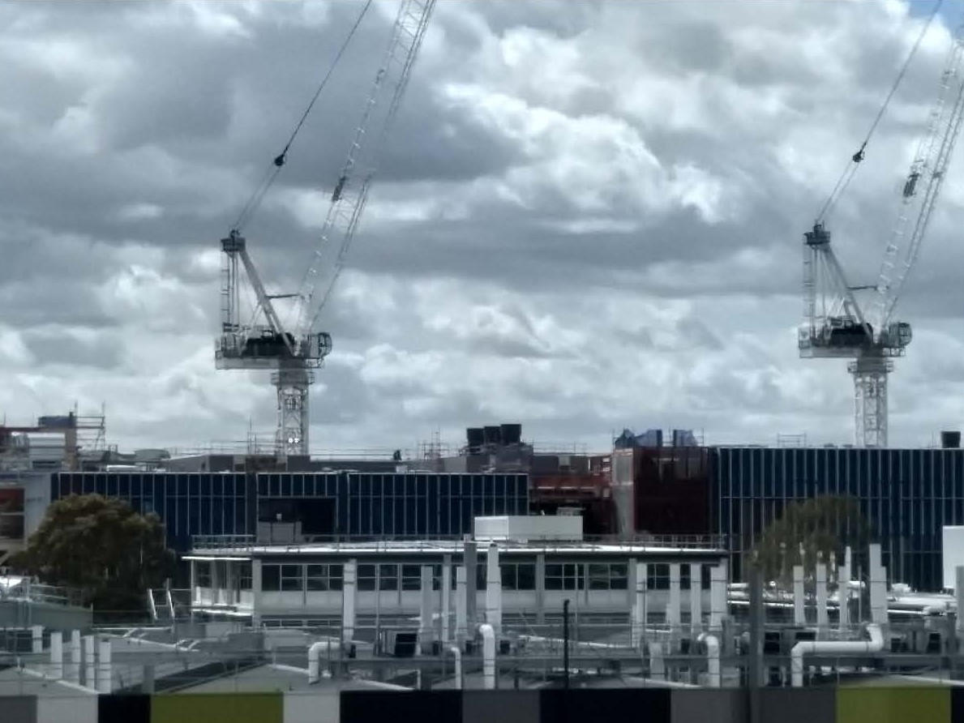

Photo 2

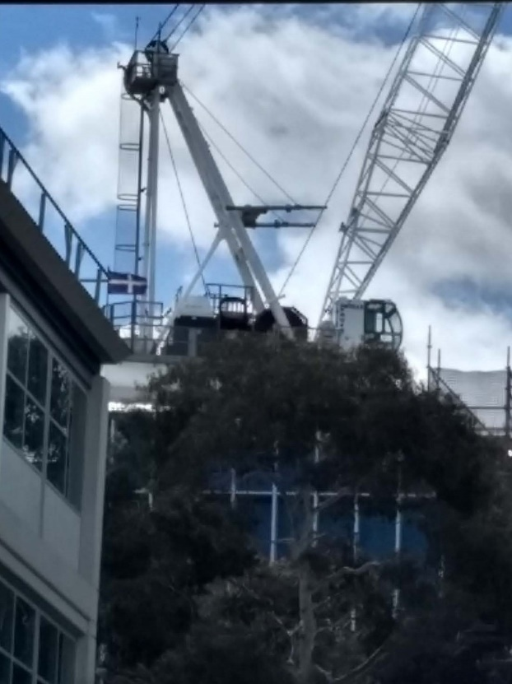

Photo 5

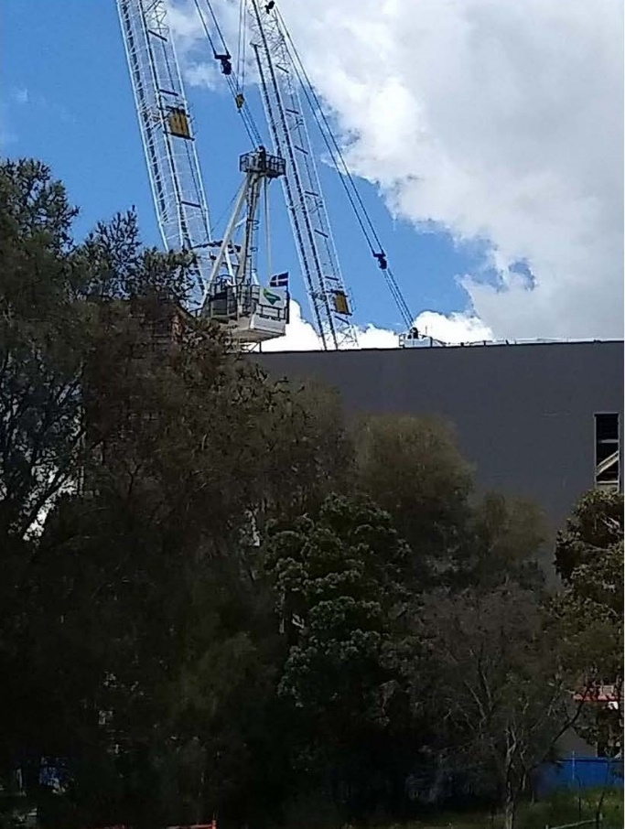

Photo 12

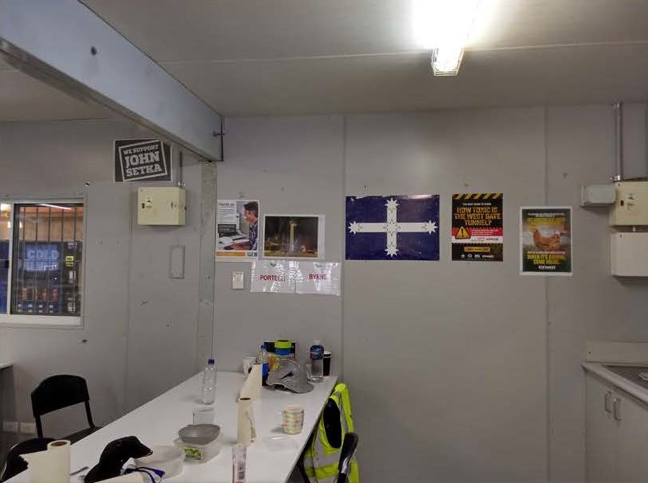

Photo 13

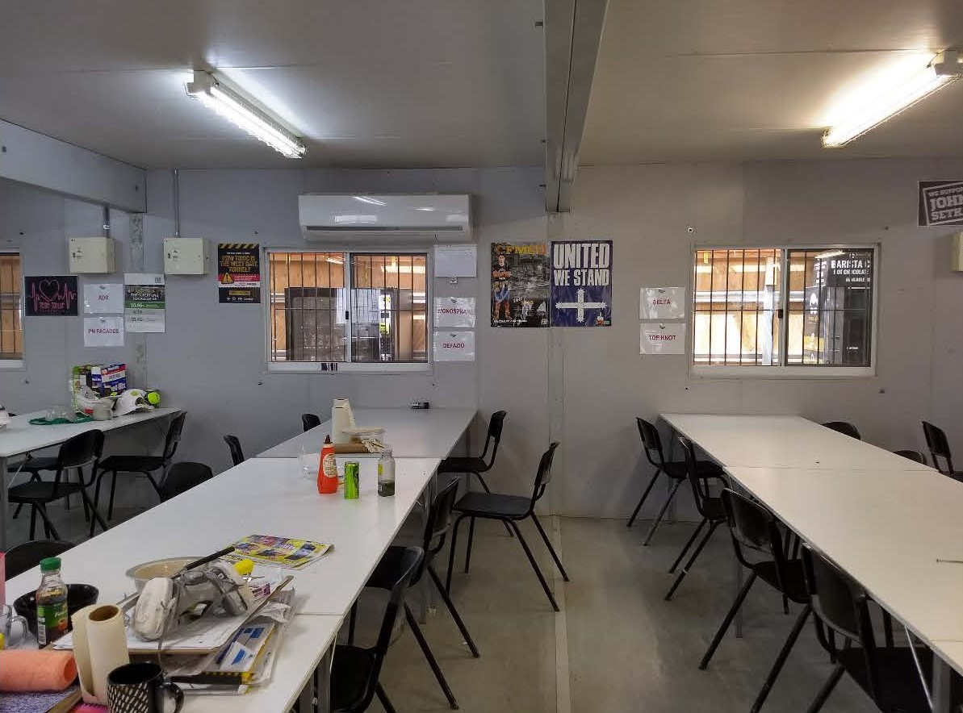

Photo 14

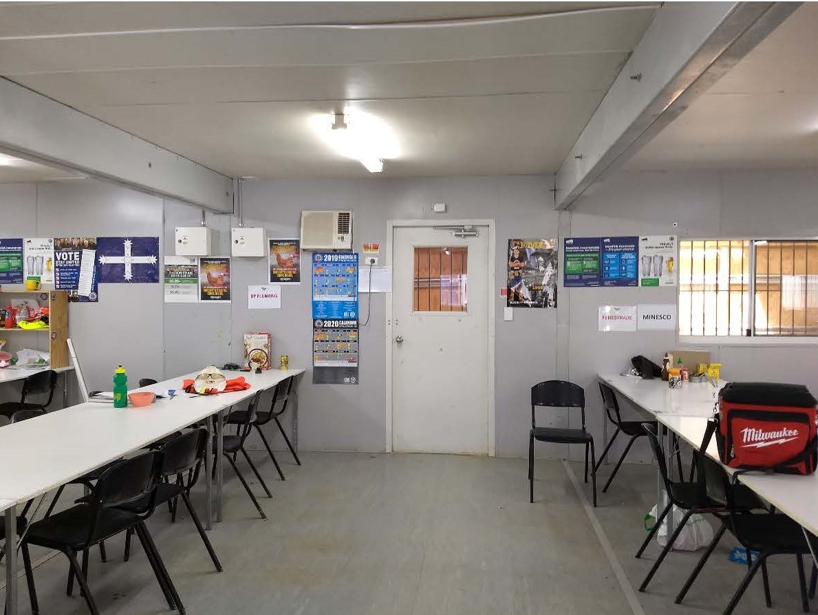

Photo 15

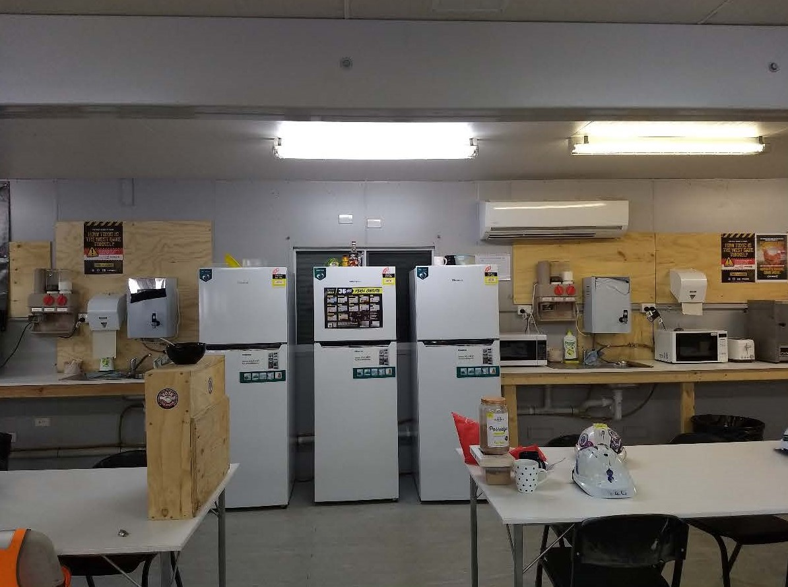

Photo 16

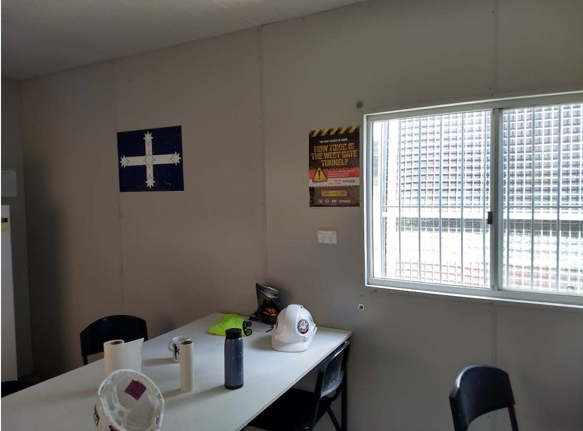

Photo 17

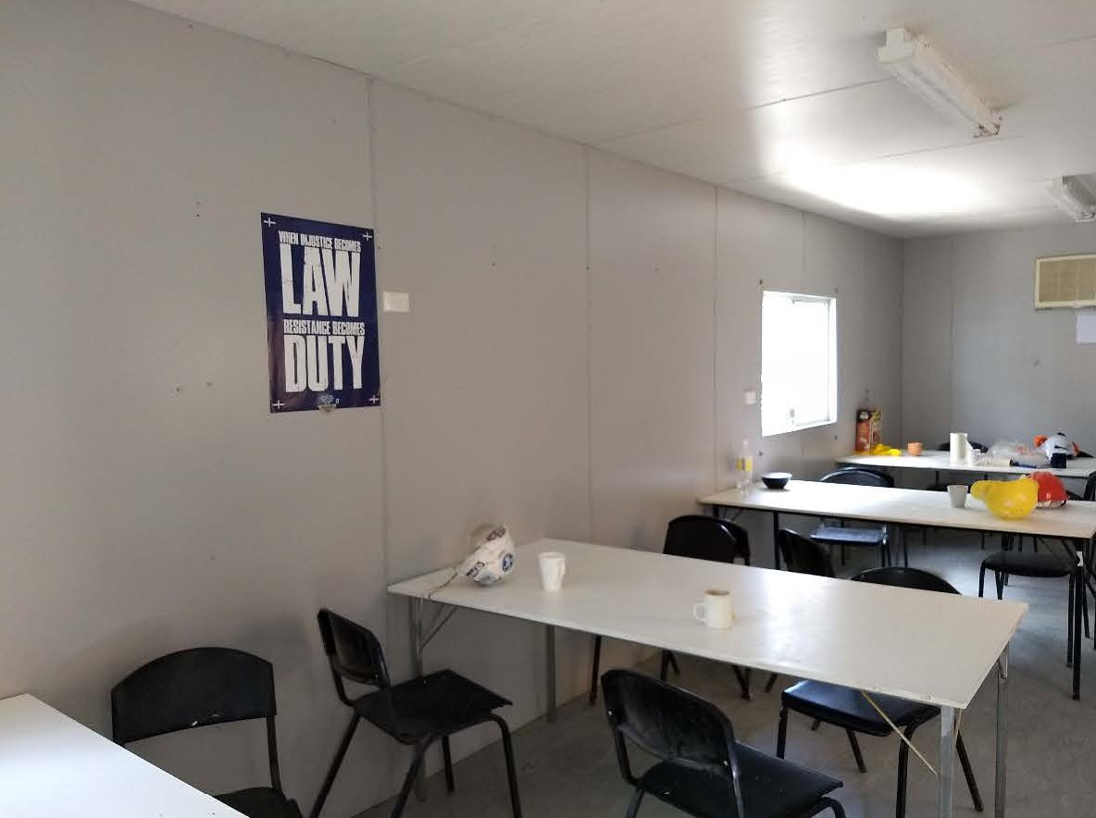

Photo 18

