FEDERAL COURT OF AUSTRALIA

Nextra Australia Pty Limited v Fletcher [2014] FCA 399

|  |  |
| --- | --- |
| Citation: | Nextra Australia Pty Limited v Fletcher [2014] FCA 399 |
|  |  |
| Parties: | **NEXTRA AUSTRALIA PTY LIMITED (ACN 070 924 677) v MARK TIMOTHY FLETCHER** |
|  |  |
| File number: | QUD 146 of 2011 |
|  |  |
| Judge: | **COLLIER J** |
|  |  |
| Date of judgment: | 24 April 2014 |
|  |  |
| Catchwords: | **CONSUMER LAW** – injunction sought to restrain alleged misleading or deceptive conduct – s 18 and s 232 *Australian Consumer Law* – promotional flyer published by franchisor of newsagent franchise – online blog article critical of flyer – online blog authored by director and co-owner of rival franchise group – whether article was conduct in trade or commerce – whether flyer was misleading or deceptive – class of consumers likely to be misled – whether article made imputations claimed by applicant – whether imputations misleading or deceptive or likely to mislead or deceive – whether Court’s discretion should be exercised in favour of granting injunction – whether Court should order retraction of article or apology |
|  |  |
| Legislation: | *Australian Consumer Law* (Sch 2 to the *Competition and Consumer Act 2010* (Cth)) ss 18, 232, 237  *Trade Practices Act 1974* (Cth) s 52 |
|  |  |
| Cases cited: | *Australian Competition and Consumer Commission v TPG Internet Pty Ltd* (2013) 304 ALR 186; [2013] HCA 54  *Butcher v Lachlan Elder Realty Pty Ltd* (2004) 218 CLR 592  *Campomar Sociedad, Limitada v Nike International Limited* (2000) 202 CLR 45  *Concrete Constructions (NSW) Pty Ltd v Nelson* (1990) 169 CLR 594  *Fasold v Roberts* (1997) 70 FCR 489  *Firewatch Australia Pty Ltd v Country Fire Authority* (1999) 93 FCR 520  *Forest v Queensland Health* [2007] FCA 1236  *Jones v Scully* (2001) 113 FCR 343  *Jones v Toben* [2002] FCA 1150  *Jones on behalf of the Executive Council of Australian Jewry v The Bible Believers’ Church* [2007] FCA 55  *King Furniture Australia v Dare Gallery* [2007] FCA 1845  *Parkdale Custom Built Furniture Pty Ltd v Puxu Pty Ltd* (1982) 149 CLR 191  *Petty v Penfold Wines Pty Ltd* [1993] ATPR 41-263  *Prosperity Group International Pty Ltd v Queensland Communication Company Pty Ltd (No 3)* [2011] FCA 1122  *Toben v Jones* (2012) 298 ALR 203; [2012] FCA 1193  *Universal Music Australia Pty Ltd v Cooper* (2005) 150 FCR 1 |
|  |  | |
| Date of hearing: | 2, 3 and 4 July 2013 | |
|  |  | |
| Place: |  | |
|  |  | |
| Division: |  | |
|  |  | |
| Category: | Catchwords | |
|  |  | |
| Number of paragraphs: | 110 | |
|  |  | |
| Counsel for the Applicant: | Dr G Dempsey with Mr MG Watson (pupil) | |
|  |  | |
| Solicitor for the Applicant: | Cranston McEachern Lawyers | |
|  |  | |
| Counsel for the Respondent: | Mr S Gannon | |
|  |  | |
| Solicitor for the Respondent: | The Law Offices of Barry Fried | |

|  |  |
| --- | --- |
| IN THE FEDERAL COURT OF AUSTRALIA |  |
| QUEENSLAND DISTRICT REGISTRY |  |
| GENERAL DIVISION | QUD 146 of 2011 |

|  |  |
| --- | --- |
| BETWEEN: | NEXTRA AUSTRALIA PTY LIMITED (ACN 070 924 677)  Applicant |
| AND: | MARK TIMOTHY FLETCHER  Respondent |

|  |  |
| --- | --- |
| JUDGE: | COLLIER J |
| DATE OF ORDER: | 24 APRIL 2014 |
| WHERE MADE: | BRISBANE |

THE COURT ORDERS THAT:

Within 21 days the parties shall submit a form of Orders reflecting the findings in this judgment.

Note: Entry of orders is dealt with in Rule 39.32 of the *Federal Court Rules 2011*.

|  |  |
| --- | --- |
| IN THE FEDERAL COURT OF AUSTRALIA |  |
| QUEENSLAND DISTRICT REGISTRY |  |
| GENERAL DIVISION | QUD 146 of 2011 |

|  |  |
| --- | --- |
| BETWEEN: | NEXTRA AUSTRALIA PTY LIMITED (ACN 070 924 677)  Applicant |
| AND: | MARK TIMOTHY FLETCHER  Respondent |

|  |  |
| --- | --- |
| JUDGE: | COLLIER J |
| DATE: | 24 APRIL 2014 |
| PLACE: | BRISBANE |

**REASONS FOR JUDGMENT**

1. The applicant, Nextra Australia Pty Ltd (“Nextra”) is the franchisor of a newsagency franchise system throughout Australia. Nextra is the licensee of the trademarks “Nextra” and “News Extra” from Nexcorp Australia Pty Ltd, of which Nextra is a wholly owned subsidiary.
2. The respondent, Mr Fletcher, is a director and 50% shareholder in NewsXpress Pty Ltd (“NewsXpress”), which is the franchisor of a separate newsagency franchise system throughout Australia under the brand name “newsXpress”. The newsXpress franchise system is a competitor of the Nextra franchise system.
3. Mr Fletcher operates an internet blog known as the “Australian Newsagency Blog” at the web address www.newsagencyblog.com.au (“the Blog”). On 27 April 2011 Mr Fletcher posted an article on the Blog entitled “Nasty campaign from nextra misleads newsagents” (“the Article”), referring to a flyer previously distributed by Nextra. By an amended originating application filed 28 June 2012, Nextra seeks injunctions pursuant to s 232 of the *Australian Consumer Law* (“ACL”) (Sch 2 to the *Competition and Consumer Act 2010* (Cth)):

* requiring Mr Fletcher to remove the Article from the Blog, as well as any responses he may have received;
* restraining Mr Fletcher from publishing the Article in any other form;
* requiring Mr Fletcher to publish on the Blog a retraction of the Article and an apology to the applicant.

1. Further or alternatively, the applicant seeks orders to the same effect pursuant to s 237 of the ACL.
2. In my view Mr Fletcher has engaged in conduct which was misleading or deceptive within the meaning of s 18 of the ACL. However I am not persuaded that the applicant is entitled to injunctive relief in the broad terms it seeks. I have formed this view for reasons to which I now turn.

# THE APPLICANT’S CLAIM

1. The claim of the applicant is relatively simple. The applicant claims (and Mr Fletcher admits) that the Blog is read widely by newsagents and other persons associated with the newsagency industry throughout Australia, including actual and potential franchisees of the applicant. On 27 April 2011 Mr Fletcher wrote and published the Article on his Blog. The article was as follows:

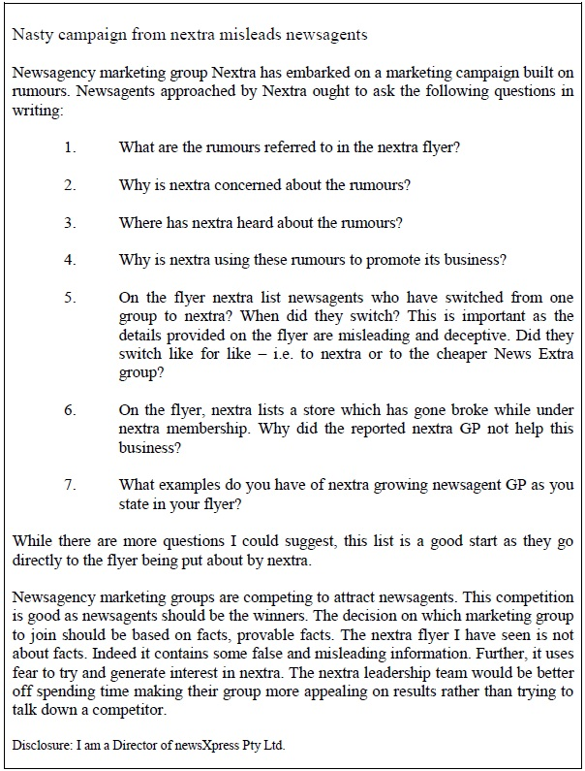

1. The Article refers to a flyer distributed by the applicant (“the Flyer”), which lists newsagents who have switched from membership of other newsagent franchises to the Nextra franchise. The Article does not append a copy of the Flyer.
2. The Flyer was an undated, single sheet of A4 paper printed on both sides. The heading on one side of the Flyer reads:

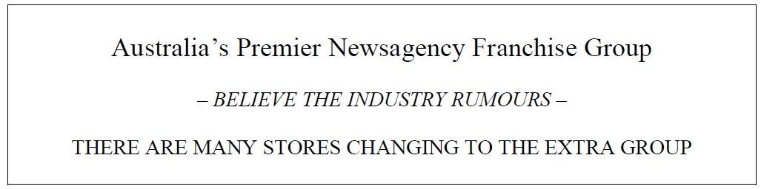

1. The Flyer includes three testimonials from the franchisees of News Extra Bullsbrook, Nextra Shellharbour and Nextra Crosslands, in which those franchisees expound the benefits of having joined the Nextra franchise group. Underneath the testimonials are the following statements:

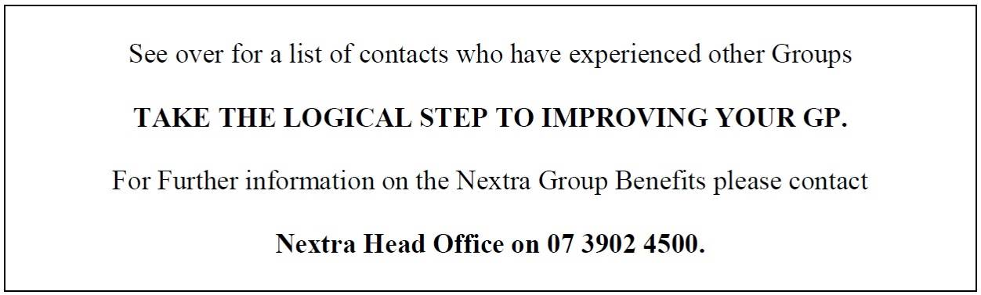

1. On the reverse side of the Flyer reads the heading:

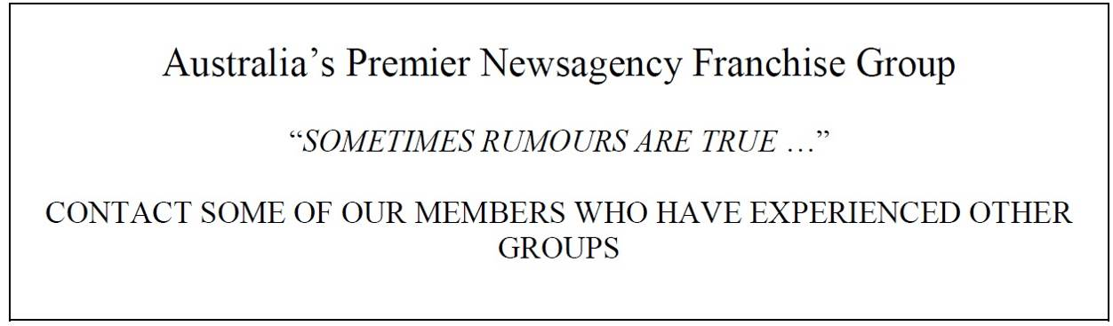

1. The Flyer lists 14 Nextra and News Extra franchisees available for contact and then sets out the following statements:

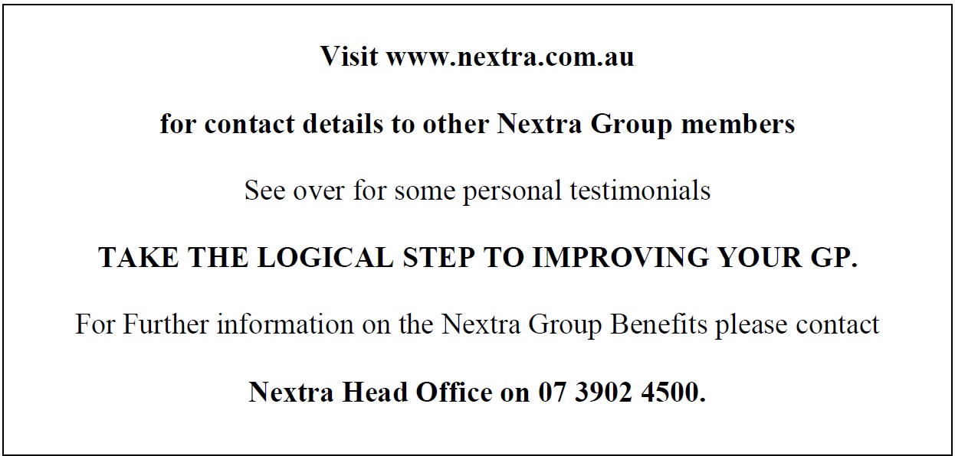

1. The Flyer in its entirety is as follows:

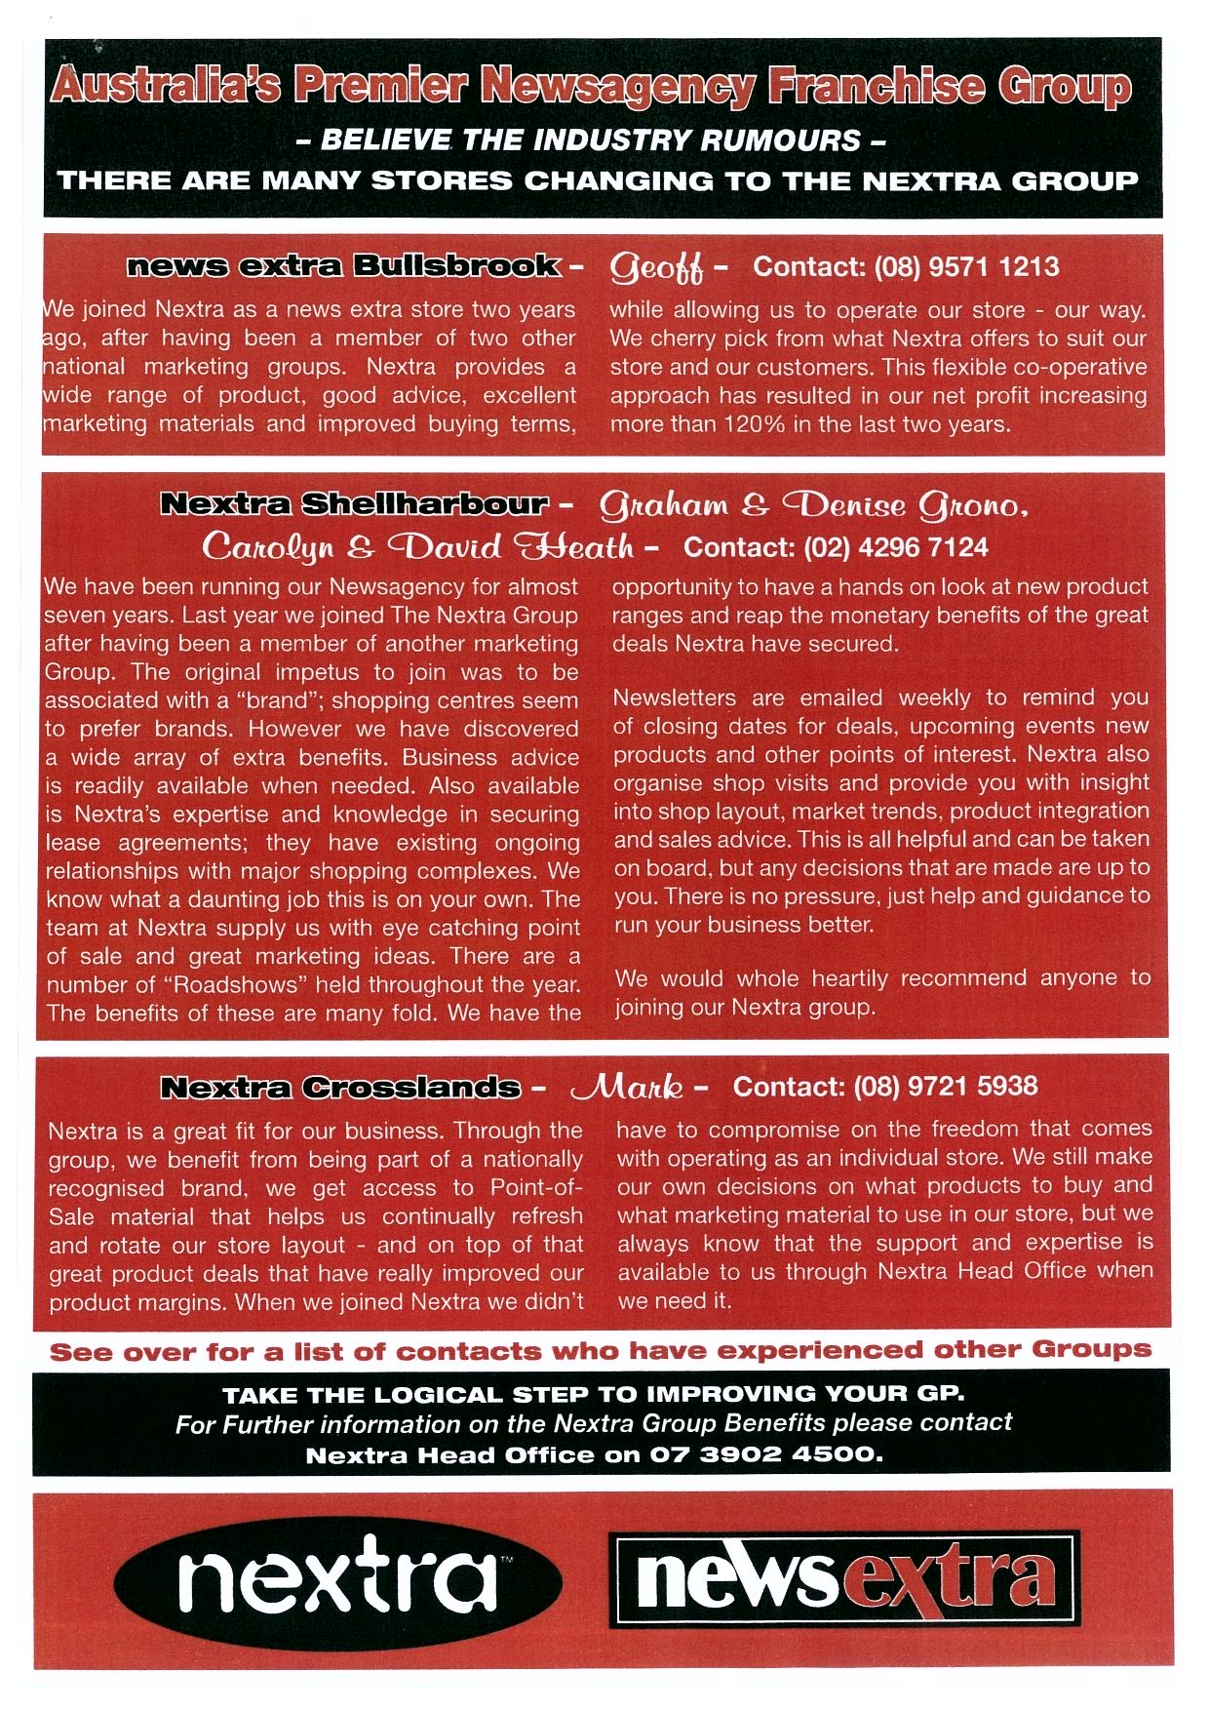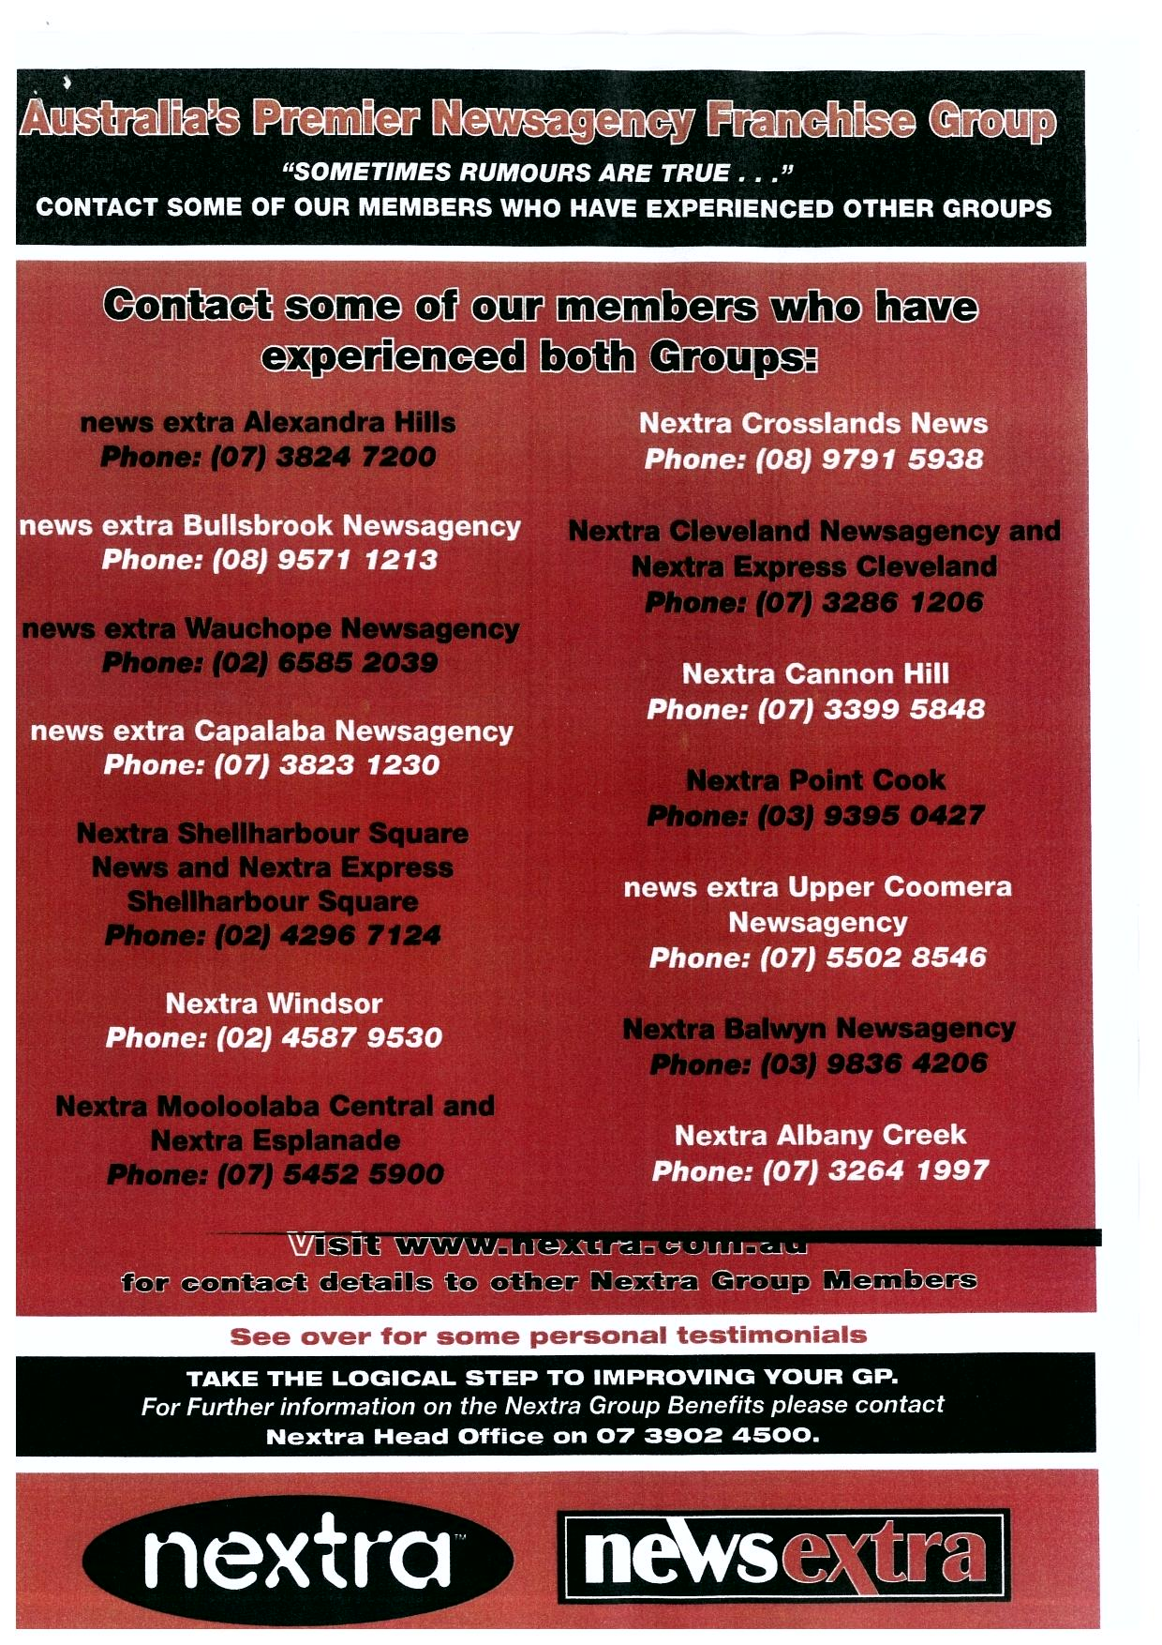

1. I note evidence of Mr Brian McFarlane, a director of Nextra, in his affidavit sworn 19 March 2013, that the Flyer was distributed in print form only during the first few months of 2011. I understand the Flyer has never been published electronically. Mr McFarlane also gave evidence that the Flyer was primarily directed to newsagents in the Newspower franchise, large independent newsagents and newsagents in the newsXpress franchise (transcript 2 July 2013 p 41 ll 3-4). The purpose of the Flyer was to encourage non-member newsagents to join the Nextra Group. None of this evidence was disputed.
2. The applicant claims that the Article states or alternatively implies that the applicant promoted the Nextra franchise in a manner which:

* distributed false information;
* relied upon false innuendo; and
* was intended to or had the effect of creating a sense of fear.

1. The applicant claims that the Article states or alternatively implies that:

* Some or all of the newsagents had not in fact switched to Nextra or to News Extra.
* The Flyer was deceptive by reason that the flyer failed to differentiate between the franchisees who had switched to Nextra and the franchisees who had switched to News Extra.
* One of the franchisees listed in the flyer was in fact insolvent, and such insolvency was by reason of the Nextra franchise system.
* The testimonials contained in the Flyer were either false or out of date.
* The Nextra franchise system did not in fact improve the gross profit of any of the franchisees listed in the Flyer.

1. The applicant claims further that:

* The respondent knew that the use of the word “rumours” in the Flyer did not constitute reliance by the applicant on ***false*** innuendo or rumour in the manner implied by the Article.
* The effect of the Flyer was not to create a sense of fear.
* The effect of the Flyer was not to attack the newsXpress franchise or any other franchise system.
* The Flyer did differentiate between the franchisees that had switched to Nextra and the franchisees that had switched to News Extra.
* Each of the testimonials in the Flyer were genuine.
* Each of the franchisees listed had in fact switched to Nextra or News Extra.
* The respondent had no reasonable basis to suggest that the testimonials were false or out of date, or that the franchisees had not in fact switched to Nextra or News Extra.
* The respondent had no reasonable basis for suggesting that any franchise had become insolvent or that such insolvency was by reason of the Nextra franchise system.
* The respondent had no reasonable basis for suggesting that the Nextra franchise system did not in fact improve the gross profit of any of the franchisees listed in the Flyer.

1. The applicant claims that the respondent, by writing and posting the Article on the Blog, engaged in conduct that was misleading or deceptive in contravention of s 18 of the ACL.
2. The applicant invited the respondent to publish a retraction of the Article and an apology, however the respondent refused.

# THE DEFENCE

1. In his defence Mr Fletcher claims, in summary, as follows:

* The franchise membership fees in respect of the brand names “Nextra” and “News Extra” are different. The services offered to members of the “News Extra” brand are substantially more limited than those offered to “Nextra” franchise members.
* newsXpress offers a full service to its franchisees which is of a similar level to that offered by the “Nextra” franchise, but is substantially greater than those offered by the “News Extra” franchise. Accordingly, it would not be a valid comparison and would be misleading to compare the services offered by News Extra with those offered by newsXpress and/or Nextra.
* newsXpress is a competitor of the Nextra franchise. Other competitors include NewsPower, Supanews and Lucky Charm.
* He admits that the Blog is read (and intended to be read) widely by newsagents and other persons associated with the newsagency industry throughout Australia.
* The conduct of Mr Fletcher in writing and posting the Article was not conduct in trade or commerce. His authoring of the Blog was for the purpose of information and discussion by participants in the newsagency industry and interested members of the public as opposed to trade and commerce.
* He admits that the Article states or alternatively implies that the applicant promoted the Nextra franchise in a manner which distributed false information and was intended to or had the effect of creating a sense of fear, but denies that the manner of promotion relied upon false innuendo.
* The Flyer was misleading and intended to create a sense of fear in that, read as a whole it:

o failed to differentiate between the services provided by Nextra and News Extra;

o stated or implied that Nextra and news Extra were both on an equal and comparable footing to newsXpress;

o drew comparisons between Nextra and News Extra on the one hand and newsXpress on the other which were false and misleading;

o created a false sense of urgency amongst newsagents by the claim that many stores were changing from the newsXpress franchise to Nextra or News Extra;

o used the words “believe the industry rumours” and “sometimes rumours are true” and intentionally failed to state what was meant by such statements or rumours.

* The Article was a response to and is required to be read in conjunction with the Flyer.
* The Article when read as a whole was fair, accurate, appropriate and a justified response to the Flyer.
* At the time of publication of the Article the Nextra Windsor franchise listed in the Flyer had gone out of business, therefore point 5 of the Article was a fair and justified query in light of the claims made in the Flyer and testimonials concerning gross profits of those who had switched to membership of the applicant’s franchise.
* The Flyer contained factual inaccuracies.

# PROCEEDINGS

1. Five witnesses were called in the proceedings. The applicant called:

* Mr Brian McFarlane, a director of Nextra Australia Pty Ltd and Nexcorp Australia Pty Ltd;
* Mr Geoffrey Harris, a newsagent;
* Ms Denise Grono, a newsagent;
* Mr Mark Dennis, a newsagent.

1. Mr Fletcher gave evidence on his own behalf.
2. In their submissions the parties closely followed the case stated in the pleadings.
3. Materially, the applicant submits:

* The Article, viewed as a whole, would leave a reasonable reader with the impression that Nextra had distributed false information and had deployed false innuendo to engender fear by way of its marketing campaign.
* The Flyer did not create any sense of fear, but rather was positive as it “talked up” Nextra rather than “talked down” any competitor.
* The reference to “rumours” was no more than an advertising puff.
* The Article imputes by use of the Flyer that Nextra falsely and unfairly attacked the newsXpress franchise system.
* The Article carries the imputation that the Flyer falsely listed franchisees that had not in fact switched to Nextra from another group. The imputation arises from:

o repeated use in the Article of the words “false” and “misleading”;

o point 5 of the Article which asks “When did they switch? This is important as the details on the flyer are misleading and deceptive”;

o the Article does not identify “the details provided on the flyer” that are said to be misleading or deceptive.

* The Article carries the imputation that the Flyer was false and misleading because it failed to differentiate between franchisees that had switched to Nextra as opposed to those franchisees that had switched to News Extra, however that imputation is misleading both in respect of the testimonials and the list of contracts because the Flyer clearly indicated not only the franchisees’ locations but also whether they were with Nextra or News Extra.
* The Article carries the imputation – in particular at point 6 – that one of the franchisees listed in the Flyer was rendered insolvent by reason of the Nextra franchise system. Clearly Mr Fletcher had no knowledge of the financial circumstances of Nextra Windsor, which was the newsagency the subject of the imputation. He had no reasonable basis to suggest that the closure was attributable to Nextra. Further, Mr Fletcher failed to prove that Nextra continued to distribute the Flyer knowing Nextra Windsor’s insolvency.
* The Article carried the imputation that the testimonials in the Flyer were either false or out of date, however Mr Fletcher admitted in the Defence that the testimonials were genuine, and it is apparent from his own evidence that he lacked reasonable grounds to contend that the testimonials were not genuine.
* The testimonial in relation to News Extra Bullsbrook was accurate, because the evidence demonstrated that News Extra Bullsbrook had joined the franchise on 1 December 2007 and provided a testimonial two years and two months later in February 2010. Further there was no evidence that News Extra Bullsbrook newsagent had changed his opinion concerning the franchise.
* All three franchisees called by the applicant who were cross-examined by Counsel for the respondent continued to maintain strongly that their testimonials were true.
* The question at point 7 of the Article calls into question the profitability of all Nextra franchisees, relying on the closure of Nextra Windsor. However under cross-examination Mr Fletcher accepted that he had no knowledge of the particular performance of most of the Nextra stores, and accepted that gross profits were not the sole determinant of the success or failure of a business.
* In assessing Mr Fletcher’s conduct in publishing the Article, regard must be had to the members of the class to whom the conduct was directed and what a reasonable person in the position of a person reading the Article would make of the Article, particularly if they had not read the Flyer. It is important that Mr Fletcher did not attach a copy of the Flyer to the Article. The impression formed by a reader of the Article as to the content of the Flyer and the conduct of Nextra would be negative.
* The Court should find that Mr Fletcher, through his Blog, sought to promote his commercial interests (in particular his newsXpress and Tower interests), and in any event sought to attack a competitor, Nextra, thus protecting his own commercial interests. Mr Fletcher’s claim that his publication of the Blog was for purely altruistic reasons untainted by commercial interests should not be accepted.

1. In response Mr Fletcher submits, in summary, as follows:

* The Article was not published in trade or commerce, rather it is a public forum for matters affecting the newsagency industry. It was directed at Nextra’s advertising campaign, and is not used as a platform for promotion of Mr Fletcher’s business interests.
* The class of consumers who is likely to be misled is the newsagency community who bother to read the blog. An average newsagent is reasonably critical and forms their own judgment.
* The test is whether a member of the relevant class is likely to be misled or deceived, which involves a degree of speculation and judgment as to how a reader might react based on the evidence. The Article and the Flyer must be read together, and if on a reasonably open reading the Flyer was misleading the Article cannot be.
* It was open to read the Flyer as misleading since, as the evidence showed, it:

o was distributed after March 2011 using Nextra Windsor as a referee in support of Nextra’s claim to improve gross profits when it had closed;

o was distributed by Nextra using testimonials which, by the time of distribution, were out of date, without any corrective or explanatory note;

o coupled with the claim “there are many stores switching” suggested that the testimonial writers had switched recently, which was not correct;

o referred to “industry rumours” which were not specified and could be taken to be sinister, particularly in the context of there being “many stores switching”, 13 out of 14 of which were former newsXpress stores;

o did not articulate that some of those who had “switched” (being former newsXpress stores) went to the cheaper News Extra model rather than the premium Nextra franchise which was comparable to the respondent’s newsXpress franchise. The comparative costs were different;

o some authors of the testimonials had received financial incentives to switch, being reductions in fees. If a person receives an incentive to switch it is not a “like for like” switch.

* The Flyer was either open to be read as misleading or it was not. If it was, the Article was justified, and it was not misleading to call Nextra’s advertising campaign “Nasty”.
* No one has been or is likely to be moved to action, to their detriment, by the Article. Those who read the Article would be likely to:

o ignore or dismiss it as mere opinion;

o if they have read the Flyer, ask Nextra the questions contained in the Article;

o if they have not read the Flyer, make further inquiry of Nextra.

* It is open to the Court to make a finding of misleading or deceptive conduct without granting an injunction.

# CONSIDERATION

1. The applicant claims that Mr Fletcher has engaged in conduct contravening s 18 of the ACL. Section 18 provides:

**Misleading or deceptive conduct**

(1) A person must not, in trade or commerce, engage in conduct that is misleading or deceptive or is likely to mislead or deceive.

(2) Nothing in Part 3-1 (which is about unfair practices) limits by implication subsection (1).

1. The questions for determination by the Court in this case are clear. They are as follows:
2. Did the actions of the respondent, in posting the Article on his Blog, constitute conduct engaged “in trade or commerce”?
3. What is the class of consumers likely to be misled or deceived by the respondent’s conduct and what are the characteristics of that class?
4. Did the Article convey the imputations the applicant claims?
5. Were the imputations in the Article misleading or deceptive or likely to mislead or deceive?
6. If the Article is found to be misleading or deceptive, should the Court’s discretion be exercised in favour of granting an injunction and, if so, on what terms?
7. I will consider each of these questions in turn.

## Question 1: did the actions of the respondent, in posting the Article on the Blog, constitute conduct engaged “in trade or commerce”?

1. As I have already observed, Mr Fletcher denies that his conduct in respect of the Article was “in trade or commerce” within the meaning of s 18 of the ACL. This is an important threshold issue in this proceeding.
2. The leading authority analysing the meaning of “in trade or commerce” in the trade practices context is *Concrete Constructions (NSW) Pty Ltd v Nelson* (1990) 169 CLR 594. In that decision the applicant sued his employer for personal injuries sustained during the course of his employment when he fell to the bottom of an air-conditioning shaft while attempting to remove a grate positioned at the entry point. The applicant claimed that he suffered injuries as a result of conduct of the foreman who incorrectly told him that the grates at the entry points of the air-conditioning shafts were fixed by three bolts on each side and that it was safe to remove them (when in fact the grates were not so affixed). The applicant alleged that those facts gave rise to a cause of action under s 52 of the *Trade Practices Act 1974* (Cth) (being equivalent to s 18 of the ACL) in that conduct of the foreman was misleading or deceptive or liable to mislead or deceive. At 602-604 of the decision Mason CJ and Deane, Dawson and Gaudron JJ said:

It is well established that the words “trade” and “commerce”, when used in the context of s. 51(i) of the Constitution, are not terms of art but are terms of common knowledge of the widest import. The same may be said of those words as used in s. 52(1) of the Act. Indeed, in the light of the provisions of s. 6(2) of the Act which give an extended operation to s. 52 and which clearly use the words “trade” and “commerce” in the sense which the words bear in s. 51(i) of the Constitution, it would be difficult to maintain that those words were used in s. 52 with some different meaning. The real problem involved in the construction of s. 52 of the Act does not, however, spring from the use of the words “trade or commerce”. It arises from the requirement that the conduct to which the section refers be “***in***” trade or commerce. Plainly enough, what is encompassed in the plenary grant of legislative power “with respect to ... Trade and commerce” in s. 51(i) of the Constitution is not of assistance on the question of the effect of the word “in” as part of the requirement that the conduct proscribed by s. 52(1) of the Act be “in trade or commerce”.

The phrase “in trade or commerce” in s. 52 has a restrictive operation. It qualifies the prohibition against engaging in conduct of the specified kind. As a matter of language, a prohibition against engaging in conduct “in trade or commerce” can be construed as encompassing conduct in the course of the myriad of activities which are not, of their nature, of a trading or commercial character but which are undertaken in the course of, or as incidental to, the carrying on of an overall trading or commercial business. If the words “in trade or commerce” in s. 52 are construed in that sense, the provisions of the section would extend, for example, to a case where the misleading or deceptive conduct was a failure by a driver to give the correct hand signal when driving a truck in the course of a corporation’s haulage business. It would also extend to a case, such as the present, where the alleged misleading or deceptive conduct consisted of the giving of inaccurate information by one employee to another in the course of carrying on the building activities of a commercial builder. Alternatively, the reference to conduct “in trade or commerce” in s. 52 can be ***construed as referring only to conduct which is itself an aspect or element of activities or transactions which, of their nature, bear a trading or commercial character***. So construed, to borrow and adapt words used by Dixon J. in a different context in *Bank of NSW v The Commonwealth*, the words “in trade or commerce” refer to “the central conception” of trade or commerce and not to the “immense field of activities” in which corporations may engage in the course of, or for the purposes of, carrying on some overall trading or commercial business.

As a matter of mere language, the arguments favouring and militating against these alternative constructions of s. 52 are fairly evenly balanced…. Nonetheless, when the section is read in the context provided by other features of the Act, which is “An Act relating to certain Trade Practices”, the narrower (i.e. the second) of the alternative constructions of the requirement “in trade or commerce” is the preferable one… [T]he section was not intended to impose, by a side-wind, an overlay of Commonwealth law upon every field of legislative in connection with, carrying on its trading or commercial activities. What the section is concerned with is the conduct of a corporation towards persons, be they consumers or not, with whom it (or those whose interests it represents or is seeking to promote) has or may have dealings in the course of those activities or transactions which, of their nature, bear a trading or commercial character. ***Such conduct includes, of course, promotional activities in relation to, or for the purposes of, the supply of goods or services to actual or potential consumers***, be they identified persons or merely an unidentifiable section of the public. In some areas, the dividing line between what is and what is not conduct “in trade or commerce” may be less clear and may require the identification of what imports a trading or commercial character to an activity which is not, without more, of that character. The point can be illustrated by reference to the examples mentioned above. The driving of a truck for the delivery of goods to a consumer and the construction of a building for another pursuant to a building contract are, no doubt, trade or commerce in so far as the relationship between supplier and actual or potential customer or between builder and building owner is concerned. That being so, to drive a truck with a competitor’s name upon it in order to mislead the customer or to conceal a defect in a building for the purpose of deceiving the building owner may well constitute misleading or deceptive conduct “in trade or commerce” for the purposes of s. 52. On the other hand, the mere driving of a truck or construction of a building is not, without more, trade or commerce ***and to engage in conduct in the course of those activities which is divorced from any relevant actual or potential trading or commercial relationship or dealing will not, of itself, constitute conduct “in trade or commerce” for the purposes of that section***. That being so, the giving of a misleading hand signal by the driver of one of its trucks is not, in the relevant sense, conduct by a corporation “in trade or commerce”. ***Nor, without more, is a misleading statement by one of a building company’s own employees to another employee in the course of their ordinary activities. The position might well be different if the misleading statement was made in the course of, or for the purposes of, some trading or commercial dealing between the corporation and the particular employee.***

(emphasis added, footnotes deleted.)

1. The question whether Mr Fletcher’s conduct in respect of the Article was “in trade or commerce” was complicated by his multiple business interests. Clearly Mr Fletcher is a director and part owner of newsXpress (which operates a separate newsXpress blog). He is also a newsagent in his own business, and owns 100% of Tower Systems International Australia Proprietary Limited (“Tower”) which sells point of sale software for newsagents (and which also operates a blog). Nextra submitted that Mr Fletcher, through the Blog, promotes his commercial interests (in particular the newsXpress franchise and Tower software) and in any event Mr Fletcher through the Article sought to attack Nextra thus protecting his commercial interests.
2. Where a person works in a particular industry, it would not always be conduct “in trade or commerce” for such a person to engage in an activity relating to that industry. So, for example it is possible that a person who worked in a particular industry, and who wrote an informative article dealing with an aspect of that industry where that article was subsequently published in a trade or industry magazine, would not be engaging in conduct in trade or commerce. As Yates J observed in *Toben v Jones* (2012) 298 ALR 203; [2012] FCA 1193 at [42], without more the simple act of publication of a monthly magazine and a free email news and commentary service does not constitute conduct in trade or commerce within the meaning of s 18 of the ACL. A further example of such conduct was that of the respondent in *Fasold v Roberts* (1997) 70 FCR 489 where the Court held that a person who gave public lectures and performed paid consultancy work did not engage in conduct in trade or commerce in so doing, because his activities lacked the qualities which would allow them to be characterised as conduct in trade or commerce.
3. Similarly, self-publication by a person of articles or thought pieces relevant to a particular industry – on, for example, a blog – do not necessarily constitute conduct in trade or commerce where, for example, it is clear that the particular blog permits ventilation of personal opinions by the publisher on topics in which he or she is interested, and is provided for the interest of readers.
4. Mr Fletcher claims that he publishes the Blog for – essentially – altruistic reasons – that is, for the interest, information and benefit of the newsagent community. He points to the fact that the Blog contains articles on numerous topics which are unrelated to the applicant or the respondent’s commercial interests, and claims that the Blog has been the subject of more than 12,000 blog posts.
5. From the evidence before the Court it seems that Mr Fletcher’s motives in posting material on the Blog are in fact mixed. I am satisfied that he appreciates the status and authority that publication of a Blog of this nature confers on him in the newsagency community. He submitted that he “is considered an experienced and influential figure and voice in the newsagency industry”, and indeed such stature as is conferred upon Mr Fletcher from the publication of the Blog for the information of the newsagent community lends weight to that claim. Further, I am satisfied that Mr Fletcher has a genuine interest and aim in promoting discussion in the newsagency community on topics of interests to newsagents, and that the Blog is a key element in achieving that objective.
6. However I am also satisfied that Mr Fletcher has not hesitated to use the Blog to promote his own commercial interests (including newsXpress). So, for example:

* He published on the Blog in 2009 an article entitled “How to Choose the Right Marketing Group for your Newsagency”, which promoted the benefits of membership of the newsXpress franchise. No equivalent article promoting the benefits of membership of any other newsagency franchise were brought to my attention.
* On 28 March 2006 he posted an article entitled “Copying is flattering but not great for business” which lauds his own initiatives and those of newsXpress, and is critical of Newspower, as follows:

I’ve been chronicling here the success we have been having in my newsagency with the magazine club card which I which developed and implemented a year and half ago. This was the newsagency channel’s first magazine based loyalty program. It’s been a huge success and I’m aware of close to 100 newsagencies running the promotion. The newXpress group, of which I am a Director, adopted the program in October 2005 and launched it a month later. I just found out that the Newspower marketing group is about to launch its own magazine loyalty program. While I wish newsagents well with the Newspower program, I would have liked to see them offer a point of difference in the loyalty stakes. The more the newsagency marketing groups copy each other the more diluted the offering becomes. If the Newspower offering is similar to what I have created I’ll start looking for new playing fields.

* On 23 March 2006 he posted an article entitled “Getting ‘cut through’ with newsagents” in which he promoted Tower by reference to a hyperlink to Tower and comments including the following:

Suppliers to Australian newsagents often complain at the difficult [sic] in achieving compliance, traction, engagement, cut through – call it what you will. As a newsagent (through my software company) and a newsagent I see both sides of such communication …

Having considered a full week of communication I suggest that suppliers could boost their “cut through” by making communication simpler, provide context for the action requested, don’t over explain and focus on the payoff for the newsagent as a result of compliance.

…

I’m speaking from personal experience here. We achieve rapid compliance across 1,100 newsagents with software updates by following the newsagent communications guidelines noted above …

* On 13 March 2007 he posted an article entitled “Confusing newsagency brands” in which he was “particularly suspicious” of Nextra’s choice of “Nextra express” as a brand name:

as it is very close in name to newsXpress of which I am a Director and shareholder. I would have preferred the Nextra experts demonstrate their skill by coming up with a more unique name.

For the record, newsXpress has nothing to do with Nextra express or indeed any of the other groups. Our stores are called newsXpress and nothing else.

* On 31 January 2008 he posted an article entitled “The team behind newsXpress” in which he praised the strategies, commercial terms, and resources provided by newsXpress to its members, in terms including the following:

I’ve owned my newsagency at Forest Hill in Victoria since February 1996 and over the twelve years have been independent, with Newspower and with Nextra – before joining newsXpress in mid 2005. What I looked for in a group was business building strategies as well as excellent commercial terms. While I am biased about newsXpress, since I’m now a shareholder, my relationship with this brand has been the best for my business.

While any of the marketing groups can negotiate brand based deals, it’s the team behind the brand which drives the point of difference. Below is a photo of the full-time team behind newsXpress. From the national merchandise team to the in-store Business development Managers, this team represents an exceptional resource for my business and the businesses of all newsXpress members.

As with any of the marketing groups, newsXpress is not for everyone. It’s for entrepreneurial newsagents who want to redefine their newsagency and fish for new customers and a build a more valuable shopping basket. Chasing above average growth is hard work and not for everyone. But, then, good rewards do take hard work.

I’m glad to have good relationships with many Nextra and Newspower newsagents. Those groups, too, are not for everyone. I am sure their members would be equally complimentary of them.

Key in assessing a newsagency marketing group is to look at its goals for members and the people who will help you achieve those goals. Finding the right group backed by the right people can make your newsagency a truly valuable investment. The team behind newsXpress is a good mixture of hands-on newsagency experience as well as experience from outside our channel which benefits the brand.

The days of the independent newsagent are coming to an end. Without a well-managed brand behind your business it is easy to get lost in the rush to lure new customers.

Disclosure: I am a shareholder in and Director of newsXpress Pty Ltd

* On 31 January 2010 he posted an article entitled “Newsagency casual vacancy” which read as follows:

We are looking for someone to join our newsXpress Forest Hill (VIC) store on a casual basis. If you know anyone please have them email me.

* In the Blog he made posts referring to:

o “our aggressive magazine promotion strategies” and “Our sales rate bounces between 70% and 90% with the average of 80%”, where “our sales” referred to newsXpress (Blog posting of 25 November 2005, transcript p 228 l 25);

o the newXpress program as “a killer magazine loyalty program in our store and which is driving well above average sales growth” (Blog posting of 16 December 2005).

1. Mr Fletcher relied on the observations of Yates J in *Toben v Jones*, however in my view a closer analogy to the facts of this case appears in *Universal Music Australia Pty Ltd v Cooper* (2005) 150 FCR 1 where Tamberlin J, in the course of considering whether conduct in hosting a website with free music files constituted conduct in trade or commerce, observed:

[90] ***The evidence is that Cooper benefited financially from sponsorship and advertisements on the website and the attraction to users of accessing the site to obtain downloads from remote sites. I am therefore satisfied that the operation of the website occurred within a trading or commercial context and as part of trade and commerce***, however, I do not consider that Cooper can be said to have been engaged in trading in relation to the digital music files themselves. The commercial benefit to Cooper was a collateral one, arising from the sponsorship and funding he received as a result of the exposure of the advertising material on his website. I consider that he used the hyperlinks on his website, and the high traffic of internet users which was generated by these hyperlinks, to procure such sponsorship.

…

[140] The respondents deny the alleged contraventions of the TPA on the basis that Cooper was not relevantly engaged “in trade or commerce”. This expression refers to “the central conception” of trade or commerce and not to the “immense field of activities” in which corporations may engage in the course of, or for the purpose of, carrying on some overall trading or commercial business: *Concrete Constructions (NSW) Pty Ltd v Nelson* (1990) 169 CLR 594 at 603-604 per Mason CJ, Deane, Dawson and Gaudron JJ. Cooper did not charge visitors to the website any sum of money for the ability to downloading the sound recordings, to which the website provided hyperlinks, from the remote websites on which they were stored. However, the evidence is that Cooper received a commercial benefit from third parties for sponsorship and advertisements on the website. ***The commercial reality is that Cooper used the hyperlinks on the website, and the high traffic of internet users attracted by the freely available music recordings, to gain this sponsorship and advertising revenue. Therefore, Cooper’s business activity was closely connected with the availability and accessibility of the music recordings and the representations formed part of the “central conception” of that business.***

(emphasis added.)

1. In summary, I am satisfied that Mr Fletcher has used the Blog for commercial purposes, to promote newsXpress and his business interests in Tower, and the Article was an example of where Mr Fletcher has done so.
2. The posting of the Article by Mr Fletcher was not conduct divorced from his relevant actual or potential trading or commercial relationships, as envisaged in *Concrete Constructions*. While Mr Fletcher did not purport to post the Blog on behalf of newsXpress, or the newsXpress franchise, it is clear from perusing the Article that he did so to defend newsXpress from what he saw as potential poaching of franchisees by Nextra. This conduct was more than merely being “in relation to” trade or commerce. I am satisfied that the posting of the Article on the Blog was conduct in trade or commerce within the meaning of s 18 of the ACL.

## Question 2: what is the class of consumers likely to be misled or deceived by the respondent’s conduct and what are the characteristics of that class?

1. As Gibbs CJ explained in *Parkdale Custom Built Furniture Pty Ltd v Puxu Pty Ltd* (1982) 149 CLR 191:

[9] Section 52 does not expressly state what persons or class of persons should be considered as the possible victims for the purpose of deciding whether conduct is misleading or deceptive or likely to mislead or deceive. ***It seems clear enough that consideration must be given to the class of consumers likely to be affected by the conduct.*** Although it is true, as has often been said, that ordinarily a class of consumers may include the inexperienced as well as the experienced, and the gullible as well as the astute, the section must in my opinion by regarded as contemplating the effect of the conduct on reasonable members of the class. The heavy burdens which the section creates cannot have been intended to be imposed for the benefit of persons who fail to take reasonable care of their own interests. What is reasonable will of course depend on all the circumstances …

(emphasis added.)

(cf *Campomar Sociedad, Limitada v Nike International Ltd* (2000) 202 CLR 45; *Butcher v Lachlan Elder Realty Pty Ltd* (2004) 218 CLR 592.)

1. In this case I am satisfied that the class of consumers who could be misled is members of the newsagency community. Critically, the class of consumers is not confined to the limited group of newsagents who received the Flyer in the mail and who could informatively compare the contents of the Flyer with the questions and comments posed in the Article.
2. Mr Fletcher submits that the relevant class is “newsagents who are sufficiently inclined to read the Blog”. I am not satisfied, however, that the class should be so narrowed. The Blog is publicly and freely available to anyone with an interest in accessing it, and is particularly directed at the newsagent community. There is no evidence before me to suggest that “newsagents” should be confined to “newsagents who are sufficiently inclined to read the Blog” in the context of this case.

## Question 3: did the Article convey the imputations the applicant claims?

1. Nextra claims that the Article conveyed the following imputations:
2. In the Flyer Nextra had distributed material Nextra knew to be false, and had intended creating a sense of fear in the reader.
3. In the Flyer Nextra falsely and unfairly attacked the newsXpress franchise system.
4. In the Flyer Nextra falsely listed franchisees that had not in fact switched to Nextra from another group.
5. Nextra had disseminated false information because the Flyer failed to differentiate between franchisees who had switched to Nextra as opposed to those who had switched to NewsExtra.
6. One of the franchisees listed in the Flyer – namely Nextra Windsor – had been rendered insolvent by reason of the Nextra franchise system.
7. The testimonials in the Flyer were either false or out of date.
8. The Nextra franchise system did not improve the gross profit of any of the franchisees listed in the Flyer.
9. In respect of these issues I have formed the following conclusions.

### (a) Sense of fear

1. The Article contains the following statement:

The nextra flyer I have seen is not about facts. Indeed it contains some false and misleading information. Further, it uses fear to try and generate interest in nextra.

1. It is clear from this statement that the Article did impute that the Flyer contained material Nextra knew to be false, and had intended creating a sense of fear in the reader. Indeed Mr Fletcher admits that he stated or implied that Nextra used false information, and that the Flyer was intended to or had the effect of creating a sense of fear.

### (b) False and unfair attack on the newsXpress franchise system

1. In substantiating this claim the applicant submits, in summary, that:

* The Article states “The nextra leadership team would be better off spending time making their group more appealing on results rather than trying to talk down a competitor”.
* This statement, within the context of facts including Mr Fletcher’s disclosed interest in newsXpress, imputes a false and unfair attack on the newsXpress franchise.

1. I am not satisfied that the Article carries this imputation. While Mr Fletcher is clearly a director of a competitor, the Article does not suggest that the Flyer is a direct or exclusive attack on newsXpress. Rather the Article suggests the Flyer constitutes an attack on competitors of Nextra. The reference to “a competitor” in the Article is, in my view, a generic reference to rival newsagency franchises.
2. I am unable to identify any other statement in the Article which supports the imputation alleged by the applicant.

### (c) Nextra falsely listed franchisees that had not in fact switched to Nextra from another group

1. In substantiating this claim the applicant submits, in summary, that this imputation can be drawn from:

* The repeated use in the Article of the words “false” and “misleading”.
* In referring to newsagents switching to Nextra, the Article then stating “On the flyer nextra list [sic] newsagents who have switched from one group to nextra? When did they switch? ***This is important as the details provided on the flyer are misleading and deceptive***”. (Emphasis added.)

1. In my view this claim of the applicant is substantiated. It would be open to a reader of the Article to form the view that the Flyer has falsely listed newsagents who have transferred to Nextra.

### (d) Nextra had disseminated false information because the Flyer failed to differentiate between franchisees who had switched to Nextra as opposed to those who had switched to NewsExtra

1. In substantiating this claim the applicant submits, in summary, that this imputation can be drawn from the repeated use of the words “false” and “misleading”. Further in the Article following the suggestion that franchisees that had not in fact switched to Nextra from another group, Mr Fletcher asks “Did they switch like for like – i.e. to nextra or the cheaper News Extra group?”.
2. In my view this claim is substantiated. The Article does suggest that the Flyer has not differentiated between the Nextra brand and the News Extra brand.

### (e) One of the franchisees listed in the Flyer – namely Nextra Windsor – had been rendered insolvent by reason of the Nextra franchise system

1. Mr Fletcher denies that the Article carried this imputation.
2. The basis of the applicant’s claim is a statement in the Flyer, in the context of the repeated use of “false” and “misleading”, as follows:

On the flyer, nextra lists a store which has gone broke while under nextra membership. Why did the reported nextra GP not help this business?

1. The applicant submits that although the insolvent Nextra store is not identified in the Flyer, Mr Fletcher’s statement imputes that one of the franchisees was insolvent, that Mr Fletcher knew that the relevant franchisee was insolvent, and that such insolvency was by reason of the Nextra franchise system.
2. It is not in dispute that Mr Fletcher had no specific knowledge of the financial circumstances of the relevant Nextra store, which was identified in Court as Nextra Windsor. The applicant submitted that Mr Fletcher possessed no reasonable basis to suggest that the closure of Nextra Windsor was attributable to Nextra. Mr McFarlane for Nextra gave evidence that in fact Nextra Windsor already had “deep seated problems under a different brand” by the time it joined the Nextra franchise.
3. Mr Fletcher submitted that the question he posed concerning the Nextra Windsor store was legitimate because Nextra Windsor was already insolvent by April 2011 at which time the Flyer was distributed by Nextra.
4. In my view the Article does not impute that any Nextra store has become insolvent ***because*** of its membership of the Nextra franchise – rather the Article imputes that membership of the Nextra franchise did not ***save*** a troubled business which had “gone broke”. This is clear from the question “Why did the reported nextra GP not help this business?” It follows that this claim of the applicant is not substantiated.

### (f) The testimonials in the Flyer were either false or out of date

1. Mr Fletcher denies that the Article carried this imputation.
2. In the Article Mr Fletcher writes:

On the flyer nextra list newsagents who have switched from one group to nextra? When did they switch? This is important as the details provided on the flyer are misleading and deceptive.

1. Later in the Article there appears the following statement:

The nextra flyer I have seen is not about facts. Indeed it contains some false and misleading information.

1. The applicant contends that the reference to “details” in the Article would be read by a reasonable reader as including the testimonials on the Flyer. I agree. In my view the applicant has substantiated this claim.

### (g) The Nextra franchise system did not improve the gross profit of any of the franchisees listed in the Flyer

1. Mr Fletcher denies that the Article conveyed this imputation.
2. The applicant submits that the imputation was clearly conveyed by the Article because:

* It referred repeatedly to “false” and “misleading” information.
* It posed the question “What examples do you have of nextra growing newsagent GP as you state in your flyer”.
* It posed the question:

On the flyer, nextra lists a store which has gone broke while under nextra membership. Why did the reported nextra GP not help this business?

* A reasonable reader would understand from the Article that the Flyer falsely claimed that the Nextra and News Extra franchise systems improved gross profits and that Mr Fletcher had reasonable grounds to assert the claims were false.

1. From the material before me, it is clear that the applicant has substantiated this claim. I am satisfied that the Flyer did suggest that the Nextra franchise system did not improve the gross profit of the franchisees listed in the Flyer.

## Question 4: Were the imputations in the Article misleading or deceptive or likely to mislead or deceive?

1. I am satisfied that the Article imputed that:
   * + - 1. In the Flyer Nextra had distributed material Nextra knew to be false, and had intended creating a sense of fear in the reader.
         2. In the Flyer Nextra falsely listed franchisees that had not in fact switched to Nextra from another group.
         3. Nextra had disseminated false information because the Flyer failed to differentiate between franchisees who had switched to Nextra as opposed to those who had switched to NewsExtra
         4. The testimonials in the Flyer were either false or out of date.
         5. The Nextra franchise system did not improve the gross profit of any of the franchisees listed in the Flyer.
2. The next question for determination by the Court is whether these imputations were misleading or deceptive or likely to mislead or deceive.
3. Section 18 of the Act and earlier equivalent legislation has seen the development of a large body of case law. Relevant principles are not disputed by the parties. Materially:

* Conduct is misleading or deceptive, or likely to mislead or deceive, if it has a tendency to lead into error. There must be a sufficient causal link between the conduct and error on the part of persons exposed to it. The prohibitions in s 18 of the ACL were not enacted for the benefit of people who failed to take reasonable care of their own interests: *Australian Competition and Consumer Commission v TPG Internet Pty Ltd* (2013) 304 ALR 186; [2013] HCA 54 at [39].
* The relevant test is the reactions or likely reactions of the “ordinary” or “reasonable” members of the class likely to be affected by the conduct: *Parkdale Custom Built Furniture* at 199; *Campomar Sociedad, Limitada* at 86.
* Intent is not relevant. The court must decide objectively whether the conduct is misleading or deceptive or likely to mislead or deceive. Evidence that members of the public have actually been misled is not conclusive: *Parkdale Custom Built Furniture*.
* Whether “puffery” is misleading or deceptive for the purposes of s 18 of the ACL will depend on the facts and circumstances (contrast *Prosperity Group International Pty Ltd v Queensland Communication Company Pty Ltd (No 3)* [2011] FCA 1122 (misleading and deceptive) and *Petty v Penfold Wines Pty Ltd* [1993] ATPR 41-263 (puffery)).

### (i) Imputation that in the Flyer Nextra had distributed material Nextra knew to be false, and had intended creating a sense of fear in the reader

1. In my view the Article is misleading or deceptive within the meaning of s 18 of the ACL to the extent that it conveys this imputation.
2. First, on the face of the Flyer the “rumours” referred to appear to be that many stores were switching to the Nextra group to improve their gross profits. There is no menace or threat associated with this suggestion, or the contents of the Flyer generally. I do not accept the submission of Mr Fletcher that the rumours related to something sinister, or that stores had switched to Nextra because of a threat or fear of some kind.
3. Second, there is no evidence before the Court that there had, in fact, been any “industry rumours” about newsagents switching to the Nextra franchise. Certainly Mr Dennis, the owner of Nextra Crosslands, gave evidence that he was not aware of any such rumours (transcript 3 July 2014 p 150). In my view the statement “BELIEVE THE INDUSTRY RUMOURS” is meant to create an air of excitement and mystery, so as to encourage potential members to switch franchises and join the Nextra group. It is not a false statement, because it is clearly advertising puff.
4. Third, evidence was given by the three franchisees who had provided the testimonials included in the Flyer, to the effect that their testimonials were genuine. The testimonials included praise for Nextra’s franchise system, and the benefits flowing from that system. The Flyer suggests that improvements to gross profits of Nextra franchisees flows from “Nextra Group Benefits”. This suggestion is made on the basis of the testimonials (in particular the testimonial of News Extra Bullsbrook), and the fact that fourteen newsagencies had apparently transferred to Nextra seeking to take advantage of those benefits and improve their gross profits. The Flyer goes no further, but rather encourages prospective franchisees to contact the Nextra and News Extra newsagencies listed, and make their own inquiries. In this light the suggestion by Nextra in the Flyer that newsagencies had switched to Nextra to improve their gross profit was clearly not false.
5. Fourth, I do not consider the claim of Mr Fletcher concerning thirteen of the fourteen “switching” stores identified on the Flyer, namely that they were former newsXpress stores, to be of any moment. There is no indication on the Flyer that any of the franchisees who had provided testimonials were previously members of the newsXpress franchise. Clearly, the Flyer suggests that the franchisees had been members of rival franchises, but although the Flyer referred to “both Groups” newsXpress is in no way identified or distinguished from any other newsagency franchise. Further I do not accept Mr Fletcher’s submission that in light of the small size of the newsagency industry the former membership of these franchisees would be known to many newsagencies. Although evidence as to the number of newsagents in Australia was not conclusive such evidence as is before the Court indicates that the Australian newsagent community is significant in size. I note that Mr McFarlane gave evidence that his membership numbered in the realm of four and half thousand people (transcript 2 July 2013 p 51 ll 43-44) and Mr Fletcher described subscription to his newsagency channel as being in the realm of approximately three and half thousand people (transcript 4 July 2013 p 212 ll 41-42).
6. Fifth, I consider that there no basis for the general imputation in the Article that Nextra had, in the Flyer, distributed material it knew to be false. So, for example:

* Mr Fletcher does not dispute that each of the franchisees named as giving testimonials included in the Flyer had in fact switched to Nextra or to News Extra from other franchises.
* The testimonials clearly identify both the Nextra franchisees who had given testimonials and the Nextra franchisees who invited contact from prospective Nextra franchisees.
* The Flyer clearly identified whether the franchisees traded under the Nextra or News Extra logo.
* There is no evidence that senior personnel at Nextra, including Mr McFarlane, knew that one of the newsagencies listed (that is, Nextra Windsor) was insolvent at the time of distribution of the Flyer.
* There is no evidence that the testimonials included in the Flyer were false.

1. Mr Fletcher submits that an average newsagent who is interested in reading the Blog is reasonably critical, and forms their own judgment. While that may be true, important issues in this case are that:

* a copy of the Flyer was not appended to the Article; and
* the Flyer was not posted on the internet, but rather had been posted by Nextra to individual newsagents.

1. I am not persuaded that a reasonable reader of the Article, if sufficiently moved by it would be likely to ask of Nextra the questions posed in the Article. In my view the questions posed in the Article bear little relationship to the actual contents of the Flyer.
2. Further, any reader of the Article – critical or otherwise – who had not received the Flyer in the post or otherwise from a person who had so received it, would be reliant on the Article for information concerning the contents of the Flyer. A reasonable member of the newsagency community reading the Article would, in my view, assume that the Article accurately reflected the contents of the Flyer. It did not.

### (ii) Imputation that in the Flyer Nextra falsely listed franchisees that had not in fact switched to Nextra from another group

1. Mr Fletcher admits in his defence that each of the franchisees listed had in fact switched to Nextra or News Extra.
2. For reasons I have already given I am satisfied that this imputation was misleading or deceptive within the meaning of s 18 of the ACL.

### (iii) Imputation that Nextra had disseminated false information because the Flyer failed to differentiate between franchisees who had switched to Nextra as opposed to those who had switched to NewsExtra

1. Much was made at the hearing as to whether the newsagencies identified in the Flyer had transferred from membership of equivalent franchises to either Nextra or News Extra –the “like for like” question posed by Mr Fletcher in the Article.
2. Merely asking whether franchisees had exchanged “like for like” franchises is a reasonable question, and indeed is not itself misleading or deceptive. The issue here, however, is that Mr Fletcher goes further than this in the Article, and imputes that the Flyer does not identify whether franchisees have ***switched to*** Nextra as opposed to News Extra. The Flyer clearly does do this. Persons reading the Flyer can identify the Nextra brand under which the relevant newsagencies are operating and draw conclusions from that information. So, for example, it would be open to a newsagent reading the Flyer, identifying that Crosslands newsagency had switched from another newsagency franchise to the comparatively “no frills” News Extra brand (as distinct from Nextra), to form the view that Crosslands newsagency had improved its profits ***because*** of the lower fees associated with News Extra compared, for example, with more expensive franchise branding. To the extent that the Article imputes that Nextra, in the Flyer, has not disclosed whether newsagencies had switched to Nextra or News Extra, the Article is misleading or deceptive within the meaning of s 18 of the ACL.

### (iv) The testimonials in the Flyer were either false or out of date

1. From the evidence before the Court it appears that the Flyer was distributed in early 2011. The Flyer contained three testimonials, from News Extra Bullsbrook in Western Australia, Nextra Shellharbour in New South Wales, and Nextra Crosslands in Western Australia.
2. Affidavits were provided by Mr Geoffrey Harris who operates the News Extra store in Bullsbrook, Ms Denise Grono who operates the Nextra store in Shellharbour, and Mr Mark Dennis who is the trustee of a trust which owns the Nextra Crosslands store. Each witness deposed in their respective affidavit that they had provided a testimonial on behalf of their store.
3. The first testimonial from News Extra Bullsbrook contained the statement

We joined Nextra as a news extra store two years ago, after having been a member of two other national marketing groups.

1. At the hearing Mr Harris gave evidence that News Extra Bullsbrook had joined the group in December 2007 and that he had provided the testimonial to Nextra in early 2010 (transcript 3 July 2013 pp 136-137).
2. I am satisfied, on a proper reading of the testimonial, that Nextra did not represent in the Flyer that the testimonial had been provided by Mr Harris two years before the Flyer was distributed in early 2011. The testimonial is undated, as is the Flyer. Indeed, the only relevance of the statement in the testimonial (that Mr Harris’ newsagency had joined the franchise two years earlier) appears to be the reference in the testimonial to the fact that the net profit of the business had apparently increased more than 120% in those two years of membership of News Extra. I am satisfied that a reasonable newsagent reading the Flyer would not assume that the testimonial had been given by Mr Harris precisely two years prior to receipt by reader, and that there would inevitably be some delay between the provision of the testimonial and the preparation and distribution of the Flyer.
3. I am satisfied that the News Extra Bullsbrook testimonial is genuine, that it was provided to Nextra approximately two years after the newsagency had joined the franchise, and that it was in no way false or outdated as submitted by the respondent.
4. The second testimonial from Nextra Shellharbour contained the statement:

We have been running our Newsagency for almost seven years. Last year we joined The Nextra Group after having been a member of another marketing group.

1. At the hearing Ms Grono gave evidence that Nextra Shellharbour had joined the Nextra group shortly before May 2009 and that she had provided to Nextra the testimonial subsequently included in the Flyer on 15 March 2010.
2. As was the case with the testimonial provided by Mr Harris and News Extra Bullsbrook, I am satisfied that Nextra did not represent in the Flyer that the testimonial provided by Ms Grono and Nextra Shellharbour had been provided by Ms Grono “last year”, that is in the year prior to distribution of the Flyer.
3. Further, I am satisfied that the testimonial provided by Ms Grono was genuine. While there was some suggestion by Counsel for the respondent during cross-examination that Ms Grono had provided the testimonial on the basis of a financial incentive offered by Nextra, this was clearly refuted by Ms Grono.
4. The third testimonial from Nextra Crosslands did not make any time sensitive references. At the hearing Mr Dennis gave evidence that he had provided the testimonial on behalf of Nextra Crosslands a few weeks after joining the Nextra group, based largely upon the extensive due diligence he had conducted in relation to Nextra prior to joining the group and his satisfaction with membership of the franchise after joining (transcript 3 July 2013 p 149).
5. I am satisfied that the testimonial of Nextra Crosslands was genuine and not out dated.
6. It follows that I am satisfied that the respondent’s imputation that the testimonials were false or out of date is itself misleading or deceptive within the meaning of s 18 of the ACL.

### (v) The Nextra franchise system did not improve the gross profit of any of the franchisees listed in the Flyer

1. During cross-examination (at transcript 2 July 2013 Pp 37-38) Mr McFarlane gave the following evidence:

So just to perhaps wind up: if Mr Gannon asks you a question just answer it. You don’t need – unless you need to elaborate, just answer the question?---Well, on the GP issue, your Honour, I think it’s necessary to elaborate because it is so important. It’s fundamental to the survival of the newsagency industry and our strategy as a group, we designed what we called concept stores and in those concept stores what we did was diversify. We reduced our circulation product, our magazines and our papers and we put in a specific shop within a shop, like a gift shop with a different ambience. We produced these concept stores and the specific purpose of those was to improve GP. Now, I looked at a lot of newsagencies to purchase back in the 1990s and the average GP that I looked at in those days was anything from 22 to 26 to 27 per cent. Now, we knew that we had to get that into the 30s to survive. Now, having had interest in 15 newsagencies myself we pioneered these concept stores to improve GP and the result reflected in our stores were improvement in GP. We have statements from other newsagencies who did follow the model that they’re – to me personally – that they’re GP improved. So it has always been our strategy and we have specifically designed stores. We have come up with concepts to improve GP. Our diversification strategy was entirely directed at GP and it has been very, very successful. You will notice in all our flyers we say, ring the newsagent – ring the agent and ask them themselves. We’re making statements that can be substantiated by the newsagent.

MR GANNON: So to make it quite clear, you abide by the proposition that Nextra News Extra improves the GP of its members?---Well, that’s our tactic, to – I mean we can put the plan in place. We can put the tactics in place - - -

No, no, let me ask quite simply – you’ve given evidence that that has been your strategy from day 1?---To improve our GP.

You’ve made claims in advertising that your business does improve GP from day 1, haven’t you?---Yes.

And you stick by that now, don’t you?---Yes.

And you’re aware that the flyer, which is the subject of this proceedings, also made claims that Nextra improves the GP of its members. You agree with that?---It doesn’t quite say that. It says - - -

You’re aware of that, aren’t you? Mr McFarlane, answer the question. You’re aware of it, aren’t you?---Sorry, repeat the question.

You’re aware that the flyer contains a claim about Nextra improving GP?---It says taking the logical steps to improve your GP.

Yes?---See, we can give someone the logical steps but if they decide to change their mark-up or decide - - -

No, it’s - - -

HER HONOUR: No, no, let him answer the question, Mr Gannon.

MR GANNON: Well, your Honour - - -

HER HONOUR: Mr Gannon.

MR GANNON: Yes.

THE WITNESS: If a particular shop does not want to have a mark-up of 200 per cent or 100 per cent, if they choose to have bargains on their shelf for whatever reason, if they choose to have a differing mark-up set up than we recommend, we’re not going to go in and audit them and say you must mark your product up at this price. We can recommend that they mark the product up at a certain price in which case their GP will be improved.

1. The testimonial of News Extra Bullsbrook contains the following statement in relation to the benefits of the News Extra system:

This flexible co-operative approach has resulted in our net profit increasing more than 120% in the last two years.

1. Further, the testimonial of Nextra Crosslands contains the following statement:

Through the group, we benefit from being part of a nationally recognised brand, we get access to Point-of-Sale material that helps us continually refresh and rotate our store layout – and on top of that great product deals that have really improved our product margins.

1. Both Mr Harris and Mr Dennis gave evidence that these testimonials were genuine and accurate.
2. This evidence is not strongly supportive of whether the Nextra franchise system improves the gross profits of members. However it is supportive of the facts that:

* Nextra offers strategies to assist members improve their gross profits; and
* At least two franchise members – namely News Extra Bullsbrook and Nextra Shellharbour – improved their profits as members of Nextra (although News Extra Bullsbrook refers to ***net*** profits rather than gross profits).

1. There is evidence before the Court that the Nextra Windsor newsagency became insolvent whilst a member of Nextra. However, there is no real evidence before the Court as to why the Nextra Windsor newsagency became insolvent. Mr McFarlane gave the following evidence during cross-examination (transcript 3 July 2013 p 123 ll 29-39):

Before I go to that, let me establish what is your knowledge of the financial affairs of Nextra Windsor, and the reasons for its bankruptcy?---Well, I’m told they had deep-seated problems. Now, when they came to us they obviously had serious issues at the time, that’s why – sometimes when people have problems, they come to us too late; we can’t fix the problems.

MR GANNON: Yes?---And obviously they were deep seated problems under a previous brand; came to us; we did our best; we knew that there were issues there; he raised issues. Greg Campbell did a lot of work, and he really tried hard. He, as I said yesterday, he re-negotiated his usage clause, which, is very important. And I do believe he got him rent relief. I do not know the amount of rent relief.

1. Certainly Mr Fletcher had no insight as to the financial difficulties experienced by the Nextra Windsor newsagency or why it had become insolvent.
2. In my view the imputation in the Article that the Nextra franchise system did not improve the gross profit of any of the franchisees listed in the Flyer would lead the persons at whom the Article was targeted into error. There is evidence before the Court that the Nextra franchise system provides a strategy for members to improve their gross profits. Mr Fletcher had no reasonable grounds upon which to base this imputation, particularly in light of the testimonials of News Extra Bullsbrook and Nextra Crosslands. I am not satisfied that the insolvency of Nextra Windsor provided any basis for the imputation conveyed by the Article.

## Question 5: Should the Court’s discretion be exercised in favour of granting an injunction and, if so, on what terms?

1. In my view the applicant is entitled to orders pursuant to s 232 of the ACL requiring Mr Fletcher to remove the Article from the Blog and restraining him from publishing the Article in any other form. I am satisfied that readers of the Article, including potential members of the Nextra group, would be misled by the Article (or any revised and subsequently published version) into forming negative and erroneous views about Nextra. While the Article was published some time ago, it is likely that any reader of the Blog searching for postings about Nextra could find the Article, particularly as Mr Fletcher admitted that the Blog is “searchable” (transcript 3 July 2013 p 260 ll 1-5). It is in the public interest for material which is misleading or deceptive about a major Australian newsagent franchise to be removed from a blog which is not only targeted at the newsagent community but available to be read by members of the general public.
2. However I am not satisfied that Mr Fletcher should publish either an apology or corrective advertising.
3. As a general proposition, I consider that a court-ordered apology serves little purpose, and is an inappropriate remedy to be granted by this Court: cf *Jones on behalf of the Executive Council of Australian Jewry v The Bible Believers’ Church* [2007] FCA 55; *Forest v Queensland Health* [2007] FCA 1236; *Jones v Toben* [2002] FCA 1150; *Jones v Scully* [2001] FCA 879; (2001) 113 FCR 343; *King Furniture Australia v Dare Gallery* [2007] FCA 1845.
4. Further, I agree with the submissions of the respondent that:

* corrective advertising at this point would merely draw attention to the Article and would be counterproductive;
* there is no evidence before the Court that anyone is now affected by the Article other than the parties to this litigation; and
* corrective advertising is likely to simply cause confusion.

1. In this respect I particularly note the following comments of Goldberg J in *Firewatch Australia Pty Ltd v Country Fire Authority* (1999) 93 FCR 520 at [100]:

If I were to order the publication of a correcting statement it would have the potential for confusion and further misunderstanding as it would be necessary to refer back to the bulletin and explain which statement was incorrect. In doing so it would be necessary to ensure that the explanation did not relate to or affect any other statement in the bulletin.

1. Similar considerations apply in the circumstances currently before me.

# CONCLUSION

1. In conclusion, I am satisfied that Mr Fletcher has engaged in misleading or deceptive conduct in contravention of s 18 of the ACL. It is appropriate to order that the Article be removed forthwith from the Blog, and Mr Fletcher be restrained from publishing the Article in any other form.
2. At the conclusion of the trial Counsel requested the Court to forbear making any orders as to costs pending determination of relevant findings of fact. In the circumstances, I will now hear submissions from the parties as to a form of final orders, and an appropriate way forward in respect of costs.

|  |
| --- |
| I certify that the preceding one hundred and ten (110) numbered paragraphs are a true copy of the Reasons for Judgment herein of the Honourable Justice Collier. |

Associate:

Dated: 23 April 2014