FEDERAL COURT OF AUSTRALIA

Fulton on behalf of the Mambali Amaling-Gan, Murungun Igalumba, Murungun Milgawirri, Budal Yuwaran and Guyal Bardi Bardi Dumnyun-Ngatanyana Estate Groups v Northern Territory of Australia [2020] FCA 1271
File number: | NTD 20 of 2013
Judgment of: | WHITE J
Date of judgment: | 9 September 2020
Catchwords: | NATIVE TITLE – consent determination – requirements under s 87 of the Native Title Act 1993 (Cth) – agreement of parties – determination of native title by consent.
Legislation: | Aboriginal Land Rights (Northern Territory) Act 1976 (Cth)  Native Title Act 1993 (Cth) ss 57(2), 67, 68, 87, 87A, 94A, 223, 225
Cases cited: | Cox on behalf of the Yungngora People v State of Western Australia [2007] FCA 588  Freddie v Northern Territory [2017] FCA 867  King on behalf of the Eringa Native Title Claim Group v State of South Australia [2011] FCA 1386; (2011) 285 ALR 454  Members of the Yorta Yorta Aboriginal Community v State of Victoria [2002] HCA 58; (2002) 214 CLR 422  Munn for and on behalf of the Gunggari People v State of Queensland [2001] FCA 1229; (2001) 115 FCR 109  Risk v Northern Territory of Australia [2006] FCA 404
Division: | General Division
Registry: | Northern Territory
National Practice Area: | Native Title
Number of paragraphs: | 33
Date of hearing: | 9 September 2020
Counsel for the Applicant: | Ms E Zola
Solicitor for the Applicant: | Northern Land Council
Counsel for the First Respondent: | Ms K Gatis
Solicitor for the First Respondent: | Solicitor for the Northern Territory
Counsel for the Second Respondent: | The Second Respondent did not appear

ORDERS
 |  | NTD 20 of 2013
BETWEEN: | VINCENT FULTON, ROY CRESSWELL, PETER ELLIS, BARNEY ELLAGA AND NELSON LIMMEN (ON BEHALF OF THE MAMBALI AMALING-GAN, MURUNGUN IGALUMBA, MURUNGUN MILGAWIRRI, BUDAL YUWARAN AND GUYAL BARDI BARDI DUMNYUNG-NGATANYANA ESTATE GROUPS)  Applicant
AND: | NORTHERN TERRITORY OF AUSTRALIA  First Respondent  LEXCRAY PTY LTD  Second Respondent

order made by: | WHITE J
DATE OF ORDER: | 9 SEPTEMBER 2020

THE COURT NOTES THAT:

A. On 12 November 2013, the Applicant made a native title determination application over the land and waters within the bounds of the Nutwood Downs Pastoral Lease (Perpetual Pastoral Lease No. 1052) (the “Application”).
B. The Applicant and the Respondents to this proceeding (the “Parties”) have reached agreement within the meaning of s 87(1)(a) of the Native Title Act 1993 (Cth) (the Act) as to the terms of a proposed determination of native title in relation to the land and waters covered by the Application.
C. The Parties have, in accordance with s 87(1)(b) of the Act), filed with the Court their agreement in writing (the “Determination”).
D. The external boundaries of the area subject to the proposed Determination are described in Schedule A of the Determination and depicted on the map comprising Schedule B of the Determination (the “Determination Area”).
E. Pursuant to ss 87 and 94A of the Act, the terms of the Parties’ agreement involve the making of consent orders for a determination that native title exists in relation to the Determination Area as provided by the Determination.
F. The Parties acknowledge that the effect of making the Determination is that the members of the native title claim group, in accordance with the traditional laws acknowledged and the traditional customs observed by them, be recognised as the native title holders for the Determination Area as provided by the Determination.
G. The Parties request that the Court hear and determine this proceeding in accordance with their agreement.
BEING SATISFIED that a determination of native title in the terms of the Determination in respect of the proceeding would be within the power of the Court and, it appearing to the Court appropriate to do so, pursuant to s 87 of the Act and by the consent of the Parties:

THE COURT ORDERS THAT:

1. There be a determination of native title in terms of the Determination set out below.
2. The native title is not to be held on trust.
3. The Top End (Default PBC/CLA) Aboriginal Corporation be appointed as the prescribed body corporate for the purposes of s 57(2) of the Act in respect of the area the subject of the Determination.
4. There be no order as to costs.
5. The Parties have liberty to apply to establish the precise location and boundaries of public works and adjacent land and waters identified in relation to any part or parts of the Determination Area referred to in Schedule D of this Determination.

THE COURT DETERMINES THAT:

The Determination Area

1. The Determination Area is the land and waters described in Schedule A hereto and depicted on the map comprising Schedule B.
2. Native title exists in those parts of the Determination Area identified in Schedule C.
3. Native title does not exist in those parts of the Determination Area identified in Schedule D.
4. In the event of any inconsistency between a description of an area in a schedule and the depiction of that area on the map in Schedule B, the written description will prevail.

The native title holders

5. The land and waters of the Determination Area comprises the whole or part of five estates, which are held respectively by the members of the following estate groups:
(a) The Murungun Milgawirri estate group;
(b) The Budal Yuwaran estate group;
(c) The Mambali Amaling-Gan estate group;
(d) The Murungun Igalumba estate group; and
(e) The Guyal Bardi Bardi Dumnyun-Ngatanyana estate group.
These persons, together with the Aboriginal people referred to in clause 7, are collectively referred to as the “native title holders”.
6. Each of the estate groups referred to in clause 5 includes persons who are members of the group by reason of:
(a) patrilineal descent;
(b) his or her mother, father’s mother or mother’s mother being or having been a member of the group by reason of patrilineal descent; or
(c) having been adopted or incorporated into the descent relationships referred to in (a) or (b) above.
These persons are collectively referred to as the “estate group members”.
7. In accordance with the traditional laws acknowledged and the traditional customs observed by the estate group members, other Aboriginal people have native title rights and interests in respect of the Determination Area, subject to the native title rights and interests of the estate group members, such people being:
(a) members of estate groups from neighbouring estates; and
(b) spouses of the estate group members.
8. Each of the estate groups referred to in clause 7(a) includes persons who are members of the group by reason of:
(a) patrilineal descent;
(b) his or her mother, father’s mother or mother’s mother being or having been a member of the group by reason of patrilineal descent; or
(c) having been adopted or incorporated into the descent relationships referred to in (a) or (b) above.

The native title rights and interests

9. The native title rights and interests of the estate group members referred to in clause 5 in relation to those parts of the Determination Area identified in Schedule C, being an area where there has been partial extinguishment of native title, are the rights:
(a) to access, remain on and use the areas;
(b) to access and to take for any purpose the resources of the areas; and
(c) to protect places, areas and things of traditional significance.
10. The native title rights and interests of the persons referred to in clause 7 above in relation to those parts of the Determination Area identified in Schedule C, being an area where there has been partial extinguishment of native title, are the rights:
(a) to access, remain on and use the areas; and
(b) to access the resources of the areas.
11. The native title rights and interests do not confer on the native title holders:
(a) possession, occupation, use and enjoyment of those parts of the Determination Area identified in Schedule C to the exclusion of all others;
(b) any right to control access to and use of those parts of the land and waters of the areas or their resources;
(c) any right to access or take:
(i) water captured by the holders of Perpetual Pastoral Lease No. 1052; or
(ii) resources that are the private or personal property of another, including but not limited to:
A. infrastructure or fixtures;
B. chattels, equipment, machinery or supplies;
C. animals, including stock within the meaning of the Pastoral Land Act 1992 (NT) and the progeny of any such animal, that are the private or personal property of another; and
D. plants, crops and grasses that are the private or personal property of another.
12. The native title rights and interests are subject to and exercisable in accordance with:
(a) the traditional laws and customs of the native title holders; and
(b) the laws of the Northern Territory of Australia and the Commonwealth of Australia.
13. There are no native title rights and interests in:
(a) minerals (as defined in s 2 of the Minerals (Acquisition) Act 1953 (NT));
(b) petroleum (as defined in s 5 of the Petroleum Act 1984 (NT)); or
(c) prescribed substances (as defined in s 3 of the Atomic Energy (Control of Materials) Act 1946 (Cth) and/or s 5(1) of the Atomic Energy Act 1953 (Cth)),
in the Determination Area.

Non-exhaustive List of Activities

14. Without limiting the native title rights and interests described in clauses 9 and 10 in any way, and without purporting to exhaustively describe the activities which those rights authorise or permit, the rights and interests referred to in clause 9 enable the estate group members referred to in clause 5 to:
(a) travel over, move about and access those areas;
(b) hunt and fish on the land and waters of those areas;
(c) gather and to use the natural resources of those areas such as food, medicinal plants, wild tobacco, timber, stone and resin;
(d) take and to use the natural water on those areas, but this does not include the rights to take or use water captured by the holders of Perpetual Pastoral Lease No. 1052;
(e) live and camp on the areas, and to erect shelters and other structures on those areas;
(f) light fires on the areas for domestic purposes and not for the clearance of vegetation;
(g) conduct and participate in the following activities on those areas:
(i) cultural activities;
(ii) cultural practices relating to birth and death, including burial rites;
(iii) ceremonies;
(iv) meetings;
(v) teaching the physical and spiritual attributes of sites and places on those areas that are of traditional significance;
(h) maintain and protect sites and places on those areas that are of traditional significance;
(i) be accompanied onto the land and waters by persons who, though not native title holders, are:
(i) people required by traditional law and custom for the performance of ceremonies or cultural activities on those areas;
(ii) people who have rights in relation to the areas according to the traditional laws and customs acknowledged by the estate group members; and
(iii) people required by the estate group members to assist in, observe, or record traditional activities on the areas.

Other interests in the Determination Area

15. The nature and extent of other interests in relation to the Determination Area are the interests, created by the Crown or otherwise, as follows:
(a) in relation to NT portion 1513, the rights and interests of the holder of Perpetual Pastoral Lease No. 1052;
(b) the rights and interests of Telstra Corporation Limited:
(i) as the owner or operator of telecommunications facilities within the Determination Area;
(ii) created pursuant to the Post and Telegraph Act 1901 (Cth), the Telecommunications Act 1975 (Cth), the Australian Telecommunications Corporation Act 1989 (Cth), the Telecommunications Act 1991 (Cth) and the Telecommunications Act 1997 (Cth), including rights:
A. to inspect land;
B. to install and operate telecommunications facilities; and
C. to alter, remove, replace, maintain, repair and ensure the proper functioning of its telecommunications facilities;
(iii) for its employees, agents or contractors to access its telecommunications facilities in, and in the vicinity of, the Determination Area, in the performance of their duties; and
(iv) under any lease, licence, access agreement or easement relating to its telecommunications facilities in the Determination Area;
(c) the rights of Aboriginal persons (whether or not native title holders) pursuant to the reservation in favour of Aboriginal peoples in Perpetual Pastoral Lease No. 1052 made by s 38 of the Pastoral Land Act 1992 (NT);
(d) the rights of Aboriginal persons (whether or not native title holders) pursuant to the Northern Territory Aboriginal Sacred Sites Act 1989 (NT);
(e) rights of access by an employee, servant, agent or instrumentality of the Northern Territory or Commonwealth, or other statutory authority as required in the performance of statutory duties;
(f) the rights to water lawfully captured by the holders of other interests;
(g) the rights and interests of persons to whom valid and validated rights and interests have been:
(i) granted by the Crown pursuant to statute or otherwise in the exercise of executive power; or
(ii) otherwise conferred by statute;
(h) the rights and interests of the holders of the following titles granted under the Mineral Titles Act 2010 (NT) and the Petroleum Act 1984 (NT), depicted in Schedule E:
(i) Exploration Licence Title No. 32009 granted on 7 May 2019;
(ii) Exploration Permit 153 granted on 1 July 2013; and
(iii) Exploration Permit 98 granted on 4 February 2004.

Relationship between the native title and other interests

16. The other rights and interests referred to in clause 15, and the doing of an activity in giving effect to them or of an activity required or permitted by them, prevail over but do not extinguish the native title rights and interests referred to in clauses 9 and 10, and the existence and exercise of the native title rights and interests do not prevent the carrying on of any such activity.

Definitions

17. In this determination, unless the contrary intention appears:
“the Act” means the Native Title Act 1993 (Cth);
“land” and “waters” respectively have the same meanings as in the Act;
“resources” for the purposes of clauses 9 and 10 of this Determination does not include minerals, petroleum and prescribed substances;
“the Commonwealth” means the Commonwealth of Australia; and
“the Northern Territory” means the Northern Territory of Australia.

Note: Entry of orders is dealt with in Rule 39.32 of the Federal Court Rules 2011.

SCHEDULE A

Description of Determination Area

The Determination Area comprises the following areas of land:

1. NT Portion 1513, being land the subject of Perpetual Pastoral Lease No. 1052.

SCHEDULE B

Map of Determination Area

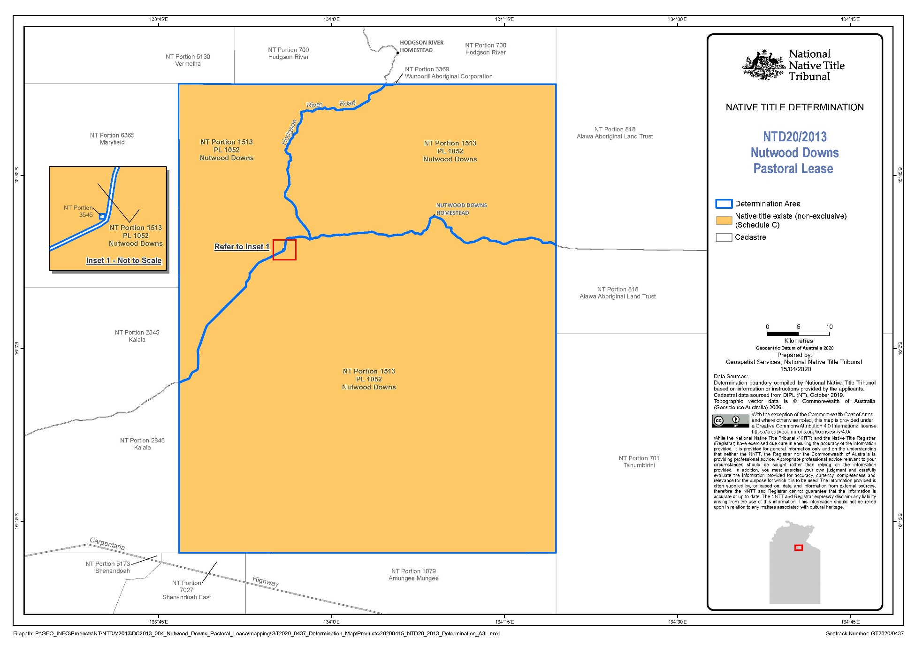

SCHEDULE C

Areas where native title exists

The areas of land and waters in respect of which the native title rights and interests in clauses 9 and 10 apply are:
1. NT portion 1513, being land the subject of Perpetual Pastoral Lease No. 1052, except those parts thereof referred to in Schedule D.

SCHEDULE D

Areas where native title does not exist

Native title rights and interests have been wholly extinguished in the following areas of land and waters:
1. Those parts of the Determination Area covered by public works as defined in s 253 of the Act (including adjacent land or waters as defined in s 251D of the Act) which were constructed, established or situated prior to 23 December 1996 or commenced to be constructed or established on or before that date, including but not limited to:
(a) public roads, whether rural roads, arterial roads or national highways;
(b) community and pastoral access roads which are not otherwise public roads;
(c) gravel pits adjacent to the roads referred to at paragraphs (a) and (b) hereof used to maintain those roads;
(d) access roads or tracks to the public works referred to in this clause;
(e) Government bores and associated infrastructure including bores used for the establishment, operation or maintenance of public and other roads;
(f) river and rain gauges;
(g) transmission and distribution water pipes and associated infrastructure;
(h) sewer pipes, sewer pump stations and associated infrastructure; and
(i) electricity transmission lines, towers, poles and associated infrastructure.

SCHEDULE E

Map of interests granted under the Mineral Titles Act 2010 (NT) and the Petroleum Act 1984 (NT)

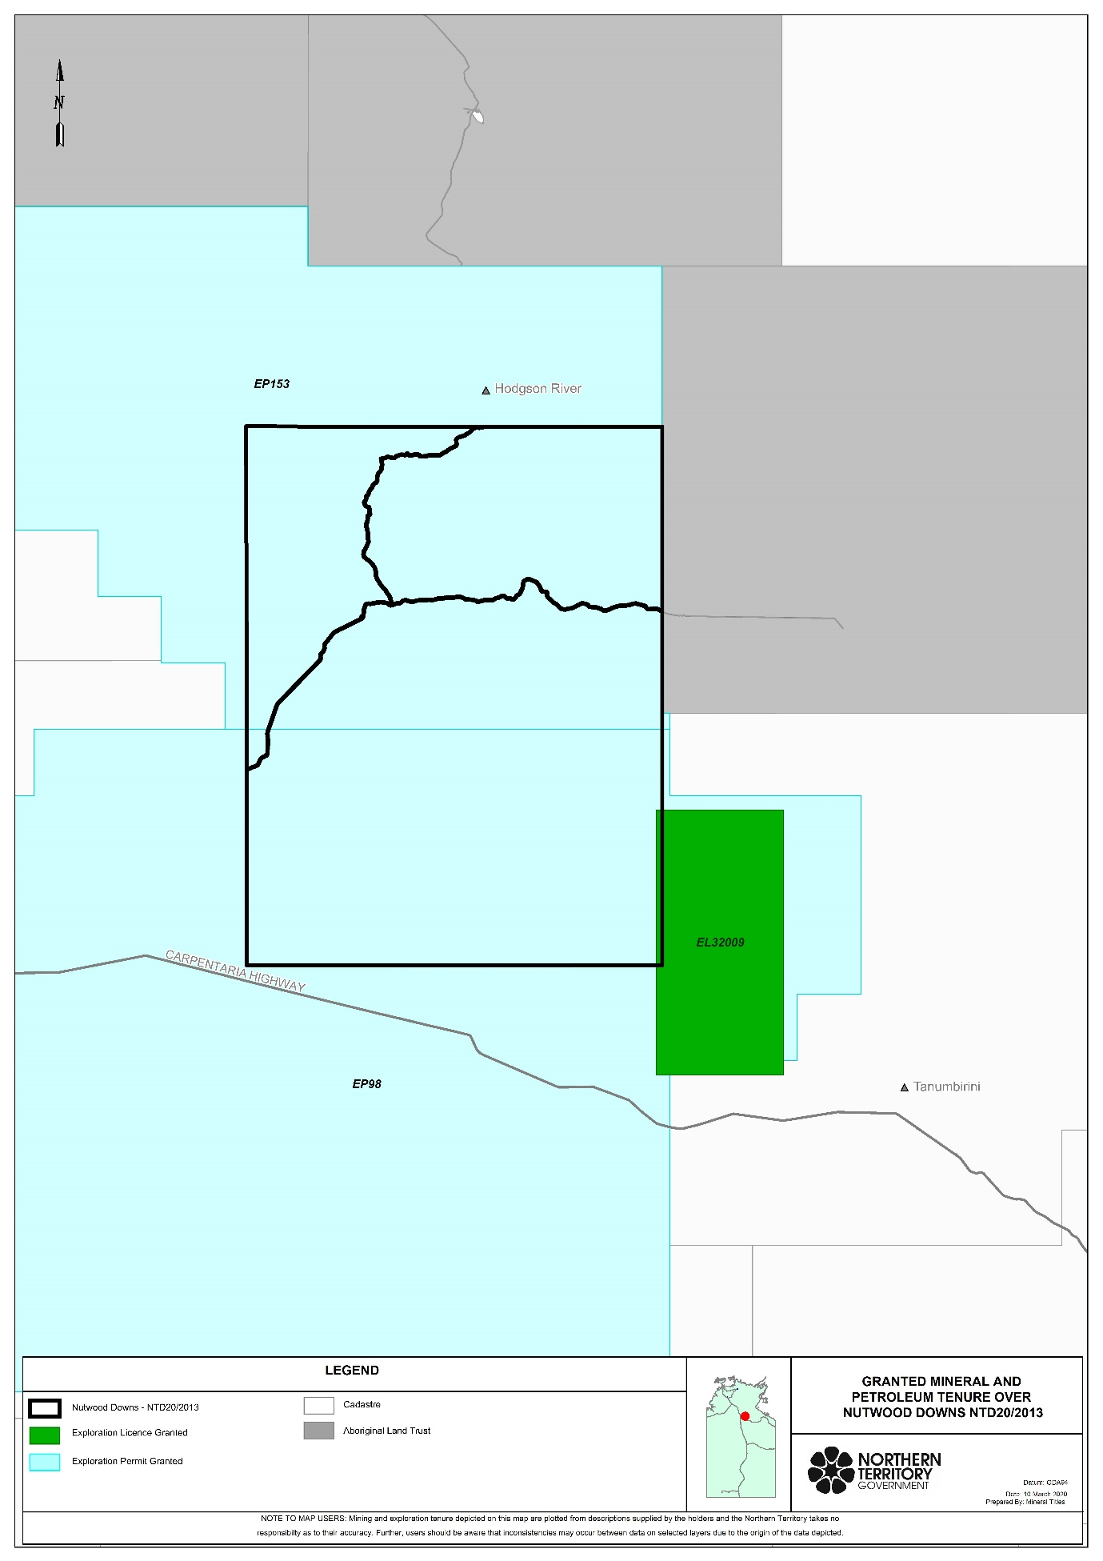

REASONS FOR JUDGMENT
WHITE J:
1 On 12 November 2013, the applicant applied for a determination of native title under the Native Title Act 1993 (Cth) (the Act) over the land and waters within the boundary of the Nutwood Downs Pastoral Lease, being Perpetual Pastoral Lease No. 1052, in the Northern Territory.
2 The application was filed on the same day as another application filed in respect of the land and waters over the adjacent Hodgson River Pastoral Lease, being Perpetual Pastoral Lease No. 1010, in the Northern Territory. The two applications have travelled together and have formed part of a group of applications known in the Court as the “Minyerri Subgroup”.
3 The parties in the Nutwood Downs application have now reached agreement and have applied, pursuant to s 87 of the Act, for a determination of native title by consent. Likewise, the parties in the Hodgson River application have reached agreement and also seek a determination of native title by consent. The hearing of the two applications are occurring simultaneously, but the Court will provide separate (albeit similar) judgments in respect of each.
4 The proposed determination area in the Nutwood Downs application is approximately 4,358 km² and comprises the whole of the area of the Nutwood Downs Pastoral Lease.
5 For the reasons which follow, I am satisfied that it is appropriate to make the determination sought by the parties.

The statutory provisions
6 Section 87 of the Act provides (relevantly):
87 Power of Federal Court if parties reach agreement
Application
(1) This section applies if, at any stage of proceedings after the end of the period specified in the notice given under section 66:
(a) agreement is reached between the parties on the terms of an order of the Federal Court in relation to:
(i) the proceedings; or
(ii) a part of the proceedings; or
(iii) a matter arising out of the proceedings; and
(b) the terms of the agreement, in writing signed by or on behalf of the parties, are filed with the Court; and
(c) the Court is satisfied that an order in, or consistent with, those terms would be within the power of the Court.
Power of Court
(1A) The Court may, if it appears to the Court to be appropriate to do so, act in accordance with:
(a) whichever of subsection (2) or (3) is relevant in the particular case; and
(b) if subsection (5) applies in the particular case—that subsection.
Agreement as to order
(2) If the agreement is on the terms of an order of the Court in relation to the proceedings, the Court may make an order in, or consistent with, those terms without holding a hearing or, if a hearing has started, without completing the hearing.
Note: If the application involves making a determination of native title, the Court’s order would need to comply with section 94A (which deals with the requirements of native title determination orders).
…

7 As is apparent, s 87 applies when the parties reach agreement in a proceeding, file the signed agreement with the Court and when the Court is satisfied that an order in, or consistent with the agreed terms, is within the Court’s power. The first two of those requirements are satisfied in the present case and I will return to the third.
8 Section 94A of the Act requires that an order of this Court by which a determination of native title is made must set out details of the matters mentioned in s 225. Section 225 provides:
225 Determination of native title
A determination of native title is a determination whether or not native title exists in relation to a particular area (the determination area) of land or waters and, if it does exist, a determination of:
(a) who the persons, or each group of persons, holding the common or group rights comprising the native title are; and
(b) the nature and extent of the native title rights and interests in relation to the determination area; and
(c) the nature and extent of any other interests in relation to the determination area; and
(d) the relationship between the rights and interests in paragraphs (b) and (c) (taking into account the effect of this Act); and
(e) to the extent that the land or waters in the determination area are not covered by a non-exclusive agricultural lease or a non-exclusive pastoral lease—whether the native title rights and interests confer possession, occupation, use and enjoyment of that land or waters on the native title holders to the exclusion of all others.
Note: The determination may deal with the matters in paragraphs (c) and (d) by referring to a particular kind or particular kinds of non-native title interests.

9 The expression “native title rights and interests” appearing in s 225(b) is defined in s 223(1) as follows:
223 Native title
Common law rights and interests
(1) The expression native title or native title rights and interests means the communal, group or individual rights and interests of Aboriginal peoples or Torres Strait Islanders in relation to land or waters, where:
(a) the rights and interests are possessed under the traditional laws acknowledged, and the traditional customs observed, by the Aboriginal peoples or Torres Strait Islanders; and
(b) the Aboriginal peoples or Torres Strait Islanders, by those laws and customs, have a connection with the land or waters; and
(c) the rights and interests are recognised by the common law of Australia.
Hunting, gathering and fishing covered
(2) Without limiting subsection (1), rights and interests in that subsection includes hunting, gathering, or fishing, rights and interests.

The Court’s power
10 The Court must have a valid application before it, which is the case presently.
11 The Court does have power to make a determination of native title, as sought by the parties. That power derives in particular from Pt 4 of the Act, which includes s 87. The exercise of that power is constrained in certain ways, including by s 94A referred to above.
12 There are no “disqualifying” circumstances impacting on the Court’s power to make the determination. It does not overlap the area of another application (s 67(1)) and no previous determination has been made in respect of the area covered by the Nutwood Downs Pastoral Lease (s 68).

The Court’s approach
13 Section 87(1A) requires the Court to be satisfied that it is appropriate to make the proposed determination.
14 In former times, the Court’s assessment of the appropriateness of the making of the orders required it to consider evidence bearing on that question. It is now accepted that the Court may proceed more flexibly. As is apparent, s 87(2) permits the Court to make the order by consent without conducting a hearing or receiving evidence. In King on behalf of the Eringa Native Title Claim Group v State of South Australia [2011] FCA 1386; (2011) 285 ALR 454, Keane CJ at [19], noted the permissible approach:
More recently, the Court has been prepared to rely upon the processes of the relevant State or Territory about the requirements of s 223 being met to be satisfied that the making of the agreed orders is appropriate. That is because each State and Territory has developed a protocol or procedure by which it determines whether native title (as defined in s 223) has been established. It acts in the public interest and as the public guardian in doing so. It has access to anthropological, and where appropriate, archaeological, historical and linguistic expertise. It has a legal team to manage and supervise the testing as to the existence of native title in the claimant group. Although the Court must, of course, preserve to itself the question whether it is satisfied that the proposed orders are appropriate in the circumstances of each particular application, generally the Court reaches the required satisfaction by reliance upon those processes. They are commonly explained in the joint submissions of the parties in support of the orders agreed …

15 The approach stated by Keane CJ has now been recognised and followed in numerous authorities.
16 Accordingly, when s 87 is invoked, the Court does not routinely embark on its own inquiry into the merits of the claim in order to be satisfied that the orders sought are supportable and in accordance with law. It places particular reliance on the agreement of the parties and on the discharge by the State or Territory concerned of its responsibility in assessing the application. The Court may, however, have regard to evidence for the more limited purpose of satisfying itself that a consenting State or Territory is acting in good faith and rationally – see King v State of SA at [21].
17 In considering, in the manner discussed in King v State of SA, whether it is appropriate to make an order in the terms agreed by the parties, the Court takes into account a number of matters. These include the fact that the determination made by the Court will bind the community generally and not just the parties to the proceeding: Munn for and on behalf of the Gunggari People v State of Queensland [2001] FCA 1229; (2001) 115 FCR 109 at [22]; Cox on behalf of the Yungngora People v State of Western Australia [2007] FCA 588 at [3]. As was noted by Mortimer J in Freddie v Northern Territory [2017] FCA 867 at [18], the nature of the rights conferred by the determination (being proprietary) indicate that clarity in the terms of the determination (as to the claim area, the nature of the native title rights and interests and the manner of affectation on other proprietary interests) is required as well as a need for appropriate notification, and for the consent of all parties to be free and informed. And, as indicated, while relying very much on the agreement of the State or Territory party, the Court considers whether there is a credible and rational basis for the determination proposed.

Consideration
18 The parties have provided considerable assistance to the Court to support a conclusion that the making of the determination is appropriate. They have provided a statement of facts agreed between the applicant and the Northern Territory, joint submissions by the applicant and the Northern Territory, witness statements from Ms Hodgson and Mr Fulton, a shortform anthropological report by Ms Gay English, and a more extensive anthropological report from Mr Jeffery Stead. Those materials amply demonstrate that, during the long period during which the proceedings have been on foot, the Territory has engaged in a careful assessment of the evidence in support of the application, including by obtaining its own anthropological assessment of the report provided by Mr Stead and Ms English. The materials also indicate that there is a sound rational basis for the Territory’s consent to the determination.
19 The second respondent has indicated that it does not dispute any of the facts agreed by the applicant and the Northern Territory.
20 I turn then to the matters which s 94A requires be included in the determination and, inferentially, about which the Court must be satisfied.
21 The meaning of the expression “native title rights and interests” used in s 225(b) was considered by the High Court in Members of the Yorta Yorta Aboriginal Community v State of Victoria [2002] HCA 58; (2002) 214 CLR 422. The authorities were also reviewed by Mansfield J in Risk v Northern Territory of Australia [2006] FCA 404 at [44]-[58] and it is not necessary to repeat that review presently. The native title rights and interests to be recognised in the proposed determination are of the kind discussed in these authorities.
22 Clauses 5-8 in the proposed determination identify the group of native title holders. These are the members of five estate groups associated with the Alawa language group, which is part of the Alawa/Ngandji wider regional cultural bloc. Unlike some determinations in which the native title holders are identified as the persons who are descendants, whether biologically or by adoption, of named apical ancestors, the determination recognises that the native title is held by the members of five estate groups and indicates that membership of an estate group is determined, directly or indirectly, by patrilineal descent or by adoption.
23 The materials indicate that the five estate groups are united in and by the body of laws and customs of the wider regional bloc; and that they held native title rights and interests at sovereignty (1825); and that they have continued to do so in the present time. They indicate in particular that a number of features of traditional society continue to operate today and that the estate groups continue to be connected to the land and waters which is the subject of the determination area. The native title rights and interest to be recognised in the determination are consistent with the rights and interests observed traditionally.
24 Four of the five estate groups have been recognised as traditional owners in land claims made under the Aboriginal Land Rights (Northern Territory) Act 1976 (Cth) in respect of nearby areas.
25 The particular country of each estate group is in largely different parts of the area of the Nutwood Downs Pastoral Lease.
26 The proposed determination sets out with particularity the area in which native title is being recognised (cll 1 and 2 and Schedules B and C).
27 The proposed determination identifies by character (rather than specific places or structures) the infrastructure and other public works in the determination area in respect of which it is agreed that native title rights and interests have been wholly extinguished (cl 3, Schedule D). The determination will provide for a liberty to apply to be exercised in the event of any dispute concerning the precise identification of the infrastructure or other works over which native title has been extinguished.
28 Clauses 9-13 identify the native title rights and interests, cl 14 identifies particular activities acknowledged to be permitted by the native title rights and interests, cl 15 identifies the nature and extent of other interests in relation to the determination area and cl 16 provides for the relationship between the other interests and the determined native title rights and interests.
29 Orders 2 and 3 indicate that the native title is not to be held on trust and that the Top End (Default PBC/CLA) Aboriginal Corporation is to be appointed as the prescribed body corporate for the purposes of s 57(2) of the Act.

General
30 All parties have had the opportunity to obtain independent legal advice. There is no reason for the Court to suppose that a lack of legal representation has caused disadvantage to any party.
31 It is an evident policy in the Act that parties to native title claims are encouraged to reach agreement on applications for native title. Sections 87 and 87A are themselves an indication that that is so by providing the means by which determinations may be made to give effect to their agreements.
32 The matters which I have reviewed above indicate that in this case it is appropriate to give effect to the parties’ agreement. It is important to note that, in doing so, the Court does not grant native title. The Court’s order will instead be a formal recognition that the native title rights and interests of the estate groups exist, and have always existed, at least since European settlement.
33 For these reasons, I make orders in the terms proposed by the parties.
I certify that the preceding thirty-three (33) numbered paragraphs are a true copy of the Reasons for Judgment of the Honourable Justice White.

Associate:

Dated: 9 September 2020

