FEDERAL COURT OF AUSTRALIA

McNamara on behalf of the Gawler Ranges People v State of South Australia [2011] FCA 1471

|  |  |  |
| --- | --- | --- |
| Citation: | | McNamara on behalf of the Gawler Ranges People v State of South Australia [2011] FCA 1471 |
|  | |  |
| Parties: | | **ELLIOTT LANCELOT MCNAMARA, KENNETH HARRY SMITH, HOWARD RICHARDS, ANDREW DINGAMAN ON BEHALF OF THE GAWLER RANGES PEOPLE v THE STATE OF SOUTH AUSTRALIA AND OTHERS** |
|  | |  |
| File number: | |  |
|  | |  |
| Judge: | |  |
|  | |  |
| Date of judgment: | | 19 December 2011 |
|  | |  |
| Catchwords: | | **NATIVE TITLE** – consent determination – resolution by agreement of claims for determination of native title |
|  | |  |
| Legislation: | | *Native Title Act 1993* (Cth)  *Aboriginal Heritage Act 1988* (SA) |
|  | |  |
| Cases cited: | | *Munn (for and on behalf of the Guggari People) v The State of Queensland* (2001) 115 FCR 109 cited  *King on behalf of the Eringa Native Title Claim Group v State of South Australia* [2011] FCA 1386 cited  *Cox on behalf of the Yungngora People v State of Western Australia* [2007] FCA 588 cited  *Smith v State of Western Australia* (2000) 104 FCR 494  *Members of the* *Yorta Yorta Aboriginal Community v Victoria* (2002) 214 CLR 422 cited  *Risk v Northern Territory* [2006] FCA 404 cited  *Western Australia v Ward* (2002) 213 CLR 1 cited  *De Rose v State of South Australia (No 2)* (2005) 145 FCR 290 cited |
|  |  | |
| Date of hearing: | 19 December 2011 | |
|  |  | |
| Date of last submissions: | 8 December 2011 | |
|  |  | |
| Place: | Paney | |
|  |  | |
| Division: |  | |
|  |  | |
| Category: | Catchwords | |
|  |  | |
| Number of paragraphs: | 93 | |
|  |  | |
| Counsel for the Applicants and South Australian Native Title Services: | A Beckworth and O Linde | |
|  |  | |
| Solicitor for the Applicants and South Australian Native Title Services: | South Australian Native Title Services Ltd | |
|  |  | |
| Counsel for the State of South Australia: | The Hon John Hill MP, Acting Attorney-General | |
|  |  | |
| Solicitor for State of South Australia: | Crown Solicitor’s Office | |
|  |  | |
| Counsel for the Commonwealth of Australia: | V Vuksan | |
|  |  | |
| Solicitor for the Commonwealth of Australia: | Australian Government Solicitor | |
|  |  | |
| Counsel for SA Farmers Federation Grouped Pastoralists: | K Scott | |
|  |  | |
| Solicitor for SA Farmers Federation Grouped Pastoralists: | Piper Alderman | |
|  |  | |
| Counsel for Iron Clad Mining: | E Olekains | |
|  |  | |
| Solicitor for Iron Clad Mining: | Hunt and Hunt | |

|  |  |
| --- | --- |
| IN THE FEDERAL COURT OF AUSTRALIA |  |
| SOUTH AUSTRALIA DISTRICT REGISTRY |  |
| GENERAL DIVISION | SAD 6020 of 1998 |

|  |  |
| --- | --- |
| BETWEEN: | ELLIOTT LANCELOT MCNAMARA, KENNETH HARRY SMITH, HOWARD RICHARDS, ANDREW DINGAMAN ON BEHALF OF THE GAWLER RANGES PEOPLE  Applicants |
| AND: | THE STATE OF SOUTH AUSTRALIA AND OTHERS  Respondents |

|  |  |
| --- | --- |
| JUDGE: | MANSFIELD J |
| DATE OF ORDER: | 19 DECEMBER 2011 |
| WHERE MADE: | PANEY |

**THE COURT NOTES THAT:**

A The Applicant first lodged Native Title Determination Application No. SAD 6020 of 1998 (the Application) with the National Native Title Tribunal on 12 September 1997 in relation to lands and waters in the Gawler Ranges area of South Australia which are now the subject of a proposed determination of native title. The Application was referred to the Federal Court of Australia on 30 September 1998.

B The Applicant, the State of South Australia and the other respondents have reached an agreement as to the terms of a determination of native title to be made in relation to the land and waters covered by the Application. They have filed with this Court pursuant to s 87(2) of the *Native Title Act 1993* (Cth) (the NT Act) an agreement in writing to seek the making of Consent Orders for a determination.

C The State of South Australia asserts that the Vesting (as defined in paragraph 1(b)) in the Crown of those parts of the Determination Area listed in Schedule 4 (the Schedule 4 Areas) means that the exercise of all native title rights and interests in relation to those areas (whether exclusive or non-exclusive) was suppressed at the date of the Vesting, pursuant to the non-extinguishment principle established by the NT Act. Accordingly, all native title rights and interests in the Schedule 4 Areas remain suppressed for as long as those areas remain vested in the Crown under the *National Parks and Wildlife Act 1972* (the NPWA) or other relevant State legislation.

D The Applicants assert with regard to the Schedule 4 Areas that some native title rights are not suppressed by the Vesting but acknowledge the operation of the non-extinguishment principle provided for in the NT Act.

E The Parties have agreed to the following orders in relation to the native title rights and interests, reflecting (insofar as those orders relate to the Schedule 4 Areas) a compromise of the issue addressed in Recitals C and D.

F The Parties acknowledge that the effect of the making of the Determination will be that the Gawler Ranges people, in accordance with the traditional laws acknowledged and the traditional customs observed by them, will be recognised as the native title holders for the Determination Area as defined by paragraph 2 of this Order.

G The Parties have requested that the Court determine the proceedings without a trial.

Being satisfied that a Determination in the terms sought by the Parties would be within the power of the Court and it appearing to the Court appropriate to do so and by the consent of the Parties:

**THE COURT ORDERS, DECLARES AND DETERMINES BY CONSENT THAT:**

**Interpretation & Declaration**

1. In this Determination, including its schedules:

(a) unless the contrary intention appears, the words and expressions used have the same meaning as they are given in Part 15 of the NT Act;

(b) “the Vesting” means the vesting of a Park or Reserve in the Crown pursuant to the NPWA as listed in Schedule 4; and

(c) in the event of an inconsistency between a description of an area and the depiction of that area on a map, the written description shall prevail.

2. Native title exists in the areas described in Schedule 1 but does not exist in those areas described in paragraphs 9, 11, 12, and 14 (the Determination Area).

**Native Title Holders**

3. Under the relevant traditional laws and customs of the Gawler Ranges People, the native title holders comprise those living Aboriginal people who have recognised filial links either through birth or adoption to:

(a) one or more of the following Gawler Ranges antecedents:

* Harry Croft
* Phyllis Hart
* Victor McNamara
* Jean Glennie
* Mary Glennie
* Bill Wingfield
* Archie Yalatu
* Eva Reagan
* Harry Dare
* Archie Eyles
* Bert Eyles
* Percy Davis
* Dolly Eyles
* Dick Thomas
* Winnie Watson
* Ada Eyles
* George Reid
* Mick Reid
* Susie Captain
* Hilda Captain
* William Smith
* Molly Clawton
* Harry Peel
* Rose O’Loughlin
* Frank Dunnett
* Elizabeth Eyles
* Fred Richards
* Emma McNamara
* Hilda Richards
* Roy Ernest Wilson
* Elizabeth Miller
* George Turner; or

(b) any other person acknowledged by the Native Title Holders as a Gawler Ranges antecedent where it can be demonstrated that the antecedent:

(i) gained his or her knowledge of Gawler Ranges law and custom in accordance with traditional law and custom from a recognised and authoritative Gawler Ranges person; or

(ii) was a long term resident of the Gawler Ranges; and

(iii) maintained relations with other members of the Gawler Ranges society in accordance with the traditional laws and customs of the Gawler Ranges people;

AND

who are recognised by other Native Title Holders under the relevant traditional laws and customs of the Gawler Ranges people as having activated their membership rights and therefore as holding Native Title rights and interests in the Determination Area.

**Rights And Interests**

4. Subject to paragraphs 5, 6 & 7, the nature and extent of the native title rights and interests of the Gawler Ranges People in relation to the Determination Area are non-exclusive rights to use and enjoy in accordance with their traditional laws and customs the land and waters of the Determination Area, being:

(a) the right to access and move about the Determination Area;

(b) the right to live, to camp and, for the purpose of exercising their native title rights and interests, to erect shelters and other structures on the Determination Area;

(c) the right to hunt in the Determination Area;

(d) the right to gather and use the natural resources of the Determination Area such as food, medicinal plants, wild tobacco, timber, resin, ochre and feathers;

(e) the right to share and exchange the subsistence and other traditional resources of the Determination Area;

(f) the right to use the natural water resources of the Determination Area;

(g) the right to cook on the Determination Area and to light fires for domestic purposes but not for the clearance of vegetation;

(h) the right to engage and participate in cultural activities on the Determination Area including those relating to births and deaths;

(i) the right to conduct ceremonies and hold meetings on the Determination Area;

(j) the right to teach on the Determination Area the physical and spiritual attributes of locations and sites within the Determination Area;

(k) the right to visit, maintain and protect sites and places of cultural and religious significance to Native Title Holders under their traditional laws and customs on the Determination Area;

(l) the right to be accompanied on to the Determination Area by those people who, though not Native Title Holders, are:

(i) spouses of native title holders; or

(ii) people required by traditional law and custom for the performance of ceremonies or cultural activities on the Determination Area; or

1. people who have rights in relation to the Determination Area according to the traditional laws and customs acknowledged by the native title holders;

**General Limitations**

5. The native title rights and interests are for personal, domestic and communal use but do not include commercial use of the Determination Area or the resources from it.

6. The native title rights and interests described in paragraph 4 do not confer possession, occupation, use and enjoyment of the Determination Area on the Native Title Holders to the exclusion of others.

7. Native title rights and interests are subject to and exercisable in accordance with:

(a) the traditional laws and customs of the native title holders;

(b) the valid laws of the State and Commonwealth, including the common law.

For the avoidance of doubt, the native title interest expressed in paragraph 4(f) (the right to use the natural water resources of the Determination Area) is subject to the *Natural Resources Management Act* *2004* (SA).

8. Native title does not exist in the areas and resources described in paragraphs 9, 11, 12 and 14 herein.

9. Native title rights and interests do not exist in respect of those parts of the Determination Area being any house, shed or other building or airstrip or any dam or other stock watering point constructed pursuant to the pastoral leases referred to in paragraph 15(a) below constructed prior to the date of this determination. These areas include any adjacent land or waters the exclusive use of which is necessary for the enjoyment of the improvements referred to.

10. To be clear, paragraph 9 does not preclude the possibility of further extinguishment, according to law, of native title over other limited parts of the Determination Area by reason of the construction of new pastoral improvements of the kind referred to in paragraph 9 after the date of this determination.

11. Native title rights and interests do not exist in:

(a) Minerals, as defined in s 6 of the *Mining Act 1971* (SA); or

(b) Petroleum, as defined in s 4 of the *Petroleum and Geothermal Energy Act 2000* (SA); or

(c) a naturally occurring underground accumulation of a regulated substance as defined in s 4 of the *Petroleum and Geothermal Energy Act 2000* (SA), below a depth of 100 metres from the surface of the earth; or

(d) a natural reservoir, as defined in s 4 of the *Petroleum and Geothermal Energy Act 2000* (SA), below a depth of 100 metres from the surface of the earth; or

(e) geothermal energy, as defined in s 4 of the *Petroleum and Geothermal Energy Act 2000* (SA) the source of which is below a depth of 100 metres from the surface of the earth.

For the purposes of this paragraph 11 and the avoidance of doubt:

(i) a geological structure (in whole or in part) on or at the earth's surface or a natural cavity which can be accessed or entered by a person through a natural opening in the earth's surface, is not a natural reservoir;

(ii) thermal energy contained in a hot or natural spring is not geothermal energy as defined in s 4 of the *Petroleum and Geothermal Energy Act 2000* (SA);

(iii) the absence from this order of any reference to a natural reservoir or a naturally occurring accumulation of a regulated substance, as those terms are defined in s 4 of the *Petroleum and Geothermal Energy Act 2000* (SA), above a depth of 100 metres below the surface of the earth or geothermal energy the source of which is above a depth of 100 metres below the surface of the earth is not, of itself, to be taken as an indication of the existence or otherwise of native title rights or interests in such natural reservoir, naturally occurring accumulation of a regulated substance or geothermal energy.

12. Native title rights do not exist in the areas covered by Public Works (including the land defined in s 251D of the NT Act) which were constructed, established or situated prior to 23 December 1996 or commenced to be constructed or established on or before that date.

13. Public Works constructed, established or situated after 23 December 1996 have had such effect as has resulted from Part 2, Division 3, of the Native Title Act or as agreed pursuant to the terms of the Gawler Ranges Native Title Claim Settlement ILUA as described in Schedule 7.

14. Those areas described in Schedule 3 have been excluded from the Determination Area because native title has been extinguished over them.

**Other Interests & Relationship with Native Title**

15. The nature and extent of other interests in the Determination Area are:

(a) the interests within the Determination Area created by the following pastoral leases:

| **Lease name** | **Pastoral Lease No** | **Crown Lease** |
| --- | --- | --- |
| Beacon Hill | PE 2170 | Volume 1205 Folio 3 |
| Buckleboo | PE 2286 | Volume 1290 Folio 42 |
| Bungeroo | PE 2168 | Volume 1196 Folio 14 |
| Coondambo | PE 2349 | Volume 1284 Folio 10 |
| Hiltaba | PE 2301 | Volume 1289 Folio 14 |
| Kokatha | PE 2355 | Volume 1292 Folio 32 |
| Kolendo | PE 2323 | Volume 1290 Folio 23 |
| Kondoolka | PE 2313 | Volume1290 Folio 33 |
| Koweridda | PE 2330B | Volume 1311 Folio 34 |
| Lake Everard | PE 2393 | Volume 1310 Folio 48 |
| Lockes Claypan | PE 2530 | Volume 1610 Folio 47 |
| Mahanewo | PE 2351 | Volume 1292 Folio 43 |
| Mahanewo South | PE 2177 | Volume 1213 Folio 44 |
| Moonaree | PE 2329 | Volume 1298 Folio 26 |
| Mount Ive | PE 2289 | Volume 1286 Folio 9 |
| Nonning | PE 2328 | Volume 1298 Folio 25 |
| Part Hiltaba | PE 2294 | Volume 1287 Folio 12 |
| Part Thurlga | PE 2305 | Volume 1609 Folio 55 |
| Pinjarra | PE 2196 | Volume 1266 Folio 14 |
| Siam | PE 2254 | Volume 1287 Folio 8 |
| Siam North | PE 2423A | Volume 1433 Folio 2 |
| Thurlga | PE 2305B | Volume 1609 Folio 56 |
| Unalla | PE 2330 | Volume 1311 Folio 32 |
| Uno | PE 2314 | Volume 1290 Folio 4 |
| Wilgena | PE 2364 | Volume 1298 Folio 30 |
| Wirraminna | PE 2348 | Volume 1293 Folio 46 |
| Wirraminna South | PE 2155 | Volume 1165 Folio 13 |
| Yardea | PE 2330A | Volume 1311 Folio 33 |
| Yarna | PE 2253 | Volume 1287 Folio 25 |
| Yeltana | PE 2529 | Volume 1608 Folio 35 |

(b) the interests of the Crown in right of the State of South Australia;

(c) In relation to those Reserves set out in Schedule 5:

(i) The rights and interests of the Crown of South Australia pursuant to the *National Parks and Wildlife Act 1972* (SA); and

(ii) The rights and interests of the public to use and enjoy those Reserves consistent with the *National Parks and Wildlife Act 1972* (SA).

(d) the interests of persons to whom valid or validated rights and interests have been granted or recognised by the Crown in right of the State of South Australia or by the Commonwealth of Australia pursuant to statute or otherwise in the exercise of executive power including, but not limited to, rights and interests granted or recognised pursuant to the *Crown Land Management Act 2009* (SA), *Crown Lands Act 1929* (SA), *Mining Act 1971* (SA), *Petroleum and Geothermal Energy Act 2000* (SA) and *Opal Mining Act 1995* (SA), all as amended from time to time;

(e) rights or interests held by reason of the force and operation of the laws of the State or of the Commonwealth;

(f) the rights to access land by an employee or agent or instrumentality of the State, Commonwealth or other statutory authority as required in the performance of his or her statutory or common law duties where such access would be permitted to private land;

(g) the rights and interests of all parties to the Indigenous Land Use Agreements listed in Schedule 7 arising by reason of those agreements;

(h) the rights and interests of Telstra Corporation Limited (or its corporate successor):

(i) as the owner or operator of telecommunications facilities within the Determination Area;

(ii) created pursuant to the *Post and Telegraph Act 1901* (Cth), the *Telecommunications Act 1975* (Cth), the *Australian Telecommunications Corporation Act 1989* (Cth), the *Telecommunications Act 1991* (Cth) and the T*elecommunications Act 1997* (Cth) including rights:

(1) to inspect land;

(2) to install and operate telecommunication facilities;

(3) to alter, remove, replace, maintain, repair and ensure the proper functioning of its telecommunications facilities; and

(4) for its employees, agents or contractors to access its telecommunications facilities in and in the vicinity of the Determination Area in performance of their duties:

(iii) under or arising from s 18 of the *Crown Land Management Act 2009* (SA) or under s 5 of the *Crown Lands Act 1929* (SA) in respect of the following areas under Telstra’s care, control and management:

(1) Section 1568, Out of Hundreds (Childara) (Waverley DRCS)

(iv) under any lease, licence, access agreement or easement relating to its telecommunications facilities in the Determination Area;

(i) the Commonwealth rights and interests in the Woomera Prohibited Area, being:

(i) the rights and interests authorised under regulation 34 of the Defence Force Regulations 1952 on 22 May 2007, by the Minister for Defence, to enter upon, and the use on behalf of the Commonwealth of, the area of land situated in the State of South Australia and delineated on the plan numbered GP 249/1989 deposited in the General Registry Office at Adelaide, South Australia, for the purpose of carrying out operations for the testing of war material; and

(ii) the rights and interests of the Commonwealth in the area, being all that piece of land situate in the State of South Australia and delineated on the plan deposited in the General Registry Office at Adelaide and numbered GP 249/1989, declared as a prohibited area under regulation 35 of the Defence Force Regulations 1952 on 29 June 1989 by the Minister for Defence Science and Personnel (Commonwealth of Australia Gazette No GN 26, 12 July 1989, 1564).

(j) the rights, interests and entitlements of ETSA Utilities (a partnership of Spark Infrastructure SA (No.1) Pty Ltd, Spark Infrastructure SA (No.2) Pty Ltd, Spark Infrastructure SA (No.3) Pty Ltd, CKI Utilities Development Limited and HEI Utilities Development Limited) and its related and successor entities, including its rights, interests and entitlements:

(i) to exercise its entitlements and discharge its obligations as the owner and/or operator of electricity infrastructure (as defined in the *Electricity Act 1996* (SA) (Electricity Act) and telecommunications facilities and infrastructure within the Determination Area (Existing Infrastructure);

(ii) to exercise its entitlements and discharge its obligations as the holder of a licence under the Electricity Act and/or as an electricity entity under the Electricity Act;

(iii) to exercise its entitlements and discharge its obligations as the holder of a carrier licence under the *Telecommunications Act 1997* (Cth);

(iv) to install new electricity and telecommunications infrastructure within the Determination Area (New Infrastructure) and modify, maintain and repair Existing Infrastructure;

(v) under easements, leases or licences (whether registered, unregistered, statutory or otherwise) relating to Existing Infrastructure or New Infrastructure within the Determination Area (Easements);

(vi) to provide its employees, agents or contractors with access to Existing Infrastructure, New Infrastructure and the Easements within the Determination Area; and

(vii) to the extent permitted by law, to restrain any person from performing any act, or compel any person to perform any act, for the purposes of ensuring that ETSA Utilities complies with its obligations under any law, including, but not limited to, excluding any person from entering an area containing Existing Infrastructure or New Infrastructure for the purposes of maintaining the safety of any person and the security and protection of such infrastructure;

(k) the rights and interests created by Crown Lease Miscellaneous No. 20983 for tourism purposes Volume 1640 Folio 67.

16. The relationship between the native title rights and interests in the Determination Area that are described in paragraph 4 and the other rights and interests described in paragraph 15 (the Other Interests) is that:

(a) to the extent that any of the Other Interests are inconsistent with the continued existence, enjoyment or exercise of the native title rights and interests, the native title rights and interests continue to exist in their entirety, but the native title rights and interests have no effect in relation to the Other Interests to the extent of the inconsistency during the currency of the Other Interests; and otherwise,

(b) the existence and exercise of the native title rights and interests do not prevent the doing of any activity required or permitted to be done by or under the Other Interests, and the Other Interests, and the doing of any activity required or permitted to be done by or under the Other Interests, prevail over the native title rights and interests and any exercise of the native title rights and interests, but, subject to any application of s 24 IB or s 24JA of the NT Act, do not extinguish them;

(c) in the Schedule 4 Areas, the native title rights and interests continue to exist but have no effect in relation to the Vesting.

(d) the native title is subject to extinguishment by:

(i) the lawful powers of the Commonwealth and of the State of South Australia; and/or

(ii) the lawful grant or creation of interests pursuant to the Laws of the Commonwealth and the State of South Australia.

**AND THE COURT MAKES THE FOLLOWING FURTHER ORDERS:**

17. The native title is not to be held in trust.

18. The Gawler Ranges (Aboriginal Corporation), is to:

(a) be the prescribed body corporate for the purposes of s 57(2) of the NT Act; and

(b) perform the functions mentioned in s 57(3) of the NT Act after becoming a registered native title body corporate.

19. The parties have liberty to apply on 14 days notice to a single judge of the Court for the following purposes:

(a) to establish the precise location and boundaries of any public works and adjacent land and waters referred to in paragraphs 12 and 13 of this Order;

(b) to determine the effect on native title rights and interests of any public works as referred to in paragraph 13 of this Order; or

(c) to determine whether a particular area is included in the description in paragraph 9 of this Order.

Note: Entry of orders is dealt with in Rule 39.32 of the Federal Court Rules 2011.

**Schedules**

**SCHEDULE 1 – Location of and areas comprising the Determination Area**

The Determination Area is located wholly within and comprises all land and waters bounded by the following line with the exception of those areas described in paragraphs 9, 11, 12 and Schedule 3.

**External Boundary Description:**

Commencing at a point on the northern boundary of Allotment 100 DP 67929 [Yellabinna Regional Reserve], being its intersection with south-easternmost corner of Block 1117 OH(Tarcoola) [Malbooma Pastoral Lease]. Generally north easterly along the said eastern boundary of the Block 1117 OH(Tarcoola) and eastern boundaries of Section 1218 OH(Tarcoola) to its intersection with the southern boundary of Section 173 OH(Tarcoola) [Trans Australian Railway].

Generally north-easterly, south-easterly, north-easterly and south-easterly along the said southern boundary of Section 173 OH(Tarcoola), Section 172 OH(Tarcoola), Allotment 54 FP217137, Section 170 OH(Kingoonya) and Section 169 OH(Kingoonya) [being also the southern boundary of the Trans Australian Railway] to the south eastern corner of the said Section 169, thence northerly along the eastern boundary of Section 169 and western boundary of Block 864 OH(Kingoonya) to its intersection with the southern boundary of Block 850 OH(Kingoonya).

Thence easterly and northerly along the southern boundaries of said Block 850 OH(Kingoonya) [Bon Bon Pastoral Lease] and Block 300 OH(Kingoonya), [Mt Vivian Pastoral Lease], to the intersection with an eastern boundary of Block 864 OH(Kingoonya) [Coondambo Pastoral Lease]. Thence southerly and easterly along an eastern and northern boundaries of the said Block 864 to a point on said boundary 5 kilometres west of the northwestern corner of the Block 857 OH(Kingoonya).

General south easterly through the points defined by the following latitude and longitude values – 136.0055186 East, 30.944618 South; 136.081614 East, 31.020656 South; 136.101435 East, 31.12314 South; 136.124559 East, 31.222319 South; 136.14438 East, 31.281826 South; 136.1642 East, 31.354557 South; 136.243483 East, 31.562832 South; 136.273216 East, 31.688459 South; 136.312856 East, -31.860368 South; 136.362408; East, 32.019054 South; 136.405353 East, 32.071949 South; 136.484636 East, 32.111621 South; 136.600258 East, 32.147986 South; thence south-easterly to its intersection with the northern boundary of Block 1223 OH(Port Augusta) [Siam North Pastoral Lease] approximately 2.5 kilometres from the northwesternmost corner of the said Block 1223.

Generally easterly, south-easterly and southerly along the northern and eastern boundaries of the said Block 1223, Block 820 OH(Port Augusta) [Siam Pastoral Lease], and Block 814 OH(Port Augusta) [Uno Pastoral Lease] to its intersection with the northern shoreline of Lake Gilles. Generally north-easterly, south easterly and south-westerly along the northern and eastern shorelines of Lakes Gilles to its intersection with the southern boundary of the aforesaid Block 814. Generally westerly, northerly and north-westerly along the southern and western boundaries of the said Block 814 to its intersection with the production north-easterly of the southern boundary of Section 18 Hundred of Cunyarie. Generally westerly along the southern boundaries of Sections 18, 17, 16, 13, 12, 11, 10 and 9, Hundred of Cunyarie, northerly along the western boundaries of Section 9, 8 and 1 Hundred of Cunyarie to the north western corner of said Section 1.

Thence north-westerly across the road to the south eastern corner of Block 955A OH(Yardea) [Bungeroo Pastoral Lease]. Thence westerly along the southern boundary of the said Block 955A and Block 265 OH(Yardea) [Buckleboo Pastoral Lease] to its intersection with the production northerly of the eastern boundary of Section 112, Hundred of Buckleboo. Southerly along the eastern boundaries of Sections 112 and 113 Hundred of Buckleboo, thence generally westerly along the southern boundaries of Sections 113, 114, 115, 116, 117 and 148 Hundred of Buckleboo, Section 241 Hundred of Corrabinnie and Block 1256 OH(Yardea) and Allotment 501 DP59476 [Gawler Ranges Nation Park] to its intersection with the north-eastern corner of the Hundred of Pinbong.

Northerly and north-westerly through the points defined by the following latitude and longitude values – 135.481328 East 32.703562 South; 135.455594 East 32.688612 South; 135.454992 East 32.6820672 South; 135.451719 East 32.681720 South; 135.402714 East 32.654851 South; 135.400475 East 32.654249 South and 135.392035 East 32.648909 South, then to its intersection with the north-eastern corner of Section 82 OH(Yardea). North–westerly along the north-eastern boundary of the said Section 82 to its intersection with the south eastern corner of Piece 7 DP56946, thence northerly, north westerly, south-westerly and westerly along the eastern, northern, western and southern boundaries of pieces 7, 6, 8, 9 and 1 DP56946. Northerly along the western boundary of the said Piece 1 DP56946 for a distance of approximately 3.4 kilometres, thence north westerly to its intersection with the north-eastern corner of Section 1, Hundred of Bockelberg. Westerly along the northern boundary of the said Section 1 to its intersection with the western boundary of Block 638A OH(Yardea) thence northerly to the north western corner of the said Block 638A.

North-westerly though Section 2 & 56 OH(Streaky Bay) and across road to the north-easternmost corner of northern portion of Section 741 OH(Streaky Bay), thence westerly along the northern boundary of the said Section 741 to its intersection with the north-eastern boundary of Section 125 OH(Streaky Bay). Thence north-westerly, south westerly and southerly along the north-eastern, north-western and western boundaries of the said Section 125 to its intersection with the north-eastern corner of Allotment 11 DP35936 [Pureba Conservation Park]. Generally north-westerly northerly and north easterly along the eastern and north eastern boundaries of Allotments 11 & 10 DP35936 and allotment 400 DP25122 [Pureba Conservation Park], and Allotment 100 DP67929 [Yellabinna Regional Reserve] to the point of commencement.

**SCHEDULE 2 – Maps of the Determination Area**

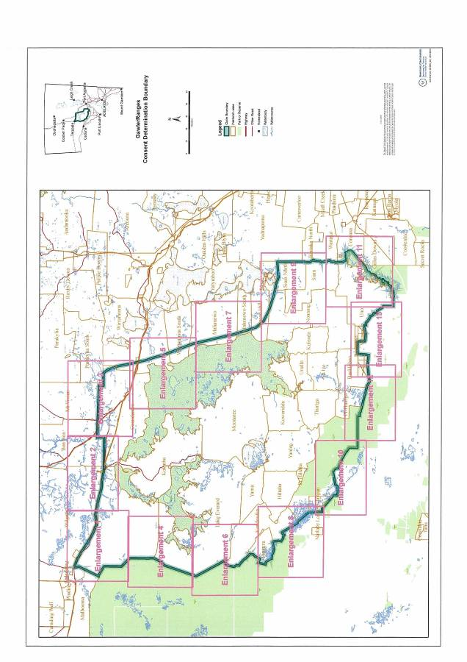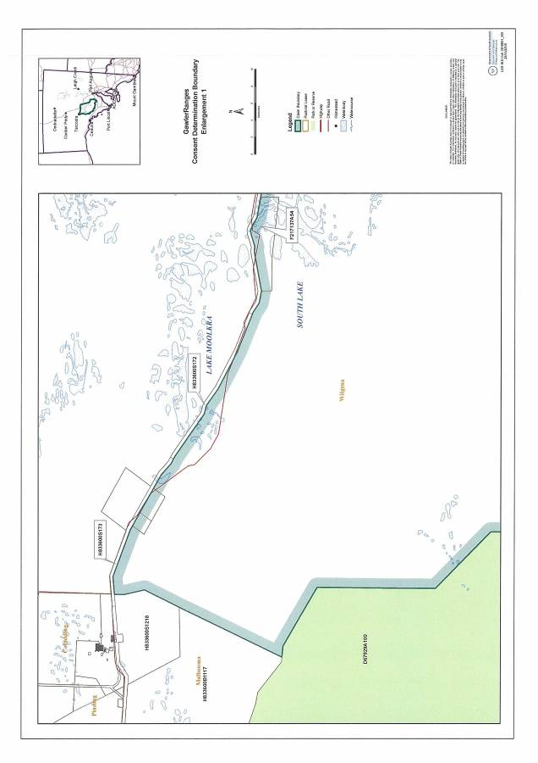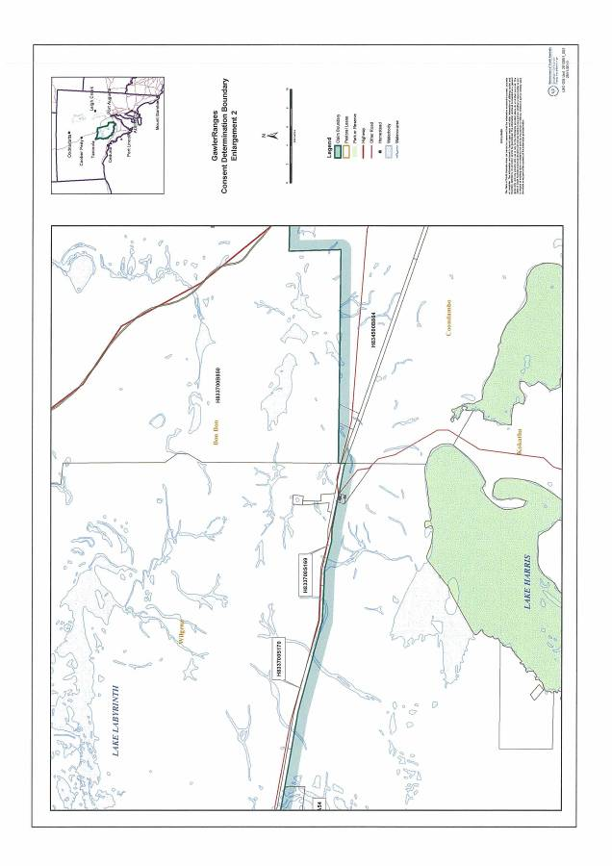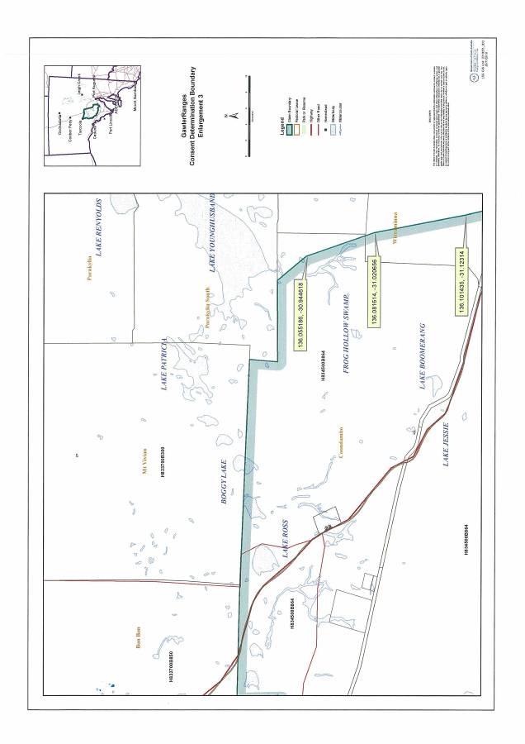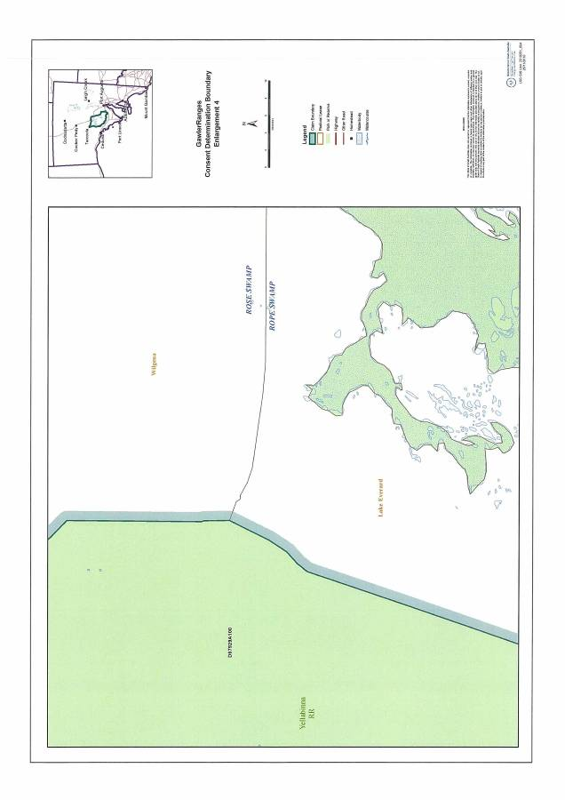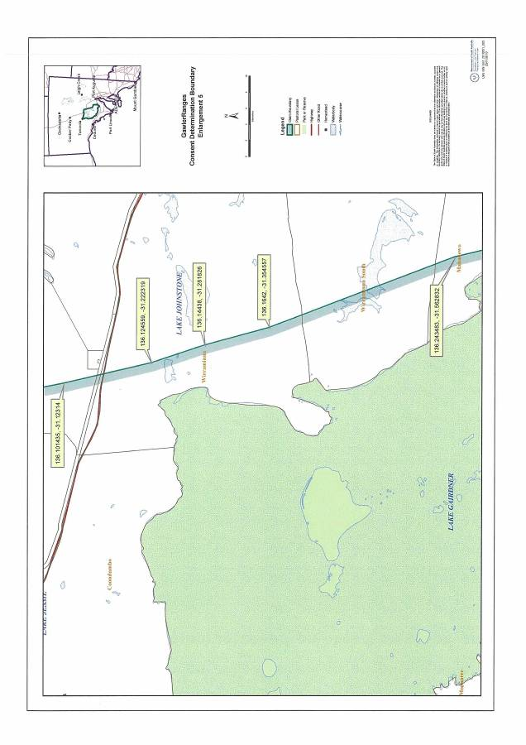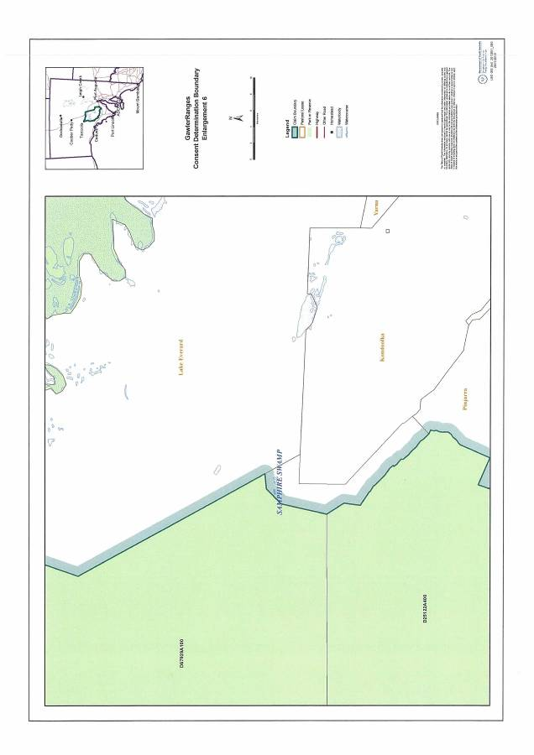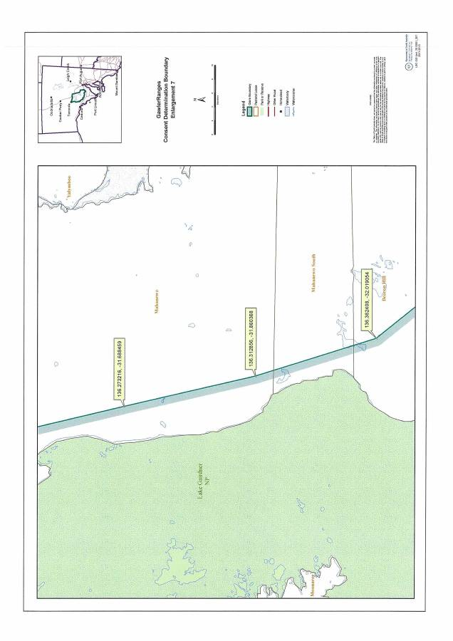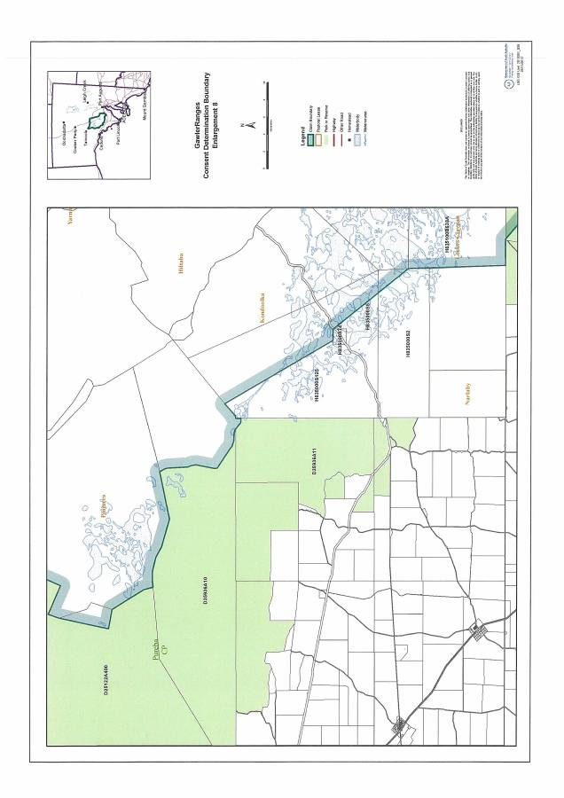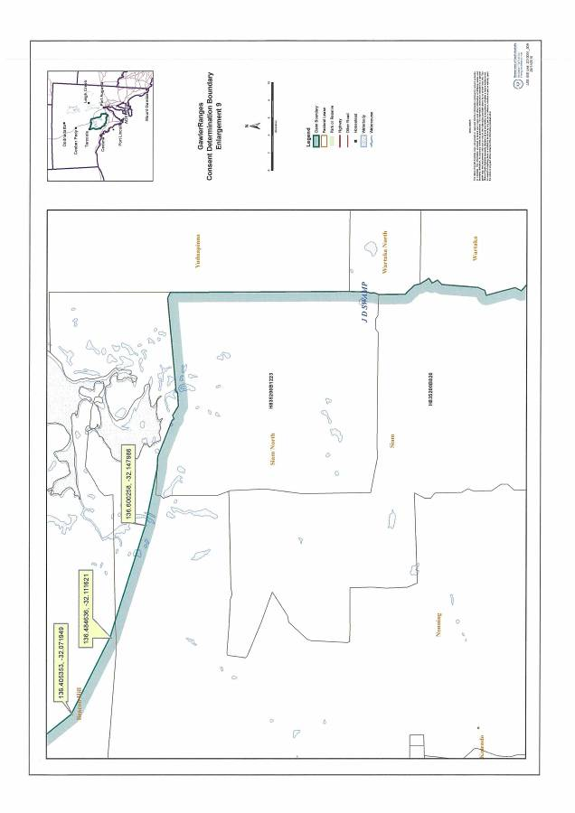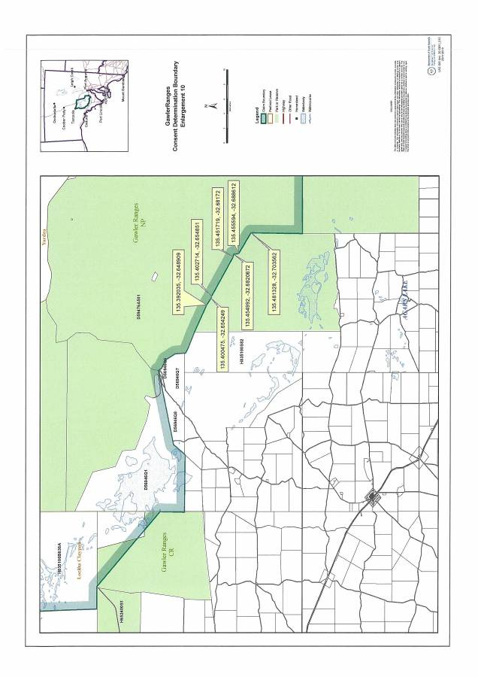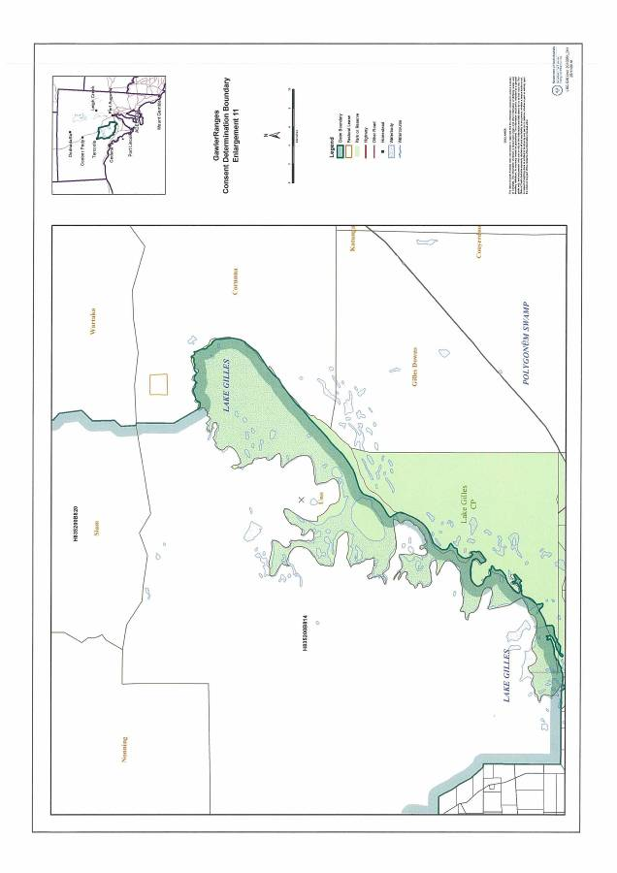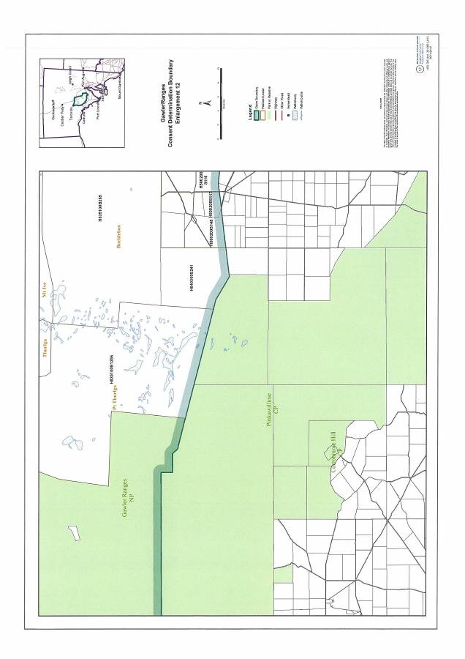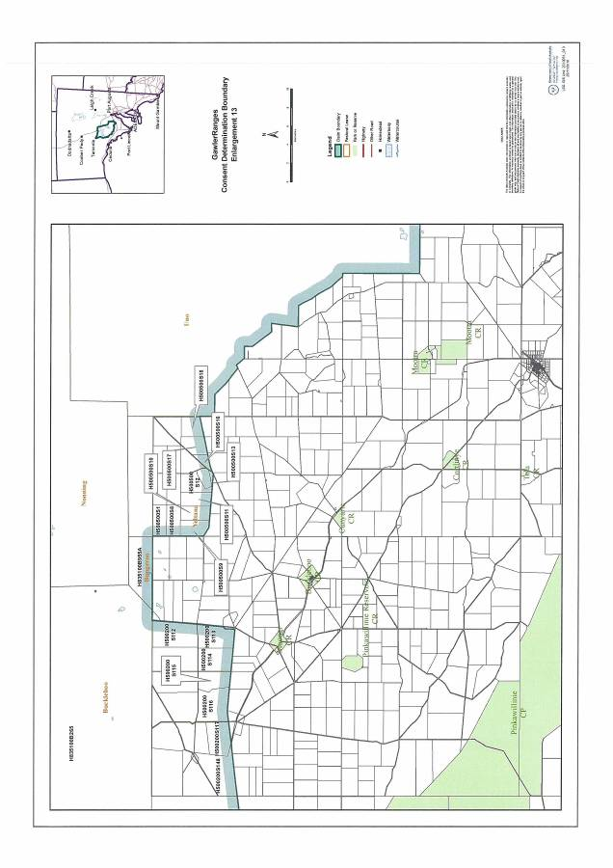

**SCHEDULE 3 – Areas within the external boundaries of the Determination Area which are excluded from the Determination Area because native title has been extinguished**

The following areas are agreed to have been excluded from the Determination Area by reason of the fact that native title has been extinguished in those areas:

1. All roads which have been delineated in a public map pursuant to s 5(d)(II) of the *Crown Lands Act 1929* (SA) or s 70(3) or (4) of the *Crown Land Management Act 2009* or which have otherwise been validly established pursuant to South Australian Statute or common law as shown in brown on the attached map.

1. The following listed land parcels:

**Pastoral and Crown Land subject to prior extinguishing tenure**

|  |  |  |
| --- | --- | --- |
| **Parcel Identifier** | **Hundred** | **Current Tenure** |
| DP31950 A20 | Bockleberg | CL 1610/47 PE 2530 |
| DP31950 A21 | Bockleberg | CR 5772/460 Gawler Ranges Conservation Reserve (Gazette 11/11/1993) |
| Section 106 | Buckleboo | CL 1290/42 PE 2286 |
| Section 107 | Buckleboo | CL 1290/42 PE 2286 |
| Section 108 | Buckleboo | CL 1290/42 PE 2286 |
| Section 109 | Buckleboo | CL 1290/42 PE 2286 |
| Section 110 | Buckleboo | CL 1290/42 PE 2286 |
| Section 111 | Buckleboo | CL 1290/42 PE 2286 |
| Section 112 | Buckleboo | CL 1290/42 PE 2286 |
| Section 113 | Buckleboo | CL 1290/42 PE 2286 |
| Section 114 | Buckleboo | CL 1290/42 PE 2286 |
| Section 115 | Buckleboo | CL 1290/42 PE 2286 |
| Section 116 | Buckleboo | CL 1290/42 PE 2286 |
| Section 117 | Buckleboo | CL 1290/42 PE 2286 |
| Section 118 | Buckleboo | CL 1290/42 PE 2286 |
| Section 119 | Buckleboo | CL 1290/42 PE 2286 |
| Section 146 | Buckleboo | CL 1290/42 PE 2286 |
| Section 147 | Buckleboo | CL 1290/42 PE 2286 |
| Section 148 | Buckleboo | CL 1290/42 PE 2286 |
| Section 1 | Cunyarie | CL 1608/35 PE 2529 |
| Section 2 | Cunyarie | CL 1608/35 PE 2529 |
| Section 3 | Cunyarie | CL 1608/35 PE 2529 |
| Section 4 | Cunyarie | CL 1608/35 PE 2529 |
| Section 5 | Cunyarie | CL 1608/35 PE 2529 |
| Section 6 | Cunyarie | CL 1608/35 PE 2529 |
| Section 7 | Cunyarie | CL 1608/35 PE 2529 |
| Section 8 | Cunyarie | CL 1608/35 PE 2529 |
| Section 9 | Cunyarie | CL 1608/35 PE 2529 |
| Section 10 | Cunyarie | CL 1608/35 PE 2529 |
| Section 11 | Cunyarie | CL 1608/35 PE 2529 |
| Section 12 | Cunyarie | CL 1608/35 PE 2529 |
| Section 13 | Cunyarie | CL 1608/35 PE 2529 |
| Section 15 | Cunyarie | CL 1608/35 PE 2529 |
| Section 16 | Cunyarie | CL 1608/35 PE 2529 |
| Section 17 | Cunyarie | CL 1608/35 PE 2529 |
| Section 18 | Cunyarie | CL 1608/35 PE 2529 |
| DP35936 A12* *excluding small area at southern tip as depicted on attached map 1. | Koolgera | CL 1290/33 PE 2313 |
| Section 1568 | OH (Childara) | CR 5759/593 Land dedicated for Digital Radio Concentrator purposes |
| Section 298 | OH (Gairdner) | CL 1298/30 PE 2364 |
| Section 428 | OH (Gairdner) | CL 1284/10 PE 2349 |
| Section 429 | OH (Gairdner) | CL 1284/10 PE 2349 |
| Section 438 | OH (Gairdner) | CL 1284/10 PE 2349 |
| Section 430 | OH (Kingoonya) | CL 1284/10 PE 2349 |
| Section 2 | OH (Streaky Bay) | CL 1425/11 OM 14891 |
| Section 5 | OH (Streaky Bay) | CL 1546/48 OM 16628 |
| Section 124 | OH (Streaky Bay) | CL 1290/33 PE 2313 |
| DP56946 Q1 | OH (Yardea) | CL 1647/93 OM 21374 |
| DP56946 Q2 | OH (Yardea) | CL 1647/93 OM 21374 |
| Block 4 | OH (Yardea) | CL 1290/33 PE 2313 |
| Section 6 | OH (Yardea) | CL 1546/48 OM 16628 |
| Section 86 | OH (Yardea) | CL 1429/12 OM 15455 |
| Section 116 | OH (Yardea) | CL 1546/48 OM 16628 |

**Land within Claim area (outside towns) held under Certificate of Title**

|  |  |  |
| --- | --- | --- |
| **Parcel Identifier** | **Hundred** | **Current Tenure** |
| Section 164 | OH (Gairdner) | CT 5875/921 Australian Rail Track Corp Ltd |
| Section 467 | OH (Gairdner) | CT5489/317 Commonwealth of Australia |
| Section 1555 | OH (Gairdner) | CT 5866/957 Telstra Corp Ltd |
| DP18335 A1 | OH (Gairdner) | CT 5875/921 Australian Rail Track Corp Ltd |
| FP17318 A102 | OH (Gairdner) | CT 5875/921 Australian Rail Track Corp Ltd |
| FP 217137 A52 | OH (Gairdner & Kingoonya) | CT 5875/921 Australian Rail Track Corp Ltd |
| Section 167 | OH (Kingoonya) | CT 5875/921 Australian Rail Track Corp Ltd |
| Section 168 | OH (Kingoonya) | CT 5875/921 Australian Rail Track Corp Ltd |
| Section 169 | OH (Kingoonya) | CT 5875/921 Australian Rail Track Corp Ltd |
| Section 170 | OH (Kingoonya) | CT 5875/921 Australian Rail Track Corp Ltd |
| FP 217137 A54 | OH (Kingoonya & Tarcoola) | CT 5875/921 Australian Rail Track Corp Ltd |
| Section 172 | OH (Tarcoola) | CT 5875/921 Australian Rail Track Corp Ltd |
| Section 173 | OH (Tarcoola) | CT 5875/921 Australian Rail Track Corp Ltd |
| Section 433 | OH (Tarcoola) | CT 5858/71 Minister for Transport |
| Section 434 | OH (Tarcoola) | CT 5858/71 Minister for Transport |
| Section 1563 | OH (Yardea) | CT 5833/591 Telstra Corp Ltd |
| Section 1564 | OH (Yardea) | CT 5833/592 Telstra Corp Ltd |
| Section 1565 | OH (Yardea) | CT 5833/593 Telstra Corp Ltd |
| Section 1566 | OH (Yardea) | CT 5833/590 Telstra Corp Ltd |
| Section 1567 | OH (Yardea) | CT 5833/589 Telstra Corp Ltd |

**Land Within the Town of Glendambo**

|  |  |  |
| --- | --- | --- |
| **Parcel Identifier** | **Hundred** | **Current Tenure** |
| T833702 A1320 | OH (Kingoonya) | CT 5459/923 |
| T833702 A1323 | OH (Kingoonya) | CT 5382/720 |
| T833702 A1324 | OH (Kingoonya) | CT 5382/732 |
| T833702 A1325 | OH (Kingoonya) | CT 5428/468 |
| T833702 A1326 | OH (Kingoonya) | CT 5428/468 |
| T833702 A1327 | OH (Kingoonya) | CT 5428/468 |
| T833702 A1328 | OH (Kingoonya) | CT 5382/731 |
| T833702 A1329 | OH (Kingoonya) | CT 5416/722 |
| T833702 A1330 | OH (Kingoonya) | CT 5229/538 |
| T833702 A1331 | OH (Kingoonya) | CT 5229/538 |
| T833702 A1332 | OH (Kingoonya) | CT 5416/723 |
| T833702 A1333 | OH (Kingoonya) | CT 5149/70 |
| T833702 A1334 | OH (Kingoonya) | CT 5149/70 |
| T833702 A1335 | OH (Kingoonya) | CT 5318/862 |
| T833702 A1336 | OH (Kingoonya) | CT 5393/919 |
| T833702 A1337 | OH (Kingoonya) | CT 5425/238 |
| T833702 A1338 | OH (Kingoonya) | CT 5424/172 |
| T833702 A1339 | OH (Kingoonya) | CT 5429/409 |
| T833702 A1340 | OH (Kingoonya) | CR 5575/603 Annual Licence OL20680 (Residential) |
| T833702 A1341 | OH (Kingoonya) | CT 5428/895 |
| T833702 A1342 | OH (Kingoonya) | CR 5750/391 Crown Land |
| T833702 A1343 | OH (Kingoonya) | CT 5425/245 |
| T833702 A1344 | OH (Kingoonya) | CT 5428/100 |
| T833702 A1347 | OH (Kingoonya) | CT 5478/713 |
| T833702 A1348 | OH (Kingoonya) | CR 5758/709 Land dedicated for Power Station |

**Land Within the Town of Kingoonya**

|  |  |  |
| --- | --- | --- |
| **Parcel Identifier** | **Hundred** | **Current Tenure** |
| Section 222 | OH (Kingoonya) | CR 5758/708 Public Convenience Reserve |
| Section 788 | OH (Kingoonya) | CR 5764/564 Land dedicated for Cemetery Purposes |
| DP42350 A2 | OH (Kingoonya) | CT 5845/192 |
| DP42350 A3 | OH (Kingoonya) | CT 5845/192 |
| T833701 A1 | OH (Kingoonya) | CT 6082/335 |
| T833701 A2 | OH (Kingoonya) | CT 6082/335 |
| T833701 A3 | OH (Kingoonya) | CT 5735/787 |
| T833701 A4 | OH (Kingoonya) | CT 5566/778 |
| T833701 A5 | OH (Kingoonya) | CT 5735/857 |
| T833701 A9 | OH (Kingoonya) | CT 5737/447 |
| T833701 A10 | OH (Kingoonya) | CT 5738/553 |
| T833701 A15 | OH (Kingoonya) | CT 6073/210 |
| T833701 A16 | OH (Kingoonya) | CT 6073/210 |
| T833701 A17 | OH (Kingoonya) | CT 6073/209 |
| T833701 A18 | OH (Kingoonya) | CT 5735/787 |
| T833701 A19 | OH (Kingoonya) | CT 5543/983 |
| T833701 A20 | OH (Kingoonya) | CT 6082/334 |
| T833701 A21 | OH (Kingoonya) | CT 5739/9 |
| T833701 A22 | OH (Kingoonya) | CT 5398/5 |
| T833701 A23 | OH (Kingoonya) | CT 5574/974 |
| T833701 A24 | OH (Kingoonya) | CT 5574/974 |
| T833701 A25 | OH (Kingoonya) | CT 5737/446 |
| T833701 A26 | OH (Kingoonya) | CT 5601/85 |
| T833701 A27 | OH (Kingoonya) | CT 5601/86 |
| T833701 A28 | OH (Kingoonya) | CT 6073/210 |
| T833701 A29 | OH (Kingoonya) | CT 6073/210 |
| T833701 A30 | OH (Kingoonya) | CT 5386/237 |
| T833701 A31 | OH (Kingoonya) | CT 5386/237 |
| T833701 A32 | OH (Kingoonya) | CT 5386/237 |
| T833701 A33 | OH (Kingoonya) | CT 5386/237 |
| T833701 A34 | OH (Kingoonya) | CT 5386/237 |
| T833701 A35 | OH (Kingoonya) | CT 5386/237 |
| T833701 A36 | OH (Kingoonya) | CT 5601/169 |
| T833701 A37 | OH (Kingoonya) | CT 5729/851 |
| T833701 A38 | OH (Kingoonya) | CT 5835/766 |
| T833701 A40 | OH (Kingoonya) | CT 5419/800 |
| T833701 A41 | OH (Kingoonya) | CT 5419/800 |
| T833701 A42 | OH (Kingoonya) | CT 5253/347 |
| T833701 A43 | OH (Kingoonya) | CT 5253/348 |
| T833701 A44 | OH (Kingoonya) | CT 5606/268 |
| T833701 A45 | OH (Kingoonya) | CT 5618/67 |
| T833701 A46 | OH (Kingoonya) | CT 5280/971 |
| T833701 A47 | OH (Kingoonya) | CT 5290/721 |
| T833701 A48 | OH (Kingoonya) | CT 5845/193 |
| T833701 A50 | OH (Kingoonya) | CT 5732/478 |
| T833701 A51 | OH (Kingoonya) | CT 5581/262 |
| T833701 A52 | OH (Kingoonya) | CT 5730/975 |
| T833701 A55 | OH (Kingoonya) | CT 5731/962 |
| T833701 A59 | OH (Kingoonya) | CT 5739/10 |
| T833701 A60 | OH (Kingoonya) | CT 5739/10 |
| T833701 A61 | OH (Kingoonya) | CT 5253.346 |
| T833701 A62 | OH (Kingoonya) | CT 5424/616 |
| T833701 A63 | OH (Kingoonya) | CT 5680/974 |
| T833701 A65 | OH (Kingoonya) | CT 5286/237 |
| T833701 A67 | OH (Kingoonya) | CT5835/766 |
| T833701 AROAD | OH (Kingoonya) | Public Road |

**MAP 1: Areas where Native Title is Extinguished**

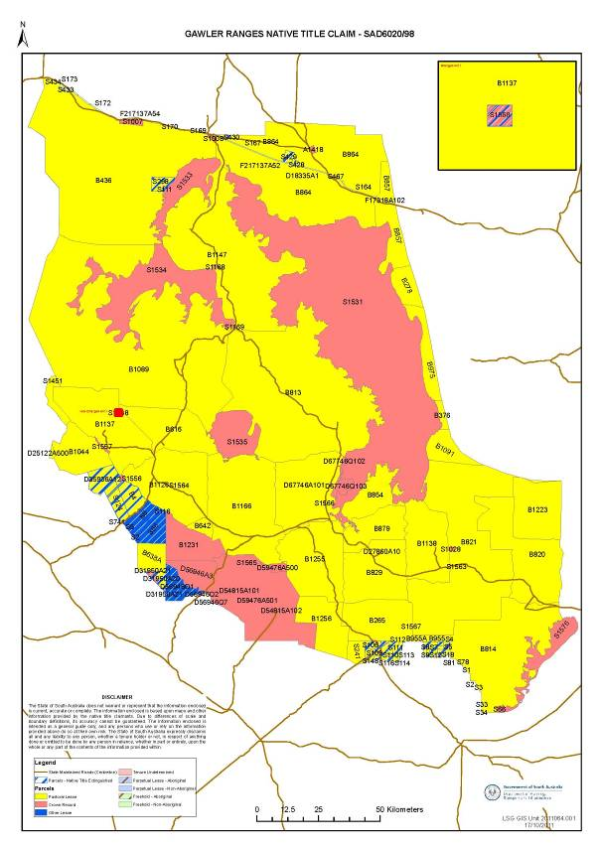

**Map 2: Areas in the town of Glendambo where Native Title is Extinguished**

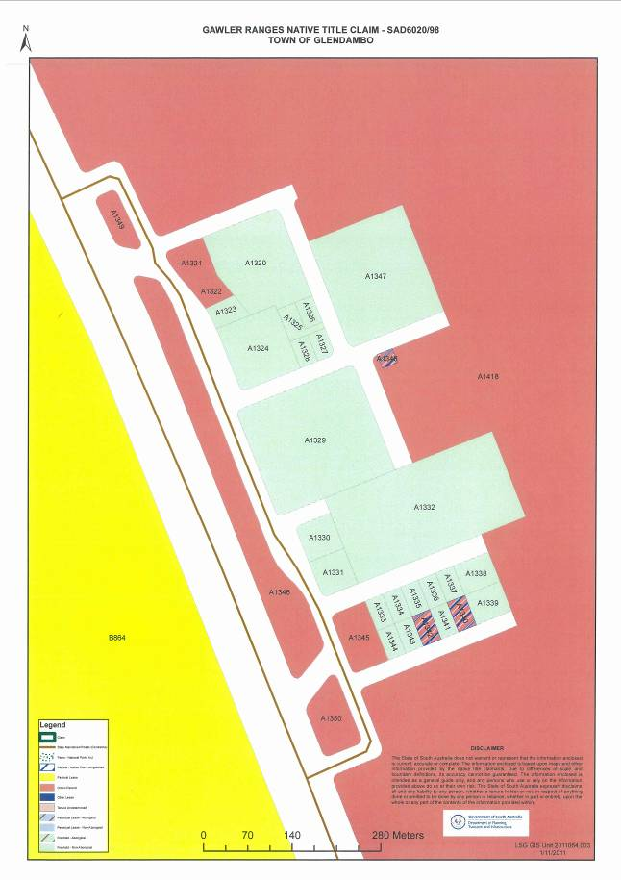

**Map 3: Areas in the town of Kingoonya where Native Title is Extinguished**

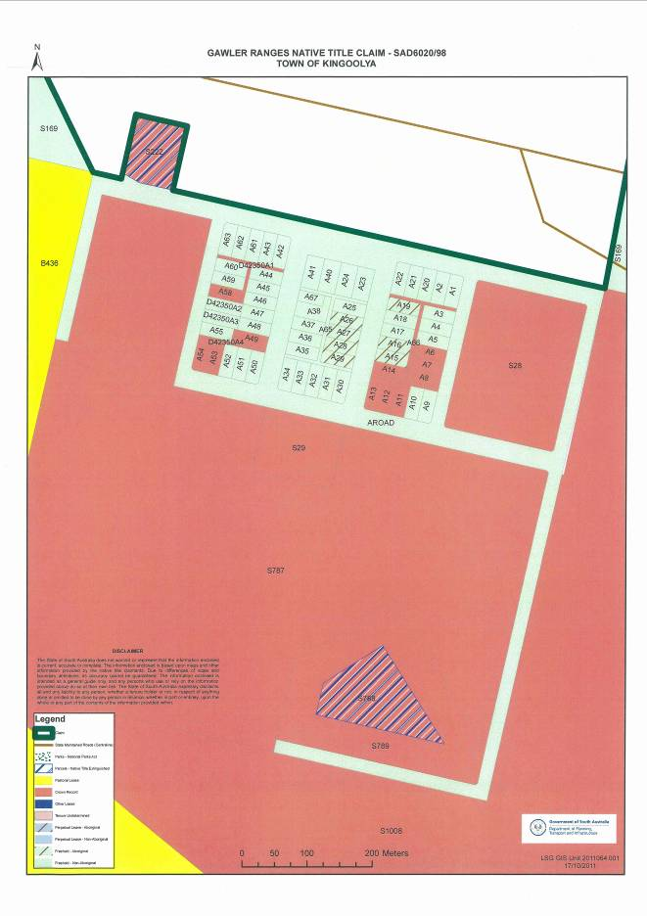

**SCHEDULE 4 - Areas where the non-extinguishment principle applies by reason of a Vesting**

|  |  |  |
| --- | --- | --- |
| **Park name** | **Legislation proclaimed under** | **Reference** |
| Lake Gairdner National Park | *National Parks and Wildlife Act*  *1972* (SA) | S1531 Out of Hundreds (Gairdner and  Yardea)  Section 1533 Out of Hundreds  Gairdner  Section 1534 Out of Hundreds  (Childara and Gairdner) proclaimed  on 19 December 1991 |

**SCHEDULE 5 - Reserves under National Parks and Wildlife Act 1972**

|  |  |
| --- | --- |
| **Park name** | **Reference** |
| Gawler Ranges National Park | Block 1231 Out of Hundreds (Yardea), Allotment 3 in Deposited Plan 56946 and Allotment 501 in Deposited Plan 59476 |
| Lake Gairdner National Park | Section 1531 Out of Hundreds (Gairdner and Yardea), Section 1533 Out of Hundreds Gairdner, Section 1534 Out of Hundreds (Childara and Gairdner) Pieces 102 and 103 DP 67746 Out of Hundreds (Yardea) |
| Lake Gilles Conservation Park | Section 66 Hundred of Moseley, Section 1576 Out of Hundreds (Port Augusta and Whyalla) |

**SCHEDULE 7 - Details of Indigenous Land Use Agreements in the Determination Area**

**PASTORAL**

|  |  |  |
| --- | --- | --- |
| **Name** | **NNTT Reference Number** | **Date Registered** |
| Moonaree Pastoral ILUA | S12009/003 | 13/06/2010 |
| Coondambo Pastoral ILUA | S12009/004 | 13/06/2010 |
| Kokatha Pastoral ILUA | S12009/005 | 13/06/2010 |
| Siam North Pastoral ILUA | S12008/007 | 27/05/2009 |
| Hiltaba Pastoral ILUA | S12008/017 | 26/05/2009 |
| Wilgena Pastoral ILUA (AJ & PA McBride Pty Ltd) | S12008/016 | 26/05/2009 |
| Lockes Claypan Pastoral ILUA | S12008/015 | 26/05/2009 |
| Yardea Pastoral ILUA | S12008/014 | 26/05/2009 |
| Thurlga Pastoral ILUA | S12007/003 | 26/05/2009 |
| Yeltana Pastoral ILUA | S12008/010 | 26/05/2009 |
| Part Hiltaba Pastoral ILUA | S12008/009 | 26/05/2009 |
| Siam Pastoral ILUA | S12008/011 | 26/05/2009 |
| Yarna Pastoral ILUA | S12008/008 | 26/05/2009 |
| Koweridda Pastoral ILUA | S12008/012 | 26/05/2009 |
| Lake Everard Pastoral ILUA | S120008/013 | 26/05/2009 |

**MINERALS**

|  |  |  |
| --- | --- | --- |
| **Name** | **NNTT Reference Number** | **Date Registered** |
| Gawler Ranges Mineral Exploration ILUA | S12004/004 | 30/06/2006 |

**PARKS**

1. **Gawler Ranges National Park ILUA:**

Agreement to be executed by Elliott McNamara, Kenneth Smith, Howard Richards and Andrew Dingaman on behalf of the Gawler Ranges Native Title Claim Group, Elliott McNamara, Barry Croft, Lorraine Dare, Howard Richards, Jody Miller, Marlene Weetra-Height and Lavinia Heron on behalf of the Barngarla Native Title Claim Group, the Gawler Ranges (Aboriginal Corporation) and the State of South Australia.

1. **Lake Gilles (Gawler Ranges Native Title Claim) Conservation Park ILUA:**

Agreement to be executed by Elliott McNamara, Kenneth Smith, Howard Richards and Andrew Dingaman on behalf of the Gawler Ranges Native Title Claim Group, the Gawler Ranges (Aboriginal Corporation) and the State of South Australia.

1. **Lake Gairdner National Park ILUA:**

Indigenous Land Use Agreement between Elliott McNamara, Kenneth Smith, Howard Richards and Andrew Dingaman on behalf of the Gawler Ranges Native Title Claim Group, the Gawler Ranges (Aboriginal Corporation) and the State of South Australia.

**OTHER**

**Gawler Ranges Native Title Claim Settlement ILUA:**

Agreement to be executed by Elliott McNamara, Kenneth Smith, Howard Richards and Andrew Dingaman on behalf of the Gawler Ranges Native Title Claim Group, the Gawler Ranges (Aboriginal Corporation) and the State of South Australia.

**Schedule 8**

**Applicants**

Applicant: Elliott McNamara

Applicant: Kenneth Smith

Applicant: Howard Richards

Applicant: Andrew Dingaman

**Respondents**

Respondent: Commonwealth of Australia

Respondent: South Australian Native Title Services Ltd

Respondent: AJ & PA McBride Pty Ltd

Respondent: David William Henderson

Respondent: Megan Joy Henderson

Respondent: Lake Everard Pty Ltd

Respondent: Colleen Mary Manning

Respondent: Paul Stephen Manning

Respondent: D.H. Morris

Respondent: R.R. Morris

Respondent: Nonning Pastoral Company Pty Ltd

Respondent: Pinevale Pastoral Company Pty Ltd

Respondent: Unalla Pastoral Company Pty Ltd

Respondent: Yarrah Nominees Pty Ltd

Respondent: Mount Ive Station Pty Ltd

Respondent: Adelaide Resources Ltd

Respondent: Gravity Capital Ltd

Respondent: Telstra Corporation Limited

Respondent: Electranet Pty Ltd

Respondent: South Australian Apiarists Association Inc

Respondent: Ironclad Mining Ltd

Respondent: Tarcila Resources Pty Ltd

|  |  |
| --- | --- |
| IN THE FEDERAL COURT OF AUSTRALIA |  |
| DISTRICT REGISTRY |  |
|  |  |

|  |  |
| --- | --- |
| BETWEEN: | ELLIOTT LANCELOT MCNAMARA, KENNETH HARRY SMITH, HOWARD RICHARDS, ANDREW DINGAMAN ON BEHALF OF THE GAWLER RANGES PEOPLE  Applicant |
| AND: | THE STATE OF SOUTH AUSTRALIA AND OTHERS  Respondent |

|  |  |
| --- | --- |
| : |  |
| DATE: |  |
| PLACE: | PANEY |

**REASONS FOR JUDGMENT**

1. The Court is today to make orders declaring that the People of the Gawler Ranges were and are the traditional owners of the land we are on. It is important to emphasise that the Court’s orders are not to grant that status but to declare that that status exists and has always existed at least since European settlement.

These orders are made under the *Native Title Act 1993* (Cth) (the Native Title Act). On behalf of the Australian people, the Native Title Act recognised in its Preamble that the Aboriginal people inhabited this country for many years prior to European settlement and were progressively dispossessed of their lands. The Preamble further recorded that, by the overwhelming vote of the people of Australia, the Constitution was amended to enable laws such as the Native Title Act to be passed to facilitate the recognition by our shared legal system of the native title rights and interests in land which existed at the time of European settlement. The determination gives effect to those objectives.

The determination is made with the consent of the State of South Australia and of all the respondents whose interests might be affected by the orders to be made today. It is important to make that observation because the consent of the State and others whose rights might be affected reflects that the whole of the community shares in, and supports the recognition of the status of the People of the Gawler Ranges.

# THE DETERMINATION AREA

The land being recognised as the land of the Gawler Ranges People covers an area which includes the Gawler Ranges and the salt lake region immediately to their north. The total area covered by the claim is approximately 3.5 million hectares. It is a vast area. It is an area of extraordinary geological history. And it is an area of dramatic contrasts and dramatic beauty.

The majority of the claim area is pastoral land (approximately 76%) with the remainder covered by Park (21%) or other Crown Record. There are also two small townships within the claim area, Glendambo and Kingoonya.

The three parks in the claim area are the Gawler Ranges National Park, the Lake Gairdner National Park (a large portion of which is registered as an Aboriginal site under the *Aboriginal Heritage Act 1988* (SA)), and Lake Gilles Conservation Reserve. Indigenous Land Use Agreements will be executed in relation to each of the parks on the same day as the Consent Determination is made.

# The Requirements of the Native Title Act

Section 87 of the Native Title Act empowers the Court to make orders by consent on an application for the determination of native title under s 61 upon certain conditions. Those conditions are not onerous, but they must be satisfied.

Certain of those conditions are procedural in nature. The period of notice under s 66 must have elapsed. It has clearly done so. A signed copy of the agreed orders must have been filed with the Court. That has also taken place.

More substantively, s 87(1) of the Native Title Act requires that, for the Court to make the proposed Consent Determination of native title without a hearing, the Court must be satisfied that such an order would be within its power, and s 87(2) requires the Court to be satisfied that it would be appropriate to make the orders agreed upon. In addition, because the orders seek a determination of native title, they must comply with s 94A of the Native Title Act. That section requires the proposed orders to set out details of the matters mentioned in s 225 of the Native Title Act.

Section 225 defines a determination of native title as:

A determination…whether or not native title exists in relation to a particular area (the ***determination*** ***area***) of land or waters and, if it does exist, a determination of:

(a) who the persons, or each group of persons, holding the common or group rights comprising the native title are; and

(b) the nature and extent of the native title rights and interests in relation to the determination area; and

(c) the nature and extent of any other interests in relation to the determination area; and

(d) the relationship between the rights and interests in paragraphs (b) and (c) (taking into account the effect of this Act); and

(e) to the extent that the land or waters in the determination area are not covered by a non-exclusive agricultural lease or a non-exclusive pastoral lease—whether the native title rights and interests confer possession, occupation, use and enjoyment of that land or waters on the native title holders to the exclusion of all others.

The term “native title rights and interests” is defined in s 223(1) of the Native Title Act as:

[T]he communal, group or individual rights and interests of Aboriginal peoples…in relation to land or waters, where:

(a) the rights and interests are possessed under the traditional laws acknowledged, and the traditional customs observed, by the Aboriginal peoples…; and

(b) the Aboriginal peoples…, by those laws and customs, have a connection with the land or waters; and

(c) the rights and interests are recognised by the common law of Australia.

It is important to explain why those requirements are satisfied. It is especially important, because the recognition given by the orders to be made will apply not just between the parties who have participated in the proceeding, but to all the people of Australia: *Munn (for and on behalf of the Guggari People) v The State of Queensland* (2001) 115 FCR 109 (*Munn*).

In *King on behalf of the Eringa Native Title Claim Group v State of South Australia* [2011] FCA 1386, the Chief Justice at [19] ff explained that the Court has been prepared to rely upon the processes of the relevant State or Territory about the requirements of s 223 being met to be satisfied that the making of agreed orders is appropriate. That is because each State and Territory has developed a protocol or procedure by which it determines whether native title (as defined in s 223) has been established. It acts in the public interest and as the public guardian in doing so. It has access to anthropological, and where appropriate, archaeological, historical and linguistic expertise. It has a legal team to manage and supervise the testing as to the existence of native title in the claimant group. Although the Court must, of course, preserve to itself the question whether it is satisfied that the proposed orders are appropriate in the circumstances of each particular application, generally the Court reaches the required satisfaction by reliance upon those processes. They are commonly explained in the joint submissions of the parties in support of the orders agreed. That is the case in this instance. I shall not repeat what his Honour there said at [17]-[23]. I respectfully adopt his Honour’s reasons.

The Court does not therefore routinely embark on its own inquiry of the merits of the claim made in the application to be satisfied that the orders sought are supportable and in accordance with the law: *Cox on behalf of the Yungngora People v State of Western Australia* [2007] FCA 588 at [3] per French J. However, it might consider that evidence for the limited purpose of being satisfied that the State is acting in good faith and rationally: *Munn* at [29]-[30] per Emmett J. See also *Smith v State of Western Australia* (2000) 104 FCR 494 at [38] per Madgwick J:

State governments are necessarily obliged to subject claims for native title over lands and waters owned and occupied by the State and State agencies, to scrutiny just as careful as the community would expect in relation to claims by non-Aborigines as to significant rights over such land.

That approach has been adopted in a number of recent decisions.

In this matter, the Court has had the benefit of the joint submissions. They confirm that the State is satisfied that the agreed determination is a proper one. It has had the benefit of a thorough examination of the available evidentiary material. The joint submissions in turn refer at considerable length to the material on which it has relied.

It is helpful to refer to that material in a little detail.

The evidence in this matter consisted of a detailed anthropological report by Drs Deane Fergie and Rod Lucas (the Native Title Report). The Native Title Report was accompanied and informed by a detailed Ethnohistory Report by Mandy Paul, a Family History Report by Tom Gara, detailed genealogies, and a male only restricted report prepared by Dr Rod Lucas. In addition, the State was provided with a Heritage Report relating to Lake Gairdner which was prepared in 2004 by Dr Neale Draper.

Drs Fergie and Lucas are consultant anthropologists with considerable professional and academic experience, both generally and with regard to native title. Dr Fergie holds a Senior Lectureship in Anthropology at the University of Adelaide, and is the founder of LocuSAR, an interdisciplinary social analysis and research team at the University of Adelaide. Dr Fergie has prepared native title reports for claims in both South Australia and Victoria.

Dr Lucas also holds a Lectureship in Anthropology at the University of Adelaide. He has been a consultant on a large number of cultural heritage surveys and several native title matters, and in these contexts has worked with a number of Aboriginal groups across South Australia.

The conclusions of Drs Fergie and Lucas in the Native Title Report are based on a comprehensive assessment of the ethnohistorical accounts and the historical records relating to the claim area, as well as significant fieldwork with contemporary Aboriginal people.

That material was assessed by Professor Nicolas Peterson for the State. Professor Peterson is Professor at the School of Archaeology and Anthropology at the Australian National University. Professor Peterson prepared an initial assessment of the Native Title Report in August 2009 which raised a number of issues. Following this a meeting of all experts was held, which was also attended by the State’s (then) in-house anthropologist, Mr McCaul. Subsequent to this meeting Drs Fergie and Lucas amended their Report, and provided additional information to the Crown. This material was the subject of a supplementary assessment by Professor Peterson in January 2010.

All of that material was considered by external Counsel, Mr Andrew Hall.

In October 2010, Counsel provided his written opinion that a decision by the State to consent to Orders recognising native title rights in favour of the claim group over the claim area would be justifiable on the basis of the material before him.

A position paper explaining the basis for the State’s view was distributed to all other respondent parties in December 2010.

In this matter, it is evident that the State has applied a rigorous approach to assess the proposed evidence of the claims, broadly in accordance with its document entitled *Consent Determinations in South Australia: A Guide to Preparing Native Title Reports* (sometimes called the State’s CD Policy). The State conducted its assessment of the evidence in light of the State’s CD Policy.

The fact that the State is sufficiently satisfied as to the proposed evidence of the Gawler Ranges People and has considered the interests of the community generally means the Court can move with some assurance to proceed to make the Determination.

Each of the respondents has received a position paper explaining the basis for the State’s view and has had the opportunity to review its conclusions and to ask any questions about them. I am also satisfied that the consent of the State and the other respondent parties to the proposed determination is a fully informed and conscientious one, having considered the requirements of the Native Title Act.

However, it is fitting that I should explain why the Court is satisfied of those matters. The evidence must show that there is a recognisable group or society that presently recognises and observes traditional law and customs in the Determination Area. In defining that group or society, the following must also be addressed:

that the claim group comprises a society united in and by their acknowledgement and observance of a body of accepted laws and customs; and

that the present day body of accepted laws and customs of the society in essence is the same body of laws and customs acknowledged and observed by the ancestors or members of the society adapted to modern circumstances; and

that the acknowledgement and observance of those laws and customs has continued substantially uninterrupted by each generation since sovereignty, and that the society has continued to exist throughout that period as a body united in and by its acknowledgement and observance of those laws and customs.

The claim group must show that it still possesses rights and interests under the traditional laws acknowledged and the traditional customs observed by them, and that those laws and customs give them a connection to the land. See generally *Members of the* *Yorta Yorta Aboriginal Community v Victoria* (2002) 214 CLR 422; *Risk v Northern Territory* [2006] FCA 404; and *Western Australia v Ward* (2002) 213 CLR 1.

## The relevant society for the purposes of s 223 of the Native Title Act

The native title claimant group identifies itself as the traditional owner of the claim area because its members are descended from those who had close ties to this area at sovereignty.

The group is made up of persons that have their origins in what are generally regarded as three different and distinct language groups: Kokatha, Wirangu and Barngarla. The Kokatha are part of the ‘Western Desert Bloc” of Aboriginal people. The Western Desert Region includes a vast area within Western Australia and South Australia generally to the north-west of the Gawler Ranges. The Barngarla are part of what has been termed the ‘Lakes Groups’ who are associated with areas generally to the east of the Gawler Ranges, and the Wirangu is associated with the coastal areas to the west and south.

The evidence suggests that native title rights arise in the Determination Area though a person’s membership of a distinct Gawler Ranges Society. Membership is dependent upon both filiation from a Gawler Ranges antecedent, and activation of rights in accordance with traditional law and custom.

The distinctive geological nature of the claim area, with its capacity to provide resources for a hunter gatherer lifestyle, and a fall-back area for Aboriginal people from surrounding areas with less reliable and accessible water resources, supports the conclusion of Drs Fergie and Lucas that the claim area is one in which people of different language groups have historically come together and interacted to form a society acknowledging and observing common laws and customs. This is supported by the (historical) existence of Gawler Ranges variants of each of the three language groups, indicating that a close relationship has existed between the speakers of these three language groups in the claim area over a long period of time.

The Native Title Report establishes that the claimants are part of a distinct and bounded “Gawler Ranges Society”, the membership of which arises from descent or succession from an “apical ancestor” who was born in the claim area from about 1860 (being the time of the earliest records) or had other known or inferred “Gawler Ranges” connections. Accordingly, membership is not open to all Barngarla, Kokatha and Wirangu persons, but only those who can establish filiation (either through birth or adoption) from a recognised Gawler Ranges antecedent.

In addition, potential rights arising from birth and filiation must be activated through an appropriate ongoing connection to the claim area and other members of the society in accordance with traditional laws and customs to give rise to native title rights in the land. This requires:

* birth and or / long term residence in or close to the claim area; and / or
* repeated and regular visitation of the claim area;

as well as acknowledgement and acceptance as a gawler ranges person by other families so identified. This second rule qualifies the requirement for filiation and ensures that the group does not extend to the entire cognatic stock of relatives.

There is some level of contestation amongst the claim group in relation to membership of the claim group and the basis upon which people can claim rights in land. However from the evidence before the State these arguments appear to be more based on the level of activation than the principles of ancestral connection, which appears to be a broadly accepted normative principle. Whilst this is an intra-mural issue, in the context of a Consent Determination, the State has required that a native title holding body be put in place which is appropriately structured to facilitate the smooth running of that body and the administration of the native title rights and interests into the future.

I accept that the level of detail provided by the Gawler Ranges People to identify the native title claim group and its society satisfies the requirements of the Native Title Act.

## The relationship between the claim group’s society and the society in the Determination Area at sovereignty

The relevant date of sovereignty for this area is 1788. The State is prepared in this matter to infer connection from the earliest records of contact.

The Native Title Report adopts two approaches to establishing the connection of today’s claimants with the native title holders at sovereignty. One is by analysing the historic literature relevant to the area and identifying broad correlations between the language groups recorded there with the language group identities of the claimants. The other is by way of claimant family histories.

The material presented in the Ethnohistory Report confirms that the claim area was at sovereignty associated with people of what are now referred to as the Barngarla, Wirangu and Kokatha language groups.

The Native Title Report, including the Ethnohistorical Report and the Family History Report, also details genealogical connections of a substantial number of the claimants back to the 1850’s and demonstrates a broad correlation between the peoples recorded in the area at first European settlement and those constituting the claimant group now.

On the basis of the information contained in the evidence and for the purposes of a Consent Determination, I am satisfied that the contemporary native title claimants’ society is directly linked to the native title holders at sovereignty.

## Has there been substantially uninterrupted observance of traditional laws and customs since sovereignty?

Unlike for the Western Desert Bloc Societies to the north-west of the claim area, and the Lakes Societies to the east, there is a paucity of historical ethnography for the claim area itself against which the traditional nature and continuity of the laws and customs of the Gawler Ranges society can be assessed.

A Consent Determination can be made without the necessity of strict proof and direct evidence of each issue as long as inferences can legitimately be made. In Consent Determination negotiations, it is the State’s policy to focus on contemporary expressions of traditional laws and customs and pay less regard to laws and customs that may have ceased. The State can reasonably infer that such contemporary expressions are sourced in the earlier laws and customs.

The Native Title Report provides evidence that much of the claimants’ behaviour is regulated or influenced by laws and customs which have been handed down from previous generations surrounding:

* Kinship, including the use of Aboriginal English Kinship terms, and obligations to kin;
* The significance of gender restrictions, in particular in the restricted cultural domain;
* Authority structures. The evidence is that elders with knowledge of the country and senior men and women with spiritual knowledge and experience have certain authority with regard to certain issues. There is no traditional authority structure that can make binding decisions for the whole of the claim group which, the Report argues, is consistent with the nature of the small, family based bands that occupied the area pre-sovereignty;
* ‘Dreaming stories’ or Tjukurpa. Professor Peterson raised a number of issues regarding the claimants’ knowledge of land based stories, and in particular the secrecy which now surrounds these amongst members of the claim group, and the lack of site names provided. In response to these issues Dr Lucas prepared a male restricted attachment to the Native Title Report, which outlined a number of dreaming narratives of particular import to the claim area, and which provided evidence that people know places in the claim area associated with those different stories, albeit they are no longer referred to in language names. Counsel considered that even if the system has undergone some attrition since sovereignty this does not lead to the conclusion that the Gawler Ranges Group has not continued to acknowledge and observe ‘substantially’ the same laws and customs as existed at sovereignty;
* Ceremonial activity on the evidence there has not been any ceremonial activity in the claim area since the older claimants were children, however there remains a subset of men who participate in ceremonial activity away from the claim area. Whilst Dr Peterson was also sceptical about this, this is not unique to this claim area, and the evidence suggests that ceremonial practices relating to sites and stories on the claim area are known and transmitted.

Other laws and customs for which there is contemporary evidence include:

* expectations about appropriate and respectful behaviour when visiting country for cultural business;
* physically maintaining and protecting sites of significance; and
* beliefs and fears of spiritual forces relating to the land, people, and animals.

In regard to land-holding rules, the evidence shows that the claimants’ society pre sovereignty was likely to have been comprised of:

(i) one or more local estates -

* In the south east of the claim area held by (a) descent group(s) which predominantly spoke the Gawler Ranges variant of Barngarla;
* In the south west of the claim area held by (a) descent group(s) which predominantly spoke the Gawler Ranges variant of Wirangu; and
* In the north west of the claim area held by (a) descent group(s) which predominantly spoke a Gawler Ranges variant of Kokatha; and that

(ii) underlying title to the claim area was held by the Gawler Ranges society as a whole, which was composed of the members of these descent groups.

The evidence suggests that these local estate groups were destabilised in the first phase of pastoral settlement, beginning a process which led to the rights and interests vested in local descent groups giving way to the broader Gawler Ranges society claiming generalised rights over the whole claim area. The claimants argue and those advising the State accept that this can be seen as an acceptable transformation.

In the context of negotiations for a Consent Determination, I agree that it is appropriate to infer that the pre-sovereignty normative society has continued to exist throughout the period since sovereignty, and whilst there has been inevitable adaptation and evolution of the laws and customs of that society, there is nothing apparent in the evidence to suggest the inference should not be made that the society today (as descendents of those placed in the area in the earliest records) acknowledges and observes a body of laws and customs which is substantially the same normative system as that which existed at sovereignty.

## Connection to the Determination Area by traditional laws and customs

It is a requirement of native title law that the claimants must show that they follow traditional laws and customs which are connected to the land, and which give rise to rights and responsibilities in relation to that land. Therefore it is not “connection” to the land in the abstract that must be considered, but the content of the traditional laws and customs, the nature and extent of the connection with the land required under those laws and customs and the relationship between the laws and customs and rights or interests in land.

The evidence is that the rules regarding membership of the society differentiate between different ‘levels’ of membership, which go to the nature of rights that can be exercised by each member in the claim group.

The broadest level, which the evidence calls “secondary membership”, requires a recognised genealogical connection to a Gawler Ranges antecedent. This level does not of itself give the member any direct rights in relation to the land in the claim area, but does give the right to “activate” or “re-activate” a “primary membership” status.

According to the evidence, “primary membership” depends on the fulfilment of a number of criteria. The “primary member” must fulfil the criteria for “secondary membership” of the society, but in addition at least one person from the “primary members” family group must have spent part of his or her childhood in the claim area, or have been born in the claim area, or have repeatedly and regularly visited the claim area to exercise their rights and interests and take care of the country.

It is primary or active membership of the claim group that gives rise to the rights and interests in land.

The Native Title Report evidences that a number of the families in the native title claim group satisfy the requirements of the “rules” of the society for active membership of the society and consequently for holding rights and interests in the claim area.

Evidence was provided that a number of claimant families have maintained a fairly active presence on the claim land, and have knowledge of the cultural and physical landscape of the area. There is evidence that a number of claimants continue to camp, hunt and use the resources of the area in accordance with traditional rules. Knowledge of a number of Dreaming narratives related to the area was evidenced in the restricted attachment to the Native Title Report.

Evidence was provided of transmission of cultural knowledge, both physical and spiritual, to younger generations which occurs both on and off the claim area.

I am is satisfied that the native title claim group’s traditional laws and customs give them a connection to the claimed area.

## The relationship between the traditional laws and customs of the relevant society and the rights and interests claimed by the applicant

The rights and interests which it is contemplated will be recognised through a native title determination are set out at paragraph 4 of the Consent Determination.

These rights are consistent with rights recognised by the Federal Court elsewhere in South Australia. The rights and interests recognised are consistent with the traditional rights and interests that would have been observed previously.

The Native Title Report provides evidence that a number of claimants continue to regularly access and move about the claim area, including for the purpose of camping, hunting and gathering, and that their actions whilst undertaking these activities are governed by traditional laws and customs. A number of the older claimants have also lived on the claim area for substantial periods. There is evidence that a number of claimants know medicinal plants from the area, and continue to access quandong, mingul (a bush tobacco) and other foods such as wild potatoes and wild tomatoes. There is also some evidence of the importance of rockholes, and of people accessing water from roots.

The Report also provides some evidence that members of the claim group continue to share game and bush tucker from the claim area.

Whilst there is no evidence in relation to the continued holding of initiation or like ceremonies on the claim area, there is evidence of other ritual activities and important meetings or events taking place on the claim area.

While births and deaths today are more often associated with large centres such as Whyalla, Port Augusta or Adelaide, there is evidence of the claimants’ antecedents being born and buried on the claim area.

There is also evidence of claimants maintaining rockholes and seeking to protect significant sites from damage or disturbance, particularly through mining and development. Most notably the whole of Lake Gairdner is a registered site under the *Aboriginal Heritage Act 1988* (SA).

Exclusive native title rights are not consistent with the traditional laws and customs put forward by the claimants, particularly in the contemporary setting, and therefore form no part of the Consent Determination.

I am satisfied that the native title rights and interests claimed arise from the claimants’ traditional law and customs and inferences can be made that they have evolved from the native title rights and interests as they were likely to have been at sovereignty.

## Recognisable by laws of Australia

There is no right or interest within the terms of the proposed Consent Determination that would not be recognised by the laws of Australia.

## Section 225 Native Title Act

Section 225 of the Native Title Act governs what the Consent Determination must include. The proposed Consent Determination complies with each requirement. It sets out with particularity the area in which native title exists. Paragraphs 9, 11, 12 and Schedule 3 set out all areas excluded from the Determination Area because native title has been extinguished.

Paragraph 3 of the Consent Determination defines the group of native title holders and the criteria by which they have group membership. It is sufficiently precise and it reflects the evidence about relevant ancestors through whom individuals hold rights and interests in land.

Paragraph 4 of the Consent Determination sets out the nature and extent of the native title rights and interests in the Determination Area.

Paragraph 15 of the Consent Determination sets out the nature and extent of other interests in the Determination Area. This has been the subject of some negotiation between the Applicant and the State and various respondents.

There has been ample opportunity for any other interest-holders in the area to identify themselves and join as parties to the claim.

The State’s comprehensive tenure searches have not identified any other relevant interest holders in the Determination Area.

Paragraph 16 of the Consent Determination describes the relationship between the native title rights in Paragraph 4 and those other rights in Paragraph 15.

The majority of the Determination Area is covered by non-exclusive pastoral lease.

There are no exclusive native title rights in the Determination Area.

## Section 87 Native Title Act

Agreement has been reached between all parties to these proceedings on the terms of the Consent Determination and signed copies of that Determination have been filed with the Court.

On the basis of the evidence it is clearly appropriate, and within the Court’s power, to make orders pursuant to section 87.

The Gawler Ranges native title claim was first lodged with the National Native Title Tribunal on 12 September 1997.

The application which provides the action number for the current proceeding was lodged with this Court on 30 September 1998 and full notification by the National Native Title Tribunal under s 66 of the Native Title Act (using current tenure data provided by the State) last closed on 1 November 2000. The Court is satisfied that all relevant interest holders in the area have had an opportunity to take part in the proceeding.

The South Australian Native Title Services Ltd is the relevant native title representative body for the Determination Area and is a party to the proceedings.

The Commonwealth is a party to the proceedings.

The parties who have signed the Minute of Consent Determination of Native Title are:

* The Applicant
* The State
* The Commonwealth of Australia
* South Australian Native Title Services Ltd
* South Australian Farmers Federation grouped pastoralists: AJ & PA McBride Pty Ltd; David William Henderson; Megan Joy Henderson; Lake Everard Pty Ltd; Colleen Mary Manning; Paul Stephen Manning; D.H Morris; R.R Morris; Nonning Pastoral Company Pty Ltd; Pinevale Pastoral Company Pty Ltd; Unalla Pastoral Company Pty Ltd; Yarrah Nominees Pty Ltd
* Mount Ive Station Pty Ltd
* Adelaide Resources Ltd
* Telstra Corporation Ltd
* Electranet Pty Ltd
* South Australian Apiarists Association Inc
* Ironclad Mining Ltd
* Tarcila Resources Pty Ltd

The State has filed the Minute of Consent Determination of native title, signed as described above. There is one party who has not signed the Minute, but the affidavit of Mimosa Kennedy, affirmed on 2 December 2011 and filed with the Court, sets out the details of that party. Clearly the proposed Determination will not in any material way affect that party.

## Representation

Apart from one or two of the mining respondents, who have a relatively minor interest, all parties to the Determination have had independent and competent legal advice in the proceeding. There is no reason to believe that the lack of representation will have disadvantaged any unrepresented mining respondents such that a final determination should not be made.

## The Determination Area

Schedule 1 to the Consent Determination contains a detailed description of the Determination Area. Paragraphs 9, 11, 12 and Schedule 3 describe those areas which are excluded from the Determination Area because native title has been extinguished.

## Extinguishment

A full tenure history of the claim area was provided by the State, and made available to all the parties to the claim. The State has carried out a detailed analysis of both historic and contemporary tenure which informed the Consent Determination negotiations. This has allowed the State and the Applicants to agree those areas where native title has been extinguished by prior grant of tenure and to record those areas with specificity in the Consent Determination.

In line with decision of the Full Court of the Federal Court in *De Rose v State of South Australia (No 2)* (2005) 145 FCR 290 and subsequent Consent Determinations in this State, paragraph 9 of the Determination recognises the extinguishment of native title rights and interests over those parts of the pastoral leases within the Determination Area where exclusive possession-style improvements authorised by the pastoral leases have been constructed.

Due to disagreement between the parties on whether the Full Court judgment in *De Rose Hill* held that all future pastoral improvements occurring after the date of the Consent Determination extinguish native title, paragraph 10 of the Consent Determination has been drafted to cover the position until the law in relation to future improvements is settled.

Extinguishment of native title rights and interests in the Determination Area by reason of the construction of Public Works is provided for in paragraphs 12 and 13 of the Consent Determination. These paragraphs provide for native title to be wholly extinguished over Public Works constructed, established or situated, or commenced to be constructed or established, prior to 23 December 1996, and leaves it to Part 2 Division 3 of the Native Title Act to determine the effect of those Public Works constructed, established or situated after 23 December 1996, subject to the Gawler Ranges Native Title Claim Settlement Indigenous Land Use Agreement (the Gawler Ranges Settlement ILUA) agreed between the Applicant and the State and due to be entered into contemporaneously with this Order.

## The Gawler Ranges Settlement ILUA

Immediately following the making of the Determination, the State, the Gawler Ranges People and the nominated prescribed body corporate will execute the Gawler Ranges Settlement ILUA. This ILUA provides for the provision of compensation and benefits in full and final settlement of the State’s existing compensation liability pursuant to the Native Title Act in relation to the Determination Area, and a process for the undertaking of future acts by the State in the Determination Area.

# Conclusion

The *Native Title Act 1993* (Cth) encourages the resolution by agreement of claims for determinations of native title. For the reasons set out above, the Court is firmly of the view that the Consent Determination should be made, in conjunction with the Gawler Ranges Settlement ILUA. By signing the Minute of Consent Determination of native title all parties to the proceeding have indicated their agreement. The Court accordingly makes the Determination recognising that the Gawler Ranges People have the native title rights and interests in the claim area in the terms agreed by the parties.

|  |
| --- |
| I certify that the preceding ninety-three (93) numbered paragraphs are a true copy of the Reasons for Judgment herein of the Honourable Justice Mansfield. |

Associate:

Dated: 19 December 2011