FEDERAL COURT OF AUSTRALIA

Croft on behalf of the Barngarla Native Title Claim Group v State of South Australia (No 2) [2016] FCA 724

|  |  |
| --- | --- |
| File number: | SAD 6011 of 1998 |
|  |  |
| Judge: | **MANSFIELD J** |
|  |  |
| Date of judgment: | 23 June 2016 |
|  |  |
| Catchwords: | **NATIVE TITLE** – determination following finding of existence of native title rights and interests - extinguishment |
|  |  |
| Legislation: | *Native Title Act 1993* (Cth) |
|  |  |
| Cases cited: | *Croft on behalf of the Barngarla Native Title Claim Group v State of South Australia* [2015] FCA 9; 2016 325 ALR 213 |
|  |  |
| Date of hearing: | 19-23 November 2012, Adelaide  19-23 November 2012, Adelaide  26 November 2012, Winters Hill, Port Lincoln  27 November 2012, Pildappa Rock  28 November 2012, Lake Umeewarra  29 November 2012, Whyalla  30 November 2012, Mt Laura  3-7 December 2012, Adelaide  10-11 December 2012, Adelaide  30-31 July 2013, Adelaide  1 August 2013, Adelaide  16-17 September 2013, Adelaide |
|  |  |
| Date of last submissions: | 18 March 2016 |
|  |  |
| Registry: | South Australia |
|  |  |
| Division: | General Division |
|  |  |
| National Practice Area: | Native Title |
|  |  |
| Category: | Catchwords |
|  |  |
| Number of paragraphs: | 5 |
|  |  |
| Counsel for the Applicant: | T McAvoy SC; L Goodchild and P Teitzel |
|  |  |
| Solicitor for the Applicant: | Teitzel & Partners |
|  |  |
| Counsel for the State of South Australia | M Evans QC; D O’Leary and A Wells |
|  |  |
| Solicitor for the State of South Australia: | Crown Solicitor for South Australia |
|  |  |
| Counsel for the Commonwealth: | R Webb QC; N Kidson and S Davis |
|  |  |
| Solicitor for the Commonwealth: | Australian Government Solicitor |
|  |  |
| Counsel for the Director of National Parks: | N Kidson and S Davis |
|  |  |
| Solicitor for the Director of National Parks: | Australian Government Solicitor |

|  |  |
| --- | --- |
| **Table of Corrections** |  |
|  |  |
| 28 June 2016 | The dates of hearing on the cover page have been corrected. |

ORDERS

|  |  |  |
| --- | --- | --- |
|  | | SAD 6011 of 1998 |
|  | | |
| BETWEEN: | BARRY CROFT AND OTHERS ON BEHALF OF THE BARNGARLA NATIVE TITLE CLAIM GROUP  Applicant | |
| AND: | STATE OF SOUTH AUSTRALIA AND OTHERS  Respondent  See Schedule 10 for the Full List of Parties | |

|  |  |
| --- | --- |
| JUDGE: | MANSFIELD J |
| DATE OF ORDER: | 23 JUNE 2016 |

**Preamble**

A Native Title Determination Application No. SAD 6011 of 1998 (the Application) was first lodged with the National Native Title Tribunal on 4 April 1996, and was referred to the Federal Court of Australia on 30 September 1998. A detailed history of the Application is set out in the reasons of this Court published on 22 January 2015 in *Croft on behalf of the Barngarla Native Title Claim Group v State of South Australia* [2015] FCA 9 (Croft).

B In 2012 the Application was split, allowing the Port Augusta Town Area, which is subject to overlapping claims, to be dealt with separately from the remainder of the Application.

C In November 2012, a hearing commenced to determine whether there has been, since sovereignty, a continuous acknowledgement and observance of the traditional Barngarla laws and customs under which rights and interests in land and waters are possessed, and have been handed down to the present day native title claim group, such that those rights and interests can be recognised and protected under the *Native Title Act 1993* (Cth) (NTA).

D On 22 January 2015 findings were handed down by this Court on the questions of connection that were before it (Croft). Since that time, the parties have been identifying and resolving issues of tenure and extinguishment.

E The principal parties, including the Applicant, the State of South Australia (the State) and the other respondents (together, the Principal Parties) have now reached an agreement as to the terms of a determination of native title to be made in relation to the land and waters covered by the Application (excluding the Port Augusta Town Area) which orders give effect to the findings of this Court made on 22 January 2015 and to the agreed resolution of issues of extinguishment.

F The State and the Applicant have identified a number of areas where it is appropriate to resolve issues of extinguishment through an Indigenous Land Use Agreement (the Barngarla Settlement ILUA). It is the intent of the Principal Parties that the Determination will take effect upon the Registration of that ILUA.

G The Principal Parties acknowledge that the effect of the Determination coming into effect will be that the members of the native title claim group, in accordance with the traditional laws acknowledged and the traditional customs observed by them, will be recognised as the Native Title Holders for the Native Title Land.

Being satisfied that a determination in the terms sought by the Principal Parties would be within the power of the Court and it appearing to the Court appropriate to do so:

**THE COURT ORDERS THAT:**

1. There be a determination of native title in the Determination Area in the terms set out at paragraphs 5 to 21 below (the Determination).
2. The Determination will take effect upon the Barngarla Settlement ILUA being registered on the Register of Indigenous Land Use Agreements.
3. In the event that the Barngarla Settlement ILUA is not registered on the Register of Indigenous Land Use Agreements within 12 months of the date of this Order, or such later time as the Court may order, the matter is to be listed for further directions.
4. The Applicant, the State or any other respondent have liberty to apply on 14 days’ notice to a single judge of the Court:
   1. if that party considers it unlikely that the Barngarla Settlement ILUA will be finalised and registered on the Register of Indigenous Land Use Agreements within 12 months of the date of this Order;
   2. to make consequential amendments to Schedules 2 to 7 as necessary to reflect the terms of the Barngarla Settlement ILUA;
   3. to establish the precise location and boundaries of any Public Works and adjacent land and waters referred to in items 2 or 3 of Schedule 6;
   4. to determine the effect on native title rights and interests of any Public Works as referred to in item 3 of Schedule 6.

**THE COURT DETERMINES THAT:**

**Interpretation & Declaration**

1. In this Determination, including its schedules:
   1. unless the contrary intention appears, the words and expressions used have the same meaning as they are given in Part 15 of the NTA;
   2. “Adjacent land” and “Subjacent land” have the meaning given to those terms in the *Harbors and Navigation Act 1993* (SA);
   3. “Native Title Land” means the land and waters referred to in paragraphs 8, 9 and 10 of these Orders;
   4. “Port Augusta Town Area” means the area of this proceeding that is also covered by the Nukunu Native Title Application (SAD6012/1998) that was split from this proceeding pursuant to the Court Order of 12 November 2012;
   5. “Reserves” means a reserve as defined in the *National Parks and Wildlife Act 1972* (SA) and a Wilderness Protection Area or Wilderness Protection Zone under the *Wilderness Protection Act 1992* (SA); and
   6. in the event of an inconsistency between a description of an area in a schedule and the depiction of that area on the maps in Schedule 2, the written description shall prevail.

**Determination Area**

1. Schedule 1 describes the external boundaries of the Determination Area (the Determination Area).
2. Other than the Port Augusta Town Area, to the extent that the area covered by the Application extends beyond the Determination Area, it is dismissed.

**Areas within Determination Area where native title exists (Native Title Land)**

1. Subject to items 1, 2, 3 and 4 of Schedule 6, native title exists in the lands and waters described in Schedule 3.
2. Sections 47 or 47A of the NTA apply to those parcels or parts of parcels described in Schedule 4 and section 47B of the NTA applies to those parcels or parts of parcels described in Schedule 5. Subject to items 1, 2, 3 and 4 of Schedule 6, the prior extinguishment of native title rights and interests over those areas is disregarded and native title exists in those parcels or parts of parcels.
3. Native title exists in those areas which are agreed as Native Title Land in the Barngarla Settlement ILUA.

**Areas within Determination Area where native title is extinguished**

1. Native title has been extinguished in those areas described in Schedule 6.
2. Native title is extinguished in those areas over which native title rights and interests are surrendered under the Barngarla Settlement ILUA.

**Areas within Determination Area where the native title status is prescribed by ILUA**

1. The Court notes that the State and the Applicant have agreed to negotiate the Barngarla Settlement ILUA which will, upon it being registered on the Register of Indigenous Land Use Agreements, agree the effect on native title of acts done in relation to the areas described in Schedule 7 and prescribe the native title status of those areas.

**Native Title Holders**

1. Under the relevant traditional laws and customs of the Barngarla People the group of persons holding the common or group rights are those Barngarla People:
   1. who are related by means of the principle of descent to the following Barngarla apical ancestors:
      1. the siblings Percy Richards and Susie Richards;
      2. Maudie Blade who is the mother of Phyllis Croft;
      3. George Glennie and Mary Glennie;
      4. the siblings Bob Eyles and Harry Croft;
      5. Jack Stuart;
      6. Arthur Davis (also known as King Arthur) and his sons, Andrew Davis, Jack Davis, Stanley Davis and Percy Davis; and
   2. who have a connection with the Determination Area in accordance with the traditional laws and customs of the Barngarla People; and
   3. who identify as a Barngarla person and who are accepted by the Barngarla People as a Barngarla person.

(Collectively, the Native Title Holders)

**Rights And Interests**

1. Subject to paragraphs 17 and 19, the native title rights and interests in relation to the lands set out in Schedule 4 include those rights set out in paragraphs 16(a) to 16(h) below and are an entitlement to possession, occupation, use and enjoyment of those lands to the exclusion of all others.
2. Subject to paragraphs 17, 18 and 19 the nature and extent of the native title rights and interests in the Native Title Land, other than the lands set out in Schedule 4, are non-exclusive rights to use and enjoy, in accordance with the Native Title Holders’ traditional laws and customs, those lands and waters, being:
   1. The right to live on, use and enjoy the land and waters;
   2. The right to make decisions about the use and enjoyment of the land and waters by those Aboriginal people who recognise themselves to be governed by the traditional laws and customs acknowledged by the Native Title Holders;
   3. The right of access to the land and waters;
   4. The right to control the access of other Aboriginal people who recognise themselves to be governed by the traditional laws and customs acknowledged by the Native Title Holders to the land and waters;
   5. The right to use and enjoy resources of the land and waters but excluding those resources referred to in item 1 of Schedule 6;
   6. The right to control the use and enjoyment of resources on the land and waters by other Aboriginal people who recognise themselves to be governed by the traditional laws and customs acknowledged by the Native Title Holders but excluding those resources referred to in item 1 of Schedule 6;
   7. The right to maintain and protect places of importance under traditional laws, customs and practices on the land and waters; and
   8. The right to conduct burial ceremonies on the land and waters.

**General Limitations**

1. The native title rights and interests set out at paragraphs 15 and 16 are for personal, domestic and communal use but do not include the right to trade in, or the commercial use of, the Native Title Land or the resources from it.
2. For the avoidance of doubt, the native title rights and interests described in paragraph 16 do not confer possession, occupation, use and enjoyment of the land and waters on the Native Title Holders to the exclusion of others.
3. The native title rights and interests set out at paragraphs 15 and 16 are subject to and exercisable in accordance with:
   1. the traditional laws and customs of the Native Title Holders;
   2. the valid rights of other interest holders in the Native Title Land in accordance with paragraphs 20 and 21 of this Order; and
   3. the valid laws of the State and Commonwealth, including the common law.

**Other Interests & Relationship with Native Title**

1. The nature and extent of other interests in the Native Title Land are:
   1. the interests created by the following pastoral leases:

| **Lease name** | **Pastoral Lease No** | **Crown Lease** |
| --- | --- | --- |
| Carriewerloo | PE2423 | CL1433/10 |
| Cooyerdoo | PE2456 | CL1368/48 |
| Corraberra | PE2496 | CL1436/40 |
| Corunna | PE2215 | CL1277/23 |
| Gilles Downs | PE2388 | CL1318/7 |
| Illeroo | PE2274 | CL1282/45 |
| Iron Baron | PE2218 | CL1278/18 |
| Katunga | PE2283 | CL1299/37 |
| Kootaberra | PE2373 | CL1296/32 |
| Lincoln Park | PE2366 | CL1306/19 |
| Lockes Claypan | PE2530 | CL1610/47 |
| Mt Arden | PE2257 | CL1282/43 |
| Myall Creek | PE2332 | CL1292/2 |
| Myola | PE2281 | CL1279/45 |
| Narlaby | PE2531 | CL1629/6 |
| Nonning | PE2328 | CL1298/25 |
| Pandurra | PE2272 | CL1281/27 |
| Secret Rocks | PE2542 | CL1648/33 |
| Wartaka | PE2252 | CL1287/7 |
| Wartaka North | PE2423B | CL1433/3 |
| Wilkatana | PE2296 | CL1290/7 |
| Yadlamalka | PE2277 | CL1282/13 |
| Yudnapinna | PE2372 | CL1296/31 |

* 1. the interests of the Crown in right of the State of South Australia;
  2. any subsisting public right to fish in the Determination Area;
  3. the public right to navigate in the Determination Area;
  4. where applicable, the international right of innocent passage over waters affected by the Determination;
  5. in relation to Reserves:
     1. the rights and interests of the Crown in right of the State of South Australia pursuant to the *National Parks and Wildlife Act 1972* (SA) and the *Wilderness Protection Act 1992* (SA); and
     2. the rights and interests of the public to use and enjoy those Reserves consistent with the *National Parks and Wildlife Act 1972* (SA) and the *Wilderness Protection Act 1992* (SA);
  6. the rights and interests of the Crown in right of the State of South Australia pursuant to the *Harbors and Navigation Act 1993* (SA);
  7. the interests of the registered proprietors of the lands set out in Schedule 4;
  8. the interests of persons to whom valid or validated rights and interests have been granted or recognised by the Crown in right of the State of South Australia or by the Commonwealth of Australia pursuant to statute or otherwise in the exercise of executive power including, but not limited to, rights and interests granted or recognised pursuant to the *Crown Land Management Act 2009* (SA), *Crown Lands Act 1929* (SA), *Mining Act 1971* (SA), *Petroleum and Geothermal Energy Act 2000* (SA) and *Opal Mining Act 1995* (SA), all as amended from time to time;
  9. rights or interests held by reason of the force and operation of the laws of the State or of the Commonwealth;
  10. the rights to access land by an employee or agent or instrumentality of the State, Commonwealth or other statutory authority as required in the performance of his or her statutory or common law duties where such access would be permitted to private land;
  11. the rights and interests of all parties to the Indigenous Land Use Agreements listed in Schedule 8 arising by reason of those agreements;
  12. the rights and interests of Telstra Corporation Limited (ACN 051 775 556):
      1. as the owner or operator of telecommunications facilities within the Determination Area;
      2. created pursuant to the *Post and Telegraph Act 1901* (Cth), the *Telecommunications Act 1975* (Cth), the *Australian Telecommunications Corporation Act 1989* (Cth), the *Telecommunications Act 1991* (Cth) and the *Telecommunications Act 1997* (Cth), including rights:

1. to inspect land;
2. to install and operate telecommunications facilities; and
3. to alter, remove, replace, maintain, repair and ensure the proper functioning of its telecommunications facilities;
   * 1. for its employees, agents or contractors to access its telecommunications facilities in and in the vicinity of the Determination Area in performance of their duties; and
     2. under any lease, licence, access agreement or easement relating to its telecommunications facilities in the Determination Area, including but not limited to:
4. the Iron Knob Main Radio Terminal located within CR6054/711 (D71557A102), OH (Port Augusta);
5. the Mount Laura “CMTS” located within CR6140/886 (D9369A21), OH (Port Augusta);
6. the Tooligie Hill “SAGRN” located within CR5763/103 (H533000S49), Hundred of Tooligie; and
7. the Caralue Bluff “SAGRN” located within CR5764/682 (D37135A4), Hundred of Caralue;
   1. the rights, interests and entitlements of SA Power Networks (a partnership of Spark Infrastructure SA (No.1) Pty Ltd, Spark Infrastructure SA (No.2) Pty Ltd, Spark Infrastructure SA (No.3) Pty Ltd, CKI Utilities Development Limited and PAI Utilities Development Limited) and its related and successor entities, including its rights, interests and entitlements:
      1. to exercise its entitlements and discharge its obligations as the owner and/or operator of electricity infrastructure (as defined in the *Electricity Act 1996* (SA)) (Electricity Act) and telecommunications facilities and infrastructure within the Determination Area including but not limited to existing infrastructure (Existing Infrastructure);
      2. to exercise its entitlements and discharge its obligations as the holder of a licence under the Electricity Act and/or as an electricity entity under the Electricity Act;
      3. to exercise its entitlements and discharge its obligations as the holder of a carrier licence under the *Telecommunications Act 1997* (Cth);
      4. to install new electricity and telecommunications infrastructure on the Determination Area (New Infrastructure) and modify, maintain and repair Existing Infrastructure;
      5. under easements, leases or licences (whether registered, unregistered, statutory or otherwise) relating to Existing Infrastructure or New Infrastructure on the Determination Area including but not limited to the Easements identified in Schedule 9 (Easements);
      6. to provide its employees, agents or contractors with access to Existing Infrastructure, New Infrastructure and the Easements on the Determination Area; and
      7. to the extent permitted by law, to restrain any person from performing any act, or compel any person to perform any act, for the purposes of ensuring that SA Power Networks complies with its obligations under any law, including, but not limited to, excluding any person from entering an area containing Existing Infrastructure or New Infrastructure for the purposes of maintaining the safety of any person and the security and protection of such infrastructure;
   2. the rights and interests of each of the District Council of Ceduna, the District Council of Cleve, the District Council of Elliston, the District Council of Lower Eyre Peninsula, the District Council of Franklin Harbour, the District Council of Kimba, the District Council of Streaky Bay, the District Council of Tumby Bay, the Corporation of the City of Whyalla, the Flinders Ranges Council, Port Augusta City Council, City of Port Lincoln, Unincorporated Area of Whyalla, Wudinna District Council and the Outback Communities Authority:
      1. under the *Local Government Act 1934* (SA), the *Local Government Act 1999* (SA) or the *Outback Communities (Administration and Management) Act 2009* (SA);
      2. as an entity exercising statutory powers in respect of land and waters within the Determination Area; and
      3. in relation to dedicated land placed under its care, control and management pursuant to the *Crown Land Act 1929* (SA) or the *Crown Land Management Act 2009* (SA)
   3. the rights and interests of Epic Energy South Australia Pty Ltd (formerly Tenneco Gas South Australia Pty Ltd) (Epic):
      1. as:

(1) holders of Pipeline Licence No. 1 (PL1) issued pursuant to the *Petroleum Act 1940* (SA) on 12 March 1969 and renewed on 27 March 1990 pursuant to the *Petroleum Act 1940* (SA) and continuing in force by the operation of clause 2 of the Schedule to the *Petroleum Act 2000* (SA);

(2) owner of the pipeline the subject thereof by virtue of having been a purchaser of the pipeline (as purchaser is defined in section 16 of the *Natural Gas Authority Act 1967* (SA) as amended by the *Pipelines Authority (Sale of Pipelines) Amendment Act 1995* (SA) (the Sale Legislation) from the former Pipeline Authority of South Australia (PASA, now the Natural Gas Authority of South Australia (NGASA)) pursuant to a Sale Agreement dated 30 June 1995 under the Sale Legislation; and

(3) the holders of a statutory easement established by section 9 of the Sale Legislation;

* + 1. the statutory easement entitles Epic, *inter alia*, to install, maintain and operate the pipeline and to carry out authorised purposes including the installation, operation, inspection, extension, alteration, repair and removal of the pipeline or associated equipment and the carrying out of maintenance work on the pipeline or associated equipment;
    2. for Epic, its employees, agents and contractors (or any of them) to enter the Determination Area to access Epic’s rights and interests and to do all things necessary to exercise those rights and interests and perform all obligations in the vicinity of the Determination Area in performance of their duties;
  1. the rights and interests of Onesteel Manufacturing Pty Ltd created pursuant to *The Broken Hill Proprietary Company, Limited’s, Hummock Hill to Iron Knob Tramways and Jetties Act 1900* (SA), *Hummock Hill to Iron Knob Tramway Extension Act 1927* (SA), *Broken Hill Proprietary Company’s Indenture Act 1937* (SA) (including the Indenture contained therein); and *Whyalla Steel Works Act 1958* (SA) (including the Indenture contained therein);
  2. the rights and interests of the holder from time to time of Pipeline Licence No. 2 (PL 2), who at the date of this determination is comprised of Santos Limited, Santos Petroleum Pty Ltd, Santos (BOL) Pty Ltd, Vamgas Pty Ltd, Reef Oil Pty Ltd, Alliance Petroleum Australia Pty Ltd, Bridge Oil Developments Pty Ltd, Delhi Petroleum Pty Ltd, Origin Energy Resources Limited, Basin Oil Pty Ltd and Santos (NARNL Cooper) Pty Ltd;
  3. the rights and interests of Santos Limited, Santos Petroleum Pty Ltd, Santos (BOL) Pty Ltd, Vamgas Pty Ltd, Reef Oil Pty Ltd, Alliance Petroleum Australia Pty Ltd, Bridge Oil Developments Pty Ltd, Delhi Petroleum Pty Ltd, Origin Energy Resources Limited, Basin Oil Pty Ltd and Santos (NARNL Cooper) Pty Ltd under any lease, licence, easement, permit or agreement on the Native Title Land, including but not limited to:
     1. the Port Bonython Section 240 Land Licence Agreement dated 1 August 2014; and
     2. the Port Bonython Jetty Licence Agreement dated 19 August 1985.

and

* 1. the rights and interests of BHP Billiton Olympic Dam Corporation Pty Ltd:
     1. in the Indenture (as amended) and ratified by the *Roxby Downs (Indenture Ratification) Act 1982* (SA), and rights, powers, privileges and interests comprised in, conferred under or in accordance with or pursuant to that *Indenture and the Roxby Downs (Indenture Ratification) Act 1982* (SA);
     2. in the Variation Deed amending the Indenture and ratified by the *Roxby Downs (Indenture Ratification) (Amendment of Indenture) Amendment Act 2011* (SA), and rights, powers, privileges and interests comprised in, conferred under or in accordance with or pursuant to that Variation Deed amending the Indenture and the *Roxby Downs (Indenture Ratification) (Amendment of Indenture) Amendment Act 2011* (SA); and
     3. for its employees, agents or contractors to enter the Determination Area to access BHP Billiton Olympic Dam Corporation Pty Ltd's rights and interests and to do all things necessary to exercise those rights and interests in the vicinity of the Determination Area in performance of their duties.

1. The relationship between the native title rights and interests in the Native Title Land that are described in paragraphs 15 and 16 and the other rights and interests that are described in paragraph 20 (the Other Interests) is that:
   1. to the extent that any of the Other Interests are inconsistent with the continued existence, enjoyment or exercise of the native title rights and interests, the native title rights and interests continue to exist in their entirety, but the native title rights and interests have no effect in relation to the Other Interests to the extent of the inconsistency during the currency of the Other Interests;
   2. the existence and exercise of the native title rights and interests do not prevent the doing of any activity required or permitted to be done by or under the Other Interests, and the Other Interests, and the doing of any activity required or permitted to be done by or under the Other Interests, prevail over the native title rights and interests and any exercise of the native title rights and interests, but, subject to any application of the NTA or the *Native Title (South Australia) Act 1994* (SA), do not extinguish them;
   3. in relation to the land and waters set out in Schedules 4 and 5 the non-extinguishment principle applies in relation to the grant or vesting of the land, or the creation of any other prior interest in the land.

**AND THE COURT MAKES THE FOLLOWING FURTHER ORDERS:**

1. Within 6 months of the date on which these Orders are made, the Applicant shall indicate to the Court in accordance with sections 56 and 57 NTA:
   1. whether the Native Title Holders intend to have the native title held in trust, and if so nominate a prescribed body corporate to be the Trustee of the native title; or
   2. if the native title is not to be held in trust, nominate a prescribed body corporate for the purpose of section 57(2) NTA.
2. On this Determination coming into effect:
   1. where a prescribed body corporate is nominated in accordance with section 56 NTA to be the Trustee of the native title, the prescribed body corporate is to hold the native title rights and interests in trust for the Native Title Holders and shall perform the functions mentioned in section 57(1) NTA after becoming a registered native title body corporate; or
   2. where the native title is not to be held in trust, the prescribed body corporate is to be the prescribed body corporate for the purpose of section 57(2) NTA, and shall perform the functions mentioned in section 57(3) NTA after becoming a registered native title body corporate.

Note: Entry of orders is dealt with in Rule 39.32 of the Federal Court Rules 2011.

**Schedules**

**Schedule 1 – Location of and areas comprising the Determination Area**

1. The Determination Area is located wholly within and comprises all land and waters bounded by the following line:

Commencing at a point being the south-western corner of Section 45, Hundred of Petina (Port Lincoln – Thevenard Railway corridor / Tod River Pipeline parcel); then north-westerly along the south-western boundary of Section 45, Hundred of Petina; northerly along portion of the western boundary of Section 45 to its intersection with the production south-easterly of the south-western boundary of Section 41, Hundred of Petina; generally north-westerly along the said production and south-western boundary of Sections 41 and 40; westerly along portion of the southern boundary of Piece 2 of Deposited Plan 83365; north-westerly along the south-western boundary of Piece 2, Allotment 4 and Piece 3 of Deposited Plan 83365; northerly along portion of the western boundary of Piece 3 to its intersection with the production south-easterly of the south-western boundary of Section 34, Hundred of Petina; north-westerly along the said production and the south-western boundary of Section 34 and portion of Section 36 (following the Railway and Tod River pipeline parcel) to its intersection with the production south-westerly of the line between the points Longitude 134.417465 East, Latitude 32.293306 South and Longitude 134.459361 East, Latitude 32.260575 South; north-easterly along the said production and line; north-easterly along in a straight line through Longitude 134.477244 East, Latitude 32.247802 South, a straight line to the south-eastern corner of Allotment 100 of Deposited Plan 34367 being a point on the southern boundary of the Hundred of Nunnyah; (through Pureba Conservation Park) along the south-eastern boundary of Allotment 100 of Deposited Plan 34367 and Allotment 400 of Deposited Plan 25122 [being along portion of the external boundary of the Far West Coast Consent Determination area – SAD6008/1998 (SCD2013/002)].

Then easterly along the northern boundary of Allotment 10 of Deposited Plan 35936; generally south and south-easterly along the eastern boundary of Allotment 10, the north-eastern boundary of Allotment 11 of Deposited Plan 35936 (Pureba Conservation Park); northerly, generally north-easterly and south-easterly along portion of the western, the north-western and north-eastern boundary of Section 125, Out of Hundreds (Streaky Bay); easterly along portion of the northern boundary of the northern portion of Section 741, Out of Hundreds (Streaky Bay) to its north-eastern corner; south-easterly in a straight line to the north-western corner of Block 638A, Out of Hundreds (Yardea); southerly along the western boundary of Block 638A; easterly along portion of the northern boundary of Section 1, Hundred of Bockelberg (Gawler Ranges Conservation Park) to its north-eastern corner; south-easterly in a straight line through Allotment 21 of Deposited Plan 31950 (Gawler Ranges Conservation Park) and Allotment 20 of Deposited Plan 31950 to a point being approximately 3.4 kilometres along the western boundary of Piece 1 of Deposited Plan 56946 from the south-west corner of the said Piece 1 at Latitude 32.591946 South; southerly, easterly and north-easterly along the western, southern and south-eastern boundary of Piece 1; north-easterly along the northern boundary of Piece 8 of Deposited Plan 56946 to its eastern-most corner; north-easterly in a straight line to the northern-most corner of the Piece 6 of Deposited Plan 56946; south-easterly along the north-eastern boundary of Piece 6, to its eastern-most corner; south-easterly in a straight line to the northern-most corner of Piece 7 of Deposited Plan 56946; south-easterly along the north-eastern and eastern boundary of Piece 7; generally south-easterly along the north-eastern boundary of Section 82, Out of Hundreds (Yardea) to its north-eastern corner; south-easterly in straight lines passing through the following points (through Gawler Ranges National Park)

|  |  |
| --- | --- |
| Longitude East | Latitude South |
| 135.392035 | 32.648909 |
| 135.400475 | 32.654249 |
| 135.402714 | 32.654851 |
| 135.451719 | 32.681720 |
| 135.454992 | 32.682067 |
| 135.455594 | 32.688612 |
| 135.481328 | 32.703562 |

southerly in a straight line to the north-eastern corner of the Hundred of Pinbong; easterly, generally south-easterly along the southern boundary of Allotment 501 of Deposited Plan 59476 (Gawler Ranges National Park, also being the northern boundary of Pinkawillinie Conservation Park); generally south-easterly along the southern boundary of Block 1256 Out of Hundreds (Yardea) and Hundred of Corrobinnie (Part Thurlga Pastoral Lease, PE2305) (the northern boundary of Pinkawillinie Conservation Park); generally south-easterly and north-easterly along the southern boundary of Section 241, Hundred of Corrobinnie (Buckleboo Pastoral Lease, PE2286) (portion of the northern boundary of Pinkawillinie Conservation Park); easterly along the southern boundaries of Sections 148, 117, across road, 116, 115, across road, 114, 113, Hundred of Buckleboo; northerly along the eastern boundaries of Section 113, across road, Section 112, Hundred of Buckleboo and production to the southern boundary of Block 265, Out of Hundreds (Yardea) (Buckleboo Pastoral Lease, PE2286); easterly along the southern boundaries of Block 265, Block 955A, Out of Hundreds (Yardea) (Bungeroo Pastoral Lease, PE2168); south-easterly across road to the north-western corner of Section 1, Hundred of Cunyarie (Yeltana Pastoral Lease, 2529); southerly along the western boundaries of Sections 1, 8, 9, Hundred of Cunyarie; generally easterly along the southern boundaries of Sections 9, 10, 11, 12, 13, across road, Sections 16, 17, 18, Hundred of Cunyarie (Yeltana Pastoral Lease, PE2529 ), production across road to the western boundary of Block 814, Hundred of Cunyarie (Uno Pastoral Lease, PE2314); generally south-easterly, southerly and easterly along the south-western, western and southern boundary of Block 814, Hundreds of Cunyarie, Wilcherry and Moseley to its intersection with the southern shoreline of Lake Gilles; (through portion of Lake Gilles Conservation Park) generally north-easterly, generally westerly along the eastern and northern shoreline of Lake Gilles to its intersection with an eastern boundary of Block 814; northerly along the eastern boundary of Block 814; westerly along portion of the northern boundary of Block 814 to the south-eastern corner of Block 820, OH(Port Augusta) (Siam Pastoral Lease, PE2254); northerly along the eastern boundary of Block 820 and Block 1223, Out of Hundreds (Port Augusta) (Siam North Pastoral Lease, PE2423A); north-westerly along portion of the northern boundary of Block 1223 to Longitude 136.835243 East, Latitude 32.168841 South [being along portion of the external boundary of the Gawler Ranges People Consent Determination area – SAD6020/1998 (SCD2011/005)].

Then generally easterly and generally north-easterly in straight lines passing through the following points;

|  |  |
| --- | --- |
| Longitude East | Latitude South |
| 136.991407 | 32.163061 |
| 137.114193 | 32.159633 |
| 137.249660 | 32.151069 |
| 137.323811 | 32.145360 |
| 137.388492 | 32.135959 |
| 137.439429 | 32.127630 |
| 137.495486 | 32.112898 |
| 137.499022 | 32.111969 |
| 137.556617 | 32.090812 |
| 137.583916 | 32.075484 |
| 137.679131 | 32.002183 |

North-easterly in a straight line to the intersection of the eastern shoreline of Lake Torrens with Latitude 31.941163 South [being along portion of the external boundary of the Kokatha People (Part A) native title Consent Determination area - SAD90/2009 (SCD2014/004)].

Then generally northerly along the eastern shoreline of Lake Torrens to its intersection with Latitude 31.859571 South [being along portion of the external boundary of the Kokatha Native Title Claim area – SAD90/2009 (SC2014/002) as accepted for registration 17 November 2014].

Then generally easterly in straight lines passing through the following points [being along the external boundary of the Adnyamathanha People No.1 (Stage 1) Consent Determination area – SAD6001/1998 (SCD2009/003)]

|  |  |
| --- | --- |
| Longitude East | Latitude South |
| 137.777193 | 31.860294 |
| 137.791170 | 31.864120 |
| 137.803178 | 31.869816 |
| 137.813158 | 31.875585 |
| 137.821656 | 31.879434 |
| 137.830919 | 31.880296 |
| 137.842653 | 31.878023 |
| 137.854584 | 31.875174 |
| 137.864075 | 31.874526 |
| 137.871033 | 31.876994 |
| 137.876404 | 31.882176 |
| 137.879425 | 31.884159 |
| 137.930275 | 31.857870 |

Then generally south-easterly in straight lines passing through the following points [being along the external boundary of the Adnyamathanha No.1 native title claim area];

|  |  |
| --- | --- |
| Longitude East | Latitude South |
| 137.942965 | 31.856559 |
| 137.958719 | 31.856996 |
| 137.994602 | 31.863111 |
| 138.042738 | 31.874469 |
| 138.063305 | 31.886264 |
| 138.089999 | 31.912040 |
| 138.099626 | 31.936941 |
| 138.099701 | 31.939800 |

Then generally westerly and generally north-westerly, in straight lines passing through the following points;

|  |  |
| --- | --- |
| Longitude East | Latitude South |
| 138.084798 | 31.943229 |
| 138.076242 | 31.944163 |
| 138.071028 | 31.943362 |
| 138.063675 | 31.940693 |
| 138.057926 | 31.934687 |
| 138.048701 | 31.925077 |

north-westerly to the intersection of Latitude 31.923761 South with the north-western boundary of Section 12, Hundred of Warrakimbo (Stirling North - Telford Railway corridor parcel); south-westerly along the north-western boundaries of Section 12, across road, Section 11, Hundred of Warrakimbo, Section 50, Hundred of Wyacca, Section 366, Out of Hundreds (Port Augusta), across road, Allotment 122, portion Allotment 121 of Filed Plan 218170 (Stirling North - Telford Railway corridor parcels) to its intersection with Latitude 32.320798 South (in the vicinity of Emeroo); south-westerly in a straight line to the intersection of the centreline of Spencer Gulf with Yorkey Crossing causeway (at approximately Longitude 137.754496 East, Latitude 32.404304 South); generally southerly along the centreline of Spencer Gulf to its intersection with Latitude 32.471072 South; west to the eastern boundary of the Hundred of Copley; generally north-westerly along the latter boundary to its intersection with the mid-point of the eastern boundary of Section 261, Hundred of Copley, (Port Augusta – Whyalla Railway corridor parcel); westerly and south-westerly along the centreline of Section 261 and its production to its intersection with the centreline of the Stuart Highway; north-westerly along the centreline of the Stuart Highway to its intersection with the production north-easterly of the centreline of the southern portion of Section 286, Hundred of Copley; south-westerly along the said production and centreline, the centreline of Section 290, Hundred of Copley and its production to its intersection with the production northerly of the centreline of Section 291, Hundred of Copley; southerly along the said production and centreline, through Allotment 8 of Deposited Plan 28199, along the centreline of Section 292, Hundred of Copley, across road, portion of the centreline of Section 293, Hundreds of Copley and Gillen and production southerly to its intersection with the centreline of Caroona Road (near the north-east corner of Section 256, Hundred of Gillen); north-easterly along the centreline of the Caroona Road to its intersection with the production westerly of the northern boundary of Section 255, Hundred of Copley; easterly along the said production and boundary and across road to the south-western corner of Section 299, Hundred of Copley; easterly along the southern boundary of Section 299, the southern boundary of the Hundred of Copley and its production to the 10 metres seaward of Lowest Astronomical Tide [being along portion of the external boundary of the Nukunu Native Title Claim area – SAD6012/1998 (SC1996/005) as accepted for registration 3 December 2012].

Then generally southerly and generally south-westerly along a line 10 metres seaward of Lowest Astronomical Tide, across the entrance to the marina at Whyalla, Hundred of Randell (Allotment 3 of Deposited Plan 26088), continuing along the said line 10 metres seaward of Lowest Astronomical Tide, across the entrance to the Wallaroo to Lucky Bay Ferry Terminal at Lucky Bay, Hundred of Wilton, continuing along the said line 10 metres seaward of Lowest Astronomical Tide to its intersection with the south-eastern boundary of the Harbor of Cowell (Franklin Harbor); south-westerly along the south-eastern boundary of the Harbor of Cowell (Franklin Harbor) to its intersection with a line 10 metres seaward of Lowest Astronomical Tide; generally south-westerly along a line 10 metres seaward of Lowest Astronomical Tide to its intersection with an eastern boundary of Allotment 1 of Deposited Plan 68273 (marina at Arno Bay parcel, Hundred of Boothby); south-easterly and generally north-westerly along the eastern and southern boundary of Allotment 1 to its intersection with a line 10 metres seaward of Lowest Astronomical Tide; generally south-westerly along the said line, across the mouth of the marina at Port Lincoln (along a portion of the eastern boundary of Section 970, Hundred of Lincoln) ), continuing along the said line 10 metres seaward of Lowest Astronomical Tide to its intersection with the production south-easterly of a north-eastern boundary of Section 669, Hundred of Lincoln (near the southern corner of Allotment 21 of Filed Plan 10165).

Then north-westerly along the said production and boundary (through Section 669), across road to the southern corner of Allotment 21 of Filed Plan 10165; north-westerly along the south-western boundary of Allotment 21, Allotments 11 and 12 of Deposited Plan 11317; north-easterly along the north-western boundaries of Allotments 12, 13 and 14 of Deposited Plan 11317 (to Section 188, Hundred of Lincoln); generally south-westerly and westerly along the southern boundary of Section 188, Hundred of Lincoln (Port Lincoln – Thevenard Railway corridor parcel) to its south-western corner; north-westerly across road to the southern-most corner of Section 191, Hundred of Lincoln; north-westerly along the south-western boundary of Sections 191, 95, Hundred of Lincoln; northerly along portion of the western boundary of Section 95 to the south-eastern corner of Section 535, Hundred of Lincoln; westerly along the southern boundary of Section 535 to its south-western corner, across road to the nearest corner of Section 495, Hundred of Lincoln; generally south-westerly and westerly along the eastern and southern boundary of Section 495 and production westerly to the eastern boundary of Section 642, Hundred of Lincoln; southerly, south-westerly, westerly and northerly along the portion of the eastern, the south-eastern, southern and portion of the western boundary of Section 642 to the south-eastern corner of the north-eastern portion Section 38, Hundred of Uley; westerly along the southern boundary of north-eastern portion of Section 38; north-westerly along the south-western boundary of the north-eastern portions of Sections 38 and 39, Hundred of Uley to its intersection with a straight line between Longitude 135.643258 East, Latitude 34.748132 South and Longitude 135.674622 East, Latitude 34.742987 South; [being a point on the external boundary of the Nauo Native Title Claim area – SAD6021/1998 (SC1997/008) as accepted for registration 29 May 2012].

Then north-easterly along the said line to Longitude 135.674622 East, Latitude 34.742987 South; generally northerly, in straight lines passing through the following coordinate points,

|  |  |
| --- | --- |
| Longitude East | Latitude South |
| 135.674682 | 34.621109 |
| 135.674837 | 34.597787 |
| 135.674877 | 34.591769 |
| 135.673475 | 34.578221 |
| 135.678041 | 34.564697 |
| 135.676713 | 34.539865 |
| 135.682745 | 34.530108 |
| 135.683486 | 34.517165 |
| 135.682682 | 34.505435 |

Then northerly to the intersection of Latitude 34.488491 South with the centreline of the Tod Highway road reserve; generally northerly along the centreline of the Tod Highway road reserve to its intersection with the centreline of the Eyre Highway road reserve; north-westerly along the centreline of the Eyre Highway road reserve to its intersection with the production north-easterly of the centreline of road reserve between Piece 31 of Deposited Plan 71537 and Section 10, Hundred of Wannamana [being along portion of the eastern external boundary of the Nauo Native Title Claim area – SAD6021/1998 (SC1997/008) as accepted for registration 29 May 2012].

Then continuing north-westerly along the centreline of the Eyre Highway road reserve, until it intersects with the production south westerly of the south-eastern boundary of Section 59, Hundred of Walpuppie [being along the eastern external boundary of the Wirangu No. 2 Native Title Claim area – SAD6019/1998 (SC1997/006) as accepted for registration 7 February 2000]; north-easterly along the said production, then north-westerly along the south-western boundary of Sections 59, Hundred of Walpuppie, Section 20, Hundred of Perlubie (Port Lincoln – Thevenard Railway corridor parcels) to the point of commencement.

**Data Reference and source**

Cadastral data sourced from Department of Planning, Transport & Infrastructure SA (15 May 2016).

Lake Torrens shoreline referenced to GEODATA TOPO 250K – Series 3 © Commonwealth of Australia (Geoscience Australia).

Lowest Astronomical Tide of the mainland as defined by Geoscience Australia Coastline Information Capture Program Australia 2016 (excludes inlands).

Harbors as defined in Government Gazette 27/8/2009, pursuant to the Harbors and Navigation Act, 1993.

**Reference datum**

Geographical coordinates have been provided by the NNTT Geospatial services and geographical coordinates are referenced to the Geocentric Datum of Australia 1994 (GDA94), in decimal degrees.

**Use of Coordinates**

Where coordinates are used within the description to represent cadastral or topographical boundaries or the intersection with such, they are intended as a guide only.  As an outcome of the custodians of cadastral and topographical data continuously recalculating the geographic position of their data based on improved survey and data maintenance procedures, it is not possible to accurately define such a position other than by detailed ground survey.

**SCHEDULE 2 - Maps**

**Part A: Map of the external Boundaries of the Determination Area**

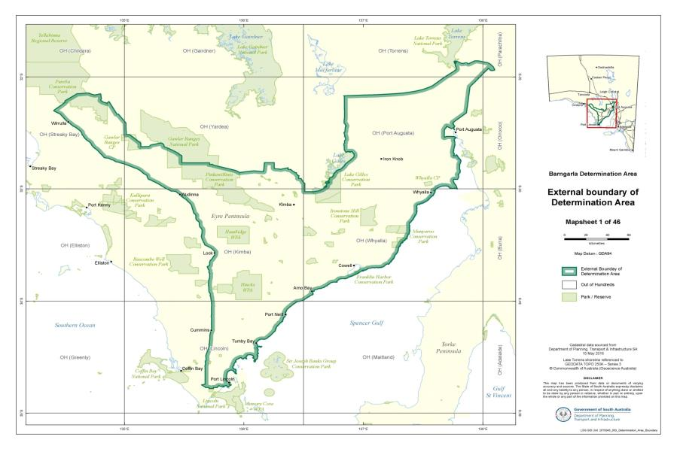

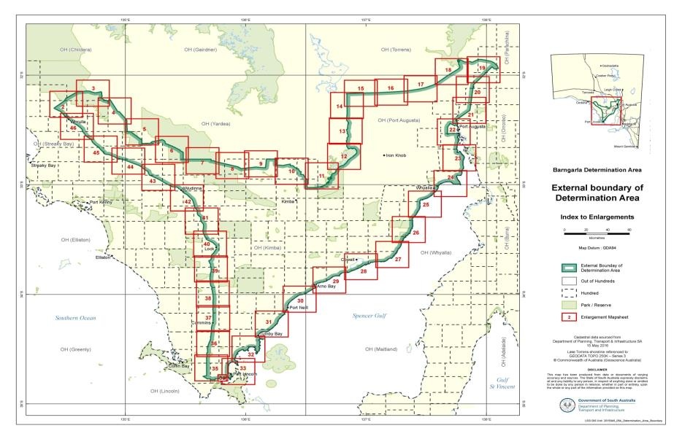

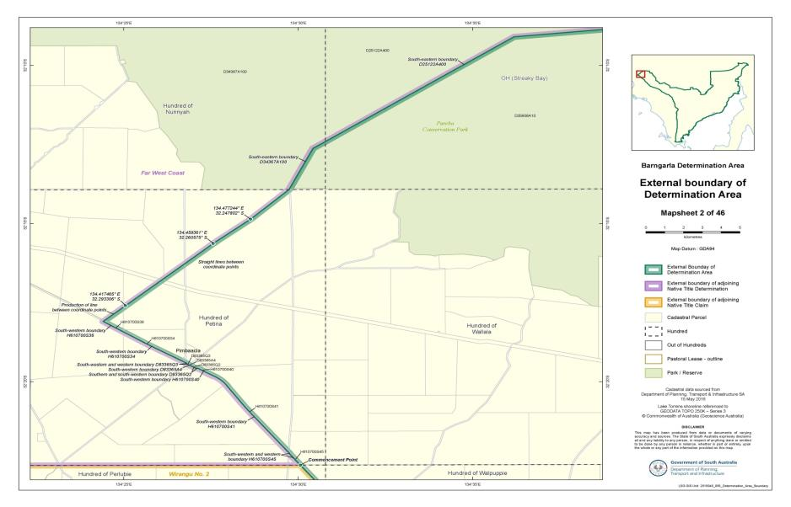

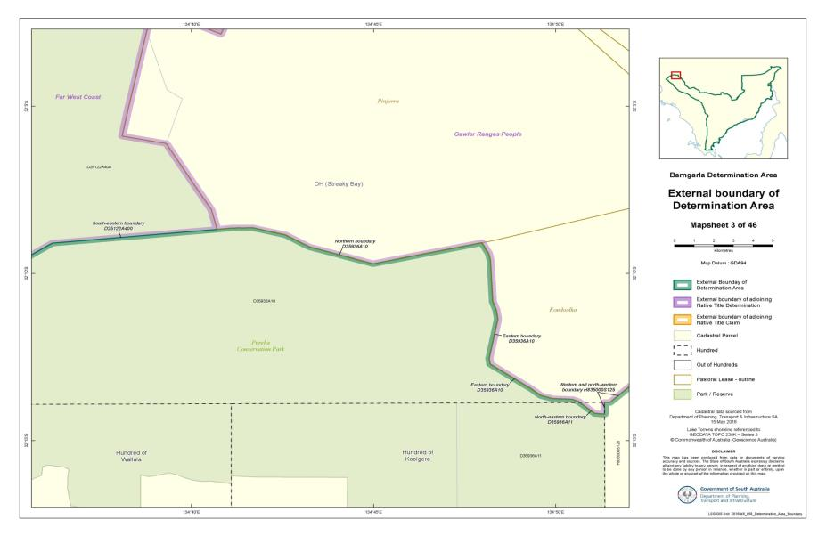

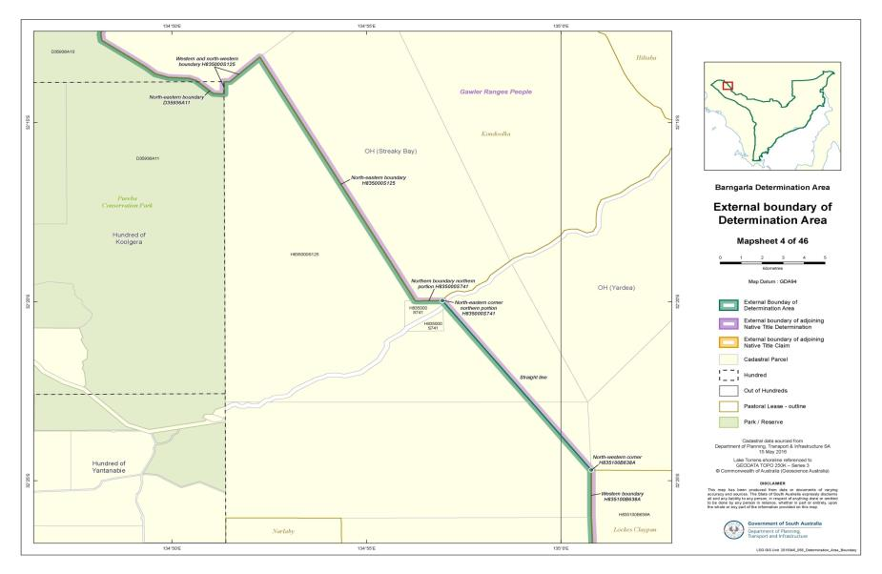

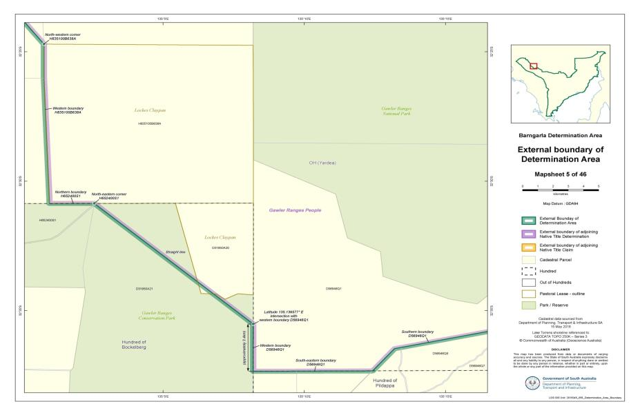

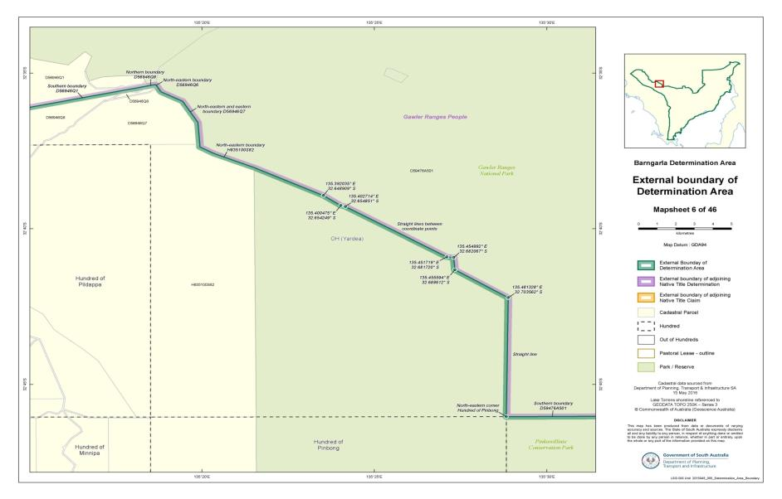

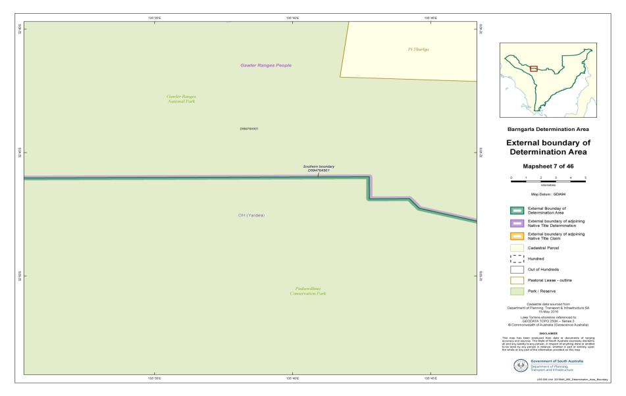

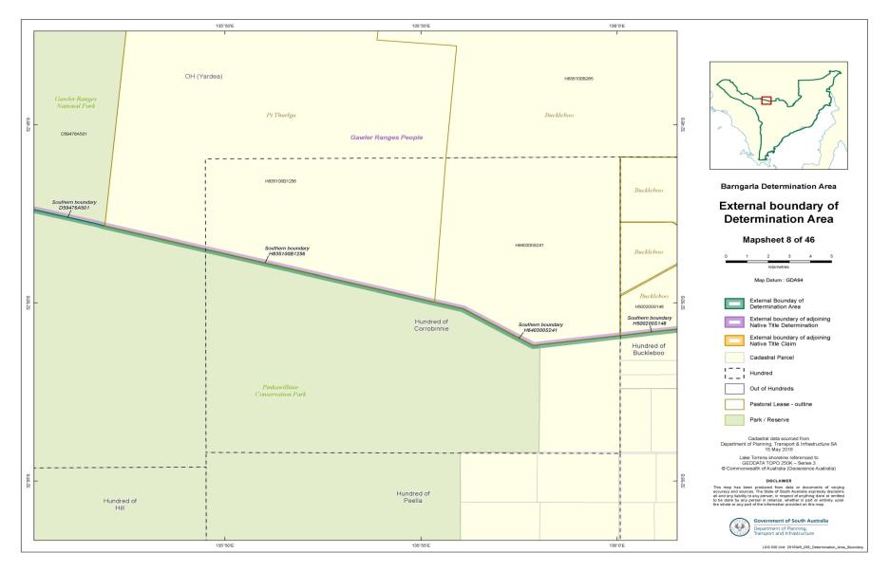

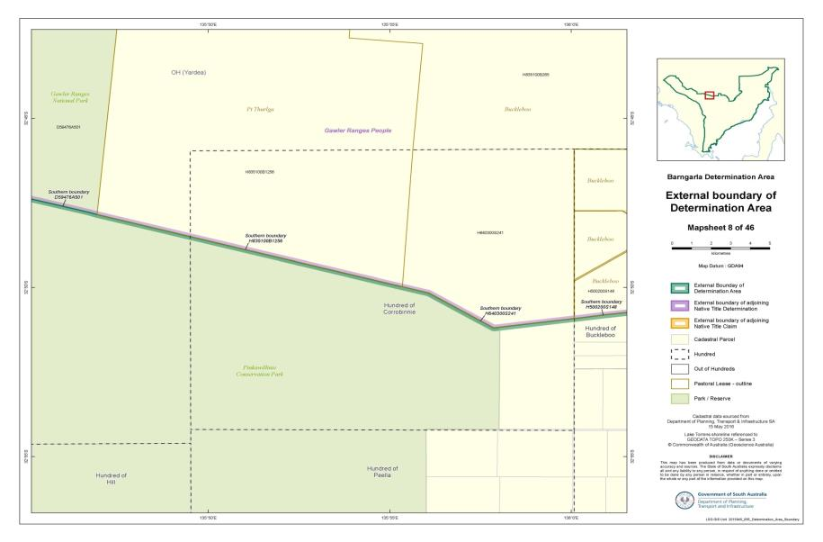

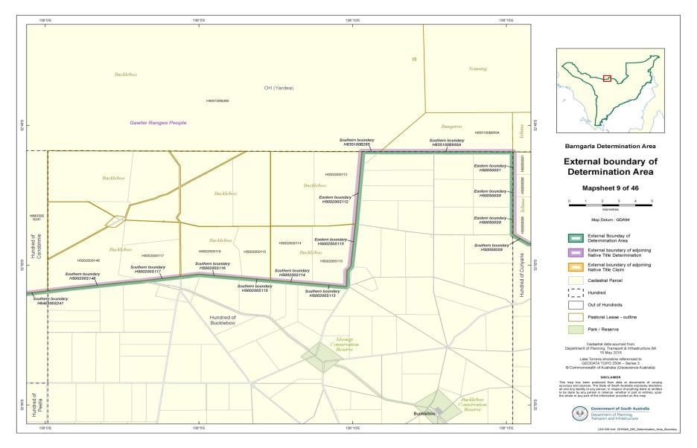

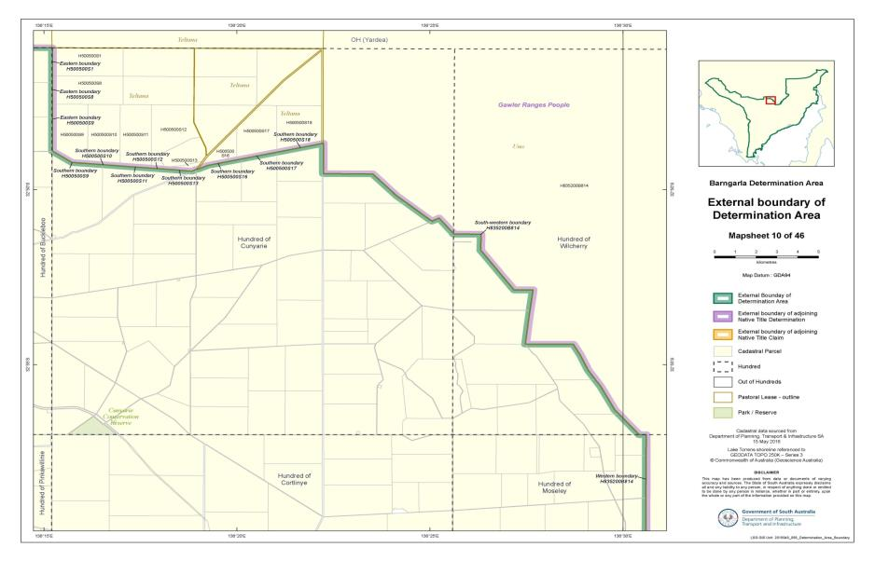

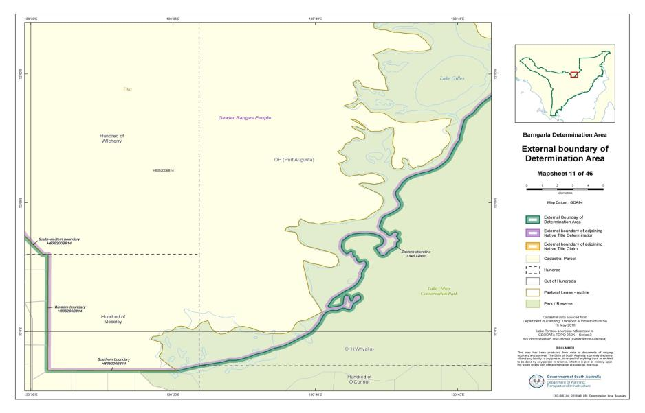

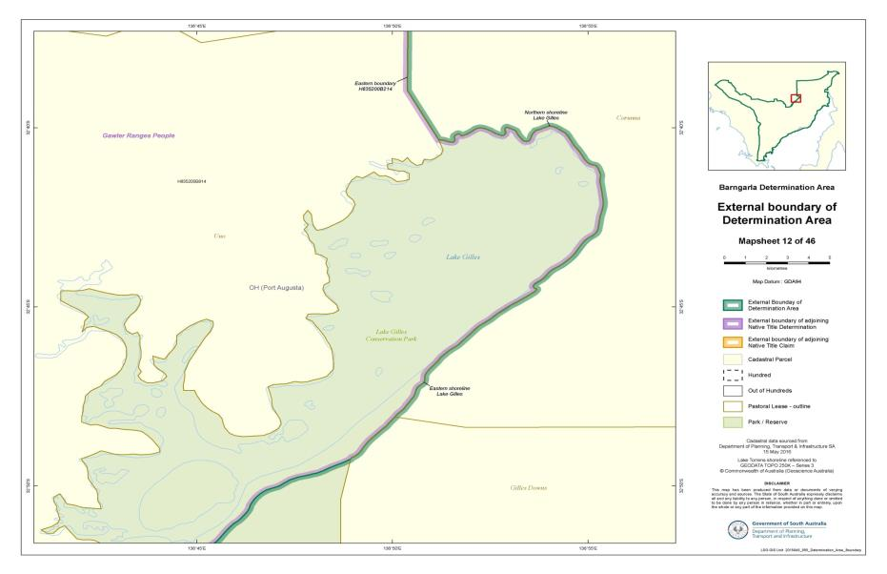

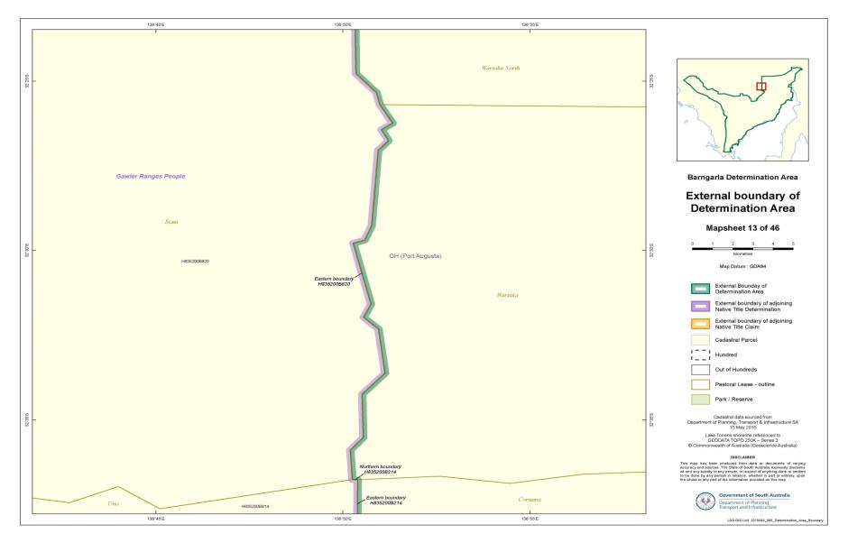

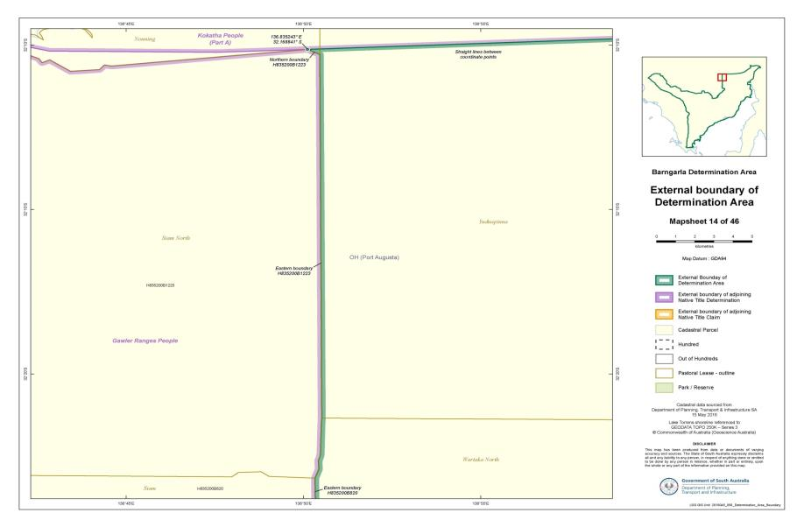

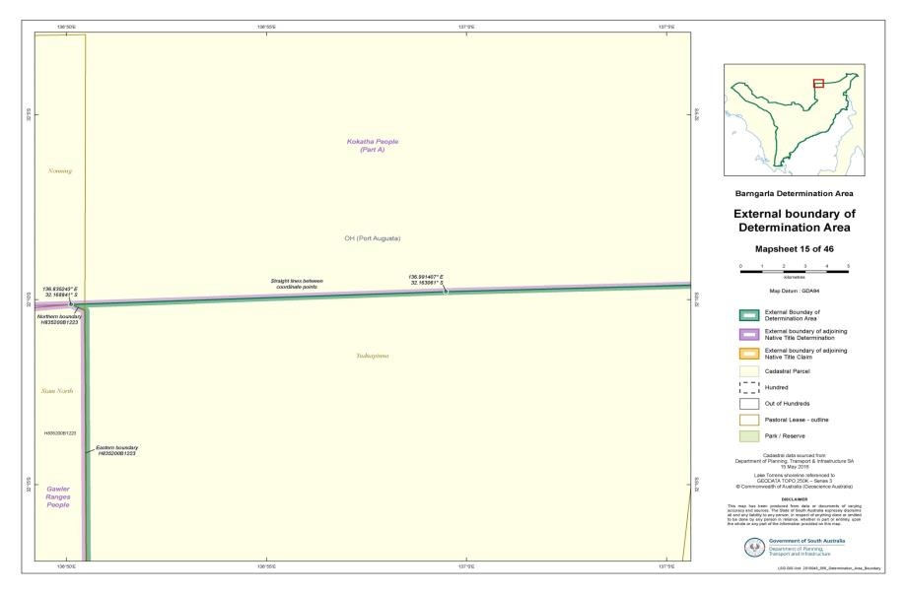

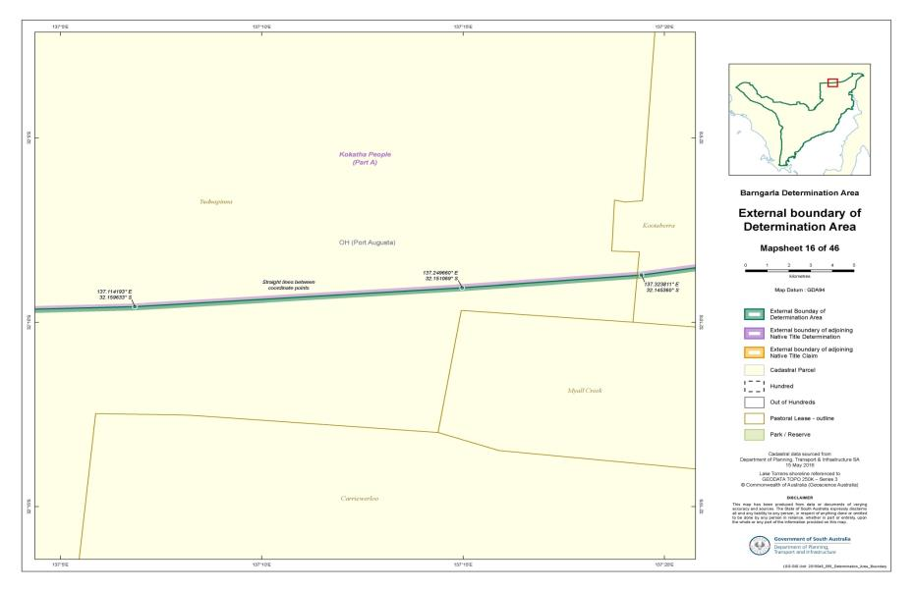

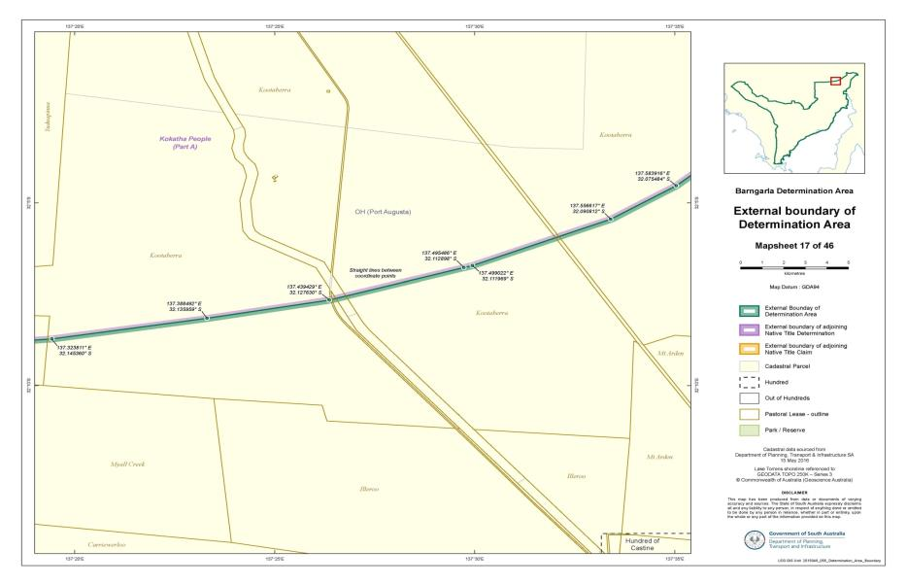

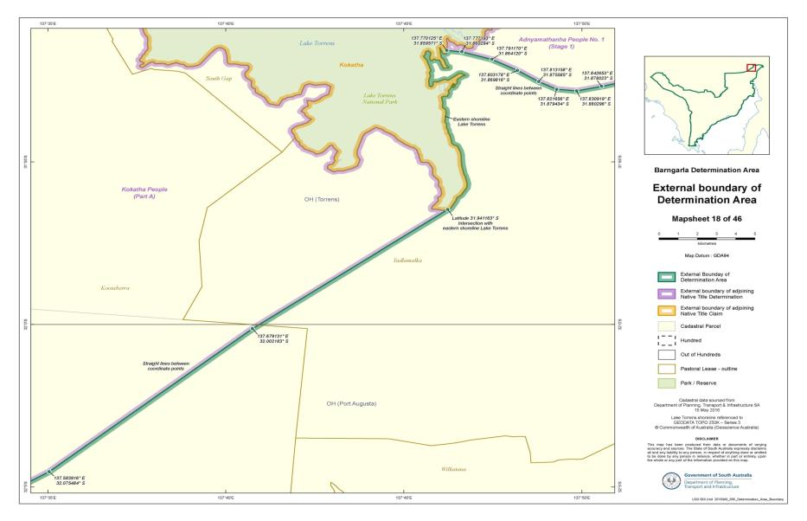

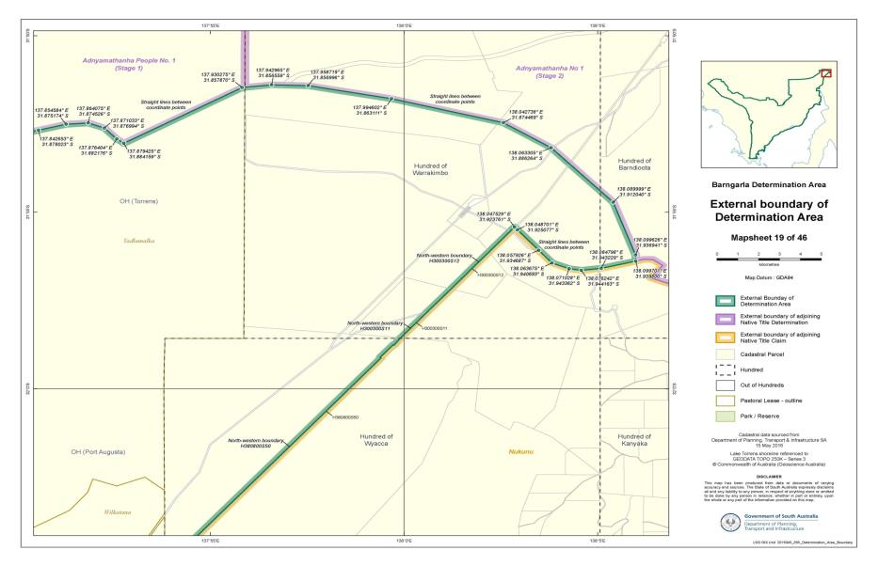

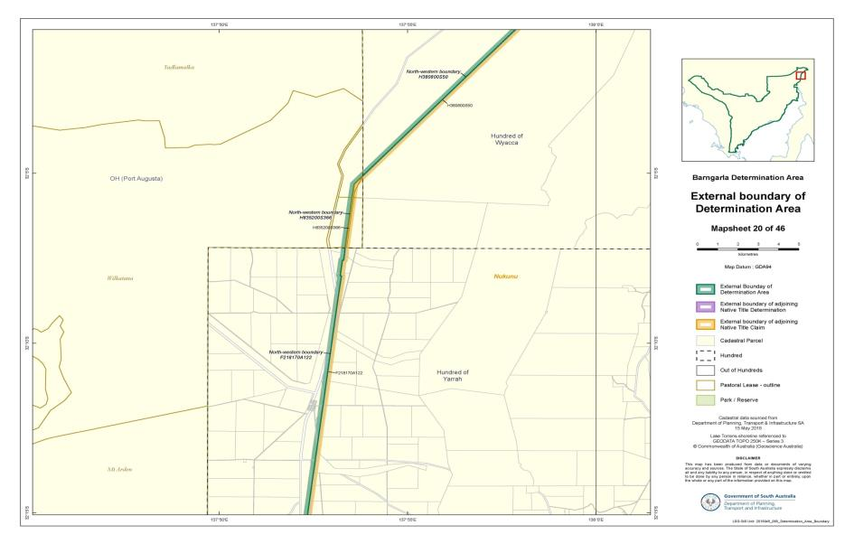

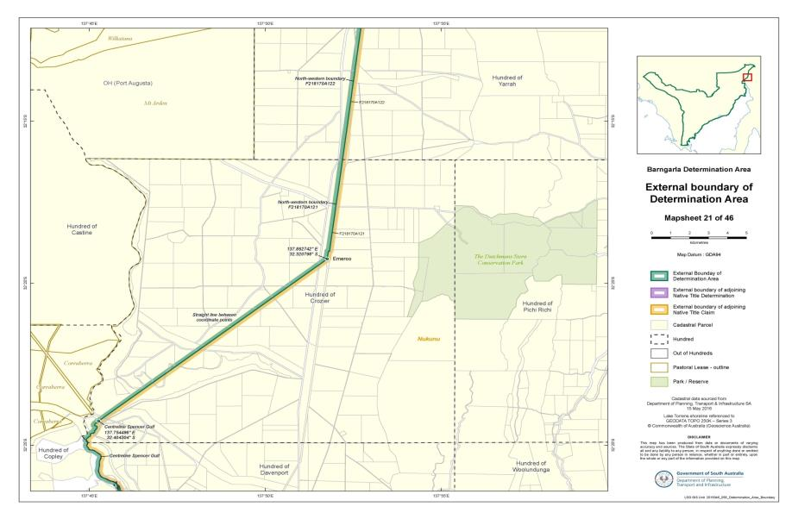

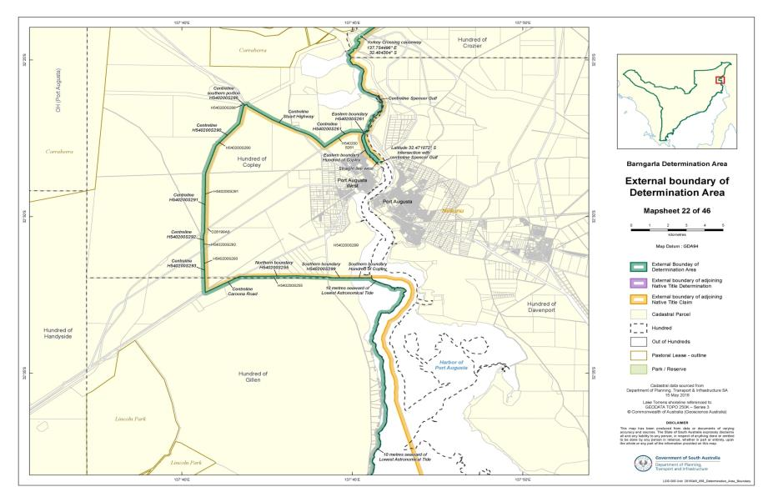

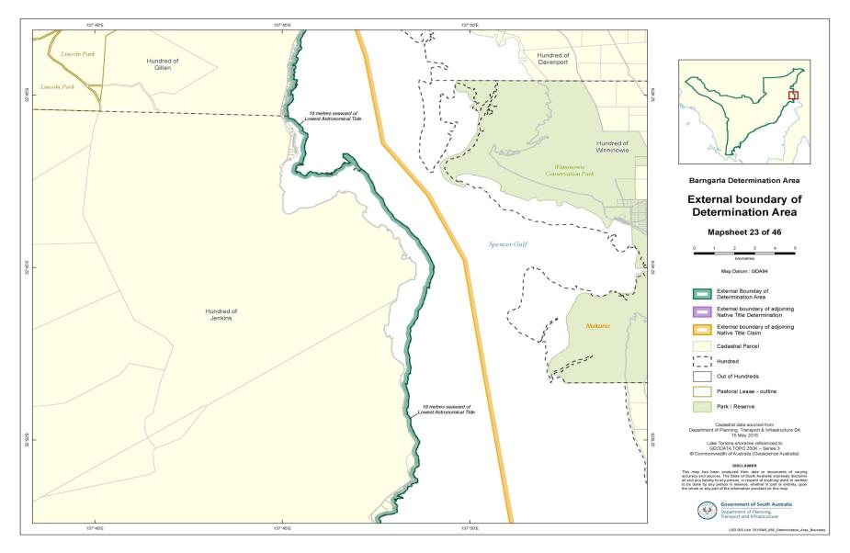

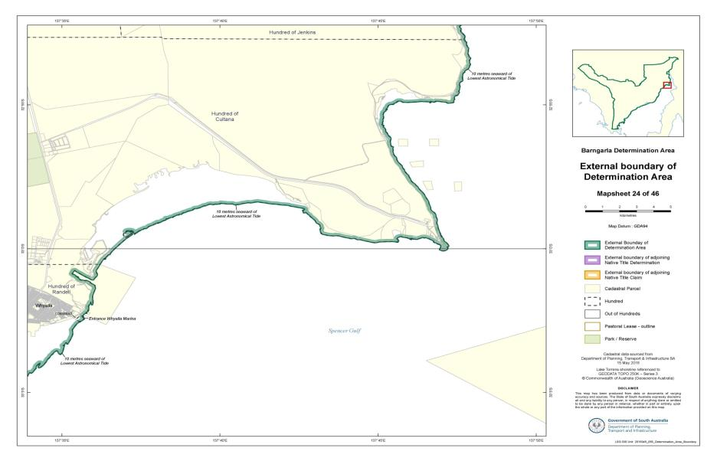

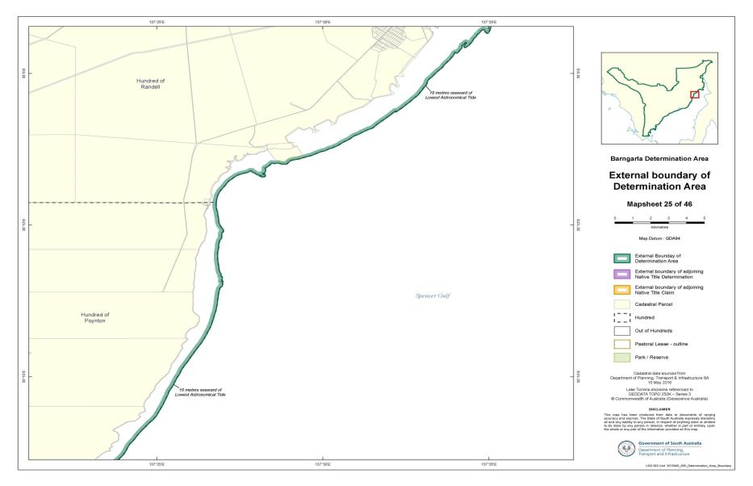

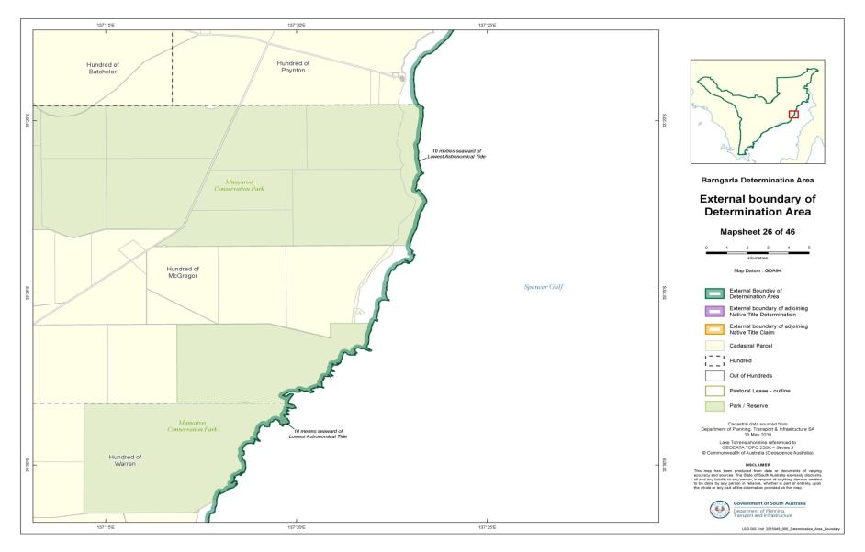

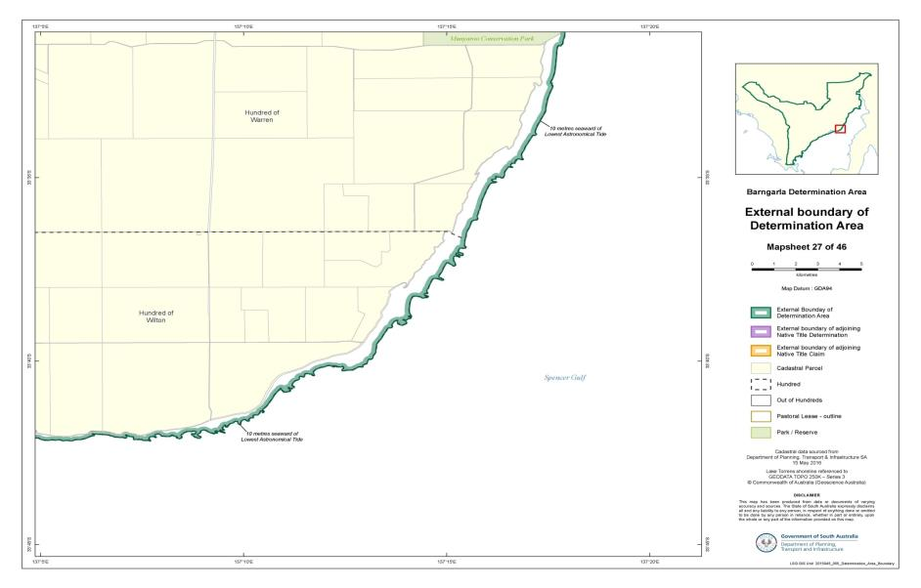

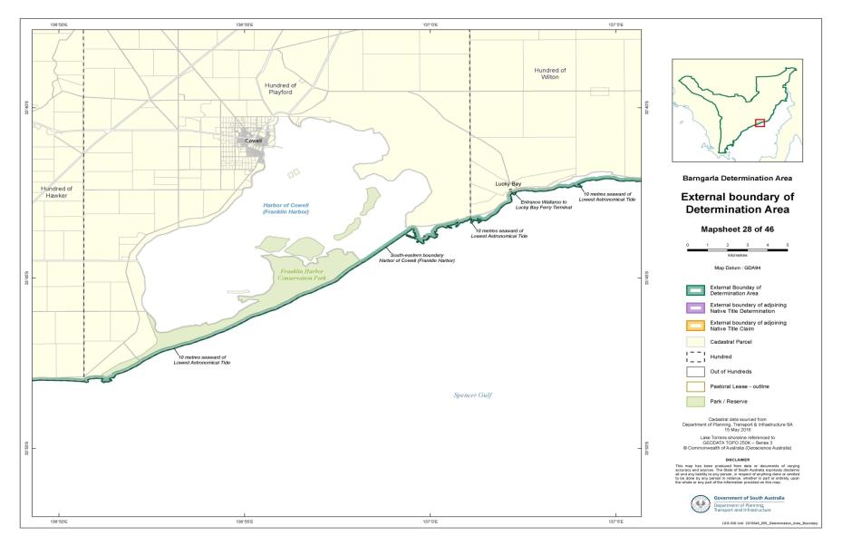

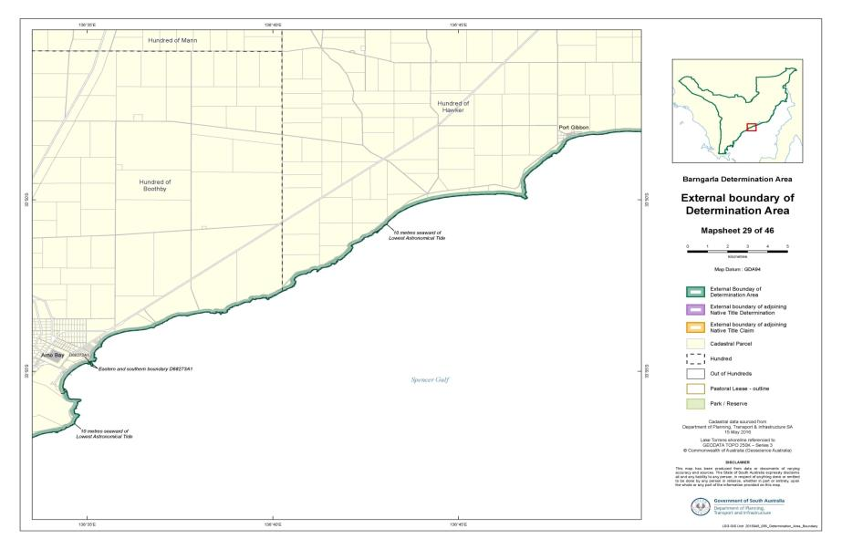

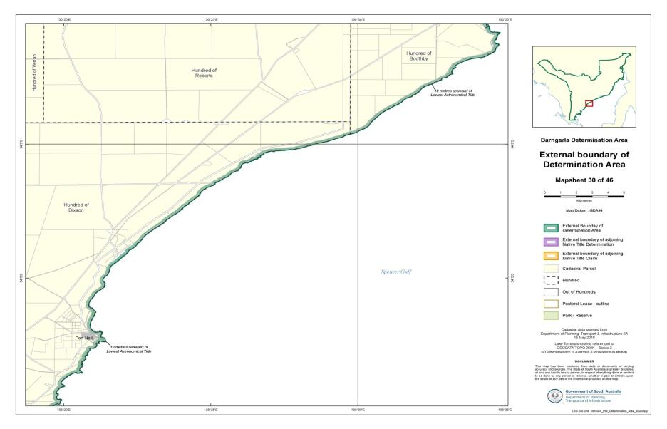

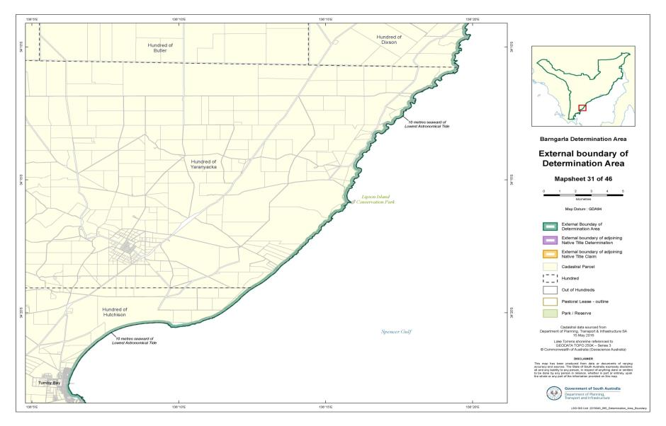

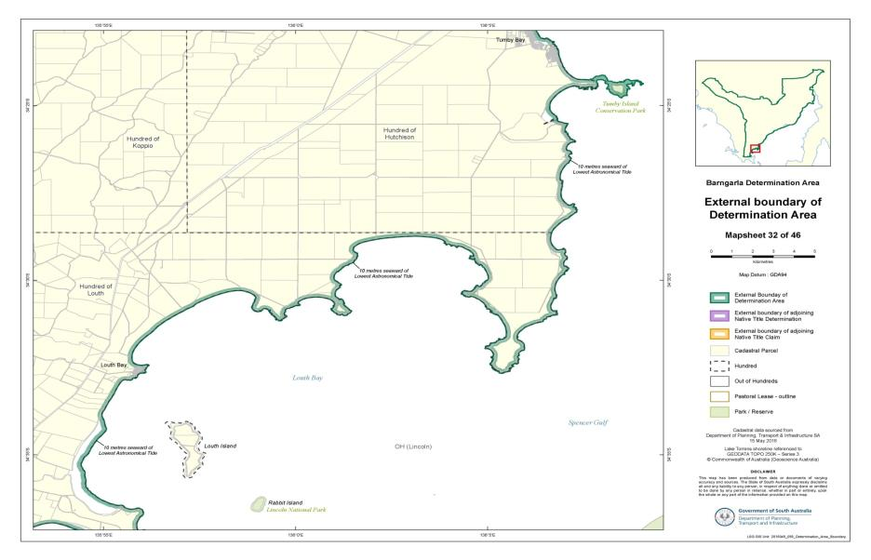

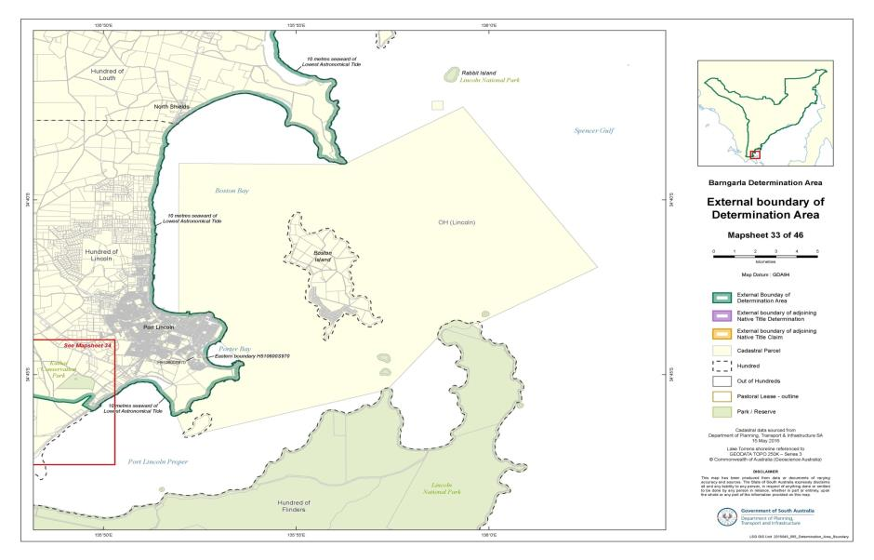

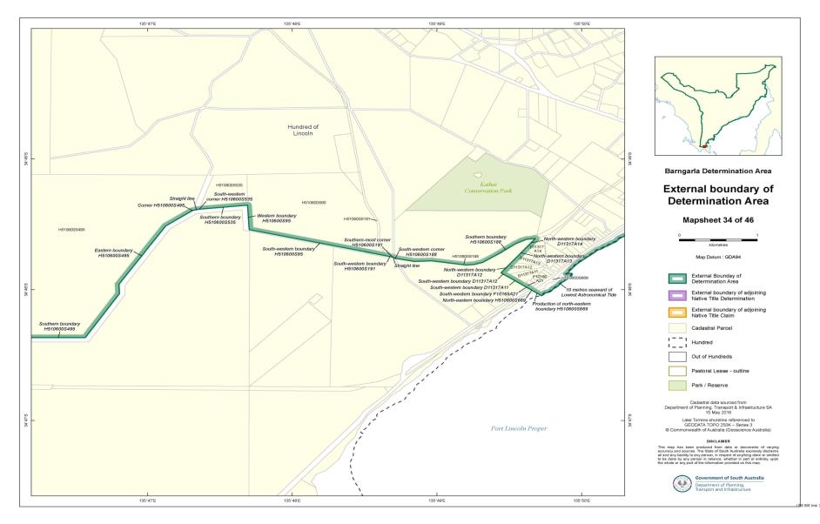

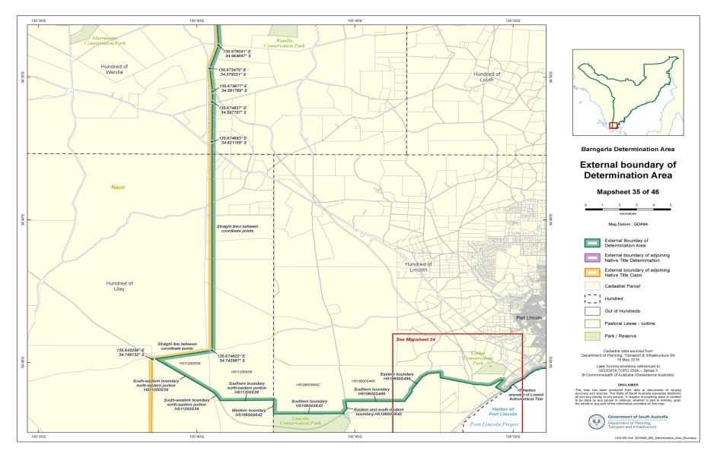

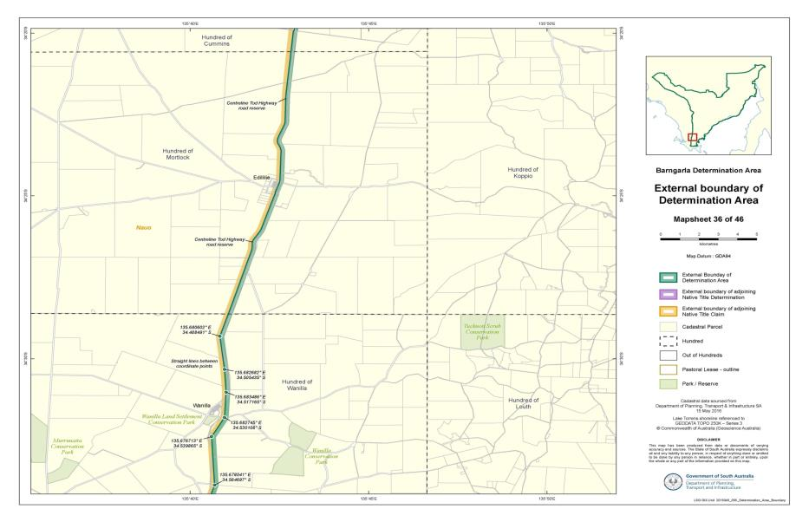

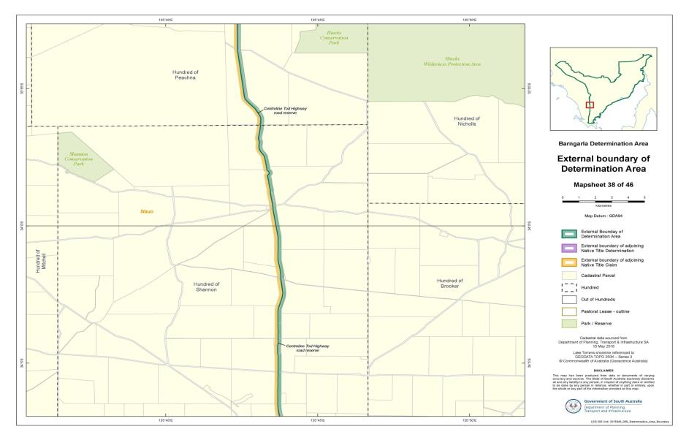

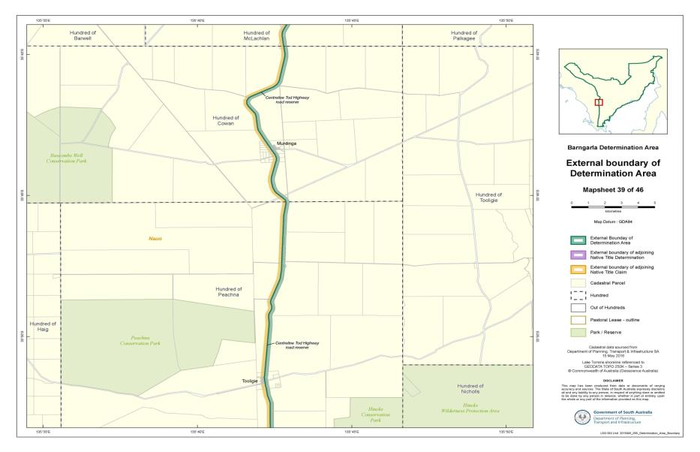

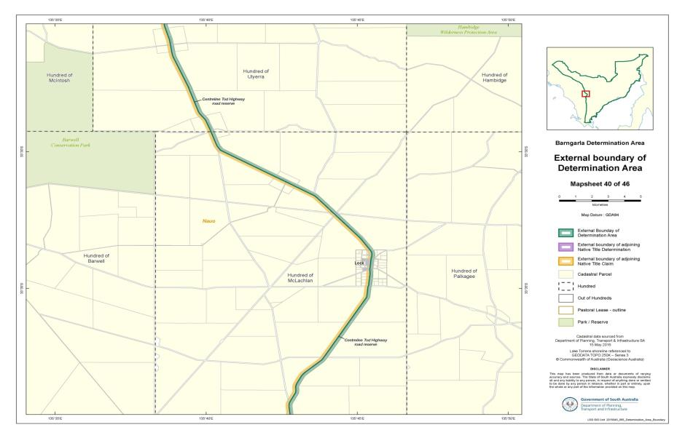

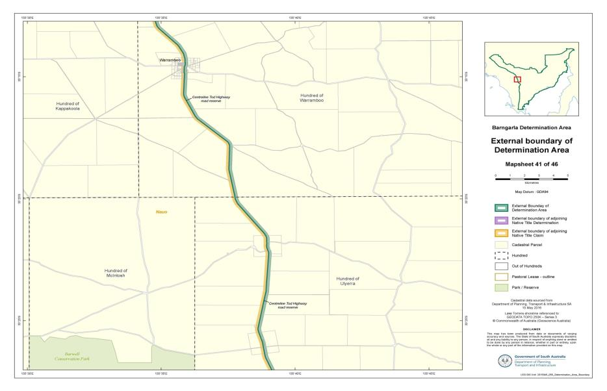

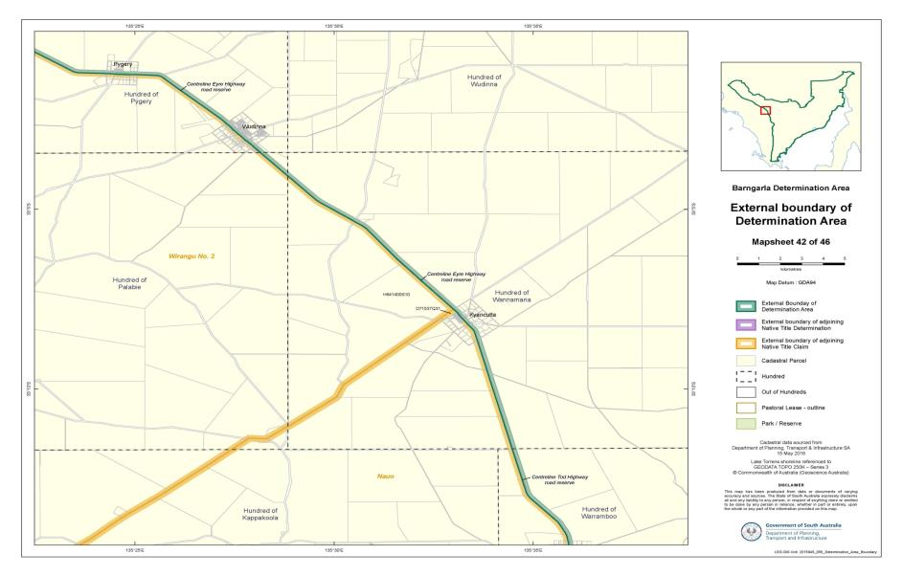

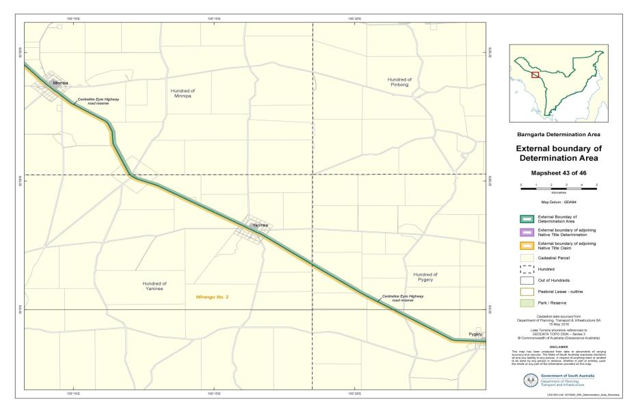

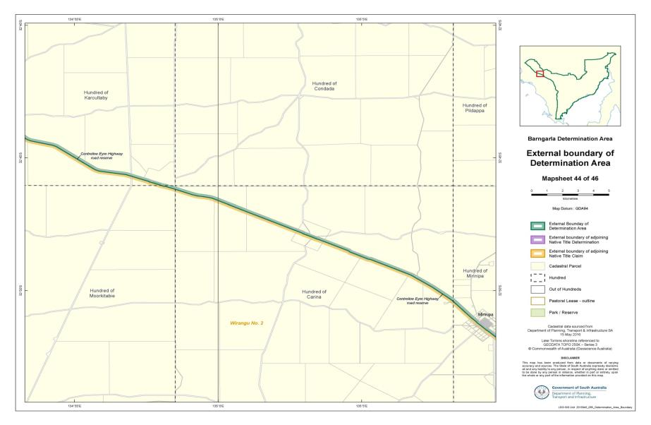

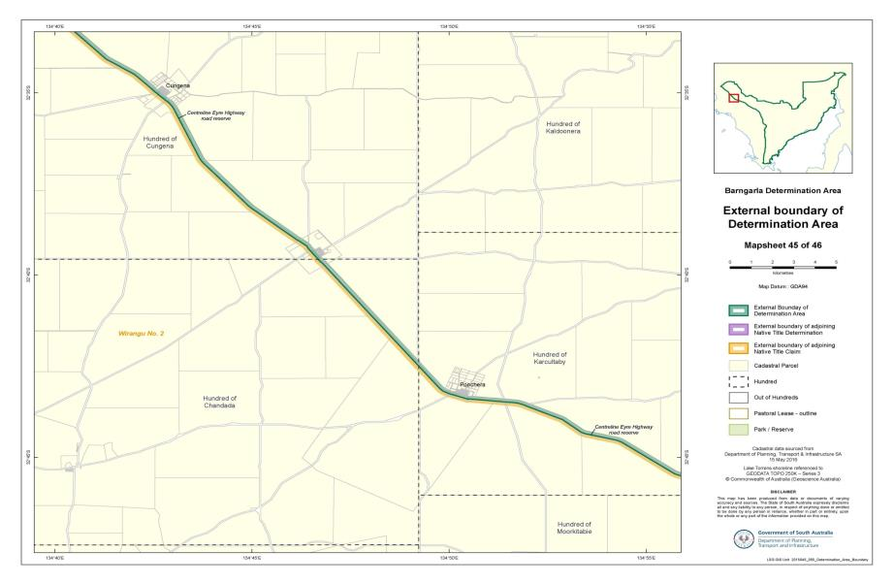

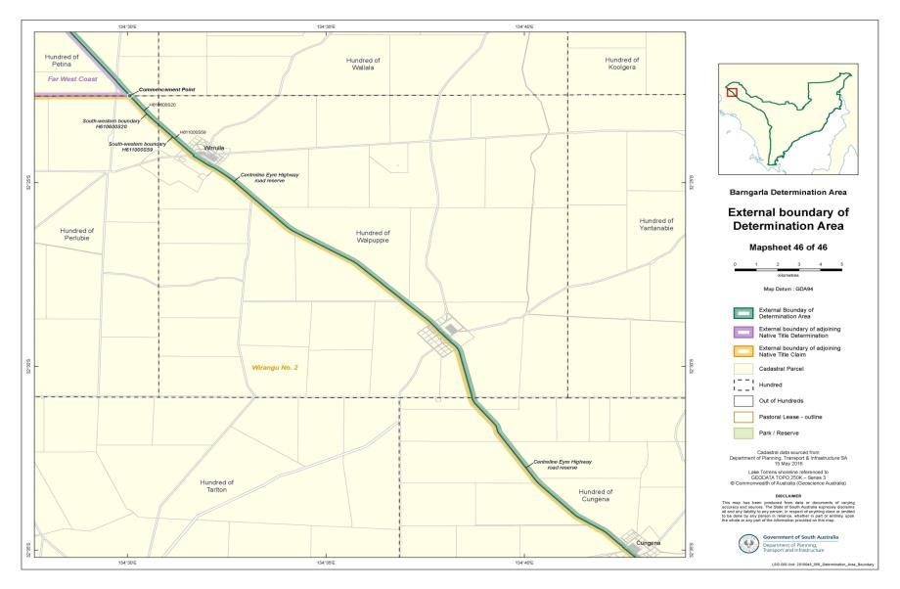

**SCHEDULE 2 - Maps**

Part B: Maps depicting Native Title Land and areas within the Determination Area where native title is extinguished

Please see maps provided separately

**SCHEDULE 3 – land and waters where native title exists (Native Title Land)**

Note: Please refer to Schedule 2 Part B for further detail where a portion of a parcel is indicated

| **Parcel Identifier** | **Hundred** | **Title Reference** | **Schedule** |
| --- | --- | --- | --- |
| H560100S13 | ASH | CR5763/165 | 3 |
| H500100S29 | BARNA | CR5747/671 | 3 |
| H560200S32 | BATCHELOR | CR5763/166 | 3 |
| H530100S42 | BOONERDO | CR5763/48 | 3 |
| H530100S43 | BOONERDO | CR5763/49 | 3 |
| D35379A6 (portion) | BOOTHBY | CR5752/751 | 3, 6 |
| D35379A7 | BOOTHBY | CR5748/780 | 3 |
| D38620A11 | BOOTHBY | CR5748/252 | 3 |
| D38620A12 | BOOTHBY | CR5339/270 | 3 |
| D38620A13 | BOOTHBY | CR5748/253 | 3 |
| D50666A201 (portion) | BOOTHBY | CR5679/897 | 3, 6 |
| D58391A15 (portion) | BOOTHBY | CR5962/940 | 3, 5 |
| D68273Q2 (portion) | BOOTHBY | CR5997/215 | 3, 6 |
| D68273Q3 (portion) | BOOTHBY | CR5997/215 | 3, 6 |
| H530200S312 | BOOTHBY | CR5763/50 | 3 |
| H530200S317 | BOOTHBY | CR5714/806 | 3 |
| H530200S320 | BOOTHBY | CR5757/757 | 3 |
| H530200S321 (portion) | BOOTHBY | CR5861/229 | 3, 6 |
| H530200S338 | BOOTHBY | CR5750/36 | 3 |
| H530200S339 | BOOTHBY | CR5747/692 | 3 |
| H530200S340 | BOOTHBY | CR5747/693 | 3 |
| H530200S341 | BOOTHBY | CR5747/694 | 3 |
| H530200S344 | BOOTHBY | CR5747/695 | 3 |
| H530200S356 | BOOTHBY | CR5755/158 | 3 |
| H530200S357 | BOOTHBY | CR5399/187 | 3 |
| H530200S432 | BOOTHBY | CR5755/159 | 3 |
| D29426A1 | BUCKLEBOO | CR5374/209 | 3 |
| H500200S102 | BUCKLEBOO | CR5762/981 | 3 |
| H500200S39 | BUCKLEBOO | CR5757/905 | 3 |
| H500200S40 (portion) | BUCKLEBOO | CR5757/905 | 3, 6 |
| H500200S89 | BUCKLEBOO | CR5762/980 | 3 |
| T500201A11 | BUCKLEBOO | CR5759/929 | 3 |
| T500201A8 | BUCKLEBOO | CR5759/928 | 3 |
| T500201A9 | BUCKLEBOO | CR5759/928 | 3 |
| H530400S74 | BUTLER | CR5763/51 | 3 |
| D26192A2 (portion) | CARALUE | CR5772/126 | 3, 6 |
| D26192A3 (portion) | CARALUE | CR5772/126 | 3, 6 |
| D37135A2 (portion) | CARALUE | CR5629/598 | 3, 6 |
| D37135A4 | CARALUE | CR5764/682 | 3 |
| H500300S21 | CARALUE | CR5763/12 | 3 |
| H500300S26 | CARALUE | CR5768/453 | 3 |
| H500300S32 | CARALUE | CR5773/858 | 3 |
| H500300S53 | CARALUE | CR5763/13 | 3 |
| H500300S55 | CARALUE | CR5755/50 | 3 |
| H500300S83 | CARALUE | CR5755/51 | 3 |
| T500301A19 | CARALUE | CR5768/454 | 3 |
| T500301A31 | CARALUE | CR5763/14 | 3 |
| T500301A32 | CARALUE | CR5763/15 | 3 |
| H650300S48 | CARINA | CR5768/840 | 3 |
| D47635Q3 | CASTINE | CL1282/43 PE2257 | 3 |
| D47635Q4 | CASTINE | CL1282/43 PE2257 | 3 |
| H540100S11 | CASTINE | CR5763/107 | 3 |
| H650400S92 | CHANDADA | CR5749/656 | 3 |
| H650500S33 | CONDADA | CR5763/292 | 3 |
| H650500S34 | CONDADA | CR5763/293 | 3 |
| H640200S28 | COOTRA | CR5763/255 | 3 |
| H640200S47 | COOTRA | CR5763/256 | 3 |
| H640200S49 | COOTRA | CR5763/257 | 3 |
| H640200S66 | COOTRA | CR5763/258 | 3 |
| H640200S67 | COOTRA | CR5763/259 | 3 |
| D47635Q1 | COPLEY | CL1282/43 PE2257 | 3 |
| D47635Q2 | COPLEY | CL1282/43 PE2257 | 3 |
| D47829Q3 | COPLEY | CR5476/602 | 3 |
| D47829Q4 | COPLEY | CR5476/602 | 3 |
| H540200S214 | COPLEY | CR5272/264 | 3 |
| H540200S245 | COPLEY | CR5440/740 | 3 |
| H540200S250 | COPLEY | CR5435/459 | 3 |
| H540200S283 | COPLEY | CR5619/686 | 3 |
| H540200S284 | COPLEY | CR5619/685 | 3 |
| H540200S285 | COPLEY | CR5619/684 | 3 |
| H540200S286 (portion) | COPLEY | CR5761/989 | 3, 6 |
| H540200S287 | COPLEY | CR5763/109 | 3 |
| H540200S288 | COPLEY | CR5761/990 | 3 |
| H540200S289 | COPLEY | CR5763/110 | 3 |
| H540200S290 (portion) | COPLEY | CR5763/111 | 3, 6 |
| H540200S291 (portion) | COPLEY | CR5763/112 | 3, 6 |
| H540200S296 | COPLEY | CR5767/526 | 3 |
| H540200S297 (portion) | COPLEY | CR5767/527 | 3, 7 |
| H540200S298 | COPLEY | CR5767/528 | 3 |
| H540200S311 | COPLEY | CL1436/40 PE2496 | 3 |
| H540200S312 | COPLEY | CL1436/40 PE2496 | 3 |
| H540200S330 | COPLEY | CR5767/530 | 3 |
| SPENCER GULF (portion) | COPLEY |  | 3,6 |
| H640300S100 (portion) | CORROBINNIE | CR5772/886 | 3, 6 |
| H500400S49 | CORTLINYE | CR5757/906 | 3 |
| H500400S50 | CORTLINYE | CR5757/906 | 3 |
| H500400S87 | CORTLINYE | CR5773/859 | 3 |
| H500400S88 | CORTLINYE | CR5773/859 | 3 |
| H500400S90 | CORTLINYE | CR5773/861 | 3 |
| H500400S91 | CORTLINYE | CR5768/455 | 3 |
| H500400S93 | CORTLINYE | CR5755/52 | 3 |
| H500400S94 | CORTLINYE | CR5756/703 | 3 |
| H500400S95 | CORTLINYE | CR5772/121 | 3 |
| H500400S96 | CORTLINYE | CR5755/53 | 3 |
| H500400S98 | CORTLINYE | CR5773/863 | 3 |
| H550400S31 | COWAN | CR5756/347 | 3 |
| H550400S9 | COWAN | CR5767/537 | 3 |
| T550401A1 | COWAN | CR5763/121 | 3 |
| T550401A14 | COWAN | CR5767/542 | 3 |
| T550401A15 | COWAN | CR5767/543 | 3 |
| T550401A18 | COWAN | CR5767/544 | 3 |
| T550401A19 | COWAN | CR5767/545 | 3 |
| T550401A2 | COWAN | CR5763/122 | 3 |
| T550401A20 | COWAN | CR5767/546 | 3 |
| T550401A21 | COWAN | CR5767/547 | 3 |
| T550401A22 | COWAN | CR5767/548 | 3 |
| T550401A23 | COWAN | CR5767/549 | 3 |
| T550401A26 | COWAN | CR5767/552 | 3 |
| T550401A27 | COWAN | CR5767/553 | 3 |
| T550401A28 | COWAN | CR5750/45 | 3 |
| T550401A3 | COWAN | CR5767/538 | 3 |
| T550401A31 | COWAN | CR5756/349 | 3 |
| T550401A4 | COWAN | CR5767/539 | 3 |
| T550401A5 | COWAN | CR5767/540 | 3 |
| T550401A6 | COWAN | CR5767/541 | 3 |
| T550401A7 | COWAN | CR5763/123 | 3 |
| T550401A8 | COWAN | CR5763/124 | 3 |
| H380200S143 | CROZIER | CR5619/687 | 3 |
| H380200S144 (portion) | CROZIER | CR5747/625 | 3, 6 |
| H380200S145 | CROZIER | CR5768/343 | 3 |
| H380200S150 | CROZIER | CR5762/257 | 3 |
| H380200S152 | CROZIER | CR5762/259 | 3 |
| H380200S155 | CROZIER | CR5762/260 | 3 |
| H380200S159 | CROZIER | CR5768/346 | 3 |
| H380200SGULF (portion) | CROZIER |  | 3, 7 |
| D42001A1 | CULTANA | CR5346/946 | 3 |
| D42001A2 | CULTANA | CR5346/947 | 3 |
| D42001Q10 | CULTANA | CR5346/949 | 3 |
| D42001Q11 | CULTANA | CR5346/949 | 3 |
| D42001Q3 | CULTANA | CR5346/948 | 3 |
| D42001Q5 | CULTANA | CR5346/948 | 3 |
| D42001Q6 | CULTANA | CR5346/949 | 3 |
| D42001Q7 | CULTANA | CR5346/949 | 3 |
| D42001Q8 | CULTANA | CR5346/949 | 3 |
| D42001Q9 | CULTANA | CR5346/949 | 3 |
| D53874A112 (portion) | CULTANA | CR5800/763 | 3, 5 |
| D53874A113 (portion) | CULTANA | CR5800/764 | 3, 5 |
| D53874A114 (portion) | CULTANA | CR5800/765 | 3, 5 |
| D54184Q14 (portion) | CULTANA | CR5966/391 | 3, 6 |
| D55504A124 (portion) | CULTANA | CR5867/224 | 3, 5 |
| D85851A68 | CULTANA | CL1648/75 OM53500 | 3 |
| D85851A69 | CULTANA | CR6140/412 | 3 |
| D85851A72 | CULTANA | CL1648/75 OM53500 | 3 |
| D85851Q70 | CULTANA | CR6140/412 | 3 |
| D85851Q71 | CULTANA | CR6140/412 | 3 |
| D93251A66 | CULTANA | CR6140/94 | 3 |
| D93251A67 | CULTANA | CL1648/75 OM53500 | 3 |
| H560300S14 | CULTANA | CR5438/431 | 3 |
| H560300S4 | CULTANA | CR5752/623 | 3 |
| H560300S42 | CULTANA | CR5768/659 | 3 |
| H560300S43 | CULTANA | CR5750/56 | 3 |
| H560300S44 | CULTANA | CR5768/660 | 3 |
| H560300S46 | CULTANA | CR5768/661 | 3 |
| H560300S47 | CULTANA | CR5241/500 | 3 |
| H560300S48 | CULTANA | CR5768/662 | 3 |
| H560300S49 | CULTANA | CR5768/663 | 3 |
| H560300S50 | CULTANA | CR5768/664 | 3 |
| H560300S51 | CULTANA | CR5768/665 | 3 |
| H560300S84 (portion) | CULTANA | CR5750/57 | 3, 5 |
| H650600S101 | CUNGENA | CR5763/295 | 3 |
| H650600S105 | CUNGENA | CR5755/900 | 3 |
| H650600S41 | CUNGENA | CR5763/294 | 3 |
| H650600S45 | CUNGENA | CR5771/154 | 3 |
| H650600S52 | CUNGENA | CR5771/155 | 3 |
| H650600S53 | CUNGENA | CR5771/156 | 3 |
| H650600S54 | CUNGENA | CR5771/157 | 3 |
| H650600S55 | CUNGENA | CR5771/158 | 3 |
| H650600S56 | CUNGENA | CR5771/159 | 3 |
| H650600S83 | CUNGENA | CR5755/899 | 3 |
| H650600S91 | CUNGENA | CR5771/161 | 3 |
| H650600S92 | CUNGENA | CR5749/659 | 3 |
| H650600S95 | CUNGENA | CR5771/163 | 3 |
| H650600S96 | CUNGENA | CR5749/660 | 3 |
| T650601A13 | CUNGENA | CR5771/165 | 3 |
| T650601A14 | CUNGENA | CR5771/166 | 3 |
| T650601A15 | CUNGENA | CR5771/167 | 3 |
| T650601A16 | CUNGENA | CR5771/168 | 3 |
| T650601A19 | CUNGENA | CR5771/169 | 3 |
| T650601A20 | CUNGENA | CR5771/170 | 3 |
| T650601A21 | CUNGENA | CR5771/171 | 3 |
| T650601A22 | CUNGENA | CR5771/172 | 3 |
| T650601A23 | CUNGENA | CR5771/173 | 3 |
| T650601A24 | CUNGENA | CR5771/174 | 3 |
| T650601A25 | CUNGENA | CR5771/175 | 3 |
| T650601A26 | CUNGENA | CR5771/176 | 3 |
| T650601A27 | CUNGENA | CR5771/177 | 3 |
| T650601A32 | CUNGENA | CR5771/178 | 3 |
| T650601A39 | CUNGENA | CR5771/179 | 3 |
| T650601A42 | CUNGENA | CR5763/298 | 3 |
| T650601A43 | CUNGENA | CR5771/180 | 3 |
| T650601A44 | CUNGENA | CR5771/181 | 3 |
| T650601A45 | CUNGENA | CR5771/182 | 3 |
| T650601A46 | CUNGENA | CR5771/183 | 3 |
| T650601A47 | CUNGENA | CR5763/299 | 3 |
| T650601A48 | CUNGENA | CR5763/300 | 3 |
| T650601A49 | CUNGENA | CR5771/184 | 3 |
| T650601A5 | CUNGENA | CR5755/901 | 3 |
| T650601A50 | CUNGENA | CR5771/185 | 3 |
| T650601A51 | CUNGENA | CR5771/186 | 3 |
| T650601A52 | CUNGENA | CR5771/187 | 3 |
| T650601A53 | CUNGENA | CR5771/188 | 3 |
| T650601A54 | CUNGENA | CR5771/189 | 3 |
| T650601A55 | CUNGENA | CR5771/190 | 3 |
| T650601A56 | CUNGENA | CR5771/191 | 3 |
| T650601A57 | CUNGENA | CR5771/192 | 3 |
| T650601A6 | CUNGENA | CR5755/901 | 3 |
| T650601A61 | CUNGENA | CR5771/193 | 3 |
| T650601A64 | CUNGENA | CR5771/194 | 3 |
| T650601A65 | CUNGENA | CR5771/195 | 3 |
| T650601A66 | CUNGENA | CR5763/301 | 3 |
| T650601A67 | CUNGENA | CR5771/196 | 3 |
| T650601A68 | CUNGENA | CR5771/197 | 3 |
| T650601A69 | CUNGENA | CR5771/198 | 3 |
| T650601A70 | CUNGENA | CR5771/199 | 3 |
| T650601A71 | CUNGENA | CR5771/200 | 3 |
| T650601A72 | CUNGENA | CR5771/201 | 3 |
| T650602A1 | CUNGENA | CR5771/202 | 3 |
| T650602A10 | CUNGENA | CR5771/208 | 3 |
| T650602A11 | CUNGENA | CR5763/303 | 3 |
| T650602A12 | CUNGENA | CR5763/303 | 3 |
| T650602A13 | CUNGENA | CR5771/209 | 3 |
| T650602A14 | CUNGENA | CR5771/210 | 3 |
| T650602A15 | CUNGENA | CR5771/211 | 3 |
| T650602A16 | CUNGENA | CR5771/212 | 3 |
| T650602A17 | CUNGENA | CR5771/213 | 3 |
| T650602A18 | CUNGENA | CR5771/214 | 3 |
| T650602A19 | CUNGENA | CR5771/215 | 3 |
| T650602A2 | CUNGENA | CR5771/203 | 3 |
| T650602A20 | CUNGENA | CR5771/216 | 3 |
| T650602A21 | CUNGENA | CR5771/217 | 3 |
| T650602A22 | CUNGENA | CR5771/218 | 3 |
| T650602A23 | CUNGENA | CR5771/219 | 3 |
| T650602A24 | CUNGENA | CR5771/220 | 3 |
| T650602A25 | CUNGENA | CR5771/221 | 3 |
| T650602A26 | CUNGENA | CR5771/222 | 3 |
| T650602A27 | CUNGENA | CR5771/223 | 3 |
| T650602A28 | CUNGENA | CR5771/224 | 3 |
| T650602A29 | CUNGENA | CR5771/225 | 3 |
| T650602A3 | CUNGENA | CR5771/204 | 3 |
| T650602A30 | CUNGENA | CR5771/226 | 3 |
| T650602A31 | CUNGENA | CR5771/227 | 3 |
| T650602A32 | CUNGENA | CR5771/228 | 3 |
| T650602A33 | CUNGENA | CR5771/229 | 3 |
| T650602A34 | CUNGENA | CR5771/230 | 3 |
| T650602A35 | CUNGENA | CR5771/231 | 3 |
| T650602A36 | CUNGENA | CR5771/232 | 3 |
| T650602A37 | CUNGENA | CR5771/233 | 3 |
| T650602A38 | CUNGENA | CR5771/234 | 3 |
| T650602A39 | CUNGENA | CR5771/235 | 3 |
| T650602A4 | CUNGENA | CR5763/302 | 3 |
| T650602A40 | CUNGENA | CR5771/236 | 3 |
| T650602A41 | CUNGENA | CR5771/237 | 3 |
| T650602A43 | CUNGENA | CR5771/238 | 3 |
| T650602A44 | CUNGENA | CR5771/239 | 3 |
| T650602A45 | CUNGENA | CR5771/240 | 3 |
| T650602A46 | CUNGENA | CR5771/241 | 3 |
| T650602A47 | CUNGENA | CR5771/242 | 3 |
| T650602A48 | CUNGENA | CR5771/243 | 3 |
| T650602A49 | CUNGENA | CR5771/244 | 3 |
| T650602A5 | CUNGENA | CR5763/302 | 3 |
| T650602A50 | CUNGENA | CR5771/245 | 3 |
| T650602A51 | CUNGENA | CR5763/304 | 3 |
| T650602A52 | CUNGENA | CR5763/304 | 3 |
| T650602A53 | CUNGENA | CR5763/304 | 3 |
| T650602A7 | CUNGENA | CR5771/205 | 3 |
| T650602A8 | CUNGENA | CR5771/206 | 3 |
| T650602A9 | CUNGENA | CR5771/207 | 3 |
| H500500S44 | CUNYARIE | CR5757/907 | 3 |
| H500500S68 | CUNYARIE | CR5763/18 | 3 |
| H500500S69 | CUNYARIE | CR5763/19 | 3 |
| H500500S70 | CUNYARIE | CR5763/20 | 3 |
| H500500S73 | CUNYARIE | CR5757/908 | 3 |
| H500500S74 | CUNYARIE | CR5757/908 | 3 |
| H500500S83 | CUNYARIE | CR5763/21 | 3 |
| H500500S99 | CUNYARIE | CR5755/54 | 3 |
| H530700S56 | DARKE | CR5763/53 | 3 |
| H530700S58 | DARKE | CR5772/863 | 3 |
| D38058A1 (portion) | DIXSON | CR5753/675 | 3, 6 |
| D38058A2 (portion) | DIXSON | CR5753/672 | 3, 6 |
| H530800S104 | DIXSON | CR5768/546 | 3 |
| H530800S105 | DIXSON | CR5768/547 | 3 |
| H530800S106 | DIXSON | CR5768/548 | 3 |
| H530800S119 | DIXSON | CR5756/515 | 3 |
| H530800S121 | DIXSON | CR5756/515 | 3 |
| H530800S144 | DIXSON | CR5763/54 | 3 |
| H530800S193 | DIXSON | CR5756/518 | 3 |
| H530800S194 | DIXSON | CR5756/518 | 3 |
| H530800S195 | DIXSON | CR5756/518 | 3 |
| D24577A10 | GILLEN | CR5764/665 | 3 |
| D24577A12 | GILLEN | CR5950/860 | 3 |
| D47645A501 (portion) | GILLEN | CR5704/615 | 3, 5 |
| D47646A502 (portion) | GILLEN | CR5882/798 | 3, 5 |
| D47647A503 (portion) | GILLEN | CR5654/817 | 3, 5 |
| D47648A504 (portion) | GILLEN | CR5859/456 | 3, 5 |
| D47649A505 (portion) | GILLEN | CR5842/493 | 3, 5 |
| D47650A506 (portion) | GILLEN | CR5666/950 | 3, 5 |
| H540300S260 | GILLEN | CR5761/991 | 3 |
| H530900S36 | GLYNN | CR5747/696 | 3 |
| H530900S37 | GLYNN | CR5747/697 | 3 |
| H531000S7 | HAMBIDGE | CR5772/864 | 3 |
| D88907Q4 | HANDYSIDE | CL1281/27 PE2272 | 3 |
| H540400S16 | HANDYSIDE | CR5763/115 | 3 |
| H540400S17 | HANDYSIDE | CR5763/116 | 3 |
| H540400S18 (portion) | HANDYSIDE | CR5761/992 | 3, 6 |
| H540400S19 (portion) | HANDYSIDE | CR5761/993 | 3, 6 |
| H540400S20 | HANDYSIDE | CR5763/117 | 3 |
| H540400S21 | HANDYSIDE | CR5761/994 | 3 |
| H540400S25 | HANDYSIDE | CL1436/40 PE2496 | 3 |
| H540400S26 | HANDYSIDE | CR5763/118 | 3 |
| D67571A14 (portion) | HAWKER | CR5963/684 | 3, 6 |
| H531100S322 | HAWKER | CR5763/55 | 3 |
| H531100S323 | HAWKER | CR5763/56 | 3 |
| H531100S338 | HAWKER | CR5768/556 | 3 |
| H531100S409 | HAWKER | CR5768/557 | 3 |
| H531100S418 | HAWKER | CR5388/431 | 3 |
| H531100S454 | HAWKER | CR5763/57 | 3 |
| H531100S491 | HAWKER | CR5388/432 | 3 |
| H531100S492 | HAWKER | CR5388/433 | 3 |
| H531100S493 | HAWKER | CR5388/434 | 3 |
| H531100S528 | HAWKER | CR5763/59 | 3 |
| H531100S530 | HAWKER | CR5763/60 | 3 |
| H531100S531 | HAWKER | CR5768/561 | 3 |
| H531100S532 | HAWKER | CR5388/435 | 3 |
| H531100S533 | HAWKER | CR5768/562 | 3 |
| H531100S534 | HAWKER | CR5747/698 | 3 |
| H531100S535 | HAWKER | CR5747/699 | 3 |
| H531100S536 | HAWKER | CR5747/700 | 3 |
| H531200S2 | HEGGATON | CR5402/265 | 3 |
| H531200S3 | HEGGATON | CR5402/266 | 3 |
| H531200S4 | HEGGATON | CR5402/267 | 3 |
| H531200S5 | HEGGATON | CR5402/268 | 3 |
| H531200S7 | HEGGATON | CR5402/269 | 3 |
| H640400S10 | HILL | CR5763/261 | 3 |
| H640400S12 | HILL | CR5763/262 | 3 |
| H640400S13 | HILL | CR5763/263 | 3 |
| H640400S23 | HILL | CR5772/887 | 3 |
| H640400S24 | HILL | CR5772/888 | 3 |
| H640400S9 | HILL | CR5763/260 | 3 |
| H531300S2 | HINCKS | CR5772/866 | 3 |
| H510300S103 | HUTCHISON | CR5756/481 | 3 |
| H510300S340 | HUTCHISON | CR5756/484 | 3 |
| H510300S345 | HUTCHISON | CR5768/459 | 3 |
| H510300S346 | HUTCHISON | CR5768/460 | 3 |
| H510300S347 | HUTCHISON | CR5768/461 | 3 |
| H510300S348 | HUTCHISON | CR5768/462 | 3 |
| H510300S349 | HUTCHISON | CR5768/463 | 3 |
| H510300S350 | HUTCHISON | CR5768/464 | 3 |
| H510300S351 | HUTCHISON | CR5768/465 | 3 |
| H510300S352 | HUTCHISON | CR5756/485 | 3 |
| H510300S353 | HUTCHISON | CR5756/485 | 3 |
| H510300S354 | HUTCHISON | CR5768/466 | 3 |
| H510300S355 (portion) | HUTCHISON | CR5768/467 | 3, 5 |
| H510300S357 | HUTCHISON | CR5768/468 | 3 |
| H510300S358 | HUTCHISON | CR5768/469 | 3 |
| H510300S359 | HUTCHISON | CR5768/470 | 3 |
| H510300S360 | HUTCHISON | CR5768/471 | 3 |
| D29397A7 | JENKINS | CL1648/75 OM53500 | 3 |
| D47651A507 (portion) | JENKINS | CR5596/105 | 3, 5 |
| D53874A115 (portion) | JENKINS | CR5800/766 | 3, 5 |
| D53874A116 (portion) | JENKINS | CR5800/767 | 3, 5 |
| D53874A117 (portion) | JENKINS | CR5895/243 | 3, 5 |
| D53874A500 | JENKINS | CR5957/790 | 3 |
| H540500S123 | JENKINS | CR5750/44 | 3 |
| H651200S34 | KALDOONERA | CR5763/313 | 3 |
| H651200S35 | KALDOONERA | CR5763/314 | 3 |
| D61769A155 (portion) | KARCULTABY | CR5898/941 | 3, 6 |
| H651100S68 | KARCULTABY | CR5755/906 | 3 |
| H651100S69 | KARCULTABY | CR5755/907 | 3 |
| H651100S70 (portion) | KARCULTABY | CR5755/907 | 3, 6 |
| H651100S71 (portion) | KARCULTABY | CR5755/907 | 3, 6 |
| H651100S72 (portion) | KARCULTABY | CR5755/907 | 3, 6 |
| H651100S75 | KARCULTABY | CR5763/310 | 3 |
| H651100S80 | KARCULTABY | CR5763/311 | 3 |
| T651102A1 | KARCULTABY | CR5753/855 | 3 |
| T651102A2 | KARCULTABY | CR5753/855 | 3 |
| T651102A29 | KARCULTABY | CR5758/712 | 3 |
| T651102A30 | KARCULTABY | CR5758/712 | 3 |
| T651102A49 | KARCULTABY | CR5763/312 | 3 |
| T651102A62 | KARCULTABY | CR5771/255 | 3 |
| T651102A63 | KARCULTABY | CR5771/256 | 3 |
| T651102A64 | KARCULTABY | CR5771/257 | 3 |
| T651102A65 | KARCULTABY | CR5771/258 | 3 |
| T651102A67 | KARCULTABY | CR5771/259 | 3 |
| T651102A68 | KARCULTABY | CR5771/260 | 3 |
| T651102A71 | KARCULTABY | CR5771/261 | 3 |
| T651102A8 | KARCULTABY | CR5234/180 | 3 |
| T651102A9 | KARCULTABY | CR5234/179 | 3 |
| H500600S122 | KELLY | CR6059/52 | 3 |
| D35936A11 (portion) | KOOLGERA | CR5772/455 | 3, 6 |
| H610400S17 | KOOLGERA | CR5763/193 | 3 |
| H610400S18 | KOOLGERA | CR5763/194 | 3 |
| H640600S19 | KOONGAWA | CR5772/127 | 3 |
| H640600S33 | KOONGAWA | CR5755/16 | 3 |
| H640600S39 | KOONGAWA | CR5772/127 | 3 |
| H640600S40 (portion) | KOONGAWA | CR5772/889 | 3, 6 |
| T640601A13 | KOONGAWA | CR5763/266 | 3 |
| T640601A14 | KOONGAWA | CR5763/267 | 3 |
| T640601A8 | KOONGAWA | CR5763/265 | 3 |
| H510400S147 | KOPPIO | CR5756/503 | 3 |
| H510400S252 | KOPPIO | CR5756/505 | 3 |
| H510400S49 | KOPPIO | CR5756/500 | 3 |
| D37022Q5 (portion) | LINCOLN | CR5752/239 | 3, 6 |
| H510600S509 (portion) | LINCOLN | CR5754/983 | 3, 6 |
| H510600S515 (portion) | LINCOLN | CR5753/934 | 3, 6 |
| H510600S528 (portion) | LINCOLN | CR6060/554 | 3, 6 |
| H510600S645 | LINCOLN | CR5763/32 | 3 |
| H510600S650 | LINCOLN | CR5753/937 | 3 |
| H510600S651 | LINCOLN | CR5763/33 | 3 |
| H510600S652 | LINCOLN | CR5763/34 | 3 |
| H510600S653 | LINCOLN | CR5768/498 | 3 |
| H510600S667 | LINCOLN | CR5757/944 | 3 |
| D30320A4 (portion) | LOUTH | CR5752/777 | 3, 6 |
| D35206A604 (portion) | LOUTH | CR5753/956 | 3, 6 |
| D35206A608 (portion) | LOUTH | CR5752/782 | 3, 6 |
| D48625A51 (portion) | LOUTH | CR5559/70 | 3, 6 |
| D77567A3 | LOUTH | CR6033/75 | 3 |
| H510700S10 | LOUTH | CR5763/36 | 3 |
| H510700S15 | LOUTH | CR5754/987 | 3 |
| H510700S16 | LOUTH | CR5768/502 | 3 |
| H510700S17 (portion) | LOUTH | CR5750/30 | 3, 5 |
| H510700S18 (portion) | LOUTH | CR5750/31 | 3, 5 |
| H510700S20 | LOUTH | CR5747/683 | 3 |
| H510700S22 (portion) | LOUTH | CR5753/956 | 3, 6 |
| H510700S23 | LOUTH | CR5753/956 | 3 |
| H510700S25 (portion) | LOUTH | CR5768/504 | 3, 5 |
| H510700S26 (portion) | LOUTH | CR5768/505 | 3, 5 |
| H510700S28 | LOUTH | CR5747/684 | 3 |
| H510700S29 | LOUTH | CR5768/507 | 3 |
| H510700S37 | LOUTH | CR5747/685 | 3 |
| H510700S40 (portion) | LOUTH | CR5747/686 | 3, 5 |
| H510700S41 | LOUTH | CR5768/509 | 3 |
| H510700S46 | LOUTH | CR5754/987 | 3 |
| H510700S492 | LOUTH | CR5768/511 | 3 |
| H531600S21 | MANGALO | CR5402/272 | 3 |
| H531600S22 | MANGALO | CR5402/273 | 3 |
| H531700S361 (portion) | MANN | CR5758/89 | 3, 6 |
| H531700S373 | MANN | CR5763/61 | 3 |
| H531700S374 | MANN | CR5763/62 | 3 |
| H531700S375 | MANN | CR5763/63 | 3 |
| H531700S377 | MANN | CR5763/64 | 3 |
| H531700S378 | MANN | CR5763/65 | 3 |
| H531700S379 | MANN | CR5763/66 | 3 |
| H531700S380 | MANN | CR5763/67 | 3 |
| H531700S381 | MANN | CR5763/68 | 3 |
| H531700S385 | MANN | CR5763/70 | 3 |
| T533401A251 | MANN | CR5755/187 | 3 |
| D38411A101 | MCGREGOR | CR5773/870 | 3 |
| H531800S13 (portion) | MCGREGOR | CR5772/869 | 3, 6 |
| H531800S14 (portion) | MCGREGOR | CR5772/869 | 3, 6 |
| H531800S33 (portion) | MCGREGOR | CR5747/701 | 3, 6 |
| H551000S114 | MCLACHLAN | CR5758/593 | 3 |
| H531900S107 | MILTALIE | CR5763/72 | 3 |
| H531900S108 | MILTALIE | CR5755/125 | 3 |
| H531900S109 | MILTALIE | CR5763/73 | 3 |
| H532000S135 | MINBRIE | CR5763/74 | 3 |
| H532000S136 | MINBRIE | CR5763/75 | 3 |
| D26238A2 (portion) | MINNIPA | CR5752/770 | 3, 6 |
| H640800S111 (portion) | MINNIPA | CR5324/307 | 3, 6 |
| H640800S112 | MINNIPA | CR5324/308 | 3 |
| H640800S113 (portion) | MINNIPA | CR5324/308 | 3, 6 |
| H640800S26 (portion) | MINNIPA | CR5757/306 | 3, 6 |
| H640800S27 | MINNIPA | CR5757/306 | 3 |
| H640800S28 | MINNIPA | CR5757/306 | 3 |
| H640800S87 | MINNIPA | CR5323/551 | 3 |
| H640800S99 | MINNIPA | CR5767/697 | 3 |
| T640801A100 | MINNIPA | CR5763/271 | 3 |
| T640801A101 | MINNIPA | CR5763/272 | 3 |
| T640801A110 | MINNIPA | CR5767/705 | 3 |
| T640801A111 | MINNIPA | CR5767/706 | 3 |
| T640801A112 | MINNIPA | CR5767/707 | 3 |
| T640801A113 | MINNIPA | CR5767/708 | 3 |
| T640801A114 | MINNIPA | CR5767/709 | 3 |
| T640801A115 | MINNIPA | CR5767/710 | 3 |
| T640801A130 | MINNIPA | CR5767/711 | 3 |
| T640801A131 | MINNIPA | CR5767/712 | 3 |
| T640801A132 | MINNIPA | CR5767/713 | 3 |
| T640801A133 | MINNIPA | CR5767/714 | 3 |
| T640801A134 | MINNIPA | CR5767/715 | 3 |
| T640801A135 | MINNIPA | CR5767/716 | 3 |
| T640801A136 | MINNIPA | CR5767/717 | 3 |
| T640801A137 | MINNIPA | CR5767/718 | 3 |
| T640801A138 | MINNIPA | CR5767/719 | 3 |
| T640801A139 | MINNIPA | CR5767/720 | 3 |
| T640801A140 | MINNIPA | CR5767/721 | 3 |
| T640801A141 | MINNIPA | CR5767/722 | 3 |
| T640801A144 | MINNIPA | CR5767/723 | 3 |
| T640801A145 | MINNIPA | CR5767/724 | 3 |
| T640801A146 | MINNIPA | CR5767/725 | 3 |
| T640801A147 | MINNIPA | CR5767/726 | 3 |
| T640801A149 | MINNIPA | CR5767/727 | 3 |
| T640801A150 | MINNIPA | CR5767/728 | 3 |
| T640801A151 | MINNIPA | CR5767/729 | 3 |
| T640801A152 | MINNIPA | CR5767/730 | 3 |
| T640801A153 | MINNIPA | CR5767/731 | 3 |
| T640801A154 | MINNIPA | CR5767/732 | 3 |
| T640801A156 | MINNIPA | CR5767/733 | 3 |
| T640801A157 | MINNIPA | CR5767/734 | 3 |
| T640801A158 | MINNIPA | CR5767/735 | 3 |
| T640801A159 | MINNIPA | CR5767/736 | 3 |
| T640801A160 | MINNIPA | CR5767/737 | 3 |
| T640801A161 | MINNIPA | CR5767/738 | 3 |
| T640801A79 | MINNIPA | CR5767/698 | 3 |
| T640801A80 | MINNIPA | CR5767/699 | 3 |
| T640801A81 | MINNIPA | CR5767/700 | 3 |
| T640801A82 | MINNIPA | CR5767/701 | 3 |
| T640801A83 | MINNIPA | CR5767/702 | 3 |
| T640801A88 | MINNIPA | CR5763/269 | 3 |
| T640801A89 | MINNIPA | CR5763/270 | 3 |
| T640801A90 | MINNIPA | CR5767/703 | 3 |
| H532100S52 | MOODY | CR5756/521 | 3 |
| D25261A50 | MOONABIE | CR5753/190 | 3 |
| D83666A81 | MOONABIE | CR6059/794 | 3 |
| D83666A82 | MOONABIE | CR6059/795 | 3 |
| D83666A83 | MOONABIE | CR6059/796 | 3 |
| D83666A84 (portion) | MOONABIE | CR6059/797 | 3, 6 |
| D83666A85 | MOONABIE | CR6059/798 | 3 |
| D83666A86 | MOONABIE | CR6059/799 | 3 |
| D83666A87 | MOONABIE | CR6059/800 | 3 |
| D83666A88 | MOONABIE | CR6059/801 | 3 |
| D83666A89 | MOONABIE | CR6059/802 | 3 |
| D83666Q79 | MOONABIE | CR6059/793 | 3 |
| D83666Q80 | MOONABIE | CR6059/793 | 3 |
| H560600S10 | MOONABIE | CR6072/724 | 3 |
| H560600S13 | MOONABIE | CR5768/700 | 3 |
| H560600S7 | MOONABIE | CR5746/473 | 3 |
| H560600S8 | MOONABIE | CR6072/723 | 3 |
| H510800S95 | MORTLOCK | CR5759/930 | 3 |
| H500700S19 | MOSELEY | CR5773/861 | 3 |
| H500700S41 | MOSELEY | CT6085/822 | 3 |
| H500700S57 | MOSELEY | CR5757/918 | 3 |
| H500700S65 | MOSELEY | CR5773/861 | 3 |
| H500700S66 | MOSELEY | CR5773/862 | 3 |
| H500700S67 | MOSELEY | CR5773/862 | 3 |
| H500700S69 | MOSELEY | CR5773/861 | 3 |
| H500700S71 | MOSELEY | CR5773/863 | 3 |
| H532200S13 | MURLONG | CR5763/76 | 3 |
| H532200S25 | MURLONG | CR5772/870 | 3 |
| H532300S11 (portion) | NICHOLLS | CR5772/871 | 3, 6 |
| H532300S12 | NICHOLLS | CR5772/871 | 3 |
| H560700S3 | NILGINEE | CL1648/33 PE2542 | 3 |
| H560700S4 | NILGINEE | CL1648/33 PE2542 | 3 |
| H560700S6 | NILGINEE | CR5768/701 | 3 |
| H500800S10 (portion) | O'CONNOR | CR5775/158 | 3, 6 |
| H500800S11 (portion) | O'CONNOR | CR5775/158 | 3, 6 |
| H500800S12 | O'CONNOR | CR5775/158 | 3 |
| H500800S13 | O'CONNOR | CR5775/158 | 3 |
| H500800S16 (portion) | O'CONNOR | CR5775/158 | 3, 6 |
| H500800S17 | O'CONNOR | CR5775/158 | 3 |
| H500800S2 (portion) | O'CONNOR | CR5775/158 | 3, 6 |
| H500800S33 (portion) | O'CONNOR | CR5775/158 | 3, 6 |
| H500800S34 (portion) | O'CONNOR | CR5775/158 | 3, 6 |
| H500800S35 (portion) | O'CONNOR | CR5775/158 | 3, 6 |
| H500800S38 (portion) | O'CONNOR | CR5775/158 | 3, 6 |
| H500800S40 | O'CONNOR | CR5775/158 | 3 |
| H500800S41 (portion) | O'CONNOR | CR5775/158 | 3, 6 |
| H500800S42 | O'CONNOR | CR5775/158 | 3 |
| H500800S43 | O'CONNOR | CR5775/158 | 3 |
| H500800S8 (portion) | O'CONNOR | CR5775/158 | 3, 6 |
| H835600S364 | OH(KIMBA) | CR5773/876 | 3 |
| H835600S365 | OH(KIMBA) | CR5773/877 | 3 |
| D31606A1 | OH(LINCOLN) | CR5773/900 | 3 |
| D24350A1 (portion) | OH(PORT AUGUSTA) | CR5748/95 | 3, 6 |
| D26331A10 (portion) | OH(PORT AUGUSTA) | CR5435/446 | 3, 5, 6 |
| D26331A11 (portion) | OH(PORT AUGUSTA) | CR5435/445 | 3, 5, 6 |
| D26331A12 (portion) | OH(PORT AUGUSTA) | CR5435/466 | 3, 6 |
| D29397Q10 | OH(PORT AUGUSTA) | CL1648/75 OM53500 | 3 |
| D29397Q11 | OH(PORT AUGUSTA) | CL1648/75 OM53500 | 3 |
| D29397Q8 | OH(PORT AUGUSTA) | CL1648/75 OM53500 | 3 |
| D29397Q9 | OH(PORT AUGUSTA) | CL1648/75 OM53500 | 3 |
| D47635Q5 | OH(PORT AUGUSTA) | CL1282/43 PE2257 | 3 |
| D47707Q1 | OH(PORT AUGUSTA) | CL1296/32 PE2373 | 3 |
| D47707Q2 | OH(PORT AUGUSTA) | CL1296/32 PE2373 | 3 |
| D47707Q3 | OH(PORT AUGUSTA) | CL1296/32 PE2373 | 3 |
| D47707Q5 | OH(PORT AUGUSTA) | CL1296/32 PE2373 | 3 |
| D71557A100 | OH(PORT AUGUSTA) | CR5982/398 | 3 |
| D71557A101 | OH(PORT AUGUSTA) | CR6054/710 | 3 |
| D71557A102 (portion) | OH(PORT AUGUSTA) | CR6054/711 | 3, 6 |
| D72921A1 | OH(PORT AUGUSTA) | CR6058/124 | 3 |
| D85850A33 | OH(PORT AUGUSTA) | CR6140/89 | 3 |
| D85850A34 | OH(PORT AUGUSTA) | CR6140/90 | 3 |
| D85850Q30 | OH(PORT AUGUSTA) | CL1648/75 OM53500 | 3 |
| D85850Q31 | OH(PORT AUGUSTA) | CL1648/75 OM53500 | 3 |
| D85850Q32 | OH(PORT AUGUSTA) | CL1648/75 OM53500 | 3 |
| D85852Q81 | OH(PORT AUGUSTA) | CL1648/75 OM53500 | 3 |
| D85852Q82 | OH(PORT AUGUSTA) | CL1648/75 OM53500 | 3 |
| D85852Q83 | OH(PORT AUGUSTA) | CL1648/75 OM53500 | 3 |
| D85852Q84 | OH(PORT AUGUSTA) | CL1277/23 PE2215 | 3 |
| D85852Q85 | OH(PORT AUGUSTA) | CL1299/37 PE2283 | 3 |
| D85852Q86 (portion) | OH(PORT AUGUSTA) | CL1299/37 PE2283 | 3, 6 |
| D85852Q87 | OH(PORT AUGUSTA) | CL1299/37 PE2283 | 3 |
| D85852Q89 (portion) | OH(PORT AUGUSTA) | CL1277/23 PE2215 | 3, 6 |
| D85852Q90 | OH(PORT AUGUSTA) | CL1277/23 PE2215 | 3 |
| D85852Q91 (portion) | OH(PORT AUGUSTA) | CL1277/23 PE2215 | 3, 6 |
| D85852Q92 (portion) | OH(PORT AUGUSTA) | CL1277/23 PE2215 | 3, 6 |
| D88907A6 | OH(PORT AUGUSTA) | CL1648/75 OM53500 | 3 |
| D88907Q5 (portion) | OH(PORT AUGUSTA) | CL1281/27 PE2272 | 3, 6 |
| D93696A21 | OH(PORT AUGUSTA) | CR6140/886 | 3 |
| F250108A101 | OH(PORT AUGUSTA) | CL1433/10 PE2423 | 3 |
| F250278A104 | OH(PORT AUGUSTA) | CL6161/265 PE2456 | 3 |
| F250345Q1 | OH(PORT AUGUSTA) | CL6166/828 PE2388 | 3 |
| F250345Q2 | OH(PORT AUGUSTA) | CL6166/828 PE2388 | 3 |
| H835100B821 | OH(PORT AUGUSTA) | CL1298/25 PE2328 | 3 |
| H835200B1005 | OH(PORT AUGUSTA) | CL1282/45 PE2274 | 3 |
| H835200B1010 | OH(PORT AUGUSTA) | CL1292/2 PE2332 | 3 |
| H835200B1224 | OH(PORT AUGUSTA) | CL1433/3 PE2423B | 3 |
| H835200B53 (portion) | OH(PORT AUGUSTA) | CL1278/18 PE2218 | 3, 6 |
| H835200B675 (portion) | OH(PORT AUGUSTA) | CL1292/2 PE2332 | 3, 6 |
| H835200B676 | OH(PORT AUGUSTA) | CL1282/45 PE2274 | 3 |
| H835200B679 (portion) | OH(PORT AUGUSTA) | CL1436/40 PE2496 | 3, 6 |
| H835200B811 (portion) | OH(PORT AUGUSTA) | CL1287/7 PE2252 | 3, 6 |
| H835200B878 | OH(PORT AUGUSTA) | CL1290/7 PE2296 | 3 |
| H835200B958 | OH(PORT AUGUSTA) | CR5775/158 | 3 |
| H835200B973 | OH(PORT AUGUSTA) | CL1296/31 PE2372 | 3 |
| H835200S1228 | OH(PORT AUGUSTA) | CR5381/571 | 3 |
| H835200S1420 (portion) | OH(PORT AUGUSTA) | CR5748/3 | 3, 6 |
| H835200S1421 | OH(PORT AUGUSTA) | CR5748/4 | 3 |
| H835200S1441 | OH(PORT AUGUSTA) | CR5769/168 | 3 |
| H835200S1442 | OH(PORT AUGUSTA) | CR5435/457 | 3 |
| H835200S1480 (portion) | OH(PORT AUGUSTA) | CR5764/601 | 3, 6 |
| H835200S1481 (portion) | OH(PORT AUGUSTA) | CR5764/602 | 3, 6 |
| H835200S1482 | OH(PORT AUGUSTA) | CR5764/603 | 3 |
| H835200S1596 | OH(PORT AUGUSTA) | CR5769/169 | 3 |
| H835200S1597 | OH(PORT AUGUSTA) | CR5769/170 | 3 |
| H835200S402 | OH(PORT AUGUSTA) | CR5757/336 | 3 |
| H835200S781 | OH(PORT AUGUSTA) | CR5764/599 | 3 |
| H835200S782 | OH(PORT AUGUSTA) | CR5764/600 | 3 |
| H835200S783 | OH(PORT AUGUSTA) | CR5756/659 | 3 |
| H835200S91 (portion) | OH(PORT AUGUSTA) | CR5759/726 | 3, 6 |
| T835201A16 | OH(PORT AUGUSTA) | CR5764/604 | 3 |
| H835000B1265 | OH(STREAKY BAY) | CL1629/6 PE2531 | 3 |
| H834600B877 | OH(TORRENS) | CL1282/13 PE2277 | 3 |
| H835700S38 (portion) | OH(WHYALLA) | CR5773/862 | 3, 6 |
| H835100S1496 (portion) | OH(YARDEA) | CR5773/875 | 3, 6 |
| H532400S34 | PALKAGEE | CR5758/591 | 3 |
| H500900S27 | PANITYA | CR5755/59 | 3 |
| H500900S28 | PANITYA | CR5755/60 | 3 |
| H500900S29 | PANITYA | CR5772/857 | 3 |
| H532500S100 | PASCOE | CR5772/873 | 3 |
| H532500S102 | PASCOE | CR5755/166 | 3 |
| H532500S104 | PASCOE | CR5772/873 | 3 |
| H532500S107 | PASCOE | CR5755/166 | 3 |
| H532500S108 | PASCOE | CR5755/166 | 3 |
| H532500S109 | PASCOE | CR5755/166 | 3 |
| H532500S110 | PASCOE | CR5755/166 | 3 |
| H532500S111 | PASCOE | CR5763/79 | 3 |
| H532500S112 | PASCOE | CR5763/80 | 3 |
| H532500S113 | PASCOE | CR5763/81 | 3 |
| H532500S114 | PASCOE | CR5763/82 | 3 |
| H532500S116 | PASCOE | CR5772/874 | 3 |
| H532500S117 | PASCOE | CR5763/83 | 3 |
| H532500S118 | PASCOE | CR5763/84 | 3 |
| H532500S119 | PASCOE | CR5763/85 | 3 |
| H532500S91 | PASCOE | CR5763/77 | 3 |
| H532500S92 | PASCOE | CR5763/78 | 3 |
| T532501A1 | PASCOE | CR5768/564 | 3 |
| T532501A10 | PASCOE | CR5763/87 | 3 |
| T532501A11 | PASCOE | CR5763/88 | 3 |
| T532501A14 | PASCOE | CR5768/569 | 3 |
| T532501A15 | PASCOE | CR5768/570 | 3 |
| T532501A16 | PASCOE | CR5763/89 | 3 |
| T532501A17 | PASCOE | CR5763/90 | 3 |
| T532501A18 | PASCOE | CR5768/571 | 3 |
| T532501A2 | PASCOE | CR5768/565 | 3 |
| T532501A20 | PASCOE | CR5768/572 | 3 |
| T532501A21 | PASCOE | CR5768/573 | 3 |
| T532501A22 | PASCOE | CR5768/574 | 3 |
| T532501A23 | PASCOE | CR5768/575 | 3 |
| T532501A24 | PASCOE | CR5768/576 | 3 |
| T532501A25 | PASCOE | CR5768/577 | 3 |
| T532501A26 | PASCOE | CR5768/578 | 3 |
| T532501A27 | PASCOE | CR5768/579 | 3 |
| T532501A28 | PASCOE | CR5768/580 | 3 |
| T532501A29 | PASCOE | CR5768/581 | 3 |
| T532501A3 | PASCOE | CR5768/566 | 3 |
| T532501A30 | PASCOE | CR5768/582 | 3 |
| T532501A31 | PASCOE | CR5768/583 | 3 |
| T532501A32 | PASCOE | CR5768/584 | 3 |
| T532501A33 | PASCOE | CR5768/585 | 3 |
| T532501A34 | PASCOE | CR5768/586 | 3 |
| T532501A35 | PASCOE | CR5768/587 | 3 |
| T532501A36 | PASCOE | CR5768/588 | 3 |
| T532501A37 | PASCOE | CR5768/589 | 3 |
| T532501A38 | PASCOE | CR5768/590 | 3 |
| T532501A39 | PASCOE | CR5768/591 | 3 |
| T532501A4 | PASCOE | CR5768/567 | 3 |
| T532501A40 | PASCOE | CR5768/592 | 3 |
| T532501A41 | PASCOE | CR5768/593 | 3 |
| T532501A42 | PASCOE | CR5768/594 | 3 |
| T532501A43 | PASCOE | CR5768/595 | 3 |
| T532501A44 | PASCOE | CR5768/596 | 3 |
| T532501A45 | PASCOE | CR5768/597 | 3 |
| T532501A46 | PASCOE | CR5768/598 | 3 |
| T532501A47 | PASCOE | CR5768/599 | 3 |
| T532501A48 | PASCOE | CR5768/600 | 3 |
| T532501A49 | PASCOE | CR5768/601 | 3 |
| T532501A5 | PASCOE | CR5768/568 | 3 |
| T532501A50 | PASCOE | CR5768/602 | 3 |
| T532501A51 | PASCOE | CR5768/603 | 3 |
| T532501A52 | PASCOE | CR5768/604 | 3 |
| T532501A53 | PASCOE | CR5768/605 | 3 |
| T532501A54 | PASCOE | CR5768/606 | 3 |
| T532501A55 | PASCOE | CR5763/91 | 3 |
| T532501A56 | PASCOE | CR5763/92 | 3 |
| T532501A57 | PASCOE | CR5763/93 | 3 |
| T532501A58 | PASCOE | CR5763/94 | 3 |
| T532501A9 | PASCOE | CR5763/86 | 3 |
| T532502A11 | PASCOE | CR5759/754 | 3 |
| T532502A61 | PASCOE | CR5768/607 | 3 |
| T532502A62 | PASCOE | CR5768/608 | 3 |
| T532502A63 | PASCOE | CR5768/609 | 3 |
| H551200S31 | PEACHNA | CR5767/572 | 3 |
| H551200S32 | PEACHNA | CR5756/358 | 3 |
| H551200S45 | PEACHNA | CR5763/136 | 3 |
| H551200S46 | PEACHNA | CR5763/137 | 3 |
| H551200S50 | PEACHNA | CR5767/575 | 3 |
| H551200S51 | PEACHNA | CR5767/576 | 3 |
| H641000S3 | PEELLA | CR5772/890 | 3 |
| H610700S100 | PETINA | CR5763/197 | 3 |
| H610700S101 | PETINA | CR5763/198 | 3 |
| H610700S74 | PETINA | CR5749/649 | 3 |
| H600100S17 | PILDAPPA | CR5749/646 | 3 |
| H600100S22 | PILDAPPA | CR5763/184 | 3 |
| H600100S23 | PILDAPPA | CR5763/185 | 3 |
| H600100S41 | PILDAPPA | CR5764/794 | 3 |
| H600100S8 | PILDAPPA | CR5755/14 | 3 |
| H641100S27 | PINBONG | CR5767/741 | 3 |
| H641100S34 | PINBONG | CR5763/273 | 3 |
| H641100S35 | PINBONG | CR5763/274 | 3 |
| H641100S36 | PINBONG | CR5763/275 | 3 |
| H641100S38 | PINBONG | CR5763/276 | 3 |
| H641100S7 | PINBONG | CR5767/740 | 3 |
| H501000S41 | PINKAWILLINIE | CR5757/921 | 3 |
| H501000S42 | PINKAWILLINIE | CR5757/921 | 3 |
| H501000S43 | PINKAWILLINIE | CR5763/23 | 3 |
| H501000S44 | PINKAWILLINIE | CR5763/24 | 3 |
| H501000S45 | PINKAWILLINIE | CR5755/61 | 3 |
| H532600S213 | PLAYFORD | CR5763/95 | 3 |
| H532600S214 | PLAYFORD | CR5763/96 | 3 |
| H532600S232 | PLAYFORD | CR5753/283 | 3 |
| H532600S263 | PLAYFORD | CR5755/129 | 3 |
| H532600S264 | PLAYFORD | CR5755/129 | 3 |
| H532600S266 | PLAYFORD | CR5755/129 | 3 |
| H532600S267 | PLAYFORD | CR5755/129 | 3 |
| H532600S268 | PLAYFORD | CR5755/130 | 3 |
| H532600S288 | PLAYFORD | CR5759/934 | 3 |
| H532600S289 | PLAYFORD | CR5779/738 | 3 |
| H532600S311 | PLAYFORD | CR5750/39 | 3 |
| H532600S312 | PLAYFORD | CR5747/702 | 3 |
| H532600S313 | PLAYFORD | CR5750/40 | 3 |
| H532600S314 | PLAYFORD | CR5747/703 | 3 |
| H532600S316 | PLAYFORD | CR5768/610 | 3 |
| H532600S317 | PLAYFORD | CR5750/41 | 3 |
| H532600S318 | PLAYFORD | CR5768/611 | 3 |
| H532600S319 | PLAYFORD | CR5768/612 | 3 |
| H532600S320 | PLAYFORD | CR5768/613 | 3 |
| H532600S321 | PLAYFORD | CR5750/42 | 3 |
| H532600S322 | PLAYFORD | CR5750/43 | 3 |
| H532600S332 | PLAYFORD | CR5768/614 | 3 |
| H532600S333 | PLAYFORD | CR5768/615 | 3 |
| D39604A2 (portion) | POYNTON | CR5748/258 | 3, 5 |
| D56246A180 (portion) | POYNTON | CR5904/209 | 3, 5 |
| D58443A151 (portion) | POYNTON | CR5876/402 | 3, 5 |
| H560400S60 | POYNTON | CR5768/669 | 3 |
| H560400S61 | POYNTON | CR5539/581 | 3 |
| H560400S62 | POYNTON | CR5539/582 | 3 |
| H560400S64 | POYNTON | CR5763/167 | 3 |
| H560400S65 (portion) | POYNTON | CR5768/670 | 3, 5 |
| H560400S66 (portion) | POYNTON | CR5768/671 | 3, 5 |
| H560400S67 (portion) | POYNTON | CR5768/672 | 3, 5 |
| H560400S68 (portion) | POYNTON | CR5768/673 | 3, 5 |
| H560400S69 (portion) | POYNTON | CR5768/674 | 3, 5 |
| H560400S70 (portion) | POYNTON | CR5768/675 | 3, 5 |
| H560400S71 | POYNTON | CR5539/583 | 3 |
| H641300S132 | PYGERY | CR5925/132 | 3 |
| H641300S137 (portion) | PYGERY | CR5755/24 | 3, 6 |
| H641300S150 | PYGERY | CR5758/599 | 3 |
| H641300S152 | PYGERY | CR5755/27 | 3 |
| H641300S153 | PYGERY | CR5755/27 | 3 |
| H641300S93 | PYGERY | CR5755/21 | 3 |
| T641302A103 | PYGERY | CR5755/34 | 3 |
| T641302A156 | PYGERY | CR5504/323 | 3 |
| H560500S125 | RANDELL | CR5768/678 | 3 |
| H560500S14 | RANDELL | CR5763/168 | 3 |
| H560500S407 | RANDELL | CR5768/680 | 3 |
| H560500S489 | RANDELL | CR5768/688 | 3 |
| H560500S493 | RANDELL | CR5768/691 | 3 |
| T560501A7097 | RANDELL | CR5318/30 | 3 |
| H532800S49 | RUDALL | CR5772/876 | 3 |
| H532800S63 | RUDALL | CR5768/617 | 3 |
| H532800S78 | RUDALL | CR5755/168 | 3 |
| H532800S81 | RUDALL | CR5755/169 | 3 |
| H532800S82 | RUDALL | CR5755/169 | 3 |
| H532800S83 | RUDALL | CR5755/169 | 3 |
| H532800S84 | RUDALL | CR5755/169 | 3 |
| H532800S87 | RUDALL | CR5755/170 | 3 |
| H532800S88 | RUDALL | CR5768/619 | 3 |
| H532800S89 | RUDALL | CR5768/620 | 3 |
| H532800S90 | RUDALL | CR5768/621 | 3 |
| T532801A43 | RUDALL | CR5768/622 | 3 |
| T532801A44 | RUDALL | CR5768/623 | 3 |
| T532801A46 | RUDALL | CR5768/624 | 3 |
| T532801A47 | RUDALL | CR5768/625 | 3 |
| T532801A48 | RUDALL | CR5768/626 | 3 |
| T532801A49 | RUDALL | CR5763/98 | 3 |
| T532801A50 | RUDALL | CR5763/99 | 3 |
| T532801A55 | RUDALL | CR5768/627 | 3 |
| T532801A56 | RUDALL | CR5768/628 | 3 |
| T532801A57 | RUDALL | CR5768/629 | 3 |
| T532801A58 | RUDALL | CR5768/630 | 3 |
| T532801A59 | RUDALL | CR5768/631 | 3 |
| T532801A60 | RUDALL | CR5768/632 | 3 |
| T532801A61 | RUDALL | CR5768/633 | 3 |
| T532801A62 | RUDALL | CR5768/634 | 3 |
| T532801A63 | RUDALL | CR5768/635 | 3 |
| T532801A65 | RUDALL | CR5767/458 | 3 |
| T532801A66 | RUDALL | CR5767/459 | 3 |
| H551400S133 | SHANNON | CR5763/148 | 3 |
| H532900S115 (portion) | SMEATON | CR5757/295 | 3, 6 |
| H532900S88 | SMEATON | CR5767/460 | 3 |
| T532901A1 | SMEATON | CR5763/100 | 3 |
| T532901A12 | SMEATON | CR5763/101 | 3 |
| T532901A13 | SMEATON | CR5753/847 | 3 |
| T532901A14 | SMEATON | CR5753/847 | 3 |
| T532901A2 | SMEATON | CR5763/100 | 3 |
| T532901A20 | SMEATON | CR5767/465 | 3 |
| T532901A29 | SMEATON | CR5767/466 | 3 |
| T532901A3 | SMEATON | CR5767/462 | 3 |
| T532901A30 | SMEATON | CR5767/467 | 3 |
| T532901A31 | SMEATON | CR5767/468 | 3 |
| T532901A32 | SMEATON | CR5767/469 | 3 |
| T532901A33 | SMEATON | CR5767/470 | 3 |
| T532901A34 | SMEATON | CR5767/471 | 3 |
| T532901A35 | SMEATON | CR5767/472 | 3 |
| T532901A36 | SMEATON | CR5767/473 | 3 |
| T532901A37 | SMEATON | CR5767/474 | 3 |
| T532901A38 | SMEATON | CR5767/475 | 3 |
| T532901A39 | SMEATON | CR5767/476 | 3 |
| T532901A4 | SMEATON | CR5767/463 | 3 |
| T532901A40 | SMEATON | CR5767/477 | 3 |
| T532901A41 | SMEATON | CR5767/478 | 3 |
| T532901A42 | SMEATON | CR5767/479 | 3 |
| T532901A44 | SMEATON | CR5767/480 | 3 |
| T532901A45 | SMEATON | CR5767/481 | 3 |
| T532901A46 | SMEATON | CR5767/482 | 3 |
| T532901A47 | SMEATON | CR5767/483 | 3 |
| T532901A48 | SMEATON | CR5767/484 | 3 |
| T532901A49 | SMEATON | CR5767/485 | 3 |
| T532901A50 | SMEATON | CR5767/486 | 3 |
| T532901A51 | SMEATON | CR5767/487 | 3 |
| T532901A52 | SMEATON | CR5767/488 | 3 |
| T532901A53 | SMEATON | CR5767/489 | 3 |
| T532901A54 | SMEATON | CR5767/490 | 3 |
| T532901A55 | SMEATON | CR5767/491 | 3 |
| T532901A56 | SMEATON | CR5767/492 | 3 |
| T532901A57 | SMEATON | CR5767/493 | 3 |
| T532901A58 | SMEATON | CR5767/494 | 3 |
| T532901A59 | SMEATON | CR5767/495 | 3 |
| T532901A60 | SMEATON | CR5767/496 | 3 |
| T532901A61 | SMEATON | CR5767/497 | 3 |
| T532901A62 | SMEATON | CR5767/498 | 3 |
| T532901A63 | SMEATON | CR5767/499 | 3 |
| T532901A64 | SMEATON | CR5767/500 | 3 |
| T532901A65 | SMEATON | CR5767/501 | 3 |
| T532901A66 | SMEATON | CR5767/502 | 3 |
| T532901A67 | SMEATON | CR5763/102 | 3 |
| T532901A68 | SMEATON | CR5763/102 | 3 |
| T532901A69 | SMEATON | CR5767/503 | 3 |
| T532901A70 | SMEATON | CR5767/504 | 3 |
| T532901A71 | SMEATON | CR5767/505 | 3 |
| T532901A72 | SMEATON | CR5767/506 | 3 |
| D38941A100 | SOLOMON | CR5753/198 | 3 |
| D38941A102 (portion) | SOLOMON | CR5752/766 | 3, 6 |
| H501100S119 | SOLOMON | CR5755/63 | 3 |
| H501100S129 | SOLOMON | CR5755/50 | 3 |
| H501100S193 | SOLOMON | CR5757/453 | 3 |
| H501100S198 | SOLOMON | CR5755/65 | 3 |
| H501100S204 | SOLOMON | CR5755/65 | 3 |
| H501100S208 | SOLOMON | CR6098/538 | 3 |
| H501100S209 | SOLOMON | CR5773/866 | 3 |
| H501100S210 | SOLOMON | CR5755/66 | 3 |
| H501100S216 | SOLOMON | CR5755/65 | 3 |
| H501100S220 (portion) | SOLOMON | CR5755/68 | 3, 6 |
| H501100S221 | SOLOMON | CR5756/703 | 3 |
| H501100S222 | SOLOMON | CR5772/123 | 3 |
| H501100S226 | SOLOMON | CR5772/124 | 3 |
| H501100S228 | SOLOMON | CR5772/125 | 3 |
| H501100S229 | SOLOMON | CR5755/69 | 3 |
| H501100S230 | SOLOMON | CR5755/70 | 3 |
| H501100S233 | SOLOMON | CR6098/539 | 3 |
| T501101A195 | SOLOMON | CR5755/71 | 3 |
| H511000S116 | STOKES | CR5756/506 | 3 |
| H511000S117 | STOKES | CR5756/507 | 3 |
| H533000S49 | TOOLIGIE | CR5763/103 | 3 |
| H551800S60 | ULYERRA | CR5758/595 | 3 |
| H551800S61 | ULYERRA | CR5758/595 | 3 |
| H533100S62 | VERRAN | CR5767/507 | 3 |
| H533100S71 | VERRAN | CR5772/878 | 3 |
| H533100S85 | VERRAN | CR5767/508 | 3 |
| H533100S86 | VERRAN | CR5767/509 | 3 |
| H533100S87 | VERRAN | CR5767/510 | 3 |
| H533100S88 | VERRAN | CR5755/175 | 3 |
| H533100S89 | VERRAN | CR5767/511 | 3 |
| H533100S90 | VERRAN | CR5767/512 | 3 |
| H533100S91 (portion) | VERRAN | CR5767/513 | 3, 6 |
| H533100S92 | VERRAN | CR5755/176 | 3 |
| H533100S93 (portion) | VERRAN | CR5755/177 | 3, 6 |
| H610900S34 | WALLALA | CR5763/199 | 3 |
| H610900S35 | WALLALA | CR5763/200 | 3 |
| D62518A157 | WALPUPPIE | CR5901/291 | 3 |
| H611000S24 | WALPUPPIE | CR5768/721 | 3 |
| H611000S52 | WALPUPPIE | CR5768/722 | 3 |
| H611000S62 | WALPUPPIE | CR5755/895 | 3 |
| H611000S92 | WALPUPPIE | CR5755/897 | 3 |
| H611000S96 | WALPUPPIE | CR5901/292 | 3 |
| H611000S97 | WALPUPPIE | CR5901/292 | 3 |
| T611001A100 | WALPUPPIE | CR5763/202 | 3 |
| T611001A101 | WALPUPPIE | CR5763/203 | 3 |
| T611001A26 | WALPUPPIE | CR5768/725 | 3 |
| T611001A61 | WALPUPPIE | CR5763/201 | 3 |
| T611001A65 | WALPUPPIE | CR5768/728 | 3 |
| T611001A84 | WALPUPPIE | CR5753/850 | 3 |
| T611002A11 | WALPUPPIE | CR5763/204 | 3 |
| T611002A12 | WALPUPPIE | CR5763/205 | 3 |
| T611002A20 | WALPUPPIE | CR5768/729 | 3 |
| T611002A21 | WALPUPPIE | CR5768/730 | 3 |
| T611002A22 | WALPUPPIE | CR5768/731 | 3 |
| T611002A23 | WALPUPPIE | CR5768/732 | 3 |
| T611002A24 | WALPUPPIE | CR5768/733 | 3 |
| T611002A25 | WALPUPPIE | CR5768/734 | 3 |
| T611002A26 | WALPUPPIE | CR5768/735 | 3 |
| T611002A27 | WALPUPPIE | CR5768/736 | 3 |
| T611002A28 | WALPUPPIE | CR5768/737 | 3 |
| T611002A29 | WALPUPPIE | CR5753/851 | 3 |
| T611002A30 | WALPUPPIE | CR5753/851 | 3 |
| T611002A32 | WALPUPPIE | CR5768/738 | 3 |
| T611002A33 | WALPUPPIE | CR5768/739 | 3 |
| T611002A34 | WALPUPPIE | CR5768/740 | 3 |
| T611002A35 | WALPUPPIE | CR5768/741 | 3 |
| T611002A37 | WALPUPPIE | CR5768/742 | 3 |
| T611002A38 | WALPUPPIE | CR5768/743 | 3 |
| T611002A39 | WALPUPPIE | CR5768/744 | 3 |
| T611002A40 | WALPUPPIE | CR5768/745 | 3 |
| T611002A41 | WALPUPPIE | CR5768/746 | 3 |
| T611002A42 | WALPUPPIE | CR5763/206 | 3 |
| T611002A45 | WALPUPPIE | CR5768/747 | 3 |
| T611002A46 | WALPUPPIE | CR5768/748 | 3 |
| T611002A47 | WALPUPPIE | CR5768/749 | 3 |
| T611002A49 | WALPUPPIE | CR5759/776 | 3 |
| T611002A5 | WALPUPPIE | CR5759/774 | 3 |
| T611002A50 | WALPUPPIE | CR5768/750 | 3 |
| T611002A51 | WALPUPPIE | CR5768/750 | 3 |
| T611002A52 | WALPUPPIE | CR5768/750 | 3 |
| T611002A53 | WALPUPPIE | CR5768/750 | 3 |
| T611002A54 | WALPUPPIE | CR5768/750 | 3 |
| T611002A55 | WALPUPPIE | CR5768/751 | 3 |
| T611002A56 | WALPUPPIE | CR5768/752 | 3 |
| T611002A57 | WALPUPPIE | CR5768/753 | 3 |
| T611002A58 | WALPUPPIE | CR5768/754 | 3 |
| T611002A59 | WALPUPPIE | CR5768/755 | 3 |
| T611002A6 | WALPUPPIE | CR5759/775 | 3 |
| T611002A60 | WALPUPPIE | CR5768/756 | 3 |
| T611002A61 | WALPUPPIE | CR5768/757 | 3 |
| T611002A62 | WALPUPPIE | CR5768/758 | 3 |
| T611002A63 | WALPUPPIE | CR5768/759 | 3 |
| T611002A64 | WALPUPPIE | CR5768/760 | 3 |
| T611002A65 | WALPUPPIE | CR5768/761 | 3 |
| T611002A66 | WALPUPPIE | CR5768/762 | 3 |
| T611002A67 | WALPUPPIE | CR5768/763 | 3 |
| T611002A68 | WALPUPPIE | CR5768/764 | 3 |
| T611002A69 | WALPUPPIE | CR5768/765 | 3 |
| T611002A70 | WALPUPPIE | CR5768/766 | 3 |
| T611002A71 | WALPUPPIE | CR5768/767 | 3 |
| T611002A72 | WALPUPPIE | CR5768/768 | 3 |
| H641400S23 | WANNAMANA | CR5767/743 | 3 |
| H641400S87 | WANNAMANA | CR5755/35 | 3 |
| H300300S13 | WARRAKIMBO | CR5761/436 | 3 |
| H300300S15 | WARRAKIMBO | CR5761/438 | 3 |
| H300300S16 | WARRAKIMBO | CR5761/439 | 3 |
| H300300S17 (portion) | WARRAKIMBO | CR5761/440 | 3, 6 |
| H300300S18 (portion) | WARRAKIMBO | CR5761/441 | 3, 6 |
| H641500S106 | WARRAMBOO | CR5755/43 | 3 |
| H641500S41 | WARRAMBOO | CR5763/282 | 3 |
| D38411A102 (portion) | WARREN | CR5773/870 | 3, 6 |
| H533200S43 | WARREN | CR5767/514 | 3 |
| H533200S44 | WARREN | CR5767/515 | 3 |
| H533200S45 | WARREN | CR5767/516 | 3 |
| H501200S11 | WILCHERRY | CR5757/928 | 3 |
| H501200S12 | WILCHERRY | CR5757/928 | 3 |
| D22738A61 | WILTON | CR5581/82 | 3 |
| D42395A20 (portion) | WILTON | CR5843/815 | 3, 6 |
| D84420A52 | WILTON | CR6105/10 | 3 |
| D88637A5 | WILTON | CR6093/82 | 3 |
| D88637A6 | WILTON | CR6093/83 | 3 |
| H533300S29 | WILTON | CR5767/518 | 3 |
| H533300S30 | WILTON | CR5767/519 | 3 |
| H533300S31 | WILTON | CR5767/520 | 3 |
| H533300S34 | WILTON | CR5767/522 | 3 |
| H533300S50 | WILTON | CR5767/523 | 3 |
| D59272A101 | WUDINNA | CR5897/847 | 3 |
| H641600S51 | WUDINNA | CR5763/286 | 3 |
| H641600S53 | WUDINNA | CR5772/129 | 3 |
| H641600S58 | WUDINNA | CR5768/802 | 3 |
| H533400S214 | YADNARIE | CR5752/750 | 3 |
| H533400S215 | YADNARIE | CR5752/750 | 3 |
| H533400S228 | YADNARIE | CR5755/178 | 3 |
| H533400S404 | YADNARIE | CR5755/179 | 3 |
| H533400S405 | YADNARIE | CR5755/179 | 3 |
| H533400S406 | YADNARIE | CR5755/179 | 3 |
| H533400S407 (portion) | YADNARIE | CR5755/179 | 3, 6 |
| H533400S408 | YADNARIE | CR5755/179 | 3 |
| H533400S417 (portion) | YADNARIE | CR5755/180 | 3, 6 |
| H533400S439 | YADNARIE | CR5755/183 | 3 |
| H533400S440 (portion) | YADNARIE | CR5755/184 | 3, 6 |
| H533400S448 | YADNARIE | CR5747/704 | 3 |
| H533400S449 | YADNARIE | CR5747/705 | 3 |
| H533400S463 | YADNARIE | CR5763/104 | 3 |
| H533400S464 | YADNARIE | CR5763/105 | 3 |
| H533400S465 | YADNARIE | CR5763/106 | 3 |
| H533400S469 | YADNARIE | CR5752/750 | 3 |
| T533401A226 | YADNARIE | CR5755/186 | 3 |
| D79326A86 | YALANDA | CR6034/163 | 3 |
| D79326A87 | YALANDA | CR6034/163 | 3 |
| H501300S20 | YALANDA | CR5763/25 | 3 |
| H501300S21 | YALANDA | CR5763/26 | 3 |
| H501300S24 | YALANDA | CR5768/458 | 3 |
| H501300S25 | YALANDA | CR5763/27 | 3 |
| H501300S26 | YALANDA | CR5763/28 | 3 |
| H641700S42 | YANINEE | CR5755/46 | 3 |
| H641700S92 | YANINEE | CR5755/49 | 3 |
| T641701A15 | YANINEE | CR5753/854 | 3 |
| T641701A16 | YANINEE | CR5753/854 | 3 |
| T641701A50 | YANINEE | CR5763/289 | 3 |
| T641701A51 | YANINEE | CR5763/290 | 3 |
| T641701A52 | YANINEE | CR5768/813 | 3 |
| T641701A53 | YANINEE | CR5768/814 | 3 |
| T641701A54 | YANINEE | CR5768/815 | 3 |
| T641701A55 | YANINEE | CR5768/816 | 3 |
| T641701A56 | YANINEE | CR5768/817 | 3 |
| T641701A57 | YANINEE | CR5768/818 | 3 |
| T641701A58 | YANINEE | CR5768/819 | 3 |
| T641701A59 | YANINEE | CR5768/820 | 3 |
| T641701A60 | YANINEE | CR5768/821 | 3 |
| T641701A61 | YANINEE | CR5768/822 | 3 |
| T641701A62 | YANINEE | CR5768/823 | 3 |
| T641701A63 | YANINEE | CR5768/824 | 3 |
| T641701A64 | YANINEE | CR5768/825 | 3 |
| T641701A65 | YANINEE | CR5768/826 | 3 |
| T641701A66 | YANINEE | CR5768/827 | 3 |
| T641701A67 | YANINEE | CR5768/828 | 3 |
| T641701A68 | YANINEE | CR5768/829 | 3 |
| T641701A69 | YANINEE | CR5768/830 | 3 |
| T641701A70 | YANINEE | CR5768/831 | 3 |
| T641701A72 | YANINEE | CR5768/832 | 3 |
| T641701A74 | YANINEE | CR5768/833 | 3 |
| T641701A75 | YANINEE | CR5768/834 | 3 |
| T641701A8 | YANINEE | CR5763/287 | 3 |
| T641701A80 | YANINEE | CR5768/835 | 3 |
| T641701A81 | YANINEE | CR5768/836 | 3 |
| T641701A82 | YANINEE | CR5768/837 | 3 |
| T641701A83 | YANINEE | CR5768/838 | 3 |
| T641701A84 | YANINEE | CR5768/839 | 3 |
| T641701A9 | YANINEE | CR5763/288 | 3 |
| D32063A3 | YANTANABIE | CR5748/195 | 3 |
| H611100S30 | YANTANABIE | CR5768/769 | 3 |
| H611100S36 | YANTANABIE | CR5763/207 | 3 |
| D32699A2 (portion) | YARANYACKA | CR5772/138 | 3, 6 |
| D43194A1 (portion) | YARANYACKA | CR5314/394 | 3, 6 |
| D43194Q2 | YARANYACKA | CR5314/395 | 3 |
| D43194Q3 | YARANYACKA | CR5314/395 | 3 |
| D78440A22 (portion) | YARANYACKA | CR6029/385 | 3, 6 |
| D78441A25 (portion) | YARANYACKA | CR6029/386 | 3, 6 |
| H511600S454 | YARANYACKA | CR5756/508 | 3 |
| H511600S455 | YARANYACKA | CR5772/136 | 3 |
| H511600S459 | YARANYACKA | CR5768/538 | 3 |
| H511600S460 | YARANYACKA | CR5768/539 | 3 |
| H511600S461 | YARANYACKA | CR5768/540 | 3 |
| T511601A65 (portion) | YARANYACKA | CR5756/510 | 3, 6 |
| H380900S214 | YARRAH | CR5762/294 | 3 |
| H380900S217 | YARRAH | CR5762/296 | 3 |
| H380900S219 | YARRAH | CR5762/297 | 3 |
| H380900S220 | YARRAH | CR5762/298 | 3 |
| T380901A174 | YARRAH | CR5767/323 | 3 |
| T380901A175 | YARRAH | CR5767/324 | 3 |
| T380901A176 | YARRAH | CR5767/325 | 3 |
| T380901A177 | YARRAH | CR5767/326 | 3 |
| T380901A178 | YARRAH | CR5767/327 | 3 |
| T380901A179 | YARRAH | CR5767/328 | 3 |
| T380901A181 | YARRAH | CR5767/329 | 3 |
| T380901A182 | YARRAH | CR5767/330 | 3 |
| T380901A183 | YARRAH | CR5767/331 | 3 |
| T380901A184 | YARRAH | CR5767/332 | 3 |
| T380901A185 | YARRAH | CR5767/333 | 3 |
| T380901A186 | YARRAH | CR5767/334 | 3 |
| T380901A187 | YARRAH | CR5767/335 | 3 |
| T380901A188 | YARRAH | CR5767/336 | 3 |
| T380901A189 | YARRAH | CR5767/337 | 3 |
| T380901A190 | YARRAH | CR5767/338 | 3 |
| T380901A195 | YARRAH | CR5767/340 | 3 |
| T380901A196 | YARRAH | CR5767/341 | 3 |

**SCHEDULE 4 - Native Title Land to which paragraph 15 of the Determination applies**

1. Areas where extinguishment of native title is disregarded by virtue of the application of sections 47 or 47A NTA.

Section 47 NTA

|  |  |  |  |
| --- | --- | --- | --- |
| **Parcel Identifier** | **Hundred** | **Title Reference** | **Schedule** |
| H380200S24 | CROZIER | CL1313/47 OP10670 | 4 |
| H380200S25 | CROZIER | CL1313/47 OP10670 | 4 |
| H380200S26 | CROZIER | CL1313/47 OP10670 | 4 |
| H380200S27 | CROZIER | CL1313/47 OP10670 | 4 |
| H380200S28 | CROZIER | CL1313/47 OP10670 | 4 |
| H380200S31 | CROZIER | CL1313/47 OP10670 | 4 |

Section 47A NTA

|  |  |  |  |
| --- | --- | --- | --- |
| **Parcel Identifier** | **Hundred** | **Title Reference** | **Schedule** |
| D39715A50 | LINCOLN | CT6095/609 | 4 |
| D5470A15 | LINCOLN | CT5965/336 | 4 |
| F104690A10 | LINCOLN | CT5149/845 | 4 |
| F104691A11 | LINCOLN | CT5149/847 | 4 |
| F121472A3 | LINCOLN | CT5210/868 | 4 |
| F12657A3 | LINCOLN | CT6135/710 | 4 |
| F179552A330 | LINCOLN | CT5774/199 | 4 |
| F18627A1 | LINCOLN | CT5270/236 | 4 |
| T510651A696 | LINCOLN | CT5396/10 | 4 |
| F6352A3 | LOUTH | CT5418/761 | 4 |
| H510700S1 | LOUTH | CT6135/788 | 4 |
| H510700S457 | LOUTH | CT6135/788 | 4 |

1. Other Parcels

| **Parcel Identifier** | **Hundred** | **Title Reference** | **Schedule** |
| --- | --- | --- | --- |
| D47829Q7 | CROZIER | CR5476/604 | 4 |
| D47829Q8 | CROZIER | CR5476/604 | 4 |
| T640601A1 | KOONGAWA | CR5767/691 | 4 |
| T640601A2 | KOONGAWA | CR5767/692 | 4 |
| T640601A3 | KOONGAWA | CR5767/693 | 4 |
| T640601A4 | KOONGAWA | CR5767/694 | 4 |
| T640601A5 | KOONGAWA | CR5767/695 | 4 |
| T300301A72 | WARRAKIMBO | CR5761/442 | 4 |
| T300301A74 | WARRAKIMBO | CR5766/206 | 4 |
| T300301A75 | WARRAKIMBO | CR5766/207 | 4 |
| T300301A76 | WARRAKIMBO | CR5766/208 | 4 |
| T300301A77 | WARRAKIMBO | CR5766/209 | 4 |
| T300301A78 | WARRAKIMBO | CR5766/210 | 4 |
| T300301A79 | WARRAKIMBO | CR5766/211 | 4 |
| T300301A80 | WARRAKIMBO | CR5766/212 | 4 |
| T300301A81 | WARRAKIMBO | CR5766/213 | 4 |
| T300301A82 | WARRAKIMBO | CR5766/214 | 4 |
| T300301A83 | WARRAKIMBO | CR5766/215 | 4 |
| T300301A84 | WARRAKIMBO | CR5766/216 | 4 |
| T300301A85 | WARRAKIMBO | CR5766/217 | 4 |
| T300301A86 | WARRAKIMBO | CR5766/218 | 4 |
| T300301A87 | WARRAKIMBO | CR5766/219 | 4 |
| T300301A88 | WARRAKIMBO | CR5766/220 | 4 |
| T300301A89 | WARRAKIMBO | CR5766/221 | 4 |
| T300301A90 | WARRAKIMBO | CR5766/222 | 4 |
| T300301A91 | WARRAKIMBO | CR5766/223 | 4 |
| T300301A92 | WARRAKIMBO | CR5766/224 | 4 |
| T300301A93 | WARRAKIMBO | CR5766/225 | 4 |

**SCHEDULE 5 - Areas where extinguishment of native title is disregarded by virtue of the application of section 47B NTA**

Note: Please refer to Schedule 2 Part B for further detail where a portion of a parcel is indicated

| **Parcel Identifier** | **Hundred** | **Title Reference** | **Schedule** |
| --- | --- | --- | --- |
| D58391A15 (portion) | BOOTHBY | CR5962/940 | 3, 5 |
| D53874A112 (portion) | CULTANA | CR5800/763 | 3, 5 |
| D53874A113 (portion) | CULTANA | CR5800/764 | 3, 5 |
| D53874A114 (portion) | CULTANA | CR5800/765 | 3, 5 |
| D53874A90 | CULTANA | CR5800/756 | 5 |
| D53874A91 | CULTANA | CR5800/757 | 5 |
| D53874A92 | CULTANA | CR5800/758 | 5 |
| D53874A93 | CULTANA | CR5800/759 | 5 |
| D53874A94 | CULTANA | CR5800/760 | 5 |
| D53874A95 | CULTANA | CR5800/761 | 5 |
| D55504A124 (portion) | CULTANA | CR5867/224 | 3, 5 |
| D70647Q50 (portion) | CULTANA | CR5970/774 | 5, 6 |
| D70647Q51 | CULTANA | CR5970/774 | 5 |
| D70647Q55 | CULTANA | CR5970/776 | 5 |
| H560300S84 (portion) | CULTANA | CR5750/57 | 3, 5 |
| H560300S91 | CULTANA | CR5750/58 | 5 |
| D24910A2 | DIXSON | CR5763/697 | 5 |
| D24910A3 | DIXSON | CR5763/697 | 5 |
| D24910A6 | DIXSON | CR5763/697 | 5 |
| D28268A23 | DIXSON | CR5763/733 | 5 |
| D62083A101 (portion) | DIXSON | CR5904/216 | 5, 6 |
| D68240A24 (portion) | DIXSON | CR5963/418 | 5, 6 |
| D70625A11 (portion) | DIXSON | CR5980/23 | 5, 6 |
| D77855A14 (portion) | DIXSON | CR6030/571 | 5, 6 |
| D47644A400 (portion) | GILLEN | CR5596/94 | 5, 6 |
| D47645A501 (portion) | GILLEN | CR5704/615 | 3, 5 |
| D47646A502 (portion) | GILLEN | CR5882/798 | 3, 5 |
| D47647A503 (portion) | GILLEN | CR5654/817 | 3, 5 |
| D47648A504 (portion) | GILLEN | CR5859/456 | 3, 5 |
| D47649A505 (portion) | GILLEN | CR5842/493 | 3, 5 |
| D47650A506 (portion) | GILLEN | CR5666/950 | 3, 5 |
| H510300S355 (portion) | HUTCHISON | CR5768/467 | 3, 5 |
| D47651A507 (portion) | JENKINS | CR5596/105 | 3, 5 |
| D47651A512 | JENKINS | CR5596/106 | 5 |
| D53874A115 (portion) | JENKINS | CR5800/766 | 3, 5 |
| D53874A116 (portion) | JENKINS | CR5800/767 | 3, 5 |
| D53874A117 (portion) | JENKINS | CR5895/243 | 3, 5 |
| D53874A96 | JENKINS | CR5800/762 | 5 |
| H510600S187 | LINCOLN | CR5768/496 | 5 |
| D35206Q601 (portion) | LOUTH | CR5763/778 | 5, 6 |
| H510700S17 (portion) | LOUTH | CR5750/30 | 3, 5 |
| H510700S18 (portion) | LOUTH | CR5750/31 | 3, 5 |
| H510700S25 (portion) | LOUTH | CR5768/504 | 3, 5 |
| H510700S26 (portion) | LOUTH | CR5768/505 | 3, 5 |
| H510700S40 (portion) | LOUTH | CR5747/686 | 3, 5 |
| D26331A10 (portion) | OH(PORT AUGUSTA) | CR5435/446 | 3, 5, 6 |
| D26331A11 (portion) | OH(PORT AUGUSTA) | CR5435/445 | 3, 5, 6 |
| H835200S1035 (portion) | OH(PORT AUGUSTA) | CR5748/2 | 5, 6 |
| H835200S306 (portion) | OH(PORT AUGUSTA) | CR5750/439 | 5, 6 |
| H835700S1575 | OH(WHYALLA) | CR5770/598 | 5 |
| H835100S82 (portion) | OH(YARDEA) | CR5750/437 | 5, 6 |
| H600100S33 | PILDAPPA | CR6103/963 | 5 |
| H600100S34 | PILDAPPA | CR6103/963 | 5 |
| D39604A2 (portion) | POYNTON | CR5748/258 | 3, 5 |
| D56246A180 (portion) | POYNTON | CR5904/209 | 3, 5 |
| D58443A151 (portion) | POYNTON | CR5876/402 | 3, 5 |
| H560400S65 (portion) | POYNTON | CR5768/670 | 3, 5 |
| H560400S66 (portion) | POYNTON | CR5768/671 | 3, 5 |
| H560400S67 (portion) | POYNTON | CR5768/672 | 3, 5 |
| H560400S68 (portion) | POYNTON | CR5768/673 | 3, 5 |
| H560400S69 (portion) | POYNTON | CR5768/674 | 3, 5 |
| H560400S70 (portion) | POYNTON | CR5768/675 | 3, 5 |
| H560400S76 | POYNTON | CR5749/637 | 5 |
| H560400S77 | POYNTON | CR5749/638 | 5 |
| D26386A7 | RANDELL | CR5763/721 | 5 |
| D74902A15 (portion) | RANDELL | CR5998/434 | 5, 6 |
| D74902Q11 | RANDELL | CR6088/161 | 5 |
| D74902Q12 | RANDELL | CR6088/161 | 5 |
| D74902Q13 | RANDELL | CR6088/162 | 5 |
| D74902Q14 | RANDELL | CR6088/162 | 5 |
| H560500S123 | RANDELL | CR5768/677 | 5 |
| H560500S403 (portion) | RANDELL | CR5746/470 | 5, 6 |
| H560500S408 | RANDELL | CR5768/681 | 5 |
| H560500S409 | RANDELL | CR5768/682 | 5 |
| H560500S467 | RANDELL | CR5768/683 | 5 |
| H560500S468 | RANDELL | CR5768/684 | 5 |
| H560500S469 | RANDELL | CR5768/685 | 5 |
| H560500S481 | RANDELL | CR5768/686 | 5 |
| H560500S482 | RANDELL | CR5768/687 | 5 |
| H560500S483 | RANDELL | CR5746/471 | 5 |
| H560500S490 | RANDELL | CR5768/689 | 5 |
| H560500S491 | RANDELL | CR5768/690 | 5 |
| H560500S492 (portion) | RANDELL | CR5690/497 | 5, 6 |
| H560500S499 | RANDELL | CR5749/640 | 5 |
| H560500S500 | RANDELL | CR5749/641 | 5 |
| H560500S501 | RANDELL | CR5749/642 | 5 |
| H560500S502 | RANDELL | CR5749/643 | 5 |
| H532800S73 | RUDALL | CR5768/618 | 5 |
| H532900S114 | SMEATON | CR5767/461 | 5 |
| T532901A5 | SMEATON | CR5767/464 | 5 |
| D42395A21 | WILTON | CR5843/815 | 5 |
| H511600S464 | YARANYACKA | CR5768/542 | 5 |
| H511600S466 | YARANYACKA | CR5768/543 | 5 |
| H511600S467 | YARANYACKA | CR5768/544 | 5 |
| H380900S210 (portion) | YARRAH | CR5762/292 | 5, 6 |
| H380900S211 | YARRAH | CR5762/293 | 5 |
| T380901A192 | YARRAH | CR5767/339 | 5 |

**SCHEDULE 6 - Areas where native title has been extinguished**

1. Native title rights and interests do not exist in:
   1. Minerals as defined in section 6 of the *Mining Act 1971* (SA);
   2. Petroleum, as defined in section 4 of the *Petroleum and Geothermal Energy Act 2000* (SA);
   3. a naturally occurring underground accumulation of a regulated substance as defined in section 4 of the *Petroleum and Geothermal Energy Act 2000* (SA), below a depth of 100 metres from the surface of the earth;
   4. a natural reservoir, as defined in section 4 of the *Petroleum and Geothermal Energy Act 2000* (SA), below a depth of 100 metres from the surface of the earth;
   5. geothermal energy, as defined in section 4 of the *Petroleum and Geothermal Energy Act 2000* (SA) the source of which is below a depth of 100 metres from the surface of the earth.

For the purposes of this item 1 and the avoidance of doubt:

* 1. a geological structure (in whole or in part) on or at the earth’s surface or a natural cavity which can be accessed or entered by a person through a natural opening in the earths surface, is not a natural reservoir;
  2. thermal energy contained in a hot or natural spring is not geothermal energy as defined in section 4 of the *Petroleum and Geothermal Energy Act 2000* (SA);
  3. the absence from this Order of any reference to a natural reservoir or a naturally occurring accumulation of a regulated substance, as those terms are defined in section 4 of the *Petroleum and Geothermal Energy Act 2000* (SA), above a depth 100 metres below the surface of the earth or geothermal energy the source of which is above a depth of 100 metres below the surface of the earth is not, of itself, to be taken as an indication of the existence or otherwise of native title rights or interests in such natural reservoir, naturally occurring accumulation of a regulated substance or geothermal energy.

1. Native title rights and interests have been extinguished in the areas covered by Public Works (including the land and waters defined in section 251D of the NTA) which were constructed, established or situated prior to 23 December 1996 or commenced to be constructed or established on or before that date.
2. Public Works constructed, established or situated after 23 December 1996 have had such effect as has resulted from Part 2, Division 3, of the NTA.
3. Native title rights and interests have been extinguished over all roads which have been delineated in a public map pursuant to section 5(d)(ii) of the Crown Lands Act 1929 (SA) or section 70(3) or (4) of the Crown Land Management Act 2009 (SA) or which have otherwise been validly established pursuant to South Australian statute or common law and are shown as a road on the maps in Schedule 2.
4. Native title rights and interests have been extinguished over the following parcels or portion of parcels:

Note: Please refer to Schedule 2 Part B for further detail where a portion of a parcel is indicated

**SCHEDULE 7 - Areas where native title status is prescribed by virtue of the effect of the Barngarla Settlement ILUA**

1. Excluding those areas identified in Schedule 6, Adjacent land and that portion of Subjacent land that lies within the Determination Area that is vested in the Minister under section 15(1)(a) of the Harbors and Navigation Act 1993 (SA) as identified on the maps at Schedule 2.
2. The following parcels or portion of parcels:

Note: Please refer to Schedule 2 Part B for further detail where a portion of a parcel is indicated

| **Parcel Identifier** | **Hundred** | **Title Reference** | **Schedule** |
| --- | --- | --- | --- |
| H560100S11 | ASH | CL504/25 OP7915 | 7 |
| D51145A50 (portion) | BOOTHBY | CT5807/892 | 6, 7 |
| D51145A51 (portion) | BOOTHBY | CT5807/893 | 6, 7 |
| D51145A52 (portion) | BOOTHBY | CT5807/894 | 6, 7 |
| D51145A53 (portion) | BOOTHBY | CT5807/895 | 6, 7 |
| D68273A1 | BOOTHBY | CT5962/38 | 7 |
| H540200S297 (portion) | COPLEY | CR5767/527 | 3, 7 |
| H380200S160 | CROZIER | CR5768/347 | 7 |
| H380200SGULF (portion) | CROZIER |  | 3, 7 |
| D35207A773 | LINCOLN | CT5784/900 | 7 |
| H532500S36 (portion) | PASCOE | CT5916/39 | 6, 7 |
| D50937A31 | PLAYFORD | CT5675/224 | 7 |
| D52460A32 | PLAYFORD | CT6134/752 | 7 |
| D75391A29 (portion) | PYGERY | CR6006/280 | 6, 7 |
| D67562A1 (portion) | RANDELL | CT6120/234 | 6, 7 |
| H560500S487 | RANDELL | CR5752/650 | 7 |
| D62518A156 | WALPUPPIE | CR5901/290 | 7 |
| T611001A27 | WALPUPPIE | CT6081/536 | 7 |
| H533300S38 | WILTON | CL1647/8 OM21290 | 7 |
| H533300S39 | WILTON | CL1647/8 OM21290 | 7 |
| H533300S40 | WILTON | CL1647/8 OM21290 | 7 |
| H533300S41 | WILTON | CL1647/8 OM21290 | 7 |
| H533300S42 | WILTON | CL1647/8 OM21290 | 7 |
| H533300S43 | WILTON | CL1647/8 OM21290 | 7 |
| H533300S44 | WILTON | CL1647/8 OM21290 | 7 |

**SCHEDULE 8- Details of Indigenous Land Use Agreements in the Determination Area**

Cultana Expansion Area ILUA (Area Agreement) SI2013/001

Middleback Ranges SA ILUA (Area Agreement) SI2013/002

Barngarla / Central Eyre Iron Project ILUA (Area Agreement)

Barngarla Settlement ILUA

**SCHEDULE 9 – Existing interests of SA Power Networks**

| **PARCEL IDENTIFIER** | | **EASEMENT**  **CT** | **PLAN REFERENCE** | **TG/GU** | **TYPE** | | **VOLTAGE** |
| --- | --- | --- | --- | --- | --- | --- | --- |
| PETINA (HD 610700) | SEC 70 | 6088/863 |  | 11661947 | O/H | | 19 |
| PETINA (HD 610700) | SEC 73 | 6092/902 |  | 11713719 | O/H | | 19 |
| PETINA (HD 610700) | P 100 | 6095/610 | FP 53393 | 11746954 | O/H | | 19 |
| PYGERY (HD 641300) | LOT 52 | 6017/154 | DP 61801 | 11003619 | U/G | | 11 |
| KELLY (HD 500600) | SEC 27 | 6099/638 |  | 11757478 | O/H | | 19 |
| SOLOMON (HD 501100) | SEC 194 | 6024/57 |  | 11041653 | U/G | | 11 |
| SOLOMON (HD 501100) | SEC 194 |  |  |  | T/F | | 11 |
| PANITYA (HD 500900) | SEC 16 | 5953/750 |  | 10289191 | O/H | | 19 |
| MILTALIE (HD 531900) | SECS 22 & 112 | 6013/438 |  | 10841706 | O/H | | 19 |
| CAMPOONA (530500) | SEC 1 | 6076/997 |  | 11548150 | U/G | | 11 |
| PLAYFORD (HD 532600) | SEC 273 | CT 6110/32 |  | 11906771 | T/F | | 11 |
| PLAYFORD (HD 532600) | P 10 | 6030/84 | DP 39344 | 11067104 | O/H | | 19 |
| HAWKER (HD 531100) | SECS. 394,429,435,436,464,465,474,561,562 | 6014/678 |  | 10885881 | O/H | | 19 |
| HAWKER (HD 531100) | SEC 477,508 & 509 | 6021/445 |  | 10958121 | O/H | | 19 |
| HAWKER (HD 531100) | SEC 176 | 6076/957 |  | 11551686 | U/G | | 19 |
| YADNARIE (HD 533400) | SEC 95 & 104 | 6074/992 |  | 11534232 | U/G | | 11 |
| YADNARIE (HD 533400) | SEC 95 & 104 |  |  |  | U/G | | 11 |
| YADNARIE (HD 533400) | SEC 414 | 6093/49 |  | 11723434 | U/G | | 11 |
| YADNARIE (HD 533400) | LOT 5 | 6167/555 | DP 78448 | 12389285 | T/F | | 11 |
| YADNARIE (HD 533400) | LOT 52 | 6163/826 |  | 12372143 | S/C | | 11 |
| YADNARIE (HD 533400) | PIECE 11 | 5884/236 | DP 27976 | 9433007 | O/H | | 19 |
| RUDALL (HD 532800) | L 5 | 5855/400 | DP 51537 | 9120800 | U/G | | 11 |
| RUDALL (HD 532800) | L 5 |  | DP 51537 |  | T/F | | 11 |
| TOOLIGIE (HD 533000) | SECTIONS 15 & 16 | 6144/77 |  | 12160772 | O/H | | 19 |
| BOOTHBY (HD 530200) | PIECE 2 | 5997/214 | DP 68273 | 10770523 | U/G | | 11 |
| BOOTHBY (HD 530200) | LOT 52 | 6054/66 | DP 66411 | 11303098 | O/H | | 11 |
| BOOTHBY (HD 530200) | SEC 318 | 6093/807 |  | 11727643 | U/G | | LV |
| VERRAN (HD 533100) | LOT 1 | 6054/450 | FP 8053 | 11307436 | O/H | | 19 |
| VERRAN (HD 533100) | LOT 50 | 6167/158 | DP 93642 | 12411627 | O/H | | 19 |
| BROOKER (HD 530300) | SEC 67 | 6095/808 |  | 11757694 | O/H | | 19 |
| YARANYACKA (HD 511600) | LOT 12 | 6099/917 | DP 62478 | 11802824 | O/H | | 19 |
| YARANYACKA (HD 511600) | LOT 61 | 6136/115 | DP 83274 | 12080377 | O/H | | 19 |
| YARANYACKA (HD 511600) | SECTION 21 | CT 6146/514 |  | 12173979 | O/H | | 19 |
| YARANYACKA (HD 511600) | SECTION 249 | 6147/944 |  | 12187518 | O/H | | 19 |
| YARANYACKA (HD 511600) | LOT 60 |  | DP 83274 |  | O/H | | 19 |
| YARANYACKA (HD 511600) | SEC 45 | 5905/800 |  | 9668874 | O/H | | 19 |
| YARANYACKA (HD 511600) | LOT 6 | 5977/613 | DP 67226 | 10525350 | O/H | | 19 |
| YARANYACKA (HD 511600) | LOT 8 | 5982/200 | DP 67226 | 10604973 | O/H | | 19 |
| YARANYACKA (HD 511600) | LOT 7 | 5983/844 | DP 67226 | 10549304 | O/H | | 19 |
| YARANYACKA (HD 511600) | LOT 15 | 6019/778 | DP 62478 | 10901047 | O/H | | 19 |
| YARANYACKA (HD 511600) | LOT 14 | 6020/549 | DP 62478 | 10921467 | O/H | | 19 |
| YARANYACKA (HD 511600) | LOT 14 |  | DP 62478 |  | U/G | | LV |
| YARANYACKA (HD 511600) | LOT 13 | 6019/776 | DP 62478 | 10901045 | O/H | | 19 |
| YARANYACKA (HD 511600) | LOT 13 |  | DP 62478 |  | U/G | | LV |
| YARANYACKA (HD 511600) | LOT 12 | 6019/777 | DP 62478 | 10901046 | O/H | | 19 |
| YARANYACKA (HD 511600) | LOT 12 |  | DP 62478 |  | U/G | | LV |
| HUTCHISON (HD 510300)/YARANYACKA (HD 511600) | LOT 4 | 6065/61 | DP 78961 | 11426253 | O/H | | 19 |
| HUTCHISON (HD 510300)/YARANYACKA (HD 511600) | LOT 11 | 6069/927 | DP 78961 | 11464299 | O/H | | 19 |
| YARANYACKA (HD 511600) | SEC 312 | 6096/569 |  | 11760697 | O/H | | 19 |
| CUMMINS (HD 510100) | PIECE 5 | 6067/141 | DP 63436 | 11453963 | T/F | | 11 |
| HUTCHISON (HD 510300) | LOT 2000 | 6103/90 | DP 15416 | 11838423 | S/C | | 11 |
| HUTCHISON (HD 510300) | LOT 17 | 6146/470 | DP 87739 | 12176486 | O/H | | 19 |
| HUTCHISON (HD 510300) | LOT 16 | 6149/658 | DP 87739 | 12220115 | O/H | | 19 |
| HUTCHISON (HD 510300) | LOT 18 | 6149/25 | DP 87739 | 12213285 | O/H | | 19 |
| HUTCHISON (HD 510300) | SEC 203 | 6159/532 |  | 12307309 | O/H | | 19 |
| HUTCHISON (HD 510300) | LOT 1 | 5899/603 | DP 56991 | 9600315 | O/H | | 19 |
| HUTCHISON (HD 510300) | LOT 12 | 5940/91 | DP 20723 | 10159343 | O/H | | 11 |
| HUTCHISON (HD 510300) | LOT 3 | 5940/727 | DP 60906 | 10182991 | O/H | | 11 |
| HUTCHISON (HD 510300) | LOT 1 | 5942/786 | DP 60906 | 10190185 | O/H | | 11 |
| HUTCHISON (HD 510300) | LOT 2 | 5946/566 | DP 60906 | 10205347 | O/H | | 11 |
| HUTCHISON (HD 510300) | LOTS 4,5,6,7,8 & 9 | 5964/410 |  | 10384228 | O/H | | 19 |
| HUTCHISON (HD 510300) | PIECE 9 |  |  | 10384222 | O/H | | 11 |
| HUTCHISON (HD 510300) | LOT 7 |  |  | 10384230 | O/H | | 19 |
| HUTCHISON (HD 510300) | LOT 6 |  | DP 65957 | 10384224 | O/H | | 11 |
| HUTCHISON (HD 510300) | LOT 5 |  | DP 65957 | 10384226 | O/H | | 19 |
| HUTCHISON (HD 510300) | LOT 4 |  | DP 65957 | 10384220 | O/H | | 19 |
| HUTCHISON (HD 510300) | LOT 13 | 6008/73 | DP 72230 | 10802034 | O/H | | 11 |
| HUTCHISON (HD 510300) | LOT 2 | 6007/150 | DP 60906 | 10812058 | O/H | | 11 |
| HUTCHISON (HD 510300) | LOT 41 | 6007/13 | DP 66065 | 10736396 | O/H | | 11 |
| HUTCHISON (HD 510300) | L 4 | CL 1176/40 |  | 10881431 | O/H | | 11 |
| HUTCHISON (HD 510300) | LOT 12 | 6012/779 | DP 72230 | 10860110 | O/H | | 19 |
| HUTCHISON (HD 510300) | LOT 9 | 6012/670 | DP 72197 | 10885878 | O/H | | 19 |
| HUTCHISON (HD 510300) | LOT 5 | 6012/322 | DP 61111 | 10880853 | O/H | | 11 |
| HUTCHISON (HD 510300) | LOT 6 | 6014/613 | DP 61111 | 10905302 | O/H | | 11 |
| HUTCHISON (HD 510300) | LOT 42 | 6021/542 | DP 66065 | 10801869 | O/H | | 11 |
| HUTCHISON (HD 510300) | LOT 1 | 6022/717 | DP 60906 | 10852902 | O/H | | 11 |
| HUTCHISON (HD 510300) | LOT 6 | 6064/924 | DP 78961 | 11431157 | O/H | | 19 |
| HUTCHISON (HD 510300) | LOT 8 | 6064/920 | DP 78961 | 11424582 | O/H | | 19 |
| HUTCHISON (HD 510300) | LOT 3 | 6067/861 | DP 78961 | 11453527 | O/H | | 19 |
| KOPPIO (HD 51400) | SEC 164 | 6166/261 |  | 12396901 | O/H | | 19 |
| LOUTH (HD 510700) | SEC 137 | 5890/37 |  | 9469158 | O/H | | 19 |
| LOUTH (HD 510700) | SEC 159 | 5890/408 |  | 9491880 | O/H | | 33 |
| LOUTH (HD 510700) | SEC 160 | 5892/532 |  | 9512529 | O/H | | 33 |
| LOUTH (HD 510700) | SEC 157,158, 161, 163 & 329 | 5895/576 |  | 9546227 | O/H | | 33 |
| LOUTH (HD 510700) | SEC 157, 158, 161, 163 & 329 |  |  |  | U/G | | 33 |
| LOUTH (HD 510700) | SEC 156 | 5896/906 |  | 9546208 | O/H | | 33 |
| LOUTH (HD 510700) | LOT 17 | 5974/265 | DP 56329 | 10476946 | O/H | | 19 |
| LOUTH (HD 510700) | SEC 323 | 5979/527 |  | 10529493 | O/H | | 19 |
| LOUTH (HD 510700) | LOT 18 | 5988/570 | DP 56329 | 10626741 | O/H | | 19 |
| LOUTH (HD 510700) | LOT 837 | 5996/326 | FP 180059 | 10748285 | O/H | | 33 |
| LOUTH (HD 510700) | P 203 | 6018/54 | DP 78172 | 11012638 | U/G | | 11 |
| LOUTH (HD 510700) | LOTS 2 & 3 | 6048/936 | DP 75052 | 11226606 | U/G | | 11 |
| LOUTH (HD 510700) | LOTS 2 & 3 |  | DP 75052 |  | T/F | | 11 |
| LOUTH (HD 510700) | N/K | 6044/181 | CP 25691 | 11240836 | U/G | | 11 |
| LOUTH (HD 510700) | N/K |  | CP 25691 |  | U/G | | 11 |
| LOUTH (HD 510700) | N/R |  | CP 25691 |  | U/G | | 11 |
| WANILLA (HD 511400) | LOT 13 | 6082/45 | FP 8999 | 11616726 | O/H | | 11 |
| LINCOLN (HD 510600) | LOT 790 & 792 | 6090/320 | FP 179202 & 179204 | 11678920 | T/F | | 11 |
| LINCOLN (HD 510600) | LOT 790 & 792 |  | FP 179202 & 179204 | | U/G | | 11 |
| LINCOLN (HD 510600) | SEC 305 | 6095/708 |  | 11753799 | T/F | | 11 |
| LINCOLN (HD 510600) | SEC 305 |  |  |  | U/G | | 11 |
| LINCOLN (HD 510600) | LOT 1 | 6097/802 | FP 7889 | 11777705 | T/F | | 11 |
| LINCOLN (HD 510600) | LOT 184 | 6105/587 | DP 43322 | 11860003 | S/C | | 11 |
| LINCOLN (HD 510600) | LOT 1 | 5752/237 | DP 31966 | 11953033 | S/C | | 11 |
| LINCOLN (HD 510600) | SEC 793 | 6114/418 |  | 11953040 | S/C | | 11 |
| LINCOLN (HD 510600) | LOT 24 | 6114/545 | DP 59689 | 11953063 | U/G | | 33 |
| LINCOLN (HD 510600) | LOT 104 | 6119/185 | FP 213427 | 12000254 | S/C | | LV |
| LINCOLN (HD 510600) | LOT 400 | 6136/574 | DP 93340 | 12018105 | U/G | | 33 |
| LINCOLN (HD 510600) | LOT 400 |  | DP 93340 |  | U/G | | 33 |
| LINCOLN (HD 510600) | LOT 100 | 6128/2 | DP 67862 | 12028329 | O/H | | 19 |
| LINCOLN (HD 510600) | LOT 31 | 6131/190 | DP 57884 | 12057461 | O/H | | 19 |
| LINCOLN (HD 510600) | LOT 352 | 6161/652 | FP 179574 | 12364832 | T/F | | 11 |
| LINCOLN (HD 510600) | LOT 104 | 6162/215 | FP 213427 | 12372122 | T/F | | 11 |
| LINCOLN (HD 510600) | LOT 2 | 6162/543 | DP 39256 | 12372161 | O/H | | 11 |
| LINCOLN (HD 510600) | LOT 305 (RESERVE) | 6159/142 | DP 81637 | 12334828 | T/F | | 11 |
| LINCOLN (HD 510600) | LOT 200 | 6169/369 |  | 12449996 | T/F | | 11 |
| LINCOLN (HD 510600) | LOT 773 | 6163/740 | FP 179185 | 12375846 | T/F | | 11 |
| LINCOLN (HD 510600) | LOT 832 | 6166/135 | FP 179244 | 12390316 | S/C | | HV & LV |
| LINCOLN (HD 510600) | LOT 3 | 6168/341 | DP 92099 | 12416395 | T/F | | 11 |
| LINCOLN (HD 510600) | L 20 | 5859/548 | DP 18769 | 9167315 | T/F | | 11 |
| LINCOLN (HD 510600) | LOT 13 | 5898/863 | DP 27729 | 9585033 | U/G | | LV |
| LINCOLN (HD 510600) | LOT 12 & PIECE 101 | 5898/538 | DP 60966 | 9572610 | O/H | | 11 |
| LINCOLN (HD 510600) | LOT 12 & PIECE 101 |  | DP 60966 |  | O/H | | 11 |
| LINCOLN (HD 510600) | LOT 5 | 5899/112 | DP 60966 | 9580621 | O/H | | 11 |
| LINCOLN (HD 510600) | LOT 611 | 5897/219 | CP 21620 | 9554667 | U/G | | 11 |
| LINCOLN (HD 510600) | LOT 611 |  | CP 21620 |  | T/F | | 11 |
| LINCOLN (HD 510600) | LOT 28 | 5903/615 | DP 45596 | 9633842 | U/G | | LV |
| LINCOLN (HD 510600) | LOT 14 | 5902/332 | DP 60966 | 9611364 | O/H | | 11 |
| LINCOLN (HD 510600) | LOT 13 | 5903/208 | DP 60966 | 9621896 | O/H | | 11 |
| LINCOLN (HD 510600) | SEC 498 | 5904/959 |  | 9649285 | O/H | | 11 |
| LINCOLN (HD 510600) | LOT 112 | 5905/439 | DP 60926 | 9633492 | U/G | | 11 |
| LINCOLN (HD 510600) | LOT 112 |  | DP 60926 |  | T/F | | 11 |
| LINCOLN (HD 510600) | LOT 109 | 5913/22 |  | 9731896 | T/F | | 11 |
| LINCOLN (HD 510600) | LOT 21 | 5935/909 | DP 57340 | 9801115 | U/G | | 33 |
| LINCOLN (HD 510600) | LOT 24 & LOT 8 | 6114/544 | DP 59689 & CP 21426 | 9830781 | U/G | | 33 |
| LINCOLN (HD 510600) | LOT 24 & LOT 8 |  | DP 59689 & CP 21426 | U/G | | | 33 |
| LINCOLN (HD 510600) | PORTION OF COMMON PROPERTY | 5938/239 | CP 21426 | 9839917 | | U/G | 33 |
| LINCOLN (HD 510600) | LOT 100 | 5948/672 | DP 62176 | 10241795 | | O/H | LV |
| LINCOLN (HD 510600) | LOT 100 |  | DP 62176 |  | | U/G | 11 |
| LINCOLN (HD 510600) | LOT 880 | 5975/41 | FP 179292 | 10503201 | | S/C | 11 |
| LINCOLN (HD 510600) | LOT 118 | 5987/492 | FP 179340 | 10650248 | | T/F | LV |
| LINCOLN (HD 510600) | LOT 23 | 5996/328 | DP 71966 | 10748290 | | U/G | LV |
| LINCOLN (HD 510600) | LOT 22 | 5996/58 | DP71966 | 10748287 | | U/G | LV |
| LINCOLN (HD 510600) | LOT 24 | 5996/586 |  | 10753256 | | U/G | LV |
| LINCOLN (HD 510600) | LOT 43 | 5999/683 | DP 3816 | 10776428 | | T/F | 11 |
| LINCOLN (HD 510600) | LOT 131 | 6000/530 | DP 9239 | 10787023 | | T/F | 11 |
| LINCOLN (HD 510600) | SEC 465 | 5997/79 |  | 10748279 | | O/H | 11 |
| LINCOLN (HD 510600) | SEC 465 |  |  |  | | U/G | 11 |
| LINCOLN (HD 510600) | LOT 15 | 6006/30 | FP 27836 | 10821396 | | T/F | 11 |
| LINCOLN (HD 510600) | LOT 506 | 6007/215 | DP 57355 | 10812340 | | U/G | 33 |
| LINCOLN (HD 510600) | SEC 475 | 6016/255 |  | 10985718 | | T/F | 11 |
| LINCOLN (HD 510600) | LOT 8 | 6019/643 | DP 23693 | 10972453 | | T/F | 11 |
| LINCOLN (HD 510600) | SEC 196 | 6013/725 |  | 10842247 | | U/G | 11 |
| LINCOLN (HD 510600) | SEC 196 |  |  |  | | O/H | 11 |
| LINCOLN (HD 510600) | LOT 11 | 6022/616 | DP 22743 | 11031453 | | O/H | LV |
| LINCOLN (HD 510600) | LOT 32 | 6028/346 | DP 77191 | 11003506 | | O/H | 11 |
| LINCOLN (HD 510600) | L 111 | 6034/507 | DP71440 | 11142214 | | U/G | 11 |
| LINCOLN (HD 510600) | L 111 |  | DP 71440 |  | | T/F | 11 |
| LINCOLN (HD 510600) | L 112 | 6033/309 | DP 71440 | 11142202 | | U/G | 11 |
| LINCOLN (HD 510600) | L 311 | 6033/446 | DP 71581 | 11106283 | | T/F | 11 |
| LINCOLN (HD 510600) | LOT 507 | 6057/275 | DP 57355 | 11359438 | | U/G | 33 |
| LINCOLN (HD 510600) | SEC 526 | 6060/553 |  | 11410912 | | U/G | 11 |
| LINCOLN (HD 510600) | LOT 14 | 6066/343 | DP 72489 | 11459034 | | U/G | 11 |
| LINCOLN (HD 510600) | S 85 | 6071/893 |  | 11496830 | | O/H | 11 |
| LINCOLN (HD 510600) | SEC 160 | 6074/824 |  | 11508864 | | O/H | 11 |
| LINCOLN (HD 510600) | SECTION 199 | 6078/355 |  | 11555170 | | O/H | 11 |
| ULEY (HD 511200) | LOT 9 | 5883/559 | FP 35799 | 0 | | O/H | 33 |
| ULEY (HD 511200) | LOT 9 |  | FP 35799 |  | | U/G | 11 |
| ULEY (HD 511200) | LOT 9 |  | FP 35799 |  | | O/H | 11 |
| ULEY (HD 511200) | SEC 34 | 6028/664 |  | 10846655 | | U/G | 33 |
| ULEY (HD 511200) | SEC 39 | 6031/660 |  | 11109797 | | U/G | 33 |
| YARRAH (HD 380900) | SEC 184, 151, 186 & LOT 100 | 0000/000 |  | 9419740 | | O/H | 19 |
| YARRAH (HD 380900) | SEC 181, 151, 186 AND LOT 100 |  |  |  | | U/G | 19 |
| DAVENPORT (HD 330600) | LOT 5 | 5943/455 | FP 13831 | 10183058 | | O/H | 19 |
| DAVENPORT (HD 330600) | LOT 102 | 5988/423 | DP 55756 | 10693713 | | O/H | 19 |
| DAVENPORT (HD 330600) | LOT 100 | 5995/908 | DP 55756 | 10748295 | | O/H | 19 |
| DAVENPORT (HD 330600) | LOT 50 | 6030/360 | DP 61418 | 11070875 | | T/F | 11 |
| DAVENPORT (HD 330600) | LOT 50 |  | DP 61418 |  | | U/G | 11 |
| DAVENPORT (HD 330600) | LOT 11 | 6030/815 | DP 68056 | 11097918 | | U/G | 11 |
| DAVENPORT (HD 330600) | LOT 11 |  | DP 68056 |  | | T/F | 11 |
| DAVENPORT (HD 330600) | LOT 115 | 6054/624 | N/K | 11249706 | | U/G | 11 |
| DAVENPORT (HD 330600) | LOT 115 |  |  |  | | T/F | 11 |
| DAVENPORT (HD 330600) | LOT 21 & 102 | 6071/296 | FP 207262 & DP 2848 | 11493218 | | T/F | 11 |
| DAVENPORT (HD 330600) | LOT 3 | 6078/412 | FP 6134 | 11543244 | | O/H | 11 |
| DAVENPORT (HD 330600) | SEC 1080 | 6087/815 |  | 11654414 | | U/G | 11 |
| DAVENPORT (HD 330600) | SEC 1080 |  |  |  | | T/F | 11 |
| DAVENPORT (HD 330600) | LOT 116 | 6092/529 |  | 11716618 | | T/F | 11 |
| DAVENPORT (HD 330600) | LOT 1 | 6093/815 | FP 115086 | 11740461 | | S/C | 11 |
| DAVENPORT (HD 330600) | LOT 1 | 6116/944 | FP 9065 | 11974522 | | T/F | 11 |
| DAVENPORT (HD 330600) | LOT 501 | 6157/987 | DP 45798 | 12313424 | | U/G | 11 |
| DAVENPORT (HD 330600) | LOT 501 |  | DP 45798 |  | | T/F | 11 |
| DAVENPORT (HD 330600) | LOT 742 | 6169/536 | DP 83356 | 12442858 | | U/G | 11 |
| DAVENPORT (HD 330600) | LOT 82 | 6058/100 | DP 49257 | 9044460 | | U/G | 11 |
| DAVENPORT (HD 330600) | LOT 82 |  | DP 49527 |  | | T/F | 11 |
| DAVENPORT (HD 330600) | L 83 | 5854/377 | DP 49527 | 9132907 | | U/G | 11 |
| DAVENPORT (HD 330600) | SEC 1077 | 5868/539 |  | 9210530 | | U/G | LV |
| DAVENPORT (HD 330600) | LOT 50 | 5871/799 | DP 57962 | 9299646 | | U/G | LV |
| CULTANA (HD 560399) | LOTS 8 & 9 | 5921/948 | DP 57307 | 9102194 | | U/G | LV |
| CULTANA (HD 560399) | P14 | 5966/390 | DP 54184 | 0 | | O/H | 19 |
| CULTANA (HD 560399) | P 14 |  | DP 54184 |  | | O/H | 19 |
| CULTANA (HD 560399) | LOTS 120 & 1000 | 6123/294 | DP 79748 | 12015432 | | O/H | 33 |
| HANDYSIDE (HD 540400) | LOT 1 | 6058/123 | DP 72921 | 11368738 | | U/G | 11 |
| HANDYSIDE (HD 540400) | LOT 1 |  | DP 72921 |  | | T/F | 11 |
| GILLEN (HD 540300) | L55 |  | DP 47646 | 9102402 | | O/H | LV |
| GILLEN (HD 540300) | L 56 | 5860/250 | DP 47646 | 9167305 | | O/H | LV |
| GILLEN (HD 540300) | LOT 502 | 5882/797 | DP 47646 | 0 | | O/H | LV |
| COPLEY (HD 540200) | LOT 1 | 6013/58 | DP 18654 | 10962310 | | O/H | 33 |
| COPLEY (HD 540200) | LOT 106 | 6154/23 | DP 50393 | 10972684 | | O/H | 33 |
| COPLEY (HD 540200) | LOT 11 | 6083/517 | DP 18148 | 11627120 | | U/G | 11 |
| COPLEY (HD 540200) | LOT 11 |  | DP 18148 |  | | T/F | 11 |
| COPLEY (HD 540200) | LOT 101 | 6102/804 | DP 10544 | 11834800 | | U/G | 11 |
| COPLEY (HD 540200) | LOT 11 | 6112/74 | DP 18148 | 11930298 | | T/F | 11 |
| RANDELL (HD 560500) | LOT 2 | 5883/981 | DP 44349 | 9405100 | | U/G | LV |
| RANDELL (HD 560500) | LOT 102 | 5987/166 | DP 68509 | 10352731 | | U/G | 11 |
| RANDELL (HD 560500) | LOT 102 |  | DP 68509 |  | | T/F | 11 |
| RANDELL (HD 560500) | LOT 1 | 5988/171 | DP 44349 | 10660651 | | U/G | 11 |
| RANDELL (HD 560500) | LOT 1 |  | DP 44349 |  | | T/F | 11 |
| RANDELL (HD 560500) | LOT 152 | 6005/542 | FP 186664 | 10787009 | | T/F | 11 |
| RANDELL (HD 560500) | SEC 9 |  |  | 11035516 | | O/H | 19 |
| RANDELL (HD 560500) | LOT 7046 | 6023/189 |  | 11054450 | | U/G | 11 |
| RANDELL (HD 560500) | L 610 | 6035/419 |  | 11135967 | | T/F | 11 |
| RANDELL (HD 560500) | LOT 2 | 6055/164 | DP 77105 | 11330136 | | U/G | 11 |
| RANDELL (HD 560500) | LOT 2 |  | DP 77105 |  | | T/F | 11 |
| RANDELL (HD 560500) | LOT 1 | 6054/333 | DP 77105 | 11314155 | | U/G | 11 |
| RANDELL (HD 560500) | LOT 1 |  | DP 77105 |  | | T/F | 11 |
| RANDELL (HD 560500) | LOT 6 | 6056/342 | FP 8882 | 11341149 | | U/G | 11 |
| RANDELL (HD 560500) | LOT 6 |  | FP 8882 |  | | T/F | 11 |
| RANDELL (HD 560500) | LOT 100 | 6045/582 | DP 61444 | 11259361 | | U/G | 11 |
| RANDELL (HD 560500) | LOT 100 |  | DP |  | | T/F | 11 |
| RANDELL (HD 560500) | LOT 50 | 6069/375 | DP 81069 | 11468138 | | T/F | 11 |
| RANDELL (HD 560500) | LOT 1 | 6070/704 | DP 67562 | 11419500 | | T/F | 11 |
| RANDELL (HD 560500) | LOT 50 | 6092/527 | DP 27329 | 11716614 | | T/F | 11 |
| RANDELL (HD 560500) | PIECE 2011 | 6090/871 | DP 83532 | 11686680 | | T/F | 11 |
| RANDELL (HD 560500) | PIECE 2011 |  | DP 83532 |  | | S/C | 11 |
| RANDELL (HD 560500) | LOT 4100 | 6095/587 |  | 11753908 | | T/F | 11 |
| RANDELL (HD 560500) | LOT 6533 | 6108/129 |  | 11888852 | | T/F | 11 |
| RANDELL (HD 560500) | LOT 501 | 6122/47 | DP 53708 | 11995896 | | O/H | 33 |
| RANDELL (HD 560500) | LOT 2 | 6141/631 | DP 79059 | 12129628 | | T/F | 11 |
| RANDELL (HD 560500) | SEC 231 | 6171/134 |  | 12385970 | | T/F | 11 |

**SCHEDULE 10**

No: (P)SAD6011/1998

Federal Court of Australia

District Registry: South Australia

Division: General

**NATIVE TITLE ACTION FILED BY BARNGARLA NATIVE TITLE CLAIM**

Applicant: LORRAINE DARE

Applicant: HARRY EYLES

Applicant: HOWARD RICHARDS

Applicant: ELLIOTT MCNAMARA

Respondent: DISTRICT COUNCIL OF TUMBY BAY

Respondent: DISTRICT COUNCIL OF STREAKY BAY

Respondent: DISTRICT COUNCIL OF LOWER EYRE PENINSULA

Respondent: DISTRICT COUNCIL OF KIMBA

Respondent: DISTRICT COUNCIL OF FRANKLIN HARBOUR

Respondent: DISTRICT COUNCIL OF ELLISTON

Respondent: THE FLINDERS RANGES COUNCIL

Respondent: CITY OF PORT LINCOLN

Respondent: CORPORATION OF THE CITY OF PORT AUGUSTA

Respondent: DISTRICT COUNCIL OF CLEVE

Respondent: CORPORATION OF THE CITY OF WHYALLA

Respondent: NUKUNU PEOPLES

Respondent: ARABUNNA PEOPLES NATIVE TITLE CLAIM GROUP

Respondent: RICHARD CHARLES REID

Respondent: ADNYAMATHANHA PEOPLE

Respondent: FRANCIS CAPOWIE PTY LTD

Respondent: STEPHEN HARRADINE

Respondent: GREENFIELD PASTORAL COMPANY LTD

Respondent: HELEN HARRADINE

Respondent: GWITHIAN DONALD ALASTAIR MCCALLUM

Respondent: DAVID JAMES MICHAEL

Respondent: JILLIAN MAXINE MICHAEL

Respondent: BARRY HUTCHENS

Respondent: MIDDLE BACK INVESTMENTS PTY LTD

Respondent: MONDALEE NOMINEES PTY LTD

Respondent: NONNING PASTORAL COMPANY PTY LTD

Respondent: DONALD NICHOLSON

Respondent: ROBERT SAVAGE

Respondent: CYNTHIA SAVAGE

Respondent: JAMES ALLENDER

Respondent: BROKEN HILL PROPRIETARY COMPANY LIMITED

Respondent: GREGORY NEIL WOOLFORD

Respondent: JEFFREY FREEMAN

Respondent: EPIC ENERGY SOUTH AUSTRALIA PTY LTD

Respondent: PERILYA LTD

Respondent: ONESTEEL MANUFACTURING PTY LTD

Respondent: MALATA NOMINEES PTY LTD

Respondent: VAMGAS PTY LTD

Respondent: BASIN OIL PTY LTD

Respondent: ALLIANCE PETROLEUM AUSTRALIA PTY LTD

Respondent: DARYL KEITH AITCHISON

Respondent: DAVID ALLPORT

Respondent: ORIGIN ENERGY RESOURCES LIMITED

Respondent: SANTOS PETROLEUM PTY LTD

Respondent: DELHI PETROLEUM PTY LTD

Respondent: SANTOS LTD

Respondent: SANTOS (BOL) PTY LTD

Respondent: REEF OIL PTY LTD

Respondent: PETER G ANDERSON

Respondent: BRIDGE OIL DEVELOPMENTS PTY LTD

Respondent: IAN HARRY BACKLER

Respondent: DOROTHY BARWICK

Respondent: JENNIFER BARWICK

Respondent: R W BAILEY

Respondent: RICHARD J BAKER

Respondent: BARKER FISHERIES PTY LTD

Respondent: ADAM BARNES

Respondent: BEN L BARNES

Respondent: JARRAD BARNES

Respondent: JEFFREY BARNES

Respondent: DONALD ROY BARRAND

Respondent: PETER BARRAND

Respondent: ROBERT WILLIAM BARTSCH

Respondent: ROBERT BAKER

Respondent: PETER BARWICK

Respondent: KENNETH ANDREWS

Respondent: STEPHANOS ATHANASOS

Respondent: DAVID GORDON AYRES

Respondent: DAVID BACKER

Respondent: LINDSAY DENE BOTT

Respondent: MERVYN JOHN CAMP

Respondent: ROBERT JOHN BUTSON

Respondent: BASCOZ PTY LTD

Respondent: RONALD A BATES

Respondent: DAVID BECK

Respondent: STEWART JOHN BUTSON

Respondent: BARTHOLOMEW BRETT BUTSON

Respondent: RANDALL J BENDER

Respondent: DONALD M BLACK

Respondent: ANTON BLASLOV

Respondent: BOSTON BAY ROCK LOBSTERS PTY LTD

Respondent: BARRY J BOWYER

Respondent: JOHN BOZANIC

Respondent: FRANE BRALIC

Respondent: IVAN BRALIC

Respondent: ROBERT BRICE

Respondent: DAVID BRYANT

Respondent: LEWIS BRYANT

Respondent: CARINA ASSOCIATES PTY LTD

Respondent: RUSSELL EDWIN BOORD

Respondent: PAUL CUBELIC

Respondent: CONSTRUCTION DIVERS PTY LTD

Respondent: PETER S CLARKSON

Respondent: CG SIMMS NOMINEES PTY LTD

Respondent: GEOFFREY RUSSELL CUMMINGS

Respondent: JOHN COLLINSON

Respondent: PAUL ALEXANDER CLAUGHTON

Respondent: ANDREW MICHAEL DYER

Respondent: G V DIXON

Respondent: COLIN DIGHTON

Respondent: NORA DAVIES

Respondent: A R DANIS

Respondent: PM DANIS

Respondent: TONY D CUSTANCE

Respondent: KATHRYN LOUISE CUNNINGHAM

Respondent: IAN DEGILIO

Respondent: RUDOLF WILHELMUS DUURLAND

Respondent: JEFFREY JOHN DALE

Respondent: EYREWOOLF ENTERPRISES PTY LTD

Respondent: SHANE NEIL EDWARDS

Respondent: CHRISTOPHER FEWSTER

Respondent: A FIGL

Respondent: C E FIGL

Respondent: PA FIGL

Respondent: CRAIG FLETCHER

Respondent: GRAHAM FORD

Respondent: FROMAGER PTY LTD

Respondent: DAVID EDWARDS

Respondent: GARRY NOEL EDWARDS

Respondent: DON EDMONDS

Respondent: WAYNE JEFFREY GALPIN

Respondent: IAN FULLER

Respondent: DEBRA LEA FERGUSON

Respondent: DAVID JOHN FOSTER

Respondent: CRAIG NEIL EDWARDS

Respondent: TREVOR NORMAN EDWARDS

Respondent: DAVID ENGE

Respondent: BARRY J EVANS

Respondent: MALCOLM ETTRIDGE

Respondent: FARSIDE FISHERIES

Respondent: ANDREW GEERING

Respondent: SHANNON MAUREEN GILL

Respondent: DAVID FARADAY GILL

Respondent: JUNE ROSEMARY GILL

Respondent: JOSIP GOBIN

Respondent: JOHN C HAAGMANS

Respondent: MICHAEL JAMES GUBBIN

Respondent: TREVOR GILMORE

Respondent: AJKA GOBIN

Respondent: LAURIE GOBIN

Respondent: GRAND ABALONE NOMINEES PTY LTD

Respondent: BRYAN ALLEN GREEN

Respondent: H M POPE PTY LTD

Respondent: ALAN R HALDANE

Respondent: TREVLYN JOHN HAMMAT

Respondent: LOVRE A GOBIN

Respondent: TRENT GREGORY

Respondent: DAVID WILLIAM HALL

Respondent: WILLIAM JOHN HENDRY

Respondent: STEPHEN B HINGE

Respondent: GJ HOOD

Respondent: DENNIS HOLDER

Respondent: HERBERT NOEL HENDRY

Respondent: TIMOTHY R HOLDER

Respondent: BRIAN D JONES

Respondent: VALDIS IEVINS

Respondent: HUBERT BRIAN HURRELL

Respondent: BARRY J HURRELL

Respondent: RICHARD W HOWARD

Respondent: PETER HICKMAN

Respondent: SYLVIA HOLDER

Respondent: ANDREW N HOGG

Respondent: STEPHEN RAYMOND HEYES

Respondent: GRAHAM FRANK HARROWFIELD

Respondent: N HOOD

Respondent: PETER WAYNE HUTCHINSON

Respondent: ANN LUKIN

Respondent: TONY KINGDON

Respondent: KYM BRYAN MALLYON

Respondent: MICHAEL ARTHUR LEECH

Respondent: DAVID HALL LANGDON

Respondent: DAVID JOHN KENNEDY

Respondent: PAUL D MANNERS

Respondent: DEAN LUKIN

Respondent: ANTE LUKIN

Respondent: CYNTHIA LEECH

Respondent: LA CLOTURE FISHERIES PTY LTD

Respondent: SIMON FREDERIC MANNERS

Respondent: DAVID LAWRIE

Respondent: CRAIG LAWRIE

Respondent: DARO KOLEGA

Respondent: ALDO KOLEGA

Respondent: KINNOCK PTY LTD

Respondent: KINKAWOOKA PTY LTD

Respondent: ANTHONY PAUL MANNERS

Respondent: PAUL MANTHORPE

Respondent: PETER JOSEPH MARTIN

Respondent: JOHN EDWARD MCGOVERN

Respondent: TERRY J MORAN

Respondent: STEPHEN MORIARTY

Respondent: DONALD MARK NATTRASS

Respondent: HAYDN JOHN O'BRIEN

Respondent: TERRY K MANNERS

Respondent: ARTHUR MARKELLOS

Respondent: VICTOR J MARSHALL

Respondent: RENO MARTINOVIC

Respondent: JOHN THORNTON MCCARTHY

Respondent: CRAIG DAVID MCCATHIE

Respondent: EUGENE MONTGOMERY

Respondent: K R MULLAN

Respondent: DAVID B MUNDY

Respondent: GUY MANTHORPE

Respondent: T MCNAB

Respondent: TA MCNAB

Respondent: MD & RA LOWE PTY LTD

Respondent: DAVID KEITH MULES

Respondent: NAVAJO PTY LTD

Respondent: OCEANIC OYSTERS

Respondent: GEOFFREY OCTOMAN

Respondent: MERVYN ALLAN PITTAWAY

Respondent: ALLEN FRANCIS JAMES PITTAWAY

Respondent: PETER PARISSOS

Respondent: RAYMOND OTTEY

Respondent: ALAN PAYNE

Respondent: KIM A REDMAN

Respondent: JENNIFER M PURTELL

Respondent: BARRY POWER

Respondent: LESLIE A POLKINGHORNE

Respondent: MAX POLACCO

Respondent: ROBERT TYRER PENNINGTON

Respondent: ADAM DAVID OLDS

Respondent: BRIAN POLLARD

Respondent: TERRY PHILIP REHN

Respondent: R MARTINOVIC (MANAGEMENT) PTY LTD

Respondent: BOB PUGLISI

Respondent: JOHN PASCULLI

Respondent: ARMAND NEIL PALMER

Respondent: KONSTANTINE PALEOLOGOUDIAS (CON PAUL)

Respondent: COLLEEN OCTOMAN

Respondent: PHILIP ROBINSON

Respondent: BENEVENUTO R RIGONI

Respondent: CHRISTOPHER JOHN ROYANS

Respondent: RONALD PETER ROWE

Respondent: ROGER SAUNDERS

Respondent: MARK JAMES ROTHALL

Respondent: WILLIAM PERCY RITTER

Respondent: MARK ANTHONY RETSAS

Respondent: C J ROGERS

Respondent: S & Z LUKIN NOMINEES PTY LTD

Respondent: JORDAN SARUNIC

Respondent: JEFFREY F SCHMUCKER

Respondent: ANDREW NAIRNE SCHULTZ

Respondent: T SCHULTZ

Respondent: D SCHULTZ

Respondent: ANTHONY SCHUTZ

Respondent: MARTIN RESNAIS

Respondent: RIBARI PTY LTD

Respondent: MILORAD RICOU

Respondent: MATEO RICOV

Respondent: JOSIP SANTIC

Respondent: RODNEY SMITH

Respondent: DARYL MARK SPENCER

Respondent: RENE JOHN SPRUYT

Respondent: ERIC WILLIAM STACEY

Respondent: DAVID SHERRY

Respondent: EDWARD THOMAS SMITH

Respondent: COLIN ROY SIMMS

Respondent: SOUTH AUSTRALIAN OYSTER HATCHERY PTY LTD

Respondent: SPENCER GULF AQUACULTURE PTY LTD

Respondent: GARY WILLIAM STEELE

Respondent: DAVID SHERIDAN

Respondent: SEAFOOD COUNCIL SA LTD

Respondent: JOHN SPADAVECHIA

Respondent: HELEN IVY SMITH

Respondent: MICHAEL SLATTERY

Respondent: DESMOND JOHN SLATTERY

Respondent: TREVOR SMITH

Respondent: SPENCER GULF PROPERTY PTY LTD

Respondent: BILL TSOUPAS

Respondent: LAWRENCE JOHN VAHLBERG

Respondent: RITA VALCIC

Respondent: JEFFREY ROBERT SWINCER

Respondent: TARAKAN PTY LTD

Respondent: DARREN K TRESSIDER

Respondent: MEGAN B TRESSIDER

Respondent: TUNA BOAT OWNERS ASSOCIATION OF AUSTRALIA

Respondent: BRIAN TURVEY

Respondent: DEIDRE TURVEY

Respondent: ERROL EDWARD TYRRELL

Respondent: GEOFF TURNER

Respondent: ANNE ELIZABETH TAPLEY

Respondent: GRAHAM MARK TAPLEY

Respondent: JOHN THEAKSTONE

Respondent: LANCE LEON TYLEY

Respondent: BRENTON SYMONS

Respondent: T GARNAUT NOMINEES PTY LTD

Respondent: DOMONIC TATTOLI

Respondent: WAYNE JOHN TAYLOR

Respondent: ROBERT THEAKSTONE

Respondent: MICHAEL B TILLEY

Respondent: PETER DEAN VICKERS

Respondent: B WALLER

Respondent: WHITE POINTER FISHERIES

Respondent: LEON CHARLES WRIGHT

Respondent: LILIANA VITLOV

Respondent: MICHAEL H WILDE

Respondent: ALBERT THOMAS WHITTLE

Respondent: GREGORY WARD

Respondent: GRAHAM LESLIE WALDEN

Respondent: JEFFERY PAUL WAIT

Respondent: MICHAEL CHARLES WHILLAS

Respondent: WEST COAST ENTERPRISES PTY LTD

Respondent: WELLMET PTY LTD

Respondent: SCOTT WEAVER

Respondent: W B MATTNER NOMINEES P/L

Respondent: A H WOOD

Respondent: PETER ANTHONY WILLIAMSON

Respondent: GRISELDA SPRIGG (DECEASED)

Respondent: BOSTON ISLAND PTY LTD

Respondent: ETSA UTILITIES

Respondent: ST JOHN AMBULANCE AUSTRALIA SA INC

Respondent: SOUTH AUSTRALIAN APIARISTS ASSOCIATION INC

Respondent: SA AMBULANCE SERVICE

Respondent: MARGARET SPRIGG

Respondent: DOUGLAS P SPRIGG

Respondent: TELSTRA CORPORATION LIMITED

Respondent: DEAN JAMES BARNES

Respondent: DEAN C WOODWARD

Respondent: BHP BILLITON OLYMPIC DAM CORPORATION PTY LTD

Respondent: SOUTH AUSTRALIAN NATIVE TITLE SERVICES LTD

Respondent: WILDCATCH FISHERIES SA INC

Respondent: WUDINNA DISTRICT COUNCIL

Respondent: AUSTRALIAN MARITIME SAFETY AUTHORITY

Respondent: TASMAN RESOURCES LTD

Respondent: COMMONWEALTH OF AUSTRALIA

Respondent: RICHARD GILES MOULD

Respondent: JULIE-ANN MOULD

Respondent: WARTAKA PASTORAL CO PTY LTD ACN 052 501 621

Respondent: SANTOS (NARNL COOPER) PTY LTD

Respondent: McBRIDE YUDNAPINNA PTY LTD ACN 608 111 020

Other: LYNDA JEAN ARBON

Other: IAN CHRISTOPHER GREENWOOD

REASONS FOR JUDGMENT

MANSFIELD J:

1. I gave judgment in this matter on 22 January 2015: *Croft on behalf of the Barngarla Native Title Claim Group v State of South Australia* [2015] FCA 9; 2016 325 ALR 213.
2. I did not make orders at the time, as the issue of extinguishment was required to be heard and determined separately.
3. As a result of submissions from the parties, they have been given time to explore the agreed resolution of the extinguishment issues. Given the extensive claim area, and the number of settlements and townships and towns within it, that has been a prolonged process. The principal parties are now agreed upon the nature and extent of extinguishment of the native title rights and interests which I found to exist. The other parties, no doubt very sensibly, have acquiesced in that process as – on the issue of extinguishment – the applicant on the one hand as the claimant and the State on the other as the holder of the relevant information has the responsibility on behalf of the people of the State to properly apply it in accordance with the law.
4. They have presented a form of Determination which reflects the findings I made, and incorporates the extent to which those recognised native title rights and interests have been extinguished over the claim area. I am content to act upon that common agreement.
5. I accordingly, now make a Determination recognising the native title rights and interests of the Barngarla native title claim group in accordance with the terms of the agreed proposed determination presented by the parties.

|  |
| --- |
| I certify that the preceding five (5) numbered paragraphs are a true copy of the Reasons for Judgment herein of the Honourable Justice Mansfield. |

Associate:

Dated: 23 June 2016