FEDERAL COURT OF AUSTRALIA

Ryan (Snr) on behalf of the Warrgamay People v State of Queensland [2021] FCA 977
File number: | QUD 882 of 2015
Judgment of: | MURPHY J
Date of judgment: | 18 August 2021
Catchwords: | NATIVE TITLE – consent determination – requirements of s 87 Native Title Act 1993 (Cth) – appropriate to make orders – requirements of ss 55 and 56 Native Title Act 1993 (Cth) – determination of native title made
Legislation: | Corporations (Aboriginal and Torres Strait Islander) Act 2006 (Cth)  Native Title Act 1993 (Cth)
Cases cited: | Eagles on behalf of the Combined Thiin-Mah, Warriyangka, Tharrkari and Jiwarli People v State of Western Australia [2019] FCA 508  Lovett v Victoria [2007] FCA 474  Munn v Queensland [2001] FCA 1229; 115 FCR 109  Nangkiriny v Western Australia [2004] FCA 1156  Nelson v Northern Territory of Australia [2010] FCA 1343; 190 FCR 344  Trevor Close on behalf of the Githabul People v Minister for Lands [2007] FCA 1847
Division: | General Division
Registry: | Queensland
National Practice Area: | Native Title
Number of paragraphs: | 41
Date of last submissions: | 28 July 2021
Date of hearing: | 18 August 2021
Counsel for the Applicants: | Ms J Phillips
Solicitor for the Applicants: | North Queensland Land Council
Counsel for the State of Queensland: | Ms R Wooley
Solicitor for the State of Queensland: | Crown Law
Solicitor for the Tablelands Regional Council: | M Wright of Preston Law
Solicitor for the Charters Towers Regional Counsel, Hinchinbrook Shire Council and Ergon Energy Corporation Council: | Holding Redlich
Counsel for the Cassowary Coast Regional Council: | Mr A Buck
Solicitor for the Cassowary Coast Regional Council: | MacDonnells Law
Solicitor for Telstra Corporation Limited: | King & Wood Mallesons
Counsel for P Cantamessa, J Cantamessa, I Craig, G Erkkila, C Falcomer, B Kehl, S Kehl, S Manenti and B Tento: | Mr C Cooper
Solicitor for Paul John Cantamessa, Jeffrey Joseph Cantamessa, Ian Robert Craig, Gregory Edward Erkkila, Coralie Dawn Falcomer, Barbara Joan Kehl, Stewart Alan Kehl, Steven Luigi Manenti and Brendan Lawrence Tento: | C J Cooper & Associates
Solicitor for Michelle Renee Edwards: | Ms Edwards was self-represented

ORDERS
 |  | QUD 882 of 2015
BETWEEN: | MICHAEL RYAN (SNR) AND OTHERS ON BEHALF OF THE WARRGAMAY PEOPLE  First Applicant  SAM BACKO  Second Applicant  JANIE EATON (and others named in the Schedule)  Third Applicant
AND: | STATE OF QUEENSLAND  First Respondent  CASSOWARY COAST REGIONAL COUNCIL  Second Respondent  CHARTERS TOWERS REGIONAL COUNCIL (and others named in the Schedule)  Third Respondent

order made by: | MURPHY J
DATE OF ORDER: | 18 AUGUST 2021

THE COURT ORDERS BY CONSENT THAT:

1. There be a determination of native title in the terms set out below (the determination).
2. Each party to the proceeding is to bear its own costs.

THE COURT DETERMINES BY CONSENT THAT:

3. The determination area is the land and waters described in Schedule 4 and depicted in the map attached to Schedule 6 to the extent those areas are within the External Boundary and not otherwise excluded by the terms of Schedule 5 (the Determination Area). To the extent of any inconsistency between the written description and the map, the written description prevails.
4. Native title exists in the Determination Area.
5. The native title is held by the Warrgamay People described in Schedule 1 (the Native Title Holders).
6. Subject to orders 8, 9 and 10 below the nature and extent of the native title rights and interests in relation to the land and waters described in Part 1 of Schedule 4 are:
(a) other than in relation to Water, the right to possession, occupation, use and enjoyment of the area to the exclusion of all others; and
(b) in relation to Water, the non-exclusive rights to:
(i) hunt, fish and gather from the Water of the area for personal, domestic and non-commercial communal purposes;
(ii) take the Natural Resources of the Water in the area for personal, domestic and non-commercial communal purposes; and
(iii) take the Water of the area for personal, domestic, and non-commercial communal purposes.
7. Subject to orders 8, 9 and 10 below the nature and extent of the native title rights and interests in relation to the land and waters described in Part 2 of Schedule 4 are the non-exclusive rights to:
(a) access, be present on, move about on and travel over the area;
(b) live on the land and camp, and for that purpose build temporary shelters on the area;
(c) hunt, fish and gather on the land and waters of the area for personal, domestic and non-commercial communal purposes;
(d) take and share Natural Resources from the land and waters of the area for personal, domestic and non-commercial communal purposes;
(e) take the Water of the area for personal, domestic and non-commercial communal purposes;
(f) conduct ceremonies on the area;
(g) bury Native Title Holders within the area;
(h) maintain places of importance and areas of significance to the Native Title Holders under their traditional laws and customs and protect those places and areas from physical harm;
(i) teach on the area the physical and spiritual attributes of the area;
(j) hold meetings on the area; and
(k) light fires on the area for domestic purposes including cooking, but not for the purpose of hunting or clearing vegetation.
8. The native title rights and interests are subject to and exercisable in accordance with:
(a) the Laws of the State and the Commonwealth; and
(b) the traditional laws acknowledged and traditional customs observed by the Native Title Holders.
9. The native title rights and interests referred to in orders 6(b) and 7 do not confer possession, occupation, use or enjoyment to the exclusion of all others.
10. There are no native title rights in or in relation to minerals as defined by the Mineral Resources Act 1989 (Qld) and petroleum as defined by the Petroleum Act 1923 (Qld) and the Petroleum and Gas (Production and Safety) Act 2004 (Qld).
11. The nature and extent of any other interests in relation to the Determination Area (or respective parts thereof) are set out in Schedule 2.
12. The relationship between the native title rights and interests described in orders 6 and 7 and the other interests described in Schedule 2 (the Other Interests) is that:
(a) the Other Interests continue to have effect, and the rights conferred by or held under the Other Interests may be exercised notwithstanding the existence of the native title rights and interests;
(b) to the extent the Other Interests are inconsistent with the continued existence, enjoyment or exercise of the native title rights and interests in relation to the land and waters of the Determination Area, the native title continues to exist in its entirety but the native title rights and interests have no effect in relation to the Other Interests to the extent of the inconsistency for so long as the Other Interests exist; and
(c) the Other Interests and any activity that is required or permitted by or under, and done in accordance with, the Other Interests, or any activity that is associated with or incidental to such an activity, prevail over the native title rights and interests and any exercise of the native title rights and interests.
DEFINITIONS AND INTERPRETATION

13. In this determination, unless the contrary intention appears:
“External Boundary” means the area described in Schedule 3;
“High Water Mark” has the meaning given in the Land Act 1994 (Qld);
“land” and “waters”, respectively, have the same meanings as in the Native Title Act 1993 (Cth);
“Laws of the State and the Commonwealth” means the common law and the laws of the State of Queensland and the Commonwealth of Australia, and includes legislation, regulations, statutory instruments, local planning instruments and local laws;
“Local Government Act” has the meaning given in the Local Government Act 2009 (Qld);
“Local Government Area” has the meaning given in the Local Government Act 2009 (Qld);
“Natural Resources” means:
(a) any animal, plant, fish and bird life found on or in the lands and waters of the Determination Area; and
(b) any clays, soil, sand, gravel or rock found on or below the surface of the Determination Area,
that have traditionally been taken and used by the Native Title Holders, but does not include:
(a) animals that are the private personal property of another;
(b) crops that are the private personal property of another; and
(c) minerals as defined in the Mineral Resources Act 1989 (Qld); or
(d) petroleum as defined in the Petroleum Act 1923 (Qld) and the Petroleum and Gas (Production and Safety) Act 2004 (Qld);
“Reserve” means a reserve dedicated or taken to be a reserve under the Land Act 1994 (Qld);
“Water” means:
(a) water which flows, whether permanently or intermittently, within a river, creek or stream;
(b) any natural collection of water, whether permanent or intermittent;
(c) water from an underground water source; and
(d) tidal water.
“Works” has the same meaning as in the Electricity Act 1994 (Qld).
Other words and expressions used in this determination have the same meanings as they have in Part 15 of the Native Title Act 1993 (Cth).

THE COURT DETERMINES THAT:

14. The native title is held in trust.
15. The Warrgamay Traditional Owners Aboriginal Corporation (ICN: 9530), incorporated under the Corporations (Aboriginal and Torres Strait Islander) Act 2006 (Cth), is to:
(a) be the prescribed body corporate for the purpose of ss 56(2)(b) and 56(3) of the Native Title Act 1993 (Cth); and
(b) perform the functions mentioned in s 57(1) of the Native Title Act 1993 (Cth) after becoming a registered native title body corporate.

Note: Entry of orders is dealt with in Rule 39.32 of the Federal Court Rules 2011.

LIST OF SCHEDULES
Schedule 1 – Native Title Holders 12
Schedule 2 – Other Interests in the Determination Area 13
Schedule 3 – External Boundary 17
Schedule 4 – Description of Determination Area 22
Schedule 5 – Areas Not Forming Part of the Determination Area 30
Schedule 6 – Map of Determination Area 31

Schedule 1 – Native Title Holders

1. The Native Title Holders are the Warrgamay People. The Warrgamay People are the biological and adopted (in accordance with traditional law and custom) descendants of the following people:
(a) John Tooth (father of Beryl Tooth and others);
(b) Maggie (mother of Cocky, also known as Cockie, and Manala, and grandmother of Lambert Cocky);
(c) Annie Tim (mother of Kathleen Saunders, Agnes Cooktown and others);
(d) Elsie Barnes (mother of William Morganson and others);
(e) Harry Ingham and Jinnie (or Jennie and Jeannie) (parents of Mark also known as Sam Smith, Laura Jackson and others);
(f) Bien (father of Peter, Esau and Annie);
(g) Kitty (mother of Alice Wye, Ivy Wyles and Nora Boyd);
(h) Rosie (mother of Charlie Choolburra and others);
(i) Lizzie (mother of Maggie and Albert Blackman);
(j) Christina Kinch (mother of Melba Devow and others);
(k) Kitty Shepherd (mother of George Shepherd and Florence Shepherd);
(l) Annie and Alec (parents of Laura Ambrym);
(m) Billy King (father of Bridget who was wife of Esau); or
(n) Adelaide Kingsburra (mother of Marjorie Sunna and others).

Schedule 2 – Other Interests in the Determination Area

The nature and extent of the other interests in relation to the Determination Area are the following as they exist as at the date of the determination:
1. The rights and interests of the holders of the following lease and permit to occupy, respectively, granted pursuant to the Land Act 1962 (Qld) or Land Act 1994 (Qld):
(a) rolling term lease for grazing purposes SL 24/50282 over lot 53 on Crown Plan CWL3430; and
(b) permit to occupy No. 241734 over Lot 13 on Crown Plan AP11745.
2. The rights and interests of Telstra Corporation Limited ACN 051 775 556:
(a) as the owner or operator of telecommunications facilities within the Determination Area;
(b) created pursuant to the Post and Telegraph Act 1901 (Cth), the Telecommunications Act 1975 (Cth), the Australian Telecommunications Corporation Act 1989 (Cth), the Telecommunications Act 1991 (Cth) and the Telecommunications Act 1997 (Cth), including rights:
(i) to inspect land;
(ii) to install, occupy and operate telecommunication facilities; and
(iii) to alter, remove, replace, maintain, repair and ensure the proper functioning of its telecommunications facilities;
(c) for its employees, agents or contractors to access its telecommunication facilities in and in the vicinity of the Determination Area in the performance of their duties; and
(d) under any lease, licence, access agreement, permit or easement relating to its telecommunications facilities in the Determination Area.
3. The rights and interests of Ergon Energy Corporation Limited ACN 087 646 062:
(a) as the owner and operator of any Works within the Determination Area;
(b) as an electricity entity under the Electricity Act 1994 (Qld), including but not limited to:
(i) as the holder of a distribution authority;
(ii) to inspect, maintain and manage any Works in the Determination Area; and
(iii) in relation to any agreement or consent relating to the Determination Area existing or entered into before the date these orders are made; and
(c) to enter the Determination Area by its employees, agents or contractors to exercise any of the rights and interests referred to in this clause.
4. The rights and interests of Charters Towers Regional Council, Hinchinbrook Shire Council, Cassowary Coast Regional Council and Tablelands Regional Council (Council):
(a) under their local government jurisdiction and functions under the Local Government Act 2009 (Qld), under the Stock Route Management Act 2002 (Qld) and under any other legislation, for that part of the Determination Area within the area declared to be their respective Local Government Areas:
(b) as the:
(i) lessor under any leases which were validly entered into before the date on which these orders are made and whether separately particularised in these orders or not;
(ii) grantor of any licences or other rights and interests which were validly granted before the date on which these orders were made and whether separately particularised in these orders or not;
(iii) holder of any estate or any other interest in land;
(iv) trustee of any Reserves or holder of any interest under access agreements or easements;
(c) as the owner and operator of infrastructure, structures, earthworks, access works and any other facilities and other improvements located in the Determination Area validly constructed or established on or before the date on which these orders are made, including but not limited to:
(i) undedicated but constructed roads except for those not operated by Council;
(ii) water pipelines and water supply infrastructure;
(iii) drainage facilities;
(iv) watering point facilities;
(v) recreational facilities;
(vi) transport facilities;
(vii) gravel pits operated by Council;
(viii) cemetery and cemetery related facilities; and
(ix) community facilities;
(d) to enter the land for the purposes described in paragraphs 4(a), 4(b) and 4(c) above by their employees, agents or contractors to:
(i) exercise any of the rights and interests referred to in this paragraph 4 and paragraph 5 below;
(ii) use, operate, inspect, maintain, replace, restore and repair the infrastructure, facilities and other improvements referred to in paragraph 4(c) above; and
(iii) undertake operational activities in its capacity as a local government such as feral animal control, erosion control, waste management and fire management.
5. The rights and interests of the State of Queensland and the Charters Towers Regional Council, Hinchinbrook Shire Council, Tablelands Regional Council and Cassowary Coast Regional Council to access, use, operate, maintain and control the dedicated roads in the Determination Area and the rights and interests of the public to use and access the roads.
6. The rights and interests of the State of Queensland in Reserves, the rights and interests of the trustees of those Reserves and the rights and interests of the persons entitled to access and use those Reserves for the respective purpose for which they are reserved, including the rights and interests of the holders of permits issued by the trustees of the Reserves.
7. The rights and interests of the State of Queensland or any other person existing by reason of the force and operation of the laws of the State of Queensland, including those existing by reason of the following legislation or any regulation, statutory instrument, declaration, plan, authority, permit, lease or licence made, granted, issued or entered into under that legislation:
(a) the Fisheries Act 1994 (Qld);
(b) the Land Act 1994 (Qld);
(c) the Nature Conservation Act 1992 (Qld);
(d) the Forestry Act 1959 (Qld);
(e) the Water Act 2000 (Qld);
(f) the Planning Act 2016 (Qld);
(g) the Transport Infrastructure Act 1994 (Qld);
(h) the Fire and Rescue Service Act 1990 (Qld) or Ambulance Service Act 1991 (Qld);
(i) the Marine Parks Act 2004 (Qld);
(j) the Coastal Protection and Management Act 1995 (Qld);
(k) the Transport Operations (Marine Safety) Act 1994 (Qld); and
(l) the Transport Operations (Marine Pollution) Act 1995 (Qld).
8. The rights and interests of members of the public arising under the common law, including but not limited to the following:
(a) any subsisting public right to fish; and
(b) the public right to navigate.
9. So far as confirmed pursuant to s 212(2) of the Native Title Act 1993 (Cth) and s 18 of the Native Title Act (Queensland) Act 1993 (Qld) as at the date of this Determination, any existing public access to, and enjoyment of, the following places in the Determination Area:
(a) waterways;
(b) beds and banks or foreshores of waterways;
(c) stock routes; and
(d) areas that were public places at the end of 31 December 1993.
10. Any other rights and interests:
(a) held by the State of Queensland or Commonwealth of Australia; or
(b) existing by reason of the force and operation of the Laws of the State and the Commonwealth.

Schedule 3 – External Boundary

The area of land and waters:

Commencing at the intersection of the centreline of the Herbert River and the line joining the seaward extremities at the High Water Mark of each of the opposite banks of that river at approximately Longitude 146.317305° East, Latitude 18.524257° South and extending generally south westerly along that centreline to Longitude 146.117105° East, being a point opposite the centreline of the mouth of Boundary Creek; then generally south westerly passing through the following coordinate points:
Longitude° East | Latitude° South
146.099003 | 18.644573
146.059434 | 18.673730
146.034501 | 18.680498
146.024947 | 18.681901
146.001078 | 18.708574
146.001972 | 18.733311

then southerly to the Herbert River 100K river basin boundary at Latitude 18.734707° South; then generally southerly along that river basin boundary to the western boundary of Lot 59 on NPW935 (Paluma Range National Park); then generally south westerly passing through the following coordinate points:
Longitude° East | Latitude° South
146.050220 | 18.888324
146.046910 | 18.888498
146.043077 | 18.890414
146.037327 | 18.892505

then south westerly to the western boundary of Furber Road, being a boundary of native title determination QUD85/2005 Gugu Badhun People #2 (QCD2012/002), at Latitude 18.911051° South; then generally north westerly along that determination boundary (boundary of Lot 6 on AP20093) to the northern boundary of Fuber Road at Longitude 145.989000 East; then again generally north westerly along the northern boundary of that road to Lot 3 on WG274; then generally northerly and generally westerly along the northern boundary of that lot to again Furber Road; then generally northerly and generally easterly along the eastern and northern boundaries of that road and onwards to a corner of Lot 1 on AP19251 at Longitude 145.893031° East; then generally westerly, generally north westerly, generally northerly and again north westerly along the southern boundary of that lot and then eastern boundary of native title determination QUD85/2005 Gugu Badhun People #2 (QCD2012/002), being Lot 6 on AP20093 to the eastern boundary of native title determination QUD111/2004 Warrungnu [Warrungu] People #2 (QCD2013/004) at Longitude 145.711079° East; then generally north westerly along the external boundary of that native title determination, further described as:
Generally northerly through the following coordinate points:
Longitude° East | Latitude° South
145.709074 | 18.607288
145.708573 | 18.605408
145.709074 | 18.603152
145.709450 | 18.600145
145.709200 | 18.594130
145.708698 | 18.590370
145.706568 | 18.586611
145.703310 | 18.583854
145.700051 | 18.579969
145.699425 | 18.577463
145.700571 | 18.575145
145.701375 | 18.573448
145.701196 | 18.571661
145.700839 | 18.569517
145.700392 | 18.568624
145.699857 | 18.567820
145.700214 | 18.567016
145.701018 | 18.566034
145.702683 | 18.564806
145.705315 | 18.562926
145.706693 | 18.560671
145.706944 | 18.558039
145.707069 | 18.556911
145.706818 | 18.556285
145.705315 | 18.554656
145.703184 | 18.550520
145.701304 | 18.546635
145.699425 | 18.545382
145.699299 | 18.544254
145.700427 | 18.542625
145.701931 | 18.542124
145.703059 | 18.540996
145.702432 | 18.539116
145.700678 | 18.535858
145.700427 | 18.533101
145.701179 | 18.529592
145.701806 | 18.526836
145.704312 | 18.522449
145.706192 | 18.518815
145.705564 | 18.515808
145.705063 | 18.513803
145.705564 | 18.510670
145.706317 | 18.508163
145.707569 | 18.507036
145.709449 | 18.505156
145.709575 | 18.503903
145.708447 | 18.501271
145.706443 | 18.500519
145.703811 | 18.501271
145.705439 | 18.497637
145.707090 | 18.493417
145.709502 | 18.493238
145.711914 | 18.493238
145.712628 | 18.488147

then northerly to an eastern boundary of Lot 3 on WU32 at Latitude 18.479744° South; then generally north westerly along the eastern boundary of that lot to Longitude 145.680249° East; then generally north westerly through the following coordinate points:
Longitude° East | Latitude° South
145.678501 | 18.428202
145.678125 | 18.426573
145.678626 | 18.421560
145.676496 | 18.418428
145.669227 | 18.415295
145.665468 | 18.412663
145.662335 | 18.411034

then north westerly to the western boundary of former forest reserve being Lot 750 on AP6351 at Latitude 18.408324˚ South; then generally south easterly along the western boundary of that former forest reserve to a corner on the western boundary of Lot 18 on NPW936 at Longitude 145.672729° East; then generally westerly and north westerly along the northern boundary of Lot 3 on WU32 to Latitude 18.358898° South;

then generally north westerly passing through the following coordinate points:
Longitude° East | Latitude° South
145.549071 | 18.348149
145.526074 | 18.268007
to the centreline of the Herbert River at Longitude 145.528165° East; then generally south easterly along that centreline, the centreline of Yamamie Creek and an unnamed creek to it’s source at Longitude 145.813980° East, Latitude 18.292870° South; then easterly to the Herbert River 100K river basin boundary at Longitude 145.816391° East, Latitude 18.293854° South; then generally south easterly, generally easterly, again generally south easterly and again generally easterly along that river basin boundary to a south western bank of the Seymour River; then generally south easterly along the boundary of Lot 18 on NPW936 to Longitude 146.215124° East; then north east to the westernmost corner of Lot 183 on CWL3484; then generally easterly, generally northerly, generally south easterly and generally north easterly along the northern boundaries of that lot, Lot 3 on SP118940, Lot 1 on AP11571, western boundaries of Lot 10 on SP118939, Lot 2 on AP11571, Lot 9 on SP193141, Lot 166 on CWL3565, Lot 20 on USL39588, again Lot 166 on CWL3565 and Lot 30 on USL39588, eastern boundaries of again Lot 166 on CWL3565, Lots 1 & 2 on AP15941 and again Lot 166 on CWL3565, northern boundaries of Lot 3 on AP11571, Lot 9 on SP193141, Lot 4 on AP11571, again Lot 9 on SP193141, Lot 5 on AP11571, again Lot 9 on SP193141, Lots 4, 1, 49, 3 & 15 on SP162790 and Lot 18 on NPW936 to the western bank of the Seaforth Channel; then north easterly across that channel to the western boundary of Lot 17 on USL39599 at Latitude 18.521398° South; then generally north westerly, generally northerly and generally south easterly along the boundary of that lot to its easternmost corner; then north easterly back to the commencement point.

Note
Data Reference and source
• Application boundary data compiled by National Native Title Tribunal.
• Native title determination QUD85/2005 Gugu Badhun People #2 (QCD2012/002) as determined by the Federal Court on 1 August 2012.
• Native title determination QUD111/2004 Warrungnu [Warrungu] People #2 (QCD2013/004) as determined by the Federal Court on 23 September 2013.
• Cadastre data sourced from Department of Natural Resources and Mines, Qld (1 August 2014).
• Rivers / Creeks and roads based on Cadastre data, where available, else Topographic vector data © Commonwealth of Australia (Geoscience Australia) 2003.
• High Water Mark is as defined in the QLD Land Act 1994.
• Lot 6 on AP20093 sourced from Native title determination QUD85/2005 Gugu Badhun People #2 (QCD2012/002).
• 100K River Basin data depicts a subdivision of the major drainage basins (catchment) in Queensland, Dataset sourced from and supplied by Department of Natural Resources and Mines, Qld (20 Feb 2009).

Reference datum
Geographical coordinates have been provided by the NNTT Geospatial Services and are referenced to the Geocentric Datum of Australia 1994 (GDA94), in decimal degrees and are based on the spatial reference data acquired from the various custodians at the time.

Use of Coordinates
Where coordinates are used within the description to represent cadastral or topographical boundaries or the intersection with such, they are intended as a guide only. As an outcome to the custodians of cadastral and topographic data continuously recalculating the geographic position of their data based on improved survey and data maintenance procedures, it is not possible to accurately define such a position other than by detailed ground survey.

Prepared by Geospatial Services, National Native Title Tribunal (23 June 2015)

Schedule 4 – Description of Determination Area

The determination area comprises all of the land and waters described by lots on plan, or relevant parts thereof, and any rivers, streams, creeks or lakes described in the first column of the tables in the Parts immediately below, and depicted in the maps in Schedule 6, to the extent those areas are within the External Boundary and not otherwise excluded by the terms of Schedule 5.

Part 1 — Exclusive Areas
All of the land and waters described in the following table and depicted in dark blue on the determination map contained in Schedule 6:
Area description (at the time of the determination) | Determination Map Sheet Reference | Note
Lot 1 on Plan AP11571 | 20
Lot 1 on Plan AP11745 | 24
Lot 1 on Plan AP20127 | 24
Lot 1 on Plan AP3545 | 24-25
Lot 1 on Plan AP5496 | 16
Lot 1 on Plan B8902 | 28
Lot 1 on Plan SP162790 | 20-21
Lot 10 on Plan AP11745 | 25
Lot 10 on Plan USL39337 | 7
Lot 101 on Plan CWL1401 | 6
Lot 106 on Plan USL39332 | 7
Lot 11 on Plan AP11745 | 25
Lot 11 on Plan SP118939 | 20
Lot 12 on Plan AP11745 | 25
Lot 131 on Plan CWL337 | 14
Lot 132 on Plan SP150368 | 9 | ~
That part of Lot 14 on Plan CWL3347 that falls within the External Boundary | 17
Lot 14 on Plan USL39347 | 10
Lot 144 on Plan CWL3483 | 7
Lot 149 on Plan AP15529 | 33
Lot 17 on Plan USL39599 | 19 and 22
That part of Lot 18 on Plan CWL837590 that falls within the External Boundary | 32
Lot 197 on Plan AP11731 | 28
Lot 2 on Plan AP11571 | 20
Lot 2 on Plan AP11745 | 23 and 24
Lot 2 on Plan AP20127 | 24
Lot 2 on Plan AP23433 | 13
Lot 2 on Plan AP2824 | 31
Lot 2 on Plan CWL837584 | 32
Lot 2 on Plan SP227818 | 9
Lot 20 on Plan USL39588 | 20
Lot 23 on Plan SP234213 | 9
Lot 26 on Plan USL39347 | 10
Lot 27 on Plan CWL1523 | 30
Lot 28 on Plan USL39338 | 10
Lot 3 on Plan AP11571 | 20-21
Lot 3 on Plan AP11745 | 24
Lot 3 on Plan AP2824 | 31
Lot 3 on Plan SP118940 | 20
Lot 3 on Plan SP162790 | 19
Lot 30 on Plan A9113 | 8
Lot 30 on Plan USL39588 | 20
Lot 31 on Plan A9113 | 8
Lot 32 on Plan USL39338 | 7
Lot 35 on Plan USL39364 | 32
Lot 36 on Plan USL39364 | 32
Lot 380 on Plan CWL3605 | 18
Lot 4 on Plan AP11571 | 21
Lot 4 on Plan AP11745 | 24
Lot 4 on Plan USL39337 | 7
Lot 40 on Plan AP2824 | 31
Lot 40 on Plan AP23433 (previously described as Lot 40 on Plan USL39345) | 13
Lot 41 on Plan CWL160 | 19 | ~
Lot 44 on Plan USL39365 | 29 and 32
Lot 5 on Plan AP11571 | 21
Lot 5 on Plan AP11745 | 24
Lot 51 on Plan CWL1482 | 9
Lot 53 on Plan USL39331 | 7
Lot 6 on Plan AP11745 | 24
Lot 6 on Plan CWL837584 | 32
Lot 6 on Plan USL38670 | 5 | ~
Lot 7 on Plan AP11745 | 24
Lot 7 on Plan USL39338 | 7 and 10
Lot 714 on Plan A9114 | 8
Lot 727 on Plan AP15766 | 19 and 27
Lot 77 on Plan USL39348 | 10
Lot 79 on Plan USL39312 | 8
Lot 8 on Plan AP11745 | 24
Lot 8 on Plan SP150368 | 9 | ~
Lot 85 on Plan USL39544 | 9
Lot 87 on Plan CWL1508 | 5
Lot 9 on Plan USL39338 | 7 and 10
Lot 905 on Plan A9114 | 8

~ denotes areas to which s 47B of the Native Title Act 1993 (Cth) applies

Part 2 — Non-Exclusive Areas
All of the land and waters described in the following table and depicted in light blue on the determination map contained in Schedule 6:
Area description (at the time of the determination) | Determination Map Sheet Reference | Note
Lot 1 on Plan AP15941 | 20
That part of Lot 1 on Plan AP19251 that falls within the External Boundary | 29 and 31
Lot 1 on Plan AP22467 | 7
Lot 1 on Plan AP2824 | 31
Lot 1 on Plan SP118940 | 20
Lot 1 on Plan SP315514 (previously described as that part of Lot 153 on Plan SP104507 which excluded the area formerly described as Lot 46 on Plan CWL2443) | 29 and 32
Lot 10 on Plan AP22467 | 9
Lot 100 on Plan CWL2607 | 10
Lot 107 on Plan CP854019 | 2, 7
Lot 11 on Plan AP22467 | 9
Lot 12 on Plan AP22467 | 12
Lot 13 on Plan AP11745 | 24
Lot 13 on Plan AP22467 | 12
Lot 132 on Plan CWL800987 | 5
Lot 134 on Plan CWL3680 | 5
That part of Lot 14 on Plan CWL627 excluding the area formerly described as Lot 462 on Plan CAR12483 | 33
Lot 14 on Plan AP22467 | 12
Lot 15 on Plan AP22467 | 12
Lot 16 on Plan AP22467 | 12
Lot 17 on Plan AP22467 | 12
Lot 170 on Plan CWL2740 | 15
That part of Lot 18 on Plan AP22472 that falls within the External Boundary and excluding the areas formerly described as Lot 46 on CWL2443 and Lot 33 and 56 on CWL3188 | 1-5, 7, 9-10, 12, 17-18, 23-24, 29-30 and 32
Lot 18 on Plan AP22467 | 12
Lot 181 on Plan SP110339 | 25
Lot 19 on Plan AP22467 | 7
That part of Lot 19 on Plan AP22472 that falls within the external boundary | 17, 19 and 20
Lot 2 on Plan A9112 | 8
Lot 2 on Plan AP15941 | 20
Lot 2 on Plan AP22467 | 3 and 10
Lot 2 on Plan CWL3626 | 29 and 32
Lot 2 on Plan SP118940 | 20
That part of Lot 2 on Plan SP205224 that falls within the External Boundary | 4-5 and 29
Lot 21 on Plan CWL1514 | 33
Lot 3 on Plan AP22467 | 9-10
Lot 3 on Plan CP857764 | 29 and 32
That part of Lot 3 on Plan SP301977 that falls within the External Boundary | 4-5
Lot 4 on Plan AP22467 | 9
Lot 4 on Plan AP2824 | 31
Lot 41 on Plan SP204134 | 14
That part of Lot 466 on Plan OL407 that falls within the External Boundary | 32
That part of Lot 484 on Plan CWL3573 that falls within the External Boundary | 32-34
Lot 5 on Plan AP22467 | 11
Lot 500 on Plan CP855277 | 2
Lot 515 on Plan OL228 | 29 and 31-32
That part of Lot 5252 on Plan SP275931 that falls within the External Boundary | 9, 32 and 34
Lot 53 on Plan CWL3430 | 32
Lot 54 on Plan CWL3430 | 32
Lot 591 on Plan AP22467 | 3 and 9-12
Lot 6 on Plan AP22467 | 9 and 11
Lot 64 on Plan CWL321 | 33
Lot 68 on Plan CWL715 | 32
Lot 7 on Plan AP22467 | 9 and 12
Lot 700 on Plan FTY1907 | 5, 9 and 32
Lot 710 on Plan A9114 | 8
Lot 711 on Plan A9114 | 8
Lot 712 on Plan A9114 | 8
Lot 713 on Plan A9114 | 8
Lot 78 on Plan AP22472 | 19 and 27
Lot 8 on Plan AP22467 | 12
Lot 9 on Plan AP11745 | 24
Lot 9 on Plan AP22467 | 12
Save for any waters forming part of a lot on plan, all rivers, creeks, streams and lakes within the External Boundary described in Schedule 3, including but not limited to:  (i) Anabranch;  (ii) Arnot Creek;  (iii) Boundary Creek;  (iv) Broadwater Creek;  (v) Bullock Creek;  (vi) Dalrymple Creek;  (vii) Elphinstone Creek;  (viii) Fungus Creek;  (ix) Garawalt Creek;  (x) Gowrie Creek;  (xi) Hawkins Creek;  (xii) Herbert River;  (xiii) Hinchinbrook Channel;  (xiv) Horsehoe Swamp;  (xv) Lannercost Creek;  (xvi) Lee Creek;  (xvii) Leigh Creek;  (xviii) Macknade Creek;  (xix) Merrybank Creek;  (xx) Midway Creek;  (xxi) Nelson Creek;  (xxii) Ripple Creek;  (xxiii) Sandy Creek;  (xxiv) Seaforth Channel;  (xxv) Seymour River;  (xxvi) Stone River;  (xxvii) Stony Creek;  (xxviii) Tinkle Creek;  (xxix) Trebonne Creek;  (xxx) Waterfall Creek; and  (xxxi) Yard Creek. | 1-2, 5-7, 9-10, 12, 14-17, 19-20, 22-29 and 31-33

Schedule 5 – Areas Not Forming Part of the Determination Area

The following areas of land and waters are excluded from the determination area as described in Part 1 of Schedule 4 and Part 2 of Schedule 4:
1. Those land and waters within the External Boundary which at the time the native title determination application was made were the subject of one or more Previous Exclusive Possession Acts, within the meaning of s 23B of the Native Title Act 1993 (Cth) as they could not be claimed in accordance with s 61A of the Native Title Act 1993 (Cth).
2. Specifically, and to avoid any doubt, the land and waters described in (1) above includes:
(a) the Previous Exclusive Possession Acts described in ss 23B(2) and 23B(3) of the Native Title Act 1993 (Cth) to which s 20 of the Native Title (Queensland) Act 1993 (Qld) applies, and to which none of ss 47, 47A or 47B of the Native Title Act 1993 (Cth) applied; and
(b) the land and waters on which any public work, as defined in s 253 of the Native Title Act 1993 (Cth), is or was constructed, established or situated, and to which ss 23B(7) and 23C(2) of the Native Title Act 1993 (Cth) and to which s 21 of the Native Title (Queensland) Act 1993 (Qld), applies, together with any adjacent land or waters in accordance with s 251D of the Native Title Act 1993 (Cth).
3. Those land and waters within the External Boundary on which, at the time the native title determination application was made, public works were validly constructed, established or situated after 23 December 1996, where s 24JA of the Native Title Act 1993 (Cth) applies, and which wholly extinguished native title.
4. Those land and waters within the External Boundary which, at the time the native title determination application was made, were the subject of one or more Pre-existing Rights Based Acts, within the meaning of s 24IB of the Native Title Act 1993 (Cth), which wholly extinguished native title.

Schedule 6 – Map of Determination Area
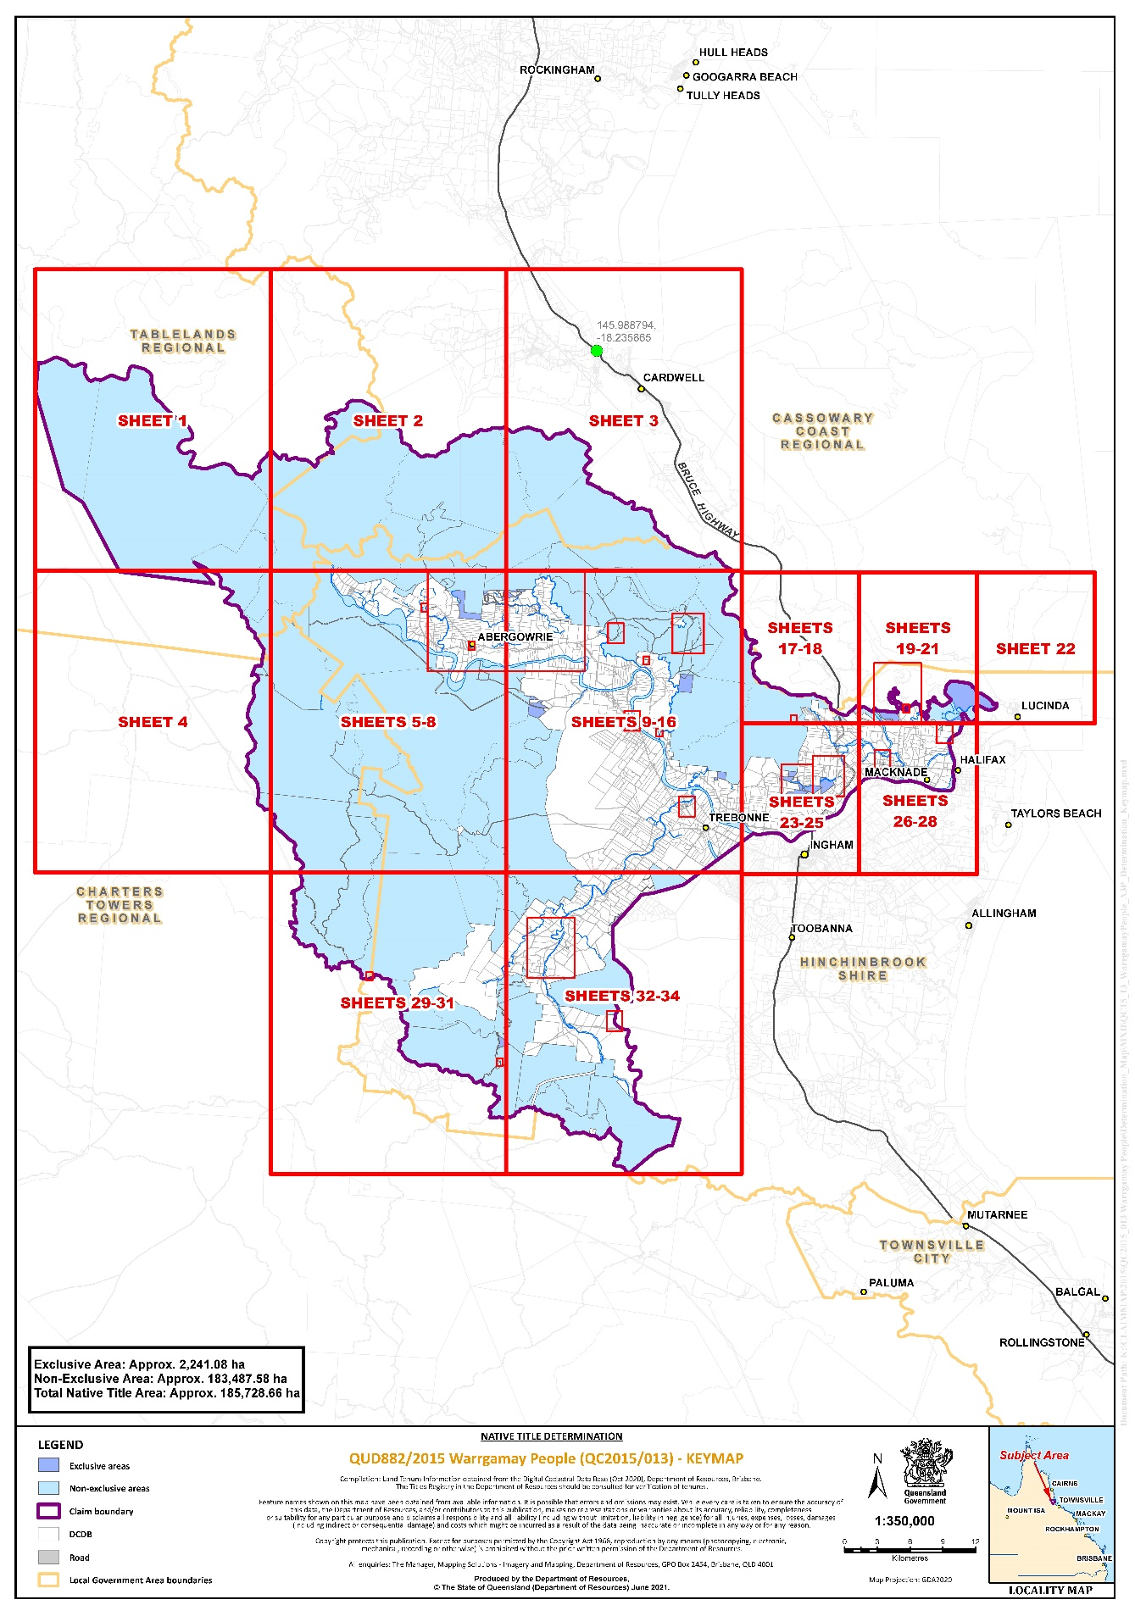
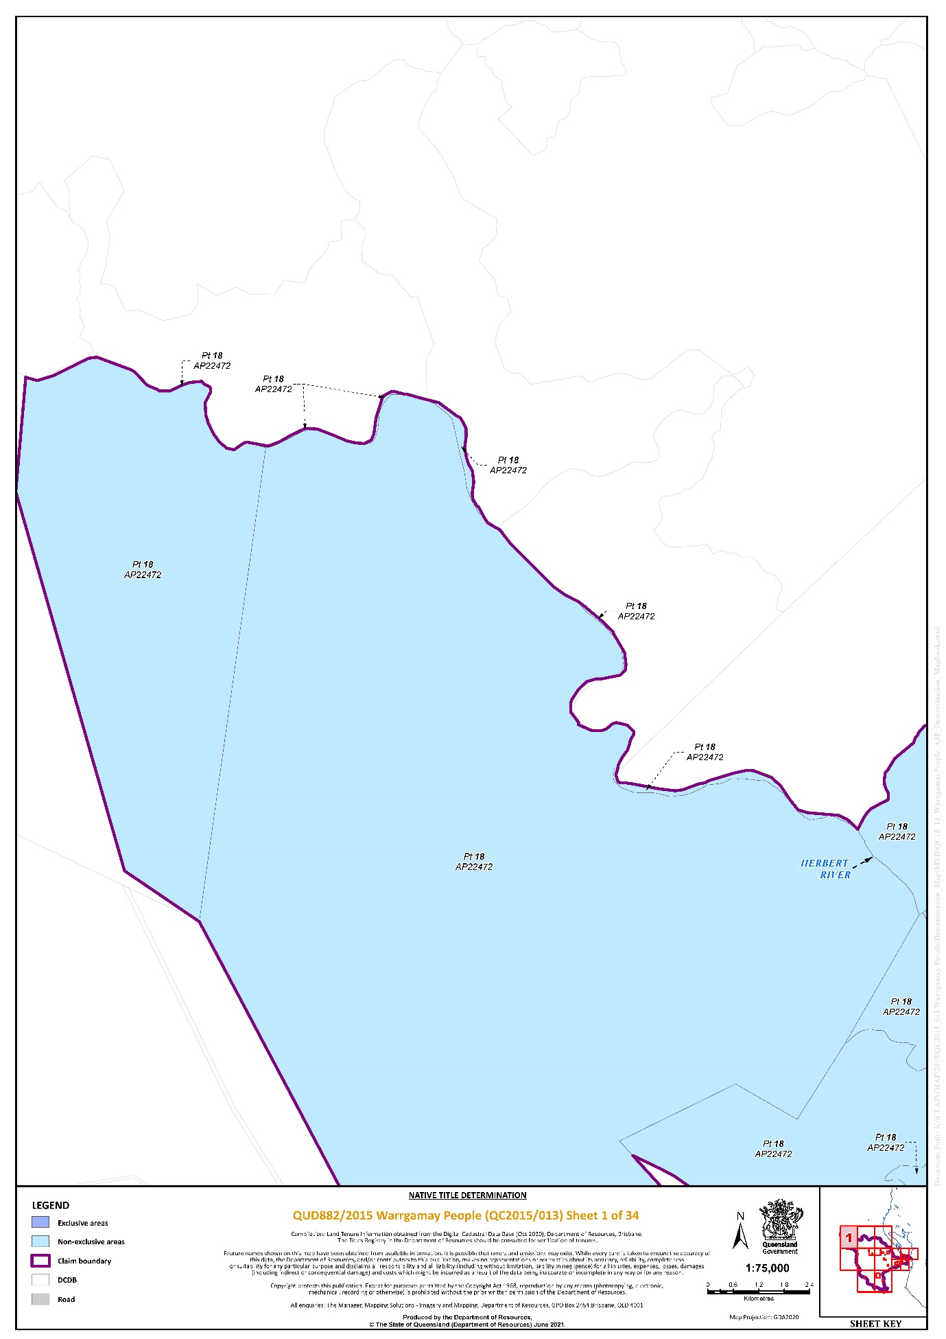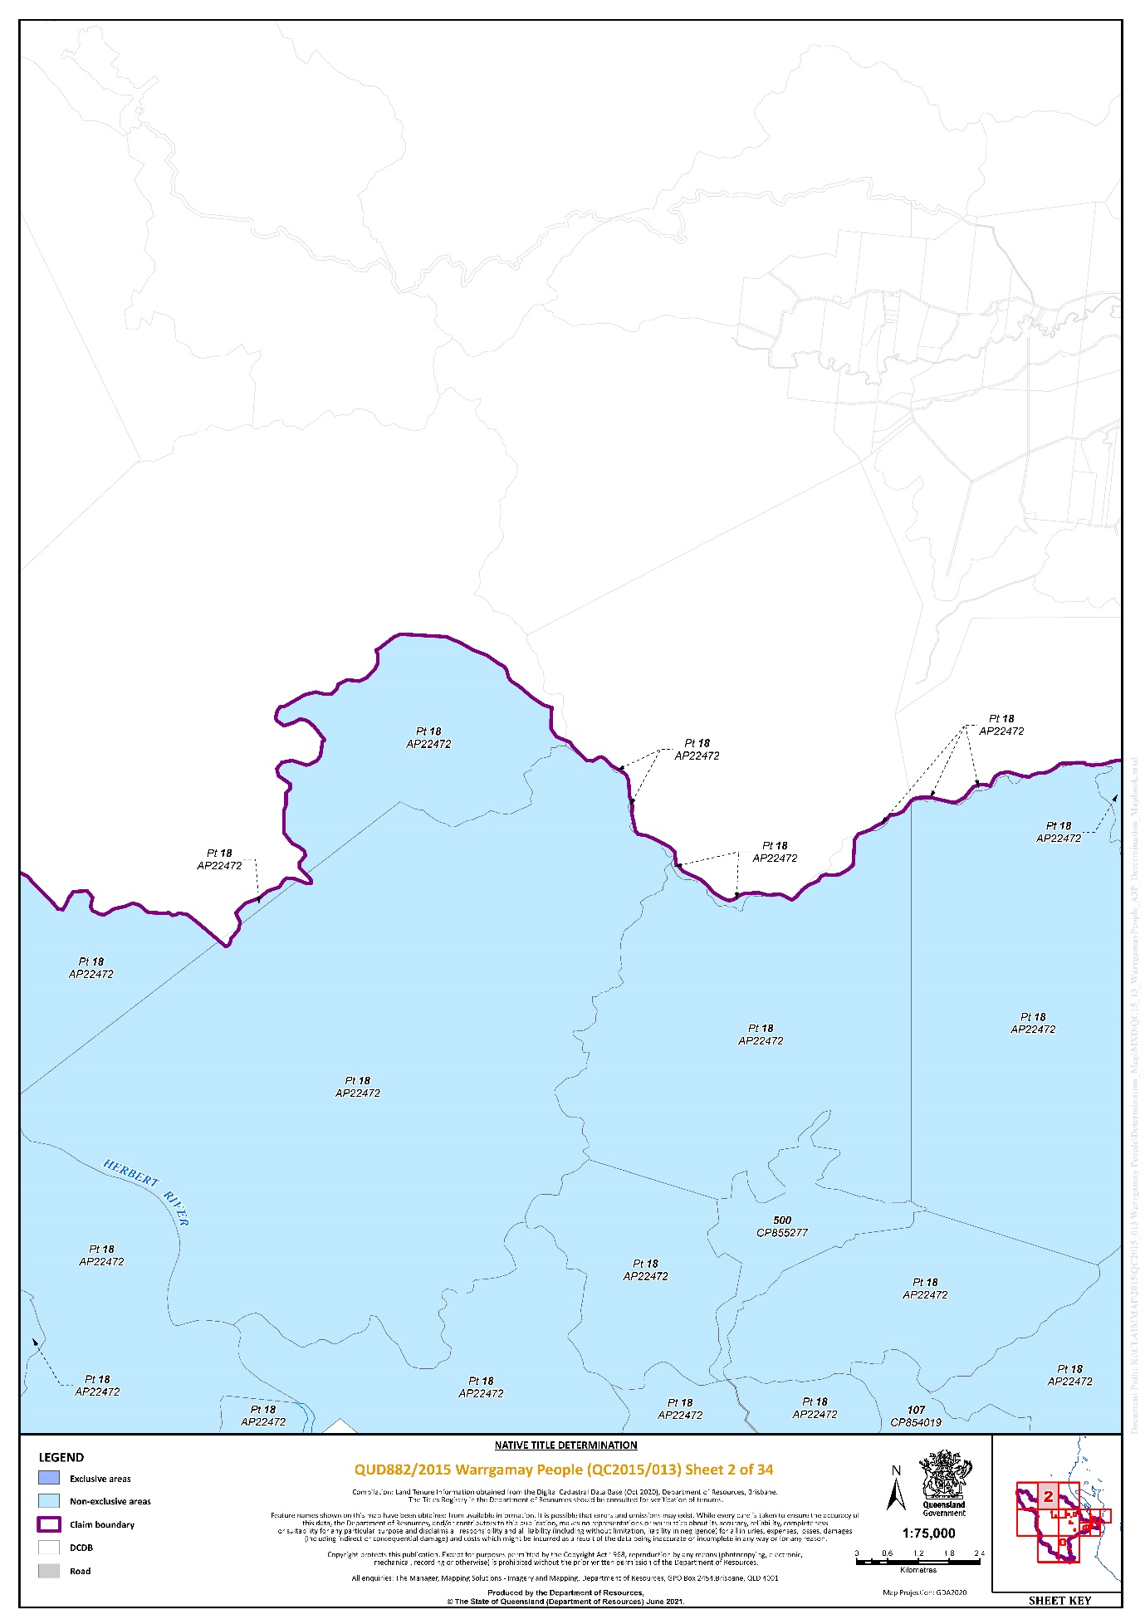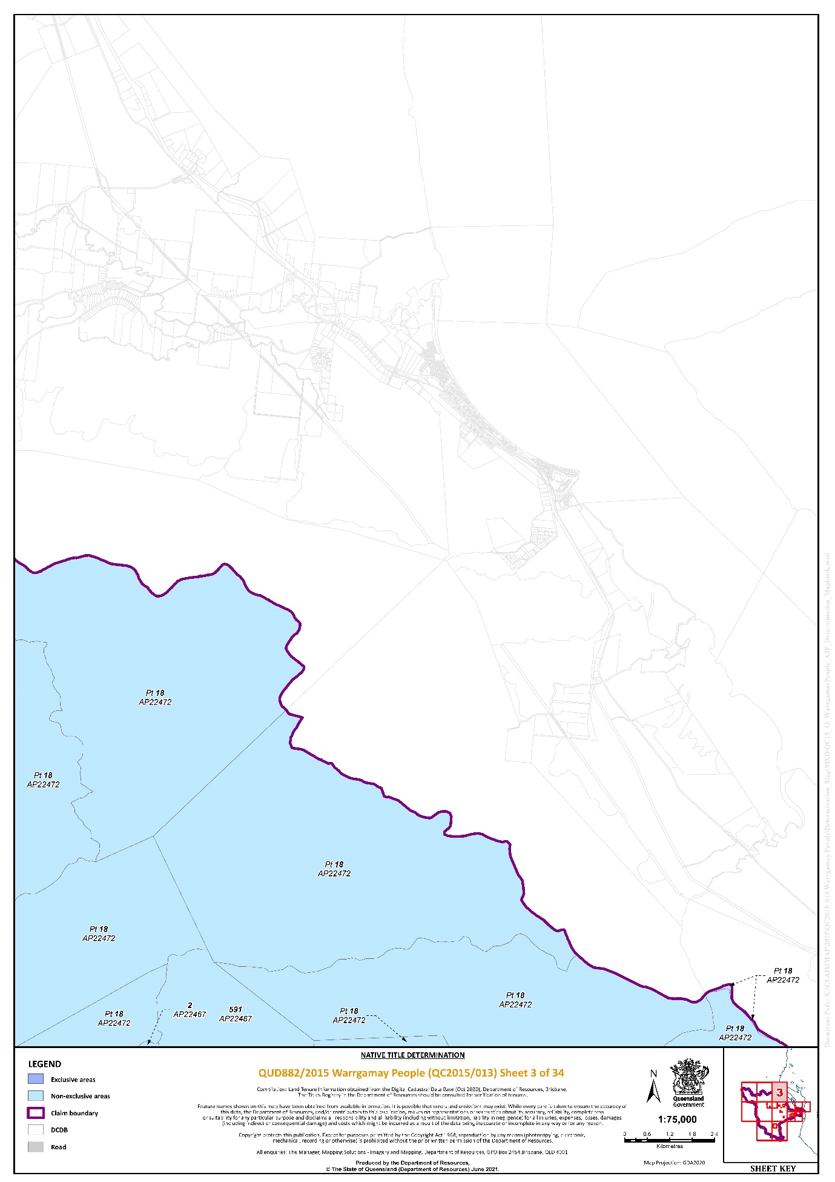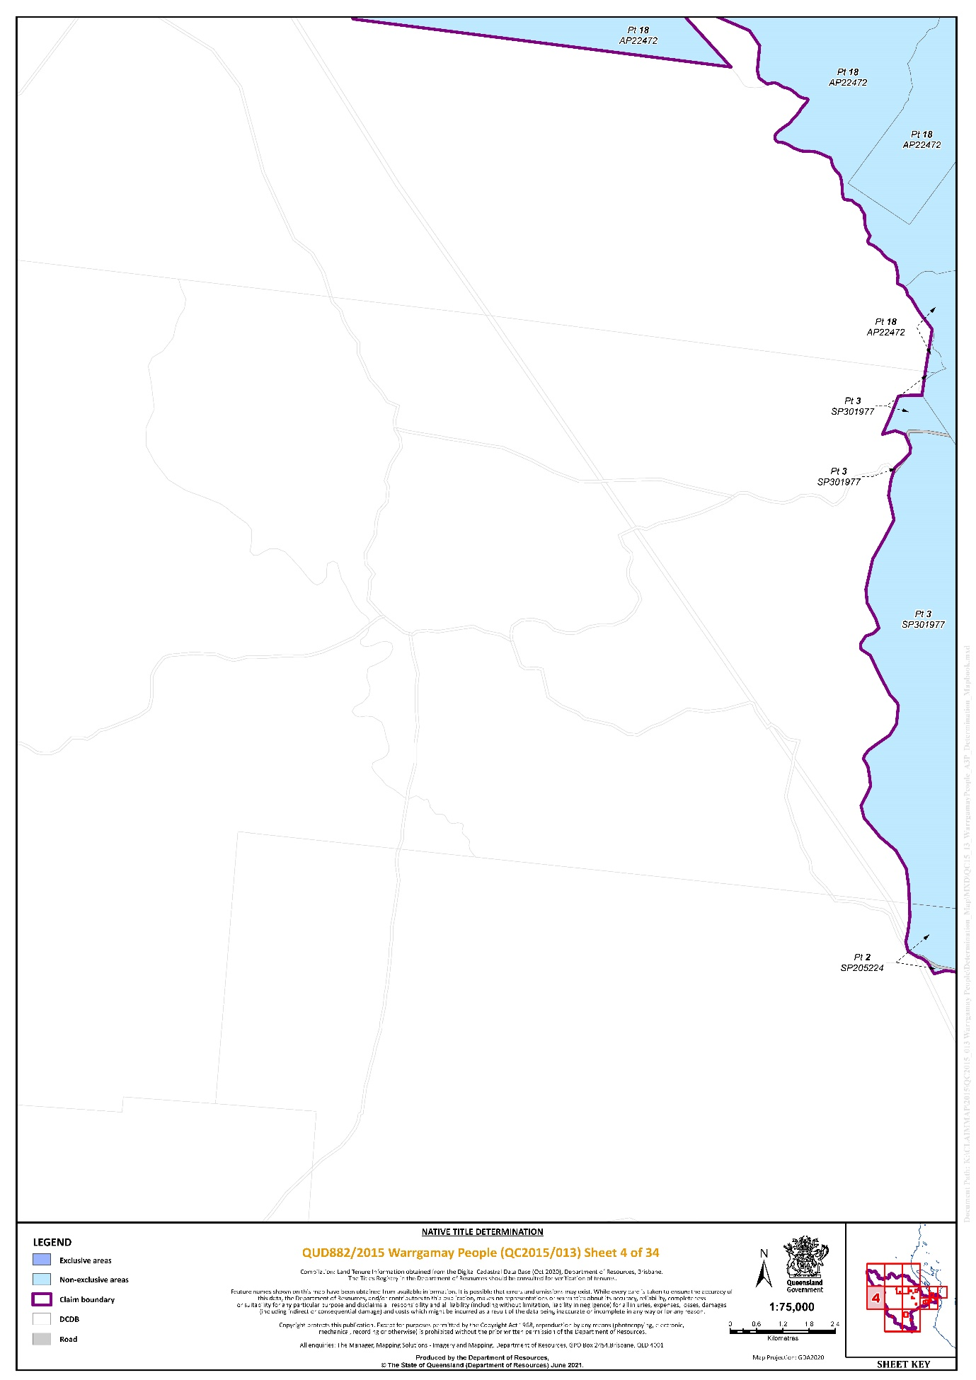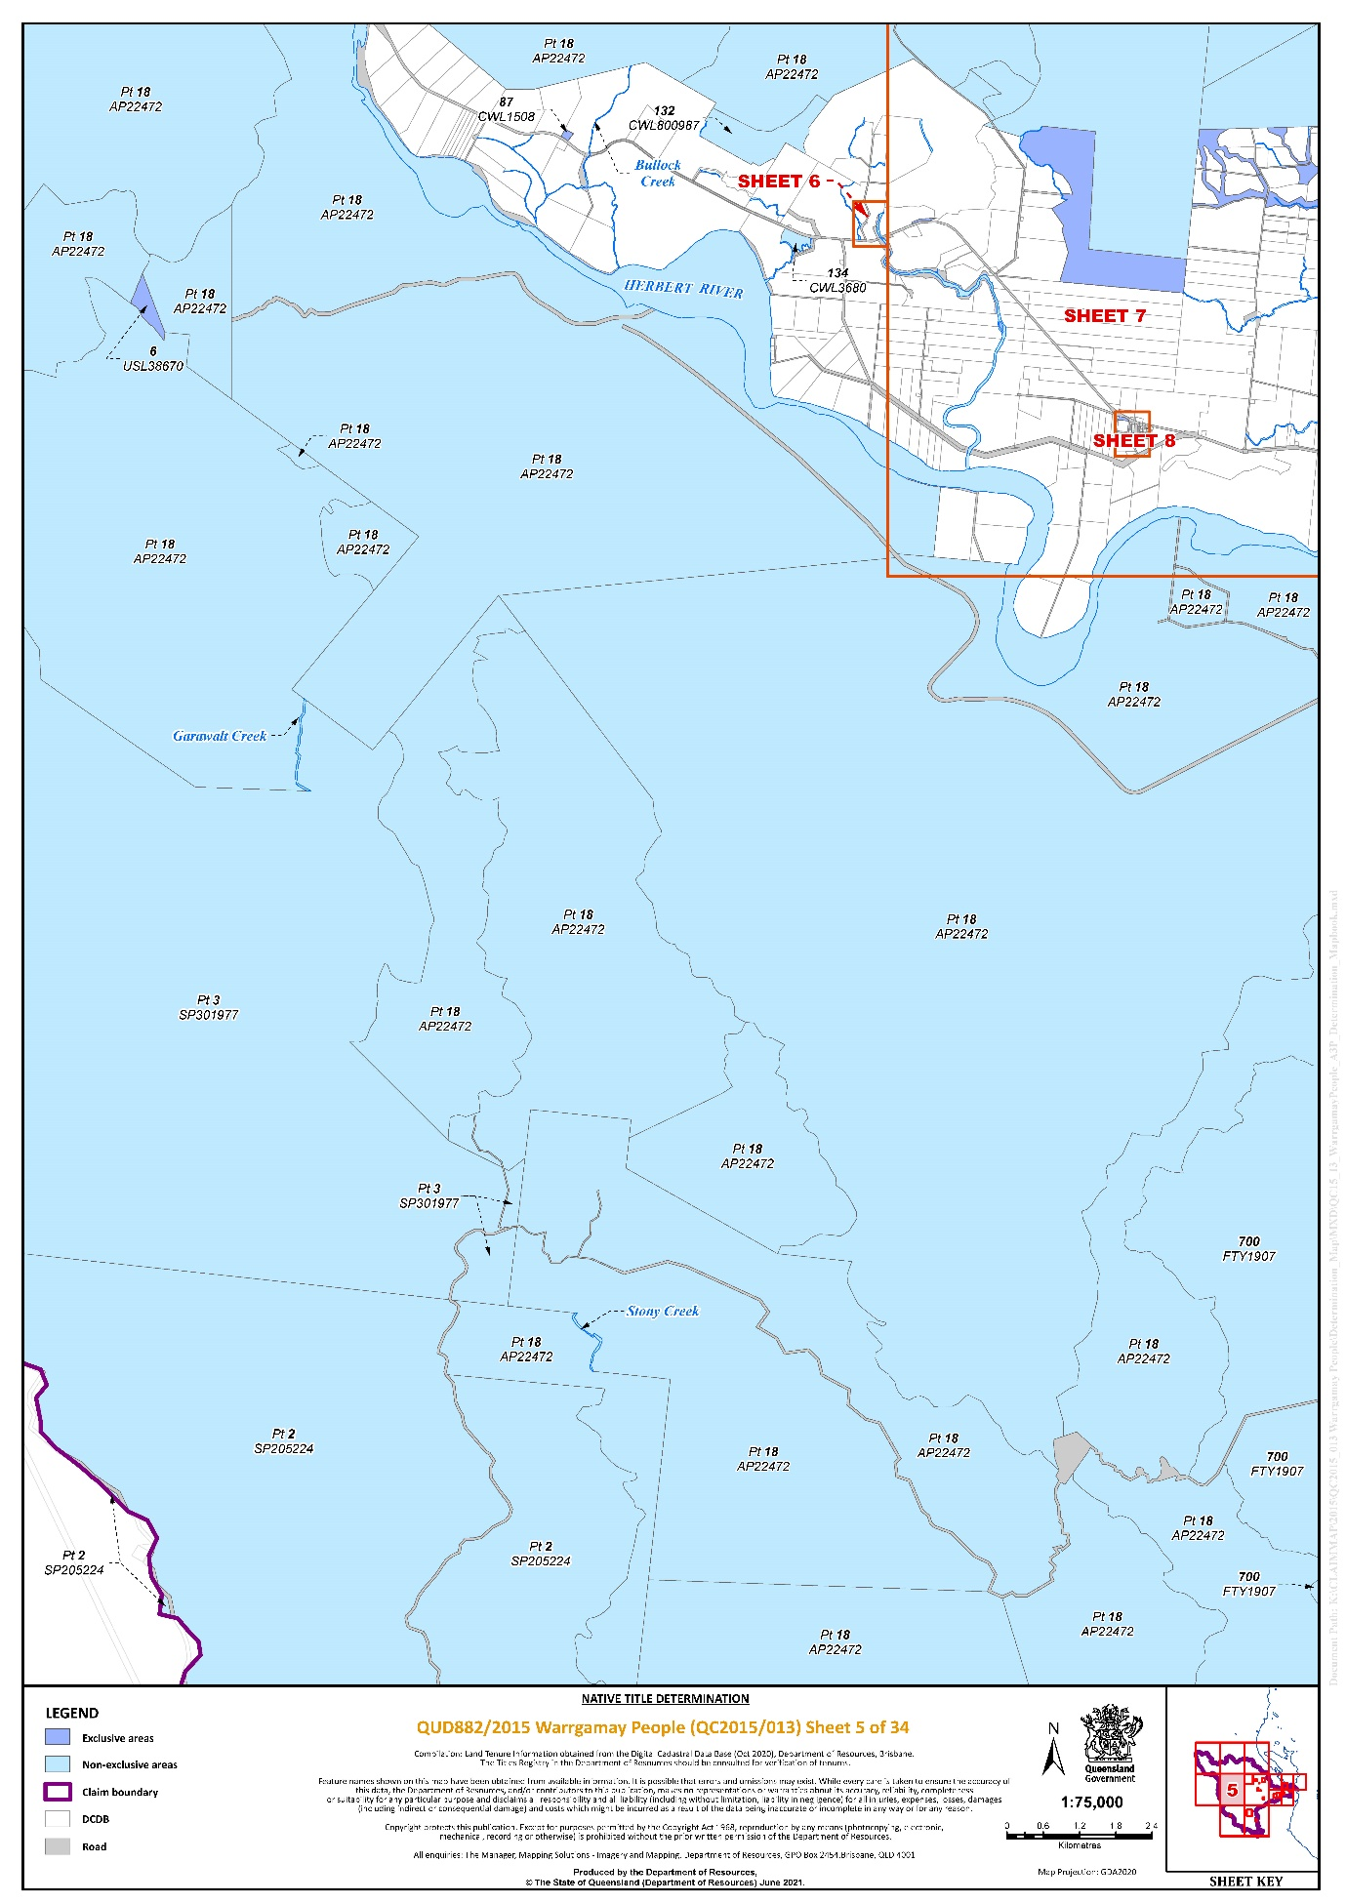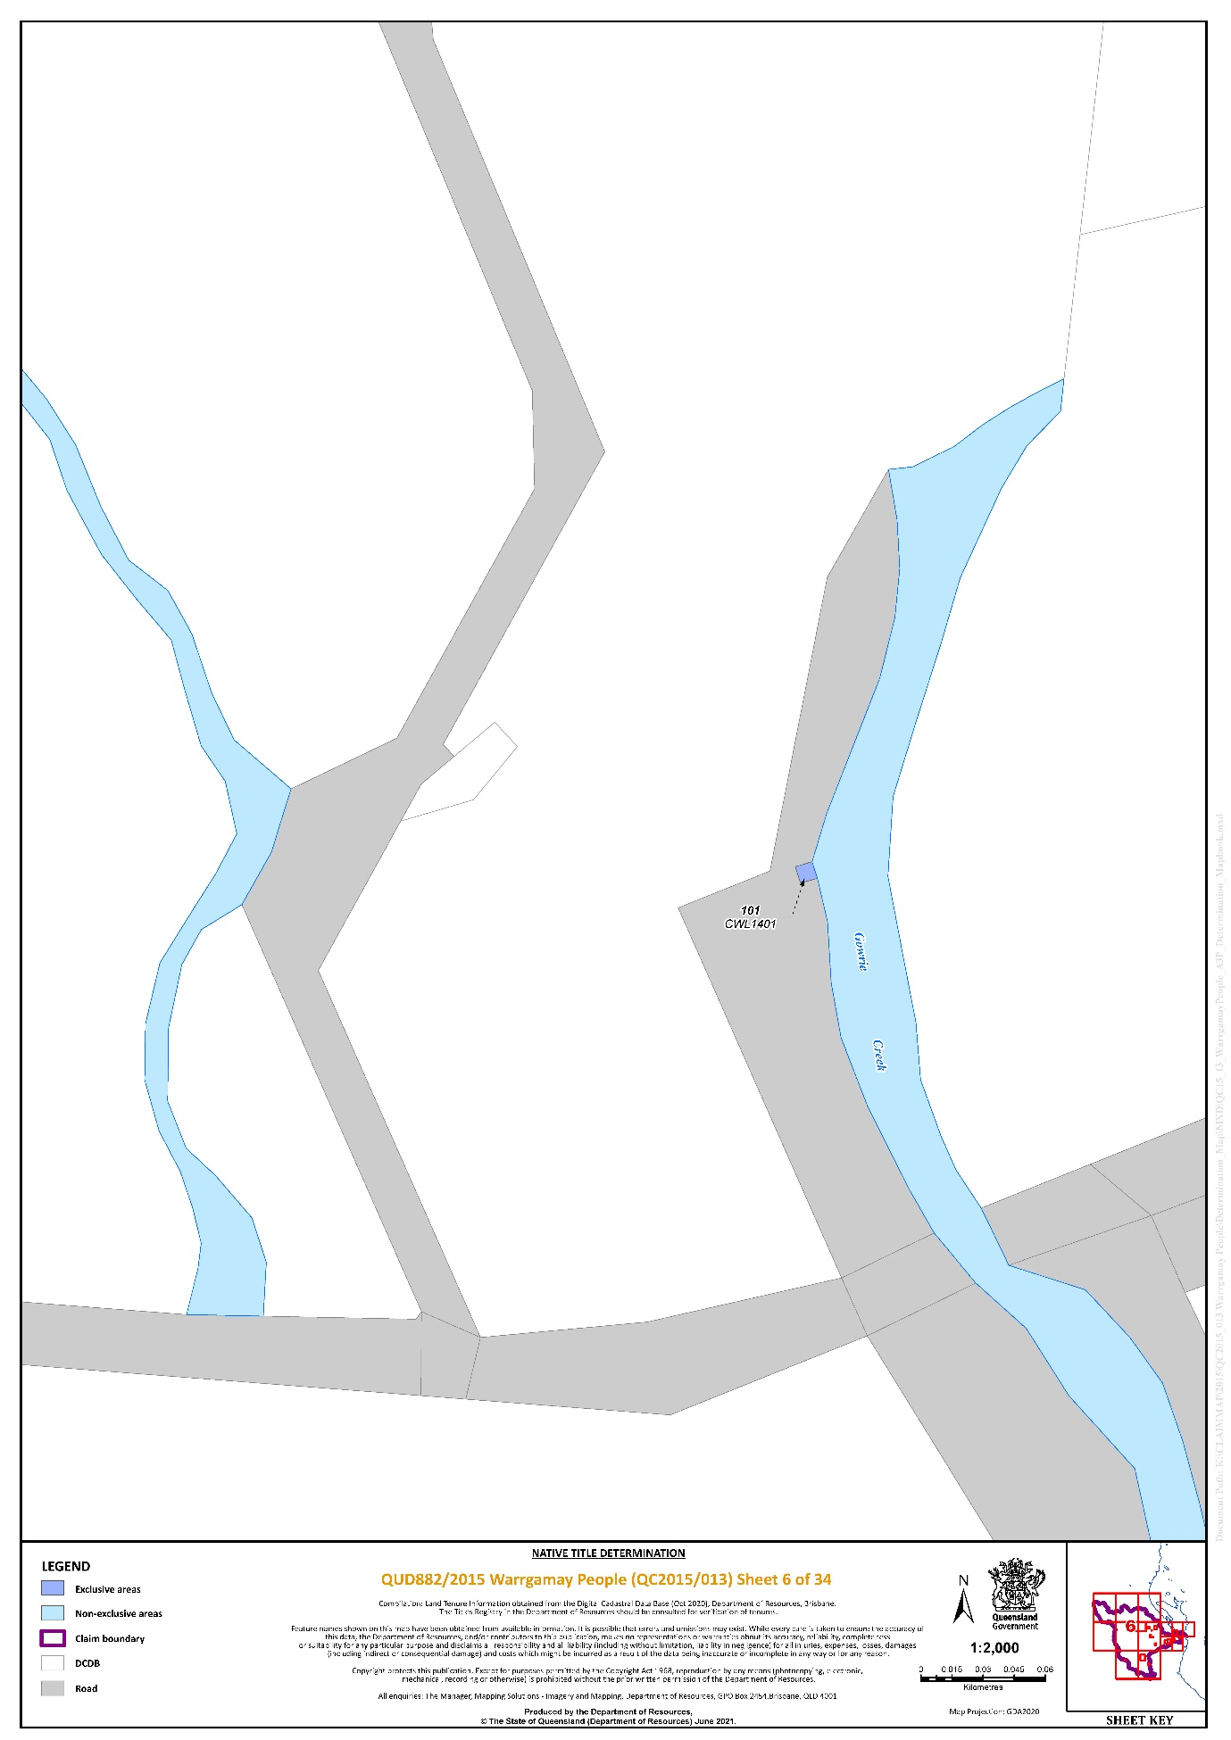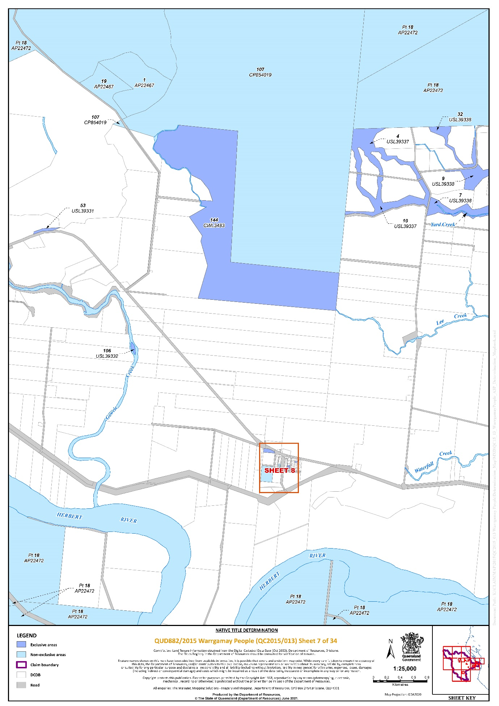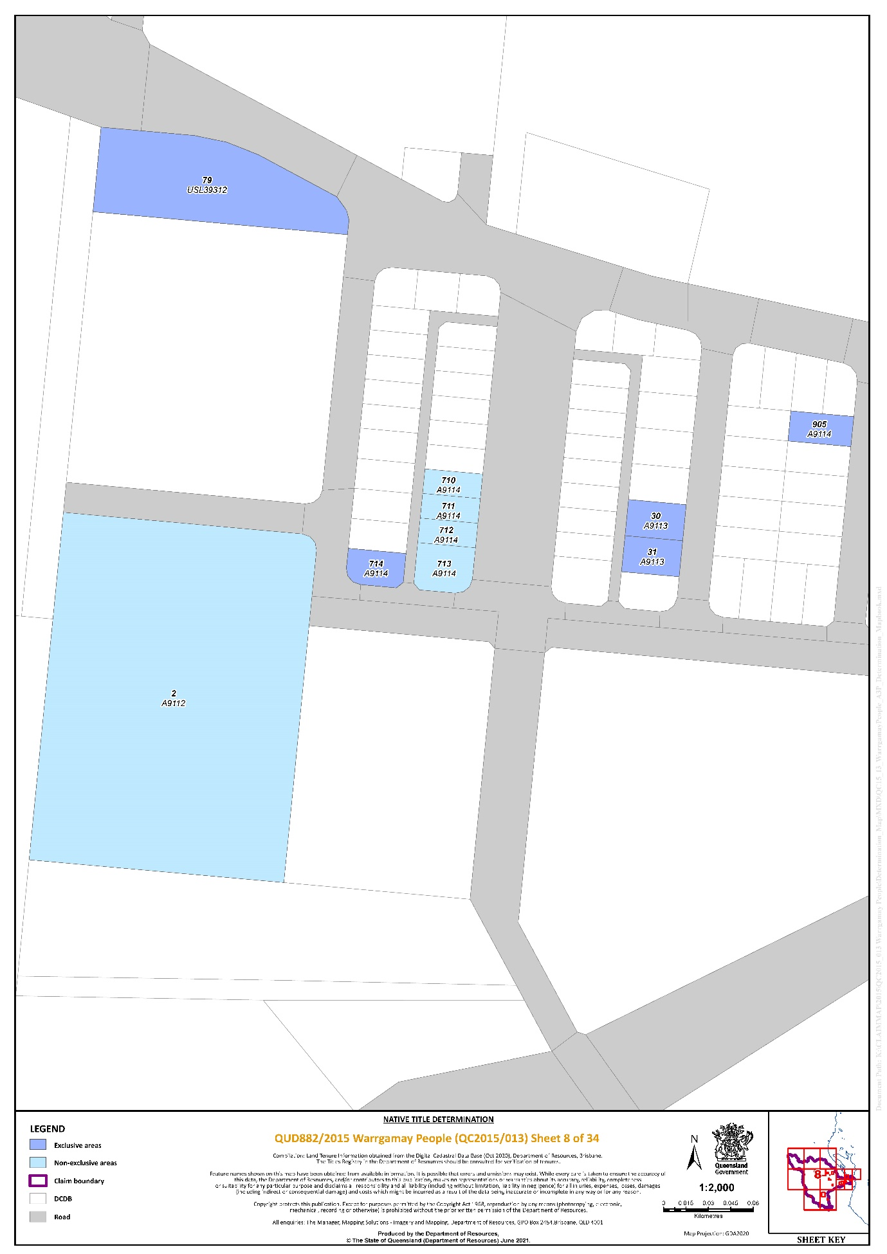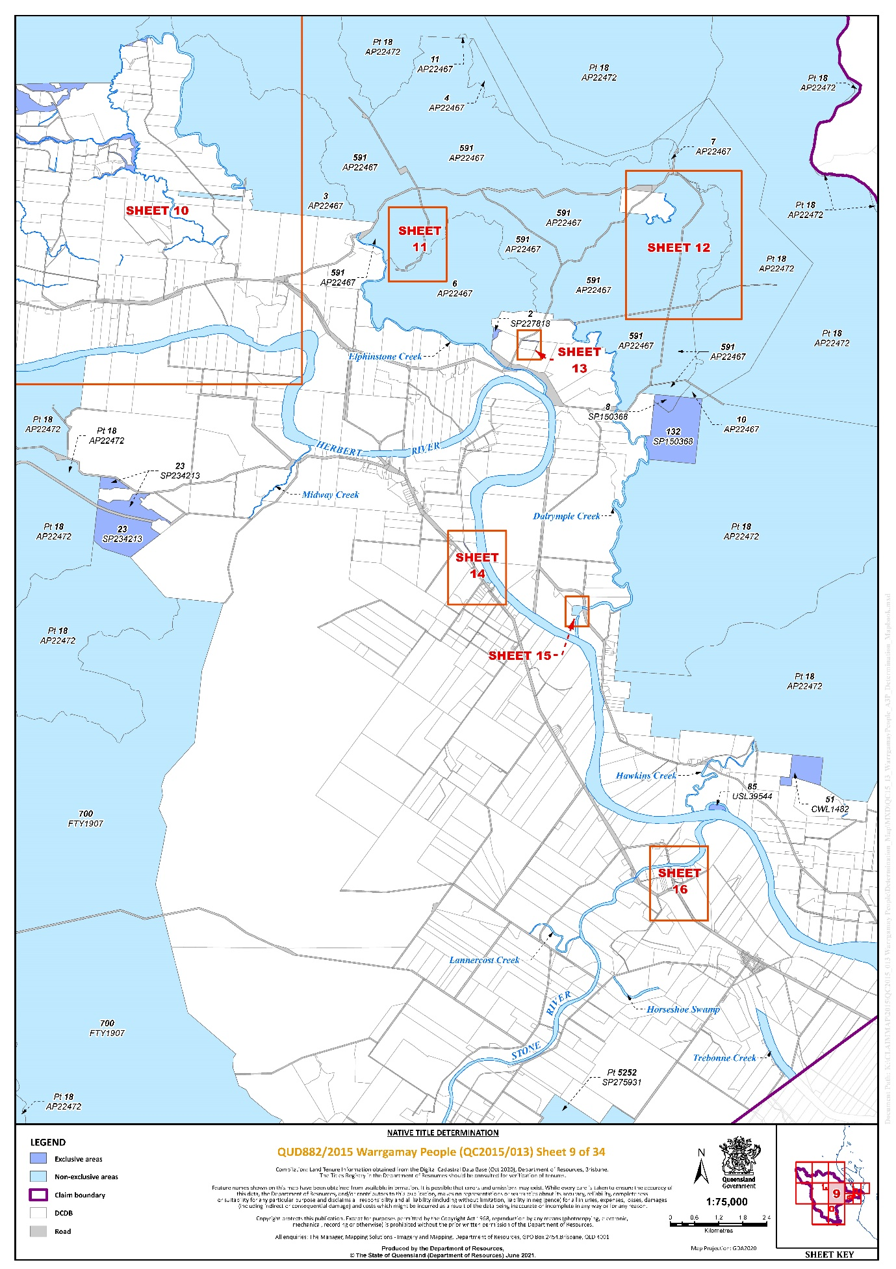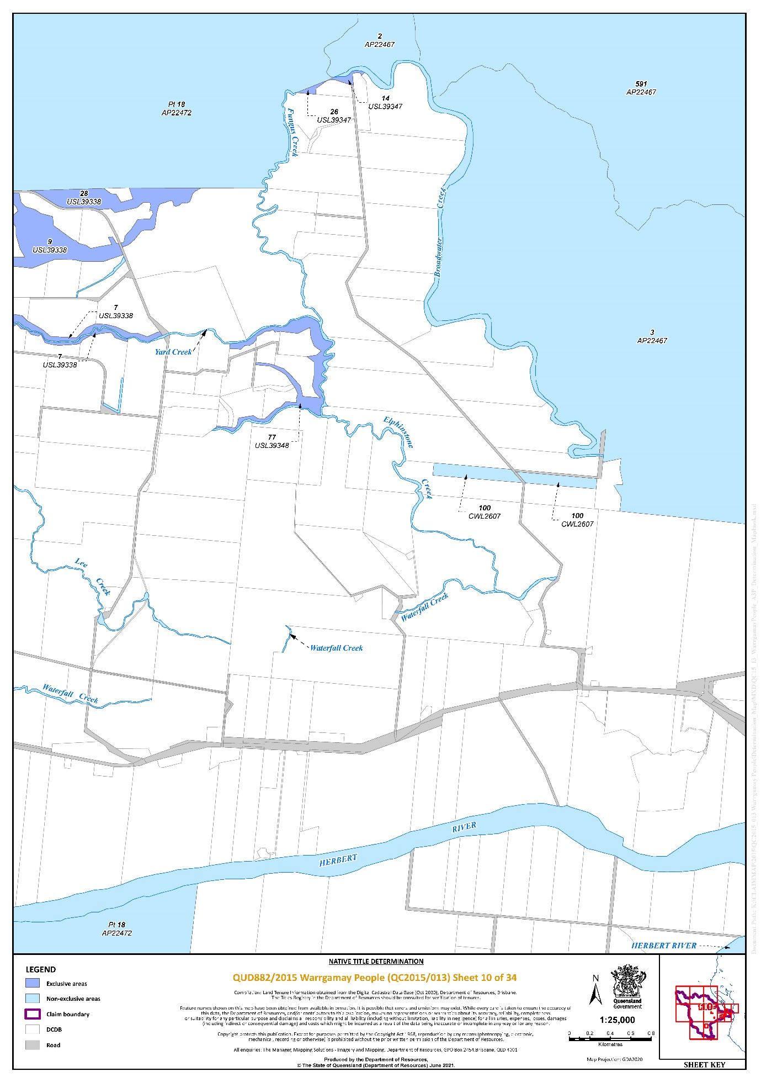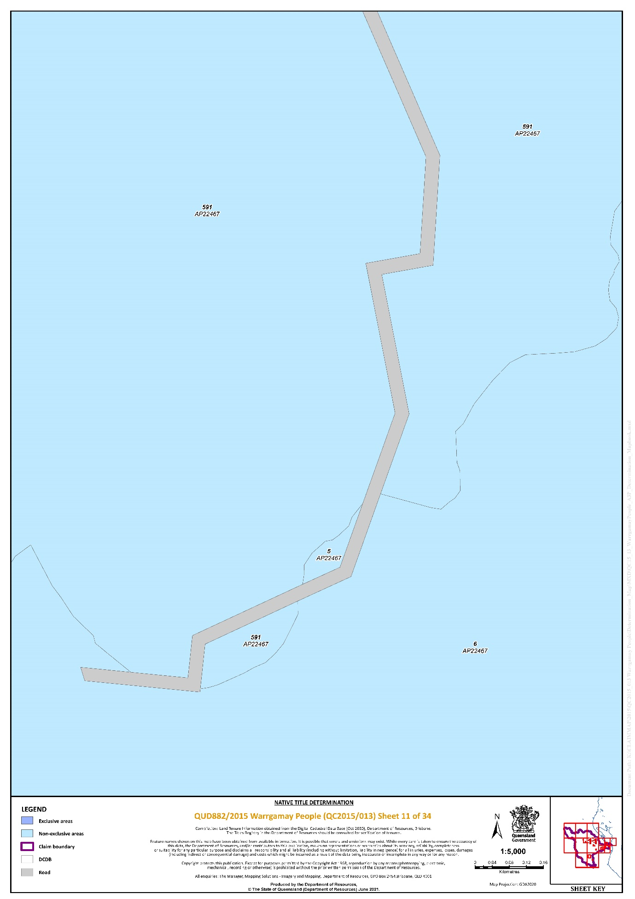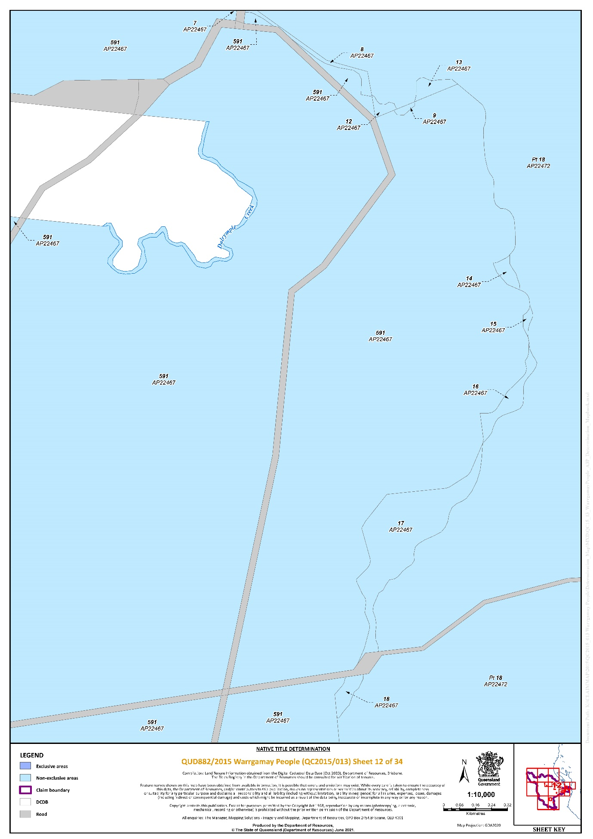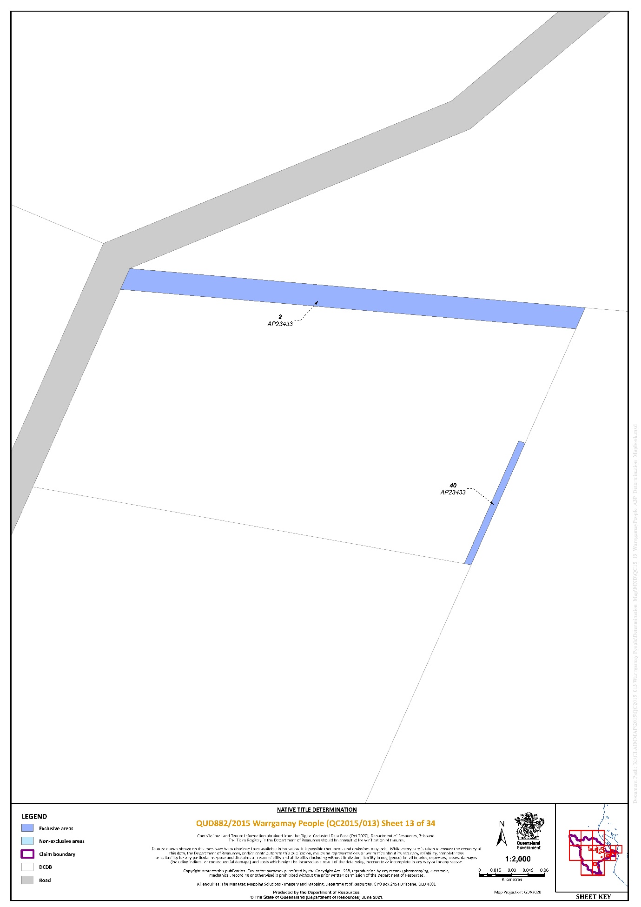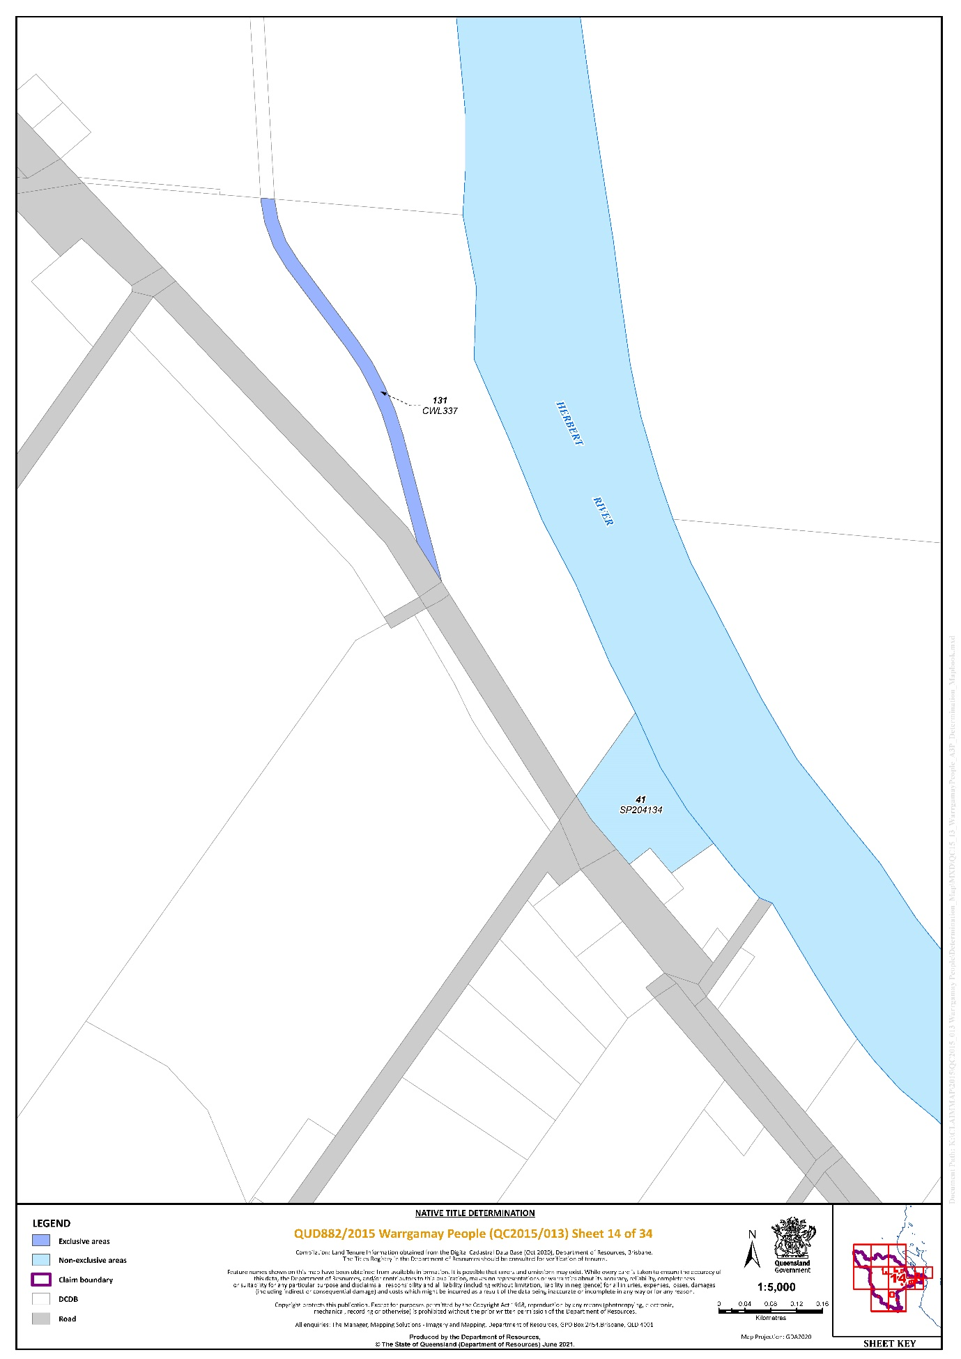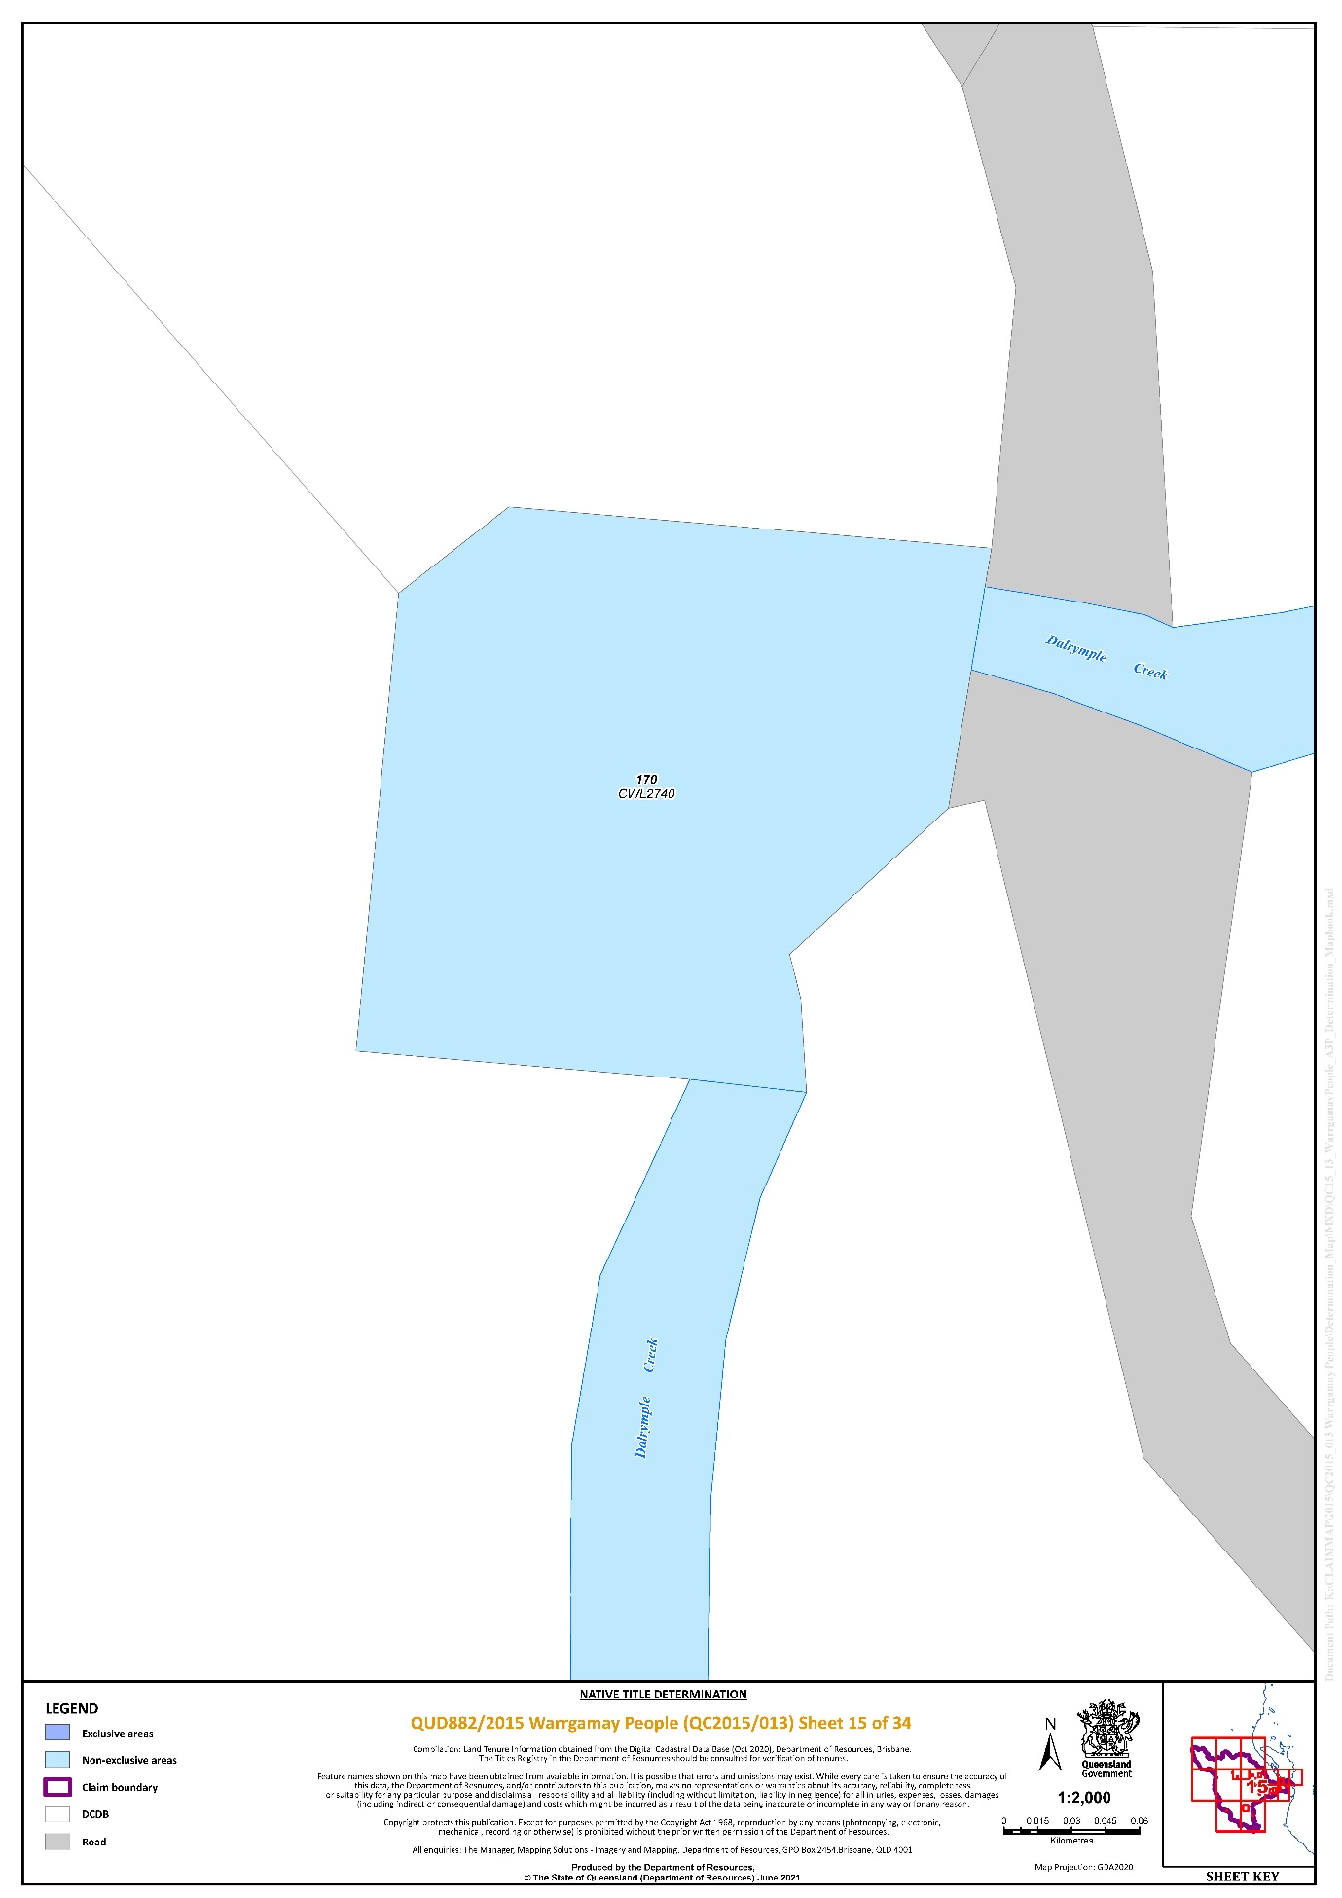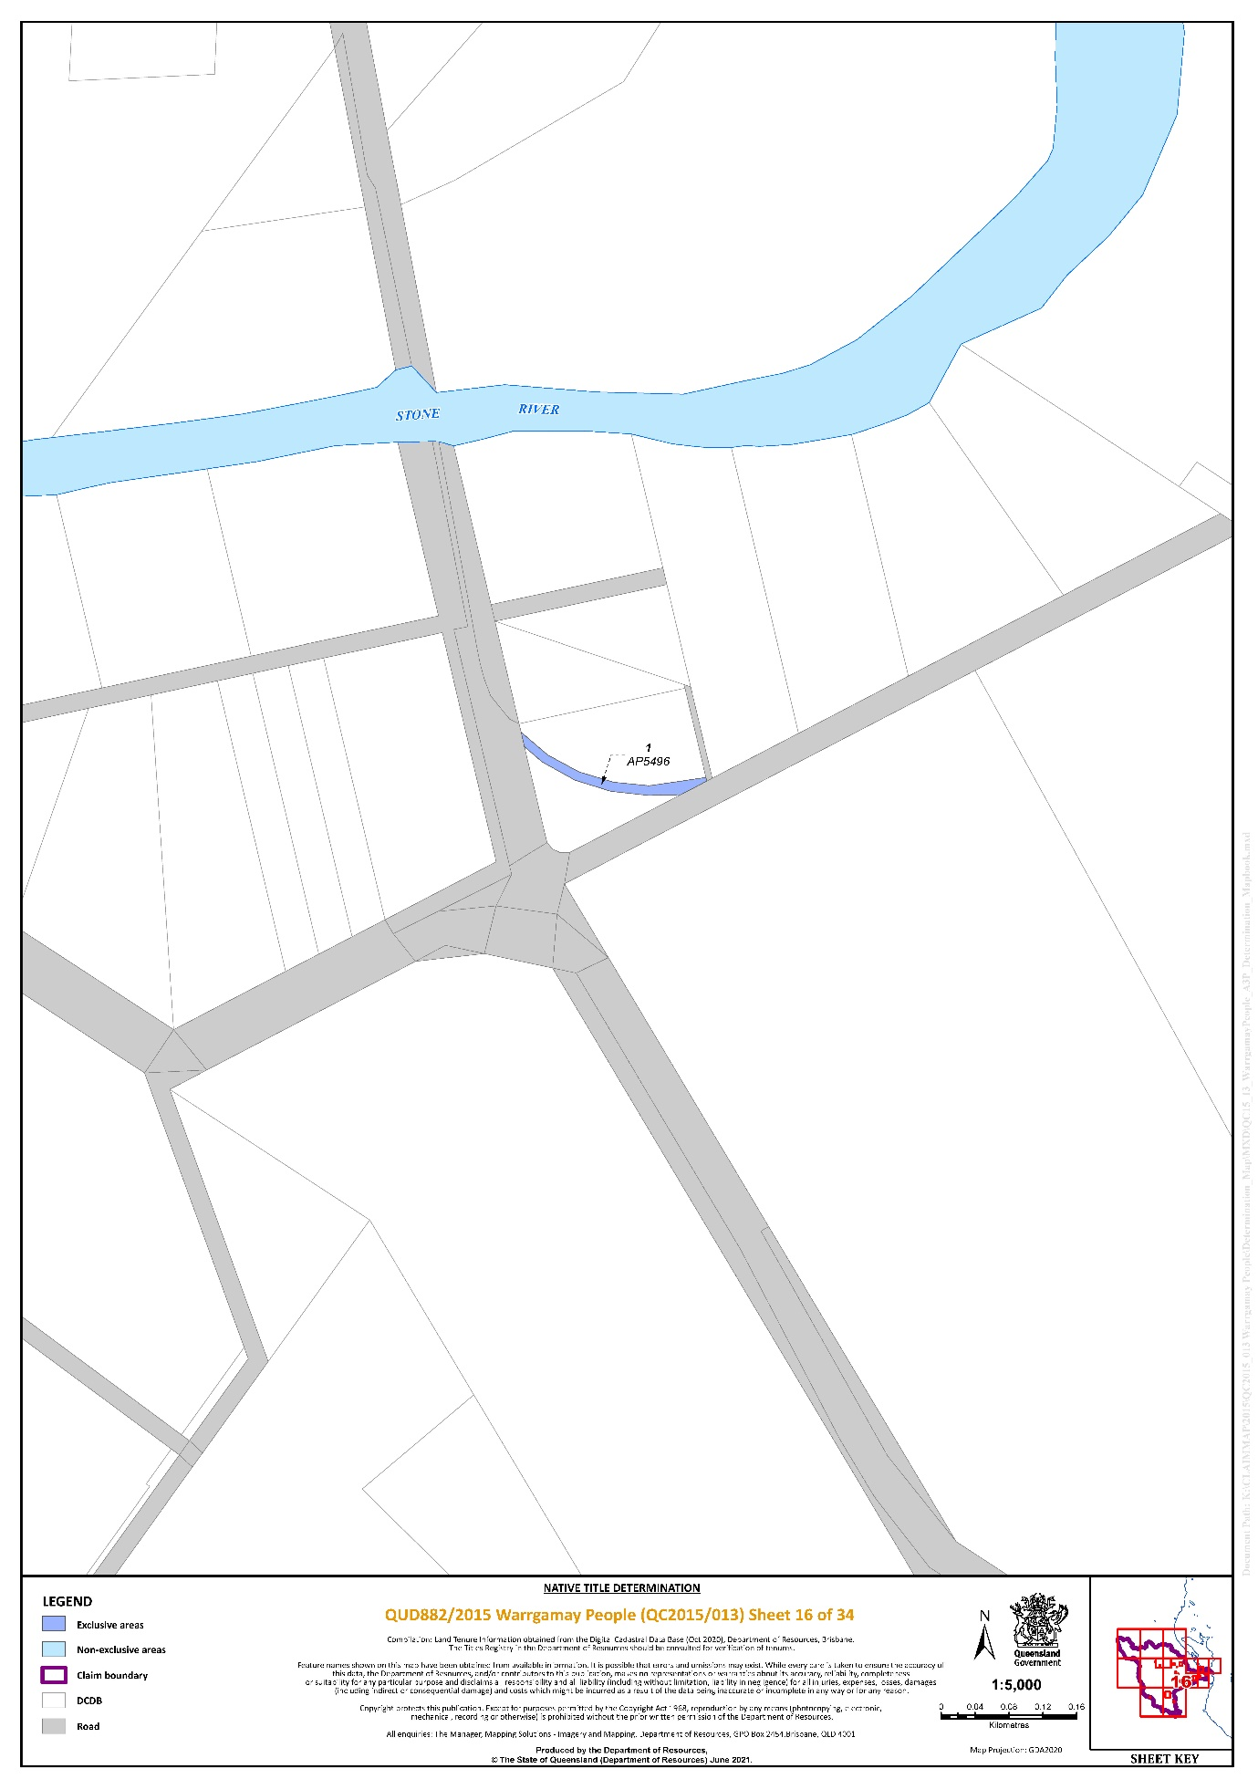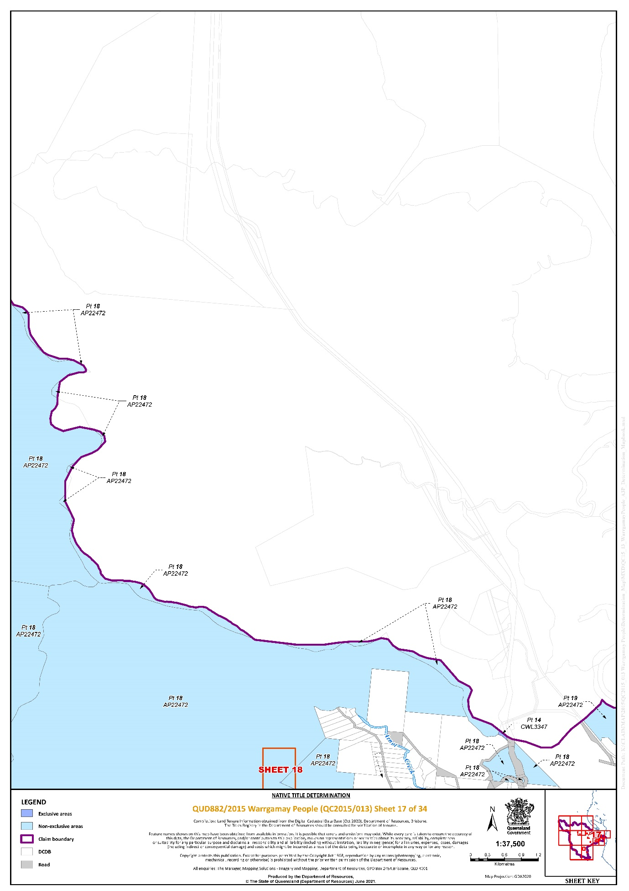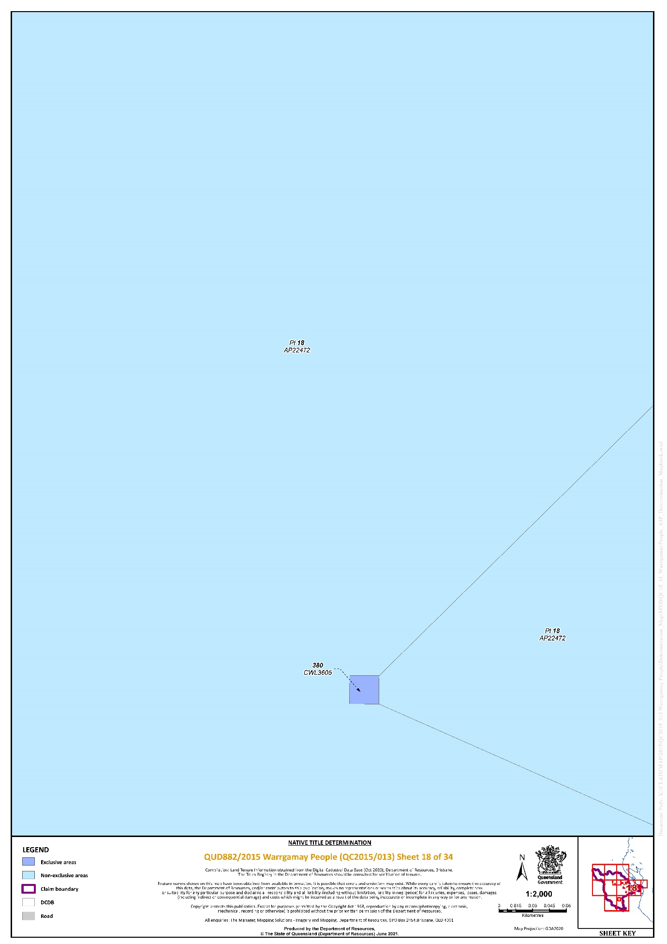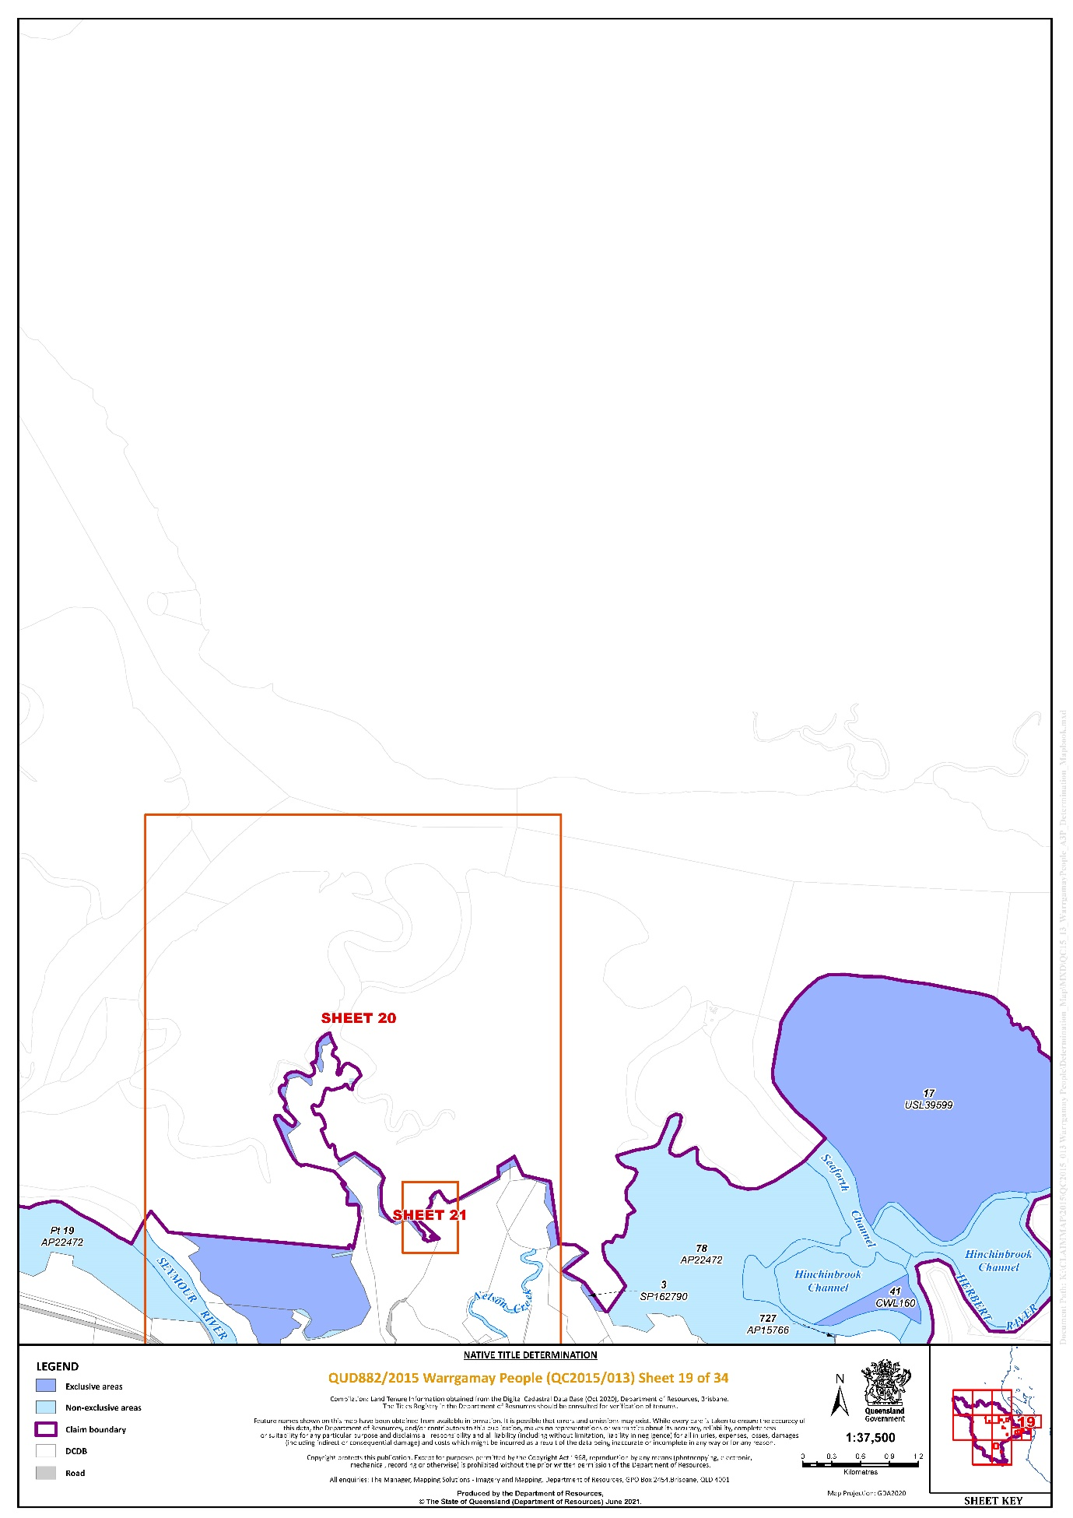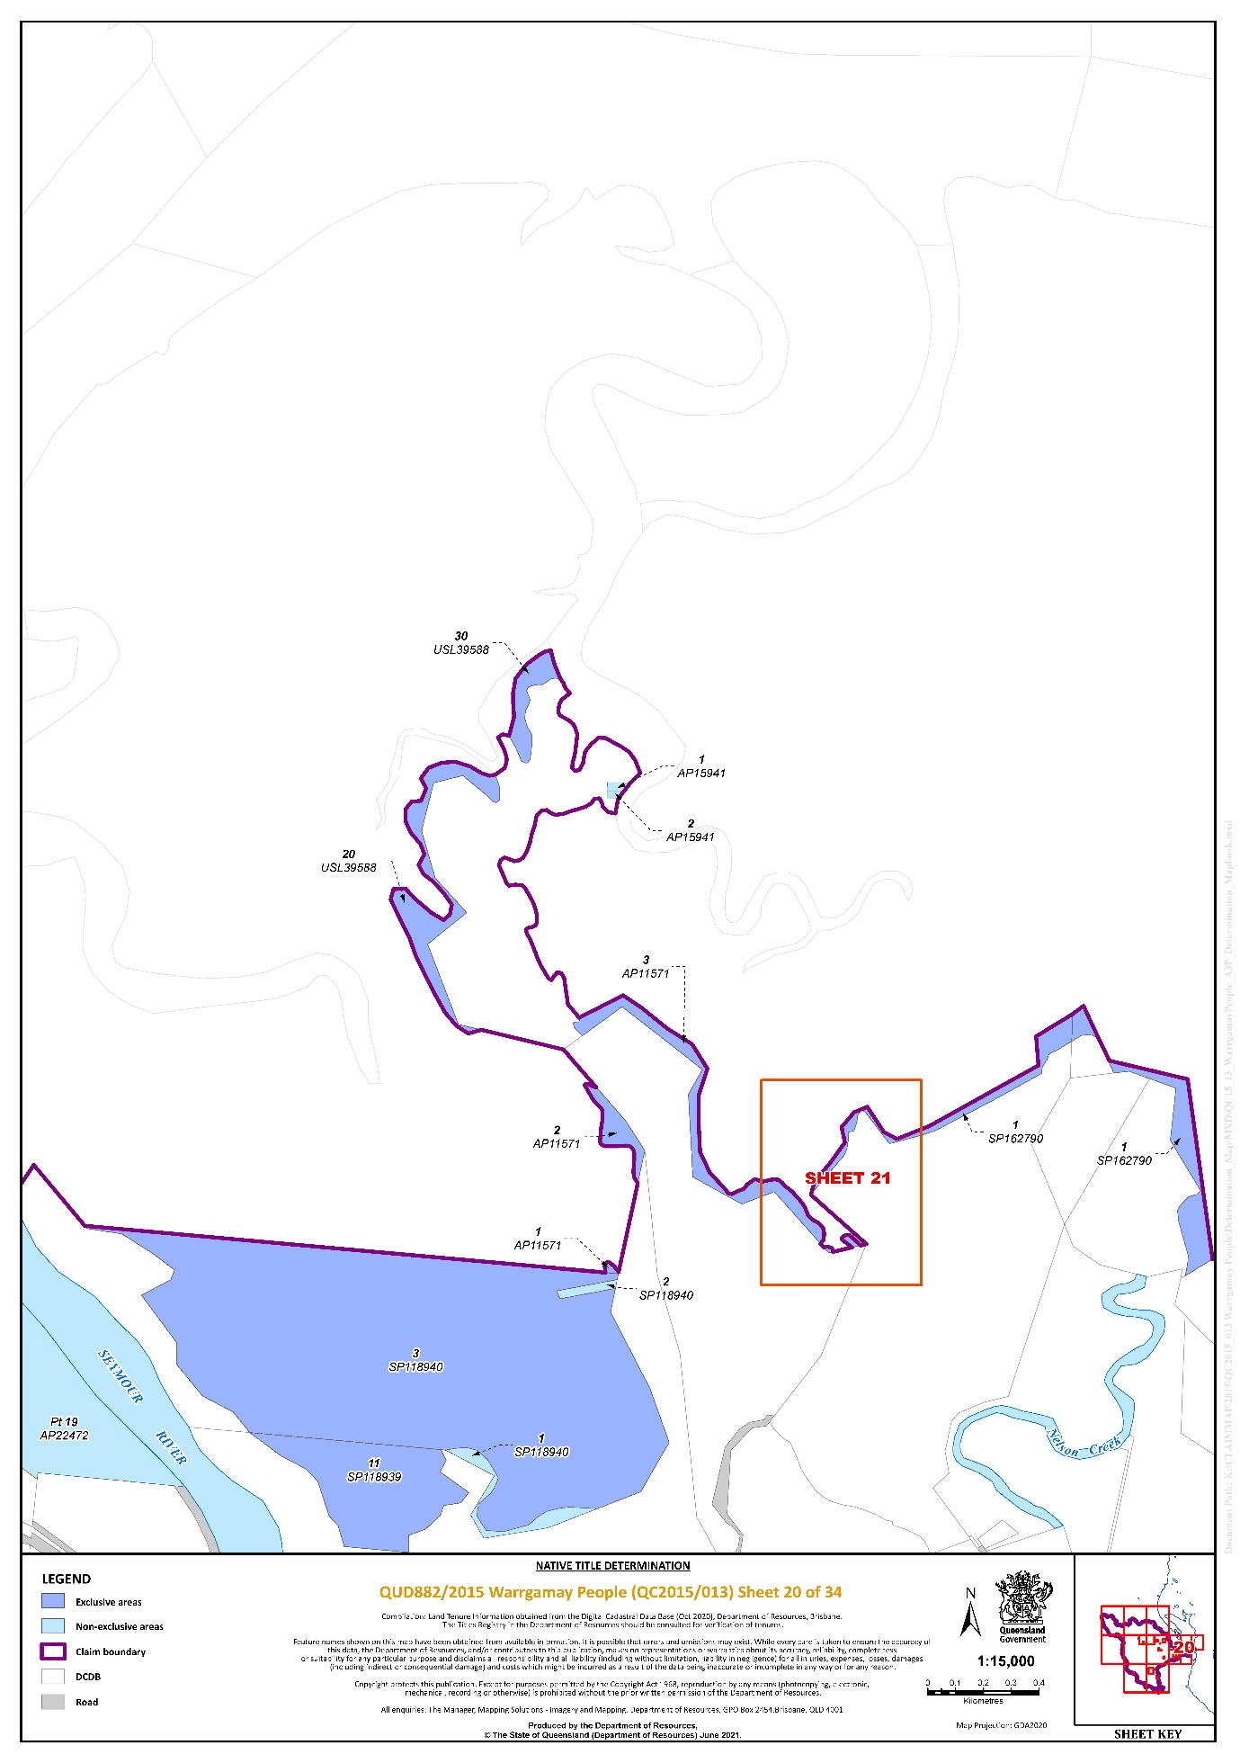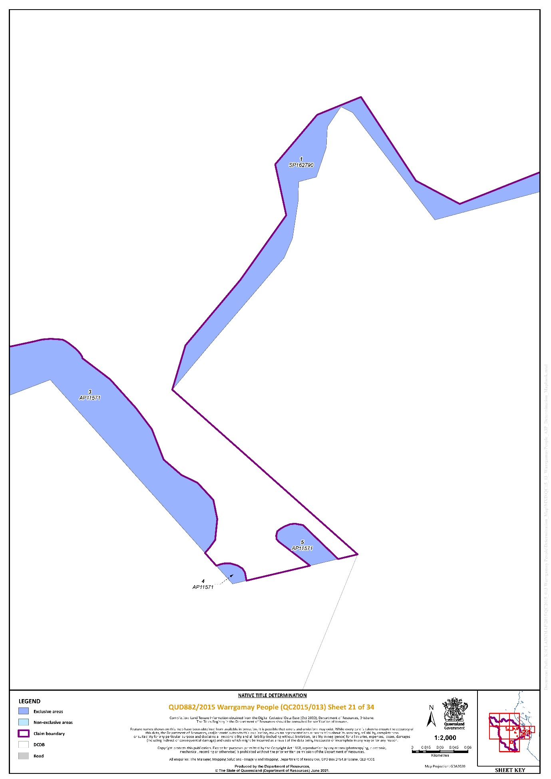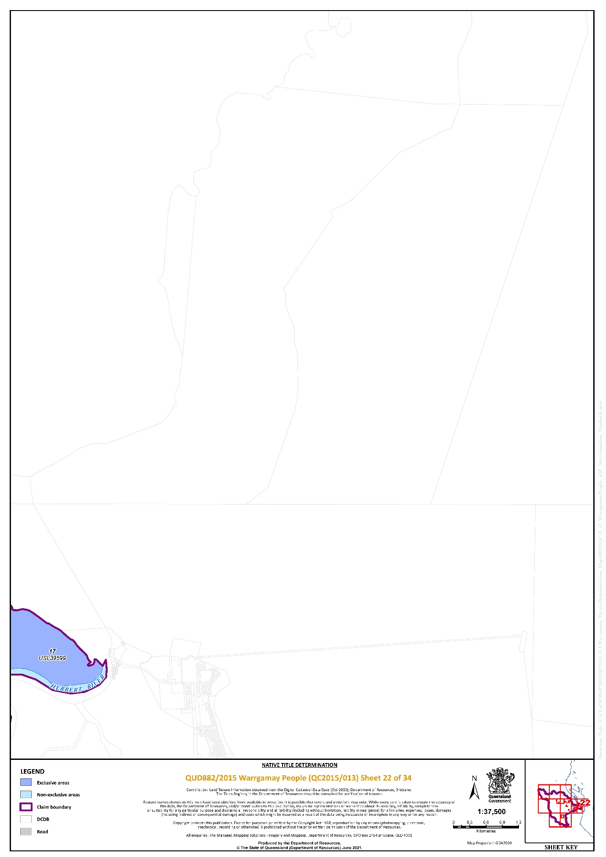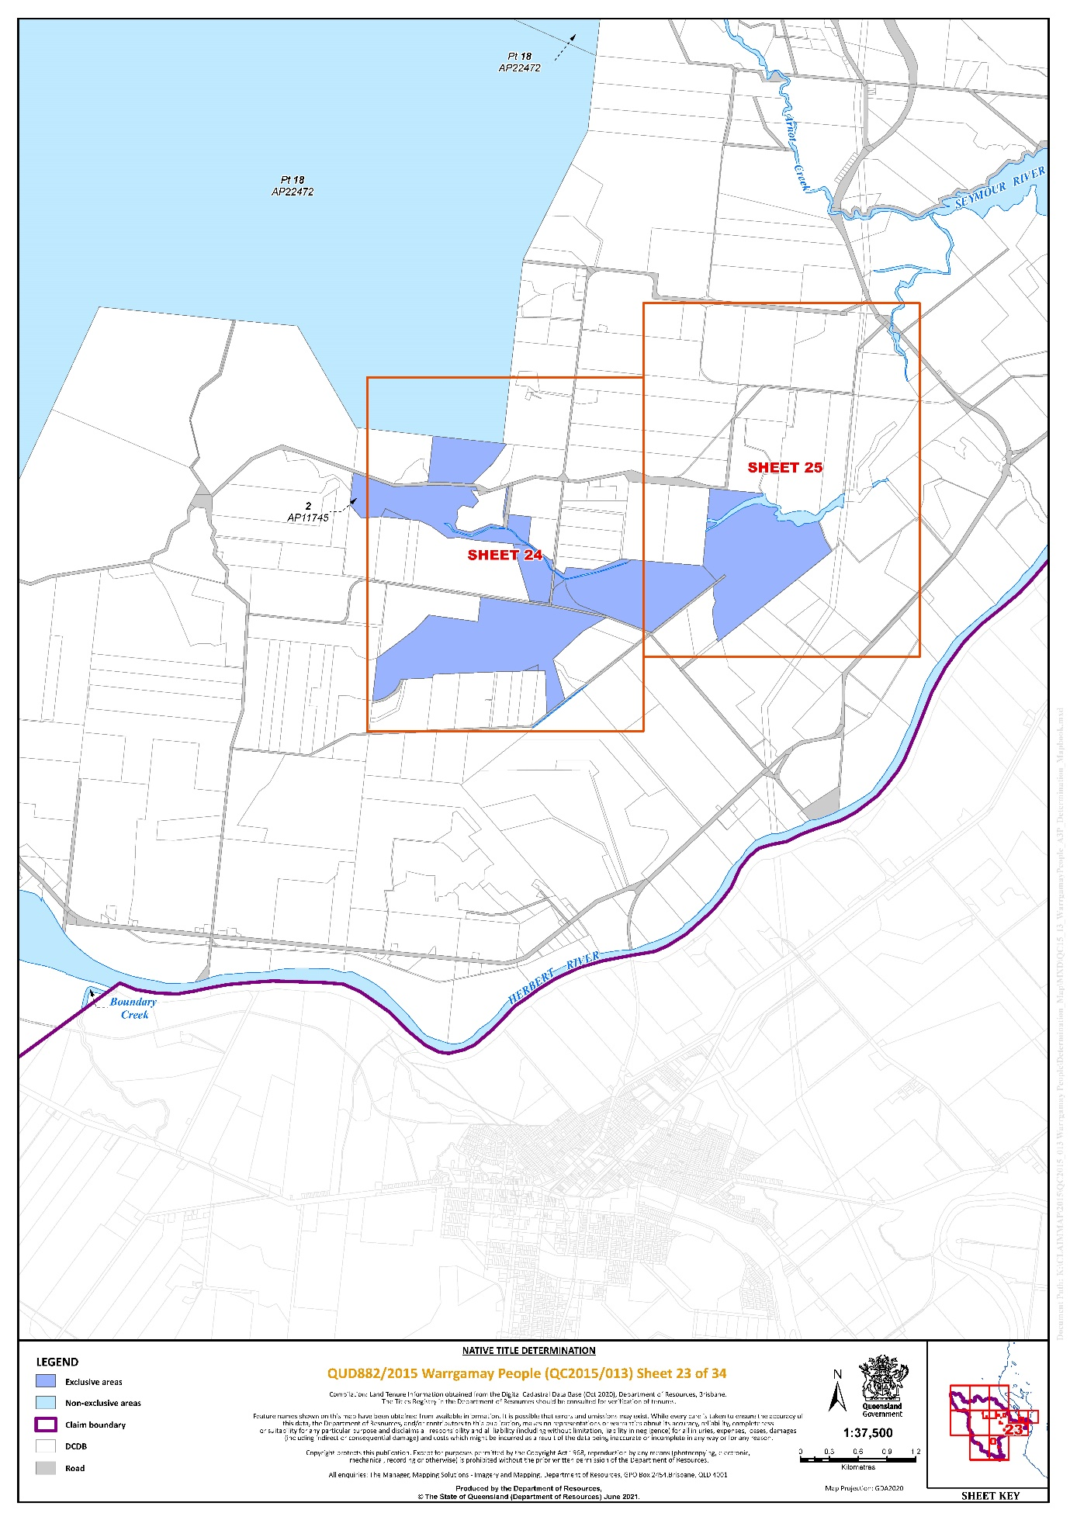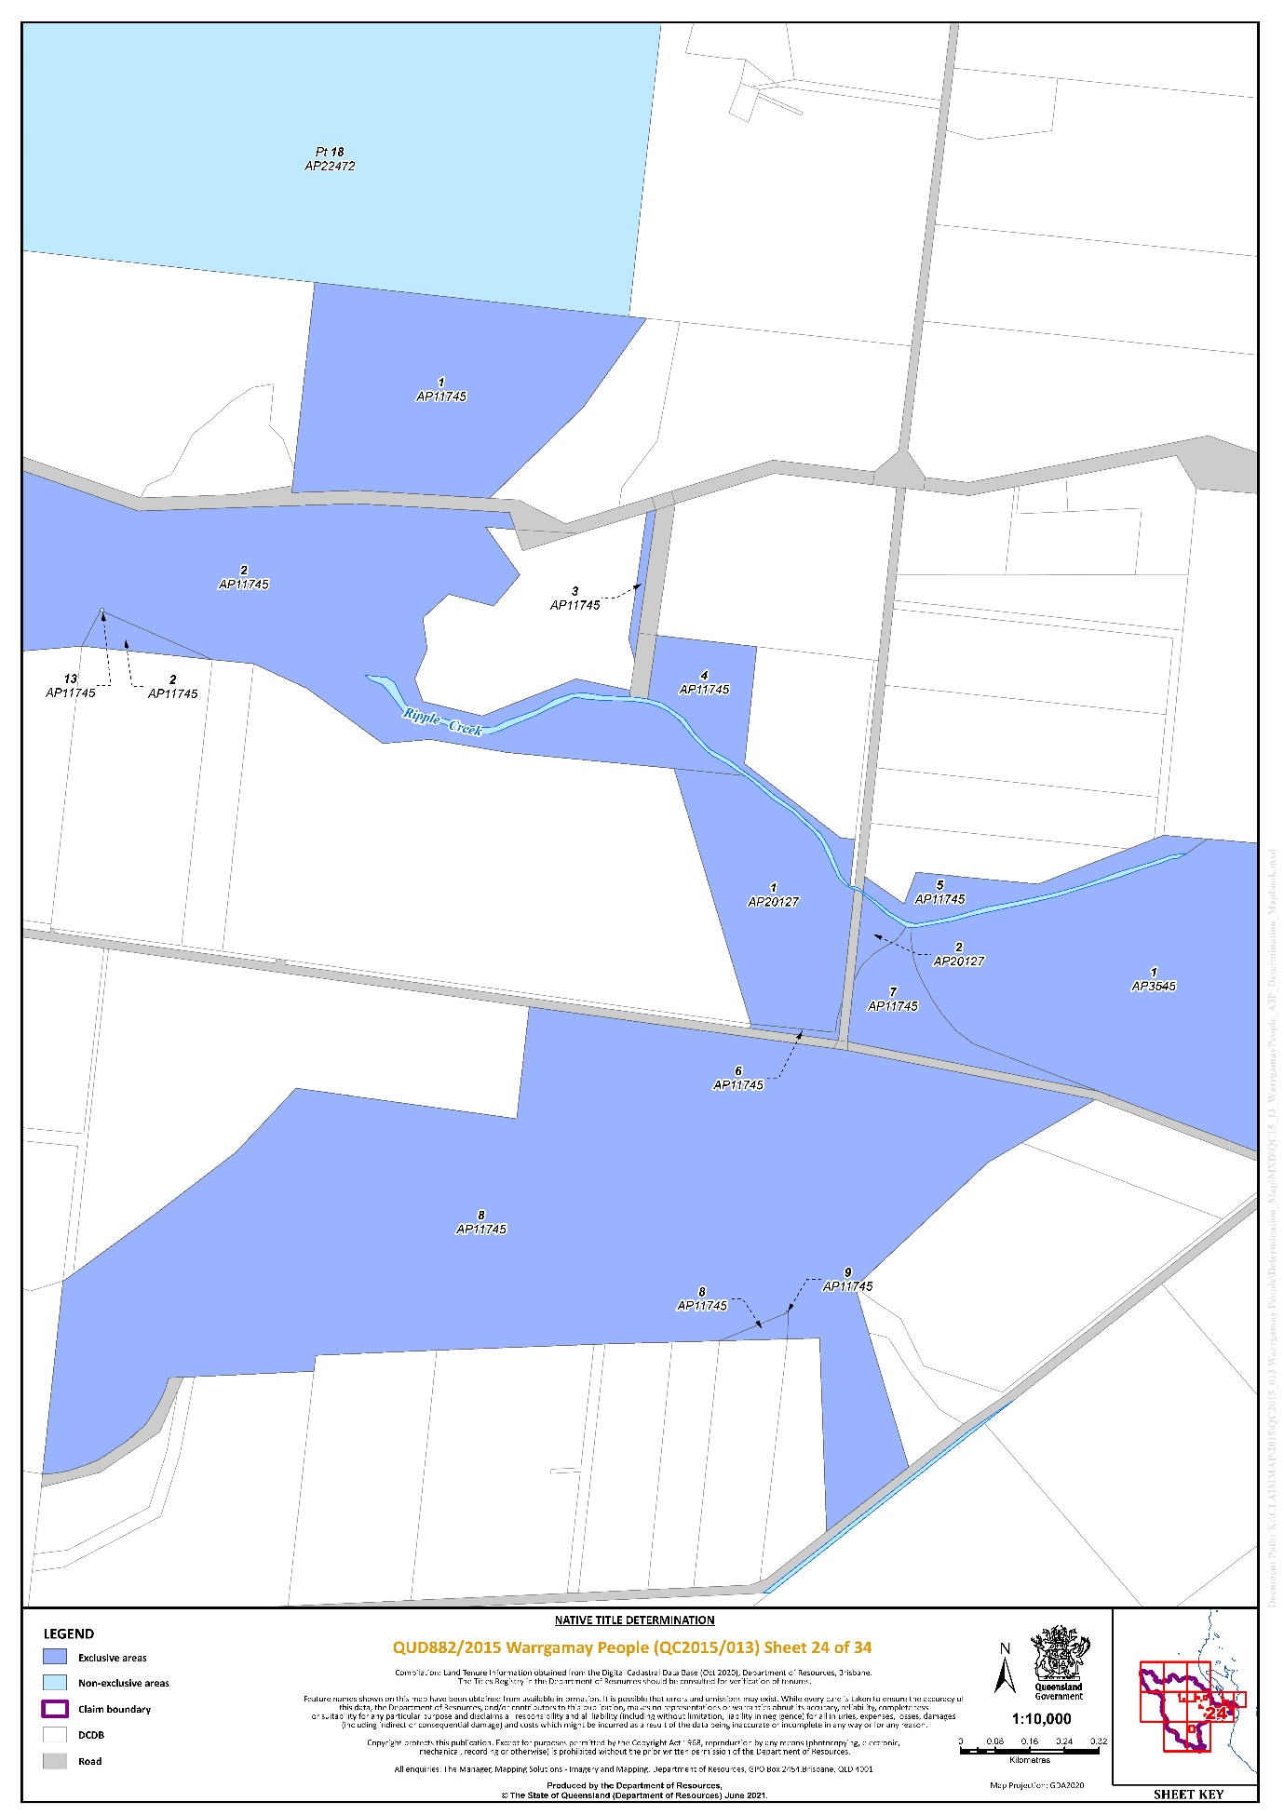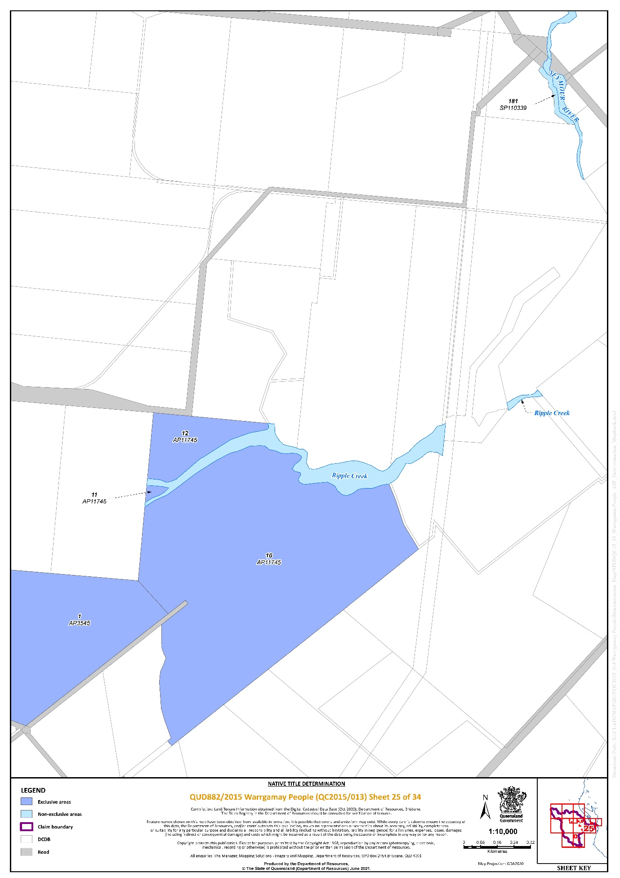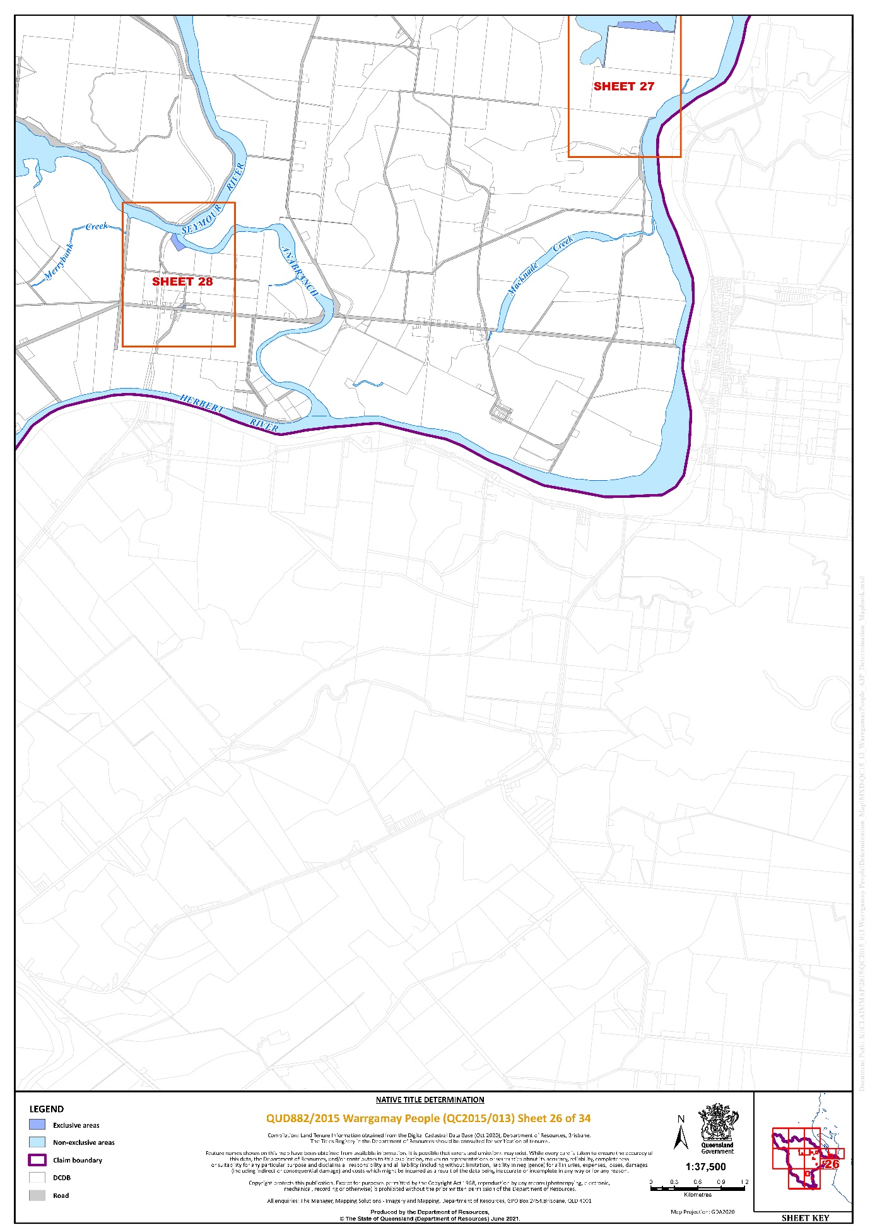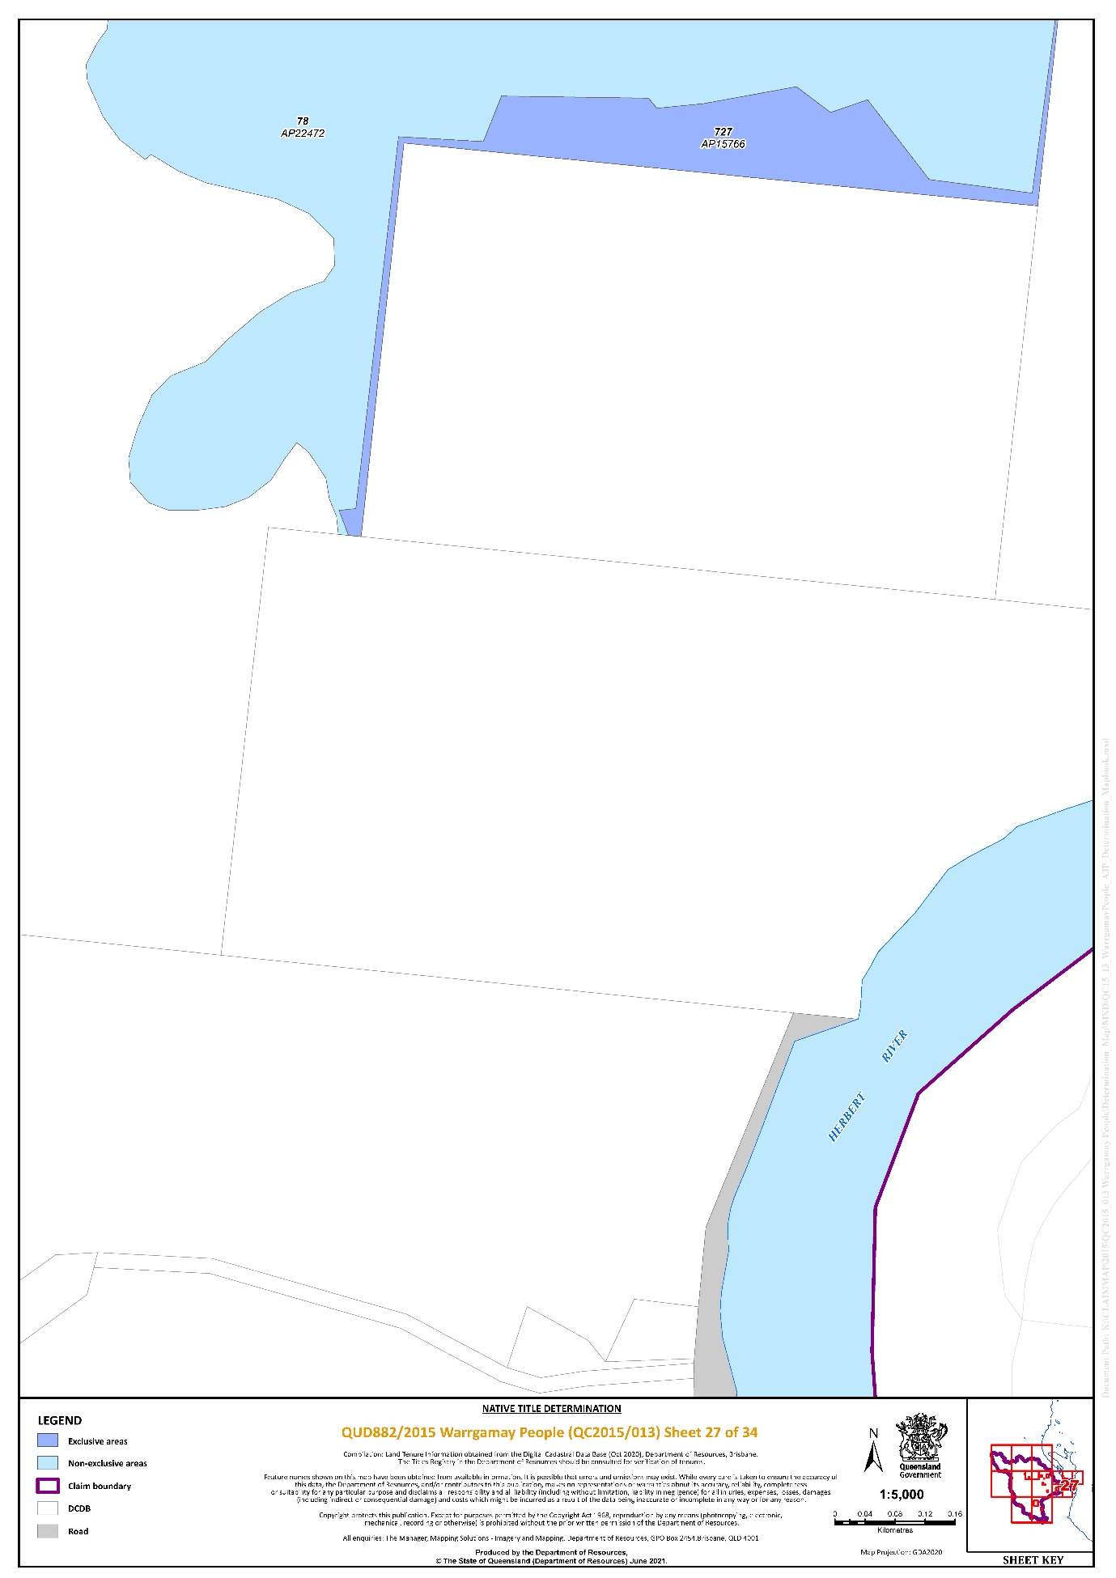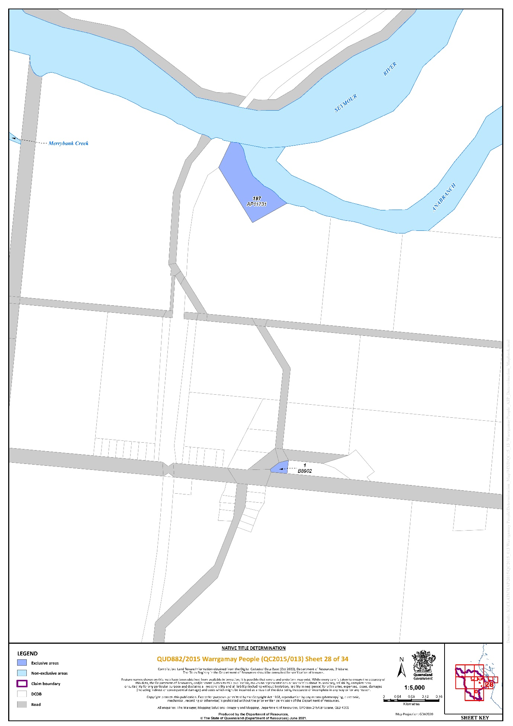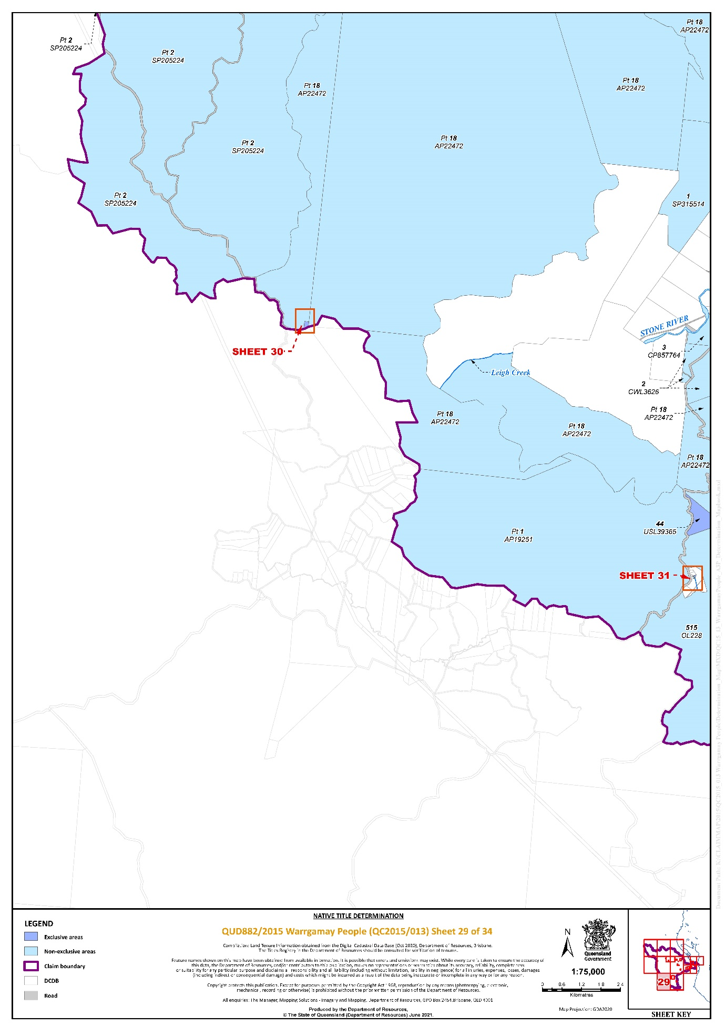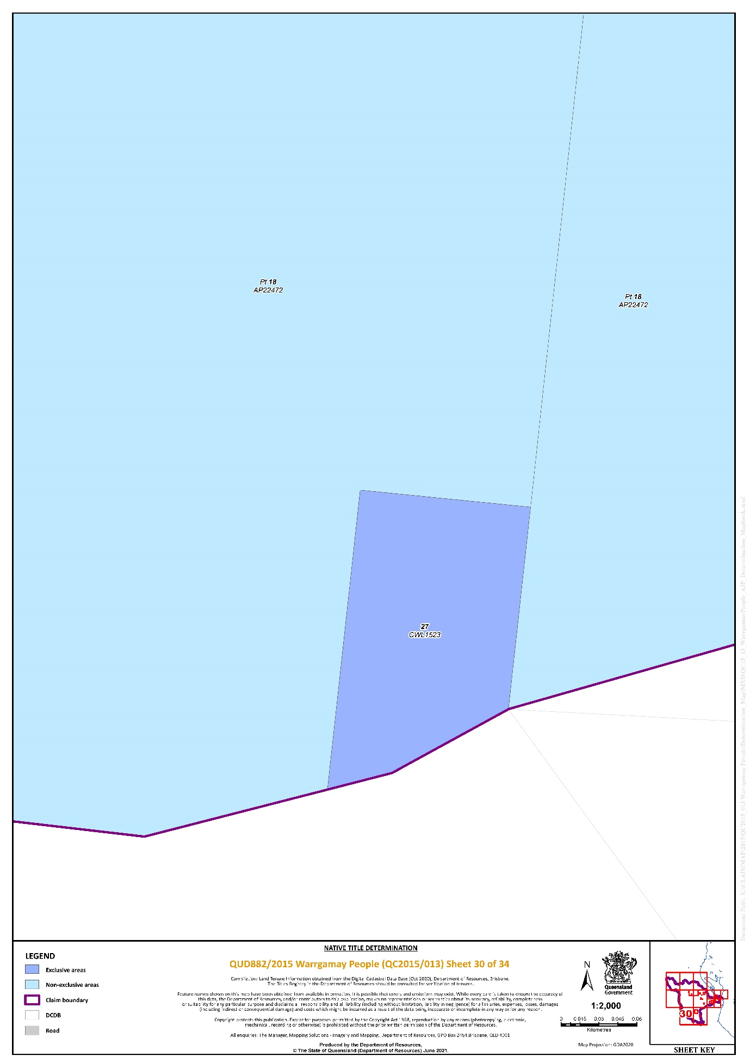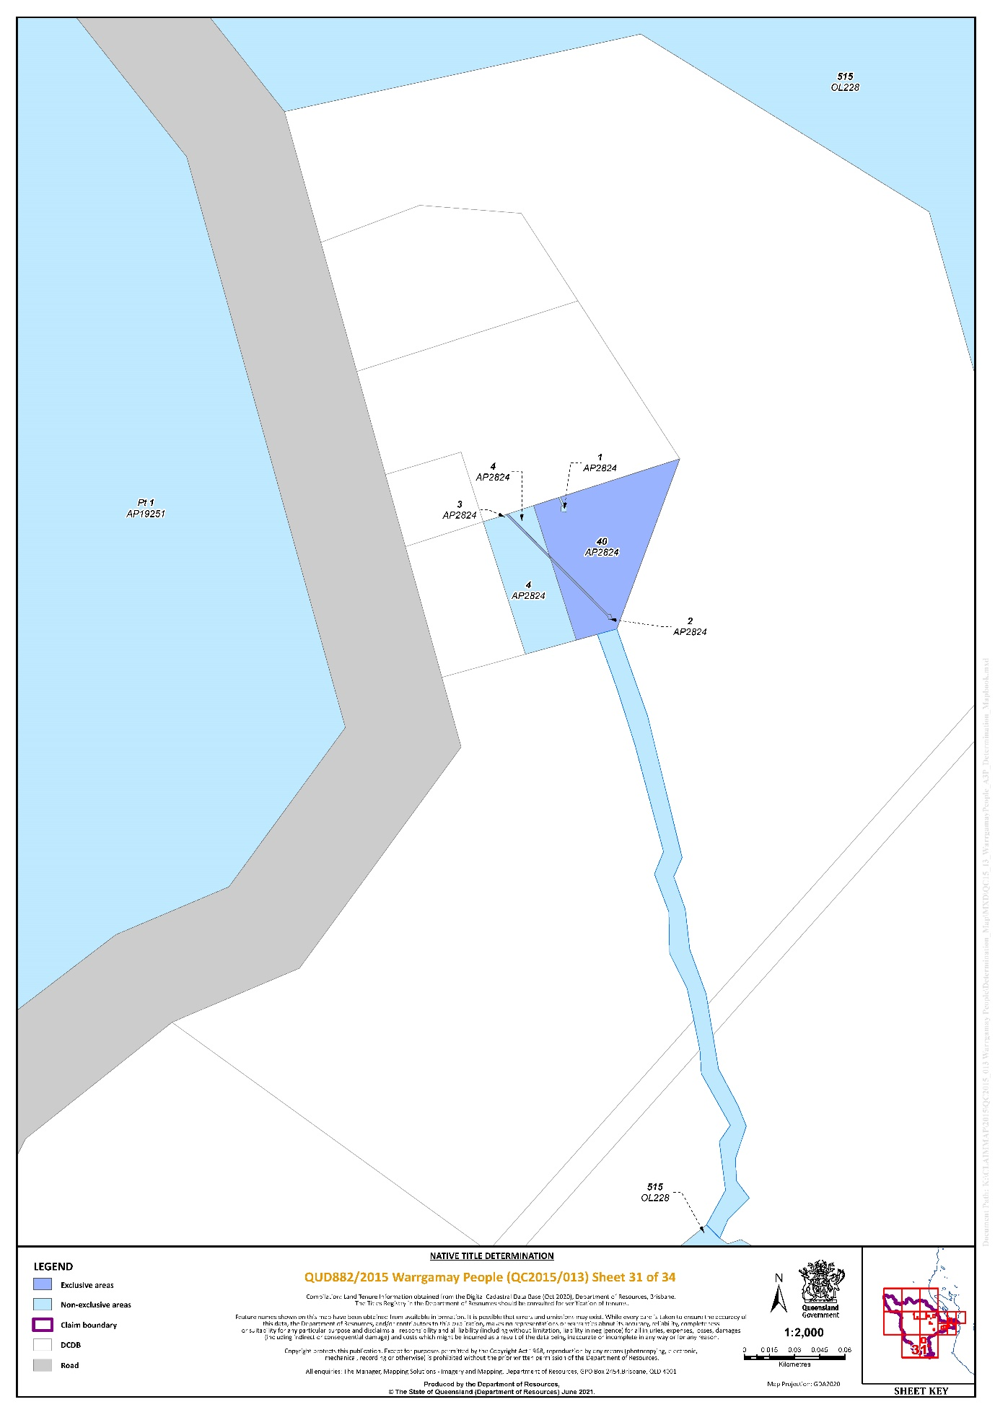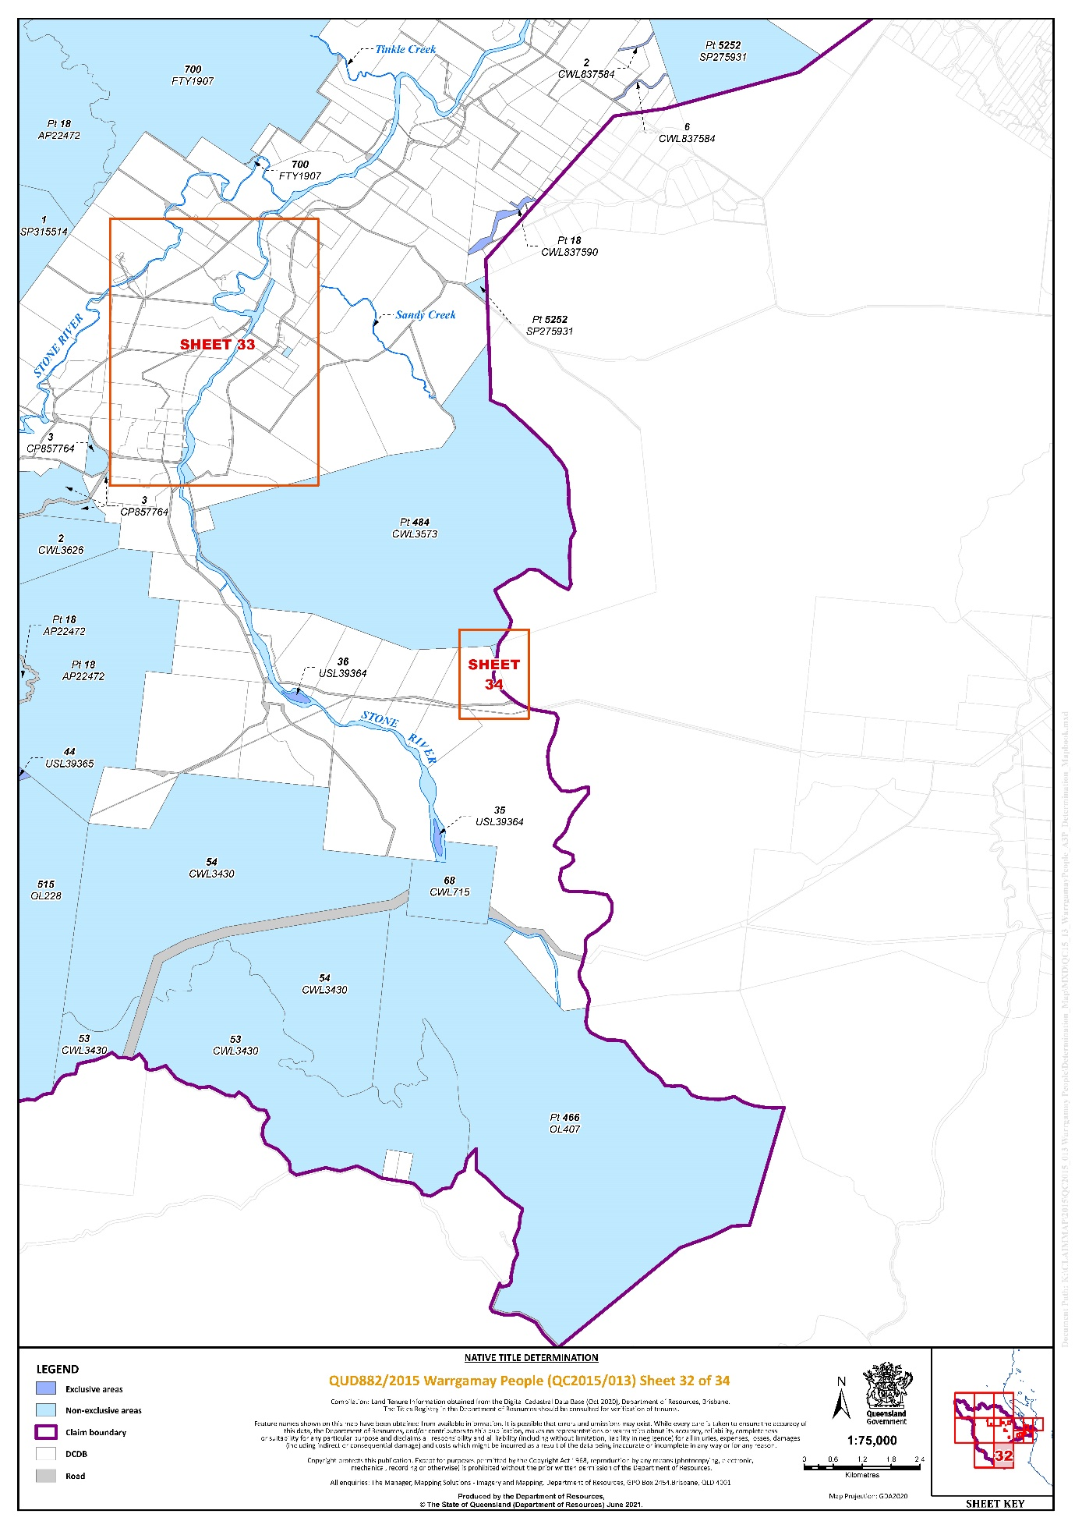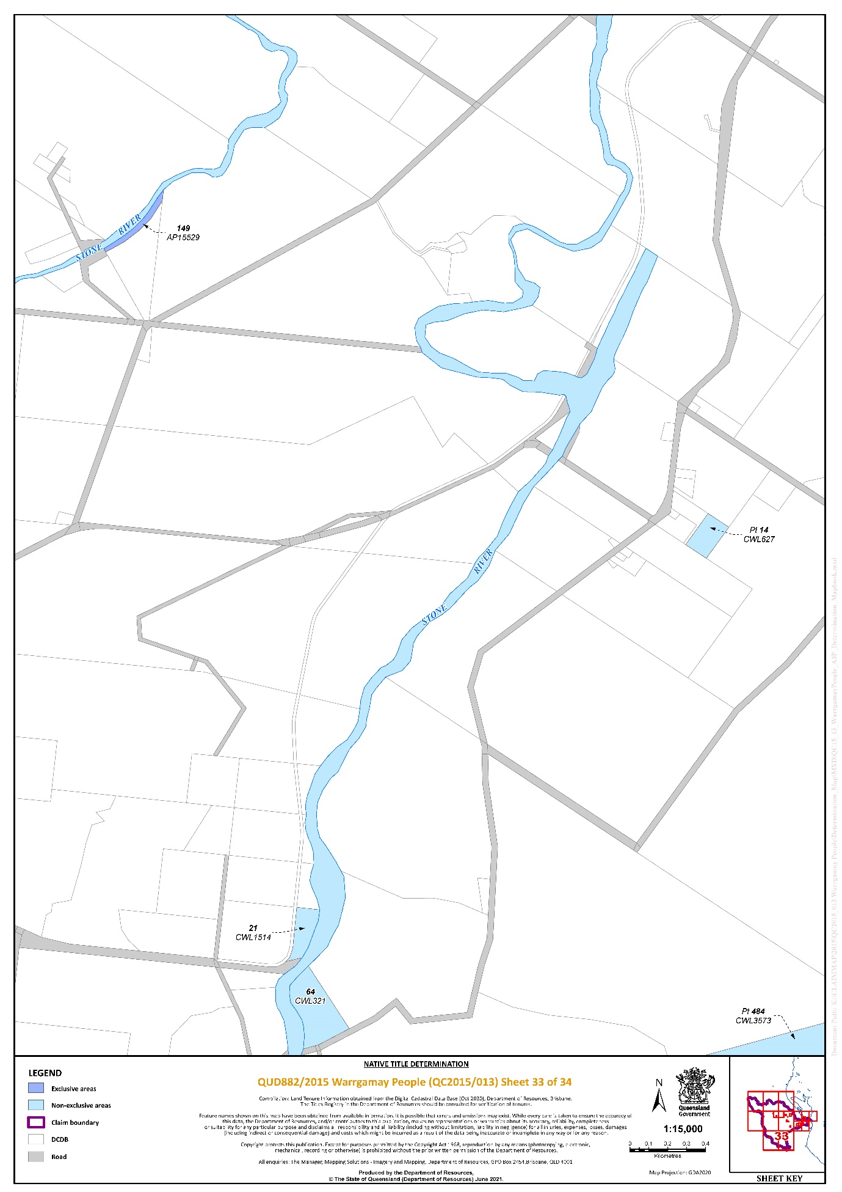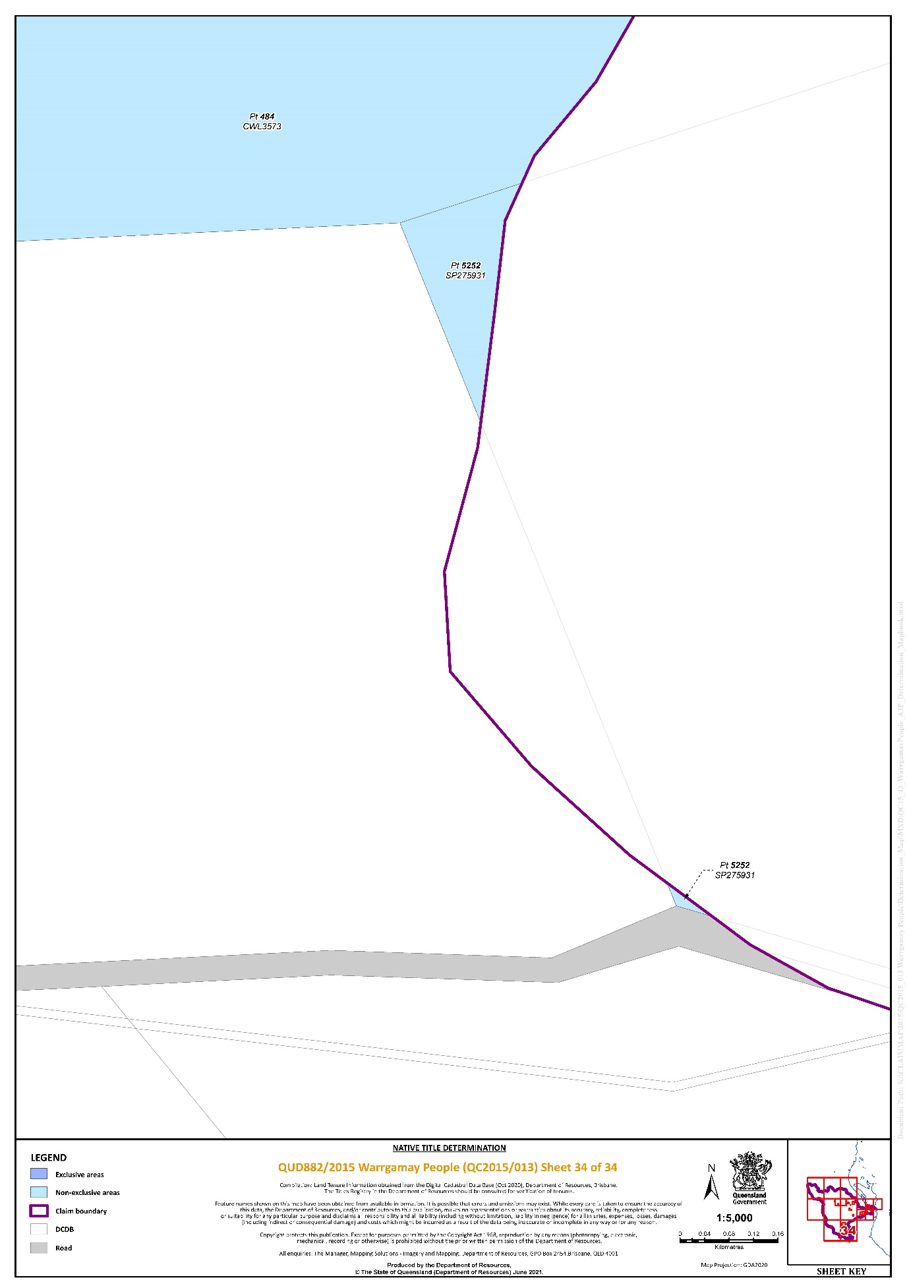

REASONS FOR JUDGMENT
MURPHY J:
1 This is an application by Michael Ryan (Snr) and others on behalf of the Warrgamay People (the Applicant) for a determination of native title over lands and waters which can generally be described as the Herbert River Valley in North Queensland, including places such as the Herbert River in the north, Sea View Range in the West, Mount Fox in the South, and the coastal area around the mouth of the Herbert River and Seymour Creek as the eastern mainland extent of country; it also includes townships like Abergowrie and Trebonne, inland from Ingham (the Warrgamay Application). The Applicant seeks orders under s 87 of the Native Title Act 1993 (Cth) (NTA) for a determination of native title which gives effect to the terms of the agreement reached between the parties (the Section 87 Agreement) including Draft Consent Determination Orders (the Draft Orders) to recognise the native title rights and interests of the Warrgamay People in the Determination Area (as defined).
2 For the reasons set out below, the Court is satisfied that it is within the power of the Court to make the orders sought, and that it is appropriate to do so.

THE WARRGAMAY PEOPLE
3 The persons comprising the representative Applicant are Mr Ryan (Snr), Charles Morganson, Janie Eaton, Jedda Priman, Sam Backo, Hayley Mazzoni, Virginia Wyles, Brett Leathers, John Tooth, Alec Sammons, Regina Hussey, Norman Griven and Joe Morganson. They should be commended for their diligence and work in representing the interests of the Warrgamay People.
4 The Warrgamay People are as described in Schedule 1 of the Draft Orders. They are the biological and adopted (in accordance with traditional law and custom) descendants of the following people:
(a) John Tooth (father of Beryl Tooth and others);
(b) Maggie (mother of Cocky, also known as Cockie, and Manala, and grandmother of Lambert Cocky);
(c) Annie Tim (mother of Kathleen Saunders, Agnes Cooktown and others);
(d) Elsie Barnes (mother of William Morganson and others);
(e) Harry Ingham and Jinnie (or Jennie and Jeannie) (parents of Mark also known as Sam Smith, Laura Jackson and others);
(f) Bien (father of Peter, Esau and Annie);
(g) Kitty (mother of Alice Wye, Ivy Wyles and Nora Boyd);
(h) Rosie (mother of Charlie Choolburra and others);
(i) Lizzie (mother of Maggie and Albert Blackman);
(j) Christina Kinch (mother of Melba Devow and others);
(k) Kitty Shepherd (mother of George Shepherd and Florence Shepherd);
(l) Annie and Alec (parents of Laura Ambrym);
(m) Billy King (father of Bridget who was wife of Esau); or
(n) Adelaide Kingsburra (mother of Marjorie Sunna and others).

The Determination Area
5 The Determination Area is generally described above. It is defined in Order 3 of the Draft Orders by reference to the written descriptions in Schedules 4 and 5 and the depiction in the map attached to Schedule 6 (Determination Area).

THE PROCESS TOWARDS A CONSENT DETERMINATION
6 The Applicant filed the Warrgamay Application on 25 September 2015. It was referred to the Native Title Registrar who was satisfied that the application met the criteria of the registration test under s 190A of the NTA. The application was entered onto the Register of Native Title Claims on 12 February 2016, and notice was given by the Native Title Registrar under s 66 of the NTA on 4 May 2016. The closing date for the notification period was 3 August 2016.
7 The respondent parties to the Warrgamay Application are:
(a) the State of Queensland (the State);
(b) Cassowary Coast Regional Council;
(c) Charters Towers Regional Council;
(d) Hinchinbrook Shire Council;
(e) Tablelands Regional Council;
(f) Telstra Corporation Limited;
(g) Ergon Energy Corporation Limited;
(h) Jeffrey Joseph Cantamessa;
(i) Paul John Cantamessa;
(j) Ian Robert Craig;
(k) Michelle Renee Edwards;
(l) Gregory Edward Erkkila;
(m) Coralie Dawn Falcomer;
(n) Barbara Joan Kehl;
(o) Stewart Alan Kehl;
(p) Steven Luigi Manenti; and
(q) Brendon Lawrence Tento.
8 On 21 July 2016, the matter was referred to a Judicial Registrar - Native Title (Registrar) for case management. As part of the case management process, the Applicant provided various statements and expert anthropologist reports to the State aimed at showing that the Warrgamay People had native title rights and interests in the Determination Area.
9 Within the context of this case management process, the parties ultimately reached agreement that native title exists in relation to the Determination Area.
10 At a meeting held in May 2021, the native title claim group in the Warrgamay Application authorised the Applicant to agree to the Draft Orders as presented to the meeting, subject to any further minor amendments that may be necessary.
11 Subsequently, all parties executed the Section 87 Agreement to which the Draft Orders are annexed, and it was filed. The Applicant seeks a determination of native title in the terms of the Draft Orders agreed by the parties.

THE MATERIAL BEFORE THE COURT
12 The application for a consent determination is supported by the following materials:
(a) the application pursuant to s 61 of the NTA;
(b) the s 87 Agreement and annexed Draft Orders;
(c) an affidavit of Jasmin Mae Phillips, a solicitor employed by the North Queensland Land Council Native Title Representative Body Aboriginal Corporation (NQLC), affirmed on 28 July 2021 including annexures JMP-35 to JMP-40;
(d) a second affidavit of Jasmin Mae Phillips affirmed on 29 July 2021 including annexure JMP-41; and
(e) the Applicant’s submissions in support of the application.

THE REQUIREMENTS OF SECTION 87

Whether the Court has power to make the proposed orders
13 Pursuant to s 87(1) of the NTA the Court may make a determination of native title by consent without holding a hearing where:
(a) the period specified in the notice given under s 66 of the NTA has ended (s 87(1));
(b) there is an agreement for a proposed determination of native title in relation to the proceeding (s 87(1)(a));
(c) the terms of the proposed determination, in writing signed by or on behalf of all of the parties, is filed with the Court (s 87(1)(b)); and
(d) the Court is satisfied that an order in, or consistent with, those terms would be within the power of the Court (s 87(1)(c)).
14 Having regard to the material before the Court, it is satisfied that:
(a) the notice periods specified in ss 66(8) and 66(10)(c) of the NTA have ended; and
(b) there is an agreement for a proposed determination of native title in relation to the proceeding, that the terms of the proposed determination are in writing, have been signed on behalf of all of the parties, and have been filed with the Court (s 87(1)(a) and (b)).
15 An order under s 87 of the NTA will be within power (s 87(1)(c)) if:
(a) it is consistent with s 94A of the NTA;
(b) the rights and interests included in the proposed determination are recognisable by the common law of Australia; and
(c) there is no other native title determination in existence over the area the subject of the proposed determination.
: Nelson v Northern Territory of Australia [2010] FCA 1343; 190 FCR 344 at [4] (Reeves J).
16 Section 94A provides that an order in which the Court makes a determination of native title must set out details of the matters mentioned in s 225 of the NTA. Section 225 provides:
A determination of native title is a determination whether or not native title exists in relation to a particular area (the determination area) of land or waters and, if it does exist, a determination of:
(a) who the persons, or each group of persons, holding the common or group rights comprising the native title are; and
(b) the nature and extent of the native title rights and interests in relation to the determination area; and
(c) the nature and extent of any other interests in relation to the determination area; and
(d) the relationship between the rights and interests in paragraphs (b) and (c) (taking into account the effect of this Act); and
(e) to the extent that the land or waters in the determination area are not covered by a non-exclusive agricultural lease or a non-exclusive pastoral lease – whether the native title rights and interests confer possession, occupation, use and enjoyment of that land or waters on the native title holders to the exclusion of all others.
17 The Court is satisfied as to each of the matters in s 225, being that:
(a) the persons holding the common or group rights comprising the native title are identified as the Warrgamay People in Order 5. The Warrgamay People are the descendants of the ancestors identified in Schedule 1, in accordance with the traditional laws and customs of the Warrgamay People (s 225(a));
(b) the nature and extent of the native title rights and interests in relation to the Determination Area are set out in Orders 6 to 10 (s 225(b));
(c) the nature and extent of any “other interests” in relation to the Determination Area are set out in Schedule 2 (s 225(c));
(d) the relationship between the rights and interests relevant to subs 225 (b) and (c) is set out in Order 12. The Draft Orders identify all “other interests” in relation to the Determination Area and specify that, to the extent that there is an inconsistency between those “other interests” and the determined native title, the “other interests” will prevail for as long as the “other interests” exist (s 225(d)); and
(e) the Draft Orders identify those parts of the Determination Area where the native title rights and interests are held exclusively by the Warrgamay People (see Order 6 and Part 1 of Schedule 4), and those areas where the native title rights and interests are held non-exclusively by the Warrgamay People (see Order 7 and Part 2 of Schedule 4) (s 225(e)).
18 The Court is satisfied that the native title rights and interests included in the Draft Orders are capable of being recognised by the common law of Australia.
19 Finally, the Court is satisfied that there is no other native title determination in existence over the area subject to the proposed determination, and that there are no other proceedings before the Court relating to native title determination applications that cover any part of the area subject to the proposed determination and which would otherwise require orders to be made under s 67(1) of the NTA.
20 The Court is satisfied that the orders sought are consistent with the terms of the parties’ agreement as reflected in the Draft Orders, and are within the Court’s power to pronounce.

Whether the proposed orders are appropriate to make
21 Section 87(1A) provides:
The Court may, if it appears to the Court to be appropriate to do so, act in accordance with:
(a) whichever of subsection (2) or (3) is relevant in the particular case; and
(b) if subsection (5) applies in the particular case – that subsection.
22 In the present case, subsection (2) is the relevant subsection and subsection (5) does not apply. Subsection 87(2) provides:
If the agreement is on the terms of an order of the Court in relation to the proceedings, the Court may make an order in, or consistent with, those terms without holding a hearing or, if a hearing has started, without completing the hearing.
23 The words “… if it appears to the Court to be appropriate to do so …” in s 87(1A) confer a discretion on the Court. Once the conditions precedent to the exercise of the discretion have been satisfied, it is unfettered, although it must be exercised judicially in accordance with legal principle. In exercising the discretion, the Court must have regard to the objects and purposes of the NTA which include that it is designed to encourage parties to take responsibility for resolving proceedings by negotiation without the need for determination in a contested hearing. The power in s 87 must be understood in that context: Munn v Queensland [2001] FCA 1229; 115 FCR 109 at [26] and [28] (Emmett J); Lovett v Victoria [2007] FCA 474 at [36]-[37] (North J).
24 The wording of s 87(1A) and (2) provide that the question for the Court is whether it is appropriate to make an order in the terms of the agreement reached between the parties, and the primary focus of the section is that agreement. As I said in Eagles on behalf of the Combined Thiin-Mah, Warriyangka, Tharrkari and Jiwarli People v State of Western Australia [2019] FCA 508 at [19]-[22]:
[19] In deciding whether it is appropriate to make the proposed orders it must be kept in mind that the Court’s function under s 87 focuses on the making of an agreement by the parties, and the power must be understood in the context of the Act’s emphasis on negotiation and alternative dispute resolution, rather than judicial determination in a contested proceeding. The power in s 87 is only exercisable when an agreement has been reached and the power should be exercised flexibly and with regard to the purpose for which the provisions are designed.
[20] The Court is not necessarily required to make findings or embark on its own inquiry as to the merits of the claim made in an application for a consent determination under s 87: see Ward v State of Western Australia [2006] FCA 1848 (Ward) at [8] (North J); Cox on behalf of the Yungngora People v State of Western Australia [2007] FCA 588 (Cox) at [3] (French J); Lander v State of South Australia [2012] FCA 427 at [11]-[12] (Mansfield J); Freddie v Northern Territory [2017] FCA 867 (Freddie) at [16]-[17] (Mortimer J). Rather, the Court must be satisfied, inter alia, that it is appropriate to make the orders sought. The indicia that will be sufficient to satisfy the Court of the appropriateness of a consent determination will be determined on a case by case basis. In some cases it may be appropriate to make orders under s 87 where the Court has received no evidence of the primary facts substantiating native title if the Court is satisfied that the parties have freely and on an informed basis come to an agreement: see Hughes (on behalf of the Eastern Guruma People) v Western Australia [2007] FCA 365 at [9] and Ward at [8].
[21] Even so, as French J observed in Cox the concept of appropriateness also recognises that the determination made by the Court is one made as against the whole world, and not just between the parties to the proceeding. The Court must be conscious that the rights conferred are enduring legal rights, proprietary in nature. This informs considerations including the requirement for the free and informed consent of all parties and the State’s agreement that there is a credible and rational basis for the determination proposed: Freddie at [18].
[22] The requirements of s 87 may, and will likely, be met where the Court is satisfied that a relevant government respondent (such as the State in the present case), through competent legal representation, is satisfied as to the cogency of the evidence upon which the Applicant relies. The Court is entitled to rely on the processes established by a State or Territory for assessing native title claims and to proceed on the basis that the State or Territory has made a reasonable and rational assessment of the material to which it has had access in deciding to enter into an agreement: Freddie at [23]-[24] and the authorities there cited.
25 The primary question is whether there exists a free and informed agreement between the parties. It is necessary to understand the process followed by the respondent parties and how they went about assessing the underlying evidence as to the existence of native title. Other considerations, all directed to the processes that led to the agreement or what was agreed, that have previously been set out by the Court include: whether the parties have independent and competent legal representation: Munn at [29], [39] and [40]; Lovett at [39]–[40]; whether the terms of the proposed order are unambiguous and clear: Munn at [32]; and whether the agreement has been preceded by a mediation process: Nangkiriny v Western Australia [2004] FCA 1156 at [6] (North J); Trevor Close on behalf of the Githabul People v Minister for Lands [2007] FCA 1847 (Branson J) at [6] and Lovett at [41]–[42].
26 The Court is satisfied that the s 87 Agreement reflects a free and informed agreement between the parties. It was negotiated in a case management process with the assistance of a Registrar who is experienced in dispute resolution in native title cases.
27 Throughout the case and the case management process, the Warrgamay People have been legally represented by counsel and by solicitors from NQLC. The State has also been legally represented, including by competent senior counsel. All but one of the other respondent parties have also had competent legal representation, and the Applicant’s submissions indicate that the unrepresented respondent was encouraged on numerous occasions to seek legal advice. The Court is satisfied that the process of reaching agreement was fair.
28 The Applicant provided the State with the following affidavits, witness statements and reports of expert anthropologists, on a without prejudice basis, for the purpose of informing it as to the native title rights and interests of the Warrgamay People which are capable of recognition pursuant to s 223 of the NTA:
(a) an affidavit of Michael Ryan Snr affirmed 9 September 2015 (which is also Attachment R2 to the native title determination application filed 25 September 2015);
(b) an anthropological report by Dr Sandra Pannell, titled Warrgamay People Connection Report, dated May 2013, with minor revisions made 21 August 2015 (Pannell Report);
(c) an anthropological report by Mr Ray Wood, titled Supplementary Report Warrgamay Native Title Application, dated 19 January 2016;
(d) an outline of submissions on behalf of the Applicant in support of connection provided 17 March 2017;
(e) an affidavit of Alec Sammons, sworn 12 October 2017;
(f) an affidavit of Greg Croton, affirmed October 2017;
(g) an affidavit of Joy Hunter, affirmed 5 October 2017;
(h) an affidavit of Regina Hussey, sworn 24 October 2017;
(i) an affidavit of Tammy Choolburra, sworn 25 October 2017;
(j) a witness Statement of Valma Togo, dated 18 June 2019;
(k) a witness Statement of Samson Neale Backo, dated 1 July 2019;
(l) a witness Statement of Melinda Holden, dated 8 July 2019;
(m) a witness Statement of Tammy Choolburra, dated 8 July 2019;
(n) a witness Statement of Bridget Priman, dated 12 July 2019;
(o) a witness Statement of Reginald Joseph Morganson, dated 25 July 2019; and
(p) a witness Statement of Alec Sammons, dated 14 August 2019,
(the Connection Material).
29 Provision was made for all respondent parties to request a copy of the Connection Material and submissions for their review, but only one respondent party other than the State took up that opportunity. Ms Edwards requested and was provided with the Pannell Report. All other respondent parties advised that they would adopt the position of the State.
30 As part of the case management process the State undertook historical tenure investigations to determine whether native title rights and interests were capable of being recognised if connection was established, and also to determine the existence and nature of “other interests” under s 225(c) of the NTA within the Warrgamay Determination Area. Relevant “other interests” are set out in Schedule 2 of the orders herein, and the relationship between the native title rights and interests and the “other interests” is described in Order 12.
31 Senior counsel and anthropologists engaged by the State reviewed and assessed the Connection Material in accordance with the “Guidelines for preparing and assessing connection material for Native Title Claims in Queensland” dated November 2016. The State’s review of the Connection Material included the State requesting and assessing further evidence that it thought was required. The State also played an active role in the negotiation of the Draft Orders. The terms of the Draft Orders are unambiguous and clear.
32 Having regard to the above, the Court is satisfied that the State, acting on behalf of the broader community, has taken a real interest in the proceeding and has engaged in a thorough examination of the application such that it is properly satisfied that there is a credible basis for the making of the proposed determination pursuant to the requirements of the NTA.
33 The Court is satisfied that it is appropriate to make a determination of native title in the terms of the Draft Orders.

THE CONNECTION OF THE WARRGAMAY PEOPLE TO THEIR COUNTRY
34 As described above, the Court’s task in an application for a native title determination under s 87 is based on the parties’ free and informed agreement, and does not require judicial determination of the issues in the application. However, this determination and the reasons which accompany it stand as a permanent record for the Warrgamay People of judicial recognition of their native title rights, and it is appropriate to say something about the Warrgamay People and their country.
35 The submissions before the Court provide that the Connection Material establishes:
(a) that the Warrgamay People today are descended from a community of people who spoke Warrgamay language and who used and occupied Warrgamay country prior to 1788;
(b) the identity of the Warrgamay apical ancestors and locates them as a community of Warrgamay People in the early days of European contact in Warrgamay People’s country (in the 1880s);
(c) the acquisition and transfer of the cultural knowledge of the Warrgamay People throughout the 20th century;
(d) that the Warrgamay People are today, and were in 1900, an organised society that possesses native title rights and interests in accordance with observed and acknowledged traditional laws and customs;
(e) the intergenerational transfer of those laws and customs and supports an inference that they, as well as the rights possessed in accordance with them, have their origins in a pre-sovereignty Warrgamay society;
(f) that despite the impact of sustained settlement in the Warrgamay claim area and the impacts of European settlement on the Warrgamay population, Warrgamay people have continued to possess native title in accordance with observed and acknowledged traditional law and custom. Whilst there have been some adaptions of law and customs as a result of the impacts of sustained European settlement, those changes have not affected the laws and customs of the Warrgamay People to the extent that the rights or interests asserted are no longer possessed under the traditional laws acknowledged and the traditional customs observed;
(g) that the rights and interests in the Draft Orders are not antithetical to fundamental tenants of the common law and, subject to permissible adaption, existed at sovereignty, survived that fundamental change in legal regime, and now can be enforced and protected. As such, they are recognised by the common law of Australia;
(h) that the members of the Warrgamay People have maintained a traditional, physical and spiritual connection to their lands and waters since sovereignty; and
(i) the continuity of Warrgamay People as a society possessing native title in accordance with observed and acknowledged traditional law and custom.

THE REQUIREMENTS OF S 55 AND 56 - PRESCRIBED BODY CORPORATE
36 Where the Court proposes to make a determination that native title exists it must determine whether the native title is to be held in trust and if so by whom: ss 55 and 56(1) of the NTA.
37 The Court may determine that the native title is to be held in trust if the common law holders (being the Warrgamay People as described in Schedule 1) have given a nomination of the kind referred to in s 56(2)(a).
38 The Applicant has filed a nomination in writing that the Warrgamay Traditional Owners Aboriginal Corporation (ICN 9530) incorporated under the Corporations (Aboriginal and Torres Strait Islander) Act 2006 (Cth) be the prescribed body corporate to hold the rights and interests comprising the native title in trust for the common law holders, pursuant to s 56(2)(a) of the NTA. At a meeting of the company’s Board of Directors on 19 July 2021, the directors resolved to accept the role and obligations of the prescribed body corporate in respect of the determination of native title in this proceeding.
39 It is therefore appropriate to make Orders 14 and 15 of the Draft Orders to record the Court’s determination that:
(a) the native title is held in trust;
(b) the Warrgamay Traditional Owners Aboriginal Corporation is to be the prescribed body corporate for the purposes of ss 56(2)(b) and 56(3) of the NTA; and
(c) after becoming the prescribed body corporate, the Warrgamay Traditional Owners Aboriginal Corporation is to perform the functions mentioned in s 57(1) of the NTA.

CONCLUSION
40 For the Warrgamay People, the Section 87 Agreement and the orders herein vindicate their claim for judicial recognition as the people who have always held native title rights and interests in the Determination Area; it is and always has been their country.
41 Ordinarily, as a symbol of the recognition of native title the Court would hand bound copies of the consent determination to the representatives of the Warrgamay People. Unfortunately, the COVID-19 pandemic has meant that it is not possible for an in person hearing to be held. As a substitute, this hearing is being recorded and will be played at a celebration by the Warrgamay People to be held on 19 August 2021 on their country.

I certify that the preceding forty-one (41) numbered paragraphs are a true copy of the Reasons for Judgment of the Honourable Justice Murphy.

Associate:

Dated: 18 August 2021

SCHEDULE OF PARTIES

 | QUD 882 of 2015
Applicants
Fourth Applicant: | NORMAN GRIVEN
Fifth Applicant: | REGINA HUSSEY
Sixth Applicant: | BRETT LEATHERS
Seventh Applicant: | HAYLEY MAZZONI
Eighth Applicant: | CHARLES MORGANSON
Ninth Applicant: | JOE MORGANSON
Tenth Applicant: | JEDDA PRIMAN
Eleventh Applicant: | ALEX SAMMONS
Twelfth Applicant: | JOHN TOOTH
Thirteenth Applicant: | VIRGINIA WYLES
Respondents
Fourth Respondent: | HINCHINBROOK SHIRE COUNCIL
Fifth Respondent: | TABLELANDS REGIONAL COUNCIL
Sixth Respondent: | TELSTRA CORPORATION LIMITED
Seventh Respondent: | ERGON ENERGY CORPORATION LIMITED ACN 087 646 062
Eighth Respondent: | JEFFREY JOSEPH CANTAMESSA
Ninth Respondent: | PAUL JOHN CANTAMESSA
Tenth Respondent: | IAN ROBERT CRAIG
Eleventh Respondent: | MICHELLE EDWARDS
Twelfth Respondent: | GREGORY EDWARD ERIKKLA
Thirteenth Respondent: | CORALIE DAWN FALCOMER
Fourteenth Respondent: | BARBARA JOAN KEHL
Fifteenth Respondent: | STEWART ALAN KEHL
Sixteenth Respondent: | STEVEN LUIGI MANENTI
Seventeenth Respondent: | BRENDON LAWRENCE TENTO

