FEDERAL COURT OF AUSTRALIA

Bandjalang People No 1 and No 2 v Attorney General of New South Wales [2013] FCA 1278

Citation: | Bandjalang People No 1 and No 2 v Attorney General of New South Wales [2013] FCA 1278
Parties: | BANDJALANG PEOPLE NO 1 v THE NSW ATTORNEY GENERAL AS THE STATE MINISTER FOR NEW SOUTH WALES AND OTHERS  BANDJALANG PEOPLE NO 2 v THE NSW ATTORNEY GENERAL AS THE STATE MINISTER FOR NEW SOUTH WALES AND OTHERS
File numbers: | NSD 6034 of 1998  NSD 6107 of 1998
Judge: | JAGOT J
Date of judgment:  Corrigendum: | 2 December 2013  29 January 2014  17 February 2014
Catchwords: | NATIVE TITLE – consent determination
Legislation: | Corporations (Aboriginal and Torres Strait Islanders) Act 2006 (Cth)  Federal Court of Australia Act 1976 (Cth)  Native Title Act 1993 (Cth)
Cases cited: | King on behalf of The Eringa Native Title Claim Group v State of South Australia (2011) 285 ALR 454; [2011] FCA 1386  Lovett (on behalf of the Gunditjmara People) v Victoria [2007] FCA 474  Munn v Queensland (2001) 115 FCR 109; [2001] FCA 1229  Nangkiriny v State of Western Australia (2002) 117 FCR 6; [2002] FCA 660  Ward v Western Australia [2006] FCA 1848
Date of hearing: | 2 December 2013
Place: | Evans Head
Division: | GENERAL DIVISION
Category: | Catchwords
Number of paragraphs: | 23
Counsel for the Applicants: | S B Phillips
Solicitor for the Applicants: | NTS Corp
Counsel for the Respondent: | G Kennett SC with T Jowett
Solicitor for the Respondent: | NSW Crown Solicitor

FEDERAL COURT OF AUSTRALIA

Bandjalang People No 1 and No 2 v Attorney General of New South Wales [2013] FCA 1278

CORRIGENDUM
- In the first sentence of paragraph 18, delete 1992 and insert in its place 2002.

I certify that the preceding one (1) numbered paragraph is a true copy of the Corrigendum to Reasons for Judgment herein of the Honourable Justice Jagot.

Associate:

Dated: 29 January 2014.
FEDERAL COURT OF AUSTRALIA

Bandjalang People No 1 and No 2 v Attorney General of New South Wales [2013] FCA 1278

CORRIGENDUM
- Amended orders have been inserted as at 30 January 2014.

I certify that the preceding one (1) numbered paragraph is a true copy of the Corrigendum to Reasons for Judgment herein of the Honourable Justice Jagot.

Associate:

Dated: 17 February 2014.

IN THE FEDERAL COURT OF AUSTRALIA
NEW SOUTH WALES DISTRICT REGISTRY
GENERAL DIVISION | NSD 6034 of 1998  NSD 6107 of 1998

BETWEEN: | ANTHONY EDWARD WILSON and DOUGLAS STEVEN WILSON ON BEHALF OF BANDJALANG PEOPLE NO 1  Applicant
AND: | THE NSW ATTORNEY GENERAL AS THE STATE MINISTER FOR NEW SOUTH WALES AND OTHERS  Respondent

JUDGE: | JAGOT J
DATE OF ORDER: | 2 DECEMBER 2013
WHERE MADE: | EVANS HEAD  (AMENDED PURSUANT TO R. 39.05)

BEING SATISFIED that a determination of native title in the terms sought by the parties is within the power of the Court, and it appearing appropriate to do so by consent of the parties and pursuant to ss. 87(4) and 94A of the Native Title Act 1993 (Cth) 1993,

THE COURT NOTES THAT:
- It is the intention of the State of New South Wales and the Applicant without delay to enter into an Indigenous Land Use Agreement for the following purposes:
  - To establish regimes for the future management of the State Forests, National Parks, Crown reserves, the travelling stock reserves and the fisheries resource within the Consent Determination Area;
  - To provide a regime for the undertaking of Future Acts in the Consent Determination Area; and
  - To achieve a final settlement with the Bandjalang People for any past affect to their native title rights and interests.
- The parties have agreed that the land within the claim area for the Proceedings that wasubject to an order under Regulation 54 of the National Security (General) Regulations be included within the Consent Determination Area.
- The parties have also agreed that the NSW Attorney General may seek to vary the Consent Determination Area in accordance with s.13(1)(b) and (5) of the Native Title Act 1993 (Cth) in the event that the High Court decision (or a Full Federal Court decision in respect of which either special leave to appeal to the High Court is refused or is not sought) that an order under Regulation 54 of the National Security (General) Regulations wholly extinguishes any native title rights and interests by seeking to remove from the Consent Determination Area that part of the Consent Determination Area that was subject to an order made under Regulation 54.
- Subject to paragraph E of these notations below, if the NSW Attorney General makes an application to seek a variation of the determination in accordance with paragraph C above, the parties agree to orders being made that provide for the application for variation to be served on the parties to the Proceeding, that any party wishing to respond to the application for variation shall, within 28 days of the service of the application, file a Notice of Address for Service, that any party who does not file a Notice of Address for Service within the stated 28 days shall no longer be a party to the application for variation, and that any party who files a Notice of Address for Service will consent to the application for variation being argued on the merits.
- For the avoidance of doubt:
  - nothing in paragraph D above of these notations or otherwise prevents any party from opposing a variation to the determination on the basis of the merits of such application; and
  - nothing in paragraphs C and D above of these notations or otherwise is or will be an admission by any of the parties that if a Full Federal Court or High Court decision of the nature referred to in those paragraphs is made, the NSW Attorney General will necessarily be entitled to a variation of the determination.

THE COURT ORDERS THAT:

- There be a determination of native title in the terms set out below (the Determination).
- The native title is to be held on trust.
- The Bandjalang Aboriginal Corporation Prescribed Body Corporate (ICN 7930) is to:
  - be the prescribed body corporate for the purposes of s. 57(1) of the Native Title Act 1993 (Cth); and
  - perform the functions set out in s. 57(1) of the Native Title Act 1993 (Cth) and the Native Title (Prescribed Bodies Corporate) Regulations 1999 (Cth).
- There be no orders as to costs.

Note: Entry of orders is dealt with in Rule 39.32 of the Federal Court Rules 2011.

THE COURT DETERMINES THAT:

Existence of Native Title
- Native title exists in relation to:
  - each of the areas of land and waters described in Schedule One, to the extent that each falls within the external boundaries of the claim area as described in Attachment B to the Further Amended Claimant Application in the Proceedings (which is reproduced as Schedule Three to this Consent Determination) ("External Boundaries"); and
  - all land between the mean high water mark and the mean low water mark within the External Boundaries
  - collectively the areas described at (a) and (b) above are the "Consent Determination Area".

Native title holders
- Native title is held by the Bandjalang People who are Aboriginal persons who are:
  - the biological descendants of:
    - King Harry, Jack Wilson, Susannah mother of Frank Jock Jnr, Michael “Mundoon” Wilson, George James, Eliza Breckenridge, Jack Breckenridge, Frank Jock Jnr, Ada Jock, Gibson Robinson, Grace Bond; and
  - persons adopted or incorporated into the families of those persons (and the biological descendants of any such adopted or incorporated persons) and who identify as and are accepted as Bandjalang People in accordance with Bandjalang traditional laws and customs.

Nature and extent of native title rights and interests
- Subject to paragraphs 4 to 9 inclusive the nature and extent of the native title rights and interests held by the Bandjalang People in the Consent Determination Area identified in Schedule One, are the non-exclusive rights set out below:
  - the right to hunt, fish and gather the traditional natural resources of the Consent Determination Area for non-commercial personal, domestic and communal use;
  - the right to take and use waters on or in the Consent Determination Area;
  - the right to access and camp on the Consent Determination Area;
  - the right to do the following activities on the land:
    - conduct ceremonies;
    - teach the physical, cultural and spiritual attributes of places and areas of importance on or in the land and waters; and
    - to have access to, maintain and protect from physical harm, sites in the Consent Determination Area which are of significance to the Bandjalang People under their traditional laws and customs.

General Limitations
- Native title does not exist in:
  - minerals as defined in the Mining Act 1992 (NSW) and the Mining Regulation 2010 (NSW); and
  - petroleum as defined in the Petroleum (Onshore) Act 1991 (NSW) and the Petroleum (Submerged Lands) Act 1982 (NSW).
- Native title rights and interests do not exist in the areas within the Consent Determination Area covered by Public Works (including the land defined in section 251D of the Native Title Act 1993 (Cth)) which were constructed, established or situated prior to 23 December 1996 or commenced to be constructed or established on or before that date.
- Public Works within the Consent Determination Area constructed, established or situated after 23 December 1996 have had or will have, if yet to be constructed, such effect as has resulted from Part 2 Division 3 of the Native Title Act 1993 (Cth).
- Native title rights and interests do not exist in any area of land which has been dedicated as a public road or a main road in accordance with the statutory requirements for such dedication, even if the land is no longer so dedicated.
- The native title rights and interests described in paragraph 3 are exercised for personal, domestic and non-commercial communal purposes and do not confer possession, occupation, use or enjoyment to the exclusion of all others. The native title rights and interests do not confer any right to control public access or public use of the land and waters of the Consent Determination Area.
- The native title rights and interests in the Consent Determination Area are subject to and exercisable in accordance with:
  - the laws of the State of New South Wales and the Commonwealth , including the common law; and
  - the traditional laws acknowledged and traditional customs observed by the Bandjalang People.

Nature and extent of other rights and interests
- The nature and extent of other rights and interests in the Consent Determination Area are described in Schedule Two.
- Any reference in a clause of Schedule Two to a specific right or interest, which is said to be included in a broader class of rights or interests described in that clause, is included for abundant caution and is not intended to limit the generality of that broader class.

Relationship between native title rights and interests and other rights and interests
- The relationship between the native title rights and interests in the Consent Determination Area that are described in paragraph 3 and the other rights and interests described in paragraph 10 and Schedule Two (“the Other Interests”) is that:
  - the Other Interests continue to have effect; and
  - the Other Interests and any activity done in accordance with or incidental to the exercise of a right conferred or held under the Other Interests, while they are in existence, prevail over but do not extinguish the native title rights and interests and any exercise of those native title rights and interests.
  - the native title is subject to extinguishment by:
    - the lawful powers of the Commonwealth and of the State of New South Wales; and/or
    - the lawful grant or creation of interests pursuant to the Laws of the Commonwealth and the State of New South Wales.

Definitions
- In these orders, unless the contrary intention appears:
“Bandjalang People” means the native title holders as described in order 2.
“camp” means to stay on the Consent Determination Area for temporary periods. Tents or other like structures are permitted. It does not include the right to permanently reside or build permanent structures or fixtures.
“Consent Determination Area” means the land and waters described and mapped in Schedule One.
“laws” include statutes, regulations and other subordinate legislation and the common law.
“Proceedings” means the application for determination of native title made by Anthony Edward Wilson and Douglas Steven Wilson for and on behalf of the Bandjalang People (NC96/16; NSD6034/98) and any matters arising from those proceedings.
- If a word or expression is not defined in these orders, but is defined in the Native Title Act 1993 (Cth), then it has the meaning given to it in the Native Title Act 1993 (Cth).
SCHEDULE ONE – CONSENT DETERMINATION AREA
The land and waters in which the Bandjalang People hold native title are the parcels described in Annexure A as shown on the map attached at Annexure B.
In the event of an inconsistency between the written description provided in this attachment and the map, the written description shall prevail.
Annexure A to SCHEDULE ONE
DESCRIPTION OF THE CONSENT DETERMINATION AREA
ID AREA | PARCEL | DESCRIPTION OF LAND
2 | Lot 7050 DP 1112972
8 | Lot 7015 DP 1076665 & Lot 7096 DP 1113511
11 | Lot 7020 DP 1051335
12 | Lot 7019 DP 1051692
13 | Lot 7094 DP 1113512
20 | Unidentified Crown Land as shown on the map at Annexure B
23 | Lot 7307 DP 1153014
24 | Lot 7308 DP 1153014
30 | Lot 7017 DP 1112984
31 | Lot 91 DP 755614
32 | Lot 7301 DP 1163536
44 | Lot 7095 DP 1113843
48 | Unidentified Crown Land as shown on the map at Annexure B
116 | Lot 161 DP 755624 | Bundjalung National Park GG 25/1/1980
117 | Unidentified land | Bundjalung National Park GG 30/1/1981
119 | Lot 70 DP 755614 | Bundjalung National Park GG 25/1/1980
120 | Lot 42 DP 755614 | Bundjalung National Park GG 4/11/1983
122 | Lot 49 DP 755614 | Bundjalung National Park GG 25/1/1980
123 | Unidentified land | Bundjalung National Park GG 25/1/1980
124 | Unidentified land | Bundjalung National Park GG 25/1/1980
125 | Part of Lot 7302 DP 1163536 | Bundjalung National Park GG 25/1/1980
126 except in relation to 126(c) | Part of Lot 52 DP 755614 | Bundjalung National Park GG 25/1/1980
127 | Part of 7302 DP 1163536 | Bundjalung National Park GG 25/1/1980
129 except in relation to 129 (C) | Part of Lot 53 DP 755614 | Bundjalung National Park GG 25/1/1980
130 | Part of Lot 53 DP 755614 | Bundjalung National Park GG 25/1/1980
132 | Lot 13 DP 755613 | Bundjalung National Park GG 25/1/1980
144 | Unidentified | Bundjalung National Park GG 26/2/1999 addition
149 | Part of Lot 3 DP 755610 | Tabbimoble Swamp Nature Reserve GG 26/2/1999
150 | Part of Lot 3 DP 755610 | Tabbimoble Swamp Nature Reserve GG 26/2/1999
168 | Lot 63 DP 755624 | Broadwater National Park GG 12/7/1974
170 | Lot 7058 DP 96632 | Broadwater National Park GG 5/3/1999
171 | Unidentified land | Broadwater National Park GG 22/8/1980
172 | Unidentified | Broadwater National Park GG 12/7/1974
175 | Unidentified | Broadwater National Park GG 12/7/1974
176 | Unidentified | Broadwater National Park GG 12/7/1974
177 | Unidentified | Broadwater National Park GG 28/5/1982
178 | Unidentified | Bundjalung National Park GG 25/1/1980
179 | Unidentified | Bundjalung National Park GG 25/1/1980
180 | Unidentified | Bundjalung National Park GG 25/1/1980
181 | Unidentified | Bundjalung National Park GG 25/1/1980 & 22/7/1983
182 | Unidentified | Bundjalung National Park GG 25/1/1980 & 22/7/1983
183 | Lot 377 DP 755624 | Broadwater National Park GG 19/7/1985
184 | Lot 378 DP 755624 | Broadwater National Park GG 19/7/1985
185 | Lot 379 DP 755624 | Broadwater National Park GG 19/7/1985
186 | Lot 384 DP 755624 | Broadwater National Park GG 19/7/1985
187 | Lot 386 DP 755624 | Broadwater National Park GG 19/7/1985
188 | Lot 387 DP 755624 | Broadwater National Park GG 19/7/1985
190 | Lot 399 DP 755624 | Broadwater National Park GG 19/7/1985
191 | Lot 400 DP 755624 | Broadwater National Park GG 19/7/1985
192 | Lot 401 DP 755624 | Broadwater National Park GG 19/7/1985
193 | Lot 7105 DP 1123365 | Broadwater National Park GG 5/3/1999
194 | Part of Lot 7058 DP 96632 | Broadwater National Park GG 5/3/1999
196 | Lot 7014 DP 1057092 | Broadwater National Park GG 5/3/1999
197 | Unidentified | Broadwater National Park GG 5/3/1999
198 | Unidentified | Broadwater National Park GG 22/8/1980
200 | Unidentified | Broadwater National Park GG 22/8/1980
201 | Unidentified | Broadwater National Park GG 12/7/1974
202 | Unidentified | Broadwater National Park GG 12/7/1974
203 | Unidentified | Broadwater National Park GG 12/7/1974
204 | Unidentified | Broadwater National Park GG 12/7/1974
205 | Unidentified | Broadwater National Park GG 12/7/1974
206 | Unidentified | Bundjalung National Park GG 25/1/1980
207 | Unidentified | Part Esk River
213 | Unidentified | Broadwater National Park GG 22/8/1980
214  Except in relation to 214D | Unidentified | Bundjalung National Park GG 25/1/1980
215 | Unidentified | Bundjalung National Park GG 25/1/1980
217 | Unidentified | Bundjalung National Park GG 25/1/1980
219 North of the southern boundary | Unidentified | Bundjalung National Park GG 25/1/1980
220 | Unidentified | Bundjalung National Park GG 25/1/1980

Annexure B to SCHEDULE ONE
MAP OF CONSENT DETERMINATION AREA
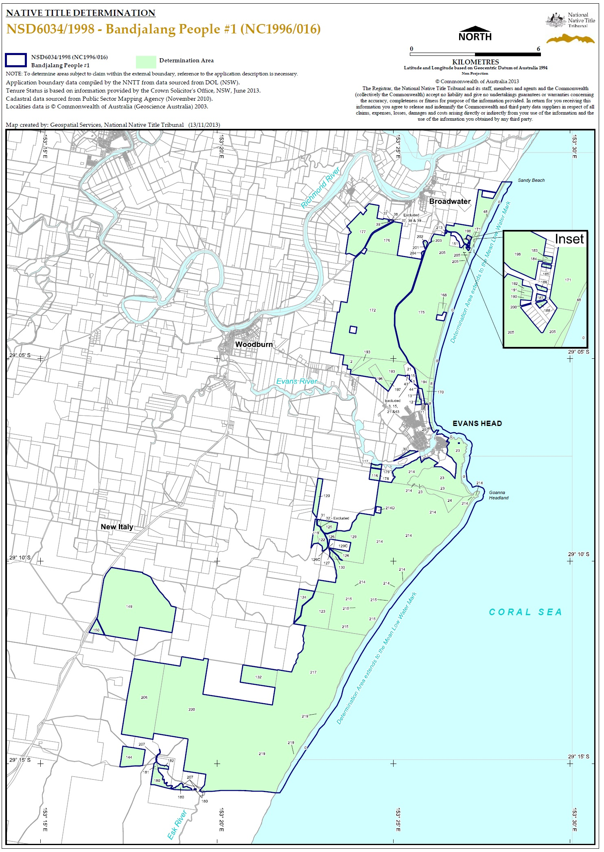

SCHEDULE TWO
OTHER RIGHTS AND INTERESTS
            - The rights and interests of Telstra Corporation Limited;
  - as the owner or operator of telecommunications facilities within the Consent Determination Area;
  - as the holder of a carrier licence under the Telecommunications Act 1997 (Cth);
  - created pursuant to the Post and Telegraph Act 1901 (Cth), the Telecommunications Act 1975 (Cth), the Australian Telecommunications Corporations Act 1989 (Cth), the Telecommunications Act 1991 (Cth) and the Telecommunications Act 1997 (Cth), including rights
(i) to inspect land;
(ii) to install and operate telecommunications facilities; and
(iii) to alter, remove, replace, maintain, repair and ensure the proper functioning of its telecommunications facilities;
  - for its employees, agents or contractors to access its telecommunications facilities in and in the vicinity of the Consent Determination Area in performance of their duties;
  - under any lease, licence, access agreement or easement relating to its telecommunications facilities in the Consent Determination Area: and
  - under a consent granted by the NSW Minister for the Environment on 13 January 1995 for the installation of an underground fibre optic cable through Broadwater National Park.
- The rights and interests of the Richmond Valley Council and Clarence Valley Council under their local government jurisdiction and as entities exercising statutory powers in respect of the land and waters in their local government areas, including existing access to public work.
- The rights and interests of the Crown in right of the State of New South Wales.
- The rights and interests granted or recognised by the State of New South Wales pursuant to statute or otherwise in the exercise of its executive power and under any regulations made pursuant to such legislation, and including, for the avoidance of any doubt, but not limited to, the following rights and interests that have been granted or recognised by:
- permissive occupancy C130 (PO 1952/3) granted to the Commonwealth by the State of New South Wales under s 136K of the Crown Lands Consolidation Act 1913 (NSW); and
- permissive occupancy C241 (PO 1963/30) granted to the Commonwealth by the State of New South Wales under s 136K of the Crown Lands Consolidation Act 1913 (NSW).
- (i) the day use area at Broadwater Beach in Broadwater National Park;
(ii) the day use area at Gummigurrah in Bundjalung National Park; and
(iii) the camping area at Black Rocks in Bundjalung National Park.
- The rights and interests granted by the Commonwealth pursuant to statute or otherwise in the exercise of its executive power and under any regulations made pursuant to such legislation and including, for the avoidance of any doubt, but not limited to, the following rights and interests:
- the "Defence Practice Area" otherwise declared and described as "Item and Map No. 8 Evans Head" in the Schedule to the "Declaration of Defence Practice Areas" made by the Minister for Defence pursuant to sub-regulation 49(1) of the Defence Force Regulations on 17 October 1994, and published in Commonwealth of Australia Gazette No. GN 46 on 23 November 1994.
- The rights or interests held by reason of the force and operation of the laws of the State of New South Wales or of the Commonwealth.
- The rights and interests of members of the public arising under the common law including but not limited to:
  - the public right to fish;
  - the public right to navigate.
- The right to access land by an employee or agent or instrumentality of the State of New South Wales, of the Commonwealth or of other statutory authority as required in the performance of his or her statutory or common law duties.
- So far as confirmed pursuant to sections 16 and 18 of the Native Title (New South Wales) Act 1994 as at the date of the determination, any existing public access to and enjoyment of:
  - waterways;
  - the beds and banks or foreshores of waterways;
  - coastal waters;
  - beaches;
  - stock routes; and
  - areas that were public places at the end of 31 December 1993.
- Any other:
  - legal or equitable estate or interest in the land or waters of the Consent Determination Area; or
  - right (including a right under an option and a right of redemption), charge, power or privilege over, or in connection with:
    - the land or waters of the Consent Determination Area; or
    - an estate or interest in the land or waters of the Consent Determination Area.
SCHEDULE THREE
EXTERNAL BOUNDARIES

Eastern boundary Description
The Eastern boundary of the of the application is described as Commencing at the north eastern most corner of Broadwater National Park and extending easterly to the Mean Low Water Mark of the South Pacific Ocean at Latitude 29.010562° South and east to a point 200 metres seaward of that Mean Low Water Mark; then generally southerly along a buffer 200 metres seaward of that Mean Low Water Mark to Latitude 29.262071° South.

Southern Boundary Description
Commencing at point 200 metres seaward of the Mean Low Water Mark of the South Pacific Ocean at Latitude 29.262071° South and extending generally westerly through the following coordinate points;
Longitude (East) | Latitude (South)
153.360841 | 29.262077
153.358195 | 29.261741
153.354467 | 29.261408
153.350453 | 29.261418
153.346922 | 29.261166
153.342022 | 29.261097
153.335250 | 29.261115
153.330938 | 29.261468
153.328489 | 29.261474
153.326235 | 29.261741
153.323896 | 29.260799
153.319573 | 29.260981
153.313098 | 29.260735
153.309566 | 29.260057
153.303778 | 29.258780
153.296623 | 29.258462
153.286520 | 29.256237
153.279618 | 29.254752

Then westerly to a point on the eastern boundary of Devils Pulpit State Forest, also a point on a western boundary of Bundjalung National Park at Latitude 29.254752° South.

The application area also covers all land and waters including the following land parcels:

STATE ID  (Area Number) | Current  Lot Description
2 | Lot 7050 DP1112972
3 | Part Lot 10 DP1075394
8 | Lot 7096 DP1113511
8 | Lot 7015 DP1076665  Crown Land, between the High Water Mark and Low Water Mark
11 | Lot 7020 DP1051335
12 | Lot 7019 DP1051692
13 | Lot 7094 DP1113512
15 | Part Lot 10 DP1075394
20 | Unidentified Crown Land  Crown Land, between the High Water Mark and Low Water Mark
21 | Part Lot 10 DP1075394
23 | Lot 7092 DP1113531
23 | Lot 7012 DP1112973
23 | Lot 7091 DP1113534
24 | Lot 7002 DP1112982
30 | Lot 7017 DP1112984
31 | Lot 91 DP755614
32 | Lot 7001 DP92541
32 | Part Lot 52 DP755614
37 | Lot 10 DP868045
38 | Lot 13 DP868045
39 | Lot 7011 DP1051693
43 | Part Lot 10 DP1075394
44 | Lot 7095 DP1113843
48 | Crown Land, between the High Water Mark and Low Water Mark
116 | Part Lot 161 DP755624  Part Bundjalung National Park
117 | Part Lot 161 DP755624  Part Bundjalung National Park
117 | Unidentified Crown Land
119 | Lot 70 DP755614  Part Bundjalung National Park
120 | Lot 42 DP755614  Part Bundjalung National Park
122 | Lot 49 DP755614  Part Bundjalung National Park
123 | Part Crown Plan 357 – 3052  Part Bundjalung National Park
124 | Part Crown Plan 357 – 3052  Part Bundjalung National Park
125 | Part Lot52 DP755614  Part Bundjalung National Park
126  Except in relation to 126C | Part Lot52 DP755614  Part Bundjalung National Park
127 | Part Lot 52 DP755614  Part Bundjalung National Park
129  Except in relation to 129C | Part Lot 53 DP755614  Part Bundjalung National Park
130 | Part Lot 53 DP755614  Part Bundjalung National Park
132 | Lot 13 DP755613  Part Bundjalung National Park
144 | Part Lot 19 DP755629  Part Bundjalung National Park
149 | Part Lot 3 DP755610  Part  Tabbimoble Swamp Nature Reserve
150 | Part Lot 3 DP755610  Part  Tabbimoble Swamp Nature Reserve
151 | Lot 283 DP755624  Part Broadwater National Park
168 | Lot 63 DP755624  Part Broadwater National Park
170 | Part Lot 7058 DP96632  Part Broadwater National Park
171 | Lot 1701 – 3050  Part Broadwater National Park
172 | Part Broadwater National Park
175 | Part Broadwater National Park
176 | Part Broadwater National Park
177 | Part Broadwater National Park
178 | Part Bundjalung National Park
179 | Part Broadwater National Park
180  North of the Southern Boundary  as Described | Part Bundjalung National Park
181 | Part Bundjalung National Park
182 | Part Bundjalung National Park
183 | Lot 377 DP755624  Part Broadwater National Park
184 | Lot 378 DP755624  Part Broadwater National Park
185 | Lot 379 DP755624  Part Broadwater National Park
186 | Lot 384 DP755624  Part Broadwater National Park
187 | Lot 386 DP755624  Part Broadwater National Park
188 | Lot 387 DP755624  Part Broadwater National Park
190 | Lot 399 DP755624  Part Broadwater National Park
191 | Lot 400 DP755624  Part Broadwater National Park
192 | Lot 401 DP755624  Part Broadwater National Park
193 | Part Lot 7048 DP1057102  Part Broadwater National Park
193 | Lot 7105 DP1123365  Part Broadwater National Park
194 | Part Lot 7058 DP96632  Part Broadwater National Park
196 | Lot 7014 DP1057092  Part Broadwater National Park
197 | Part Broadwater National Park
198 | Part Broadwater National Park
198 | Part Broadwater National Park
198 | Part Broadwater National Park
200 | Part Broadwater National Park
201 | Part Broadwater National Park
202 | Part Broadwater National Park
203 | Part Broadwater National Park
204 | Part Broadwater National Park
205 | Part Broadwater National Park
206 | Part Broadwater National Park
207  North of the Southern Boundary as described | Part Esk River
213 | Part Broadwater National Park
214  Except in relation to 214D | Part Bundjalung National Park
215 | Part Bundjalung National Park
217 | Part Bundjalung National Park
219  North of the Southern Boundary as described | Part Bundjalung National Park
220 | Part Bundjalung National Park

and;
That portion of Bundajlung National Park north of State ID 214 and south of that parcel of unidentified Crown land west of Lot 529 on DP721119. Bounded in the east by State ID 23, in the west by Oyster Creek and south of Evans River.

Note
Data Reference and source
- Application boundary data compiled by National Native Title Tribunal based on data sourced from Dept of Lands, Land and Property Information Division, NSW.
- Area Numbers sourced from the historical and current land tenure report 20 May 2003.
- Cadastral data sourced from Public Sector Mapping Agency (May 2008) some lot references sourced from Dept of Lands (NSW), online Geospatial Portal (Nov 2007).
- Road reserve data sourced from Dept of Lands, NSW (July 2001).
- Conservation data sourced from Department of Environment and Conservation NSW (June 2006).

Reference datum
Geographical coordinates have been provided by the NNTT Geospatial Unit and are referenced to the Geocentric Datum of Australia 1994 (GDA94), in decimal degrees and are based on the spatial reference data acquired from the various custodians at the time
Use of Coordinates
Where coordinates are used within the description to represent cadastral or topographical boundaries or the intersection with such, they are intended as a guide only. As an outcome to the custodians of cadastral and topographic data continuously recalculating the geographic position of their data based on improved survey and data maintenance procedures, it is not possible to accurately define such a position other than by detailed ground survey.

IN THE FEDERAL COURT OF AUSTRALIA
NEW SOUTH WALES DISTRICT REGISTRY
GENERAL DIVISION | NSD 6107 of 1998

BETWEEN: | ANTHONY EDWARD WILSON and DOUGLAS STEVEN WILSON ON BEHALF OF THE BANDJALANG PEOPLE NO 2  Applicant
AND: | THE NSW ATTORNEY GENERAL AS THE STATE MINISTER FOR NEW SOUTH WALES AND OTHERS  Respondent

JUDGE: | JAGOT J
DATE OF ORDER: | 2 DECEMBER 2013
WHERE MADE: | evans head  (AMENDED PURSUANT TO R. 39.05)

BEING SATISFIED that a determination of native title in the terms sought by the parties is within the power of the Court, and it appearing appropriate to do so by consent of the parties and pursuant to ss. 87(4) and 94A of the Native Title Act 1993 (Cth) 1993,

THE COURT NOTES THAT:
- It is the intention of the State of New South Wales and the Applicant without delay to enter into an Indigenous Land Use Agreement for the following purposes:
  - to establish regimes for the future management of the State Forests, National Parks, Crown reserves, the travelling stock reserves and the fisheries resource within the Consent Determination Area;
  - to provide a regime for the undertaking of Future Acts in the Consent Determination Area; and
  - to achieve a final settlement with the Bandjalang People for any past affect to their native title rights and interests.

THE COURT ORDERS THAT:

- There be a determination of native title in the terms set out below (the Determination).
- The native title is to be held on trust.
- The Bandjalang Aboriginal Corporation Prescribed Body Corporate (ICN 7930) is to:
  - be the prescribed body corporate for the purposes of s. 57(1) of the Native Title Act 1993 (Cth); and
  - to perform the functions set out in s. 57(1) of the Native Title Act 1993 (Cth) and the Native Title (Prescribed Bodies Corporate) Regulations 1999 (Cth).
- There be no orders as to costs.

Note: Entry of orders is dealt with in Rule 39.32 of the Federal Court Rules 2011.

THE COURT DETERMINES THAT:

Existence of Native Title
- Native title exists in relation to each of the areas of land and waters described in Schedule One, to the extent that each falls within the external boundaries of the claim area as described in Attachment B to the Further Amended Claimant Application in these proceedings (which is reproduced as Schedule Three to this Consent Determination) ("External Boundaries") (“Consent Determination Area”). Each of the areas described in Schedule One is to be taken to include any creek occurring within its boundaries.

Native title holders
- Native title is held by the “Bandjalang People” who are Aboriginal persons who are:
  - the biological descendants of:
    - King Harry, Jack Wilson, Susannah mother of Frank Jock Jnr, Michael “Mundoon” Wilson, George James, Eliza Breckenridge, Jack Breckenridge, Frank Jock Jnr, Ada Jock, Gibson Robinson, Grace Bond; and
  - Persons adopted or incorporated into the families of those persons (and the biological descendants of any such adopted or incorporated persons) and who identify as and are accepted as Bandjalang People in accordance with Bandjalang traditional laws and customs.

Nature and extent of native title rights and interests
- Subject to paragraphs 4 to 9 the nature and extent of the native title rights and interests held by the Bandjalang People in the Consent Determination Area identified in Schedule One, are the non-exclusive rights set out below:
  - the right to hunt, fish and gather the traditional natural resources of the Consent Determination Area for non-commercial personal, domestic and communal use;
  - the right to take and use waters on or in the Consent Determination Area;
  - the right to access and camp on the Consent Determination Area;
  - the right to do the following activities on the land:
    - conduct ceremonies;
    - teach the physical, cultural and spiritual attributes of places and areas of importance on or in the land and waters; and
    - to have access to, maintain and protect from physical harm, sites in the Consent Determination Area which are of significance to the Bandjalang People under their traditional laws and customs.

General Limitations
- Native title does not exist in:
  - Minerals as defined in the Mining Act 1992 (NSW) and the Mining Regulation 2010 (NSW); and
  - Petroleum as defined in the Petroleum (Onshore) Act 1991 (NSW) and the Petroleum (Submerged Lands) Act 1982 (NSW).
- Native title rights and interests do not exist in the areas covered by Public Works (including the land defined in section 251D of the Native Title Act (Cth) 1993) which were constructed, established or situated prior to 23 December 1996 or commenced to be constructed or established on or before that date.
- Public Works constructed, established or situated after 23 December 1996 have had or will have, if yet to be constructed, such effect as results from Part 2 Division 3 of the Native Title Act (Cth) 1993.
- Native title rights and interests do not exist in any area of land which has been dedicated as a public road or a main road in accordance with the statutory requirements for such dedication, even if the land is no longer so dedicated.
- The native title rights and interests described in paragraph 3 are exercised for personal, domestic and non-commercial communal purposes and do not confer possession, occupation, use or enjoyment to the exclusion of all others. The native title rights and interests do not confer any right to control public access or public use of the land and waters of the Consent Determination Area.
- The native title rights and interests in the Consent Determination Area are subject to and exercisable in accordance with:
  - the laws of the State of New South Wales and the Commonwealth, including the common law; and
  - the traditional laws acknowledged and traditional customs observed by the Bandjalang People.

Nature and extent of other rights and interests
- The nature and extent of other rights and interests in the Consent Determination Area are described in Schedule Two.
- Any reference in a clause of Schedule Two to a specific right or interest, which is said to be included in a broader class of rights or interests described in that clause, is included for abundant caution and is not intended to limit the generality of that broader class.

Relationship between native title rights and interests and other rights and interests
- The relationship between the native title rights and interests in the Consent Determination Area that are described in paragraph 3 and the other rights and interests described in paragraph 10 and Schedule Two (“the Other Interests”) is that:
  - the Other Interests continue to have effect; and
  - the Other Interests and any activity done in accordance with or incidental to the exercise of a right conferred or held under the Other Interests, while they are in existence, prevail over but do not extinguish the native title rights and interests and any exercise of those native title rights and interests.
  - the native title is subject to extinguishment by:
    - the lawful powers of the Commonwealth and of the State of New South Wales; and/or
    - the lawful grant or creation of interests pursuant to the Laws of the Commonwealth and the State of New South Wales.

Definitions
- In these orders, unless the contrary intention appears:
“Bandjalang People” means the native title holders as described in order 2.
“camp” means to stay on the Consent Determination Area for temporary periods. Tents or other like structures are permitted. It does not include the right to permanently reside or build permanent structures or fixtures.
“Consent Determination Area” means the land and waters described and mapped in Schedule One.
“laws” include statutes, regulations and other subordinate legislation and the common law.
“Proceedings” means the application for determination of native title made by Anthony Edward Wilson and Douglas Steven Wilson for and on behalf of the Bandjalang People (NC98/19; NSD6107/98) and any matters arising from those proceedings.
- If a word or expression is not defined in these orders, but is defined in the Native Title Act 1993 (Cth), then it has the meaning given to it in the Native Title Act 1993 (Cth).
SCHEDULE ONE
CONSENT DETERMINATION AREA
- The land and waters in which the Bandjalang People hold native title are the parcels described in Annexure A and as shown on the map attached at Annexure B.
- Save for the land described as unidentified land in column 3 in the Annexure A, in the event of an inconsistency between the written description provided in this attachment and the map, the written description shall prevail
- Columns 1 and 2 in Annexure A of schedule one set out the Area and Identification (ID) numbers respectively for each individual parcel of land within the consent determination area. The Area and ID numbers are internal identifiers used by the State for convenience.
- Column 3 contains the parcel identifiers. Where possible this is by reference to the lot and deposited plan. However where no lot and deposited plan is available, the land is identified by reference to the map attached at Annexure B of Schedule One.
- In many instances native title exists over part of a parcel but has been extinguished over the balance of the parcel. In those instances, Column 4 contains a short reference to the act or fact that has caused the extinguishment of the native title over those areas.
- The spatial extent of extinguishment has not been surveyed or otherwise fixed but is to be determined by the spatial extent of the extinguishing act or interest referred to in Column 4. In a given parcel it is possible that, as a result of the spatial extent of an extinguishing act or interest being determined, native title may be found to have been extinguished over the entire parcel.
Annexure A to SCHEDULE ONE
DESCRIPTION OF THE CONSENT DETERMINATION AREA
Area | ID | Description of Land | Comments including Roads and Public Works Limitations
1 | 8 | Part of closed Road adjoining the bottom half of Lot 13 in Deposited Plan 845649 | Only that part of the lot not affected by a road, that road being subject to clause 7.
1 | 12 | Closed Road adjoining Lot 194 in DP755742 | Only that part of the lot not affected by a road, that road being subject to clause 7.
2 | 2 | 24/755727
2 | 4 | 330/726561
2 | 5 | 245/755727
2 | 6 | Unidentified land adjoining Lot 24/755727 as shown on the maps at Annexure B (now Lot 7308/1162852)
2 | 7 | 7304/1138123
2 | 181 | 7015/1051717 (excluding that part of the land which is the Richmond River see ID 329)
2 | 183 | 243/755727 | Only that part of the lot not affected by public work being development for sporting grounds and facilities, that public work being subject to clause 5.
2 | 184 | 190/755727 | Only that part of the lot not affected by public work being development for sporting grounds and facilities, that public work being subject to clause 5.
2 | 231 | Unidentified land abutting north west boundary of ID222 of Area 2 (Abutting Lot 194/755627)
2 | 232 | 7007/92627
2 | 275 | 7006/92628 | Only that part of the lot not affected by public works, being drainage and associated infrastructure, that public work being subject to clause 5.
2 | 278 | Unidentified Land as shown on the maps at Annexure B (within Lot 27/755627)
2 | 289 | Unidentified land as shown on the maps at Annexure B (within Lot 33/755627)
2 | 295 | Unidentified land as shown on the maps at Annexure B (within Lot 38/755627)
2 | 300 | 7015/1120401
2 | 329 | Part of the Richmond River (tidal waterway)
2 | 330 | Horseshoe Lagoon (non-tidal waterway)
2 | 331 | Crown waterway  (non-tidal) as shown on the maps at Annexure B (Adjoining 2/102290)
3 | 26 | Closed Road – adjoining Lot 21 DP8737 | Only that part of the lot not affected by a road, that road being subject to clause 7.
3 | 57 | 246/755742 | Only that part of the lot not affected by a road, that road being subject to clause 7.
3 | 243 | 7003/1054006 | Only that part of the lot not affected by public work being development for cricket oval including sheds that public work being subject to clause 5.
3 | 338 | Part of the  Long Lagoon  (non-tidal waterway)
3 | 339 | Part of the Richmond River (tidal waterway)
3 | 340 | Part of Oakey Creek  (non-tidal waterway)
4 | 10 | 259/728186
4 | 143 | 216/755742
4 | 174 | 260/728185
4 | 190 | 6/252746 | Only that part of the lot not affected by a road, that road being subject to clause 7.
4 | 192 | 7/252746 | Only that part of the lot not affected by a road, that road being subject to clause 7.
4 | 193 | Walshs Creek  Non tidal
4 | 194 | Richmond River  Tidal
6 | 59 | 139/755618
6 | 60 | 112/755618
6 | 61 | 111/755618
6 | 64 | 49/755618
6 | 69 | Mongogarie Creek
6 | 70 | Cherrytree Creek
6 | 72 | 1/242829 | Only that part of the lot not affected by a road, that road being subject to clause 7.
7 | 13 | 7002/1050851
7 | 23 | Closed Road Adjoining Lot 2 DP 573121 | Only that part of the lot not affected by a road, that road being subject to clause 7.
7 | 45 | 7007/1050852
7 | 73 | Land adjoining Lots 101 and 103 in DP 755606, and Lot 139 in DP 5125
7 | 75 | Mongogarie Creek  (non-tidal waterway)  as shown on the maps at Annexure B
7 | 76 | Middle Creek  (non-tidal waterway)
8 | 29 | 248/755627 | Only that part of the lot not affected by public work being development for Yorklea School, Community Centre and RFS Headquarters, that public work being subject to clause 5.
8 | 85 | 161/755623 | Only that part of the lot not affected by public work being development for a horse riding facility, that public work being subject to clause 5.
8 | 86 | 7001/92675 | Only that part of the lot not affected by a road, that road being subject to clause 7.
8 | 87 | 211/42433 | That part of the lot not affected by public work being development for a horse riding facility, that public work being subject to clause 5.  That part not affected by a road, that road being subject to clause 7.
8 | 88 | 210/42433
8 | 89 | 7005/1054013
8 | 94 | Closed road adjoining Lot 161 in DP 755623 (now 7300/DP1177568) | Only that part of the lot not affected by a road, that road being subject to clause 7.
8 | 168 | Unidentified land adjoining Lots 84, 185, 52 and 53 in DP 755623
8 | 231 | 114/1031643
8 | 233 | 32/755606
8 | 279 | Shannon Brook  Non-tidal
8 | 280 | Branch Creek  Non-tidal
8 | 281 | Drainage reserve adjoining Lot 2 in DP 807368
9 | 15 | 133/755634 | Only that part of the lot not affected by a road, that road being subject to clause 7.
9 | 16 | 7001/92649 | That part of the lot not affected by public work being development for Cattle Tick Dip Site since 1953.  Fenced yards and earthworks, that public work being subject to clause 5.  That part of the lot not affected by a road, that road being subject to clause 7.
9 | 17 | 7300/1161352 | Only that part not affected by a road, that road being subject to clause 7.
9 | 183 | 7001/1054024
9 | 256 | Unidentified land as shown on the maps at Annexure B (Adjoining Allot 2 Lot 2 DP1494) | Only that part of the lot not affected by a road, that road being subject to clause 7.
9 | 470 | 5/256992 | Only that part of the lot not affected by a road, that road being subject to clause 7.
9 | 471 | 6/256992 | Only that part of the lot not affected by a road, that road being subject to clause 7.
10 | 74 | 352/728160
10 | 75 | 353/728160
10 | 87 | 7304/1145407
10 | 108 | 7002/1053005
10 | 109 | 72/755628
10 | 185 | 256/726656
10 | 195 | 9/252746 | Only that part of the lot not affected by a road, that road being subject to clause 7.
10 | 196 | 8/252746 | Only that part of the lot not affected by a road, that road being subject to clause 7.
10 | 198 | 10/252746 | Only that part of the lot not affected by a road, that road being subject to clause 7.
10 | 201 | 1/63/758257
10 | 365 | 7300/1152640
10 | 370 | Part of the Lagoon  (non-tidal waterway)
11 | 5 | 213/755728
11 | 35 | Unidentified land as shown on the maps at Annexure B (Adjoining Lot 1 DP953829 and Lot 19 DP755728 | Only that part of the lot not affected by a road, that road being subject to clause 7.
11 | 61 | 246/755728 | Only that part of the lot not affected by public work being development for cattle handling facilities, that public work being subject to clause 5.  Only that part of the lot not affected by a road, that road being subject to clause 7.
11 | 79 | 242/755728
11 | 80 | 243/755728
11 | 81 | 244/755728
11 | 82 | 181/755728
11 | 86 | 71/755628
11 | 87 | 7001/92680
11 | 162 | 1/44756 | Only that part of the lot not affected by a road, that road being subject to clause 7.
11 | 356 | 340/727822
11 | 461 | 246/755631 | Only that part of the lot not affected by public work being development for night soil depot and landfill, that public work being subject to clause 5.
11 | 462 | 342/728104 | Only that part of the lot not affected by a road, that road being subject to clause 7.
11 | 463 | 343/728104
11 | 499 | 2/251860 | Only that part of the lot not affected by a road, that road being subject to clause 7.
11 | 500 | 3/251860 | Only that part of the lot not affected by a road, that road being subject to clause 7.
11 | 501 | 5/251860 | Only that part of the lot not affected by a road, that road being subject to clause 7.
11 | 526 | Unidentified land as shown on the maps at Annexure B (Adjoining Lot 1 DP798966)
11 | 539 | 310/755631
11 | 545 | 351/728135 | Only that part not affected by public work being developed as Coraki Riverside Park including caravan park, amenities, constructed beach, landscaping and amphitheatre, that public work being subject to clause 5.
11 | 546 | 350/728135 | Only that part of the lot not affected by public work being development for Coraki Riverside Park including wharves and boat ramp, that public work being subject to clause 5.
11 | 611 | 187/755631 | Only that part of the lot not affected by public work being development for cattle tick dip infrastructure, that public work being subject to clause 5.
11 | 622 | 188/755631 | Only that part of the lot not affected by public work being development for Coraki Cattle Pound, fenced with yards with trough, that public work being subject to clause 5.
11 | 623 | 341/728103
11 | 624 | 345/728106
11 | 625 | 349/728108 | Only that part of the lot not affected by public work being development for Coraki Hockey Fields with buildings and earthworks, including amenities, canteen, shelter and lights, that public work being subject to clause 5.
11 | 738 | 337/728156 | Only that part of the lot not affected by public work being development for Coraki sports fields (rugby league and hockey), including tennis courts, basketball, a skate park, a canteen and other amenities, landscaping, a large drain through the site and a former horse racecourse, that public work being subject to clause 5.
11 | 739 | 101/755631
11 | 842 | 6/23/758291
11 | 843 | 5/23/758291
11 | 1142.1 | 347/728109 | Only that part of the lot not affected by public work being development for Coraki Memorial Park parks infrastructure including war memorial, landscaping, amenities, pathways, road, parking, fill, a shelter, shade sails and fixed playground equipment, that public work being subject to clause 5.
11 | 1144.1 | 344/728105
11 | 1145.1 | Part of the Wilsons River  (tidal waterway)  as shown on the maps at Annexure B
12 | 66 | Unidentified land adjoining Lot 4 in Deposited Plan 717103 | Only that part of the lot not affected by a road, that road being subject to clause 7.
12 | 67 | Unidentified land adjoining Lot 32 in Deposited Plan 627286 | Only that part of the lot not affected by a road, that road being subject to clause 7.
12 | 68 | Unidentified land adjoining Lot 2 in Deposited Plan 706413 | Only that part of the lot not affected by a road, that road being subject to clause 7.
14 | 2 | 7300/1143257
14 | 9 | 99/726569
14 | 23 | 85/755636
14 | 33 | 7301/1146727
14 | 34 | 7302/1146727
14 | 35 | 7303/1146727
14 | 36 | 7304/1146727
14 | 40 | 64/755604
14 | 41 | 66/755604
14 | 42 | 43/755604
14 | 72 | 7300/1143007
14 | 73 | Busby Creek
14 | 77 | 7301/1146725
14- | 78 | 69/755604
14 | 79 | 98/726569
14 | 80 | 1/722771 | Only that part of the lot not affected by a road, that road being subject to clause 7.
15 | 9 | 64/755604
15 | 10 | 7304/1146727
15 | 13 | 7300/1144004
15 | 18 | Unidentified land adjoining Lots 106/755616, 114/755616 and 110/755616
15 | 80 | 7300/1144348
15 | 99 | 119/46878
15 | 100 | 113/755616
15 | 118 | 7005/92542
15 | 119 | 7004/92542
15 | 148 | Sandy Creek  (non-tidal waterway) as shown on the maps at Annexure B
15 | 149 | Busbys Creek  (non-tidal waterway) as shown on the maps at Annexure B
15 | 150 | Myrtle Creek  (non-tidal waterway) as shown on the maps at Annexure B
16 | 18 | 7301/1146838
16 | 21 | Unidentified land as shown on the maps at Annexure B (Adjoining Lot 2 DP545456 and Lot 16 DP839378)
16 | 22 | 78/755621
16 | 23 | 49/755621
16 | 30 | 7003/92533
16 | 37 | 7310/1147265
16 | 38 | 7311/1147265
16 | 39 | 7312/1147265
16 | 40 | 7313/1147265
16 | 41 | 7309/1147265
16 | 42 | 7308/1147265
16 | 48 | 7304/1146782
16 | 50 | 16/755621 | Only that part of the lot not affected by public work being development for Rappville Landfill and Transfer Station, that public work being subject to clause 5.
16 | 51 | 12/755621
16 | 83 | 7306/1147042
16 | 90 | Fiddle Creek  as shown on the maps at Annexure B
16 | 91 | Sandy Creek  as shown on the maps at Annexure B
17 | 60 | Closed Road (Adjoining Lot 11 DP702010) | Only that part of the lot not affected by a road, that road being subject to clause 7.
17 | 81 | Closed non-public Crown subdivision road adjoin Lot 1 in Deposited Plan 908595 | Only that part of the lot not affected by a road, that road being subject to clause 7.
17 | 97 | 1/908595
17 | 99 | 7003/92546
17 | 100 | 7003/1050829
17 | 117 | Unidentified land adjoining Lot 113 DP 755612
17 | 118 | Unidentified land as shown on the maps at Annexure B (Adjoining Lot 1 DP755612)
17 | 119 | Part of  Camp Creek  (non-tidal waterway)  as shown on the maps at Annexure B.
18 | 76 | Unidentified land below lot 1 in Deposited Plan 619685
18 | 77 | 110/ DP755612
18 | 78 | Unidentified land adjoining 58/755607 and1/755612
18 | 79 | Unidentified land adjoining Lot 17 in DP 860145 as shown on the maps at Annexure B.
19 | 65 | Closed Road adjoining 783/794107 | Only that part of the lot not affected by a road, that road being subject to clause 7.
19 | 104 | 192/755631
19 | 105 | 193/755631
19 | 106 | 221/755631
19 | 112 | Closed Road (Adjoining Lot 136 DP755631) | Only that part of the lot not affected by a road, that road being subject to clause 7.
19 | 123 | Closed Roads through 150/755631 and 137/755631 (Adjoining Lot 150 and Lot 137 DP755631) | Only that part of the lot not affected by a road, that road being subject to clause 7.
19 | 134 | 1/631162
19 | 135 | 2/631162
19 | 136 | 3/631162
19 | 141 | Closed Road as shown on the maps at Annexure B (Adjoining Lot 3 DP620109) | Only that part of the lot not affected by a road, that road being subject to clause 7.
19 | 152 | Unidentified land through 11/738070, 12/738070, 7/264108, 6/264108, 5/264108
19 | 157 | Unidentified land adjoining Lot 314 in Deposited Plan 755631 and River
19 | 177 | Unidentified land adjoining Lot 201 in DP 755631 and Lot 4 in DP 738253
19 | 193 | Part of  Bungawalbin Creek  (tidal waterway)  as shown on the maps at Annexure B
19 | 194 | Part of  Bungawalbin Creek  (tidal waterway)  as shown on the maps at Annexure B
20 | 110 | 7002/92602 | Only that part of the lot not affected by a road, that road being subject to clause 7.
20 | 111 | 7003/92603 | Only that part of the lot not affected by a road, that road being subject to clause 7.
20 | 138 | Closed road as shown on the maps at Annexure B (within Lot 1 DP122858) | Only that part of the lot not affected by a road, that road being subject to clause 7.
20 | 185 | 152/755603
20 | 187 | Closed road as shown on the maps at Annexure B (within Lot 11 DP755603) | Only that part of the lot not affected by a road, that road being subject to clause 7.
20 | 254 | Unidentified land as shown on the maps at Annexure B (Adjoining Lot 2 DP1081829) | Only that part of the lot not affected by a road, that road being subject to clause 7.
20 | 256 | Unidentified land as shown on the maps at Annexure B (Adjoining Lot 17 DP1087147) | Only that part of the lot not affected by a road, that road being subject to clause 7.
20 | 257 | Unidentified land as shown on the maps at Annexure B (Adjoining Lot 17 DP1087147) | Only that part of the lot not affected by a road, that road being subject to clause 7.
20 | 286 | Unidentified land as shown on the maps at Annexure B (Adjoining Lot 1 DP981554) | Only that part of the lot not affected by a road, that road being subject to clause 7.
20 | 340 | Unidentified land as shown on the maps at Annexure B(Adjoining Lot 270 DP728198) | Only that part of the lot not affected by a road, that road being subject to clause 7.
20 | 341 | 270/728198
20 | 342 | 271/728198
20 | 548 | Richmond River as shown on the maps at Annexure B
20 | 549 | Swan Bay as shown on the maps at Annexure B
20 | 550 | Swampy Creek as shown on the maps at Annexure B
20 | 551 | Bungawalbin Creek as shown on the maps at Annexure B
20 | 552 | Sandy Creek as shown on the maps at Annexure B
20 | 553 | Bora Creek as shown on the maps at Annexure B
21 | 20 | 1/712974
21 | 21 | 1/712972
21 | 25 | 1/712973
21 | 45 | 1/261225
21 | 46 | 2/261225
21 | 47 | 3/261225
21 | 52 | 417/755624
21 | 53 | 365/755624
21 | 54 | 2/872308
21 | 55 | 5/872309
21 | 56 | 7/872309
21 | 57 | 2/614743
21 | 58 | 531/721343
21 | 240 | 1/27/759110 | Only that part of the lot not affected by public work being Woodburn Park, used to stockpile mineral sands (major earthwork), that public work being subject to clause 5.
21 | 383 | 1/31/759110
21 | 526 | 542/821656
21 | 573 | 2/1006289
21 | 574 | 347/755624 (now 2/963095)
21 | 575 | 348/755624 (now 2/963095)
21 | 579 | 1/821927 | Only that part of the lot not affected by a road, that road being subject to clause 7.
21 | 592 | 200/755624 | Only that part of the lot not affected by public work being previously developed for Rileys Hill Public School (now Rileys Hill Community Centre), including landscaping, fixed playground equipment and fixed sporting infrastructure, that public work being subject to clause 5.
21 | 593 | 477/755624
21 | 595 | 1/129076
21 | 597 | 2/B/250411
21 | 611 | 17/B/250411
21 | 612 | 18/B/250411
21 | 613 | 19/B/250411
21 | 614 | 20/B/250411
21 | 615 | 21/B/250411
21 | 616 | 22/B/250411
21 | 617 | 23/B/250411
21 | 618 | 24/B/250411
21 | 619 | 9/A/250411
21 | 620 | 10/A/250411
21 | 621 | 11/A/250411
21 | 622 | 12/A/250411
21 | 623 | 13/A/250411
21 | 624 | 365/755624
21 | 625 | 1/16/759110
21 | 774 | 271/728180
21 | 779 | 124/755691
21 | 780 | 117/755691 | Only that Part of the lot not affected by Public work (Dungarubba Hall), water tanks, that public work being subject to clause 5 and partial road subject to clause 7.
21 | 781 | Closed road passing through 2/875523 | Only that part of the lot not affected by a road, that road being subject to clause 7.
21 | 846 | Closed road adjoining 152/755699 | Only that part of the lot not affected by a road, that road being subject to clause 7.
21 | 853 | 7046/1024027
21 | 856 | 7009/1052506
21 | 857 | 7010/1052506
21 | 858 | 7007/1021524
21 | 875 | 361/914704
22 | 160 | 7008/92609
22 | 165 | 5/846760
22 | 168 | 1/604378
22 | 174 | Part of the Richmond River (Tidal) – Crown Waterway Parish of Broadwater County of Rous as shown on the maps at Annexure B
22 | 175 | Part of the Richmond River (Tidal) – Crown Waterway Parish of Riley County of Richmond as shown on the maps at Annexure B
22 | 176 | Site of Licence 390250 on Richmond River Tidal as shown on the maps at Annexure B
22 | 177 | Site of Licence 390250 on Richmond River Tidal as shown on the maps at Annexure B
22 | 178 | Site of Crown Permissive Occupancy 157011 – Richmond River Tidal as shown on the maps at Annexure B
22 | 179 | Site of Crown Licence 397577 as shown on the maps at Annexure B
22 | 180 | Crown Licence 403844 – Richmond River Tidal as shown on the maps at Annexure B
22 | 181 | Crown Licence 201097 – Richmond River Tidal as shown on the maps at Annexure B
22 | 182 | Crown Licence 394430- Richmond River Tidal as shown on the maps at Annexure B
22 | 183 | Crown Licence 201019 – Richmond River Tidal as shown on the maps at Annexure B
22 | 184 | Crown Licence 201056 – Richmond River Tidal as shown on the maps at Annexure B
22 | 185 | Crown Licence 378756 – Richmond River Tidal as shown on the maps at Annexure B
22 | 186 | Crown Licence 201094 – Richmond River Tidal as shown on the maps at Annexure B
22 | 187 | Crown Licence 201039 – Richmond River Tidal as shown on the maps at Annexure B
22 | 188 | Crown Licence 467410 – Richmond River Tidal as shown on the maps at Annexure B
22 | 189 | Crown Licence 166660 – Richmond River Tidal as shown on the maps at Annexure B
22 | 190 | Crown Licence 201037 – Richmond River Tidal as shown on the maps at Annexure B
22 | 191 | Crown Licence 202717 – Richmond River Tidal as shown on the maps at Annexure B
23 | 1 | Myrtle Creek
23 | 20 | 7300/1144145
24 | 50 | 7002 /DP92534
24 | 60 | 94/755635
24 | 116 | 29/755608
24 | 117 | Myrtle Creek
24 | 118 | Four Mile Creek
25 | 15 | 6/241031 | Only that part of the lot not affected by a road, that road being subject to clause 7.
25 | 18 | 5/241031 | Only that part of the lot not affected by a road, that road being subject to clause 7.
25 | 19 | 4/241031 | Only that part of the lot not affected by a road, that road being subject to clause 7.
25 | 20 | 3/241031 | Only that part of the lot not affected by a road, that road being subject to clause 7.
25 | 21 | 2/241031 | Only that part of the lot not affected by a road, that road being subject to clause 7.
25 | 24 | 1/241031 | Only that part of the lot not affected by a road, that road being subject to clause 7.
25 | 26 | 7305/1146782
25 | 27 | 97/755621
25 | 59 | 7001/94674
25 | 112 | 150/755620
25 | 113 | Unidentified as shown on the maps at Annexure B (Adjoining Lots 130 and 158 DP755620)
25 | 114 | 23/755620
25 | 115 | 21/755620
25 | 116 | 22/755620
25 | 117 | 24/755620
25 | 118 | 144/755620
25 | 119 | 7002/1028470
25 | 123 | 60/755620 | Only that part of the lot not affected by a road, that road being subject to clause 7.
25 | 124 | 7300/1147282
25 | 167 | 7315/1150632
25 | 168 | 105/821984
25 | 179 | 1/5/758869
25 | 203 | 60/1143788
25 | 221 | 80/1143790
25 | 224 | 18/755621
25 | 225 | 7007/92537 | Only that part of the lot not affected by a road, that road being subject to clause 7.
25 | 271 | Part of Myrtle Creek Road, unidentified land adjoining part of Lot 155 in DP 755620 | Only that part of the lot not affected by a road, that road being subject to clause 7.
25 | 274 | 8/241031 | Only that part of the lot not affected by a road, that road being subject to clause 7.
25 | 275 | Pumphouse Waterhole  (non-tidal waterway)  as shown on the maps at Annexure B.
25 | 276 | Part of Myrtle Creek  (non-tidal waterway)  as shown on the maps at Annexure B
25 | 277 | 7301/1145112
25 | 278 | 66/755620
26 | 19 | Closed road adjoining Lot 15 in Deposited Plan 755607 | Only that part of the lot not affected by a road, that road being subject to clause 7.
26 | 89 | 141/755620
26 | 90 | Unidentified land adjoining Lots 4 to 6 in Deposited Plan 264440
26 | 91 | Unidentified land adjoining Lot 10 DP701873; Lot 30 DP755607 and Lot 9 in DP701873
26 | 92 | Unidentified land adjoining Lot 28 DP755607; Lot 34 DP755607
26 | 94 | Part of the Two Mile Creek  (non-tidal waterway)  as shown on the maps at Annexure B.
27 | 39 | 7300/1143819
27 | 51 | 7001/92545
27 | 62 | 7302/1165914 | Only that part of the lot not affected by a road, that road being subject to clause 7.
27 | 63 | Unidentified land adjoining Lot 57 in DP755607 and Lot 30 in DP755607 and Lot 58 in DP755607
27 | 64 | Unidentified land adjoining Lot A DP368416; Lot 1 Dp863209
27 | 65 | 9/755607
27 | 66 | 8/755607
27 | 67 | 10/755607
27 | 68 | 61/755607
27 | 71 | 159/820005
27 | 72 | 30/755601
27 | 73 | 31/755601
27 | 74 | 34/755601
27 | 75 | 35/755601
27 | 77 | Part of the  Deep Lagoon (non-tidal waterway) and  Bungawalbin Creek  (tidal waterway)  as shown on the maps at Annexure B.
28 | 3 | 82/755609
28 | 4 | 84/755609
28 | 52 | Unidentified land as shown on the maps at Annexure B (Adjoining Lot 2 DP863209)
28 | 58 | 255/755631
28 | 61 | 256/755631
28 | 66 | 209/755603
28 | 70 | 7301/1152023
28 | 73 | 210/755603 (now Lots 219 and 220 DP1184550 and Lot 7302 DP1143147)
28 | 77 | Unidentified land as shown on the maps at Annexure B (Adjoining Lot 209 DP755603)
28 | 115 | Unidentified land as shown on the maps at Annexure B (Adjoining Lot 122 DP755609)
28 | 118 | 7300/1143229
28 | 119 | Unidentified land as shown on the maps at Annexure B (Adjoining Lot 19 DP755609)
28 | 120 | Unidentified land as shown on the maps at Annexure B (Adjoining Lots 83 and 84 DP755609
28 | 121 | A strip of unidentified land within Lot 82 in DP 755609 as shown on the maps at Annexure B
29 | 221 | 21/755610
29 | 224 | 4/755610
29 | 225 | 60/755609
29 | 226 | 99/755609
29 | 227 | 107/755609
29 | 229 | 72/755609
29 | 230 | 73/755609
29 | 231 | 129/755609
29 | 235 | Unidentified land adjoining part of Lot 25 in DP 755610 as shown on the maps at Annexure B | Only that part of the lot not affected by a road, that road being subject to clause 7.
29 | 239 | Unidentified land adjoining Lot 122 in DP 755609 and part of Lot 25 in DP 755610 as shown on the maps at Annexure B.
29 | 240 | Unidentified land adjoining Lot 107 in DP 755609 as shown on the maps at Annexure B.
29 | 241 | Part of Rocky Mouth Creek (non-tidal waterway) as shown on the maps at Annexure B
30 | 0.5 | 8/791853 | Only that part of the lot not affected by a road, that road being subject to clause 7.
30 | 0.6 | 9/791853 | Only that part of the lot not affected by a road, that road being subject to clause 7.
30 | 96 | 7060/1065370
30 | 97 | 7005/1065371
30 | 98 | 7061/1065370
30 | 99 | 7099/1113635
30 | 100 | 7100/1113635
30 | 101 | 7101/1113535
30 | 109 | 2/1158542
30 | 112 | 7103/1113538
30 | 113 | 7104/1113538
30 | 114 | 7102/1113538
30 | 183 | 190/755624
30 | 184 | 189/755624
30 | 185 | 415/755624
30 | 192 | Unidentified land adjoining Lot 139 DP755624
30 | 194 | 154/755624
30 | 203 | 197/755624
30 | 207A | Part 429/755624
30 | 214 | 7081/1113522
30 | 216A | Part 503/755624
30 | 226 | 152/755624
30 | 227 | 7056/96631
30 | 228 | 458/755624
30 | 314 | 7004/92607
30 | 341 | Unidentified land adjoining Lots 36 and 90 in DP 755614 | Only that part of the lot not affected by a road, that road being subject to clause 7.
31 | 8 | 7034/1112995 | Only that part of the lot not affected by a road, that road being subject to clause 7.
31 | 9 | 7079/1113524
31 | 10 | 370/755624 | Only that part of the lot not affected by public work being Evans Head night soil depot and landfill, that public work being subject to clause 5.
31 | 11 | 7080/1113529
31 | 12 | 7073/1113463
31 | 13 | 7072/1113463
31 | 14 | 7068/1109610
31 | 15 | 7067/1109610
31 | 18 | 7065/1109609
31 | 19 | 7066/1109609
31 | 21 | 4/25/758403
31 | 35 | 6/775828
31 | 36 | 1/726511 | Only that part of the lot not affected by a road, that road being subject to clause 7.
31 | 37 | 7074/1096182
31 | 58 | 7076/1113527
31 | 59 | 7075/1113527
31 | 60 | 7071/1109608
31 | 101 | 15/727468
31 | 195 | 7017/1112984
31 | 196 | 7097/1113638
31 | 199 | 7030/1075732
31 | 204 | 13/112782
31 | 205 | 14/112782
31 | 218 | 7013/92610
31 | 236 | 2/727469
31 | 453 | 7304/1136547
31 | 481 | 7303/1136547 | Only that part of the lot not affected by public work being development for Silver Sands holiday Park. Contains a surf club, car park, drainage infrastructure, concrete revetment wall, cycle ways, skate park, filling, landscaping, roads, stormwater infrastructure, that public work being subject to clause 5.
31 | 487 | 7033/92651 | Only that part of the lot not affected by public work being part of Stan Payne Oval. Site subject to major earthworks in 1938-40 associated with an air base, that public work being subject to clause 5.
31 | 490 | 4922/1151963 | Only that part of the lot not affected by public work being part of Stan Payne Oval. Site subject of major earthworks in 1938-40 associated with an air base. Also contains cricket oval, drainage, car park, training area for fire fighters, road and pathways, that public work being subject to clause 5.
31 | 748 | 2/1012063 | Only that part of the lot not affected by a road, that road being subject to clause 7.
31 | 828 | 7040/1052589 | Only that part of the lot not affected by public work being part of the site occupied by wetland infrastructure, cycleway, amenities, tracks, boardwalk and beach access, that public work being subject to clause 5.
31 | 829 | 7093/1113518 | Only that part of the lot not affected by public work including board walk and beach access, that public work being subject to clause 5.
31 | 873 | 2/1012063 | Only that part of the lot not affected by a road, that road being subject to clause 7.
31 | 889 | 7028/1113043 | Only that part of the lot not affected by public work being Kalimna Park infrastructure including amenities such as fixed tables, chairs and barbeques and landscaping, that public work being subject to clause 5.
31 | 898 | 517/755624
31 | 899 | 9/43/758403
31 | 901 | 10/43/758403
31 | 902 | 11/43/758403
31 | 903 | 12/43/758403
31 | 904 | 13/43/758403
31 | 905 | 14/43/758403
31 | 906 | 15/43/758403
31 | 907 | 16/43/758403
31 | 908 | 17/43/758403
31 | 909 | 18/43/758403
31 | 910 | 19/43/758403
31 | 911 | 3/44/758403
31 | 912 | 1/44/758403
31 | 913 | 2/44/758403
31 | 919 | 7064/1095755
31 | 921 | 7063/1095754
31 | 925 | 5/247154
31 | 1098 | 7026/1112980 | Only that part of the lot not affected by public work being South Evans Head Drainage Reserve and associated infrastructure, that public work being subject to clause 5.
31 | 1146 | 7027/1112996 | Only that part of the lot not affected by public work being original quarry and currently including Razor Back lookout and Shark Bay. Contains roads, car park, lookout, marine rescue facilities, playground equipment, fixed tables, chairs and barbeques, shelters, quarry, landscaping and amenities, that public work being subject to clause 5.
31 | 1153 | 7089/1113373
31 | 1155 | 1/40/758403
31 | 1156 | 2/40/758403
31 | 1157 | 3/40/758403
31 | 1158 | 4/40/758403
31 | 1159 | 5/40/758403
31 | 1160 | Unidentified Land adjoining Ocean Road and Allot 5 Lot 40 DP 758403
31 | 1968 | 7098/1113382
32 | 1 | 29/755608
32 | 2 | 30/755608
32 | 3 | 32/755608
32 | 4 | 31/755608
32 | 5 | 1/755617
32 | 6 | 2/755617
32 | 17 | Unidentified Land as shown on the maps at Annexure B (Adjoining Lot 23 DP755608) | Only that part of the lot not affected by a road, that road being subject to clause 7.
32 | 22 | Unidentified land as shown on the maps at Annexure B (Adjoining Lot 137 DP755620) | Only that part of the lot not affected by a road, that road being subject to clause 7.
33 | 18 | 34/755622 (Auto consol 15183-189
33 | 20 | 22/755620
33 | 34 | 7001/92538
33 | 54 | 102/755605
33 | 55 | Unidentified land to the south-west of lot 44 in deposited plan 704327 (Adjoining Lot 26 DP755622)
33 | 56 | 7004/92539
33 | 58 | 94/755605
33 | 60 | 7300/1145531
33 | 64 | 52/755632
34 | 2 | 139/755620
34 | 3 | Land adjoining Lot 141 in Deposited Plan 755620 | Only that part of the lot not affected by a road, that road being subject to clause 7.
34 | 4 | Land adjoining Lot 139 in Deposited Plan 755620 | Only that part of the lot not affected by a road, that road being subject to clause 7.
34 | 13 | Land adjoining Lot 48 in Deposited Plan 755632 | Only that part of the lot not affected by a road, that road being subject to clause 7.
34 | 15 | 50/755632
34 | 16 | Land adjoining Lot 50 in Deposited Plan 755632 | Only that part of the lot not affected by a road, that road being subject to clause 7.
34 | 17 | 53/755632
34 | 19 | Land adjoining Lot 52 and 53 in Deposited Plan 755632 | Only that part of the lot not affected by a road, that road being subject to clause 7.
34 | 20 | Land adjoining Lot 47 in Deposited Plan 755632 | Only that part of the lot not affected by a road, that road being subject to clause 7.
34 | 23 | Land adjoining Lots 134 and 153 in Deposited Plan 755620 | Only that part of the lot not affected by a road, that road being subject to clause 7.
34 | 25 | Land adjoining Lot 91 in Deposited Plan 755632 | Only that part of the lot not affected by a road, that road being subject to clause 7.
34 | 26 | Land adjoining Lots 49, 50, 48, 51 and 33 in Deposited Plan 755632 | Only that part of the lotnot affected by a road, that road being subject to clause 7.
34 | 30 | Land adjoining Lots 44 and 64 in Deposited Plan 755632 | Only that part of the lot not affected by a road, that road being subject to clause 7.
34 | 32 | 59/755620
34 | 33 | Land adjoining State Forest and near Lot 13 in Deposited Plan 755620 | Only that part of the lot not affected by a road, that road being subject to clause 7.
34 | 34 | Land adjoining Lot 153 in Deposited Plan 755620
35 | 11 | 34/755601
35 | 34 | 7300/1144154
35 | 51 | 29/755615
35 | 60 | 31/755610
35 | 61 | Unidentified land adjoining lot 31 in Deposited Plan 755610
35 | 62 | 30/755610
35 | 63 | 33/755615
35 | 64 | Unidentified land adjoining Lots 32 and 31 in Deposited Plan 755615
35 | 65 | 43/ 755615 | Only that part of the lot that is reserved under the National Parks and Wildlife Act (NSW) (1974) at the date of this determination
35 | 66 | Unidentified Land adjoining Lots 30, 31, 32, 33, 43, 46, 47, 49 and 50 in Deposited Plan 755615
35 | 67 | 46/755615
35 | 68 | 47/755615 | Only that part of the lot that is reserved under the National Parks and Wildlife Act (NSW) (1974) at the date of this determination
35 | 69 | 50/755615 | Only that part of the lot that is reserved under the National Parks and Wildlife Act (NSW) (1974) at the date of this determination
35 | 70 | 31/ 755615
35 | 71 | 30/755615
35 | 72 | 7003/92715
35 | 73 | 4/755632
35 | 74 | Physics Creek and Bungawalbin Creek
36 | 4 | 36/755610
36 | 6 | Unidentified land as shown on the maps at Annexure B (Adjoining lot 36 DP755610
36 | 7 | 37/755610
36 | 11 | 12/755610
36 | 12 | 53/755615
36 | 13 | Unidentified land as shown on the maps at Annexure B (within Lot 53 DP755615)
36 | 21 | Jackybulbin Creek - Parish of Lawrence County of Clarence
37 | 1 | Lot 20 in Deposited Plan 755610
37 | 5 | Lot 11 in Deposited Plan 755610
37 | 7 | Lot 4 in Deposited Plan 247562
37 | 8 | Lot 3 in Deposited Plan 247562
37 | 9 | Lot 2 in Deposited Plan 247562
37 | 23 | Land Adjoining Lot 5 and 2 in Deposited Plan 755613
37 | 27 | 38/755614
37 | 34 | 7301/1143242
38 | 9 | 1/755613
38 | 10 | 3/755613
39 | 18 | Lot 7300 in Deposited Plan 1143399
39 | 19 | Lot 8 in Deposited Plan 755617
39 | 25 | Part of Myall Creek (Non-Tidal)
39 | 26 | Part of Camira Creek (Non-Tidal)
39 | 27 | Part of Camira Creek (Non-Tidal)
40 | 2 | 7001/92548
40 | 12 | Unidentified land as shown on the maps at Annexure B (Adjoining Lot 73 DP755605)
40 | 13 | Unidentified land as shown on the maps at Annexure B (Adjoining Lot 73 DP755605)
40 | 14 | Unidentified land as shown on the maps at Annexure B (Adjoining Lot 73 DP755605)
40 | 33 | Unidentified land as shown on the maps at Annexure B (Adjoining Lot 36 DP755605)
40 | 34 | Unidentified land as shown on the maps at Annexure B (Adjoining Lot 1 DP653466)
40 | 73 | Unidentified land as shown on the maps at Annexure B (within Lot 11A DP12978) | Only that part of the lot not affected by a road, that road being subject to clause 7.
40 | 74 | Unidentified land as shown on the maps at Annexure B (within Lot 11A DP12978) | Only that part of the lot not affected by a road, that road being subject to clause 7.
40 | 75 | Unidentified land as shown on the maps at Annexure B (within Lot 11A DP12978) | Only that part of the lot not affected by a road, that road being subject to clause 7.
40 | 78 | 7301/1145531
40 | 97 | 36/755619
40 | 100 | 7300/1144180
40 | 101 | 14/755619
40 | 102 | 39/755619 | Only that part of the lot not affected by public work being the Whiporie Landfill and transfer depot, that public work being subject to clause 5.
40 | 126 | Unidentified land as shown on the maps at Annexure B
40 | 127 | Unidentified land as shown on the maps at Annexure B
41 | 1 | 54/755632
41 | 2 | Unidentified land within Lots 54, 46, 20, 12, 11, 3, 9, 10, 7, 2, 39in DP 755632
41 | 8 | Unidentified land as shown on the maps at Annexure B (Adjoining Lot 8 DP751357)
41 | 28 | Unidentified land within 6/755619
41 | 29 | Unidentified land as shown on the maps at Annexure B (Adjoining Lot 6 DP755619) | Only that part of the lot not affected by a road, that road being subject to clause 7.
41 | 32 | 20/755619
41 | 49 | Part Myall Creek (in the Parishes of Whiporie and Myall, County of Richmond) Non-tidal
41 | 50 | Part Mangrove Creek (in the Parish of Richmond, County of Clarence) Non-tidal
41 | 53 | Unidentified land adjoining Lot 31 in DP 755619 as shown on the maps at Annexure B | Only that part of the lot not affected by a road, that road being subject to clause 7.
42 | 1 | Unidentified land adjoining Lots 30 and 31 in Deposited Plan 755619 and lot 1 in Deposited Plan 751367
42 | 2 | Unidentified land as shown on the maps at Annexure B
42 | 3 | Unidentified land adjoining Lots 49, 35, 34, 21, 19 and 17 in Deposited Plan 755615
42 | 19 | 54/755615
42 | 41 | 1/751367
42 | 45 | Mangrove Creek
43 | 1 | 53/755615
43 | 2 | 10/755629
43 | 3 | Unidentified land adjoining 10/755629 and 53/755615
43 | 4 | 30/755629
43 | 5 | 1/1134934
44 | 1 | Unidentified as shown on the maps at Annexure B (Adjoining Lot 50 DP755617)
45 | 1 | Unidentified land as shown on the maps at Annexure B (Adjoining Banyabba Creek)
45 | 2 | Unidentified land as shown on the maps at Annexure B (Adjoining Lot 12A DP12978 and Lot 90 DP755605
45 | 3 | 54/751357
45 | 4 | 50/751357
45 | 5 | 52/751357
45 | 6 | 48/751357
45 | 7 | 47/751357
45 | 8 | 45/751357
45 | 9 | Unidentified land as shown on the maps at Annexure B (Adjoining Lot 45 DP751357)
45 | 14 | 46/751357
45 | 15 | 40/751357
45 | 36 | Saltwater Creek Non Tidal
45 | 37 | Travellers Rest Creek Non Tidal
45 | 38 | Banyabba Creek Non Tidal
45 | 40 | Unidentified land adjoining Lots 11, 15, 16, 31 and 46 in DP 751357, as shown on the maps at Annexure B
45 | 41 | Unidentified land adjoining Lots 47, 50 and 54 in DP 751357, as shown on the maps at Annexure B
45 | 42 | Unidentified land adjoining Lots 1 and 25 in DP 751357 as shown on the maps at Annexure B as shown on the maps at Annexure B
46 | 48 | 67/751382
46 | 49 | 55/751357
46 | 50 | 7002/96614
46 | 51 | 235/751377
46 | 55 | Unidentified closed road adjoining Lot 21 DP751357 as shown on the maps at Annexure B | Only that part of the lot not affected by a road, that road being subject to clause 7.
46 | 56 | Unidentified closed road adjoining Lot 20 DP751357 as shown on the maps at Annexure B | Only that part of the lot not affected by a road, that road being subject to clause 7.
46 | 57 | 51/751357
46 | 58 | 19/751357
46 | 59 | 8/751357
46 | 60 | 56/751357
46 | 61 | 67/751382
46 | 62 | Unidentified land adjoining lot 20 DP 751357 and Lot 8 DP751357 as shown on the maps at Annexure B
46 | 63 | 70/751382 | Only that part of the lot that is reserved under the National Parks and Wildlife Act (NSW) (1974) at the date of this determination
46 | 64 | 71/751382
46 | 65 | Unidentified land adjoining Lots 12 and 16 in DP 839379, as shown on the maps at Annexure B
46 | 70 | 41/751357
46 | 71 | Unidentified land marked as 4-2390 as shown on the maps at Annexure B. Land adjoins Lots 20 and 21 in DP 751357.
47 | 4 | 70/751382 | Only that part of the lot that is reserved under the National Parks and Wildlife Act (NSW) (1974) at the date of this determination
47 | 5 | 71/751382 | Only that part of the lot that is reserved under the National Parks and Wildlife Act (NSW) (1974) at the date of this determination
48 | 26 | 64/751387
48 | 27 | 65/751387
48 | 28 | 70/822811
48 | 31 | 63/751387
48 | 39 | 7001/1054575
48 | 49 | Part Sportsman Creek (Non- Tidal) as shown on the maps at Annexure B
49 | 66 | 7005/1126962
49 | 67 | 7004/92576
49 | 86 | Unidentified land adjoining Lot 222 in Deposited Plan 751377
50 | 15 | 316/751386
50 | 33 | Land above Lot 265 DP751386 and below Lot 2 DP773689
50 | 34 | 265/751386
50 | 54 | Land above Lot 7002 and below Lot 265 in DP751386 as shown on the maps at Annexure B
50 | 57 | Unidentified land adjoining Lots 85 and 265 in DP 751386, as shown on the maps at Annexure B.
51 | 4 | Crown Waterway – part Sportmans Creek
51 | 18 | Crown Waterway Parish of Lawrence County Clarence  (Former Tidal Inlet)
51 | 20 | 7300/1142472
51 | 44 | Crown Waterway – Part of Warragai Creek
51 | 46 | 320/751386
51 | 47 | 321/751386
51 | 48 | 217/751386
51 | 56 | 7001/92577
51 | 57 | 355/751386
51 | 59 | 15/751386 | Only that part of the lot that is reserved under the National Parks and Wildlife Act (NSW) (1974) at the date of this determination
51 | 78 | 81/751386
51 | 79 | 79/751386
51 | 80 | Previously a reserve road now part of the State Forest. Land adjoining Lot 74 in DP751386 and lot 79 in DP751386 | Only that part of the lot not affected by a road, that road being subject to clause 7.
51 | 81 | 74/751386
52 | 17 | 7003/92905
52 | 24 | 7002/92906
52 | 25 | 7003/92906
52 | 73 | 7015/93007
52 | 74 | 7301/1145476
52 | 75 | 268/1139113 | Only that part of the lot not affected by a road, that road being subject to clause 7.
52 | 76 | 267/1139113
53 | 1 | 84/751386
53 | 3 | 40/751386
53 | 4 | 39/751386
53 | 5 | 43/751386
53 | 6 | 42/751386
53 | 7 | 7/820691 | Only that part of the lot not affected by a road, that road being subject to clause 7.
53 | 8 | 80/751386
53 | 10 | 38/751386
53 | 11 | 29/751386
53 | 58 | 6/820691 | Only that part of the lot not affected by a road, that road being subject to clause 7.
53 | 59 | 7/820691 | Only that part of the lot not affected by a road, that road being subject to clause 7.

Annexure B to SCHEDULE ONE
MAP OF THE CONSENT DETERMINATION AREA
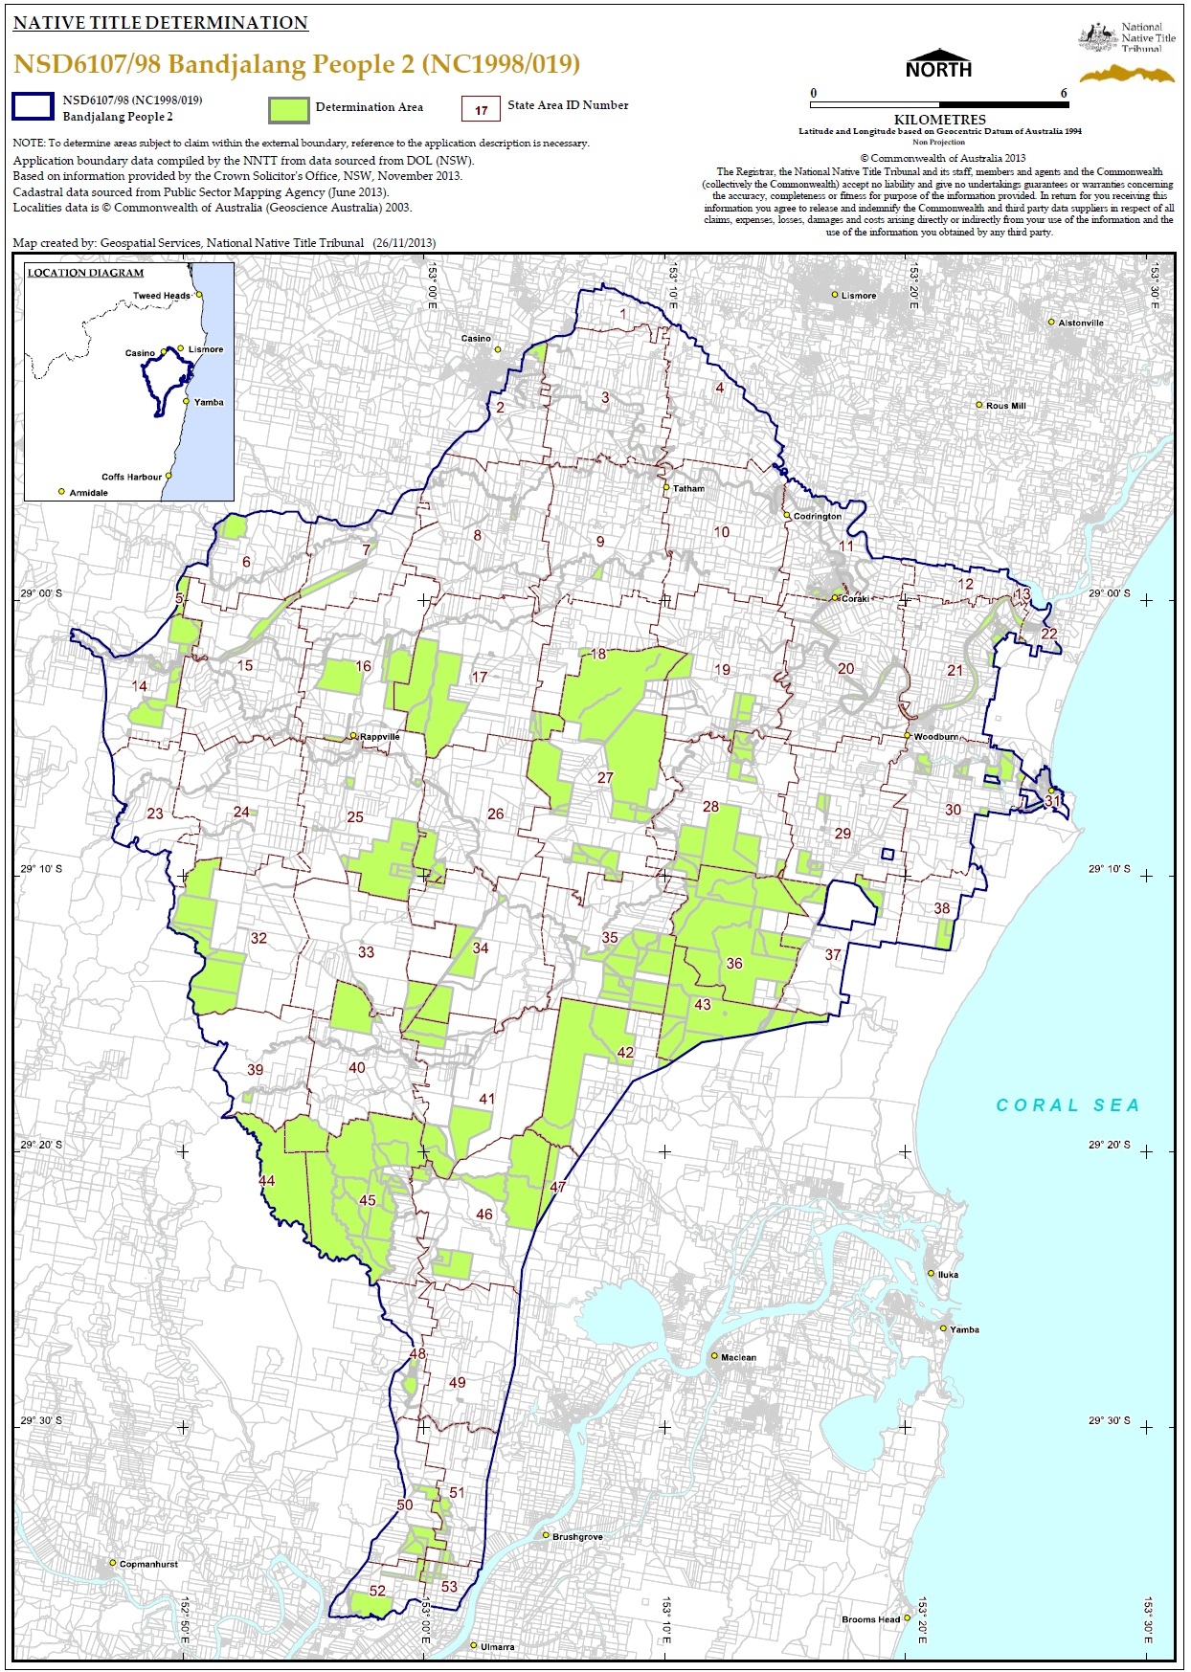
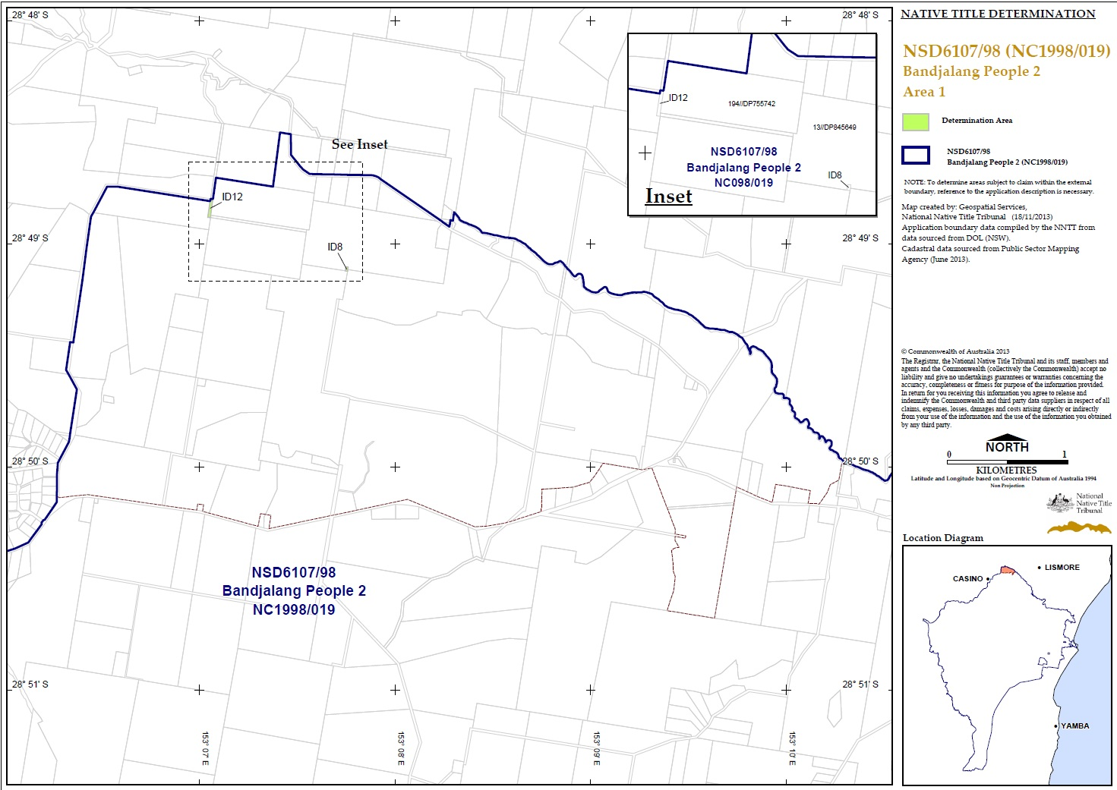
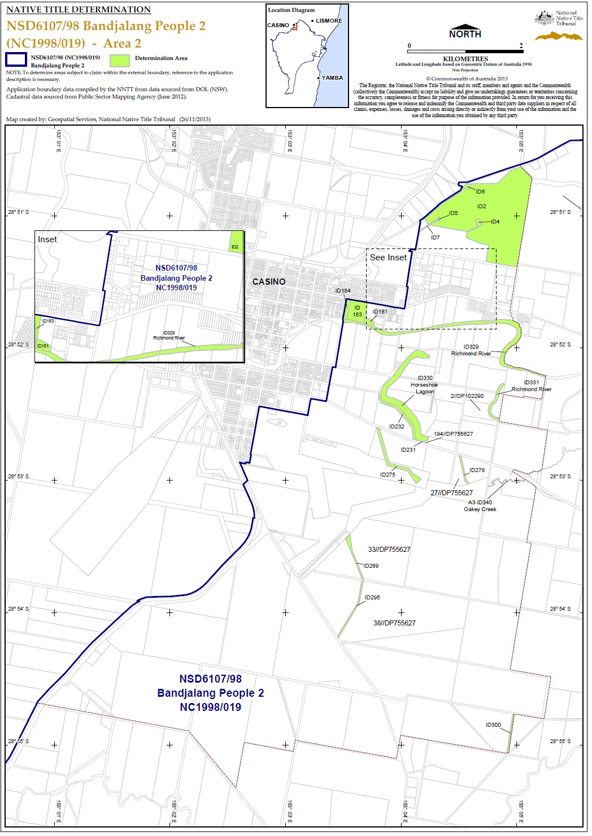

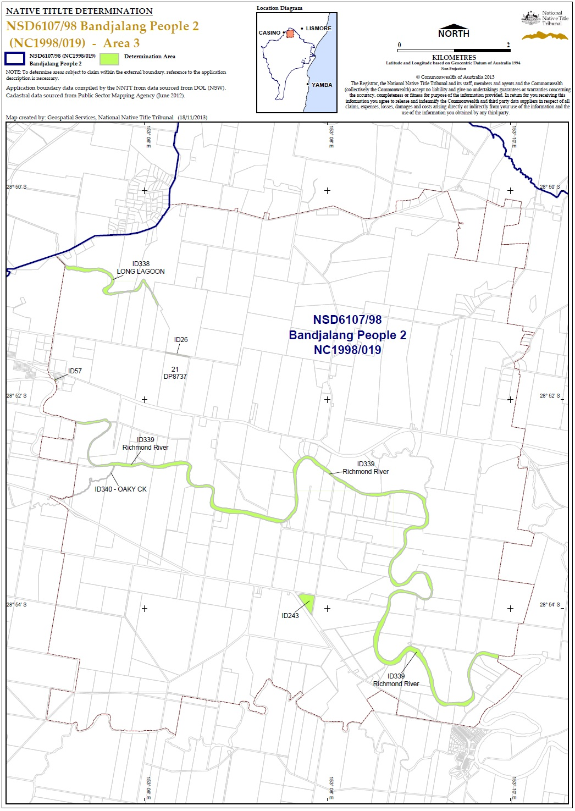

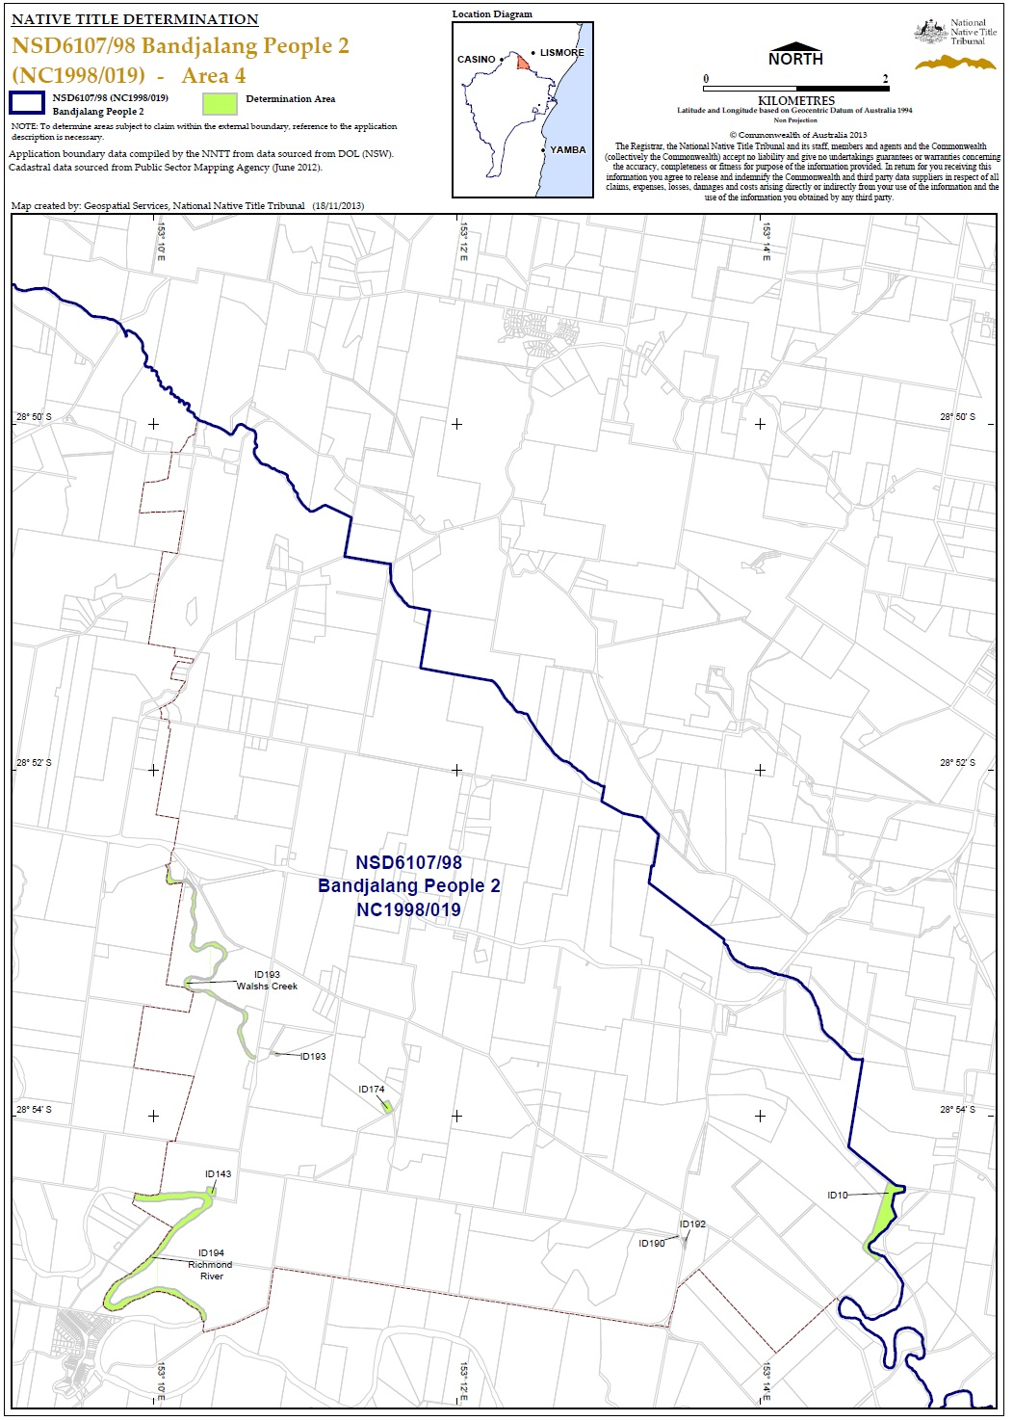
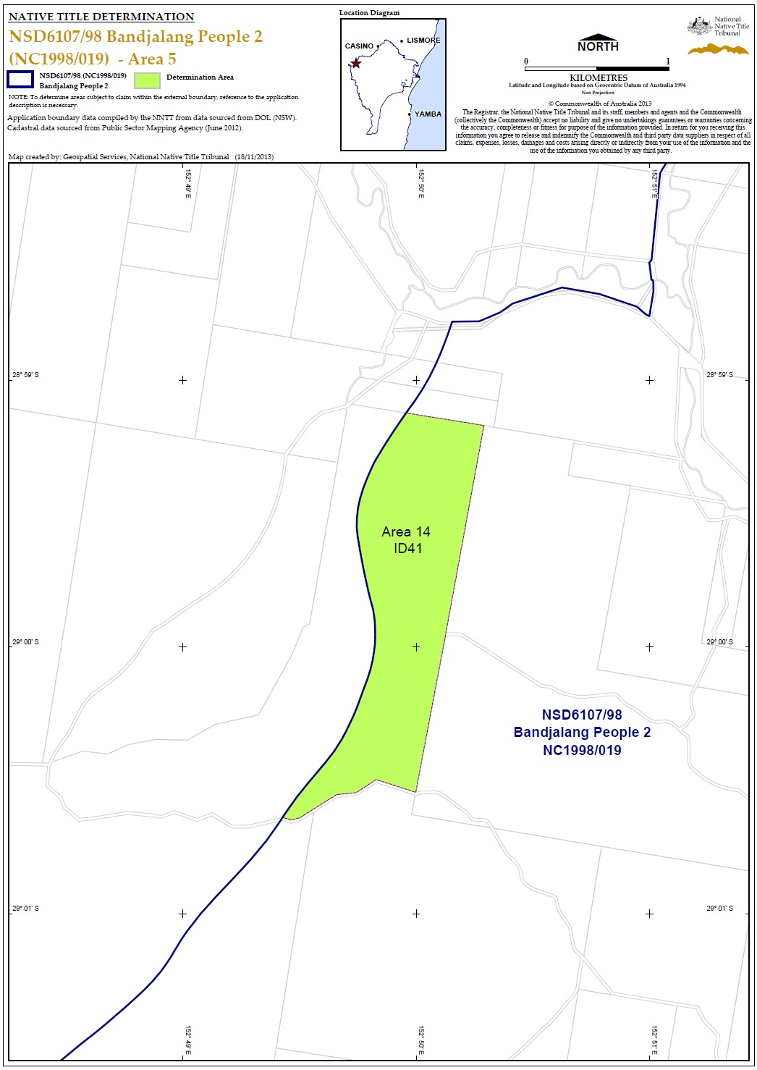
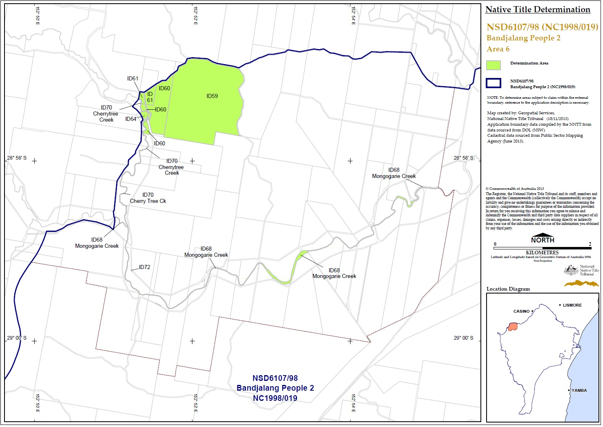
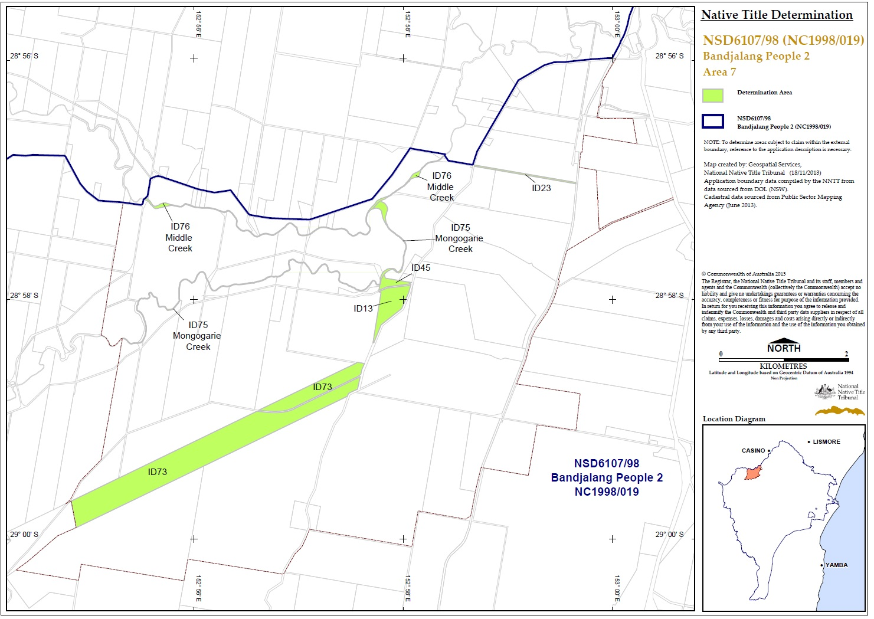
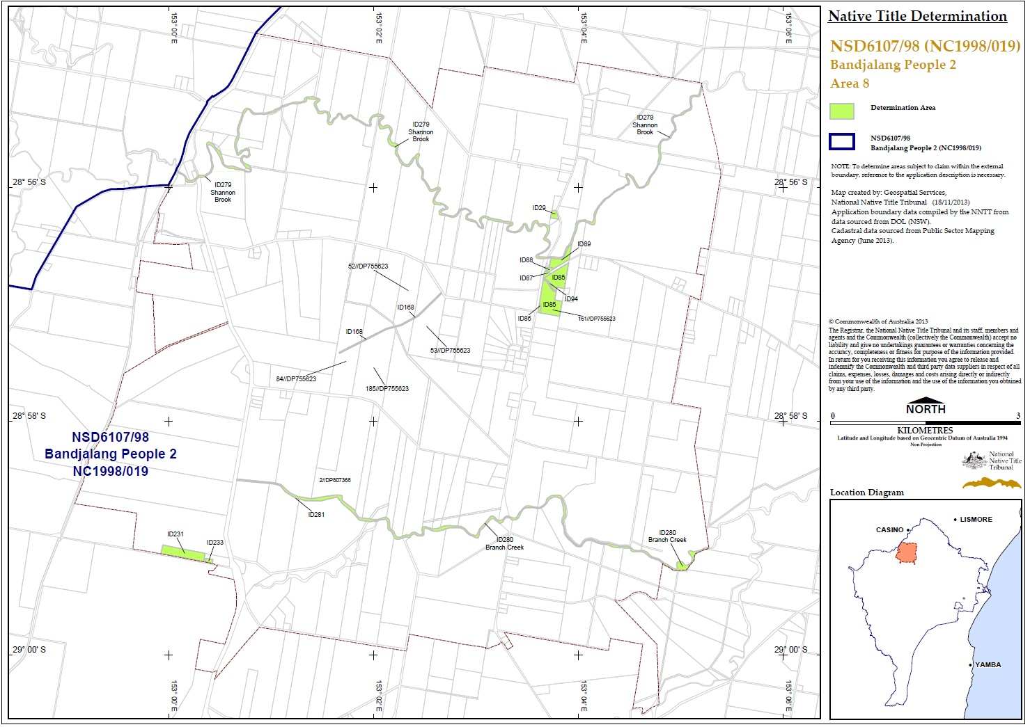
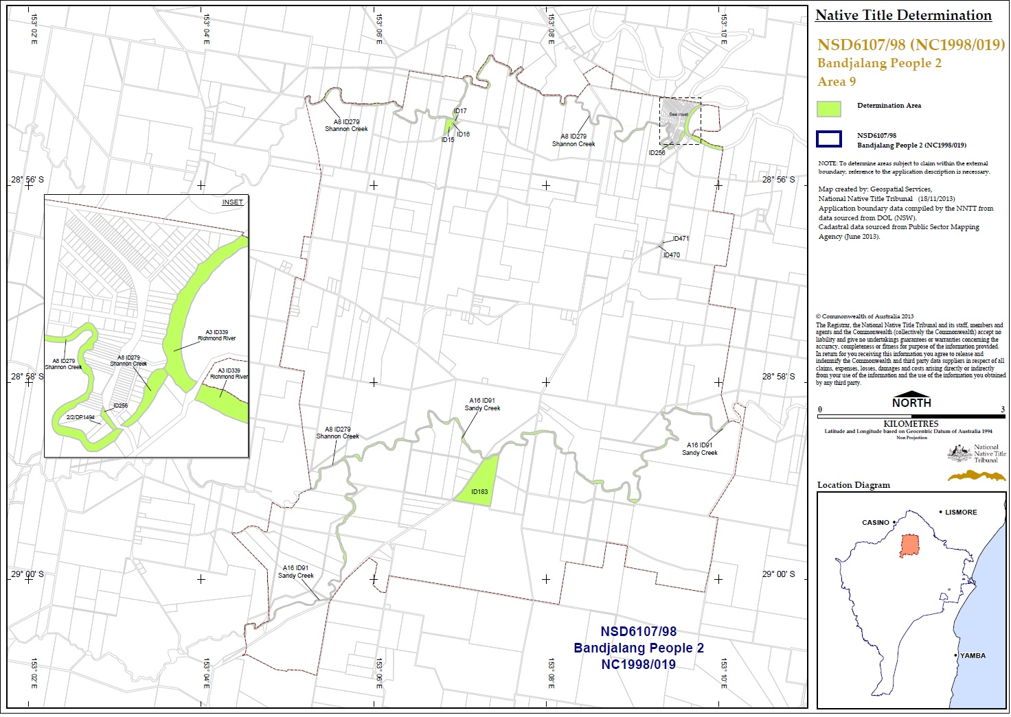
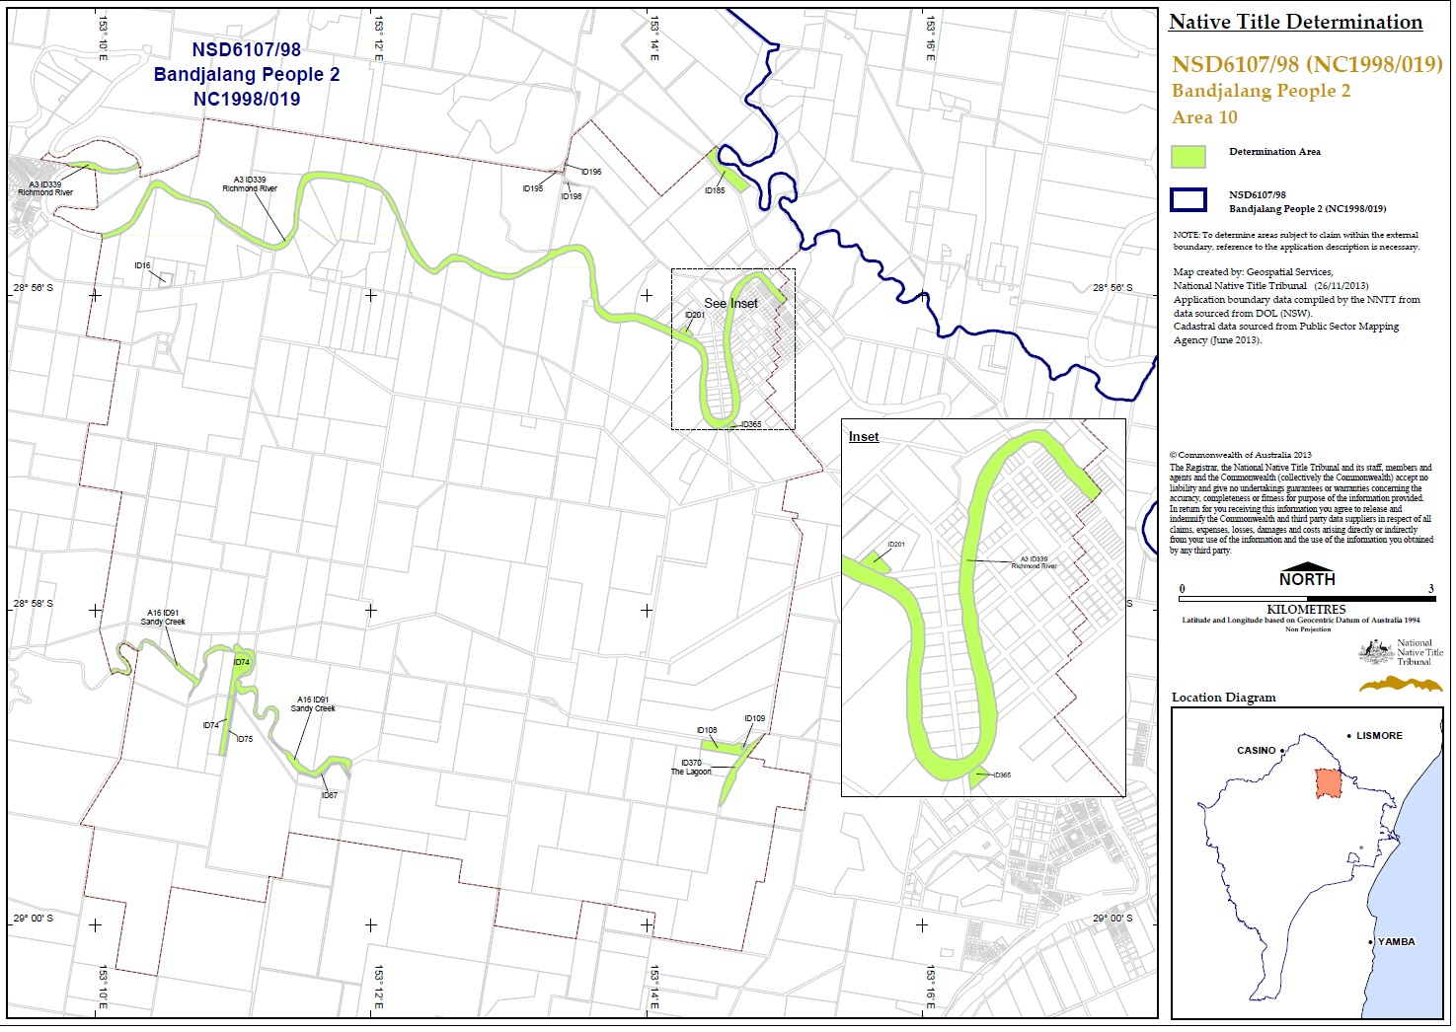
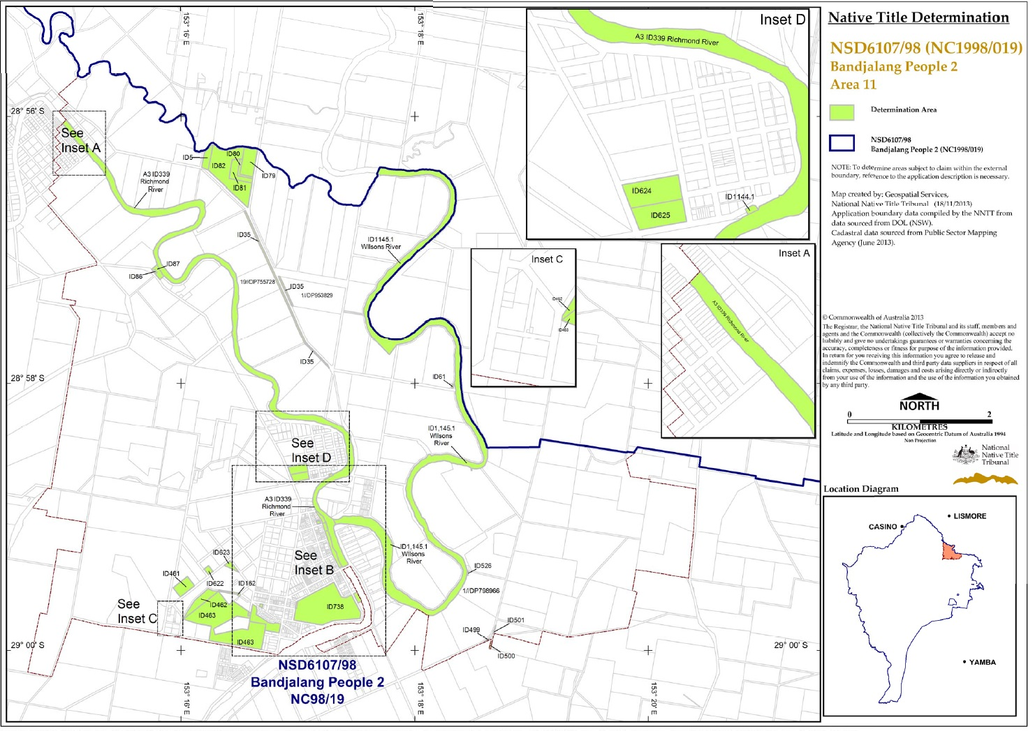
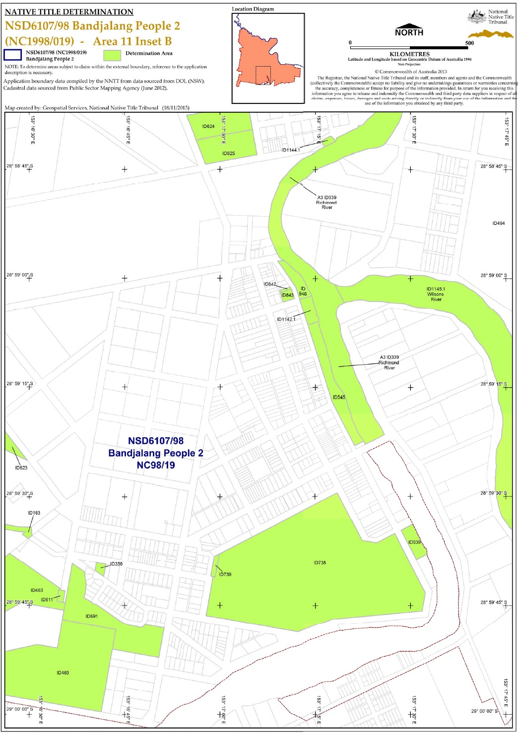
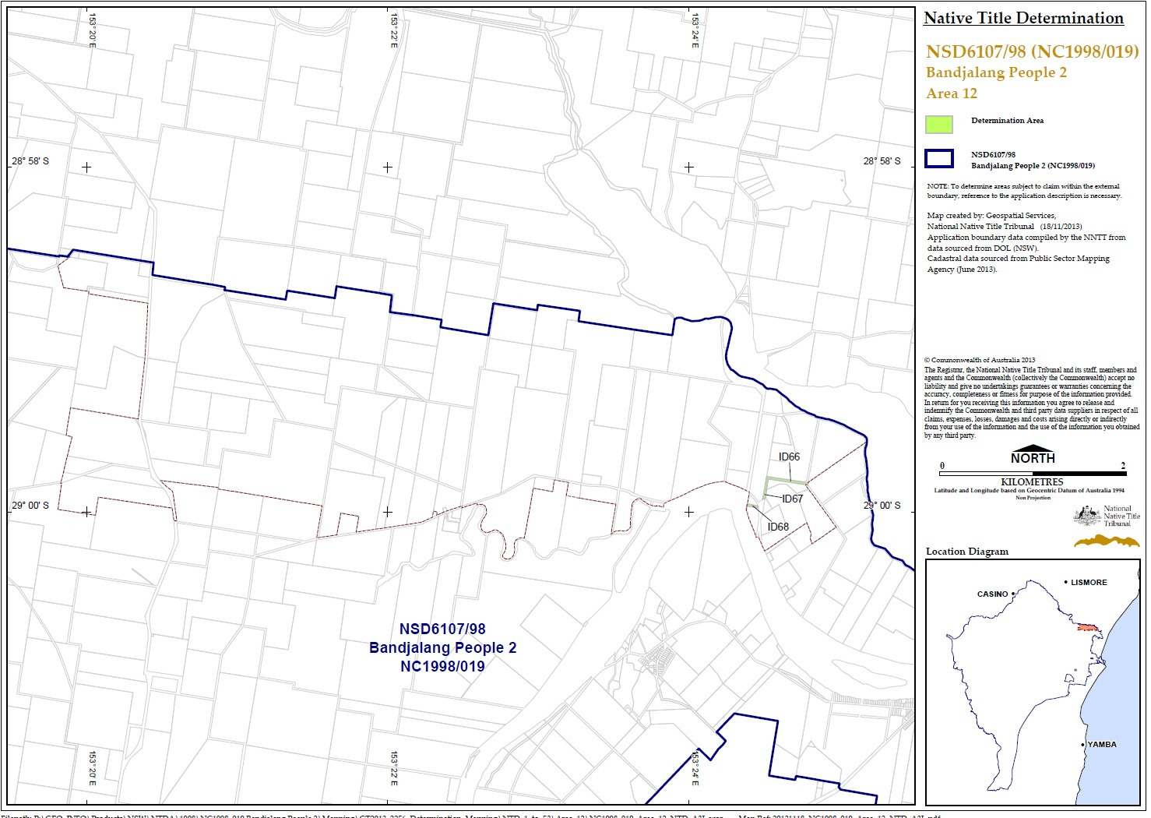
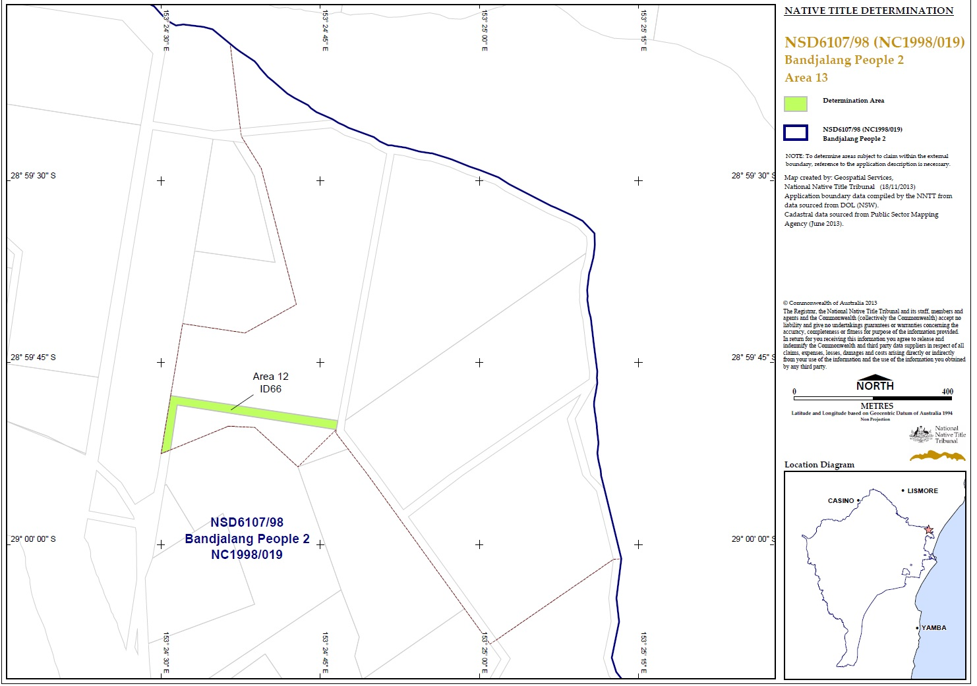
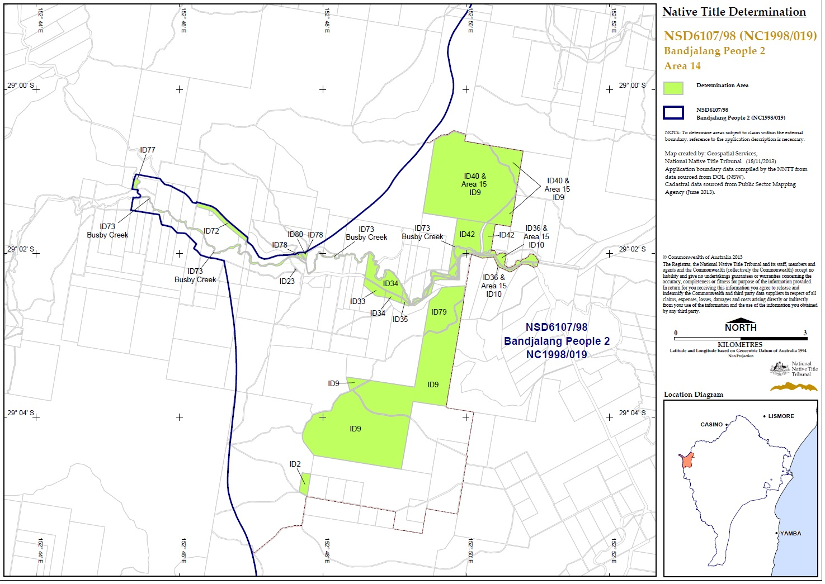
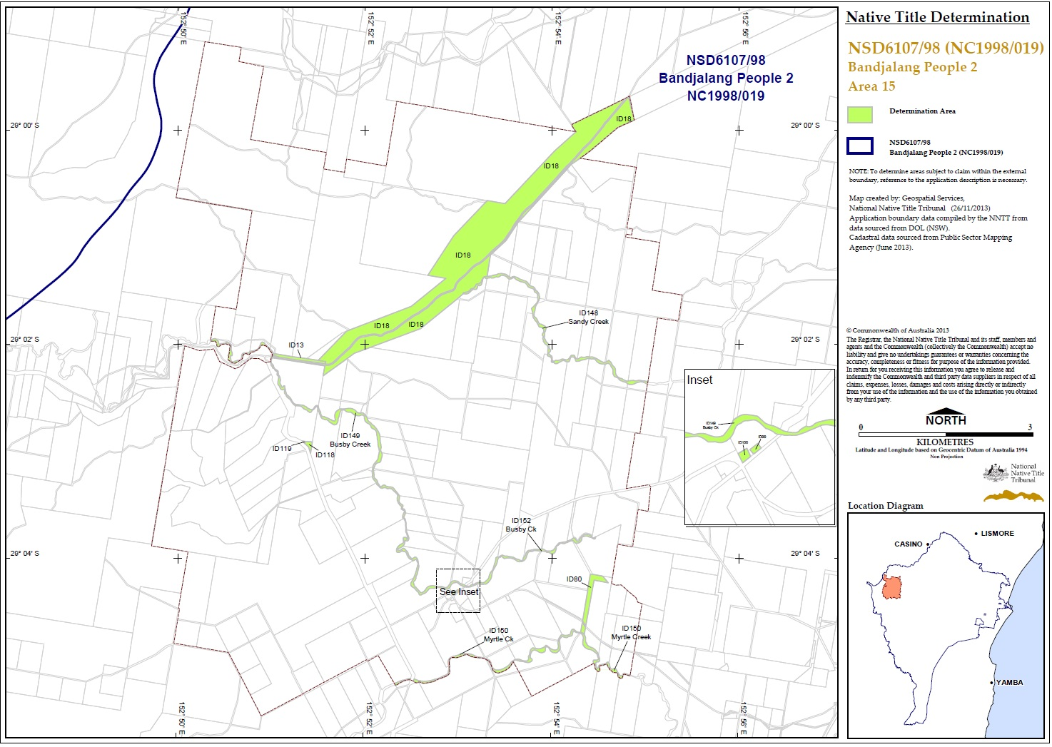
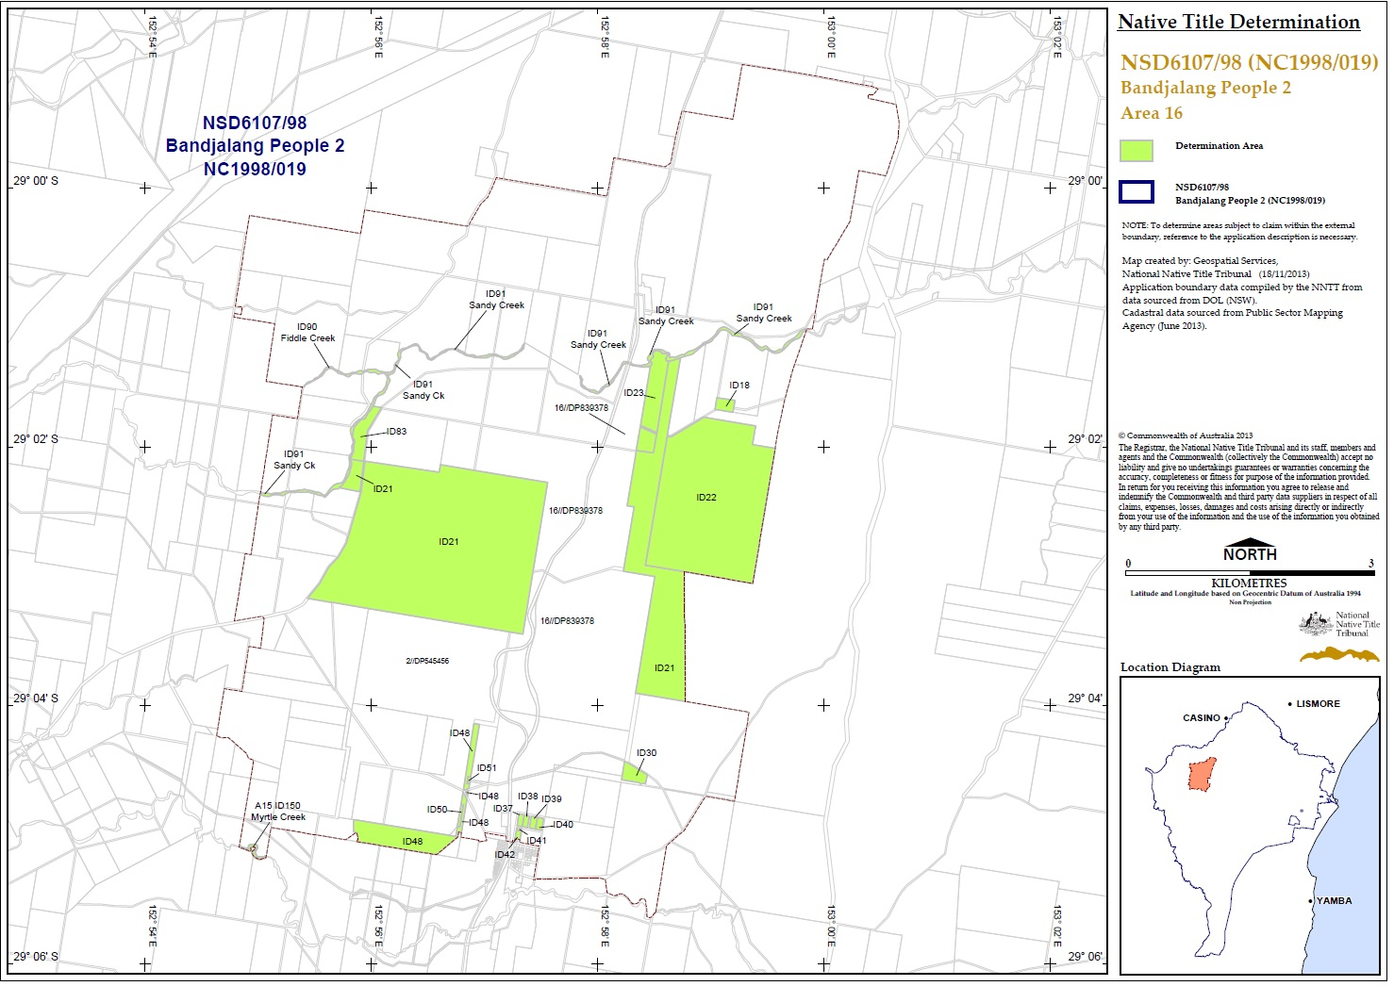
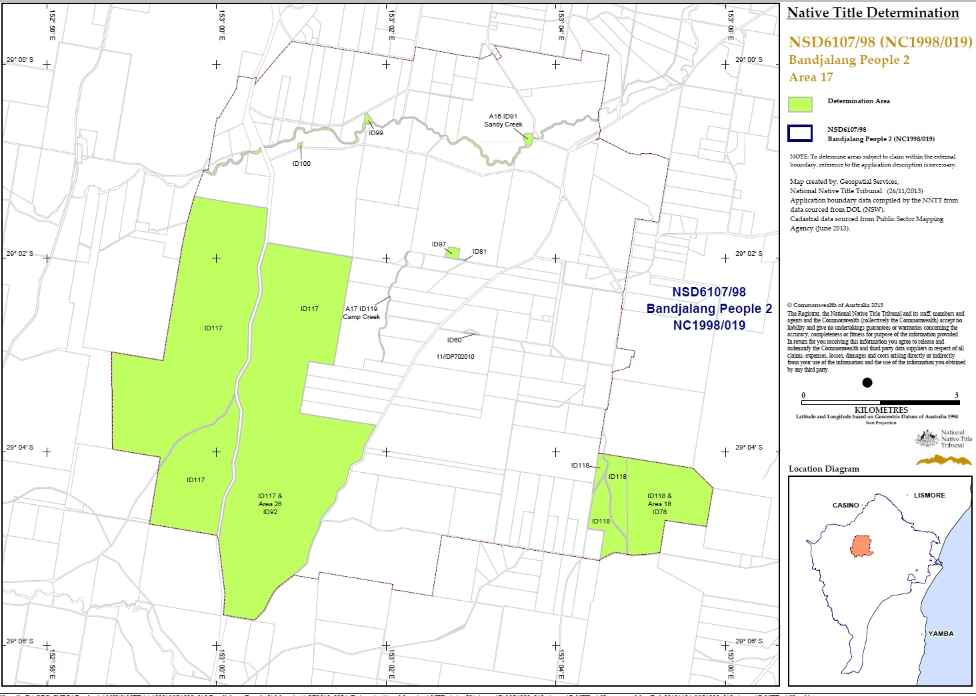
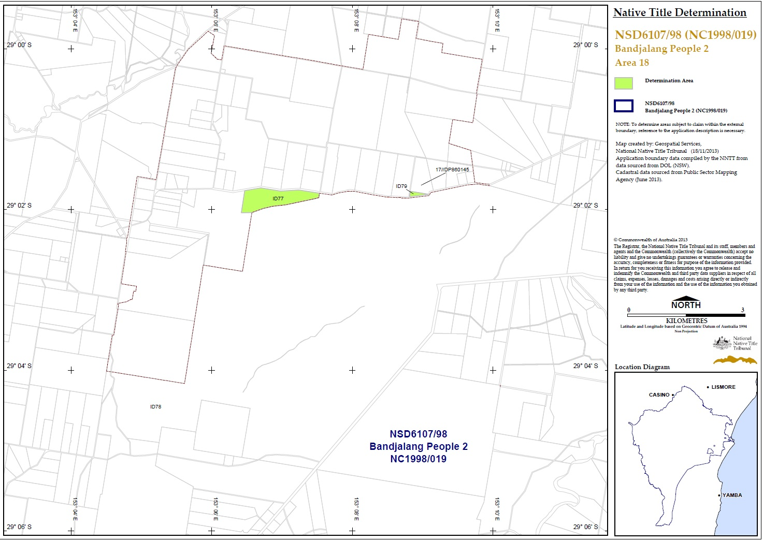
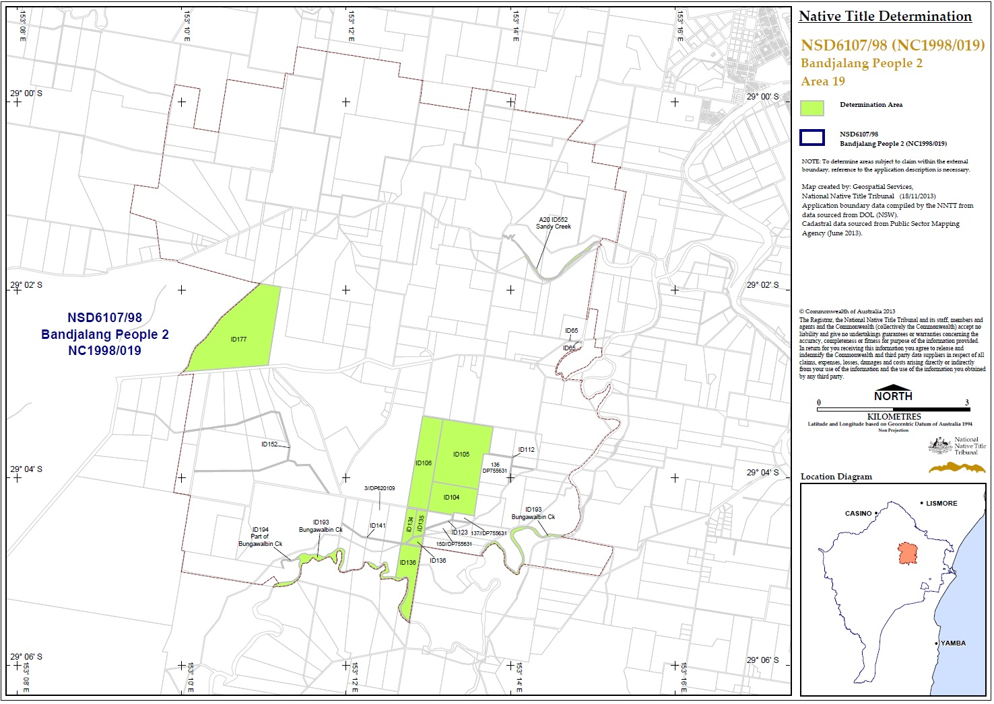
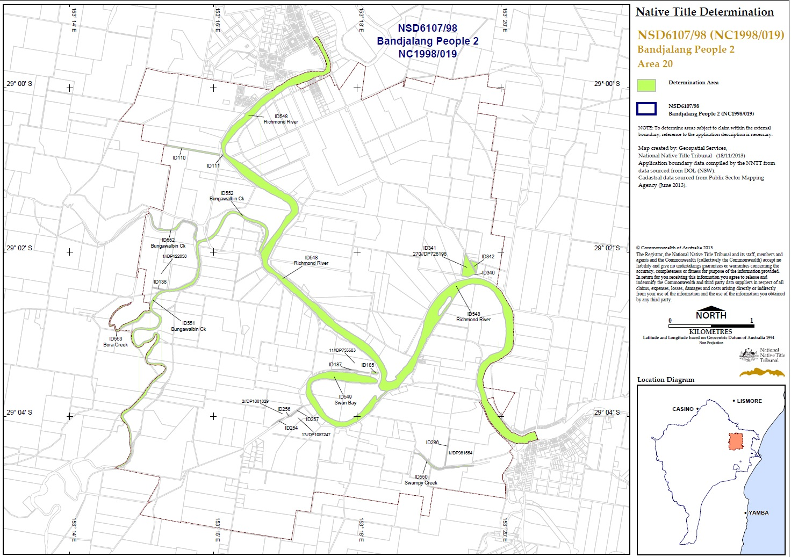
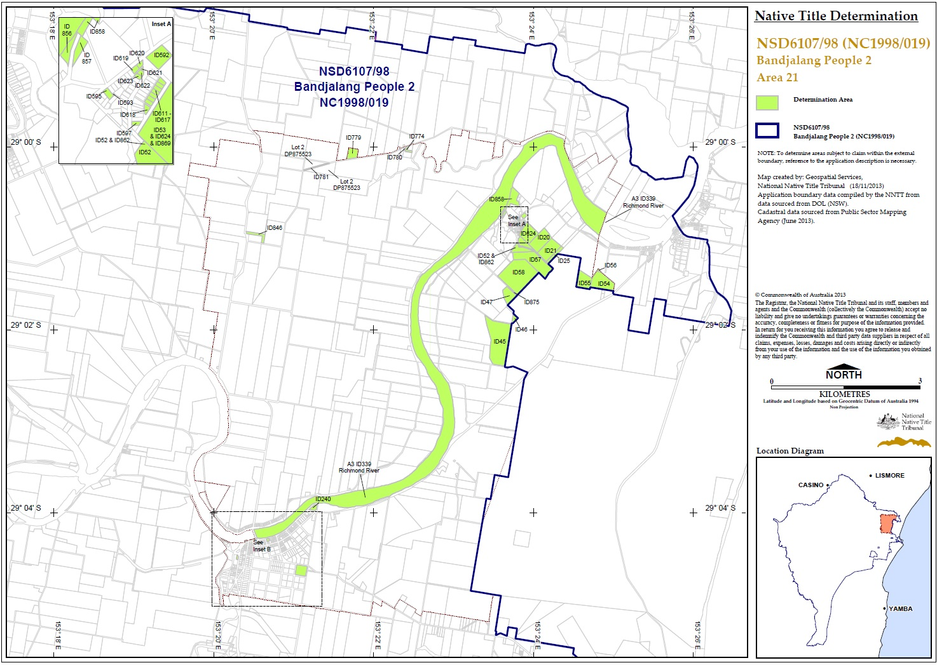
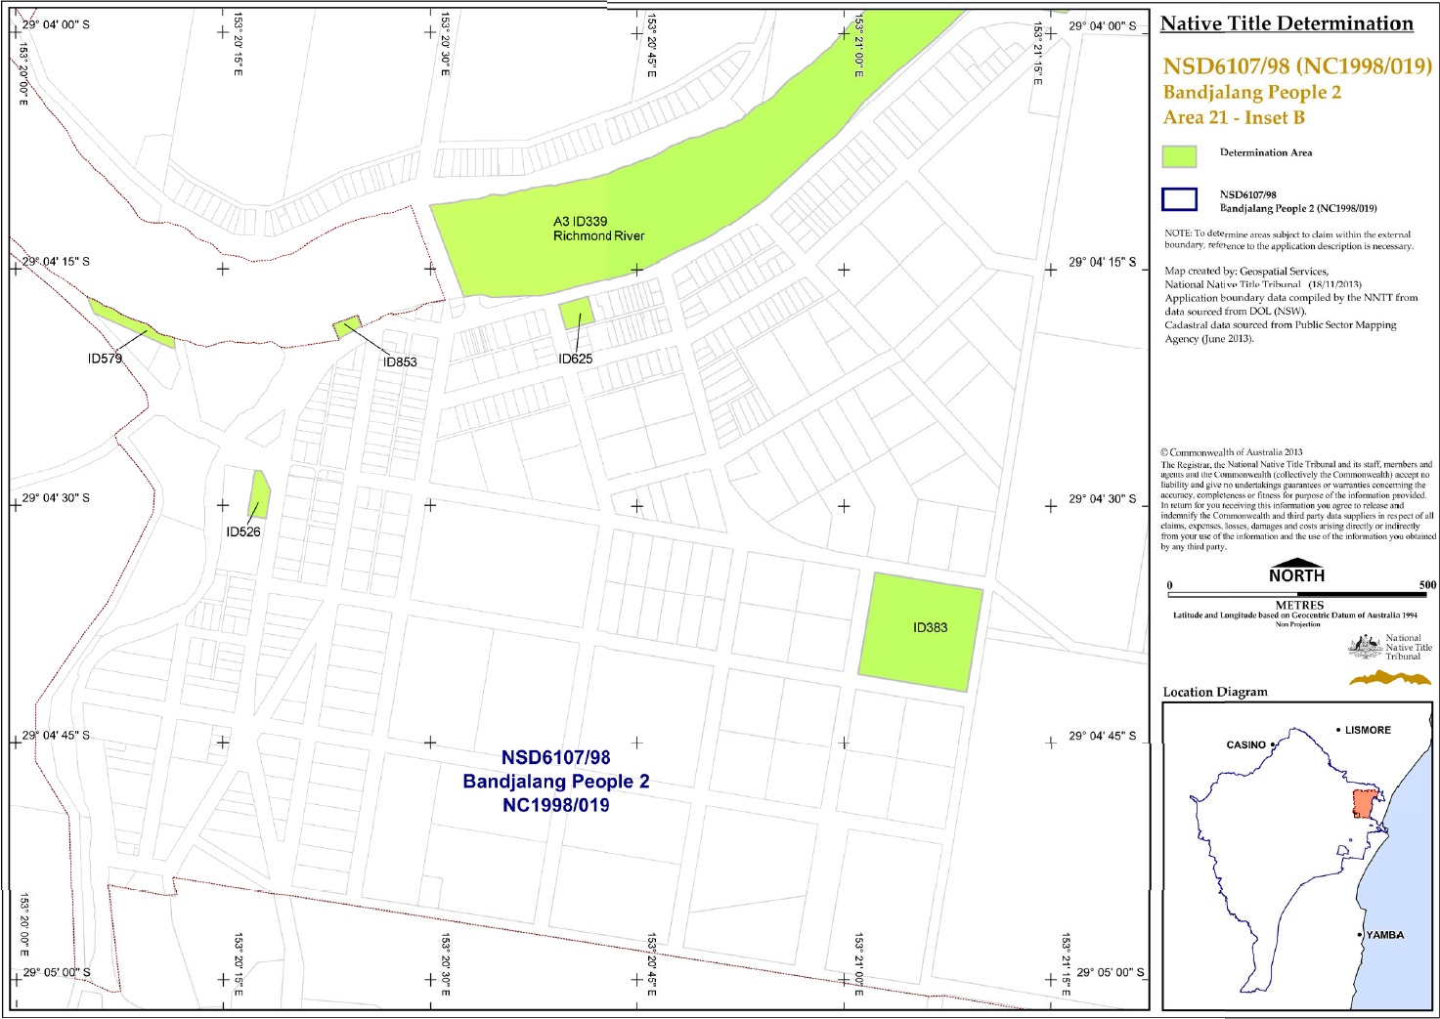
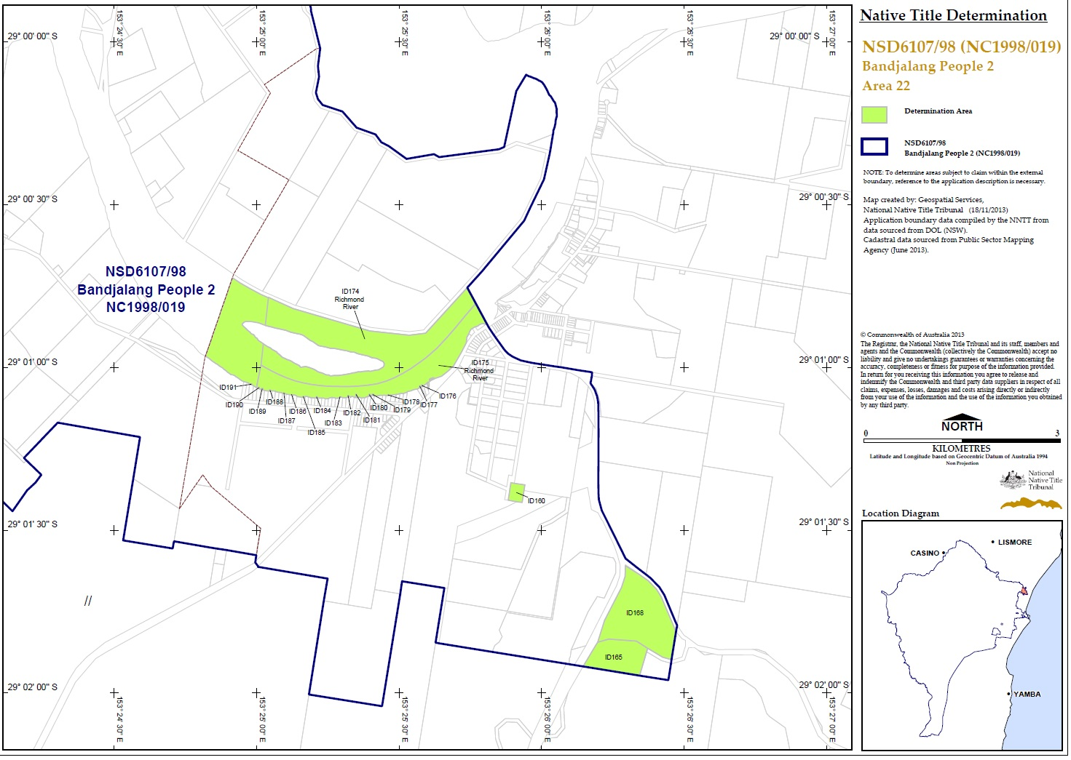
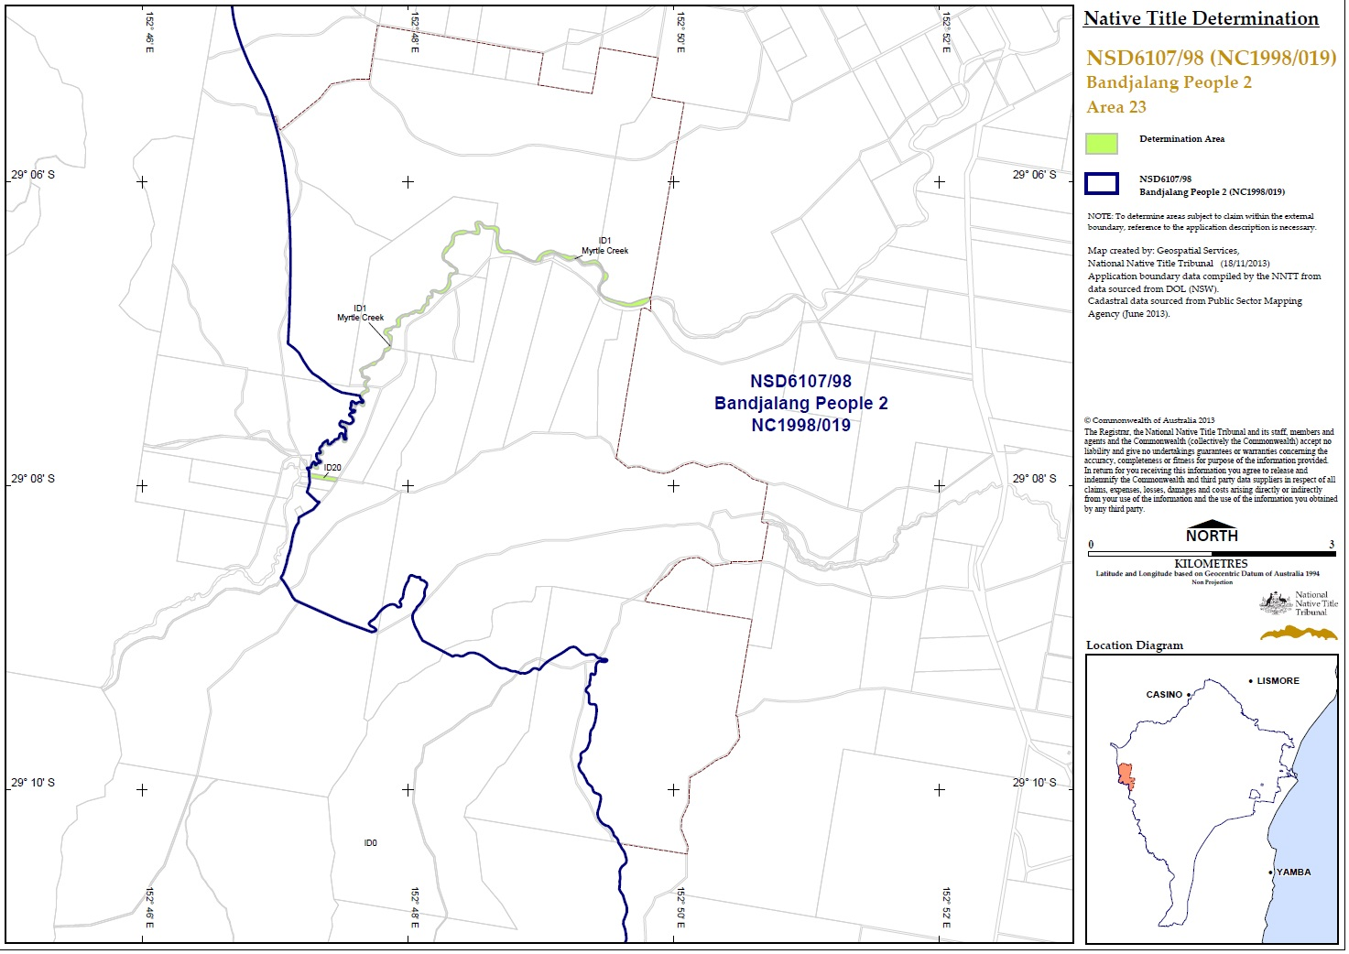
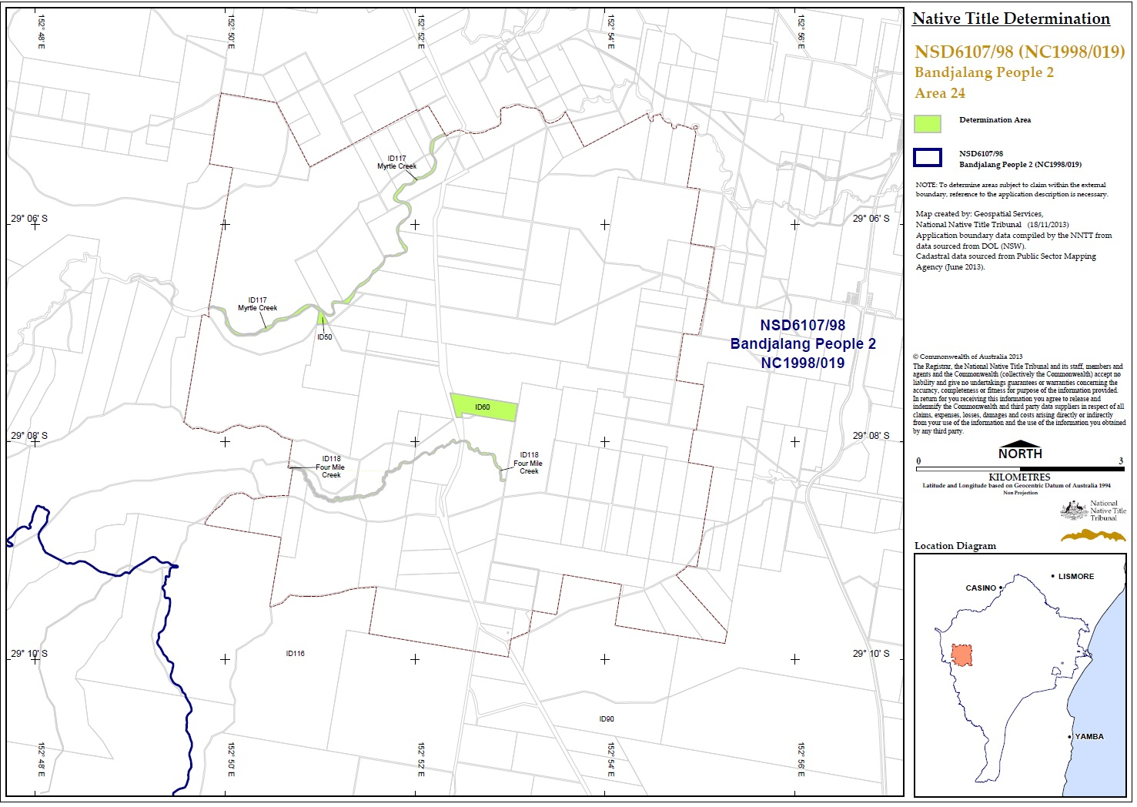
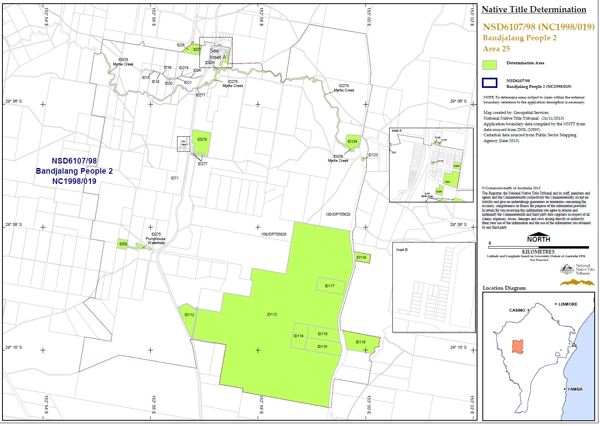
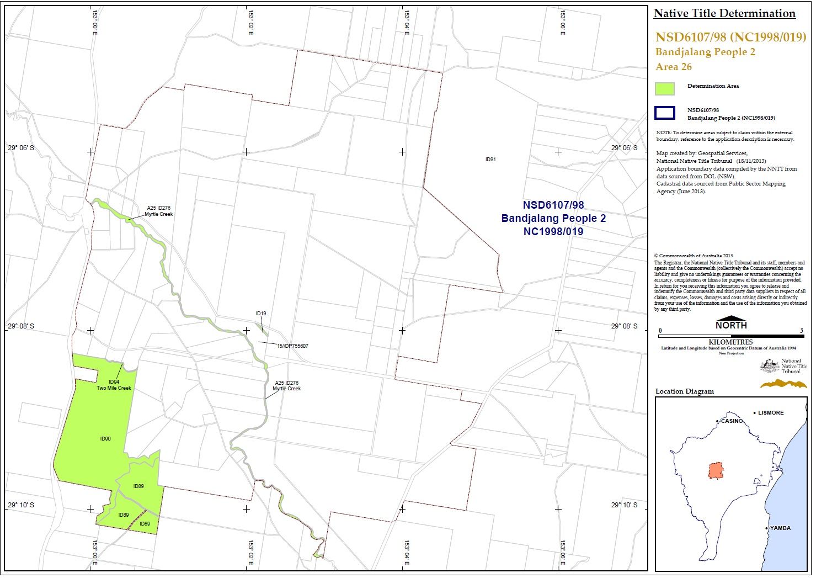
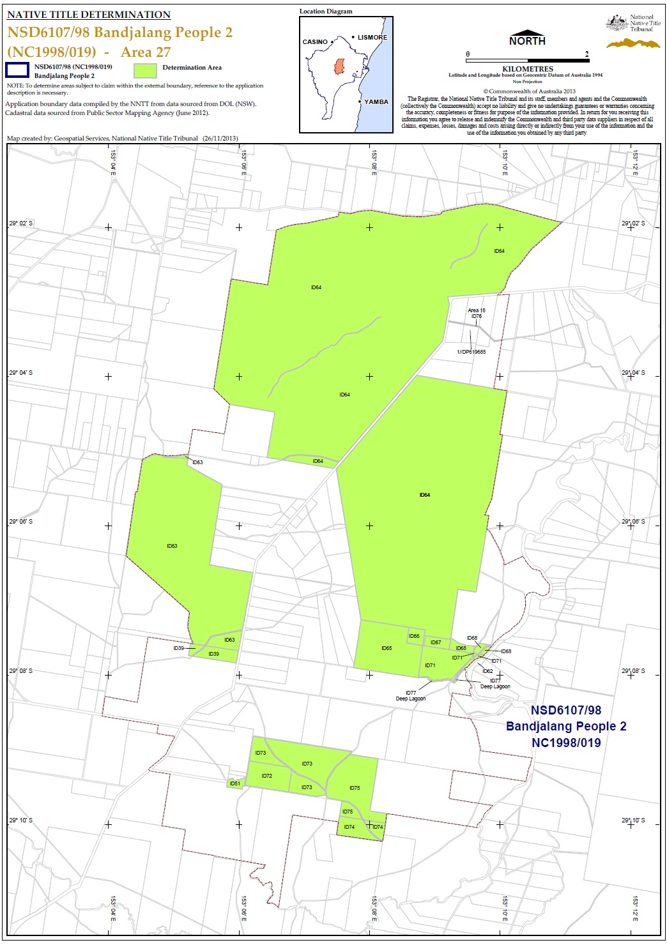
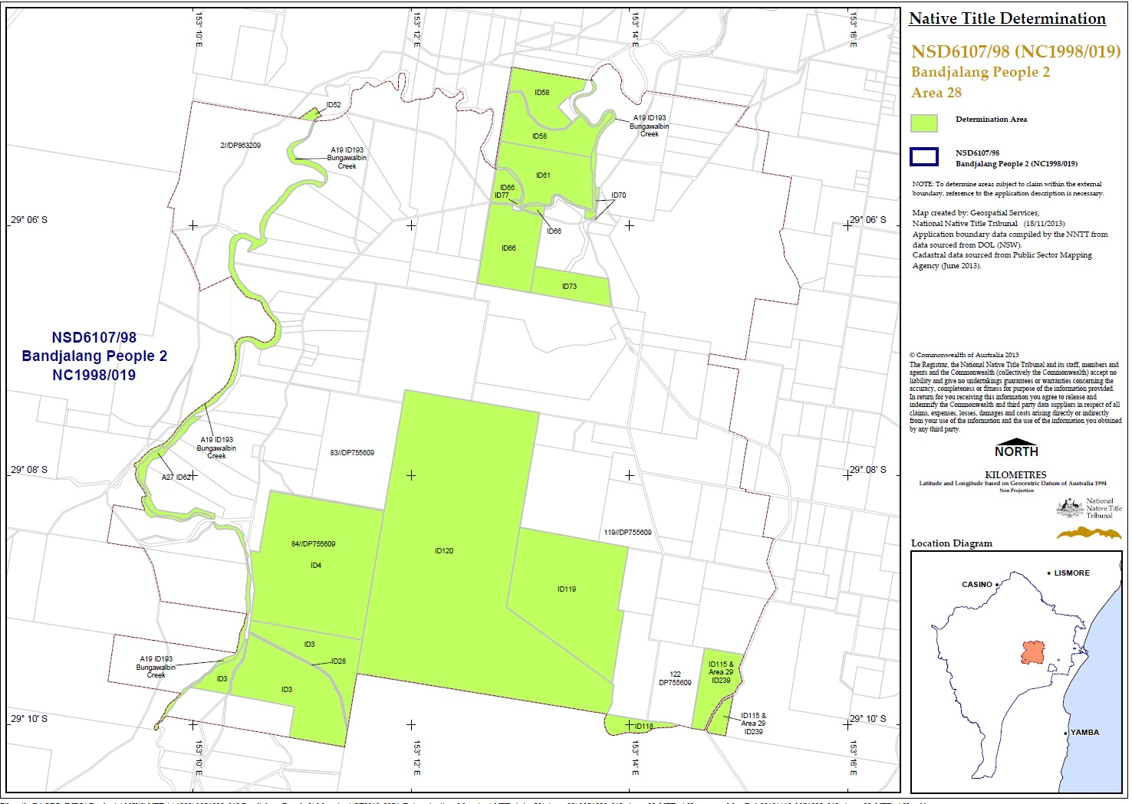
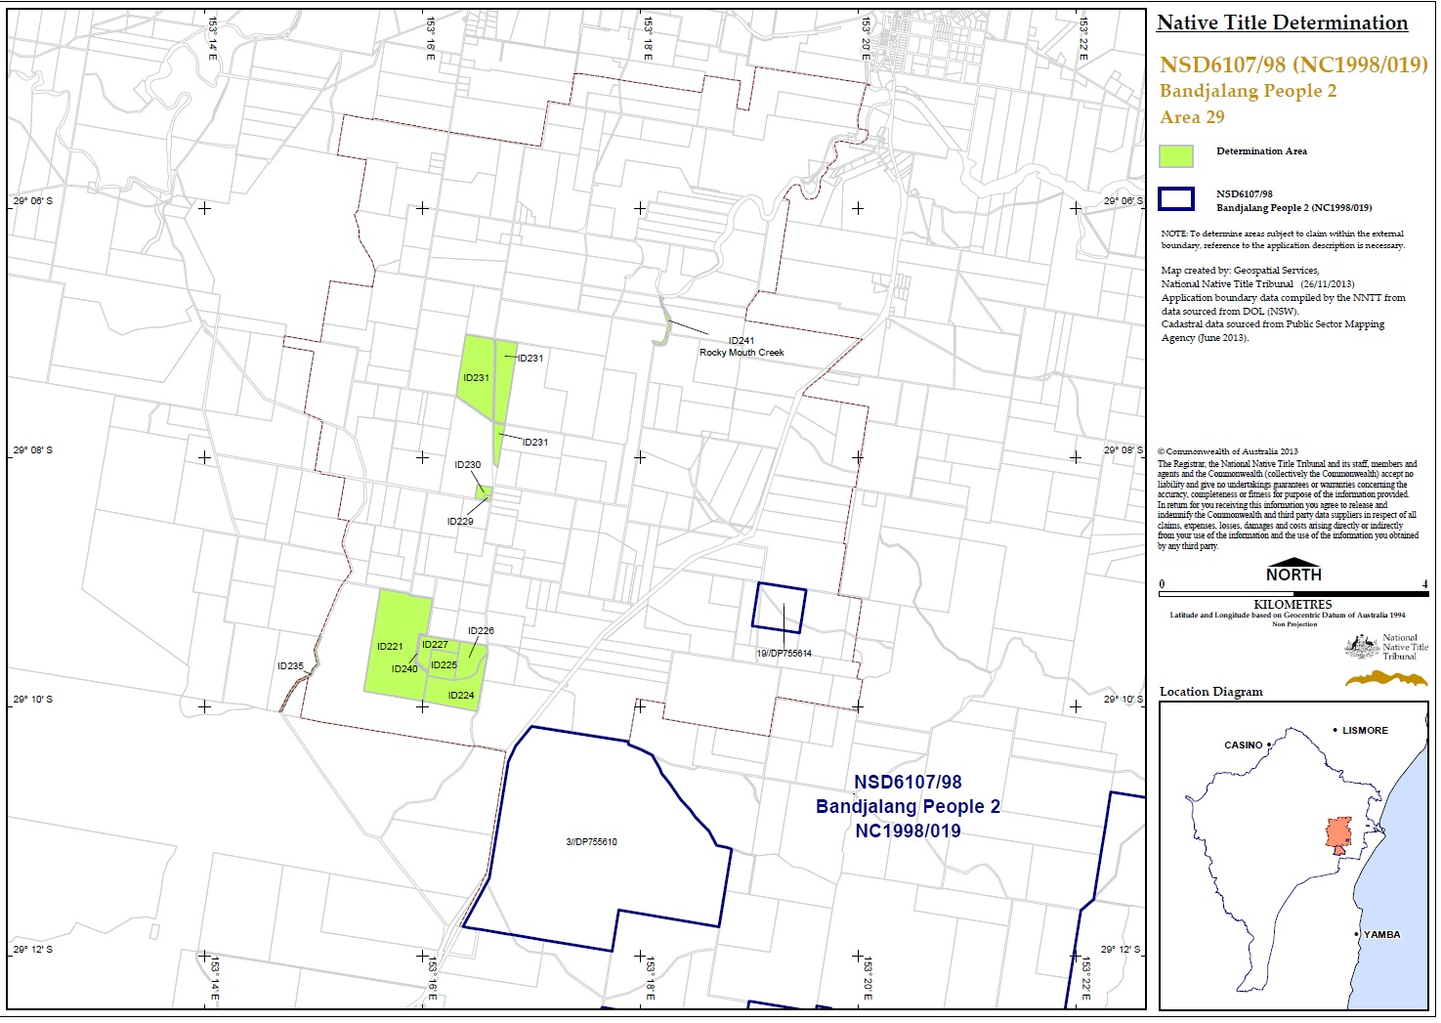
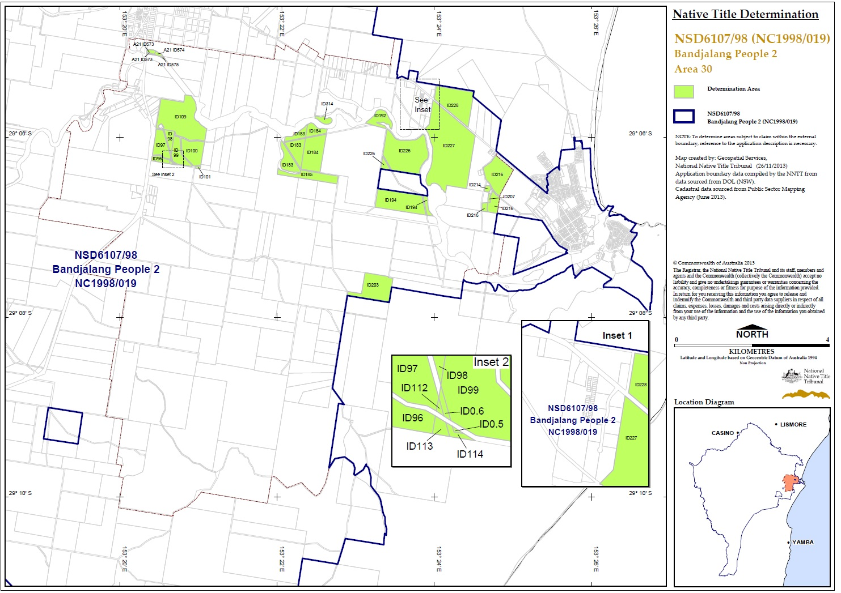
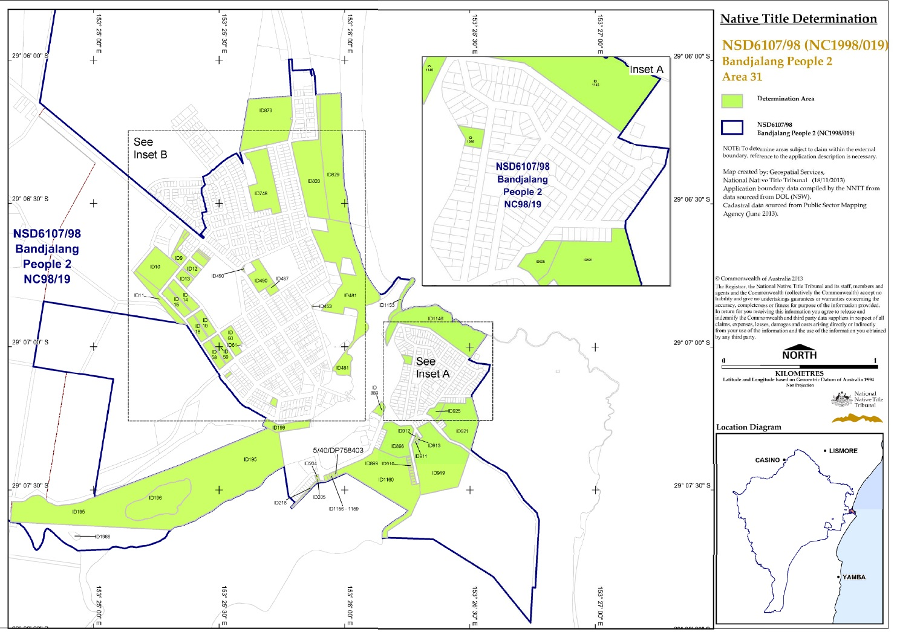
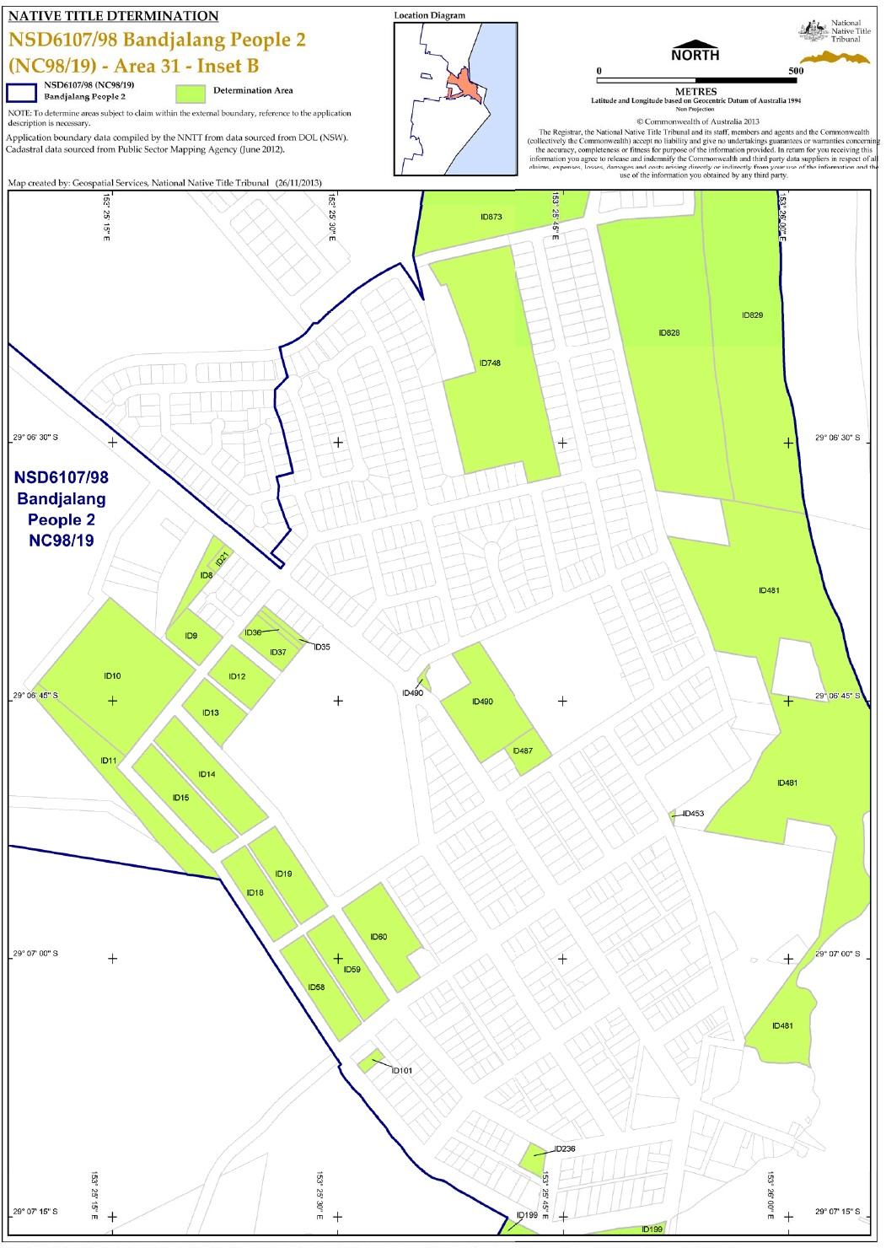
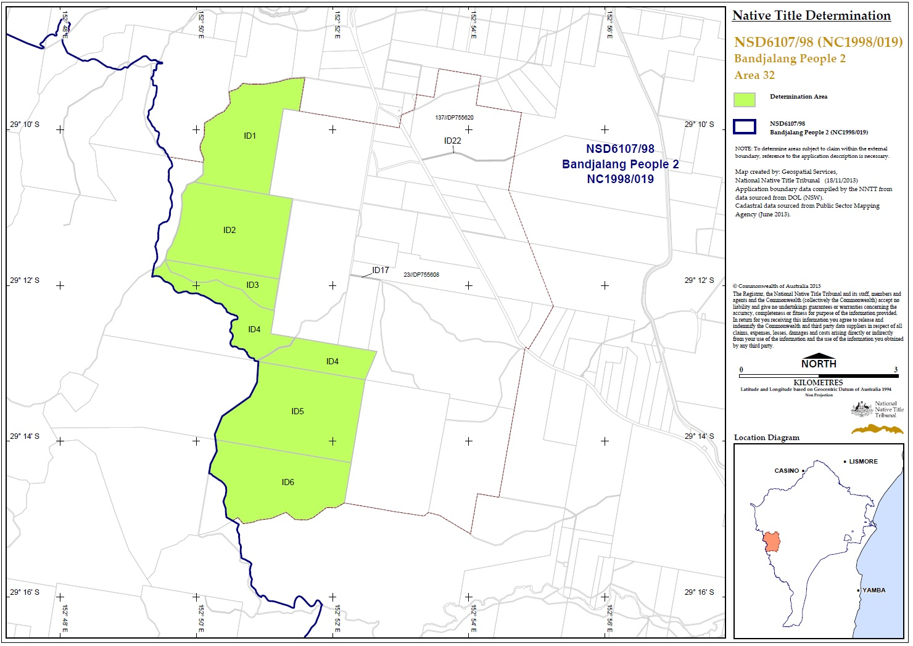
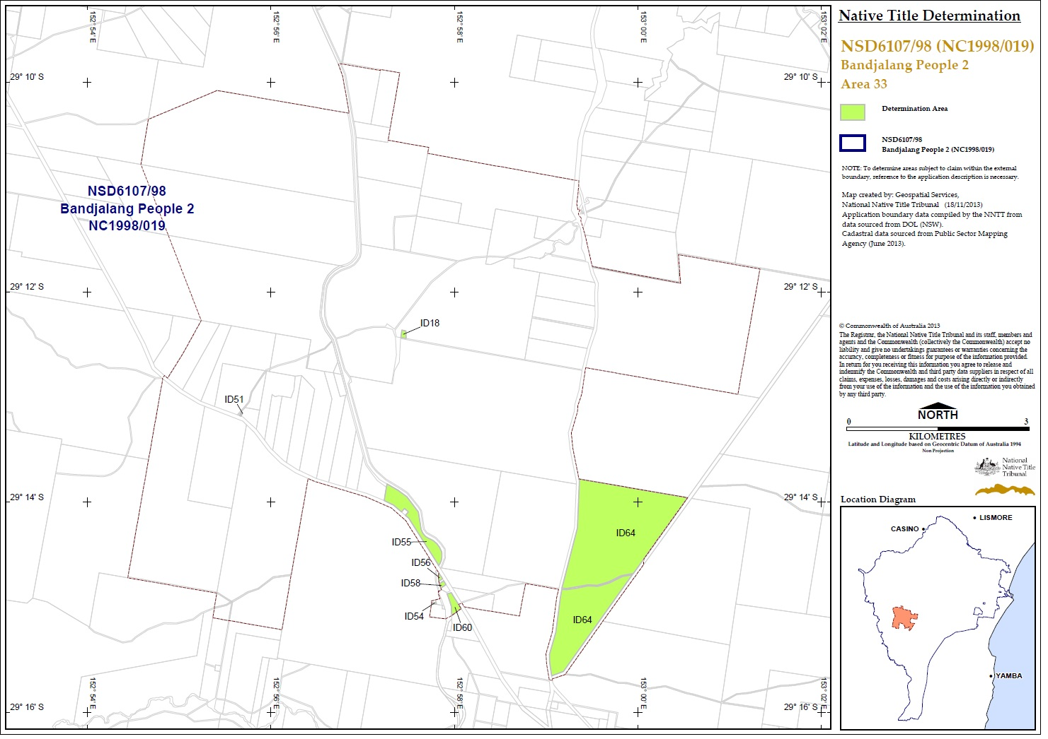
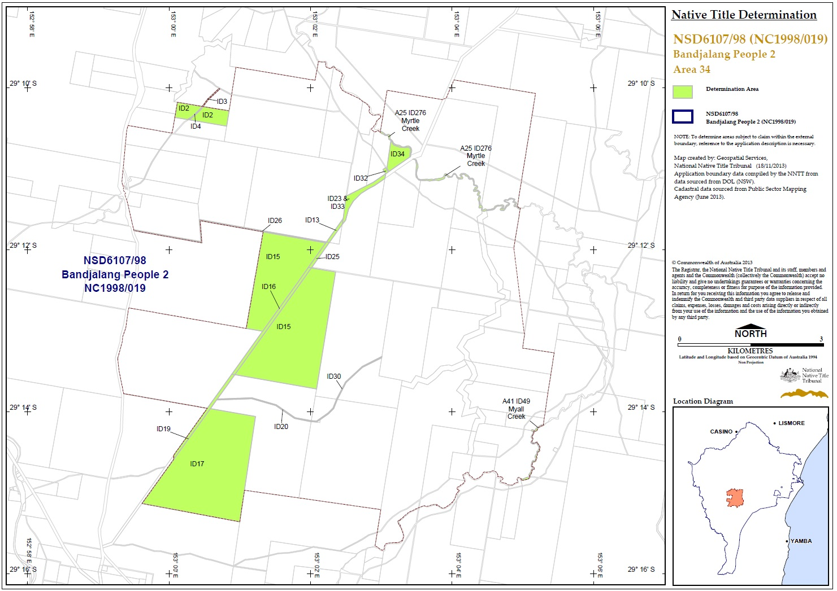
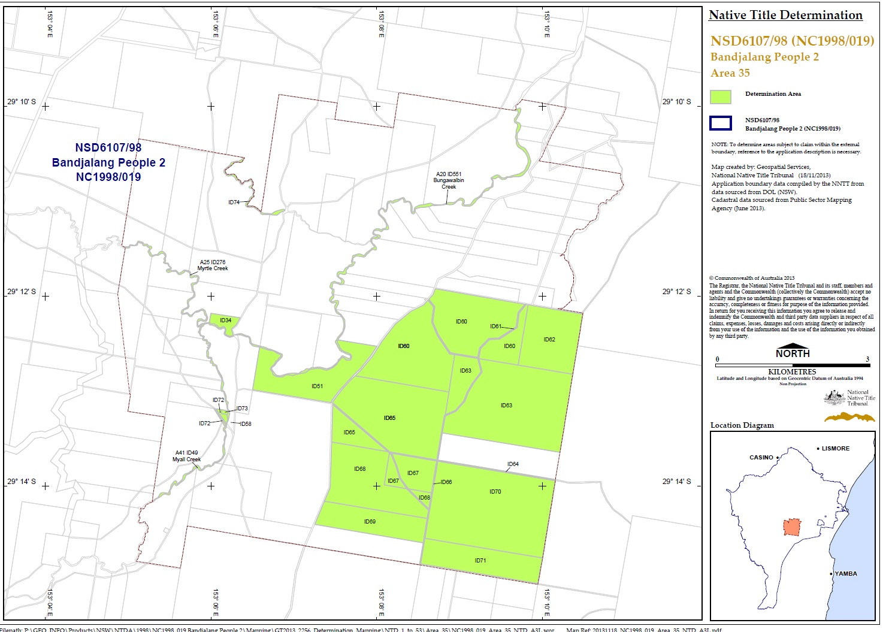
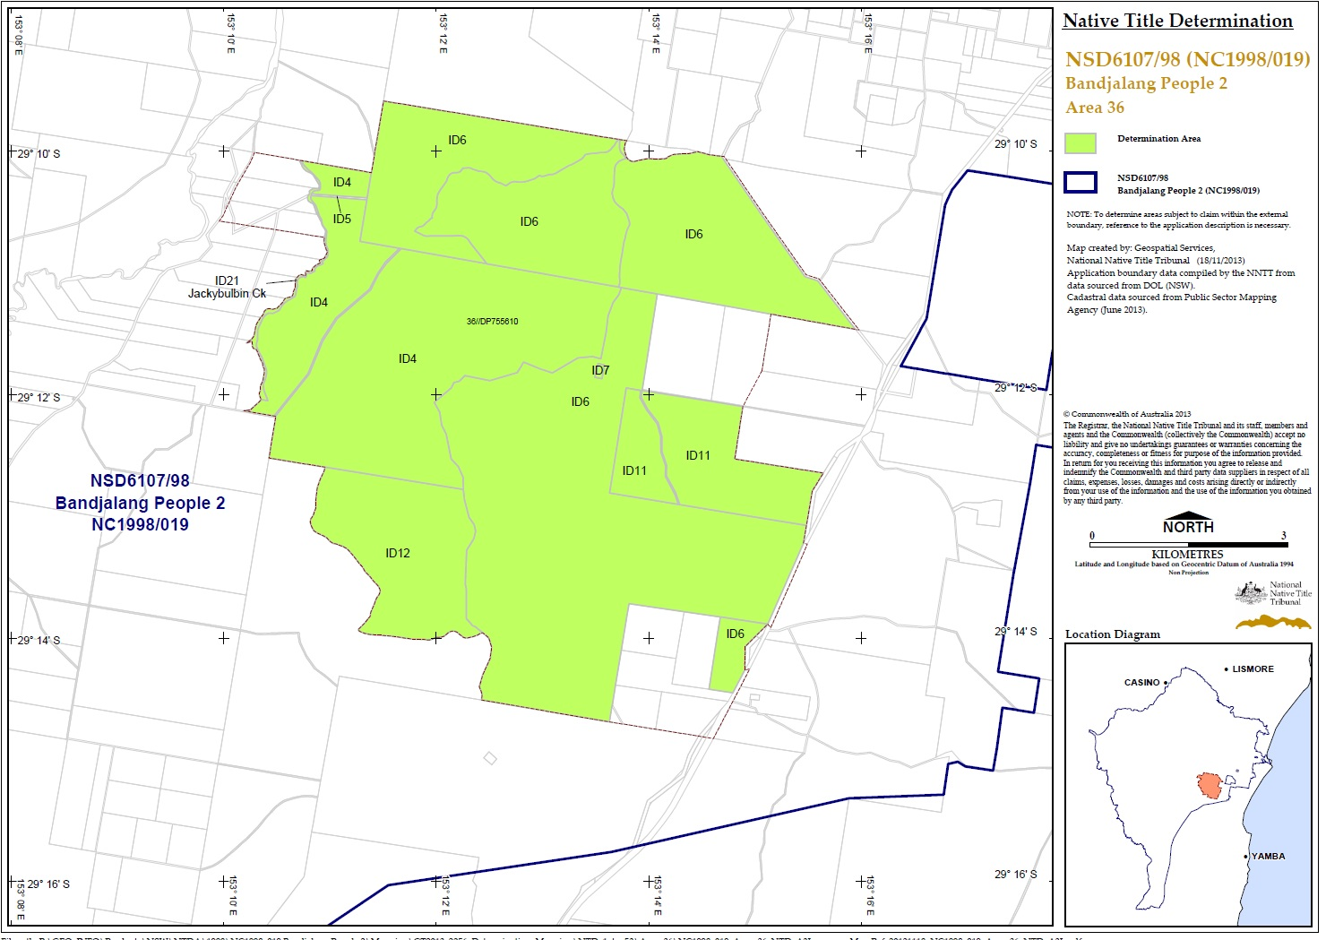
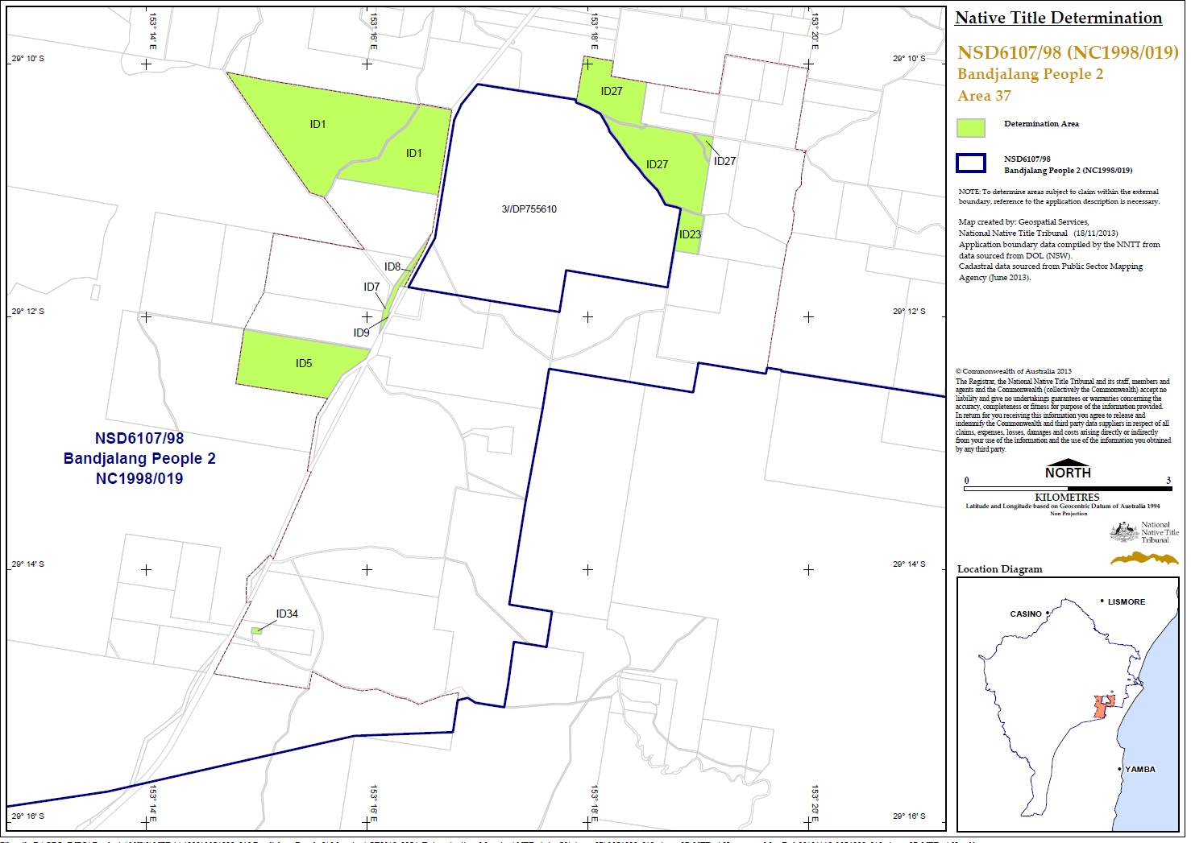
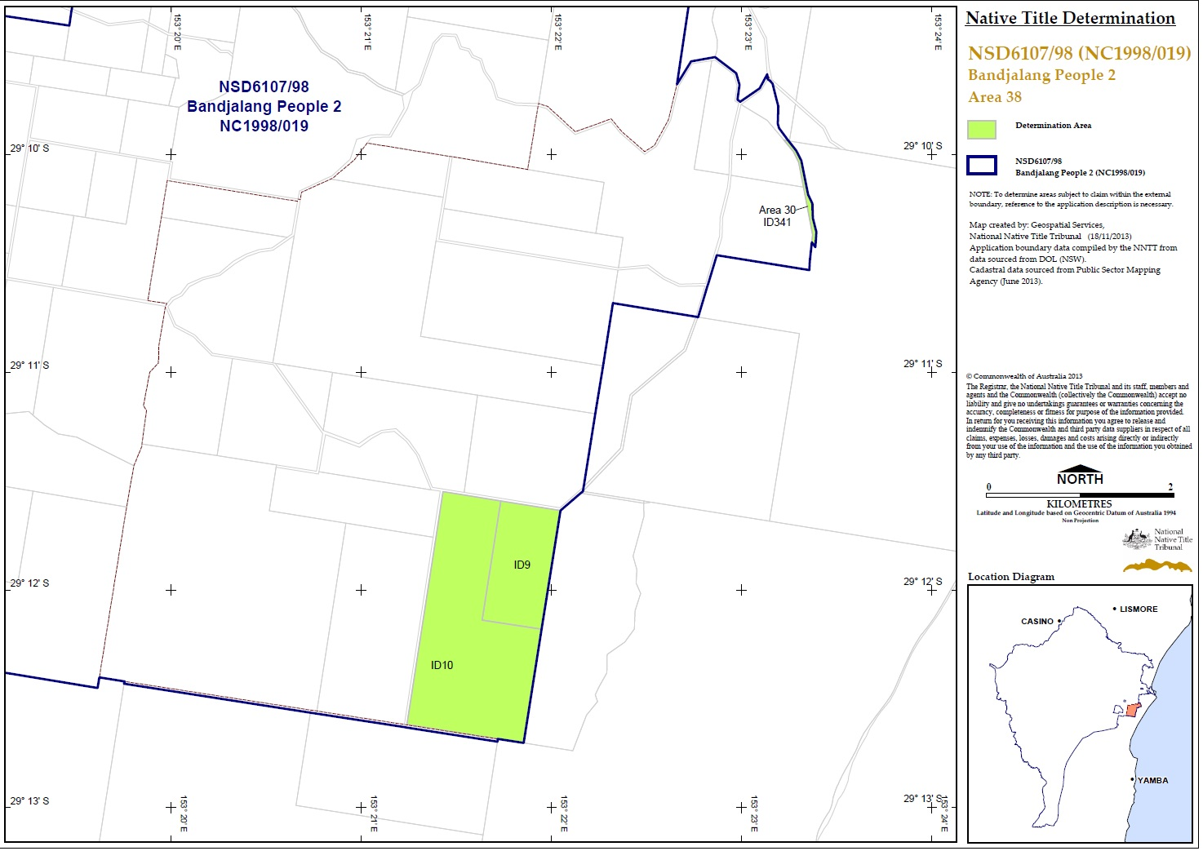
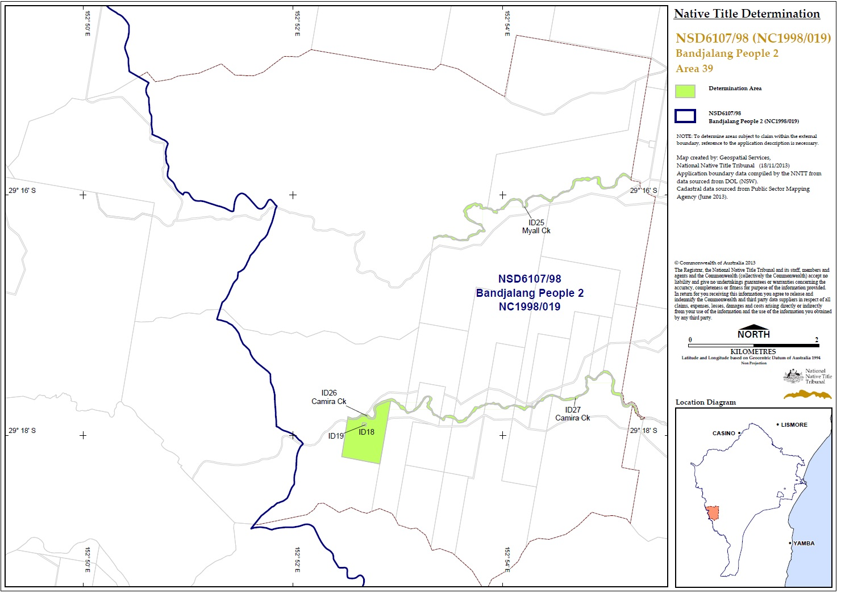
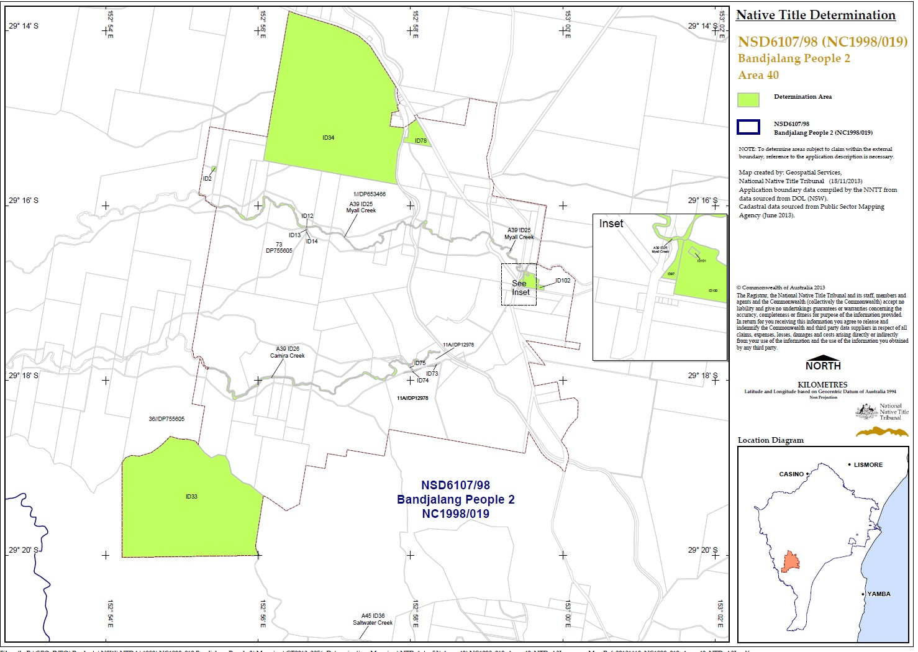
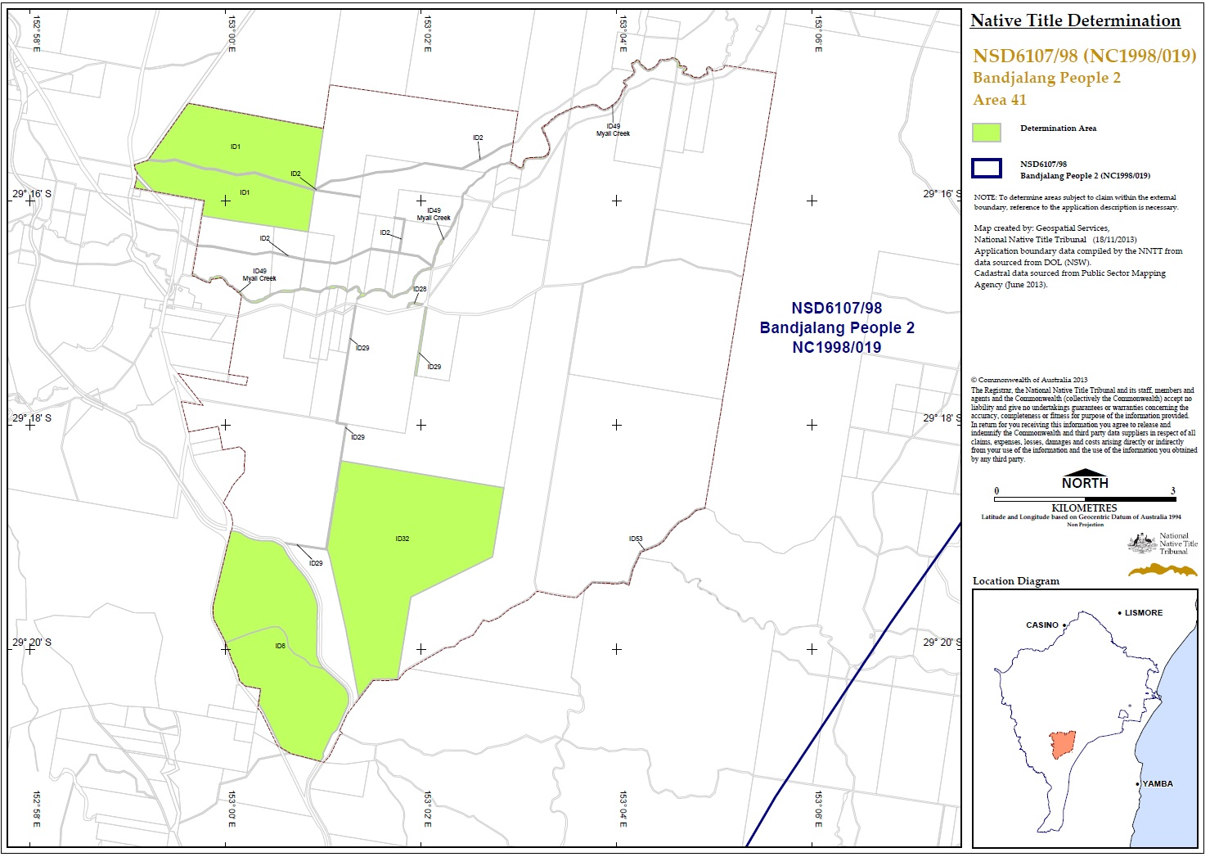
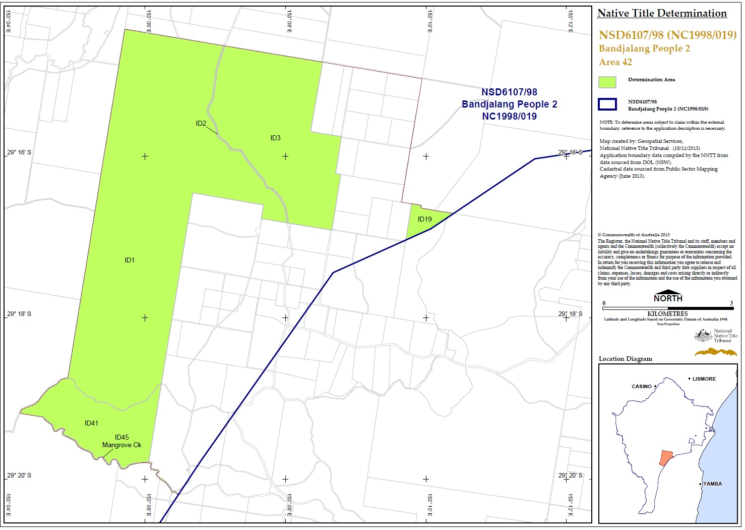
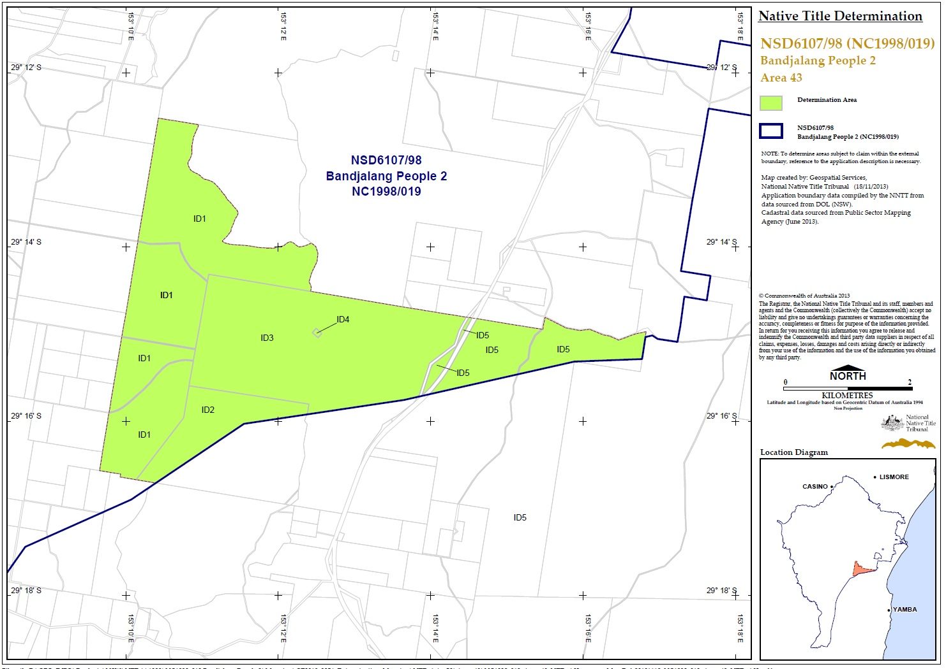
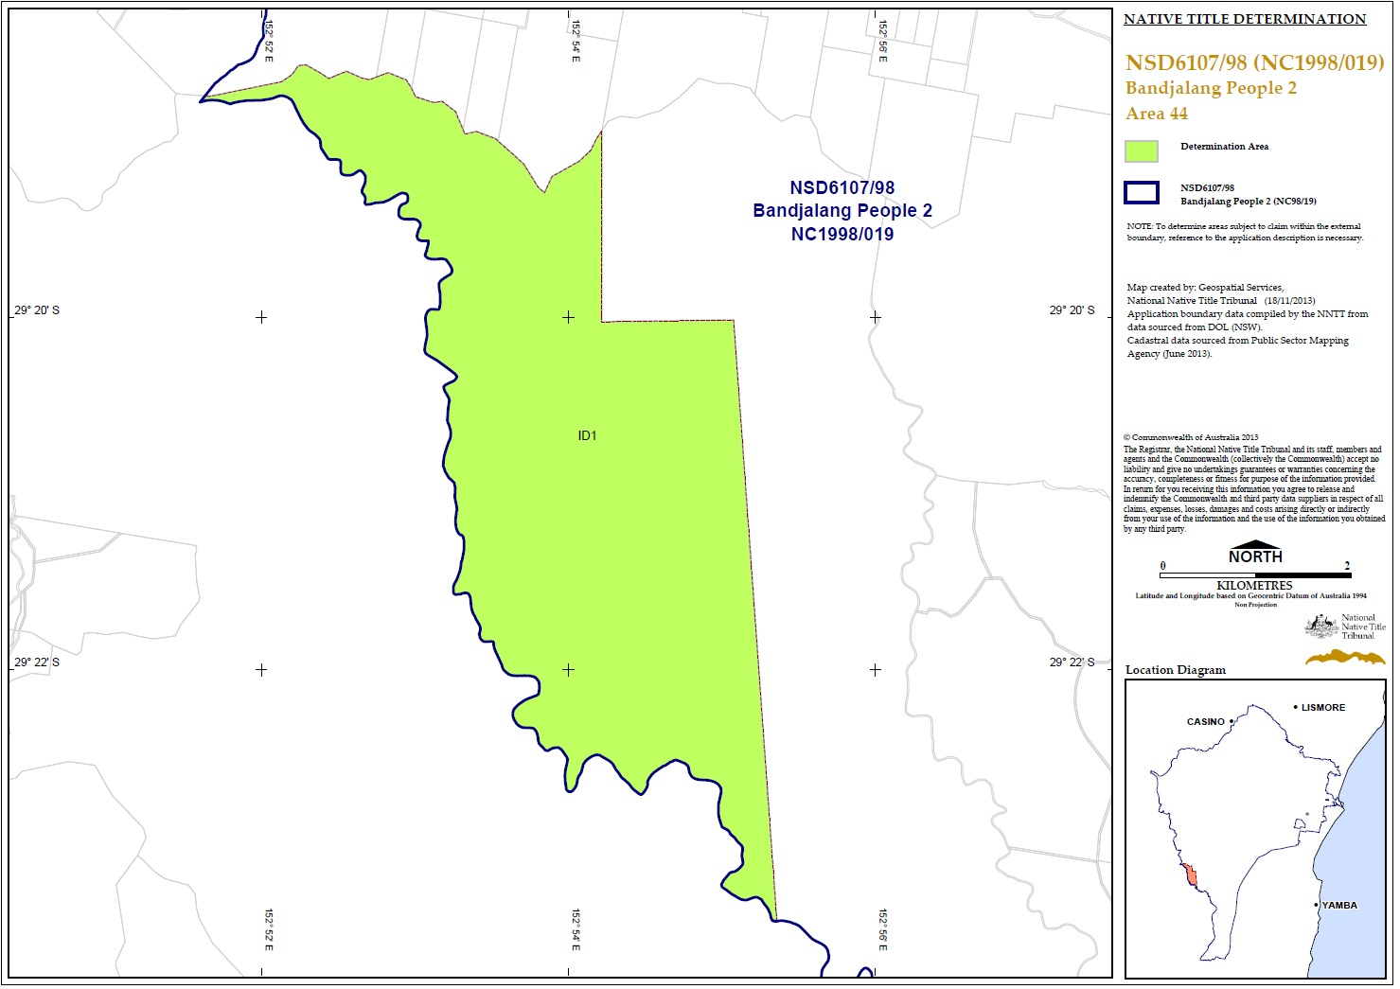
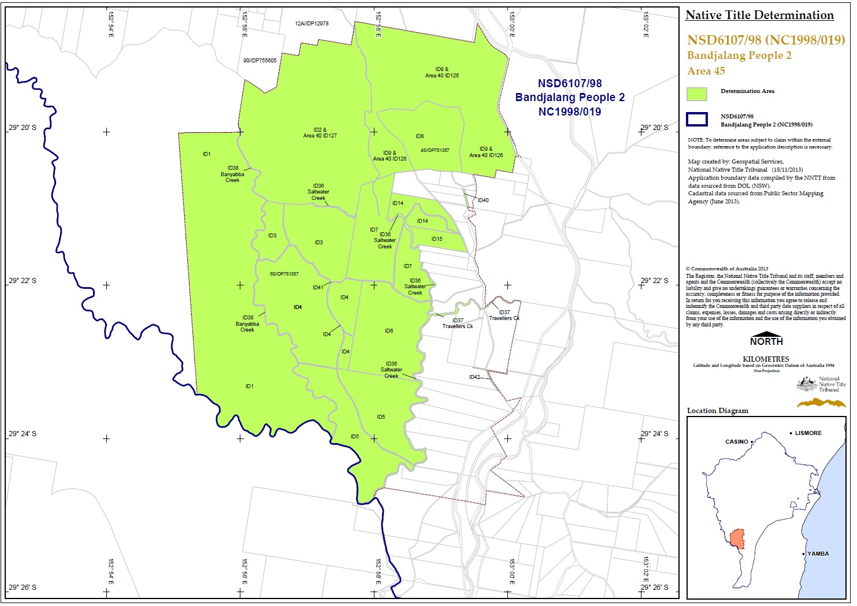
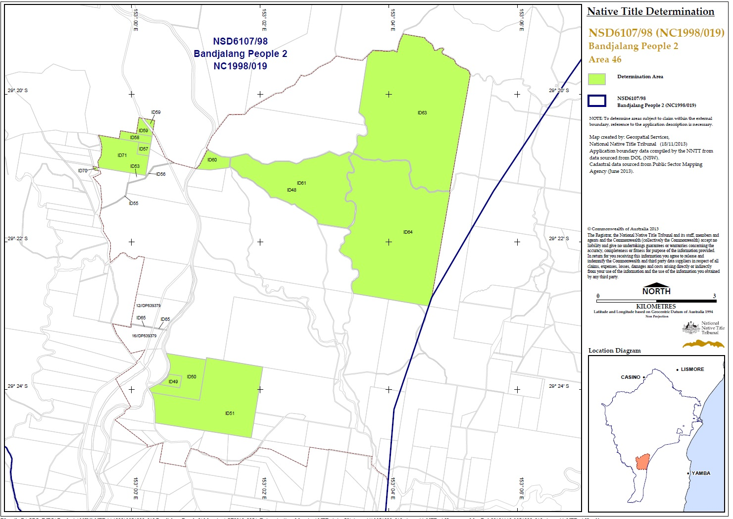
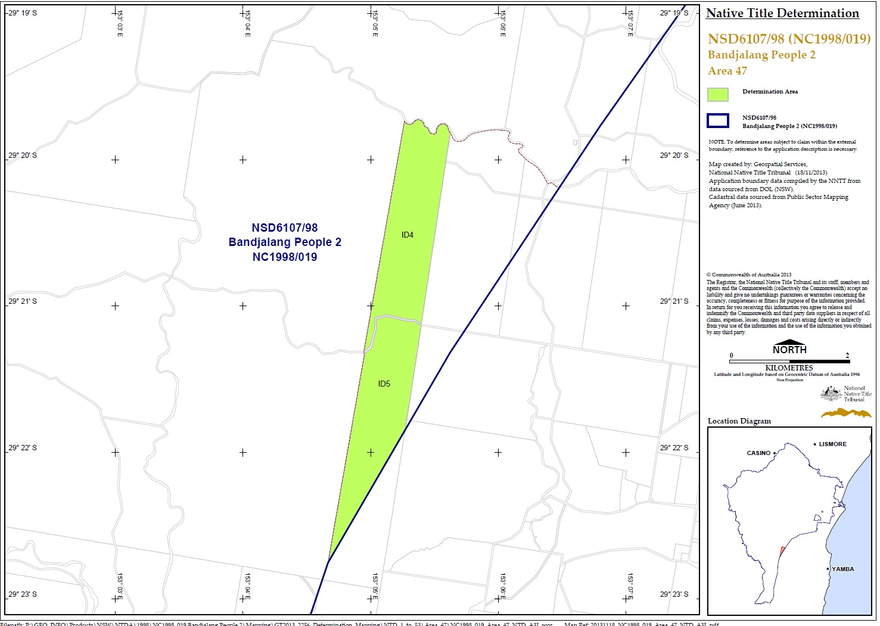
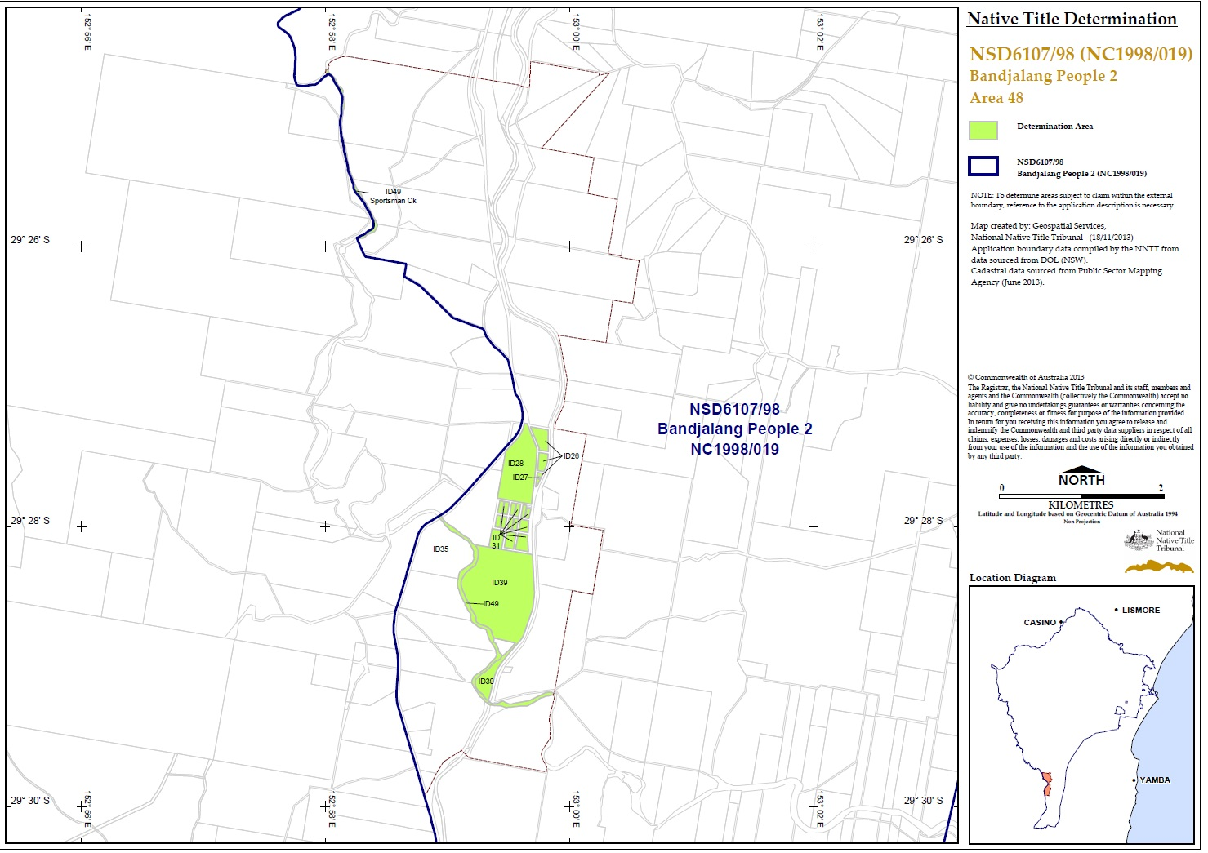
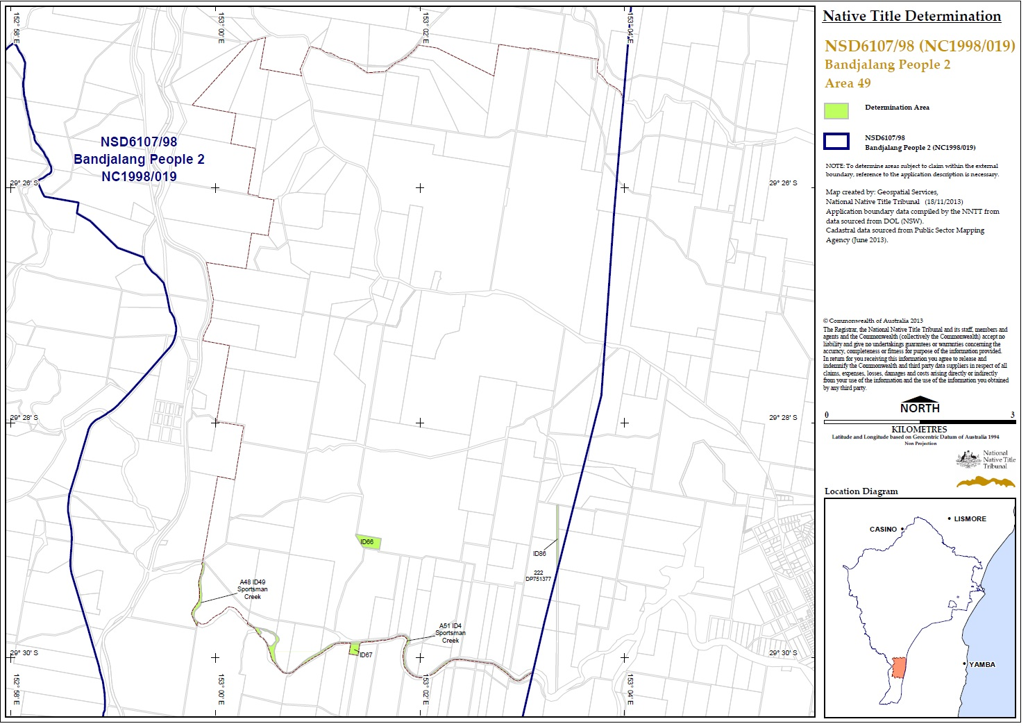
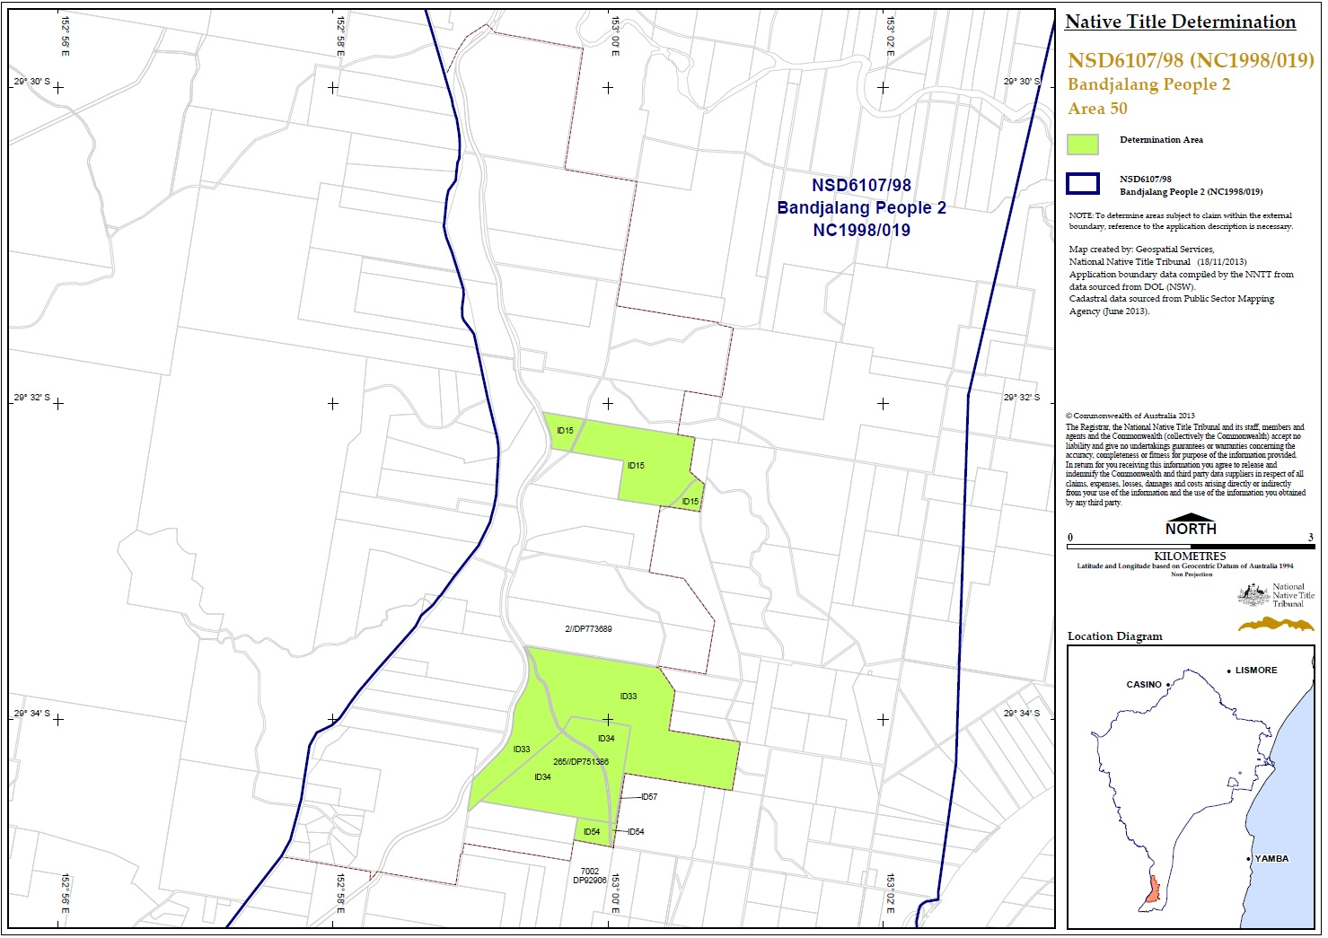
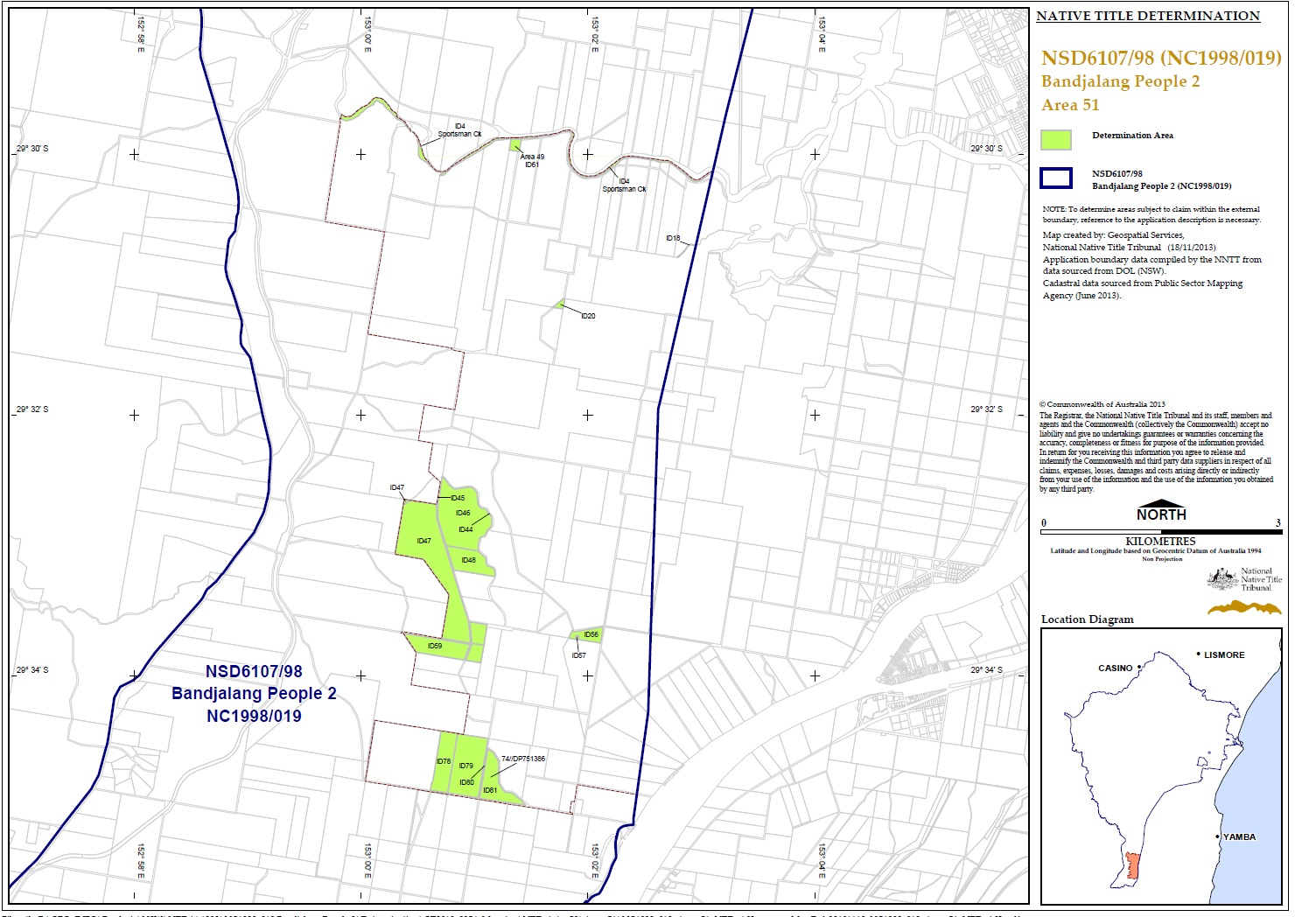
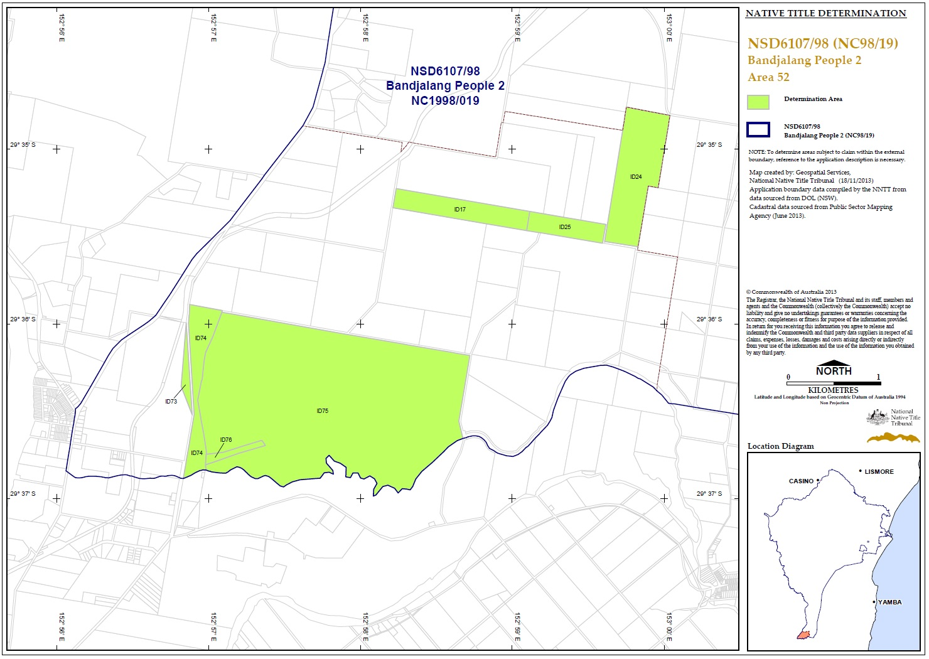
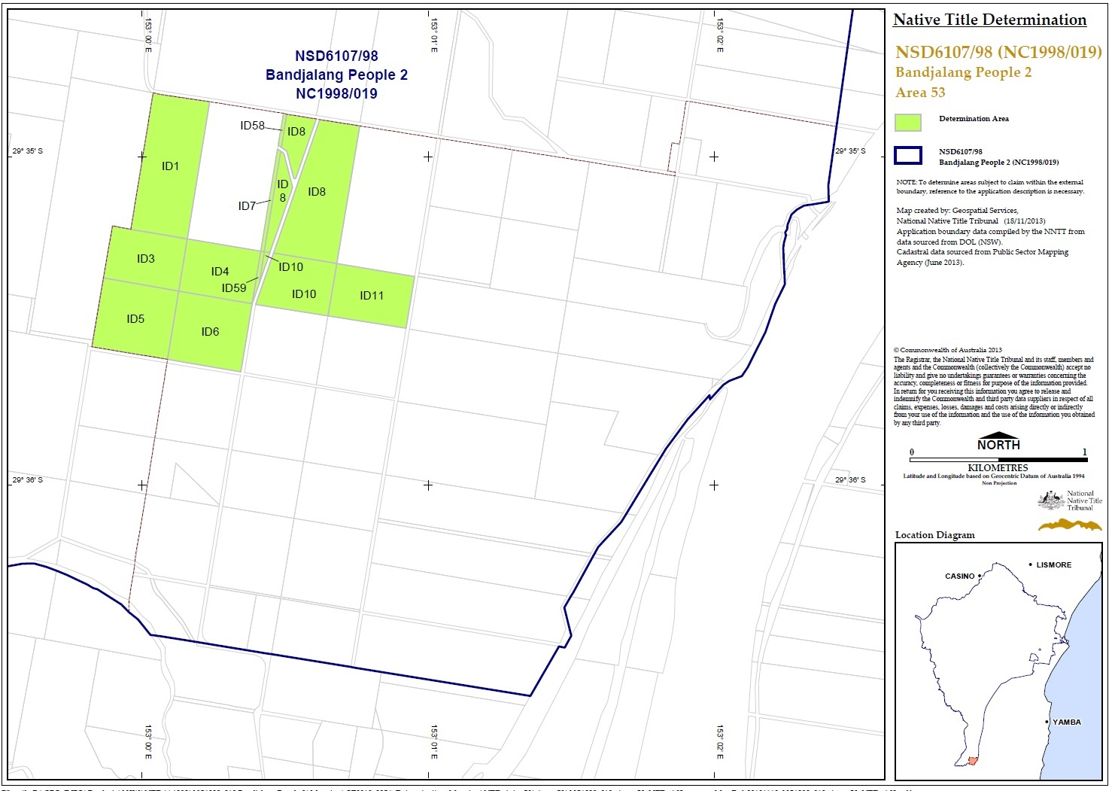
SCHEDULE TWO
OTHER RIGHTS AND INTERESTS
- The rights and interests of Telstra Corporation Limited;
  - as the owner or operator of telecommunications facilities within the Consent Determination Area;
  - as the holder of a carrier licence under the Telecommunications Act 1997 (Cth);
  - created pursuant to the Post and Telegraph Act 1901 (Cth), the Telecommunications Act 1975 (Cth), the Australian Telecommunications Corporations Act 1989 (Cth), the Telecommunications Act 1991 (Cth) and the Telecommunications Act 1997 (Cth), including rights
(i) to inspect land;
(ii) to install and operate telecommunications facilities; and
(iii) to alter, remove, replace, maintain, repair and ensure the proper functioning of its telecommunications facilities;
  - for its employees, agents or contractors to access its telecommunications facilities in and in the vicinity of the Consent Determination Area in performance of their duties; and
  - under any lease, licence, access agreement or easement relating to its telecommunications facilities in the Consent Determination Area.
- The rights and interests of an energy services corporation within the meaning of the Energy Services Corporations Act 1995 (NSW) to exercise functions, powers or rights in accordance with the laws of the State of New South Wales or Commonwealth and as owner and operator of electricity transmission facilities and associated infrastructure situated on the Consent Determination Area including but not limited to the right to enter the Consent Determination Area in order to access, use, install, maintain, repair, replace, upgrade or otherwise deal with facilities and infrastructure.
- The rights and interests of the Richmond Valley Council, Clarence Valley Council and Lismore City Council under their local government jurisdiction and as entities exercising statutory powers in respect of the land and waters in their local government area, including existing access to public work.
- The rights and interests of the Crown in right of the State of New South Wales.
- The rights and interests granted or recognised by the State of New South Wales pursuant to statute or otherwise in the exercise of its executive power and under any regulations made pursuant to such legislation.
- The rights and interests granted by the Commonwealth pursuant to statute or otherwise in the exercise of its executive power and under any regulations made pursuant to such legislation.
- The rights or interests held by reason of the force and operation of the laws of the State of New South Wales or of the Commonwealth.
- The rights and interests of New South Wales Aboriginal Land Council, Bogal Local Aboriginal Land Council, Casino-Boolangle Local Aboriginal Land Council, Jali Local Aboriginal Land Council, Ngulingah Local Aboriginal Land Council and/or Yaegl Local Aboriginal Land Council arising under the Aboriginal Land Rights Act 1983 (NSW) in relation to land which is subject to an undetermined Aboriginal land claim made by one or more of them under s.36 of the Aboriginal Land Rights Act 1983 (NSW), including the right of that Council or those Councils to have that claim determined according to law and, subject only to a determination that the land is claimable Crown land as defined in s.36(1) of that Act, the right to the transfer of an estate in fee-simple, which estate will be subject to any native title rights and interests existing in relation to the land immediately before the transfer, as described in s.36(9) of that Act.
- The rights and interests of members of the public arising under the common law including but not limited to:
  - the public right to fish;
  - the public right to navigate;
- The right to access land by an employee or agent or instrumentality of the State, Commonwealth or other statutory authority as required in the performance of his or her statutory or common law duties.
- So far as confirmed pursuant to sections 16 and 18 of the Native Title (New South Wales) Act 1994 as at the date of this determination, any existing public access to and enjoyment of:
  - waterways;
  - the beds and banks or foreshores of waterways;
  - coastal waters;
  - beaches;
  - stock routes;
  - areas that were public places at the end of 31 December 1993.
- Any other:
  - legal or equitable estate or interest in the land or waters of the Consent Determination Area; or
  - right (including a right under an option and a right of redemption), charge, power or privilege over, or in connection with:
    - the land or waters of the Consent Determination Area; or
    - an estate or interest in the land or waters of the Consent Determination Area.

SCHEDULE THREE
EXTERNAL BOUNDARIES

Description
All the land and waters with the area commencing at a point on the eastern boundary of Devils Pulpit State Forest, being a western boundary of Bundjalung National park at Latitude 29.254752° South; and extending generally south westerly and generally southerly passing through the following coordinate points.
Longitude (East) | Latitude (South)
153.264756 | 29.255241
153.227477 | 29.262587
153.192489 | 29.267155
153.167808 | 29.281629
153.144657 | 29.290681
153.113298 | 29.329522
153.093752 | 29.355259
153.077801 | 29.379187
153.068028 | 29.404464
153.064957 | 29.436957
153.062885 | 29.462769
153.053646 | 29.494724
153.043861 | 29.531731
153.043774 | 29.532011
153.043662 | 29.532373
153.043649 | 29.532705
153.042673 | 29.557416
153.042173 | 29.571270
153.040003 | 29.584791
Then southerly to the southern boundary of Lawrence Road road reserve at Longitude 153.040025° East; then generally south westerly along that road reserve to the prolongation easterly of the northern boundary of Lot 56 DP751386; then westerly to the north eastern corner of that lot; then southerly and generally westerly along the boundaries of that lot, southern boundaries of Lot 55 DP665203, Lot 2 DP373160 and Lot 10 DP820691 and onwards to the south eastern corner of Lot 53 DP751386; again westerly along the southern boundaries of that lot, Lot 11 DP113364 and again Lot 53 DP751386 to the eastern bank of Bunyip Creek; then westerly to the western bank of that creek at Latitude 29.607567° South; then generally north westerly and generally westerly along the bank of that creek to Longitude 152.935264° East; then north westerly to the western boundary of The Summerland Way road reserve at Latitude 29.614039° South; then generally northerly and generally north westerly along that road reserve and the western boundary of Khan Road road reserve to the eastern boundary of Lot 69 DP725852 (Gurranang State Conservation Area); then northerly, westerly and generally north westerly along boundaries of that lot to its northern most corner; again north westerly to the western bank of Sportsmans Creek at Latitude 29.432304° South; then generally north easterly, generally north westerly and generally westerly along the bank of that creek to Longitude 152.863356° East; again generally westerly and generally northerly passing through the following coordinate points.
Longitude (East) | Latitude (South)
152.862999 | 29.313041
152.862483 | 29.312881
152.862155 | 29.312824
152.861523 | 29.312760
152.861089 | 29.312768
152.860564 | 29.312826
152.860015 | 29.312978
152.861668 | 29.311168
152.861889 | 29.311039
152.862348 | 29.310682
152.862725 | 29.310435
152.863328 | 29.309955
152.863569 | 29.309875
152.864158 | 29.309429
152.864412 | 29.309379
152.864740 | 29.309249
152.865093 | 29.309155
152.865396 | 29.308983
152.865723 | 29.308760
152.865813 | 29.308660
152.866083 | 29.308157
152.866256 | 29.307745
152.866500 | 29.307267
152.866876 | 29.306828
152.866909 | 29.306600
152.866864 | 29.305951
152.866915 | 29.305531
152.867019 | 29.305202
152.867182 | 29.304696
152.867256 | 29.303150
152.867304 | 29.302835
152.867386 | 29.302519
152.867524 | 29.302182
152.867884 | 29.301557
152.868285 | 29.301206
152.868080 | 29.300955
152.867957 | 29.300847
152.867596 | 29.300626
152.867169 | 29.300196
152.866889 | 29.299988
152.866291 | 29.299702
152.865724 | 29.299510
152.865191 | 29.299360
152.864871 | 29.299203
152.864346 | 29.298902
152.864044 | 29.298788
152.864033 | 29.297992
152.863933 | 29.297246
152.863941 | 29.296866
152.863799 | 29.295296
152.863764 | 29.294364
152.863665 | 29.293876
152.863501 | 29.293360
152.863295 | 29.292995
152.863171 | 29.292730
152.863122 | 29.292515
152.863073 | 29.291521
152.862743 | 29.291181
152.861183 | 29.290086
152.860961 | 29.289915
152.860600 | 29.289578
152.860255 | 29.289206
152.859992 | 29.288812
152.859802 | 29.288325
152.859663 | 29.288117
152.859433 | 29.287895
152.858941 | 29.287523
152.858760 | 29.287343
152.858390 | 29.286684
152.858086 | 29.285889
152.857872 | 29.285581
152.857560 | 29.285223
152.857034 | 29.284743
152.856690 | 29.284571
152.856575 | 29.284543
152.856526 | 29.284485
152.856493 | 29.284485
152.856181 | 29.284314
152.855238 | 29.284064
152.854779 | 29.283979
152.854590 | 29.283915
152.855472 | 29.281518
152.855521 | 29.281518
152.855693 | 29.281417
152.855914 | 29.281223
152.856094 | 29.280994
152.856486 | 29.280369
152.856601 | 29.280097
152.857206 | 29.278977
152.857369 | 29.278755
152.857729 | 29.278410
152.857844 | 29.278259
152.857885 | 29.278108
152.857964 | 29.277390
152.858203 | 29.277312
152.858446 | 29.277197
152.858826 | 29.276967
152.859006 | 29.276759
152.859300 | 29.276292
152.859365 | 29.276120
152.859676 | 29.275632
152.859938 | 29.275059
152.860461 | 29.274577
152.860739 | 29.274261
152.861296 | 29.273493
152.861385 | 29.273279
152.861680 | 29.272990
152.862229 | 29.272579
152.862572 | 29.272164
152.862670 | 29.271999
152.862858 | 29.271504
152.863364 | 29.270428
152.863756 | 29.269223
152.863870 | 29.268749
152.863992 | 29.268426
152.864137 | 29.268233
152.863844 | 29.268025
152.863721 | 29.267846
152.863393 | 29.267488
152.863168 | 29.267336
152.863089 | 29.267338
152.863066 | 29.267311
152.862827 | 29.267367
152.862679 | 29.267546
152.862320 | 29.268135
152.862140 | 29.268343
152.862017 | 29.268429
152.861730 | 29.268587
152.861411 | 29.268595
152.861222 | 29.268545
152.861050 | 29.268445
152.860697 | 29.268137
152.859736 | 29.267150
152.859113 | 29.266655
152.858874 | 29.266526
152.858604 | 29.266462
152.858473 | 29.266462
152.858249 | 29.266516
152.857973 | 29.266685
152.857736 | 29.266980
152.857613 | 29.267188
152.857442 | 29.267626
152.857361 | 29.267998
152.857239 | 29.268880
152.857173 | 29.268938
152.857009 | 29.268953
152.856764 | 29.268896
152.855869 | 29.268502
152.855148 | 29.268274
152.854780 | 29.268194
152.852540 | 29.267575
152.852031 | 29.267493
152.851671 | 29.267511
152.851294 | 29.267477
152.851089 | 29.267427
152.850851 | 29.267291
152.850514 | 29.266933
152.850268 | 29.266625
152.850252 | 29.266568
152.850071 | 29.266410
152.849850 | 29.266331
152.849645 | 29.266310
152.849448 | 29.266325
152.849342 | 29.266418
152.849208 | 29.266654
152.848686 | 29.266312
152.848439 | 29.266118
152.848234 | 29.265889
152.848037 | 29.265596
152.847856 | 29.265180
152.847725 | 29.264986
152.847610 | 29.264865
152.846909 | 29.264310
152.846789 | 29.264149
152.846739 | 29.263961
152.846773 | 29.263603
152.846921 | 29.262848
152.846934 | 29.262729
152.846819 | 29.262485
152.846639 | 29.262213
152.846532 | 29.261861
152.846523 | 29.261559
152.846531 | 29.261302
152.846465 | 29.260987
152.846464 | 29.260671
152.846548 | 29.260301
152.846584 | 29.260211
152.846834 | 29.259577
152.846626 | 29.259308
152.846413 | 29.259158
152.846142 | 29.259015
152.846060 | 29.259001
152.845759 | 29.258854
152.845256 | 29.258615
152.844748 | 29.258443
152.844326 | 29.258250
152.844356 | 29.257961
152.844197 | 29.257002
152.844230 | 29.255845
152.844187 | 29.255604
152.843940 | 29.255275
152.843883 | 29.255024
152.843865 | 29.254378
152.843782 | 29.253716
152.843795 | 29.253382
152.843782 | 29.253231
152.843757 | 29.253152
152.843461 | 29.252708
152.843354 | 29.252400
152.843329 | 29.252199
152.843370 | 29.251927
152.843476 | 29.251647
152.843787 | 29.251116
152.842180 | 29.250300
152.840687 | 29.249542
152.840548 | 29.248403
152.840554 | 29.247768
152.840058 | 29.246517
152.839996 | 29.246322
152.839995 | 29.246136
152.840044 | 29.245935
152.840207 | 29.245462
152.840482 | 29.244857
152.840630 | 29.244100
152.840637 | 29.243663
152.840621 | 29.243146
152.840406 | 29.242797
152.840062 | 29.242411
152.839628 | 29.241967
152.839452 | 29.241847
152.839284 | 29.241746
152.838858 | 29.241560
152.838612 | 29.241374
152.837875 | 29.240989
152.837433 | 29.240717
152.837023 | 29.240374
152.836745 | 29.240253
Then westerly to the eastern boundary of an unnamed road reserve passing through Lot 2 DP755617 at Latitude 29.240187° South; then generally northerly along that road reserve to the southern boundary of Lot 31 DP755608; then westerly along the boundary of that lot to Longitude 152.847533° East; then generally northerly and generally north westerly and again generally northerly passing through the following coordinate points.
Longitude (East) | Latitude (South)
152.847541 | 29.215949
152.847524 | 29.215770
152.847393 | 29.215627
152.847188 | 29.215549
152.846845 | 29.215521
152.846599 | 29.215464
152.846378 | 29.215371
152.846173 | 29.215178
152.846058 | 29.214978
152.845771 | 29.214627
152.845714 | 29.214477
152.845707 | 29.214303
152.845542 | 29.214212
152.845329 | 29.213961
152.845083 | 29.213740
152.844780 | 29.213633
152.844518 | 29.213612
152.844216 | 29.213627
152.843913 | 29.213591
152.843700 | 29.213513
152.843348 | 29.213227
152.843299 | 29.213213
152.843282 | 29.213184
152.842881 | 29.213078
152.842669 | 29.213056
152.842546 | 29.213057
152.842225 | 29.213126
152.841883 | 29.212879
152.841760 | 29.212728
152.841670 | 29.212492
152.841655 | 29.212240
152.841759 | 29.211869
152.842150 | 29.211367
152.842240 | 29.211087
152.842264 | 29.210829
152.842214 | 29.210507
152.842083 | 29.210300
152.841984 | 29.210192
152.841624 | 29.209921
152.841559 | 29.209835
152.841559 | 29.209694
152.841607 | 29.209405
152.841836 | 29.209125
152.841925 | 29.208925
152.841966 | 29.208695
152.841858 | 29.208165
152.841866 | 29.207915
152.842037 | 29.207635
152.842152 | 29.207527
152.842470 | 29.207369
152.842691 | 29.207318
152.843280 | 29.207246
152.843353 | 29.207224
152.843419 | 29.207167
152.843451 | 29.207009
152.843426 | 29.206845
152.843352 | 29.206665
152.843262 | 29.206558
152.843074 | 29.206451
152.842747 | 29.206394
152.842566 | 29.206294
152.841838 | 29.206116
152.841716 | 29.206081
152.841159 | 29.205795
152.840873 | 29.205708
152.840782 | 29.205567
152.840618 | 29.205108
152.840462 | 29.204944
152.840118 | 29.204687
152.839766 | 29.204258
152.839429 | 29.203974
152.839103 | 29.203886
152.838563 | 29.203830
152.837998 | 29.203709
152.837793 | 29.203609
152.837449 | 29.203380
152.836647 | 29.202923
152.835149 | 29.202224
152.834495 | 29.202081
152.834344 | 29.202002
152.834069 | 29.201882
152.833734 | 29.201775
152.833374 | 29.201704
152.832662 | 29.201726
152.832098 | 29.201706
152.831820 | 29.201678
152.831468 | 29.201571
152.831451 | 29.201585
152.831116 | 29.201328
152.830903 | 29.201278
152.830214 | 29.201319
152.829905 | 29.201437
152.829137 | 29.201596
152.829006 | 29.201596
152.828821 | 29.201547
152.828368 | 29.201318
152.828196 | 29.201204
152.827957 | 29.200948
152.827819 | 29.200775
152.827638 | 29.200230
152.827523 | 29.200080
152.827220 | 29.199816
152.826974 | 29.199644
152.826672 | 29.199487
152.826639 | 29.199444
152.826524 | 29.199387
152.826189 | 29.199294
152.825780 | 29.199223
152.825664 | 29.199178
152.825379 | 29.199002
152.824969 | 29.198537
152.824715 | 29.198315
152.824404 | 29.198145
152.824191 | 29.198066
152.823897 | 29.198008
152.823463 | 29.197988
152.823210 | 29.197995
152.822686 | 29.198126
152.822498 | 29.198147
152.823050 | 29.195424
152.823491 | 29.194900
152.823630 | 29.194656
152.823743 | 29.194255
152.823776 | 29.194011
152.823775 | 29.193711
152.823726 | 29.193281
152.823511 | 29.192350
152.823339 | 29.191813
Then north westerly to a point on the western bank of Fullers Arm at Latitude 29.191710° South; then generally northerly along the bank of that watercourse to the southern bank of Cabbage Tree Creek; then generally westerly along the bank of that creek to Longitude 152.814088° East; then generally westerly and generally northerly passing through the following coordinate points.
Longitude (East) | Latitude (South)
152.813861 | 29.153762
152.813508 | 29.153669
152.813019 | 29.153627
152.812813 | 29.153592
152.812364 | 29.153399
152.812102 | 29.153342
152.811824 | 29.153328
152.811505 | 29.153264
152.811072 | 29.153050
152.810369 | 29.152635
152.810106 | 29.152449
152.809386 | 29.152028
152.809043 | 29.151849
152.808790 | 29.151735
152.808274 | 29.151628
152.807817 | 29.151615
152.807547 | 29.151680
152.806959 | 29.151953
152.806771 | 29.152003
152.806559 | 29.152003
152.806248 | 29.151918
152.806083 | 29.151897
152.805920 | 29.151918
152.805618 | 29.152026
152.801855 | 29.150298
152.801446 | 29.149740
152.801331 | 29.149425
152.800905 | 29.148738
152.800667 | 29.148172
152.800585 | 29.147886
152.800577 | 29.147521
152.800739 | 29.147126
152.800984 | 29.146868
152.801147 | 29.146596
152.801515 | 29.146251
152.801799 | 29.145921
152.802078 | 29.145498
152.802110 | 29.145341
152.802077 | 29.145033
152.802125 | 29.144682
152.802272 | 29.144488
152.802395 | 29.144244
152.802395 | 29.144087
152.802354 | 29.143979
152.802213 | 29.143865
152.801977 | 29.143722
152.801642 | 29.143622
152.801544 | 29.143529
Then northerly to a point on the southern bank of Four Mile Creek at Longitude 152.801515° East; then generally westerly and generally south westerly along the bank of that creek to the southern boundary of an unnamed road reserve passing through Lot 77 DP755635 at Latitude 29.149361° South; then generally north westerly along that road reserve and onwards to the western boundary of Seery Road road reserve; then generally north easterly along that road reserve to the southern boundary of Wyan Creek Road road reserve; then generally north westerly and generally northerly along that road reserve to the northern bank of Myrtle Creek; then generally north easterly along the bank of that creek to Latitude 29.123443° South; then generally north westerly and generally northerly passing through the following coordinate points.
Longitude (East) | Latitude (South)
152.791725 | 29.123079
152.790751 | 29.122685
152.790030 | 29.122263
152.789457 | 29.121833
152.789212 | 29.121704
152.788819 | 29.121432
152.788057 | 29.120974
152.787582 | 29.120522
152.787402 | 29.120308
152.786862 | 29.119591
152.786338 | 29.118760
152.785904 | 29.118380
152.785609 | 29.118166
152.784938 | 29.117734
152.784992 | 29.116953
152.785081 | 29.115383
152.785151 | 29.113813
152.785201 | 29.112243
152.785233 | 29.110911
152.785255 | 29.109578
152.785261 | 29.108245
152.785245 | 29.106913
152.785201 | 29.105582
152.785118 | 29.104097
152.785005 | 29.102613
152.784862 | 29.101130
152.784689 | 29.099651
152.784485 | 29.098178
152.784461 | 29.098034
152.784137 | 29.096550
152.783767 | 29.095068
152.783335 | 29.093602
152.782831 | 29.092168
152.782239 | 29.090781
152.781828 | 29.089996
152.781372 | 29.089233
152.780898 | 29.088477
152.780436 | 29.087715
152.780017 | 29.086933
152.779549 | 29.085958
152.779100 | 29.084967
152.778691 | 29.083959
152.778348 | 29.082936
152.778092 | 29.081901
152.777935 | 29.080715
152.777898 | 29.079504
152.777939 | 29.078279
152.778017 | 29.077051
152.778092 | 29.075832
152.778188 | 29.074439
152.778328 | 29.073047
152.778493 | 29.071656
152.778667 | 29.070266
152.778832 | 29.068876
152.779052 | 29.067100
152.779297 | 29.065326
152.779535 | 29.063551
152.779736 | 29.061775
152.779869 | 29.059995
152.779935 | 29.057926
152.779933 | 29.055850
152.779869 | 29.053773
152.779747 | 29.051699
152.779573 | 29.049635
152.779434 | 29.048358
152.779270 | 29.047083
152.779086 | 29.045810
152.778889 | 29.044539
152.778684 | 29.043270
152.778395 | 29.041569
152.778086 | 29.039871
152.777755 | 29.038176
152.777403 | 29.036486
Then northerly to the north eastern corner of the south western severance of Lot 65 DP755636, a point on the southern boundary of Busbys School Road road reserve; then generally north westerly and generally westerly along that road reserve to the north western corner of the southern severance of Lot 13 DP755636; then northerly to and along the western boundary of the northern severance of that lot and onwards to the northern bank of Busbys Creek; then generally easterly and generally north westerly along the bank of that creek and the western bank of Lollback Creek to the northern boundary of Lot 36 DP755604; then westerly along the boundary of that lot to the western boundary of Wyan Alice Road road reserve; then generally northerly, easterly and generally south easterly along that road reserve to Longitude 152.792097° East; then generally easterly and generally north easterly passing through the following coordinate points.
Longitude (East) | Latitude (South)
152.793252 | 29.033441
152.793561 | 29.033551
152.794120 | 29.033241
152.794433 | 29.033167
152.794744 | 29.033147
152.795881 | 29.033123
152.796474 | 29.032822
152.797056 | 29.032529
152.797639 | 29.032232
152.798219 | 29.031933
152.798797 | 29.031630
152.799359 | 29.031336
152.799921 | 29.031041
152.800482 | 29.030742
152.801037 | 29.030435
152.801586 | 29.030118
152.802086 | 29.029812
152.802582 | 29.029497
152.803075 | 29.029176
152.803565 | 29.028851
152.804053 | 29.028526
152.805118 | 29.027812
152.806172 | 29.027085
152.807221 | 29.026349
152.808267 | 29.025608
152.809311 | 29.024865
152.809824 | 29.024503
152.810338 | 29.024143
152.810850 | 29.023780
152.811357 | 29.023412
152.811859 | 29.023034
152.812524 | 29.022524
152.813188 | 29.022009
152.813839 | 29.021478
152.814462 | 29.020921
152.815044 | 29.020328
152.815436 | 29.019857
152.815800 | 29.019362
152.816151 | 29.018855
152.816504 | 29.018350
152.816876 | 29.017861
152.817952 | 29.016658
152.819118 | 29.015529
152.820319 | 29.014428
152.821502 | 29.013310
152.822609 | 29.012130
152.823065 | 29.011581
152.823509 | 29.011022
152.823947 | 29.010459
152.824389 | 29.009897
152.824839 | 29.009344
152.825482 | 29.008629
152.826159 | 29.007937
152.826830 | 29.007244
152.827464 | 29.006527
152.828025 | 29.005762
152.828333 | 29.005258
152.828621 | 29.004742
152.828891 | 29.004214
152.829143 | 29.003677
152.829379 | 29.003135
152.829616 | 29.002576
152.829846 | 29.002009
152.830054 | 29.001435
152.830223 | 29.000856
152.830336 | 29.000270
152.830386 | 28.999750
152.830404 | 28.999220
152.830389 | 28.998688
152.830338 | 28.998159
152.830255 | 28.997644
152.830079 | 28.997083
152.829914 | 28.996518
152.829764 | 28.995949
152.829625 | 28.995377
152.829503 | 28.994801
152.829379 | 28.994232
152.829255 | 28.993657
152.829150 | 28.993081
152.829089 | 28.992506
152.829094 | 28.991939
152.829184 | 28.991311
152.829347 | 28.990683
152.829568 | 28.990061
152.829831 | 28.989454
152.830116 | 28.988873
152.830366 | 28.988431
152.830645 | 28.988005
152.830943 | 28.987588
152.831248 | 28.987174
152.831548 | 28.986760
152.832092 | 28.986035
152.832663 | 28.985327
152.833235 | 28.984621
152.833782 | 28.983900
152.834275 | 28.983147
152.834654 | 28.982479
152.835009 | 28.981793
152.835338 | 28.981093
152.835639 | 28.980382
Then north easterly to the northern boundary of an unnamed road reserve passing through lot 2 DP832403, south of Mongogarie Creek at Longitude 152.835913° East; then generally easterly along that road reserve to the northern boundary of Lot 1 DP113913; again generally easterly along the boundaries of that lot and again the northern boundary of that unnamed road reserve to the western boundary of another unnamed road reserve, west of Cherry Tree Creek; then generally northerly along the boundary of that road reserve to Latitude 29.956606° South; then north easterly to the western most corner of Lot 111 DP755618; then northerly along the boundary of that lot to the northern boundary of an unnamed road reserve passing through that lot; then generally north easterly and generally easterly along the boundary of that road reserve and the boundary of Hogarth Range Road road reserve to the western boundary of Mongogarie Road road reserve; then generally northerly, generally easterly and generally north easterly along that road reserve to the western boundary of the Nor-coa Railway reserve; then generally north easterly along that railway reserve to the southern boundary of Shannon Brook Road; then northerly to the south western corner of Lot 1 DP180967; then north easterly and south easterly along boundaries of that lot to again the western boundary of the Nor-coan Railway reserve; then generally north easterly along that railway reserve to the prolongation easterly of the southern boundary of Lot 108 DP755633; then westerly along that prolongation to the southern most corner of that lot; then generally north easterly along the boundary of an unnamed road reserve west of Nor-coa Railway reserve to the southern boundary of Lot 167 DP755627; then easterly and generally northerly along boundaries of that lot and the eastern boundary of Lot 7001 DP1059064 to its eastern most north eastern corner; then north easterly to the south western corner of Lot 72 DP755627; then north westerly and generally easterly along the boundary that lot and western and northern boundaries of Lot 73 DP755627 to the western boundary of Lot 101 DP971685; then generally northerly along boundaries of that lot to the southern boundary of Bennett Street road reserve; then westerly along that road reserve to the prolongation southerly of the eastern boundary of Walker Street road reserve; then generally northerly to and along that road reserve to the southern boundary of Light Street road reserve, then easterly along that road reserve and onwards to the eastern boundary of East Street road reserve, then northerly to the southern boundary of Hare Street road reserve, then easterly along that road reserve and onwards to the prolongation southerly of the eastern boundary of Boundary Street road reserve, then northerly to and along that road reserve to the southern boundary of Hartley Street road reserve, then easterly along that road reserve to the prolongation southerly of the eastern boundary of Grays Lane road reserve, then generally northerly to and along that road reserve and the eastern boundary of Short Street road reserve to the southern boundary of Johnston Street; then easterly along that road reserve to the prolongation southerly of the eastern boundary of Dyraaba Street road reserve, then generally northerly and westerly to and along that road reserve to the southeast corner of Lot 3 DP859772; then generally northerly along the boundary of that lot, the eastern boundary of Lot 101 DP828533; southern and eastern boundaries of Lot 318 DP755727 to the north eastern corner of Lot 318 DP755727; then north westerly to the northern boundary of Spring Grove Road road reserve at 153.069353 East°; then generally north easterly and generally northerly along that road reserve and the western boundary of Pratts Road road reserve to the north eastern corner of the southern severance of Lot 2 DP707496; then easterly along the prolongation of the northern boundary of that severance to the eastern boundary of Pratts Road road reserve; again generally northerly and generally easterly along that road reserve to the prolongation southerly of the western boundary of Lot 9 DP114205; then northerly to the south western corner of that lot and easterly along the southern boundary of that lot to the western boundary of Lot 194 DP755742; then northerly and easterly along boundaries of that lot to the southwest corner of Lot 184 DP755742; then northerly and easterly along boundaries of that lot and onwards to the eastern boundary of Gores Road road reserve; then generally south easterly along that road reserve to the western boundary of an unnamed road reserve north of Lot 11 DP845649; then northerly and easterly along that road reserve to the western boundary of Lot 10 DP845649; then northerly along the boundary of that lot to the northern bank of Pelican Creek; then generally south easterly along the bank of that creek to the northern boundary of Lot 2 DP866264; then generally easterly and southerly along boundaries of that lot to the northern boundary of Caniaba Road road reserve; then easterly along that road reserve to again the northern bank of Pelican Creek; again generally south easterly along the bank of that creek to Longitude 153.194725° East; then easterly to north western corner of Lot 105 DP755736; then southerly and easterly along boundaries of that lot to again the northern bank of Pelican Creek; again generally south easterly along the bank of that creek to the western boundary of Lot 145 DP755736; then southerly and generally south easterly along boundaries of that lot, southern boundaries of Lot 125 DP755736, Lot 13 DP113663 and Lot 14 DP113663 to the north western corner of Lot 4 DP122848; then generally southerly and generally south easterly along boundaries of that lot, northern and eastern boundaries of Lot 2 DP534003 to again the northern bank of Pelican Creek; then generally south easterly again along the bank of that creek to the western boundary of Lot 139 DP755736; then generally southerly and generally south easterly along the boundary of that lot, western boundary of Lot 2 DP594856, western and southern boundaries of Lot 4 DP739070 and northern and eastern boundaries of Lot 259 DP728186 to an eastern bank of again Pelican Creek; then generally southerly and generally south easterly along the bank of that creek to the southern bank of the Wilsons River; then northerly to the northern bank of that river at Longitude 153.295028° East; then generally easterly and generally southerly along the bank of that river to the northern boundary of Delelvin Lane road reserve; then generally easterly along that road reserve and northerly along the western boundary of Tuckurimba Road road reserve to the prolongation westerly of the northern boundary of Paffs Lane road reserve; then easterly to and along that road reserve and the northern boundary of Lot 2 DP114827 to again the northern boundary of Paffs Lane roads reserve; again generally easterly again along that road reserve and the northern boundary of Maxwell Road road reserve and onwards to the eastern boundary of Wyrallah Road road reserve; then southerly along that road reserve to the northern boundary of Dungarubba Road road reserve; then easterly along that road reserve to the southern boundary of Lot 1 DP627659; then generally easterly along boundaries of that lot, southern and eastern boundaries of Lot 154 DP755691, southern boundary of Lot 170 DP755691, southern and western boundaries of Lot 1 DP115382, southern boundary of Lot 227 DP755691, northern and eastern boundaries of Lot 162 DP755691, western, southern and eastern boundaries of Lot 226 DP755691 to the prolongation westerly of the southern boundary of Lot 126 DP755691, then generally easterly to and along boundaries of that lot, western and northern boundaries of Lot 29 DP755691 to the western bank of the Tuckean Broadwater; then generally south easterly along the bank of that broadwater to the western bank of the Richmond River; then generally south westerly along the bank of that river to Latitude 29.012574° South; then south easterly to the north western corner of Lot 9, Section 5 DP2769, being the northern boundary of McDonald Street road reserve; then generally south easterly along that road reserve, northern and eastern boundaries of the Broadwater Evans Head Road road reserve and northern boundary of Broadwater Beach Road road reserve and onwards to the High Water Mark of the South Pacific Ocean; then generally southerly along that high water mark to Latitude 29.262076° South; then generally westerly passing through the following coordinate points back to the commencement point.
Longitude (East) | Latitude (South)
153.360841 | 29.262077
153.358195 | 29.261741
153.354467 | 29.261408
153.350453 | 29.261418
153.346922 | 29.261166
153.342022 | 29.261097
153.335250 | 29.261115
153.330938 | 29.261468
153.328489 | 29.261474
153.326235 | 29.261741
153.323896 | 29.260799
153.319573 | 29.260981
153.313098 | 29.260735
153.309566 | 29.260057
153.303778 | 29.258780
153.296623 | 29.258462
153.286520 | 29.256237

The application excludes any area within the external boundary of native title determination application NSD6034/98 Bandjalang People #1 (NC96/16) as accepted for registration on 16 February 2000.

The application does not include any area which was not previously claimed by NSD6107/98 Bandjalang People #2 (NC98/19).

Note
Data Reference and source
- Application boundary compiled by National Native Title Tribunal.
- Cadastre data (CADLite) sourced from Public Sector Mapping Agency (2007).
- Roads based on casement data sourced from Dept of Lands, NSW (2006). Some road names have been sourced from Dept of Lands, GeoSpatial portal (GSP) website.
- Rivers and Creeks based on casement data sourced from Dept of Lands, NSW (2006) where available or topographic image data (1:100K) supplied by Geoimage Pty Ltd under licence from Geoscience Australia. Image data is © Commonwealth of Australia.
Reference datum
Geographical coordinates have been provided by the NNTT Geospatial Services and are referenced to the Geocentric Datum of Australia 1994 (GDA94), in decimal degrees and are based on the spatial reference data acquired from the various custodians at the time
Use of Coordinates
Where coordinates are used within the description to represent cadastral or topographical boundaries or the intersection with such, they are intended as a guide only. As an outcome to the custodians of cadastral and topographic data continuously recalculating the geographic position of their data based on improved survey and data maintenance procedures, it is not possible to accurately define such a position other than by detailed ground survey.

IN THE FEDERAL COURT OF AUSTRALIA
NEW SOUTH WALES DISTRICT REGISTRY
GENERAL DIVISION | NSD 6034 of 1998  NSD 6107 of 1998

BETWEEN: | BANDJALANG PEOPLE NO 1  BANDJALANG PEOPLE NO 2  Applicant
AND: | THE NSW ATTORNEY GENERAL AS THE STATE MINISTER FOR NEW SOUTH WALES AND OTHERS  Respondent

JUDGE: | JAGOT J
DATE: | 2 DECEMBER 2013
PLACE: | EVANS HEAD

REASONS FOR JUDGMENT

INTRODUCTION
- The importance of what is about to happen today for the Bandjalang people cannot be overstated. Today, after some seventeen years, the Bandjalang people will at last be recognised for what, in fact, they have always been, the traditional owners of the land identified in the two amended applications for determinations of native title lodged on behalf of the Bandjalang people known as the Bandjalang No 1 and Bandjalang No 2 claims. Every party to the proceedings consents to the making of orders which embody these acts of recognition and, in so doing, has given effect to that part of the Preamble to the Native Title Act 1993 (Cth) (the NTA) which records that “the common law of Australia recognises a form of native title that reflects the entitlement of the indigenous inhabitants of Australia, in accordance with their laws and customs, to their traditional lands”.
- Your combined efforts and achievements in reaching this result will justifiably give rise to a real and well deserved sense of pride and celebration. That is only right. I know the work of the parties over the past months has been tireless and that as problems and issues have arisen, as they always do, the parties have dealt with them constructively and sensibly, not losing sight of the ultimate goal.
- In this time of celebration, however, we should not overlook the fact that this process has taken seventeen years to complete. The matters have been through the hands of five judges of the Court. One of those judges, the esteemed Hely J who heard preservation evidence in 2002, subsequently passed away. So too the original applicant on both claims, Lawrence Wilson, did not live to see this day. We, who together are responsible for managing the legislative scheme for the determination of native title applications in New South Wales, should not forget on this day, of all days, that the past injustices which the Preamble to the NTA identifies have led to Aboriginal peoples and Torres Strait Islanders being “as a group, the most disadvantaged in Australian society” are not rectified as that Act contemplates by assuming that the express overarching purpose of all of the civil practice and procedure provisions of the Court do not apply to native title applications. The overarching purpose, with which all parties and their lawyers must act consistently, as set out in ss 37M and 37N of the Federal Court of Australia Act 1976 (Cth), is to facilitate the just resolution of disputes, according to law, and as quickly, inexpensively and efficiently as possible.
- The fact that the NTA embodies a scheme emphasising the importance of outcomes based on agreement rather than judicial imposition, if at all possible, should act to support and promote the conduct of native title matters in a way which routinely ensures that disputes are resolved by agreement and according to law, and as quickly, inexpensively and efficiently as possible. There is no conflict between these schemes and, indeed, the overarching purpose should enhance the operation of the NTA as contemplated. To date in New South Wales, however, there have been only two determinations by consent of native title. Today, we will see the third and fourth determinations made. The passing of seventeen years to obtain this result is not what either statute contemplates. Failure to recognise and redress this reality will undermine the objects of both statutes. Renewed dedication to ensuring that native title disputes are resolved justly, according to law, and as quickly, inexpensively and efficiently as possible is required. That dedication, and the flexibility of mind to see constructive resolutions and new ways of doing things, which I do see in the terms of the proposed determinations in the present case, is a responsibility we share. It is not only my hope, but also my expectation, that the work which has enabled these determinations to be made today will enable future outcomes of a similar kind to be more readily achievable.

THE RELEVANT POWERS AND PROVISIONS
- Section 87(1) of the NTA permits the Court, at any stage of proceedings after the end of the period specified in the notice given under s 66, to make an order in or consistent with the terms of an agreement between the parties without holding a hearing where:
(a) agreement is reached between the parties on the terms of an order of the Federal Court in relation to:
(i) the proceedings; or
(ii) a part of the proceedings; or
(iii) a matter arising out of the proceedings; and

(b) the terms of the agreement, in writing signed by or on behalf of the parties, are filed with the Court; and

(c) the Court is satisfied that an order in, or consistent with, those terms would be within the power of the Court.

- By s 87(1A) the Court may, if it appears appropriate to do so, act in accordance with whichever of the succeeding provisions is applicable in the particular case.
- Section 87(5) provides that that if such an order makes a determination of native title the order may also give effect to terms of the agreement that involve matters other than native title and is the applicable provision in the present case. It follows that the orders may be made provided that the requirements of ss 87(1) and 87(1A) are satisfied.
- In the present case the notice periods under s 66 of the NTA have ended and agreement has been reached between the parties on the terms of orders in relation to both proceedings. The terms of the agreement have been recorded in writing, signed on behalf of all parties, and filed with the Court. The parties, accordingly, seek orders pursuant to s 87(5) making determinations of native title and other matters.
- As explained by Keane CJ in King on behalf of The Eringa Native Title Claim Group v State of South Australia (2011) 285 ALR 454; [2011] FCA 1386 (Eringa), s 87(1)(c) requires the order to be within the power of the Court. As a consequence, the provisions of s 223, 225 and 94A of the NTA are called up for consideration.
- Section 223(1) informs us that:
The expression native title or native title rights and interests means the communal, group or individual rights and interests of Aboriginal peoples or Torres Strait Islanders in relation to land or waters, where:

      - the rights and interests are possessed under the traditional laws acknowledged, and the traditional customs observed, by the Aboriginal peoples or Torres Strait Islanders; and

      - the Aboriginal peoples or Torres Strait Islanders, by those laws and customs, have a connection with the land or waters; and

      - the rights and interests are recognised by the common law of Australia.

- By s 94A an “order in which the Federal Court makes a determination of native title must set out details of the matters mentioned in section 225 (which defines determination of native title)”.
- Section 225 provides that:
A determination of native title is a determination whether or not native title exists in relation to a particular area (the determination area ) of land or waters and, if it does exist, a determination of:

- who the persons, or each group of persons, holding the common or group rights comprising the native title are; and

- the nature and extent of the native title rights and interests in relation to the determination area; and

- the nature and extent of any other interests in relation to the determination area; and

- the relationship between the rights and interests in paragraphs (b) and (c) (taking into account the effect of this Act); and

- to the extent that the land or waters in the determination area are not covered by a non-exclusive agricultural lease or a non-exclusive pastoral lease - whether the native title rights and interests confer possession, occupation, use and enjoyment of that land or waters on the native title holders to the exclusion of all others.

- In Eringa at [16] Keane CJ explained that it is important to explain why these statutory requirements have been satisfied because orders recognising native title have effect not only as between the parties but also as between all people within Australia. At [19] Keane CJ observed that:
…the court has been prepared to rely upon the processes of the relevant State or Territory about the requirements of s 223 being met to be satisfied that the making of the agreed orders is appropriate. That is because each State and Territory has developed a protocol or procedure by which it determines whether native title (as defined in s 223) has been established. It acts in the public interest and as the public guardian in doing so. It has access to anthropological, and where appropriate, archaeological, historical and linguistic expertise. It has a legal team to manage and supervise the testing as to the existence of native title in the claimant group. Although the court must, of course, preserve to itself the question whether it is satisfied that the proposed orders are appropriate in the circumstances of each particular application, generally the court reaches the required satisfaction by reliance upon those processes.

- At [20] Keane CJ cited with approval the observations of North J in Lovett (on behalf of the Gunditjmara People) v Victoria [2007] FCA 474 at [36]-[37] where this was said:

The Act [Native Title Act] is designed to encourage parties to take responsibility for resolving proceeding without the need for litigation. Section 87 must be construed in this context. The power must be exercised flexibly and with regard to the purpose for which the section is designed.

In this context, when the court is examining the appropriateness of an agreement, it is not required to examine whether the agreement is grounded on a factual basis which would satisfy the Court at a hearing of the application. The primary consideration of the Court is to determine whether there is an agreement and whether it was freely entered into on an informed basis: Nangkiriny v State of Western Australia (2002) 117 FCR 6; [2002] FCA 660; Ward v Western Australia [2006] FCA 1848. Insofar as this latter consideration applies to a State party, it will require the Court to be satisfied that the State party has taken steps to satisfy itself that there is a credible basis for an application: Munn v Queensland (2001) 115 FCR 109; [2001] FCA 1229.

- Under s 56 of the NTA, “[o]ne of the determinations that the Federal Court must make is whether the native title is to be held in trust, and, if so, by whom”. Section 56(2) sets out the steps the Court must take in respect of that determination.

APPROPRIATE TO MAKE ORDERS?
- I am satisfied that it is appropriate to make the orders sought. There is no question that the relevant procedural requirements are satisfied. Equally, the evidence which has been adduced by the parties discloses that they have reached an agreement freely and on a properly informed basis.
- The native title claim group consists of the descendants, both biological and adopted, of 12 apical ancestors who identify as and are accepted to be Bandjalang people in accordance with the traditional laws and customs of those people. The claims relate to land on the north coast of New South Wales at and around Evans Head.
- As the affidavit of Janet Moss, solicitor for the State of New South Wales (the State), discloses, anthropological and linguistic evidence was provided by the applicants to the State in support of the Bandjalang claims as early as 1992. In the same year evidence was given before Hely J by two members of the claim group. Thereafter, sixteen members of the claim group provided statements in support of the claim. A supplementary anthropological report was also provided. The State retained another anthropologist to review all of the material with which it had been provided. The State also had available to it expert assistance from an in-house anthropologist and historian. The State raised issues of concern to it which were addressed thereafter including through further anthropological and historical reports and material and amendments to the applications. The State also had available to it legal advice from the Crown Solicitor’s Office and counsel, both senior and junior. By 2009 the State had the benefit of counsel’s advice that it could be satisfied that there was a cogent and credible basis for a consent determination recognising non-exclusive native title rights and interests of the Bandjalang people within the claim areas.
- These conclusions are consistent with the opinions expressed in other affidavits. Michael Bennett, historian, who has been involved in the preparation of material to support the claims since June 2002 has expressed the opinion that the present Bandjalang people are “the descendants of the Bandjalang apical ancestors whose predecessors at sovereignty exercised and held rights and interests which have as their source a system of traditional law and custom which continues to be binding upon and observed by Bandjalang People”. Simon Correy, anthropologist, has been involved in these claims since 2002. He has expressed the opinion that the “Bandjalang People of the present are the same Bandjalang group who at sovereignty exercised and held rights and interests which have as their source a system of traditional law and custom which continues to be binding upon and observed by Bandjalang People”.
- It will be apparent that these opinions directly engage the relevant requirements for the establishment of native title rights and interests. Keane CJ summarised those requirements in Eringa at [3] as follows:
1. that the claim group comprises a society united in and by their acknowledgement and observance of a body of accepted laws and customs; and

2. that the present day body of accepted laws and customs of the society in essence is the same body of laws and customs acknowledged and observed by the ancestors or members of the society adapted to modern circumstances; and

3. that the acknowledgement and observance of those laws and customs has continued substantially uninterrupted by each generation since sovereignty, and that the society has continued to exist throughout that period as a body united in and by its acknowledgement and observance of those laws and customs.

- In the joint submissions which have been filed and signed by the parties it is recorded that the parties propose that the rights and interests that should be recognised in the claim areas to be the subject of the determinations are non-exclusive rights to: (a) hunt, fish and gather the traditional natural resources for non-commercial, personal and domestic use, (b) take and use waters, (c) access and camp, (d) conduct ceremonies, teach the physical, cultural and spiritual attributes of places and areas of importance on or in the land and water, and have access to, maintain and protect from physical harm sites which are of significance to the Bandjalang people under their traditional laws and customs.
- The proposed determinations reflect this agreement. The proposed determinations identify the land, the holders of native title, the nature and extent of their non-exclusive native title rights and interests, limits on and exclusions from those rights and interests, and the relationship between those rights and interests and other interests. The determinations also propose that the native title be held on trust by the Bandjalang Aboriginal Corporation Prescribed Body Corporate (the Corporation). The affidavits of Victoria Edwards, solicitor, disclose that this Corporation, registered under the Corporations (Aboriginal and Torres Strait Islanders) Act 2006 (Cth) on 13 August 2013, was nominated to hold the native title on trust at a meeting of the claim group on 25 October 2013. The Corporation accepted this nomination on the same day. Otherwise, the requirements of s 56(2) of the NTA are satisfied and, pursuant to s 87(5), the determinations should include this part of the terms agreed between the parties.

CONCLUSIONS
- Agreement having been reached between all parties and all substantive and procedural requirements having been met, orders should be made which recognise the native title rights and interests of the Bandjalang people in accordance with the proposed consent determinations. I note the matters set out in those proposed determinations and make orders accordingly.

I certify that the preceding twenty-three (23) numbered paragraphs are a true copy of the Reasons for Judgment herein of the Honourable Justice Jagot.

Associate:

Dated: 2 December 2013

