Federal Court of Australia

Carter on behalf of the Warrwa Mawadjala Gadjidgar and Warrwa People Native Title Claim Groups v State of Western Australia [2020] FCA 1702

|  |  |
| --- | --- |
| File numbers: | WAD 16 of 2019  WAD 33 of 2019 |
|  |  |
| Judgment of: | **BANKS-SMITH J** |
|  |  |
| Date of judgment: | 1 December 2020 |
|  |  |
| Catchwords: | **NATIVE TITLE** - consent determinations of native title - agreement of parties - joint reasons - s 87 and s 87A of the *Native Title Act 1993* (Cth) |
|  |  |
| Legislation: | *Native Title Act 1993* (Cth) ss 13, 47A, 47B, 56, 61, 62A, 66, 66A, 67, 68, 87, 87A, 94A, 190A, 223, 225, 251B |
|  |  |
| Cases cited: | *Brown (on behalf of the Ngarla People) v State of Western Australia* [2007] FCA 1025  *Gomeroi People v Attorney-General of New South Wales* [2016] FCAFC 75; (2016) 241 FCR 301  *Hughes (on behalf of the Eastern Guruma People) v State of Western Australia* [2007] FCA 365  *Lota Warria on behalf of the Poruma and Masig Peoples v State of Queensland* [2005] FCA 1117  *O'Connor on behalf of the Palyku People v State of Western Australia* [2019] FCA 330  *Ward v State of Western Australia* [2006] FCA 1848  *Watson on behalf of the Nyikina Mangala People v State of Western Australia (No 6)* [2014] FCA 545  *Western Bundjalung People v Attorney General of New South Wales* [2017] FCA 992 |
|  |  |
| Division: | General Division |
|  |  |
| Registry: | Western Australia |
|  |  |
| National Practice Area: | Native Title |
|  |  |
| Number of paragraphs: | 90 |
|  |  |
| Date of hearing: | Determined on the papers |
|  |  |
|  |  |
| **For WAD 16 of 2019:** |  |
|  |  |
| Solicitor for the Applicant: | Ms JM Toohey of the Kimberley Land Council |
|  |  |
| Solicitor for the State of Western Australia: | Mr JW O'Halloran of the State Solicitors Office |
|  |  |
| Solicitor for the Commonwealth of Australia: | Ms S Davies of the Australian Government Solicitor |
|  |  |
| Solicitor for Jock Hugh Maclachlan: | Mr S Palmer of the Pastoralists & Graziers Association of WA Inc |
|  |  |
| **For WAD 33 of 2019:** |  |
|  |  |
| Solicitor for the Applicant: | Ms JM Toohey of the Kimberley Land Council |
|  |  |
| Solicitor for the State of Western Australia: | Mr JW O'Halloran of the State Solicitors Office |
|  |  |
| Solicitor for the Commonwealth of Australia: | Ms S Davies of the Australian Government Solicitor |
|  |  |
| Solicitor for the Kimberley Land Counsel: | Ms JM Toohey of the Kimberley Land Council |
|  |  |
| Solicitor for Callum Hugh Maclachlan, Jock Hugh Maclachlan, Napier Corporation Pty Ltd and Yeeda Station Pty Ltd: | Mr S Palmer of the Pastoralists & Graziers Association of WA Inc |
|  |  |
| Solicitor for Telstra Corporation Limited: | Mr SE Singleton of King Wood & Mallesons |

**Table of Contents**

|  |  |
| --- | --- |
| Orders (WAD 16 of 2019) | 1 - 2 |
| Attachment A: Determination | 3 - 6 |
| Schedule One: Determination Area | 7 - 8 |
| Schedule Two: Maps of the Determination Area | 9 - 11 |
| Schedule Three: Exclusive native title areas | 12 |
| Schedule Four: Non-exclusive native title areas | 13 |
| Schedule Five: Areas where native title does not exist (paragraph 2) | 14 - 15 |
| Schedule Six: Areas to which sections 47A or 47B *Native Title Act* apply (paragraph 11) | 16 |
| Schedule Seven: Other Interests | 17 - 19 |
| Schedule Eight: Native Title Holders (paragraph 3) | 20 |
| Orders (WAD 33 of 2019) | 21 - 22 |
| Attachment A: Determination | 23 - 26 |
| Schedule One: Determination Area | 27 - 30 |
| Schedule Two: Maps of the Determination Area | 31 - 36 |
| Schedule Three: Exclusive native title areas | 37 - 38 |
| Schedule Four: Non-exclusive native title areas | 39 - 40 |
| Schedule Five: Areas where native title does not exist (paragraph 2) | 41 - 42 |
| Schedule Six: Areas to which sections 47A or 47B *Native Title Act* apply (paragraph 11) | 43 - 44 |
| Schedule Seven: Other Interests | 45 - 50 |
| Schedule Eight: Native Title Holders (paragraph 3) | 51 |
| Reasons for Judgment | 52 - 71 |

ORDERS - Warrwa Mawadjala Gadjidgar

|  |  |  |
| --- | --- | --- |
|  | | WAD 16 of 2019 |
|  | | |
| BETWEEN: | TIMOTHY CARTER, PATRICIA JUBOY, DEBRA ANN MAHER, LAWRENCE TATAYA, HERBERT MARSHALL, BARRY LENNARD, GAIL WILLIAMS, NATHAN LENNARD, ELAINE LARAIA, PATRICK LAWSON, THOMAS WILLIAMS, STEPHEN HUNTER  Applicant | |
| AND: | STATE OF WESTERN AUSTRALIA  Respondent  COMMONWEALTH OF AUSTRALIA  Respondent  JOCK HUGH MACLACHLAN  Respondent | |

|  |  |
| --- | --- |
| order made by: | BANKS-SMITH J |
| DATE OF ORDER: | 1 DECEMBER 2020 |

THE COURT NOTES THAT:

A. The Applicant in proceeding WAD 16 of 2019 has made a native title determination application (**Warrwa Mawadjala Gadjidgar Application**).

B. The Applicant in the Warrwa Mawadjala GadjidgarApplication, the State of Western Australia and the other Respondents to the proceedings have reached an agreement as to the terms of a determination which is to be made in relation to the land and waters covered by the Warrwa Mawadjala GadjidgarApplication (**Determination Area**).

C. Pursuant to s 87(1), (1A) and (2) of the *Native Title Act 1993* (Cth) the parties have filed with the Court their agreement in relation to this proceeding.

D. The terms of the agreement involve the making of consent orders for a determination of native title in relation to the land and waters the subject of this proceeding pursuant to s 87 and s 94A of the *Native Title Act*.

E. The parties acknowledge that the effect of the making of the determination is that the members of the native title claim group, in accordance with the traditional laws acknowledged and the traditional customs observed by them, should be recognised as the native title holders for the Determination Area as set out in the determination.

F. Pursuant to s 87(2) of the *Native Title Act*, the parties have requested that the Court determine the proceeding that relates to the Determination Area without holding a hearing.

**BEING SATISFIED** that a determination of native title in the terms set out in Attachment A to these orders would be within the power of the Court and, it appearing to the Court appropriate to do so, pursuant to s 87 and s 94A of the *Native Title Act* and by the consent of the parties:

THE COURT ORDERS THAT:

1. In relation to the Determination Area, there be a determination of native title in terms of the determination as provided for in Attachment A to these orders.
2. The Warrwa People Aboriginal Corporation shall hold the determined native title in trust for the native title holders pursuant to s 56(2) of the *Native Title Act*.
3. There be no order as to costs.

Note: Entry of orders is dealt with in Rule 39.32 of the *Federal Court Rules 2011*.

**ATTACHMENT A - Warrwa Mawadjala Gadgigar**

**DETERMINATION**

**Note:** defined terms are set out in paragraph 14 below.

**THE COURT ORDERS, DECLARES AND DETERMINES THAT:**

**Existence of native title: s 225 *Native Title Act***

1. Subject to paragraph 2, native title exists in the Determination Area in the manner set out in paragraphs 4 and 5 of this Determination.

2. Native title does not exist in those parts of the Determination Area that are identified in Schedule Five.

**Native title holders: s 225(a) *Native Title Act***

3. The native title in the Determination Area is held by the Native Title Holders.

**The nature and extent of native title rights and interests: s 225(b) and s 225(e) *Native Title Act***

***Exclusive native title rights and interests***

4. Subject to paragraphs 7, 8, 9 and 10 the nature and extent of the native title rights and interests in relation to the Exclusive Area referred to in Schedule Three is the right to possession, occupation, use and enjoyment of the Exclusive Area as against the whole world.

***Non-exclusive native title rights and interests***

5. Subject to paragraphs 6, 7, 8, 9 and 10 the nature and extent of the native title rights and interests in relation to the Non-Exclusive Area referred to in Schedule Four are the following:

(a) the right to have access to, remain in and use that part. For the avoidance of doubt, some of the ways in which that right may be exercised include but are not limited to the following activities:

(i) to access and move freely through and within that part;

(ii) to live, being to enter and remain on, camp and erect temporary shelters and other structures for those purposes on that part;

(iii) to light controlled contained fires but not for the clearance of vegetation;

(iv) to engage in cultural activities in that part, including the transmission of cultural heritage knowledge; and

(v) to hold meetings in that part.

(b) the right to access and take for any purpose the resources on that part. For the avoidance of doubt, one of the ways in which that right may be exercised includes but is not limited to the following activity:

(i) to access and take water other than water which is lawfully captured or controlled by the holders of pastoral leases.

(c) the right to protect places, areas and objects of traditional significance on that part. For the avoidance of doubt, some of the ways in which that right may be exercised include but are not limited to the following activities:

(i) to conduct and participate in ceremonies in that part; and

(ii) to conduct burials and burial rites and other ceremonies in relation to death in that part; and

(iii) to visit, maintain and protect from physical harm, areas, places and sites of importance in that part.

6. The native title rights and interests referred to in paragraph 5 do not confer:

(a) possession, occupation, use and enjoyment of those parts of the Determination Area on the Native Title Holders to the exclusion of all others; nor

(b) a right to control the access of others to the land or waters of those parts of the Determination Area.

7. The native title rights and interests are subject to and exercisable in accordance with:

(a) the laws of the State and the Commonwealth, including the common law; and

(b) the traditional laws and customs of the Native Title Holders.

8. Notwithstanding anything in this Determination, there are no native title rights and interests in the Determination Area in or in relation to:

(a) minerals as defined in the *Mining Act 1904* (WA) (repealed) and in the *Mining Act 1978* (WA), except to the extent that ochre is not a mineral pursuant to the *Mining Act 1904* (WA);

(b) petroleum as defined in the *Petroleum Act 1936* (WA) (repealed) and in the *Petroleum and Geothermal Energy Resources Act 1967* (WA); or

(c) water lawfully captured or controlled by the holders of the Other Interests.

9. The native title rights and interests are subject to the *Petroleum and Geothermal Energy Resources Act 1967* (WA).

10. For the avoidance of doubt, the native title rights and interests set out in paragraphs 4 and 5 do not confer exclusive rights in relation to water in any watercourse, wetland or underground water source as defined in the *Rights in Water and Irrigation Act 1914* (WA) as at the date of this Determination.

**Areas where extinguishment is disregarded: s 47A or s 47B *Native Title Act***

11. Section 47A and s 47B of the *Native Title Act* apply to disregard any prior extinguishment in relation to the areas described in Schedule Six.

**The nature and extent of any Other Interests: s 225(c) *Native Title Act***

12. The nature and extent of the Other Interests are described in Schedule Seven.

**Relationship between native title rights and Other Interests: s 225(d) *Native Title Act***

13. The relationship between the native title rights and interests described in paragraphs 4 and 5 and the Other Interests is as follows:

(a) the Other Interests co-exist with the native title rights and interests;

(b) this Determination does not affect the validity of those Other Interests; and

(c) to the extent of any inconsistency, the native title rights and interests yield to the Other Interests and the existence and exercise of native title rights and interests cannot prevent activities permitted under the Other Interests.

**Definitions and Interpretation**

14. In this Determination, unless the contrary intention appears:

'**Determination Area**' means the land and waters described in Schedule One and depicted on the maps at Schedule Two;

'**Exclusive Area**' means those lands and waters of the Determination Area described in Schedule Three (being areas where any extinguishment must be disregarded) which are not Non Exclusive Areas or described in paragraph 2 as an area where native title does not exist. Exclusive Areas are generally shown as shaded green on the maps at Schedule Two;

'**high water mark**' means the mean high water mark at common law;

'**land**' and '**waters**' respectively have the same meanings as in the *Native Title Act*;

'***Native Title Act***' means the *Native Title Act 1993* (Cth);

'**Native Title Holders**' means the people described in Schedule Eight and referred to in paragraph 3;

'**Non-Exclusive Area**' means those lands and waters of the Determination Area described in Schedule Four (being areas where there can only be partial recognition of native title). Non-Exclusive Areas are generally shown as shaded yellow on the maps at Schedule Two;

'**Other Interests**' means the legal or equitable estates or interests and other rights in relation to the Determination Area described in Schedule Seven and referred to in paragraph 12;

'**State**' means the State of Western Australia; and

'***Titles Validation Act***' means the *Titles (Validation) and Native Title (Effect of Past Acts) Act 1995* (WA).

15. In the event of any inconsistency between the written description of an area in Schedules One, Three, Four, Five, Six or Seven and the area as depicted on the maps at Schedule Two the written description prevails.

**SCHEDULE ONE**

**DETERMINATION AREA**

The Determination Area, generally shown as bordered in blue on the maps at Schedule Two, comprises all land and waters bounded by the following description:

All those lands and waters commencing at a point on the southern boundary of Native Title Determination WAD6061/1998 Dambimangari (WCD2011/002) at Longitude 123.706595 East and extending southeasterly, southerly and westerly passing through the following coordinate points:

|  |  |
| --- | --- |
| **LATITUDE (SOUTH)** | **LONGITUDE (EAST)** |
| 17.180957 | 123.845807 |
| 17.278393 | 123.845807 |
| 17.278393 | 123.789035 |

Then southerly to the northwestern corner of Reserve 14560; then southerly along the western boundary of that reserve and the eastern boundary of Lot 9000 on Deposited Plan 66307 to the intersection with the northern boundary of Reserve 12474; then southerly to the northern boundary of the Derby Gibb River Road reserve at approximate Longitude 123.789091 East; then westerly along the northern boundary of that road reserve to an eastern boundary of Reserve 1326; then northerly and westerly to an intersection with the eastern side of Bungarun Road as shown on Deposited Plan 215872 and onwards to the western side of that Road and northerly along the western side of that Road to its northwestern corner, being an intersection with the easternmost northeastern corner General Lease L245229; then generally westerly, generally northwesterly and generally southwesterly along the boundaries of that general lease to the intersection of a southwestern corner of Pastoral Lease N050375 (Meda) being the northernmost northeastern corner of Lot 355 on Deposited Plan 35972; then generally northwesterly and northeasterly passing through the following coordinate points:

|  |  |
| --- | --- |
| **LATITUDE (SOUTH)** | **LONGITUDE (EAST)** |
| 17.145141 | 123.478429 |
| 17.00000 | 123.433585 |
| 16.917519 | 123.487198 |

Then easterly to an eastern boundary of again Native Title Determination WAD6061/1998 Dambimangari (WCD2011/002); then southerly and easterly along the boundaries of that Native Title Determination back to the commencement point.

**Note: Geographic Coordinates provided in Decimal Degrees.**

**All referenced Deposited Plans and Diagrams are held by the Western Australian Land Information Authority, trading as Landgate.**

**Cadastral boundaries sourced from Landgate's Spatial Cadastral Database dated 1 October 2020**

For the avoidance of doubt the Determination Area excludes any land and waters subject to:

• Native Title Determination WAD6061/1998 Dambimangari (WCD2011/002) as determined in the Federal Court on 26 May 2011.

• Native Title Determination WAD359/2013 Bindunbur (WCD2018/005) as determined in the Federal Court on 2 May 2018.

**Datum: Geocentric Datum of Australia 2020 (GDA2020)**

**Prepared By: Graphic Services (Landgate) 4 October 2020**

**Use of Coordinates:**

Where coordinates are used within the description to represent cadastral or topographical boundaries or the intersection with such, they are intended as a guide only. As an outcome of the custodians of cadastral and topographic data continuously recalculating the geographic position of their data based on improved survey and data maintenance procedures, it is not possible to accurately define such a position other than by detailed ground survey.

**SCHEDULE TWO**

**MAPS OF THE DETERMINATION AREA**

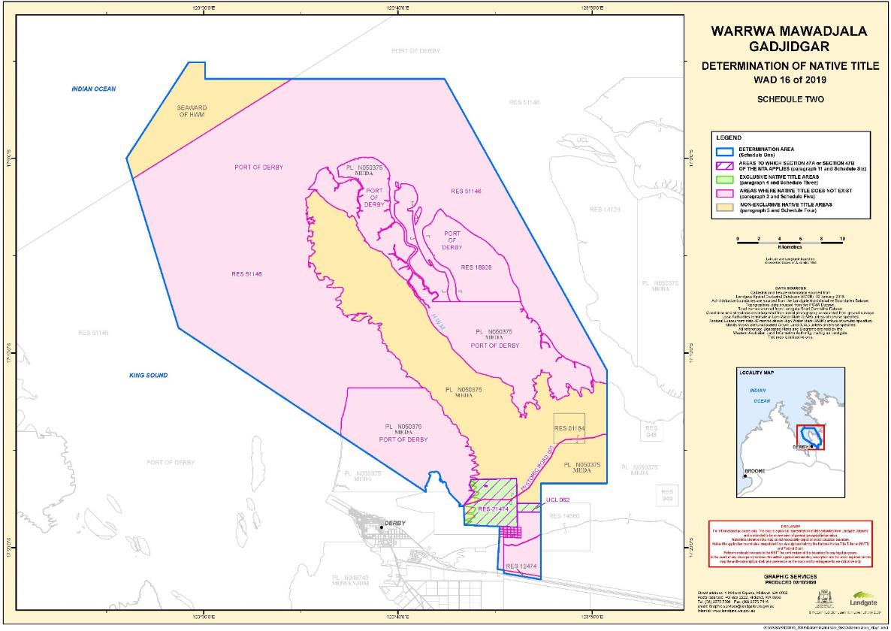

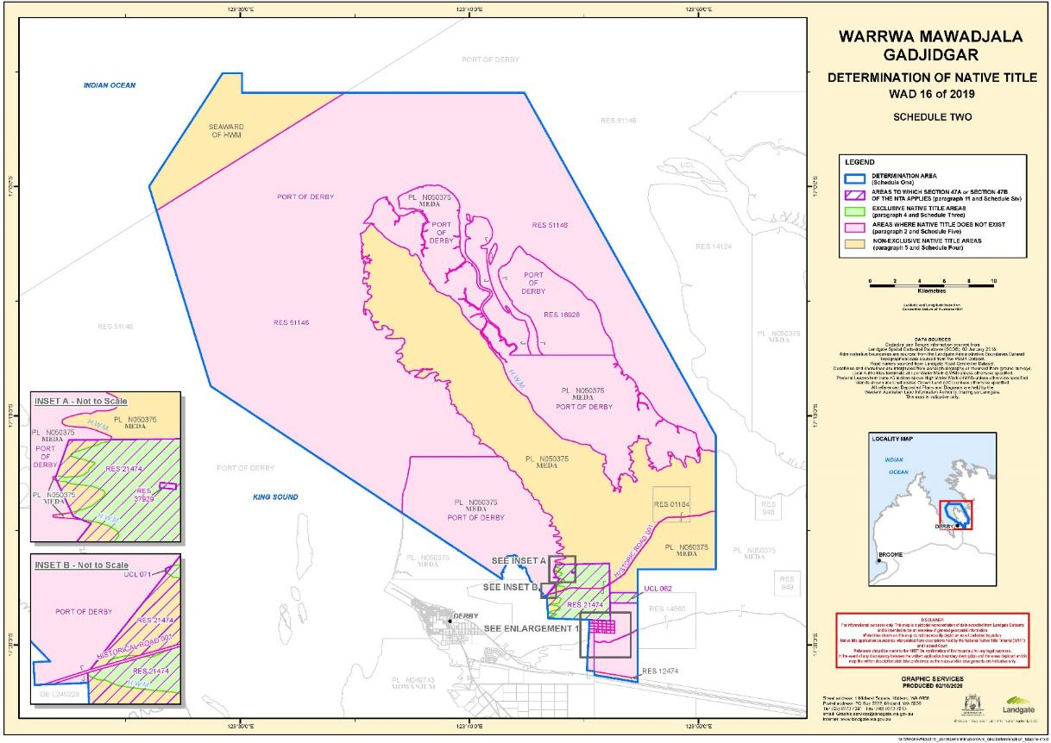

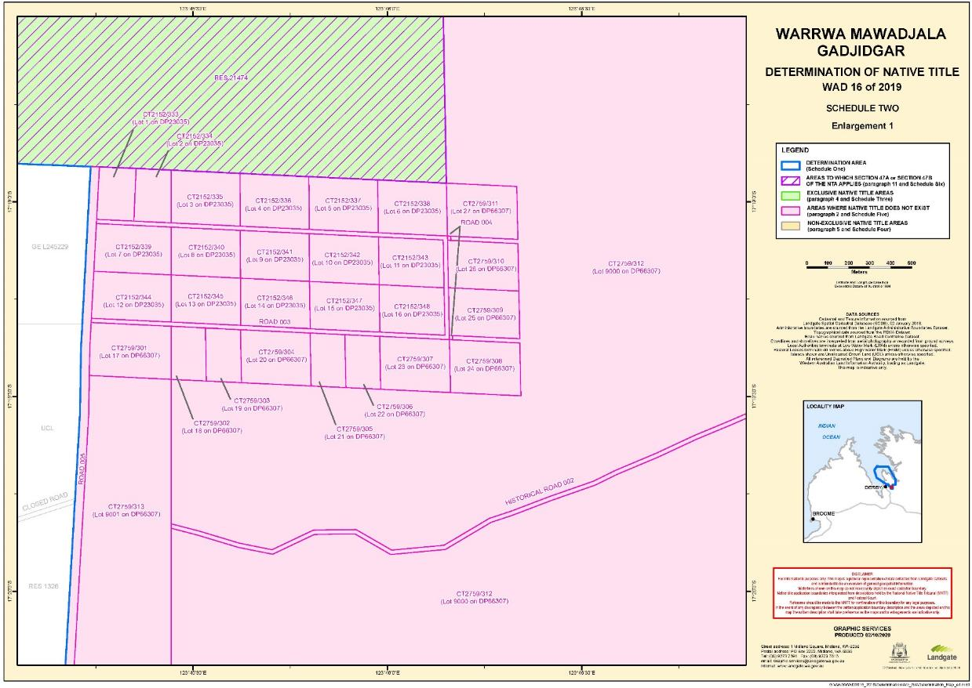

**SCHEDULE THREE**

**EXCLUSIVE NATIVE TITLE AREAS**

**Areas where native title comprises the rights set out in paragraph 4**

The following land and waters (generally shown as shaded green on the maps at Schedule Two):

**1. Reserves**

|  |  |
| --- | --- |
| **Reserve Number** | **Current / Last Purpose** |
| 21474 (part)1 | Use and benefit of Aboriginal inhabitants |

**2. Unallocated Crown Land**

|  |  |
| --- | --- |
| **MapInfo ID** | **Description** |
| UCL 062 | Whole of Lot 153 on DP 215872 |
| UCL 071 (part) | That part of UCL 071 not subject to the proclamations made under the *Marine and Harbours Act 1981* (WA) relating to the Derby Port Area |

1. To the extent that Reserve 21474 lies landward of the high water mark.

**SCHEDULE FOUR**

**NON-EXCLUSIVE NATIVE TITLE AREAS**

**Areas where native title comprises the rights set out in paragraph 5**

The following land and waters (generally shown as shaded yellow on the maps at Schedule Two):

**1. Pastoral leases**

|  |  |
| --- | --- |
| **Lease Number** | **Station Name** |
| N050375 | Meda |

**2. Reserves**

|  |  |
| --- | --- |
| **Reserve Number** | **Current / Last Purpose** |
| 01184 | Water and stopping place |
| 12474 | Stock route |
| 21474 (part)2 | Use and benefit of Aboriginal inhabitants |

**3. Areas seaward of the high water mark**

Any land or waters within the Determination Area which are seaward of the high water mark (and which, for the avoidance of doubt, are not described in paragraph 2 as an area where native title does not exist).

2. To the extent that Reserve 21474 lies seaward of the high water mark.

**SCHEDULE FIVE**

**AREAS WHERE NATIVE TITLE DOES NOT EXIST (PARAGRAPH 2)**

Native title does not exist in relation to land and waters the subject of the following interests within the Determination Area which, with the exception of public works (as described in clause 5 of this Schedule), are generally shown as shaded in pink on the maps at Schedule Two.

**1. Freeholds**

The following grants of fee simple within the Determination Area:

|  |  |  |  |  |  |  |
| --- | --- | --- | --- | --- | --- | --- |
| **Tenure ID** |  | **Tenure ID** |  | **Tenure ID** |  | **Tenure ID** |
| CT0215200333 |  | CT0215200341 |  | CT0275900301 |  | CT0275900309 |
| CT0215200334 |  | CT0215200342 |  | CT0275900302 |  | CT0275900310 |
| CT0215200335 |  | CT0215200343 |  | CT0275900303 |  | CT0275900311 |
| CT0215200336 |  | CT0215200344 |  | CT0275900304 |  | CT0275900312 |
| CT0215200337 |  | CT0215200345 |  | CT0275900305 |  | CT0275900313 |
| CT0215200338 |  | CT0215200346 |  | CT0275900306 |  |  |
| CT0215200339 |  | CT0215200347 |  | CT0275900307 |  |  |
| CT0215200340 |  | CT0215200348 |  | CT0275900308 |  |  |

**2. Reserves**

The following reserves:

|  |  |
| --- | --- |
| **Reserve Number** | **Current / Last Purpose** |
| 16928 | Public utility |
| 37929 | Cemetery |
| 51146 | Harbour purposes |

**3. Roads**

The following dedicated roads, roads set aside, taken or resumed, or roads which are to be considered public works (as that expression is defined in the *Native Title Act* and the *Titles Validation Act*):

| **MapInfo ID.** | **Description** | **Shown on** |
| --- | --- | --- |
| ROAD 003 | Savannah Way | Plan 23035 |
| ROAD 004 | Road widenings Savannah Way | DP 66307 |
| ROAD 005 | Leprosarium Road | DP 215872 |
| HIST ROAD 001 | Portion of Road No.229 | Gazette 11.02.1886, 22.04.1910  CPP 505411  CPP 505789 |
| HIST ROAD 002 | Portion of Road No.5209 | Gazette 01.07.1921, 08.07.1921, 23.12.1977, 05.05.1978  DP 13494 |

**4. Port of Derby**

The Derby Port Area as vested in the Minister for Transport by proclamation on 5 February 1982 under the *Marine and Harbours Act 1981* (WA).

**5. Public Works**

Any other public work as that expression is defined in the *Native Title Act* and the *Titles Validation Act* (including the land and waters on which a public work is constructed, established or situated as described in s 251D of the *Native Title Act*) and to which s 12J of the *Titles Validation Act* or s 23C(2) of the *Native Title Act* applies.

**SCHEDULE SIX**

**AREAS TO WHICH SECTIONS 47A OR 47B *NATIVE TITLE ACT* APPLY (PARAGRAPH 11)**

**Section 47A**

Section 47A of the *Native Title Act* applies with the effect that any extinguishment by the creation of the following interests (and by the creation of any other prior interests in relation to the area of the following interests) is to be disregarded:

|  |  |
| --- | --- |
| **Interest** | **Description / Purpose** |
| Reserve 21474  [not including the area of Hist Road 001] | Use and benefit of Aboriginal inhabitants |

**Section 47B**

Section 47B of the *Native Title Act* applies with the effect that any extinguishment over the following areas is to be disregarded:

|  |  |
| --- | --- |
| **MapInfo ID** | **Description** |
| UCL 062 | Whole of Lot 153 on DP 215872 |
| UCL 071 (part) | That part of UCL 071 not subject to the proclamations made under the *Marine and Harbours Act 1981* (WA) relating to the Derby Port Area |

**SCHEDULE SEVEN**

**OTHER INTERESTS (PARAGRAPH 12)**

The nature and extent of the Other Interests in relation to the Determination Area are as follows.

Land tenure interests registered with the Western Australian Land Information Authority are current as at 1 October 2020. Mining tenements and petroleum interests registered with the Department of Mines, Industry Regulation and Safety are current as at 30 October 2020. All other interests are current as at the date of the Determination.

**1. Pastoral leases**

|  |  |
| --- | --- |
| **Lease Number** | **Station Name** |
| N050375 | Meda |

NOTE: The rights and obligations of the pastoralists pursuant to the pastoral leases referred to in clause 1 of Schedule Seven above include responsibilities and obligations to adopt and exercise best practice management of the pasture and vegetation resources, livestock and soils within the boundaries of the pastoral leases in order to manage stock and for the management, conservation and regeneration of pasture for permitted uses.

**2. Reserves**

The interests of persons who have the care, control and management of the following reserves and the interests of people entitled to access and use these reserves for the respective purposes for which they are reserved, subject to any statutory limitations upon those rights:

|  |  |
| --- | --- |
| **Reserve Number** | **Current / Last Purpose** |
| 01184 | Water and stopping place |
| 12474 | Stock route |
| 21474 | Use and benefit of Aboriginal inhabitants |

**3. Petroleum interests**

The following petroleum interests granted under the *Petroleum and Geothermal Energy Resources Act 1967* (WA) and/or the *Petroleum Pipelines Act 1969* (WA) and the rights and interests of the holders from time to time of those petroleum interests:

|  |  |
| --- | --- |
| **Tenement ID** | **Tenement type** |
| EP 487 | Exploration Permit |
| EP 104 R6 | Exploration Permit |
| L 15 | Production Licence |
| R 1 R2 | Retention Lease |

**4. Telstra interests**

The rights and interests of Telstra Corporation Limited (ACN 051 775 556):

(a) as the owner or operator of telecommunications facilities within the Determination Area;

(b) created pursuant to the *Post and Telegraph Act 1901* (Cth), the *Telecommunications Act 1975* (Cth), the *Australian Telecommunications Corporation Act 1989* (Cth), the *Telecommunications Act 1991* (Cth) and the *Telecommunications Act 1997* (Cth), including rights:

(i) to inspect land;

(ii) to install, occupy and operate telecommunications facilities; and

(iii) to alter, remove, replace, maintain, repair and ensure the proper functioning of its telecommunications facilities;

(c) for its employees, agents or contractors to access its telecommunications facilities in and in the vicinity of the Determination Area in performance of their duties; and

(d) under any lease, licence, permit, access agreement or easement relating to its telecommunications facilities in the Determination Area.

**5. Miscellaneous rights and interests**

(a) Valid or validated rights and interests, including licences and permits, granted by the Crown in right of the State or of the Commonwealth pursuant to statute or otherwise in the exercise of its executive power and any regulations made pursuant to such statutes.

(b) Valid or validated rights and interests held by reason of the force and operation of the laws of the State or of the Commonwealth including the *Rights in Water and Irrigation Act 1914* (WA).

(c) The rights and interests of the Australian Fisheries Management Authority in relation to plans of management made under the *Fisheries Management Act 1991* (Cth), including for the Western Tuna and Billfish Fishery, the Western Skipjack Tuna Fishery and the Southern Bluefin Tuna Fishery.

(d) Rights and interests of members of the public arising under the common law including:

(i) the public right to fish;

(ii) the public right to navigate; and

(iii) the right of any person to use any road in the Determination Area (subject to the laws of the State) over which, as at the date of this Determination, members of the public have a right of access under common law.

(e) The international right of innocent passage though the territorial sea.

(f) The right to access the Determination Area by an employee, agent or instrumentality of:

(i) the State;

(ii) the Commonwealth; or

(iii) any local government authority,

as required in the performance of his or her statutory or common law duties where such access would be permitted to private land.

(g) So far as confirmed pursuant to s 212(2) of the *Native Title Act* and s 14 of the *Titles Validation Act* as at the date of this Determination, any existing public access to and enjoyment of:

(i) waterways;

(ii) beds and banks or foreshores of waterways;

(iii) coastal waters;

(iv) beaches; and

(v) areas that were public places at the end of 31 December 1993.

**SCHEDULE EIGHT**

**NATIVE TITLE HOLDERS (PARAGRAPH 3)**

1. The Native Title Holders are:

(a) those Aboriginal persons who are:

(i) descended from one or more of the people listed in clause 2 of this Schedule; or

(ii) recognised by the descendants of the people listed in clause 2 of this Schedule as having traditional rights and interests in the Determination Area under traditional law and custom; and

(b) Tommy May (Ngarralja), who is a named custodian only for the Determination Area, and is recognised by the Native Title Holders to hold specific, non‑transferable rights and interests in the Determination Area.

2. The people referred to in clause 1(a)(i) of this Schedule are those Aboriginal persons who are the biological or adopted descendants of the following apical ancestors:

(a) Topsy Mouwudjala;

(b) Gudayi and Bobby Ah Choo; and

(c) Nani.

ORDERS - Warrwa People

|  |  |  |
| --- | --- | --- |
|  | | WAD 33 of 2019 |
|  | | |
| BETWEEN: | TIMOTHY CARTER, PATRICIA JUBOY, DEBRA ANN MAHER, STEPHEN HUNTER, THOMAS WILLIAMS, PATRICK LAWSON, LAWRENCE TATAYA, NATHAN LENNARD, GAIL WILLIAMS, BARRY LENNARD, HERBERT MARSHALL, ELAINE LARAIA  Applicant | |
| AND: | STATE OF WESTERN AUSTRALIA  Respondent  COMMONWEALTH OF AUSTRALIA  Respondent  KIMBERLEY LAND COUNCIL  Respondent  **CALLUM HUGH MACLACHLAN**  Respondent  **JOCK HUGH MACLACHLAN**  Respondent  **NAPIER CORPORATION PTY LTD**  Respondent  **YEEDA STATION PTY LTD**  Respondent  **TELSTRA CORPORATION LIMITED**  Respondent | |

|  |  |
| --- | --- |
| order made by: | BANKS-SMITH J |
| DATE OF ORDER: | 1 DECEMBER 2020 |

THE COURT NOTES THAT:

A. The Applicant in proceeding WAD 33 of 2019 has made a native title determination application (**Warrwa Combined Application**).

B. The Applicant in the Warrwa Combined Application, the State of Western Australia and the other Respondents to the proceedings (**the parties**) have reached an agreement as to the terms of a determination which is to be made in relation to part of the land and waters covered by the Warrwa Combined Application (**the Part A Determination Area**).

C. The parties have agreed that in respect of the balance of the land and waters of the Warrwa Combined Application, no determination be made at present.

D. Pursuant to s 87A(1) and (2) of the *Native Title Act 1993* (Cth) the parties have filed with the Court their agreement in relation to part of the Warrwa Combined Application.

E. The terms of the agreement involve the making of consent orders for a determination of native title in relation to part of the land and waters the subject of this proceeding pursuant to s 87A and s 94A of the *Native Title Act*.

F. The parties acknowledge that the effect of the making of the determination is that the members of the native title claim group, in accordance with the traditional laws acknowledged and the traditional customs observed by them, should be recognised as the native title holders for the Part A Determination Area as set out in the determination.

G. Pursuant to s 87A(4) of the *Native Title Act*, the parties have requested that the Court determine the proceeding that relates to the Part A Determination Area without holding a hearing.

**BEING SATISFIED** that a determination of native title in the terms set out in Attachment A would be within the power of the Court and, it appearing to the Court appropriate to do so, pursuant to s 87A and s 94A of the *Native Title Act* and by the consent of the parties:

THE COURT ORDERS THAT:

1. In relation to the Part A Determination Area, there be a determination of native title in WAD 33 of 2019 in terms of the determination as provided for in Attachment A.
2. The Warrwa People Aboriginal Corporation shall hold the determined native title in trust for the native title holders pursuant to s 56(2) of the *Native Title Act*.
3. There be no order as to costs.

Note: Entry of orders is dealt with in Rule 39.32 of the *Federal Court Rules 2011*.

**ATTACHMENT A - Warrwa People**

**DETERMINATION**

**Note:** defined terms are set out in paragraph 14 below

**THE COURT ORDERS, DECLARES AND DETERMINES THAT:**

**Existence of native title: s 225 *Native Title Act***

1. Subject to paragraph 2, native title exists in the Part A Determination Area in the manner set out in paragraphs 4 and 5 of this Determination.

2. Native title does not exist in those parts of the Part A Determination Area that are identified in Schedule Five.

**Native title holders: s 225(a) *Native Title Act***

3. The native title in the Part A Determination Area is held by the Native Title Holders.

**The nature and extent of native title rights and interests: s 225(b) and s 225(e) *Native Title Act***

***Exclusive native title rights and interests***

4. Subject to paragraphs 7, 8, 9 and 10 the nature and extent of the native title rights and interests in relation to the Exclusive Area referred to in Schedule Three is the right to possession, occupation, use and enjoyment of the Exclusive Area as against the whole world.

***Non-exclusive native title rights and interests***

5. Subject to paragraphs 6, 7, 8, 9 and 10 the nature and extent of the native title rights and interests in relation to the Non-Exclusive Area referred to in Schedule Four are the following:

(a) the right to have access to, remain in and use that part. For the avoidance of doubt, some of the ways in which that right may be exercised include but are not limited to the following activities:

(i) to access and move freely through and within that part;

(ii) to live, being to enter and remain on, camp and erect temporary shelters and other structures for those purposes on that part;

(iii) to light controlled, contained fires but not for the clearance of vegetation;

(iv) to engage in cultural activities in that part, including the transmission of cultural heritage knowledge; and

(v) to hold meetings in that part.

(b) the right to access and take for any purpose the resources on that part. For the avoidance of doubt, one of the ways in which that right may be exercised includes but is not limited to the following activity:

(i) to access and take water other than water which is lawfully captured or controlled by the holders of pastoral leases.

(c) the right to protect places, areas and objects of traditional significance on that part. For the avoidance of doubt, some of the ways in which that right may be exercised include but are not limited to the following activities:

(i) to conduct and participate in ceremonies in that part; and

(ii) to conduct burials and burial rites and other ceremonies in relation to death in that part; and

(iii) to visit, maintain and protect from physical harm, areas, places and sites of importance in that part.

6. The native title rights and interests referred to in paragraph 5 do not confer:

(a) possession, occupation, use and enjoyment of those parts of the Part A Determination Area on the Native Title Holders to the exclusion of all others; nor

(b) a right to control the access of others to the land or waters of those parts of the Part A Determination Area.

7. The native title rights and interests are subject to and exercisable in accordance with:

(a) the laws of the State and the Commonwealth, including the common law; and

(b) the traditional laws and customs of the Native Title Holders.

8. Notwithstanding anything in this Determination, there are no native title rights and interests in the Part A Determination Area in or in relation to:

(a) minerals as defined in the *Mining Act 1904* (WA) (repealed) and in the *Mining Act 1978* (WA), except to the extent that ochre is not a mineral pursuant to the *Mining Act 1904* (WA);

(b) petroleum as defined in the *Petroleum Act 1936* (WA) (repealed) and in the *Petroleum and Geothermal Energy Resources Act 1967* (WA); or

(c) water lawfully captured or controlled by the holders of the Other Interests.

9. The native title rights and interests are subject to the *Petroleum and Geothermal Energy Resources Act 1967* (WA).

10. For the avoidance of doubt, the native title rights and interests set out in paragraphs 4 and 5 do not confer exclusive rights in relation to water in any watercourse, wetland or underground water source as defined in the *Rights in Water and Irrigation Act 1914* (WA) as at the date of this Determination.

**Areas where extinguishment is disregarded: s 47A or s 47B *Native Title Act***

11. Section 47A and s 47B of the *Native Title Act* apply to disregard any prior extinguishment in relation to the areas described in Schedule Six.

**The nature and extent of any Other Interests: s 225(c) *Native Title Act***

12. The nature and extent of the Other Interests are described in Schedule Seven.

**Relationship between native title rights and Other Interests: s 225(d) *Native Title Act***

13. The relationship between the native title rights and interests described in paragraphs 4 and 5 and the Other Interests is as follows:

(a) the Other Interests co-exist with the native title rights and interests;

(b) this Determination does not affect the validity of those Other Interests; and

(c) to the extent of any inconsistency, the native title rights and interests yield to the Other Interests and the existence and exercise of native title rights and interests cannot prevent activities permitted under the Other Interests.

**Definitions and Interpretation**

14. In this Determination, unless the contrary intention appears:

'**Exclusive Area**' means those lands and waters of the Part A Determination Area described in Schedule Three (being areas where any extinguishment must be disregarded) which are not Non Exclusive Areas or described in paragraph 2 as an area where native title does not exist. Exclusive Areas are generally shown as shaded green on the maps at Schedule Two;

'**high water mark**' means the mean high water mark at common law;

'***Native Title Act***' means the *Native Title Act 1993* (Cth);

'**land**' and '**waters**' respectively have the same meanings as in the *Native Title Act*;

'**Native Title Holders**' means the people described in Schedule Eight and referred to in paragraph 3;

'**Non-Exclusive Area**' means those lands and waters of the Part A Determination Area described in Schedule Four (being areas where there can only be partial recognition of native title). Non-Exclusive Areas are generally shown as shaded yellow on the maps at Schedule Two;

'**Other Interests**' means the legal or equitable estates or interests and other rights in relation to the Part A Determination Area described in Schedule Seven and referred to in paragraph 12;

'**Part A Determination Area**' means the land and waters described in Schedule One and depicted on the maps at Schedule Two;

'**State**' means the State of Western Australia; and

'***Titles Validation Act***' means the *Titles (Validation) and Native Title (Effect of Past Acts) Act 1995* (WA).

15. In the event of any inconsistency between the written description of an area in Schedules One, Three, Four, Five, Six or Seven and the area as depicted on the maps at Schedule Two the written description prevails.

**SCHEDULE ONE**

**DETERMINATION AREA**

The Part A Determination Area, generally shown as bordered in blue on the maps at Schedule Two, comprises all land and waters bounded by the following description:

All those lands and waters commencing at a point on the southern boundary of Portion A of Native Title Determination WAD6061/1998 Dambimangari (WCD2011/002) at Longitude 123.706595 East and extending generally easterly along the southern boundary of that native title determination to Longitude 123.918226 East; then southerly, southeasterly, easterly, northeasterly, generally northwesterly, and again northeasterly passing through the following coordinate positions:

|  |  |
| --- | --- |
| **LATITUDE (SOUTH)** | **LONGITUDE (EAST)** |
| 16.968127 | 123.918551 |
| 17.004533 | 123.933542 |
| 17.004533 | 123.952459 |
| 16.984188 | 123.967449 |
| 16.973124 | 123.956385 |
| 16.958133 | 123.944963 |
| 16.950995 | 123.972089 |

Then northwesterly to a point on the southern boundary of again Portion A of Native Title Determination WAD6061/1998 Dambimangari (WCD2011/002) at Longitude 123.955215 East; then generally easterly, northerly, and again generally easterly, and generally southerly along the boundaries of that native title determination to an intersection with a point on the northern boundary of Native Title Determination WAD6016/1996, WAD6015/1999, WAD6006/2002 Wanjina - Wunggurr Wilinggin Native Title Determination No. 1 (WCD2004/001) being a northern boundary of Pastoral Lease N049855 (Napier Downs) at approximate coordinate position Latitude 17.028266 South Longitude 124.641146 East; then westerly along a northern boundary of that native title determination to an intersection with the easternmost southeastern corner of Portion B of Native Title Determination WAD6061/1998 Dambimangari (WCD2011/002); then northerly, generally westerly and generally southerly along the boundaries of that native title determination to the intersection with a northern boundary of again Native Title Determination WAD6016/1996, WAD6015/1999, WAD6006/2002 Wanjina - Wunggurr Wilinggin Native Title Determination No 1 (WCD2004/001); then generally southwesterly along the boundaries of that determination to an intersection with a northeastern corner of again Portion B of Native Title Determination WAD6061/1998 Dambimangari (WCD2011/002); then west and south along the boundaries of that native title determination to an intersection with a western boundary of again Native Title Determination WAD6016/1996, WAD6015/1999, WAD6006/2002 Wanjina - Wunggurr Wilinggin Native Title Determination No 1 (WCD2004/001); then generally southerly, generally southeasterly, generally easterly, again generally southeasterly, again easterly, again southeasterly, and northeasterly along the boundaries of that native title determination to Longitude 124.837152 East, being a point on Napier Range; then generally easterly and generally southeasterly through the following coordinate positions:

| **LATITUDE (SOUTH)** | **LONGITUDE (EAST)** |
| --- | --- |
| 17.350142 | 124.839667 |
| 17.350666 | 124.841809 |
| 17.350190 | 124.844046 |
| 17.349857 | 124.845093 |
| 17.348762 | 124.845997 |
| 17.348762 | 124.846663 |
| 17.349714 | 124.847615 |
| 17.350047 | 124.848995 |
| 17.350142 | 124.851803 |
| 17.350095 | 124.853659 |
| 17.349904 | 124.855752 |
| 17.348620 | 124.857561 |
| 17.347811 | 124.859988 |
| 17.348239 | 124.861892 |
| 17.350238 | 124.863272 |
| 17.353474 | 124.862653 |
| 17.355615 | 124.862796 |
| 17.357471 | 124.864699 |
| 17.358946 | 124.866127 |
| 17.359898 | 124.867888 |
| 17.361611 | 124.869791 |
| 17.362801 | 124.871029 |
| 17.363943 | 124.871600 |
| 17.365038 | 124.871695 |
| 17.366370 | 124.873218 |
| 17.368274 | 124.873979 |
| 17.369987 | 124.874836 |
| 17.371415 | 124.875216 |
| 17.372842 | 124.876216 |
| 17.374318 | 124.877072 |
| 17.375365 | 124.877786 |
| 17.376221 | 124.878786 |
| 17.377030 | 124.879975 |

Then southeasterly to an intersection with a point on a northwestern boundary of Native Title Determination WAD94/2012 Bunuba People #2 Part A (WCD2015/009) at Longitude 124.883103 East; then generally southwesterly along the boundaries of that native title determination to its westernmost northwestern corner, being a northeastern corner of WAD6099/1998 Nyikina Mangala (WCD2014/003); then westerly, generally northwesterly, and again westerly along the boundaries of that native title determination to an intersection with the centreline of an unnamed creek at Longitude 123.895970 East; then generally northerly along the centreline of that unnamed creek to an intersection with the northern boundary of the northern severance of Derby Gibb River Road Reserve at Longitude 123.906174 East; then westerly along the northern boundary of that road reserve to Longitude 123.789091 East; then northerly, easterly and again northerly passing through the following coordinate positions:

|  |  |
| --- | --- |
| **LATITUDE (SOUTH)** | **LONGITUDE (EAST)** |
| 17.278393 | 123.789035 |
| 17.278393 | 123.845807 |
| 17.180957 | 123.845807 |

Then northwesterly back to the commencement point.

**Note: Geographic Coordinates provided in Decimal Degrees.**

**All referenced Deposited Plans and Diagrams are held by the Western Australian Land Information Authority, trading as Landgate.**

**Creeks sourced from © Commonwealth of Australia (Geoscience Australia) 2006.**

**Napier Ranges derived from 250K raster data sourced from © Commonwealth of Australia (Geoscience Australia) 2008.**

**Cadastral boundaries sourced from Landgate's Spatial Cadastral Database dated 1 October 2020**

For the avoidance of doubt the Part A Determination Area excludes any land and waters subject to:

• Native Title Determination WAD6061/1998 Dambimangari (WCD2011/002) as determined in the Federal Court on 26 May 2011.

• Native Title Determination WAD94/2012 Bunuba People No. 2 Part A (WCD2015/009) as determined in the Federal Court on 22 December 2015.

• Native Title Determination WAD6016/1996, WAD6015/1999, WAD6006/2002 Wanjina - Wunggurr Wilinggin (WCD2004/001) as determined in the Federal Court on 27 August 2004.

• Native Title Determination WAD6099/1998 Nyikina Mangala (WCD2014/003) as determined in the Federal Court on 29 May 2014.

**Datum: Geocentric Datum of Australia 2020 (GDA2020)**

**Prepared By: Graphic Services (Landgate) 22 October 2020**

**Use of Coordinates:**

Where coordinates are used within the description to represent cadastral or topographical boundaries or the intersection with such, they are intended as a guide only. As an outcome of the custodians of cadastral and topographic data continuously recalculating the geographic position of their data based on improved survey and data maintenance procedures, it is not possible to accurately define such a position other than by detailed ground survey.

G:\WAG\WAD0033_2019\Determination\Determination_TD\WAD33_2019_Warrwa_Combined_Part_A_Determination_TD.docx

**SCHEDULE TWO**

**MAPS OF THE DETERMINATION AREA**

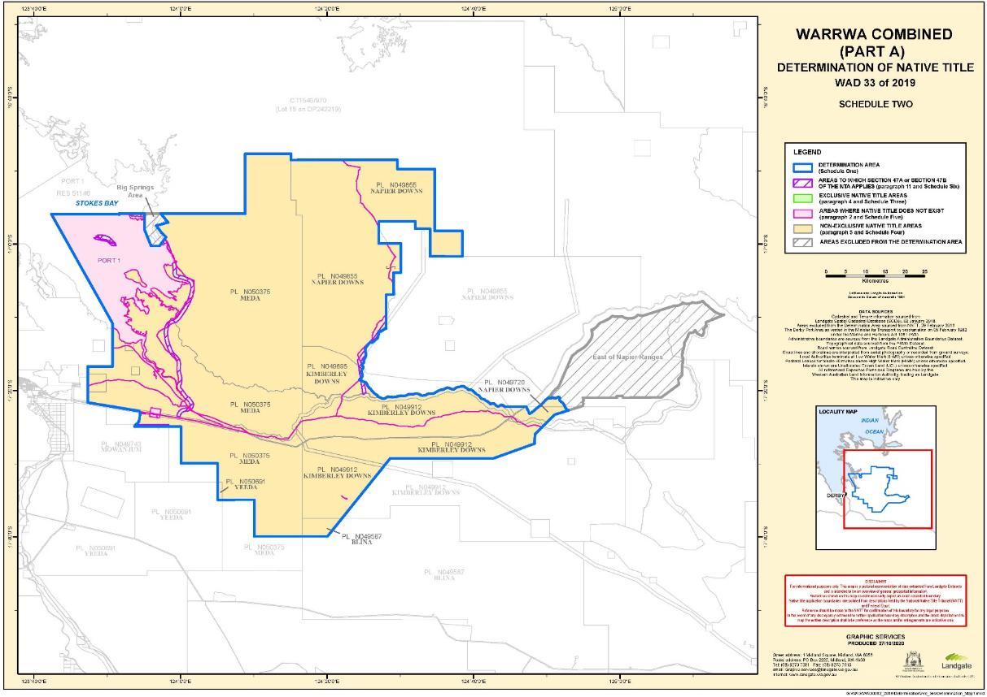

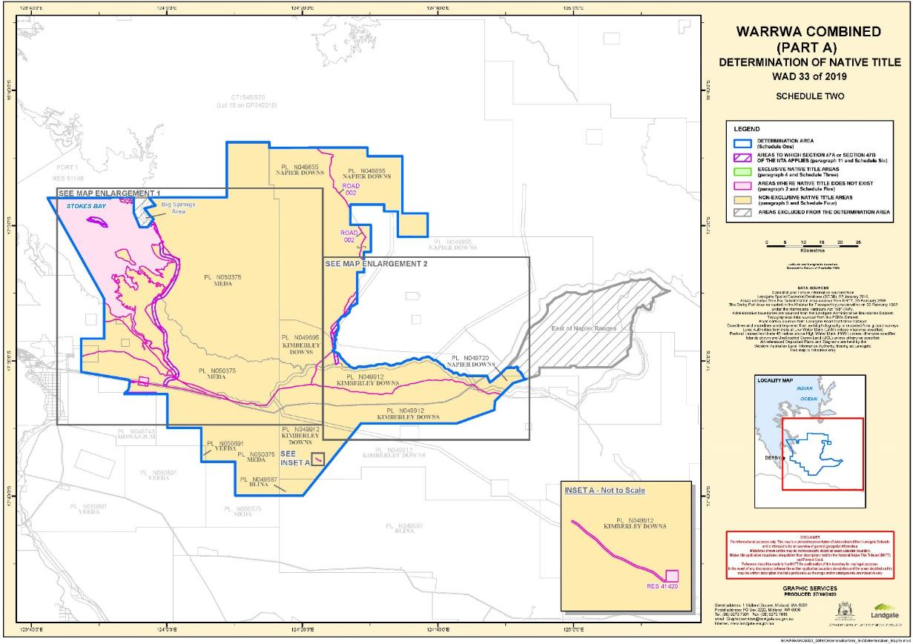

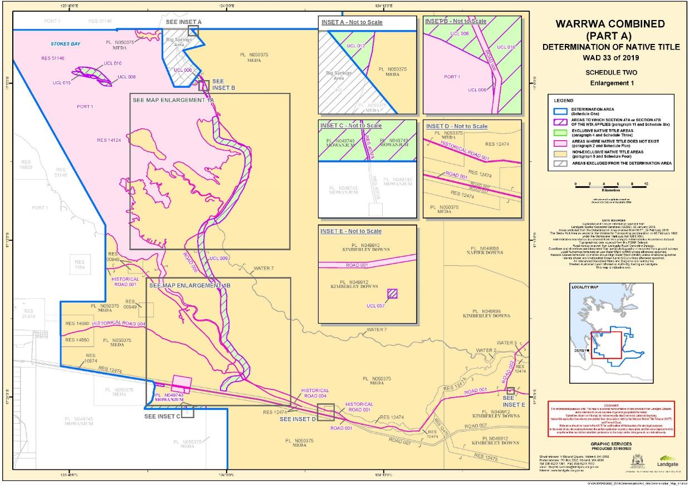

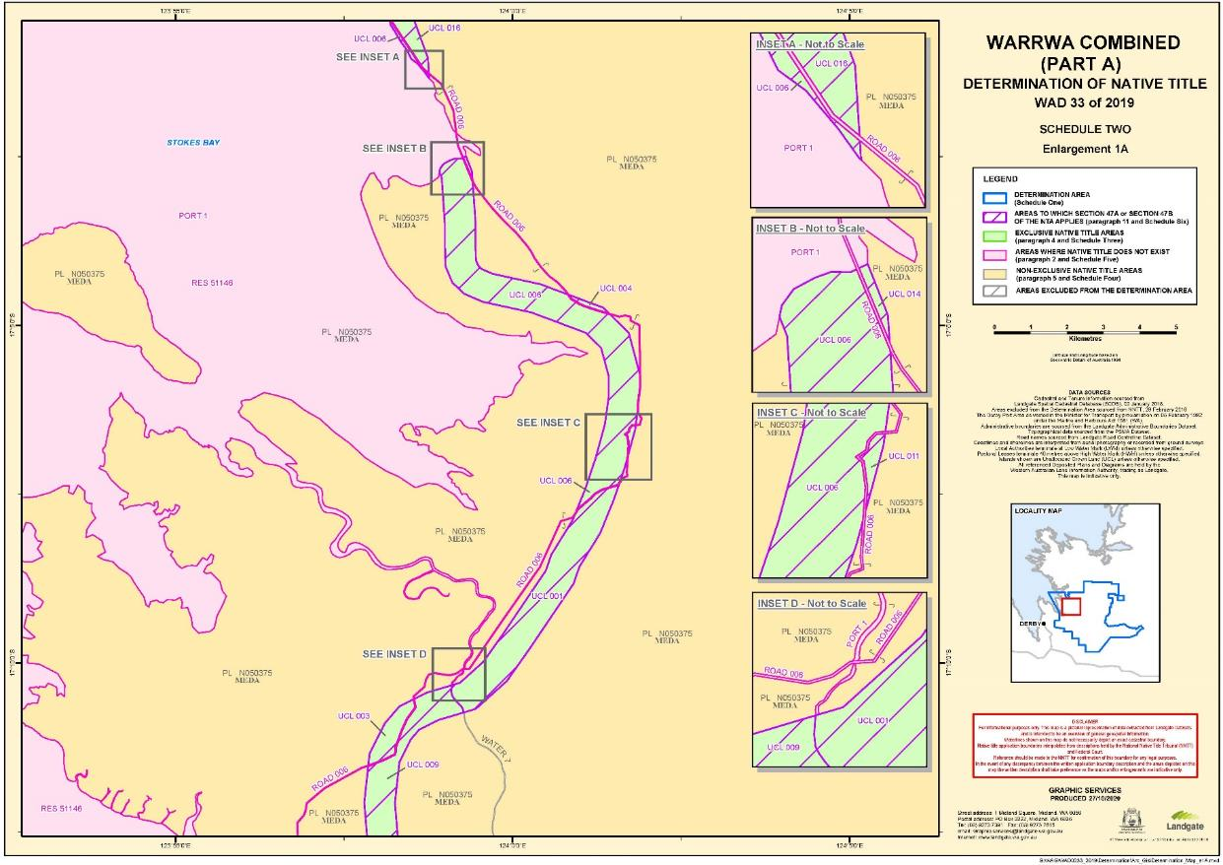

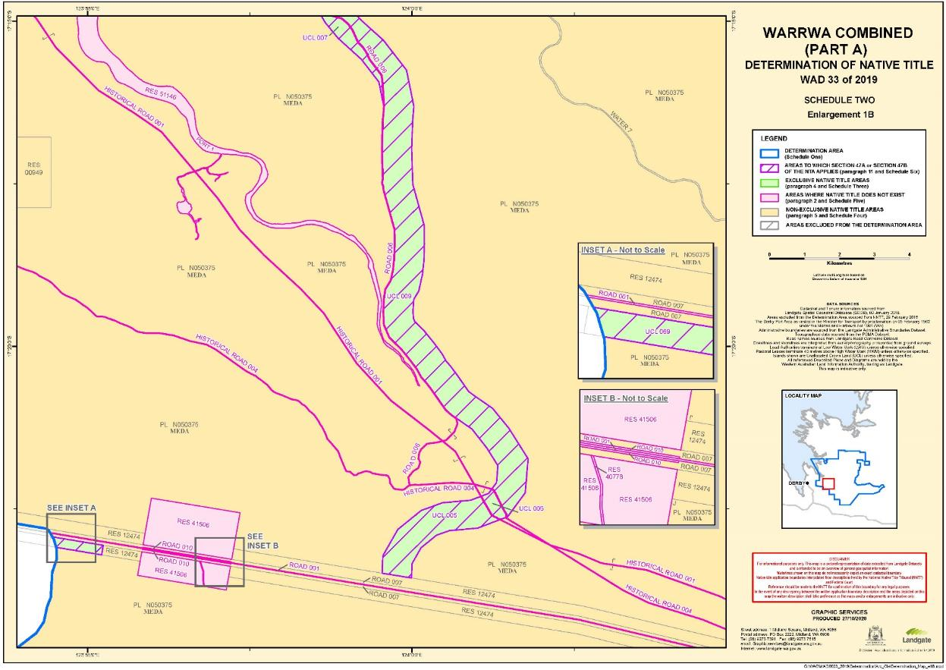

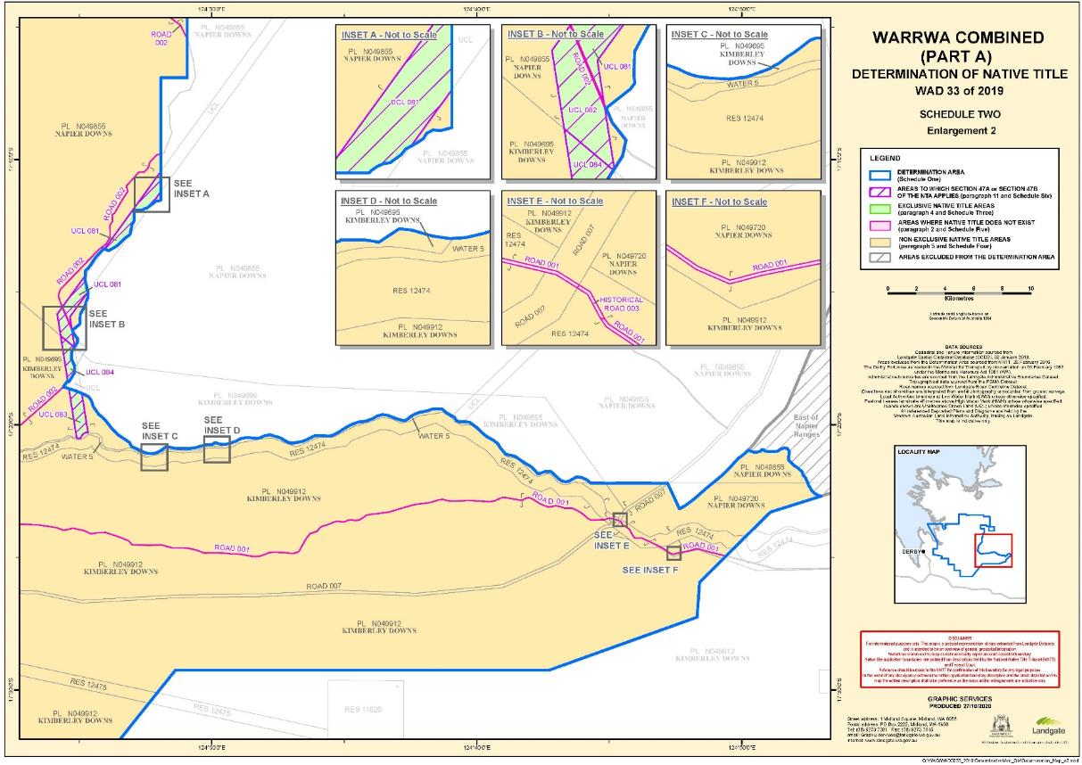

**SCHEDULE THREE**

**EXCLUSIVE NATIVE TITLE AREAS**

**Areas where native title comprises the rights set out in paragraph 4**

The following land and waters (generally shown as shaded green on the maps at Schedule Two):

**1. Unallocated Crown Land**

|  |  |
| --- | --- |
| **MapInfo ID** | **Description** |
| UCL 001 | Whole of area |
| UCL 003 | Whole of area |
| UCL 004 | Whole of area |
| UCL 005 (part) | That part of UCL 005 not subject to Historical Road 001 |
| UCL 006 (part)1 | That part of UCL 006 not subject to the proclamation made under the *Marine and Harbours Act 1981* (WA) dated 1 May 2012 and published in the Government Gazette on 8 May 2012 relating to the Derby Port Area |
| UCL 007 | Whole of area |
| UCL 008 | That part of UCL 008 not subject to the proclamation made under the *Marine and Harbours Act 1981* (WA) dated 1 May 2012 and published in the Government Gazette on 8 May 2012 relating to the Derby Port Area |
| UCL 009 | Whole of area |
| UCL 010 | That part of UCL 010 not subject to the proclamation made under the *Marine and Harbours Act 1981* (WA) dated 1 May 2012 and published in the Government Gazette on 8 May 2012 relating to the Derby Port Area |
| UCL 011 | Whole of area |
| UCL 012 (part)2 | That part of UCL 012 not subject to the proclamation made under the *Marine and Harbours Act 1981* (WA) dated 1 May 2012 and published in the Government Gazette on 8 May 2012 relating to the Derby Port Area |

1. To the extent that UCL 006 lies landward of the high water mark.

2. To the extent that UCL 012 lies landward of the high water mark.

|  |  |
| --- | --- |
| **MapInfo ID** | **Description** |
| UCL 014 (part)3 | That part of UCL 014 not subject to the proclamation made under the *Marine and Harbours Act 1981* (WA) dated 1 May 2012 and published in the Government Gazette on 8 May 2012 relating to the Derby Port Area |
| UCL 015 | That part of UCL 015 not subject to the proclamation made under the *Marine and Harbours Act 1981* (WA) dated 1 May 2012 and published in the Government Gazette on 8 May 2012 relating to the Derby Port Area |
| UCL 016 | Whole of area |
| UCL 057 | Whole of Lot 59 on DP 175604 |
| UCL 069 | That part of Lot 303 on DP 34202 which falls within the Part A Determination Area |
| UCL 081, 082 | Those parts of Lot 300 on DP 55954 which fall within the Part A Determination Area |
| UCL 083, 084 | Those parts of Lot 301 on DP 55954 which fall within the Part A Determination Area |

**2. Pastoral Lease**

|  |  |
| --- | --- |
| **Lease** | **Description** |
| N049743 (part) | That part of Lot 253 on DP 238348 that falls within the Part A Determination Area |

3. To the extent that UCL 014 lies landward of the high water mark.

**SCHEDULE FOUR**

**NON-EXCLUSIVE NATIVE TITLE AREAS**

**Areas where native title comprises the rights set out in paragraph 5**

The following land and waters (generally shown as shaded yellow on the maps at Schedule Two):

**1. Pastoral leases**

|  |  |
| --- | --- |
| **Lease Number** | **Station Name** |
| N049587 | Blina |
| N049695 | Kimberley Downs |
| N049720 | Napier Downs |
| N049855 | Napier Downs |
| N049912 | Kimberley Downs |
| N050375 | Meda |
| N050691 | Yeeda |

**2. Reserves**

|  |  |
| --- | --- |
| **Reserve Number** | **Current / Last Purpose** |
| 00948 | Water |
| 00949 | Water |
| 10674 | Water |
| 12474 | Stock route |
| 12475 | Stock route |
| 14560 | Water and camping |

**3. Roads**

The following roads and the rights and interests of the persons having the care, control and management of those roads from time to time:

| **MapInfo ID.** | **Description** | **Shown on** |
| --- | --- | --- |
| ROAD 007 | Gibb River Road | Lot 318 on DP 220720  Lot 319 on DP 220720  Lot 320 on DP 220720  Lot 321 on DP 220721  Lot 322 on DP 220722  Lot 323 on DP 220722  Lot 324 on DP 220723  Lot 325 on DP 220724  Lot 326 on DP 220724  Lot 327 on DP 220724  Lot 328 on DP 220725  Lot 329 on DP 220726  Lot 330 on DP 220727  Lot 331 on DP 220728  Lot 332 on DP 220728  Lot 40 on DP 220728  Lot 41 on DP 220729 |

**4. Water areas**

|  |  |
| --- | --- |
| **MapInfo ID.** | **Description** |
| Water 2 | Meda River and Lennard River |
| Water 5 | Lennard River |
| Water 7 | Meda River |

**5. Areas seaward of the high water mark**

Any land or waters within the Part A Determination Area which are seaward of the high water mark (and which, for the avoidance of doubt, are not described in paragraph 2 as an area where native title does not exist).

**SCHEDULE FIVE**

**AREAS WHERE NATIVE TITLE DOES NOT EXIST (PARAGRAPH 2)**

Native title does not exist in relation to land and waters the subject of the following interests within the Part A Determination Area which, with the exception of public works (as described in clause 4 of this Schedule), are generally shown as shaded in pink on the maps at Schedule Two.

**1. Reserves**

The following reserves:

|  |  |
| --- | --- |
| **Reserve Number** | **Current / Last Purpose** |
| 14124 | Public utility |
| 40778 | Repeater station site and access |
| 41420 | Repeater station site |
| 41506 | Gravel |
| 51146 | Harbour purposes |

**2. Port of Derby**

The Derby Port Area as vested in the Minister for Transport by proclamation on 5 February 1982 under the *Marine and Harbours Act 1981* (WA).

**3. Roads**

The following dedicated roads, roads set aside, taken or resumed or roads which are to be considered public works (as that expression is defined in the *Native Title Act* and the *Titles Validation Act*):

| **MapInfo ID.** | **Description** | **Shown on** |
| --- | --- | --- |
| ROAD 001 | Deviation of Road No. 229 | Gazette 08.02.1907  CPP 507014  CPP 507016  CPP 503252 |
| ROAD 002 | Road No. 230 | Gazette 11.02.1886  CPP 503252 |
| ROAD 006 | Road No. 319 | Gazette 12.02.1891  CPP 507016  CPP 507349 |
| ROAD 010 | Widening of Gibb River Road | DP 217160 |
| HIST ROAD 001 | Portion of Road No.229 | Gazette 11.02.1886, 22.04.1910  CPP 505411  CPP 505789 |
| HIST ROAD 003 | Portion of Road No.229 | Gazette 11.02.1886, 22.04.1910  CPP 505411 |
| HIST ROAD 004 | Road No.5209 | Gazette 01.07.1921, 08.07.1921, 23.12.1977  CPP 507014 |

**4. Public Works**

Any other public work as that expression is defined in the *Native Title Act* and the *Titles Validation Act* (including the land and waters on which a public work is constructed, established or situated as described in s 251D of the *Native Title Act*) and to which s 12J of the *Titles Validation Act* or s 23C(2) of the *Native Title Act* applies.

**SCHEDULE SIX**

**AREAS TO WHICH SECTIONS 47A OR 47B *NATIVE TITLE ACT* APPLY (PARAGRAPH 11)**

**Section 47A**

Section 47A of the *Native Title Act* applies with the effect that any extinguishment by the creation of the following interests (and by the creation of any other prior interests in relation to the area of the following interests) is to be disregarded:

|  |  |
| --- | --- |
| **Lease** | **Description** |
| N049743 (part) | That part of Lot 253 on DP 238348 that falls within the Part A Determination Area |

**Section 47B**

Section 47B of the *Native Title Act* applies with the effect that any extinguishment over the following areas is to be disregarded:

| **MapInfo ID** | **Description** |
| --- | --- |
| UCL 001 | Whole of area |
| UCL 003 | Whole of area |
| UCL 004 | Whole of area |
| UCL 005 | That part of UCL 005 not subject to Historical Road 001 |
| UCL 006 | That part of UCL 006 not subject to the proclamation made under the *Marine and Harbours Act 1981* (WA) dated 1 May 2012 and published in the Government Gazette on 8 May 2012 relating to the Derby Port Area |
| UCL 007 | Whole of area |
| UCL 008 | That part of UCL 008 not subject to the proclamation made under the *Marine and Harbours Act 1981* (WA) dated 1 May 2012 and published in the Government Gazette on 8 May 2012 relating to the Derby Port Area |
| UCL 009 | Whole of area |
| UCL 010 | That part of UCL 010 not subject to the proclamation made under the *Marine and Harbours Act 1981* (WA) dated 1 May 2012 and published in the Government Gazette on 8 May 2012 relating to the Derby Port Area |
| UCL 011 | Whole of area |
| UCL 012 | That part of UCL 012 not subject to the proclamation made under the *Marine and Harbours Act 1981* (WA) dated 1 May 2012 and published in the Government Gazette on 8 May 2012 relating to the Derby Port Area |
| UCL 014 | That part of UCL 014 not subject to the proclamation made under the *Marine and Harbours Act 1981* (WA) dated 1 May 2012 and published in the Government Gazette on 8 May 2012 relating to the Derby Port Area |
| UCL 015 | That part of UCL 015 not subject to the proclamation made under the *Marine and Harbours Act 1981* (WA) dated 1 May 2012 and published in the Government Gazette on 8 May 2012 relating to the Derby Port Area |
| UCL 016 | Whole of area |
| UCL 057 | Whole of Lot 59 on DP 175604 |
| UCL 069 | That part of Lot 303 on DP 34202 which falls within the Part A Determination Area |
| UCL 081, 082 | Those parts of Lot 300 on DP 55954 which fall within the Part A Determination Area |
| UCL 083, 084 | Those parts of Lot 301 on DP 55954 which fall within the Part A Determination Area |

**SCHEDULE SEVEN**

**OTHER INTERESTS (PARAGRAPH 12)**

The nature and extent of the Other Interests in relation to the Part A Determination Area are as follows.

Land tenure interests registered with the Western Australian Land Information Authority are current as at 1 October 2020. Mining tenements and petroleum interests registered with the Department of Mines, Industry Regulation and Safety are current as at 30 October 2020. All other interests are current as at the date of the Determination.

**1. Pastoral leases**

|  |  |
| --- | --- |
| **Lease Number** | **Station Name** |
| N049587 | Blina |
| N049695 | Kimberley Downs |
| N049720 | Napier Downs |
| N049743 | Mowanjum |
| N049855 | Napier Downs |
| N049912 | Kimberley Downs |
| N050375 | Meda |
| N050691 | Yeeda |

NOTE: The rights and obligations of the pastoralists pursuant to the pastoral leases referred to in clause 1 of Schedule Seven above include responsibilities and obligations to adopt and exercise best practice management of the pasture and vegetation resources, livestock and soils within the boundaries of the pastoral leases in order to manage stock and for the management, conservation and regeneration of pasture for permitted uses.

**2. Reserves**

The interests of persons who have the care, control and management of the following reserves and the interests of people entitled to access and use these reserves for the respective purposes for which they are reserved, subject to any statutory limitations upon those rights:

|  |  |
| --- | --- |
| **Reserve Number** | **Current / Last Purpose** |
| 00948 | Water |
| 00949 | Water |
| 10674 | Water |
| 12474 | Stock route |
| 12475 | Stock route |
| 14560 | Water and camping |

**3. Roads**

The following roads and the rights and interests of the persons having the care, control and management of those roads from time to time:

|  |  |  |
| --- | --- | --- |
| **MapInfo ID.** | **Description** | **Shown on** |
| ROAD 007 | Gibb River Road | Lot 318 on DP 220720  Lot 319 on DP 220720  Lot 320 on DP 220720  Lot 321 on DP 220721  Lot 322 on DP 220722  Lot 323 on DP 220722  Lot 324 on DP 220723  Lot 325 on DP 220724  Lot 326 on DP 220724  Lot 327 on DP 220724  Lot 328 on DP 220725  Lot 329 on DP 220726  Lot 330 on DP 220727  Lot 331 on DP 220728  Lot 332 on DP 220728  Lot 40 on DP 220728  Lot 41 on DP 220729 |

**4. Mining tenements**

The following mining tenements granted under the *Mining Act 1904* (WA) (repealed) and/or the *Mining Act 1978* (WA) and the rights and interests of the holders from time to time of those tenements:

**(a) Exploration licence**

|  |  |  |  |  |
| --- | --- | --- | --- | --- |
| **Tenement ID** |  | **Tenement ID** |  | **Tenement ID** |
| E 0401169 |  | E 0402466 |  | E 0402608 |
| E 0401533 |  | E 0402467 |  | E 0402612 |
| E 0401972 |  | E 0402468 |  | E 0402617 |
| E 0402026 |  | E 0402469 |  | E 0402623 |
| E 0402060 |  | E 0402478 |  | E 0402659 |
| E 0402142 |  | E 0402480 |  |  |
| E 0402299 |  | E 0402486 |  |  |
| E 0402314 |  | E 0402530 |  |  |
| E 0402325 |  | E 0402544 |  |  |
| E 0402390 |  | E 0402549 |  |  |
| E 0402405 |  | E 0402560 |  |  |
| E 0402416 |  | E 0402563 |  |  |
| E 0402423 |  | E 0402573 |  |  |

**(b) General Purpose Lease**

|  |
| --- |
| **Tenement ID** |
| G 0400051 |

**(c) Mining Lease**

|  |
| --- |
| **Tenement ID** |
| M 0400038 |
| M 0400213 |
| M 0400308 |
| M 0400310 |
| M 0400343 |
| M 0400396 |
| M 0400447 |
| M 0400449 |
| M 0400465 |

**(d) Miscellaneous Licence**

|  |
| --- |
| **Tenement ID** |
| L 0400053 |
| L 0400054 |
| L 0400055 |
| L 0400064 |
| L 0400065 |
| L 0400098 |
| L 0400100 |

**(e) Retention Licence**

|  |
| --- |
| **Tenement ID** |
| R 0400001 |

**5. Petroleum interests**

The following petroleum interests granted under the *Petroleum and Geothermal Energy Resources Act 1967* (WA) and/or the *Petroleum Pipelines Act 1969* (WA) and the rights and interests of the holders from time to time of those petroleum interests:

|  |  |
| --- | --- |
| **Tenement ID** | **Tenement type** |
| EP 129 R6 | Exploration Permit |
| EP 487 | Exploration Permit |
| L 15 | Production Licence |
| L 17 | Production Licence |
| L 6 R1 | Production Licence |
| L 8 R1 | Production Licence |

**6. Telstra interests**

The rights and interests of Telstra Corporation Limited (ACN 051 775 556):

(a) as the owner or operator of telecommunications facilities within the Part A Determination Area;

(b) created pursuant to the *Post and Telegraph Act 1901* (Cth), the *Telecommunications Act 1975* (Cth), the *Australian Telecommunications Corporation Act 1989* (Cth), the *Telecommunications Act 1991* (Cth) and the *Telecommunications Act 1997* (Cth), including rights:

(i) to inspect land;

(ii) to install, occupy and operate telecommunications facilities; and

(iii) to alter, remove, replace, maintain, repair and ensure the proper functioning of its telecommunications facilities;

(c) for its employees, agents or contractors to access its telecommunications facilities in and in the vicinity of the Part A Determination Area in performance of their duties; and

(d) under any lease, licence, permit, access agreement or easement relating to its telecommunications facilities in the Part A Determination Area.

**7. Miscellaneous rights and interests**

(a) Valid or validated rights and interests, including licences and permits, granted by the Crown in right of the State or of the Commonwealth pursuant to statute or otherwise in the exercise of its executive power and any regulations made pursuant to such statutes.

(b) Valid or validated rights and interests held by reason of the force and operation of the laws of the State or of the Commonwealth including the *Rights in Water and Irrigation Act 1914* (WA).

(c) The rights and interests of the Australian Fisheries Management Authority in relation to plans of management made under the *Fisheries Management Act 1991* (Cth), including for the Western Tuna and Billfish Fishery, the Western Skipjack Tuna Fishery and the Southern Bluefin Tuna Fishery.

(d) Rights and interests of members of the public arising under the common law including:

(i) the public right to fish;

(ii) the public right to navigate; and

(iii) the right of any person to use any road in the Part A Determination Area (subject to the laws of the State) over which, as at the date of this Determination, members of the public have a right of access under common law.

(e) The international right of innocent passage though the territorial sea.

(f) The right to access the Part A Determination Area by an employee, agent or instrumentality of:

(i) the State;

(ii) the Commonwealth; or

(iii) any local government authority,

as required in the performance of his or her statutory or common law duties where such access would be permitted to private land.

(g) So far as confirmed pursuant to s 212(2) of the *Native Title Act* and s 14 of the *Titles Validation Act* as at the date of this Determination, any existing public access to and enjoyment of:

(i) waterways;

(ii) beds and banks or foreshores of waterways;

(iii) coastal waters;

(iv) beaches; and

(v) areas that were public places at the end of 31 December 1993.

**SCHEDULE EIGHT**

**NATIVE TITLE HOLDERS (PARAGRAPH 3)**

1. The Native Title Holders are:

(a) those Aboriginal persons who are:

(i) descended from one or more of the people listed in clause 2 of this Schedule; or

(ii) recognised by the descendants of the people listed in clause 2 of this Schedule as having traditional rights and interests in the Part A Determination Area under traditional law and custom; and

(b) Tommy May (Ngarralja), who is a named custodian for the Part A Determination Area, and is recognised by the Native Title Holders to hold specific, non-transferable rights and interests in the Part A Determination Area.

2. The people referred to in clause 1(a)(i) of this Schedule are those Aboriginal persons who are the biological or adopted descendants of the following apical ancestors:

(a) Topsy Mouwudjala;

(b) Gudayi and Bobby Ah Choo; and

(c) Nani.

REASONS FOR JUDGMENT

BANKS-SMITH J:

## Delivery of joint reasons

1. The Court is privileged to have been invited on country to formally deliver these reasons.
2. These reasons relate to two determinations of native title. That is why there are two separate sets of orders published with these reasons, each with their own 'Attachment A' setting out the content of the determination and each with their own schedules to those attachments. However, the applications for native title are made by the same applicant, albeit on behalf of separate claim groups; the members of the claim groups are almost the same (the differences being described by the parties as inconsequential); and the land and waters the subject of the native title claims are in the same geographical area, surrounding the town of Derby in the north‑west Kimberley region of Western Australia.
3. With so much in common between the applications, it is appropriate that there be one set of reasons that addresses both.

## Summary of each application

1. These proceedings were commenced by the filing of separate applications under s 61 of the *Native Title Act 1993* (Cth).
2. The Application on behalf of the Warrwa Mawadjala Gadjigar native title claim group, referred to as the **Warrwa MG Application**,is brought under s 87 of the *Native Title Act*. This determination deals with all the area the subject of the Warrwa MG Application. That area is referred to as the **Warrwa MG Determination Area**.
3. The Application on behalf of the Warrwa People native title claim group has a more complicated history. It is the product of a combination of two earlier claims, and so is referred to as the **Warrwa Combined Application**. This determination addresses only part of the area the subject of theWarrwa Combined Application. Therefore it is brought under s 87A of the *Native Title Act* and, in anticipation that there may be further determinations relating to the balance area, I will refer to the area that is the subject of this determination as the **Warrwa Combined Part A Determination Area**.
4. I will refer to the determinations the subject of these reasons for the Warrwa MG Determination Area and the Warrwa Combined Part A Determination Area collectively as the **Determinations**.
5. The parties refer to the Warrwa MG Determination Area and the Warrwa Combined Part A Determination Area together as the **Warrwa Core Country**. I respectfully adopt that description in these reasons.

## Procedural history of the Warrwa MG Application

1. The Warrwa MG Application was filed with the Federal Court pursuant to s 61 of the *Native Title Act* on 7 April 2011 and given Federal Court file proceeding number WAD 104 of 2011
2. The application was subsequently considered by the Native Title Registrar pursuant to s 190A of the *Native Title Act* (commonly known as the registration test). The Native Title Registrar was satisfied that the Warrwa MG Application addressed the criteria of the registration test and the application was entered on the Register of Native Title Claims on 23 June 2011.
3. Notice of the Warrwa MG Application was given by the Native Title Registrar to the relevant persons and the public as required by s 66(3) of the *Native Title Act*. The content of the notice included the matters (such as entry on the Register) required by s 66(10).
4. The notice by the Native Title Registrar specified a day as the 'notification day'. The notice explained that a person who wants to be a party in relation to the application must notify this Court in writing within three months of the notification day: s 66(8) and s 66(10)(c) of the *Native Title Act*.
5. The period of three months after the notification day in the present case ended on 23 November 2011.
6. By order of the Court dated 15 January 2019, the Warrwa MG Application was given a new electronic court file proceeding number, being WAD 16 of 2019.
7. The current parties to the Warrwa MG Application are:
   1. the Applicant;
   2. the State of Western Australia;
   3. the Commonwealth of Australia; and
   4. Jock Hugh Maclachlan.

## Procedural history of the Warrwa Combined Application

1. The Warrwa Combined Application is the result of the combination of two native title determination applications made by the Warrwa People, being:
   1. Warrwa People Application filed on 16 September 2010 (WAD 262 of 2010) which was, in effect, a claim lodged in response to a future act; and
   2. Warrwa #2 Application filed on 3 October 2012 (WAD 258 of 2012).
2. Both the Warrwa People Application and the Warrwa #2 Application were filed with the Federal Court pursuant to s 61 of the *Native Title Act* and were subsequently considered by the Native Title Registrar pursuant to s 190A of the *Native Title Act*. The Native Title Registrar was satisfied that both the Warrwa People Application and the Warrwa #2 Application addressed the criteria of the registration test and the applications were entered on the Register of Native Title Claims on 13 October 2010 and 9 November 2011 respectively.
3. Notice of the applications was given by the Native Title Registrar pursuant to s 66 of the *Native Title Act*. The period of three months after the notification day referred to in s 66(8) and s 66(10)(c) of the *Native Title Act* ended on 28 March 2011 and 27 May 2013 respectively.
4. By leave granted by the Court on 12 May 2014, the Warrwa People Application and the Warrwa #2 Application were amended. The amended application, known as the Warrwa Combined Application, was filed with the Federal Court on 24 September 2014 and continued under Federal Court file number WAD 258 of 2012.
5. The amended application was considered by the Native Title Registrar pursuant to s 190A of the *Native Title Act*. The Registrar was satisfied that the amended application addressed the criteria of the registration test and thus the Warrwa Combined Application was entered on the Register of Native Title Claims on 26 November 2014.
6. On 1 December 2014 the Native Title Registrar gave notice pursuant to s 66A(2)(a) of the combining of the Warrwa People Application and the Warrwa #2 Application to each person who, immediately before the combining, was a party to either proceeding.
7. By order of the Court made 16 January 2019 the Warrwa Combined Application was given a new electronic court file proceeding number WAD 33 of 2019.
8. The current parties to the Warrwa Combined Application are:
   1. the Applicant;
   2. the State of Western Australia;
   3. the Commonwealth of Australia;
   4. Kimberley Land Council;
   5. Callum Hugh Maclachlan;
   6. Jock Hugh Maclachlan;
   7. Napier Corporation Pty Ltd;
   8. Yeeda Station Pty Ltd; and
   9. Telstra Corporation Ltd.

**The materials before the Court**

1. The parties to the proceedings have signed a **Minute** in each respective proceeding consenting to orders effectively in terms of the Determinations.
2. The State and the Applicant also signed joint submissions by their legal representatives that address the matters relevant to the Determinations. I acknowledge that much of what is said about the issues of connection and occupation in these reasons is based on the materials provided by way of the joint submissions.
3. The Applicant relies on an affidavit of Ashley Mumford affirmed 5 November 2020 that addresses the authorisation process for consent to the proposed Determinations. I will address that evidence further below.
4. Preservation evidence was heard by O'Bryan J during November 2019 at various locations within the area covered by the Warrwa Combined Application from three Warrwa witnesses, namely Henry Ah Choo, Barry Lennard and Tommy May.
5. Further, the Court has actively monitored the progress of the proceedings, and negotiations in relation to the proceedings, through case management and mediation.
6. As is usual in consent determinations and for reasons that include the preservation of confidentiality of sensitive material, the connection material relevant to the native title claims have not been filed but have been provided to the State for its consideration.

## The determination areas - a description of Warrwa Core Country

1. The Warrwa Core Country amounts to approximately 7,842.45 square kilometers of land and waters in the north-west of the Kimberley region of Western Australia. Approximately 1,244.40 square kilometers falls within the Warrwa MG Determination Area and approximately 6,598.05 square kilometers falls within the Warrwa Combined Part A Determination Area.
2. The Warrwa Combined Application is overlapped in part by the Boorroola Moorrool Moorrool Application (WAD 598 of 2016). The area of overlap concerns the town of Derby (**Overlap Area**) and is specifically excluded from the Warrwa Combined Part A Determination Area.
3. Also excluded from the Warrwa Combined Part A Determination Area are two separate areas known as 'Big Springs' and 'the area east of the Napier Ranges', both of which are depicted in the maps in Schedule Two at pages 31 to 36 of these orders and reasons. The Applicant's decision to exclude these areas from the Warrwa Combined Part A Determination Area follows the result of anthropological research which suggests that, in addition to native title rights and interests claimed by the Warrwa People, both of these areas may also be the subject of native title rights and interests held by neighbouring groups. The Applicant intends to progress claims for native title in these areas separately and following consultation with the relevant neighbouring groups.
4. Having explained these exclusions, the parties' joint submissions then focus on the areas that are the subject of the Determinations, that is, the Warrwa Core Country. It is described as follows:
   1. Warrwa Core Country is bounded in the north by the distinct geography of the northern Kimberley ranges and its rivers, gorges and plateaus. Warrwa's neighbours to the north are Worrora speaking and identifying people;
   2. to the east of Warrwa Core Country are Ngarinyn and Unggumi speakers, whose country is similarly associated with the northern Kimberley ranges. Worrorra, Ngarinyn and Unggumi people form a cultural group that is distinct from Warrwa;
   3. to the south-east, the central Kimberley ranges divide Warrwa Core Country from country associated with Bunuba speaking people;
   4. to the west of Warrwa Core Country is the Overlap Area around Derby and the southern part of King Sound leading to the mouth of the Fitzroy River; and
   5. in the south, Warrwa country is comprised of much the same undulating pindan scrub found across most of the western Fitzroy Valley. Warrwa's neighbours to the west and south are Nyikina speaking people.

## The assessment by the State of Connection Material

1. In support of the claim for recognition of native title in Warrwa Core Country, the Applicant provided the State with an anthropological report authored by Dr Bill Kruse entitled 'Connection Report in the matter of Warrwa Combined (WAD 258 of 2012) and Warrwa Mawadjala Gadjidgar (WAD 104 of 2011) Native Title Claims: Warrwa Core Country' dated January 2018 (**Kruse Report**), which also included genealogical charts and a detailed site map.
2. The following additional material was provided by the Applicant to the State:
   1. a supplementary report authored by Dr Kruse entitled 'Supplementary Connection Report in the matter of Warrwa Combined (WAD 258 of 2012) and Warrwa Mawadjala Gadjidgar (WAD 104 of 2011) Native Title Claims: Warrwa Sea Country' dated September 2018;
   2. a memorandum prepared by Dr Kruse and Leo Hayward dated 25 February 2020 regarding proposed apical ancestors Jerry Wandamara/Dora Urda and Nani (**Apical Memorandum**); and
   3. various materials in support of the application of s 47A and s 47B of the *Native Title Act* to certain areas within Warrwa Core Country, including:
      1. witness Statements of Barry Lennard dated 25 July 2019 and 1 September 2020;
      2. witness Statements of Nathan Lennard dated 25 July 2019 and 1 September 2020;
      3. a table referencing the potential s 47A and s 47B areas to occupation evidence contained in the Kruse Report and affidavits affirmed by Harry Lennard and Glenys Lennard on 15 September 2010 which were attached to the Form 1 application for the Warrwa People Application (WAD 262 of 2010) and provided to the First Respondent on 30 July 2019 and updated on 8 July 2020);
      4. Witness statement of Patrick Lawson dated 8 June 2020; and
      5. Affidavit of Leo Christopher Hayward affirmed 8 July 2020.
3. The State has indicated by the joint submissions that it considered the above material, referred to collectively as the **Connection Material**, and assessed whether in its view it established there was a 'credible or cogent' basis to conclude that the requirements of s 223 of the *Native Title Act* can be satisfied in relation to the Warrwa MG Application and the Warrwa Combined Application to the extent they concern Warrwa Core Country. In each step of this process, the State's assessment was informed by legal advice from the State Solicitor's Office.
4. The State says that it referred to the threshold of 'credible or cogent' basis based on the decision of Jagot J in *Western Bundjalung People v Attorney General of New South Wales* [2017] FCA 992 at [21]. I will refer to this decision further below.
5. The State has agreed to sign the Minutes on the basis that the Connection Material evidences the connection of Warrwa People to Warrwa Core Country.
6. The State has also accepted that the Connection Material provides sufficient evidence of occupation to support the application of s 47A or s 47B (as relevant) of the *Native Title Act* to various areas covered by the Warrwa MG Application and the Warrwa Combined Application. As a result, the prior extinguishment of native title rights and interests by the creation of prior interests over the respective areas can be disregarded.

## The native title holders

1. The Warrwa MG Application provides that the application is brought on behalf of the descendants of the following apical ancestors: Warlayakurdang, Galera, Topsy Mouwudjala, Gudayi, Bobby Ah Choo, Milngangurru, Djabilangurul, Bararangudu, Rimarrangudu, Binjangudu, Lanjangudu and Walgananudu.
2. The Warrwa Combined Application provides that the application is brought on behalf of the descendants of the same list of apical ancestors, except the Warrwa MG apical Bararangudu is not included. Further, the Warrwa Combined Application includes an additional apical, known as Cararangudu.
3. Despite the claim group differences in the Warrwa MG Application and the Warrwa Combined Application, I was told that the Applicant in each proceeding and the State have been proceeding as if those applications were made on behalf of the same persons and that the differences are inconsequential. The differences were said to be inconsequential because the Kruse Report concluded that some of the apical ancestors referred to in the applications, including Bararangudu and Cararangudu, did not have any known descendants.
4. I was informed that the parties, having had regard to the Kruse Report and the Apical Memorandum, and following discussions at an on-country mediation conducted by a Judicial Registrar of this Court, ultimately settled on the description of native title holders that is set out in Schedule Eight of the respective Minutes. Therefore, the parties accept that the native title holders are those Aboriginal persons who are the biological or adopted descendants of the following apical ancestors:
   1. Topsy Mouwudjala;
   2. Gudayi and Bobby Ah Choo; and
   3. Nani,

or who are recognised by the descendants of the those apical ancestors as having traditional rights and interests in the Warrwa Core Country under traditional law and custom.

1. As is also reflected in Schedule Eight of the respective Minutes, the parties also agreed that Tommy May (Ngarralja), who is a named custodian only for the Determination Area, is recognised by the native title holders to hold specific, non‑transferable rights and interests in the Warrwa Core Country. Mr May is recognised by the Warrwa People as a 'custodian' who holds contingent rights in Warrwa Core Country. Mr May has a deep knowledge of Warrwa law and ceremony, as well as a deep knowledge of country, particularly around Meda pastoral station. Mr May's rights are not transmissible to his offspring.
2. The description of the native title holders included in Schedule Eight of the respective Minutes was approved by a meeting of the respective claim groups on 27 October 2020 and the Applicant was authorised to consent to the Court making a determination that acknowledged those persons as the native title holders. The authorisation process is assessed below.

## Connection to country

1. The joint submissions provided considerable detail regarding the Warrwa People's connection to country, which I respectfully adopt and summarise as follows:
2. The Native Title Holders are the Warrwa People who are descended from Warrwa speaking ancestors and have rights and interests in Warrwa Core Country stemming from their system of law and culture.
3. The term 'Warrwa', or some variation thereof, has always existed, having been identified in the earliest of the ethno-historical materials. The Kruse Report presented sufficient material and analysis to allow the State to reasonably infer that a group known as 'Warrwa' were in occupation of Warrwa Core Country prior to effective sovereignty.
4. Warrwa People hold rights and interests in the Determination Area through the principle of spiritual imbuement to country, which is transferred via descent from ancestors who are recognised as deriving spiritually and physiologically from Warrwa Core Country and who held rights and interests there.
5. The Warrwa People's society is situated within a broader regional society within the West Kimberley region of Western Australia, which includes both Warrwa and Nyikina Peoples. Religious beliefs, systems of social kinship and language are largely similar across the regional society. Within the regional society, the term 'Warrwa' denotes a distinct language as well as a distinct group of people with a connection to the Warrwa Core Country area.
6. For Warrwa People, their religious connection with Warrwa Core Country arises from the Dreamtime, or the creative epoch. Some particular elements of the Dreamtime beliefs include:
   1. spiritual imbuement through the religious relationship between person and country;
   2. totemic patrifiliation to totemic centres within named estate areas; and
   3. other social forms, such as 'finding' a newborn child in country.
7. The most significant religious beliefs, rules and actions of the regional society, including Warrwa People, in relation to country comprise: the 'right' families speaking for country; spiritual imbuement to country; belief in mythical creatures being present in the landscape; and concerns that country, or visitors to country, may be physically or spiritually harmed if proper protocols are not followed.
8. The religious basis for Warrwa People's connection to country also founded a duty of care in particular Warrwa People, and Warrwa People as a whole, to look after sites in Warrwa Core Country. There are some sites in Warrwa Core Country with dangerous potency and enormous numinous power. Warrwa People who know country and its dangers therefore have an obligation to protect strangers and others who have no knowledge of those dangers from the power of those sites in Warrwa Core Country. This duty of care is closely linked to the right of Warrwa People to reside in, access and utilise Warrwa Core Country as a consequence of spiritual imbuement. Warrwa claimant, Barry Lennard, provides the following example about Milala, a place on Meda Station, within Warrwa Core Country:

The boab trees are like a magnet to me; I feel their power in me. I warn people about those special trees that they should not touch. My father told me about that place. He taught me where to go and where not to go; he guided me. I warn people not to go to the tree at Milala because it's a dangerous place that needs to be protected, and because my father warned me about it. My father told me that if people went to that tree and touched it, it could kill them; so we always walked around it. I warn people about that place; I warn them not to go near there.

1. Mr May also refers to spirits, or *rai*, which exist within particular places on Warrwa Core Country, and the need to exercise caution due to the presence of these spirits:

There are lots of places on Meda Station where you need to be careful: Murungul places. The places where the rai are called murungul. You have to be careful because someone is there watching and listening to you at those places. They could make you mad. There are good and bad spirits. You have to listen to the old people when they tell you where not to· go, to avoid those spirits

1. Warrwa People define the extent of Warrwa Core Country with reference to the following concepts:
   1. language embedded in country;
   2. areas of country to which members of the Warrwa claim group have a descent‑based connection to, and spiritual imbuement from (and with reference to two named estate groups in Warrwa Core Country, namely *Imarbla* and *Emama Nguda*: see further below);
   3. knowledge of song and ceremony for country;
   4. knowledge of areas of country where forebears where born and/or are buried;
   5. by reference to forebears living on and utilising the resources of Warrwa Core Country;
   6. knowledge of, and ceremonial responsibility for, certain sacred sites (some of which are considered boundary markers);
   7. by reference to creeks, rivers, mountain ranges, pools and a range of other key distinguishing geological features;
   8. some Warrwa People having greater knowledge of coastal areas and coastal flora and fauna (*Emama Nguda* estate), in contrast to riverine peoples along the Fitzroy River (*Imarbla* estate);
   9. areas of country in relation to which they assert exclusive rights and interests, that is, country which is not subject to traditional use or occupation by other native title groups; and
   10. by distinction from areas in relation to which native title has already been determined.
2. Warrwa People continue to access and utilise ceremonial and traditional resource areas within Warrwa Core Country, including Milala Pool, Poulton Pool and the May River crossing. These areas are used for hunting, fishing, cooking, camping and taking and utilising the natural products of the land and conducting cultural activities.
3. Use of the land and its resources is constrained by cultural rules and protocols. One example is that because some sites within Warrwa Core Country are gender restricted, women and children cannot access areas of Warrwa Core Country, and likewise neither can men.
4. For Warrwa People, access to and use of places on Warrwa Core Country is intertwined with religious belief about country. Warrwa claimant, Barry Lennard, provides the following example, recalling visiting locations on Warrwa Core Country as a child:

The Warrwa places we went had language names: Bambidan, Kula, which is close to Milala, and Milala … At one place, at Number One Bore on the May River, there is a big rock pile where I was told to sing out names of the old people to the spirits so that we would be able to get fish. If you did that, the spirits of the old people would help you get fish.

1. The laws and customs practised by Warrwa People today remain rooted in the religious and social systems arising from the Dreamtime, and remain consistent with the laws and customs practised by the claimants' ancestors. The Warrwa People's society has substantially maintained its identity and existence to the present day and Warrwa People are united by traditional laws and customs by which they have an ongoing connection to Warrwa Core Country.

## Authorisation and nomination of prescribed body corporate

1. Section 61(1) of the *Native Title Act* permits the making of a native title determination application by those persons who are authorised by 'all the persons (the native title claim group) who, according to their traditional laws and customs, hold the common or group rights and interests comprising the particular native title claimed, provided the person or persons are also included in the native title claim group'. Where more than one person is appointed, the persons who comprise the applicant are appointed jointly: s 61(2)(c).
2. Section 62A of the *Native Title Act* relevantly provides that in the case of a claimant application, 'the applicant may deal with all matters arising under this Act in relation to the application'. This includes consenting to a determination of native title pursuant to s 87A of the *Native Title Act*.
3. The role of an applicant appointed under s 61(1) is therefore quite distinct from the role of the claim group (although members of the applicant must be members of the claim group). A designated applicant is appointed to assist in dealings by the claim group with third parties. The applicant may authorise the making of applications and deal with matters relating to it: s 251B. The powers granted to the applicant by the *Native Title Act* are such that it is important that the evidence clearly disclose that the applicant has had the opportunity to properly consider the nature of any proposed consent determination and has properly authorised it on behalf of the claim group: see generally as to the role and powers of an applicant *Gomeroi People v Attorney-General of New South Wales* [2016] FCAFC 75; (2016) 241 FCR 301 at [69]‑[82] (Barker J). The role of applicant is not to be taken lightly.
4. The Applicant for both the Warrwa MG Application and the Warrwa Combined Application is comprised of the following persons: Timothy Carter, Stephen Hunter, Patricia Juboy, Elaine Laraia, Patrick Lawson, Nathan Lennard, Debra Ann Maher, Gail Williams, Thomas Williams, Barry Lennard, Herbert Marshall and Lawrence Tataya.
5. Mr Mumford in his affidavit deposes to the manner in which the Applicant considered and authorised the signing of the Minute on behalf of the Applicant in these present proceedings.
6. Mr Mumford states that the Applicant's legal representatives, the Kimberly Land Council, organised and convened a meeting of the Warrwa MG and the Warrwa People native title claim groups that was held at Birdwood Downs Station, via Derby, on 27 October 2020. Mr Mumford deposes to the giving of notice of the meeting (and a copy was in evidence), and states that he attended the meeting in person. He presented the proposed Minutes of consent determination to the respective claim groups. Mr Mumford gave a presentation on the content and meaning of the proposed Determinations and there was time for discussion by the claim groups. Mr Mumford deposes to the fact that in the absence of a traditional decision-making process, those present at the meeting resolved to proceed by consensus. Resolutions were passed as to the identity of the members of the Applicant, the description of the native title holders for the claims and authorising the Applicant to agree to and authorise the proposed consent Determinations as presented at the meeting.
7. I am satisfied that consent to the Determinations in the proposed terms has been authorised in accordance with the requirements of s 251B of the *Native Title Act*.
8. The meeting continued on 28 October 2020. On that date the members of the claim groups present resolved in accordance with s 56(2)(a)(i) of the *Native Title Act* to nominate Warrwa People Aboriginal Corporation as their prescribed body corporate and to be the trustee of the native title rights and interests determined by and in accordance with these proceedings.
9. Mr Mumford deposes to the fact that the Warrwa People Aboriginal Corporation was incorporated under the *Corporations (Aboriginal and Torres Strait Islanders) Act* *2006* (Cth) on 4 November 2020 and that it operates under a Rule Book approved by a delegate of the Registrar of Indigenous Corporations on 4 November 2020.

## Section 87 and s 87A *Native Title Act* are satisfied

1. As noted, the Warrwa MG Application is to be determined under s 87 of the *Native Title Act* and the Warrwa Combined Application, to the extent of the Warrwa Combined Part A Determination Area, is to be determined under s 87A of the *Native Title Act*.
2. Section 87 of the *Native Title Act* provides, in effect, that the Court may make a determination of native title by consent without holding a hearing where:
   1. the period specified in the notice given under s 66 of the *Native Title Act* has ended (s 87(1));
   2. there is an agreement for a proposed determination of native title in relation to the proceeding (s 87(1)(a));
   3. the terms of the proposed determination, in writing signed by or on behalf of all of the parties, is filed with the Court (s 87(1)(b));
   4. the Court is satisfied that an order in, or consistent with, those terms would be within the power of the Court (s 87(1)(c)); and
   5. it appears appropriate to the Court to make the orders sought (s 87(1A) and s 87(2)).
3. Section 87A of the *Native Title Act* provides, in effect, that the Court may make a determination of native title by consent over part of an application area without holding a hearing where:
   1. the period specified in the notice given under s 66 of the *Native Title Act* has ended (s 87A(1)(b));
   2. there is an agreement for a proposed determination of native title in relation to part of an area covered by the native title application (s 87A(1)(b));
   3. the terms of the proposed determination are in writing, signed by or on behalf of all of the parties required to be parties to the agreement pursuant to s 87A(1)(c) and are filed with the Court (s 87A(1)(c), s 87A(1)(d) and s 87A(2));
   4. the Registrar of the Federal Court has given notice to the other parties to the proceeding who have not become, or are not required to be, parties to the agreement that the proposed determination of native title has been filed with the Court (s 87A(3));
   5. the Court has taken into account any objection made by the other parties to the proceeding (s 87A(8));
   6. the Court is satisfied that an order in, or consistent with, those terms would be within the power of the Court (s 87A(4)(a)); and
   7. it appears appropriate to the Court to make the orders sought (s 87A(4)(b)).
4. Given that similar considerations apply with regard to the application of s 87 and s 87A except where I have otherwise provided, the conditions relevant to both applications can be dealt with together.

### Section 66 notice period expired: s 87(1) and s 87A(1)(b)

1. This condition is satisfied. The notification period referred to in s 66(8) and s 66(10)(c) of the *Native Title Act* has ended with respect to both the Warrwa MG Application and the Warrwa Combined Application.

### Agreement for a proposed determination in writing in relation to part of the area covered by the Warrwa Combined Application: s 87A(1)(b)

1. This condition is satisfied with respect to the Warrwa Combined Application. The proposed determination is in respect of only part of the land and waters the subject of the Warrwa Combined Application.
2. This condition is not relevant to the Warrwa MG Application (being a determination under s 87 of the *Native Title Act,* and not under s 87A).

### The terms of an agreement between required parties are filed with the Court, the agreement is in writing and signed by the relevant parties: s 87(1)(a), s 87(1)(b), s 87A(1)(c), s 87A(1)(d) and s 87A(2)

1. There is an agreement in writing filed in this Court, as recorded in the Minutes, for both proposed Determinations.
2. In respect of the Warrwa MG Application, the Minute has been signed by or on behalf of all parties to the Warrwa MG Application (as required by s 87(1)(b)).
3. In respect of the Warrwa Combined Application, the Minute has been signed by the Applicant (as required by s 87A(1)(c)(i)).
4. Further, as to the Warrwa Combined Application, all persons who are required by s 87A(1)(c)(ii)-(ix) to be parties to the proposed determination with respect to the Warrwa Combined Part A Determination Area are parties and have signed the Minute (s 87A(1)(d)). In particular:
   1. there are no other registered native title claimants or persons who claim to hold native title in relation to the Warrwa Combined Part A Determination Area (s 87A(1)(c)(ii) and (vi));
   2. the representative Aboriginal and Torres Strait Islander body for the region (Kimberley Land Council) is a party to the Warrwa Combined Application and has signed the Minute (s 87A(1)(c)(iv));
   3. the Commonwealth of Australia is a party to the Warrwa Combined Application and has signed the Minute but the Commonwealth Minister individually is not a party (s 87A(1)(c)(vii));
   4. the State of Western Australia is a party to the Warrwa Combined Application and has signed the Minute but the State Minister individually is not a party (s 87A(1)(c)(viii));
   5. no local government body for the Warrwa Combined Part A Determination Area is a party to the Warrwa Combined Application (s 87A(1)(c)(ix)); and
   6. all respondent parties who claim to hold an interest in relation to the Warrwa Combined Part A Determination Area are parties to the agreement and have signed the Minute (s 87A(1)(c)(v)).
5. Therefore, I am satisfied that these requirements under the *Native Title Act* are satisfied.

### Notice to the other parties: s 87A(3) and objections s 87A(8)

1. All parties to the Warrwa Combined Application are parties to the agreement the subject of the Minute and therefore the Registrar of the Federal Court need not give notice to any party under s 87A(3) of the *Native Title Act*.
2. Given that all parties to the Warrwa Combined Application are parties to the agreement the subject of the Minute, there are no objections for the Court to take into account under s 87A(8) of the *Native Title Act*.

### Orders are within the Court's power: s 87(1)(c) and s 87A(4)(a)

1. Having regard to the following matters, I am satisfied that orders consistent with the terms of the Minutes are within the power of the Court.
2. The Warrwa MG Application and the Warrwa Combined Application were validly made, having been authorised by the native title claim groups according to a decision-making process that, under the traditional laws and customs of the claim group, authorised the Applicant to make both native title determination applications, as required by s 251B of the *Native Title Act*.
3. The Minutes provide for determinations of native title in relation to areas for which there is no approved determination of native title (s 13(1)(a) of the *Native Title Act*) and there remains no approved determination in relation to the areas the subject of the proposed Determinations (s 68 of the *Native Title Act*).
4. There are no other proceedings before the Court relating to native title determination applications that cover any part of the areas the subject of the proposed Determinations which would otherwise require orders to be made under s 67(1) of the *Native Title Act*.
5. The proposed Determinations set out the matters prescribed by s 225 and so comply with s 94A of the *Native Title Act*. Section 225 provides as follows:

**Determination of native title**

A determination of native title is a determination whether or not native title exists in relation to a particular area (the determination area ) of land or waters and, if it does exist, a determination of:

(a) who the persons, or each group of persons, holding the common or group rights comprising the native title are; and

(b) the nature and extent of the native title rights and interests in relation to the determination area; and

(c) the nature and extent of any other interests in relation to the determination area; and

(d) the relationship between the rights and interests in paragraphs (b) and (c) (taking into account the effect of this Act); and

(e) to the extent that the land or waters in the determination area are not covered by a non-exclusive agricultural lease or a non-exclusive pastoral lease--whether the native title rights and interests confer possession, occupation, use and enjoyment of that land or waters on the native title holders to the exclusion of all others.

Note: The determination may deal with the matters in paragraphs (c) and (d) by referring to a particular kind or particular kinds of non-native title interests.

1. Having considered the native title rights and interests set out in the Minutes, I am satisfied that they are rights and interests in relation to land or water that are recognisable by the common law of Australia (s 223 and s 225 of the *Native Title Act*).
2. The requirements in s 87 (in respect of the Warrwa MG Application) and s 87A of the *Native Title Act* (in respect of the Warrwa Combined Application) are otherwise satisfied.

### Orders are appropriate: s 87(1)(c) and s 87(4)(b)

1. It therefore remains to confirm that the Court is satisfied that it is appropriate to make the determination sought by the parties.
2. The principles that guide the exercise of the Court's discretion pursuant to either s 87 or s 87A of the *Native Title Act* are relevantly the same: *Brown (on behalf of the Ngarla People) v State of Western Australia* [2007] FCA 1025 at [22]; and *O'Connor on behalf of the Palyku People v State of Western Australia* [2019] FCA 330 at [34].
3. Those principles are well recognised.
4. The discretion conferred by s 87(1) must be exercised judicially and within the broad boundaries ascertained by reference to the subject matter, scope and purpose of the Act. That includes the resolution of native title disputes by mediation and agreement: *Hughes (on behalf of the Eastern Guruma People) v State of Western Australia* [2007] FCA 365 (Bennett J), citing Black CJ in *Lota Warria* *on behalf of the Poruma and Masig Peoples v State of Queensland* [2005] FCA 1117 at [7].
5. The present proceedings reflect the culmination of a mediation and agreement process, as anticipated and encouraged by the terms of the *Native Title Act*.
6. Having regard to the process, the *Native Title Act* does not necessarily require the Court to receive evidence and make findings, or even to form a concluded view, as to whether the legal requirements for proving native title have been met: *Watson on behalf of the Nyikina Mangala People v State of Western Australia (No 6)* [2014] FCA 545 at [29]. Orders may be made when the Court is satisfied that the parties have freely and on an informed basis come to an agreement: *Ward v State of Western Australia* [2006] FCA 1848 at [8]. The requirements should not be construed so as to require evidence as if in a trial: *Ward* at [8].
7. The requirements of s 87(2) and s 87A(4) of the *Native Title Act* will often be met where the Court is satisfied that a relevant government respondent, such as the State, has through competent legal representation satisfied itself as to the cogency of the evidence upon which an applicant relies. Generally this will not involve the Court making findings on the evidence on which the State relies.
8. The role and obligations of the State are vital in applications such as this. In *Western Bundjalung People* Jagot J observed:

[17] The discharge of its duty by the State party is particularly critical. It is the State party which is the landed successor to the dispossession of Aboriginal peoples. It is the State party with whom the principal negotiations about native title claims must take place. It is within the power of the State party to agree to resolve a claim by an applicant without the need for contested litigation and in a manner which is timely, efficient and does not involve disproportionate resources. It is the State party which is subject not only to the duties imposed by the NTA and the Court Act but also by the obligations of a model litigant. Unless the State party is both vigilant about discharging all of its duties in good faith, recognising the objects of the NTA and its unique role, and committed to taking responsibility for driving sensible and fair outcomes in a timely manner, there is no real prospect of other parties or the Court being able to effectively discharge their and its duties. There is also no prospect of matters being resolved in a manner which is consistent with the objects of the NTA.

…

[20] It is also apparent from the authorities that the Court recognises that the State party is effectively the guardian of all of the interests of its people in a native title claim. It should go without saying that the people to whom the State owes a duty include the Aboriginal people who are the claimants. Thus it would be wrong for the State to conceive of its role as merely a gatekeeper through which cogent claims may ultimately be permitted to pass if the claim is one that comes to be supported by so much material that, in all probability, the claim would succeed before the Court if litigated; in particular, ensuring *prima facie* cogent claims are resolved by agreement in a timely and fair manner, at a reasonable and proportionate cost to claimant groups, is an important part of the public interest the State is intended to protect and promote.

1. I have had regard to those principles and authorities for the purpose of these applications.
2. In this case, the Applicant and the State have been legally represented throughout the case management process.
3. The joint submissions disclose that through an assessment process that has included consideration of the Connection Material, the State has satisfied itself that the determination is justified.
4. In the circumstances, based on the material filed and taking into account the State's active role in the negotiations, I am satisfied that it is appropriate to make orders under s 87 and s 87A respectively of the *Native Title Act*.
5. In considering applications for orders by consent such as in the present case, there are many standard matters that must be addressed. Those matters of process and procedure are important in light of the significance of the confirmation of native title rights to all involved. However, these reasons also provide an opportunity to commit to the public record important information about connection to country that might otherwise not be readily available. The Court acknowledges the work of all those involved in providing a written record of the connection to country of the Warrwa People. The Court also acknowledges the contribution of the Applicant members past and present, the State Solicitor's Office and the Kimberley Land Council, in pursuing these Determinations over many years and achieving this result for the claim groups.
6. The Australian community now formally confirms and recognises the Warrwa People's native title rights that have always existed over these lands and waters.

|  |
| --- |
| I certify that the preceding ninety (90) numbered paragraphs are a true copy of the Reasons for Judgment of the Honourable Justice Banks-Smith. |

Associate:

Dated: 1 December 2020