FEDERAL COURT OF AUSTRALIA

Coulthard v State of South Australia [2015] FCA 1379

|  |  |
| --- | --- |
| Citation: | Coulthard v State of South Australia [2015] FCA 1379 |
|  |  |
| Parties: | **VINCENT COULTHARD and OTHERS v STATE OF SOUTH AUSTRALIA and OTHERS**  **(see Schedule 6 for full list of parties)** |
|  |  |
| File number: | SAD 6001 of 1998 |
|  |  |
| Judge: | **MANSFIELD J** |
|  |  |
| Date of judgment: | 8 December 2015 |
|  |  |
| Catchwords: | **NATIVE TITLE** – consent determination – conditions prescribed by ss 87 and 87A of the *Native Title Act 1993* (Cth) satisfied – resolution by agreement of claim for determination of native title |
|  |  |
| Legislation: | *Native Title Act 1993* (Cth) |
|  |  |
| Cases cited: | *Far West Coast Native Title Claim v State of South Australia (No 7)* [2013] FCA 1285  *Munn (for and on behalf of the Gunggari People) v Queensland* (2001) 115 FCR 109  *Lander v State of South Australia* [2012] FCA 427  *Adnyamathanha No 1 Native Title Claim Group v The State of South Australia (No 2)* [2009] FCA 359  *Coulthard v The State of South Australia* [2014] FCA 124 |
|  |  |
| Date of hearing: | 8 December 2015 |
|  |  |
| Date of last submissions: | 27 November 2015 |
|  |  |
| Place: |  |
|  |  |
| Division: | GENERAL DIVISION |
|  |  |
| Category: | Catchwords |
|  |  |
| Number of paragraphs: | 60 |
|  |  |
| Counsel for the Applicants: | G Harbord with R Bradshaw |
|  |  |
| Solicitor for the Applicants: | Johnston Withers |
|  |  |
| Counsel for the First Respondent: | S Hoffmann with S McCaul |
|  |  |
| Solicitor for the First Respondent: | Crown Solicitor for the State of South Australia |
|  |  |
| Counsel for the South Australian Native Title Services: | A Beckworth |
|  |  |
| Solicitor for South Australian Native Title Services: | South Australian Native Title Services Ltd |
|  |  |
| Counsel for the Pastoralists: | T Mellor |
|  |  |
| Solicitor for the Pastoralists: | Mellor Olsson |
|  |  |
| Counsel for Mining Interests: | G Scott |
|  |  |
| Solicitor for Mining Interests: | Ashurst Australia |
|  |  |
| Counsel for SA Power Networks: | S Gaertner |
|  |  |
| Solicitor for SA Power Networks: | Johnson Winter & Slattery |

|  |  |
| --- | --- |
| IN THE FEDERAL COURT OF AUSTRALIA |  |
| SOUTH AUSTRALIA DISTRICT REGISTRY |  |
| GENERAL DIVISION | SAD 6001 of 1998 |

|  |  |
| --- | --- |
| BETWEEN: | VINCENT COULTHARD and OTHERS  Applicants |
| AND: | STATE OF SOUTH AUSTRALIA and OTHERS  Respondents |

|  |  |
| --- | --- |
| JUDGE: | MANSFIELD J |
| DATE OF ORDER: | 8 DECEMBER 2015 |
| WHERE MADE: | ADELAIDE |

**THE COURT NOTES THAT:**

1. This determination covers certain parts of the land and waters subject to the Adnyamathanha No 1 Native Title Determination Application (SAD 6001 of 1998) ("the Adnyamathanha No 1 claim") being that area formerly overlapped by the Malyangapa Peoples native title claim (SAD 251 of 2013).
2. *Schedule 1* describes the Determination Area where native title exists. The Parties to the determination (the Parties) agree that those areas listed in *Schedule 2* are not included in the Determination Area.
3. The Parties have now reached agreement as to the terms of a determination of native title to be made in relation to the Determination Area. They have filed an agreement in writing with this Court pursuant to section 87A(1) of the *Native Title Act 1993* (Cth) (the Act)to seek the making of consent orders for a determination.
4. The Parties acknowledge that the effect of the making of this determination will be that those people described in Paragraph 6, in accordance with their traditional laws and customs, will be recognised as the native title holders for the Determination Area (the Native Title Holders).
5. The Parties have requested that the Court make a determination over the Determination Area without a trial.
6. Separate Orders are proposed for the remaining areas of the Adnyamathanha No.1 Native Title Claim as follows:
   1. that area overlapped by the Ngadjuri Nation Native Title Claim (SAD 147 of 2010) (described by the parties as Area C);
   2. that area described by the parties as Area F; and
   3. the area of the Adnyamathanha No 3 Native Title Claim (SAD 69 of 2010).

**BY CONSENT THE COURT MAKES THE FOLLOWING DETERMINATION OF NATIVE TITLE PURSUANT TO SECTION 87 A OF THE NATIVE TITLE ACT:**

1. In this determination, including its schedules, unless the contrary intention appears, the words and expressions used have the same meaning as they are given in Part 15 of the Act.

2. In this determination, the "Determination Area" means those parcels of the Adnyamathanha No 1 Claim as are described in Schedule 1. The Determination Area does not include those parcels listed in Schedule 2.

3. In this determination including its schedules, in the event of an inconsistency between a description of an area in a schedule and the depiction of that area on the maps in Annexure A, the written description shall prevail.

**Existence of Native Title**

4. Subject to Paragraphs 13 and 14 herein, native title exists in the Determination Area.

5. Native title does not exist in relation to the areas and resources described in Paragraphs 13 and 14 herein.

**The Native Title Holders**

6. The Native Title Holders are those living Aboriginal persons who are described in Schedule 4 who:

(a) identify as Adnyamathanha; and

(b) are recognised by other Native Title Holders under the relevant Adnyamathanha traditional laws and customs as having maintained an affiliation with, and continuing to hold native title rights and interests in, the Determination Area.

**Native title rights and interests**

7. Subject to Paragraphs 8, 9 and 10, the nature and extent of the native title rights and interests held by the Native Title Holders in relation to the Determination Area are rights to use, stay on and enjoy the land and waters of the Determination Area, being:

(a) The right to access and move about the Determination Area;

(b) The right to live, to camp and to erect shelters on the Determination Area;

(c) The right to hunt and fish on the Determination Area;

(d) The right to gather and use the natural resources of the Determination Area such as food, plants, timber, resin, ochre and soil;

(e) The right to cook and to light fires for cooking and camping purposes on the Determination Area;

(f) The right to use the natural water resources of the Determination Area;

(g) The right to distribute, trade or exchange the natural resources of the Determination Area;

(h) The right to conduct ceremonies and hold meetings on the Determination Area;

(i) The right to engage and participate in cultural activities on the Determination Area including those relating to births and deaths;

(j) The right to carry out and maintain burials of deceased native title holders and of their ancestors within the Determination Area;

(k) The right to teach on the Determination Area the physical and spiritual attributes of locations and sites within the Determination Area;

(l) The right to visit, maintain and preserve sites and places of cultural or spiritual significance to Native Title Holders within the Determination Area;

(m) The right to speak for and make decisions in relation to the Determination Area about the use and enjoyment of the Determination Area by Aboriginal people who recognise themselves to be governed by the traditional laws and customs acknowledged by the Native Title Holders;

(n) The right to be accompanied on to the Determination Area by those people who, though not Native Title Holders, are:

(i) spouses of Native Title Holders; or

(ii) people required by traditional law and custom for the performance of ceremonies or cultural activities on the Determination Area; or

(iii) people who have rights in relation to the Determination Area according to the traditional laws and customs acknowledged by the Native Title Holders.

**General Limitations**

8. The native title rights and interests described in Paragraph 7 do not confer possession, occupation, use and enjoyment of the Determination Area on the Native Title Holders to the exclusion of others.

9. The native title rights and interests are for personal, domestic and non-commercial communal use.

10. The native title rights and interests are subject to and exercisable in accordance with:

(a) the traditional laws and customs of the Native Title Holders;

(b) the valid laws of the State and Commonwealth, including the common law.

For the avoidance of doubt, the native title rights and interests expressed in Paragraph 7(f) are subject to the *Natural Resources Management Act 2004* (SA).

**Nature and extent of the other rights and interests and Relationship with Native Title**

11. The nature and extent of the other rights and interests in relation to the Determination Area are:

(a) the rights and interests within the Determination Area created by the pastoral leases described in Schedule 4;

(b) the interests of the Crown in right of the State of South Australia;

(c) in relation to the Strzelecki Regional Reserve:

(i) the rights and interests of the Crown of South Australia pursuant to the *National Parks and Wildlife Act 1972* (SA); and

(ii) the rights and interests of the public to use and enjoy the Reserve consistent with the *National Parks and Wildlife Act 1972* (SA);

(d) the interests of persons to whom valid or validated rights and interests have been granted or recognised by the Crown in right of the State of South Australia or by the Commonwealth of Australia pursuant to statute or otherwise in the exercise of executive power;

(e) rights or interests held by reason of the force and operation of the laws of the State or of the Commonwealth;

(f) the rights to access land by an employee or agent or instrumentality of the State, Commonwealth or other statutory authority as required in the performance of his or her statutory or common law duties (in accordance with any valid legislation);

(g) the rights, interests and entitlements of SA Power Networks (a partnership of Spark Infrastructure SA (No.1) Pty Ltd, Spark Infrastructure SA (No.2) Pty Ltd, Spark Infrastructure SA (No.3) Pty Ltd, CKI Utilities Development Limited and PAI Utilities Development Limited) and its related and successor entities, including its rights, interests and entitlements:

(i) to exercise its entitlements and discharge its obligations as the owner and/or operator of electricity infrastructure (as defined in the *Electricity Act 1996* (SA)) (Electricity Act) and telecommunications facilities and infrastructure on the Determination Area;

(ii) to exercise its entitlements and discharge its obligations as the holder of a licence under the Electricity Act and/or as an electricity entity under the Electricity Act;

(iii) to exercise its entitlements and discharge its obligations as the holder of a carrier licence under the *Telecommunications Act 1997* (Cth);

(iv) to install new electricity and telecommunications infrastructure on the Determination Area (New Infrastructure) and modify, maintain and repair Existing Infrastructure;

(v) under easements, leases or licences (whether registered, unregistered, statutory or otherwise) relating to Existing Infrastructure or New Infrastructure on the Determination Area (Easements);

(vi) to provide its employees, agents or contractors with access to Existing Infrastructure, New Infrastructure and the Easements on the Determination Area; and

(vii) to the extent permitted by law, to restrain any person from performing any act, or compel any person to perform any act, for the purposes of ensuring that SA Power Networks complies with its obligations under any law, including, but not limited to, excluding any person from entering an area containing Existing Infrastructure or New Infrastructure for the purposes of maintaining the safety of any person and the security and protection of such infrastructure.

(h) the rights and interests of the “Producers” as defined in the *Cooper Basin (Ratification) Act 1975* (SA):

(i) as holders of Pipeline Licence No.2 (PL2) granted to the Producers on 26 November 1981 under the *Petroleum Act 1940* (SA) and renewed on 3 May 2003 under the *Petroleum Act 2000* (SA) and continuing in force by the operation of clause 2 of the Schedule to the *Petroleum Act 2000* (SA);

(ii) created pursuant to the *Stoney Point (Liquids Project) Ratification Act 1981* (SA);

(iii) granted to the Producers pursuant to the former PASA (now NGASA) and the Producers’ Right of Way Agreement dated 26 November 1981;

(iv) for the Producers’ employees, agents or contractors to enter the Determination Area to access the Producers’ rights and interests and to do all things necessary to exercise those rights and interests in the vicinity of the Determination Area in performance of their duties.

12. The relationship between the native title rights and interests in the Determination Area that are described in Paragraph 7 and the other rights and interests that are referred to in Paragraph 11 (the Other rights and interests) is that:

(a) the Other rights and interests co-exist with the native title rights and interests;

(b) in the event of inconsistency, the Other rights and interests prevail over the native title rights and interests and any exercise of the native title rights and interests, but do not extinguish them;

(c) the existence of the native title rights and interests does not prevent the doing of any activity required or permitted to be done by, in accordance with or under the Other rights and interests.

13. Native title rights and interests do not exist in:

(a) Minerals, as defined in s 6 of the *Mining Act 1971* (SA); or

(b) Petroleum, as defined in s 4 of the *Petroleum and Geothermal Energy Act 2000* (SA); or

(c) a naturally occurring underground accumulation of a regulated substance as defined in s 4 of the *Petroleum and Geothermal Energy Act 2000* (SA), below a depth of 100 metres from the surface of the earth; or

(d) a natural reservoir, as defined in s 4 of the *Petroleum and Geothermal Energy Act 2000* (SA), below a depth of 100 metres from the surface of the earth;

(e) geothermal energy, as defined in s 4 of the *Petroleum and Geothermal Energy Act 2000* (SA) the source of which is below a depth of 100 metres from the surface of the earth.

For the purposes of this Paragraph 13 and the avoidance of doubt:

(i) a geological structure (in whole or in part) on or at the earth’s surface or a natural cavity which can be accessed or entered by a person through a natural opening in the earth’s surface, is not a natural reservoir;

(ii) thermal energy contained in a hot or natural spring is not geothermal energy as defined in section 4 of the *Petroleum and Geothermal Energy* Act 2000 (SA);

(iii) the absence from this order of any reference to a natural reservoir or a naturally occurring accumulation of a regulated substance, as those terms are defined in section 4 of the *Petroleum and Geothermal Energy Act 2000* (SA), above a depth 100 metres below the surface of the earth or geothermal energy the source of which is above a depth of 100 metres below the surface of the earth is not, of itself, to be taken as an indication of the existence or otherwise of native title rights or interests in such natural reservoir, naturally occurring accumulation of a regulated substance or geothermal energy.

14. Native title rights do not exist in the areas covered by public works attributable to the State or Commonwealth (including the land defined in s 251 D of the Act) which were constructed, established or situated prior to 23 December 1996 or commenced to be constructed or established on or before that date.

15. Public works constructed, established or situated after 23 December 1996 have had such effect on native title rights and interests as has resulted from Part 2 Division 3 of the Act.

**AND THE COURT MAKES THE FOLLOWING FURTHER ORDERS:**

16. The native title is not to be held in trust.

17. Adnyamathanha Traditional Lands Association (Aboriginal Corporation) RNTBC is to:

(a) be the prescribed body corporate for the purposes of s 57(2) of the Act; and

(b) perform the functions mentioned in s 57(3) of the Actafter becoming the registered native title body corporate in relation to the Determination Area.

18. The Parties have liberty to apply on 14 days’ notice to a single judge of the Court for the following purposes:

(a) to establish the precise location and boundaries of any public works and adjacent land and waters referred to in Paragraphs 14 and 15 of this Order; or

(b) to establish the effect on native title rights and interests of any public works referred to in Paragraph 15 of this Order.

**AND THE COURT MAKES THE FOLLOWING ANCILLARY ORDERS PURSUANT TO SECTION 87A(5) OF THE NATIVE TITLE ACT:**

19. The Court notes in relation to the Determination Area as follows:

(a) The Adnyamathanha People and the Malyangapa People have entered into a Memorandum of Understanding between them in the terms of the document comprising the "Annexure B" to Schedule5, under which the Adnyamathanha people recognise that the Malyangapa People hold traditional rights and interests in the Determination Area.

(b) The Agreement provides that the traditional rights and interests referred to in sub-paragraph (a):

(i) are not native title rights and interests; and

(ii) co-exist with the native title rights and interests.

(c) The State and other Respondent parties are not bound by the Memorandum of Understanding referred to in Paragraph 19(a) but acknowledge that the provisions of relevant State and Commonwealth legislation apply according to their terms from time to time in relation to the Determination Area.

Note: Entry of orders is dealt with in Rule 39.32 of the *Federal Court Rules 2011*.

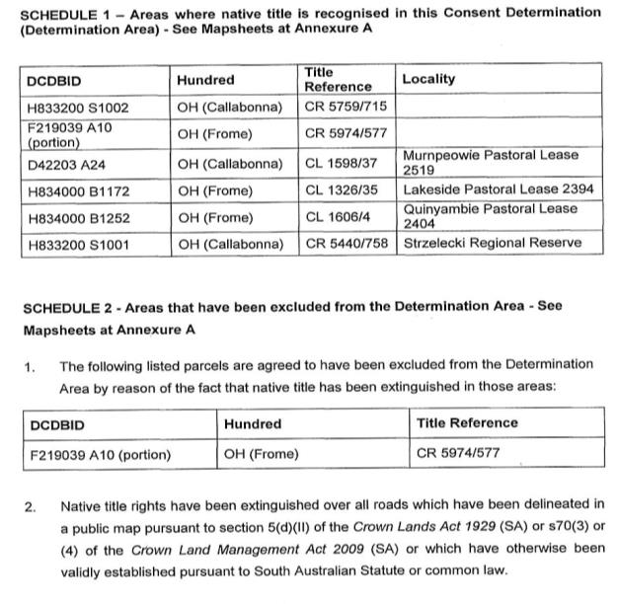

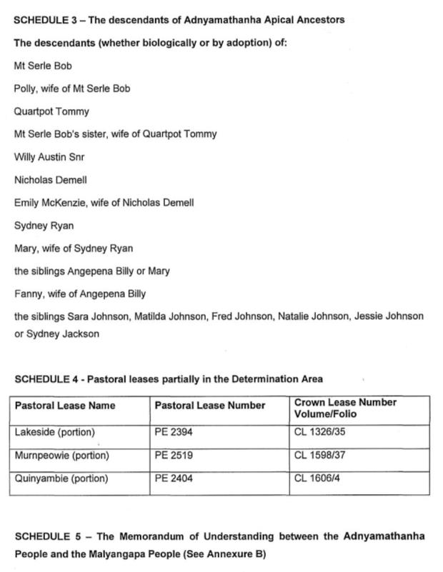

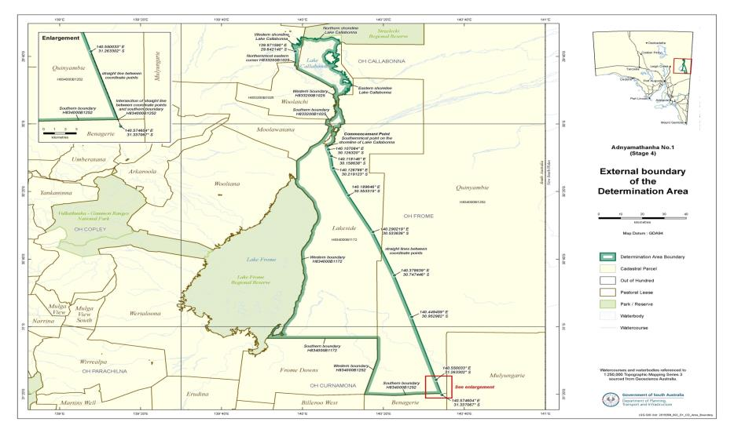

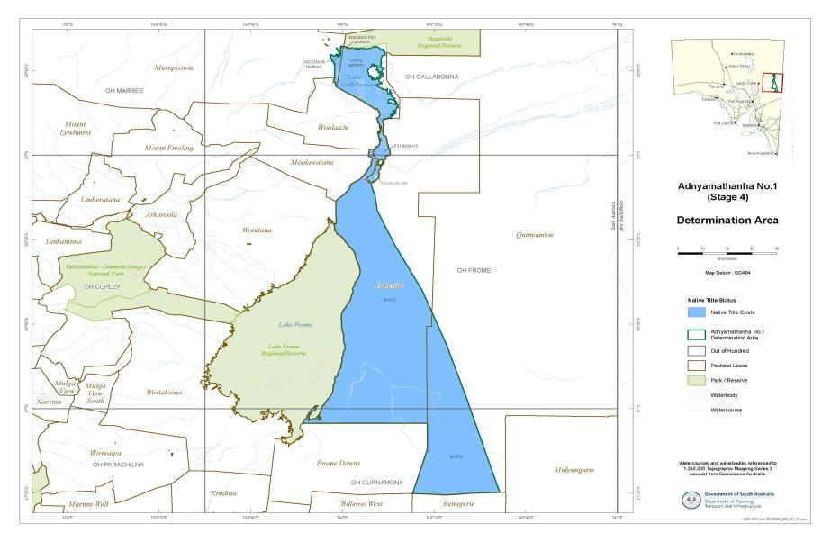

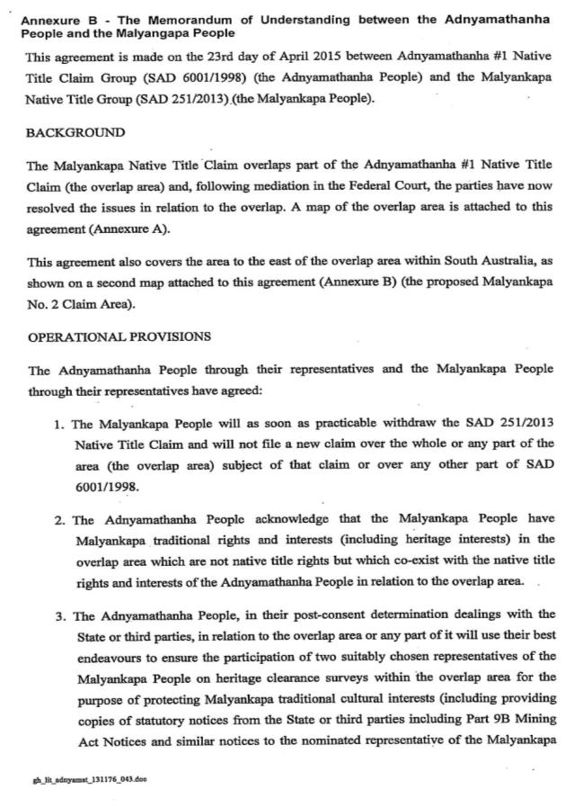

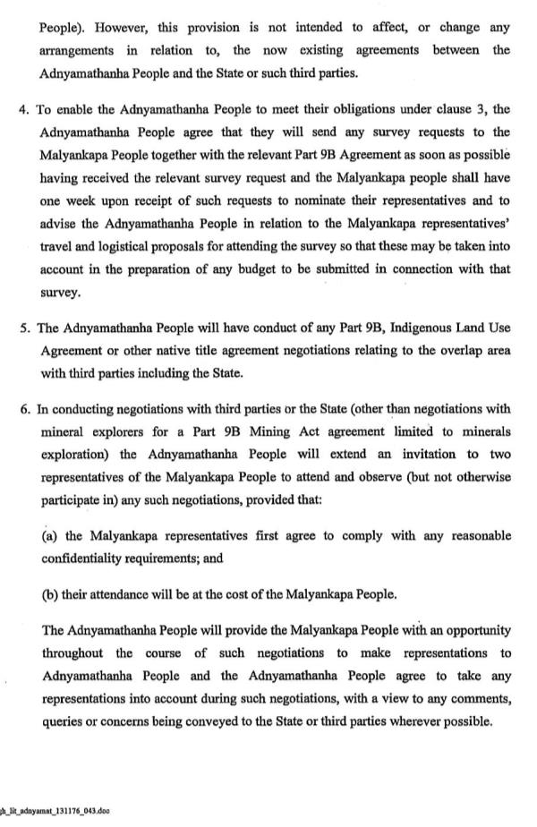

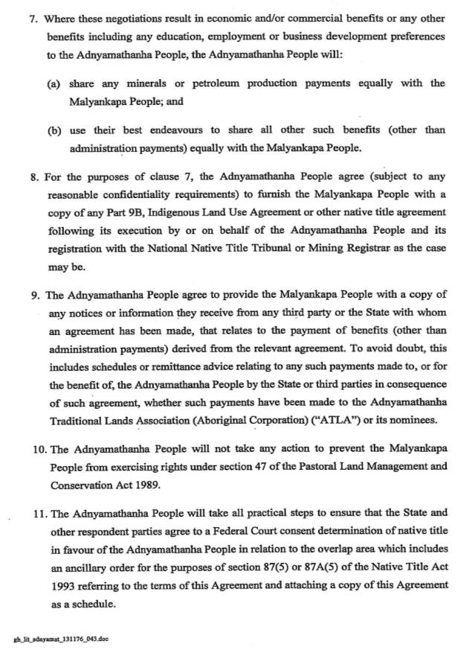

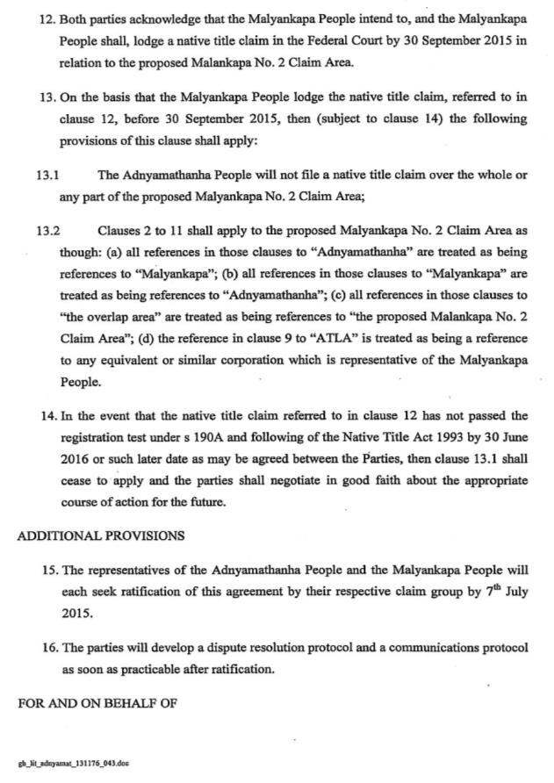

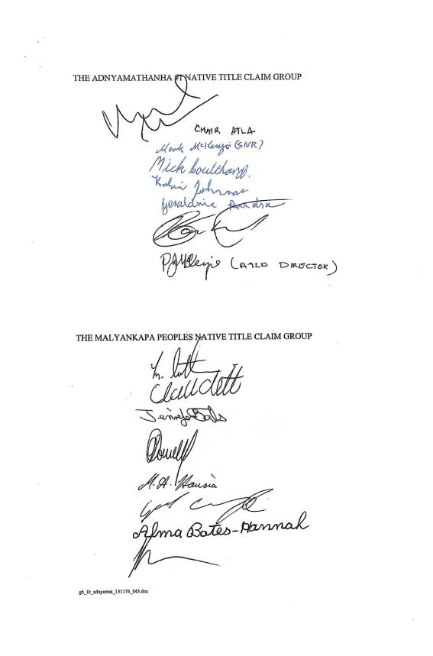

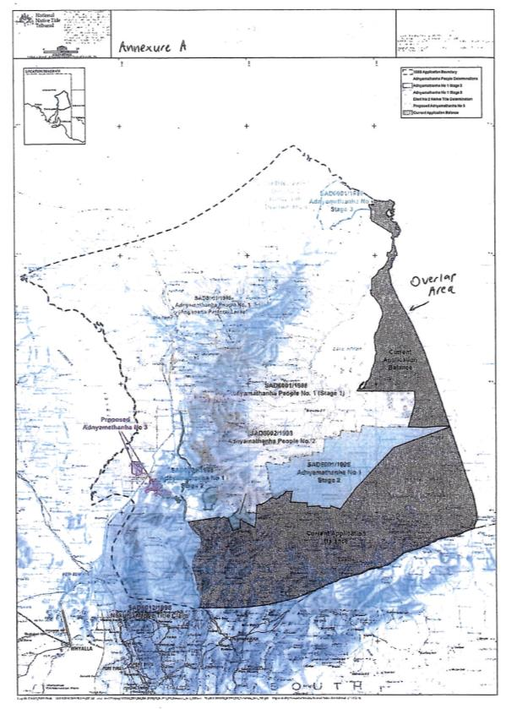

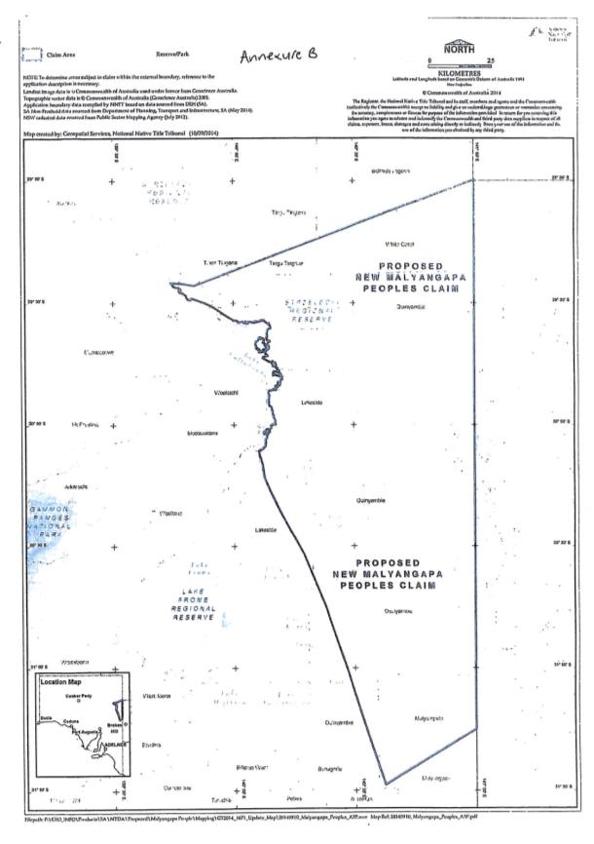

**SCHEDULE 6**

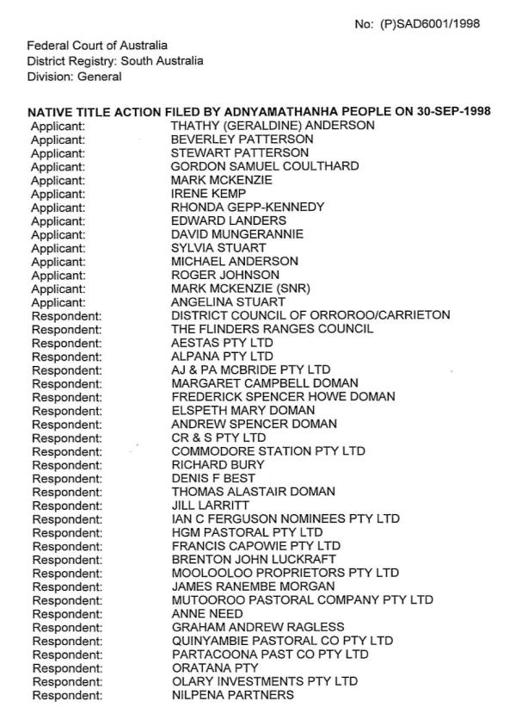

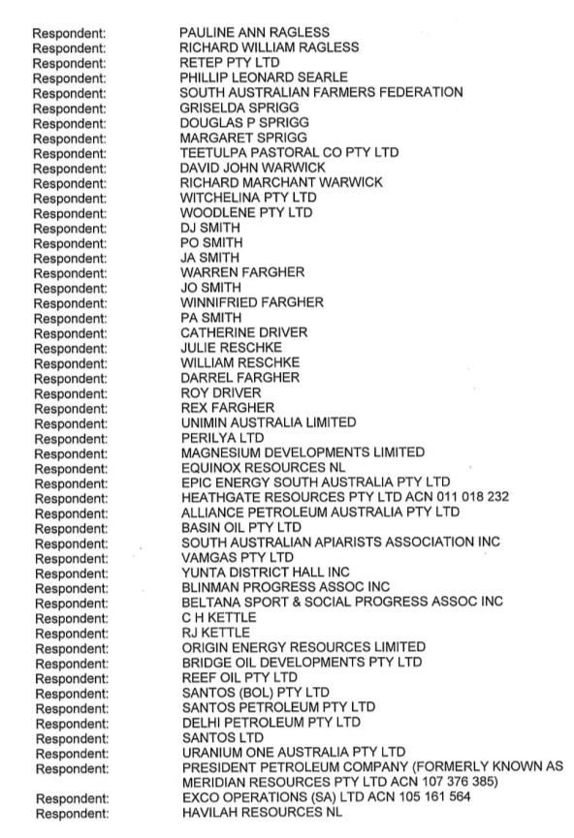

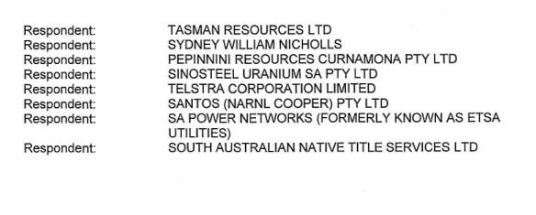

|  |  |
| --- | --- |
| IN THE FEDERAL COURT OF AUSTRALIA |  |
| SOUTH AUSTRALIA DISTRICT REGISTRY |  |
| GENERAL DIVISION | SAD 6001 of 1998 |

|  |  |
| --- | --- |
| BETWEEN: | VINCENT COULTHARD and OTHERS  Applicants |
| AND: | STATE OF SOUTH AUSTRALIA and OTHERS  Respondents |

|  |  |
| --- | --- |
| JUDGE: | MANSFIELD J |
| DATE: | 8 DECEMBER 2015 |
| PLACE: | ADELAIDE |

**REASONS FOR JUDGMENT**

1. This application is being resolved at the same time as what is called the Adnyamathanha People No 3 claim. As its number indicates, Adnyamathanha No 1 is a longstanding claim, and this determination concerns only some remaining land in what is a very large claim area in the vicinity of the Flinders Ranges in South Australia (the initial claim area). The earlier determinations recognising the native title rights of the Adnyamathanha People over most of the initial claim area were made earlier in the decisions referred to at [14] below.
2. This point of the claim area is to the east of Lake Frome, as depicted in Annexures A and B to the Determination to be made by consent. It was previously the subject of an overlapping claim: the Malyangapa Peoples Native Title Claim (SAD 251 of 2013), which has now been withdrawn. That has been done by agreement between the Adnyamathanha People and the Malyangapa People upon the terms of a Memorandum of Understanding between them of 23 April 2015, which is Annexure B to the Determination to be made, and is formally recovered as an ancillary order in Order 19 under s 87A(5) of the *Native Title Act 1993* (Cth) (the Act), and included in the Determination to be made.
3. It is noted that the claim itself has still not been fully resolved, there being two areas to be addressed either by hearing or by agreement. They are the areas described in Area C (which presently is overlapped by the Ngadjuri Nation Native Title Claim (SAD 47 of 2010) and as Area F (which is, the Court is informed, an area including certain townships and the subject of ongoing negotiations).
4. The parties have submitted that orders should be made in this proceeding pursuant to s 87A of the Act in accordance with the proposed Determination (the Determination).
5. The terms of the Determination have been agreed by all other parties to the proceeding and a Minute of Consent Determination has been signed by all parties.
6. It is necessary, having regard to that consent, to address the requirements of ss 223 and 225 of the Act and the appropriateness of making an order pursuant to s 87 of the Act.
7. In *Far West Coast Native Title Claim v State of South Australia (No 7)* [2013] FCA 1285 (*Far West Coast (No 7)*), the Court noted that it must be satisfied in terms of s 87 or 87A (as appropriate) of the Act that it should make the determination of native title by consent as proposed.
8. Section 87A enables the Court to make such a determination without a hearing under certain conditions. They are:
9. the period specified in the notice given under s 66 of the Act has ended and there is an agreement on the terms of a proposed order of the Court in relation to the proceedings (s 87A (1)(a)(b));
10. the agreement is between the Applicant, any claimants, representative bodies, parties with an interest in the area of the agreement, including relevant Ministers and local governments (s 87A (1)(c));
11. the terms of the proposed determination agreement are in writing and are signed by or on behalf of the parties (s 87A (1)(d));
12. the Court is satisfied that an order in, or consistent with, those terms would be within its power (s 87 A (4)(a)); and
13. the Court considers that it would be appropriate to make the order sought (s 87A (4)(b)).
14. In addition, the Court needs to have regard to the following before making determinations of native title by consent orders:
15. whether all parties likely to be affected by an order have had independent and competent legal representation;
16. whether the rights and interests that are to be declared in the determination are recognisable by the law of Australia or the State in which the land is situated;
17. that all of the requirements of the Act are complied with: *Munn for and on behalf of the Gunggari People v Qld* (2001) 115 FCR 109 at [29]-[32].
18. In *Lander v State of South Australia* [2012] FCA 427, the Court stated at [11]-[13] that:

The focus of the Court in considering whether the orders sought are appropriate under s 87 is on the making of the agreement by the parties. In Lovett on behalf of the *Gunditjmara People v State of Victoria* [2007] FCA 47 4 North J stated at [36]-[37] that:

The Act [Native Title Act] is designed to encourage parties to take responsibility for resolving proceeding without the need for litigation. Section 87 must be construed in this context. The power must be exercised flexibly and with regard to the purpose for which the section is designed.

In this context, when the court is examining the appropriateness of an agreement, it is not required to examine whether the agreement is grounded on a factual basis which would satisfy the Court at a hearing of the application. The primary consideration of the Court is to determine whether there is an agreement and whether it was freely entered into on an informed basis: *Nangkiriny v State of Western Australia* (2002) 117 FCR 6; [2002] FCA 660, *Ward v State of Western Australia* [2006] FCA 1848. Insofar as this latter consideration applies to a State party, it will require the Court to be satisfied that the State party has taken steps to satisfy itself that there is a credible basis for an application: *Munn v Queensland* (2001) 115 FCR 109; [2001] FCA 1229.

Therefore, the Court does not need to embark on its own inquiry of the merits of the claim made in the application to be satisfied that the orders sought are supportable and in accordance with the law: *Cox on behalf of the Yungngora People v State of Western Australia* [2007] FCA 588 at [3] per French J. However, it might consider that evidence for the limited purpose of being satisfied that the State is acting in good faith and rationally: *Munn for and on behalf of the Gunggari People v State of Queensland* (2001) 115 FCR 109 at [29]-[30] per Emmett J. See also *Smith v State of Western Australia* (2000) 104 FCR 494 at [38] per Madgwick J:

State governments are necessarily obliged to subject claims for native title over lands and waters owned and occupied by the State and State agencies, to scrutiny just as carefully as the community would expect in relation to claims by non-Aborigines to significant rights over such land.

I note also the observations of Reeves J in *Nelson v Northern Territory of Australia* (2010) 190 FCR 344; [2010] FCA 1343 at [12]-[13]:

It is appropriate to make some comments about the difficult balance a State party needs to strike between its role in protecting the community's interests, including the stringency of the process it follows in assessing the underlying evidence going to the existence of native title, and its role in the native title system as a whole, to ensure that it, like the Court and all other parties, takes a flexible approach that is aimed at facilitating negotiation and achieving agreement. In *Lovett* North J commented:

... There is a question as to how far a State party is required to investigate in order to satisfy itself of a credible basis for an application. One reason for the often inordinate time taken to resolve some of these cases is the overly demanding nature of the investigation conducted by State parties. The scope of these investigations demanded by some States is reflected in the complex connection guidelines published by some States.

The power conferred by the Act on the Court to approve agreements is given in order to avoid lengthy hearings before the Court. The Act does not intend to substitute a trial, in effect, conducted by State parties for a trial before the Court. Thus, something significantly less than the material necessary to justify a judicial determination is sufficient to satisfy a State party of a credible basis for an application. The Act contemplates a more flexible process than is often undertaken in some cases.

I respectfully agree with North J in these observations. In my view, it would be perverse to replace a trial before the Court with a trial conducted by a State party respondent and I do not consider that is what is intended by the provisions of s 87 of the Act.

1. As the Court is aware, the State has developed a process for assessing the evidence in native title claims against the requirements of the Act as outlined in the State’s policy document *Consent Determinations in South Australia: A Guide to Preparing Native Title Reports* (the State’s CD Policy).
2. After assessing the evidence presented by the Applicant (the evidence) in accordance with the State’s CD Policy, the State is satisfied that a consent determination is appropriate for the Determination Area as set out in the Consent Determination. The evidence was provided on a confidential and “without prejudice” basis but can be made available to the Court if required to support the contents of these submissions, provided confidentiality and gender restrictions are respected. For the reasons which follow, I do not regard it as necessary to refer to that material beyond the submissions. That is the more so having regard to the recognition given to the Adnyamathanha People in the earlier Determinations referred to.
3. As the introductory paragraphs of these reasons observe, this claim is called the Adnyamathanha No 1 claim. It has been variously split up for the purposes of assessment and negotiations for consent determinations under the State’s CD Policy.
4. The Adnyamathanha No 1 claim has been subject of four determinations over various parts of the original claim area (Stage 1) and one over the Adnyamathanha No 2 claim: *Adnyamathanha No 1 Native Title Claim Group v The State of South Australia (No 2)* [2009] FCA 359 (30 March 2009), *Coulthard v The State of South Australia* [2014] FCA 124 (24 February 2014). Those determinations followed a detailed assessment of material following which the State accepted the current Adnyamathanha group as having evolved from the original groups in the area and as continuing to hold native title rights there.
5. The Applicant provided further information about Area D1 which resulted in advice from Counsel that a determination would be appropriate. However, a new claim by the Malyangapa People (SAD 251 of 2013) was filed, overlapping Area D1 (including Lake Callabonna). As the Malyangapa People claim has now been withdrawn (with the Adnyamathanha agreeing to recognise traditional rights of the Malyangapa People – which will be reflected in the proposed Determination), it is no longer an obstacle to the Determination and the reasons in support of the Determination are persuasive.
6. The evidence shows that the Adnyamathanha No 1 claim reflects the combination of a number of earlier claims and various amendments to the claim over time. The existing consent determinations recognise an ongoing traditional society exercising traditional laws and customs.
7. A large amount of material has been gathered and discussed over many years. For the purpose of this Determination, the majority of the evidence relied upon by the Applicant had already been supplied to and assessed by the State for the determinations in 2009 and 2014. The former Solicitor-General of the State considered further evidence was required in this part of the claim area. Accordingly, the State sought further supplementary material over the area in the form of witness statements.
8. This was ultimately provided to the then Crown Advocate for his opinion. The Crown Advocate formed the view that there was sufficient material to make it appropriate for a recommendation to Cabinet that the State agree to a determination and that no further evidence was required. However, given the newly filed, overlapping Malyangapa claim over area D1, the State only consented to an order over the non-overlapped part (D2). As noted, as the Malyangapa claim has now been withdrawn, it is appropriate to proceed with a determination over Area D1.
9. A Position Paper explaining the basis for the State’s views was distributed to all other respondent parties in October 2015 and all affected parties either have signed the proposed Determination to indicate their agreement to it or have removed themselves as a party to the proceeding.
10. Section 223 of the Act defines native title as:

... the communal, group or individual rights and interests of Aboriginal peoples ... in relation to land or waters, where:

(a) the rights and interests are possessed under the traditional laws acknowledged, and the traditional customs observed, by the Aboriginal peoples ... ; and

(b) the Aboriginal peoples ... , by those laws and customs, have a connection with the land or waters; and

(c) the rights and interests are recognised by the common law of Australia.

1. As was stated in *Far West Coast (No 7)* at [36]-[39]:

Section 223(1) NTA has been considered extensively by the High Court, most notably in the *Yorta Yorta* decision. Subsequently, several Federal Court Judges have summarised the relevant principles, including in *Risk v Northern Territory* (2006) FCA 404 ("*Risk''*).

The State conducted its assessment of the Applicant's evidence in light of the State's CD Policy (which reflects the state of the law post-*Yorta Yorta*) and subsequent cases.

A threshold requirement is that the evidence shows that there is a recognisable group or society that presently recognises and observes traditional laws and customs in the Determination Area. In defining that group or society, the following must also be addressed:

(1) That they are a society united in and by their acknowledgement and observance of a body of accepted laws and customs;

(2) That the present day body of accepted laws and customs of the society is in essence the same body of laws and customs acknowledged and observed by the ancestors or members of the society adapted to modern circumstances; and

(3) That the acknowledgement and observance of those laws and customs has continued substantially uninterrupted by each generation since sovereignty, and that the society has continued to exist throughout that period as a body united in and by its acknowledgment and observe of those laws and customs.

(4) The claimants must show that they still possess rights and interests under the traditional laws acknowledged and the traditional customs observed by them, and that those laws and customs give them a connection to the land.

1. The State submits and I accept that the previous consent determinations in favour of the Adnyamathanha identify a society united by traditional law and custom, that satisfies the requirements of the Act. It is this society for whom the current consent determination is sought.
2. The relevant date of sovereignty for this area is 1788. The State accepted, on the ethnography since first contact in the area, the ancestral association of Adnyamathanha people to the core area that was subject to the existing Consent Determinations.
3. The further evidence provided (including numerous witness statements and various summaries) showed ancestors associated with Area D1. This included evidence of claimant ancestors including Tom Coffin, Bill McKenzie, Fred Johnson and the Driver family working and living in the proposed determination area, mostly since at least the mid-1940s but with some ancestors going back to the 1890s. Persons identified as Yadliwayara and Pirlatapa were identified as being associated with Arboola Bore and Billaroo Creek in the north. Reference was made to mura (dreaming) stories and more recent histories linking to Billaroo Creek which runs across the three Pastoral Leases that are affected by this proposed determination.
4. On the basis of the information contained in the evidence and for the purposes of a consent determination, the State is satisfied that the contemporary native title claimants’ society is directly linked to the native title holders at sovereignty.
5. A consent determination can be made without the necessity of strict proof and direct evidence of each issue as long as inferences can legitimately be made. In consent determination negotiations, it is the State's policy to focus on contemporary expressions of traditional laws and customs and pay less regard to laws and customs that may have ceased. The State can reasonably infer that such contemporary expressions are sourced in the earlier laws and customs.
6. The evidence set out in the further statements received since the existing consent determinations were made is supportive of the inferential finding that much of the claimants’ behaviour is regulated or influenced by traditional laws and customs and that there has been continuity of the core features of Adnyamathanha society from the past to the present.
7. For example, the statements provide evidence of knowledge and use of natural resources within the area proposed for this Determination. The evidence supports a conclusion that this knowledge has been learnt by the claimants from their parents, grandparents and elders, and as such demonstrates a continuous process of transmission of knowledge which the State is prepared to infer has continued from sovereignty. In addition, evidence is provided in the statements of the transmission of knowledge to the younger members of the native title claim group.
8. The State and the Court accepted in the earlier determinations that the Adnyamathanha people there continue to exercise traditional laws and customs which continue to have a vitality in contemporary society.
9. The State is prepared to infer that the pre-sovereignty normative society has continued to exist throughout the period since sovereignty, and whilst there has been inevitable adaptation and evolution of the laws and customs of that society, there is nothing apparent in the evidence to suggest the inference should not be made that the society today (as descendants of those placed in the area in the earliest records) acknowledges and observes a body of laws and customs which is substantially the same normative system as that which existed at sovereignty. In my view, that is in all the circumstances, an appropriate step to take.
10. It is a requirement of native title law that the claimants must show that they follow traditional laws and customs which are connected to the land, and which give rise to rights and responsibilities in relation to that land. Therefore it is not “connection” to the land in the abstract that must be considered, but the content of the traditional laws and customs; the nature and extent of the connection with the land required under those laws and customs and the relationship between the laws and customs and rights or interests in land.
11. There is evidence provided in the claimants' statements of the continuing connection of members of the contemporary Adnyamathanha group with at least a substantial part of the Determination Area through their laws and customs.
12. Evidence of activities undertaken in and across the proposed Determination Area include:

* travelling over and monitoring land;
* droving of cattle for pastoralists;
* visiting, camping and living there;
* hunting and cooking kangaroo;
* gathering natural resources such as the leaves from the Mapu bush;
* using Adnyamathanha language; and
* telling dreaming stories such as the willy wagtail and the boning story.

1. Kelvin Johnson relates stories of travelling through the country and camping on Yandama and Boolkaree Creeks. His grandfather was Fred Johnson who lived between Boolkaree Creek and Tilcha Bore on the eastern side of Lake Callabonna. His own father (Maurice Johnson) took the family out along Yandama Creek and Boolkaree Creek indicating where he used to live while camping, hunting and cooking kangaroos while on country. Kelvin’s father showed him how the old Adnyamathanha people in this country used to burn the leaves of the Mapu bush and mix it up with tobacco and chew it.
2. Mick Coulthard states that Tom Coffin had a traditional song for Billaroo Creek on Lakeside which Mick was taught, but has since forgotten.
3. On consideration of all the material, the State is prepared to accept that the native title claim group’s traditional laws and customs give them a connection to the proposed Determination Area.
4. The rights and interests to be recognised are set out at para 7 of the Determination.
5. These rights and interests are consistent with the rights and interests that would have been observed traditionally. They are also consistent with rights and interests recognised by the Federal Court elsewhere in South Australia.
6. There is evidence in the claimants’ statements that a number of Adnyamathanha people continue to have a physical connection with the proposed Determination Area, and regularly access this area for traditional purposes. Evidence is also presented that a number of contemporary claimants have lived and worked (droving) for periods of their life on Lakeside Pastoral Lease within the proposed Determination Area. In the 1940s Gilbert Coulthard worked on Wertaloona station and during that time he drove cattle on neighbouring Frome Downs and Lakeside Pastoral Leases. Gordon Coulthard relates stories of Fred Johnson driving donkey trains when they were drilling the artesian bores and that Fred lived at Arboola Bore for some time with the Drivers and other Adnyamathanha people.
7. A number of the relatives of the contemporary claimants are also buried on the Determination Area. One of Mick Coulthard’s aunties, the daughter of Frank Driver Sr, is buried at Arboola Bore.
8. There is also evidence that contemporary Adnyamathanha people continue to have a detailed knowledge of the area, its water sources, flora and fauna, and cultural geography.
9. The claimants’ statements provide evidence that a number of claimants continue to access the resources of the area. People continue to hunt, including for kangaroos, and gather bush foods. There is also evidence that people continue to have knowledge of traditional practices such as how to prepare and cook game, which is transmitted to younger generations.
10. There is indicative evidence of senior people taking younger generations out to such areas and passing on details about the cultural geography of the country, such as boundaries and some site information, and of Work Area Clearances being used as a means of transmitting cultural knowledge about country to younger Adnyamathanha people.
11. The State is satisfied that the native title rights and interests claimed arise from the claimants’ traditional laws and customs and inferences can be made that they have evolved from the native title rights and interests as they were likely to have been at sovereignty.
12. There is no right or interest within the Determination that would not be recognised by the laws of Australia.
13. Section 225 of the Act dictates what the Determination must include. I am satisfied that the Determination complies with each requirement of that section.
14. The Determination sets out with particularity the area in which native title exists (Schedule 1), and those areas within the Determination Area where native title is extinguished (paragraphs 13, 14 and Schedule 2).
15. For the purpose of s 225(a) of the Act, Schedule 3 of the Determination defines the group of native title holders and the criteria by which they have group membership.
16. For the purpose of s 225(b) of the Act, para 7 of the Determination sets out the nature and extent of the native title rights and interests in the Determination Area. paras 8 to 10 set out the general limitations on their exercise.
17. For the purpose of s 225(c) of the Act, para 11 of the Determination sets out the nature and extent of other interests in the Determination Area. The content of this paragraph has been informed through tenure searches undertaken by the State and input from other respondent parties to the claim. There has been ample opportunity for any other interest-holders in the area to identify themselves and join as parties to the claim. The State’s comprehensive tenure searches have not identified any other relevant interest holders in the Determination Area.
18. For the purpose of s 225(d) of the Act, para 12 of the Determination describes the relationship between the native title rights in para 7 and those other rights in para 11.
19. For the purpose of s 225(e) of the Act, the native title rights and interests recognised in the Determination are non-exclusive.
20. Agreement has been reached between the principal parties to these proceedings on the terms of the Determination and signed copies of that Determination have been filed with the Court.
21. This includes the South Australian Native Title Services Ltd, who is the native title service provider for the Determination Area, South Australian Apiarists Association Inc and a number of represented mining and pastoral interest holders.
22. On the basis of the evidence, in my view it is appropriate, and within its power, for the Court to make orders pursuant to s 87A.
23. All parties have had independent and competent legal advice in the proceeding.
24. Schedule 1 to the Determination lists the parcels where native title is recognised in the Determination Area. Paragraphs 13, 14 and Schedule 2 describe those areas which are excluded from the Determination Area because native title has been extinguished.
25. The State and the Applicants have carried out a detailed analysis of both historic and contemporary tenure which informed the consent determination negotiations. This has allowed the State and the Applicants to agree those areas where native title has been extinguished by prior grant of tenure and to record those areas with specificity in the Determination. These are recorded in Schedule 2 to the Determination.
26. The Act encourages the resolution by agreement of claims for determinations of native title. For the reasons set out above, the State and the Applicant consider that the Determination is appropriate and should be made in this proceeding. By signing the Minute of Consent Determination of native title all other parties to the proceeding have indicated their agreement. I accept their submissions.
27. Accordingly, the Court makes the Determination recognising the rights and interests of the Adnyamathanha People in the area presently being addressed in the terms of the Determination agreed to by the parties.

|  |
| --- |
| I certify that the preceding sixty (60) numbered paragraphs are a true copy of the Reasons for Judgment herein of the Honourable Justice Mansfield. |

Associate:

Dated: 8 December 2015