FEDERAL COURT OF AUSTRALIA

Barkandji Traditional Owners #8 (Part B) v Attorney-General of New South Wales [2017] FCA 971

|  |  |
| --- | --- |
| File number: |  |
|  |  |
| Judge: | **GRIFFITHS J** |
|  |  |
| Date of judgment: | 22 August 2017 |
|  |  |
| Catchwords: | **NATIVE TITLE** – consent determination covering part of the area of a native title determination application – whether consent determination should be made – requirements of ss 87A and 94A of the *Native Title Act 1993* (Cth) satisfied – appropriate to make orders |
|  |  |
| Legislation: | *Australian Telecommunications Corporations Act* *1989* (Cth)  *Corporations (Aboriginal and Torres Strait Islander) Act 2006* (Cth)  *Native Title Act 1993* (Cth) ss 13, 24CA, 47A, 56, 57, 61, 86A, 86B, 86C, 86D, 86E, 86F, 87, 87A, 88, 94A, 94E, 94G, 94P, 190A, 225, 238  *Post and Telegraph Act 1901* (Cth)  *Telecommunications Act 1991* (Cth)  *Telecommunications Act 1997* (Cth)  *Water Act 2007* (Cth)  *Native Title (Prescribed Bodies Corporate) Regulations 1999* (Cth)  *Crown Lands Act 1989* (NSW)  *Crown Lands Consolidation Act 1913*(NSW)  *Electricity Supply Act 1995* (NSW)  *Energy Services Corporations Act 1995* (NSW)  *Local Government Act 1993* (NSW)  *Mining Act 1992* (NSW)  *Murray-Darling Basin Act* 1992 (NSW) Sch 1  *Native Title (New South Wales) Act* 1994 (NSW) s 18  *Petroleum (Onshore) Act 1991* (NSW)  *Petroleum (Submerged Lands) Act 1982* (NSW)  *Water Act 1912* (NSW) Parts 9, 10, 10A, Sch 1  *Water Management Act* 2000(NSW) Part 3A  *Mining Regulation 2010* (NSW) |
|  |  |
| Cases cited: | *Barkandji Traditional Owners #8 v Attorney-General of New South Wales* [2015] FCA 604  *Bullen on behalf of the Esperance Nyungar People v State of Western Australia* [2014] FCA 197  *Cashmere on behalf of the Jirrbal People #1 v State of Queensland* [2010] FCA 1090  *Doctor on behalf of the Bigambul People v State of Queensland* [2016] FCA 1447  *Doyle on behalf of the Kalkadoon People #4 v State of Queensland (No 3)* [2011] FCA 1466  *Lander v South Australia* [2012] FCA 427  *Starkey v State of South Australia* [2014] FCA 924  *WF (Deceased) on behalf of the Wiluna People v State of Western Australia* [2013] FCA 755  *Wyman on behalf of the Bidjara People v State of Queensland (No 4)* [2014] FCA 93 |
|  |  |
| Date of hearing: | 22 August 2017 |
|  |  |
| Registry: | New South Wales |
|  |  |
| Division: | General Division |
|  |  |
| National Practice Area: | Native Title |
|  |  |
| Category: | Catchwords |
|  |  |
| Number of paragraphs: | 57 |
|  |  |
| Solicitor for the Applicant: | Ms Mishka Holt and Mr Alexander Chalmers from NTSCORP Limited |
|  |  |
| Counsel for the Attorney-General of New South Wales: | Mr Vance Hughston SC, Mr Henry El-Hage and Mr Edmund Lee |
|  |  |
| Solicitor for the Attorney-General of New South Wales: | Mr R Kelly from the NSW Crown Solicitor’s Office |
|  |  |
| Solicitor for Menindee Local Aboriginal Land Council, New South Wales Aboriginal Land Council and Wilcannia Local Aboriginal Land Council | Mr Geoffrey Winters from Chalk & Behrendt |

|  |  |
| --- | --- |
| **Table of Corrections** |  |
|  |  |
| 6 September 2017 | The map in Part B (Maps of the Extinguished Area) of Schedule 2 titled “NSD6084/1999 Barkandji # 8 Part B Extinguished Areas” with insets labelled 1, 2, 3, 4, 5, 7 and 8 has been replaced with a map with insets labelled 1, 2, 3, 4, 5, 6 and 7. |

ORDERS

|  |  |  |
| --- | --- | --- |
|  | | NSD 6084 of 1998 |
|  | | |
| BETWEEN: | MURRAY BUTCHER, DEREK HARDMAN, JENNIFER WHYMAN, WILLIAM BATES, MAUREEN O’DONNELL, MARY-ANN MARTON, CYRIL HUNTER ON BEHALF OF THE BARKANDJI TRADITIONAL OWNERS (PART B)  Applicant | |
| AND: | ATTORNEY-GENERAL OF NEW SOUTH WALES, MENINDEE LOCAL ABORIGINAL LAND COUNCIL, WILCANNIA LOCAL ABORIGINAL LAND COUNCIL, NEW SOUTH WALES ABORIGINAL LAND COUNCIL  Respondents | |

|  |  |
| --- | --- |
| JUDGE: | GRIFFITHS J |
| DATE OF ORDER: | 22 AUGUST 2017 |

THE COURT NOTES THAT:

1. On 8 October 1997, the Applicant made a native title determination application in accordance with sections 13(1) and 61 of the *Native Title Act 1993* (Cth) to the Federal Court of Australia (proceedings NSD 6084 of 1998) (the **Application**).
2. On 16 June 2015, in *Barkandji Traditional Owners #8 v Attorney-General of New South Wales* [2015] FCA 604 the Court recognised that the Barkandji and Malyangapa People hold native title over part of the land or waters within the external boundaries of the Application (the **Part A Determination**). In the Part A Determination the Court noted that the "parties have agreed, in respect of the Excluded Area [as that term is defined and the parcels of land identified in Schedule Six of the Part A Determination], no determination is to be made at present".
3. On 28 February 2017, the Court granted the Applicant leave to file an amended native title determination application to reduce the area in relation to the land or waters identified in Schedule Six of the Part A Determination. The **Discontinued Area** are those land or waters excised in the amended native title determination application filed on 16 March 2017.
4. Since the Part A Determination, the parties have reached agreement as to the terms of a **Part B Determination** of native title to be made by consent in relation to part of the land or waters listed in Schedule Six of the Part A Determination and an additional 21 parcels (identified through the mapping process undertaken by the National Native Title Tribunal) that had not been included in Schedule Six (the **Determination Area**), being that:
   1. native title exists in relation to a part of the land or waters in the Native Title Area, as defined in the Part B Determination, and
   2. native title has been extinguished in relation to the land or waters in the Extinguished Area, as defined in the Part B Determination.

Note: Native title has been wholly extinguished in relation to all 21 parcels identified by the National Native Title Tribunal.

1. In relation to the Exclusive Area as defined in the Part B Determination, reaching agreement as to the terms of a proposed determination has been facilitated by the making of the agreements referred to in paragraphs 1 and 2 of Schedule Three (**LALC Lands ILUAs**).
2. The terms of the agreement involve the making of orders by consent for a determination pursuant to section 87A, and in accordance with section 94A of the *Native Title Act 1993 (Cth)*.
3. Pursuant to section 87A(2) of the *Native Title Act 1993* (Cth), the parties have filed a Minute of Proposed Consent Determination of Native Title which reflects the terms of the agreement reached by them.
4. The Barkandji and the Malyangapa People are comprised of the Malyangapa People and the following Barkandji sub-groups:

(i) Thankali;

(ii) Barkandji;

(iii) Parintji;

(iv) Maraura;

(v) Wilyakall;

(vi) Pantjikali/Wanyiwalku;

(vii) Paruntji; and

(viii) Kurnu/Naulco.

The Barkandji and Malyangapa People are more particularly described in paragraph 4 of the Part B Determination below.

1. The Applicant has nominated the Barkandji Native Title Group Aboriginal Corporation RNTBC pursuant to s 56(2) of the *Native Title Act 1993* (Cth) to hold the determined native title in trust for the common law holders.
2. The Barkandji Native Title Group Aboriginal Corporation RNTBC has consented in writing to hold the rights and interests comprising the native title in trust for the common law holders and to perform the functions of a registered native title body corporate under the *Native Title Act 1993* (Cth).

# CONSENT DETERMINATION ORDERS

**BEING SATISFIED** that a determination of native title in the terms sought by the parties is within the power of the Court, and it appearing to the Court that it is appropriate to do so by consent of the parties pursuant to sub-sections 87A(1) and 87A(4) of the *Native Title Act 1993* (Cth),

# THE COURT ORDERS THAT:

1. There be a determination of native title in the terms set out below (the **Part B Determination**).

2. This Part B Determination shall take effect upon the LALC Lands ILUAs being registered on the Register of Indigenous Land Use Agreements.

3. In the event that the LALC Lands ILUAs are not registered on the Register of Indigenous Land Use Agreements on or before 28 May 2018, or at such later time as this Court may order, the matter is to be listed for further directions.

4. On the Part B Determination taking effect, the Barkandji Native Title Group Aboriginal Corporation RNTBC shall hold the determined native title in trust for the common law holders pursuant to s 56(2)(b) of the *Native Title Act 1993* (Cth)and is to:

(i) be the prescribed body corporate for the purposes of section 57(1) of the *Native Title Act* 1993 (Cth); and

(ii) perform the functions set out in section 57(1) of the *Native Title Act 1993* (Cth) and the *Native Title (Prescribed Bodies Corporate) Regulations 1999* (Cth).

5. There be no orders as to costs.

# THE COURT DETERMINES THAT:

1. Native title exists in the Native Title Area described and depicted in the maps attached to Schedule One.

2. Native title is extinguished in the Extinguished Area described and depicted in the maps attached to Schedule Two.

3. To the extent of any inconsistency between the written description ·in Schedules One or Two and the corresponding maps attached to those Schedules, the written description prevails.

## Native Title Holders

4. Native title in the Native Title Area is held by the Barkandji and Malyangapa People who comprise all the descendants of the following apical ancestors:

* 1. Manfred Mary/Mary Johnson/ Mary Brodie,
  2. Manfred Tommy,
  3. Louisa Brown,
  4. Cuthero Jack Brown,
  5. Susan/Annie Webster,
  6. Bill Webster,
  7. Harry Whyman,
  8. Kate Whyman,
  9. Louisa Mclean,
  10. Alec Mclean,
  11. Nganya,
  12. Sarah Cabbage,
  13. Harry Mitchell,
  14. Daniel McGregor,
  15. Lucy Benson,
  16. Jack "Doctor" Benson,
  17. Crancey,
  18. Jack Tyler,
  19. Taylor Matjulum Gibson,
  20. Tottie Gibson,
  21. Kutyi,
  22. Cate Newton/Maggie Tyler,
  23. Albert Bates,
  24. Fanny Bates,
  25. Yancannia Kitty,
  26. Judy Quayle,
  27. Nancy Watts,
  28. Topsie Crowe,
  29. Alec Bridge,
  30. Olive Barton,
  31. Margaret Payne,
  32. Kitty Knight,
  33. Jacky Knight,
  34. Matilda Murray,
  35. Paddy Black,
  36. Hero Black,
  37. Tall Boy Keegan,
  38. Kitty Keegan,
  39. Fanny Buugali Williams,

and persons adopted into the families of those persons who identify as, and are accepted as, members of the Barkandji and Malyangapa People in accordance with Barkandji and Malyangapa traditional laws and customs (and the biological descendants of any such adopted persons).

## Nature and extent of native title rights and interests

5. Subject to paragraph 9 below, the native title rights and interests in relation to the Exclusive Area, in respect of which s 47A of the *Native Title Act 1993* (Cth) applies, comprise the right of possession, occupation, use and enjoyment to the exclusion of all others.

6. Subject to paragraphs 8 and 9, the native title rights and interests in relation to the Non-Exclusive Area are:

(a) the right to enter, travel over and remain on the Non-Exclusive Area;

(b) the right to take and use the natural resources (other than water) of the Non-Exclusive Area;

(c) the right to take and use the water of the Non-Exclusive Area for personal, domestic and communal purposes (including cultural purposes and for watering native animals, cattle and other stock, and watering gardens not exceeding 2 hectares), but not extending to a right to control the use and flow of the water in any rivers or lakes which flow through or past or are situate within the land of two or more occupiers;

(d) the right to camp and for that purpose to erect temporary shelters and temporary structures in the Non-Exclusive Area;

(e) the right to light fires in the Non-Exclusive Area for domestic purposes, but not for the clearance of vegetation;

(f) the right to engage in cultural activities on the land, to conduct ceremonies, to hold meetings, and to participate in cultural practices relating to birth and death including burials on the land the subject of the Non-Exclusive Area;

(g) the right to have access to, to maintain and to protect from physical harm sites and places of importance in the Non-Exclusive Area which are of significance to the Barkandji and Malyangapa People under their traditional laws and customs;

(h) the right to teach on the Non-Exclusive Area the physical, cultural and spiritual attributes of places and areas of importance on or in the Non­ Exclusive Area;

(i) the right to hunt in the Non-Exclusive Area;

(j) the right to fish in the Non-Exclusive Area; and

(k) the right to be accompanied on the Non-Exclusive Area by persons who, though not Native Title Holders, are:

* + 1. spouses, partners or parents of Native Title Holders, together with their children and grandchildren;
    2. people whose presence is required under traditional laws and customs for the performance of cultural activities, practices or ceremonies; and
    3. people requested by the Native Title Holders to assist in, observe or record cultural activities, practices or ceremonies.

## General qualifications on native title rights and interests

7. Native title does not exist in:

(a) minerals as defined in the *Mining Act 1992* (NSW) and the *Mining Regulation 2010* (NSW); and

(b) petroleum as defined in the *Petroleum (Onshore) Act 1991* (NSW) and the *Petroleum (Submerged Lands) Act 1982* (NSW).

8. The native title rights and interests referred to in paragraph 6 do not confer:

(a) possession, occupation, use or enjoyment of the Non-Exclusive Area to the exclusion of all others; or

(b) any right to control access to, or use of, the Non-Exclusive Area.

9. The native title rights and interests in the Native Title Area are subject to and exercisable in accordance with:

(a) the laws of the State of New South Wales and of the Commonwealth;

(b) the traditional laws acknowledged and the traditional customs observed by the Barkandji and Malyangapa People; and

(c) the terms of any Indigenous Land Use Agreement which may be registered by the National Native Title Tribunal in respect of any part of the Determination Area whether made before or after the making of this Part B Determination.

## Nature and extent of Other Interests

10. The Other interests in relation to the Native Title Area are described in Schedule Four (**Other Interests**).

## Relationship between native title rights and Other Interests

11. Except as otherwise provided by law, the relationship between the native title rights and interests in the Non-Exclusive Area and the Other Interests in those areas is as follows:

(a) the Part B Determination does not affect the validity of those Other Interests;

(b) to the extent of any inconsistency between the Other Interests and the continued existence, enjoyment or exercise of the native title rights and interests, the native title rights and interests continue to exist in their entirety, but the native title rights and interests have no effect in relation to the Other Interests to the extent of the inconsistency during the currency of the Other Interests; and

(c) otherwise, the Other Interests co-exist with the native title rights and interests and, for the avoidance of doubt, the doing of an activity required or permitted under those Other Interests prevails over the native title rights and interests and their exercise, but does not extinguish them.

12. The relationship between the native title rights and interests in the Exclusive Area (in relation to which section 47A of the *Native Title Act 1993* (Cth) applies) and the Other Interests described in Paragraph 1 of Schedule Four (**Wilcannia and Menindee Local Aboriginal Land Councils' Interests**) is as follows:

(a) Wilcannia and Menindee Local Aboriginal Land Councils' Interests continue to have effect;

(b) the non-extinguishment principle in section 238 of the *Native Title Act 1993* (Cth) applies to the grant or vesting of Wilcannia and Menindee Local Aboriginal Land Councils' Interests and any prior interest in relation to the area;

(c) the native title continues to exist in its entirety but the rights and interests have no effect in relation to Wilcannia and Menindee Local Aboriginal Land Councils' Interests;

(d) Wilcannia and Menindee Local Aboriginal Land Councils' Interests, and any activity that is required or permitted by or under and done in accordance with Wilcannia and Menindee Local Aboriginal Land Councils' Interests, may be exercised and enjoyed in their entirety notwithstanding the existence of the native title rights and interest;

(e) The native title rights and interests may not be exercised in the Exclusive Area while Wilcannia and Menindee Local Aboriginal Land Councils' Interests exist;

(f) If Wilcannia and Menindee Local Aboriginal Land Councils' Interests or their effects are wholly removed or otherwise wholly cease to operate the native title rights and interests again have full effect; and

(g) If Wilcannia and Menindee Local Aboriginal Land Councils' Interests or their effects are removed to an extent or otherwise cease to operate only to an extent, the native title rights and interests again have effect to that extent.

## Definitions

13. In this Part B Determination, unless the contrary intention appears:

‘**Barkandji and Malyangapa People’** has the same meaning as Native Title Holders.

‘**Barkandji Native Title Group Aboriginal Corporation RNTBC**’ means the Barkandji Native Title Group Aboriginal Corporation RNTBC ICN 4740 incorporated under the *Corporations (Aboriginal and Torres Strait Islander) Act 2006* (Cth).

‘**cultural purposes**’, within the meaning of paragraph 6(c), means the purposes of performing the following activities or activities of a similar kind, all of which involve the use of insubstantial quantities of water:

(a) cleansing ceremonies;

(b) introductions to country (in which individuals are immersed in water or water is otherwise applied to them);

(c) the preparation of food or bush medicines;

(d) the manufacture of artefacts, art and ochre;

(e) digging out soakages; and

(f) activities involving the teaching of Native Title Holders about traditional laws, customs and practices.

‘**Determination Area**’ means the Native Title Area together with the Extinguished Area.

‘**Discontinued Area**’ means the land or waters as described in Schedule Six of the Part A Determination, but were excised as a consequence of the amended native title determination application filed on 16 March 2017.

‘**Extinguished Area**’ means the land or waters described in Schedule Two and hatched In red in the maps in Schedule Two.

‘**land**’ has the same meaning as in the *Native Title Act 1993* (Cth).

‘**laws of the State of New South Wales and of the Commonwealth**’ include statutes, regulations and other subordinate legislation, and the common law.

‘**Native Title Area**’ means the land or waters described and mapped in Schedule One and includes the Exclusive Area and the Non-Exclusive Area.

‘**Non-Exclusive Area**’ means the land or waters described in Part 2 of Schedule One and shaded in green in the maps in Schedule One.

‘**Exclusive Area**’ means the land or waters described in Part 1 of Schedule One and shaded in orange in the maps in Schedule One.

‘**LALC Lands ILUAs**’ means the agreements referred to in paragraph 1 and 2 of Schedule Three, which are intended to be registered on the Register of Indigenous Land Use Agreements under the *Native Title Act 1993* (Cth).

‘**Native Title Holders**’ means the persons described in paragraph 4.

‘**Other Interests**’ means the rights and interests described in Schedule Four.

‘**waters**’ has the same meaning as in the *Native Title Act 1993* (Cth).

‘**Wilcannia and Menindee Local Aboriginal Land Councils’ Interests**’ are those interests described in Paragraph 1 of Schedule Four.

14. If a word or expression is not defined in these orders or this Part B Determination, but is defined in the *Native Title Act* 1993 (Cth) or the *Native Title (New South Wales) Act* 1994 (NSW), then it has the meaning given to it in the *Native Title Act* 1993 (Cth) or the *Native Title (New South Wales) Act* 1994 (NSW), whichever is relevant.

# SCHEDULE ONE - NATIVE TITLE AREA

## A. Description of the Native Title Area

The Native Title Area comprises all the land or waters described in Part 1 and Part 2 below, to the extent that they are within the external boundary of the native title determination application, as amended, and depicted on the Schedule One maps.

**Part 1 - Exclusive Area**

All the land or waters described in the following list and depicted on the Schedule One maps and shaded orange:

(a) Lot 4769 in DP 767984 (ID6280),

(b) Lot 355 in DP 761037 (ID6497),

(c) Lot 2211 in DP 764218 (ID6604),

(d) Lot 1 in DP 754372 (ID10964),

(e) Lot 4 in DP 754390 (ID23001),

(f) Lot B in DP 438726 (ID23164),

(g) Lot 6 in DP 754390 (ID23193),

(h) Lot A in DP 438726 (ID23270),

(i) Lot 3728 in DP 766141 (ID6182),

(j) Lot 3445 in DP 765734 (ID2057), and

(k) Lot 4143 in DP 766648 (ID6163).

**Part 2 - Non-Exclusive Area**

All the land or waters described in the following list and depicted on the Schedule One maps and shaded green, but not any part of them that is within the Exclusive Area or Extinguished Area:

(a) the area to the south east of the Levee Easement at the eastern extremity of Lot 6, Section 38, DP 759074 (part of ID 2966);

(b) Lot 7309 in DP 1183405 (ID7446); and

(c) the area comprising the Lagoon within Lot 3 In DP 610639 (part of ID 6112).

## B. Maps of the Native Title Area

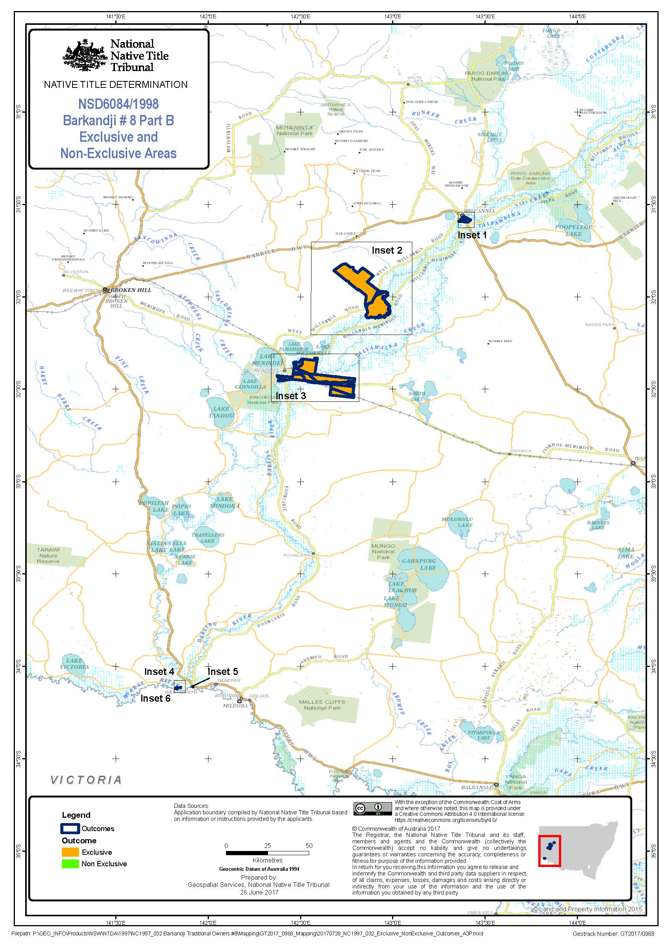

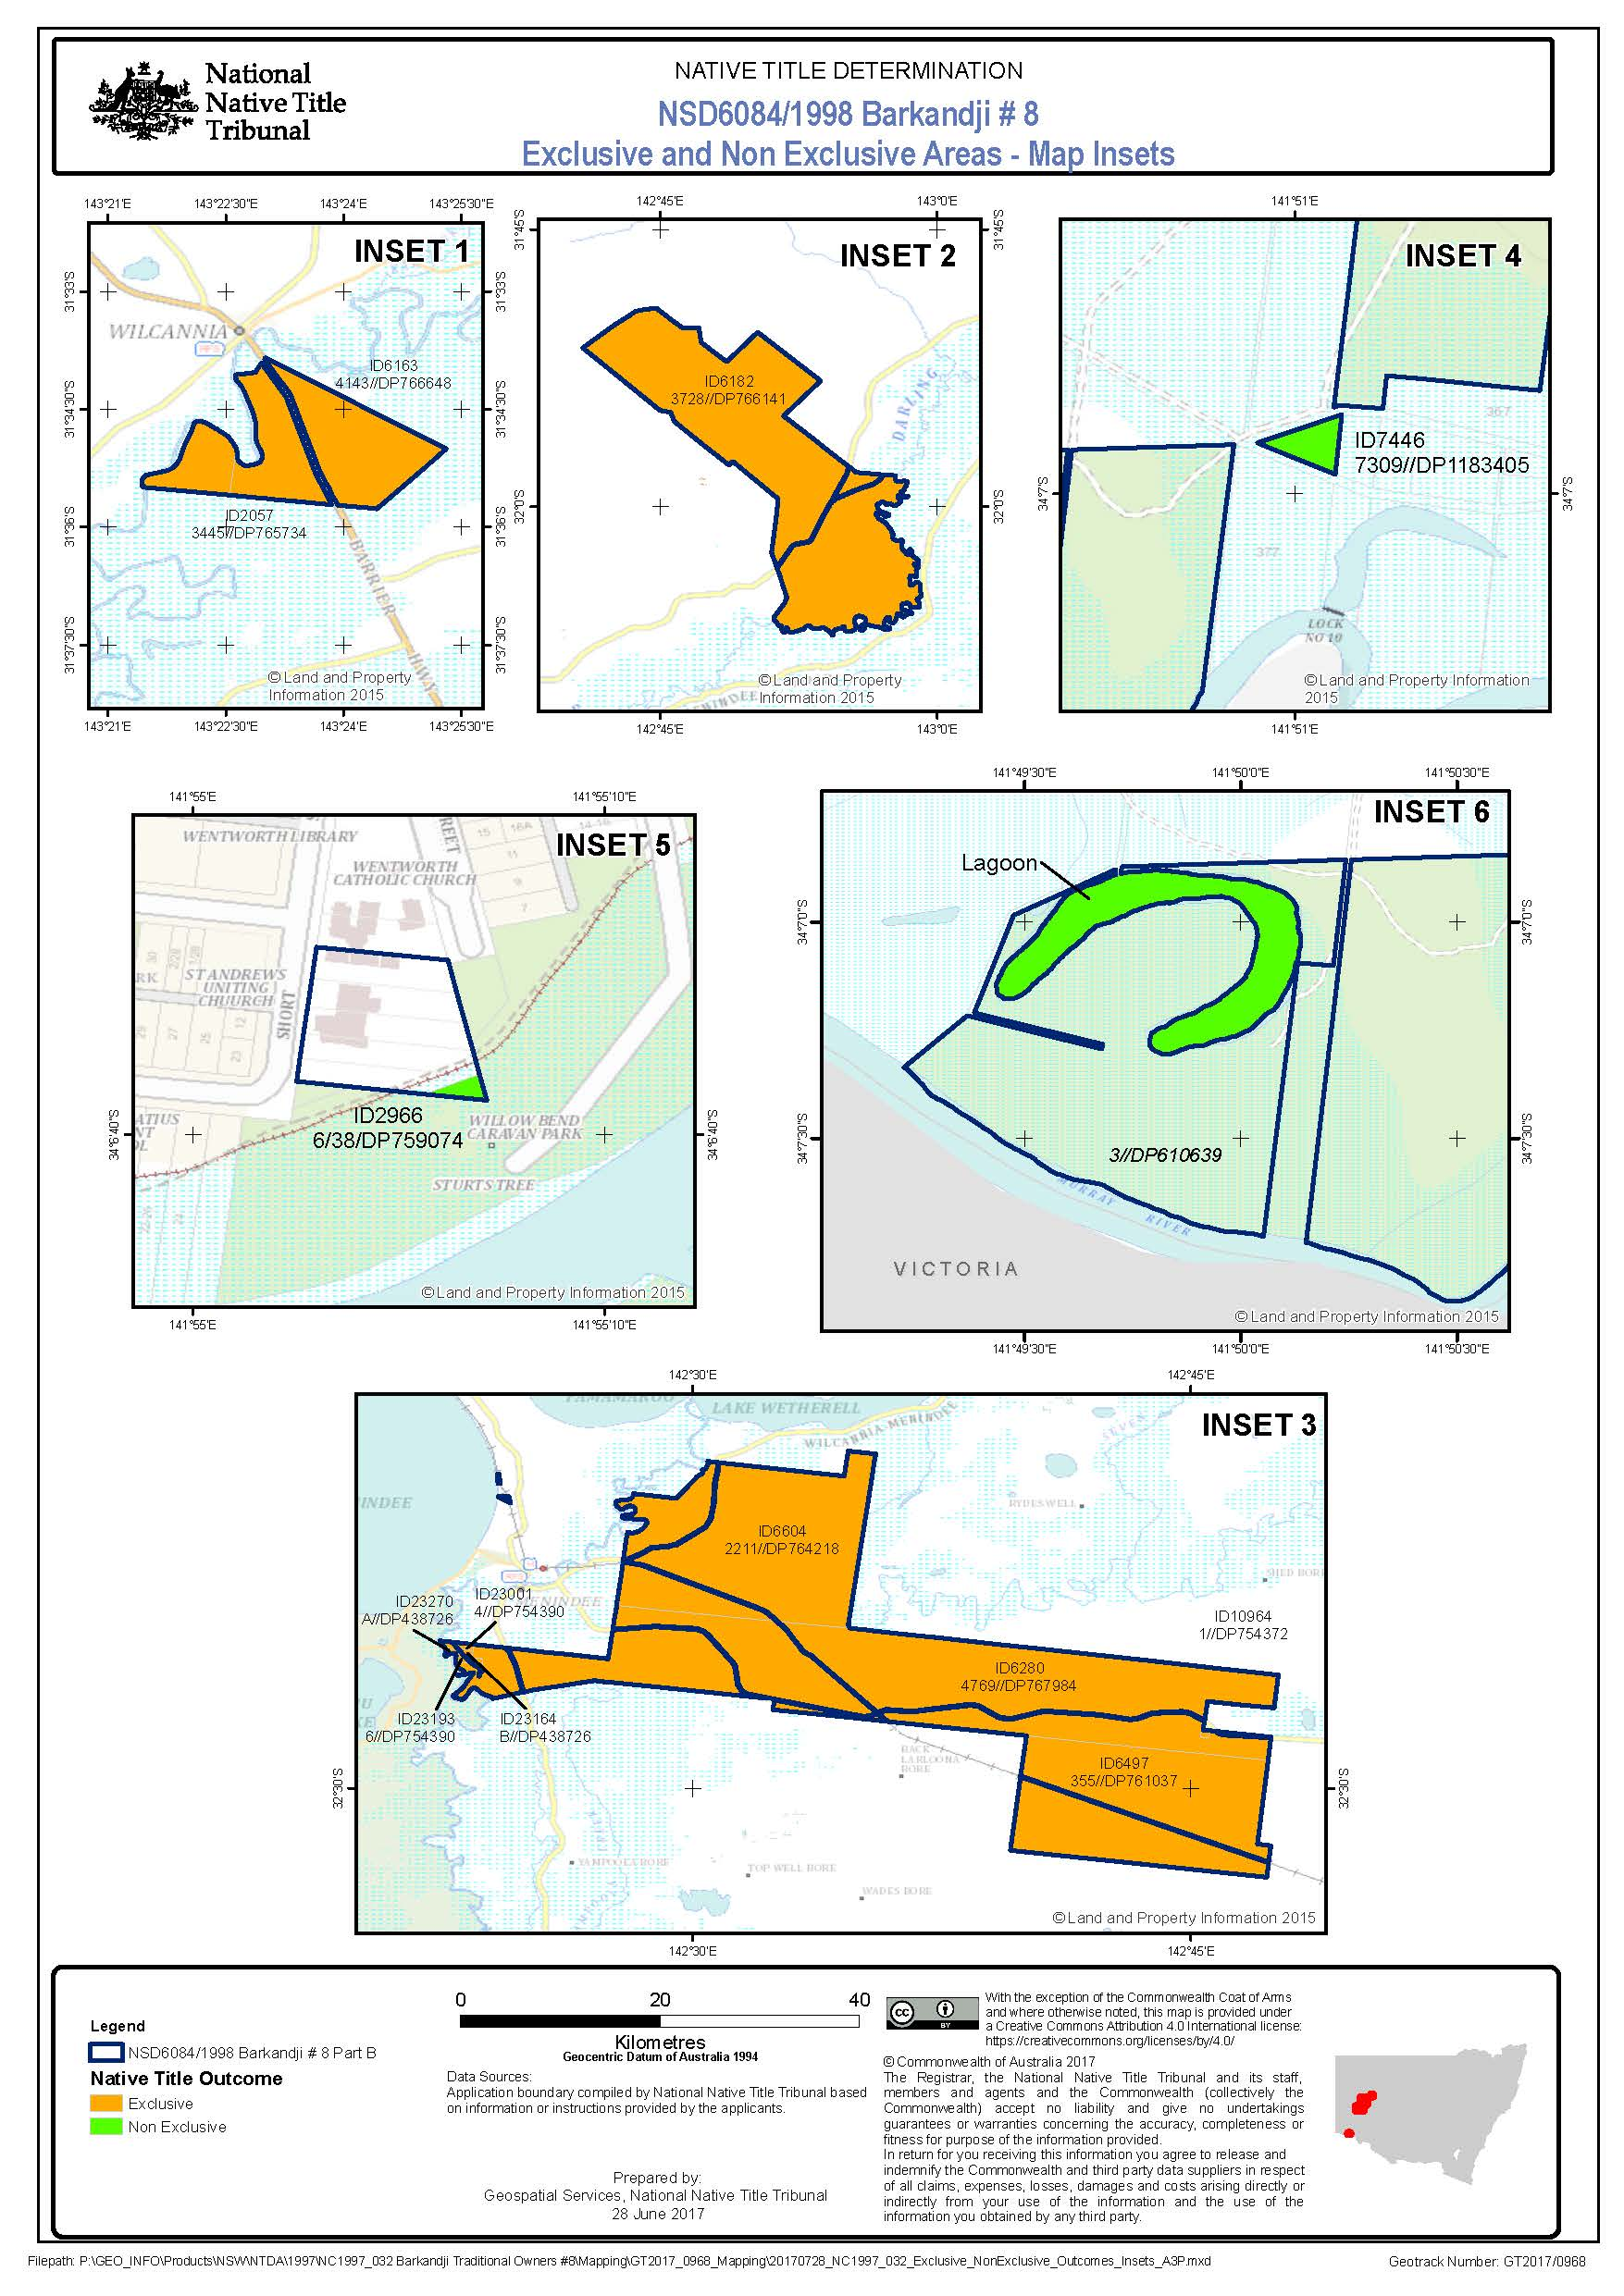

# Schedule Two – Extinguished area

## A. Description of Extinguished Area

1. The Extinguished Area comprises:

(a) the following areas of land or waters which would otherwise be within the Native Title Area:

* + 1. any land or waters on which there is or has been constructed or established valid public works (including any adjacent land or waters as described in s 251D of the *Native Title Act* 1993 (Cth)) which were constructed or established prior to 23 December 1996 or were commenced to be constructed or established on or before that date;
    2. without detracting from the generality of paragraph 1(a)(i), any land or waters upon which a public road is or was commenced to be constructed or established, on or before 23 December 1996; and
    3. any roads established under statute or common law prior to 23 December 1996, and

(b) all the land or waters described in the following list and depicted on the Schedule Two maps and hatched in red, but not any part of them that is within the Native Title Area:

* + 1. Lot 2A/38 in DP 759074 (ID2959),
    2. Lot 3/38 in DP 759074 (ID2961),
    3. Lot 6/38 in DP 759074 (ID2966),
    4. Lot 5/38 in DP 759074 (ID3152),
    5. Lot 4/38 in DP 759074 (ID3402),
    6. Lot 1/4A in DP 759074 (ID2955),
    7. Lot 10/4 in DP 759074 (ID2957),
    8. Lot 2/3 in DP 759074 (ID2958),
    9. Lot 3/3 in DP 759074 (ID2960),
    10. Lot 4/3 in DP 759074 (ID2962),
    11. Lot 5/4 in DP 759074 (ID2964),
    12. Lot 5/4A in DP 759074 (ID2965),
    13. Lot 7/4A in DP 759074 (ID2967),
    14. Lot 8/4A in DP 759074 (ID2968),
    15. Lot 1/3 in DP 759074 (ID3145),
    16. Lot 3/4A in DP 759074 (ID3150),
    17. Lot 5/3 in DP 759074 (ID3151),
    18. Lot 1/4 in DP 759074 (ID3156),
    19. Lot 2/4A in DP 759074 (ID3158),
    20. Lot 4/4 in DP 759074 (ID3161),
    21. Lot 4/4A in DP 759074 (ID3162),
    22. Lot 7/4 in DP 759074 (ID3163),
    23. Lot 8/4 in DP 759074 (ID3164),
    24. Lot 9/4 in DP 759074 (ID3166),
    25. Lot 2/4 in DP 759074 (ID3399),
    26. Lot 3/4 in DP 759074 (ID3401),
    27. Lot 6/4 in DP 759074 (ID3403),
    28. Lot 6/4A in DP 759074 (ID3404),
    29. Lot 3 in DP 610639 (ID6112),
    30. Lot 7336 in DP 1173326 (ID6830),
    31. Lot 7335 in DP 1173326 (ID6831),
    32. Lot 5201 in DP 725295 (ID1826),
    33. Lot 63 in DP 756964 (ID2555),
    34. Lot 51 in DP 756964 (ID2681),
    35. Lot 58 in DP 756964 (ID2682),
    36. Lot 59 in DP 756964 (ID2746),
    37. Lot 4 in DP 610639 (ID2748),
    38. Lot 60 in DP 756964 (ID2879),
    39. Lot 64 in DP 756964 (ID2880),
    40. Lot 5204 in DP 725295 (ID1905),
    41. Lot 7329 in DP 1195006 (ID56),
    42. That part of Lot 7330 in DP 1195006 not subject to former Lot 1 in DP 766881,
    43. SP38548,
    44. Lot 1 in DP 1163941,
    45. Lot 1 in DP 1194853,
    46. Lot 1 in DP 831423,
    47. Lot 19 in DP 735559,
    48. Lot 3 in DP 1181476,
    49. Lot 3 in DP 576696,
    50. Lot 3 in DP 776526,
    51. Lot 31 in DP 756936,
    52. Lot 32 in DP 756936,
    53. Lot 4 in DP 579216,
    54. Lot 4 in DP 733472,
    55. Lot 54 in DP 756936,
    56. Lot 588 in DP 756961,
    57. Lot 591 in DP 756961,
    58. Lot 594 in DP 756961,
    59. Lot 60 in DP 43577,
    60. That part of Lot 3 in DP 1084410 depicted in red hatching in Inset 6 of the Map of the Extinguished Area, and
    61. That part of Lot 1030 in DP 762245 which is within the Parish of Burkett and subject to Reserve R1003476. The remainder of Lot 1030 in DP 762245 forms part of Mungo National Park and is not subject to the Application.

**Note**: The land or waters described above without ID references forms part of the additional 21 parcels that were identified through the mapping process undertaken by the National Native Title Tribunal.

## B. Maps of the Extinguished Area

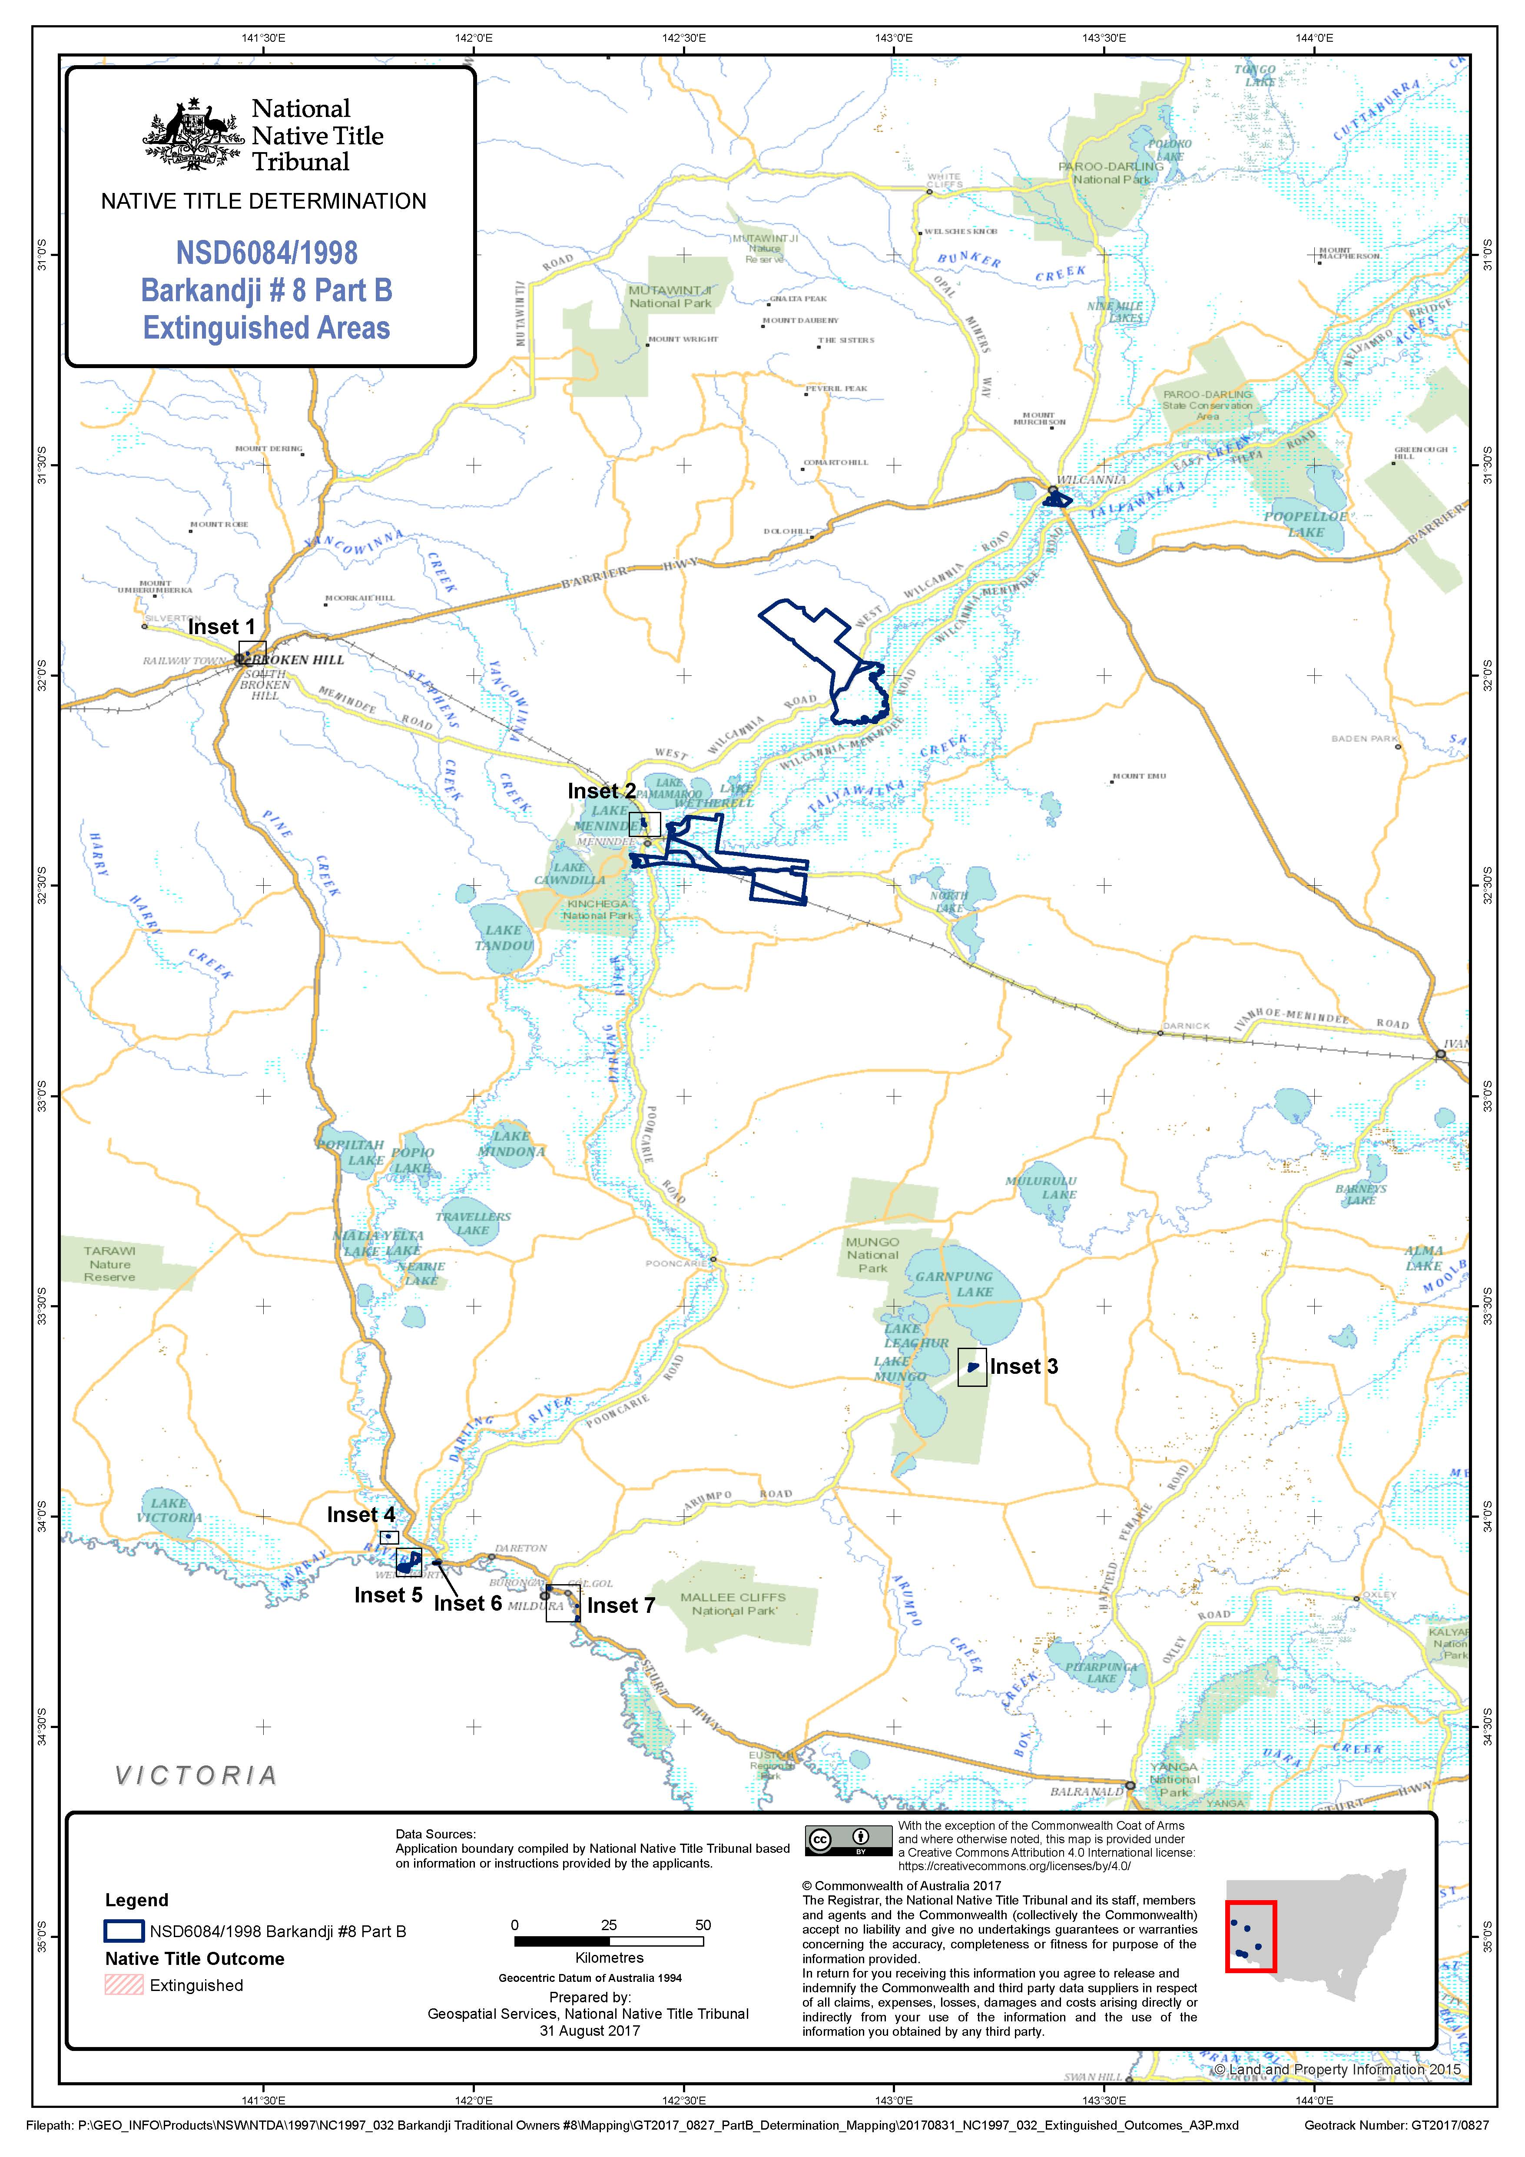

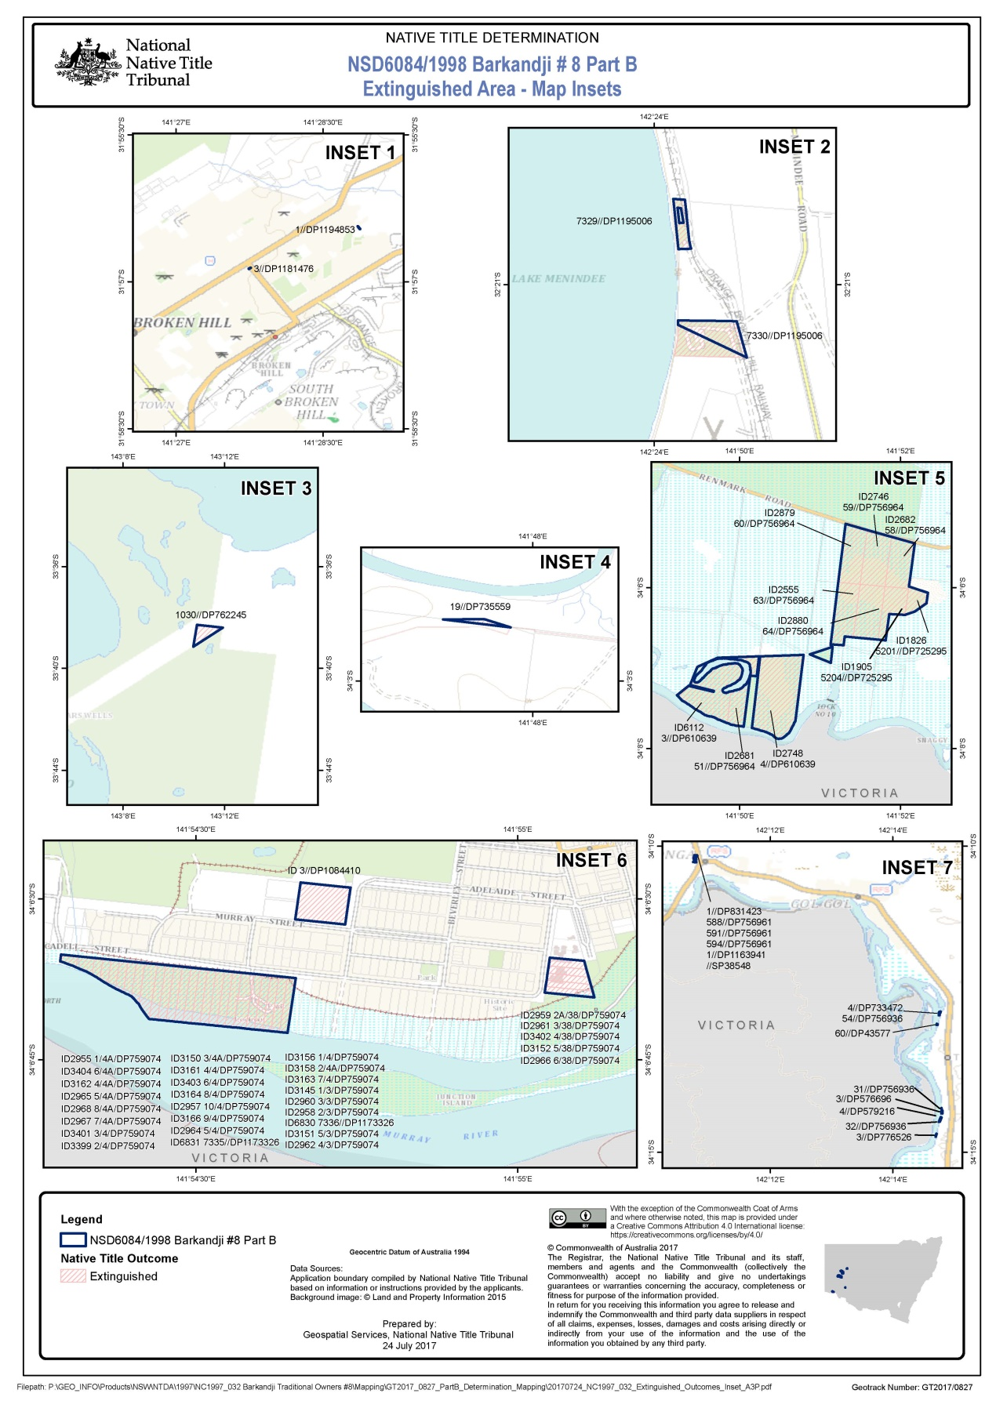

# Schedule Three – AGREEMENTS

1. The Indigenous Land Use Agreement under section 24CA of the *Native Title Act 1993* (Cth) dated 14 August 2017 made between William Charles Bates, Murray Butcher, Derek Hardman, Cyril James Hunter, Mary-Ann Marton, Maureen O'Donnell and Jennifer Jones (formerly Jennifer Whyman), as the registered native title claimant in relation to all of the land or waters in the Application Area, for and on behalf of the Barkandji and Malyangapa People, Barkandji Native Title Group Aboriginal Corporation RNTBC ICN 4740, the Menindee Local Aboriginal Land Council, and the Minister for Lands and Forestry.

2. The Indigenous Land Use Agreement under section 24CA of the *Native Title Act 1993* (Cth) dated 14 August 2017 made between William Charles Bates, Murray Butcher, Derek Hardman, Cyril James Hunter, Mary-Ann Marton, Maureen O'Donnell and Jennifer Jones (formerly Jennifer Whyman), as the registered native title claimant in relation to all of the land or waters in the Application Area, for and on behalf of the Barkandji and Malyangapa People, Barkandji Native Title Group Aboriginal Corporation RNTBC ICN 4740, the Wilcannia Local Aboriginal Land Council, and the Minister for Lands and Forestry.

3. Any other Indigenous Land Use Agreement, which, after this Part B Determination is made, is registered on the Register of Indigenous Land Use Agreements in relation to any land or waters in the Native Title Area within the Determination Area.

# Schedule Four – Other Rights and Interests

The Other Interests, as they exist at the date of this Part B Determination, are as follows:

## 1. Wilcannia and Menindee Local Aboriginal Land Council Interests

The rights and interests of Wilcannia and Menindee Local Aboriginal Land Councils as the holders of a freehold or leasehold title over the areas of land or waters within the Exclusive Area as follows:

|  |  |
| --- | --- |
| Local Aboriginal Land Council | Areas over which freehold or leasehold title held |
| Menindee Local Aboriginal Land Council | (a) Lot 4769 in DP 767984,  (b) Lot 355 in DP 761037,  (c) Lot 2211 in DP 764218,  (d) Lot 1 in DP 754372,  (e) Lot 4 in DP 754390,  (f) Lot B in DP 438726,  (g) Lot 6 in DP 754390, and  (h) Lot A in DP 438726 |
| Wilcannia Local Aboriginal Land Council | (a) Lot 3728 in DP 766141,  (b) Lot 3445 in DP 765734, and  (c) Lot 4143 in DP 766648. |

## 2. Reserves

(a) The rights of organisations or persons who have the care, control and management of any reserves within the Non-Exclusive Area;

(b) The rights of the holders of leases, licences or permits in respect of, or easements or rights of way over, any reserves within the Non-Exclusive Area; and

(c) The rights of persons entitled to access and use any reserves within the Non-Exclusive Area for the respective purposes for which they are reserved, subject to any statutory limitations upon those rights.

## 3. Mining and petroleum interests

(a) The rights of the holders of any mining interests.

(b) The rights of the holders of any petroleum interests.

## 4. Murray-Darling Basin Authority

The rights and interests of the Murray Darling Basin Authority:

(a) as the entity responsible for performing the functions and duties, and exercising the powers, relating to the management of Basin water resources conferred on it by the *Water Act 2007* (Cth) (***Water Act***);

(b) as the entity responsible for performing the functions and duties and exercising the powers conferred on it by the Murray Darling Basin Agreement set out in Schedule 1 of the *Water Act 1912* (NSW), as authorised by Parts 9, 10 and 10A of that Act and Part 3A of the *Water Management Act 2000* (NSW);

(c) created, conferred or imposed pursuant to its functions or duties or the performance thereof, or the exercise of its powers under:

(i) the *Water Act 1912* (NSW) or the *Water Management Act 2000* (NSW) and any regulation or legislative instrument made under either of those Acts;

(ii) the Murray-Darling Basin Agreement set out in Schedule 1 of the *Murray-Darling Basin Act 1992* (NSW) or any corporate plan, asset management plan, asset agreement or service level agreement made, and any river management operations and objectives an outcomes document approved, under that Agreement;

(iii) the Basin Plan adopted by the Minister under the *Murray-Darling Basin Act 1992* (NSW); and

(iv) any resolution or determination of the Murray-Darling Basin Ministerial Council or the Basin Officials Committee made under the Murray-Darling Basin Agreement.

## 5. Telecommunications interests

The rights and interests of Telstra Corporation Limited (ACN 051 775 556) and any other holder of a carrier licence under the *Telecommunications Act 1997* (Cth):

(a) as the owner or operator of telecommunications facilities within the Determination Area;

(b) created pursuant to the *Post and Telegraph Act 1901* (Cth), the *Telecommunications Act 1975* (Cth), the *Australian Telecommunications Corporations Act 1989* (Cth), the *Telecommunications Act 1991* (Cth) and the *Telecommunications Act 1997* (Cth), including rights:

(i) to inspect land; and

(ii) to install and operate telecommunications facilities; and

(iii) to alter, remove, replace, maintain, repair and ensure the proper functioning of its telecommunications facilities.

(c) for its employees, agents or contractors to access its telecommunications facilities in and in the vicinity of the Determination Area in performance of their duties; and

(d) under any lease, licence, access agreement, or easement relating to its telecommunications facilities in the Determination Area.

## 6. Electricity supply interests

(a) The rights and interests of an energy services corporation within the meaning of the *Energy Services Corporations Act 1995* (NSW) to exercise functions, powers or rights in accordance with the laws of the State of New South Wales or of the Commonwealth and as owner and operator of facilities for the transmission of electricity and other forms of energy and associated infrastructure situated on the Determination Area including but not limited to the right to enter the Determination Area in order to access, use, maintain, repair, replace, upgrade or otherwise deal with existing facilities and infrastructure.

(b) The rights and interests of:

(i) a network operator within the meaning of the *Electricity Supply Act 1995* (NSW); and

(ii) for the purposes of any privatisation transaction, any lessor or lessee of a transmission system or person who owns or is authorised to control or operate a transmission system,

to exercise functions, powers or rights in accordance with the law of the State of New South Wales or of the Commonwealth as operator of facilities for the transmission of electricity and other forms of energy and associated infrastructure situated on the Determination Area in order to access, use, maintain, repair, replace, upgrade or otherwise deal with existing facilities and infrastructure.

(c) The rights and interests of Powercor Australia Ltd:

(i) as the owner or operator of electricity facilities within the Determination Area, including overhead and underground cabling; and

(ii) for its employees, agents or contractors to enter the Determination Area in the performance of their duties, to access its electricity facilities in, and in the vicinity of, the Determination Area.

## 7. Local Government interests

The rights and interests of the Broken Hill City Council and Wentworth Shire Council as councils constituted under the *Local Government Act 1993* (NSW).

## 8. Other interests generally

(a) Rights and interests, including licences and permits granted by the Crown in right of the State of New South Wales or of the Commonwealth pursuant to statute or under regulations made pursuant to such legislation.

(b) Rights and interests held by reason of the force and operation of the laws of the State of New South Wales or of the Commonwealth.

(c) Rights and interests of members of the public arising under common law.

(d) So far as is confirmed pursuant to s 18 of the *Native Title (New South Wales) Act 1994* (NSW)as at the date of the Part B Determination, any existing public access to and enjoyment of:

(i) waterways;

(ii) the bed and banks or foreshores of waterways;

(iii) stock routes; and

(iv) areas that were public places at the end of 31 December 1993.

(e) The right of:

(i) an employee, agent or instrumentality of the State of New South Wales;

(ii) an employee, agent or instrumentality of the Commonwealth; and

(iii) an employee, agent or instrumentality of any Local Government Authority;

to access the Native Title Area and carry out actions as required in the performance of his/ her or its statutory or common law duty.

Note: Entry of orders is dealt with in Rule 39.32 of the *Federal Court Rules 2011*.

REASONS FOR JUDGMENT

GRIFFITHS J:

1. Today, the Court will make orders by consent which recognise that the Barkandji and Malyangapa People have, and always have had, native title rights and interests in land within the area the subject of this Part B Determination. The land is situated in far western New South Wales, near Lake Menindee, Lake Mungo and Lake Victoria.
2. It is desirable to say something first about the *Native Title Act (1993)* (Cth) (the ***NT Act***). As Jagot J noted in *Barkandji Traditional Owners #8 v Attorney-General of New South Wales* [2015] FCA 604, the Act takes a relatively rare form. In particular, the Preamble to the Act leaves no doubt as to why the Act was enacted and the important objectives it was intended to achieve. Relevant parts of the Preamble include as follows:

The people whose descendants are now known as Aboriginal peoples and Torres Strait Islanders were the inhabitants of Australia before European settlement.

They have been progressively dispossessed of their lands. This dispossession occurred largely without compensation, and successive governments have failed to reach a lasting and equitable agreement with Aboriginal peoples and Torres Strait Islanders concerning the use of their lands.

As a consequence, Aboriginal peoples and Torres Strait Islanders have become, as a group, the most disadvantaged in Australian society.

…

The people of Australia intend:

(a) to rectify the consequences of past injustices by the special measures contained in this Act, announced at the time of introduction of this Act into the Parliament, or agreed on by the Parliament from time to time, for securing the adequate advancement and protection of Aboriginal peoples and Torres Strait Islanders; and

(b) to ensure that Aboriginal peoples and Torres Strait Islanders receive the full recognition and status within the Australian nation to which history, their prior rights and interests, and their rich and diverse culture, fully entitle them to aspire.

…

A special procedure needs to be available for the just and proper ascertainment of native title rights and interests which will ensure that, if possible, this is done by conciliation and, if not, in a manner that has due regard to their unique character.

1. The Act is significant because it creates a special procedure for the just and proper ascertainment of native title rights and interests so as to ensure that, wherever possible, those rights and interests be established by conciliation rather than by contested, lengthy and expensive litigation. The *NT Act* contains several provisions which give effect to the Parliament’s intention that issues arising under this legislation are to be resolved primarily by negotiation and agreement and not contested litigation. They include:
2. matters must be mediated unless the Court considers that mediation would be unnecessary because of an agreement between the parties or for some other reason specified in the relevant provisions (ss 86A, 86B and 86C);
3. a mediator has important powers to facilitate an effective mediation and the parties attending a mediation are obliged to act in good faith in relation to the conduct of the mediation (ss 94E, 94G and 94P);
4. the Court is empowered to determine any question of fact or law which is referred to it by a mediator (s 86D);
5. the Court is empowered to require a mediator to provide a progress report (s 86E);
6. the parties can request the assistance of the NNTT in negotiating an agreement and an agreement which resolves a native title claim may also include matters other than native title (s 86F(1) and (2));
7. the Court is empowered to adjourn proceedings to allow for negotiation (s 86F(3));
8. the Court is empowered to make an order consistent with the terms of an agreement reached between the parties about the whole or part of any area, including giving effect to an agreement about matters other than native title (ss 87 and 87A); and
9. the Court is empowered to hold conferences “to help in resolving any matter that is relevant to the proceedings” which is presided over by an assessor who is appointed to assist the Court (s 88).
10. The parties in this proceeding are to be congratulated for having finalised proposed orders by consent. As will shortly emerge, however, it is regrettable that it has taken so long to reach this point.
11. It is desirable to now set out some relevant background matters. It is appropriate to warn Aboriginal and Torres Strait Islander people that this document contains names and material about deceased persons.

## Background

1. The Application was originally filed on 8 October 1997. It was amended on 5 August 1999, 11 December 2002, 29 September 2004, 28 June 2006 and 9 June 2015. The Application, as amended on 28 June 2006, was accepted for registration pursuant to s 190A of the *NT Act* on 2 November 2006.
2. On 16 June 2015, the Court recognised that the Barkandji and Malyangapa People hold native title over part of the land or waters within the external boundaries of the Application as it then stood (the **Part A Determination**): see *Barkandji Traditional Owners #8 v Attorney-General of New South Wales* [2015] FCA 604. In the Part A Determination, the Court noted that the “parties have agreed, in respect of the Excluded Area [as that term is defined and the parcels of land identified in Schedule Six of the Part A Determination], no determination is to be made at present”. In her reasons for judgment, Justice Jagot described some of the events which contributed to the lengthy delay in making the Part A Determination (see at [5]-[12]). It is desirable to set out in full [12] of her Honour’s reasons for judgment, with which I respectfully agree:

12. But I have said before, and I say again today, that no one in Australia should have to wait for 18 years to have their claim resolved. Timeliness, efficiency and proportionality are part and parcel of just outcomes. When justice is delayed, it is also denied. No one should be in any doubt. The winds of change are still blowing though how parties deal with native title claims. The glacial pace at which they have moved in the past is palpably unjust. Because one of the factors which delays resolution, tenure searching, is so significant, directions have been made emphasising the need for a reasonably proportionate approach – that is, an investment of resources proportionate to the outcomes to be achieved. No claim can justify the kind of tenure searching which may take years, even decades, to complete. The agreements contemplated by s 87A of the Act, which are an important means of ensuring that the object of resolution by conciliation rather than adversarial litigation is achieved, necessarily involve all kinds of mutual compromises. There is no reason that such compromises cannot extend to the determination of issues of tenure. Indeed, in my view, it is essential they do so because, presently, that is the only way in which timely resolutions of native claims becomes possible. Against the background of the Court’s enabling legislation (ss 37M and 37N of the *Federal Court of Australia Act 1976* (Cth)), which provides that the overarching purpose of all civil procedures is to facilitate the just resolution of disputes, according to law, and as quickly, inexpensively and efficiently as possible, the need for such an approach is inescapable. Other approaches may also be necessary. One possibility is to require tenure issues to be resolved before that of connection is dealt with. Negotiations would then take place about the actual land which is able to be the subject of native title rights and interests.

1. Consideration such as these informed the Court’s decision to hold a joint case management hearing, involving this and other proposed consent determinations, on 4 August 2017 (Nos NSD 6084 of 1998; NSD 168 of 2011 and NSD 2300 of 2011). The Court was concerned to avoid any further slippage in finalising these consent determinations.
2. On 28 February 2017, the Court granted the Applicant leave to file a further amended Application to reduce the claim area to parts of the land or waters identified in Schedule Six of the Part A Determination. Such further amended Application was filed on 16 March 2017. On 13 April 2017, the National Native Title Tribunal (**NNTT**) wrote to the Applicant confirming that the further amended Application had been accepted for registration pursuant to s 190A(6A) of the *NT Act*.
3. The further amended Application is brought by the Barkandji and Malyangapa People who comprise all the descendants of the following apical ancestors:

(i) Manfred Mary/Mary Johnson/Mary Brodie,

(ii) Manfred Tommy,

(iii) Louisa Brown,

(iv) Cuthero Jack Brown,

(v) Susan/Annie Webster,

(vi) Bill Webster,

(vii) Harry Whyman,

(viii) Kate Whyman,

(ix) Louisa McLean,

(x) Alec McLean,

(xi) Nganya,

(xii) Sarah Cabbage,

(xiii) Harry Mitchell,

(xiv) Daniel McGregor,

(xv) Lucy Benson,

(xvi) Jack “Doctor” Benson,

(xvii) Crancey,

(xviii) Jack Tyler,

(xix) Taylor Matjulum Gibson,

(xx) Tottie Gibson,

(xxi) Kutyi,

(xxii) Cate Newton/Maggie Tyler,

(xxiii) Albert Bates,

(xxiv) Fanny Bates,

(xxv) Yancannia Kitty,

(xxvi) Judy Quayle,

(xxvii) Nancy Watts,

(xxviii) Topsie Crowe,

(xxix) Alec Bridge,

(xxx) Olive Barton,

(xxxi) Margaret Payne,

(xxxii) Kitty Knight,

(xxxiii) Jacky Knight,

(xxxiv) Matilda Murray,

(xxxv) Paddy Black,

(xxxvi) Hero Black,

(xxxvii) Tall Boy Keegan,

(xxxviii) Kitty Keegan,

(xxxix) Fanny Buugali Williams,

and persons adopted into the families of those persons who identify as, and are accepted as, members of the Barkandji and Malyangapa People in accordance with Barkandji and Malyangapa traditional laws and customs (and the biological descendants of any such adopted persons).

## Claim area

1. The claim area covered by the further amended Application comprises 73 parcels of land and waters, 52 of which were part of the Excluded Area in Sch 6 to the Part A Determination. The remaining 21 parcels in the claim area comprise areas of land which the parties were not aware of at the time of the Part A Determination, and were only discovered following further mapping by the NNTT. The total claim area is referred to as the **Part B Area**.
2. Since the Part A Determination, the parties to the proceedings have negotiated and mediated with a view to reaching agreement on drafting the terms of an approved determination of native title under the *NT Act* with respect to the Part B Area.
3. In a joint submission, the parties submitted that there are no overlapping or competing native title claims over the Part B Area and no Aboriginal or other respondents who oppose the claim.
4. The Part B Determination is over the following parcels of land, including lands and waters where native title has been extinguished:

## A. Reserves managed by Wentworth Shire Council

* 1. Lot 2A/38 in DP 759074
  2. Lot 3/38 in DP 759074
  3. Lot 6/38 in DP 759074
  4. Lot 5/38 in DP 759074
  5. Lot 4/38 in DP 759074
  6. Lot 1/4A in DP 759074
  7. Lot 10/4 in DP 759074
  8. Lot 2/3 in DP 759074
  9. Lot 3/3 in DP 759074
  10. Lot 4/3 in DP 759074
  11. Lot 5/4 in DP 759074
  12. Lot 5/4A in DP 759074
  13. Lot 7/4A in DP 759074
  14. Lot 8/4A in DP 759074
  15. Lot 1/3 in DP 759074
  16. Lot 3/4A in DP 759074
  17. Lot 5/3 in DP 759074
  18. Lot 1/4 in DP 759074
  19. Lot 2/4A in DP 759074
  20. Lot 4/4 in DP 759074
  21. Lot 4/4A in DP 759074
  22. Lot 7/4 in DP 759074
  23. Lot 8/4 in DP 759074
  24. Lot 9/4 in DP 759074
  25. Lot 2/4 in DP 759074
  26. Lot 3/4 in DP 759074
  27. Lot 6/4 in DP 759074
  28. Lot 6/4A in DP 759074
  29. Lot 3 in DP 610639
  30. Lot 7336 in DP 1173326
  31. Lot 7335 in DP 1173326
  32. Lot 5201 in DP 725295
  33. Lot 63 in DP 756964
  34. Lot 51 in DP 756964
  35. Lot 58 in DP 756964
  36. Lot 59 in DP 756964
  37. Lot 4 in DP 610639
  38. Lot 60 in DP 756964
  39. Lot 64 in DP 756964
  40. Lot 5204 in DP 725295
  41. Lot 7329 in DP 1195006

## B. Parcels held by LALCs in freehold or leasehold

## Menindee Local Aboriginal Land Council

* 1. Lot 4769 in DP 767984,
  2. Lot 355 in DP 761037,
  3. Lot 2211 in DP 764218,
  4. Lot 1 in DP 754372,
  5. Lot 4 in DP 754390,
  6. Lot B in DP 438726,
  7. Lot 6 in DP 754390, and
  8. Lot A in DP 438726

## Wilcannia Local Aboriginal Land Council

* 1. Lot 3728 in DP 766141,
  2. Lot 3445 in DP 765734, and
  3. Lot 4143 in DP 766648.

## C. Additional 21 parcels within claim area identified by NNTT

* 1. Lot 7330 in DP 1195006,
  2. SP38548,
  3. Lot 1 in DP 1163941,
  4. Lot 1 in DP 1194853,
  5. Lot 1 in DP 831423,
  6. Lot 19 in DP 735559,
  7. Lot 3 in DP 1181476,
  8. Lot 3 in DP 576696,
  9. Lot 3 in DP 776526,
  10. Lot 31 in DP 756936,
  11. Lot 32 in DP 756936,
  12. Lot 4 in DP 579216,
  13. Lot 4 in DP 733472,
  14. Lot 54 in DP 756936,
  15. Lot 588 in DP 756961,
  16. Lot 591 in DP 756961,
  17. Lot 594 in DP 756961,
  18. Lot 60 in DP 43577,
  19. Lot 3 in DP 1084410,
  20. Lot 1030 in DP 762245, and
  21. Lot 7329 DP 1195006.

1. The land and waters in **A** above comprise Crown land which is the subject of reservation under *Crown Lands Consolidation Act 1913*(NSW).These aremanaged by the Wentworth Shire Council pursuant to the *Crown Lands Act 1989* (NSW).
2. The land and waters in **B** above are held bythe Menindee Local Aboriginal Land Council and the Wilcannia Local Aboriginal Land Council.
3. The land and waters in **C** above comprise an additional 21 parcels identified by the NNTT during the mapping of the claim area in the further amended Application. These additional parcels had not been included in Schedule Six to the Part A Determination. In these additional 21 parcels, it has been agreed that native title has been extinguished.
4. Since the Part A Determination, the parties have reached agreement as to the terms of a determination of native title to be made by consent in relation to the land and waters listed in the Determination Area, as follows:

(a) native title exists in relation to land or waters in the Native Title Area, and

(b) native title has been extinguished in relation to the land or waters in the Extinguished Area.

1. The Native Title Area comprises the following:

(a) the Exclusive Area, which are the lands or waters to which s 47A of the *NT Act* applies and are described in Part 1 of Schedule One of the Part B Determination. For the Exclusive Area, the parties reaching agreement as to the terms of the Part B Determination have been facilitated by the making of the agreements referred to in paragraphs 1 and 2 of Schedule Three (**LALC Lands ILUAs**); and

(b) the Non-Exclusive Area, which are the lands or waters described in Part 2 of Schedule One of the Part B Determination.

1. The lands and waters which the parties have agreed should be the subject of a determination that native title has been wholly extinguished are referred to as the “Extinguished Area”. These are described in Schedule Two of the Part B Determination.

## Requirements for a consent determination

1. In order for a determination by consent to be made in relation to part of the claim area the requirements of s 87A of the *NT Act* must be met.  Those requirements are:

(a) the notification period specified in s 66 has expired (s 87A(1)(b));

(b) agreement between the parties has been reached on a proposed determination of native title which has been reduced to writing and signed by or on behalf of each of those parties (s 87A(1)(b), (c) & (d));

(c) a copy of the terms of the proposed determination has been filed with the Court (s 87A(2));

(d) the Federal Court Chief Executive Officer has given notice to the other parties to the proceeding that the proposed determination of native title has been filed with the Court (s 87A(3));

(e) the Court has taken into account any objection made by the other parties to the proceeding (s 87A(8));

(f) the Court is satisfied that an Order consistent with the terms of the agreement would be within the power of the Court (s 87A(4)(a)); and

(g) it appears appropriate to make the Order (s 87A(4)(b)).

1. I find that the first three requirements, which are essentially procedural, are satisfied here:

(a) notification was complete on 28 February 2001; and

(b) the terms of the proposed consent determination have been reduced to writing, signed and filed with these submissions.

1. The requirement that the proposed orders be within the power of the Court and the appropriateness of the orders under s 87A(4) are closely related issues and decisions of the Court have considered them together.
2. As to the power of the Court, it is appropriate to note that, pursuant to s 13 and Pts 3 and 4 of the *NT Act*, the Court may make determinations concerning native title in relation to areas over which there is no existing approved determination. There is no approved determination of native title for any part of the claim area in this proceeding.
3. Further, an order is within the power of the Court if it is consistent with s 94A of the *NT Act*. That section requires the proposed orders to set out details of the matters mentioned in s 225 of the *NT Act*. Section 225 defines a ***determination of native title*** as:

*a determination whether or not native title exists in relation to a particular area (the determination area ) of land or waters and, if it does exist, a determination of:*

*(a) who the persons, or each group of persons, holding the common or group rights comprising the native title are; and*

*(b) the nature and extent of the native title rights and interests in relation to the determination area; and*

*(c) the nature and extent of any other interests in relation to the determination area; and*

*(d) the relationship between the rights and interests in paragraphs (b) and (c) (taking into account the effect of this Act); and*

*(e) to the extent that the land or waters in the determination area are not covered by a non-exclusive agricultural lease or a non-exclusive pastoral lease--whether the native title rights and interests confer possession, occupation, use and enjoyment of that land or waters on the native title holders to the exclusion of all others.*

1. Evidently, by the terms of s 225 a “determination of native title” includes both a determination that native title does exist and a determination that native title does not exist in relation to particular lands and/or waters (as to a determination that native title does not exist, see *Wyman on behalf of the Bidjara People v State of Queensland (No 4)* [2014] FCA 93). It has been accepted by this Court that the power under ss 87 and 87A extends to making a determination that native title has been extinguished: *Starkey v State of South Australia* [2014] FCA 924, especially at [86].
2. In exercising its discretion under s 87A, the Court must apply the same principles as those applying under s 87: *WF (Deceased) on behalf of the Wiluna People v State of Western Australia* [2013] FCA 755 (***WF***)at [29]. That discretion must be exercised judicially and within the broad boundaries ascertained by reference to the subject matter, scope and purpose of the *NT Act*: *WF* at [29].
3. In the context of a determination of native title by consent, Mansfield J in *Lander v South Australia* [2012] FCA 427 said:

The focus of the Court in considering whether the orders sought are appropriate under s 87 is on the making of the agreement by the parties. In *Lovett on behalf of the* *Gunditjmara People v State of Victoria* [2007] FCA 474 North J stated at [36]-[37] that:

The Act [Native Title Act] is designed to encourage parties to take responsibility for resolving proceeding without the need for litigation. Section 87 must be construed in this context. The power must be exercised flexibly and with regard to the purpose for which the section is designed.

In this context, when the court is examining the appropriateness of an agreement, it is not required to examine whether the agreement is grounded on a factual basis which would satisfy the Court at a hearing of the application. The primary consideration of the Court is to determine whether there is an agreement and whether it was freely entered into on an informed basis: *Nangkiriny v State of Western Australia* (2002) 117 FCR 6; [2002] FCA 660, *Ward v State of Western Australia* [2006] FCA 1848. Insofar as this latter consideration applies to a State party, it will require the Court to be satisfied that the State party has taken steps to satisfy itself that there is a credible basis for an application: *Munn v Queensland* (2001) 115 FCR 109; [2001] FCA 1229.

Therefore, the Court does not need to embark on its own inquiry of the merits of the claim made in the application to be satisfied that the orders sought are supportable and in accordance with the law: *Cox on behalf of the Yungngora People v State of Western Australia* [2007] FCA 588 at [3] per French J. However, it might consider that evidence for the limited purpose of being satisfied that the State is acting in good faith and rationally: *Munn for and on behalf of the Gunggari People v State of Queensland* (2001) 115 FCR 109 at [29]-[30] per Emmett J…

1. By order 2 the Part B Determination is to take effect upon the LALC Lands ILUAs being registered on the Register of Indigenous Land Use Agreements. As noted above, the LALC Lands ILUAs are an important part of the compromise made by the parties to reach agreement with respect to the Exclusive Area.
2. On 24-25 July 2017, NTSCORP Limited convened an Indigenous Land Use Agreement Authorisation meeting in relation the Indigenous Land Use Agreement described at paragraph 2 of Sch Three of the Part B Determination (**Weinteriga and Yobel Station ILUA**). At that meeting the attendees authorised the members of the Applicant, as the registered native title claimant, to enter the Weinteriga and Yobel Station ILUA for and on behalf of the Barkandji and Malyangapa People. All members of the Applicant have executed the Weinteriga and Yobel Station ILUA.
3. On 25 July 2017 NTSCORP Limited convened an Indigenous Land Use Agreement Authorisation meeting in relation the Indigenous Land Use Agreement described at paragraph 1 of Sch Three of the Part B Determination (**Appin Station ILUA**). At that meeting the attendees authorised the members of the Applicant, as the registered native title claimant, to enter the Appin Station ILUA for and on behalf of the Barkandji and Malyangapa People. All members of the Applicant have executed the Appin Station ILUA.
4. The Court has power to make an order in the form of order 2 of the Part B Determination such that this Determination of native title takes effect upon the registration of the two LALC Lands ILUAs: see *Doyle on behalf of the Kalkadoon People #4 v State of Queensland (No 3)* [2011] FCA 1466 (per Dowsett J); *Doctor on behalf of the Bigambul People v State of Queensland* [2016] FCA 1447 (per Reeves J); *Bullen on behalf of the Esperance Nyungar People v State of Western Australia* [2014] FCA 197 (per McKerracher J) and *Cashmere on behalf of the Jirrbal People #1 v State of Queensland* [2010] FCA 1090 (per Dowsett J).

## Applicant’s evidence

1. Prior to filing the further amended Application, the Applicant had provided to the State 36 lay witness affidavits on a confidential and without prejudice basis. The Applicant had also provided the following expert material on a confidential and without prejudice basis:

a. Anthropological reports by Dr Ken Lum:

i. “Barkandji Traditional Owners #8 Native Title Determination Application NSD6084/98 (NC97/32) Report for Mediation,” Ken Lum, NTSCORP, 11 December 2007;

ii “Barkandji Traditional Owners #8 Native Title Determination Application NSD6084/98 (NC97/32) Draft Supplementary Anthropological Report,” Ken Lum, NTSCORP, 20 November 2009;

iii “Barkandji Traditional Owners #8 Native Title Determination Application NSD6084/98 (NC97/32) Connection Report,” Ken Lum, NTSCORP, 7 March 2012. Supplied under s.94L Direction of 7 March 2012;

iv “Barkandji Traditional Owners #8 Native Title Determination Application NSD6084/98 (NC97/32) Connection Report,” by Ken Lum dated 25 January 2013. Supplied under confidentiality agreement of 29 January 2013.

b. Historical and other reports:

i. “Report for the Paakantji Claimants: Wentworth Native Title Claim NC95/10,” Sarah Martin, for NSWALC, May 1999;

ii "Historical Report of Kate Waters, Part 1 of 2," Kate Waters, 11 September 2007;

iii “Historical Report of Kate Waters, Part 2 of 2: Documents”, Kate Waters, 11 September 2007;

iv “Preliminary Report to the NSW Aboriginal Land Council: The Paakantyi Language Group and its position, 1788-1850,” LA Hercus, September 1998 (supplied with 2 volume set of source material on 19 May 2008).

c. Genealogical material:

i. Barkandji Gedcom Files. (Data files for claimant families, readable on genealogy software);

ii Genealogies of Fanny Buugali Williams, and two sample genealogies of claim group members, attached to letter of 29 November 2012.

d. Two volumes of source material provided on 19 May 2008.

1. In addition, the Applicant had filed the following expert material with the Court, on the following dates:

a. Anthropological Reports of Dr Ken Lum:

i. Connection Report, filed 17 April 2013; and

ii. Expert Anthropological Report, filed 5 November 2013.

b. Expert Linguist Report of Dr Luise Hercus filed 27 September 2013; and

c. Expert Historical Report of Kate Waters, filed 30 October 2013

1. The Applicant also filed 14 witness outlines of evidence between 1-6 November 2013.

## Consideration by the State

1. The State’s analysis of the Applicant’s connection evidence and other relevant material is described in the Affidavit of Sophia Illiadis affirmed 12 June 2015. That process of consideration included, *inter alia*:

a. commissioning a review by an independent anthropologist of the anthropological reports provided by the Applicant;

b. having the Applicant’s connection evidence and other relevant material reviewed and critiqued by experienced in-house researchers with tertiary qualifications in history and anthropology;

c. seeking clarification from the Applicant of various matters in relation to which the evidence was not considered sufficiently clear;

d. obtaining a number of detailed joint opinions from senior and junior counsel as to whether the evidence provided a proper basis for accepting the existence of native title.

1. Following this process the State was satisfied that the Applicant’s native title claim had a credible basis sufficient to justify the State in resolving the claim by way of consent determination. The end result, after compromises by the Applicant and the State, being the Part A Determination.
2. Because the Part B Area is within the claim area set out in the Application accepted for registration pursuant to s 190A of the *NT Act* on 2 November 2006 and already subject to the process described in paragraphs 36 and 37 above, the State accepts that it is unnecessary for it to undertake a fresh consideration of matters relevant to the question of the claimant group’s connection. The State accepts that the claim, as currently framed, has a credible basis sufficient to justify the State in resolving the proceedings by consent and entering into the Part B Determination.
3. Further compromises by the Applicant and the State were made in order to agree to the terms of the draft Part B Determination and s 87A agreement.

## Recognition of native title

1. Following the process of case management, mediation and negotiation engaged in by the parties, the parties have agreed to ask the Court to make a determination by consent of the native title rights and interests in the Native Title Area on terms as detailed below.
2. First, in respect of the Exclusive Area, the right of possession, occupation, use and enjoyment to the exclusion of all others.
3. Secondly, in respect of the Non-Exclusive Area:

a. the right to enter, travel over and remain on the Non-Exclusive Area;

b. the right to take and use the natural resources (other than water) of the Non-Exclusive Area;

c. the right to take and use the water of the Non-Exclusive Area for personal, domestic and communal purposes (including cultural purposes and for watering native animals, cattle and other stock, and watering gardens not exceeding 2 hectares), but not extending to a right to control the use and flow of the water in any rivers or lakes which flow through or past or are situate within the land of two or more occupiers;

d. the right to camp and for that purpose to erect temporary shelters and temporary structures in the Non-Exclusive Area;

e. the right to light fires in the Non-Exclusive Area for domestic purposes, but not for the clearance of vegetation;

f. the right to engage in cultural activities on the land, to conduct ceremonies, to hold meetings, and to participate in cultural practices relating to birth and death including burials on the land the subject of the Non-Exclusive Area;

g. the right to have access to, to maintain and to protect from physical harm sites and places of importance in the Non-Exclusive Area which are of significance to the Barkandji and Malyangapa People under their traditional laws and customs;

h. the right to teach on the Non-Exclusive Area the physical, cultural and spiritual attributes of places and areas of importance on or in the Non-Exclusive Area;

i. the right to hunt in the Non-Exclusive Area;

j. the right to fish in the Non-Exclusive Area; and

k. the right to be accompanied on the Non-Exclusive Area by persons who, though not Native Title Holders, are:

i. spouses, partners or parents of Native Title Holders, together with their children and grandchildren;

ii. people whose presence is required under traditional laws and customs for the performance of cultural activities, practices or ceremonies; and

iii. people requested by the Native Title Holders to assist in, observe or record cultural activities, practices or ceremonies.

1. The native title rights and interests in the Non-Exclusive Area do not confer on the native title holders rights of possession, occupation, use or enjoyment to the exclusion of all others, and nor do they confer any right to control public access to, or public use of, the land or waters within the Non-Exclusive Area.
2. Thirdly, in respect of the Extinguished Areas, a determination that native title has been wholly extinguished. The areas in which native title has been extinguished include land and water covered by public works and the areas adjacent to those public works, the use of which is necessary for or incidental to those public works.
3. It is agreed that native title does not exist in minerals or petroleum as defined in paragraph 7 of the Part B Determination.
4. The nature and extent of the other interests in relation to the Native Title Area are the current interests created or recognised at the date of the determination by the Crown, statute or common law, as set out in Sch Four of the Part B Determination.
5. The State has caused a search to be made of the tenure history of each parcel of land within the Exclusive Areas, the Non-Exclusive Area and the Extinguished Area. The results of that search were provided to the Applicant’s legal representatives, who have conducted their own analysis. The State is satisfied that the terms of the Part B Determination protect current interests and are consistent with current and historical tenure dealings.

## Determination of the prescribed body corporate

1. Section 56 of the *NT Act* provides that one of the determinations that the Federal Court must make is whether the native title is to be held in trust, and, if so, by whom. Section 56(2) sets out the steps the Court must take in making the determination, including:

a. requesting a representative of the native title holders to indicate whether their title is to be held in trust by:

i. nominating a prescribed body corporate to be the trustee; and

ii. including with the nomination the written consent of the body corporate.

1. The Applicant has indicated that the common law holders intend to have their native title held on trust, as set out in order 4 of the Part B Determination.
2. Where the native title rights and interests are to be held on trust by a prescribed body corporate, the body corporate must also perform:
3. any other function given to it as a registered native title body corporate under particular provisions of the NTA; and
4. any functions given to it as a registered native title body corporate under the regulations.
5. The Barkandji Native Title Group Aboriginal Corporation ICN 4740 has been nominated to be the prescribed body corporate for the purposes of s 57(1) of the *NT Act* and to act as trustee for the Barkandji and Malyangapa People who are the common law holders of the native title rights and interests and to perform the functions set out in s 57(1) of the *NT Act* and the *Native Title (Prescribed Bodies Corporate) Regulations 1999* (Cth).

## Authorisation by the claim group

1. On 24 June 2016 and 26 July 2017, the members of the Barkandji Traditional Owners native title claim group held claim group meetings in relation to the proposed determination and the nomination of the Barkandji Native Title Group Aboriginal Corporation RNTBC to hold their native title on trust.
2. The claim group has authorised the Applicant to consent to the draft determination in these proceedings in accordance with the draft determination presented to the meetings on 24 June 2016 and 26 July 2017.

## Why the orders should be made

1. The Court is asked to make orders under s 87A of the *NT Act* in accordance with the agreed terms of the parties.
2. In support of this application, the following documents have been filed:
3. a Minute of Consent Orders which have been signed by each of the parties to the proceeding (the **Orders**);
4. a Minute of Consent Determination of Native Title (the **Minute**); and
5. affidavits by Mr Alexander Chalmers, Dr Ken Lum and Ms Sophia Illiadis.
6. Having regard to the material which has been placed before the Court, including the joint submissions which have been summarised above, I am satisfied that the relevant requirements of ss87A and 94A of the *NT Act* are met and that it is appropriate to make the Part B Determination.
7. The Court will now make orders by consent in accordance with the Minute.

|  |
| --- |
| I certify that the preceding fifty-seven (57) numbered paragraphs are a true copy of the Reasons for Judgment herein of the Honourable Justice Griffiths. |

Associate:

Dated: 22 August 2017