FEDERAL COURT OF AUSTRALIA

Stuart v State of South Australia (No 3) [2021] FCA 230

|  |  |
| --- | --- |
| File number: | SAD 38 of 2013 |
|  |  |
| Judgment of: | **CHARLESWORTH J** |
|  |  |
| Date of judgment: | 17 March 2021 |
|  |  |
| Catchwords: | **NATIVE TITLE** – determination of native title by consent pursuant to s 87A of the *Native Title Act 1993* (Cth) |
|  |  |
| Legislation: | *Native Title Act 1993* (Cth) ss 24IB, 24JA, 55, 57, 66, 67, 87A, 94A, 223, 225, 251D  *Crown Land Management Act 2009* (SA) s 70  *Crown Lands Act 1929* (SA) s 5  *Mining Act 1971* (SA) s 6  *Natural Resources Management Act 2004* (SA)  *Opal Mining Act 1995* (SA)  *Petroleum and Geothermal Energy Act 2000* (SA) s 4 |
|  |  |
| Cases cited: | *Adnyamathanha No 1 Native Title Claim Group v The State of South Australia (No 2)* [2009] FCA 359  *Cox on behalf of the Yungngora People v State of Western Australia* [2007] FCA 588  *Dodd v State of South Australia* [2012] FCA 519  *Lander v State of South Australia* [2012] FCA 427  *Lovett on behalf of the Gunditjmara People v State of* *Victoria* [2007] FCA 474  *Nelson v Northern Territory* (2010) 190 FCR 344  *Risk v Northern Territory of Australia* [2006] FCA 404  *Smirke on behalf of the Jurruru People v State of Western Australia (No 2)* [2020] FCA 1728  *Sumner v State of South Australia (Ngarrindjeri Native Title Claim Part A)* [2017] FCA 1514  *Yorta Yorta Aboriginal Community v Victoria* (2002) 214 CLR 422 |
|  |  |
| Division: | General Division |
|  |  |
| Registry: | South Australia |
|  |  |
| National Practice Area: | Native Title |
|  |  |
| Number of paragraphs: | 27 |
|  |  |
| Date of last submissions: | 17 February 2021 |
|  |  |
| Date of hearing: | Determined on the papers |
|  |  |
| Counsel for the Applicant: | Mr S Kenny |
|  |  |
| Solicitor for the Applicant: | Camatta Lempens |
|  |  |
| Counsel for the Respondent: | Mr P Tonkin |
|  |  |
| Solicitor for the Respondent: | Crown Solicitor’s Office |

ORDERS

|  |  |  |
| --- | --- | --- |
|  | | SAD 38 of 2013 |
|  | | |
| BETWEEN: | AARON STUART, JOANNE WARREN, PETER WATTS AND GREG WARREN (SNR)  Applicant | |
| AND: | STATE OF SOUTH AUSTRALIA  Respondent | |

|  |  |
| --- | --- |
| order made by: | CHARLESWORTH J |
| DATE OF ORDER: | 17 MARCH 2021 |

# PREAMBLE

A The Applicant first lodged Native Title Determination Application No SAD 38 of 2013 (the Application) with the Federal Court on 1 March 2013 in relation to two separate areas of land in northern South Australia. Part 1 of the Application is now the subject of a proposed determination of native title.

B The Applicant and the State of South Australia have reached an agreement as to the terms of a determination of native title to be made in relation to Part 1 of the land covered by the Application. They have filed with this Court pursuant to section 87A of the *Native Title Act 1993* (Cth) (the *Native Title Act*) an agreement in writing to seek the making of consent orders for a determination.

C The Parties acknowledge that the effect of the making of the determination will be that the members of the native title claim group, in accordance with the traditional laws acknowledged and the traditional customs observed by them, will be recognised as the native title holders for the Determination Area as defined by Paragraph 2 of this Order.

D The Parties have requested that the Court determine the proceedings without a trial.

Being satisfied that a determination in the terms sought by the Parties would be within the power of the Court and it appearing to the Court appropriate to do so and by the consent of the Parties:

THE COURT ORDERS, DECLARES AND DETERMINES BY CONSENT THAT:

# INTERPRETATION & DECLARATION

1. In this determination, including its schedules:

(a) unless the contrary intention appears, the words and expressions used have the same meaning as they are given in Part 15 of the *Native Title Act*;

(b) “Native Title Land” means the land and waters referred to in paragraph 3 of these orders; and

(c) in the event of an inconsistency between a description of an area in a schedule and the depiction of that area on the map in Schedule 2, the written description shall prevail.

# DETERMINATION AREA

2. Schedule 1 describes the external boundaries of the determination area (**Determination Area**).

# AREAS WITHIN DETERMINATION AREA WHERE NATIVE TITLE EXISTS (NATIVE TITLE LAND)

3. Subject to items 1, 2, 3 and 4 of Schedule 4, native title exists in the land and waters described in Schedule 3.

# AREAS WITHIN DETERMINATION AREA WHERE NATIVE TITLE DOES NOT EXIST

4. Pursuant to s 225 of the *Native Title Act*, native title does not exist in relation to all of the land and waters comprised in those areas described in Schedule 4.

# NATIVE TITLE HOLDERS

5. Under the relevant traditional laws and customs of the Arabana people the native title holders comprise those living Aboriginal people who both self-identify as Arabana and who are recognised as being Arabana by other Arabana people based on:

(a) Filiation, including by adoption, from an Arabana parent or grandparent; or

(b) Long term co-residence with Arabana people on Arabana country;

and who satisfy one or more of the following criteria:

(i) Being raised in Arabana country and being bound by its system of law and custom;

(ii) Living and behaving appropriately with Arabana people in accordance with Arabana laws and customs;

(iii) Having knowledge of Arabana country and its stories and taking appropriate responsibility, under Arabana custom and law, for that knowledge;

(iv) Having knowledge of Arabana society and the relationships of people within it and seeking to maintain proper relationships amongst Arabana people;

(v) Having knowledge of Arabana language;

(vi) Displaying an active interest and engagement in Arabana affairs;

# RIGHTS AND INTERESTS

6. Subject to Paragraphs 7, 8 and 9, the nature and extent of the native title rights and interests of the Arabana people in relation to the Native Title Land are non-exclusive rights to use and enjoy in accordance with their traditional laws and customs the land and waters of the Native Title Land, being:

(a) the right to access and move about the Native Title Land;

(b) the right to live, to camp and, for the purpose of exercising their native title rights and interests, to erect shelters and other structures on the Native Title Land;

(c) the right to hunt and fish on the land and waters of the Native Title Land;

(d) the right to gather and use the natural resources of the Native Title Land such as food, medicinal plants, wild tobacco, timber, resin, ochre and feathers, but excluding those resources referred to in Item 1 of Schedule 4;

(e) the right to share and exchange the subsistence and other traditional resources of the Native Title Land;

(f) the right to use the natural water resources of the Native Title Land;

(g) the right to cook on the Native Title Land and to light fires for domestic purposes but not for the clearance of vegetation;

(h) the right to engage and participate in cultural activities on the Native Title Land including those relating to births and deaths;

(i) the right to conduct ceremonies and hold meetings on the Native Title Land;

(j) the right to teach on the Native Title Land the physical and spiritual attributes of locations and sites within the Native Title Land;

(k) the right to visit, maintain and protect sites and places of cultural and religious significance to Native Title Holders under their traditional laws and customs on the Native Title Land; and

(l) the right to be accompanied on to the Native Title Land by those people who, though not Native Title Holders, are:

(i) spouses of native title holders; or

(ii) people who have rights in relation to the Native Title Land according to the traditional laws and customs acknowledged by the native title holders.

# GENERAL LIMITATIONS

7. The native title rights and interests are for personal, domestic and communal use but do not include commercial use of the Determination Area or the resources from it.

8. The native title rights and interests described in paragraph 6 do not confer possession, occupation, use and enjoyment of the Determination Area on the native title holders to the exclusion of others.

9. Native title rights and interests are subject to and exercisable in accordance with:

(a) the traditional laws and customs of the native title holders; and

(b) the valid laws of the State and Commonwealth, including the common law.

For the avoidance of doubt, the native title interest expressed in paragraph 6(f) (the right to use the natural water resources of the Determination Area) is subject to the *Natural Resources Management Act 2004* (SA).

# OTHER INTERESTS & RELATIONSHIP WITH NATIVE TITLE

10. The nature and extent of other interests in the Determination Area are:

(a) the interests within the Determination Area created by the following pastoral leases:

| **Lease name** | **Pastoral Lease No** | **Crown Lease** |
| --- | --- | --- |
| Mundowdna (Portion) | PE 2298 | Volume 6171 Folio 801 |
| Witchelina (Portion) | PE 2311 | Volume 6209 Folio 252 |

(b) the interests of the Crown in right of the State of South Australia;

(c) the interests of persons to whom valid or validated rights and interests have been granted or recognised by the Crown in right of the State of South Australia or by the Commonwealth of Australia pursuant to statute or otherwise in the exercise of executive power including, but not limited to, rights and interests granted or recognised pursuant to the *Crown Land Management Act 2009* (SA), *Crown Lands Act 1929* (SA), *Mining Act 1971* (SA), *Petroleum and Geothermal Energy Act 2000* (SA) and *Opal Mining Act 1995* (SA), all as amended from time to time;

(d) rights or interests held by reason of the force and operation of the laws of the State or of the Commonwealth;

(e) the rights to access land by an employee or agent or instrumentality of the State, Commonwealth or other statutory authority as required in the performance of his or her statutory or common law duties where such access would be permitted to private land;

11. The relationship between the native title rights and interests in the Determination Area that are described in Paragraph 6 and the other rights and interests that are referred to in Paragraph 10 (“the Other Interests”) is that:

(a) to the extent that any of the Other Interests are inconsistent with the continued existence, enjoyment or exercise of the native title rights and interests, the native title rights and interests continue to exist in their entirety, but the native title rights and interests have no effect in relation to the Other Interests to the extent of the inconsistency during the currency of the Other Interests; and otherwise,

(b) the existence and exercise of the native title rights and interests do not prevent the doing of any activity required or permitted to be done by or under the Other Interests, and the Other Interests, and the doing of any activity required or permitted to be done by or under the Other Interests, prevail over the native title rights and interests and any exercise of the native title rights and interests, but, subject to any application of section 24IB or section 24JA of the *Native Title Act*, do not extinguish them.

(c) the native title rights and interests are subject to extinguishment by:

(i) the lawful powers of the Commonwealth and of the State of South Australia; and/or

(ii) the lawful grant or creation of interests pursuant to the Laws of the Commonwealth and the State of South Australia.

AND THE COURT MAKES THE FOLLOWING FURTHER ORDERS:

12. The native title is not to be held in trust.

13. An Aboriginal corporation, the name of which must be provided to the Court within 6 months of the date of this Order, is to:

(a) be the prescribed body corporate for the purposes of s57(2) of the *Native Title Act*; and

(b) perform the functions mentioned in s 57(3) of the *Native Title Act* after becoming a registered native title body corporate.

14. The Parties have liberty to apply on 14 days notice to a single judge of the Court for the following purposes:

(a) to establish the precise location and boundaries of any public works and adjacent land and waters referred to in Schedule4 of this Order; or

(b) to determine the effect on native title rights and interests of any public works referred to in Schedule4 of this Order.

# SCHEDULE 1

# LOCATION OF AND AREAS COMPRISING THE DETERMINATION AREA

## External Boundary Description

Commencing at the point Longitude 138.128406 East, Latitude 29.693668 South [being a point on the western portion of the boundary of native title determination SAD6017/1998 Dieri (SCD2012/001)], then south-easterly in a straight line to its intersection with the centreline of Frome River at Latitude 29.712754 South, then generally south-easterly along the said centreline of Frome River (described as being straight lines through the following coordinate points):

|  |  |
| --- | --- |
| Longitude East | Latitude South |
| 138.143240 | 29.714250 |
| 138.144390 | 29.715610 |
| 138.146263 | 29.716809 |
| 138.146264 | 29.716810 |
| 138.148670 | 29.718350 |
| 138.148960 | 29.718540 |
| 138.149780 | 29.719140 |
| 138.150800 | 29.720500 |
| 138.152084 | 29.723774 |
| 138.152310 | 29.724350 |
| 138.154370 | 29.727090 |
| 138.157660 | 29.731490 |
| 138.158790 | 29.735220 |
| 138.160930 | 29.739140 |
| 138.161050 | 29.741890 |
| 138.161040 | 29.741910 |
| 138.160660 | 29.742670 |
| 138.159700 | 29.743370 |
| 138.159870 | 29.744020 |
| 138.161530 | 29.745270 |
| 138.162940 | 29.746860 |
| 138.163450 | 29.747310 |
| 138.165060 | 29.747980 |
| 138.167310 | 29.748920 |
| 138.168770 | 29.748880 |
| 138.170280 | 29.748830 |
| 138.175150 | 29.753040 |
| 138.177210 | 29.754400 |
| 138.178580 | 29.756020 |
| 138.180530 | 29.757920 |
| 138.184520 | 29.760200 |
| 138.187350 | 29.761130 |
| 138.191610 | 29.761270 |
| 138.195350 | 29.762650 |
| 138.202190 | 29.763480 |
| 138.205140 | 29.764630 |
| 138.205650 | 29.765880 |
| 138.207320 | 29.767350 |
| 138.208210 | 29.769160 |
| 138.209740 | 29.770530 |
| 138.211670 | 29.771220 |
| 138.213210 | 29.772470 |
| 138.215790 | 29.773270 |
| 138.217710 | 29.774870 |
| 138.220420 | 29.775670 |
| 138.221550 | 29.775540 |
| 138.222230 | 29.775460 |
| 138.223950 | 29.775900 |
| 138.224940 | 29.776150 |
| 138.227370 | 29.778430 |
| 138.229300 | 29.779340 |
| 138.230780 | 29.780650 |
| 138.231100 | 29.780930 |
| 138.232130 | 29.781390 |
| 138.234180 | 29.783430 |
| 138.235080 | 29.784000 |
| 138.235720 | 29.784010 |
| 138.237140 | 29.785030 |
| 138.240390 | 29.785970 |
| 138.241130 | 29.786190 |
| 138.242000 | 29.786770 |
| 138.242720 | 29.787250 |
| 138.246010 | 29.789940 |
| 138.250390 | 29.791320 |
| 138.252460 | 29.791670 |
| 138.258150 | 29.791030 |
| 138.261120 | 29.791280 |
| 138.262380 | 29.791760 |
| 138.264080 | 29.792420 |
| 138.264730 | 29.792490 |
| 138.266280 | 29.792660 |
| 138.271580 | 29.791680 |
| 138.274440 | 29.790570 |
| 138.278440 | 29.790940 |
| 138.279730 | 29.790950 |
| 138.281160 | 29.790160 |
| 138.282320 | 29.790060 |
| 138.284540 | 29.788040 |
| 138.286620 | 29.786700 |
| 138.287910 | 29.786260 |
| 138.289210 | 29.786270 |
| 138.292950 | 29.787310 |
| 138.294360 | 29.788440 |
| 138.295390 | 29.788790 |
| 138.296800 | 29.790150 |
| 138.297200 | 29.790430 |
| 138.298080 | 29.791060 |
| 138.301180 | 29.792090 |
| 138.304390 | 29.793800 |
| 138.306960 | 29.795960 |
| 138.313530 | 29.798930 |
| 138.317020 | 29.799180 |
| 138.323710 | 29.802600 |
| 138.327860 | 29.805340 |
| 138.329240 | 29.806130 |
| 138.337500 | 29.807990 |
| 138.341240 | 29.808460 |
| 138.341300 | 29.808450 |
| 138.343190 | 29.808020 |
| 138.345530 | 29.806000 |
| 138.349280 | 29.805010 |
| 138.353050 | 29.802890 |
| 138.354740 | 29.801430 |
| 138.357070 | 29.800660 |
| 138.357950 | 29.800970 |
| 138.358360 | 29.801120 |
| 138.359660 | 29.801120 |
| 138.360430 | 29.801800 |
| 138.361110 | 29.802020 |
| 138.362620 | 29.802490 |
| 138.365100 | 29.802040 |
| 138.366760 | 29.801730 |
| 138.369990 | 29.801970 |
| 138.371800 | 29.801980 |
| 138.373330 | 29.801510 |

then south-easterly along the said centreline of Frome River to its intersection with a line between Longitude 138.442894 East, Latitude 29.777290 South and Longitude 138.250455 East, Latitude 29.844403 South [being a point on the southern portion of the boundary of native title determination SAD6017/1998 Dieri (SCD2012/001) and the northern portion of the boundary of native title determination SAD6001/1998 Adnyamathanha People No. 1 (Stage 1) (SCD2009/003)], [being along a portion of the western portion of the boundary of native title determination SAD6017/1998 Dieri (SCD2012/001)].

Then generally south-westerly in straight lines through the following coordinate points:

|  |  |
| --- | --- |
| Longitude East | Latitude South |
| 138.250455 | 29.844403 |
| 138.101751 | 29.891091 |
| 137.932636 | 29.937779 |

then south-westerly in a straight line to Longitude 137.862798 East, Latitude 29.956059 South [being a point on the northern portion of the boundary of native title determination SAD6001/1998 Adnyamathanha People No. 1 (Stage 1) (SCD2009/003) and the southern portion of the boundary of native title determination SAD6025/1998 Arabana People (SCD2012/002)], [being along a portion of the northern portion of the boundary of native title determination SAD6001/1998 Adnyamathanha People No. 1 (Stage 1) (SCD2009/003)].

Then generally north-easterly and northerly in straight lines through the following coordinate points:

|  |  |
| --- | --- |
| Longitude East | Latitude South |
| 138.115372 | 29.797709 |
| 138.143748 | 29.743720 |
| 138.144200 | 29.734763 |

then north-westerly in a straight line to the point of commencement [being along a portion of the southern portion of the boundary of native title determination SAD6025/1998 Arabana People (SCD2012/002)].

**Reference datum**

Geographical coordinates are referenced to the Geocentric Datum of Australia 1994 (GDA94), in decimal degrees.

**Data reference and source**

Topographic features referenced to GEODATA TOPO 250K – Series 3

© Commonwealth of Australia (Geoscience Australia).

**Use of Coordinates**

Where coordinates are used within the description to represent cadastral or topographical boundaries or the intersection with such, they are intended as a guide only. As an outcome of the custodians of cadastral and topographical data continuously recalculating the geographic position of their data based on improved survey and data maintenance procedures, it is not possible to accurately define such a position other than by detailed ground survey.

# SCHEDULE 2 - MAPS

## Part A: Map of the External Boundaries of the Determination Area

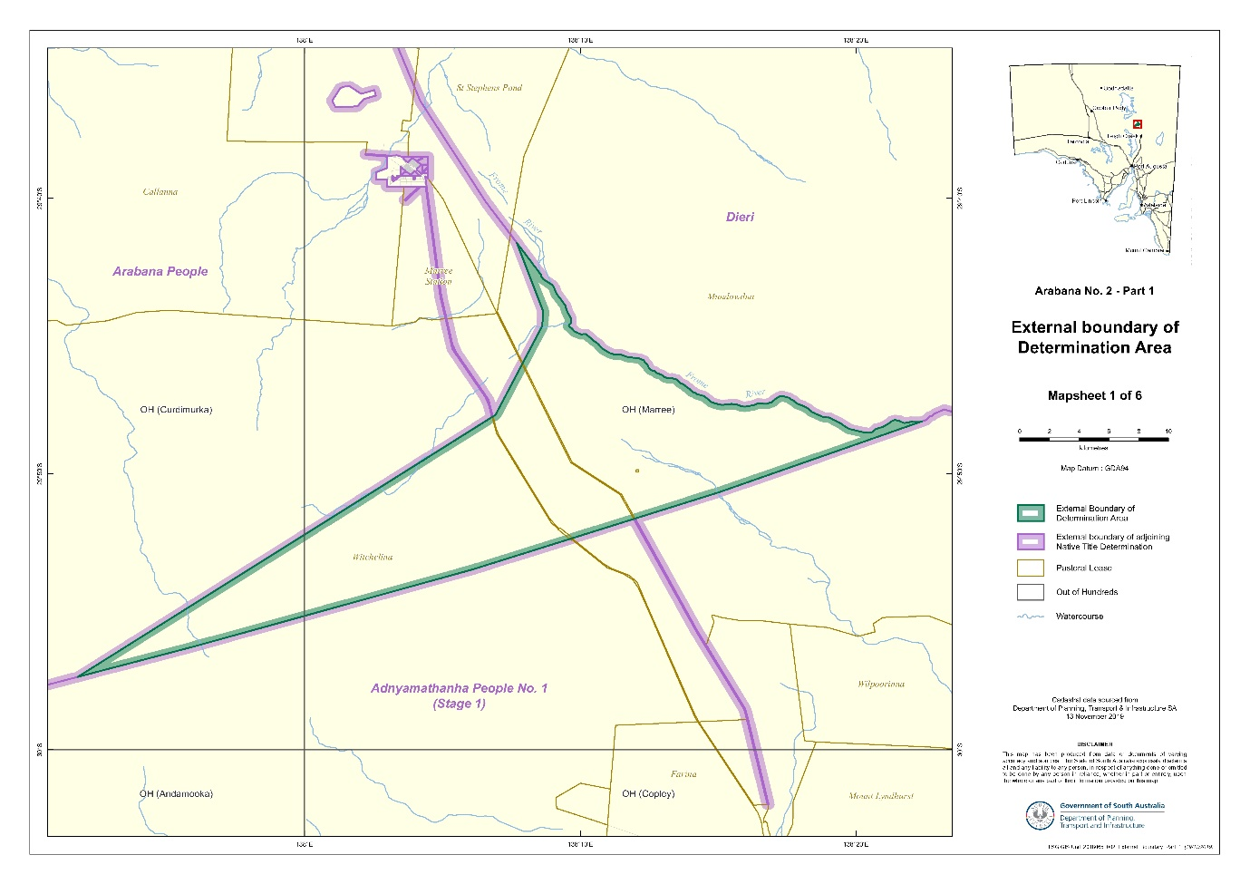



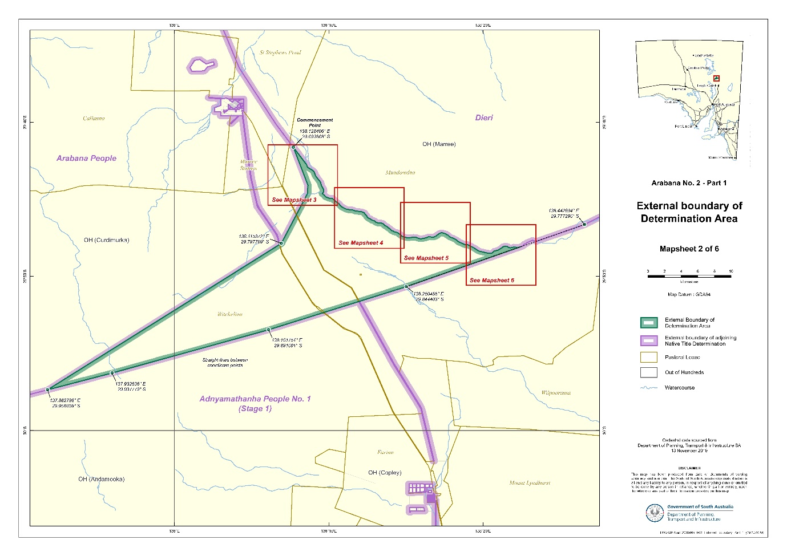

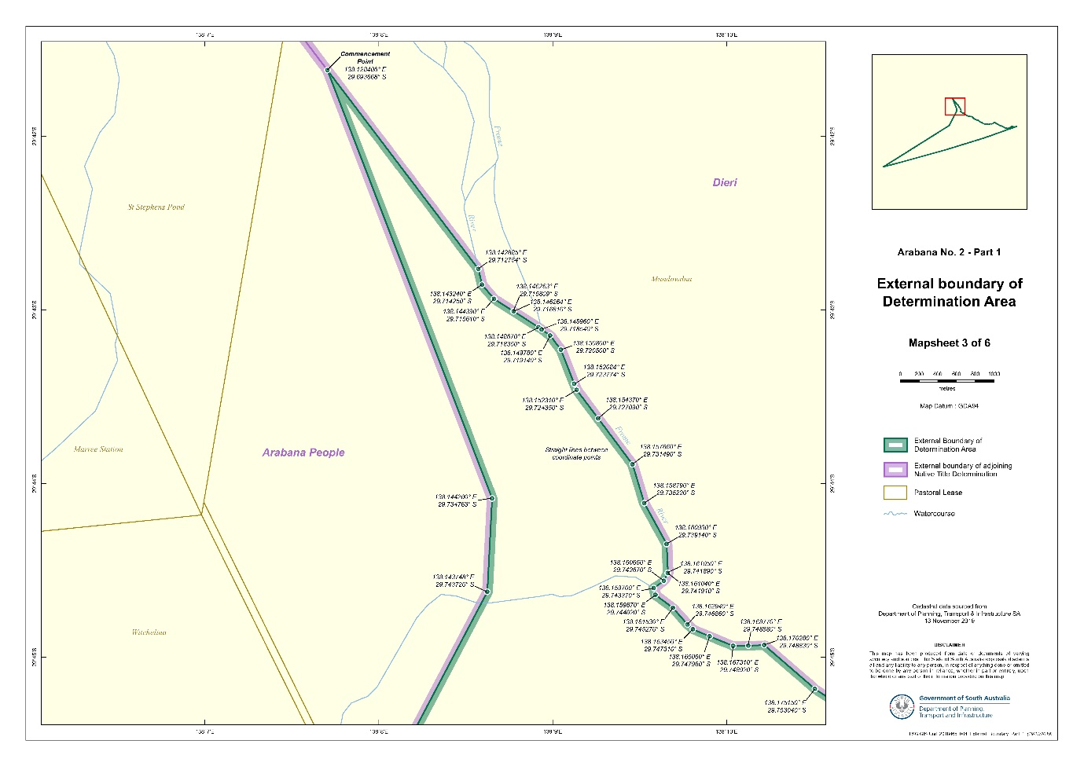

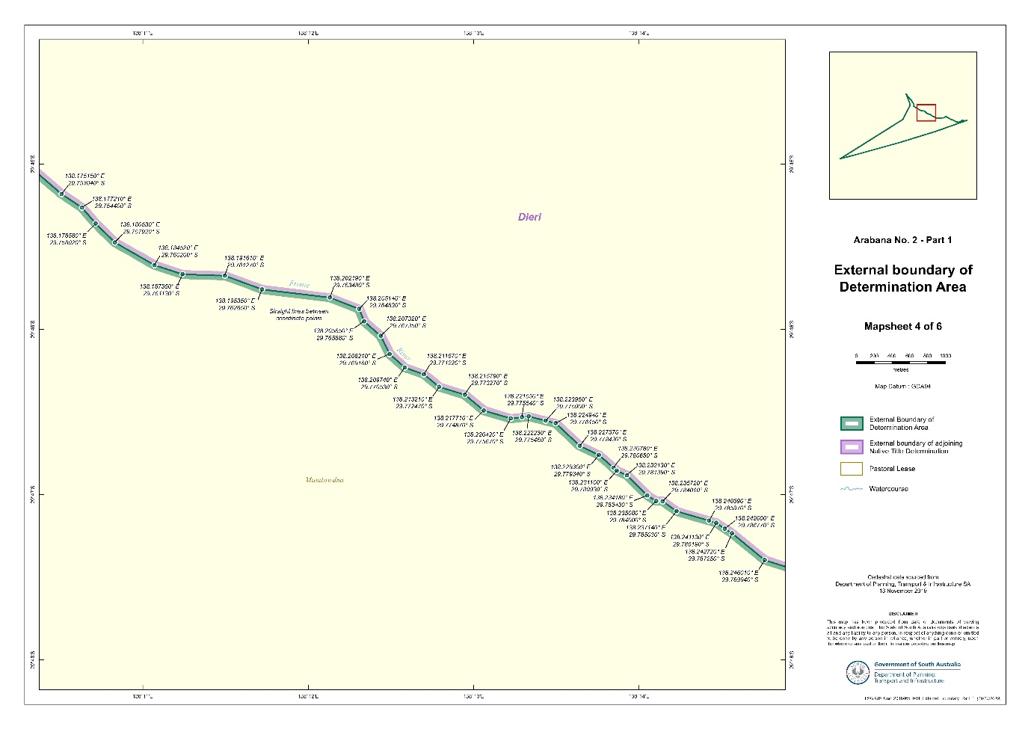

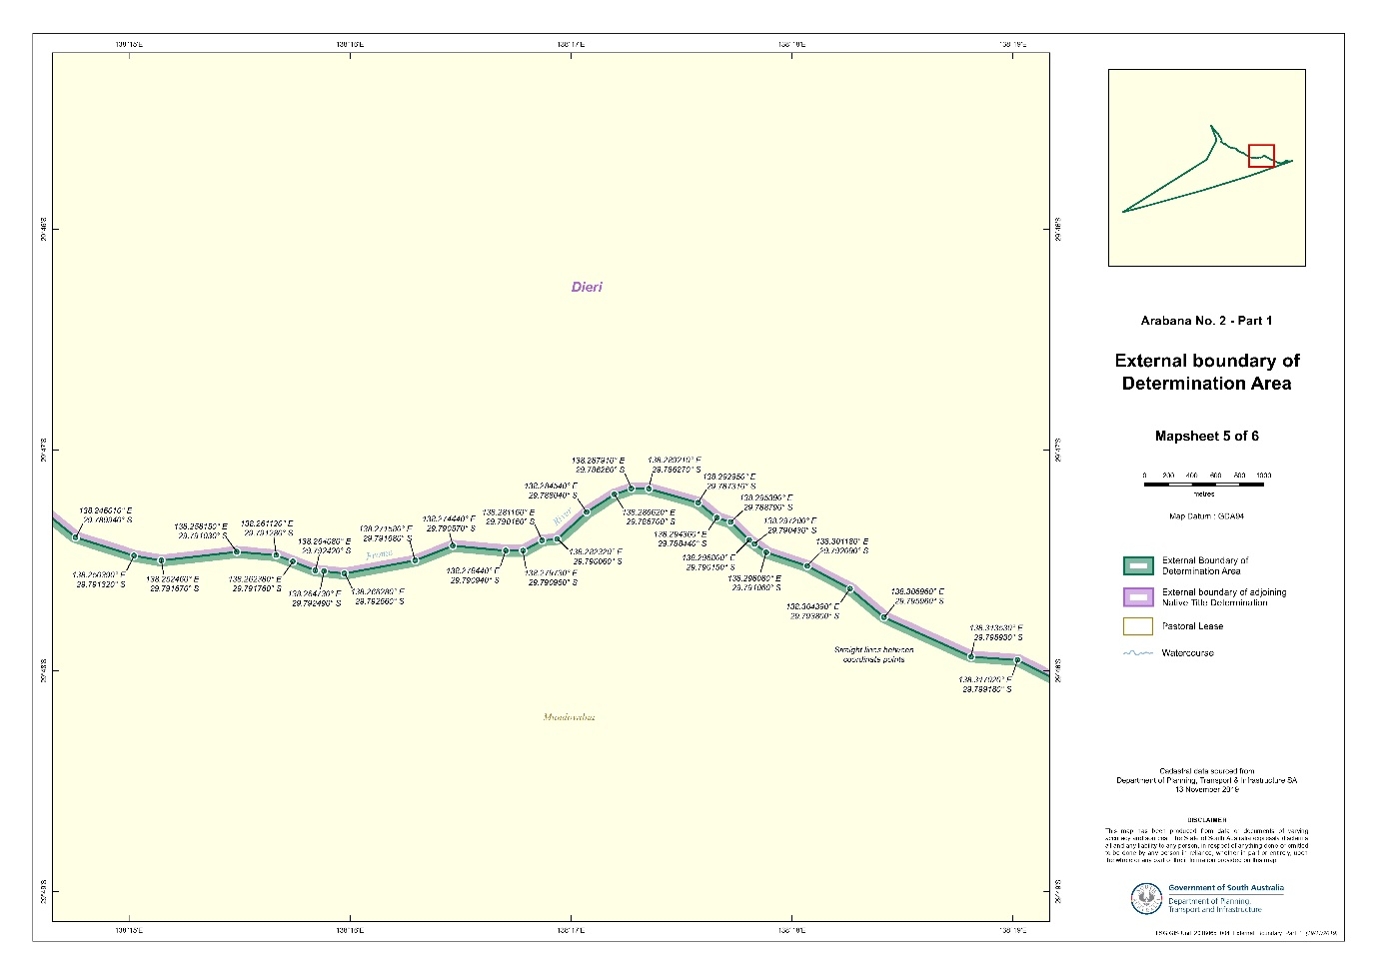

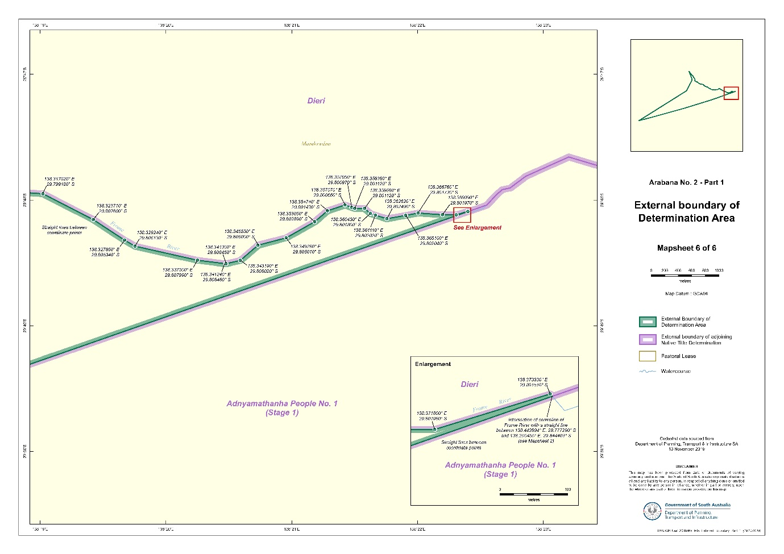

# SCHEDULE 2 - MAPS

## Part B: Maps depicting Native Title Land

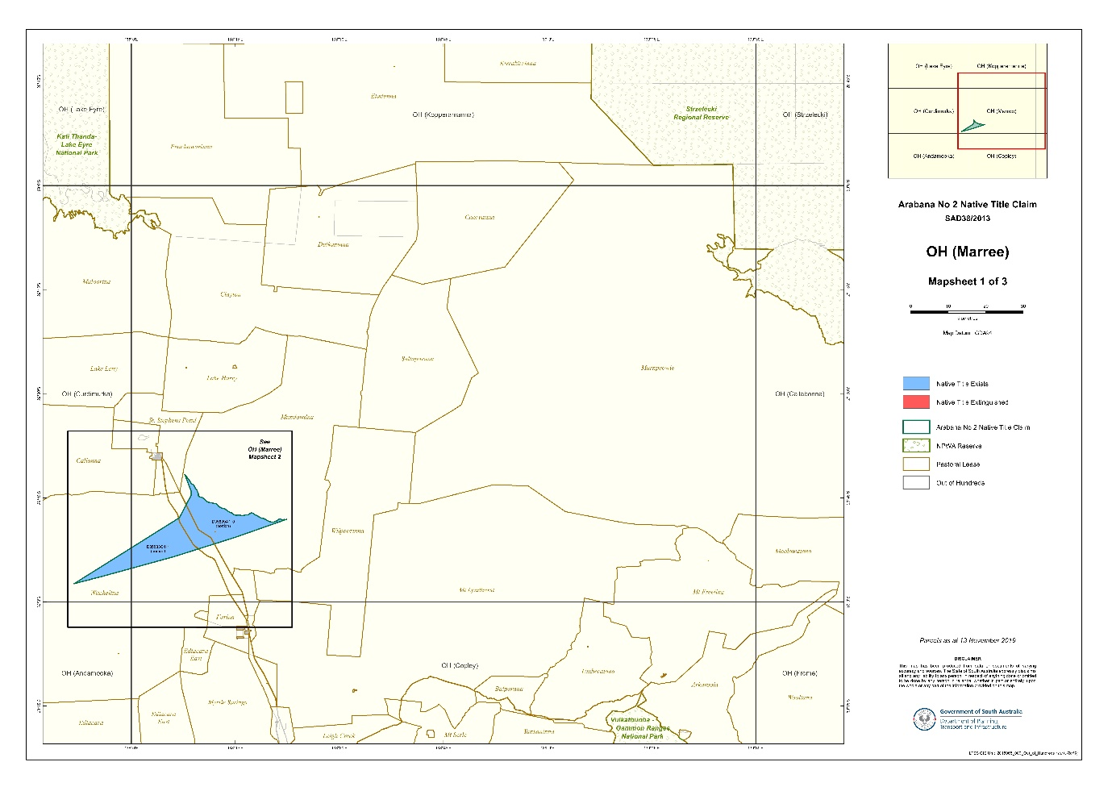

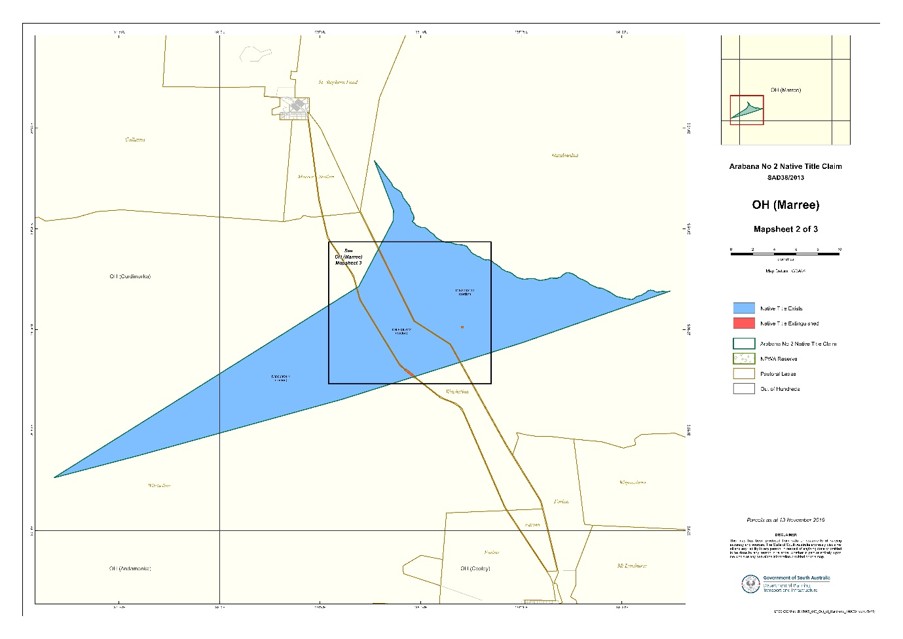

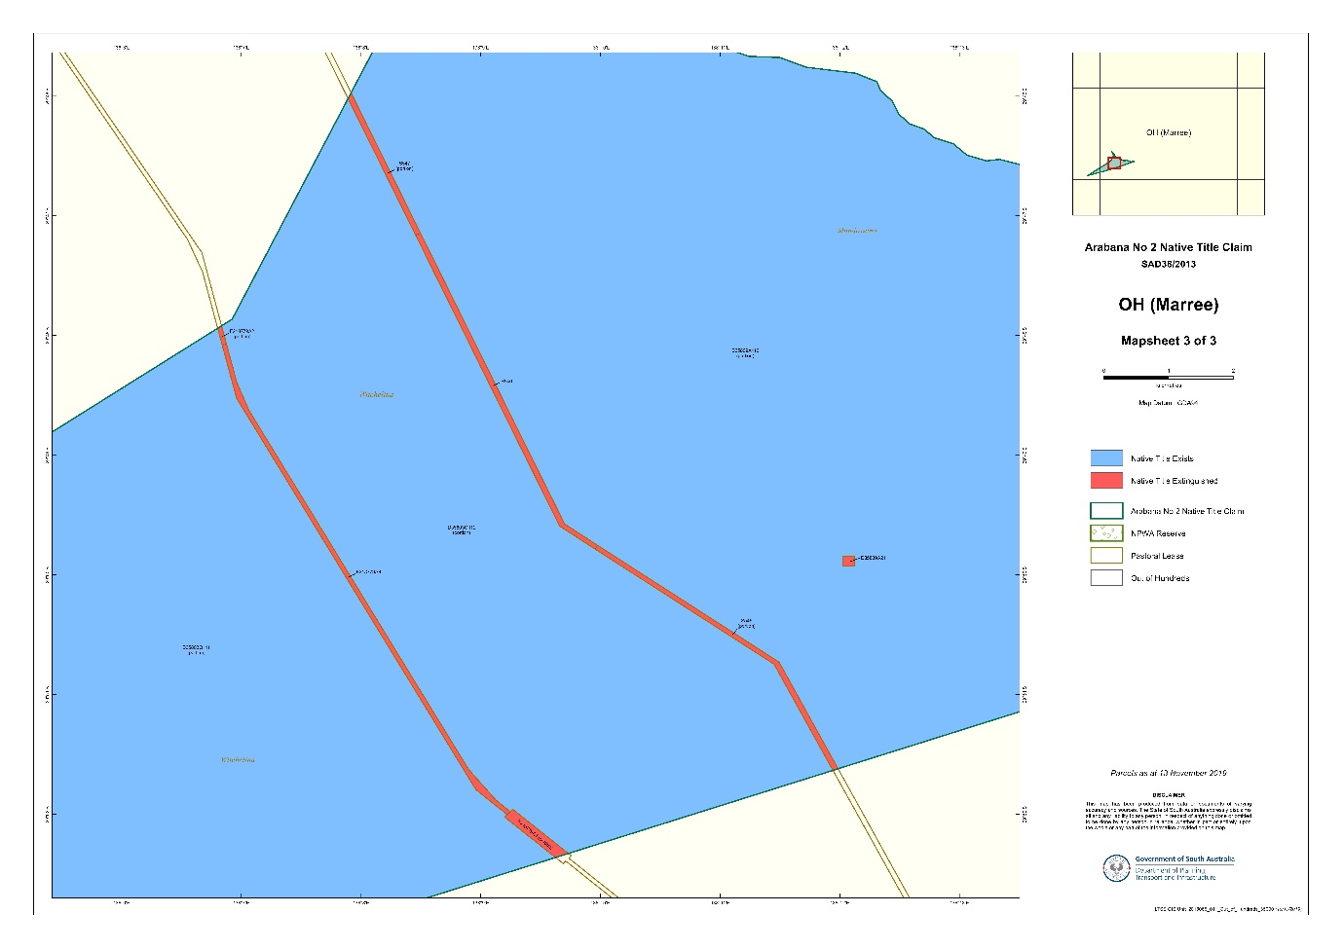

# SCHEDULE 3

## Land and waters where native title exists (Native Title Land)

Note: Please refer to Schedule 2 Part B for further detail where a portion of a parcel is indicated.

| Parcel Identifier | Hundred | Other interests |
| --- | --- | --- |
| D35803Q111 (Portion) | OH(MARREE) | CL6209/252 PE2311 |
| D35809A110 (Portion) | OH(MARREE) | CL6171/801 PE2298 |
| D35803Q112 (Portion) | OH(MARREE) | CL 6209/252 PE2311 |

# SCHEDULE 4

## Areas where native title does not exist

1. Native title rights and interests do not exist in:

(a) minerals as defined in section 6 of the *Mining Act 1971* (SA);

(b) petroleum, as defined in section 4 of the *Petroleum and Geothermal Energy Act 2000* (SA);

(c) a naturally occurring underground accumulation of a regulated substance as defined in section 4 of the *Petroleum and Geothermal Energy Act 2000* (SA), below a depth of 100 metres from the surface of the earth;

(d) a natural reservoir, as defined in section 4 of the *Petroleum and Geothermal Energy Act 2000* (SA), below a depth of 100 metres from the surface of the earth;

(e) geothermal energy, as defined in section 4 of the *Petroleum and Geothermal Energy Act 2000* (SA) the source of which is below a depth of 100 metres from the surface of the earth.

For the purposes of this item 1 and the avoidance of doubt:

(f) a geological structure (in whole or in part) on or at the earth’s surface or a natural cavity which can be accessed or entered by a person through a natural opening in the earth’s surface, is not a natural reservoir;

(g) thermal energy contained in a hot or natural spring is not geothermal energy as defined in section 4 of the *Petroleum and Geothermal Energy Act 2000* (SA);

(h) the absence from this Order of any reference to a natural reservoir or a naturally occurring accumulation of a regulated substance, as those terms are defined in section 4 of the *Petroleum and Geothermal Energy Act 2000* (SA), above a depth 100 metres below the surface of the earth or geothermal energy the source of which is above a depth of 100 metres below the surface of the earth is not, of itself, to be taken as an indication of the existence or otherwise of native title rights or interests in such natural reservoir, naturally occurring accumulation of a regulated substance or geothermal energy.

2. Native title rights and interests have been extinguished in the areas of Native Title Land covered by Public Works (including the land and waters defined in section 251D of the *Native Title Act*) which were constructed, established or situated prior to 23 December 1996 or commenced to be constructed or established on or before that date.

3. Public Works constructed, established or situated after 23 December 1996 on Native Title Land have had such effect as has resulted from Part 2, Division 3, of the *Native Title Act*.

4. Native title rights and interests have been extinguished over all roads which have been delineated in a public map pursuant to section 5(d)(ii) of the *Crown Lands Act 1929*(SA) or section 70(3) or (4) of the *Crown Land Management Act 2009* (SA) or which have otherwise been validly established pursuant to South Australian statute or common law.

5. Native title rights and interests do not exist over the following parcels (insofar as they are within the Determination area):

|  |  |  |
| --- | --- | --- |
| **Parcel Identifier** | **Hundred** | **Current Tenure** |
| H833100S547 | OH(MARREE) | CROWN |
| F218779A2 | OH(MARREE) | CT5883/110 |
| H833100S546 | OH(MARREE) | CR5771/761 |
| D35809A211 | OH(MARREE) | CR5753/160 |
| H833100S545 | OH(MARREE) | CR5771/760 |
| F218779A3 | OH(MARREE) | CT5883/110 |
| F218779A4 | OH(MARREE) | CT5883/110 |

Note: Entry of orders is dealt with in Rule 39.32 of the *Federal Court Rules 2011*.

REASONS FOR JUDGMENT

CHARLESWORTH J

1 This application for a determination of native title relates to two distinct areas near Kati Thanda (Lake Eyre) in the north of South Australia. It has been divided in two parts, known as “Part 1” and “Part 2”.

2 The Court has before it an application for determination of native title by consent under s 87A of the *Native Title* ***Act*** *1993* (Cth) relating to that part of the proceedings known as Part 1. The area over which the determination is sought is a roughly triangular area south of Marree. It comprises portions of the Mundowdna and the Witchelina pastoral leases. The old Mount Nor’ West Station is incorporated into Witchelina, as is some former railway land and a digital radio tower.

3 The only parties to the Part 1 proceeding are the applicant and the State of South Australia. There are no other claims overlapping the Part 1 determination area.

4 Part 2 of this proceeding relates to a separate area comprising the “Oodnadatta Common”. The Part 2 area is wholly overlapped by claims brought by the Walka Wani people. That part of the claim is to be the subject of a separate contested hearing pursuant to s 67 of the Act*.* It does not form a part of this determination.

5 On 22 May 2012, this Court made a determination of native title for the Arabana people by consent over a large area of land adjacent to the determination area in these proceedings:  *Dodd v State of South Australia* [2012] FCA 519 (*Arabana No 1*). Part 1 of these proceedings fills the small area between the south-east section of *Arabana No 1* and two other determinations of native title – the Dieri to the north-east and Adnyamathanha to the south:  *Lander v State of South Australia* [2012] FCA 427 and *Adnyamathanha No 1 Native Title Claim Group v The State of South Australia (No 2)* [2009] FCA 359 respectively.

# THE REQUIREMENTS OF SECTION 87A

6 Section 87A of the Act provides that the Court is not required to hold a hearing for the purpose of making a native tile determination by consent. However, the Court must nevertheless be satisfied that the substantive and procedural requirements of s 87A have been complied with:  *Sumner v State of South Australia (Ngarrindjeri Native Title Claim Part A)* [2017] FCA 1514 at [10]. The Court may only make an order consistent with the terms of the proposed determination if it considers that the orders would be within the Court’s power and that it would be appropriate to make the orders:  Act, s 87A(4).

7 Section 87A of the Act applies if four conditions are met:  there must be a proceeding in relation to an application for a determination of native title; an agreement must be reached in relation to an area included in the area covered by the application; the proposed determination must be agreed by the applicant and every party to the relevant part of the proceeding: and, the proposed determination must be in writing and signed by or on behalf of those parties:  Act, s 87A(1)(a) to (d). The agreement is to have been reached after the end of the notice period in s 66:  Act, s 87A(1)(b). The relevant period in these proceedings expired on 2 October 2013.

8 In addition, s 94A of the Act provides that an order of this Court in which a determination of native title is made must set out details of the matters mentioned in s 225. Section 225 provides:

A ***determination of native title*** is a determination whether or not native title exists in relation to a particular area (the ***determination area***) of land or waters and, if it does exist, a determination of:

(a) who the persons, or each group of persons, holding the common or group rights comprising the native title are; and

(b) the nature and extent of the native title rights and interests in relation to the determination area; and

(c) the nature and extent of any other interests in relation to the determination area; and

(d) the relationship between the rights and interests in paragraphs (b) and (c) (taking into account the effect of this Act); and

(e) to the extent that the land or waters in the determination area are not covered by a non-exclusive agricultural lease or a non-exclusive pastoral lease—whether the native title rights and interests confer possession, occupation, use and enjoyment of that land or waters on the native title holders to the exclusion of all others.

# THE DETERMINATION IS WITHIN THE COURT’S POWER

9 A proposed native title determination was initially filed with the Court in accordance with s 87A(2) on 6 July 2020. An amended proposed native title determination was filed on 17 February 2021. In accordance with s 225 of the Act, the proposed orders contain a determination “whether or not native title exists in relation to a particular area”. The area is described with precision in Schedules 1 and 2 to the proposed determination. Those people holding common group rights are set out in paragraph five of the proposed orders. The nature and extent of the native title rights and interests are set out in paragraphs six to nine, and the nature and extent of other interests are set out in paragraph 10. The relationship between the relevant rights and interests is set out in paragraph 11. Paragraph eight of the proposed determination provides that the native title rights and interests do not confer possession, occupation, use and enjoyment to the exclusion of all others.

10 The procedural preconditions for making the determination are satisfied.

# IS IT APPROPRIATE TO MAKE THE ORDERS

11 The power of the Court to make orders by consent is to be exercised in the context of the parties having come to a resolution of the proceedings other than by way of a contested trial. As North J said in *Lovett on behalf of the Gunditjmara People v State of Victoria* [2007] FCA 474:

37. In this context, when the Court is examining the appropriateness of an agreement, it is not required to examine whether the agreement is grounded on a factual basis which would satisfy the Court at a hearing of the application. The primary consideration of the Court is to determine whether there is an agreement and whether it was freely entered into on an informed basis: *Nangkiriny v State of Western Australia* (2002) 117 FCR 6; [2002] FCA 660, *Ward v State of Western Australia* [2006] FCA 1848. Insofar as this latter consideration applies to a State party, it will require the Court to be satisfied that the State party has taken steps to satisfy itself that there is a credible basis for an application:  *Munn v Queensland* (2001) 115 FCR 109; [2001] FCA 1229. There is a question as to how far a State party is required to investigate in order to satisfy itself of a credible basis for an application. One reason for the often inordinate time taken to resolve some of these cases is the overly demanding nature of the investigation conducted by State parties. The scope of these investigations demanded by some States is reflected in the complex connection guidelines published by some States.

38. The power conferred by the Act on the Court to approve agreements is given in order to avoid lengthy hearings before the Court. The Act does not intend to substitute a trial, in effect, conducted by State parties for a trial before the Court. Thus, something significantly less than the material necessary to justify a judicial determination is sufficient to satisfy a State party of a credible basis for an application. The Act contemplates a more flexible process than is often undertaken in some cases.  …

12 The parties’ joint submissions refer to the rigorous process developed by the State for assessing the evidence in native title claims, as outlined in the State’s policy document “*Consent Determinations in South Australia:  A Guide to Preparing Native Title Reports*”*.* The State has conducted an assessment of the evidence in accordance with its policy and is satisfied that the proposed determination ought to be made. In doing so, the State has struck a balance between protecting the community’s interests and taking a flexible approach to reaching agreement in accordance with the aims of the Act:  *Nelson v Northern Territory* (2010) 190 FCR 344 at [12] – [13] (Reeves J).

13 The evidence considered by the State includes two reports dated 2018 and 2019 prepared by expert anthropologists Dr Rod Lucas and Dr Deane Fergie as well as affidavit material provided by the applicant. The expert reports were evaluated by the State’s expert, Dr Lee Sackett. In addition, the State’s external counsel provided an opinion based on a review of the applicant’s reports and affidavits as to whether there was a plausible basis for concluding that the claim group held native title rights and interests in the area.

14 The term “native title rights and interests” is defined in s 223(1) of the Act as follows:

(1) The expression ***native title*** or ***native title rights and interests*** means the communal, group or individual rights and interests of Aboriginal peoples or Torres Strait Islanders in relation to land or waters, where:

(a) the rights and interests are possessed under the traditional laws acknowledged, and the traditional customs observed, by the Aboriginal peoples or Torres Strait Islanders; and

(b) the Aboriginal peoples or Torres Strait Islanders, by those laws and customs, have a connection with the land or waters; and

(c) the rights and interests are recognised by the common law of Australia.

15 As the joint submission states, a threshold requirement for a successful native title determination application is that there be a recognisable group or society that presently recognises and observes traditional laws and customs in relation to the determination area. As the High Court explained in *Yorta Yorta Aboriginal Community v Victoria* (2002) 214 CLR 422 at [49] – [56], [86] – [89] it must be shown that:

(1) the members of the claim group are, or are part of, a society united in and by their acknowledgement and observance of a body of accepted laws and customs;

(2) the present day body of accepted laws and customs is essentially that same body of laws and customs acknowledged and observed by the ancestors of members of the claim group, adapted to modern circumstances; and

(3) acknowledgment and observance of those laws and customs has continued substantially uninterrupted by each generation since sovereignty and that the society has continued to exist throughout that period as a body united in and by its acknowledgement and observance of those laws and customs.

See also *Risk v Northern Territory of Australia* [2006] FCA 404 at [802] – [811].

16 Authorities of this Court have recognised that native title rights and interests may be acquired in accordance with traditional laws and customs relating to succession. It is accepted that rights, interests and responsibilities in relation to land or waters may pass between groups within a traditional society, particularly upon the extinction of a subgroup or estate group with that society after the assertion of sovereignty in the area:  see the discussions in *Croft on behalf of the Barngarla Native Title Claim Group v State of South Australia* [2015] FCA 9 at [711] – [719] and *Smirke on behalf of the Jurruru People v State of Western Australia (No 2)* [2020] FCA 1728 at [647] – [648] (Mortimer J).

17 The ethnographic evidence place the claim area in Kuyani country at the time of effective sovereignty. The State is satisfied that the evidence provides a credible basis for concluding that the Arabana and the Kuyani, as well as the neighbouring Dieri people, are members of the wider “Lakes Group” with a shared concept of Dreaming Beings and Story Lines and laws and customs relating to male initiation (*wilyaru)*, patrilineage, and matri-totems. The joint submission of the applicant and the State is that the Arabana and Kuyani participated in each other’s responsibilities in relation to country. The determination is sought on the basis that the Arabana people have succeeded to native title rights and interests in the Part 1 area from the Kuyani people.

18 The joint submissions refer to evidence of one of the claim group members describing their father being given Kuyani ceremonial objects by the last remaining Kuyani elder in the 1940’s. That event is described as a traditional “handing over” of responsibility for and rights in country. The submissions go on to state (at [32]):

Given that evidence in the context of both the Arabana and the Kuyani being recognised as part of a group with similar laws and customs, inferences can be drawn from the apparent withdrawal of the Kuyani from the area and the assumption of their rights and responsibilities for the area, it is certainly plausible that the Arabana have legitimately succeeded the Kuyani to the rights and responsibilities of caring and being responsible for that Kuyani country.

19 The joint submission also refer to expert anthropological evidence concerning the continuing observance of traditional laws and customs of the Arabana people in relation to the determination area to the present day, including evidence of Mr Aaron Stuart of stories passed on to him by his grandfather about Rischbieth Outstation and the Willouran Range relating to *wilyaru*. The evidence shows that to the present day, members of the claim group visit the determination area for the purpose of hunting and chasing lizards, digging *yalka*, and to observe responsibilities for ochre pit and burial sites. It was on the basis of this evidence that the State was satisfied that the proposed determination should be made by consent. That was an appropriate position for the State to adopt, given the materials before it.

20 In the circumstances described, it is appropriate for the State to proceed on the basis that the Arabana people, as part of the wider “Lakes Group”, constitute a society having connection to the determination area derived by succession from the Kuyani people, and continuing to the present day. The Court is satisfied that it is appropriate to make the determination in the terms sought by the parties on that agreed basis.

# PRESCRIBED BODY CORPORATE

21 Section 55 of the Act relevantly provides that at the time of making an approved determination of native title, or as soon as practical afterwards, the Court must make a determination under s 57 as to which body is to perform the relevant functions as a prescribed body corporate.

22 The version of the proposed consent determination filed in the Court on 6 July 2020 identified the prescribed body corporate for the determination as the “Arabana Aboriginal Corporation RNTBC (ICN7729)”. That is the registered native title body corporate in relation to the existing *Arabana No. 1* consent determination. However, that prescribed body corporate had not at that time been approved by the claim group be the prescribed body corporate for the purposes of this determination.

23 In a note to the amended minute of consent determination filed on 17 February 2021, the applicant and the State indicated that the determination had been amended to allow a period of six months from the date of these orders in which an approved prescribed body corporate body is to be nominated.

24 I am satisfied that the proposed order in relation to the prescribed body corporate is appropriate.

# CONCLUSION

25 Together with the determination made in *Arabana 1*, this determination may be seen in a wider historical context, including the original occupation of the Kuyani people and the Arabana people in the north of South Australia. The determination does not confer upon the Arabana people any right or interest that did not previously exist. Rather, the determination is an expression of the recognition by the common law of Australia of rights and interests that have existed under Aboriginal traditional law and custom since before the assertion of sovereignty and for innumerable generations before that.

26 The circumstance that the rights and interests determined today are accepted by the State to have been acquired by succession also reflects a confronting aspect of Australian colonial history. As the Preamble to the Act acknowledges, for Indigenous Australians that history is characterised in large part by displacement and loss. The remembered event of the last remaining Kuyani elder handing ceremonial objects to an Arabana elder is a stark illustration of that history and so reinforces the important objectives that are served by the Act. The parties are to be commended for advancing those objectives by arriving at an agreement for the non-litigious resolution in relation to the Part 1 area, and particularly for their efforts in gathering and assessing the evidence that made their agreement possible.

27 It is appropriate to make the orders sought.

|  |
| --- |
| I certify that the preceding twenty-seven (27) numbered paragraphs are a true copy of the Reasons for Judgment of the Honourable Justice Charlesworth. |

Associate:

Dated: 17 March 2021