Federal Court of Australia

JKC Australia LNG Pty Ltd v AkzoNobel NV (No 3) [2021] FCA 1217
File number: | WAD 448 of 2017
Judgment of: | BANKS-SMITH J
Date of judgment: | 8 October 2021
Catchwords: | PRACTICE AND PROCEDURE - application for release of the implied undertaking as to use of identified documents received by way of discovery and subpoenas - release extending to draft expert report that references such documents - related arbitration and litigation with overlapping questions requiring expert opinion - application granted
Legislation: | Federal Court of Australia Act 1976 (Cth) s 37M
Cases cited: | Glencore Coal Pty Limited v Franks [2020] FCA 1801  Glencore Coal Pty Limited v Franks [2021] FCAFC 61  Harman v Secretary of State for the Home Department [1983] 1 AC 280; [1982] 2 WLR 338  Hearne v Street [2008] HCA 36; (2008) 235 CLR 125  JKC Australia LNG Pty Ltd v AkzoNobel NV [2019] FCA 1032  Liberty Funding Pty Ltd v Phoenix Capital Ltd [2005] FCAFC 3
Division: | General Division
Registry: | Western Australia
National Practice Area: | Commercial and Corporations
Sub-area: | Regulator and Consumer Protection
Number of paragraphs: | 44
Date of hearing: | 6 October 2021
Counsel for the Applicant: | Mr MJ Smith with Ms JA Thornton and Mr M Johnston
Solicitor for the Applicant: | Solomon Brothers
Counsel for the Respondents: | Mr WA Keane
Solicitor for the Respondents: | Clayton Utz

ORDERS
 |  | WAD 448 of 2017
BETWEEN: | JKC AUSTRALIA LNG PTY LTD (ACN 154 383 409)  Applicant
AND: | AKZONOBEL NV  First Respondent  INTERNATIONAL PAINT LIMITED  Second Respondent

order made by: | BANKS-SMITH J
DATE OF ORDER: | 8 OCTOBER 2021

THE COURT ORDERS THAT:

- Subject to orders 2, 3 and 4 below, JKC Australia LNG Pty Ltd (JKC), which is the applicant in the present proceedings be released from its respective obligations to use the documents listed in Annexures A, B and C (by their unique document identifiers) to these orders (Relevant Documents) only for the purpose of this proceeding, to the extent only that they may use the Relevant Documents:
  - for the purposes of any claims between JKC and:
    - INPEX Operations Australia Pty Ltd (INPEX); and/or
    - Ichthys LNG Pty Ltd (Ichthys),
in relation to the use of Intertherm 228 coating on the Ichthys Onshore Project, including in and for the purposes of international arbitration ICC Case No. 24048/PTA (C. 24191/PTA and 24203/PTA) and any judicial or other arbitral proceedings in relation thereto (Arbitral Proceedings); and
  - for the purpose of JKC's WA Supreme Court proceedings (CIV 1620 of 2020 and CIV 1729 of 2020) (Supreme Court Proceedings).
- The Documents identified as confidential in Annexure B to these orders may only be inspected by, or made available to (after they have signed confidentiality undertakings in the form set out in Annexures D and E to these orders and provided the signed undertakings to the solicitors of the applicant in the present proceeding (Solomon Brothers) and the solicitors for the respondent in the present proceeding (Clayton Utz)):
  - an employee or officer of JKC for the purposes of use in the Arbitral Proceedings or the Supreme Court Proceedings if the partner responsible for the conduct, on behalf of JKC, of the:
    - the Arbitral Proceedings; and or
    - the Supreme Court Proceedings
is of the opinion (and has advised the solicitor for JKC in the present proceedings that he or she holds such the opinion) that it is necessary for the relevant employee or officer of JKC to have access to the documents;
  - employees of DLA Piper Australia and HFW Australia, and external counsel and experts retained by them on behalf of JKC in either the Arbitral Proceedings or the Supreme Court Proceedings;
  - the Arbitral Tribunal and its staff in in respect of the Arbitral Proceedings.
  - Mr Fred Salome (who has already received the confidential Relevant Documents in the context of this proceeding, and who has signed confidentiality undertakings in the form set out in Annexures D and E to these orders).
- JKC be permitted to provide INPEX and/or Ichthys with:
  - a draft of Mr Salome's report;
  - the Relevant Documents, to the extent that they are referred to in Mr Salome's report,
for the purposes of INPEX's WA Supreme Court proceeding (CIV 1631 of 2020) (INPEX's Insurance Proceeding) which proceedings concern claims by INPEX against its insurers under the same policy of insurance that is the subject of the Supreme Court Proceedings.
- The Documents identified as confidential in Annexure B to these orders may only be inspected by, or made available to, an officer or employee of INPEX and its legal advisors (after they have signed confidentiality undertakings in the form set out in Annexures D and E to these orders and provided the signed undertakings to the solicitors of the applicant in the present proceeding (Solomon Brothers) and the solicitors for the respondent in the present proceeding (Clayton Utz)):
  - for the purposes of INPEX's Insurance Proceedings; and
  - if the partner responsible for the conduct, on behalf of INPEX, of INPEX's Insurance Proceeding, has first advised:
    - the solicitor for JKC in the present proceedings that he or she is of the opinion that that it is necessary for the relevant employee or officer of INPEX to have access to the documents identified;
    - the solicitors for the respondents in the present proceedings that INPEX will give the respondents 14 days' notice that documents the subject of these orders are to be put into evidence in INPEX's Insurance Proceeding any of the Relevant Documents that are to be made available to the relevant employee so as to permit the respondents to make an application for confidentiality or suppression orders.
- Liberty to apply.

Note: Entry of orders is dealt with in Rule 39.32 of the Federal Court Rules 2011.

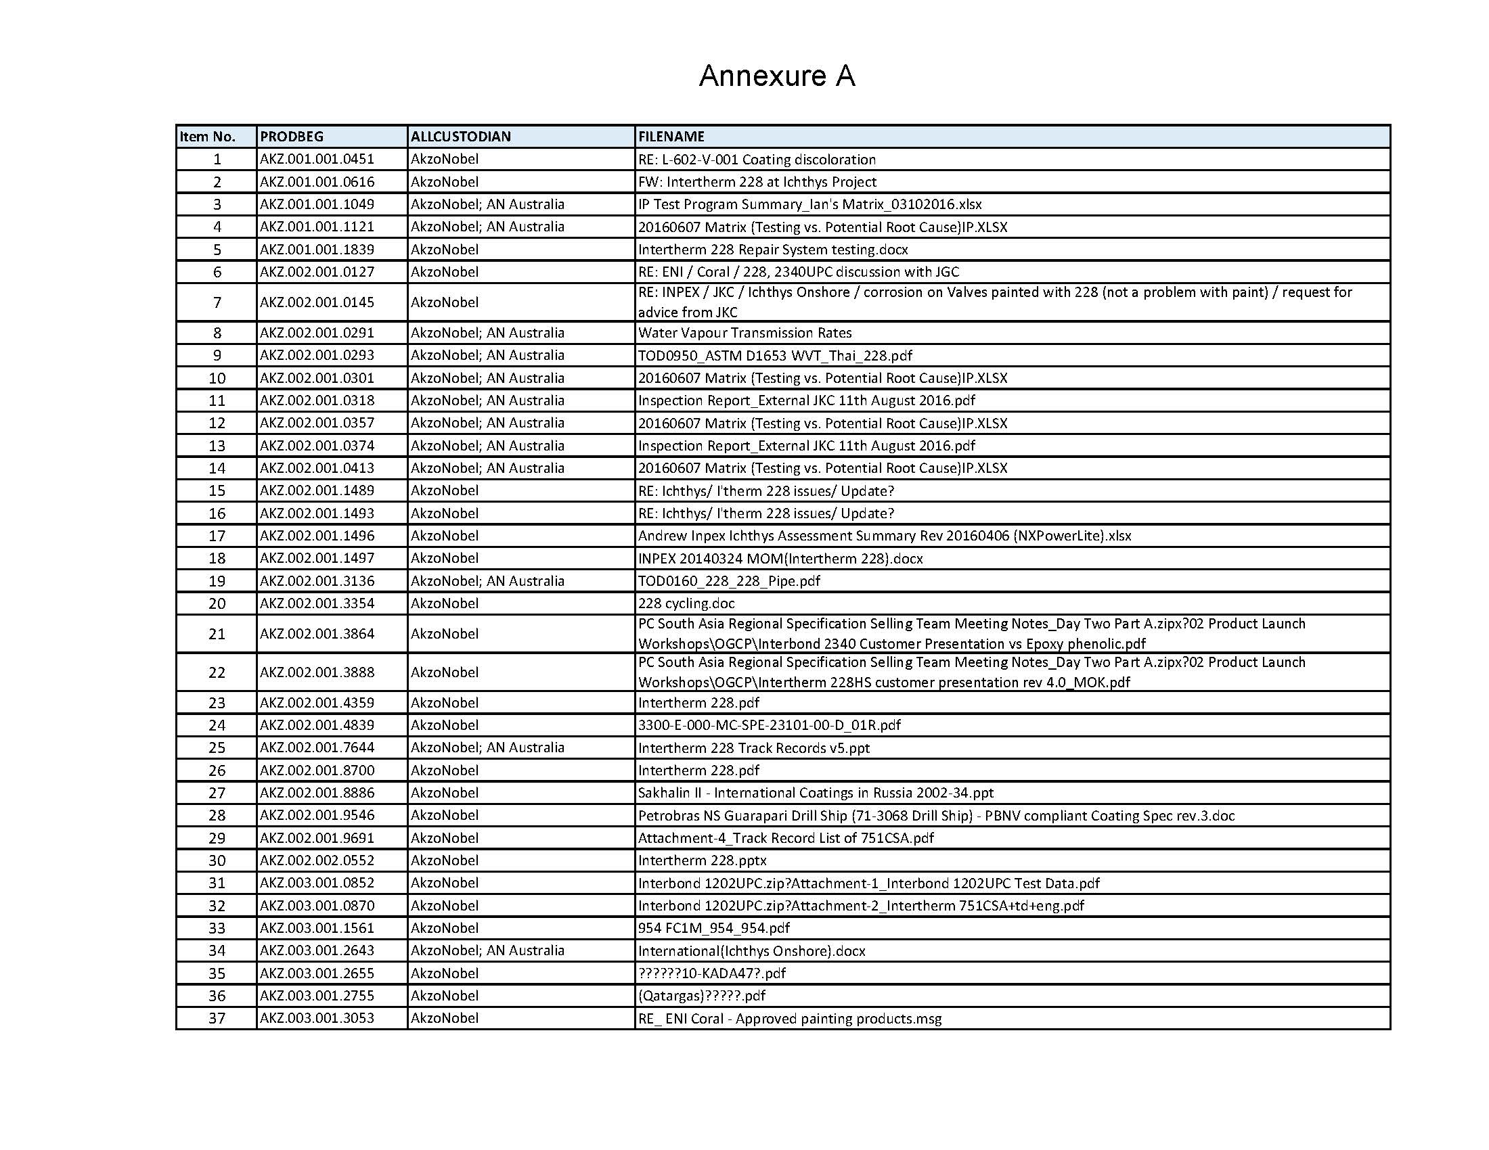
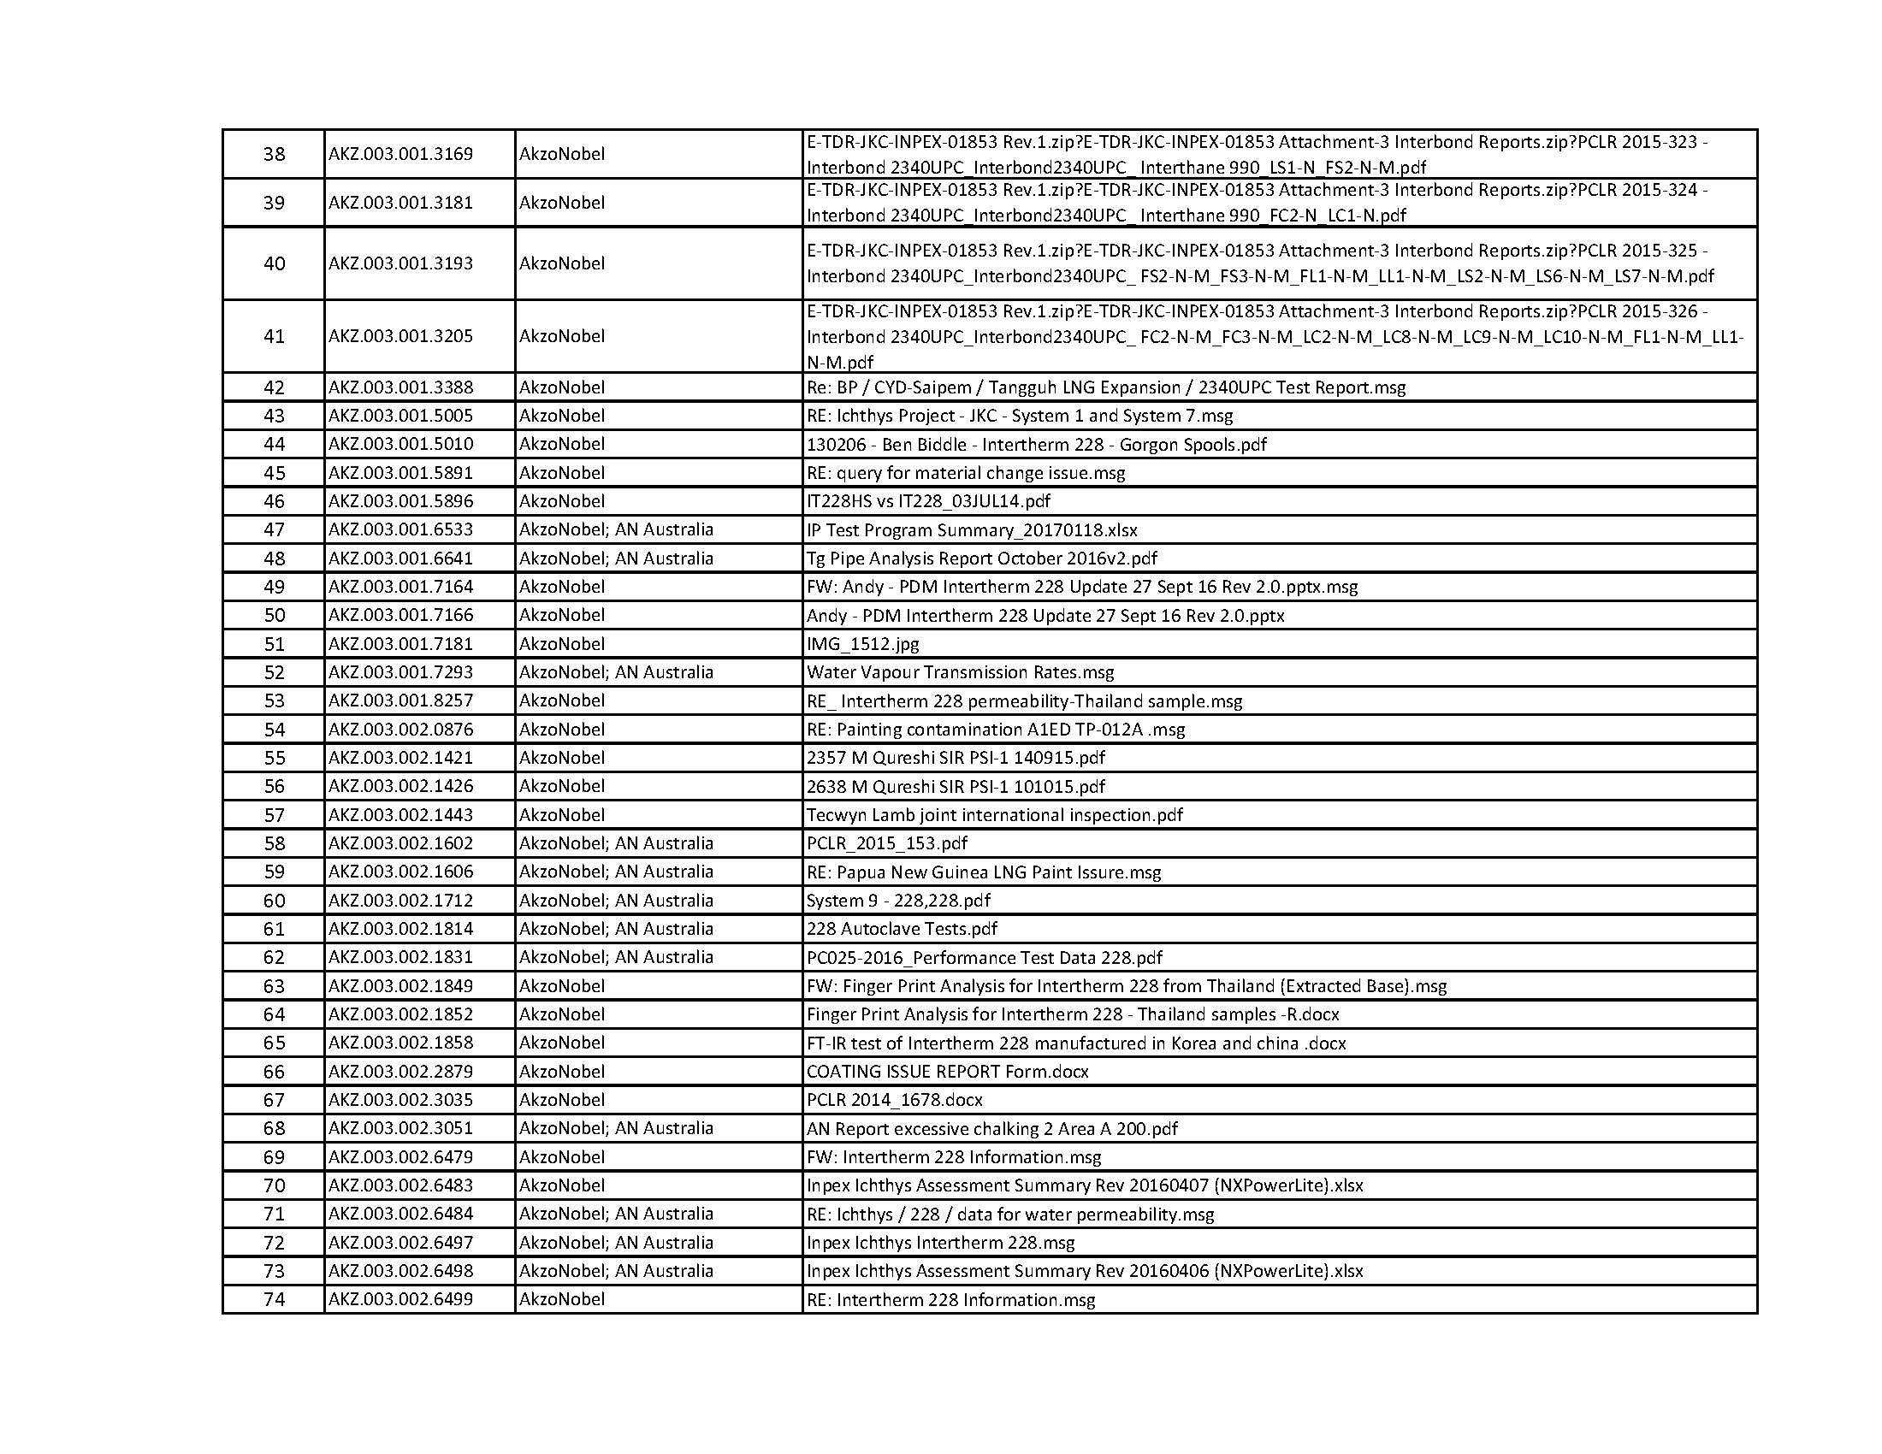
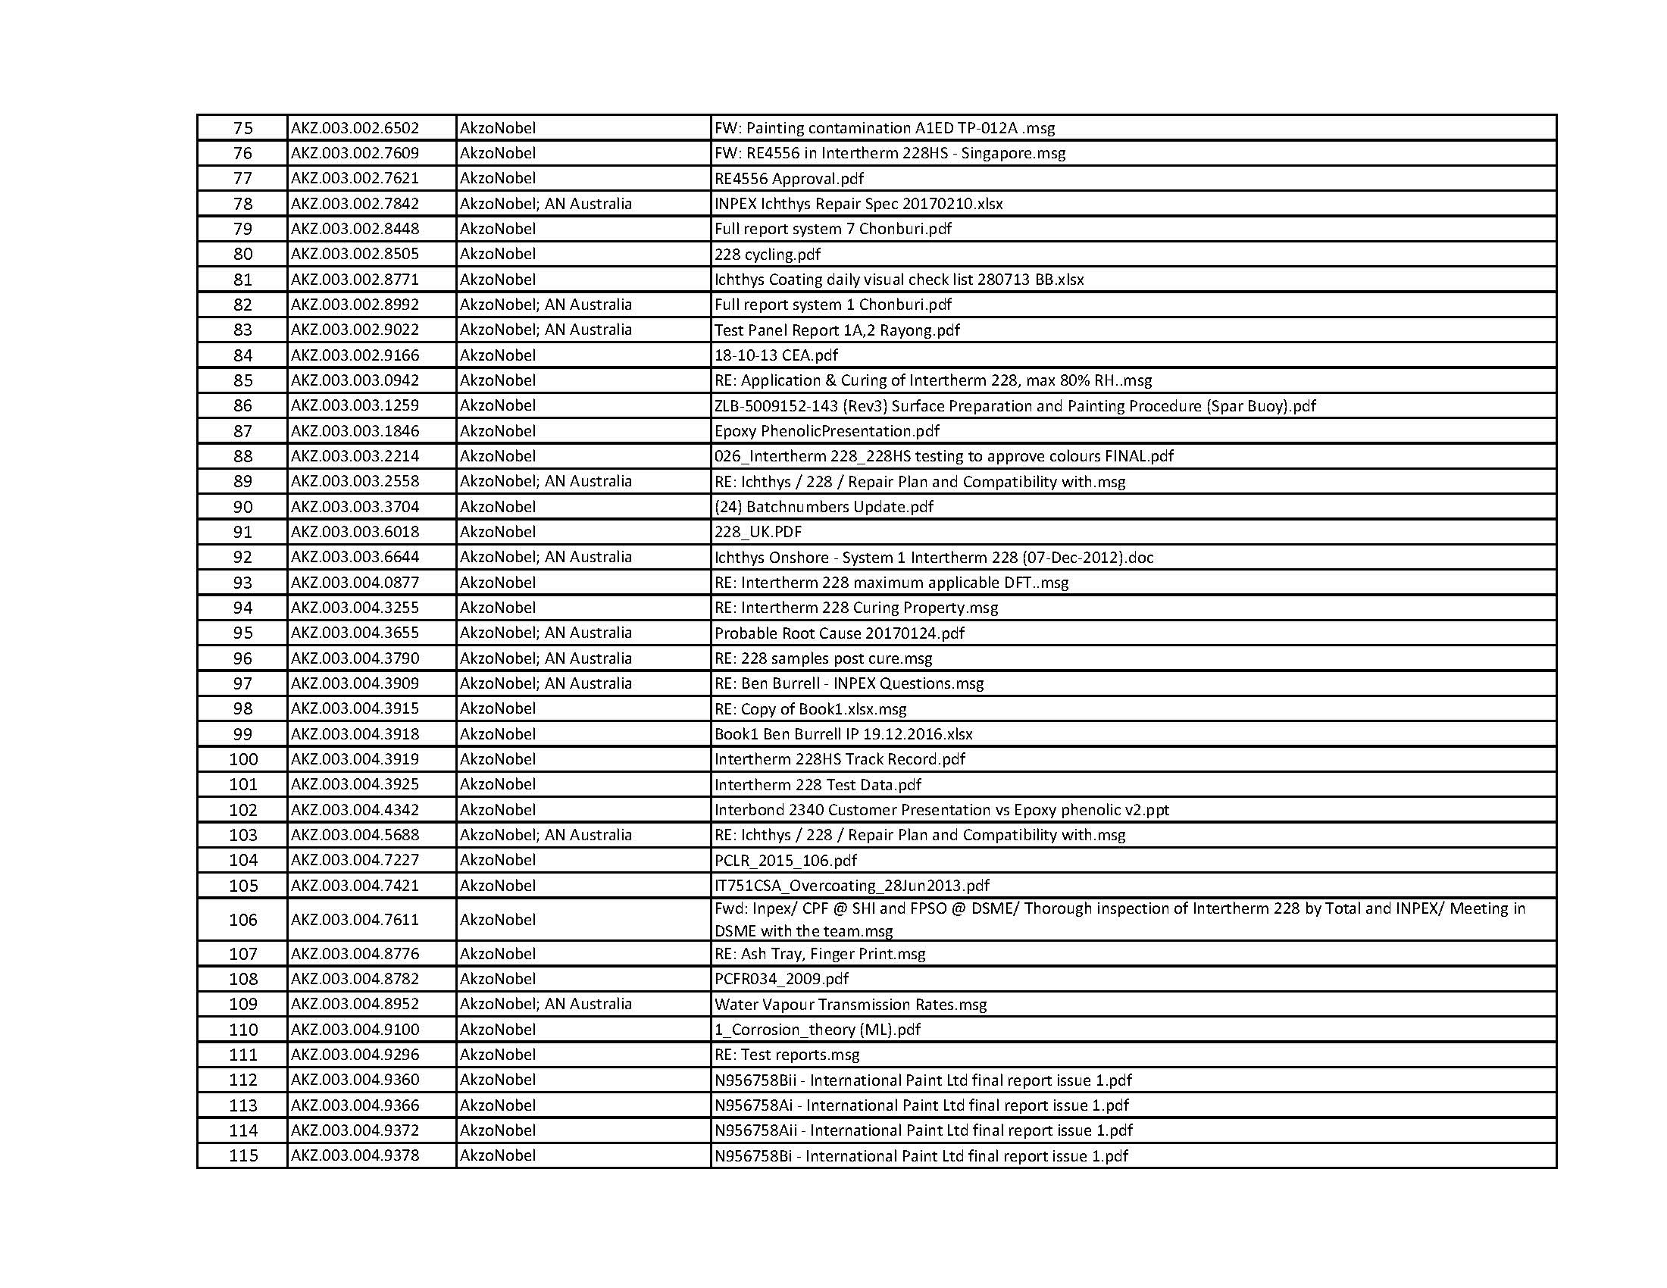
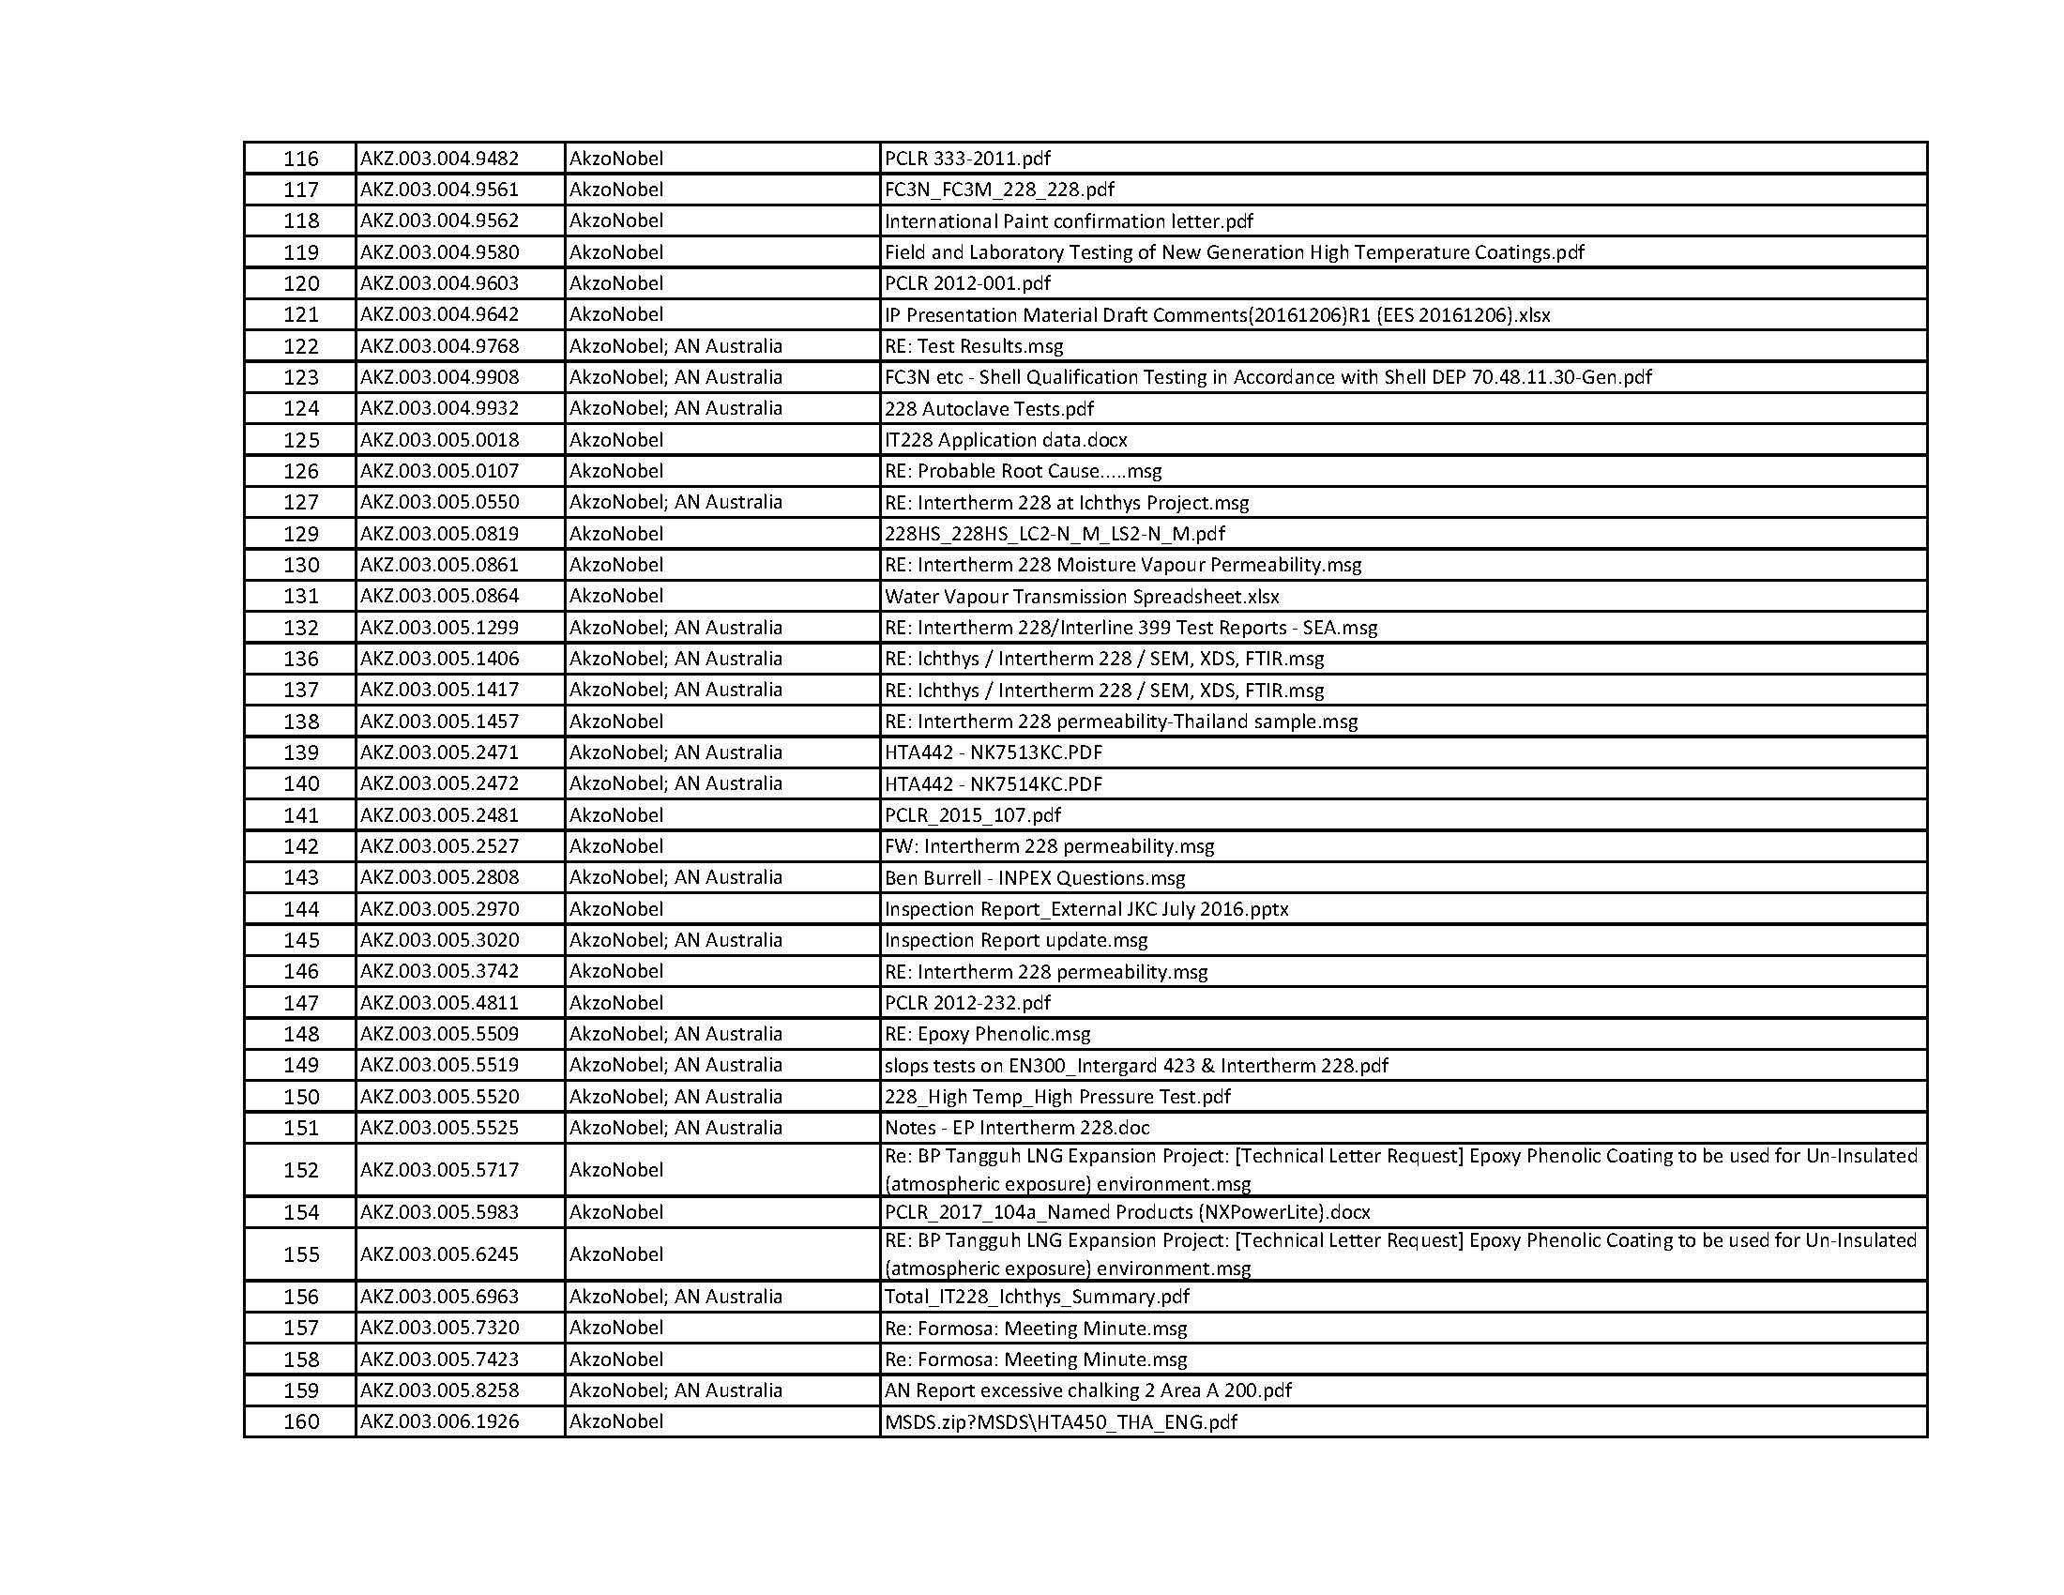
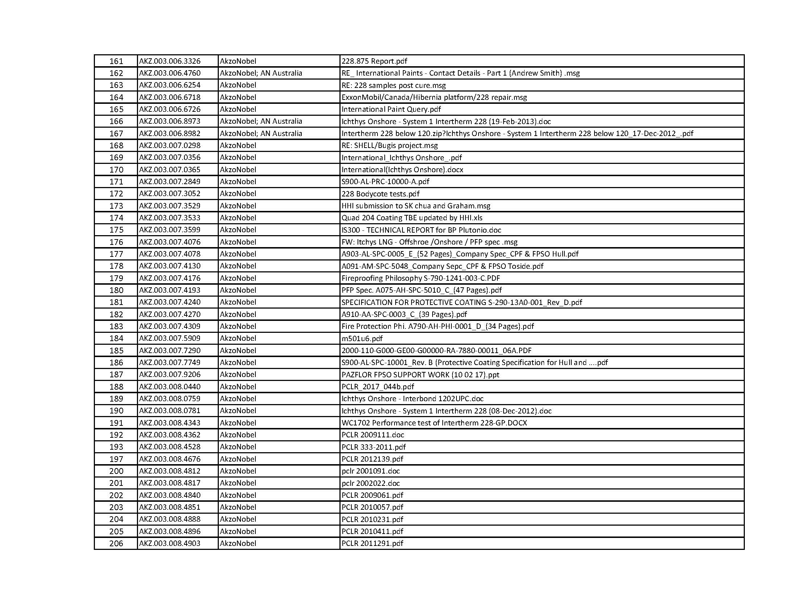
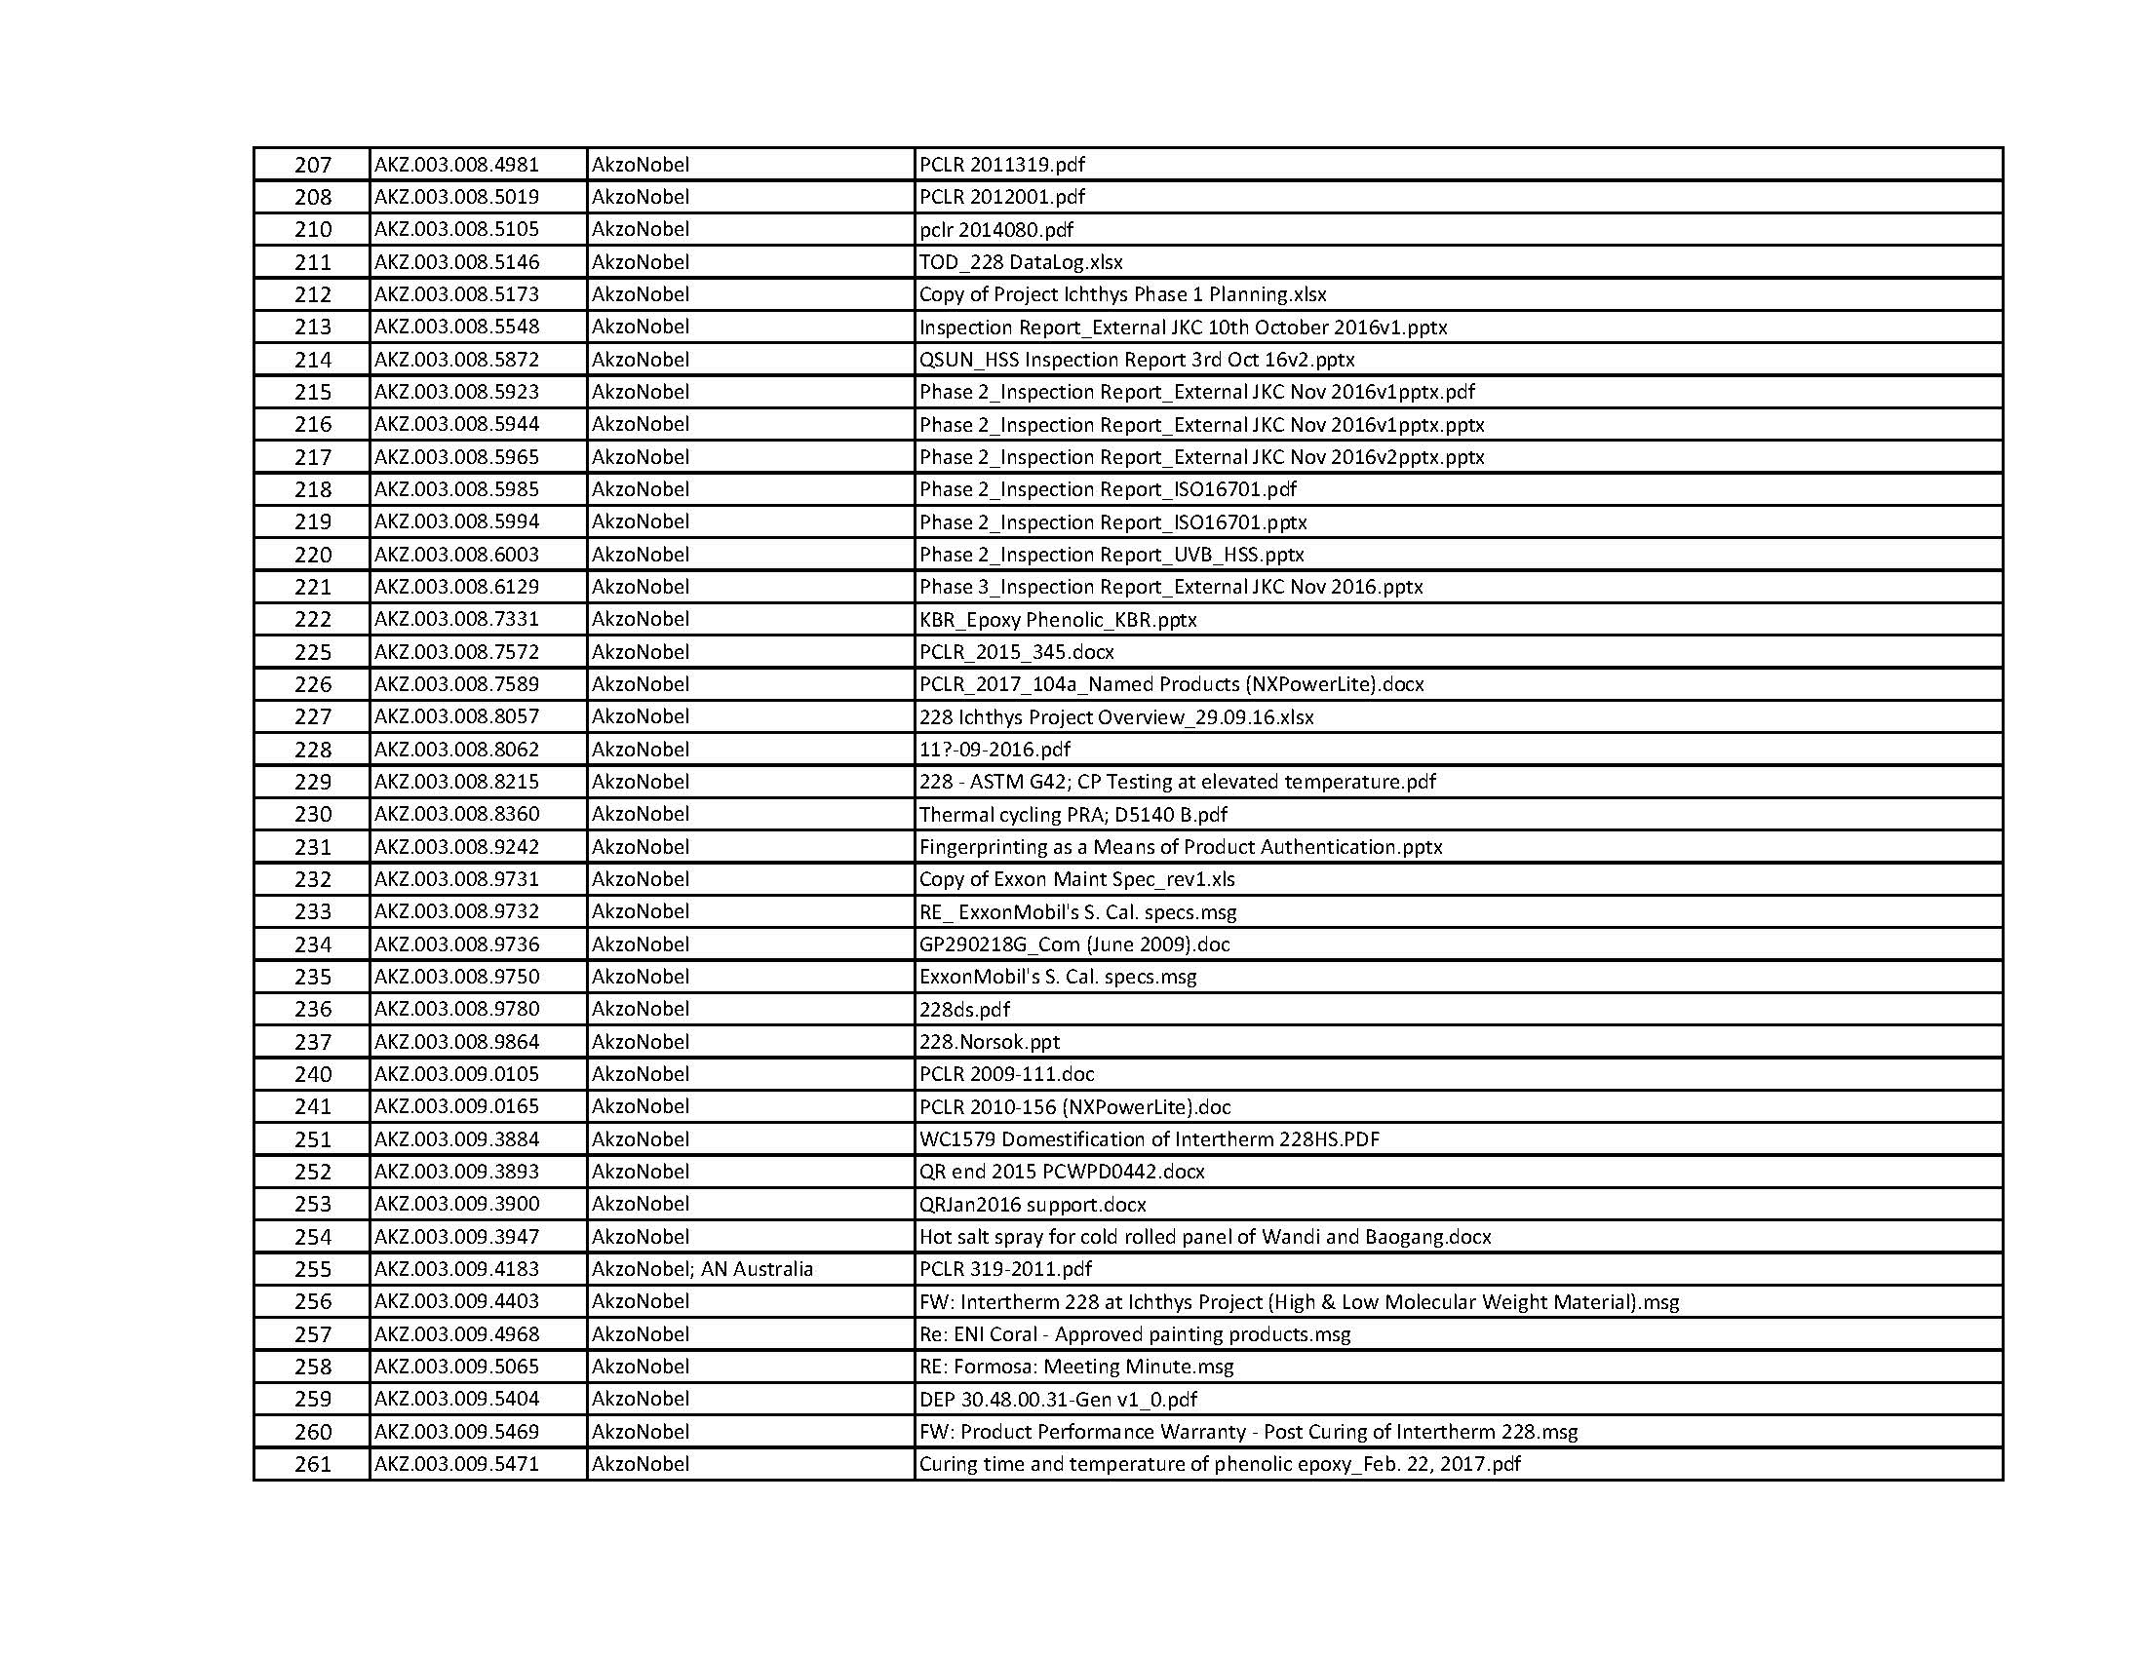
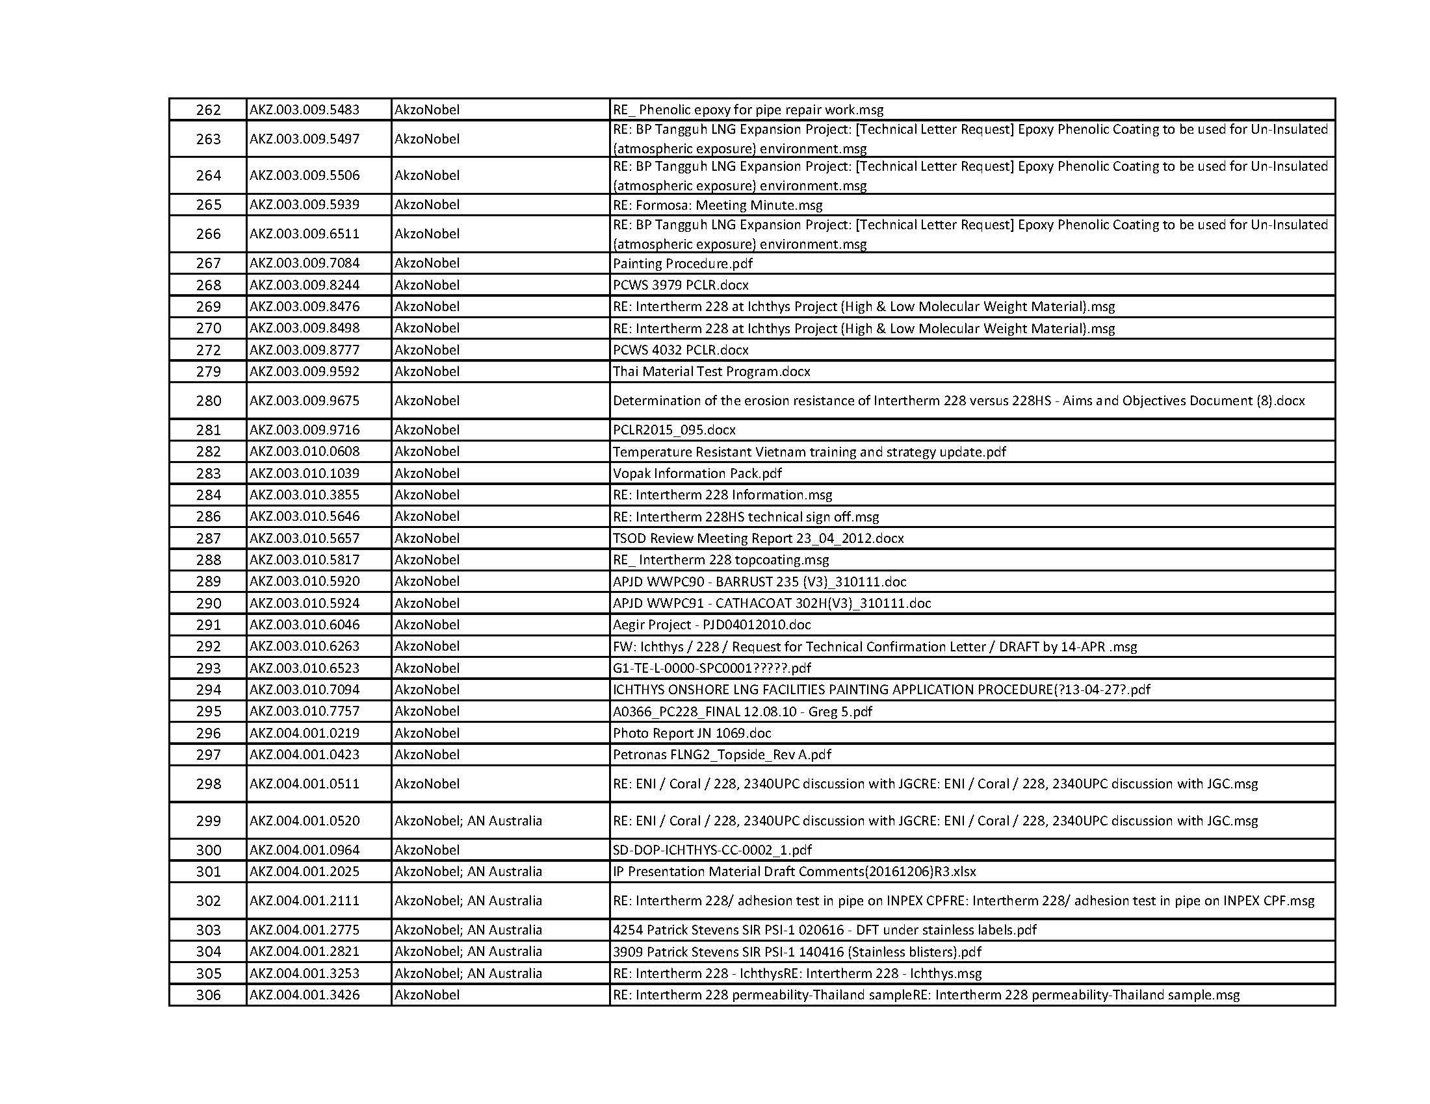
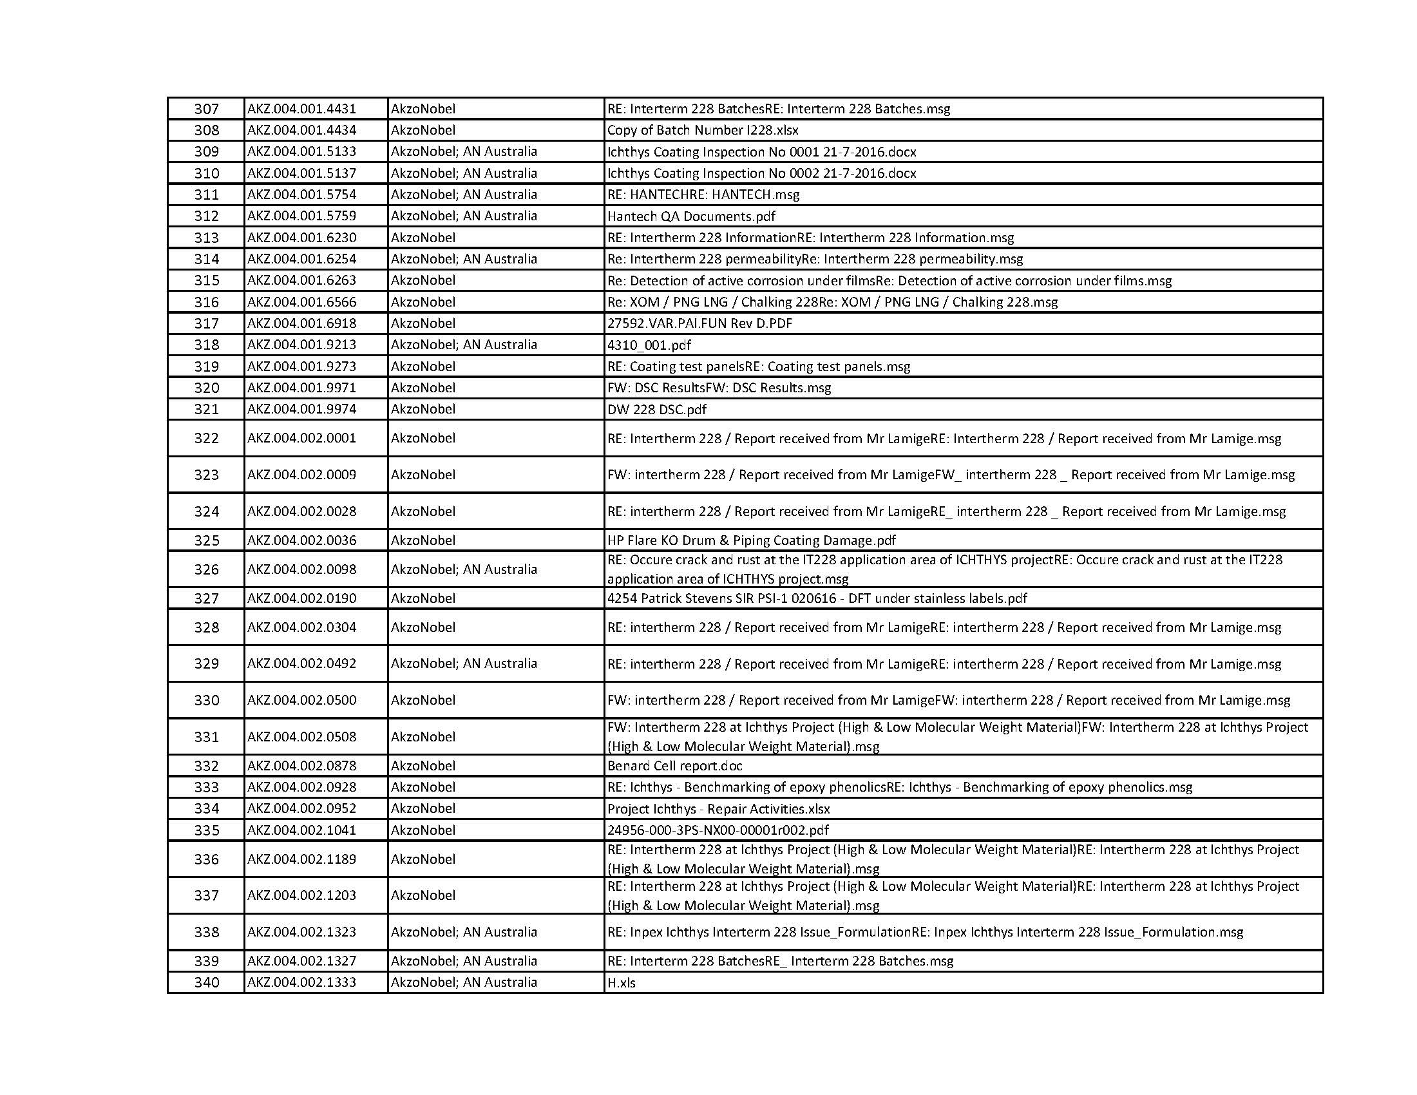
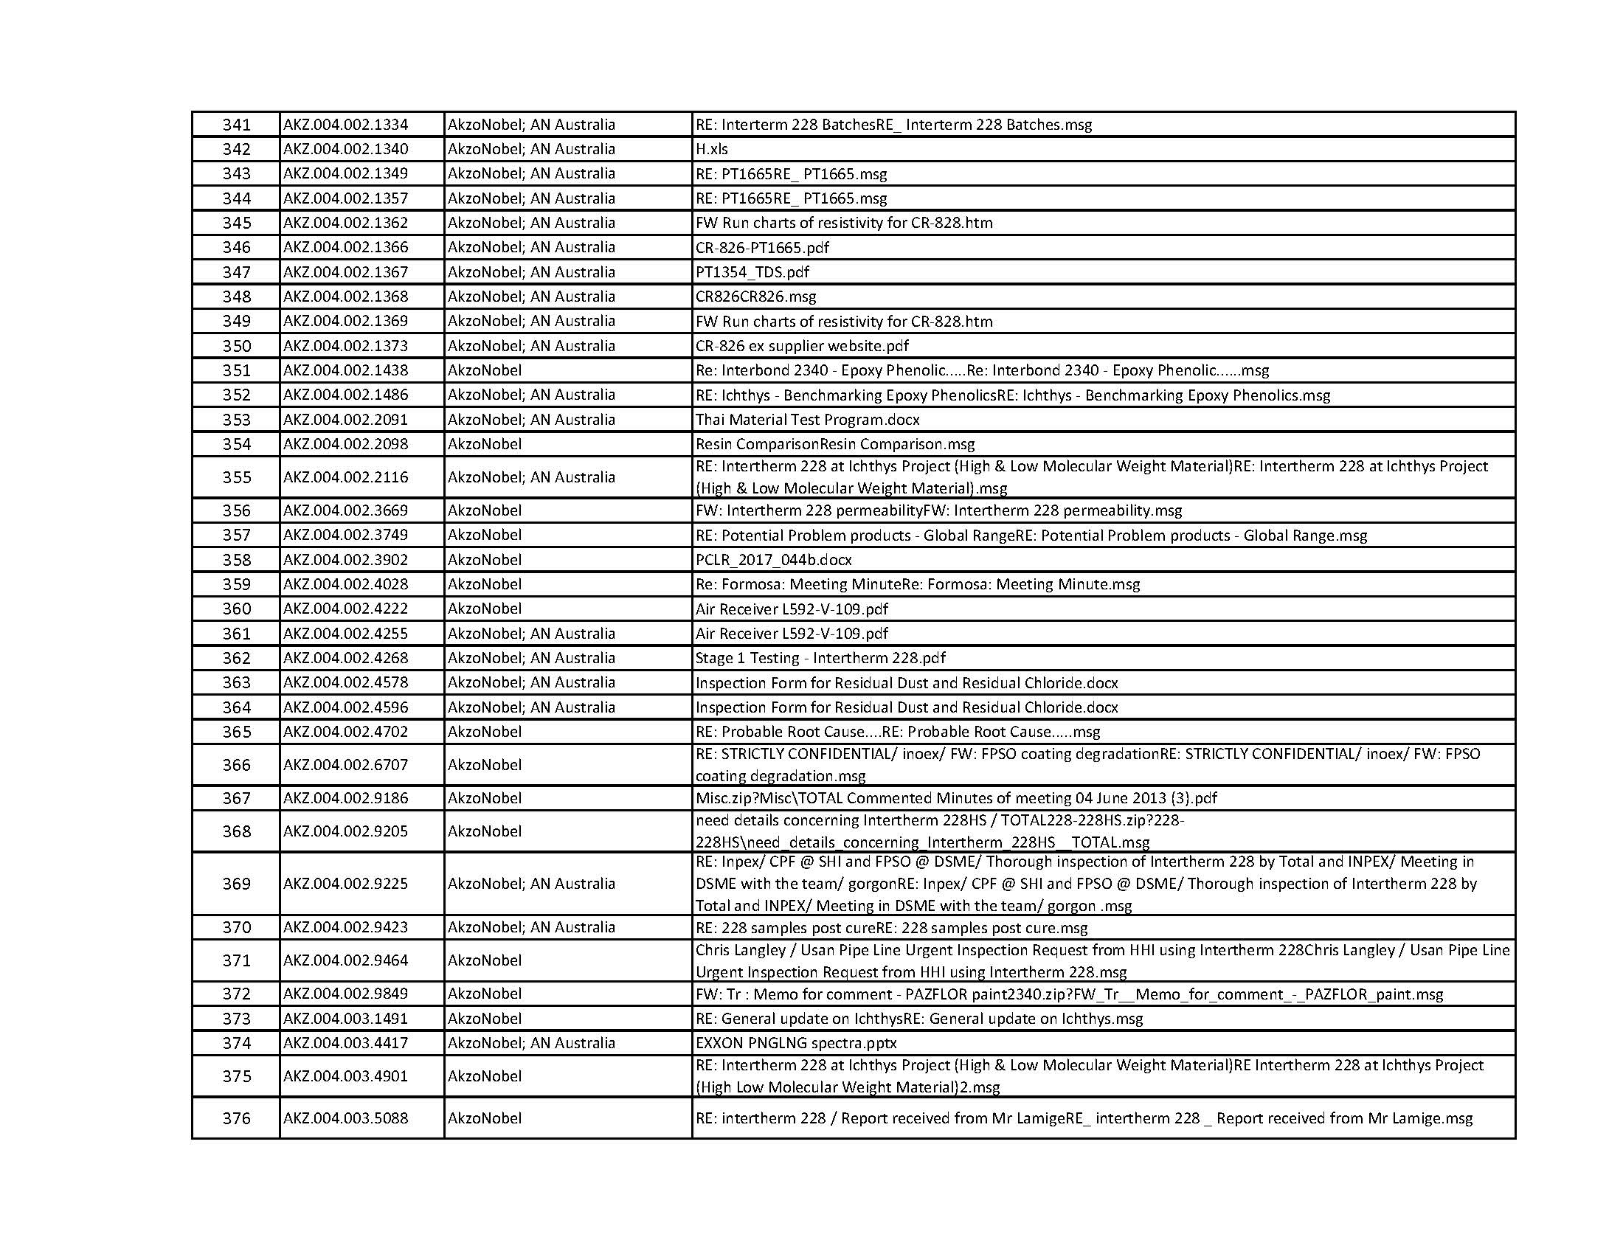
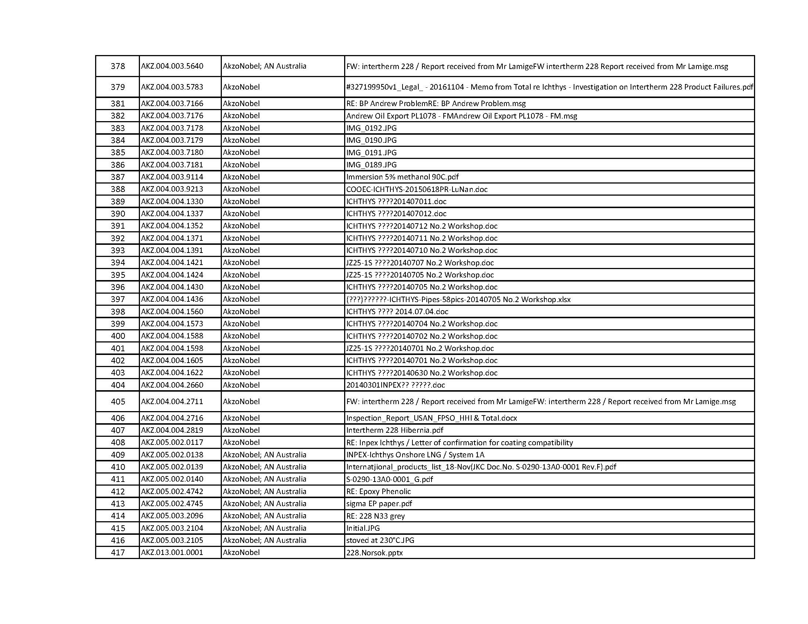
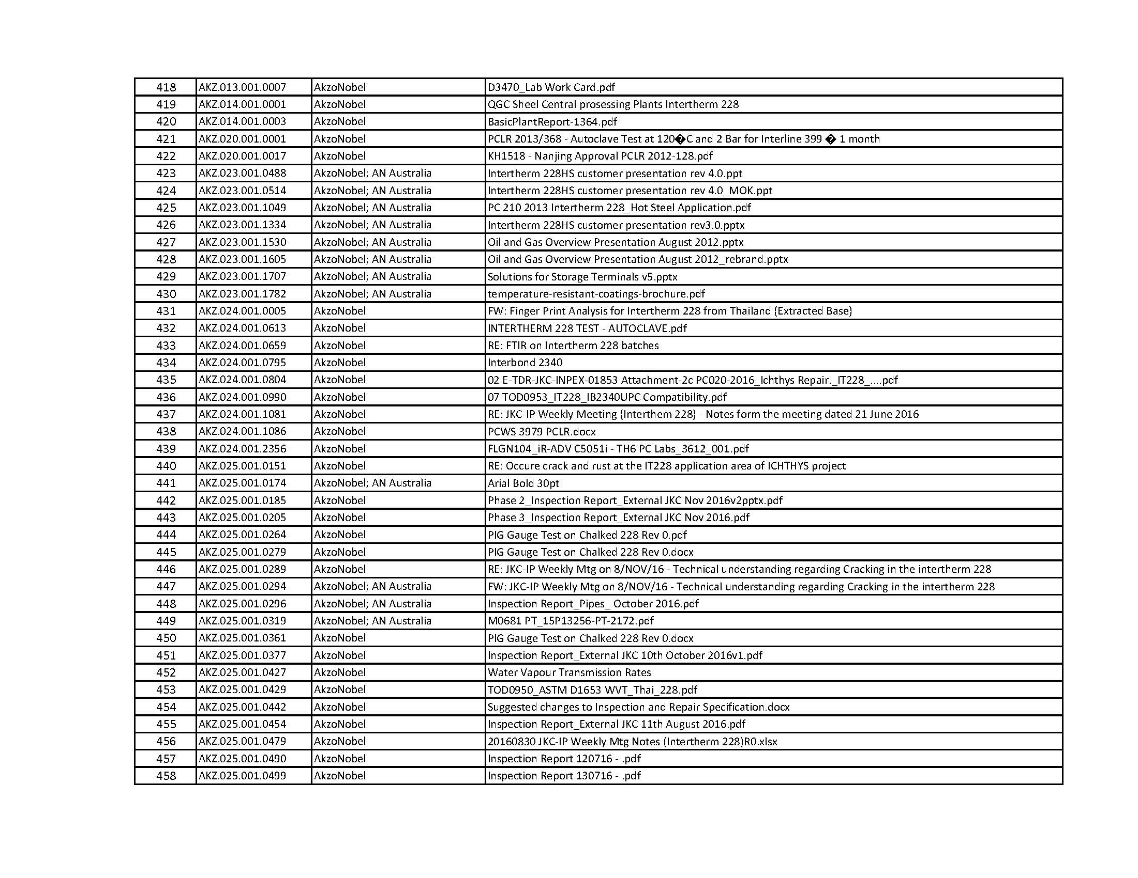
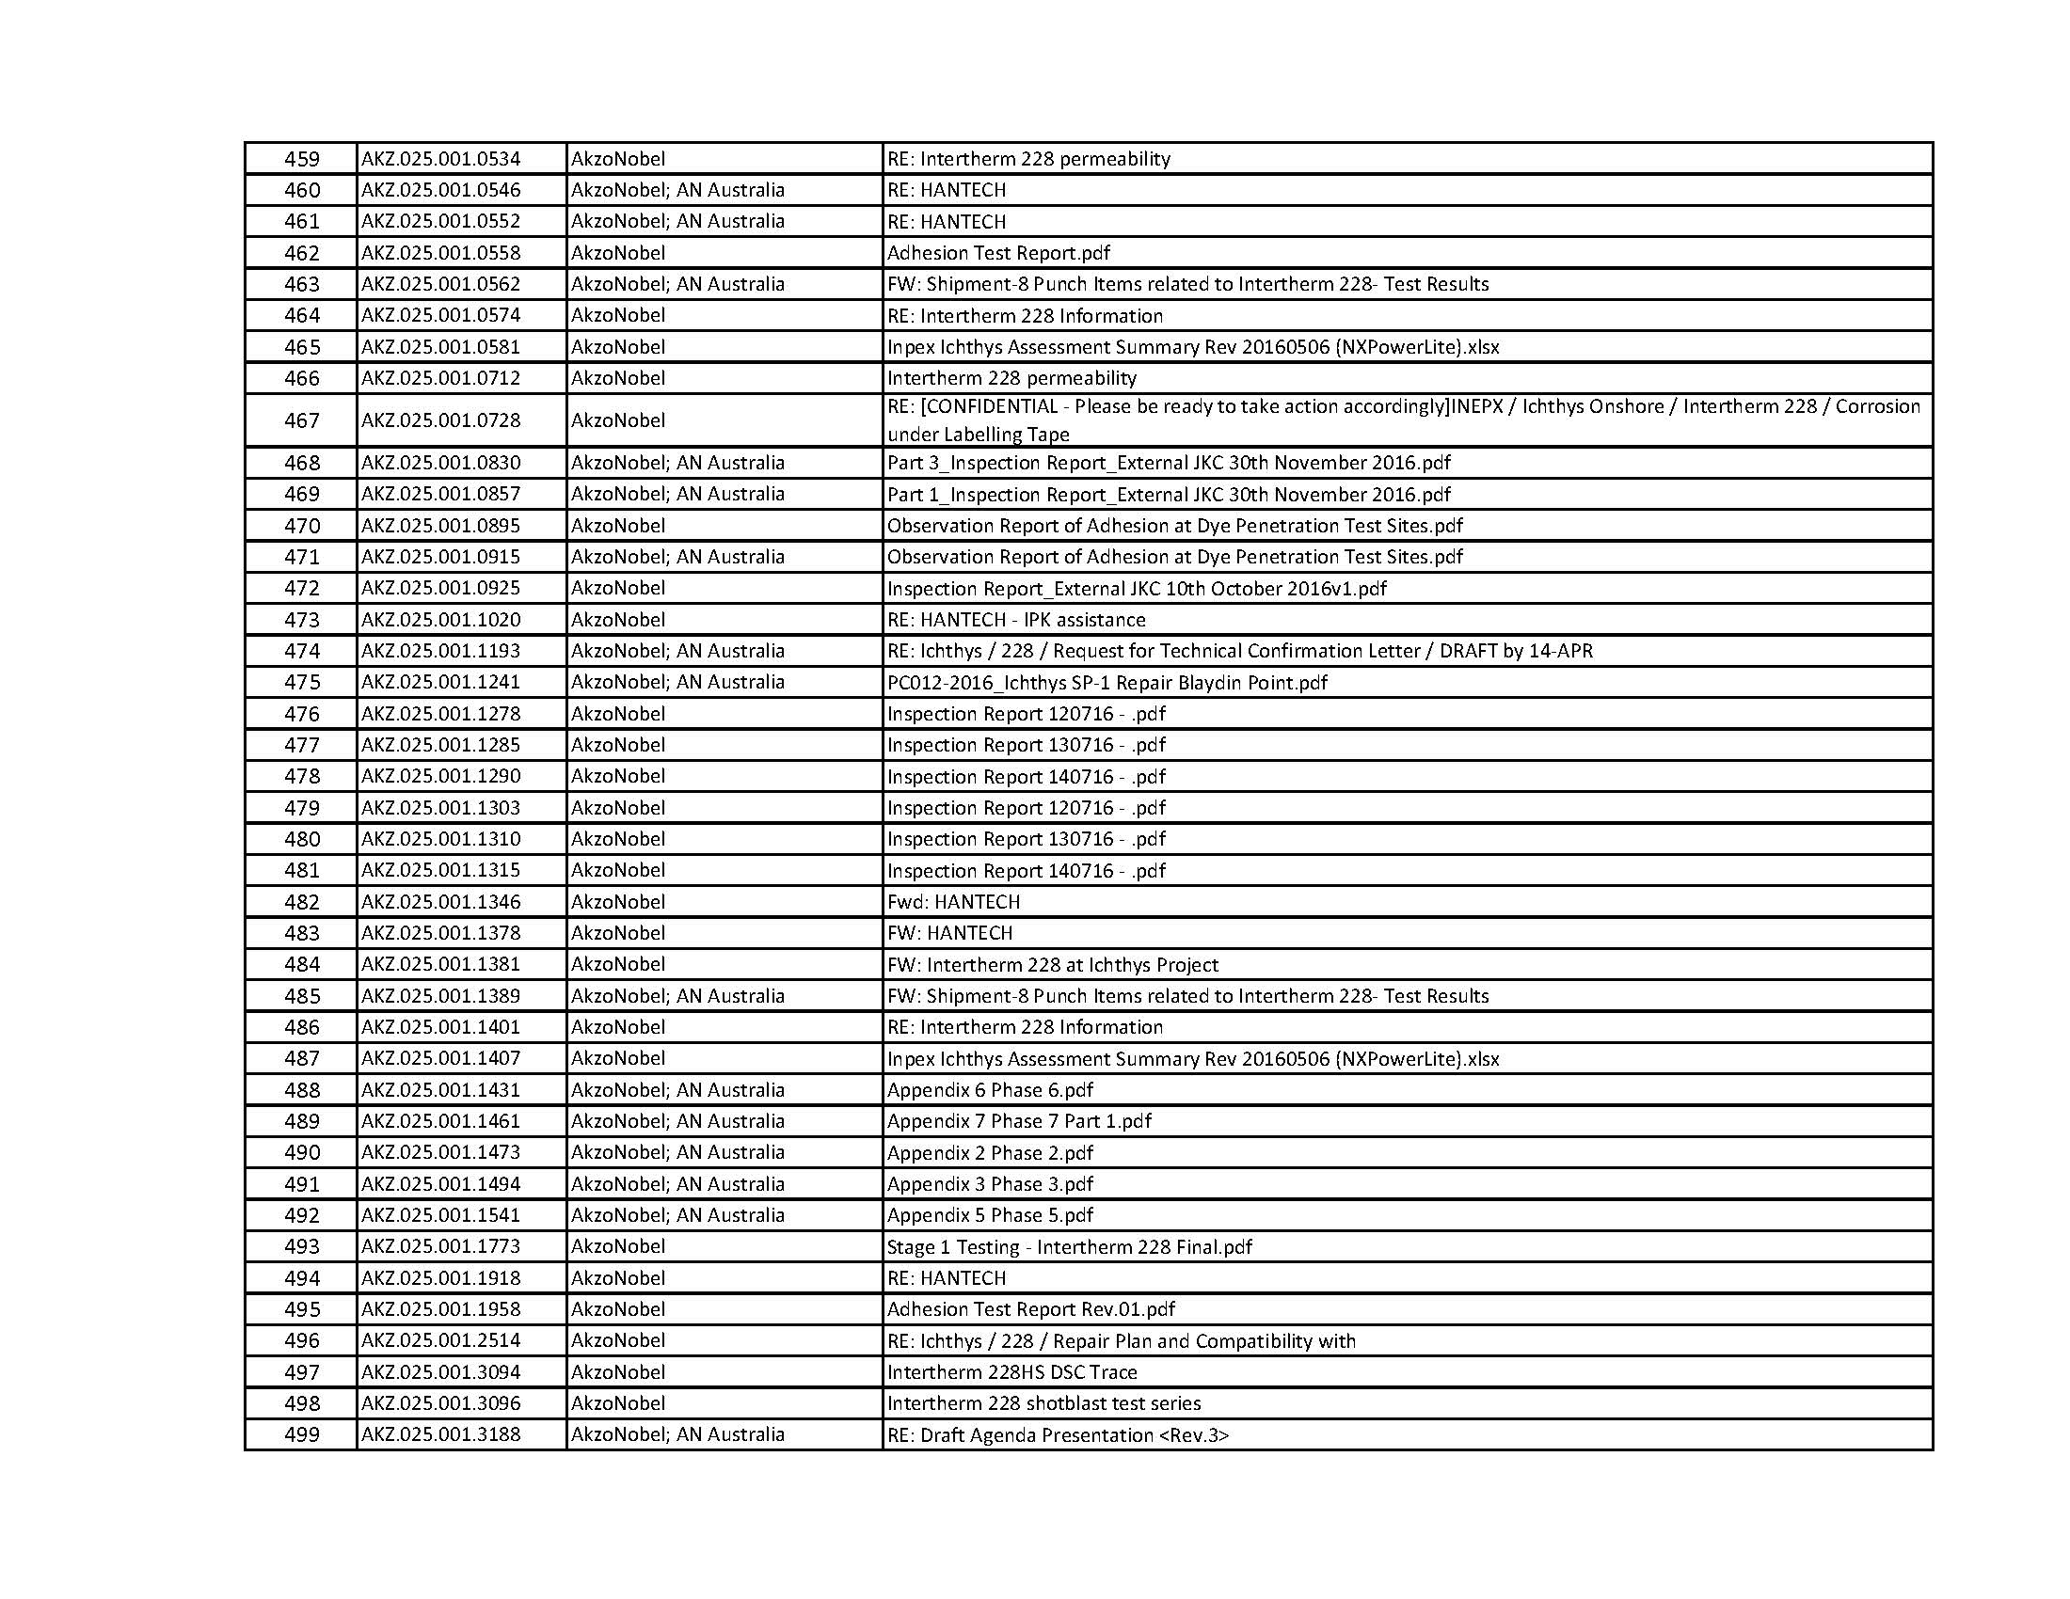
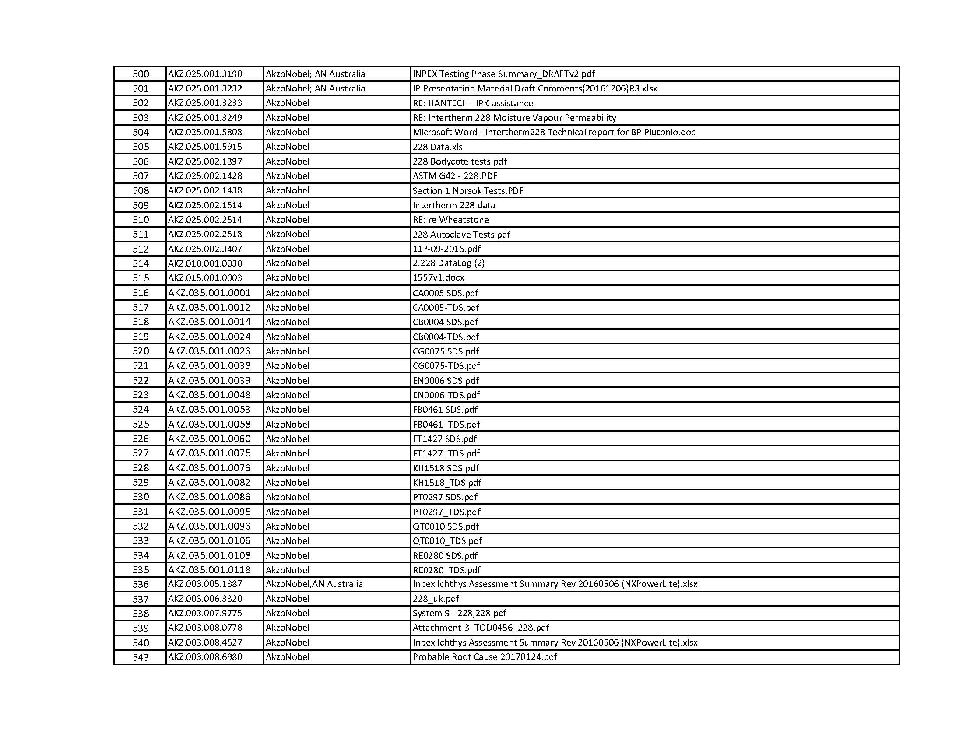

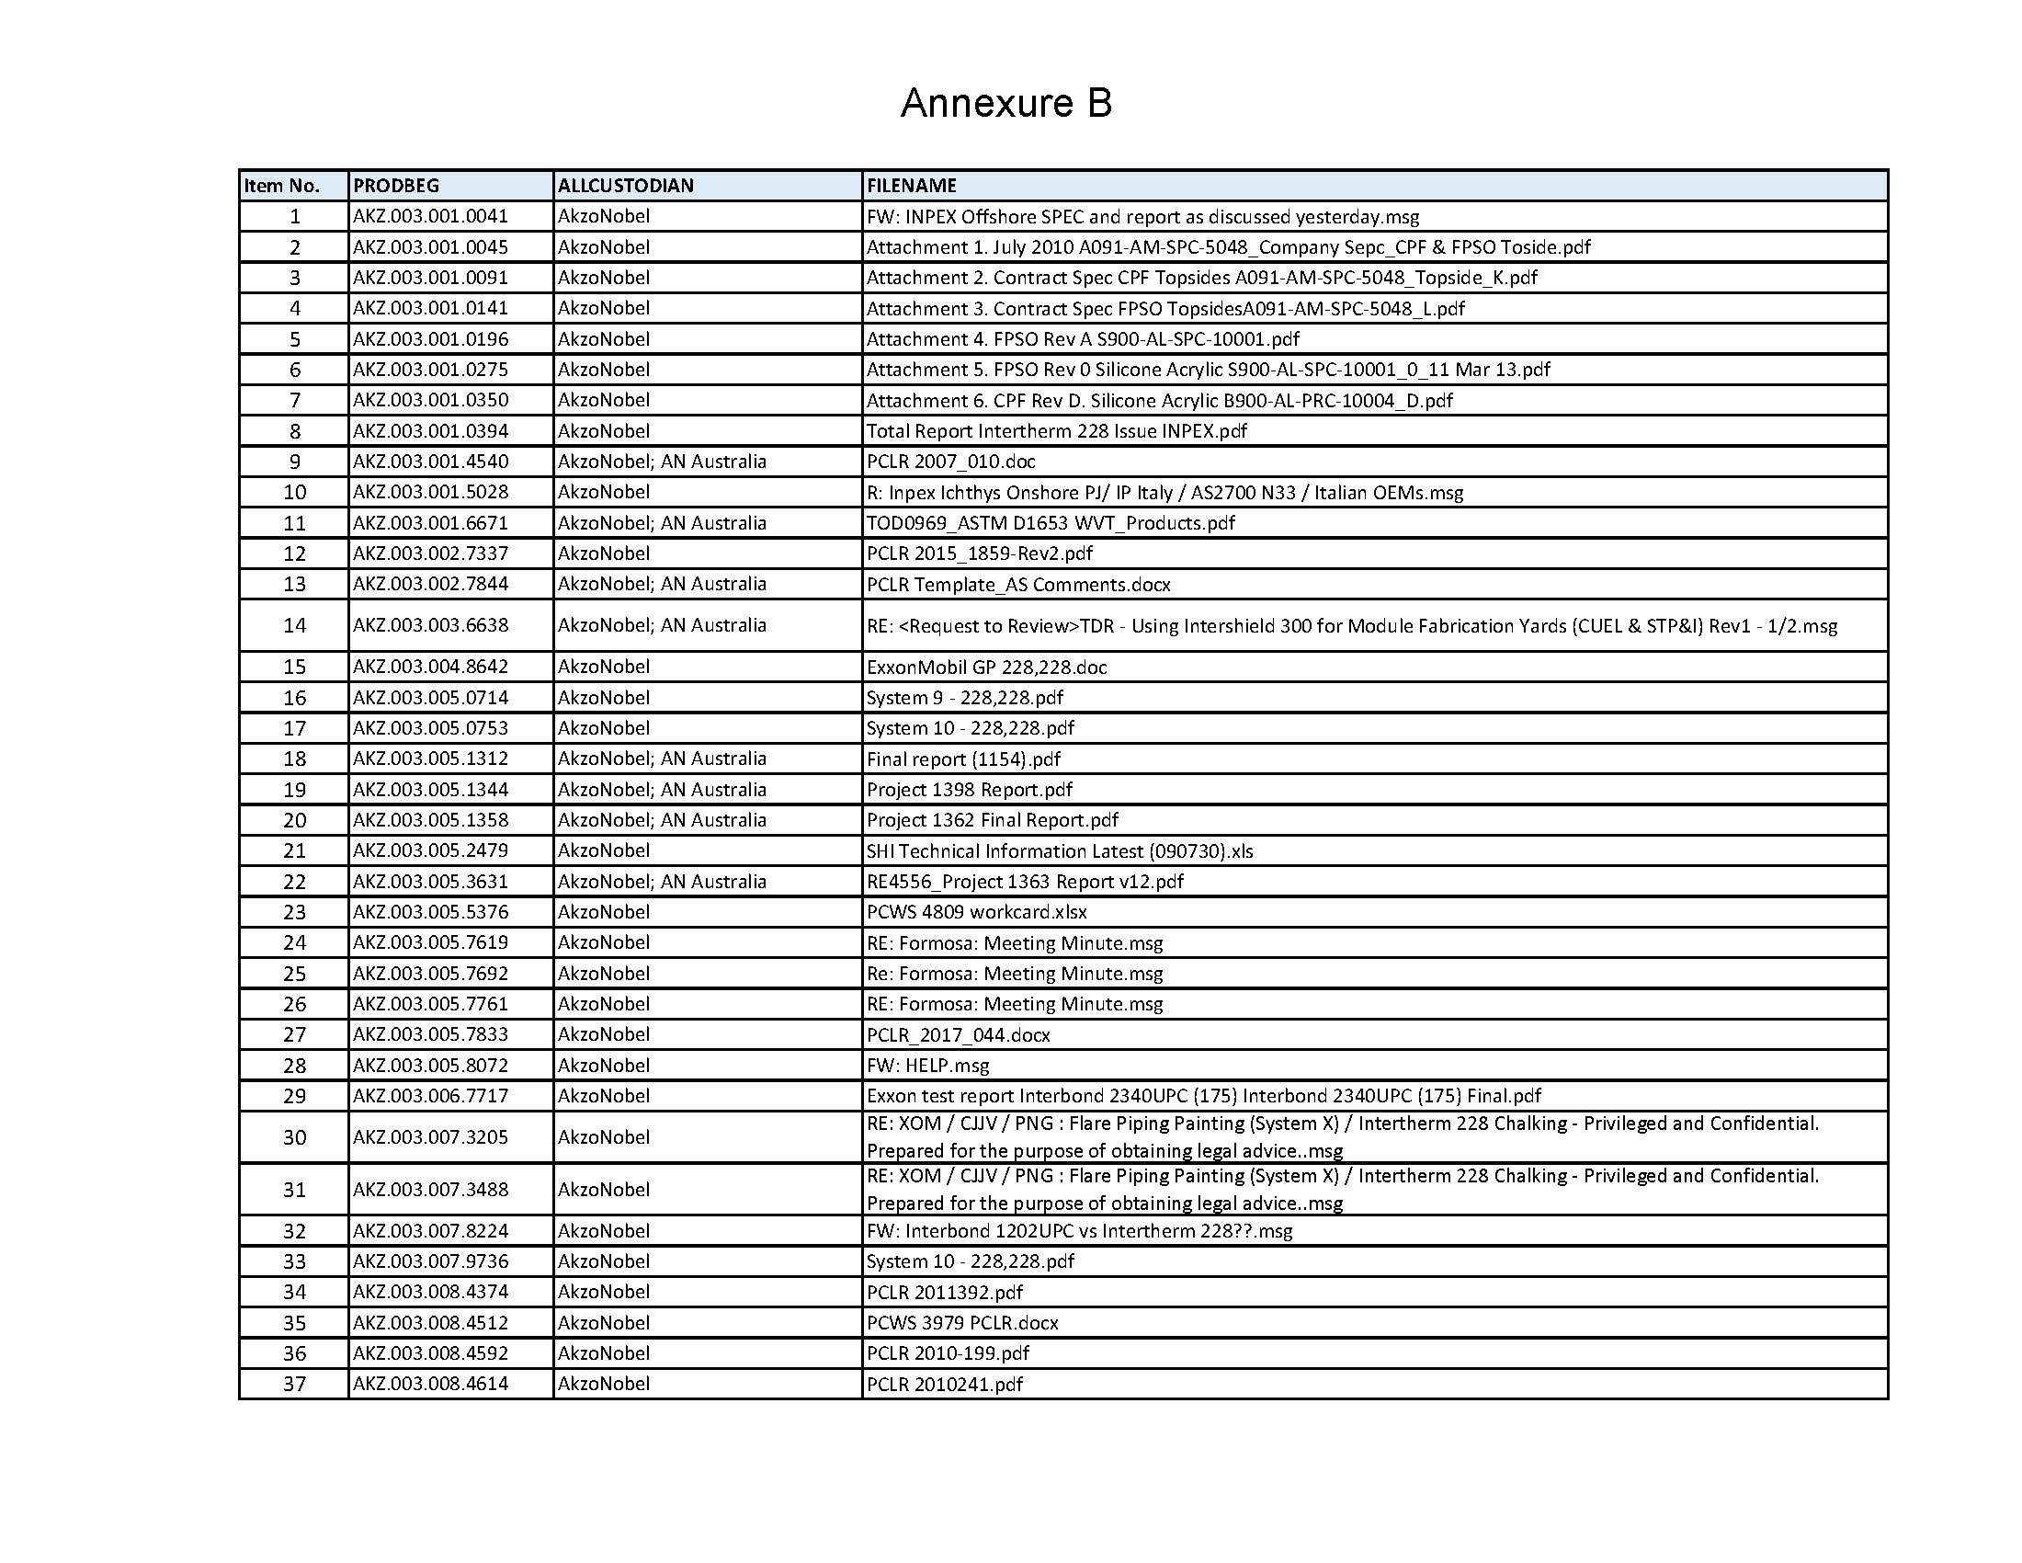
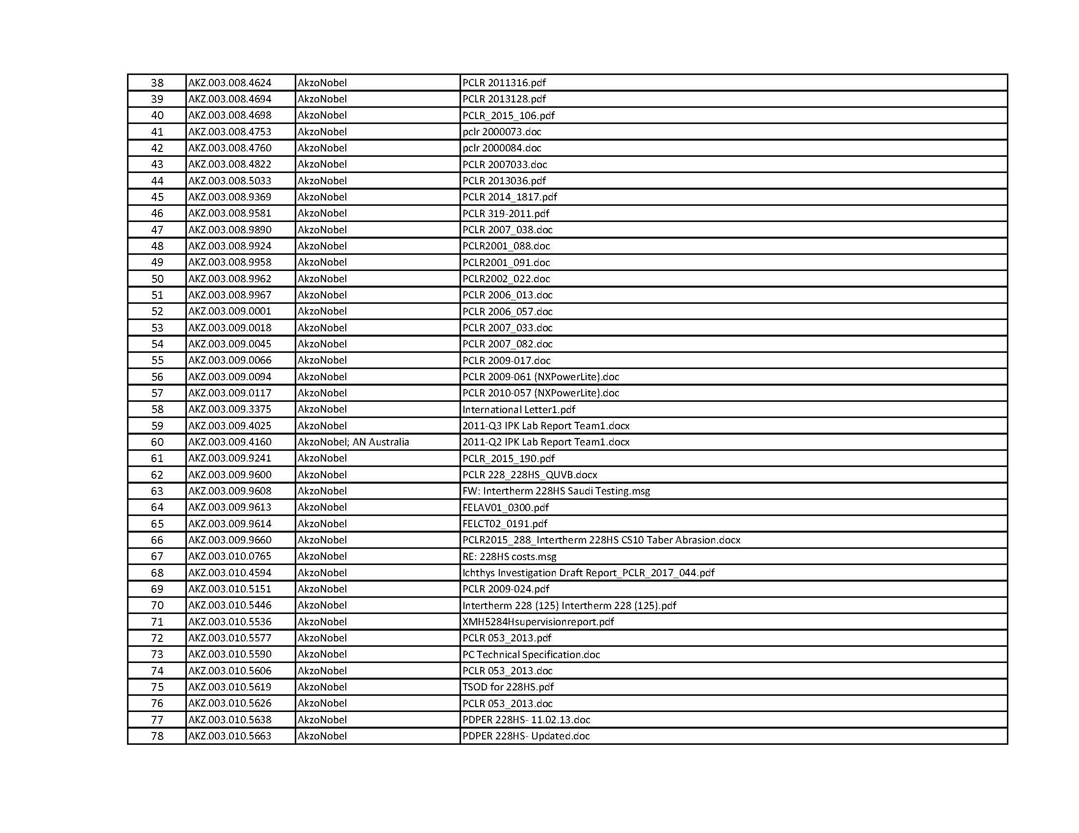
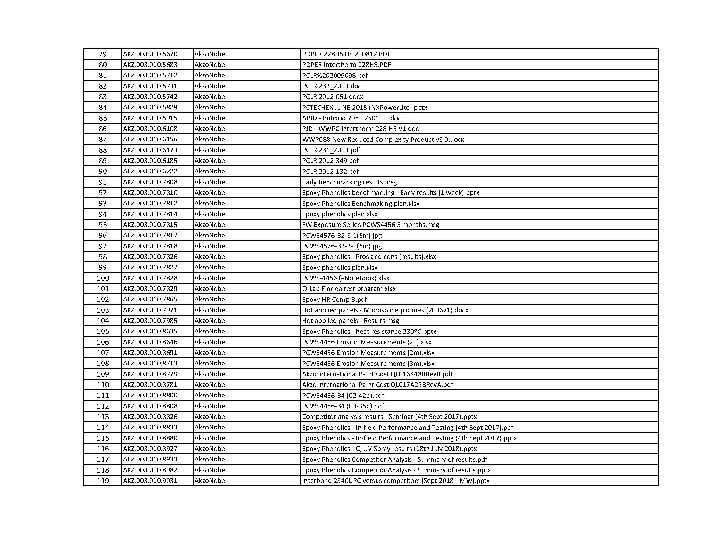
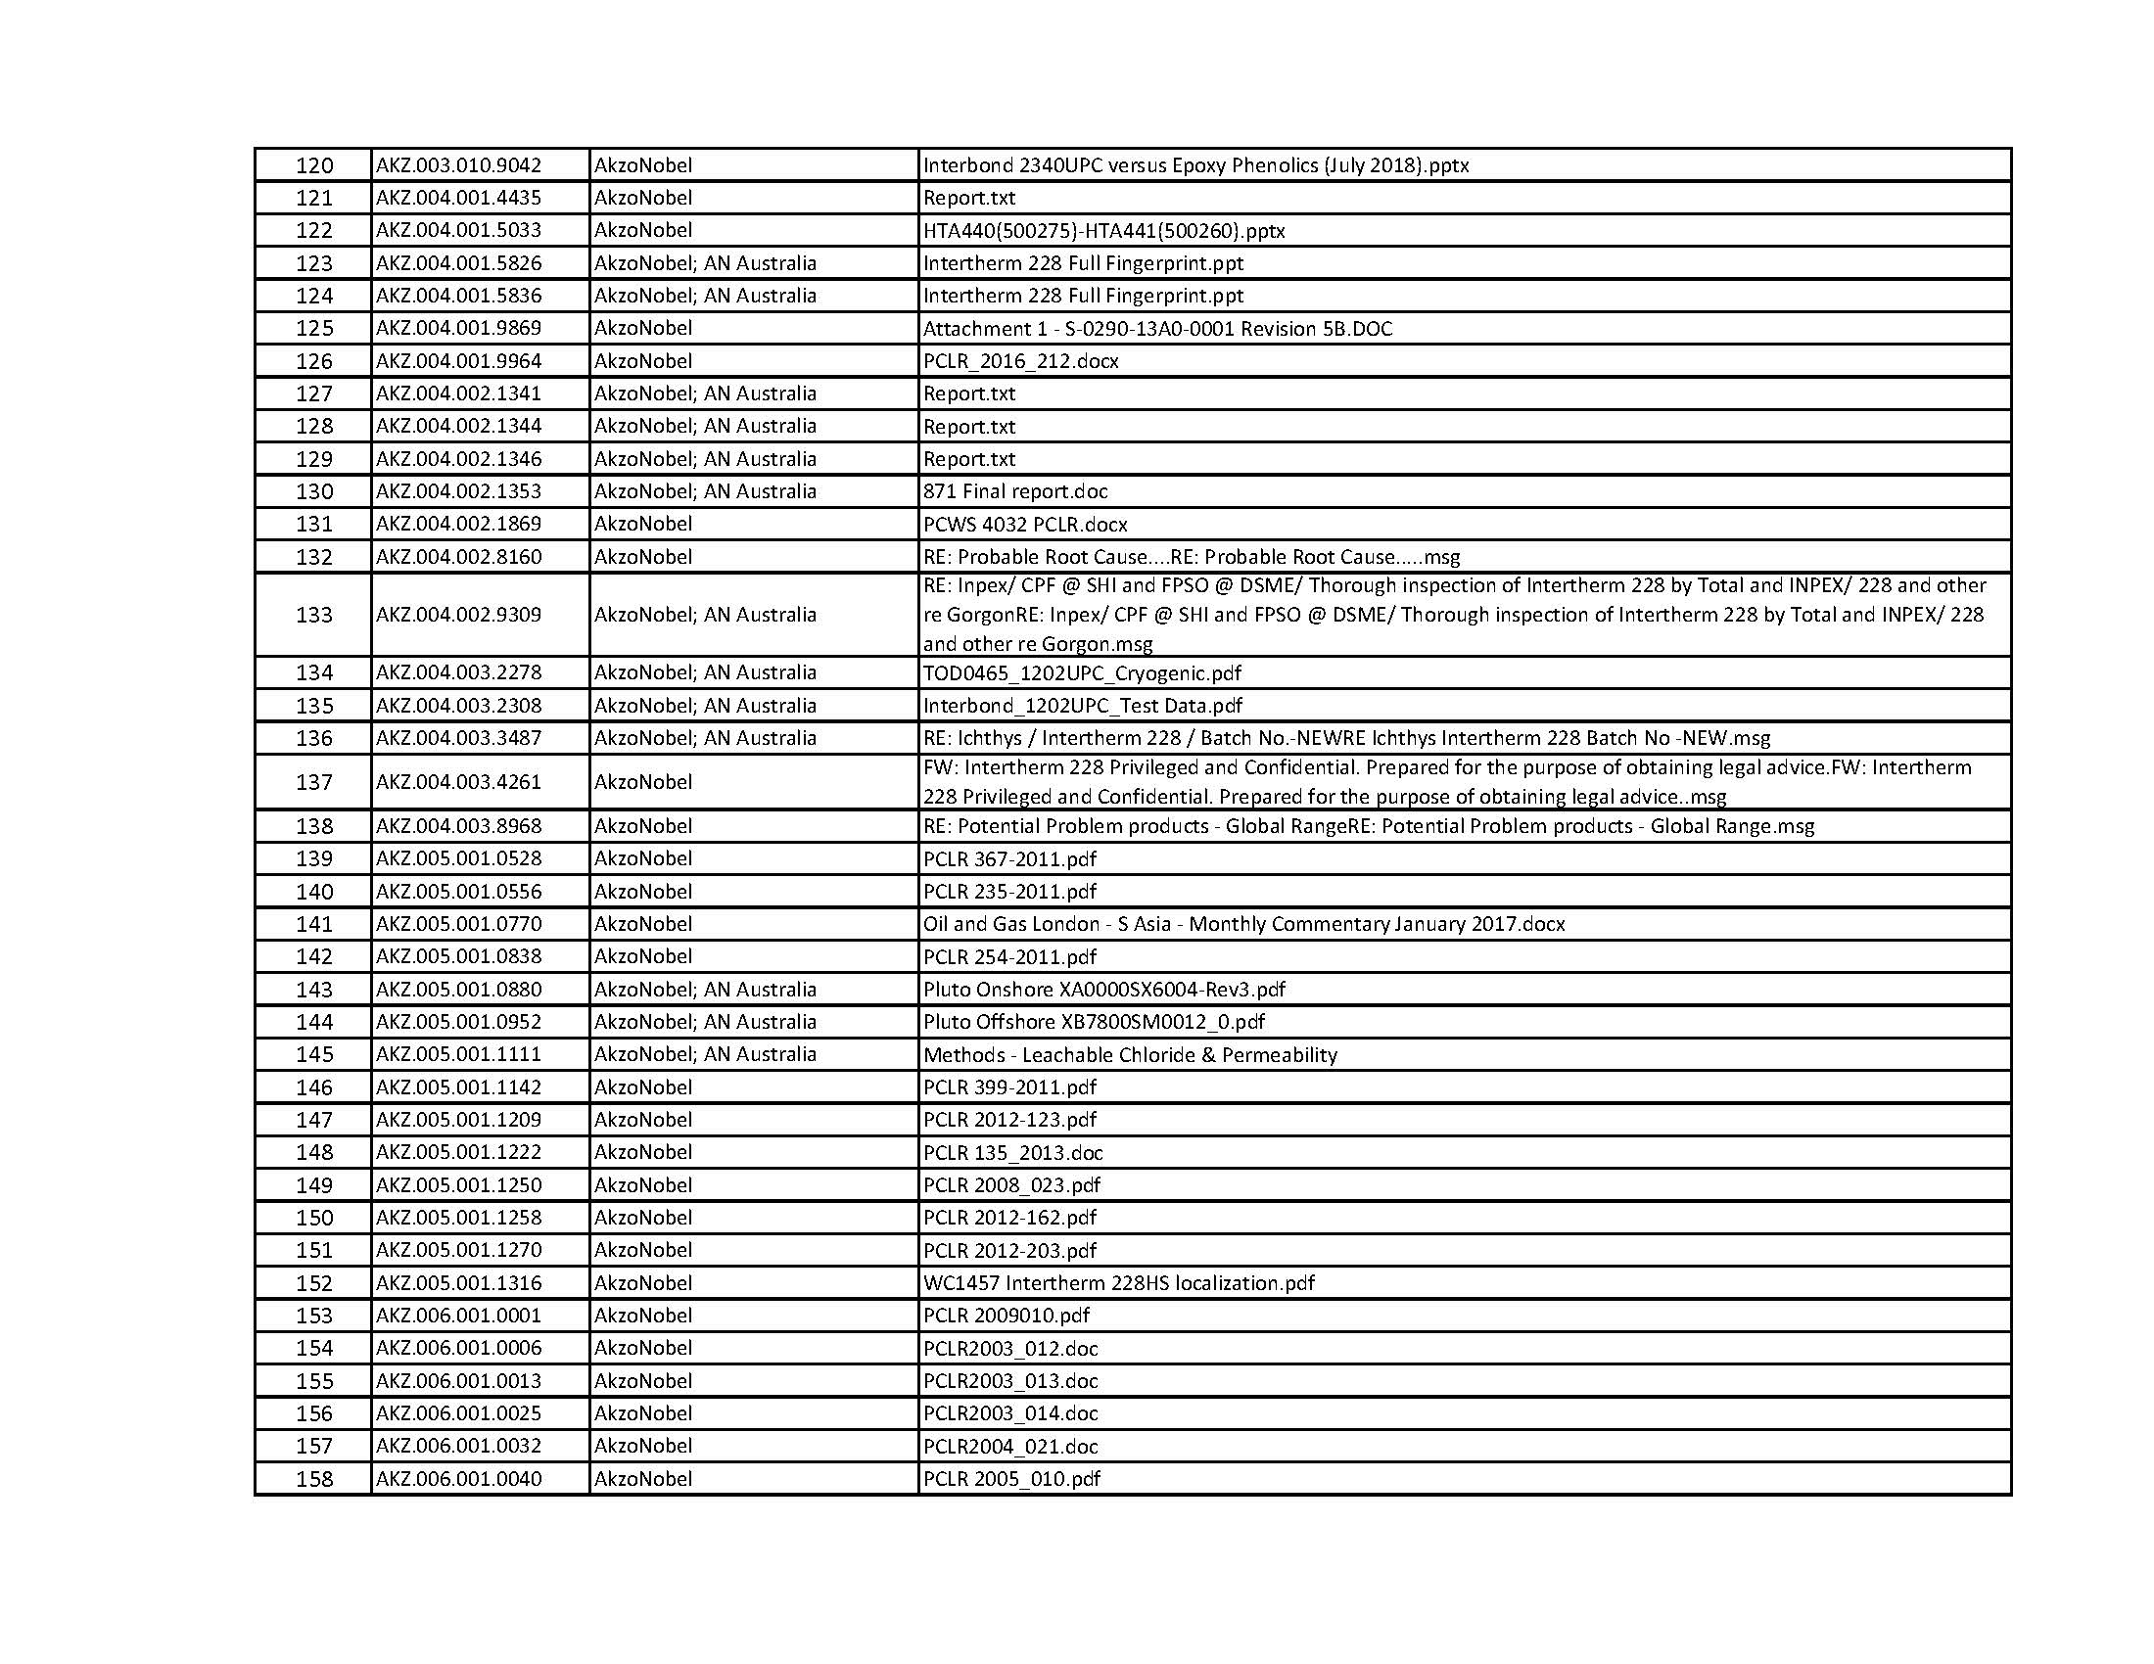
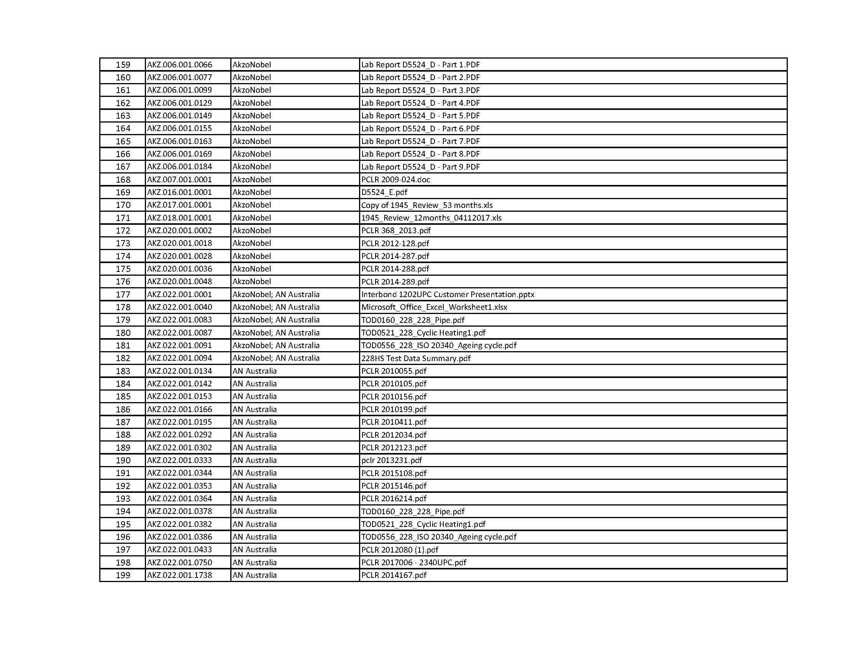
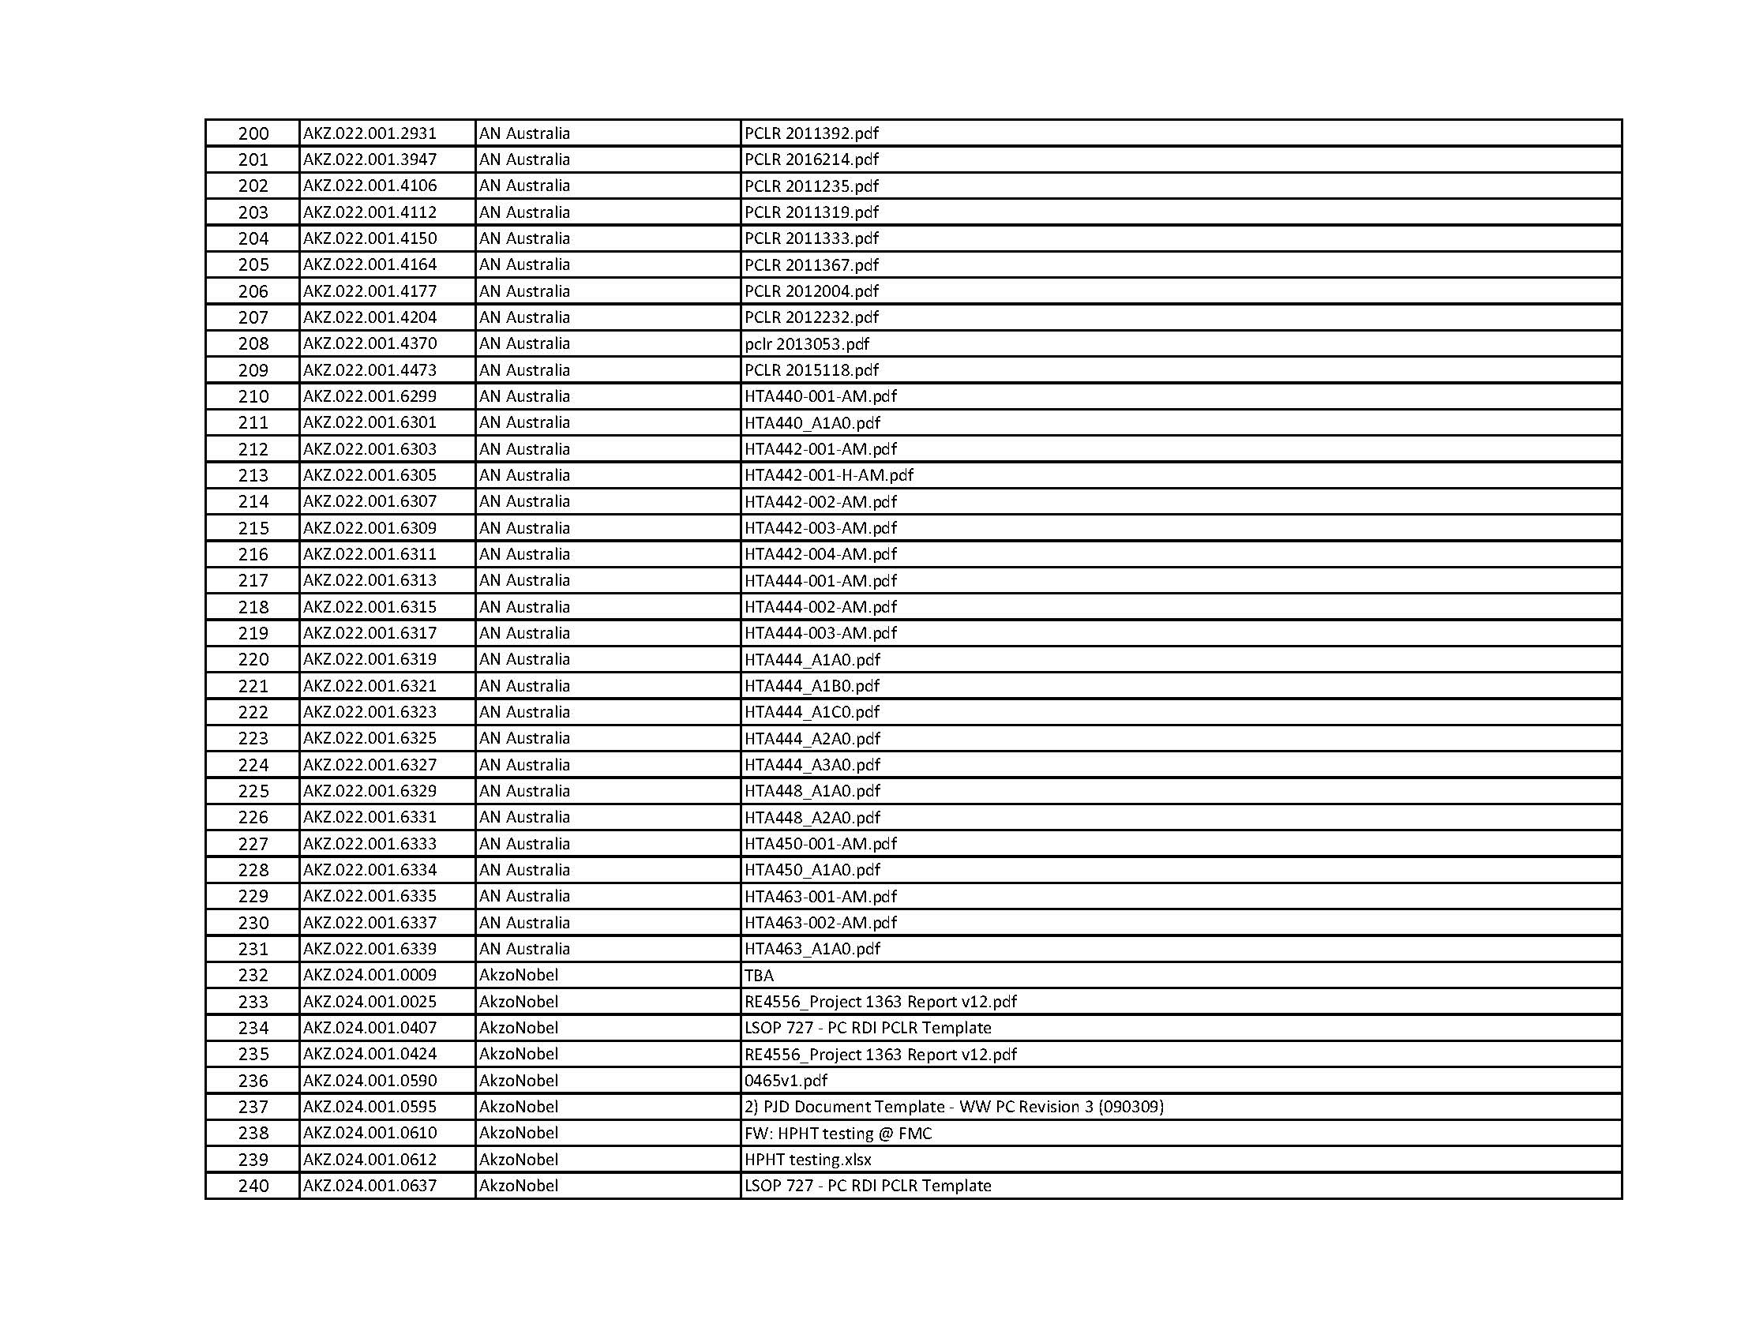
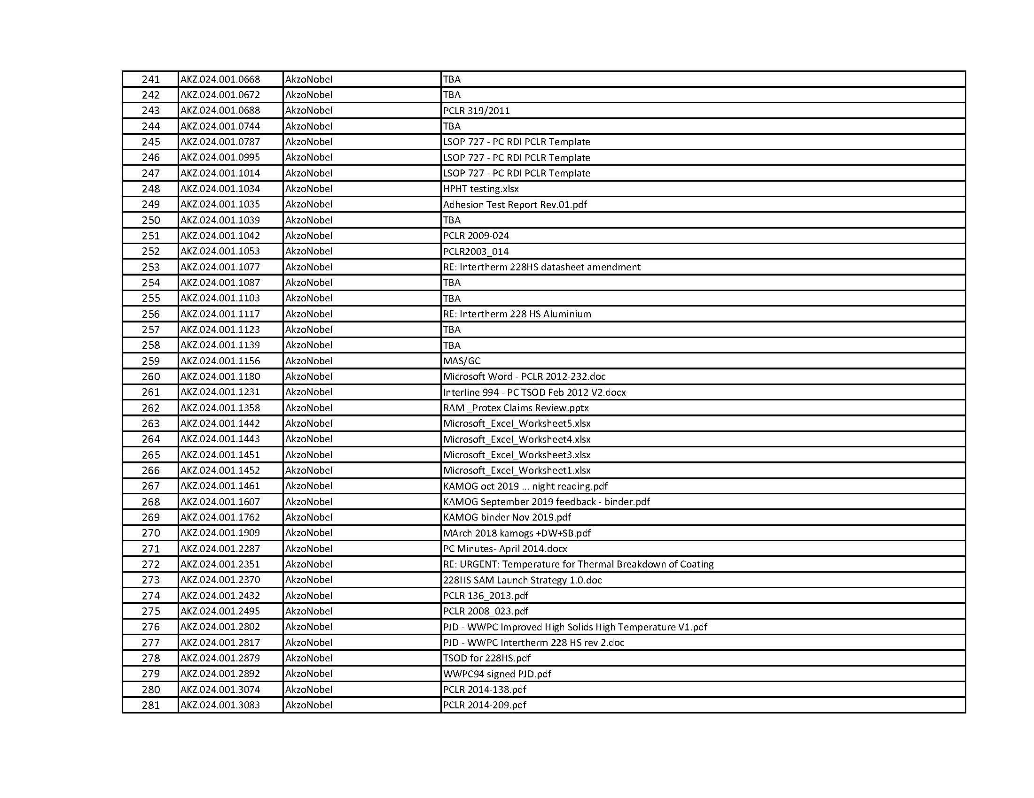
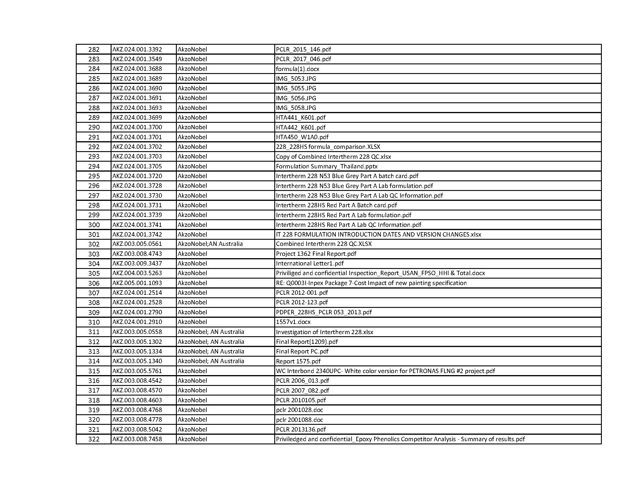
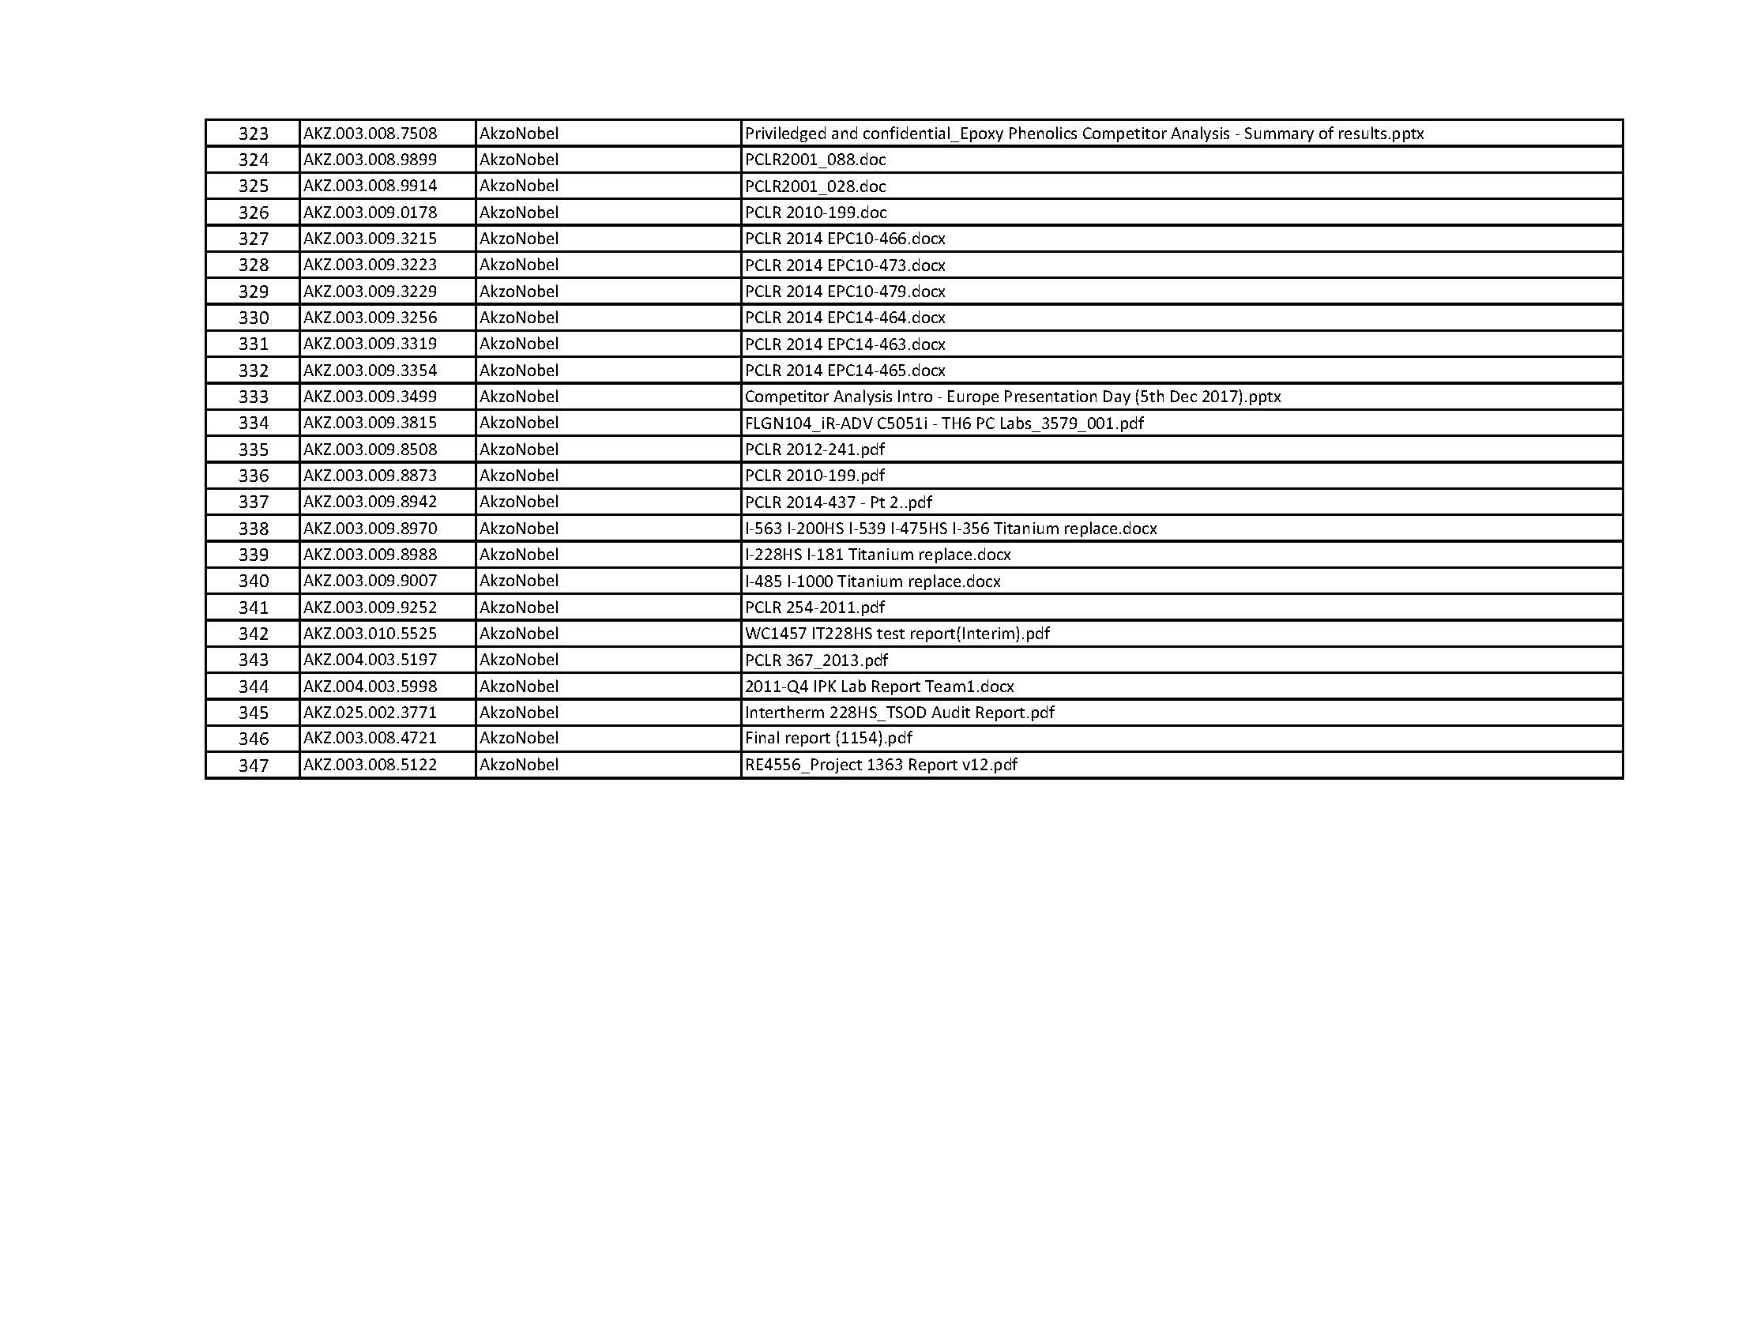
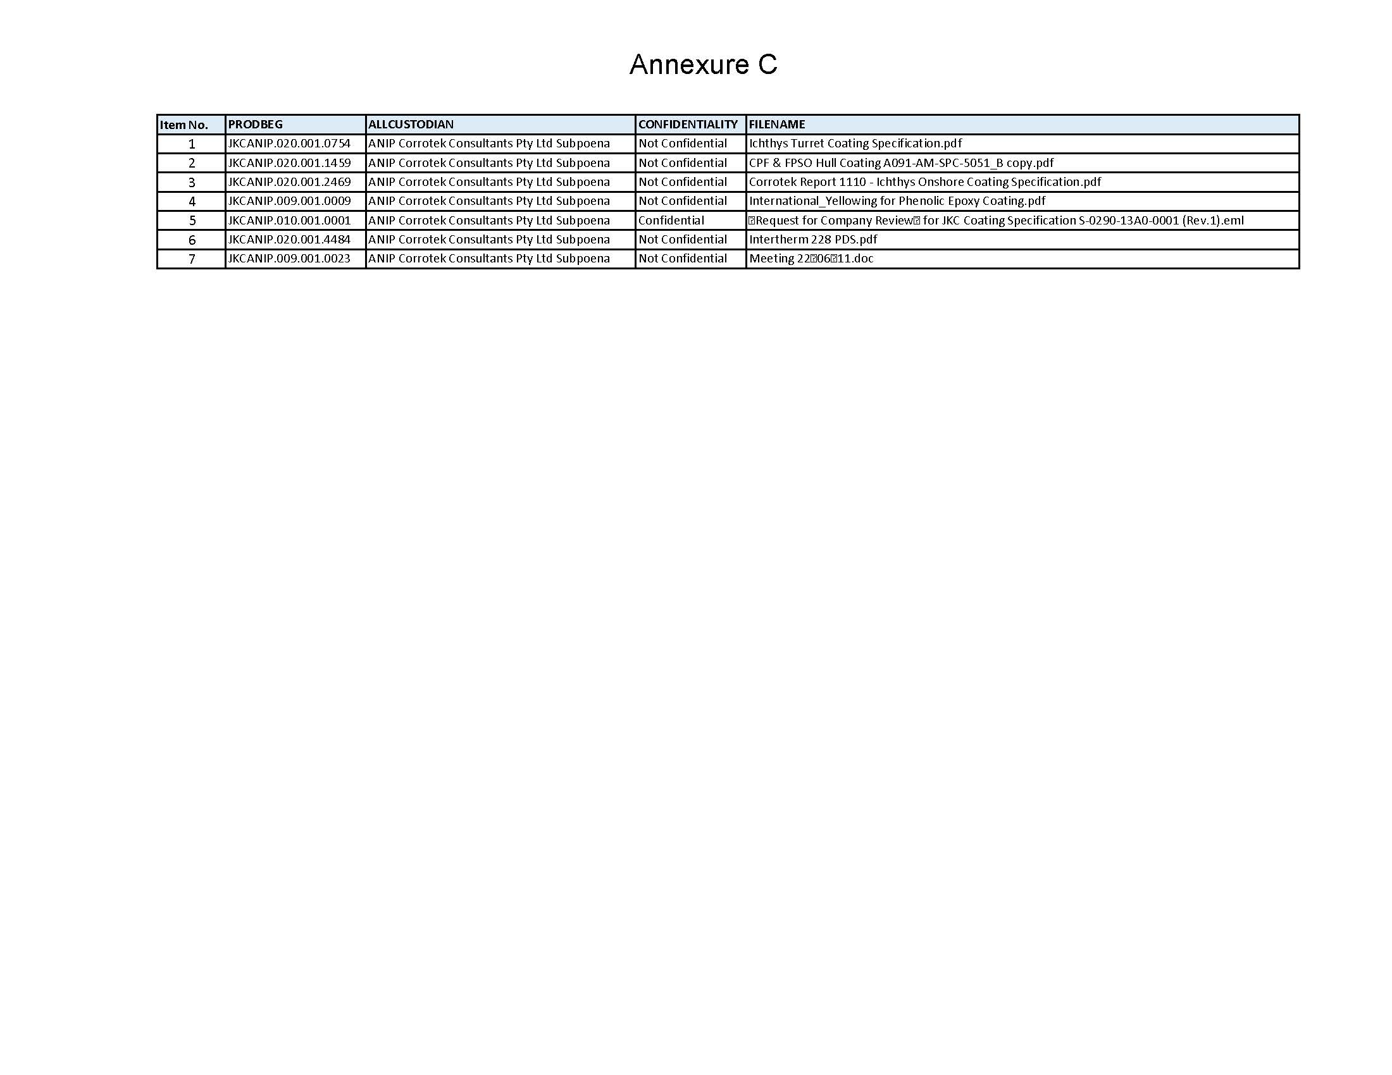
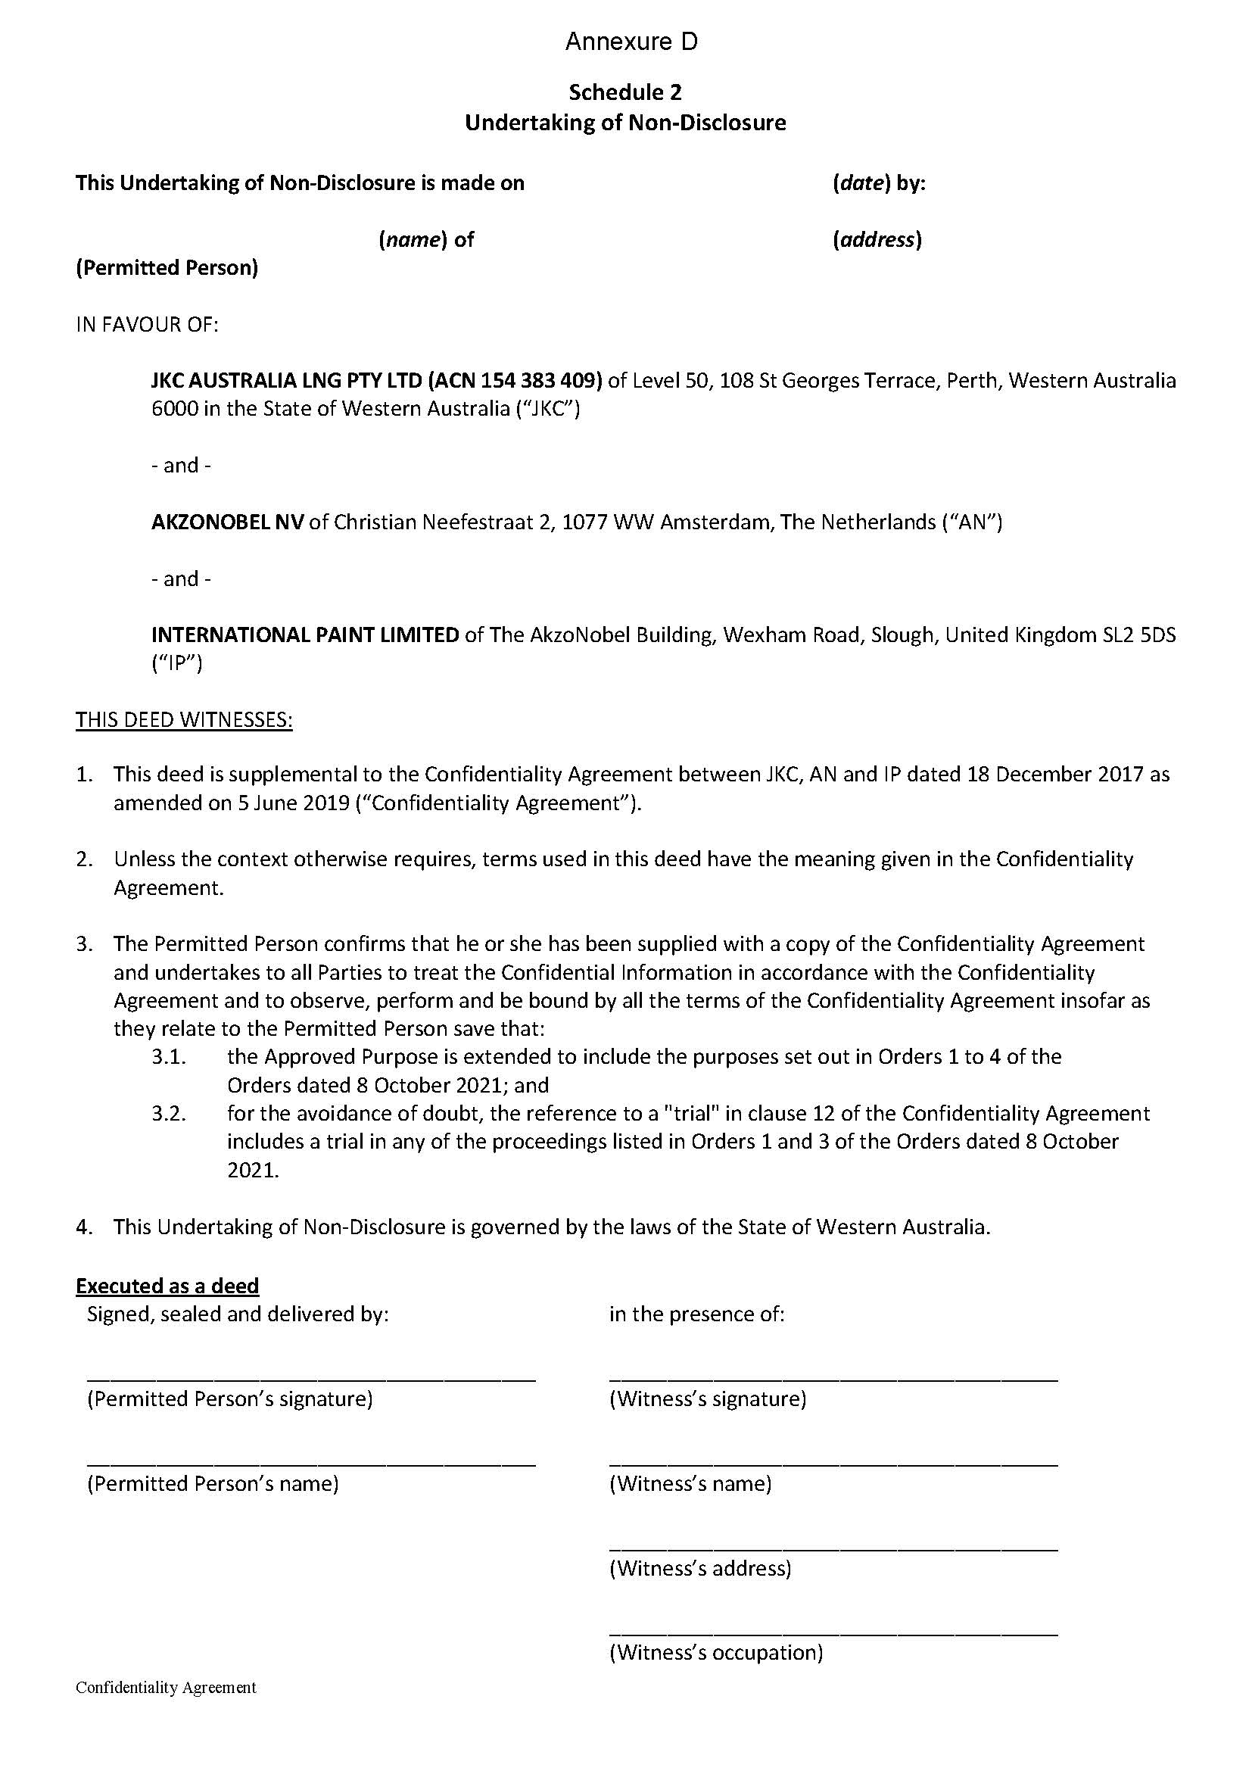

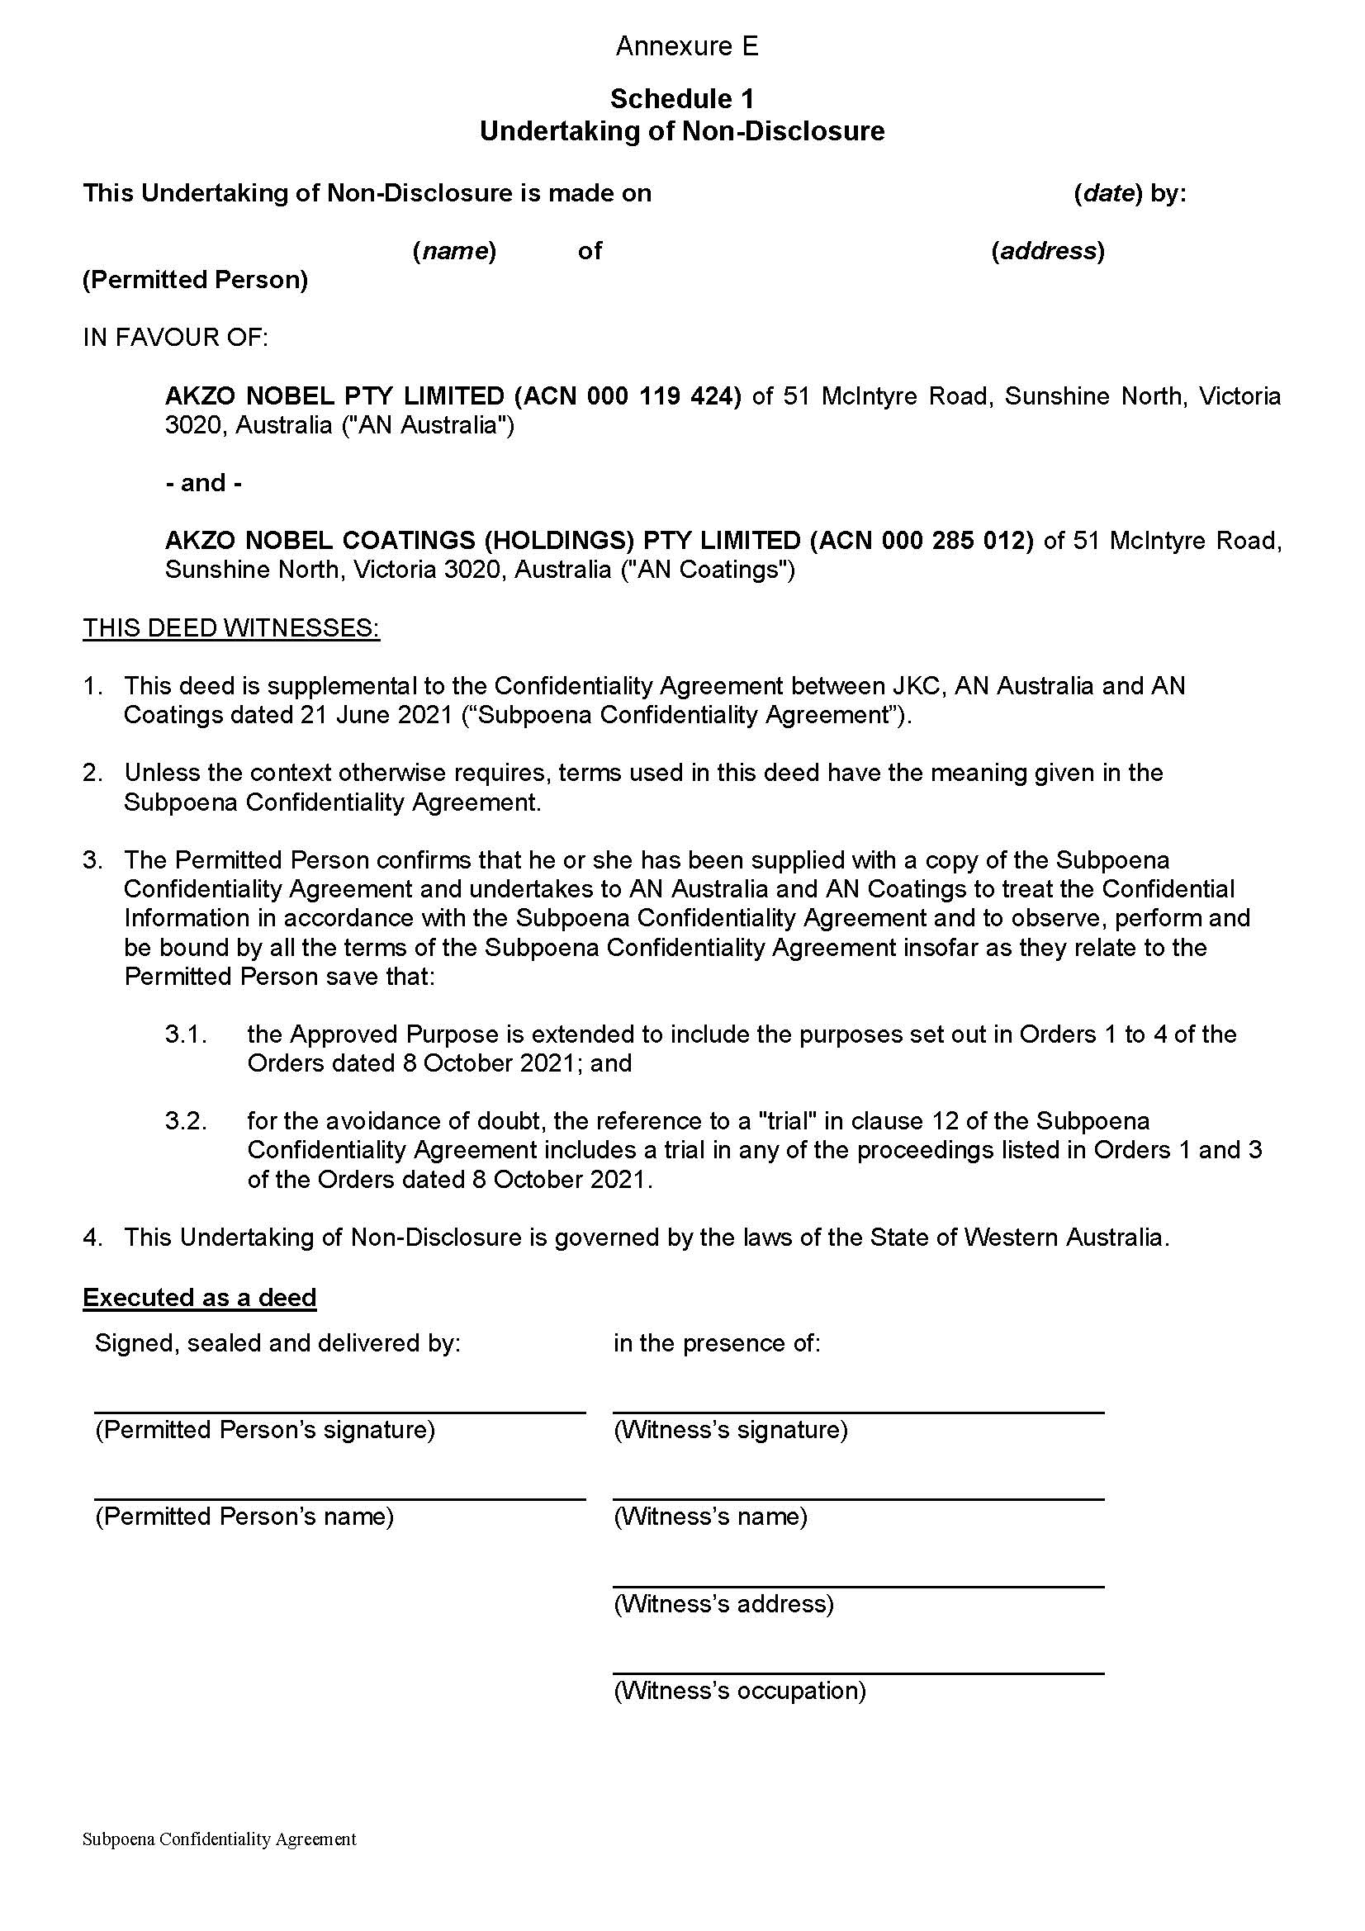

REASONS FOR JUDGMENT
BANKS-SMITH J:
- This is a second application by the applicant seeking a release of the implied undertaking to the Court, commonly referred to as the Harman undertaking, in relation to the use of documents. At the hearing on 6 October 2021 I indicated that I would make orders as requested, subject to certain revision to be discussed by the parties. A revised set of proposed orders was provided on 8 October 2021.
- In reasons dealing with the first application, JKC Australia LNG Pty Ltd v AkzoNobel NV [2019] FCA 1032 (JKC (No 1)), I provided a brief summary of the dispute between the parties. Some of what follows adopts that summary.
- The Ichthys Onshore Project (Project) is one of the world's largest liquefied natural gas developments. In short, it involves the extraction of gas and condensate from the Ichthys Field in the Browse Basin off North West Australia and transportation of the gas and condensate by 890 km of undersea pipeline to onshore LNG facilities near Darwin for conversion into LNG for export.
- The applicant in these proceedings (JKC) entered into a contract with INPEX Operations Australia Pty Ltd (INPEX) for JKC to undertake certain engineering, procurement, supply, construction and commissioning for the Project (the contract is referred to as the EPC contract).
- Relevantly, one of JKC's tasks under the contract was to develop coating specifications for pipework and equipment as necessary for the scope of its works.
- After various communications with one or both of the respondents, JKC directed certain suppliers to use a particular coating system known as Intertherm 228 on pipework and equipment modules.
- Following the use of Intertherm 228, degradation and decolourisation issues arose with respect to the coated pipework and equipment. The pleaded claim relates to the communications, selection and use of that product.
- Separately, INPEX has issued related proceedings in this Court as to the use of Intertherm 228 against parties including the respondents.
- This proceeding is relatively advanced. Relevantly, a thorough discovery process has been undertaken. Subpoenas have been issued resulting in the production of documents by certain related companies and third parties. Statements of lay evidence have been served. Preparation of expert reports is continuing.
- As a result of the document production processes, JKC has in its possession documents from the respondents and related Australian companies and from, relevantly, a third party being Corrotek Consultants Pty Ltd. The parties have determined that some of those documents are confidential.
- JKC seeks orders relieving it of the implied undertaking with respect to particular identified documents, which, consistently with JKC's submissions, I will refer to as the Relevant Documents.

Affidavits
- JKC relied relevantly upon affidavits of Trafford Gazsik, Liam Prescott and Sophy Woodward.
- Mr Gazsik holds the position of senior legal counsel for JKC and is responsible for the day-to-day management of this proceeding. I therefore infer that he has a good understanding of the matters in issue in these proceedings. I also accept that he would have a good understanding of the arbitration and insurance proceedings to which I will refer shortly. I infer that accordingly he understands the significance of the documents that have been received by JKC through the document production processes.
- Mr Prescott is a partner of the law firm DLA Piper Australia. Ms Woodward is special counsel at the law firm HFW Australia. Although JKC is represented by Solomon Brothers in this proceeding, both Mr Prescott and Ms Woodward also act for JKC, but in different capacities, as explained below.

Mr Fred Salome
- JKC has engaged Fred Salome as an expert in this proceeding. Mr Salome is a paint chemist. One question upon which Mr Salome has been engaged to opine includes the extent to which damage has arisen from the use of Intertherm 228 on the Project and the reasons for that damage. Although Mr Salome has not yet finalised his report addressing those matters, he has prepared a draft report. Mr Salome has had access to all of the Relevant Documents for the purpose of preparing his report.

Relevant Documents
- The Relevant Documents are divided into three categories, listed in Annexures A, B and C of the application.
- The documents listed in Annexures A and B are those documents that have been produced by the respondents by discovery in this proceeding and by related Australian entities under subpoenas. There are 854 documents in this category. These documents broadly comprise testing and laboratory reports, product information sheets and documents concerning the composition of products, inspection reports, correspondence and meeting minutes. The documents are divided into two categories. Non-confidential documents are listed in Annexure A. Confidential documents are listed in Annexure B.
- Mr Gazsik explained that since December 2017 the parties have had in place a protocol and agreement governing how information in documents that JKC or the respondents consider to be confidential would be treated by the parties and other persons, for example, external legal representatives.
- Relevantly, those documents listed in Annexure B are subject to a confidentiality agreement entered into between JKC and the respondents. Similarly, there is a subpoena confidentiality agreement entered into between JKC and the respondents' Australian related companies that produced documents under subpoena. JKC proposed in this application that there be similar confidentiality undertakings given by any other person who may have access to those documents in the event that the application to be relieved from the implied undertaking is granted.
- The seven documents listed in Annexure C have been produced by Corrotek under subpoena. These documents broadly comprise correspondence and other technical documents concerning the coating system used for the Project.
- All of the Relevant Documents were provided to Mr Salome to assist with his investigation into the root cause of the alleged Intertherm 228 failure. With the exception of the documents obtained by JKC through subpoenas, the Relevant Documents contain technical and testing information that is not otherwise available to JKC. Mr Gazsik deposed to the fact that he has spoken to Mr Salome who informed him that the fact that he has relied upon the Relevant Documents will be evident from the text of his report.

Proposed use of Relevant Documents
- Mr Gazsik explained that JKC and INPEX are currently involved in an arbitral dispute which arises under the EPC contract, and in which some of the key issues include the damage to the Intertherm 228 on the Project and how it is to be rectified (INPEX Dispute). The INPEX Dispute is the subject of an international arbitration (Arbitration).
- JKC has also issued proceedings in the Supreme Court of Western Australia (CIV 1620 of 2020 and CIV 1729 of 2020) (Insurance Proceedings). The Insurance Proceedings involve claims under insurance policies with respect to Intertherm 228 and its use on the Project. The proceedings are said by Mr Gazsik to also broadly relate to the same or similar factual circumstances concerning Intertherm 228. Those proceedings were required to be brought in the Supreme Court of Western Australia under an exclusive jurisdiction clause in the insurance contracts. INPEX has also brought proceedings in the Supreme Court of Western Australia against a common insurer with respect to the use of Intertherm 228 on the Project, and with respect to a common policy, and those proceedings are to be heard at the same time as the Insurance Proceedings.

Relevance to the Arbitration
- The Arbitration was referred to in general terms in JKC (No 1) at [14]. JKC has retained DLA Piper Australia in the Arbitration. Mr Prescott explained in his affidavit that the INPEX Dispute relates to the use on the Project of Intertherm 228 and what is reasonable and necessary to rectify any problems with respect to the use of Intertherm 228.
- For the purposes of the INPEX Dispute, JKC has engaged coating and rectification experts who have been considering products, testing, inspection and other technical data relating to Intertherm 228. It has received data from JKC, including the 28 documents that were the subject of JKC (No 1). The release of the implied undertaking as ordered in JKC (No 1) allowed those 28 documents to be provided to JKC's coating experts in the INPEX Dispute.
- Mr Prescott said that he is aware from communications with the solicitors for JKC in this matter (Solomon Brothers) and with Mr Gazsik that Mr Salome has had access to a much broader set of documents than the 28 documents that have already been provided to DLA Piper Australia. Mr Prescott said that he is aware of the issues in these proceedings and the fact that they concern damage said to arise from the use of Intertherm 228, being an issue common to the INPEX Dispute. He stated that in his view it is necessary to provide the documents that have already been given to Mr Salome to the experts retained by JKC for the purposes of the INPEX Dispute, so that these experts can provide an opinion on the issues relating to damage and rectification having regard to all the relevant available material. If JKC is permitted to provide the relevant documents to the experts retained for the INPEX Dispute, it will avoid the need for JKC to take further potentially costly and time consuming steps to seek those documents from the respondents, their related entities and Corrotek, including through requests for subpoenas to issue.

Relevance to the Insurance Proceedings
- Ms Woodward has the day to day conduct of the Insurance Proceedings on behalf of JKC. Ms Woodward deposed to claims brought under two policies in which JKC is a party or claims an interest as an insured. It is not necessary to set out the relevant provisions of the insurance policies in order to dispose of this application. Relevantly, however, the policies relate to damages. 'Damages' is defined under both policies to mean 'physical loss, destruction or damage'. It is therefore apparent that under both insurance policies it is relevant to establish that damage has occurred and whether the cause of any damage excludes or otherwise affects insurance cover.
- Ms Woodward deposes to the fact that she is familiar with the claims and issues raised in these proceedings and the evidence that has been served by JKC. She states that insofar as the Insurance Proceedings concern Intertherm 228, they arise from the same factual circumstances as those the subject of this proceeding, namely damage said to have been suffered as a result of the use of Intertherm 228 on the Project.
- Statements of claim in the Insurance Proceedings have not yet been filed. Ms Woodward deposed to the fact that she has spoken to Mr Salome and that, subject to this application being granted, Mr Salome is to be retained by JKC to give expert evidence in the Insurance Proceedings. JKC accordingly wishes to use the draft report in the Insurance Proceedings and also wishes to provide INPEX with the draft report of Mr Salome, having regard to its insurance proceedings. Because the report apparently refers to the Relevant Documents, JKC also seeks that any release of the implied undertaking extend to the use of the draft report in the Insurance Proceedings and the disclosure of the draft expert report of Mr Salome to INPEX.
- Ms Woodward said that if JKC is unable to rely on Mr Salome's opinion, JKC will have no choice but to engage a different expert in the Insurance Proceedings to opine on the same matters. In her view, a second expert will be obliged to form a view on the cause of any damage arising from the use of Intertherm 228 without necessarily being able to rely on the same evidence. Ms Woodward considers that there would therefore be a real risk that another expert, without the benefit of the relevant documents, would reach a different view because of a different set of briefing documents. Ms Woodward says it is clearly inefficient, costly and time consuming for JKC to engage two separate experts to opine on the same issue and also inefficient that they do so from different sets of underlying records.
- Ms Woodward says that it may be possible for JKC to seek to obtain the relevant documents from the relevant parties and subpoenaed entities at added cost. However she notes that both respondents in these proceedings are overseas entities, so that obtaining third party discovery or issuing subpoenas may not be straightforward and inevitably there would be time and costs involved.

Relevant principles
- The relevant principles are uncontroversial, and were summarised in JKC (No 1).
- The implied undertaking to the court is derived from the substantive legal obligation imposed on a party to litigation who obtains documents or information as a result of the compulsory processes of a court not to use them for any other purpose without leave of that court: Hearne v Street [2008] HCA 36; (2008) 235 CLR 125 at [96], [106]; and Harman v Secretary of State for the Home Department [1983] 1 AC 280; [1982] 2 WLR 338.
- In Liberty Funding Pty Ltd v Phoenix Capital Ltd [2005] FCAFC 3, the Full Court explained what is required to be released from the implied undertaking as follows:
[31] In order to be released from the implied undertaking it has been said that a party in the position of the appellants must show 'special circumstances': see, for example, Springfield Nominees Pty Ltd v Bridgelands Securities Ltd (1992) 38 FCR 217. It is unnecessary to examine the authorities in this area in any detail. The parties were not in disagreement as to the legal principles. The notion of 'special circumstances' does not require that some extraordinary factors must bear on the question before the discretion will be exercised. It is sufficient to say that, in all the circumstances, good reason must be shown why, contrary to the usual position, documents produced or information obtained in one piece of litigation should be used for the advantage of a party in another piece of litigation or for other non-litigious purposes. The discretion is a broad one and all the circumstances of the case must be examined. In Springfield Nominees, Wilcox J identified a number of considerations which may, depending upon the circumstances, be relevant to the exercise of the discretion. These were:
- the nature of the document;
- the circumstances under which the document came into existence;
- the attitude of the author of the document and any prejudice the author may sustain;
- whether the document pre-existed litigation or was created for that purpose and therefore expected to enter the public domain;
- the nature of the information in the document (in particular whether it contains personal data or commercially sensitive information);
- the circumstances in which the document came in to the hands of the applicant; and
- most importantly of all, the likely contribution of the document to achieving justice in the other proceeding.
- The above principles (including reference to Liberty Funding v Phoenix Capital) were also explained in detail and collected by Katzmann J more recently in Glencore Coal Pty Limited v Franks [2020] FCA 1801, passages endorsed by the Full Court in Glencore Coal Pty Limited v Franks [2021] FCAFC 61 at [16]-[22].

Determination
- I accept that each of Mr Gazsik and Mr Prescott are well placed to provide evidence as to the relevance of the Relevant Documents to the Arbitration. Similarly, Mr Gazsik and Ms Woodward are well placed to provide evidence as to the relevance of those documents to the Insurance Proceedings and the value of JKC utilising the report of Mr Salome in those proceedings.
- I accept that there is an overlap in the matters to be addressed relating to the cause of any damage relating to the use of Intertherm 228 in each of this proceeding, the Arbitration and the Insurance Proceedings. There are also overlapping matters in the Insurance Proceedings and those the subject of the insurance proceedings brought by INPEX.
- Whilst access to documents relevant to the overlapping matters might potentially be addressed by other procedures for the production of documents, there are obvious inefficiencies in requiring parties to embark on such procedures and there will inevitably be concomitant delays.
- It is also apparent that it is not in the interests of the just disposal of the various matters for Mr Salome to be in a position to rely on some documents in this proceeding but not in the Insurance Proceedings. Questions arise as to how his accumulated knowledge might properly be dealt with. Similarly, and assuming different experts are required and retained for the Arbitration, it is not in the interests of justice that JKC be placed in a position where those experts might come to different views as a result of the provision of different sets of briefing documents.
- To the extent the documents in Annexure B are confidential, JKC has proposed a confidentiality regime that will limit access to such documents and in any event require the signing of confidentiality agreements. That course is appropriate and reduces the risk of unnecessary dissemination of the information within the Relevant Documents that is said to be confidential.
- Having regard to all of those matters in the context of what was said in Liberty Funding v Phoenix Capital, and having regard to the overarching purpose set out in s 37M(1) of the Federal Court of Australia Act 1976 (Cth) of promoting the just and efficient resolution of disputes according to law, I consider there are special circumstances such that it is sensible and in the interests of justice to grant the orders sought.
- I add that the respondents appeared and indicated through counsel that they neither consented to nor opposed the grant of the orders, having regard to the fact that the undertaking operates as an undertaking given to the Court. They have provided input on the terms of the orders.
- Corrotek through correspondence tendered by an affidavit of a solicitor in the employ of Solomon Brothers also indicated that it neither consented to nor opposed the grant of the orders.
- Orders will be made in terms of the revised orders proposed by JKC accordingly.

I certify that the preceding forty-four (44) numbered paragraphs are a true copy of the Reasons for Judgment of the Honourable Justice Banks-Smith.

Associate:

Dated: 8 October 2021

