Russell v Australian Broadcasting Corporation [2023] FCA 38

|  |  |
| --- | --- |
| File number: |  |
|  |  |
| Judgment of: | **LEE J** |
|  |  |
| Date of judgment: | 1 February 2023 |
|  |  |
| Catchwords: | **DEFAMATION** – defamation proceeding brought by former commander of special forces “November Platoon” – determination of separate questions as to meaning – news articles, television broadcast and radio broadcast concerning conduct of November Platoon in Afghanistan in 2012– where pleaded imputationsconcern investigation, suspicion and guilt, killing a prisoner and committing war crimes– declaration that some defamatory imputations conveyed |
|  |  |
| Legislation: | *Criminal Code Act 1995* (Cth)  *Evidence Act 1995* (Cth) s 191  *Federal Court of Australia Act 1976* (Cth) s 37P(2)  *Federal Court Rules 2011* (Cth) rr 20.14, 30.01  *Defamation Act 2005* (NSW) ss 25, 26, 29A |
|  |  |
| Cases cited: | *Australian Broadcasting Corporation v Chau Chak Wing* [2019] FCAFC 125; (2019) 271 FCR 632  *Bass v Permanent Trustee Co Ltd* [1999] HCA 9; (1999) 198 CLR 334  *Bik v Mirror Newspapers Limited* [1979] 2 NSWLR 679  *Chakravarti v Advertiser Newspapers Limited* (1998) 193 CLR 519  *Channel Seven Sydney Pty Ltd v Parras* [2002] NSWCA 202; (2002) Aus Tort Reports ¶81-675  *Corby v Allen & Unwin Pty Ltd* [2014] NSWCA 227  *Favell v Queensland Newspapers Pty Ltd* [2005] HCA 52;(2005) 79 ALJR 1716  *Herron v HarperCollins Publishers Australia Pty Ltd* [2022] FCAFC 68; (2022) 400 ALR 56  *John Fairfax Publications Pty Ltd v Rivkin* [2003] HCA 50;(2003) 77 ALJR 1657  *Knupffer v London Express Newspapers Ltd* [1944] AC 116  *Kumova v Davison (No 2)* [2023] FCA 1  *Lewis v Daily Telegraph Ltd* [1964] AC 234  *McCormick v John Fairfax & Sons Ltd* (1989) 16 NSWLR 485  *Mirror Newspapers Limited v Harrison* (1982) 149 CLR 293  *Oliver v Nine Network Australia Pty Ltd* [2019] FCA 583  *Palmer v McGowan (No 5)* [2022] FCA 893; (2022) 404 ALR 621  *Reading v Australian Broadcasting Corporation* [2003] NSWSC 716  *Rush v Nationwide News Pty Ltd (No 7)* [2019] FCA 496  *Stead v Fairfax Media Publications Pty Ltd* [2021] FCA 15; (2021) 387 ALR 123  *Triguboff v Fairfax Media Publications Pty Ltd* [2018] FCA 845  *Trkulja v Google LLC* [2018] HCA 25; (2018) 263 CLR 149 |
|  |  |
|  | P Milmo QC and W V H Rogers (eds), *Gatley on Libel and Slander* (Thomson Reuters, 11th ed, 2008) |
|  |  |
| Division: |  |
|  |  |
| Registry: |  |
|  |  |
| National Practice Area: |  |
|  |  |
| Number of paragraphs: | 115 |
|  |  |
| Date of hearing: | 30 November 2022 |
|  |  |
| Counsel for the applicant: | Ms S Chrysanthou SC with Mr T Smartt |
|  |  |
| Solicitors for the applicant: | Company Giles |
|  |  |
| Counsel for the respondents: | Ms L Barnett |
|  |  |
| Solicitors for the respondents: | Australian Broadcasting Corporation Legal Services |
|  |  |

ORDERS

|  |  |  |
| --- | --- | --- |
|  | | NSD 745 of 2022 |
|  | | |
| BETWEEN: | HESTON RUSSELL  Applicant | |
| AND: | AUSTRALIAN BROADCASTING CORPORATION  First Respondent  JOSHUA ROBERTSON  Second Respondent  MARK WILLACY  Third Respondent | |

|  |  |
| --- | --- |
| order made by: | LEE J |
| DATE OF ORDER: | 1 FEBRUARY 2023 |

THE COURT ORDERS THAT:

1. Order 1 of the Orders dated 30 November 2022 be varied such that only the issues as to meaning joined in relation to [8], [11], [11D] and [11H] of the amended statement of claim be the subject of early and separate determination.

AND THE COURT DECLARES THAT:

1. The following specified publications identified in the amended statement of claim (**ASOC**) conveyed the following defamatory meanings:
   1. the November Article (as defined at ASOC [6]):
      1. Mr Russell was the subject of an active criminal investigation by the relevant investigatory defence authority into his conduct as a commando in Afghanistan in June or July 2012 as part of November Platoon;
      2. Mr Russell was reasonably suspected by the relevant investigatory defence authority of committing a crime or crimes when he was a commando in Afghanistan in June or July 2012 as part of November Platoon;
   2. the Linked Article (as defined at ASOC [9]):
      1. Mr Russell was the subject of an active criminal investigation by the relevant investigatory defence authority into his conduct as a commando in Afghanistan in June or July 2012 as part of November Platoon;
      2. Mr Russell was reasonably suspected by the relevant investigatory defence authority of committing a crime or crimes when he was a commando in Afghanistan in June or July 2012 as part of November Platoon;
      3. Mr Russell, as commander of November Platoon, was involved in shooting and killing an Afghan prisoner during an operation in Helmand province in mid-2012;
      4. Mr Russell, as the commander of November Platoon, habitually left “fire and bodies” in his wake when deployed in Afghanistan;
      5. Mr Russell, as a commando in Afghanistan, habitually and knowingly crossed the line of ethical conduct when he was deployed there;
      6. Mr Russell, as a commando in November Platoon, had behaved so immorally when deployed in Afghanistan, that American forces refused to work with him; and
   3. the Television Broadcast (as defined at ASOC [11B]):
      1. Mr Russell was the subject of an active criminal investigation by the relevant investigatory defence authority into his conduct as a commando in Afghanistan in June or July 2012 as part of November Platoon; and
      2. Mr Russell was reasonably suspected by the relevant investigatory defence authority of committing a crime or crimes when he was a commando in Afghanistan in June or July 2012 as part of November Platoon.

Note: Entry of orders is dealt with in Rule 39.32 of the *Federal Court Rules 2011*.

REASONS FOR JUDGMENT

LEE J:

# A INTRODUCTION

1. Mr Heston Russell, a former Major and Commando Officer within the Special Operations Command of the Australian Defence Force, sues the Australian Broadcasting Corporation (**ABC**) and two of its journalists, Joshua Robertson and Mark Willacy in defamation, in relation to the publication of two articles, a television broadcast and a radio broadcast.
2. In their defence to the amended statement of claim, the respondents deny that the pleaded imputations or any other defamatory imputations were carried, but accept that all the pleaded imputations, if carried, are defamatory (at [8(b)]; [11(b)]; [11D(b)]; [11H(b)]). They also rely upon the defences of substantial truth, contextual truth and public interest pursuant to ss 25, 26 and 29A of the *Defamation Act 2005* (NSW) (**Defamation Act**) respectively.
3. Relevantly to this case, Mr Russell was the commander of the 2nd Commando Regiment’s November Platoon (**November Platoon**) from 2011 to 2012, including during a deployment to Afghanistan within Special Operations Task Group Rotation Eighteen.
4. The publications concern the conduct of the November Platoon in Afghanistan.

# B BACKGROUND

## B.1 Procedural Backdrop

1. During a case management hearing, I made orders by consent to determine separately all questions of meaning raised by the amended statement of claim and defence to the amended statement of claim (that is, whether the pleaded imputations were carried, and whether the contextual truth imputations were conveyed) pursuant to s 37P(2) of the *Federal Court of Australia Act 1976* (Cth) (**FCA Act**) and r 30.01 of the *Federal Court Rules 2011* (Cth) (**FCR**).
2. At the separate trial, however, it became apparent that it would not be possible, or at least unsafe, to deal now with Mr Russell’s “true innuendo” case. This aspect of the case was premised upon a factual contention that was not evidenced, nor agreed pursuant to s 191 of the *Evidence Act 1995* (Cth). This meant the separate and early determination of the true innuendo case was at risk of morphing into an impermissible hypothetical exercise: see *Bass v Permanent Trustee Co Ltd* [1999] HCA 9; (1999) 198 CLR 334 (at 355–356 [47] per Gleeson CJ, Gaudron, McHugh, Gummow, Hayne and Callinan JJ). In any event, it became apparent it may be unnecessary to deal with this aspect of the case, depending upon the result of the separate hearing. Similarly, at the hearing it was considered expedient to defer consideration of the contextual imputations until after the Court had resolved what defamatory meanings relied upon by Mr Russell were conveyed. I will make an order regularising the precise ambit of the issues to be determined by the separate hearing, that is, the issues relating to the natural and ordinary meaning of the impugned publications.

## B.2 The Matters Identified

1. There is no dispute between the parties as to the metes and bounds of the relevant matters: T79.45–80.1.

### The November Article

1. On or about 19 November 2021, the respondents published an article entitled “Defence confirms criminal investigation into conduct of Australian commando platoon in Afghanistan” (**November Article**). The November Article, written by Mr Robertson and reproduced in **Annexure A** to these reasons, states that “[t]he Defence Department has revealed there is an active criminal investigation into the conduct of an Australian commando platoon in Afghanistan in 2012”. It recalls an earlier report by the ABC first published on the ABC website on 21 October 2020 and co-authored by Mr Willacy (**October Article**), concerning “allegations of a US marine who said Australian commandos shot and killed an Afghan prisoner”, and proceeds to name, picture and discuss Mr Russell. I digress here to note that the Marine is given the pseudonym “Josh”, but strangely enough is pictured, notwithstanding both the October and November Articles record he does not want to be identified because he “fears retribution”. If those responsible for publication of “Josh’s” photograph within the ABC thought there was substance in “Josh’s” fears of retribution, they must have assumed his potential assailants were a somewhat incurious and lazy lot.

### The Linked Article

1. When the November Article was published, it featured three separate links to the October Article. Mr Russell sues on the articles read together (and collectively referred to as the **Linked Article**). The Linked Article is reproduced in **Annexure B**.
2. When referring to the November Article and the Linked Article throughout these reasons, I have adopted the expedient of using the paragraph numbers in Annexures A and B.

### The Television Broadcast

1. On or about 19 November 2021, the ABC and Mr Robertson published a segment during the ABC’s “News Hour” television programme (**Television Broadcast**). Mr Robertson is interviewed by a presenter about the contents of the November Article in his capacity as a journalist “for” what is described as “ABC Investigations” (although I assume Mr Robertson and his interlocutor were both employed by the same statutory entity, the ABC).

### The Radio Broadcast

1. On or about 19 November 2021, the ABC and Mr Robertson published a segment at various times via the medium of ABC Radio (**Radio Broadcast**). The Radio Broadcast is relatively brief, and features Mr Robertson discussing the substance of the November Article.
2. I note for completeness that digital recordings of the Television Broadcast and the Radio Broadcast were admitted into evidence and played to the Court, so as to ensure that the broadcasts themselves (not just a transcript of the words said in the broadcasts) were put before the Court, allowing the tribunal of fact to absorb important auditory and visual context: *Reading v Australian Broadcasting Corporation* [2003] NSWSC 716 (at [27]–[30] per Shaw J). Further, for obvious reasons, I eschewed replaying and otherwise pouring over the disputed matters in a manner foreign to how they would be received by an ordinary viewer or listener.
3. For convenience, agreed transcripts of the Television Broadcast and Radio Broadcast, provided by the parties as *aides mémoire*, are reproduced in **Annexures C** and **D** respectively.

# C MEANING

## C.1 The Imputations

1. The pleaded imputations (identified in these reasons by reference to the paragraph of the amended statement of claim in which they appear) are numerous, overlapping and partly repetitive. As such, where expedient, I will address certain imputations together.
2. My findings as to whether the pleaded imputations, or variants of the pleaded imputations, are conveyed (explained in detail below), are as follows:

|  |  |  |
| --- | --- | --- |
| **Matter** | **Imputation** | **Conveyed** |
| **November Article** | Mr Russell was the subject of an active criminal investigation by the relevant investigatory defence authority into his conduct as a commando in Afghanistan in June or July 2012 as part of November Platoon (**Variant Imputation 8.1**) | Y |
| Mr Russell was reasonably suspected by the relevant investigatory defence authority of committing a crime or crimes when he was a commando in Afghanistan in June or July 2012 as part of November Platoon (**Variant** **Imputation 8.2/8.3**) | Y |
| Mr Russell, as commander of November Platoon, was involved in shooting and killing an Afghan prisoner during an operation in Helmand province in mid-2012 (**Imputation 8.4**) | N |
| Mr Russell, as commander of November Platoon, was involved in callously killing an Afghan prisoner in Helmand province in mid-2012 because the prisoner would not fit on a US aircraft (**Imputation 8.5**) | N/A |
| Mr Russell, as former commander of November Platoon, dishonestly denied that his soldiers shot and killed an Afghan prisoner in mid-2012 as alleged by a US Marines helicopter crew chief (**Imputation 8.6**) | N |
| Mr Russell, as former commander of November Platoon, was about to face criminal charges for unlawful killings in Afghanistan (**Imputation 8.7**) | N |
| Mr Russell executed a hogtied prisoner in mid-2012 in Helmand province in Afghanistan (**Imputation 8.8**) | N |
| Mr Russell killed a hogtied prisoner in mid-2012 in Helmand province in Afghanistan because there was no room for him on the aircraft (**Imputation 8.9**) | N |
| Mr Russell participated in the execution of a hogtied prisoner in mid-2012 in Helmand province in Afghanistan (**Imputation 8.10**) | N/A |
| Mr Russell participated in the unlawful killing of a hogtied prisoner in mid-2012 in Helmand province in Afghanistan (**Imputation 8.11**) | N/A |
| Mr Russell committed a war crime by his involvement in the killing of an Afghan prisoner in Helmand province in Afghanistan in mid-2012 (**Imputation 8.12**) | N |
| Mr Russell, as a commando in Afghanistan, habitually and knowingly crossed the line of ethical conduct when he was deployed there (**Imputation 8.13**) | N |
| **Linked Article** | Mr Russell was the subject of an active criminal investigation by the relevant investigatory defence authority into his conduct as a commando in Afghanistan in June or July 2012 as part of November Platoon (**Variant** **Imputation 11.1**) | Y |
| Mr Russell was reasonably suspected by the relevant investigatory defence authority of committing a crime or crimes when he was a commando in Afghanistan in June or July 2012 as part of November Platoon (**Variant** **Imputation 11.2/11.3**) | Y |
| Mr Russell, as commander of November Platoon, was involved in shooting and killing an Afghan prisoner during an operation in Helmand province in mid-2012 (**Imputation 11.4**) | Y |
| Mr Russell, as commander of November Platoon, was involved in callously killing an Afghan prisoner in Helmand province in mid-2012 because the prisoner would not fit on a US aircraft (**Imputation 11.5**) | N/A |
| Mr Russell, as former commander of November Platoon, dishonestly denied that his soldiers shot and killed an Afghan prisoner in mid-2012 as alleged by a US Marines helicopter crew chief (**Imputation 11.6**) | N |
| Mr Russell, as former commander of November Platoon, was about to face criminal charges for unlawful killings in Afghanistan (**Imputation 11.7**) | N |
| Mr Russell executed a hogtied prisoner in mid-2012 in Helmand province in Afghanistan (**Imputation 11.8**) | N |
| Mr Russell killed a hogtied prisoner in mid-2012 in Helmand province in Afghanistan because there was no room for him on the aircraft (**Imputation 11.9**) | N |
| Mr Russell participated in the execution of a hogtied prisoner in mid-2012 in Helmand province in Afghanistan (**Imputation 11.10**) | N/A |
| Mr Russell participated in the unlawful killing of a hogtied prisoner in mid-2012 in Helmand province in Afghanistan (**Imputation 11.11**) | N/A |
| Mr Russell committed a war crime by his involvement in the killing of an Afghan prisoner in Helmand province in Afghanistan in mid-2012 (**Imputation 11.12**) | N |
| Mr Russell, as the commander of November Platoon, habitually left “fire and bodies” in his wake when deployed in Afghanistan (**Imputation 11.13**) | Y |
| Mr Russell, as a commando in Afghanistan, habitually and knowingly crossed the line of ethical conduct when he was deployed there (**Imputation 11.14**) | Y |
| Mr Russell, as a commando in November Platoon, habitually killed people unnecessarily when deployed in Afghanistan (**Imputation 11.15**) | N |
| Mr Russell, as a commando in Afghanistan taking part in a joint drug operation with USMC, was involved in the unlawful killing of an unarmed man in 2012 (**Imputation 11.16**) | N |
| Mr Russell, as a commando in Afghanistan taking part in a joint drug operation with USMC in 2012, was involved in planting a gun on a dead man, who had been killed by members of Mr Russell’s platoon despite being unarmed (**Imputation 11.17**) | N |
|  | Mr Russell, as a commando in November Platoon, had behaved so immorally when deployed in Afghanistan, that American forces refused to work with him (**Imputation 11.18**) | Y |
| **Television Broadcast** | Mr Russell was the subject of an active criminal investigation by the relevant investigatory defence authority into his conduct as a commando in Afghanistan in June or July 2012 as part of November Platoon (**Variant Imputation 11.25/11.27**) | Y |
| Mr Russell was reasonably suspected by the relevant investigatory defence authority of committing a crime or crimes when he was a commando in Afghanistan in June or July 2012 as part of November Platoon (**Variant Imputation 11.26/11.28**) | Y |
| Mr Russell, as commander of November Platoon, shot and killed an Afghan prisoner after being told that he could not fit on a US aircraft during an operation in Helman[d] province in mid-2012 (**Imputation 11.29**) | N |
| Mr Russell, as commander of November Platoon, was involved in shooting and killing an Afghan prisoner during an operation in Helmand province in mid-2012 (**Imputation 11.30**) | N |
| Mr Russell, as commander of November Platoon, was involved in callously killing an Afghan prisoner in Helmand province in mid-2012 because the prisoner would not fit on a US aircraft (**Imputation 11.31**) | N |
| Mr Russell, as former commander of November Platoon, dishonestly denied that November Platoon had killed an Afghan prisoner in mid-2012 as alleged by a US Marine (**Imputation 11.32**) | N |
| **Radio Broadcast** | Mr Russell was the subject of an active criminal investigation by the Department of Defence into his conduct as a commando in Afghanistan in mid-2012 as part of November Platoon (**Imputation 11.39**) | N |
| Mr Russell was reasonably suspected by the Department of Defence of committing a crime or crimes when he was a commando in Afghanistan in mid-2012 as part of November Platoon (**Imputation 11.40**) | N |
| Mr Russell, as commander of November Platoon, shot and killed an Afghan prisoner after being told that he could not fit on a US aircraft during a mission in Helman[d] province in 2012 (**Imputation 11.41**) | N |
| Mr Russell, as commander of November Platoon, was involved in shooting and killing an Afghan prisoner during a mission in Helmand province in 2012 (**Imputation 11.42**) | N |
| Mr Russell, as commander of November Platoon, was involved in callously killing an Afghan prisoner in Helmand province in 2012 because the prisoner would not fit on a US aircraft (**Imputation 11.43**) | N |
| Mr Russell, as former commander of November Platoon, dishonestly denied that November Platoon shot and killed an Afghan prisoner in 2012 as alleged by a US Marine (**Imputation 11.44**) | N |

## C.2 Relevant Principles

1. The principles to be applied in determining whether a published matter is defamatory have been stated and restated innumerable times: see, generally, *Oliver v Nine Network Australia Pty Ltd* [2019] FCA 583 (at [19]–[20]); *Stead v Fairfax Media Publications Pty Ltd* [2021] FCA 15; (2021) 387 ALR 123 (at 127–128 [15]). It is nonetheless worthwhile to draw out a number of propositions which warrant emphasis in the present case.
2. *First*, the lodestar is what the ordinary reasonable person would understand by the matter in question. As the High Court explained in *Trkulja v Google LLC* [2018] HCA 25; (2018) 263 CLR 149 (at 160 [31] per Kiefel CJ, Bell, Keane, Nettle and Gordon JJ), the exercise is:

one of attempting to envisage a mean or midpoint of temperaments and abilities and on that basis to decide the most damaging meaning that ordinary reasonable people at the midpoint could put on the impugned words or images considering the publication as a whole.

1. *Secondly,* as I remarked in *Oliver v Nine Network* (at [19]–[20]), I am tasked with assessing the impugned matter as a whole, identifying its emphases and tonalities, and considering the latitude it gives to the ordinary reasonable person to draw defamatory inferences. The ordinary reasonable person is, of course, not a lawyer, but rather someone who views the publication “casually and is prone to a degree of loose thinking”: *Trkulja* (at 160–161 [32] per Kiefel CJ, Bell, Keane, Nettle and Gordon JJ).
2. *Thirdly,* and relatedly, there is a need to focus on the *impression* the ordinary reasonable person gleans from a matter, particularly in the context of publications made and viewed online. As I said in *Kumova v Davison (No 2)* [2023] FCA 1 (at [46]) (albeit in the context of matters published on social media), where the Court is concerned with questions of meaning, context is everything. The reader’s interaction with publications on available platforms is often transient. A similar observation may be made as to matters published via a news programme broadcast on radio or television.
3. *Fourthly,* where, as here, the Court is concerned with whether the imputations were in fact conveyed, I am constrained by authority to determine, on the balance of probabilities, that the alleged defamatory meaning was in fact the “single objective meaning” of the words: *Australian Broadcasting Corporation v Chau Chak Wing* [2019] FCAFC 125; (2019) 271 FCR 632 (at 646–647 [32] per Besanko, Bromwich and Wheelahan JJ); cf *Palmer v McGowan (No 5)* [2022] FCA 893; (2022) 404 ALR 621 (at 640 [71]–[72]).
4. *Fifthly,* there is a body of authorities as to imputations concerning investigation, suspicion and guilt: see, by way of summary, *Rush v Nationwide News Pty Ltd (No 7)* [2019] FCA 496 (at [86]–[88] per Wigney J). In *Favell v Queensland Newspapers Pty Ltd* [2005] HCA 52;(2005) 79 ALJR 1716, the High Court remarked (at 1720 [12] per Gleeson CJ, McHugh, Gummow and Heydon JJ) that a statement that a person is under investigation, without more, may not suffice to impute guilt. If, however, it is accompanied by an account of the “suspicious circumstances that have aroused the interest of the authorities, and that points towards a likelihood of guilt, then the position may be otherwise”: *Favell v Queensland Newspapers* (at 1720 [12] per Gleeson CJ, McHugh, Gummow and Heydon JJ); *Herron v HarperCollins Publishers Australia Pty Ltd* [2022] FCAFC 68; (2022) 400 ALR 56 (at 64–65 [31] per Rares J, Wigney J and Lee J agreeing).
5. It may be the case that a statement that a person is being investigated or is suspected of wrongdoing conveys no more than that there are reasonable grounds to suspect or investigate potential guilt: *Rush v Nationwide News* (at [86] per Wigney J); *Lewis v Daily Telegraph Ltd* [1964] AC 234 (at 267–268 per Lord Morris of Borth‐y‐Gest). The ordinary, reasonable reader is, as Sir Anthony Mason explained in *Mirror Newspapers Limited v Harrison* (1982) 149 CLR 293 (at 300), “mindful of the principle that a person charged with a crime is presumed innocent until it is proved that he is guilty”. As Wigney J noted in *Rush v Nationwide News* (at [89]), there is no reason to suppose that these general notions “do not equally apply where the relevant publication concerns a complaint which has been made to, or is being investigated by, a person or body other than the police or the prosecution service”, such as, in the present case, the Department of Defence (**DOD**) and Office of the Special Investigator (**OSI**).
6. Reference is oftentimes made in submissions on meaning involving publications of allegations of wrongful conduct to the so-called “bane and antidote” principle and the notion of “smoke and fire”. It should be said at the outset that there are dangers in fixing upon metaphors in discerning what should be the straightforward factual question of meaning and also to setting down a rigid taxonomy with respect to alleged imputations concerning guilt and suspicion: *Australian Broadcasting Corporation v Chau Chak Wing* (at 644–645 [28] per Besanko, Bromwich and Wheelahan JJ). In any event, such metaphors, like many of the short-hands used in the law of defamation, are no more than mnemonics which give colour to what is in reality a jury question.
7. As to “bane and antidote”, the real point (in contexts such as the present) is whether the reader leaves the publication understanding that the allegation is no more than an allegation (see, for example, *Bik v Mirror Newspapers Limited* [1979] 2 NSWLR 679). The mere presence of a denial of a defamatory charge does not necessarily prevent the publication being defamatory, for the viewer may be left in the position of having to choose between inconsistent assertions: see P Milmo QC and W V H Rogers (eds), *Gatley on Libel and Slander* (Thomson Reuters, 11th ed, 2008) 131–132 [3.31]. As noted by Wigney J in *Rush v Nationwide News* (at [91]), quoting *John Fairfax Publications Pty Ltd v Rivkin* [2003] HCA 50;(2003) 77 ALJR 1657 (at 1666 [50] per McHugh J), the concept reflects the reality that a “reader is entitled to give some parts of [a publication] more weight than other parts”.
8. The “smoke and fire” notion is best explained by quoting the famous remarks of Lord Devlin in *Lewis v Daily Telegraph* (at 285) (see also *Favell* (at 1720 [11]–[12] per Gleeson CJ, McHugh, Gummow and Heydon JJ)):

A man who wants to talk at large about smoke may have to pick his words very carefully if he wants to exclude the suggestion that there is also a fire; but it can be done. One always goes back to the fundamental question: what is the meaning the words convey to the ordinary man. You cannot make a rule about that. **They can convey a meaning of suspicion short of guilt; but loose talk about suspicion can very easily convey the impression that it is a suspicion that is well founded.**

(Emphasis added).

1. *Sixthly,* it is fundamental that a person who repeats a defamatory statement made by a third party is liable for the publication of it, whether or not it is expressly adopted or endorsed: *Corby v Allen & Unwin Pty Ltd* [2014] NSWCA 227 (at [139]–[141] per McColl JA, Bathurst CJ and Gleeson JA agreeing).
2. *Seventhly*, and of some significance for reasons explained below, both parties accepted that the Court is not bound by the precise form of imputations pleaded and, as was explained by Gaudron and Gummow JJ in *Chakravarti v Advertiser Newspapers Limited* (1998) 193 CLR 519 (at 546), there will usually be no disadvantage in allowing an applicant to rely on meanings comprehended in the meaning pleaded, or a meaning which is simply a variant of the meaning pleaded.

## C.3 November Article

### Imputation 8.1: The “Criminal Investigation” Imputation

1. Imputation 8.1 is that Mr Russell “was the subject of an active criminal investigation by the Department of Defence into his conduct as a commando in Afghanistan in June or July 2012 as part of November Platoon”. Mr Russell contends that the “point” of the November Article is to reveal to readers that there is new information about the murder allegations reported the year prior, and that because he is the only commando named and pictured, Mr Russell is “plainly part of the group alleged to have committed the murder”.
2. The respondents submit: *first* that Imputation 8.1 is not carried because the ordinary reasonable reader would understand that the OSI conducted the criminal investigation in question, not the DOD as pleaded; and *secondly* that the ordinary reasonable reader would understand only that the investigation is into the conduct of the November Platoon, not any individual. It is said that the ordinary reasonable reader would not understand every member of the platoon to be the subject of the allegations and investigation as only one person is alleged to have shot the prisoner, nor would he leap to the conclusion that it was Mr Russell who was the subject of the allegations or the investigation. It is said that while Mr Russell is named in the November Article, he is named in a very specific context, namely the issuance of a denial on behalf of his soldiers.
3. The following factors reinforce one another, and together result in the carriage of a variant of Imputation 8.1.
4. *First,* the November Article imputes that a criminal investigation is currently on foot. So much is evident from the title, “Defence confirms criminal investigation”, the repeated use of the word “criminal”, assertions such as (at [2]),“Defence has refused to release audio recordings […] saying to do so could compromise a current investigation and any future trial” (at [2]), and the repeated emphasis on the risk of “prejudic[ing] the conduct of a current investigation of a possible breach of the law” (at [6]) and material that “may be used as evidence” (at [7]). The first half of the November Article ([1]–[13]), in particular statements such as “[t]he release of this information prior to the conclusion of the investigation could impact the direction of the investigation” (at [8]) assert that it is an unfolding, active investigation. The by-line “ABC Investigations” adds a patina of importance and supposed rigour. No doubt an ordinary reader would assume a journalist is only a part of something described as “ABC Investigations” if they have some degree of investigative capability.
5. *Secondly,* there is no doubt the November Platoon is the subject of the investigation. The title refers to an “Australian commando platoon in Afghanistan”, which the reader learns (at [2]) is the “2nd Commando Regiment’s November platoon”. The “Key points” section (at [C]) opens with: “A US Marines helicopter crew chief alleged November platoon …”, and, as noted above, the Marine’s allegations are as to “Australian soldiers of the 2nd Commando Regiment” (at [16]). As the November Platoon is the only platoon mentioned, the fair-minded ordinary reader would connect the Marine’s allegations with the November Platoon.
6. *Thirdly,* Mr Russell puts matters too highly when he asserts that the fact that Mr Russell is *himself* the subject of investigation “screams from the page”. Underlying this contention in oral submissions was the proposition that where a person is identified in a publication as one of a class who are said to have engaged in disreputable conduct, then the ordinary reasonable reader would, without some specific refutation in the publication, understand the allegation to be directed to that person as a member of that class: *Herron v HarperCollins* (at 63 [24]–[26], 65 [32] per Rares J, with whom Wigney J and Lee J agreed). But this is an example of both overgeneralising and overcomplicating this sort of enquiry. In the present context, a mere reference would be unsurprising as the hypothetical referee would understand that it would be natural to seek comment from, and name the commander of, a platoon. But having said this, the November Article goes further. It impugns Mr Russell as a member of the November Platoon. While the formulation “Mr Russell *is the subject of*” (emphasis added) gives me some pause, it is qualified by the additional words “into his conduct as a commando” and “as part of November Platoon”. The hypothetical referee would read that Mr Russell was in a position of authority, was present on operations (see [4]), and was so closely involved that he could deny his soldiers had *ever* harmed a prisoner (at [5] and [C]). It is clear he was not only part of the Platoon, but the man in charge. The ordinary reasonable reader would glean that given the nature of his involvement, he was *the subject* of an active criminal investigation into his conduct as part of the Platoon. If there was any doubt, the inclusion of his image fortifies his alleged involvement in the conduct the subject of investigation.
7. *Fourthly,* the respondents submit that the November Article does not state that the relevant investigative body is the DOD as pleaded. This is literally true but does not matter. The difficulty, such as it is, arises from the somewhat confusing, or at least less than clear, references to “Defence” and the OSI in the November Article. I think the ordinary reader, prone to a degree of loose thinking, would likely think that the DOD and OSI are both defence bodies somehow involved in the active criminal investigation. It is entirely unclear whether the OSI is part of the DOD or the extent to which it is some sort of distinct executive government entity. In any event, how their responsibilities are demarcated is of no particular moment. What matters is that the sting of the November Article is that there is an investigation on foot by the relevant defence authority involving the conduct of Mr Russell. I am satisfied that this variant form of Imputation 8.1 is conveyed. Although Imputation 8.1 was not pleaded in this precise form, a concession it (and any other variants) were defamatory must follow. *First*, because, *ex hypothesi*, a variant does not differ in substance to the imputation pleaded; and *secondly*, because counsel for the respondents, in the course of her skilled submissions, sensibly accepted a variant framed in such terms would be defamatory (T68.9).

### Imputations 8.2 and 8.3: The “Reasonable Suspicion” Imputations

1. Imputations 8.2 and 8.3 are that Mr Russell was “reasonably suspected […] of committing a crime or crimes when he was a commando in Afghanistan in June or July 2012 as part of November Platoon”. The only difference between the imputations is that Imputation 8.2 provides that it was the DOD which held the reasonable suspicion, while Imputation 8.3 provides that it was the OSI. Senior counsel for Mr Russell explained that these imputations was pleaded to account for any confusion as to the relevant investigative body.
2. I noted above that there is no disadvantage in allowing Mr Russell to rely upon a meaning that is simply a variant. Accordingly, the “reasonable suspicion” imputations should be considered together and the focus should be on the substance or sting of the imputations.
3. Again, the respondents contend that the ordinary reasonable reader would not conclude that Mr Russell was himself the subject of suspicion. It is said that the content of his denial is not sufficient to link the suspicion to him and, indeed, “has the opposite effect”. Furthermore, the Court was told that readers would not understand the nuances of military responsibility under the *Criminal Code Act 1995* (Cth)*,* and so would not take the leap that Mr Russell was suspected of criminal liability even if he did not shoot and kill the Afghan prisoner himself.
4. A variant on the “reasonable suspicion” imputations is carried for three reasons.
5. *First,* viewed as a whole, the November Article gives the impression that those investigating suspect that Mr Russell may have been involved in misconduct to some degree.
6. *Secondly,* and relatedly,the repeated emphasis on potentially criminal conduct is not undone by the statement that Mr Russell “denied that his soldiers had ever harmed a prisoner, calling on the ABC to retract the story and apologise” (at [4]). While the denial is mentioned early on in the November Article, it is an island. It is followed by the lengthy explanation of the Marine’s story (see [15]–[27]). The attention given to the Marine’s account displaces the denial and presents the investigation and the allegations as well-founded.
7. The Marine’s account is impliedly approved by the November Article, in that it is pitched in the light of the fact that the ABC reported on the allegations the year before, which have now been worthy of attention by the authorities: “Last year, the ABC ran a story detailing the allegations of Josh” (at [15]), “Josh told ABC Investigations that his team was providing aerial covering fire for the Australian soldiers of the 2nd Commando Regiment” (at [16]). The suggestion is that the investigation concerns the subject of the Marine’s allegations, and, because the Marine and the ABC pointed this out the previous year, and now an investigation is underway, there is some substance to what was raised.
8. *Thirdly,* as accepted by counsel for the respondents, the ordinary reasonable reader would understand a commander is not immune from responsibility when something goes wrong by soldiers under his watch. Whether or not this extends to understanding the operation of vicarious liability in a military context is immaterial: it is enough that the ordinary reasonable reader would recognise that Mr Russell need not have allegedly wielded a weapon to be reasonably suspected of committing a crime. The impression conveyed by the November Article is that reasonable suspicions surround the November Platoon, and so surround Mr Russell as a member and the leader.

### Imputations 8.4 and 8.5: The “Involvement” Imputations

1. Imputations 8.4 and 8.5 both provide that Mr Russell was, as commander of the November Platoon, “involved” in misconduct. Imputation 8.4 says that conduct was “shooting and killing an Afghan prisoner during an operation in Helmand province in mid-2012”, and Imputation 8.5 says that conduct was “callously killing an Afghan prisoner in Helmand province in mid-2012 because the prisoner would not fit on a US aircraft”.
2. I pause here to note that the inclusion of the adverb “callously” in Imputation 8.5 (and repeated in later imputations) was, at first glance, peculiar. The *Oxford English Dictionary Online* (Oxford University Press, January 2023)defines “callously” as “in a callous matter, unfeelingly”, and “callous” as “not easily moved or affected emotionally; hard, unfeeling […] showing a disregard for the feelings or welfare of others; characteri[s]ed by such disregard”. When pressed on the reasons behind this choice, senior counsel for Mr Russell explained that the fact that the prisoner was allegedly killed (T83.6–11):

just because they couldn’t fit him on the plane is callous. He wasn’t killed because he was trying to kill them … he wasn’t killed because he was causing trouble. He was killed because they couldn’t fit him on the plane. That’s, in our view, callous.

1. This explanation reinforces the fact that Imputations 8.4 and 8.5 do not differ in substance. Shooting and killing a prisoner in the context described is necessarily callous. Accordingly, it is only necessary to consider Imputation 8.4.
2. It should be said at the outset that I am satisfied that, all things taken together, the November Article is pregnant with a notion that Mr Russell was “involved” in the alleged wrongdoing by reason of being present and having a position of responsibility within the November Platoon. “Involvement” is a term of many gradations, including acquiescing in conduct by watching on passively.
3. Ultimately, however, I am not satisfied that Imputation 8.4 is carried because the ordinary reasonable reader would not form the view that guilt is essentially a foregone conclusion. While the statement that the November Platoon is under investigation is accompanied by an account of suspicious circumstances (accentuated by the ominous question box, “Do you know more?” at [21]), I do not think those suspicions lead the ordinary reasonable reader to take away from the matter that persons in the November Platoon *did* shoot and kill an Afghan prisoner and that Mr Russell *was* involved in that wrongdoing. There is, as Sir Anthony Mason identified in *Mirror Newspapers Limited v Harrison* (at 300), a distinction between the reader’s understanding of what a publication *is saying* and “judgments or conclusions which he may reach as a result of his own beliefs and prejudices”. Imputation 8.4, as formulated, elides this distinction.

### Imputation 8.6: The “Dishonest Denial” Imputation

1. Imputation 8.6 is that Mr Russell, as former commander of November Platoon, dishonestly denied that his soldiers shot and killed an Afghan prisoner in mid-2012 as alleged by a US Marine.
2. As pleaded, Imputation 8.6 assumes more than the ordinary reasonable reader is disposed to assume. *First,* it assumes the denial is misleading. *Secondly,* and fundamentally, it assumes that the denial is intentionally misleading. The reader simply does not know enough of Mr Russell or the circumstances of the impugned mission from the November Article to impute dishonesty to him. While I accept that the ABC may be seen to present the Marine’s viewpoint as worthy of reporting, I do not think this rises to the level of an assertion that Mr Russell must have lied in denying the allegations.
3. Imputation 8.6 is not carried.

### Imputation 8.7: The “Criminal Charges” Imputation

1. Imputation 8.7 alleges that Mr Russell, “as former commander of November Platoon, was about to face criminal charges for unlawful killings in Afghanistan”.
2. Mr Russell submits that Imputation 8.7 arises because the ABC repeatedly emphasises that the DOD has refused it access to documents because they may be used in the investigation or in any trial. Senior counsel focussed on [9] in particular, which provides that the publication of certain evidence could “prejudice the fair trial of a person, or the impartial adjudication of a particular case”.
3. There are three problems with this submission.
4. *First,* Mr Russell’s contention is that if he was somehow complicit, as a bystander or otherwise, he would face criminal charges. But apart from being expressed too definitively, this proposition relies upon an assumption that the allegations are true. As noted above, I do not think the ABC’s presentation of the Marine’s story rises to the level of an assertion of truth.
5. *Secondly,* and relatedly, a difficulty arises from the suggestion that any criminal charges which Mr Russell may face are *for* unlawful killings in Afghanistan. An alternative formulation, such as “in relation to unlawful killings in Afghanistan” may have been closer to the mark: but this formulation differs in substance from what was pleaded.
6. *Thirdly,* Imputation 8.7assumes that criminal charges are imminent. Nowhere in the November Article is this sufficiently imputed. Even [9], the acme of Mr Russell’s submissions on this imputation, provides that the publication of certain evidence “could also ‘prejudice the fair trial of a person, or the impartial adjudication of a particular case’”. Mr Russell seeks to read into these words something to the effect of, “the publication of certain evidence could prejudice the fair trial of Mr Russell which is occurring or will occur”. That is not what the November Article, taken as a whole, says. It refers to the fair trial of aperson in the abstract, and to allegations relating to the November Platoon in general terms. I am unable to see how this imputes that criminal charges will imminently be pursued against Mr Russell.
7. I am not satisfied that Imputation 8.7 is carried.

### Imputations 8.8 and 8.9: The “Killing” Imputations

1. Imputations 8.8 and 8.9 are the high-water mark of Mr Russell’s pleading. Imputation 8.8 says that Mr Russell “executed a hogtied prisoner in mid-2012 in Helmand province in Afghanistan”, and Imputation 8.9 that Mr Russell “killed a hogtied prisoner in mid-2012 in Helmand province in Afghanistan because there was no room for him on the aircraft”.
2. I cannot accept that these imputations are carried. They are highly specific charges which require readers to engage in layers of unreasonable speculation: *first*, that Mr Russell is the person alleged to have “executed” or “killed” the prisoner (a proposition in respect of which there is no “smoke” in the Marine’s account); and *secondly*, that the allegations are true. The ordinary reasonable reader is not avid for scandal.

### Imputations 8.10 and 8.11: The “Participation” Imputations

1. Comparably with Imputations 8.4 and 8.5, the meaning of which turns on the word “involved”, Imputations 8.10 and 8.11 turn on the verb “participate”. Senior counsel for Mr Russell conceded that Imputations 8.4 and 8.10, and 8.5 and 8.11 do not differ in substance: T36.30–43. As such, there is no cause to consider Imputations 8.10 and 8.11.

### Imputation 8.12: The “War Crimes” Imputation

1. Imputation 8.12 is that Mr Russell “committed a war crime by his involvement in the killing of an Afghan prisoner in Helmand province in Afghanistan in mid-2012”.
2. Mr Russell says that the Marine’s story makes plain how “unjustifiable” the alleged conduct was, emphasising to the ordinary reasonable reader that it is beyond doubt that Mr Russell committed a war crime by his involvement in the killing. Moreover, it is said that the explanation of the establishment of the OSI in connexion with “the Brereton war crimes inquiry report, which detailed alleged unlawful killings by Australian [S]pecial [F]orces in Afghanistan” (at [10]) proffers that Mr Russell has committed a war crime.
3. I disagree. It is one thing to say that Mr Russell was involved in alleged misconduct, or under investigation relating to alleged war crimes. But it is another thing to say he “committed a war crime”. I accept that the reference to the Brereton Report (and, I might add, the inclusion of a link to it) would conjure in the mind of the hypothetical referee a sense that the *alleged* crimes may well have been war crimes, but this is smoke. Moreover, the conclusion the imputation is carried is not assisted by the reader not having clear confirmation that the OSI, the body established to investigate war crimes, has carriage of the investigation.

### Imputation 8.13: The “Crossing the Line” Imputation

1. Imputation 8.13, that Mr Russell, as a commando in Afghanistan, “habitually and knowingly crossed the line of ethical conduct when he was deployed there”, is said to arise from the caption which accompanies a link to another article, titled “We heard a pop” (see [D]). The caption reads, “During their deployment in Afghanistan, Australian [S]pecial [F]orces had a bad reputation among some US colleagues. One marine says Australians ‘would see the line and hop right over it’” (see [D]).
2. To my mind, the reading taken from this is that Mr Russell, as part of the November Platoon, is currently under investigation for alleged criminal conduct, and that, as a related point, US soldiers have been known to think Australian Special Forces act improperly in Afghanistan. I am not satisfied any closer connexion is made out.
3. In any event, the November Article refers to only one alleged event, not a pattern of conduct. On the whole, I am not satisfied that the reference to “Australian [S]pecial [F]orces” in the caption sufficiently alludes to Mr Russell or the November Platoon.
4. Imputation 8.13 is not carried.

## C.4 The Linked Article

1. Imputations 8.1–8.13 are identical to Imputations 11.1–11.12 and 11.14. Accordingly, my analysis in C.3 largely applies to the Linked Article. It is, however, necessary to revisit a number of the imputations (Imputations 11.4, 11.5 and 11.14) in the light of the combined effect of the October and November Articles.
2. Oral and written submissions on the Linked Article proceeded in relatively general terms. So as to avoid repetition, I will summarise the parties’ positions generally before examining each imputation.
3. As to the imputations which relate exclusively to the Linked Article (Imputations 11.13 and 11.15–11.18), Mr Russell submits that the Linked Article conveys that the November Platoon, including Mr Russell, engaged in two unlawful killings and frequent unethical conduct in Afghanistan in 2012. The respondents contend that the Linked Article is simply not “about” Mr Russell, as it is not referable and connected to him as a matter of fact. In making this case, the respondents rely on a line of cases concerning whether an unnamed member of a class can sue in respect of a libel on the class: see, for example, *McCormick v John Fairfax & Sons Ltd* (1989) 16 NSWLR 485; *Channel Seven Sydney Pty Ltd v Parras* [2002] NSWCA 202; (2002) Aus Tort Reports ¶81-675; *Triguboff v Fairfax Media Publications Pty Ltd* [2018] FCA 845.
4. I pointed out at the hearing that this is not an “identification” case: Mr Russell is named in the Linked Article as a member of the November Platoon. The relevant question is what his identification means in the context of the publication as a whole.
5. However, having reflected on the authorities cited (which spring from *Knupffer v London Express Newspapers Ltd* [1944] AC 116), the principles are of some use in analysing the Linked Article. As Viscount Simon LC noted in *Knupffer v London Express* (at 119), where the language used in reference to a limited class may be reasonably understood to refer to every member of the class, every member may have a cause of action. The “size of the class, the generality of the charge and the extravagance of the accusation” are all important though not conclusive considerations: *Knupffer v London Express* (at 124 per Lord Porter). I am satisfied that the repeated references to “they”, “Aussies” and “Australians” throughout the Linked Article are, within reason, references to “the Australian soldiers of the 2nd Commando Regiment” (as identified in [31]), and so references to a class of persons including Mr Russell. Read together with the November Article, these terms refer to a group of which Mr Russell was part. If there was any doubt, Mr Russell’s position as leader of the November Platoon is significant. The parties accepted that the ordinary reasonable reader would understand that a commander has liability for acts committed by his soldiers.

### Imputations 11.4 and 11.5: The “Involvement” Imputations

1. In contrast to the November Article, the Linked Article conveys Imputation 11.4 (leaving to one side Imputation 11.5, as the imputations do not differ in substance for the reasons outlined above). The October Article is liable to turn any suspicions held by the ordinary reasonable reader upon reading the November Article into conclusions.
2. In addition to the reasons canvassed above, the imputation is carried for the following reasons.
3. *First,* the Linked Article is damning. Vivid and sensationalist headings are used throughout, for example, “Australian [S]pecial [F]orces soldiers made ‘deliberate decision to break the rules of war’” (at [I]), and “Lots of fire and bodies were often left in their wake” (at [M]). In combination with the “Key points” feature (at [C]) and the question box titled, “Do you know more? Please use this form to get in contact”, these headings reinforce the Marine’s account. The assertion the Marine has chosen not to use his real name because he “fears retribution” (at [33]) suggests (albeit oddly in the light of the picture) that there is an ongoing risk of harm. The very effect of including three links to the October Article in the November Article is to direct the reader to a source elaborating and reinforcing the November Article in graphic terms.
4. *Secondly,* the October Article supplements the Marine’s account with further reports from other defence personnel present in Afghanistan – both Australian and American (see [56]–[59]). There is a sense of corroboration of the Marine’s account, which is not present in the November Article read alone.
5. *Thirdly,* the charge of “involvement” is sufficiently general to implicate all members of the November Platoon, including Mr Russell.

### Imputation 11.13: The “Fire and Bodies” Imputation

1. Imputation 11.13 is that “Mr Russell, as the commander of November Platoon, habitually left ‘fire and bodies’ in his wake when deployed in Afghanistan”. I am satisfied that Imputation 11.13 is carried: as the leader of the platoon, “fire and bodies” were left in the wake of Mr Russell and the platoon for which he was responsible. A charge to this effect is a title within the Linked Article (see [M]).
2. Such conduct is also painted as habitual. The overwhelming message of the October Article is that the impugned behaviour of the November Platoon is notorious and repeated:
3. the “Key points” section (at [K]) states that “[a] US marine says Australians were *known* to leave ‘fire and bodies’ in their wake in Afghanistan” (emphasis added);
4. repeated use of words such as “often”;
5. “that was the *first thing* that happened that didn’t quite sit right with us” (emphasis added) (at [46]);
6. the link to an article about Special Air Service misconduct in Afghanistan with an image which reads “*culture* of cover-up” (emphasis added) (at [P]); and
7. characterising a style of conduct for which November Platoon was known: “[t]hey wanted to shoot. And when you *worked* with the Aussies you get [*sic*] involved pretty often” (emphasis added) (at [51]); “the Aussies *would* just see the line and just hop right over it” (emphasis added) (at [62]).
8. Imputation 11.13 is carried.

### Imputation 11.14: The “Crossing the Line” Imputation

1. While Imputation 11.14 is identical to Imputation 8.13 analysed above, the imputation is carried in the Linked Article, notwithstanding my finding that it is not carried in the November Article read alone. I repeat the comments made above as to Imputation 11.13, and add that the title of the October Article, “Australian [S]pecial [F]orces soldiers made ‘*deliberate* decision to break the rules of war’” (emphasis added) and other like statements (for example, at [62]) convey that the conduct of Mr Russell and the November Platoon was knowing.

### Imputation 11.15: The “Habitually Killed People Unnecessarily” Imputation

1. Imputation 11.15 is that Mr Russell, “as a commando in November Platoon, habitually killed people unnecessarily when deployed in Afghanistan”.
2. I am not satisfied that this imputation is carried, as the verb “killed” implies that Mr Russell committed the unnecessary killings as a commando. The charges in the Linked Article do not go as far as supposing that Mr Russell himself killed any person.

### Imputations 11.16 and 11.17: The “Involvement” Imputation

1. Imputations 11.16 and 11.17 may be dealt with together. For Imputation 11.16 to be carried, the Linked Article must impute that Mr Russell was involved in the unlawful killing of an unarmed man in 2012; for Mr Russell to succeed as to Imputation 11.17, the Linked Article must convey that he “was involved in planting a gun on a dead man, who had been killed by members of Mr Russell’s platoon despite being unarmed”. These imputations are pleaded with a level of specificity that I do not think the ordinary reasonable reader would appreciate.

### Imputation 11.18: The “Immoral Behaviour” Imputation

1. Imputation 11.18 is that “Mr Russell, as a commando in November Platoon, had behaved so immorally when deployed in Afghanistan, that American forces refused to work with him”. The fact that American soldiers refused to work with the November Platoon generally is emphasised throughout the October Article in the “Key points” section (at [K]), in a heading (at [O]) and, in particular, from [56]–[62]. I am satisfied Mr Russell is impugned as a member of the class to which those assertions relate.

## C.5 The Television Broadcast

### Imputations 11.25 and 11.27: The “Criminal Investigation” Imputations

1. Imputations 11.25 and 11.27 can be treated together. Both provide that Mr Russell was the subject of an “active criminal investigation” as a “commando in Afghanistan in June or July 2012 as part of November Platoon”. Imputation 11.25 refers only to his “conduct as a commando”, and Imputation 11.27 is that he was suspected of “committing a crime or crimes”. As with earlier imputations, Imputation 11.25 provides that the DOD is conducting the investigation, and Imputation 11.27 the OSI.
2. The Television Broadcast makes plain that there is only one investigation underway, but confusion arises because the Television Broadcast is less than pellucid as to the body conducting the investigation. The interview begins, “The conduct of an Australian commando platoon in Afghanistan in 2012 is the subject of an active criminal investigation according to the Defence Department” (at [1]). The words “according to” could conceivably be taken, in a transient publication, to mean that the DOD is not merely reporting the existence of the investigation, but is somehow conducting the investigation. But more clearly, when the OSI is introduced, Mr Robertson says “[w]e’ve asked if [the OSI is] the investigating body in this matter, that may be looking into these materials as evidence, and a spokesperson has said that they don’t comment on individual investigations” (at [6]).
3. Again, this does not matter, and the focus must be on the sting. A variant of Imputation 11.25 and Imputation 11.27 is carried. It is beyond doubt that the Television Broadcast conveys there was an “active”, “ongoing”, “current” investigation into the November Platoon. Those words are repeated throughout. For example, Mr Robertson states that he contacted Mr Russell “to ask if he was aware of this active ongoing criminal investigation”, but that Mr Russell said he was “not aware of the investigation” (at [11]). The reality that an investigation is underway is reinforced by Mr Robertson’s verbal emphasis on the words “active ongoing criminal investigation”. It is also buttressed by the presenter, who opens the Television Broadcast with (at [1]), “the conduct of an Australian commando platoon in Afghanistan in 2012 *is* the subject of an active criminal investigation” (emphasis added).
4. While the ordinary reasonable viewer would understand that Mr Russell is singled out as the commander and thus spokesperson for the November Platoon, rather than as a person against whom any particular allegations are levelled, I am satisfied that the Television Broadcast nonetheless conveys that the investigation applies to him in that role, and as a member of the November Platoon.

### Imputations 11.26 and 11.28: The “Reasonable Suspicion” Imputations

1. As with the earlier matters, the inclusion of the Marine’s account (including the emphasis on the fact that the ABC reported the allegations last year and is content to reassert them) imports some credibility or reasonableness to the suspicions of the relevant investigatory defence authority.
2. Accordingly, I am of the view that a variant of Imputations 11.26 and 11.28 is conveyed.

### Imputation 11.29: The “Killing” Imputation

1. Imputation 11.29, that “Mr Russell, as commander of November Platoon, shot and killed an Afghan prisoner after being told that he could not fit on a US aircraft during an operation in Helman[d] province in mid-2012”, is not carried. As with Imputations 8.8, 8.9, 11.8 and 11.9, an ordinary viewer would not take from the Television Broadcast that Mr Russell himself conducted the killing.
2. Given the overall composition of the interview, I am satisfied that Mr Robertson presents a sufficient counterpoint or “antidote” to the allegations put forward. The time spent at the end of the interview discussing Mr Russell’s response to the allegations and ABC enquiries is significant. Mr Robertson explains that Mr Russell denied the allegations and called for an apology. The presenter follows up by asking, “Okay, so has there been any further response from former November Platoon commander, Heston Russell?” (at [10]) to which Mr Robertson replies (at [11]):

Well, I contacted Mr Russell this afternoon to ask if he was aware of this active ongoing criminal investigation and to ask him if the Office of the Special Investigator had contacted him or any members of his former platoon. He said he was not aware of the investigation and that neither he nor anyone else that he was aware of in the platoon had been contacted by the OSI.

1. A tonal shift is detectable at this point in the interview. The investigative air Mr Robertson attempts to build (the OSI “don’t comment on individual investigations” (at [6]); the Marine’s report concerns “around about the time […] we sought that material regarding November Platoon” (at [8])) wanes as he explains Mr Russell’s statements. Mr Robertson’s delivery slows down slightly, and his tone and bodily movements become more restrained. It is significant that the interview ends on this note.
2. Imputation 11.29 is not carried.

### Imputations 11.30 and 11.31: The “Involvement” Imputations

1. On balance, I am not satisfied that these imputations are carried by the Television Broadcast.
2. Mr Russell is primarily presented as a spokesperson for the November Platoon. It is logical, in the eyes of the fair-minded viewer, for Mr Russell alone to be identified, without this attributing any particular guilt to him.
3. As such, Imputations 11.30 and 11.31 are not carried.

### Imputation 11.32: The “Dishonest Denial” Imputation

1. As with the other “dishonest denial” imputations above, the Television Broadcast does not convey Imputation 11.32 (that Mr Russell, as former commander of November Platoon, dishonestly denied that the November Platoon had killed an Afghan prisoner in mid-2012 as alleged by a US Marine).
2. I can understand that a fair-minded viewer might take from the Television Broadcast that Mr Russell had dishonestly denied the existence of an active investigation. But that is not at the heart of what Mr Russell has pleaded.
3. It is a stretch to say that the reasonable viewer would impute that Mr Russell lied about the killing when he publicly denied the allegations and sought retraction and an apology. As far as it goes, it is not unusual for a person in a position of leadership to make a public statement of this kind. Further, nothing in the interview suggests that the allegations are true.

## C.6 The Radio Broadcast

1. The brevity of the Radio Broadcast sets it apart from the other matters in dispute.

### Imputations 11.39: The “Criminal Investigation” Imputation

1. Imputation 11.39 is that Mr Russell was the subject of an active criminal investigation by the DOD into his conduct as a commando in Afghanistan in mid-2012 as part of November Platoon.
2. On the balance of probabilities, the ordinary reasonable listener would not necessarily gather from this short broadcast that Mr Russell is under investigation. The short reference to Mr Russell as “former November Platoon commander” does not provide that Mr Russell was present on the impugned missions or involved in shooting and killing an Afghan prisoner.
3. As such, Imputation 11.39 is not carried.

### Imputation 11.40: The “Reasonable Suspicion” Imputation

1. Similarly, Imputation 11.40 is not carried. Listeners would not conclude that Mr Russell was reasonably suspected by the DOD of “committing a crime or crimes when he was a commando in Afghanistan in mid-2012 as part of November Platoon”.

### Imputations 11.41, 11.42 and 11.43: The “Killing” and “Involvement” Imputations

1. Imputations 11.41, 11.42 and 11.43 repeat allegations of shooting and killing an Afghan prisoner, and the lesser formulation of being “involved” in killing an Afghan prisoner. It follows from my conclusions as to Imputations 11.39 and 11.40 that these imputations are not carried.

### Imputation 11.44: The “Dishonest Denial” Imputation

1. Imputation 11.44 is framed in the same way as Imputations 8.6, 11.6 and 11.32: “Mr Russell, as former commander of November Platoon, dishonestly denied that November Platoon shot and killed an Afghan prisoner in 2012 as alleged by a US Marine”.
2. It should be said that the context in which Mr Russell’s denial is presented is significant. The contrasting use of the word “but” in the sentence which follows the denial, “[b]ut now Defence has flagged there’s a current criminal investigation” (at [2]), and the tone in which it is delivered, suggest there is something undercutting it.
3. On balance, however, it seems to me that the ordinary reasonable listener would conclude that this verbal emphasis (and the Radio Broadcast as a whole) is self-congratulatory. It tells the listener that there is more to what “ABC Investigations” was reporting when it put forward the allegations the previous year: a further development has occurred which adds verisimilitude to the allegations published previously. Ultimately, however, the Radio Broadcast does not convey the meaning that Mr Russell lied when he denied the allegations.
4. I am not satisfied that Imputation 11.44 is carried.

# D CONCLUSION

1. As noted above, pursuant to s 37P(2) of the FCA Act and FCR 30.01, I resolved to determine separately and before any other issue the question of the ordinary and natural meaning of the matters identified. The conclusions I have reached need to be recorded in a formal order. A separate question was not framed, so it is appropriate that my conclusions be recorded in terms of a declaration.
2. It will be now necessary for the Court to consider the defence case to be mounted by the ABC as to substantial truth, contextual truth and public interest. My preliminary view is that I should reserve the costs of the separate hearing to be dealt with at the same time as the issue of costs in the balance of the proceeding. In order to avoid any bifurcation of the proceeding but preserve the rights of the parties, I am also disposed to make an order granting leave to appeal (to the extent it is necessary), and extending time to allow any appeal from the declaration as to meaning to be filed contemporaneously with any appeal from orders made at the ultimate conclusion of this proceeding. If any party wishes to be heard as to why such orders ought not to be made, they can raise the issue with my Chambers within seven days.
3. Finally, as foreshadowed at the hearing, I propose to make orders providing for the filing of any amended defence and standard discovery pursuant to FCR 20.14. Prior to the filling of the defence, and subject to hearing from the parties, it may be convenient for a further version of the amended statement of claim to be filed to bring the applicant’s pleading into conformity with what was conveyed and to remove references to any allegations that are no longer pressed in the light of these reasons.

|  |
| --- |
| I certify that the preceding one hundred and fifteen (115) numbered paragraphs are a true copy of the Reasons for Judgment of the Honourable Justice Lee. |

Associate:

Dated: 1 February 2023

# ANNEXURE A

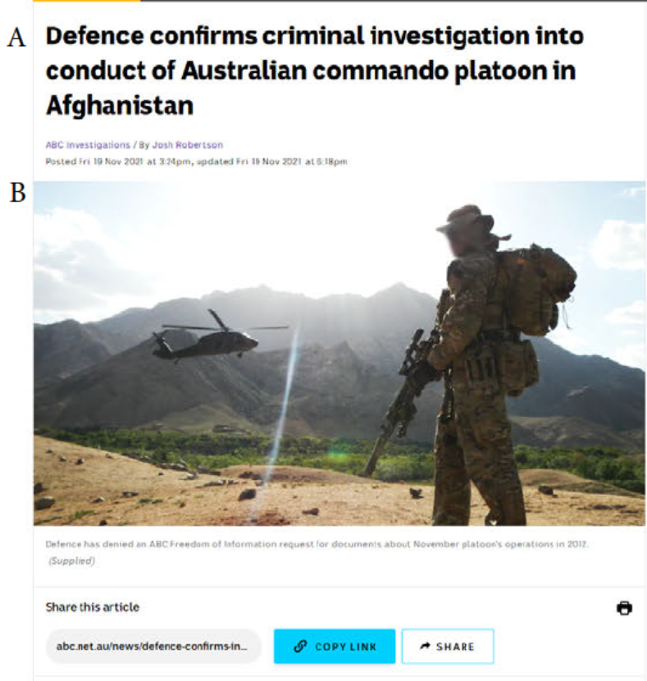

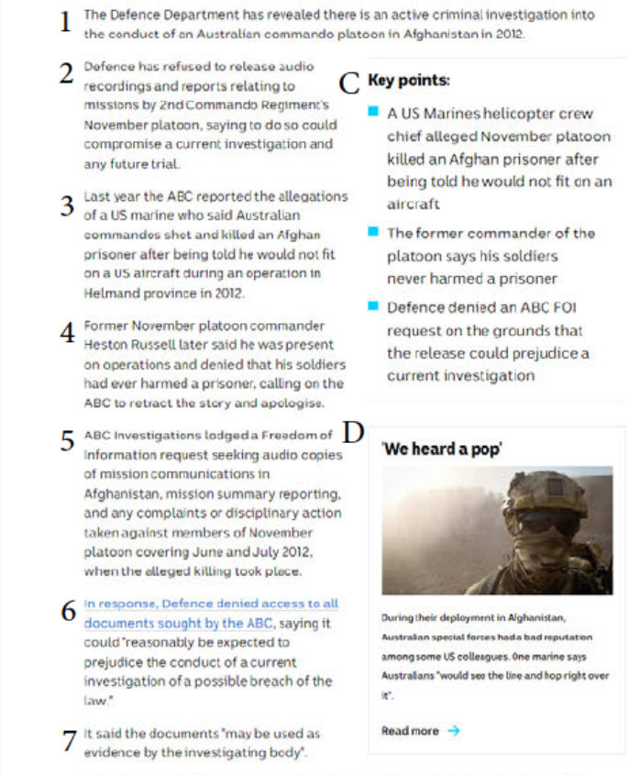

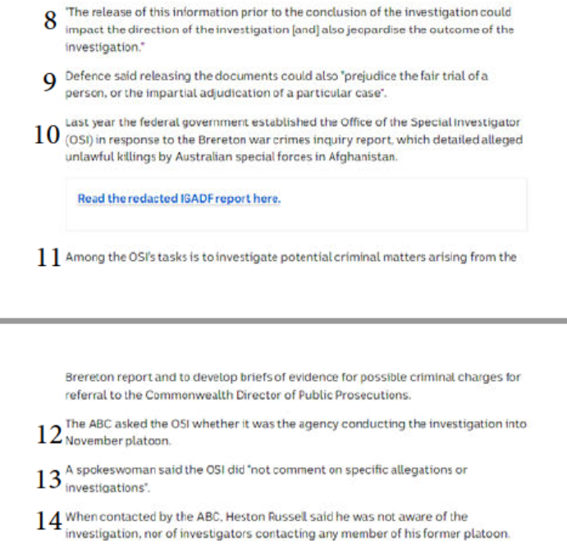

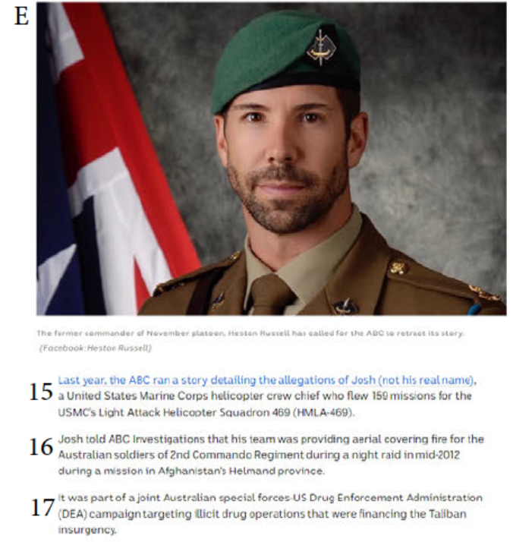

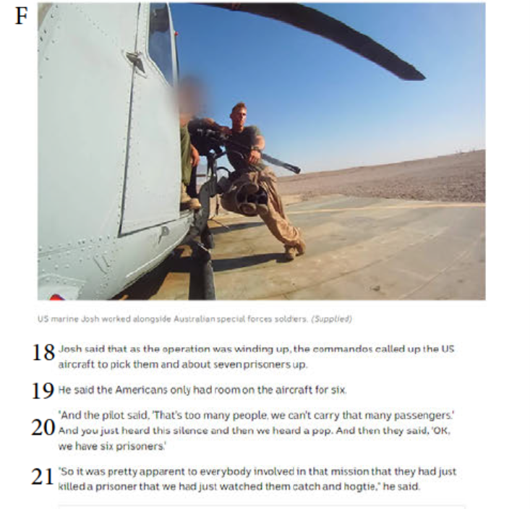

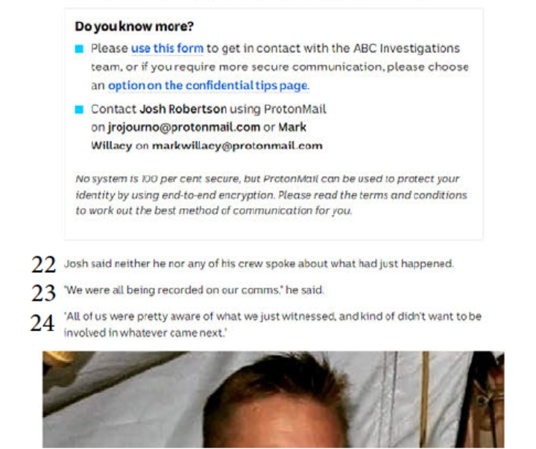

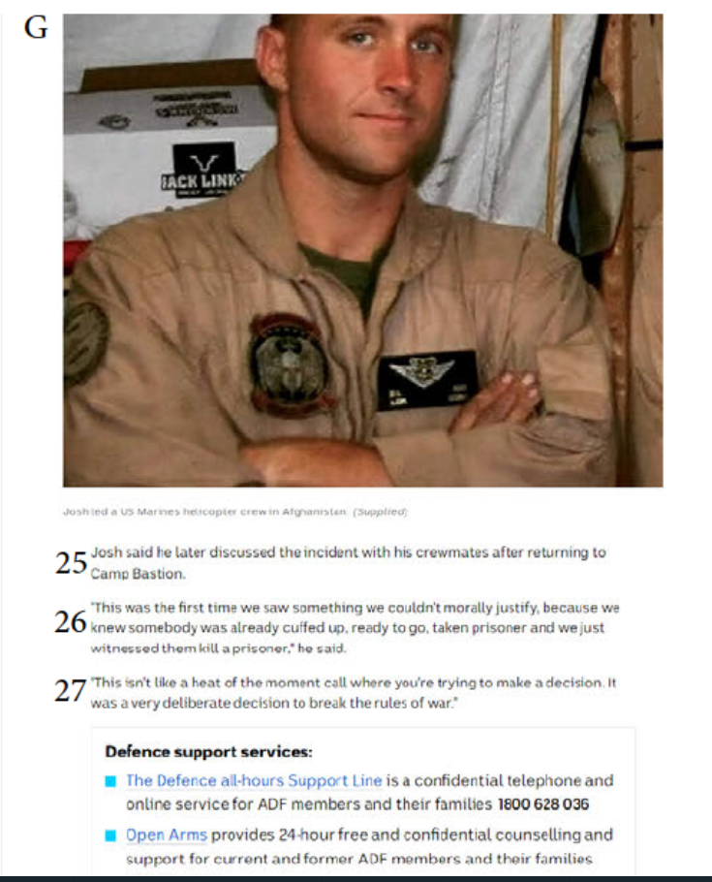

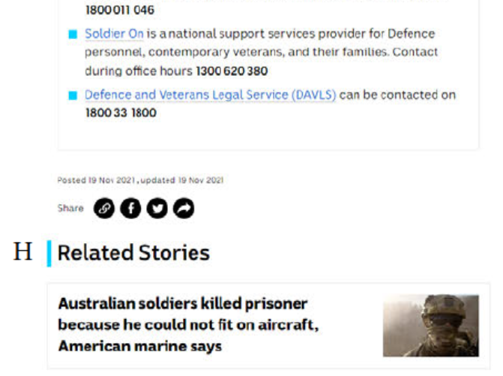

# ANNEXURE B

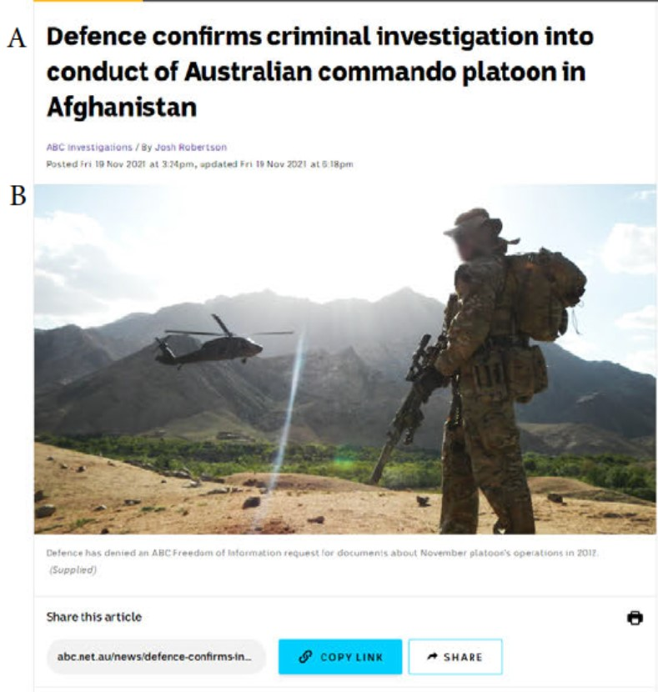

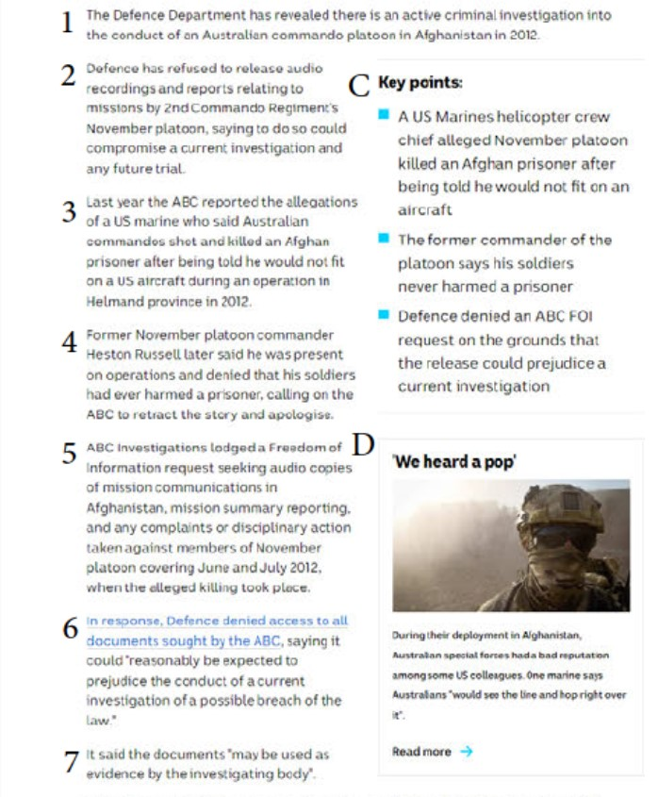

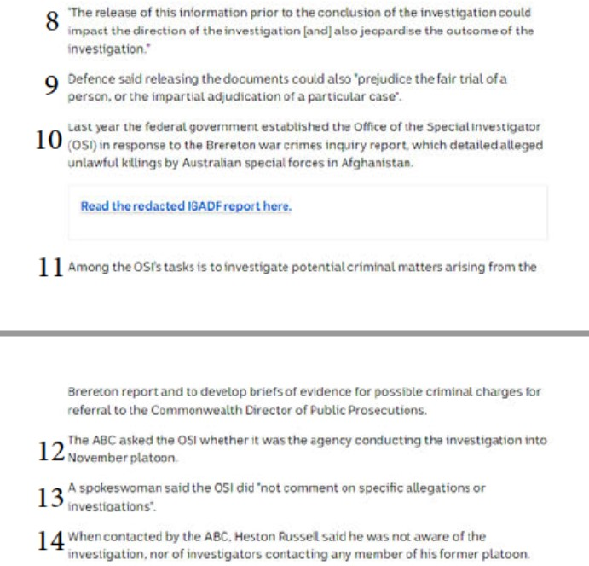

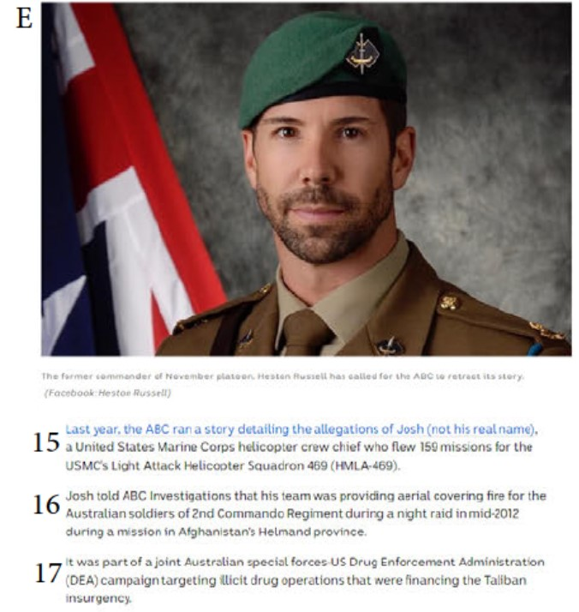

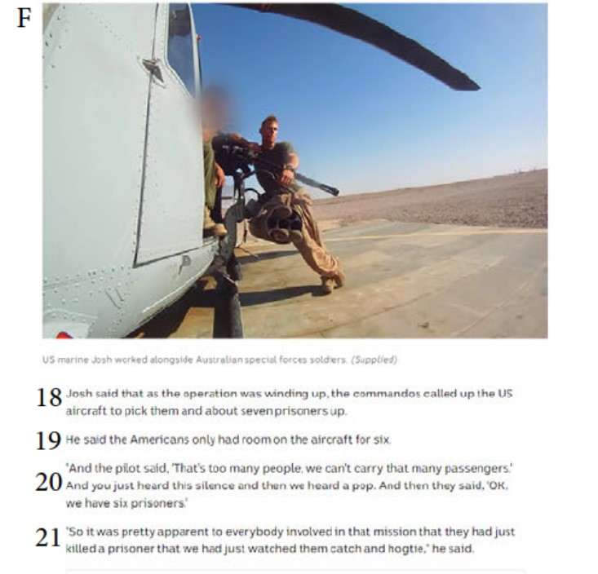

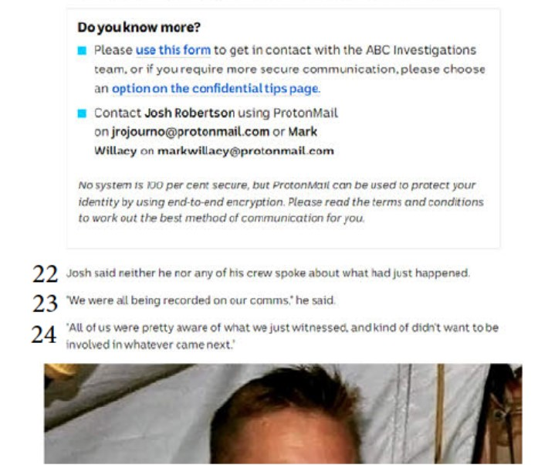

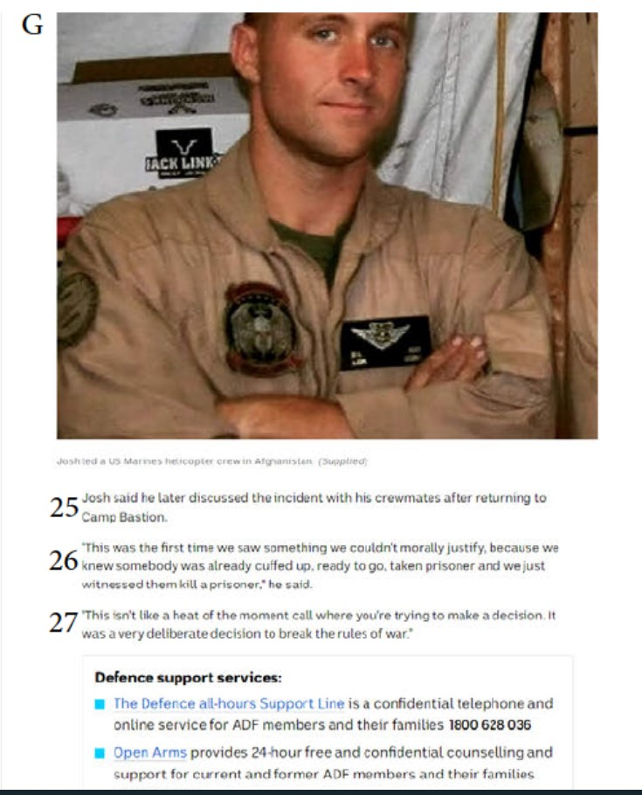

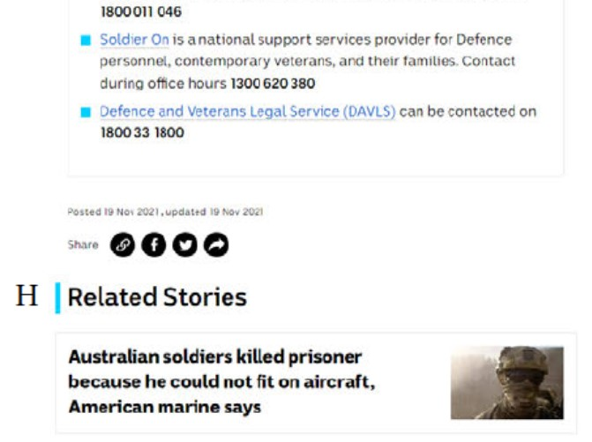

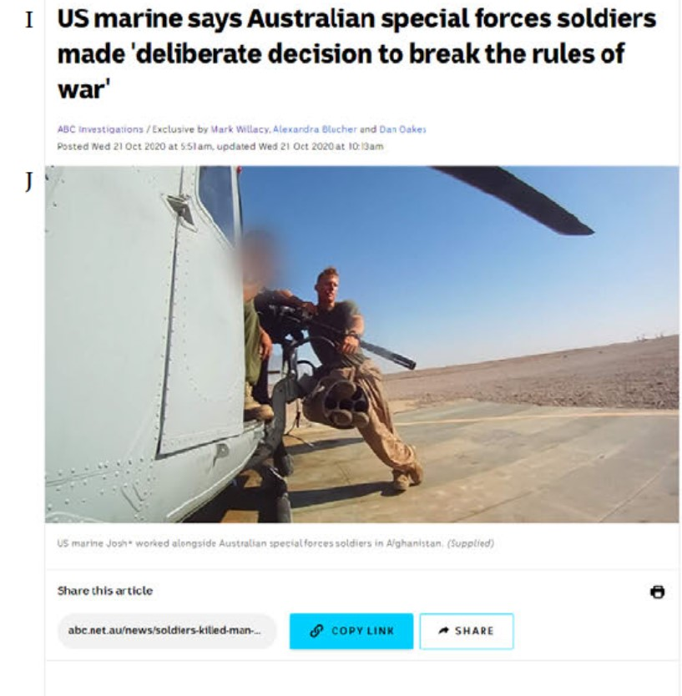

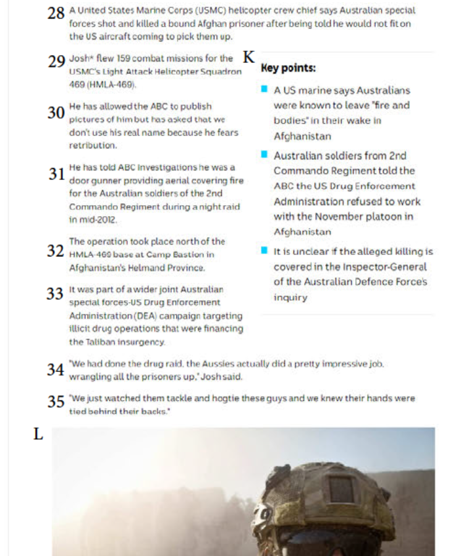

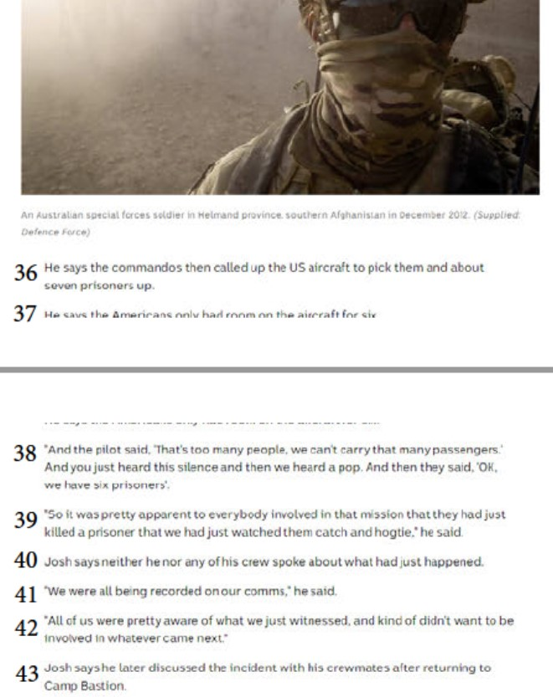

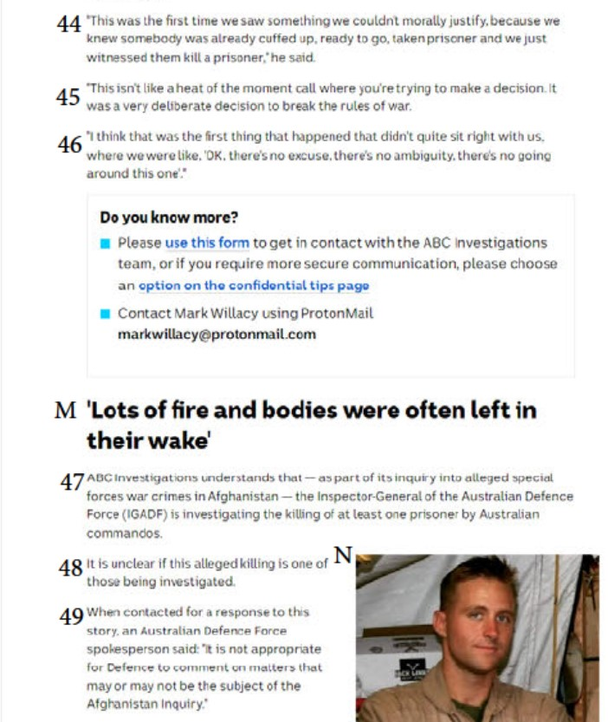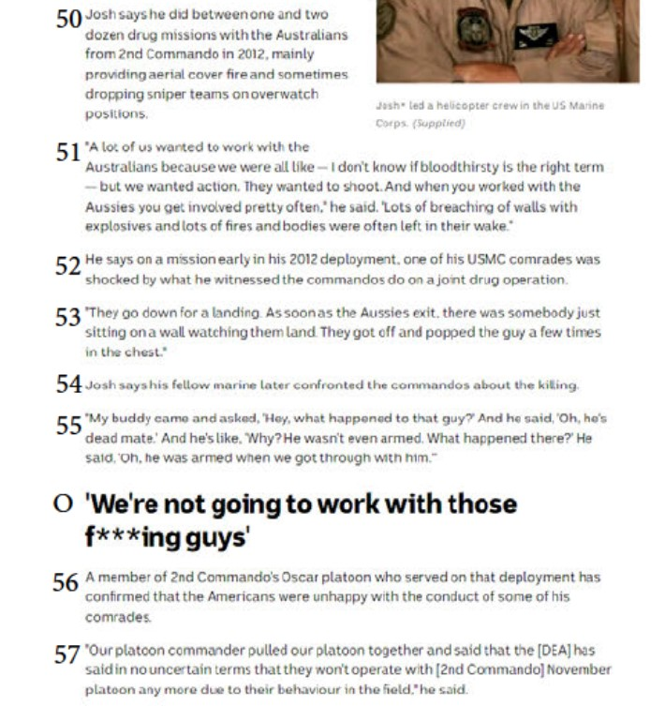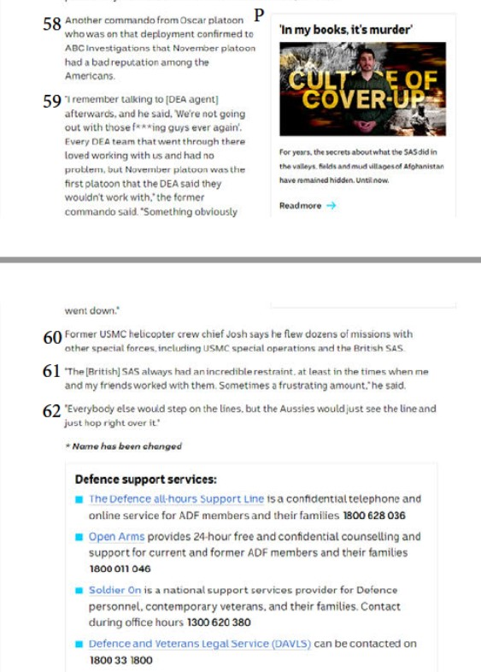

# ANNEXURE C

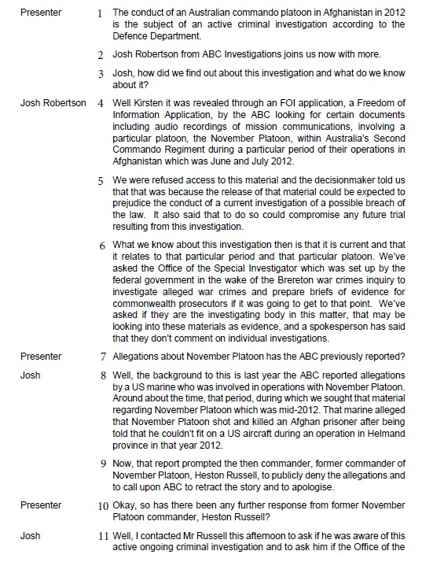

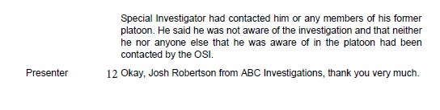

# ANNEXURE D

